**Anti-inflammatory, Antioxidant, and Diuretic Effects of Aqueous Sarcocephalus latifolius Root Extract in Wistar Rats**

**ABSTRACT**

|  |
| --- |
| This study aimed to evaluate the antioxidant, anti-inflammatory, and diuretic activities of the aqueous extract of *Sarcocephalus latifolius* roots, a medicinal plant widely used in the traditional West African pharmacopoeia. The extract demonstrated strong antioxidant potential through multiple assays: DPPH (IC₅₀ = 0.15 ± 0.11 mg/mL), FRAP (44.31 ± 1.88 µg AAE/g), ABTS (0.54 ± 0.22 mol TE/g, 81.34 ± 1.31% inhibition), and APM (7.18 ± 0.55 mMol AAE/g). These results suggest a high radical scavenging capacity, potentially protective against oxidative stress-related diseases. The anti-inflammatory activity was assessed by inhibition of heat-induced ovalbumin denaturation. The extract showed a significantly lower IC₅₀ (0.94 mg/mL) than diclofenac (5.2 mg/mL), a reference NSAID (p < 0.05), indicating strong anti-inflammatory properties. For diuretic evaluation, rats treated with 100, 200, and 300 mg/kg of the extract showed a dose-dependent increase in urine output and significant enhancement of Na⁺, K⁺, Cl⁻, and Ca²⁺ excretion compared to controls (p < 0.05). Unlike furosemide, the extract induced a slower but prolonged diuretic effect, without significant alterations in serum creatinine or urea levels, indicating a favorable short-term safety profile. Overall, these findings validate the traditional use of *Sarcocephalus latifolius* in the treatment of inflammatory, renal, and metabolic disorders. The extract shows promise as a source of bioactive molecules for phytotherapeutic development. However, further studies are required to isolate and characterize the active compounds and to confirm the pharmacological mechanisms through advanced in vivo and clinical investigations. |

**Mots clés :** *Sarcocephalus latifolius*, antioxidant, anti-inflammatory, diuretic, flavonoids, traditional medicine, Wistar rats

1. **INTRODUCTION**

The search for new bioactive substances derived from medicinal plants has seen renewed interest, especially in the context of limiting the side effects of synthetic drugs and developing better-tolerated natural treatments. In West Africa, traditional medicine relies on a wide variety of plants used in the prevention and treatment of chronic diseases such as inflammation, hypertension, kidney diseases, and metabolic disorders (Niyonzima et al., 2021 ; Oladokun et al., 2020).

Among these plants is *Sarcocephalus latifolius* (syn. Nauclea latifolia), a Rubiaceae known for its various ethnopharmacological uses : treatment of pain, infections, fever, malaria, diabetes, edema, and urinary disorders (Traoré., 2020 ; Klotoé et al., 2022). Recent studies have confirmed its richness in secondary metabolites, particularly flavonoids, tannins, saponins, phenolic compounds, and alkaloids, which are at the origin of its multiple pharmacological activities (Téné et al., 2019 ; N’Guessan et al., 2023 ; Perside et al., 2024).

Oxidative stress and chronic inflammation are two key biological processes involved in the pathophysiology of many modern ailments, such as cardiovascular, renal, neurodegenerative, or metabolic diseases (Wang et al., 2022 ; Akindele et al., 2020). In parallel, the regulation of diuresis is a major therapeutic axis in the management of hypertension, congestive heart failure, and hydro-electrolytic disorders (Hamza et al., 2019). Thus, identifying plants with both antioxidant, anti-inflammatory, and diuretic activities could support an integrated therapeutic strategy, particularly in resource-limited settings.

Several in vitro and in vivo studies have demonstrated that *S. latifolius* extracts exert protective effects on tissues due to their ability to neutralize free radicals, inhibit inflammation, and modulate urinary electrolyte excretion (Ajayi et al., 2019 ; Dossou-Yovo et al., 2023). The flavonoids it contains are also well known for their powerful antioxidant effects, capable of scavenging reactive oxygen species (ROS) and stimulating endogenous defense enzymes (Tao et al., 2023). Likewise, its phenolic and tannin compounds have shown an ability to influence renal permeability, modulate blood pressure, and promote the excretion of sodium, potassium, and chloride (Zerbo et al., 2020).

In this context, the present study aims to evaluate the antioxidant effects (using DPPH, FRAP, ABTS, and APM methods), anti-inflammatory effects (through inhibition of ovalbumin denaturation), and diuretic effects (via measurements of urinary and plasma parameters) of the aqueous extract of *Sarcocephalus latifolius* roots in Wistar rats. This approach is part of a broader perspective of valuing local phytotherapeutic resources and developing alternative solutions supported by scientific evidence.

1. **MATERIALS AND METHODS**
   1. **Materials**
      1. **Plant Material**

The plant material consisted exclusively of roots of *Sarcocephalus latifolius* harvested in Porto-Novo, southern Benin, and authenticated at the National Herbarium of Benin under the number YH 790/HNB. After harvesting, the roots were dried in a room protected from light and humidity to preserve the integrity of the bioactive compounds and accelerate drying. The finely cut dried roots were ground using a hammer mill (Retshsm 2000 type) to obtain a powder, increasing the surface area between solid and solvent to facilitate extraction. The resulting powder is yellow in color and bitter in taste.

* + 1. **Animal Material**

The animal material consisted of male and female Wistar rats weighing between 100 and 120 g. The rats were bred in the animal facility of LPMTA, Department of Animal Physiology, University of Abomey-Calavi.

All animals had an SPF (Specific Pathogen-Free) health status. Upon arrival, the rats were weighed and randomly assigned into five (05) groups of three (03) rats for an acclimatization period before experiments began. During this period, the animals had free access to food and water and were kept in an animal facility at a constant temperature (22 ± 2 °C) under a 12-hour light/dark cycle. In our laboratory, rats are fed with rabbit pellets labeled "Fattening Rabbit Feed."

* + 1. **Methods**
       1. **Preparation of the Aqueous Extract of *Sarcocephalus latifolius* Root Powder**

The extraction was carried out according to the protocol described by Ondele et al., 2015 with slight modifications :

Weigh 50 grams of *Sarcocephalus latifolius* root powder and add 500 mL of distilled water in a 1L glass bottle. Stir on a magnetic stirrer for 10 minutes ;

Boil the mixture for 15 minutes ;

After cooling, filter the decoction through a funnel ;

Filter three times using absorbent cotton ;

Place in an oven at 40°C for three days.

* **Calculation of Extraction Yield**

The extraction yield was determined as the ratio of the dry extract mass obtained after evaporation to the initial mass of plant material, using the formula :

**Yield (%) = (M1 / M0) × 100**

Where :

M1 = mass of extract after evaporation ; M0 = mass of starting plant material

* + - 1. **Evaluation of Antioxidant Activity**
* **DPPH Radical Scavenging Activity**

The DPPH (2,2-diphenyl-1-picrylhydrazyl) radical scavenging activity of the aqueous extract of *Sarcocephalus latifolius* roots was determined following the method described by Chokki et al., 2020 using a spectrophotometric cuvette assay.

100 µL of a 50 µM DPPH solution was mixed with 100 µL of extract at 200 µg/mL. The mixture was incubated in the dark for 30 minutes at room temperature. Absorbance was measured at 517 nm. The scavenging efficiency of the extract, as well as that of ascorbic acid and BHT, was calculated using the Schmeda-Hirschmann formula (El-Khawaga, 2023) :

**% Inhibition = [(Ac - Ae) / Ac] × 100**

Where :

Ac = absorbance of the control ; Ae = absorbance of the extract or reference compound

The concentration needed for 50% inhibition (IC50) was determined from the regression equation of the curve relating inhibition percentage to extract concentration.

* **Ferric Reducing Antioxidant Power (FRAP)**

The procedure was adapted from the method described by Mahajan et al., 2024 with modifications. A reagent solution was prepared by mixing 100 mL of TPTZ solution (10 mM in 40 mM HCl) with 10 mL of FeCl₃ (20 mM).

From this solution, 200 µL was used as the working solution and mixed with 50 µL of the aqueous root extract. The mixture was incubated at 37°C for 10 minutes. The absorbance of the resulting reaction mixture was measured at 593 nm. Ascorbic acid was used as the positive control with a standard curve ranging from 0 to 250 µg (y = 1.38x + 38.4, R² = 0.99).

The extract’s reducing ability was expressed in micrograms of ascorbic acid equivalents per gram of extract (µg AAE/g), calculated using :

**C = (Co × fd) / Ci**

Where :

C = concentration of reducing compounds in the dry extract (µg AAE/g) ; Co = sample concentration read ; fd = dilution factor ; Ci = initial concentration

* **ABTS Radical Cation Scavenging Assay**

To assess the ABTS radical scavenging potential, the method by Cudalbeanu et al., 2019 was used. The ABTS radical was generated by mixing 5 mL of 7.8 mM ABTS with 5 mL of 140 mM potassium persulfate, then incubating the mixture in the dark at room temperature for 12 hours. It was then diluted to reach an absorbance between 1.1 ± 0.02 at 734 nm. For the test, 100 µL of freshly prepared ABTS was mixed with 100 µL of extract. After 30 minutes of incubation, the absorbance was measured at 734 nm. Trolox (7.8 to 62.5 µg/mL) was used for the calibration curve (y = 1.299x + 12.61, R² = 0.99). Results were expressed as percent inhibition and Trolox equivalent (mol TE/g), calculated using :

**C = (Co × fd) / (Ci × M)**

Where :

C = concentration of reducing compounds in the dry extract (mol TE/g) ; Co = sample concentration read ; fd = dilution factor ; Ci = initial concentration ; M = molar mass of Trolox

* **Phosphomolybdenum (APM) Reducing Activity**

The phosphomolybdenum assay followed the protocol of Kedir et al., 2023. An aliquot of 0.1 mL of diluted sample extract was placed in test tubes in triplicate. Each tube received 1 mL of reagent solution (0.6 M sulfuric acid, 28 mM sodium phosphate, and 4 mM ammonium molybdate). The tubes were incubated in a water bath at 95°C for 90 minutes, then cooled to room temperature. Absorbance was recorded at 765 nm using a BioMATE 3S UV-Vis spectrophotometer. Ascorbic acid was the positive control for the calibration curve (y = 1.4831x - 0.1568; R² = 0.9957). Antioxidant activity equivalent (AAE) was calculated from the standard curve using :

**AAE = (X × Df) / (Cm × 1000) × Ey**

Where :

X = scavenging activity (mM/mL) ; Df = dilution factor ; Cm = initial extract concentration (mg/mL) ; Ey = extraction yield (g/kg plant material).

* + - 1. **In-vitro Anti-inflammatory Activity**

The heat-induced ovalbumin denaturation method described by Chandra et al., 2012 was used.

The reaction mixture consisted of 0.2 mL of freshly prepared ovalbumin, 2.8 mL of phosphate-buffered saline (PBS, pH 6.4), and 2 mL of extract at different concentrations (0.625 to 5 mg/mL). A similar volume of distilled water was used for the control. The mixtures were incubated at 37 ± 2°C for 15 minutes, then heated to 70°C for 5 minutes. After cooling, absorbances were measured at 660 nm against water. Diclofenac sodium (1.25 to 10 mg/mL) was used as the reference compound. Each test was performed in duplicate. The percentage of inhibition was calculated as follows :

**% Inhibition = 100 × (Vt / Vc - 1)**

Where :

Vt = absorbance of the test sample ; Vc = absorbance of the control

The concentration of the extract or reference molecule required to inhibit 50% of the activity (IC50) was determined by fitting the curve of the percentage inhibition as a function of concentration.

* + - 1. **Evaluation of the diuretic activity of the aqueous extract of *Sarcocephalus latifolius***

Wistar rats were weighed using a portable electronic balance, grouped by body weight, and labeled.

**Table 1 :** Batch Distribution Table

|  |  |  |  |  |  |
| --- | --- | --- | --- | --- | --- |
| Batch number | 1 | 2 | 3 | 4 | 5 |
| Administered solution | Distilled water | Furosemide | 100 mg/kg BW *Sarcocephalus latifolius* | 200 mg/Kg BW  *Sarcocephalus latifolius* | 300 mg/Kg BW  *Sarcocephalus latifolius* |

Two types of rat metabolic cages were used for urine collection : one was a glass system separating feces and urine (28 × 28 cm), and the other a plastic system (15 cm radius) also separating feces and urine. Each cage had a grid that separated feces from urine. A tube placed at the bottom collected the urine, and a mesh was placed at the end of this tube to filter the collected urine. Administration of the aqueous root extract and other substances was performed by oral gavage using a syringe fitted with an esophageal probe, ensuring full dose delivery.

After a 3-day adaptation period in individual metabolic cages (with free access to food and tap water), the rats were fasted for 24 hours during the experiment. The test was conducted during the rats rest phase (daytime animals), i.e., between 10 AM and 7 PM. Urine volume was measured hourly over 8 hours and again at 24 hours. Elimination rate was assessed graphically and expressed as a percentage. Urine samples were collected at 8 and 24 hours for biochemical analysis. The measured urinary parameters included Cl⁻, Na⁺, K⁺, Ca²⁺, pH, urea, creatinine, and the Na⁺/K⁺ ratio. The percentage of elimination relative to ion intake was calculated using the following formulas (based on an intake of 2 mL of water and 0.385 mmol of sodium/chloride per 100 g of body weight):

Ion elimination (%) = X × 100 / 0.385, where X is the amount of Na⁺ or Cl⁻ excreted in urine (in mmol)

Water elimination (%) = X × 100 / 2, where X is the urine volume in mL

Sodium, potassium, and chloride were simultaneously measured using a flame photometer (Caretium®). Calcium was measured using an EMPEROR 168 spectrophotometer. Urea and creatinine were measured using a BIBBY Anadès spectrophotometer.

* + - 1. **Statistical Analysis**

Data collected before and after extract treatment were recorded in Excel 2013. Normality and homogeneity of variances were tested using R Studio via Shapiro and Levene tests, respectively. Paired-sample t-tests were used for comparison. Graphs were generated with GraphPad Prism 9.5.1 (733) and Excel 2013. Statistical significance was considered at p < 0.05.

1. **RESULTS AND DISCUSSION**
   1. **Results**
      1. **Extraction Yield**

R = (24.75/229.01) × 100 = 10.80%

After three days, 24.75 g of aqueous extract was obtained, for a total yield of 10.80%.

* + 1. **Antioxidant activity of the aqueous extract of *Sarcocephalus latifolius* roots**
* **DPPH Method**

Table 2 shows the high percentage of inhibition of the DPPH free radical by the aqueous extract of *Sarcocephalus latifolius*. The antioxidant capacity of the extracts was determined using the IC50 (concentration required to reduce 50% of the DPPH radical). The lower the IC50 value, the greater the antioxidant activity of a compound (Pokorny et al., 2001). According to Table 2, ascorbic acid (0.005 ± 0.003 mg/ml) and BHT (0.011 ± 0.084 mg/ml) used as reference molecules have lower IC50s than our extract (0.15 mg/ml) and therefore, very high antioxidant activities than our extract which still has strong antioxidant activity.

Table 2 : Concentration required to reduce 50% of the DPPH radical

|  |  |  |
| --- | --- | --- |
| Extract Type | % DPPH Inhibition | IC50 (mg/ml) |
| Ascorbic Acid | 98,79±0,36 | 0,005 ±0,003 |
| BHT | 96,84±0,24 | 0,011 ±0,084 |
| Aqueous Extract of *Sarcocephalus latifolius* | 82,21±0,31 | 0,15 ±0,11 |

* **FRAP and ABTS Methods**

According to Table 3, a high ferric reducing capacity (FRAP) was found in the aqueous extract of *Sarcocephalus latifolius* (44.31 ± 1.88).

The extract also demonstrated a very high ABTS reducing power (0.54 ± 0.22 mol ET/g) with an inhibition percentage of 81.34 ± 1.31%.

Table 3 : FRAP and ABTS Test Results

|  |  |  |
| --- | --- | --- |
| FRAP Ferric Reducing Ability (µg AAE/g) | ABTS | |
| 44,31±1,88 | % Inhibition | Reducing Power (mol ET/g) |
| 81,34±1,31 | 0,54±0,22 |

EAA : ascorbic acid equivalent ; AND : trolox equivalent

* **APM method**

Our extract demonstrated very high reducing activity (7.177 ± 0.552 mMol EAA/g) and therefore has very high antioxidant activity. Our extract is therefore very rich in antioxidant compounds.

* + 1. **Anti-inflammatory activity**

Figure 1 shows the percentage inhibition of albumin denaturation and the determination of the IC50.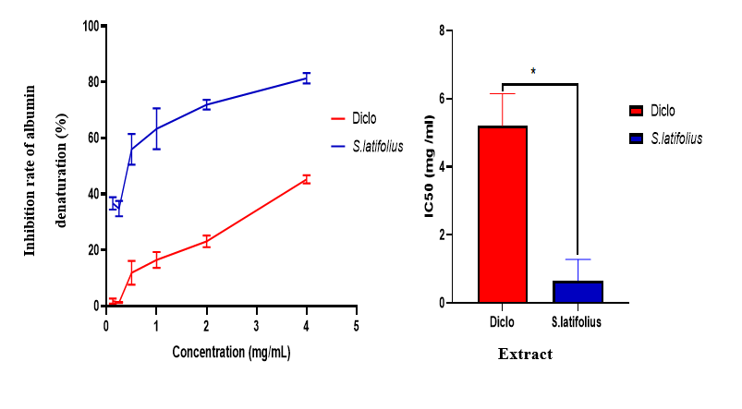

**Figure 1 :** Percentage inhibition of albumin denaturation and IC50 determination

According to Figure 1, the percentage inhibition of albumin denaturation increases with increasing concentration. Our extract behaves like diclofenac used as a reference molecule. In vitro anti-inflammatory activity was determined using the IC50. The lower the IC50 value, the greater the anti-inflammatory activity of a compound. According to Figure 1, the IC50 obtained for diclofenac (5.2±0.8 mg/ml) used as a reference molecule is higher than that of our extract (0.94±0.09 mg/ml), and therefore our extract has a much higher anti-inflammatory activity than that of diclofenac.

* + 1. **Evaluation of the diuretic activity of the aqueous extract of *Sarcocephalus latifolius***
       1. **Urinary parameters**
* **Urine volume**

Figure 2 shows the evolution of urine volume in rats. It is noted that, at 8 hours, urine volume increased, especially for the 300 mg/kg BW group. At 24 hours, the action of furosemide was complete, while that of the extract persisted.

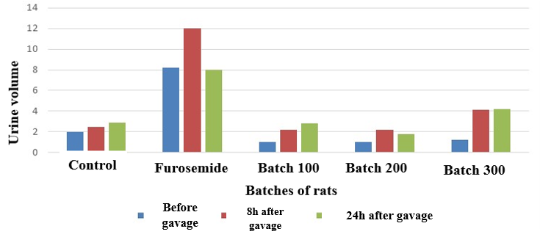

**Figure 2 :** Changes in urine volume in rats (8h-24h)

* **Elimination time**

Figure 3 shows the rate of urinary excretion in rats (1h-8h). It can be seen that the rate of urinary excretion is maximal between 6 and 8 hours : furosemide (36.74%), 100 mg/kg group (18.63%), and control (17.72%). The urinary excretion rate of group 100 (18.63%) is higher than that of the control group (17.72%).

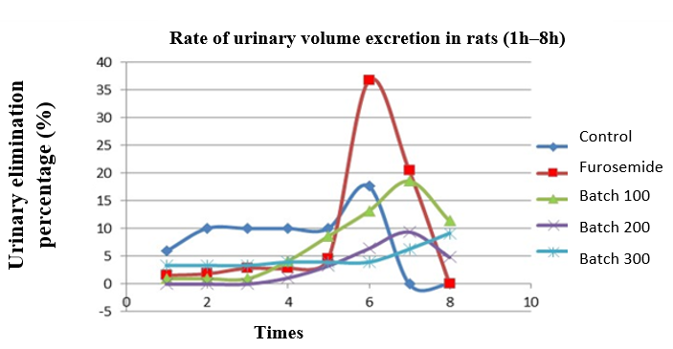

Figure 3 : Rate of urinary excretion in rats (1-8 hours)

* **Weight change at 24 hours**

Figure 4 shows the weight changes in rats before and after gavage. No significant weight change was observed, indicating the absence of fluid retention.

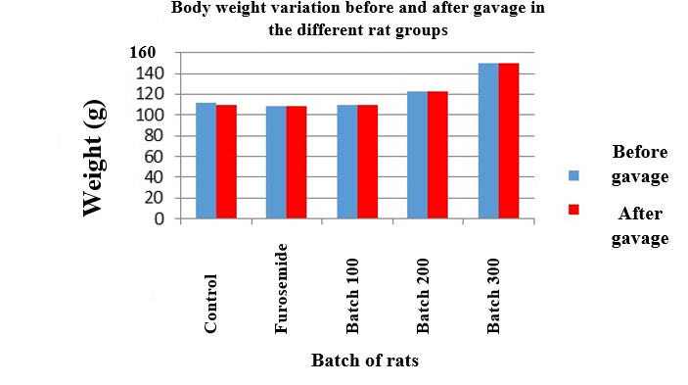

**Figure 4 :** Weight changes in rats before and after gavage

* **Variation in creatinuria**

Figure 5 shows the changes in creatinuria in rats before and 24 hours after gavage. Creatinuria increased in all groups, but significantly in the 100 mg/kg group.

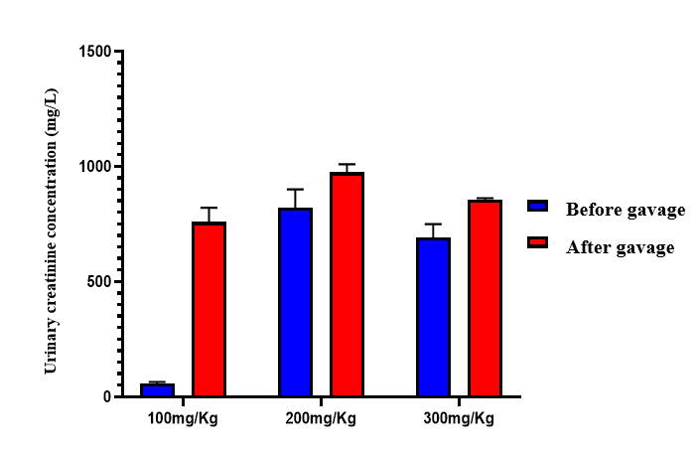

**Figure 5 :** Changes in urine creatinine in rats before and 24 hours after gavage.

* **Changes in urinary urea**

Figure 6 shows the changes in urinary urea in rats before and 24 hours after gavage. Urinary urea increased in all groups, particularly at 100 mg/kg BW.

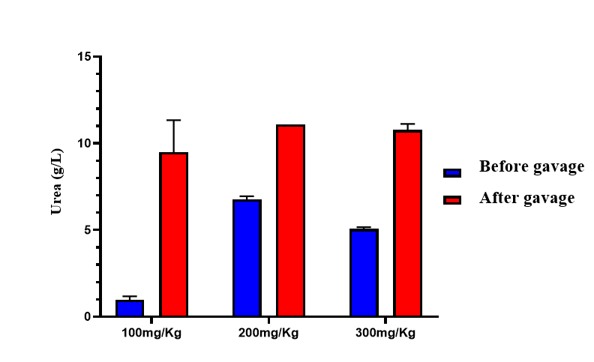

**Figure 6 :** Changes in urea in rat urine before and 24 hours after gavage

* **Urinary electrolyte excretion**

Electrolytes show increased excretion of Cl⁻, Na⁺, K⁺, and Ca²⁺ with a stable pH.

Figure 7 shows the pH changes in rats. It is noted that the pH remains stable (8.5-9) for all groups.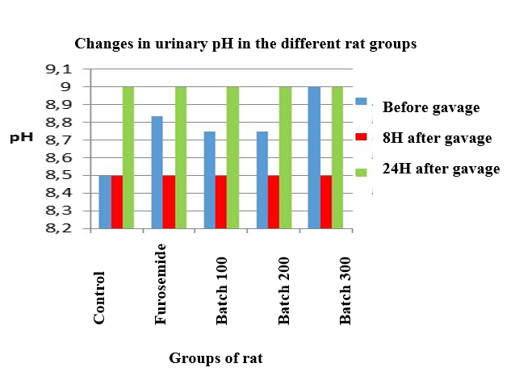

**Figure 7 :** Changes in pH in rats 24 hours before gavage, 8 hours, and 24 hours after gavage

* **Na+ ion**

Figure 8 shows the changes in Na+ ion in the groups of rats. Urinary sodium increases at 8 hours and stabilizes at 24 hours.

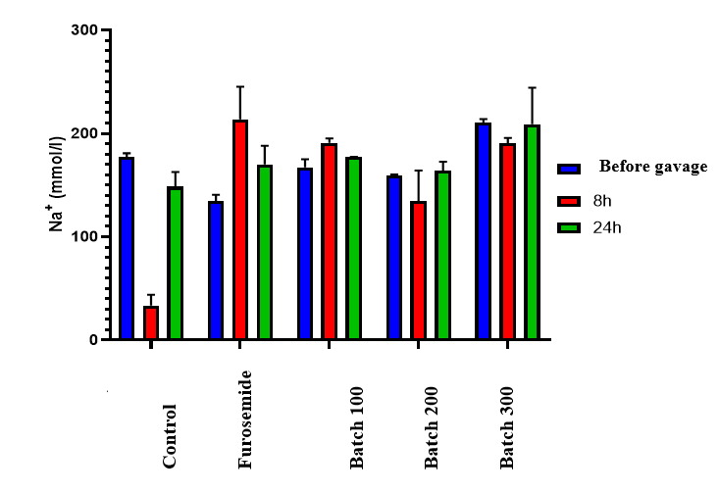

Figure 8 : Changes in Na+ ions in groups of rats 24 hours before gavage, 8 hours, and 24 hours after gavage

**K+ ions**

Figure 9 shows changes in K+ ions in rats. Urinary potassium levels gradually increase.

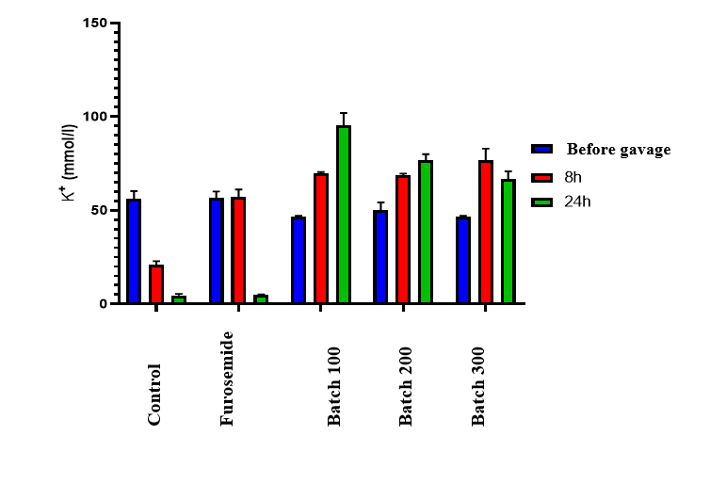

**Figure 9 :** Changes in K+ ions in rats 24 hours before, 8 hours after, and 24 hours after gavage

* **Na+/K+**

Figure 10 shows the changes in the Na+/K+ ratio. It is noted that the Na+/K+ ratio decreased at 24 hours in the treated groups, indicating higher K+ excretion.

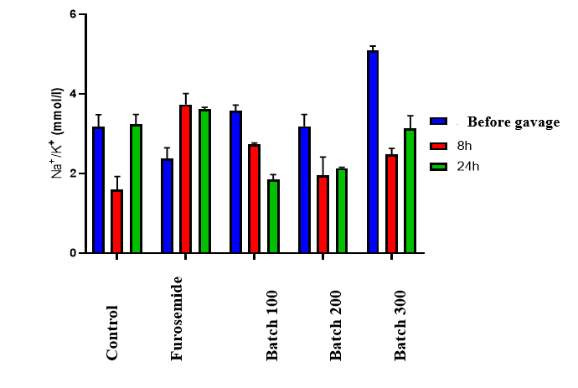

**Figure 10 :** Evolution of the Na+/K+ ion ratio in rats : 24 hours before, 8 hours after, and 24 hours after gavage.

* **Cl- ion**

Figure 11 shows the evolution of the Cl- ion in rats. Chloride levels increase at 8 hours for doses of 100 and 300 mg/kg, then decrease at 24 hours.

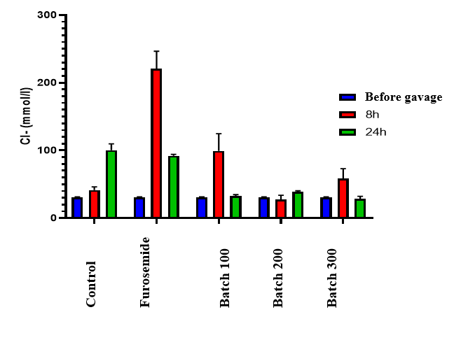

**Figure 11 :** Changes in Cl- ion in rats 24 hours before, 8 hours after, and 24 hours after gavage

* **Ca2+ ion**

Figure 12 shows the changes in Ca2+ ion. It can be seen that calcium remains relatively stable.

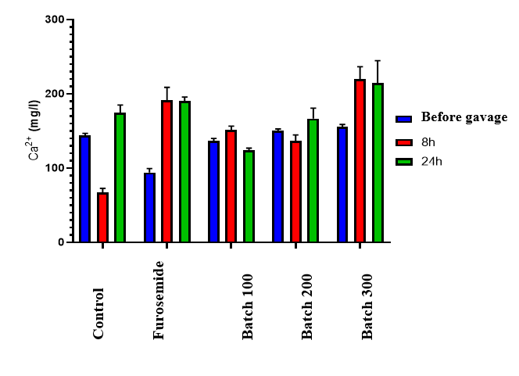

**Figure 12 :** Evolution of the Ca2+ ion in rats 24 hours before, 8 hours and 24 hours after gavage.

* **Blood Parameters**
* **Glycemia**

Figure 13 shows the changes in blood glucose levels in the rat groups. Blood glucose levels tended to increase slightly at 24 hours in the 100, 200, and 300 mg/kg BW groups.

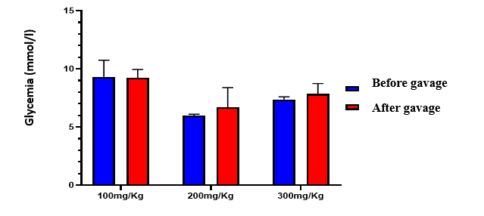

**Figure 13 :** Changes in blood glucose levels in groups of rats before and 24 hours after gavage

* **Creatinine**

Figure 14 shows the changes in blood creatinine levels in rats. It is noted that blood creatinine levels tend to increase in the treated groups, but this increase is not significant (P>0.05).

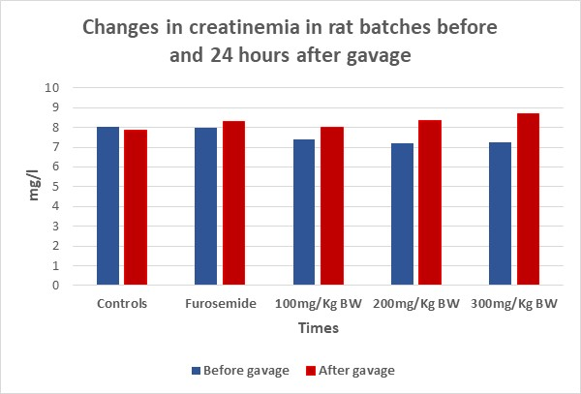

**Figure 14 :** Changes in serum creatinine in rat groups before and 24 hours after gavage

* **Urea**

Figure 15 shows the changes in serum urea in rats. There was a trend toward an increase in the treated groups, but this increase was not significant (P>0.05).

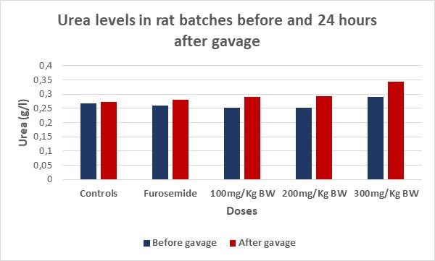

**Figure 15 :** Evolution of uremia in groups of rats before and 24 hours after gavage

* 1. **Discussion**

The results obtained in this study reveal that the aqueous extract of *Sarcocephalus latifolius* roots possesses significant antioxidant activity, illustrated by an IC50 of 0.15 ± 0.11 mg/mL for DPPH, a ferric reducing capacity (FRAP) of 44.31 ± 1.88 µg AAE/g, an ABTS reducing power of 0.54 ± 0.22 mol ET/g, and a phosphomolybdenum activity (PMA) of 7.177 ± 0.552 mMol AAE/g. These results confirm the richness of antioxidant compounds in the extract, including flavonoids, polyphenols, and tannins, identified in previous studies (Perside et al., 2024).

These observations are in agreement with those of Ajayi et al., (2019) who highlighted a strong antioxidant capacity of the extract of *Nauclea latifolia*, synonym of *S. latifolius*, attributed to flavonoids, phenolic compounds and alkaloids. Similarly, Tao et al., 2023 highlighted the role of natural flavonoids as ROS scavengers and regulators of the cellular antioxidant response. Indeed, flavonoids have antioxidant activity and are capable of scavenging O2- radicals and inhibit XORs (Trabsa et al., 2015 ; Njoya et al., 2021). Tannins have a high antioxidant capacity (Kurnia et al., 2024 ; Liu et al., 2023 ; Fraga-Corral et al., 2021 ; Cosme et al., 2025, Benkhouilli et al., 2024) because they possess phenolic nuclei and can inhibit lipid peroxidation thereby stopping auto-oxidation (Melo et al., 2024 ; Kaimkhani et al., 2021 ; Soldado et al., 2021).

Polyphenols have an ion-retaining effect, therefore they exhibit diuretic activity (Bong-Kyun et al., 2021). They are natural compounds widely distributed in the plant kingdom. Their role as natural antioxidants is due to their redox properties which allow them to act either as reducing agents (hydrogen donors), singlet oxygen scavengers or metal chelators (Njoya et al., 2021). Flavonoids are renowned antioxidants par excellence (Tao et al., 2023). The observed antioxidant potential is all the more relevant as it is close, although less powerful, to standards such as ascorbic acid (IC50 = 0.005 mg/mL) and BHT (0.011 mg/mL), confirming the results of Chabi et al., 2023 on an aqueous extract of the same plant with an IC50 of 0.299 mg/mL.

In vitro evaluation of anti-inflammatory activity, based on the inhibition of ovalbumin denaturation, shows that the extract exerts a potent inhibitory effect (IC50 = 0.94 mg/mL), lower than that of diclofenac sodium (5.2 mg/mL), indicating a superior efficacy of the extract.

This observation could be explained by the synergy between flavonoids, condensed tannins, and phenolic compounds, known to inhibit inflammatory pathways such as NF-κB and cyclooxygenase (COX) enzymes, as demonstrated by Bisht et al., (2020) and Wang et al., (2022). In particular, flavonoids interfere with the production of pro-inflammatory cytokines such as TNF-α and IL-6, thereby reducing systemic inflammation. The aqueous extract of *S. latifolius* induced a dose-dependent increase in urine volume, particularly marked at 300 mg/kg, with a prolonged action beyond that of furosemide, suggesting a different mechanism of action. The increased urinary concentrations of Na⁺, K⁺, Cl⁻ and Ca²⁺ as well as the observed weight and biochemical stability support a physiological diuretic activity without signs of acute toxicity Ellison et al (2020).

These results are comparable to those of Zerbo et al., (2020) and Dossou-Yovo et al., (2023), who also demonstrated the diuretic effect of plants rich in polyphenols, flavonoids and saponosides, by modulation of renal ion transporters. The prolonged effects observed could reflect an action on distal channels or hormonal regulation (aldosterone), as suggested by Hamza et al.,( 2019).

The progressive elimination profile and the absence of significant disturbance of creatinine or uremia indicate that the extract does not induce renal functional overload, which confirms its short-term safety. The coexistence of antioxidant, anti-inflammatory and diuretic effects suggests an integrated therapeutic potential in cardiovascular, renal and metabolic diseases, where oxidative stress, chronic inflammation and water and sodium retention are often intertwined (Akindele et al., 2020 ; Wang et al., 2022).

The ability of the extract to maintain stable electrolyte excretion while preserving biochemical constants supports its use as a natural alternative to synthetic diuretics, which are often responsible for electrolyte disorders (Hamza et al., 2019). However, subacute and chronic studies are needed to assess cumulative effects and isolate the active ingredients responsible.

1. **CONCLUSION**

This study aimed to evaluate the antioxidant, anti-inflammatory, and diuretic activity of the aqueous extract of *Sarcocephalus latifolius* roots, a medicinal plant widely used in traditional West African pharmacopoeia. The experimental approach adopted allowed us to demonstrate, in a rigorous and scientifically sound manner, that this extract possesses multiple pharmacological properties, likely explaining its empirical use in the management of several pathologies.

The results of the antioxidant tests (DPPH, FRAP, ABTS, APM) indicate a strong ability of the extract to neutralize free radicals and reduce oxidative species. The observed radical scavenging capacity suggests that the extract could play a protective role against oxidative stress, a process implicated in numerous chronic pathologies such as cardiovascular, metabolic, and neurodegenerative diseases.

On the anti-inflammatory side, the extract demonstrated a remarkable ability to inhibit heat-induced ovalbumin denaturation. The fact that the extract's IC50 was lower than that of diclofenac, a reference nonsteroidal anti-inflammatory drug, underscores the therapeutic potential of *S. latifolius* in modulating the inflammatory response. This paves the way for its use in the management of chronic inflammatory diseases, including arthritis, muscle pain, inflammatory digestive disorders, etc.

Analysis of diuretic activity revealed a dose-dependent increase in urine volume and the excretion of major electrolytes (Na⁺, K⁺, Cl⁻, Ca²⁺) without significant disruption of biological constants, including serum creatinine and urea. This profile is particularly interesting because it demonstrates a prolonged and moderate effect, without dehydration or sudden hydro-electrolytic imbalance, unlike fast-acting synthetic diuretics such as furosemide. This gives the extract a certain safety of use, at least in the short term, and makes it potentially useful in the management of pathologies such as high blood pressure, edema, or mild kidney disorders.

Taken together, these results validate the traditional uses of *Sarcocephalus latifolius* in the treatment of inflammatory, renal, and metabolic disorders. Moreover, they position this plant as a promising source of bioactive biomolecules with strong therapeutic potential. However, further studies are needed to isolate, identify, and characterize the active compounds responsible for the observed effects. Further analyses (evaluation of inflammatory markers, oxidative stress, gene expression, etc.) as well as in vivo studies on pathological models will help confirm and better understand the pharmacological action of this plant. Finally, well-designed clinical trials will be essential to validate its safety, bioavailability, and efficacy in humans.

In short, this research makes a significant contribution to the development of local phytotherapeutic resources. It supports the rational integration of traditional medicine into modern therapeutic approaches, combining endogenous knowledge and scientific validation.

**DISCLAIMER (ARTIFICIAL INTELLIGENCE)**

The authors hereby declare that ChatGPT was used during the writing process. It was used exclusively for the effective translation of certain sentences into English, in order to preserve their meaning and facilitate understanding for readers.

**ETHICAL APPROVAL**

All animal experiments were conducted in accordance with international ethical standards and approved by the Institutional Ethics Committee of the University of Abomey-Calavi.

**CONSENT**

It is not applicable.

**REFERENCES**

Ajayi, Ayodedji Michael., Akintayo, Christian Oluwaseun, & Omotola, Adebola Mary (2019). Phytochemical and antioxidant evaluation of Nauclea latifolia root extract. Journal of Ethnopharmacology, 235, 194–202. <https://doi.org/10.1016/j.jep.2019.01.038>

Akindele, Abidemi Joshua, Oboh Gideon, Akinyemi, Adetutu Josephine (2020). Medicinal plants for management of hypertension: Phytochemistry and mechanisms. Journal of Integrative Medicine, 18(4), 350–362. <https://doi.org/10.1016/j.joim.2020.04.007>

Benkhouili Souad, Ouhammou Mohamed, Bouiamrine El Hadi & Ennabili Abderrahim. (2024). Evaluation of the content of polyphenols, flavonoids and tannins, the antioxidant capacity, and the antimicrobial activity of different organic and aqueous fractions of stems of Retama monosperma. Plant Science Today, 11(1), 1–10.

Bisht, Kanika, Wagner, Karl-Heinz, & Boulmer, Abdelkrim Chouaib. (2010). Curcumin, resveratrol and flavonoids as anti-inflammatory, cyto- and DNA-protective dietary compounds. *Toxicology*, 278(1), 88–100.

Bong-Kyun Koh, Teepakorn Kongraksaweech, Andrew S Ross.2021. Effect of polyphenols on mixing properties and solvent retention of wheat flour doughs. Science of food and Agriculture.Pages 2432-2436

Chabi, Nadine, Adounkpe, Jean, Hounguevou, Marthe, & Dovonou, Rollande. (2023). Évaluation in vitro des activités antioxydantes de Sarcocephalus latifolius. *Benin Journal of Research in Health Sciences*, 9(1), 27–36.

Chokki, Mohamed, Cudalbeanu, Maria, Zongo, Cyprien, Dah-Nouvlessounon, Dieudonné, Ghinea, Otilia Ioana, Furdui, Bogdan, Raclea, Roxana, Savadogo, Alfred, Baba-Moussa, Lamine, & Avamescu, Silvia-Maria. (2020). Exploring Antioxidant and Enzymes (A-Amylase and B-Glucosidase) Inhibitory Activity of Morinda lucida and Momordica charantia leaves from Benin. *Foods*, 9(3), 434. <https://doi.org/10.3390/foods9030434>

Cosme, Fernando, Silva, Tiago, Lima, Maria S., & Pinto, Teresa. (2025). A comprehensive review of bioactive tannins in foods and beverages: Functional properties, health benefits, and sensory qualities. *Molecules*, 30(4), 800. <https://doi.org/10.3390/molecules30040800>

Cudalbeanu, Maria, Furdui, Bogdan, Cârâc, Gabriela, Barbu, Vasile, Iancu, Alexandru V., Marques, Fernanda, Leitão, José H., Sousa, Sandra A., & Dinica, Rodica M. (2019). Antifungal, antitumoral and antioxidant potential of the Danube Delta Nymphaea alba extracts. *Antibiotics*, 9(1), 7. <https://doi.org/10.3390/antibiotics9010007>

Dossou-Yovo, Alain, Bogninou, Didier, Hounkpatin, Bruno, Kpoviessi, Daouda S., & Gbenou, Joachim. (2023). Evaluation des propriétés antioxydantes et diurétiques de quelques plantes utilisées dans le traitement de l’hypertension au Bénin. *Annales de Biologie Clinique*, 81(2), 89–97.

Ellison, D. H., & Felker, G. M. (2020). Diuretic therapy in heart failure: Current approaches. European Heart Journal Supplements, 22(Suppl G), G20–G27. <https://doi.org/10.1093/eurheartj/suaa108>

Fraga-Corral, María, García-Oliveira, Paula, Pereira, Ana G., Lourenço-Lopes, Cristina, Jimenez-Lopez, Carlos, Prieto, Miguel Ángel, & Simal-Gandara, Jesús. (2021). By-products of agri-food industry as tannin-rich sources: A review of tannins’ biological activities and their potential for valorization. *Foods*, 10(1), 137. <https://doi.org/10.3390/foods10010137>

Hamza, Rania, Shehab, Naglaa G., El-Shaer, Nayera S., & Ibrahim, Nivien S. (2019). Diuretic and nephroprotective activities of traditional medicinal plants: A review. *Heliyon*, 5(9), e02462. <https://doi.org/10.1016/j.heliyon.2019.e02462>

Karimkhani, Morteza Mahdi, Jamshidi, Alireza, Zeinali, Tahereh, et al. (2021). Effect of extraction solvents on total phenolic compound, lipid peroxidation, antioxidant and cytotoxic activity of leaves of Rubus armeniacus (Himalayan blackberry). *Journal of Food Measurement and Characterization*, 15, 5725–5734. <https://doi.org/10.1007/s11694-021-01135-x>

Klotoé, Jean Robert, Dougnon, Tanguy V., Agbankpé, Adolphe J., Agbodjento, Epiphane, Bankolé, Hounsa C., Fah, Lamine D., & Baba-Moussa, Lamine. (2022). Phytochemical screening and biological activities of traditional antidiabetic plants in Benin. *BMC Complementary Medicine and Therapies*, 22(1), 76. <https://doi.org/10.1186/s12906-022-03526-4>

Kurnia, Dian, Meilinawati, Dewi, Febrina, E., & Asnawi, A. (2024). A review of Tannin compounds in Avocado as antioxidants. *Tropical Journal of Natural Product Research (TJNPR)*, 8(10), 8607–8616. <https://doi.org/10.26538/tjnpr/v8i10.1>

Liu, Han, Wei, Huan, Chen, Yi, Yan, Chen, & Yin, Yong. (2023). Comparison of the effects between tannins extracted from different natural plants on growth performance, antioxidant capacity, immunity and intestinal flora of broiler chickens. *Antioxidants*, 12(2), 441. <https://doi.org/10.3390/antiox12020441>

Melo, André, Afonso, Tânia B., Pedrosa, Maria C., Carvalho, Miguel, Rodrigues, Carla, Dias, Maria I., Ribeiro, Tânia, Machado, Manuel, Tavaria, Fernanda, Carocho, Márcio, Simas, Jorge P., Teixeira, Paula, Barros, Lillian, & Pintado, Manuela. (2024). Phenolic profile and antioxidant and biological activities of plant extracts rich in hydrolyzable tannins. *ACS Agricultural Science & Technology*, 4(10), 988–1001. <https://doi.org/10.1021/acsagscitech.4c00271>

Mfotie-Njoya, Eric. (2021). Medicinal plants, antioxidant potential, and cancer. In: *Phytomedicine: A Treasure of Pharmacologically Active Products from Plants*, Pages 349–357.

N’Guessan, Kouadio Armand, Kouakou, Kouadio Aimé, Koné, Mamadou, & Djaman, Allico Joseph. (2023). Nauclea latifolia and metabolic disorders: A review of pharmacological properties. *Pharmacognosy Reviews*, 17(33), 45–53.

Niyonzima, Gérard, Ndikumana, Bruno, Kayumba, Jean, et al. (2021). Medicinal plants in sub-Saharan Africa: A review of bioactive compounds and therapeutic potential. *Plants*, 10(12), 2543. <https://doi.org/10.3390/plants10122543>

Perside Savoeda, Atchadé Pascal Tchogou, Gbèssohèlè Justin Behanzin, Tétédé Rodrigue Christian Konfo, Steven Chokki, Espérance Médoatinsa, Félicienne Agbogba, Mélanie Ahokpe, Amegnona Agbonon, Lamine Baba-Moussa, Maximin Senou, Alphonse Sezan. (2024). Toxicity Assessment of Sarcocephalus latifolius Root Extract, Arabian Journal of Medicinal and Aromatic Plants (AJMAP), 9(3), 16-40. <https://doi.org/10.48347/IMIST.PRSM/ajmap-v9i3.49260>

Pokorny, Jan, Yanishlieva, Nevena, & Gordon, Michael. (2001). *Antioxidants in food: Practical Applications*. Cambridge: Woodhead Publishing Limited, 72(5), 145–171.

Soldado, David, Bessa, Rui Jorge Branco, & Jerónimo, Elisabete. (2021). Condensed tannins as antioxidants in ruminants—Effectiveness and action mechanisms to improve animal antioxidant status and oxidative stability of products. *Animals*, 11(11), 3243. <https://doi.org/10.3390/ani11113243>

Tao, Yimin, Zhang, Jun, Wang, Wen, Zhu, Zhe, & Chen, Kun. (2023). Natural flavonoids: potential therapeutic agents for oxidative stress and inflammation. *Oxidative Medicine and Cellular Longevity*, 2023, Article ID 6672982. <https://doi.org/10.1155/2023/6672982>

Téné, Moïse, Djama, Débora, Dougnon, Jean Thierry, Avlessi, Félix, & Agbangnan, Doué Romain. (2019). Phytochemical composition and biological activities of Sarcocephalus latifolius. *Journal of Applied Life Sciences International*, 20(3), 1–10. <https://doi.org/10.9734/jalsi/2019/v20i330078>

Trabsa, Hacène, Boussoualim, Naouel, Baghiani, Abderrahmane, Krache, Imane, Kenouf, Sofiane, & Arrar, Lekhmici. (2015). Inhibitory effects of Anchusa azurea extracts on xanthine oxidase activity and its hypouricemic effects on mice. *International Journal of Pharmacy and Pharmaceutical Sciences*, 7(8), 195–199.

Traoré, Yacouba. (2020). Étude phytochimique et activité antiradicalaire des écorces de racines de Sarcocephalus latifolius (Rubiaceae), utilisée dans la prise en charge de la douleur au Mali. *Thèse de doctorat en pharmacie*, Université des Sciences, des Techniques et des Technologies de Bamako.

Wang, Yi, Zhang, Qiang, He, Xin, & Wang, Qing. (2022). Oxidative stress, inflammation and natural antioxidants in age-related diseases. *Antioxidants*, 11(4), 798. <https://doi.org/10.3390/antiox11040798>

Zerbo, Paul, Compaoré, Mariam, Nacoulma, Odile G., & Guissou, Ibrahima P. (2020). Étude de l’activité diurétique de plantes utilisées dans la médecine traditionnelle burkinabè. *African Journal of Traditional, Complementary and Alternative Medicines*, 17(2), 90–98. https://doi.org/10.21010/ajtcam.v17i2.10