Dose-Dependent Ameliorative Effects of Apple Cider Vinegar on Ovarian Architecture and Body Weight in a Rat Model of Letrozole-Induced PCOS

Abstract
Aims:
This study aimed to evaluate the dose-dependent effects of apple cider vinegar (ACV) on body weight regulation and ovarian histoarchitecture in female Wistar rats with letrozole-induced polycystic ovary syndrome (PCOS).
Study Design
The employed randomized controlled design. A total of thirty-five adult female Wistar rats were randomly assigned to five groups (n = 7 per group). Group A (control) received normal feed; Group B received 1 mg/kg of letrozole only; while Groups C, D, and E received letrozole alongside 1 mg/kg, 2 mg/kg, and 3 mg/kg of ACV, respectively.
Place and Duration of Study
The study was carried out between February and April 2025 in the Animal Research Laboratory of the Faculty of Basic Medical Sciencs, University of Calabar, Nigeria.
Methodology:
Letrozole and ACV were administered orally for 14 consecutive days. Body weight was measured before induction, after induction, and following treatment. At the end of the treatment period, the rats were euthanized, and ovaries were harvested, fixed in 10% formalin, and processed for histological evaluation using Hematoxylin and Eosin staining. Data were analyzed using one-way ANOVA followed by Tukey’s post hoc test, with statistical significance set at p < 0.05.
Results:
Letrozole administration resulted in significant weight gain and disruption of normal ovarian architecture, including numerous primary follicles and absence of mature structures. Treatment with ACV induced dose-dependent reductions in body weight gain, with Groups D and E showing significantly lower gains compared to the PCOS group (p < 0.05). Histological analysis revealed improved ovarian morphology in ACV-treated groups, with restoration of secondary and mature Graafian follicles and corpora lutea.
Conclusion:
Apple cider vinegar demonstrated dose-dependent ameliorative effects on both body weight and ovarian histoarchitecture in a letrozole-induced PCOS model. These findings support the potential of ACV as a natural therapeutic option for managing PCOS-associated metabolic and reproductive disturbances.
Keywords: Apple cider vinegar, PCOS, Letrozole, Body weight, Ovarian histology, Graafian follicles, Wistar rats, Natural therapy.

1. Introduction
Polycystic ovary syndrome (PCOS) remained one of the most common endocrine and metabolic disorders affecting women of reproductive age, with a global prevalence of approximately 5–10% (Parua et al., 2015). It was defined by a constellation of features, including hyperandrogenism, chronic anovulation, and polycystic ovarian morphology, often accompanied by insulin resistance, obesity, dyslipidemia, and low-grade chronic inflammation (Ashraf et al., 2019; Franks et al., 2021, Zhao et al., 2023, Purwar & Nagpure, 2022, Barber et al., 2019, Liu et al., 2019, Aboeldalyl et al., 2021). These metabolic abnormalities significantly contributed to increased risks for infertility, type 2 diabetes mellitus, cardiovascular disease, and endometrial pathology.
Although the precise etiology of PCOS had not been fully elucidated, it was believed to involve a combination of genetic susceptibility and environmental or lifestyle factors. Insulin resistance and compensatory hyperinsulinemia played central roles in the pathophysiology by promoting ovarian androgen production and reducing hepatic synthesis of sex hormone-binding globulin (SHBG), thereby amplifying hyperandrogenism and disrupting folliculogenesis (Xing et al., 2022).
Animal models had been extensively employed to mimic the endocrine and metabolic disturbances observed in human PCOS. Among these, the letrozole-induced PCOS model was widely accepted due to its ability to replicate key features of the syndrome, including hyperandrogenism, ovarian cyst formation, and weight gain (Xu et al., 2020; Bries et al., 2021, Kakadiab et al., 2019, Skarra et al., 2017). Letrozole, a nonsteroidal aromatase inhibitor, suppressed estrogen synthesis and elevated androgen levels (Shaaban et al., 2023), thereby impairing ovulation and promoting cystic follicular development. As such, the model was considered reliable for evaluating therapeutic interventions targeting both reproductive and metabolic dimensions of PCOS.
While pharmacologic treatments such as oral contraceptives, insulin sensitizers (e.g., metformin), and anti-androgens were commonly used to alleviate PCOS symptoms (Spritzer, 2022, Lauretta et al., 2016, Attia et al., 2023, Alesi et al., 2023, their long-term application has often been limited by adverse effects and inconsistent efficacy. Consequently, there have been a growing interest in natural and dietary interventions, including functional foods and nutraceuticals, which were perceived as safer and more holistic alternatives (Vos et al., 2022; Agim et al., 2025).
Apple cider vinegar (ACV), a product of fermented apple juice, have gained recognition for its potential therapeutic properties. It contained acetic acid, flavonoids, polyphenols, and organic acids, which have been associated with hypoglycemic, lipid-lowering, anti-inflammatory, and antioxidant effects (Ousaaid et al., 2022; Zhang et al., 2021). Acetic acid, the main active component of ACV, has been reported to activate AMP-activated protein kinase (AMPK)—a central regulator of glucose and lipid metabolism—and to improve insulin sensitivity and reduce body weight (Li et al., 2013). These properties suggested that ACV might offer dual benefits in addressing both the metabolic and reproductive abnormalities associated with PCOS.
Although previous studies had investigated the metabolic effects of ACV, its impact on reproductive parameters, including ovarian morphology and function, remained underexplored. Some reports indicated that ACV could improve ovulatory function in women with PCOS when administered over several weeks (Wu et al., 2020), while others found no significant effects on hormonal profiles or reproductive outcomes (Shams et al., 2022). Moreover, evidence regarding dose-dependent effects of ACV in PCOS models had been limited, particularly in relation to ovarian histoarchitecture.
In light of the aforementioned considerations, the present study was designed to evaluate the dose-dependent ameliorative effects of apple cider vinegar on body weight and ovarian architecture in female Wistar rats with **letrozole-induced PCOS. This research was premised on the hypothesis that ACV, through its metabolic regulatory properties, might mitigate PCOS-associated alterations in both weight and ovarian tissue structure.
By employing graded doses of ACV, the study aimed to elucidate potential dose–response relationships and assess whether ACV could reverse characteristic ovarian lesions such as follicular cysts, stromal hyperplasia, and follicular atresia. Furthermore, the study investigated whether ACV administration could attenuate letrozole-induced weight gain, a metabolic hallmark of PCOS.
The findings were expected to contribute novel insights into the therapeutic potential of apple cider vinegar as a standalone nutraceutical intervention in PCOS. In doing so, the study sought to bridge a critical gap in existing literature and lay the groundwork for future mechanistic investigations and clinical translation, especially in resource-limited settings where affordable alternatives to conventional therapies were urgently needed.
2. Materials and Methods
2.1.1 Animal Selection and Housing Conditions
Healthy adult female Wistar rats, weighing between 110 and 200 grams, were obtained from the animal house of the Medical College, University of Calabar, Nigeria. The rats were housed in plastic cages under standard laboratory conditions with a temperature maintained at 22 ± 2°C, relative humidity of 50–60%, and a 12-hour light/dark cycle. They had unrestricted access to standard rat chow and clean drinking water. The rats were acclimatized for two weeks prior to the commencement of the experiment to minimize stress and ensure adaptation to the environment.
2.2 Experimental Design and Grouping
2.2.1 Overview of Study Design
This study employed a randomized controlled experimental design to evaluate the effects of apple cider vinegar on letrozole-induced polycystic ovary syndrome (PCOS) in female Wistar rats. The study lasted 14 days of treatment, with body weight monitored weekly and ovaries examined histologically at the end of the experiment.
2.2.2 Group Allocation and Sample Size
A total of 35 rats were randomly divided into five groups, each consisting of seven animals (n=7):
- Group A (Control): Received normal feed only.
- Group B: Received normal feed plus 1 mg/kg of letrozole.
- Group C: Received normal feed, 1 mg/kg letrozole, and apple cider vinegar at 1 mg/kg.
- Group D: Received normal feed, 1 mg/kg letrozole, and apple cider vinegar at 2 mg/kg.
- Group E: Received normal feed, 1 mg/kg letrozole, and apple cider vinegar at 3 mg/kg.

2.3. Induction of PCOS in Female Wistar Rats
2.3.1 Preparation and Administration of Letrozole
Letrozole, an aromatase inhibitor used to induce PCOS-like features, was administered orally at a dose of 1 mg/kg body weight once daily for 14 days. The drug was prepared fresh by dissolving in distilled water to ensure proper dosing. This method is based on established protocols for inducing PCOS in rodents.
2.3.2 Confirmation of PCOS Model Establishment
While not detailed here, typical confirmation includes hormonal assays (e.g., elevated testosterone, LH/FSH ratio) and ovarian histology showing follicular cyst formation, which may be part of the results.
2.4 Preparation and Administration of Apple Cider Vinegar
2.4.1 Source and Standardization of ACV
Bragg's Apple Cider Vinegar was sourced from Bragg's Live Food Products, LLC, Santa Barbara, USA. The vinegar was used as supplied; if necessary, it was diluted to achieve the desired doses for the treatment groups.
2.4.2 Dose Preparation and Treatment Regimen
Apple cider vinegar doses of 1 mg/kg, 2 mg/kg, and 3 mg/kg body weight were prepared daily. The doses were administered orally via gavage once daily, concurrently with letrozole, for 14 days. Doses were calculated based on individual animal body weights recorded weekly to ensure accuracy.
2.4.3 Dose Groups and Administration Schedule**
- Group C: 1 mg/kg ACV + letrozole
- Group D: 2 mg/kg ACV + letrozole
- Group E: 3 mg/kg ACV + letrozole
All treatments were administered daily for 14 days.

2.5. Monitoring and Data Collection
2.5.1 Body Weight Measurement
Body weights of the animals were recorded at three key time points: prior to induction (baseline), weekly during the induction and treatment periods, and at the end of the study. These measurements were taken using a calibrated digital weighing scale, and the animals were gently restrained during weighing to ensure accuracy and minimize stress. The weekly body weight data were used to monitor physiological changes over time and to adjust the dosage of treatments if necessary. The percentage change in body weight was calculated by comparing the initial (pre-induction) weight to the post-treatment weight for each animal.
2.6 Sample Collection and Tissue Processing
2.6.1 Euthanasia and Ovarian Tissue Harvesting
At the end of the treatment period, animals were humanely euthanized using Ketamine injection 0.8ml. Ovaries were carefully excised, rinsed in saline, and immediately fixed in 10% neutral buffered formalin for histological processing.
2.6.2 Fixation, Embedding, and Sectioning
Fixed ovarian tissues were processed through dehydration in graded alcohols, cleared in xylene, and embedded in paraffin wax. Sections of 5 µm thickness were cut using a microtome, mounted on glass slides, and stained with Hematoxylin and Eosin (H&E) for microscopic evaluation.

2.7 Histological Analysis of Ovarian Tissue
2.7.1 Staining Procedures
Paraffin sections were deparaffinized, rehydrated, stained with Hematoxylin for nuclear detail, counterstained with Eosin for cytoplasmic and stromal structures, then dehydrated and mounted for examination.
2.7.2 Morphological and Histometric Evaluation
Histological features such as follicular cysts, granulosa cell integrity, the state of the ovarian stroma, and presence of corpora lutea were evaluated qualitatively. Quantitative measurements, including follicle counts and cystic structures, were performed using image analysis software.
2.8. Statistical Analysis
Data were analyzed using SPSS version 20.0. Descriptive statistics were expressed as mean ± standard deviation (SD). The differences among groups were assessed using one-way Analysis of Variance (ANOVA). When significant differences were detected (p < 0.05), post hoc comparisons were performed using Tukey's Honest Significant Difference (HSD) test to identify specific group differences. The level of statistical significance was set at p < 0.05 for all analyses.

3 RESULTS
3.1Observation on Body Weight Changes
All groups showed progressive increases in body weight from pre-induction to post-treatment.
Group A (Control) recorded the highest increase in body weight, with a post-treatment value of 216.1 ± 18.48 g and a percentage change of 21.24 ± 1.86%.
Group B (Letrozole only) had a final body weight of 183.2 ± 11.98 g, with a percentage change of 16.74 ± 1.91%.
Group C (Letrozole + ACV 1 mg/kg) showed a post-treatment weight of 187.2 ± 6.16 g, and a percentage change of 16.35 ± 1.54%.
Group D (Letrozole + ACV 2 mg/kg) recorded a post-treatment body weight of 182.8 ± 10.27 g, with a percentage change of 13.80 ± 1.10%, which was significantly different from Group A (p < 0.05).
Group E (Letrozole + ACV 3 mg/kg) had a final body weight of 172.9 ± 7.10 g, and a percentage change of 12.58 ± 1.03%, also significantly different from Group A (p < 0.05).
Figure 1: Body Weight Changes in Letrozole and ACV-Treated Rats
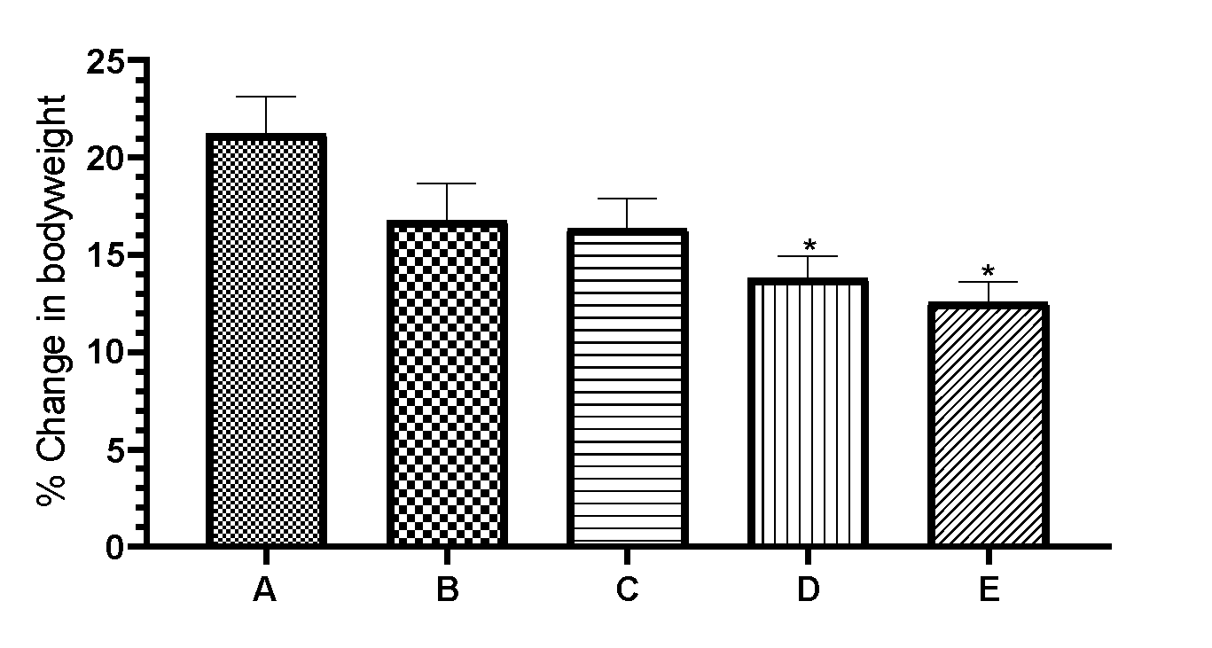
Figure 1 presents Body weight changes across experimental groups before induction, after induction, and after treatment.
Group A received normal feed (Control), Group B received letrozole only, while Groups C, D, and E received letrozole combined with apple cider vinegar (ACV) at 1 mg/kg, 2 mg/kg, and 3 mg/kg respectively.
Data are presented as mean ± standard deviation (n = 7). Asterisks indicate values significantly different from the control group (p < 0.05).

3.1 Histological Observation of the Ovary
Ovarian sections from Group A (Control) showed numerous round follicular structures with centrally located oocytes, characteristic of secondary or Graafian follicles. Additionally, the presence of a larger, acellular structure lacking nuclei was observed, suggestive of a corpus luteum.
In Group B (Letrozole only), the ovarian tissue displayed multiple round follicle-like spaces lacking centrally located oocytes, indicative of primary follicles or arrested follicular development.
Sections from Groups C, D, and E (Letrozole + ACV at 1, 2, and 3 mg/kg, respectively) revealed improved follicular architecture, with a good number of round structures containing centrally located oocytes, consistent with secondary or Graafian follicles.
Figure 2: Ovarian Histology Across Experimental Groups
Group A:
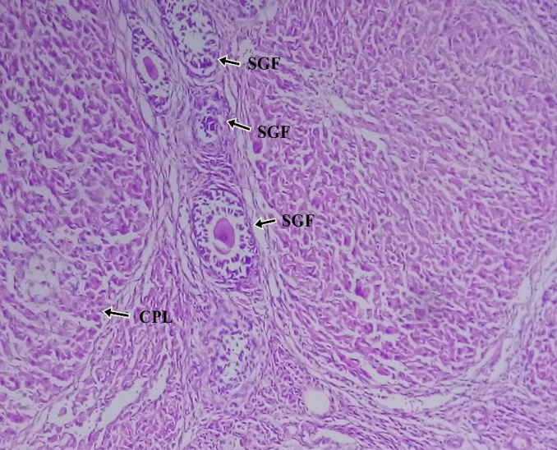
Group B:

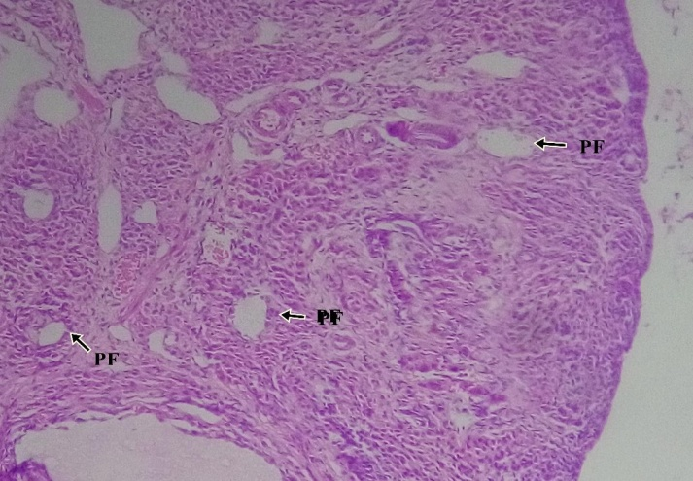
Group C:

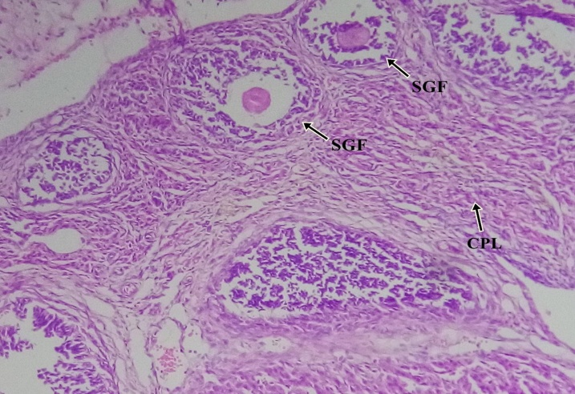
Group D:

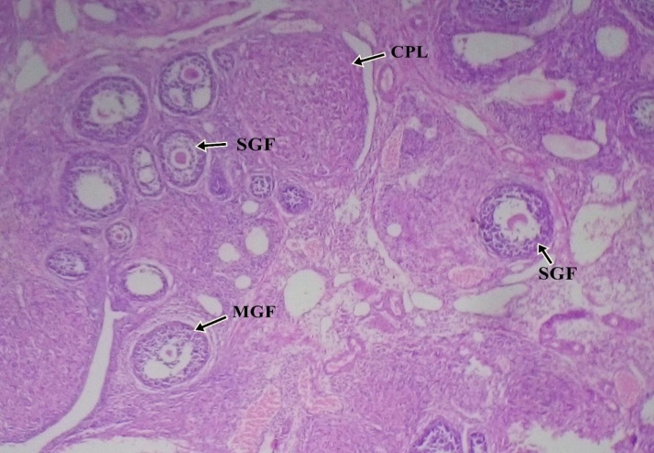
Group E:
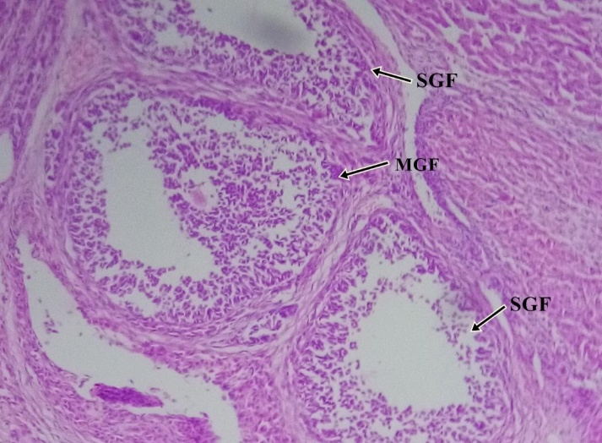
Figure 2 Representative photomicrographs of ovarian histology in control, letrozole-induced, and ACV-treated rats (H\&E, ×400).
Group A (Control) shows well-formed follicles including secondary Graafian follicles (SGF) and mature Graafian follicles (MGF), along with a visible corpus luteum (CPL).
Group B (Letrozole only) displays disrupted follicular architecture with predominance of primordial follicles (PF) and regions suggestive of ovarian cancer-like changes (OVC).
Groups C, D, and E (Letrozole + ACV at 1, 2, and 3 mg/kg, respectively) show improved follicular development, with numerous SGFs and MGFs indicating restoration of ovarian structure.
Scale bar = 400× magnification.

4. Discussion
The present study investigated the dose-dependent effects of apple cider vinegar (ACV) on body weight and ovarian histoarchitecture in female Wistar rats with letrozole-induced polycystic ovary syndrome (PCOS). Letrozole administration led to significant increases in body weight and disruption of normal ovarian morphology, consistent with previous findings that established letrozole as a reliable agent for inducing PCOS-like features in rodent models (Xu et al., 2020; Shaaban et al., 2023).
A hallmark of PCOS is weight gain, often driven by insulin resistance and hyperandrogenism (Singh et al., 2023). In this study, rats treated with letrozole alone (Group B) exhibited a substantial increase in body weight compared to the control group. However, co-administration of ACV in Groups C, D, and E resulted in a dose-dependent reduction in weight gain, with Groups D (2 mg/kg) and E (3 mg/kg) showing significantly lower percentage body weight changes relative to the control group (p < 0.05).
These findings are consistent with previous reports suggesting that ACV, via its active component acetic acid, can activate AMP-activated protein kinase (AMPK), thereby promoting lipid oxidation and improving insulin sensitivity (Li et al., 2013; Ousaaid et al., 2022). The reduction in weight gain observed in this study further supports the role of ACV as a metabolic modulator and highlights its potential utility in managing PCOS-associated obesity.
Notably, the dose-dependent response suggests that higher doses of ACV may yield stronger anti-obesogenic effects, possibly through more robust engagement of energy-regulating pathways. This aligns with the findings of Wu et al. (2020), who reported improved metabolic profiles in women with PCOS following ACV supplementation.
Letrozole-induced PCOS is characterized by the accumulation of immature follicles, ovarian cysts, and disrupted folliculogenesis (Ibrahim et al., 2022, Kar et al., 2024). Histological assessment of ovaries in the letrozole-only group revealed numerous round structures lacking centrally located oocytes, indicative of primary follicles or follicular arrest. This structural pattern reflects impaired ovulation and aligns with PCOS-like histopathology described in earlier models (Bries et al., 2021; Skarra et al., 2017).
Conversely, the ovaries of ACV-treated groups, particularly at 2 and 3 mg/kg doses, displayed restored follicular architecture with visible secondary and Graafian follicles, as well as indications of corpus luteum formation, suggesting resumed ovulatory activity. These changes indicate recovery of normal folliculogenesis and point to the restorative potential of ACV on reproductive structures.
Although earlier studies have examined the metabolic benefits of ACV, fewer have addressed its effects on reproductive morphology. This study provides novel evidence that ACV can reverse histopathological alterations in the ovary, supporting its broader therapeutic role in PCOS management. The observed improvement may be attributed to ACV’s antioxidant and anti-inflammatory constituents, which help alleviate oxidative stress and support tissue regeneration (Zhang et al., 2021; Shams et al., 2022). Similar tissue-protective effects of plant-based compounds have been demonstrated in experimental models involving reproductive and endocrine organs. For instance, flavonoid- and saponin-rich extracts from Cyperus esculentus and Phoenix dactylifera mitigated aluminum chloride-induced testicular and prostate damage in rats by improving antioxidant defenses and restoring histoarchitecture (Again et al., 2025a; Agim et al., 2025b). Likewise, myricetin treatment attenuated adrenal damage caused by MNU-induced oxidative stress (Umoh et al., 2024), and Heinsia crinita extract improved cellular integrity and neuronal function in a neurodegeneration model (Isamoh et al., 2024). Supporting this trend, Agbor et al. (2022) demonstrated that a 10% honey-supplemented diluent preserved Wistar rat sperm quality across freeze–thaw cycles, showing comparable efficacy to standard commercial cryoprotectants. This underscores the potential of natural agents in maintaining cellular integrity under stress conditions. Additionally, Agbor et al. (2024) reported that curcumin significantly reduced histopathological alterations and suppressed Ki-67 proliferative activity in a nitroso bis amine-induced rat brain tumor model, further highlighting the capacity of natural products to reverse cellular damage through antioxidant and anti-inflammatory pathways. Moreso, a recent study show that quercetin on steroidogenesis and folliculogenesis in ovary of mice with experimentally-induced polycystic ovarian syndrome (Shah et al., 2023). Together, these findings reinforce the relevance of nutraceuticals, including ACV, in modulating histological and functional recovery in toxicological or disease-induced models.
The dual impact of ACV on both metabolic (body weight) and reproductive (ovarian morphology) parameters highlights its therapeutic versatility. Unlike conventional PCOS treatments such as metformin and anti-androgens, which may have adverse effects with long-term use (Spritzer, 2022; Lauretta et al., 2016), ACV presents as a natural and cost-effective alternative with a favorable safety profile.
The demonstration of a dose-dependent effect also provides practical insight into potential dosing regimens for future studies and clinical applications. Importantly, the findings contribute to the limited pool of data on the histological impact of ACV on the ovary, addressing a gap identified in previous literature.
This study, therefore, adds valuable knowledge to the field of PCOS research, particularly in the context of exploring nutraceuticals as standalone therapies in resource-limited settings where access to conventional medications may be restricted.
While the results are promising, some limitations must be acknowledged. The study did not assess hormonal profiles, insulin resistance markers, or inflammatory cytokines, which would provide further mechanistic insights. Future studies should include these endpoints and explore the long-term effects of ACV beyond 15 days of administration.
Additionally, while the histological improvements were clear, quantitative follicle counts and staging of follicles would enhance the rigor of the morphological analysis.
4.2 Conclusion
The present study demonstrated that apple cider vinegar (ACV) exerts dose-dependent beneficial effects on both metabolic and reproductive parameters in a rat model of letrozole-induced polycystic ovary syndrome (PCOS). Specifically, ACV significantly reduced body weight gain, likely through activation of energy-regulating pathways, and improved ovarian histoarchitecture by restoring normal folliculogenesis and decreasing follicular arrest. These findings highlight ACV’s potential as a natural, safe, and cost-effective therapeutic agent for managing PCOS-associated obesity and ovarian dysfunction. Future research should focus on elucidating the underlying hormonal and molecular mechanisms, as well as evaluating long-term outcomes to facilitate translation into clinical practice.

Ethical Approval
The research protocol was reviewed and approved by the Research Ethics Committee of the Faculty of Basic Medical Sciences, University of Calabar, Nigeria, with approval number 248ANA2923. All experimental procedures adhered to established ethical standards for animal research, ensuring humane treatment and minimizing pain and distress.

Disclaimer (Artificial intelligence)
Option 1:
Author(s) hereby declare that NO generative AI technologies such as Large Language Models (ChatGPT, manuscript.

References

Aboeldalyl S, James C, Seyam E, Ibrahim EM, Shawki HE, Amer S. The Role of Chronic Inflammation in Polycystic Ovarian Syndrome-A Systematic Review and Meta-Analysis. Int J Mol Sci. 2021 Mar 8;22(5):2734. doi: 10.3390/ijms22052734. PMID: 33800490; PMCID: PMC7962967.
Agbor, C. A., Fischer, C. E., Agaba, E. A., & Nnenna, W. A. (2022). Assessment of post-thaw in-vitro quality of male Wistar rat spermatozoa preserved in diluent with natural honey as supplement. Tropical Journal of Natural Product Research, 6(6), 133–137. https://doi.org/10.26538/tjnpr/v6i1.21
Agbor, C. A., Fischer, C. E., Eru, M. E., & Umoh, N. M. (2024). Histopathological Alterations and Ki-67 Proliferation Index Evaluation Following Nitroso Bis Amine-Induced Cerebral Toxicity in Experimental Animal Model Treated With Curcumin. Asian Journal of Research and Reports in Neurology, 7(1), 146–153. https://www.journalajorrin.com/index.php/AJORRIN/article/view/111
Agim, Agaba, Eric, Ujah, Williams Oche, Enang, Kingsley Bassey, Fischer, Victor A, Emmanuel I. Odom, and Adie,Christopher Utsu. 2025. “Protective Effects of Flavonoids-Rich and Saponins-Rich Extracts from Tiger Nuts and Date Fruits onProstate Histoarchitechture in Aluminum-Exposed Wistar Rats”. Journal of Complementary and Alternative Medical Research26 (1):1-11. https://doi.org/10.9734/jocamr/2025/v26i1610.Journal
Agim, Agaba, Eric, Ujah, Williams Oche, Enang, Kingsley Bassey, Fischer, Victor A, Emmanuel I. Odom, and Adie,Christopher Utsu. 2025. “Protective Effects of Flavonoids-Rich and Saponins-Rich Extracts from Tiger Nuts and Date Fruits onProstate Histoarchitechture in Aluminum-Exposed Wistar Rats”. Journal of Complementary and Alternative Medical Research 26 (1):1-11. https://doi.org/10.9734/jocamr/2025/v26i1610.Journal
Agim, Agaba, Eric, Ujah, Williams Oche, Sadeyeng Ernest Anani, Nsikak Michael Umoh, Eteng Katherine Kenyoh,Enang Kingsley Bassey, Christie Elum Fischer, Victor Adolf Fischer, and Emmanuel I. Odom. 2025. “Protective Effects ofFlavonoid-Rich and Saponin-Rich Fractions from Cyperus Esculentus and Phoenix Dactylifera on Aluminum Chloride-InducedTesticular Damage in Male Wistar Rats”. Journal of Complementary and Alternative Medical Research 26 (3):18-34.https://doi.org/10.9734/jocamr/2025/v26i3632
Alesi, S., Forslund, M., Melin, J., Romualdi, D., Peña, A., Tay, C. T., Witchel, S. F., Teede, H., & Mousa, A. (2023). Efficacy and safety of anti-androgens in the management of polycystic ovary syndrome: A systematic review and meta-analysis of randomised controlled trials. EClinicalMedicine, 63, 102162. [https://doi.org/10.1016/j.eclinm.2023.102162](https://doi.org/10.1016/j.eclinm.2023.102162)
Ashraf, S., Nabi, M., Rasool, S. U. A., Rashid, F., Amin, S., & Jan, M. (2019). Hyperandrogenism in polycystic ovarian syndrome and role of CYP gene variants: A review. Egyptian Journal of Medical Human Genetics, 20, 25. [https://doi.org/10.1186/s43042-019-0031-0](https://doi.org/10.1186/s43042-019-0031-0)
Attia GM, Almouteri MM, Alnakhli FT. Role of Metformin in Polycystic Ovary Syndrome (PCOS)-Related Infertility. Cureus. 2023 Aug 31;15(8):e44493. doi: 10.7759/cureus.44493. PMID: 37791160; PMCID: PMC10544455.
Attia, G. M., Almouteri, M. M., & Alnakhli, F. T. (2023). Role of metformin in polycystic ovary syndrome (PCOS)-related infertility. Cureus, 15 (8), e44493. [https://doi.org/10.7759/cureus.44493](https://doi.org/10.7759/cureus.44493)
Barber, T. M., Hanson, P., Weickert, M. O., & Franks, S. (2019). Obesity and polycystic ovary syndrome: Implications for pathogenesis and novel management strategies. Clinical Medicine Insights: Reproductive Health, 13, 1179558119874042. [https://doi.org/10.1177/1179558119874042](https://doi.org/10.1177/1179558119874042)
Bries, A. E., Webb, J. L., Vogel, B., Carrillo, C., Keating, A. F., Pritchard, S. K., Roslan, G., Miller, J. W., & Schalinske, K. L. (2021). Letrozole-induced polycystic ovary syndrome attenuates cystathionine-β synthase mRNA and protein abundance in the ovaries of female Sprague Dawley rats. The Journal of Nutrition, 151 (6), 1407–1415. [https://doi.org/10.1093/jn/nxab038](https://doi.org/10.1093/jn/nxab038)
Franks, S. (2021). Polycystic ovary syndrome. Medicine, 49 (9), 529–532. [https://doi.org/10.1016/j.mpmed.2021.06.001](https://doi.org/10.1016/j.mpmed.2021.06.001)
Ibrahim, Y. F., Alorabi, M., Abdelzaher, W. Y., Toni, N. D. M., Thabet, K., Hegazy, A., Bahaa, H. A., Batiha, G. E.-S., Welson, N. N., Morsy, M. A., Venugopala, K. N., & Abdel-Aziz, A. M. (2022). Diacerein ameliorates letrozole-induced polycystic ovarian syndrome in rats. Biomedicine & Pharmacotherapy, 149, 112870. [https://doi.org/10.1016/j.biopha.2022.112870](https://doi.org/10.1016/j.biopha.2022.112870)
Isamoh, Theresa E., Sadeyeng Anani, Nsikak Umoh, Michael Oku, Eru Eru Mba, Eric Agaba, Williams Nnenna, andEmmanuel I. Odom. 2024. “Neuroprotective Effects of Heinsia Crinita and Coconut Water in a Scopolamine-InducedAlzheimer’s Model in Albino Rats: Biochemical Changes, Cellular Health, and Neuronal Activity”. Journal of Complementaryand Alternative Medical Research 25 (11):38-56. https://doi.org/10.9734/jocamr/2024/v25i11582
Kakadia, N., Patel, P., Deshpande, S., & Shah, G. (2019). Effect of *Vitex negundo* L. seeds in letrozole-induced polycystic ovarian syndrome. Journal of Traditional and Complementary Medicine, 9 (4), 336–345. [https://doi.org/10.1016/j.jtcme.2018.03.001](https://doi.org/10.1016/j.jtcme.2018.03.001)
Kar, T. K., Sil, S., Ghosh, A., Barman, A., & Chattopadhyay, S. (2024). Mitigation of letrozole-induced polycystic ovarian syndrome associated inflammatory response and endocrinal dysfunction by Vitex negundo seeds. Journal of Ovarian Research, 17 (1), 76. [https://doi.org/10.1186/s13048-024-01378-4](https://doi.org/10.1186/s13048-024-01378-4)
Lauretta, R., Lanzolla, G., Vici, P., Mariani, L., Moretti, C., & Appetecchia, M. (2016). Insulin-sensitizers, polycystic ovary syndrome and gynaecological cancer risk. International Journal of Endocrinology, 2016, 8671762. [https://doi.org/10.1155/2016/8671762](https://doi.org/10.1155/2016/8671762)
Li, X., Chen, H., Guan, Y., Li, X., Lei, L., Liu, J., Yin, L., Liu, G., & Wang, Z. (2013). Acetic acid activates the AMP-activated protein kinase signaling pathway to regulate lipid metabolism in bovine hepatocytes. PLoS ONE, 8 (7), e67880. [https://doi.org/10.1371/journal.pone.0067880](https://doi.org/10.1371/journal.pone.0067880)
Liu, Q., Xie, Y.-J., Qu, L.-H., Zhang, M.-X., & Mo, Z.-C. (2019). Dyslipidemia involvement in the development of polycystic ovary syndrome. Taiwanese Journal of Obstetrics and Gynecology, 58 (4), 447–453. [https://doi.org/10.1016/j.tjog.2019.05.003](https://doi.org/10.1016/j.tjog.2019.05.003)
Ousaaid, D., Laaroussi, H., Mechchate, H., Bakour, M., El Ghouizi, A., Mothana, R. A., Noman, O., Es-Safi, I., Lyoussi, B., & El Arabi, I. (2022). The nutritional and antioxidant potential of artisanal and industrial apple vinegars and their ability to inhibit key enzymes related to type 2 diabetes in vitro. Molecules, 27 (2), 567. [https://doi.org/10.3390/molecules27020567](https://doi.org/10.3390/molecules27020567)
Parua, S., Purkait, M. P., Bhattacharjee, A., Thangarajan, R., Rammohan, S., Islam, K., Bhattacharya, K., & Syamal, A. K. (2025). Exploring female infertility: A comprehensive review of polycystic ovary syndrome (PCOS) and its impact on reproductive health. Obesity Medicine, 55, 100619. https://doi.org/10.1016/j.obmed.2025.100619
Purwar, A., & Nagpure, S. (2022). Insulin resistance in polycystic ovarian syndrome. Cureus, 14 (10), e30351. [https://doi.org/10.7759/cureus.30351](https://doi.org/10.7759/cureus.30351)
Shaaban, Z., Derakhshanfar, A., Jafarzadeh Shirazi, M. R., Zamiri, M. J., Moayedi, J., Vahedi, M., & Valizadeh, A. (2023). The effects of letrozole-induced maternal hyperandrogenism on sexual behaviors, testicular histology, and serum biochemical traits in male offspring rats: An experimental study. International Journal of Reproductive BioMedicine, 21 (1), 71–82. [https://doi.org/10.18502/ijrm.v21i1.12669](https://doi.org/10.18502/ijrm.v21i1.12669)
Shah, M. Z., Shrivastava, V. K., Mir, M. A., Sheikh, W. M., Ganie, M. A., Rather, G. A., Shafi, M., Bashir, S. M., Ansari, M. A., Al-Jafary, M. H., & Al-Qahtani, M. H. (2023). Effect of quercetin on steroidogenesis and folliculogenesis in ovary of mice with experimentally-induced polycystic ovarian syndrome. Frontiers in Endocrinology, 14, 1153289.
Shams, F., Aghajani-Nasab, M., Ramezanpour, M., Fatideh, R. H., & Mohammadghasemi, F. (2022). Effect of apple vinegar on folliculogenesis and ovarian kisspeptin in a high-fat diet-induced nonalcoholic fatty liver disease in rat. BMC Endocrine Disorders, 22 (1), 330. [https://doi.org/10.1186/s12902-022-01205-1](https://doi.org/10.1186/s12902-022-01205-1)
Singh, S., Pal, N., Shubham, S., Sarma, D. K., Verma, V., Marotta, F., & Kumar, M. (2023). Polycystic ovary syndrome: Etiology, current management, and future therapeutics. Journal of Clinical Medicine, 12 (4), 1454. [https://doi.org/10.3390/jcm12041454](https://doi.org/10.3390/jcm12041454)
Skarra, D. V., Hernández-Carretero, A., Rivera, A. J., Anvar, A. R., & Thackray, V. G. (2017). Hyperandrogenemia induced by letrozole treatment of pubertal female mice results in hyperinsulinemia prior to weight gain and insulin resistance. Endocrinology, 158 (9), 2988–3003. [https://doi.org/10.1210/en.2016-1898](https://doi.org/10.1210/en.2016-1898)
Spritzer, P. M. (2022). Contraception for women with polycystic ovary syndrome: Dealing with a complex condition. Revista Brasileira de Ginecologia e Obstetrícia, 44 (4), 325–326. [https://doi.org/10.1055/s-0042-1748036](https://doi.org/10.1055/s-0042-1748036)
Umoh, Nsikak Michael, Paul Anyiom Odey, Williams Nnenna, Eru Eru Mba, Anani Sadeyeng, Michael Oku, EmmanuelI. Odom, Arita Okon, and Francis, Christabel Ojibima. 2024. “Histomorphological Assessment of Adrenal Glands in Wistar RatsFollowing Myricetin Treatment Against MNU-Induced Oxidative Stress”. Journal of Complementary and Alternative Medical Research 25 (12):110-21. https://doi.org/10.9734/jocamr/2024/v25i12600.
Vos, M., Deforche, B., Van Kerckhove, A., Matthys, C., De Bourdeaudhuij, I., & Vandevijvere, S. (2022). Intervention strategies to promote healthy and sustainable food choices among parents with lower and higher socioeconomic status. BMC Public Health, 22, 2378. [https://doi.org/10.1186/s12889-022-14817-y](https://doi.org/10.1186/s12889-022-14817-y)
Wu, D., Kimura, F., Takashima, A., Shimizu, Y., Takebayashi, A., Kita, N., Zhang, G., & Murakami, T. (2013). Intake of vinegar beverage is associated with restoration of ovulatory function in women with polycystic ovary syndrome. Tohoku Journal of Experimental Medicine, 230 (1), 17–23. [https://doi.org/10.1620/tjem.230.17](https://doi.org/10.1620/tjem.230.17)
Xing, C., Zhang, J., Zhao, H., & He, B. (2022). Effect of sex hormone-binding globulin on polycystic ovary syndrome: Mechanisms, manifestations, genetics, and treatment. International Journal of Women’s Health, 14, 91–105. [https://doi.org/10.2147/IJWH.S344542](https://doi.org/10.2147/IJWH.S344542)
Xu, J., Dun, J., Yang, J., Zhang, J., Lin, Q., Huang, M., Ji, F., Huang, L., You, X., & Lin, Y. (2020). Letrozole rat model mimics human polycystic ovarian syndrome and changes in insulin signal pathways. Medical Science Monitor, 26, e923073. [https://doi.org/10.12659/MSM.923073](https://doi.org/10.12659/MSM.923073)
Zhang, S., Hu, C., Guo, Y., Wang, X., & Meng, Y. (2021). Polyphenols in fermented apple juice: Beneficial effects on human health. Journal of Functional Foods, 76, 104294. [https://doi.org/10.1016/j.jff.2020.104294](https://doi.org/10.1016/j.jff.2020.104294)
Zhao, H., Zhang, J., Cheng, X. et al. Insulin resistance in polycystic ovary syndrome across various tissues: an updated review of pathogenesis, evaluation, and treatment. J Ovarian Res 16, 9 (2023). https://doi.org/10.1186/s13048-022-01091-0

