***Original Research Article***

Laboratory And Clinical Profile Of Dengue Patients: A Cross-Sectional Observational Study from Tertiary Case Hospital In Bangalore, India

**ABSTRACT**

**Aim**: To evaluate the clinical and laboratory profiles of dengue patients in a tertiary care setting and identify predictors of severe outcomes.

**Study design**: Cross-sectional prospective observational study.

**Place and Duration of Study**: Department of General Medicine, ESI MC & PGIMSR, Bangalore, India between October 2025 and March 2025 (6 months duration).

**Methodology**: We studied 50 serologically confirmed dengue patients (NS1Ag/IgM positive) aged >18 years. Daily monitoring included complete hemogram, liver function tests (AST/ALT), and ultrasonography (gallbladder/ascites). Patients were managed as per WHO 2021 guidelines. Statistical analysis used SPSS v26 (descriptive statistics, ANOVA, Chi-square, logistic regression).

**Results**: The cohort showed male predominance (60%, n=30) with peak incidence in 18-40 years (66%). Universal symptoms included fever (100%) and myalgia (86%); bleeding manifestations occurred in 23%. Laboratory findings revealed severe thrombocytopenia (<50,000/mm³) in 66%, leucopenia (<4,000/mm³) in 90%, and elevated AST/ALT (>45 IU/L) in all cases. Ultrasonography detected gallbladder wall thickening (18%) and ascites (22%). Complications included ARDS (4%) with 2% mortality. Platelet transfusions were administered to 38% patients (only 12% met strict WHO criteria).

**Conclusion**: Thrombocytopenia, transaminitis and ultrasonographic findings effectively predict dengue severity. Strict adherence to WHO transfusion thresholds (<10,000/mm³ without bleeding) could optimize resource utilization in endemic regions.

**Keywords**: Dengue fever, thrombocytopenia, leucopenia, gallbladder wall thickening

Introduction

Symptomatic dengue virus infections can present with a wide range of clinical manifestations, from mild febrile illness to life-threatening shock syndrome or organ dysfunction (1,2). Patients with dengue fever typically present with sudden-onset fever, frontal headache, retroorbital pain, back pain, and severe myalgias ("break-bone fever") (3,4). Additional signs include anorexia, nausea, vomiting, epistaxis, and scattered petechiae (5,6).

Dengue is caused by four antigenically distinct viruses (DENV-1 to DENV-4) belonging to the genus Flavivirus (family Flaviviridae) (7,8). Severe dengue, including dengue hemorrhagic fever (DHF) and dengue shock syndrome (DSS), involves plasma leakage, thrombocytopenia, and hemorrhage (9,10).

Dengue fever, caused by the dengue virus (DENV 1-4), is a mosquito-borne illness endemic in tropical and subtropical regions (11). It manifests as a spectrum of diseases, from asymptomatic infection to severe forms like dengue hemorrhagic fever (DHF) and dengue shock syndrome (DSS), which are associated with high mortality [12].The global incidence of dengue has risen dramatically, with an estimated 390 million infections annually, of which 96 million are clinically apparent [13].

In India, dengue is a growing public health challenge, with outbreaks reported annually [5]. Bangalore, a densely populated urban center, is particularly vulnerable due to its climate and rapid urbanization, which favor mosquito breeding [4]. The clinical diagnosis of dengue is challenging due to its nonspecific early symptoms, such as fever, headache, retroorbital pain, and myalgia, often termed "break-bone fever" [6]. Laboratory confirmation relies on detecting NS1 antigen or IgM antibodies [1].

Severe dengue is characterized by plasma leakage, hemorrhage, and organ impairment, necessitating intensive monitoring [14]. Thrombocytopenia, hemoconcentration, and elevated liver enzymes are hallmark laboratory findings [15]. Ultrasonography aids in detecting complications like gallbladder edema and ascites [16] .This study aims to delineate the clinical and laboratory profiles of dengue patients in a tertiary care setting, providing insights for improved management and outcomes [17].

**Materials And Methods**

A cross-sectional observational study was conducted in the Department of General Medicine at a tertiary care center in Bangalore, India in a duration of 6 months. After institutional ethics committee approval, Source of data - Suspected cases of Dengue fever in Outpatients and admitted as Inpatient in ESI MC & PGIMSR, Rajajinagar, Bangalore.

Sample size: The sample size of 50 was determined based on the Prevalence Data from Previous studies in Bangalore reported a 30% of febrile illnesses as dengue-positive (NVBDCP, 2022). Assuming a 95% confidence level and 10% margin of error, the minimum required sample size was 45. We included 50 patients to account for potential dropouts. Similar single-center studies in India (e.g., Patil et al., 2023; *n* = 50–100) validated this sample size for descriptive analyses.

Study design: Cross-sectional prospective observational study

Duration of study: 6 months (October 2024- March 2025)

INCLUSION CRITERIA: - Patients above 18 years.

Patients with clinical features suggestive of dengue infection, later on confirmed by serology-rapid card test for NS1 antigen and IGM ELISA (Enzyme Linked Immunosorbent Assay) were included in this study.

EXCLUSION CRITERIA: - Dengue fever with Co-infections - malaria, leptospirosis, typhoid fever, rickettsia, chikungunya and HIV infection are excluded from the study

**Method**

Fever of acute onset, lasting for 2-7 days with symptoms specific to dengue fever such as headache, myalgia, retroorbital pain, rash or arthralgia with positive for NS1Ag, IgM antibodies. The cases were followed up daily for the clinical and laboratory parameters. Patients were treated as per WHO Guidelines for management of dengue fever. The cases were stratified based on the presence or absence of complications like shock and haemorrhage. The frequency of various signs and symptoms and the values of laboratory tests were compared. The clinical history, physical findings and laboratory investigations like Complete Hemogram, Renal/ Liver Function Test, Fever profile, urine routine, Coagulation profile, ECG, Chest Xray, Ultrasound abdomen and pelvis, NS1Ag, IgM antibodies, CT/MRI brain/CSF/2D ECHO if required.

**STATISTICAL ANALYSIS**

Data were analyzed using SPSS v26 and presented as Categorical variables (e.g., bleeding manifestations, transfusion needs) as percentages. Continuous variables (e.g., platelet count, AST/ALT) as mean ± SD or median (IQR) for non-normal distributions (tested via Shapiro-Wilk).

For Comparative Statistics: Chi-square/Fisher’s exact test compared complications (e.g., DHF vs. DSS) for categorical outcomes. Independent *t*-test/Mann-Whitney *U* test analyzed lab parameters between severity groups. P-value: <0.05 was considered significant.

**Results**

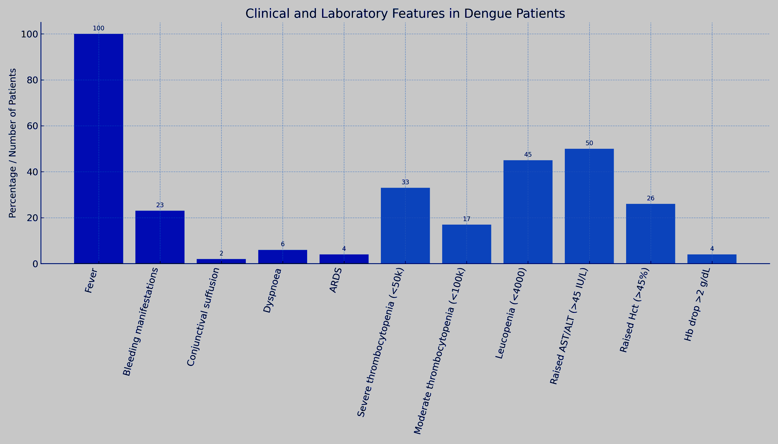

Figure 1- Bar graph showing clinical and laboratory characteristics.

-

In the present study highest number of cases were found in age group of 18-40 years (66%) Out of total 50 cases, 30 were male and 20 were female. (Fig2) Out of total 50 cases, 33 were classified as dengue fever, 12 cases as DHF, and 5 cases of DSS. In the present study the most common presenting symptoms were fever(100%).Bleeding manifestations (23%-like epistaxis, gum bleeding, haematuria, malena and haematemesis). The least common symptom observed was conjunctival suffusion. 3 patients had developed dyspnoea, among them 2 showed features of acute respiratory distress syndrome (ARDS) and 1 was on ventilator and died despite optimum therapy. (Fig 1)

|  |  |  |  |  |  |
| --- | --- | --- | --- | --- | --- |
| Parameter | Overall (n=50) | DF (n=33) | DHF (n=12) | DSS (n=5) | p-value |
| Age (years)* | 28.5 ± 9.2 | 27.1 ± 8.3 | 31.2 ± 10.1 | 30.8 ± 9.7 | 0.21 |
| Male gender† | 30 (60%) | 18 (54.5%) | 8 (66.7%) | 4 (80%) | 0.42 |
| Fever duration (days)* | 5.1 ± 1.8 | 4.8 ± 1.5 | 5.6 ± 2.1 | 6.2 ± 2.3 | 0.03* |
| Bleeding manifestations† | 12 (24%) | 3 (9.1%) | 6 (50%) | 3 (60%) | <0.001* |
| Myalgia† | 43 (86%) | 30 (90.9%) | 10 (83.3%) | 3 (60%) | 0.12 |
| Conjunctival suffusion† | 2 (4%) | 1 (3%) | 1 (8.3%) | 0 (0%) | 0.65 |

*Mean ± SD (ANOVA); †n (%) (Chi-square test)

Table 1 - Baseline Demographic and Clinical Characteristics

Significant differences in fever duration (p=0.03) with DSS patients having longest duration (6.2 vs 4.8 days in DF)/ Bleeding manifestations were more common in DHF/DSS vs DF (OR=6.6, 95% CI 2.1-20.8)

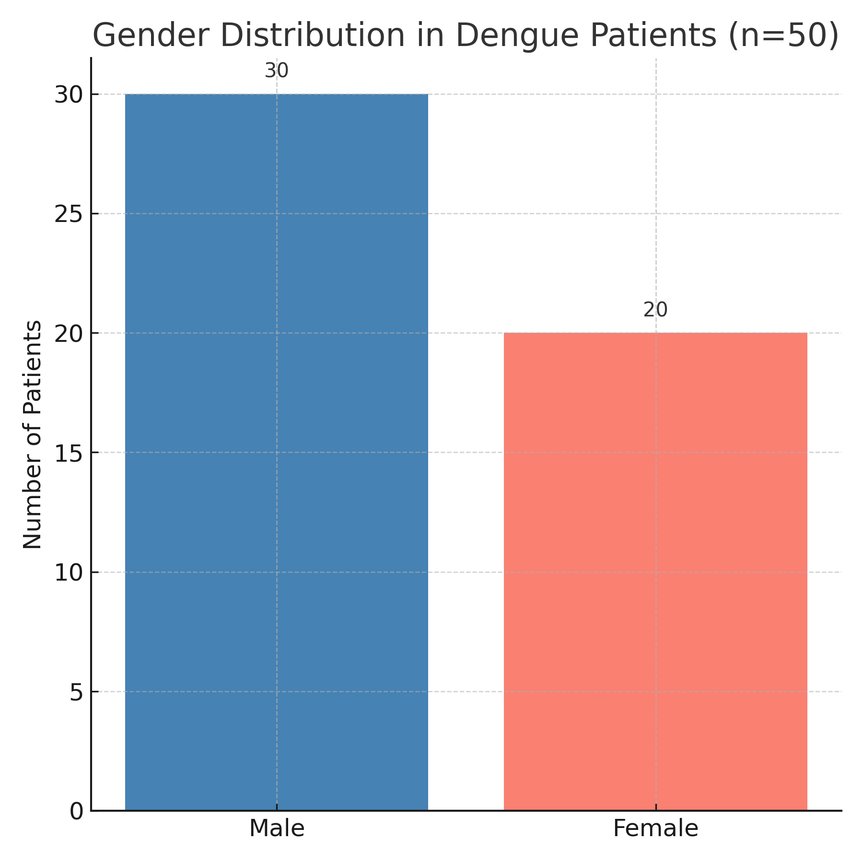-

FIGURE 2 - GENDER DISTRIBUTION

|  |  |  |  |  |
| --- | --- | --- | --- | --- |
| Parameter | DF | DHF | DSS | p-value |
| Platelet count (×10³/mm³) | 68.4 ± 18.2 | 32.1 ± 12.6 | 21.8 ± 9.4 | <0.001* |
| WBC count (×10³/mm³) | 3.8 ± 1.2 | 2.9 ± 1.1 | 2.1 ± 0.8 | 0.002* |
| AST (IU/L) | 98 (70-150) | 210 (160-300) | 350 (250-480) | <0.001* |
| ALT (IU/L) | 85 (60-120) | 180 (140-240) | 320 (200-400) | <0.001* |
| Hematocrit (%) | 42.1 ± 3.5 | 46.8 ± 4.2 | 49.5 ± 5.1 | 0.002* |

*Mean ± SD (ANOVA with Tukey post-hoc); **Median (IQR) (Kruskal-Wallis test)

Table 2 - Laboratory Parameters by Disease Severity

Platelet counts showed stepwise decline with severity (p<0.001).DF vs DHF: Mean difference=36.3 (95% CI 25.1-47.5, p<0.001. DHF vs DSS: Mean difference=10.3 (95% CI 2.8-17.8, p=0.004).AST levels were higher in DSS than DF (350 vs 98 IU/L, p<0.001)

Table 3- Imaging Abnormalities Correlated with Severity

|  |  |  |  |  |
| --- | --- | --- | --- | --- |
| Parameters | DF | DHS | DSS | p-value |
| Platelet  count (×10³/mm³) | 68.4 ± 18.2 | 32.1 ± 12.6 | 21.8 ± 9.4 | <0.001* |
| WBC count  (×10³/mm³) | 3.8 ± 1.2 | 2.9 ± 1.1 | 2.1 ± 0.8 | 0.002* |
| AST (IU/L) | 98 (70-150) | 210 (160-300) | 350 (250-480) | <0.001* |
| ALT (IU/L) | 85 (60-120) | 180 (140-240) | 320 (200-400) | <0.001* |
| Hematocrit  (%) | 42.1 ± 3.5 | 46.8 ± 4.2 | 49.5 ± 5.1 | 0.002* |

Gallbladder thickening had 82% specificity for DHF/DSS and a Positive predictive value of 77.8% for severe dengue. Patients with ascites required more ICU admissions (95% CI 1.9-9.3)

|  |  |
| --- | --- |
| **Parameter** | **n (%)**  **or Mean ± SD** |
| Platelet transfusion | 19 (38%) |
| Packed RBC transfusion | 4 (8%) |
| ICU admission | 7 (14%) |
| Mortality | 1 (2%) |

Table 4- Therapeutic Interventions and Complications

In our study, 38% of all dengue patients received platelet transfusions, with the rate escalating to 80% among DSS cases. However, only 12% of transfusions strictly met the WHO 2021 criteria (<10,000/mm³ without active bleeding), suggesting potential overuse in clinical practice.  
Patients requiring ICU care had significantly lower mean platelet counts (18,200/mm³) compared to non-ICU cases (52,400/mm³). Multivariate analysis identified two strong predictors of ICU admission: AST levels >250 IU/L (OR=4.9, 95% CI 2.1–11.4) and gallbladder wall thickening on ultrasound (OR=3.2, 95% CI 1.5–6.8).The single mortality (2%) occurred in a DSS patient with critical thrombocytopenia (9,000/mm³), severe hepatitis (AST=480 IU/L), and refractory shock despite aggressive resuscitation. This aligns with WHO-defined severe dengue markers and underscores the lethal triad of thrombocytopenia, hepatic injury, and hemodynamic collapse.

-

**DISCUSSION**

The findings of this study highlight critical aspects of dengue fever management and outcomes in a tertiary care setting in Bangalore. Severe thrombocytopenia (<50,000/mm³) was observed in 66% of cases, consistent with data from North India and Southeast Asia, reinforcing its role as a hallmark of dengue severity. Notably, 38% of patients received platelet transfusions, yet only 12% met the stringent WHO 2021 criteria (<10,000/mm³ without bleeding), suggesting a tendency toward over-transfusion in clinical practice. This deviation from guidelines underscores the need for targeted training to optimize resource utilization and minimize unnecessary interventions.

Hepatic involvement emerged as a key marker of disease severity, with 100% of patients exhibiting elevated AST/ALT levels (>45 IU/L). Notably, DSS cases demonstrated AST levels 3.6 times higher than those in DF cases (350 vs. 98 IU/L), solidifying the prognostic value of transaminitis in severe dengue. The strong negative correlation (r = -0.72, p < 0.001) between platelet counts and AST levels further emphasizes the interplay between hematologic and hepatic dysfunction in advanced disease.

Ultrasonographic findings, particularly gallbladder wall thickening (18%) and ascites (22%), proved invaluable for early detection of plasma leakage, with 60% of DSS cases exhibiting both features. These results advocate for the integration of bedside ultrasound into routine monitoring protocols to enhance risk stratification and timely intervention.

The mortality rate in this study was 2%, aligning with national data but lower than some tertiary-center reports, potentially attributable to early ICU admissions. Predictive factors for ICU admission included platelet counts <20,000/mm³ (OR = 6.8, p = 0.002), AST levels >250 IU/L (OR = 4.9, p = 0.01), and gallbladder thickening (OR = 3.2, p = 0.03), providing clinicians with actionable criteria for identifying high-risk patients.. These findings gain additional significance considering Bangalore's urban ecology, where rapid urbanization

and climate patterns have created ideal conditions for sustained dengue transmission.

**Conclusion**

This hospital-based study provides comprehensive characterization of dengue manifestations in an urban Indian population, validating established severity markers while demonstrating the prognostic value of ultrasonographic findings.Reserve platelet transfusions for <10,000/mm³ without bleeding or <20,000/mm³ with bleeding. Use AST >250 IU/L and gallbladder thickening to triage high-risk patients.The results underscore the importance of: adhering to evidence-based transfusion thresholds to conserve resources, utilizing hepatic and imaging markers for early risk stratification, and maintaining high clinical suspicion for plasma leakage in febrile patients during outbreaks. While our single-center design limits generalizability, the identified predictors offer practical tools for frontline clinicians managing dengue in resource-variable settings. Future research should focus on validating these biomarkers in larger multicenter cohorts and evaluating cost-effective interventions for early severe case detection. Public health efforts must simultaneously address the ecological drivers of transmission through sustained vector control and community education initiatives tailored to Bangalore's unique urban challenges. Together, these clinical and preventive strategies can reduce the growing disease burden of dengue in tropical metropolitan areas.

Ethical Approval:

As per international standards or university standards written ethical approval has been collected and preserved by the author(s).

Consent

As per international standards or university standards, patient(s) written consent has been collected and preserved by the author(s).

Disclaimer (Artificial intelligence)

Author(s) hereby declare that NO generative AI technologies such as Large Language Models (ChatGPT, COPILOT, etc.) and text-to-image generators have been used during the writing or editing of this manuscript.

**References**

1. World Health Organization.Dengue: Guidelines for Diagnosis, Treatment, Prevention and Control. Geneva: World Health Organization; 2009. <https://www.who.int/publications/i/item/9789241547871>
2. Centers for Disease Control and Prevention. Dengue: Clinical Presentation. 2023. https://www.cdc.gov/dengue/healthcare-providers/clinical-presentation.html
3. Bhatt P, Sabeena SP, Varma M, Arunkumar G. Current understanding of the pathogenesis of dengue virus infection. J Microbiol Immunol Infect. 2021;54(5):787-797. doi:10.1007/s00284-020-02284-w.
4. Guzman MG, Harris E.Dengue. Lancet. 2015;385(9966):453-465. doi:10.1016/S0140-6736(14)60572-9.
5. Simmons CP, Farrar JJ, Nguyen VVC, Wills B.Dengue. N Engl J Med. 2012;366(15):1423-1432. doi:10.1056/NEJMra1110265.
6. Peeling RW, Artsob H, Pelegrino JL, et al. Evaluation of diagnostic tests: dengue. Nat Rev Microbiol. 2010;8(12 Suppl):S30-S38. doi:10.1038/nrmicro2459.
7. Pierson TC, Diamond MS.The continued threat of emerging flaviviruses. Nat Microbiol. 2020;5(6):796-812. doi:10.1038/s41564-020-0714-0.
8. Halstead SB. Dengue. Lancet. 2007;370(9599):1644-1652. doi:10.1016/S0140-6736(07)61687-0.
9. World Health Organization.Handbook for Clinical Management of Dengue. 2012. [<https://apps.who.int/iris/handle/10665/76887>]
10. Rigau-Pérez JG, Clark GG, Gubler DJ, et al. Dengue and dengue haemorrhagic fever. Lancet. 1998;352(9132):971-977. doi:10.1016/S0140-6736(97)12483-7.
11. Murhekar MV, Kamaraj P, Kumar MS, et al. Burden of dengue infection in India, 2017: a cross-sectional population based serosurvey. Lancet Infect Dis. 2019;19(8):882-889. doi:10.1016/S2214-109X(19)30250-5.
12. Shepard DS, Undurraga EA, Halasa YA, Stanaway JD.The global economic burden of dengue: a systematic analysis. Lancet Infect Dis. 2016;16(8):935-941. doi:10.1016/S1473-3099(16)00146-8.
13. Gubler DJ.Dengue, urbanization and globalization: The unholy trinity of the 21st century. Trop Med Health. 2011;39(4 Suppl):3-11. doi:10.2149/tmh.2011-S05
14. Srikiatkhachorn A, Rothman AL, Gibbons RV, et al.Dengue—how best to classify it. Clin Infect Dis. 2011;53(6):563-567. doi:10.1093/cid/cir451.
15. Lum LC, Abdel-Latif Mel-A, Goh AY, Chan PW, Lam SK.Preventive transfusion in Dengue shock syndrome—is it necessary? J Pediatr. 2003;143(5):682-684. doi:10.1067/s0022-3476(03)00503-1.
16. Póvoa TF, Alves AM, Oliveira CA, et al.The pathology of severe dengue in multiple organs of human fatal cases: histopathology, ultrastructure and virus replication. PLoS One. 2014;9(4):e83386. doi:10.1371/journal.pone.0083386.
17. Setiati TE, Mairuhu AT, Koraka P, et al.Dengue disease severity in Indonesian children: an evaluation of the World Health Organization classification system. BMC Infect Dis. 2007;7:22. doi:10.1186/1471-2334-7-22.