**Diagnosis of fungi contaminating local and imported fruits in Kirkuk using PCR**

**Abstract**

This study aimed to identify fungal contaminants affecting various local and imported fruits (figs, oranges, pomegranates, and strawberries) available in the markets of Kirkuk city between November 2024 and March 2025, using both traditional and molecular diagnostic methods. A total of 100 samples exhibiting signs of spoilage were collected and cultured on selective media. Polymerase Chain Reaction (PCR) techniques were applied to confirm fungal species. Results revealed five predominant fungal species: *Aspergillus fumigatus* (40%), *Aspergillus niger* (27%), *Mucor* spp. (11.4%), *Candida* *krusei* (18%), and *Candida tropicalis* (2%). Strawberries and figs exhibited the highest contamination rates, likely due to their delicate structure and high moisture content, whereas oranges and pomegranates showed lower infection rates due to their thick peels. Molecular diagnostics proved effective in confirming fungal identities with high accuracy. The findings underscore the potential public health risk posed by fungal contamination in fresh fruits and highlight the need for strict hygiene measures during harvesting, storage, and distribution processes.

**Keywords**: Pathogenic fungi, *Aspergillus fumigatus*, *Candida krusei*, PCR , food safety.

**Introduction**

Fruits are of great importance as a primary source of vitamins and minerals for the human body. They provide a sufficient amount of important fiber and produce cellulose, which helps prevent constipation. Fruits are an essential component of the human diet due to their richness in nutrients, vitamins, and antioxidants. However, their high perishability poses a major challenge during the post-harvest, transportation, and storage stages. Fungi are among the most prominent pathogens that contribute to the deterioration of fruit quality and reduce its shelf life. These fungi are among the main causes of fruit rot and spoilage, both during tree growth and during marketing and consumption .[1] Fruit-disease-causing fungi include a wide range of genera, such as Aspergillus, Penicillium, Botrytis, and Rhizopus, which are capable of secreting plant tissue-degrading enzymes and mycotoxins that can pose a health risk to consumers. The severity of fungal infection varies depending on several factors, including fruit type, environmental conditions, storage methods, and the level of hygiene during handling]2[. Fungi infect a wide range of fruits, including figs, oranges, pomegranates, and strawberries, both during their growth stages on trees and after harvest. This issue is of particular importance in Iraq, given the importance of these fruits in local markets and the reliance of a large percentage of the population on their consumption, whether locally produced or imported. There is also a growing need for scientific studies that shed light on the fungal species associated with these fruits within the local climatic and agricultural context, and compare them with what is documented globally [ 3]. Pectinolytic enzymes are the first enzymes secreted by pathogenic fungi when they attack the cell walls of fruits ]4[. The first cell wall-degrading enzyme secreted by fungi is one of the most important virulence factors possessed by pathogenic fungi, and external conditions such as insect infestation and wounds facilitate fungal entry into fruits and vegetables] 5.[Many fungi cause significant postharvest fruit losses, as infections occur during harvesting, packaging, marketing, and storage, during display for sale, and even after they reach homes. Losses are significantly higher in developing countries, which largely lack attention to trade, storage, and even consumer access. Infection often begins in wounds during harvest and trade ]6[,.[7] Accurate and rapid fungal diagnosis is a fundamental pillar in the agricultural, medical, and food industries, given the serious diseases these organisms cause and the widespread economic losses they cause, both in agricultural crops and food products. Traditionally, fungal diagnosis methods have relied on morphological and microscopic characteristics, such as colony morphology, spore color, and hyphal composition. However, these methods often have limited accuracy, especially when dealing with closely related fungal species or those with phenotypic mutations .[8] In this context, molecular diagnostic techniques have emerged as powerful and effective tools for detecting fungi with high accuracy, based on the analysis of genetic material (DNA or RNA). Polymerase chain reaction (PCR) techniques are among the most widely used methods. They enable the amplification of specific genetic regions such as the Internal Transcribed Spacer (ITS), which is used as a molecular marker for identifying and classifying fungal species at the genus and species levels.. [9] Molecular diagnostic methods are characterized by their speed, high sensitivity, and ability to detect fungi even in complex or mixed samples, without the need for culture. This makes them ideal for post-harvest applications, food safety monitoring, and plant disease diagnosis. These techniques have proven effective in detecting many pathogenic fungal genera, such as Fusarium, Aspergillus, Penicillium, and Mucor, which pose a threat to public health and the safety of agricultural products ]10[.

**Material and Methods**

**1-Preparation of culture media:**

All culture media were prepared according to the manufacturer's instructions. All culture media were autoclaved at 121°C and 15 psi for 15 minutes. The glassware and tools used in the experiments were sterilized in an electric oven at 180°C for 120 minutes (Harley and Prescott, 1996). The media included the following:(. Sabourauds Dextrose Agar , CHROMagar )[11]

**2-Sample Collection**

One hundred samples of oranges (Iraqi, imported), figs (Iraqi), pomegranates (Iraqi and imported), and strawberries (imported) were collected from local markets in Kirkuk city during the study period from (11-1-2024) to (3-1-2025). The focus was on fruits showing clear or initial symptoms of rot such as spotting, discoloration, excessive softness, or surface fungal growths. Each sample was placed in a sterile, tightly closed polyethylene bag, then transported to the laboratory quickly and in refrigerated boxes at (4±1)°C to preserve the isolates.

**3-Visual examination of infected fruits**

Upon arrival at the laboratory, samples were examined visually to determine external signs of rot, including the predominant color of the rot area (green, black, white), the type of fungal growth (downy, cottony, powdery), and the presence of a foul odor or exudate. Symptoms were documented using digital photography, and the fruit type, source, and collection date were recorded.

**4- Culturing of Specimens**

A portion of the clinical samples, untreated with potassium hydroxide, was taken using sterile forceps and cultured on SDA medium supplemented with cycloheximide and chloramphenicol. The plates were then incubated at 28°C for 2-4 weeks. The plates were examined for fungal growth [12].

**5- Molecular diagnosis**

Using the Quick-DNA™ kit, for optimal performance, add beta-mercaptoethanol to bind fungal DNA to a final dilution of 0.5% (v/v), i.e., 500 µL per 100 mL.

1. Add 100-50 mg wet weight of fungal cells suspended in up to 200 µL of water or isotonic buffer, or up to 200 µL of tissue cultures. Add 750 µL of ZR BashingBead™ Lysis Tube (0.1 mm & 0.5 mm) 2-tube lysis solution.
2. Place in a shaker equipped with a 2 mL tube holder and process at full speed for 5 minutes.
3. Place the ZR BashingBead™ Lysis Tube in a microcentrifuge at 10,000 rpm for 1 minute.
4. Transfer up to 400 µL of the supernatant to a Zymo-Spin™ IV Orange Top spin filter in a collection tube and centrifuge at 7,000 rpm for 1 minute.

Note: Remove the base of the Zymo-Spin™ IV Orange Top spin filter before use.

1. Add 1200 µL of Fungal DNA Binding Buffer to the filter in the collection tube from step 4.
2. Transfer 800 µL of the mixture from step 5 to the Zymo-Spin™ M IIC Column3 in a collection tube and centrifuge at 10,000 rpm for 1 minute.
3. Discard the contents of the collection tube and repeat step 6.
4. Add 200 µL of DNA Pre-Wash Buffer to the Zymo-Spin T IIC column in a

new collection tube and centrifuge at 10,000 rpm for 1 minute.

1. Add 500 µL of Fungal DNA Wash Buffer to the Zymo-Spin M IIC column and centrifuge at 10,000 rpm for 1 minute.
2. Transfer the Zymo-Spin T IIC column vertically to a 1.5 mL microcentrifuge tube, containing 100 µL (35 µL) of DNA wash solution. The DNA elution solution is placed directly onto the column matrix and centrifuged at 10,000 × g for 30 seconds to extract DNA. 11- The optimal condition for (denaturation, initial annealing, initial degradation and annealing) was determined after conducting several experiments to obtain this condition. The temperature was changed by performing a gradient polymerase chain reaction for all samples to choose the optimal condition, as well as changing the concentration of the DNA template between (2-1.5) microliters) as these two factors are considered important factors in initial annealing with the complement.

**Result and Discussion**

**Isolation and Identification of Fungi**

The study included the isolation and identification of fungi contaminating local and imported fruits, collected from Iraqi markets during the period from November 1, 2024 to March 1, 2025. The samples included commonly consumed fresh fruits, including figs, oranges, pomegranates, and strawberries (local and imported), which differ in their chemical composition and surface characteristics, which are considered factors influencing their susceptibility to fungal contamination.Isolation results revealed the presence of three main fungal species: *Aspergillus fumigatus* (40%), *Aspergillus niger* (27%), and *Mucor* spp. (11.4%). Thirteen isolates of *Candida krusie* (18%) and two isolates of *C. tropicales* (2%) were also found. Strawberries and figs were more susceptible to fungal isolation, due to their fragile tissues and high moisture content. Oranges and pomegranates recorded relatively lower isolation rates, linked to the presence of relatively thick skins that hinder rapid fungal penetration. The presence of *Aspergillus* spp. on these fruits indicates a potential food safety risk, especially in imported products that may be subject to poor refrigeration and transportation. Some of these species, particularly *A. fumigatus*, are also potential pathogens, which increases the importance of fungal control of fresh foods offered for consumption. As shown in the table. 1. The results of this study are consistent with those reported in ]13[ who reported the prevalence of *Aspergillus niger* and *A. fumigatus* in similar fresh fruits (e.g., oranges and strawberries) purchased from Pakistani markets. The study indicated that high surface humidity and the presence of cracks in the fruit accelerate the growth of fungi. In a field study conducted in Saudi Arabia, [14] found that *Mucor* spp. was common in figs and strawberries specifically, and its occurrence was associated with poor storage conditions at high temperatures, especially in non-refrigerated areas. The researchers confirmed that this species leads to accelerated fruit decomposition and does not necessarily have a pathogenic effect on humans if the damaged part is discarded. In Iraq, [15]conducted a field fungal study to explore the fungal diversity associated with fresh fruits displayed in open markets in the city of Baghdad. The samples included various fruits such as apples, oranges, bananas, and pomegranates. The results revealed the presence of a wide spectrum of contaminating fungi, most notably: *Alternaria* *alternata*, *Aspergillus* spp., *Penicillium* spp., *Fusarium* spp., *Rhizopus stolonifer*, and *Geotrichum* spp. The genera *Alternaria* and *Penicillium* were the most frequent in most Samples. Some isolates also demonstrated a clear ability to produce hydrolytic enzymes such as amylase, pectinase, and lyase, indicating their potential role in accelerating fruit spoilage.

**Table (1) the isolated fungal species, the number of isolates and the percentage.**

|  |  |  |
| --- | --- | --- |
| **Fungal Type** | **Isolated Number** | **(%)percentage** |
| *Aspergillus fumigatus* | 40 | 40.0% |
| *Aspergillus niger* | 27 | 27.0% |
| *Mucor spp.* | 11 | 11.4% |
| *Candida krusei* | 18 | 18.0% |
| *Candida tropicalis* | 2 | 2.0% |

**Phenotypic Identification of Fungal Species Isolated from Fruits:**

The isolated fungi exhibited a variety of colony morphologies when cultured on SDA medium. *Aspergillus niger* isolates were characterized by black, velvety colonies with regular margins, while *A. fumigatus* isolates exhibited a similar green color and a growth rate of 2–4 days, consistent with previous reports on their cultural characteristics ]15[.On the other hand, *Mucor* spp. isolates exhibited colonies with a cottony or woolly texture, elevated and scattered on the surface, and a distinctive white color. These isolates were observed to not grow at 37°C, indicating that they are mostly non-pathogenic to humans, which is consistent with previous studies on environmental *Mucorales* fungi [16]. *C. krusei* isolates were found to form creamy-purple colonies on chromium media and milky colonies on SDA medium. Under the microscope, they appeared as spherical or oval yeast cells. Growth was rapid (within 1–2 days). *C. tropicalis* isolates were blue on chromium media and creamy on saborod medium.as shows in Fig .1

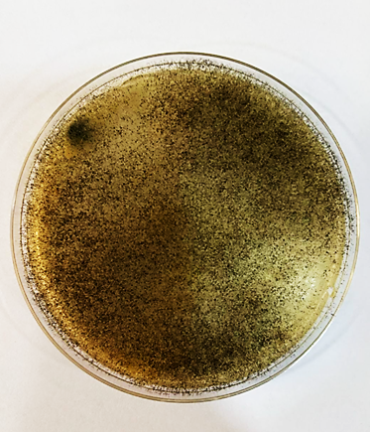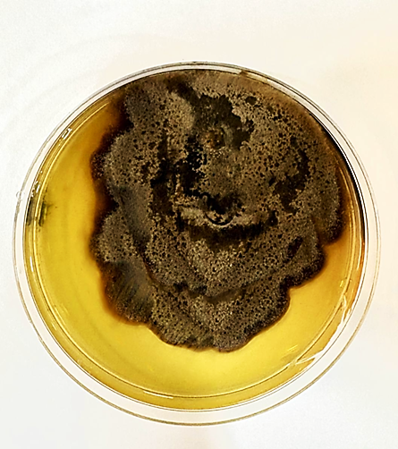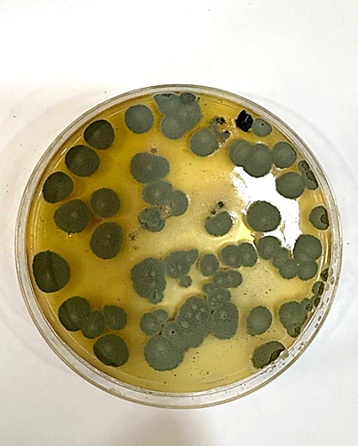

1 2 3

**Fig.1** Types of mold isolated from fruits under study on medium SDA

1. 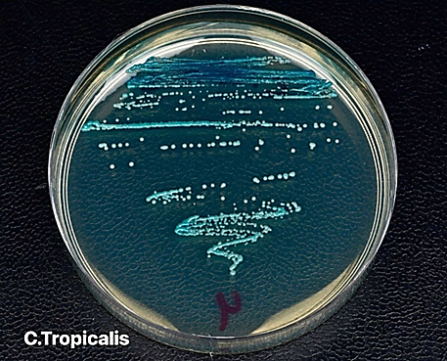*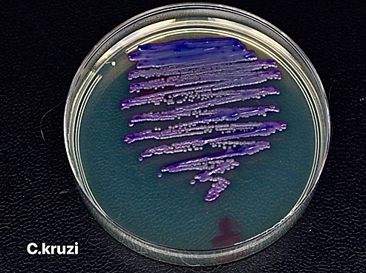A.fumigatus* 2-*A.niger* 3- *Mucore* spp

**Fig.2** Types of yeasts isolated from fruits under study on medium chrome media

**Molecular Diagnosis**

1. **Molecular Detection of *Aspergillus Fumigatus* Isolates**

Results of molecular analysis using polymerase chain reaction (PCR) primers specific to Aspergillus fumigatus showed that all isolated fruit samples (figs, oranges, strawberries, and pomegranates) yielded a single, clear amplification band with an approximate size of 586 base pairs, as shown in Figure (3). The resulting bands were compared to a standard genetic ladder (1000 bp DNA ladder), confirming the success of the amplification process and the genetic sequence matching the target species. These results clearly indicate that all tested samples were *Aspergillus fumigatus* isolates, indicating its prevalence in the fruits used in the study. The presence of this fungus is due to the favorable environmental conditions provided by the fruits, such as their high sugar content and moisture content, especially in the event of spoilage or improper storage.

Previous studies have supported these results; A study by [17] demonstrated that *A. fumigatus* can be isolated from various fruits and retail markets, indicating its ability to colonize carbohydrate-rich plant material. [18] also reported that *A. fumigatus* isolates were identified from long-stored strawberry and orange samples using similar PCR techniques, with confirmation via genetic sequencing. A study by [18] showed that *A. fumigatus* is not only a common contaminant of fresh food, but is also one of the most important opportunistic fungi causing serious respiratory diseases, especially in individuals with low immunity. This highlights the health significance of the current findings. Accordingly, the detection of this fungus in fruit samples intended for human consumption underscores the need to follow strict hygiene practices in the collection, storage, and distribution of food products, as well as to activate microbial control in local markets. Sources indicated that soil and water contamination can be a major source of infection, especially under poor irrigation conditions[19].

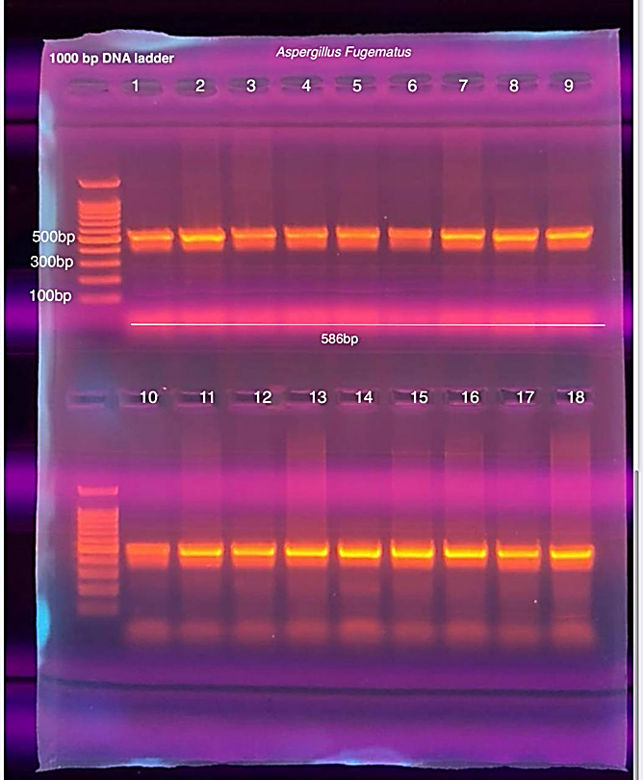

**Fig. 3** Genetic detection of *A. fungematus* in fungal isolates isolated from different fruits

**2-Molecular Detection of *Aspergillus niger* in Fungal Isolates from Different Fruits**

Polymerase chain reaction (PCR) was used to determine the molecular identity of *Aspergillus niger* in several fungal isolates extracted from local fruits, including figs, oranges, pomegranates, and strawberries. Specific primers targeting a conserved genetic sequence within the fungal DNA were used, and the results were analyzed using agarose gel electrophoresis and UV fluorescence. The results (Figure 4) showed a clear single amplification band in all samples loaded in wells 2 to 9 and 11 to 17. The band size was approximately 654 base pairs (bp), consistent with the expected size of the specific amplification product for *A. niger*. Gene ladders in wells 1, 10, and 18 showed standard bands, confirming the accuracy of the molecular quantification. These results indicate that all of the isolates studied contained a genetic sequence identical to *Aspergillus niger,* indicating the prevalence of this fungus in the studied fruits. This is likely due to the moisture- and sugar-rich environment of these fruits, which provides ideal conditions for the growth of this fungus, especially in the presence of surface scratches or suboptimal storage conditions. The results of the current study are consistent with those reported by [16] which showed that *Aspergillus niger* is a common fungus in dried and fresh fruits. It was detected using PCR techniques, and its isolation rates were high in oranges and figs stored for long periods. [20]also confirmed that this fungus has a high capacity to colonize agricultural products, is a common species on fruits and plant surfaces, and has the ability to produce mycotoxins such as ochratoxin A under favorable environmental conditions.

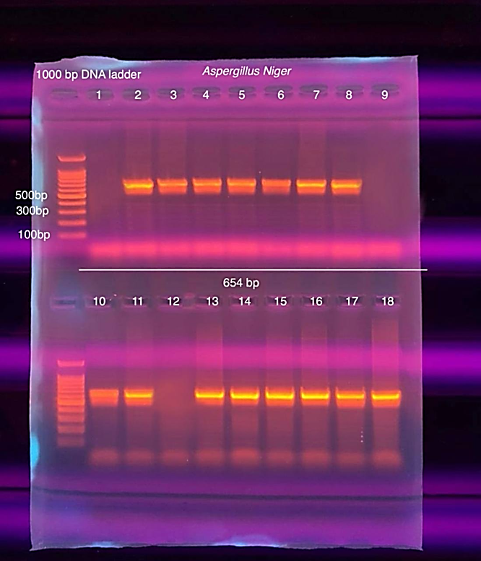

**Fig. 4** Molecular detection of *Aspergillus niger* in fungal isolates isolated from different fruits

**3-Molecular Identification of *Mucor* Fungi Isolated from Fruits Using PCR**

In this study, polymerase chain reaction (PCR) was used for the molecular identification of fungal isolates of the genus Mucor isolated from fresh fruit samples, including figs, oranges, pomegranates, and strawberries. Specific primers targeting the internal transcribed spacer (ITS) region of ribosomal RNA (rRNA), a common region in fungal taxonomy, were used. PCR electrophoresis results, as shown in Figure 5, showed the appearance of single, clear amplification bands in the sections loaded with fungal isolates (sections 2 to 8), at a molecular size of approximately 672 base pairs (bp), the expected size of the primers used for the genus Mucor. While some wells, such as well 4, showed the absence of a band, which could indicate a PCR failure or the isolate's non-affiliation with this genus, a standard genetic ladder (1000 bp DNA ladder) was loaded into well 1, which helped accurately locate the bands by comparing them with known reference bands (100, 300, and 500 bp). The current molecular results indicate that the fungal isolates examined from fresh fruits mostly contain *Mucor* gene sequences, indicating contamination with this common fungal genus. Mucor is known for its ability to colonize environments rich in moisture and organic matter, such as overripe fruits or fruits stored for long periods under unsuitable conditions. *Mucor* is characterized by rapid growth and its ability to adapt to moderate to high temperatures, and its presence in food can lead to spoilage and reduced shelf life. Although most strains do not produce mycotoxins, some species, such as *Mucor* circinelloides, can cause serious opportunistic infections in immunocompromised individuals. The results of this study are consistent with those of [21]. who demonstrated that fungi of the Zygomycetes family, particularly *Mucor* spp., are among the most common fungi in stored plant foods and have a high capacity to grow in high humidity conditions. [22] also noted the possibility of isolating *Mucor* from a number of fruits, such as figs and grapes, especially if the outer skin is damaged or stored at unsuitable temperatures. [23] confirmed that *Mucor* species grow readily in foods with high water activity and are among the fungi that should be monitored in fresh fruit products. This study highlights the importance of molecular testing in detecting fungi contaminating plant food products, as PCR technology has demonstrated high accuracy in identifying the presence of *Mucor* in various fruit samples. These results are an important indicator that calls for improving harvesting, storage and transportation methods, and paying attention to microbial control of agricultural products intended for direct consumption.

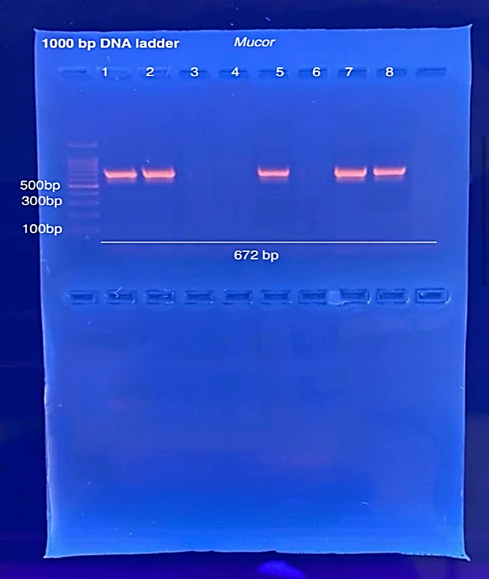

Fig .5 Molecular detection of *Mucor* fungi isolated from fruits.

**4- Molecular detection of *C. krusei* isolated from fruits using PCR.**

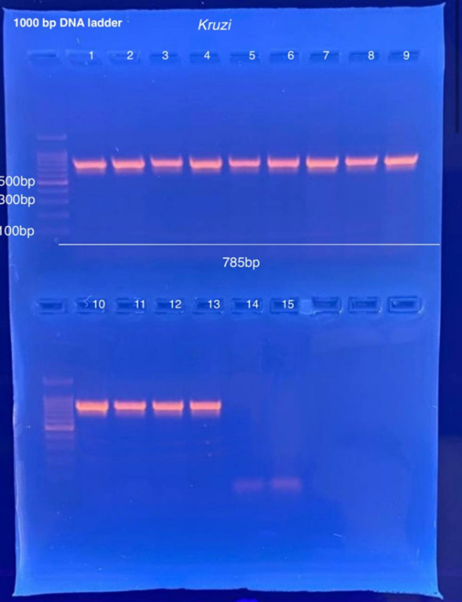Polymerase chain reaction (PCR) was performed using specific strains of the Kruzi gene characteristic of *Candida krusei*, yielding a 785-base-pair (bp) gene fragment. Electrophoresis was performed on a 1.5% agarose gel, and the results were compared using a molecular ladder (100–1000 bp). The results were as follows: Wells 1–13: All showed a clear band at ~785 bp, indicating the presence of the Kruzi gene in 13 out of 15 samples (86.7%). Wells 14–15 showed no clear crossing-over, which is understood as a negative result, as shown in Figure (6). The results were partially consistent with a study [24] that included 123 isolates from the surface of fruits, where *Candida tropicalis* was the most prevalent, followed by *Meyerozyma caribbica*, and then *C. krusei*, a fungus naturally resistant to azole. This indicates that fruits represent a suitable environment for the presence of *C. krusei*, especially since they are resistant to flizconazole*. C. krusei* is known to be naturally resistant to flizconazole and possibly other antifungals, reinforcing the health importance of its presence in the food chain. Studies have linked its presence in food to drug resistance, leading to recommendations to wash fruits to reduce the risk of these isolates reaching humans. In a genetic analysis of *C. krusei* isolates from fermented vegetables and clinics, [25] found that environmental fungi were more resistant to azoles—including fluconazole—than clinical samples, confirming the presence of *C. krusei* in food as well. The study also found that environmental isolates are closely genetically related to clinical isolates, suggesting the possibility of their transmission through the food chain.

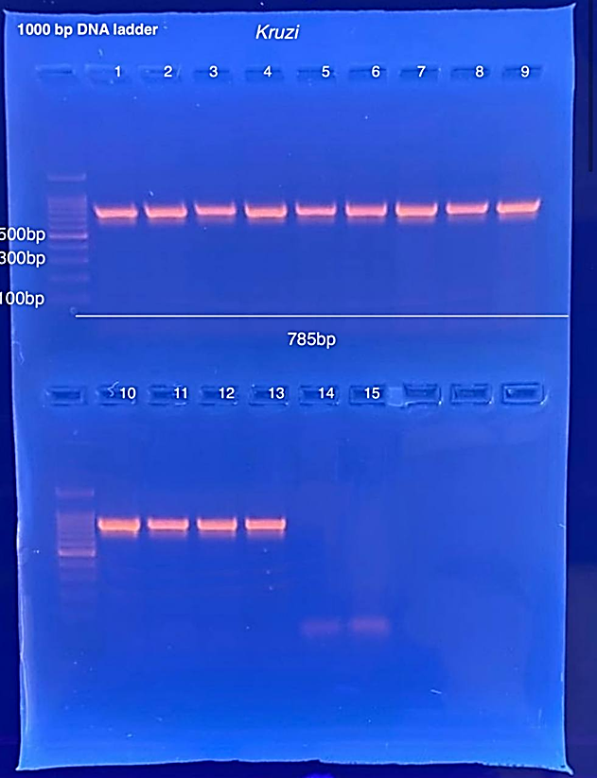

Fig. 6 Molecular detection of *C. krusei* isolated from fruits

**5-Molecular Analysis for the Identification of *Candida tropicalis* Isolates Using PCR**

In this study, the Polymerase Chain Reaction (PCR) technique was used to identify Candida tropicalis isolates isolated from fruit samples including figs, oranges, pomegranates, and strawberries. DNA was extracted from the fungal isolates, and specific primers targeting the C. tropicalis gene were then used to obtain an amplified band with the expected size of 586 base pairs (bp). Agarose gel electrophoresis results, as shown in Figure (7), showed that samples bearing paragraph numbers 19, 20, 23, 24, and 25 produced clear bands at 586 bp, confirming the presence of *Candida tropicalis* in those samples. In contrast, wells 21, 22, 26, 27 and 28 showed no clear signals at the specified location, indicating the absence of specific DNA for the fungus in question or problems with extraction or interaction. These results reflect the relative prevalence of the studied fungus within different fruits and support the effectiveness of PCR as a rapid and specific tool for the diagnosis of *C. tropicalis* compared to traditional methods that rely on morphological characteristics and biochemical tests, which may overlap between different *Candida* species.

The results of this study are consistent with those indicated by [26], who confirmed the widespread presence of *Candida tropicalis* in stored and non-stored agricultural products, particularly in areas with a humid and warm climate. [27] also indicated that *C. tropicalis* is an opportunistic species with a high ability to adapt to various environments, including plant and food surfaces. In a similar study by [28], *C. tropicalis* was isolated from imported grapes. PCR results revealed bands at 584–586 bp, reinforcing the results of the current study and demonstrating the reliability of this length as an accurate diagnostic indicator for the fungus. On the other hand, a study [29] in Iraq demonstrated the presence of *C. tropicalis* in local fruits such as dates and figs, using only traditional cultivation techniques, without the use of molecular tools. The current study highlights the superiority of molecular diagnostics in accurately identifying fungi even in complex and multi-floral samples. These results demonstrate the importance of using PCR as a sensitive and specific tool in the diagnosis of *Candida tropicalis* in food products, particularly fresh fruits. The presence of this fungus in multiple fruits also suggests the possibility of its transmission through harvesting, storage, or cross-contamination, which calls for enhanced control measures and continuous laboratory testing. Recent studies indicate a clear diversity of environmental fungi prevalent in agricultural areas and local markets, reflecting the importance of monitoring these microorganisms due to their direct impact on food safety and human health [30].

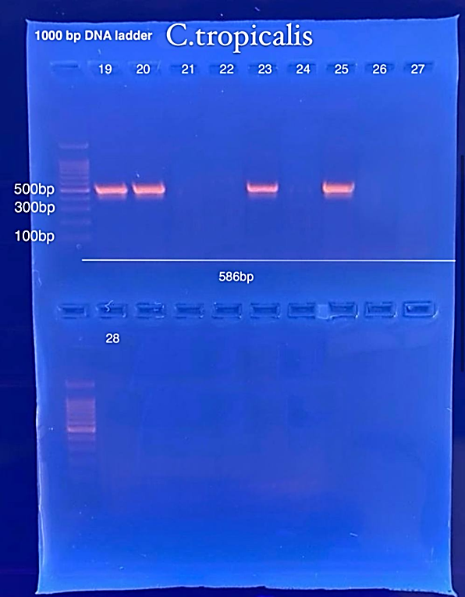

**Fig. 7** Molecular analysis for diagnosis of *Candida* *tropicalis* isolates

**Conclusion**

The study revealed that fresh fruits sold in Kirkuk markets—both local and imported—are contaminated with various fungal species, most notably *Aspergillus fumigatus* and *Candida krusei*, which may pose health risks, particularly for immunocompromised individuals. Strawberries and figs showed higher susceptibility to fungal infection due to their soft texture and high moisture content, in contrast to oranges and pomegranates, which have thicker peels that offer more resistance to contamination. Molecular diagnostic techniques (PCR) proved to be highly effective in accurately identifying fungal species, surpassing traditional methods.

Disclaimer (Artificial intelligence)

The authors of this manuscript acknowledge that they did not use any generative AI techniques, such as large language models (ChatGPT, Copilot, etc.) or text-to-image generators, while writing or editing this manuscript. The manuscript is the result of original research derived from the results of a master's thesis and was written and submitted by the submitting researcher without using any AI models.

**Reference**

1. Bonnin, E., & Pelloux, J. (2020). Pectin degrading enzymes. Pectin: technological and physiological properties, 37-60
2. Li, J., Peng, C., Mao, A., Zhong, M., & Hu, Z. (2024). An overview of microbial enzymatic approaches for pectin degradation. International Journal of Biological Macromolecules, 254, 127804.
3. Argenta, L. C., de Freitas, S. T., Mattheis, J. P., Vieira, M. J., & Ogoshi, C. (2021). Characterization and quantification of postharvest losses of apple fruit stored under commercial conditions. HortScience, 56(5), 608-616.
4. Ayofemi Olalekan Adeyeye, S. (2020). Aflatoxigenic fungi and mycotoxins in food: a review. Critical Reviews in Food Science and Nutrition, 60(5), 709-721.
5. Bolel, H., Koyuncu, M. A., & Erbaş, D. (2019). The combined effect of controlled atmosphere with ozone and prochloraz treatment on storage life and quality of pomegranate cv. Hicaznar. Academic Journal of Agriculture/Akademik Ziraat Dergisi, 8(2).
6. Matityahu, I., Marciano, P., Holland, D., Ben-Arie, R., & Amir, R. (2016). Differential effects of regular and controlled atmosphere storage on the quality of three cultivars of pomegranate (Punica granatum L.). Postharvest Biology and Technology, 115, 132-141
7. Oyekemi, A. O., & Ofon-Mbuk, D.-A. (2022). Pathogenicity of Fungi Isolated from Spoilt Sweet Oranges (Citrus sinensis) and from the Air in the Environment of the Orange Section of the Gamboru Market in Maiduguri, Nigeria. European Journal of Nutrition & Food Safety, 14(11), 160–168. https://doi.org/10.9734/ejnfs/2022/v14i111273.
8. Munhuweyi, K., Lennox, C. L., Meitz-Hopkins, J. C., Caleb, O. J., & Opara, U. L. (2016). Major diseases of pomegranate (*Punica granatum* L.), their causes and management—A review. Scientia horticulturae, 211, 126-139.
9. Carmona-Hernandez, S., Reyes-Pérez, J. J., Chiquito-Contreras, R. G., Rincon-Enriquez, G., Cerdan-Cabrera, C. R., & Hernandez-Montiel, L. G. (2019). Biocontrol of postharvest fruit fungal diseases by bacterial antagonists: A review. Agronomy, 9(3), 121
10. Schoch, C. L., Seifert, K. A., Huhndorf, S., Robert, V., Spouge, J. L., Levesque, C. A., ... & Fungal Barcoding Consortium. (2012). Nuclear ribosomal internal transcribed spacer (ITS) region as a universal DNA barcode marker for Fungi. Proceedings of the National Academy of Sciences, 109(16), 6241–6246. <https://doi.org/10.1073/pnas.1117018109>
11. Harley ,J.P., & Prescott , L.M. (1996) . Laboratory exercises in microbiology .3rd ed. WCB /McGraw-Hill .
12. Kannan, P., Janaki, C., & Selvi, G. S. (2006). Prevalence of dermatophytes and other fungal agents isolated from clinical samples. Indian journal of medical microbiology, 24(3), 212.
13. Iram, W., Anjum, T., Abbas, M., Khan, M. A., & Iqbal, M. (2017). Characterization of fungal flora from fruits and fruit juices and detection of mycotoxins by HPLC. Food Science & Nutrition, 5(2), 252–260.
14. Hashem, M., Alamri, S. A., Alqurashi, A. M. (2019). Fungal contamination of fruits and detection of mycotoxins. Saudi Journal of Biological Sciences, 26(6), 1207–1212.
15. Mohammed, A. H., & Al-Janabi, S. S. (2018). Mycological survey of fruits sold in open markets in Baghdad. Iraqi Journal of Agricultural Sciences, 49(1), 122–130.
16. Samson, R. A., et al. (2014). Phylogeny, identification and nomenclature of the genus Aspergillus. Studies in Mycology, 78, 141–173.
17. Abarca, M. L., Bragulat, M. R., Castellá, G., & Cabañes, F. J. (2003). Ochratoxin A production by strains of Aspergillus niger var. niger. Applied and Environmental Microbiology, 69(8), 5183-5185.
18. Hedayati, M. T., Pasqualotto, A. C., Warn, P. A., Bowyer, P., & Denning, D. W. (2007). Aspergillus flavus: human pathogen, allergen and mycotoxin producer. Microbiology, 153(6), 1677–1692.
19. Qader, D. A., & Azeez, R. N. (2023). Diseases of forest tree seedlings: Article Review. Kirkuk University Journal for Agricultural Sciences, 14(4), 83–90.
20. Iqbal, S. Z., Asi, M. R., & Arino, A. (2012). Determination of aflatoxins in dry fruits and nuts by high-performance liquid chromatography (HPLC). Food Control, 27(1), 36–42.
21. Ribes, J. A., Vanover-Sams, C. L., & Baker, D. J. (2000). Zygomycetes in human disease. Clinical Microbiology Reviews, 13(2), 236–301.
22. Klich, M. A. (2002). Identification of common Aspergillus species. CBS Fungal Biodiversity Centre.
23. Richardson, M. D. (2009). Zygomycetes in human disease. In Human Fungal Pathogens (pp. 325–336). Springer.
24. Zheng, T., Ji, L., et al. (2024). Biology and genetic diversity of Candida krusei isolates from fermented vegetables and clinical samples in China. Virulence, 15(1), Article 2411543.
25. Douglass, A. P., Offei, B., Braun-Galleani, S., Coughlan, A. Y., Martos, A. A. R., Ortiz-Merino, R. A., et al. (2018). Population genomics shows no distinction between pathogenic Candida krusei and environmental Pichia kudriavzevii: One species, four names. PLoS Pathogens, 14(7), e1007138.
26. Sardi, J. C. O., Scorzoni, L., Bernardi, T., Fusco-Almeida, A. M., & Mendes Giannini, M. J. S. (2013). Candida species: current epidemiology, pathogenicity, biofilm formation, natural antifungal products and new therapeutic options. Journal of Medical Microbiology, 62(1), 10–24.
27. Papon, N., Bougnoux, M. E., d’Enfert, C., & Trinel, P. A. (2013). Candida tropicalis: biology, pathogenicity, and resistance to antifungal agents. FEMS Yeast Research, 13(1), 1–17. <https://doi.org/10.1111/1567-1364.12033>
28. Silva, S., Negri, M., Henriques, M., Oliveira, R., Williams, D. W., & Azeredo, J. (2011). Candida glabrata, Candida parapsilosis and Candida tropicalis: biology, epidemiology, pathogenicity and antifungal resistance. FEMS Microbiology Reviews, 36(2), 288–305.
29. Al-Ani, H. A., Al-Khafaji, A. H., & Abdul-Rahman, S. T. (2020). Isolation and identification of some yeasts from fruits sold in local Iraqi markets. Iraqi Journal of Agricultural Sciences, 51(3), 754–762.
30. Mahmood, H. M., & Abdulrahman, K. A. (2023). Morphological and molecular identification of fungi isolated from various habitat in Kirkuk City – Iraq. Eurasian Journal of Biological and Chemical Sciences, 2(1), 15–25.