Effect of Different Organic Nutrient Sources on the Germination and Seedling Growth of Jowar (*Sorghum bicolor*) and Bajra (*Pennisetum glaucum*)

ABSTRACT

|  |
| --- |
| **Aim:** This study is to examine how different organic and inorganic variations, such as sand, cow dung, vermicompost, and cocopeat, affect the germination of jowar (Sorghum bicolor) and bajra (Pennisetum glaucum) seeds in a growth chamber environment.  **Study Design**: The study was conducted using a completely randomized design (CRD) with three replications  **Location and Length of Study:** April–May 2025, Department of Botany, Mata Jijabai Govt PG Girls College, Indore, Madhya Pradesh, India.  **Methodology:** In this study, the germination and early seedling development of two drought-tolerant cereal crops—jowar (Sorghum bicolor) and bajra (Pennisetum glaucum)—are examined in relation to various organic and natural growing media, including vermicompost, cow dung, cocopeat, sand, and their combinations. Under carefully monitored laboratory conditions, germination speed, and germination percentage.  **Results:** Vermicompost and cocopeat together greatly improved seedling vigor and germination performance, demonstrating the synergistic effects of high nutrient availability and moisture retention. While cocopeat maintained rapid germination rates, vermicompost alone showed strong support for root and shoot growth. Despite being high in organic matter, cow dung promoted moderate to strong seedling growth but produced relatively lower germination percentages. While cocopeat maintained rapid germination rates, vermicompost alone showed strong support for root and shoot growth. Despite being high in organic matter, cow dung promoted moderate to strong seedling growth but produced relatively lower germination percentages. Although sand had the highest initial germination rate, its low nutrient and water-holding capacity prevented it from supporting the growth of subsequent seedlings. The results highlight how crucial it is to choose the right growing media for the best seedling performance and imply that a vermicompost and cocopeat mixture provides an affordable, sustainable substitute for enhancing crop establishment and germination in rainfed and low-input agricultural systems.  **conclusion:** These observations can improve the yield of resilient crops in marginal soils and guide organic farming methods. |

*Keywords: Germination, Seedling Vigor, Jowar (Sorghum bicolor), Bajra (Pennisetum glaucum), Vermicompost, Cow Dung, Cocopeat, Sand Soil, Organic Amendments, Growing Media, Sustainable Agriculture, Seed Emergence, Rainfed Cropping Systems, Soil Fertility.*

1. INTRODUCTION

Germination is a crucial stage in a plant's life cycle. It greatly affects future growth and productivity. Successful germination leads to even crop establishment, which is essential for maximizing yield. This process depends on both internal factors, like seed viability, and external environmental conditions. The physical and chemical properties of the soil or growing medium play a key role (Bewley et al., 2013; Keerthana et al., 2024; Chauhan et al., 2025). Among the external factors, nutrient availability, moisture retention, aeration, and microbial activity in the germination medium are especially important for seed emergence and seedling health.

Cereal crops such as jowar (Sorghum bicolor) and bajra (Pennisetum glaucum) are key grains grown in semi-arid and arid areas. These crops resist drought and need little input, making them suitable for rainfed agriculture (Rao et al., 2014). However, improving soil fertility and structure with organic amendments can greatly boost their germination and early seedling development. Poor germination caused by degraded soils or unsuitable media can result in low plant population density and reduced yields, even in hardy crops like jowar and bajra.

**Importance of Organic Amendments and Growing Media**

The use of organic fertilizers and alternative growing media has gained more attention as a sustainable way to improve germination and early growth (Ahmed & Jha,2023). Among these, vermicompost, cow dung, cocopeat, and sand are often studied for their effects on seed germination. (Das & Senapati, 2022)

Vermicompost is an organic fertilizer made from the breakdown of organic waste by earthworms. It offers readily available nutrients, plant growth-promoting substances like auxins and cytokinins, and a helpful microbial population. These elements improve soil structure and nutrient availability, which leads to better seed germination and stronger seedlings (Arancon et al., 2004). Vermicompost also increases moisture retention and aeration in the root zone. Both are crucial during the early stages of crop establishment.

Cow dung is a traditional organic manure that contains high levels of organic carbon and beneficial microbes. It provides a slow but steady release of essential nutrients like nitrogen, phosphorus, and potassium. Well-decomposed cow dung enhances the physical properties of the soil by improving aeration and water-holding capacity. Studies show that cow dung positively affects the germination and early growth of cereals by boosting microbial activity and improving conditions in the root zone (Sahu & Mittra, 2017).

Cocopeat is a spongy material made from coconut husk. It is widely used as a soil-less growing medium in horticulture and seedling production. It features high water retention, excellent aeration, and low bulk density. Though low in nutrients, cocopeat acts as a neutral, disease-free medium ideal for seed germination, especially when mixed with nutrient-rich materials like vermicompost or cow dung (Yadav et al., 2018). Its inert nature helps maintain a stable environment around the seed and reduces water stress during imbibition and radicle emergence.

Sand consists of large particles, making it highly permeable but low in water-holding capacity. While it is not ideal as a standalone growing medium due to its limited nutrient content, it can support germination when combined with organic materials. The loose texture of sandy soil improves drainage and helps prevent waterlogging, which can hinder germination and encourage fungal infections. Its effectiveness increases significantly when mixed with compost or manure (Lehmann & Joseph, 2009).

Thus, choosing a suitable germination medium enhanced with organic inputs can be very important for improving seed performance, particularly in situations where resources are scarce. improving crop establishment in marginal environments requires an understanding of how various media affect germination and early seedling growth in crops like bajra and jowar. In order to find affordable and sustainable ways to increase crop productivity, this study will assess how different germination media affect the vigor, initial growth, and seed germination rate of sorghum bicolor and pennisetum glaucum.

.2. material and methods

2.1. **Experimental Site and Duration**

The experiment was conducted under controlled conditions in the laboratory at Department of Botany, Mata Jijabai Govt PG Girls College, Indore during the 2025. The study was carried out for a period sufficient to capture germination and early seedling development (typically 10–15 days).

2. 2**. Seed Material**

Certified seeds of two cereal crops, were obtained from a reputable agricultural seed supplier or local agricultural university. All seeds were uniform in size, free from visible defects, and tested for viability before sowing.

* Jowar (*Sorghum*)
* Bajra (*Pennisetum glaucum*)

2.3. **Growing Media** (Treatments)

Four different growing media were prepared using the following materials:

* Vermicompost (well-decomposed and mature)
* Cow dung manure (air-dried and decomposed)
* Cocopeat (washed to remove salts)
* Sand (sterilized and sieved to remove impurities)
* Vermicompost + Cocopeat (1:1)

2.5. **Experimental Design**

The experiment was laid out in a with 3 replications per treatment, for both jowar and bajra separately.

2.6. **Sowing Procedure**

* Seeds were surface sterilized using 1% sodium hypochlorite solution for 1–2 minutes and rinsed with distilled water.
* In each replicate, 10 seeds were sown uniformly in seed pots.
* Pots were kept under ambient room temperature conditions.
* Watering was done regularly using distilled water to maintain optimum moisture levels (without waterlogging).

**Table 1: The experiment included the following six treatment groups:**

|  |  |  |
| --- | --- | --- |
| S. No | Treatment Code | Composition |
|  | T1 | 100% Vermicompost |
|  | T2 | 100% Cow dung |
|  | T3 | 100% Cocopeat |
|  | T4 | 100% Sand soil |
|  | T5 | 50% Vermicompost + 50% Cocopeat (1:1) |

**2.7 Observations Recorded**

The following parameters were recorded at regular intervals:

a) Germination Parameters

* Germination percentage (%) – Number of seeds germinated / Total seeds × 100
* Mean Germination Time (MGT) – Average time taken for seeds to germinate
* Germination rate – Seeds germinated per day

3. results and discussion

**Fig 1: Germination with different composition**

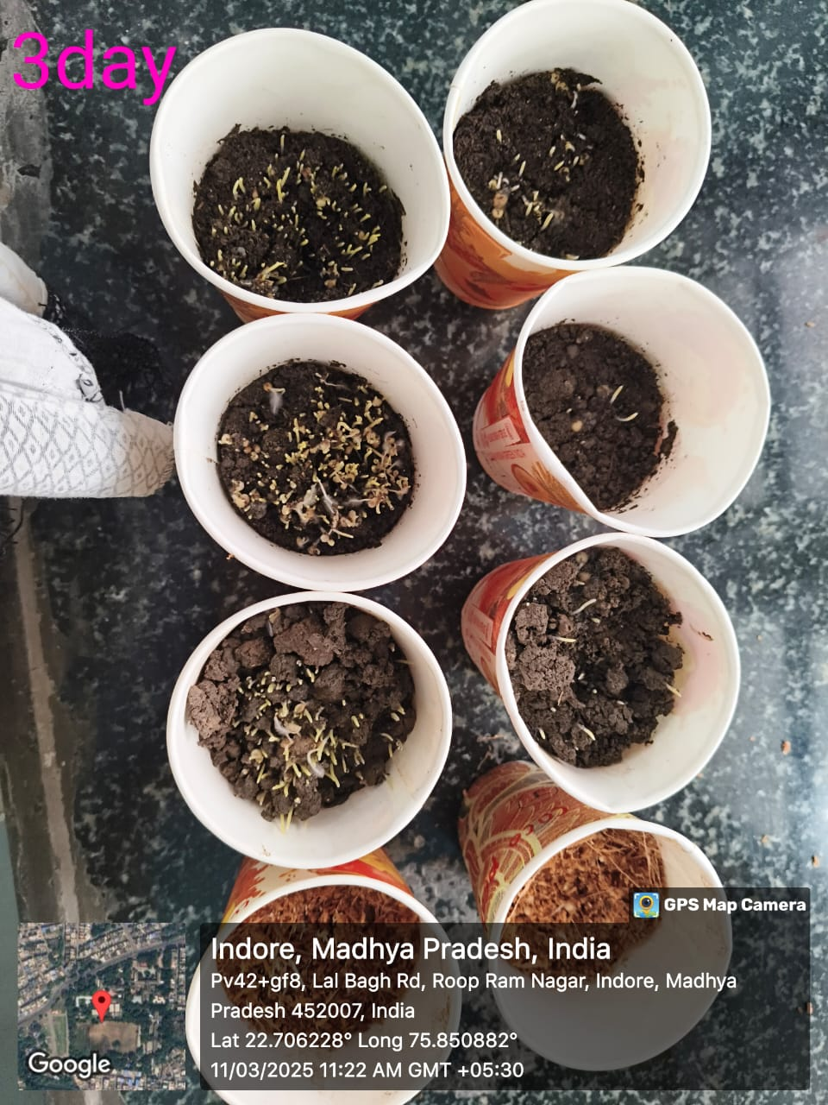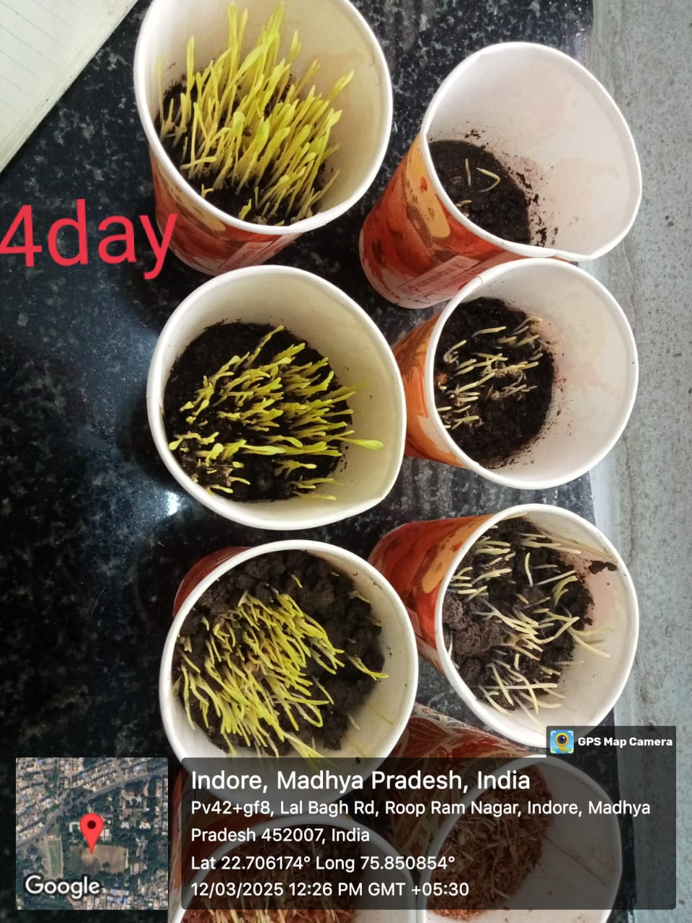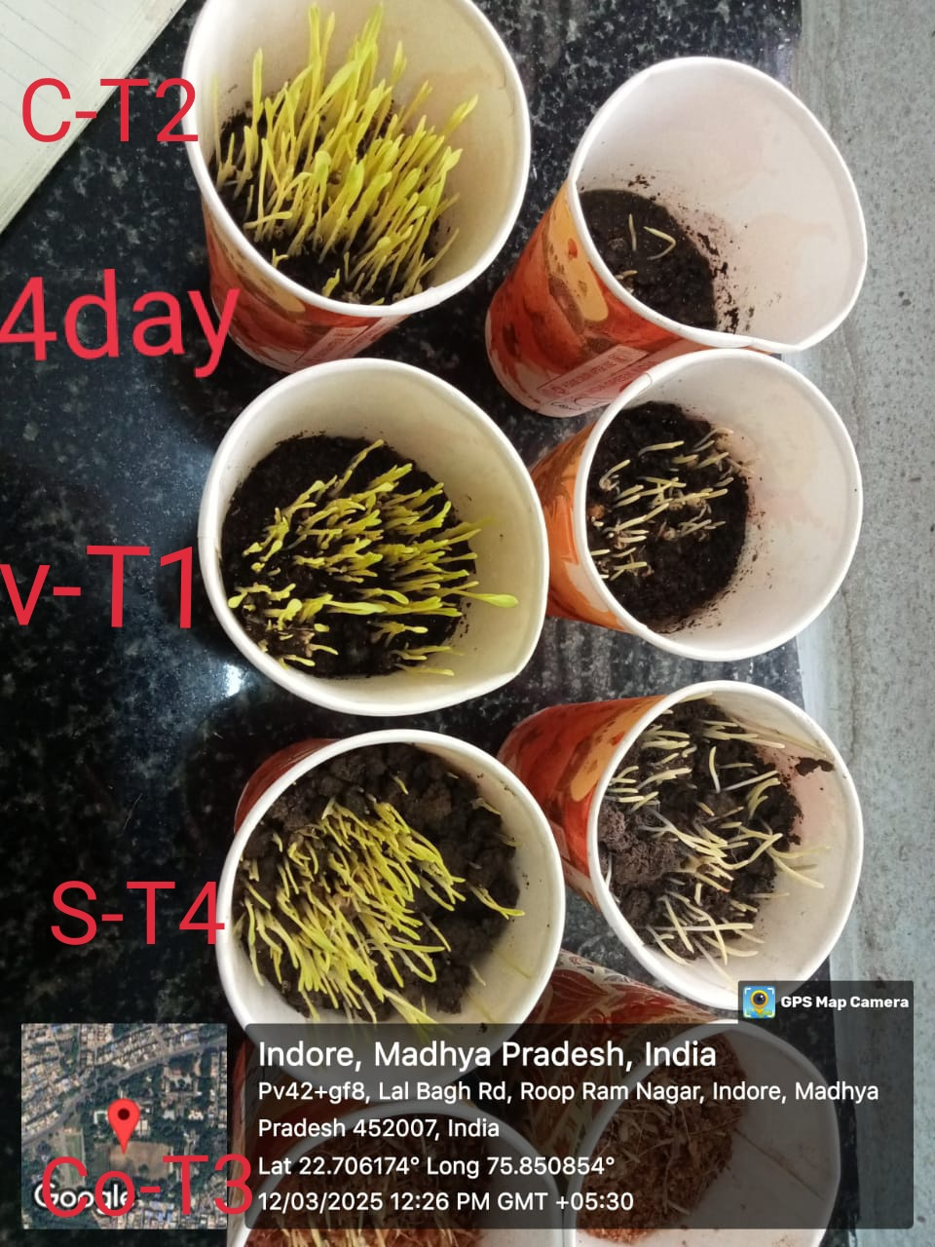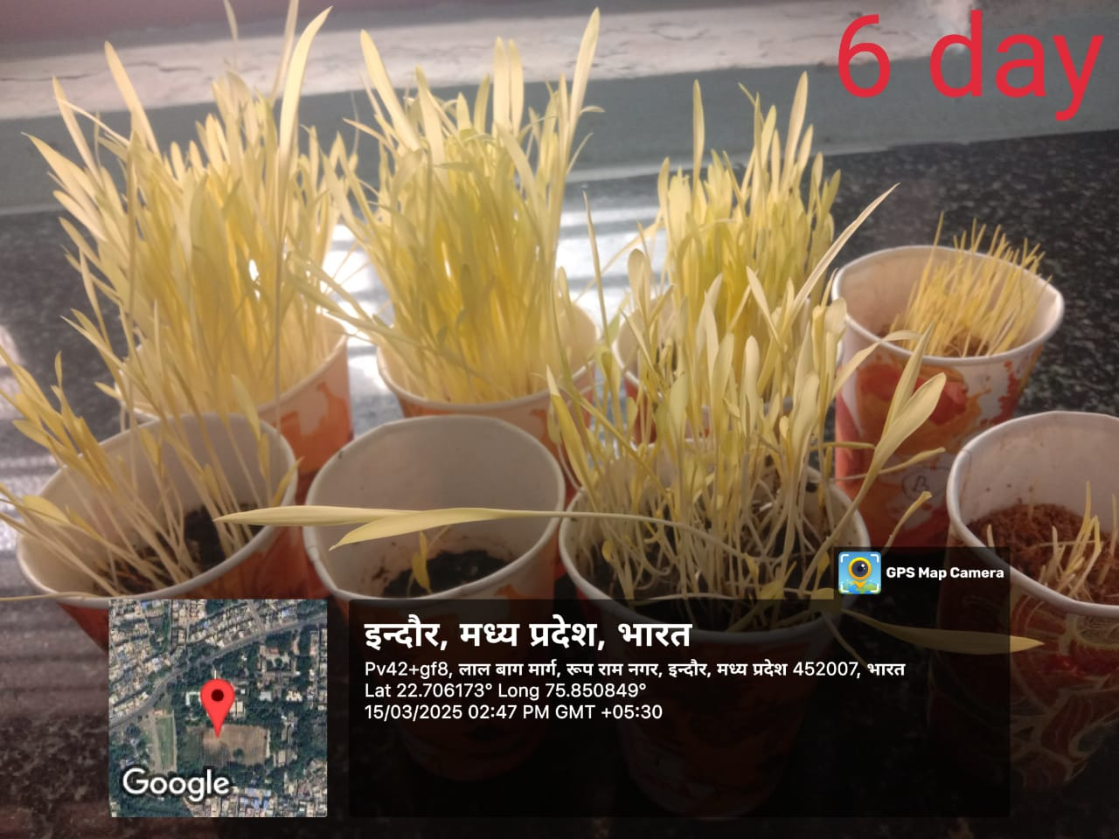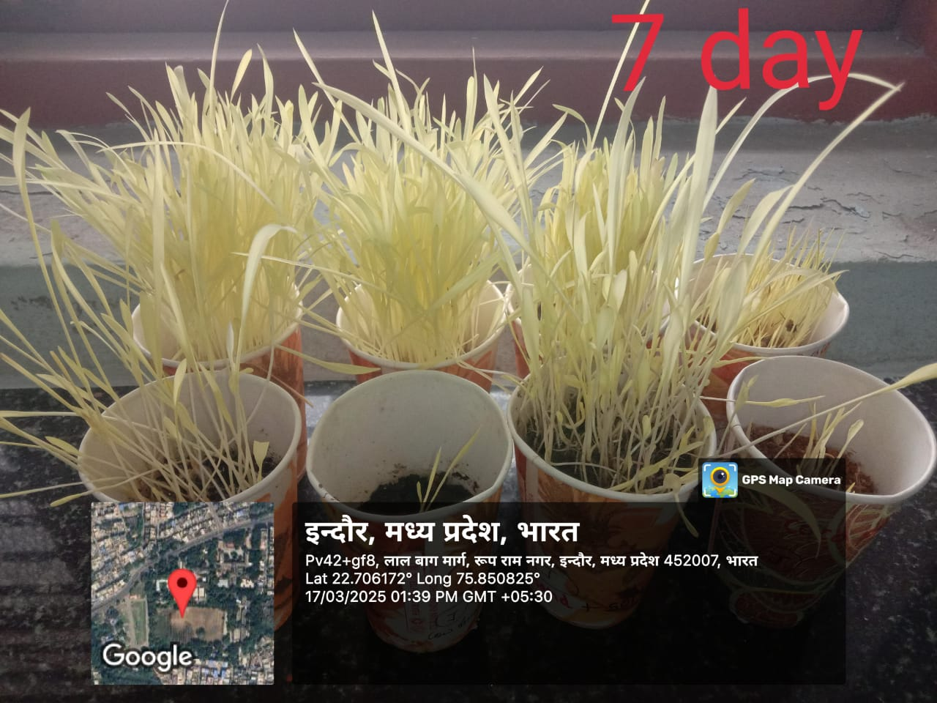

Vermicompost and cocopeat (T5) was the most successful combination of the five germination media treatments in terms of encouraging seed germination and seedling growth. In terms of germination percentage, germination speed, and the overall Seedling Vigor Index (SVI), this medium continuously performed better than the others. The complementary physical and chemical characteristics of vermicompost and cocopeat are responsible for T5's superior performance.

Cocopeat is renowned for its high porosity and exceptional moisture-retention ability, which provide the ideal conditions for gas exchange and seed hydration. These qualities are crucial in the early phases of germination because they allow the seeds to absorb water uniformly while maintaining a sufficient supply of oxygen for the developing embryo. Vermicompost, on the other hand, is abundant in easily accessible macro- and micronutrients, such as potassium, phosphorus, nitrogen, and trace elements, as well as growth-promoting compounds like humic acids and advantageous microbial populations. Faster germination rates, more vigorous root and shoot growth, and an overall higher SVI in the T5 treatment were probably caused by the synergistic interaction of these materials.

The findings of this study are in line with those of Kumar, M. & Roy, D (2024), Kavitha & Subramanian (2007) and Arancon et al. (2004), who showed that organic growing media blends, especially those that included vermicompost, improved biomass accumulation, nutrient uptake, and seedling emergence in a range of crops. Additionally, their research demonstrated how organic substrates support early root development and enhance stress tolerance by encouraging microbial colonization around the rhizosphere.

Vermicompost by itself (T1), on the other hand, promoted strong seedling growth as well, although it performed marginally worse than the T5 combination. The seeds that germinated in pure vermicompost showed healthy seedling morphology, with well-developed roots and shoots, and moderately high germination percentages. Vermicompost's rich nutritional profile, which provides vital nutrients in a form that plants can absorb, is responsible for this. Additionally, its microbial activity probably increased the enzymatic activity involved in nutrient assimilation and stimulated root elongation. However, compared to the mixture enhanced with cocopeat, the comparatively denser texture of vermicompost might have slightly limited aeration and moisture movement around the seed, which could account for the slight delay in germination speed.

Because of its lightweight structure, high water-holding capacity, and superior aeration qualities, cocopeat alone (T3) demonstrated quick and consistent germination. In contrast to T1 and T5, the seedlings generated under this treatment, however, exhibited poorer root and shoot development. This implies that cocopeat does not contain enough nutrients to support vigorous seedling growth past the initial sprouting phase, even though it supports the physical requirements for germination. These results are consistent with those of Singh et al. (2014) and Patel & Desai (2022), who highlighted the necessity of nutrient supplementation when using cocopeat as a stand-alone medium, especially when growing crops that require a lot of nutrients.

The cow dung treatment (T2) showed an intriguing but somewhat contradictory trend. Although cow dung is frequently thought of as a good organic fertilizer because of its microbial diversity and slow-release nutrient content, it performed the worst out of all the treatments in terms of germination percentage. Cow dung may effectively support post-germination development, as evidenced by the relatively strong shoot and root growth of the seedlings that did emerge from T2. The existence of germination inhibitors or ammonia toxicity in raw or insufficiently decomposed cow dung, which can prevent seed sprouting, is one reasonable explanation for this pattern. Furthermore, the availability of nutrients during the crucial early stages of germination may be delayed due to the slow mineralization of cow dung. These findings are consistent with those of Sahu and Mittra (2017), who found that unless cow dung-rich substrates are properly composted or amended, seed emergence is delayed and seedling establishment is uneven.

Sand, on the other hand, permits quick water uptake and unhindered gas exchange, as evidenced by the surprisingly high germination percentage of sand (T4). However, with shallow root systems and thin, pale shoots, the overall vigor of the seedlings was noticeably low. Sand's low nutrient-holding capacity and propensity to drain water too quickly are the causes of this underperformance, which results in an environment that is both nutrient-deficient and inconsistent in moisture for long-term seedling growth. Furthermore, the organic and microbial support that is usually found in more enriched media is absent from sand. These findings support the findings of Maheswarappa et al. (2002) and Sharma et al., 2023, who pointed out that although sand can be a useful physical medium for early germination, it is inappropriate for ongoing seedling development in the absence of organic or mineral supplementation.

When combined, the outcomes of every treatment highlight how crucial it is to have a balanced growing medium that meets the nutritional and physical requirements of growing seedlings, including aeration and water retention. Media that only provide one of these characteristics, such as sand or cocopeat, may be effective in certain germination-related aspects but insufficient in promoting the full development of seedlings. On the other hand, nutrient-rich media like vermicompost might require structural improvement to maximize germination conditions.

These advantages are successfully combined in the vermicompost + cocopeat combination (T5), which produces a synergistic environment that promotes both vigorous seedling growth and quick and consistent germination. Along with improving early plant establishment, these combinations may also increase resistance to transplant shock, which would ultimately improve field conditions for plant survival and yield. Particularly in semi-arid areas where crops like jowar and bajra are frequently grown, the combination of locally accessible, affordable, and sustainable organic materials like vermicompost and cocopeat offers a promising approach for nursery practices and resource-constrained agricultural systems.

Additionally, the results of this study highlight how important media selection is to agricultural output and suggest a sustainable crop propagation model that reduces reliance on artificial inputs. Over time, adding well-balanced organic media to seedling production systems can also enhance soil health, lessen environmental deterioration, and foster ecological resilience.  
  
In summary, the blend of vermicompost and cocopeat produced the best results for every germination and growth metric assessed in this study. For farmers and nursery operators looking to improve seedling quality and field performance at a reasonable cost, it provides a practical, environmentally friendly substitute for traditional growing media. Future studies should concentrate on maximizing the ratios of these media and investigating how they affect a larger variety of crops in a range of environmental circumstances.

**Table 2: Germination with different composition based on observation**

|  |  |  |  |  |  |
| --- | --- | --- | --- | --- | --- |
| S.No | Treatment | Germination % | Germination Speed | Root/Shoot Growth | Seedling Vigor |
| 1 | **Vermicompost** | **Moderate** | **Fast** | **Strong** | **High** |
| 2 | **Cow Dung** | **Low** | **Moderate** | **Moderate–Strong** | **Moderate–High** |
| 3 | **Cocopeat** | **Moderate** | **Fast** | **Moderate** | **Moderate** |
| 4 | **Sand Soil** | **High** | **Slow** | **Weak** | **Low** |
| 5 | **Vermicompost**  **+**  **Cocopeat** | **Very High** | **Very Fast** | **Very Strong** | **Very High** |

**Conclusion**

The study shows that seed germination, growth rate, and overall seedling vigor are all greatly impacted by the type of growing medium used. The most successful combination of treatments was Vermicompost and Cocopeat, which supported very high germination percentage, very fast germination speed, and very strong root and shoot development, all of which led to very high seedling vigor.   
Although vermicompost and cocopeat were only moderately effective on their own, when combined, they had a synergistic effect that improved performance as a whole. Cow dung, on the other hand, encouraged robust growth but was unable to facilitate effective germination, and sand, while facilitating high germination, was unable to maintain the development of healthy seedlings.

As a result, the study comes to the conclusion that a composite medium consisting of vermicompost and cocopeat is the best option for nursery and agricultural applications because it provides the best results for seed germination and seedling growth.

COMPETING INTERESTS DISCLAIMER:

Authors have declared that they have no known competing financial interests OR non-financial interests OR personal relationships that could have appeared to influence the work reported in this paper.

Disclaimer (Artificial intelligence)

**Option 1:**

Author(s) hereby declare that NO generative AI technologies such as Large Language Models (ChatGPT, COPILOT, etc.) and text-to-image generators have been used during the writing or editing of this manuscript.

References

1. Ahmed, S.& Jha, A. K. (2023). Use of sustainable organic materials in nursery media to improve crop establishment in dryland agriculture.  
   *Indian Journal of Agronomy*, 68(4), 321–328.  
   https://doi.org/10.5958/0974-7406.2023.
2. Arancon, N. Q., Edwards, C. A., Bierman, P., Welch, C., & Metzger, J. D. (2004). Influences of vermicomposts on field strawberries: Part 1. Effects on growth and yield. *Bioresource Technology*, 93(2), 145–153. https://doi.org/10.1016/j.biortech.2003.10.014
3. Arancon, N. Q., Edwards, C. A., Bierman, P., Welch, C., & Metzger, J. D. (2004). Influences of vermicomposts on field strawberries: Part 1. Effects on growth and yield. *Bioresource Technology*, 93(2), 145–153. <https://doi.org/10.1016/j.biortech.2003.10.014>
4. Bansal, S., & Kapoor, K. K. (2000). Vermicomposting of crop residues and cattle dung with Eisenia fetida. *Bioresource Technology*, 73(2), 95–98. https://doi.org/10.1016/S0960-8524(99)00137-1
5. Bewley, J. D., Bradford, K., Hilhorst, H., & Nonogaki, H. (2013). Seeds: Physiology of Development, Germination and Dormancy (3rd ed.). Springer.
6. Chauhan,R; Sahu,K; Majumder, S.K & Yadav, P (2025). Light as a Key Abiotic Driver in Enhancing Germination and Phytochemicals of Chickpea Cultivars. Environment and Ecology. 43(1),169-174.
7. Das,B.,& Senapati, A (2022). .Optimizing germination media for enhanced seedling growth in climate-resilient crops. *Sustainable Agriculture Reviews*, 59, 211–225.  
   https://doi.org/10.1007/978-3-030
8. Edwards, C. A., Arancon, N. Q., & Sherman, R. (2007). Vermiculture Technology: Earthworms, Organic Wastes, and Environmental Management. CRC Press.
9. Joshi, R., Singh, J., & Vig, A. P. (2016). Vermicompost as an effective organic fertilizer and biocontrol agent: Effect on growth, yield and quality of plants. *Reviews in Environmental Science and Bio/Technology*, 15, 137–159. https://doi.org/10.1007/s11157-015-9390-3
10. Joshi, R., Singh, J., & Vig, A. P. (2016). Vermicompost as an effective organic fertilizer and biocontrol agent: Effect on growth, yield and quality of plants. *Reviews in Environmental Science and Bio/Technology*, 15, 137–159. <https://doi.org/10.1007/s11157-015-9390-3>.
11. Kavitha, P., & Subramanian, P. (2007). Effect of Vermicompost on the growth and yield of sorghum. *Journal of Ecobiology*, 21(4), 361–365.
12. Kavitha, P., & Subramanian, P. (2007). Effect of vermicompost on the growth and yield of sorghum. *Journal of Ecobiology*, 21(4), 361–365.
13. Keerthana, D., Kumar, P., & Mehera, B. (2024). Effect of Vermicompost and Molybdenum on Growth and Yield of Groundnut (Arachis hypogaeal L.). Journal of Advances in Biology & Biotechnology, 27(5), 948–953. <https://doi.org/10.9734/jabb/2024/v27i5856>.
14. Kumar,M.,& Roy, D (2024). Influence of organic growing media on early seedling vigor of pearl millet (Pennisetum glaucum) under stress conditions.  
    *Journal of Environmental Biology*, 45(1), 89–97.  
    <https://doi.org/10.22438/jeb/45/1/MRN>.
15. Kumar, S., Bhargava, R., & Singh, D. (2015). Effect of organic and inorganic fertilizers on growth and yield of wheat. *Annals of Agricultural Research*, 36(3), 259–264.
16. Lehmann, J., & Joseph, S. (2009). Biochar for Environmental Management: Science and Technology. Earthscan Publications Ltd.
17. Maheswarappa, H. P., Nanjappa, H. V., & Hegde, M. R. (2002). Influence of organic manures on the yield of bajra and ragi under rainfed condition. *Indian Journal of Agronomy*, 47(2), 185–188.
18. Maheswarappa, H. P., Nanjappa, H. V., & Hegde, M. R. (2002). Influence of organic manures on the yield of bajra and ragi under rainfed condition. *Indian Journal of Agronomy*, 47(2), 185–188.
19. Mishra, A., & Singh, R. (2012). Effect of vermicompost on growth parameters of wheat and jowar. *Journal of Environmental Science*, 28, 95–99.
20. Patel, N., & Desai, R. (2022). Comparative assessment of vermicompost, cow dung, and cocopeat on seed germination in cereals.  
    *Agricultural Research Journal*,59(1),55–61.  
    https://doi.org/10.18805/arj.2022.
21. Ramesh, P., Singh, M., & Subba Rao, A. (2010). Organic farming: Its relevance in India. *Current Science*, 88(4), 561–568.
22. Rao, S. S., Singh, R., & Shetty, S. V. (2014). Dryland Agriculture in India: Issues and Perspectives. *Indian Journal of Agronomy*, 59(3), 405–412.
23. Sahu, P. K., & Mittra, B. N. (2017). Effect of farmyard manure and cow dung on growth and productivity of cereals. *International Journal of Agricultural Sciences*, 9(2), 569–573.
24. Sahu, P. K., & Mittra, B. N. (2017). Effect of farmyard manure and cow dung on growth and productivity of cereals. *International Journal of Agricultural Sciences*, 9(2), 569–573.
25. Sharma, A., Singh, R., & Yadav, V. (2023)**.** Effect of organic substrates on seed germination and seedling growth of sorghum under semi-arid conditions.  
    *Journal of Crop Improvement*, 37(2), 178–192.  
    https://doi.org/10.1080/15427528.2023.
26. Sharma, D., & Mehta, P. (2013). Comparative evaluation of media for seedling growth in bajra. *Agricultural Science Digest*, 33(4), 287–290.
27. Singh, A., Yadav, P. K., & Kumar, A. (2014). Comparative study of cocopeat and soil media on seed germination of cereals. *Research Journal of Agricultural Sciences*, 5(3), 521–524.
28. Singh, A., Yadav, P. K., & Kumar, A. (2014). Comparative study of cocopeat and soil media on seed germination of cereals. *Research Journal of Agricultural Sciences*, 5(3),521–524.
29. Singh, R., & Singh, A. (2016). Influence of different organic media on germination and seedling growth of bajra (Pennisetum glaucum). *Journal of Eco-Friendly Agriculture*, 11(2), 153–156.
30. Thakur, A., Sharma, R., & Kaur, S. (2015). Effect of seed priming and soil amendments on germination and growth of sorghum and pearl millet. *Journal of Applied and Natural Science*, 7(2), 829–834. <https://doi.org/10.31018/jans.v7i2.723>.
31. Yadav, M., Yadav, J. P., & Singh, A. (2018). Cocopeat as an effective growing medium for horticultural crops: A review. *Plant Archives*, 18(2), 2151–2158.