*Case report*

Treating a co-existence of hidradenitis suppurativa and psoriasis with Secukinumab : A case report

.

ABSTRACT

|  |
| --- |
| **Background:** Hidradenitis suppurativa (HS) and psoriasis are chronic inflammatory diseases that may coexist and share IL-17–mediated pathogenic pathways. Secukinumab, an anti–IL-17A monoclonal antibody, is effective in psoriasis and has shown promise in HS.  **Case report:** We report a 47-year-old man with annular pustular psoriasis (PASI 38, DLQI 16) and moderate HS (Hurley II). Previous treatments were ineffective. Secukinumab led to complete skin clearance (PASI 100 by week 8) and only one HS flare over 10 months.  **Discussion:** Given the failure of previous therapies, secukinumab (300 mg weekly for 5 weeks, then monthly) was initiated. The patient achieved complete clearance (PASI 100) by week 8, with a significant improvement in quality of life (DLQI 2), and experienced only one mild HS flare over a 10-month follow-up. This dual efficacy reinforces the central role of IL-17 in the pathogenesis of both conditions and supports the use of secukinumab as a potential therapeutic option in coexisting HS and psoriasis.  **Conclusion:** Recognizing This case highlights the effectiveness of secukinumab in treating both annular pustular psoriasis and hidradenitis suppurativa. IL-17 inhibitors may offer a valuable therapeutic strategy in patients with overlapping inflammatory dermatoses. |

*Keywords:* *Hidradenitis suppurativa, pustular psoriasis, secukinumab, IL-17, biologic therapy.*

1. INTRODUCTION

Psoriasis affects ~2 % of the world’s population, whereas hidradenitis suppurativa (HS) has a prevalence between 0.1 % and 1 %. Large-scale data show that patients with psoriasis have an 80 % higher risk of HS than matched controls (Kridin K, et al., 2023).

Hidradenitis suppurativa (HS) and psoriasis are chronic, immune-mediated inflammatory diseases that share overlapping pathogenic pathways, notably involving TNF-α signaling and the IL-23/IL-17 axis. IL-23 released by dendritic cells polarizes naïve T cells into Th17 cells, which secrete IL-17A/F and IL-22, these cytokines constitute the pathogenic core of these diseases (Fletcher JM, et al., 2020), (Alqarni SS, et al, 2025). Their coexistence is increasingly recognized, and both conditions can significantly affect patients’ quality of life.

Biologic therapies, particularly monoclonal antibodies targeting IL-17, have revolutionized psoriasis treatment and are showing promising results in HS as well (Buchanan L, 2023). Secukinumab, an IL-17A inhibitor, is approved for psoriasis and has demonstrated off-label efficacy in HS, especially in refractory cases (Wei K,et al, 2024), (Martora F, et al., 2024).

We present a case of coexisting annular pustular psoriasis and moderate HS that responded rapidly and sustainably to secukinumab, supporting its role in the management of dual inflammatory dermatoses.

2. PRESENTATION OF CASE

A 47-year-old male (BMI 28 kg/m², non-smoker, Fitzpatrick phototype I) with oculocutaneous albinism, ischemic heart disease (stent placement), and diabetes had longstanding psoriasis since age 14, previously managed with corticosteroids, methotrexate, and acitretin, with partial response. Family history revealed a mother with plaque psoriasis; no relatives had HS. Tuberculosis screening (IGRA) and hepatitis B/C serology were negative before biologic initiation.

He presented with a severe generalized flare of annular pustular psoriasis of the Bloch-Lapierre type, with dry erythroderma covering approximately 90% of the body surface, collarette scaling and whitish pustules (Figure 1 & 2). The PASI score was 38 with a DLQI score of 16. Baseline laboratory tests, including complete blood count, liver and renal function, inflammatory markers, and metabolic panel, were all within normal limits.

Additionally, the patient had a history of moderate hidradenitis suppurativa (Hurley II), with four flares per year characterized by recurrent abscesses with fistulas and purulent discharge. Examination revealed a few abscesses in the axillary folds, nape, and inguinal folds, along with a small firm nodule without purulent discharge (Figure 3 & 4).

Given prior treatment failures, secukinumab (300 mg weekly for five weeks, then monthly) was initiated, achieving PASI 100 by week 8, a DLQI of 2, and only one HS flare in 10 months. No adverse events or lab abnormalities occurred during quarterly monitoring of CBC, liver and renal function tests.

3. discussion

Hidradenitis suppurativa (HS) is a chronic, relapsing inflammatory skin condition characterized by painful nodules, abscesses, and draining sinus tracts, primarily affecting intertriginous areas (Sabat R et al., 2025). Despite recent therapeutic advances, HS remains a difficult-to-treat disease, especially in moderate to severe forms where conventional antibiotics and systemic agents often fail to achieve sustained remission. Increasing evidence suggests that HS shares key immunopathogenic pathways with psoriasis, particularly through dysregulation of the T-helper 17 (Th17) axis and overexpression of interleukin-17A (IL-17A), a pro-inflammatory cytokine central to the maintenance of cutaneous inflammation (Tampouratzi E, et al., 2020), (Molinelli, E, et al., 2023).

In both diseases, activation of dendritic cells leads to secretion of IL-23, promoting the differentiation of naïve T cells into Th17 cells. These Th17 cells secrete IL-17A/F and IL-22, which drive keratinocyte proliferation, neutrophil recruitment, and the release of antimicrobial peptides and additional pro-inflammatory mediators. This self-sustaining inflammatory loop underpins the pathophysiology of both HS and psoriasis and provides a strong rationale for targeting IL-17 in their treatment (Molinelli, E, et al., 2023), (Alqarni SS, et al, 2025).

Secukinumab is a fully human IgG1 kappa monoclonal antibody that selectively binds and neutralizes IL-17A, thereby interrupting its interaction with the IL-17 receptor. Initially approved for psoriasis and psoriatic arthritis, secukinumab has demonstrated rapid and sustained efficacy in inflammatory dermatoses driven by the IL-17 pathway (Cada DJ, et al., 2015). Until recently, adalimumab, an anti-TNF-α agent, was the only biologic therapy approved by the U.S. Food and Drug Administration (FDA) for HS. However, in October 2023, the FDA granted approval to secukinumab for the treatment of moderate to severe HS in adults (Sabat R, et al., 2025), (Pinto Salgueiro, et al. 2025).

Beyond clinical trials, several real-world case reports and small series have also shown encouraging results with secukinumab in HS, particularly in patients who had previously failed anti-TNF therapy or had contraindications to it (Christos C Zouboulis, et al. 2024), (Rachel G. Casseres, et al., 2020), (Giuseppe P, et al., 2018), (Seung Min Lee, et al., 2023). In our case, secukinumab led to a complete clearance of pustular psoriasis (PASI 100) within eight weeks and a substantial reduction in HS flares over a 10-month follow-up, suggesting dual efficacy in overlapping inflammatory dermatoses. Secukinumab effectively reduces disease severity, inflammation, and improves quality of life in HS patients, with no severe adverse effects reported. It serves as a valuable alternative to anti-TNF therapy, though caution is needed for patients with inflammatory bowel disease (Pinto Salgueiro, et al. 2025).

This case contributes to the growing body of literature supporting IL-17 blockade in the management of coexisting psoriasis and HS. It highlights the potential for a unified therapeutic approach in patients with overlapping IL-17–mediated dermatoses, improving clinical outcomes while reducing treatment burden and polypharmacy.

4. Conclusion

Secukinumab is a promising biologic therapy for both psoriasis and HS. Given its demonstrated efficacy and tolerability, it represents a potential breakthrough in managing these difficult-to-treat conditions, warranting further research for broader clinical application.

**Clinical Significance of the Case :**

This case report provides valuable clinical insight into the rare coexistence of psoriasis and hidradenitis suppurativa. The identification of such associations is essential to guide therapeutic decisions, espacially with the increasing use of biologics such as secukinumab in overlapping inflammatory dermatoses. Secukinumab, anti-il-17, is currently fda-approved for the treatment of hidradenitis suppurativa.

Consent

All authors declare that ‘written informed consent was obtained from the patient’s legal guardian for publication of this case report and accompanying images.

Ethical approval

All authors hereby declare that all experiments have been examined and approved by the appropriate ethics committee and have therefore been performed in accordance with the ethical standards laid down in the 1964 Declaration of Helsinki.

Disclaimer (Artificial intelligence)

Authors hereby declare that NO generative AI technologies such as Large Language Models (ChatGPT, COPILOT, etc.) and text-to-image generators have been used during the writing or editing of this manuscript.

References

Fletcher JM, Moran B, Petrasca A, Smith CM. IL-17 in inflammatory skin diseases psoriasis and hidradenitis suppurativa. Clin Exp Immunol. 2020 Aug;201(2):121-134. doi: 10.1111/cei.13449. Epub 2020 Jun 8. PMID: 32379344; PMCID: PMC7366742.

Alqarni SS, Afzal M, Al-Abbasi FA, Moglad E, Bawadood AS, Almalki NAR, et al. Exploring acemannan-loaded nanogel formulation for the treatment of IMQ-induced psoriasis-like inflammation: In vitro characterization and in vivo efficacy assessment. Int Immunopharmacol. 2025 Feb 20;148:114064. doi: 10.1016/j.intimp.2025.114064. Epub 2025 Jan 29. PMID: 39884082.

Buchanan L. Understanding biologic therapy switching patterns in psoriasis and psoriatic arthritis patients. Dermatology Times. 2023 Oct 22.

Wei K, Li P, He X, Yang D, Lang J, Lai L and Xiao M (2024) Clinical efficacy and safety of secukinumab in the treatment of generalized pustular psoriasis in the pediatric population: a systematic review of the literature. Front. Med. 11:1377381. doi: 10.3389/fmed.2024.1377381

Martora F, Annunziata MC, Potestio L, Battista T, Ruggiero A, Megna M. Secukinumab for Severe Hidradenitis Suppurativa in a Patient on Haemodialysis: Efficacy and Safety on 300 mg Every 2 Weeks Administration - A Case Report. Clin Cosmet Investig Dermatol. 2024 May 30;17:1275-1279. doi: 10.2147/CCID.S468268. PMID: 38831783; PMCID: PMC11146343.

Tampouratzi E, Kanni T, Katsantonis J and Douvali T. Case report: Treating a co-existence of hidradenitis suppurativa and psoriasis with different therapeutic approaches [version 2; peer review: 3 approved] F1000Research 2020, 8:2002

Molinelli, E, et al. New Insight into the Molecular Pathomechanism and Immunomodulatory Treatments of Hidradenitis Suppurativa. Int. J. Mol. Sci. 2023, 24, 8428.

Cada DJ, et al. Secukinumab. Hosp Pharm. 2015;50(8):714–27.

Sabat R, et al. Hidradenitis suppurativa. Lancet. 2025 Feb 1;405(10476):420-438. Epub 2025 Jan 22. PMID : 39862870.

Pinto Salgueiro, et al. Interleukin-17 Inhibitors in the Treatment of Hidradenitis Suppurativa. BioDrugs 39, 53–74 (2025).

Christos C Zouboulis, et al. Secukinumab in patients with moderate-to-severe hidradenitis suppurativa based on prior biologic exposure: an efficacy and safety analysis from the SUNSHINE and SUNRISE phase III trials, British Journal of Dermatology, Volume 190, Issue 6, June 2024, Pages 836–845

Rachel G. Casseres, et al. Secukinumab in the treatment of moderate to severe hidradenitis suppurativa : Results of an open-label trial. Volume 82, Issue 6p1524-1526June 2020.

Giuseppe P, et al. A Case of Moderate Hidradenitis Suppurativa and Psoriasis Treated with Secukinumab. Ann Dermatol. 2018 Aug ;30(4):462-464.

Seung Min Lee, et al. A Case of Psoriasis and Hidradenitis Suppurativa Treated with Secukinumab. Journal of the Korean Society for Psoriasis Vol. 20, No. 2, 115-119, 2023

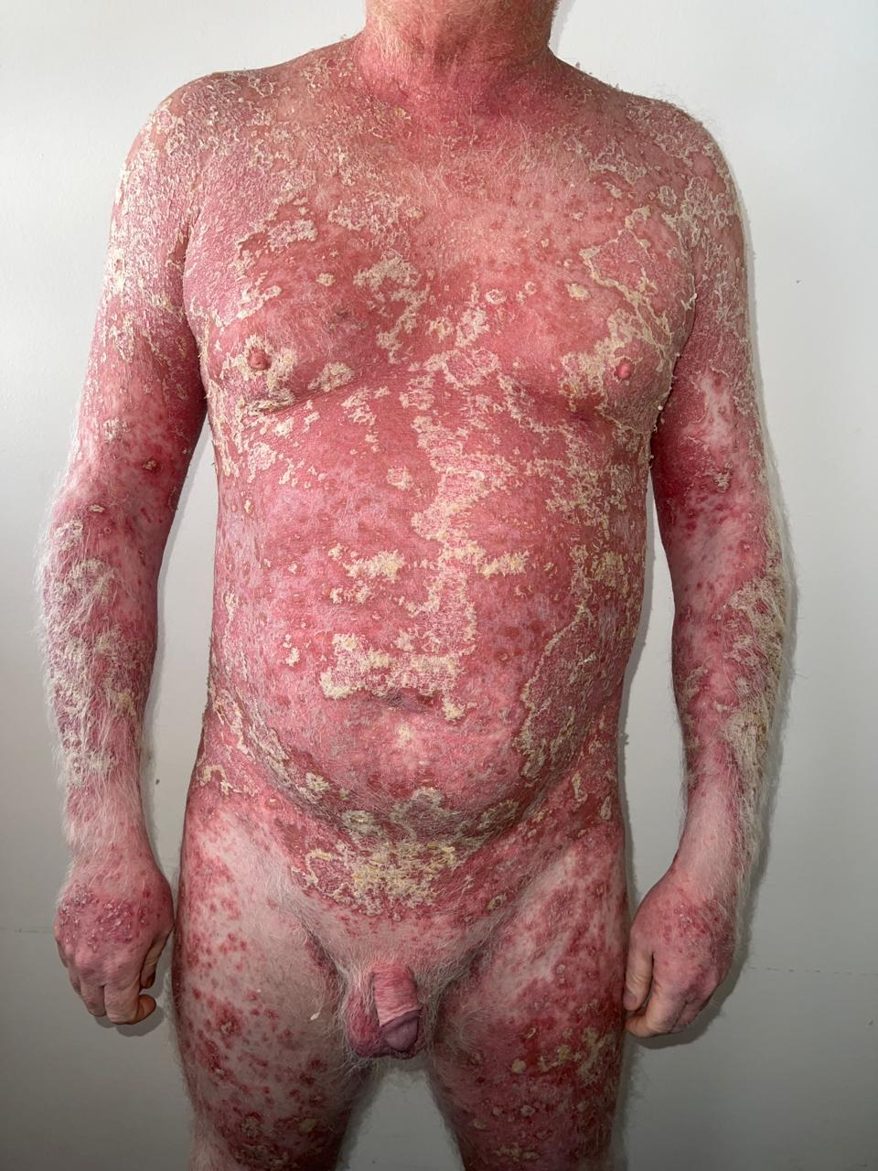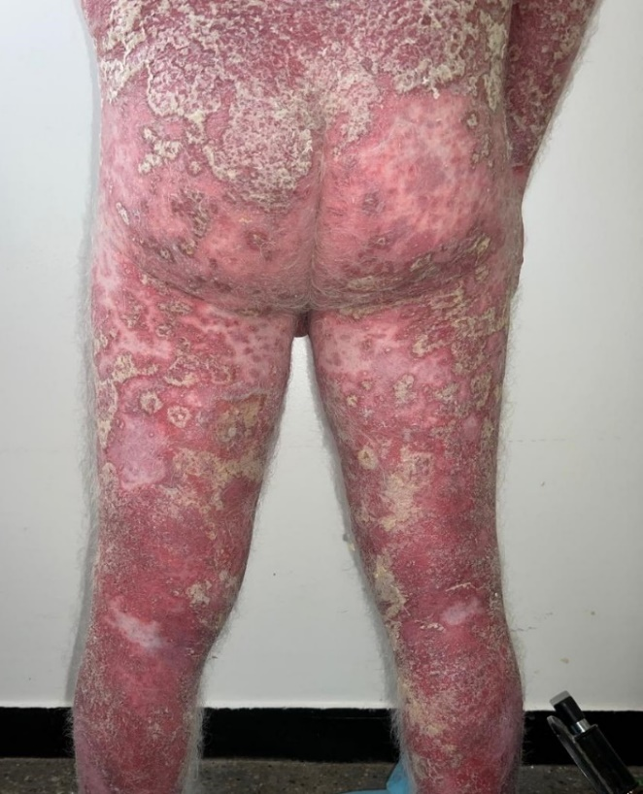

Figure 1 & 2 : Generalized flare of annular pustular psoriasis of the Bloch-Lapierre type.

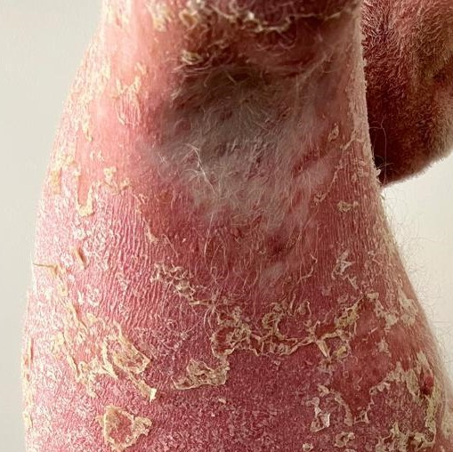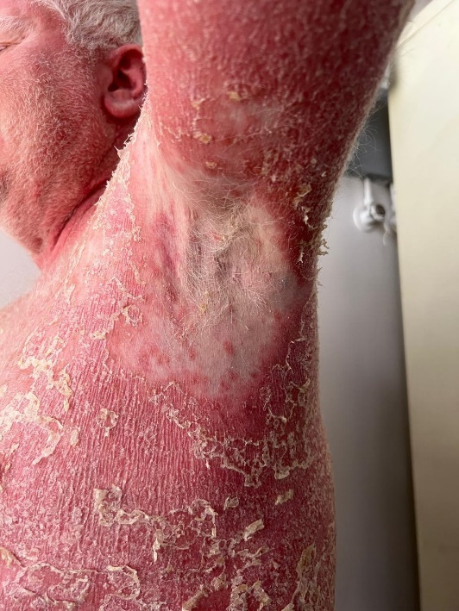

Figure 3 & 4 : Moderate hidradenitis suppurativa (Hurley II) in the axillary folds.

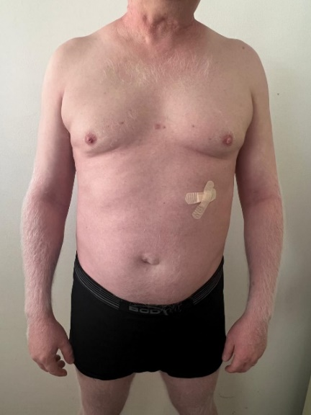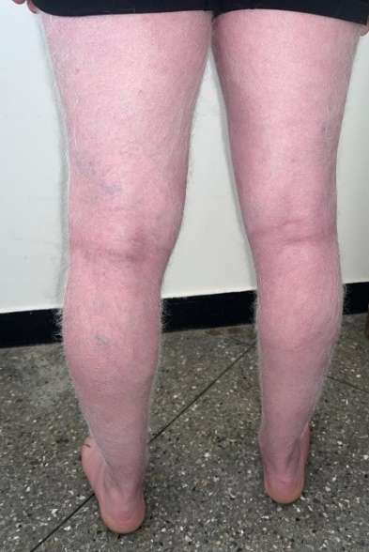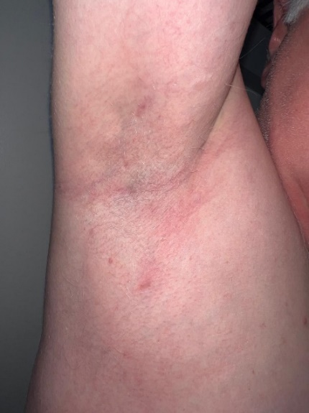

Figure 5, 6 & 7 : Complete regression of psoriasis and hidradinitis suppurativa lesions on treatment.