*Case report*

The Trichoscopic Hallmarks of Pressure Alopecia: A Case-Based Study

ABSTRACT

|  |
| --- |
| Pressure alopecia is a rare and often underrecognized form of hair loss caused by prolonged ischemia of the scalp. Frequently misdiagnosed, it requires a high index of suspicion and a careful clinical and dermoscopic assessment. Trichoscopy plays a pivotal role in its diagnosis.  In this case-based study, we highlight the distinctive trichoscopic hallmarks that can aid in the timely diagnosis of this condition. Through an illustrative clinical scenario following prolonged immobilisation, we demonstrate how trichoscopy—combined with histopathology, can be instrumental in distinguishing pressure alopecia from other alopecic disorders.  This report emphasises the diagnostic value of trichoscopy and the importance of simple preventive strategies to mitigate this avoidable complication. The case sheds light on a condition that remains underreported, urging clinicians to be aware of its subtle but telling signs. Early recognition—facilitated by trichoscopy, especially through identifying comedone-like black dots—can optimise management. Close monitoring and preventive measures can mitigate its impact and improve outcomes. |

*Keywords: Pressure alopecia; trichoscopy; scarring alopecia; hair loss diagnosis, misdiagnosed*

1. INTRODUCTION

Alopecia is defined as the reversible or irreversible loss of hair follicles, causing a diffuse loss of localized or hair density. They are classified as primary or secondary alopecia (caused by external agents). Primary alopecias are classified into non-scarring alopecia (follicle is conserved) and scarring alopecia (hair follicle is destroyed, being replaced with scar tissue) (Zhou et al., 2021; Devjani et al., 2023). Pressure-induced alopecia (PA) is an unusual pattern of circumscribed hair loss that occurs after ischemic changes on the scalp (Tortelly et al., 2020).It is an uncommon form of alopecia that present as either scarring or non-scarring hair loss. It typically occurs as a result of prolonged immobilisation of the head, leading to localised ischemia. PA usually appears 3–28 days after the trigger, as a painful, swollen, and erythematous area, followed by an abrupt patchy hair loss (Porriño-Bustamante et al., 2021). The distressful condition causes low self-esteem, affecting patients psychologically and socially. There are diverse categories of alopecia, but the commonest are androgenic alopecia (common baldness), alopecia areata and chemotherapy-induced alopecia. Causes of the conditions, including stress, heredity, hormonal, nutrition, some sicknesses, as well as certain medications like those prescribed for cancer (Rambwawasvika et al., 2021; Devjani et al., 2023).

PA can be seen postoperatively in all patients. However, in the context of prolonged proning and sedation for treatment of acute respiratory distress syndrome (ARDS) in COVID‐19 patients, this condition may become more prevalent (Thomas Perry et al., 2021). This condition often manifests as a localized area of alopecia and can be easily misdiagnosed as other forms of hair loss, especially when the temporal relationship with the triggering event is not forthcoming, or if the clinician is unfamiliar with its presentation (Neema et al., 2022; Loh SH et al., 2015). Trichoscopy plays a pivotal role in its diagnosis.

In this report, we present a case of scarring pressure alopecia that developed after an intensive care unit (ICU) stay, highlighting the key trichoscopic findings that guided the diagnosis.

2. Presentation of Case

We report the case of a 31-year-old female patient with a history of epileptic encephalopathy since childhood. She was admitted to the ICU for two months due to status epilepticus and was treated with several medications, including oxcarbazepine and levetiracetam. During her ICU stay, she required prolonged intubation, sedation, and immobilisation.

Upon referral to the dermatology department, the patient presented with aphasia and intellectual disability. She exhibited confluent alopecic plaques on the parietal and vertex scalp regions, with a negative hair pull test (Fig. 1). Heel pressure sores were also noted.

Polarised trichoscopy revealed multiple comedone-like black dots, yellow and black dots, dystrophic and miniaturised hairs (Fig. 2). Linear fine vessels and white scarred areas were observed in some areas (Fig. 3).

To further assess potential systemic involvement, periungual dermoscopy was performed, which showed normal capillary patterns without avascular areas

Given the clinical and trichoscopic findings, two main differential diagnoses were considered: pressure alopecia, due to the prolonged immobilisation in the ICU, and drug-induced lupus, given the recent introduction of anticonvulsants (oxcarbazepine and levetiracetam), both of which are known to potentially induce lupus-like syndromes.

To confirm the diagnosis, a skin biopsy was performed, revealing features consistent with pressure-induced ischemia and scarring. Additionally, direct immunofluorescence ruled out lupus by showing no immune complex deposition in the affected areas. The rest of the lupus workup was negative.

The final diagnosis of scarring pressure alopecia was established based on the clinical history, trichoscopic findings, and histopathological confirmation. The patient was started on minoxidil, with good hair regrowth observed in the non-scarring areas.

3. discussion

Pressure alopecia was first described by Abel and Lewis in 1959, who reported eight cases during the annual meeting of the American Dermatological Society (Abel RR et al., 1960). It is a rare condition resulting from ischemic obstruction of scalp capillaries, leading to alopecic areas.

Cases of pressure alopecia have been reported following various extended surgical procedures, such as cardiothoracic, gynaecological, reconstructive, genitourinary, and neurosurgical operations, as well as prolonged intensive care unit (ICU) stays. It has also been documented in association with external devices, including electroencephalogram (EEG) electrodes, orthodontic headgear, and cervical collars (Kunapareddy; White; Davis et al., 2018; Liu; Abbas; Seehra, 2019; Davies; Yesudian, 2012).

Recently, Corona-Rodarte et al. classified pressure alopecia into two types:

Type 1: Resulting from sustained external pressure on the scalp, primarily over bony prominences.

Type 2: Induced by cosmetic procedures, associated with pressure exerted by the volume of injectable products (Corona-Rodarte et al., 2024).

Clinically, pressure alopecia may present with erythema, swelling, and tenderness; however, alopecia may be the only manifestation. The presence of crusting and ulceration is associated with a worse prognosis and a higher likelihood of scarring alopecia (Corona-Rodarte et al., 2024).

Depending on the degree of pressure-induced ischemia, the condition may result in scarring or non-scarring alopecia. Milder ischemia leads to non-scarring alopecia, whereas prolonged ischemia results in ulcers and scarring (Ravaioli GM et al., 2019).

Loh et al. in their series reported that operation time is the most critical factor in determining reversibility of hair loss and duration of more than 10 h in general anaesthesia was associated with scarring alopecia (Loh SH et al., 2015).

Alopecia typically affects the convex areas of the scalp, such as the vertex and occiput, appearing 3–28 days after the inciting event. The prognosis is generally favourable, with hair regrowth observed within 1–4 months (Neema S et al., 2022).

The diagnosis is based on a characteristic history of prolonged surgery or immobilisation, along with clinical findings of occipital alopecia and associated ulceration or scarring.

Trichoscopy plays a vital role in diagnosing pressure alopecia, particularly when the triggering event is not immediately apparent. A unique trichoscopic feature, "comedone-like black dots," has been reported in 66% of cases. Other findings include yellow dots, miniaturized hairs, broken hairs, and scarring. Exclamation mark hairs, are more commonly seen in alopecia areata than in pressure alopecia. (are more commonly seen in alopecia areata).

Pressure alopecia remains a preventable condition. Simple interventions, such as regularly repositioning the patient’s head, can significantly reduce the risk. Early recognition, facilitated by trichoscopy, allows for timely intervention and minimises the impact of the condition.

In our case, the combination of trichoscopic findings and histological confirmation underscores the utility of trichoscopy in diagnosing pressure alopecia.

4. Conclusion

Pressure alopecia is a rare but significant complication, particularly following prolonged surgical procedures or immobilisation. Early recognition—facilitated by trichoscopy, especially through identifying comedone-like black dots—can optimise management. Close monitoring and preventive measures can mitigate its impact and improve outcomes.

Consent (wherever applicable)

All authors declare that written informed consent was obtained from the patient for the publication of this case report and accompanying images.

Ethical approval (wherever applicable)

All authors have obtained all necessary ethical approval, and have therefore been performed

Disclaimer (Artificial intelligence)

Authors hereby declare that NO generative AI technologies such as Large Language Models (ChatGPT, COPILOT, etc.) and text-to-image generators have been used during the writing or editing of this manuscript.

References

Neema S, Vashisht D, Yadav AK, Sinha A, Radhakrishnan S. Trichoscopy of pressure‑induced alopecia and alopecia areata: A comparative study. Int J Trichol 2022;14:17-20.

Loh SH, Lew BL, Sim WY. Pressure alopecia: Clinical findings and prognosis. J Am Acad Dermatol 2015;72:188‑9.

Abel RR, Lewis GM. Postoperative (pressure) alopecia. Arch Dermatol 1960;81:34-42.

Kunapareddy J, White C, Davis C, Nousari C. A unique case of pressure-induced alopecia following EEG monitoring. Pediatr Dermatol. 2018 Nov;35(6):e345-e347. doi: 10.1111/pde.13657.

Liu, C., Abbas, F., & Seehra, J. (2019). Headgear-induced temporary pressure alopecia. Journal of Orthodontics, 335-342. <https://doi.org/10.1177/1465312519876948>

Davies KE, Yesudian P. Pressure alopecia. Int J Trichology. 2012 Apr;4(2):64-8. doi: 10.4103/0974-7753.96901.

Corona-Rodarte, E., Cano-Aguilar, L. E., Baldassarri-Ortego, L. F., Tosti, A., & Asz-Sigall, D. (2024). Pressure alopecias : A review. Journal of the American Academy of Dermatology, 90(1), 125‑132. https://doi.org/10.1016/j.jaad.2023.07.009

Ravaioli GM, Starace M, Alessandrini AM, Guicciardi F, Piraccini BM. Pressure alopecia in pediatric and adult patients: Clinical and trichoscopic findings in 12 cases. J Am Acad Dermatol 2019;81:1021‑3.

Tortelly, V. D., Melo, D. F., Ghedin, B. S., Lima, C. D. S., Garcia, T. U., & Barreto, T. D. M. (2020). Pressure-induced alopecia: presence of thin hairs as a trichoscopic clue for the diagnosis. Skin appendage disorders, 6(1), 48-51.

Porriño-Bustamante, M. L., Arias-Santiago, S., & Fernández-Pugnaire, M. A. (2021). Trichoscopic findings in pressure alopecia: report of two cases and review of the literature. International Journal of Trichology, 13(6), 34-35.

Thomas Perry, I. I., Rosen, H., Pettit, C., & Trinidad, J. C. (2021). Pressure‐induced alopecia due to proning in COVID‐19. Dermatologic Therapy, 34(2), e14764.

Zhou, C., Li, X., Wang, C., & Zhang, J. (2021). Alopecia areata: an update on etiopathogenesis, diagnosis, and management. Clinical reviews in allergy & immunology, 61(3), 403-423.

Devjani, S., Ezemma, O., Kelley, K. J., Stratton, E., & Senna, M. (2023). Androgenetic alopecia: therapy update. Drugs, 83(8), 701-715.

Rambwawasvika, H., Dzomba, P., & Gwatidzo, L. (2021). Alopecia types, current and future treatment. J Dermatol Cosmetol, 5(4), 93-9.

Devjani, S., Ezemma, O., Kelley, K. J., Stratton, E., & Senna, M. (2023). Androgenetic alopecia: therapy update. Drugs, 83(8), 701-715.

Definitions, Acronyms, Abbreviations

Here is the Definitions section. This is an optional section.

**Term**: Definition for the term

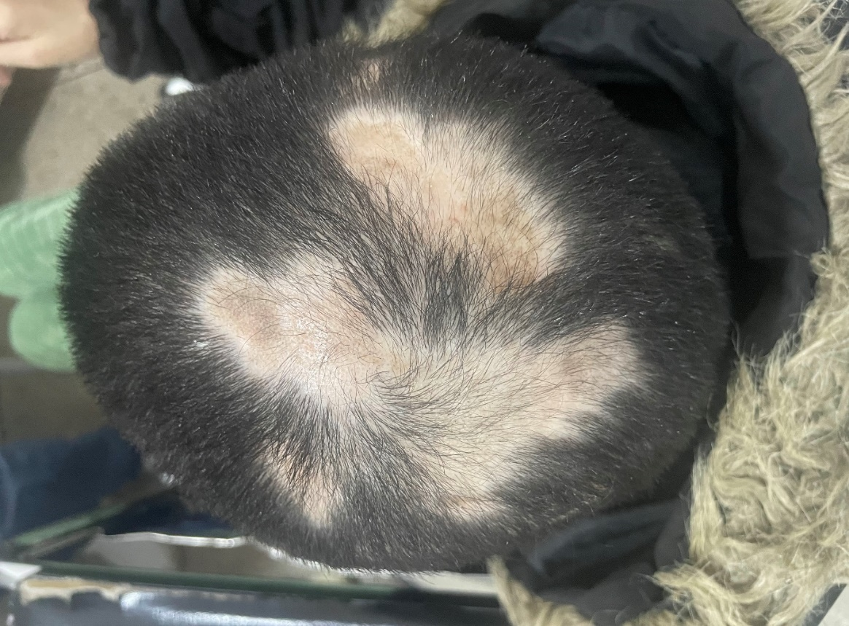

Fig.1 : Multiple confluent alopecic plaques on the vertex.

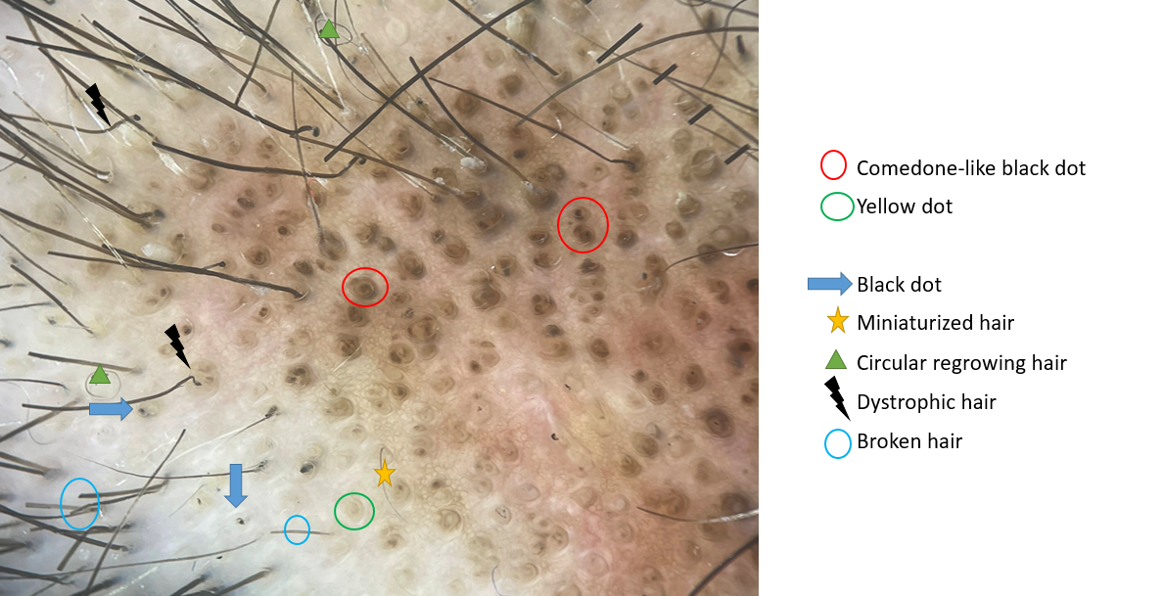

FIG. 2: POLARIZED TRICHOSCOPY OF THE ALOPECIC PLAQUES REVEALED MULTIPLE COMEDONE-LIKE BLACK DOTS, YELLOW AND BLACK DOTS, DYSTROPHIC AND MINIATURIZED HAIRS.

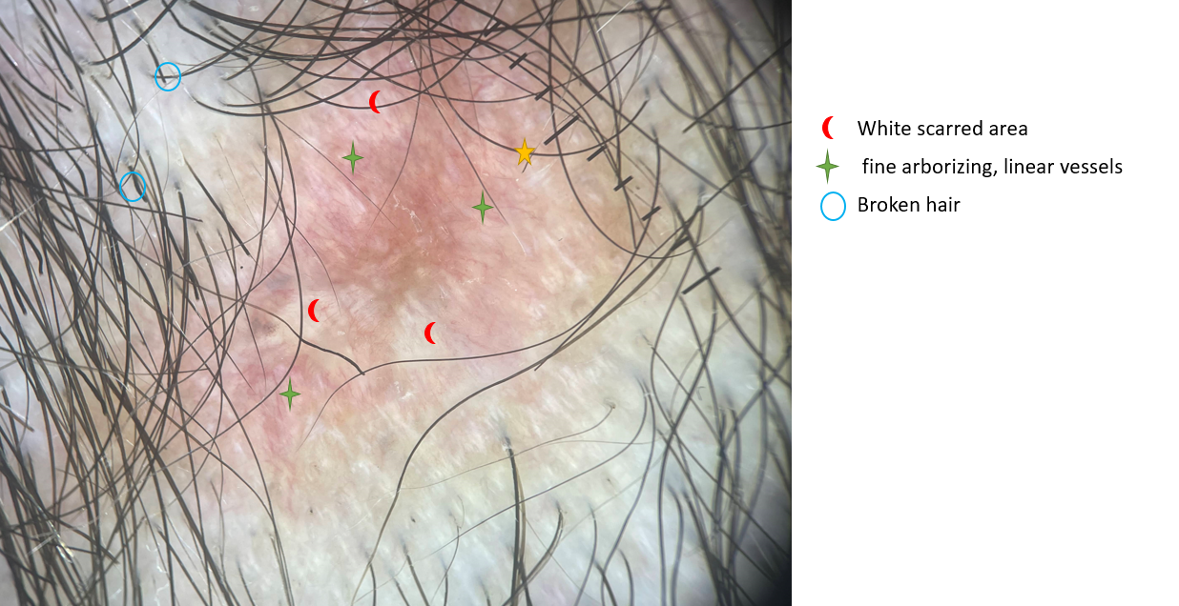

FIG. 3 : POLARIZED TRICHOSCOPY REVEALED LINEAR FINE VESSELS AND WHITE SCARRED AREA IN SOME AREAS OF THE ALOPECIC PLAQUES.