**Effect of arbuscular mycorrhizal fungi combined with exogenous calcium on papaya (*Carica papaya* L.) plant growth**

ABSTRACT

|  |
| --- |
| The study aims to develop biological strategies using arbuscular mycorrhizal fungi to enhance calcium supply and regulation in papaya, thereby reducing post-harvest losses and extending shelf life. The pawpaw (*Carica papaya* L.) is a very productive fruit tree, but is not widely exploited on the international market due to rapid deterioration of the fruits after harvest. This deterioration is due to a nutritional dysfunction related to the deficiency of nutrients, especially calcium, which is involved in the firmness of fruits in general and the papaya in particular. Two sites were selected to collect soil from the rhizosphere of C. papaya L. The symbiotic capacity of arbuscular mycorrhizae has been profiled to enhance the uptake and regulation of exchangeable calcium ions in the soil. The combined AMF/calcium effect on papaya plant growth and calcium regulation was evaluated in the screenhouse. A composite of AMF spores combined with different calcium doses (0 µM, 100 µM, 200 µM, 300 µM and 1000 µM) was applied to two papaya varieties (calcium deficiency-resistant V1 *Calina papaya* IPB9 and calcium deficiency-sensitive V2 *Solo* N°8). The AMF/Calcium 1000 µM combination significantly influenced (P = .05) the number of leaves, plant height, fresh and dry biomass of leaves, stems and roots in both varieties V1 and V2. No significant effect was observed in V1 concerning plant height. Increased accumulation of calcium ions and phytochemicals such as flavonoids and phenols was recorded in the leaves. Inoculation with AMF combined with the high calcium dose (1000 µM) promoted mycorrhizal infectivity of roots, colonisation of mycorrhizal spores in the soil and increased root absorption surface area. These results clearly show that AMF can be used as a useful biofertilizer to improve the post-harvest quality of papaya fruit. |

*Keywords: arbuscular mycorrhizal fungi, calcium deficiency, Carica papaya L.*

1. INTRODUCTION

Papaya is a very important fruit species from an economic point of view, providing a fairly considerable income per hectare alongside banana [1]. It has very high nutritional and nutraceutical properties [2]. The fruit is an important source of vitamin A, ascorbic acid, minerals (iron, calcium, potassium, etc.), polysaccharides and proteins [3]. Papaya is a polygamous plant which bears mostly three types of flowers, viz. female, male and hermaphrodite flowers [49]. The *Carica* genus comprises some 35 species, of which only papaya is cultivated for its edible fruits [4]. It is rich in phytochemical compounds like most tropical fruit pericarps [2] (and in various enzymatic compounds such as hymopapain, caricain, chymopapain, glycine endopeptidase, papain, etc. Worldwide papaya production is estimated at around 13,708,400 tonnes/year [5]. In Africa, Nigeria is the leading producer with 951,000 tonnes/year, followed by the Democratic Republic of Congo (DRC) with 220,480 tonnes/year [5]. Before, during, and after papaya plantations, leaf and soil analysis are important to understand the plant’s nutritional status [48]. In Cameroon, papaya is grown mainly in rainforests with monomodal rainfall, more precisely in the Littoral zone (Njombe-Pendja and Loum), where ecological conditions are ideal (tropical climate, altitude 20 to 500 m, average temperature 30°C, rainfall 2,350 mm, volcanic soil). National production is estimated at around 700 tonnes/year. Exports are still very low (36 tonnes/year), mainly in dried forms. This low production, despite soaring demand on the international market (17,519 tonnes/year), which far exceeds national production (36 tonnes/year), is linked to a number of biotic and abiotic constraints. These include rapid ripening of the fruit [6], lack of control over the right stage for harvesting the fruit [7], post-harvest handling [8], susceptibility to stress (hydric), parasitic and fungal diseases [6], and soil mineral nutrition such as calcium [9]. In Cameroon, depending on the variety, some highly productive papaya trees unfortunately suffer from increased post-harvest dieback, affecting production by up to 50%, which is quite considerable for the grower in terms of income [10]. Many authors [11, 12, 13, 14, 15, 16, 17] etc, have proposed two plausible explanations. In the first group, it is claimed to be a pathology caused by *Anthracnose*, *Oidium, Phytophthora, Pythium and Rhizoctonia* (fruit rot), while in the second group, it is a handicap that manifests itself during fruit ripening. Almost 80% of this physiological explanation is based on the plant's calcium nutrition [9]. The post-harvest quality of papaya fruit is affected by a deficiency in exchangeable calcium ion (Ca2+) in the soil solution, which, during the ripening process, causes diseases (viral, fungal and bacterial), softening of the fruit pulp [18], etc... As far as the fruit is concerned, calcium ion deficiency has a major impact on its exploitation in the international market. As the ion is not very mobile in the soil solution, it is adsorbed on the clay-humus complex and therefore cannot be absorbed by young papaya roots from the soil and transported to the plant via the xylem to the fruit. This adsorption is linked to nitrogen and potassium fertilisation [19], continuous papaya cultivation on the same plots without any crop rotation [20], pressure on agricultural land from the growing human population and agro-industrialisation [21], particularly in Cameroon in the Njombe-Pendja locality. These factors are responsible for disruptions to the structural and functional diversity of soil microbial communities and enzyme synthesis [22, 23, 24]. Fortunately, most plants, more specifically papaya, have coped with limited amounts of available calcium via the establishment of symbiotic associations with rhizospheric microorganisms, more precisely arbuscular mycorrhizal fungi (AMF). Plant associations with arbuscular mycorrhizal fungi (AMF) are essential for nutrient absorption and, therefore, have a significant impact on productivity through increased tolerance to abiotic and biotic stress [46]. Arbuscular mycorrhizal fungi (AMF), belonging to the Glomeromycota phylum of fungi, can form mutualistic symbiotic associations with flowering plants, bryophytes, and ferns [47]. Throughout the world, most papaya production comes from poorly structured units (home gardens, extensive fields, etc.) where the farmer pays little attention to the diversity of microorganisms found in the rhizosphere. However, knowledge of the activity of these living organisms in the soil, i.e. microbes, roots of living plants, etc., and their functional activities in the regulation, supply and absorption of calcium not only constitutes an important part of total biodiversity [25], but is also part of the solution to reducing post-harvest losses and a decisive step towards the development of papaya cultivation for international commercial purposes [26]. The use of AMF from the papaya rhizosphere [27], combined with calcium, to reduce post-harvest losses of *C. papaya* L. fruit and the production of biological seedlings is still lacking in Cameroon. Developing biological strategies for supplying and regulating calcium through the potential of AMF to reduce post-harvest losses for international exploitation is part of the solution to the problem of post-harvest softening of papaya fruit.

2. Materials and Methods

2. 1. Study site

Two sites were selected to collect soil from the rhizosphere of *C. papaya* L. They were geographically separated, and one represents the most exploited site (Table 1 and Fig. 1). The two sites were located in two different agro-ecological zones: (1) the forest zone with the monomodal rainfall, and (2) the bimodal rain forest zone (Fig.1). 100 papaya plants were randomly counted, and about twenty papaya trees were chosen. In the rhizosphere of each papaya tree, the sampling of soil and roots was carried out between 0 and 25 cm depth in the ground using a den. This method was also applied in the soil outside the rhizosphere (non-rhizosphere) of papaya (with corn as a previous crop). The fine roots of the plants were collected at the same time, at the rate of 2 g per plant. These roots were then mixed, and the whole was preserved in 50% alcohol.

**Table 1.** Characteristics of experimental sites where soil and root samples were obtained for culturing and molecular analyses ofarbuscular mycorrhizal fungi.

|  |  |  |  |  |  |  |  |  |  |
| --- | --- | --- | --- | --- | --- | --- | --- | --- | --- |
| **Sampling site** | **Climatic zone** | **Coordinates** | **Altitude (m)** |  |  | **Soil characteristics** | | |  |
| **PH** | **EC** | **Org C (%)** | **N (%)** | **C: N** | **P(mg/kg)** |
| Njombe-Pendja | Equatorial | 4°35’N; 9°39’E | 200-500 | 6.3 | 31.20 | 8.8 | 0.29 | 30 | 59.95 |
| Yaounde | Equatorial | 3°50’N; 11°31’E | 750 | 5.5 | 5.70 | 2.37 | 1.16 | 20 | 6.37 |

C:N: Carbon Nitrogen ratio; OrgC: Organic Carbon; EC: Conductivity; Total N: Total Nitrogen; P: Phosphorus.

Source: Author’s results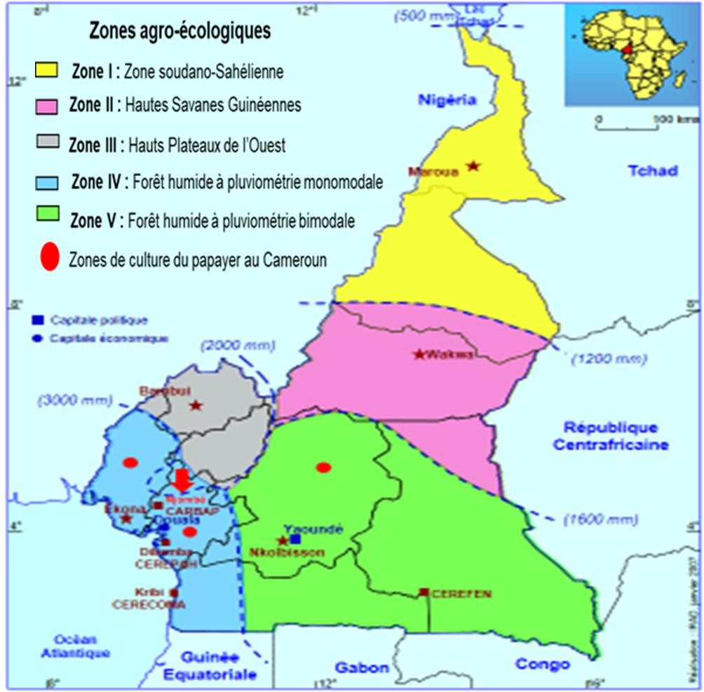

**Fig.1.** Sampled sites for arbuscular mycorrhizal fungi isolates of *C. papaya* L. in the monomodal rain forest and bimodal rain forest ecological zones of Cameroon.

Source: Institute of Agricultural Research for Development (IRAD, 2016)

**2.2. Preparation of plant materials.**

Seeds from two contrasting papaya varieties, namely the calcium deficiency-sensitive *Solo* N°8 (V2) pure line variety introduced from the Hawaiian Islands in the 1960s and safeguarded over generations by artificial self-fertilization, and the calcium deficiency-resistant *Calina papaya* IPB-9 (V1) variety from Indonesia, are the latest hermaphrodite (bi-sexual) hybrid papaya varieties developed by California Agriculture University, USA in 2013. Seed preparation followed the protocol developed by [28] (modified). The inoculum was prepared according to the protocol developed by [29]. It contained sand and propagules (spores and mycelium) [30] from AMF spores isolated and purified from the papaya rhizosphere.

**2.3. Preparing substrate and nutrient solution for watering.**

The two papaya varieties (*Solo* N°8 and *Calina papaya* IPB-9) were grown in Sanaga sand. The sand was washed with tap water (five washes), autoclaved at 121°C for 1 hour and then left to cool for 24 hours. Approximately 20 kg of sand was then introduced into sterilised 25 kg perforated white bags. A hole about 10 cm deep was made in each bag to allow inoculation and transplanting of the seedlings.

Stock solutions for 1000 ml: (g/l) Solution A- MgSO4. 7H2O--120,02; Solution B- Ca (NO3)2. 4H2O--238,04; Solution C- KH2PO4. 3H2O--115, 38; Solution D- Micro-elements: (g/l); Fe EDTA--12,500; MnSO4. 4H2O--1,121; H3BO3--1,421; (NH4)6Mo24.4H2O--0,093; ZnSO4.7H2O--0,220; CuSO4.5H2O--0,198 were prepared. From these stock solutions, the 10 ml spray solution: Stock solution 0 µM Ca(NO3)2 (10 ml of solution A, 0 ml of solution B, 10 ml of solution C, 10 ml of solution D) ; 100 µM Ca(NO3)2 (10 ml of solution A, 1 ml of solution B, 10 ml of solution C, 10 ml of solution D) ; 200 µM Ca(NO3)2 (10 ml of solution A, 2 ml of solution B, 10 ml of solution C, 10 ml of solution D) ; 300 µM Ca(NO3)2 (10 ml of solution A, 3 ml of solution B, 10 ml of solution C, 10 ml of solution D) ; 1000 µM Ca(NO3)2 (10 ml of solution A, 10 ml of solution B, 10 ml of solution C, 10 ml of solution D) with different concentrations of calcium (Ca), supplied in the form of calcium nitrate (Ca(NO3)2 were prepared. These stock solutions were kept at room temperature. From the day of transplanting, 400 ml of Rorison watering solution was added every 2 days of the week, depending on the treatment, until harvest. Tap water was added on intermediate days. Morphological growth parameters were measured. Our experiment lasted six (06) months, during which mycorrhizal symbiosis was effective in papaya [31].

**2.4. Assessment of agronomic parameters.**

The number of leaves was obtained by weekly counting of newly formed, fully expanded leaves. The last leaf to emerge was marked with a sign at the petiole to facilitate the detection of newly emerged leaves. Plant height was also measured. These parameters were taken from the first month after inoculation and transplanting of the plants through to harvest. Leaves, stems, and roots were separated and weighed immediately after harvest using a sensitive balance (SCALTEC) to obtain fresh weight. After weighing, each part was oven-dried at 65°C for 96 h, then weighed using a sensitive balance to obtain the dry biomass. Water content (g water/DW plant) was obtained using the formula in [32]: Water content (WC) = (FW - DW) / DW, where FW represents the fresh weight and DW the dry weight of the plant.

**2. 5. Extraction and dosing of mineral elements**

The quantity of mineral elements (Ca, Mg and K) contained in 1g of plant leaves, stems, and roots was analysed at the Laboratory of Soil Analysis and Environmental Chemistry of the Faculty of Agronomy and Agricultural Sciences at the University of Dschang using the protocol developed by [33]

**2.6** **Biochemical analyses**

Biochemical analyses were carried out on 0.5 g of leaves, stems, petioles and roots of papaya plants from eight (8) months of growth. Extraction of phenolic compounds and flavonoids was carried out according to the method described by [34] (modified). Determination of total flavonoid content was carried out according to the method of [35] (modified). All tests were carried out in triplicate.

**2.7. Data analysis**

Data on calcium levels in the various plant organs were subjected to analysis of variance (ANOVA). Means were compared using the Tukey, Duncan and SNK (Student and Newman-Keuls) tests at the 5% threshold.

(p=.05). R Studio version 4.0.5, IBM SPSS version 20.0 and XLSTAT 2010. Ink version 10.0 was used. Results, presented as curves and histograms, were produced using Microsoft Excel 2013. Correlations between variables were highlighted using Pearson's correlation test.

3. results and discussion

3.1. RESULTS

**3.1.1. Mycorrhiza/calcium interaction on plant height of two papaya varieties as a function of time**

AMF combined with calcium from Rorison's nutrient solution had a very significant effect (P<.001) on plant height from the 1st week after transplanting (S1AR) to the 4th week after (S4AR) in V1 and V2 (Fig.2).

Fig. 2. Effect of mycorrhizae combined with calcium on the height of papaya plants V1: *Calina papaya* IBP9 with mycorrhizae, V2: *Solo N°8* with mycorrhizae; Ca0, Ca100, Ca200, Ca300, Ca1000: Calcium concentrations in µM.

**3.1.2. Mycorrhizae/calcium interaction on the number of leaves of two papaya varieties**

**as a function of time..**

After six (06) months of screenhouse cultivation of the two papaya varieties, arbuscular mycorrhizal fungi associated with calcium in Rorison's nutrient solution had a significant (P = .05) influence on the evolution of leaf number from the 1st week after transplanting (S1AR) to the 5th week after transplanting (S5AR). From S6AR to S19AR, a highly significant increase (P < .01) in the number of leaves was observed (Fig. 3). Calcium combined with AMF has a positive influence on papaya plant growth (Fig. 4).

Fig.3. Effect of mycorrhizae on the evolution of the number of leaves on papaya plants. A: V1 *Calina papaya* IBP9 mycorrhizae, B: V2 *Solo N°8* mycorrhizae. Ca0, Ca100, Ca200, Ca300, Ca1000: Calcium concentrations in µM

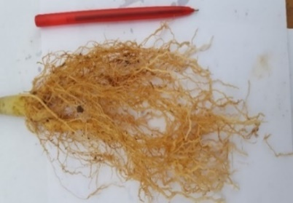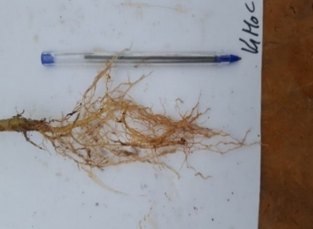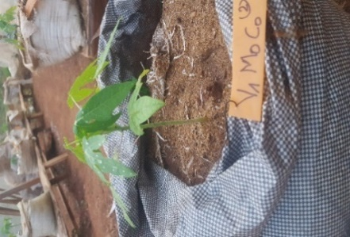

V1 Ca0 without AMF

B

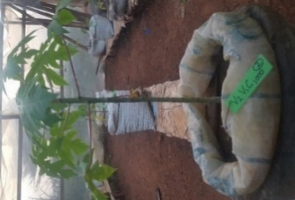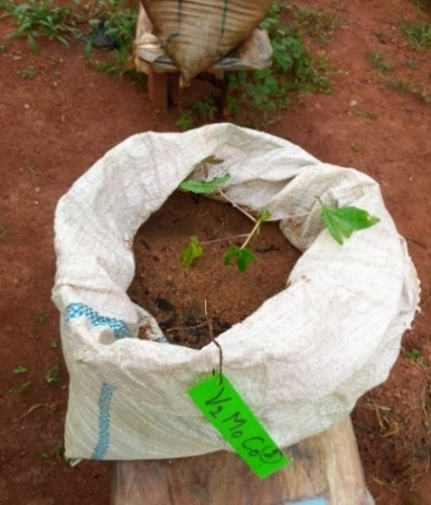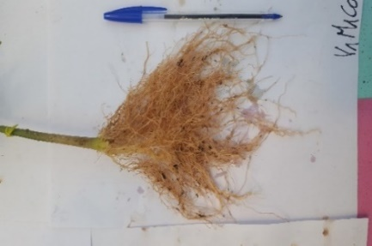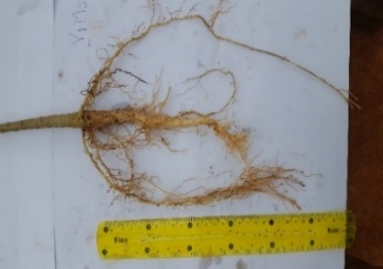

V2 Ca0 without AMF

V2 Ca1000 with CMA

E

F

G

H

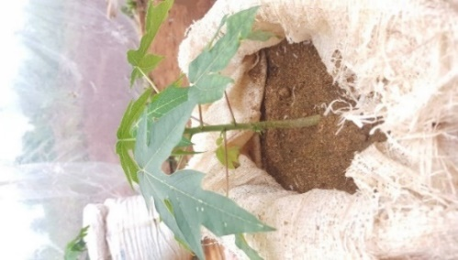

C

V1 Ca1000 with AMF

D

Fig. 4. Papaya plants mycorhized or not with or without soluble calcium from Rorison's solution after six (06) months of screenhouse cultivation. AMF: arbuscular mycorrhizal fungi; V1: resistant variety *Calina papaya* IBP9; V2: sensitive variety Solo n°8; Ca 0: calcium 0 µM; Ca1000: calcium 1000 µM; A and B: plant and roots of papaya var. *Calina papaya* IPB9 without AMF and without Ca; C and D: plant and roots of papaya var. Calina papaya IPB9 with AMF and Ca 1000µM; E and F: plant and roots of papaya var. *Solo* N°8 without AMF and Ca; G and H: plant and roots of papaya var. S*olo* N°8 with AMF and Ca 1000 µM.

**3.1.3. Fresh leaf biomass**

Calcium deficiency (0 µM) does not significantly affect (P = 0.05) the evolution of the number of leaves produced by the resistant papaya variety V2 (*Calina papaya* IPB9), whether mycorrhized or not, over time. On the other hand, a significant difference (P = 0.05) was observed in the sensitive variety V2 (*Solo* N°8) with an increase in calcium concentration, especially in the mycorrhized plants (1000 µM). (Fig. 5).

Fig.5. Changes in fresh papaya leaf biomass as a function of calcium concentration. V1: *Calina papaya* IPB9; V2: *Solo* N°8; Ca0, Ca100, Ca200, Ca300, and Ca1000: calcium concentrations in µM; M0: without mycorrhiza, M1: with mycorrhiza. Bars bearing the same letter are not significantly different at the 5% threshold.

**3. 1. 4. Fresh root and stem biomass**

The fresh biomass of papaya stems and roots increased significantly (P= 0.05) with increasing calcium concentration in the Rorison nutrient solution of mycorrhized plants, in contrast to non-mycorrhized plants in V1 and V2 (Fig. 6). Calcium deficiency (0 µM) significantly reduced (P< .001) the fresh root and stem biomass of non-mycorrhized plants in V2.

Fig. 6. Effect of calcium concentrations on fresh biomass production of papaya stems and roots after six months' growth in the screenhouse. V1: *Calina papaya* IPB9; V2: *Solo* N°8; Ca0, Ca100, Ca200, Ca300, and Ca1000: calcium concentrations in µM; M0: without mycorrhiza, M1: with mycorrhiza. Bars bearing the same letter are not significantly different at the 5% threshold.

**3.1.5.** **Total calcium content**

Calcium content increased significantly (P < .001) in papaya as a function of variation in the calcium dose of the Rorison nutrient solution (Fig. 7). Calcium content was higher (1592.667 mg/100 g) in plants treated with 1000 µM calcium and lower (570 mg/100 g) in plants treated with 0 µM calcium. Calcium has a positive influence on papaya growth.

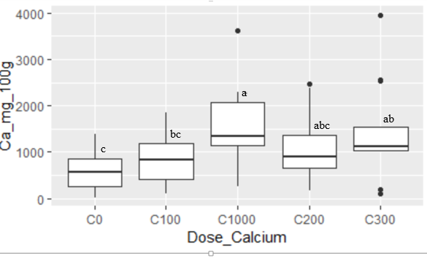

Ca2+ Content (mg/100 g)

Doses of Ca2+ (µM)

Fig. 7. Potential of arbuscular mycorrhizal fungi in calcium uptake and regulation in papaya seedlings after six (06) months of growth on sand. M0: no mycorrhiza; M1: mycorrhiza; Ca0, Ca100, Ca200, Ca300, and Ca1000: calcium concentrations in µM. Box-plots followed by the same alphabetical letter are not significantly different at the 5% threshold

**3.1.6.****Effect of arbuscular mycorrhizal fungi on calcium uptake**

Six (06) months after inoculation with AMF strains extracted from the papaya rhizosphere (composite of 11 strains: 400 to 700 spores/100 g dry soil), papaya significantly (P< .001) increases the total Ca2+ ion content in the leaves of mycorrhized plants, in contrast to non-mycorrhized plants (Fig. 8). Calcium content was higher (1964 mg/100g) in the leaves of mycorrhized plants and lower (668 mg /100g) in the leaves of non-mycorrhized plants. A highly significant difference (P<.001) in calcium content in the various organs (leaves, stems, roots) of mycorrhized and non-mycorrhized plants was observed.

AMF appear to have a positive effect on calcium uptake and regulation in the various papaya organs. The leaves of mycorrhized plants remain the organ where calcium is stored.

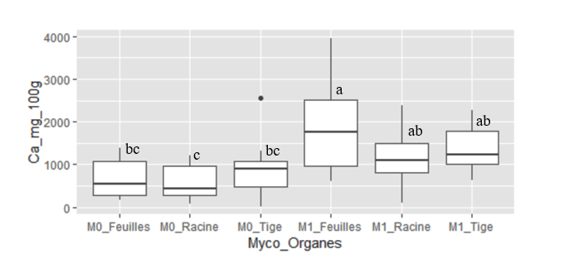

Ca2+ content (mg/100 g)

Doses of Ca2+ (µM)

Fig.8. Potential of arbuscular mycorrhizal fungi for calcium uptake in leaves, stems and roots of papaya plants after six months' growth on sterilised sand. M0: No mycorrhiza; M1: Mycorrhiza.

Box-plots followed by the same alphabetical letter are not significantly different at the 5% threshold.

**3.1.7. Arbuscular mycorrhizal fungi** **/calcium interaction in magnesium ion uptake and regulation**

Six (06) month after inoculation, the Mg2+ ion content of papaya plants did not increase significantly (P <.001) in mycorrhizal and non-mycorrhizal plants treated with Ca 0, Ca 100, Ca 200, Ca 300 calcium from Rorison's watering solution (Fig. 9). However, a highly significant difference was observed in mycorrhizal plants treated with Ca 1000 µM calcium at leaf level compared with non-mycorrhizal plants. AMF appear to have no effect on the uptake and regulation of magnesium ions in papaya. Nevertheless, when the calcium concentration of the watering solution is high (1000 µM), papaya plants store the maximum amount of magnesium ions in their leaves. And when the calcium concentration of the watering solution is low (Ca0, Ca100 and Ca200 µM), papaya stores magnesium ions in the stem. AMF influences magnesium uptake when soil calcium ions

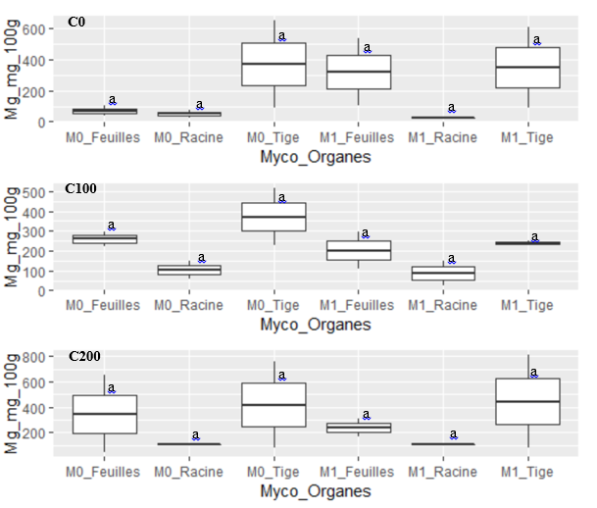

Mg2+ content (mg/100 g)



Mg2+ content (mg/100 g)

Mg2+ content (mg/100 g)

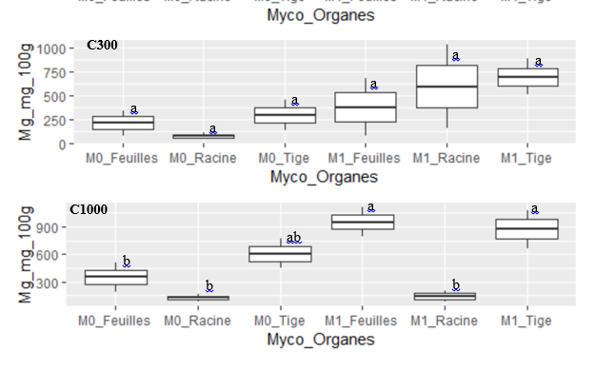

Mg2+ content (mg/100 g)



Organs

Fig. 9. Effect of calcium concentrations on magnesium ion uptake in leaves, stems and roots of papaya plants after six (06) months of growth on sterilised sand. M0: No mycorrhiza; M1: Mycorrhiza.

Box-plots followed by the same letter are not significantly different at the 5% threshold.

**3.1.8. Arbuscular mycorrhizal fungi/calcium interaction in potassium ion uptake and regulation**

After six (06) months of papaya growth on sterilized sand, calcium deficiency (Ca0) does not significantly affect potassium content in V1 (Fig. 10). On the other hand, a highly significant (P=.05) increase in potassium content is observed when the calcium concentration (300 µM) of the Rorison solution is raised in V2. The absence of calcium (Ca 0) increased potassium ion content in V1. A high concentration of potassium ions (2358.63 mg/100g) is observed in V2 when plants are treated with calcium Ca 300 from Rorison's solution. A high potassium content was observed in V1 in the absence of Ca. Increasing the calcium concentration in the growing medium reduces the potassium ion content in plants of the Solo N°8 (V2) papaya variety.

K+ content (mg/100 g)

Dose of calcium/Varieties

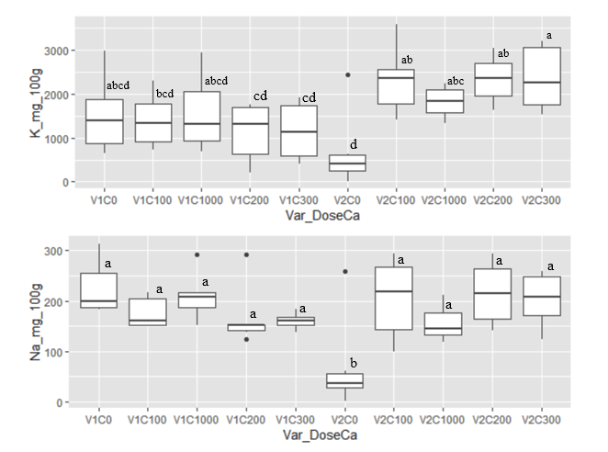

V1Ca

0

V1Ca

100

V1Ca

1000

V1Ca

200

V1Ca

300

V2Ca0

V2Ca

100

V2Ca

1000

V2Ca

200

V2Ca

300

Fig.10. Effect of calcium on potassium ion uptake in two papaya plant varieties: V1: *Calina Papaya*; V2: *Solo* N°8; Ca (0, 100, 200, 300, 1000 µM): applied calcium dose of Rorison's solution.

Box-plots followed by the same alphabetical letter are not significantly different at the 5% threshold.

**3.1.8. Effect of arbuscular/calcium mycorrhizal fungi on the flavonoid content of different parts of papaya plants**

After six (06) months' cultivation of papaya plants in the greenhouse, the application of Ca 1000 µM from

Rorison's nutrient solution to mycorhized plants significantly (P=.05) increased flavonoid content in the leaves and roots of papaya plants, in contrast to non-mycorhized plants (Fig. 11). Flavonoid content is more concentrated in the leaves of mycorrhized plants when the calcium dose is high (Ca 1000) than in other plant organs. Increased calcium reduces the beneficial action of AMF in the petioles of papaya plants. This is not conducive to increasing flavonoid content. Thus, calcium increases root colonisation and beneficial action on the leaves and stems of the plants. This implies an increase in flavonoid content, essential for regulating the establishment of mycorrhizal symbiosis in these organs. Pawpaw leaves and stems could be used as a natural source of antioxidants.

Fig.11. Effect of calcium combined with arbuscular mycorrhizal fungi on the total flavonoid content of different organs. Ca (0, 100, 200, 300, 1000 µM): Applied calcium dose of Rorison solution. Values followed by the same letter are not significantly different at the 5% threshold.

**3. 2. DISCUSSION**

**3. 2. 1. Combined effect of arbuscular mycorrhizal fungi and calcium on the fresh and dry biomass of different parts of papaya plants in the screenhouse**

Results on calcium nutrition in papaya showed that calcium supplementation improved papaya growth three weeks after transplanting. This improvement is still very significant from the first week after transplanting, when calcium supplementation is combined with AMF. The improvement occurred through increases in leaf number, plant height, fresh and dry biomass accumulation, and calcium levels. Many researchers have also reported the benefits of the combined effect of AMF and calcium on the above growth parameters [36] on peanut cultivation in China. Similar observations were made by [31] on papaya cultivation in Kenya. The improved performance of mycorrhizal seedlings could be attributed to a greater efficiency of phosphorus uptake, evidenced by increased calcium accumulation in the leaves. In a study of papaya in India, leaf petioles of mycorrhized seedlings showed higher levels of total phosphorus (0.42 - 0.63%) compared with control plants (0.35%) [37].

**3.2.2. Combined effect of arbuscular mycorrhizal fungi and calcium on the fresh and dry biomass of different parts of papaya plants in the screenhouse**

The fresh leaf biomass evaluated in this study varied according to variety and the applied calcium concentration of the Rorison solution, as well as according to the AMF treatments. AMF application and increasing calcium concentration (1000 µM) significantly influenced leaf biomass production in the susceptible V2 variety (*Solo* N°8). Similar results were obtained by [31] on papaya and by [36] on peanut cultivation. [37] justify this increase in fresh biomass as the product of improved nutrient and water uptake directly involved in the process of photosynthesis ; [38] also demonstrate that AMF increase the concentration of various macro- and micro-nutrients significantly, leading to increased production of photosynthates and thus increased biomass. The fresh biomass of papaya stems and roots increases significantly (P= .05) with increasing calcium concentration in the Rorison nutrient solution of mycorrhized plants, in contrast to non-mycorrhized plants in V1 and V2. On the other hand, calcium deficiency (0 µM) significantly (P< .001) reduces the fresh root and stem biomass of non-mycorrhized plants in V2. In the absence of calcium at the root level, lignification enzymes such as phenylalanine ammonia-lyase and peroxidases are activated [39], leading to root necrosis. These results were observed in the work of [40] on the grapevine. The addition of AMF and a high calcium concentration (1000 µM) in the V2 variety promoted root system growth and stem elongation. In fact, AMF promoted mycorrhizal infectivity of roots and colonisation of mycorrhizal spores in the soil. They improved the plants' ability to absorb nutrients, possibly by increasing the effective root surface area from which the available form of nutrients is absorbed, and also by increasing root access by filling in depletion zones [31].

**3.2.3. Combined effect of arbuscular mycorrhizal fungi /calcium in the uptake and regulation of certain mineral elements (Ca, Mg, K) in different parts of papaya plants in the screenhouse.**

Macro and micronutrient uptake vary considerably between different plant organs. [40] demonstrated this in their study of the grapevine (*Vitis vinifera*). Similar results were observed in papaya. Papaya significantly (P< .001) increases total Ca2+ ion content at the leaf level in mycorrhized plants, in contrast to non-mycorrhized plants. Calcium content is higher (1964 mg/100g) in leaves, especially in mycorrhized plants, than in other organs such as stems and roots. Papaya leaves remain the most important calcium storage organ. The abundance of Ca in leaves is explained by the formation of calcium pectate in the middle lamella of cells [13]. This result is similar to the work of [31] on papaya, [36] on peanut and [40] on grapevine. On the other hand, calcium deficiency in papaya does not affect the absorption of magnesium ions, which are stored in the stems. In fact, in the absence of calcium, a compensation of cation ions is created in order to maintain the electrical and chemical balance of the cells [39]. Cation ions (Ca2+, Mg2+, K+) substitute for each other in the event of a lack or excess of one of them [41]. If accumulated in excess, they interfere with the physiological process [42]. Calcium deficiency (0 µM) does not significantly (P< .001) affect potassium content in papaya. This result is similar to the work of [43], who demonstrated in their studies that potassium ions reduced calcium concentration in the leaves of certain plant species. Furthermore, increasing the calcium concentration of the Rorison solution increases the potassium content in papaya plants. [31] obtained similar results on papaya in Kenya. This is also consistent with a study on papaya in India, which showed that total leaf petiole potassium content was higher in mycorrhized plants and ranged from 2.68 to 4.39% compared with non-mycorrhized plants (2.26%) [44]. Potassium uptake was also increased by MAC inoculation in cowpea and sorghum [43]. This may be attributed to greater soil exploration and increased supply to the host roots. A further increase in K levels in mycorrhized plants can be attributed to the fact that MACs bind soil particles to each other and to roots, which is beneficial for nutrient uptake [45].

**3.2.3.** **Combined effect of arbuscular mycorrhizal fungi and calcium on phytochemicals in different parts of papaya plants in the screenhouse**

The results obtained from phytochemical analysis show that calcium supplementation combined with AMF increases flavonoid content, particularly in leaves, compared with other plant organs. This is justified by the fact that leaves are the organs of synthesis and distribution of synthetates [46]. [36] obtained similar results on young leaves, ripe and unripe fruits and seeds of papaya and peanut crops, respectively. The observed increase could be directly associated with the presence of the different AMF strains used and the calcium supplied. Phenolic compounds are higher in plants inoculated with AMF [37]. Indeed, AMF increase water and nutrient uptake, recalibrate plant metabolic pathways and affect the concentration of primary and secondary metabolites [47]. Furthermore, AMF combined with calcium (1000 µM) stimulates the synthesis of genes involved in flavonoid biosynthesis. These include the genes coding for chalcone synthase, involved in the early stages of biosynthesis, the BGI-novel-G001027 gene coding for shikimate O-hydroxycinnamoyltransferase and the gene (Araip.6PA6C) coding for flavonone synthase responsible for flavonoid biosynthesis [36].

**4. Conclusion**

Functional differences were observed within the MACs as a function of varying calcium concentrations (0, 100, 200, 300, 1000 µM). The difference was highly significant with calcium dose (Ca 1000 µM). The three selected AMF strains combined with calcium strongly stimulated plant growth and conferred on the plants a capacity for absorption and regulation. The positive effects were particularly noticeable in the uptake of Ca, Mg and K, through the secondary roots and preferentially stored in the leaves (an essential organ during calcium nutrition in plants). Positive effects have also been seen in the synthesis of secondary metabolites (flavonoids) which contribute to the body's defence against all forms of attack (bacterial, viral and fungal). Overall, all growth parameters were improved in mycorrhized plants of both papaya varieties, in contrast to non-mycorrhized plants. Inoculation with AMF combined with the high calcium dose (1000 µM) favoured mycorrhizal infectivity of the roots, colonisation of mycorrhizal spores in the soil and increased root surface uptake. This led to increased accumulation of calcium ions and phytochemicals such as flavonoids in the xylem of the leaves (storage organ). These results clearly show that AMF can be used as a useful biofertilizer to improve the post-harvest quality of papaya fruit.

Disclaimer (Artificial intelligence)

Option 1:

Author(s) hereby declare that NO generative AI technologies such as Large Language Models (ChatGPT, COPILOT, etc.) and text-to-image generators have been used during the writing or editing of this manuscript.

Option 2:

Author(s) hereby declare that generative AI technologies such as Large Language Models, etc., have been used during the writing or editing of manuscripts. This explanation will include the name, version, model, and source of the generative AI technology and as well as all input prompts provided to the generative AI technology.

Details of the AI usage are given below:

1.

2.

3.

References

1. Alara, O.R., Abdurahman, NH., Alara, J.A. (2020). *Carica papaya*: Comprehensive overview of the nutritional values, phytochemicals and pharmacological activities, *22,*1–31.

2. Santana FL., Inada CA., Spontoni do Espirito Santo B.L., Wander F.O., Arnildo A., Alves F.M., Guimarães R.C.A., Freitas K.C., Hiane P.A. (2019). Nutraceutical Potential of *Carica papay*a in Metabolic Syndrome. National Library of Medicine, 11(7), 1608.

3. Daagema A.A., Orafa PN., Igbua FZ. (2020). Nutritional Potentials and Uses of Pawpaw (*Carica papaya*). European Journal of Nutrition and Food Safety, 12(3), 52-66.

4. Badillo, V.M. (2002). Carica L. vs. Vasconcella St. Hil. (Caricaceae) con la rehabilitacion de este Ultimo. Ernstia, 10, 74-79.

5. FAOSTAT. (2022). Food and Agriculture Organization of the United Nations.

6. Zhu X, Yang W, Song F, Li X. (2020). Diversity and composition of arbuscular mycorrhizal fungal communities in the cropland black soils of China. Global Ecology and Conservation, 22, 964.

7. Greenwald A.G., McGhee D.E., Schwartz J.L.k., (1998). Meauring individual differences in implicit cognition: The implicit association test. Journal of personality and social Psychology, 74(6), 1464-1480.

8. Elik A., Kocak Y., Istanbullu Y., Guzelsoy NA., Yavuz A., Gogus F. (2019). Strategies to Reduce Post-Harvest Losses for Fruits and Vegetables. International Journal of Scientific and Technological Researc*h*, 5(3), 2422-8702.

**9.** Hocking B., Tyerman S.D., Burton R.A., Gilliham M. (2016). Fruit calcium: Tranport and physiology*.* Frontiers in Plant Science 7, 569.

10. Anonyme. (2020). your key to European Statistics: fruit and veg produced eurostat-news/-/DDN-20170728-1.

11. Ramakrisha M., Haribabu K. (2007). Effect of post-harvest application of calcium chloride and wax emulsion on the storage life of papaya. South Indian hort, 50 (4-6), 323-328

12. Singh P., kumar S., Maji S., Kunar A., Yadav Y.D. (2012). Effect of calcium chloride on postharvest chanes in papaya fruits. asian j. hort. 7 (1),113-117.

13. El habbash a.S.F., Faten M., Ibrahim. (2015). Calcium: physiological function, deficiency and absorption. International journal of chemtech research, 8(12), 196-202.

14. Paull R., Chen N. (2014) recent advances in post-harvest management of papaya. Acta hort, 1024: 321-327.

15. Kumar R., Manivanna M. (2011). Effect of chemicals and growth regulator on storage behavior of papaya (*Carica papaya* cv. CO - 2). Acta Horticulture, (740), 327 331.

16. Ahmad S., Thompson A.K., Perviez MA., Anwar N., Ahmad F. (2006). Effect of fruit size and temperature on the shelf life and quality of ripe banana fruit*.* Journal of Agriculture Research*,* 44(4), 313-324.

17. Asghari M., Aghdam M.S. (2010). Impact of salicyclic acid on post-harvest physiology of horticultural crops. Trends food sci technol, 21: 501-509.

18. Rajput B.S., Lekhe R., Sharma G.K., Singh I. (2008). Effect of pre and post-harvest treatments on shelf life and quality of papaya fruits. Asian j. horti. 3 (2), 368-371.

19.  Hocking B., Tyerman S.D., Burton R.A., Gilliham M. (2016). Fruit calcium: Tranport and physiology*.* Frontiers in Plant Science, 7, 569.

20. Thapliyal A. (2025). Intercropping and Crop Rotation Strategies for Nutrient Management and Yield Stability. Agri Articles, 05 (03)

21. Li B.B. Smith B., Hossain M.M. (2006). Extraction of phenolics from citrus peels: I. Solvent extraction method. Sep Purif Techno, 48(2), 182-188.

22 Constantin, M., (2011). Effect of time of inoculation of Azotobacter and mycorrhizal fungi on growth and content nutrient of papaya seedlings in nursery phase. Agronomia costarricense, 35(1), 15-31.

23 Amiri A W., Shyamalamma S., Gowda, V.N. (2010). Influence of Bio- Inoculants on Nursery Establishment of papaya cv. Solo. Acta Horticulture, 851, 295-297.

24 Wang B., Yeun L.H., Xue J-Y, Liu Y, Ané J-M, Qiu Yin-Long. (2010). Presence of three mycorrhizal genes in the common ancestor of land plants suggests a key role of mycorrhizas in the colonization of land by plants. The New Phytologist, 186, 514-525.

25. Decaëns T., Jiménez JJ., Gioia C., Lavelle P. (2006). The values of soil animals for conservation biology. European Journal of Soil Biology, 42, 23-38.

26. Marcos V., Arévalo GL., Jaen-Contreras D., Escamilla-García L, Luna-Esquive G. (2020). Quality and storage of papaya fruits from plants inoculated with Glomus mosseae, Revista Mexicana CienciasAgrícolas, 11:5.

27. Maffo FA., Ngonkeu MLE., Chaintreuil C., Temegne NC., Ntsomboh NG., Fall F., Diouf D., Youmbi E., (2022). Morphological and molecular diversity of arbuscular mycorrhizal fungi associated to *Carica papaya* L. rhizosphere in two agro-ecological zones in Cameroon. African Journal of AgriculturalResearch, 18(8): 632-646.

28. Tchio F., Youmbi E., Maffo F.A., Funamo N. (2013). Influence du mode de pollinisation et des caractéristiques des fruits semenciers sur la capacité germinative des graines du papayer *carica papaya* var.Solo N°8. Agronomie Africaine 25 (2), 93-104.

29. Ngonkeu M.E.L. (2009). Tolérance de certaines variétés de maïs aux sols à toxicité aluminique et manganique du Cameroun et diversités moléculaire et fonctionnelle des mycorhizes à arbuscules. Thèse de Doctorat Ph/ D. Université de Yaoundé I. 255.

30. Toh S.C, Lihan S., Yong B.C.W., Tiang B. R., Abdullahi R., Edward R. (2018). Isolation and characterisation of arbuscular mycorrhizal (am) fungi spores from selected plant roots and their rhizosphere soil environment. Malaysian journal of microbiology, 14(4). doi: http://dx.doi.org/10.21161/mjm.144187

31. Chebet D., Kariuki W., Wamocho L., Rimberia F. (2020). Effect of Arbuscular mycorrhizal inoculation on growth, biochemical characteristics and nutrient uptake of passion fruit seedlings under flooding stress. International Journal of Agronomy and Agricultural Research, 16(4), 24-31.

32. Smart R.E., Bingham, G.E. (1974) Rapid estimates of relative water content. Plant Physiology 53, 258-260.

33. Kumar B., Bhanita B., Haque A. (2011). Sequential extraction of common metals (Na, K, Ca and Mg) from surface soil. Journal of Chemical and Pharmaceutical, 3(5), 565-573.

34. Bahorun, T., Grinier, B., Trotin, F., Brunet, G., Pin, T., Luncky, M., Vasseur, J., Cazin, M., Cazin, C., and Pinkas, M. (1996). Oxygen species scavenging activity of phenolic extracts from hawthorn fresh plant organs and pharmaceutical preparations. Arzneimittel Forsching, 46(11), 1086-1089.

35. Boizot, N., and Charpentier, J.P. (2006). Méthode rapide d’évaluation du contenu en composés phénoliques des organes d’un arbre forestier. Amélioration, Génétique et Physiologie Forestières. Laboratoire d'Analyses Biochimiques *:* Le Cahier des Techniques de l’Inra, 79-82.

36.Cui L., Feng G., Zhang J., Yang S., Meng J.J., Geng Y., Li1,X ., Wan S. (2019). Synergy of arbuscular mycorrhizal symbiosis and exogenous Ca2+ benefts peanut (Arachis hypogaea L.) growth through the shared hormone and favonoid pathway. Scientific Reports*,* 9, 16281.

37. Mohammed A., Dongmei I., Mahtab N., Ateeq S., Xiaomin Z., Donald l. S. (2021) Biomass for a sustainable bioeconomy: An overview of world biomass production and utilization. Renewable and Sustainable Energy Reviews.139. https://doi.org/10.1016/j.rser.2020.110691

38. Mitra D., Navendra U., Panneerselvam P., Ansuman S,a. Ganeshamurthy N.,Vikas; Anddivya J. (2019). Role of mycorrhiza and its associated bacteria on plant growth promotion and nutrient management in sustainable agriculture. International journal of life sciences & applied sciences, 1(1), 1-11.

39. Finger A.T., Aneliz de Bastos A., Osvaldo F.F. ; Ferrarese F.L.L. (2006). Role of Calcium on Phenolic Compounds and Enzymes Related to Lignification in Soybean (Glycine max L.) Root Growth. Plant Growth Regulation, 49(1), 69-76. DOI: 10.1007/s10725-006-0013-7

40. Duan S. , Zhang C. , Song S. , Chao ma , Zhang C. , Wenping xu, Bondada B., Leiwang1, Shipingwang. (2022). Understanding calcium functionality by examining growth characteristics and structural aspects in calcium‑defcient grapevine. Scientifc reports, 12, 3233.

41. Ramalho J C., Rebelo M C., Santos M E., Antunes M I, Nunes M A. (1995). Effects of calcium defciency on Coffea Arabica. Nutrient changes and correlation of calcium levels with some photosynthetic parameters. Plant soil, 172, 87- 96

42. Schulte-baukloh C., Fromm J. (1993). The Effect of Calcium Starvation on Assimilate Partitioning and Mineral Distribution of the Phloem. Journal of Experimental Botany, 44 (268), 1703-1707

43. Awada M., Long C. (1980). Nitrogen and potassium fertilization effects on fruiting and petiole composition of 24 to 48 month old papaya plants. Journal of the American society for Horticultural science, 105(4), 505-507.

44.Khade S.W, Rodrigues B.F (2009). Spatio-temporal variations of arbuscular mycorrhizal (AM) fungi associated with Carica papaya L. in agro-based ecosystem of Goa. India Archives of Agronomy and Soil Science 56, 237–263. https://doi.org/10.1080/03650340903140546.

45. Garcia K., Zimmermann S. (2014). The role of mycorrhizal associations in plant potassium nutrition. Frontier in Plant Science 17(5), 337. doi: 10.3389/fpls.2014.00337

46. Dhalaria R., Verma R., Sharma R., Jomova C., Nepovimova E., Kumar H., Kuca K. (2024). Assessing the potential role of arbuscular mycorrhizal fungi in improving the phytochemical content and antioxidant properties in Gomphrena globose. Nature - Scientific Report, 14, 22830 https://doi.org/10.1038/s41598-024-73479-5

47. Machiani M.A, Javanmard A, Machiani R.H, Sadeghpour A . (2022). Arbuscular mycorrhizal Fungi and Changes in Primary and Secondary Metabolites. Plants, 11, 2183. https://doi.org/10.3390/ plants11172183

**48.** Cruz, A. F., Oliveira, B. F. D., & Pires, M. D. C. (2017). Optimum level of nitrogen and phosphorus to achieve better papaya (Carica papaya var. Solo) seedlings growth and mycorrhizal colonization. International Journal of Fruit Science, 17(3), 259-268.

49.Desai, D. H., Tank, R. V., Desai, K. D., Desai, H. S., Mehta, V. S., & Champaneri, D. D. (2022). Effect of Arbuscular Mycorrhizal Fungi and Bio - Inoculants on Germination and Seedling Growth of Carica papaya L. Var. Gujarat Junagadh Papaya-1. International Journal of Plant & Soil Science, 34(17), 1–10. https://doi.org/10.9734/ijpss/2022/v34i1731030