A SURVEY OF ORNAMENTAL PLANTS IN SCHOOLS AND CHURCHES IN ILA ORANGUN, NIGERIA

ABSTRACT
This research was carried out on the survey of ornamental plants in schools and churches, Ila Local Government Community Area Osun State. The prevalence and incidence of the plants, the economical and the medicinal value of the plant including the concept of the ornamental plant were as well examined. Ten churches and 17 schools in the Ila Orangun were surveyed for identification and description of numerous ornamental plants species commonly found in the schools and churches. The ornamental plants were identified, captured and snapped using camera. Overall ornamental plants encountered were one hundred and seventy-three (173); 144 (schools) while 29 ornamental plants (churches). Abundance Species: Vinca major (17) stands while Rareness: Hibiscus rosa-sinesis Family: Malvaceae had least (1) stand. Highest prevalence rate: Agave Sisalana perriae (Family Asparagaceae) while Tradescantia apathacea, Ixora caccinea and Opunti aengel mannii had least. Commonness plants in schools and churches: Duranta erecta; rareness plant: Hamelia patens. Species Composition in Schools and Churches: Hibiscus rosa-sinensis species of the Malvaceae family had (1) in Church and School. The most frequent ornamental species in the entire Schools Duranta erecta (Verbenaceae family). Species Abundance in Schools and Churches: Polyalthia longifolia (Annonaceae family) 7.64% schools and the least Hibiscus rosa-sinensis (0.69 %.) Most abundant ornamental species in Church was Agave sisalana perrine (Asparagaceae family):30.43% while Dieffenbachia seguine, Tradescantia spathacea, Ixora coccinea and Opuntia engel mannii had the least 4.35%. The study highlights the importance of ornamental plants in local landscapes and recommends their conservation.
Keywords: Abundance, Rareness, Prevalence, Ornamentals and Survey
INTRODUCTION
Ornamental plants play a critical role in human environments by providing aesthetic appeal, regulating microclimates, and promoting psychological well-being (Baur & Tynon, 2010; Lohr et al., 1996). Beyond beautification, several ornamental species possess economic and medicinal values that contribute to biodiversity conservation and public health (Grivetti & Ogle, 2000; Odugbemi, 2006).
Ornamental plants have been part of human environments for centuries, valued not only for their visual appeal but also for their broader contributions to ecological stability, emotional health, and economic development. In many societies, plants such as Duranta erecta, Hibiscus rosa-sinensis, and Polyalthia longifolia are commonly used to beautify schools, religious centers, homes, and urban spaces, serving both functional and symbolic roles (Odugbemi, 2006; Lohr et al., 1996).
In educational institutions, ornamental plants are utilized to create serene learning environments, promote environmental stewardship among students, and enhance school aesthetics (Dudek, 2000). Churches, similarly, use ornamental plants as expressions of spirituality, reverence, and cultural heritage, reinforcing communal ties and providing settings conducive to worship and reflection.
Despite their significance, research documenting the diversity, distribution, prevalence, and potential benefits of ornamental plants within institutional settings in Nigeria remains scarce. Most available studies focus either on public parks or urban landscaping (Ajibade, Fawole, & Kolawole, 2019; Olowokudejo, 2008), with little attention given to spaces like schools and churches, particularly in rural or semi-urban areas such as Ila-Orangun.
Given the growing recognition of plants' role in psychological well-being, environmental conservation, and educational enrichment (Grivetti & Ogle, 2000; Ulrich et al., 1991), it becomes critical to document and understand the ornamental flora present in communal institutions. Such documentation will not only highlight the biodiversity within these environments but also provide a foundation for promoting sustainable landscaping practices, environmental education, and the integration of plant-based interventions for enhancing human well-being.
This study, therefore, seeks to bridge the existing knowledge gap by conducting a detailed survey of ornamental plants found in selected schools and churches within the Ila Local Government Area of Osun State, Nigeria. It examines the prevalence, abundance, rarity, and economic and medicinal significance of these species, providing a baseline for future research, conservation strategies, and educational programs.
MATERIALS AND METHODS
This research was conducted to survey the diversity and significance of ornamental plants in schools and churches within the Ila Local Government Area of Osun State, Nigeria. The study specifically examined the prevalence and incidence of these plants, as well as their economic and medicinal values, in relation to the broader concept and function of ornamental flora in institutional environments.
Study Area
The study was carried out in Ila-Orangun, (Figure1) a semi-urban town that serves as the administrative headquarters of Ila Local Government Area, located in the northern part of Osun State. The area lies within the Guinea savanna agroecological zone and experiences a tropical climate characterized by distinct wet and dry seasons.
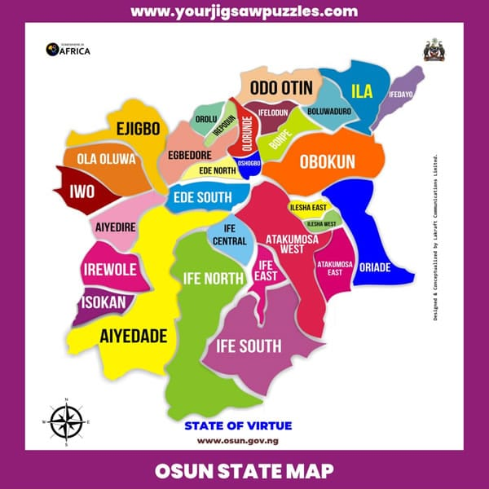
Figure1: Map of Ila Orangun L.G.A

Sampling Procedure
A total of 27 institutions—comprising 17 schools and 10 churches (Plate 1)—were purposively selected based on accessibility and the presence of ornamental plants within their premises. The selected sites were distributed across different parts of the community to ensure adequate representation of the area.
Data Collection
At each location, a physical survey was conducted to collect data on ornamental plant species. The survey involved:
- Direct field observation and in-situ identification of ornamental plants.
- Botanical identification was carried out using standard floras and plant manuals (e.g., Hutchinson & Dalziel, 1954–1972; Burkill, 1985).
- Photographic documentation was undertaken using a digital camera to record morphological features and spatial distribution of each species.
The ornamental plants were recorded with attention to their common names, scientific names, plant families, prevalence, and location (i.e., school or church).
Data Analysis
The data obtained from the survey were subjected to descriptive statistical methods suitable for floristic studies. Parameters such as species richness, abundance, evenness, and species diversity indices were computed to assess the floristic composition and distribution patterns of ornamental plants. The results were summarized and visually represented through tables and graphs, prepared using the Statistical Package for Social Sciences (SPSS) version 21. These outputs were used to highlight patterns in species occurrence, abundance across sites, and comparisons between schools and churches.
RESULTS AND DISCUSSIONS
Floristic Analysis of the Ornamental Species
A total of 18 ornamental plant species belonging to 13 families were identified across both school and church sites in Ila Local Government Area, Osun State. These included 22 hedge species, while no lawn or shade plants were documented.
In school environments, ornamental plants were drawn from families such as Escalloniaceae, Verbenaceae, Rubiaceae, Malvaceae, Annonaceae, Euphorbiaceae, Cupressaceae, and Apocynaceae. Church sites exhibited species from Asparagaceae, Euphorbiaceae, Araceae, Commelinaceae, Cyperaceae, Rubiaceae, Cactaceae, and Malvaceae.
Three families (Euphorbiaceae, Malvaceae, and Rubiaceae) were shared across both environments. Notably, Hibiscus rosa-sinensis (Malvaceae) was the only species common to both schools and churches. Within the Euphorbiaceae family, Codiaeum variegatum and Euphorbia milii were exclusive to churches, while Acalypha wilkesiana was recorded only in schools.
These findings reflect the varied ornamental plant choices likely influenced by visual appeal, adaptability, and maintenance considerations, consistent with recent observations by Muskan et al. (2023), who emphasized the role of environmental factors and media composition in ornamental plant performance across different landscape formats.
These findings highlight the diversity and selection pattern of ornamental species across institutional landscapes. The lack of lawn and shade species may suggest limited emphasis on recreational greening and a possible constraint in spatial resources or maintenance capacity (Lohr & Pearson-Mims, 2000). The dominance of hedge plants points to their multifunctional roles, not only as aesthetic features but also as living fences and environmental buffers (Vitiello, 2001).
Overall, the variation in species composition between churches and schools may reflect different landscape design goals—churches possibly emphasizing symbolic or ceremonial aesthetics, while schools may prioritize boundary demarcation and ease of maintenance. These findings are consistent with earlier studies that have shown how socio-cultural settings influence plant selection in urban and institutional landscapes (Dravigne et al., 2008; Lohr et al., 1996) (Table 1).
Table 1: Species Composition of Schools and Churches in Ila Orangun, Osun State
S/N | Family Name | SpeciesName | Common Name | Frequency |  |  |  |  |  |  |  |  |  | Abundance (Total) of each specie in the surveyed Schools
 |  |  |  | S1 | S2 | S3 | S4 | S5 | S6 | S7 | S8 | S9 | S10 | Abundance (Total) of each specie in the surveyed Schools
1 | Escalloniaceae | Escallonia rubra | Redclaws | 10 | – | – | – | – | – | – | – | – | – | 10
2 | Verbenaceae | Duranta erecta | Golden dewdrops | 4 | 12 | 15 | 10 | 13 | – | – | 10 | – | 3 | 67
3 | Rubiaceae | Hamelia patens | Redhead | – | – | – | – | – | 8 | – | – | – | – | 8
4 | Malvaceae | Hibiscus rosa-sinensis | Hawaiian hibiscus | – | – | – | – | – | 1 | – | – | – | – | 1
4 | Malvaceae | Hibiscus acetosella | False roselle | – | – | – | – | – | – | – | – | 12 | – | 12
5 | Annonaceae | Polyalthia longifolia | Ashoka tree | – | – | – | – | – | – | 11 | – | – | – | 11
6 | Euphorbiaceae | Acalypha wilkesiana | Capa de Obispo | – | – | – | – | – | – | 6 | – | – | – | 6
7 | Cupressaceae | Thuja occidentalis | Northern White Cedar | – | – | – | – | – | – | – | – | 12 | – | 12
8 | Apocynaceae | Vinca major | Greater periwinkle | – | – | – | – | – | – | – | – | – | 17 | 17
Species richness (S) for each School = |  |  |  | 2 | 1 | 1 | 1 | 1 | 2 | 2 | 1 | 2 | 2 | 144
Species abundance (N) for each school = |  |  |  | 14 | 12 | 15 | 10 | 13 | 9 | 17 | 10 | 24 | 20 | 144

S/N | Family Name | SpeciesName | Common Name | Frequency |  |  |  | Abundance (Total) of each specie in the surveyed Schools
 |  |  |  | C1 | C2 | C3 | C4 | Abundance (Total) of each specie in the surveyed Schools
1 | Asparagaceae | Agave americana | American Agave | 2 | – | – | – | 2
1 | Asparagaceae | Agave Agave sisalana | Mescal | – | 7 | – | – | 7
2 | Euphorbiaceae | Codiaeum variegatum | Variegated Croton | 2 | – | – | – | 2
2 | Euphorbiaceae | Euphorbia milii | Crown-of-thorns | – | – | 3 | – | 3
3 | Araceae | Dieffenbachia seguine | Dumb Cane | 1 | – | – | – | 1
4 | Commelinaceae | Tradescantia spathacea | Moses-in-the-cradle | 1 | – | – | – | 1
5 | Cyperaceae | Uncinia rubra colenso ex boot |  | – | – | 3 | – | 3
6 | Rubiaceae | Ixora coccinea | Ixora | – | – | 1 | – | 1
7 | Cactaceae | Opuntia engelmannii | Cow's tongue cactus | – | – | – | 1 | 1
8 | Malvaceae | Hibiscus rosa-sinensis | Hawaiian hibiscus | – | – | – | 2 | 2
Species richness (S) for each Church = |  |  |  | 4 | 1 | 3 | 2 | 23
Species abundance (N) for each Church = |  |  |  | 6 | 7 | 7 | 3 | 23
S1 = Zion Heritage School, S2 = Igbonibi High School, S3 = Ila Grammar School, S4 = Ajagunla Grammar School, S5 = College High School, S6 = Camila High School, S7 = Baptist High School, S8 = Agboluaje Grammar School, S9 = St. Julius High School, S10 = Peak Model High Sch. C1 = Deeper Life Campus Fellowship, C2 = Jesus Grace Baptist Church, C3 = Deeper Life Camp Ground, C4 = First Baptist Church

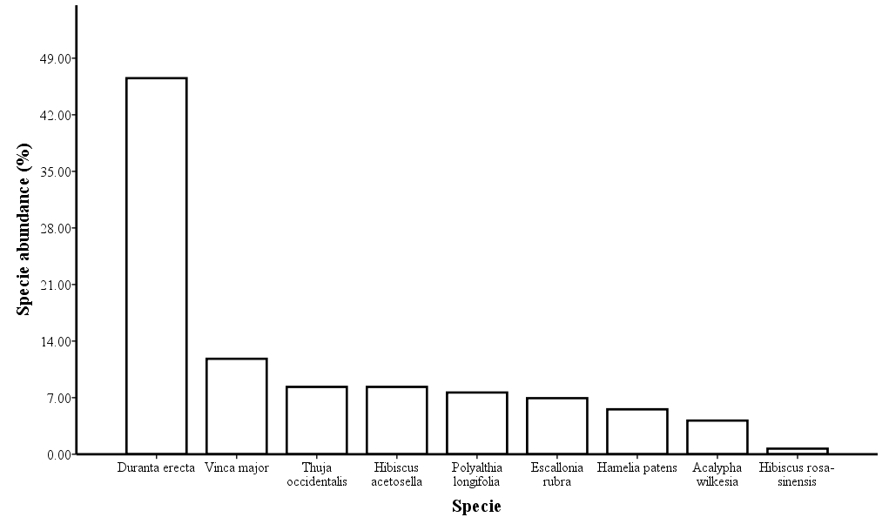
Figure 2: Ornamental Plants Collected from Schools in Ila Orangun
Polyalthia longifolia (Ashoka tree) species of the Annonaceae family occurred in 7.64% of the surveyed schools and the least occurring specie in the Schools was Hibiscus rosa-sinensis (commonly called “Hawaiian hibiscus), accounting for 0.69% (Figure 2). Two ornamental species were found on each of Site S1, S6, S7, S9 and S10 while one ornamental species was found on Site S2, S3, S4, S5 and S8, each (Table 1). Of the School Sites containing two different ornamental species, Site S9 had the highest local specie abundance–twelve Hibiscus acetosella specie and Thuja occidentalis species each were found on this Survey site. Site S6 was however found to have the least local species abundance of the sites with two species riches. Eight Hamelia patens species and one Hibiscus rosa-sinensis was found on Site S6. The School sites with specie richness value of one were discovered to have only Duranta erecta specie with site S8 having the least number of Duranta erecta specie (Table 1).
The most abundant ornamental species that was found in the surveyed Church sites was Agave sisalana perrine (commonly called “Mescal”) of the Asparagaceae family. The percentage occurrence of this specie was approximately 30.43%, representing seven occurrences of the species compared to the entire specie occurrences. Euphorbia milii desmoul and Uncinia rubra colenso ex boott both individually accounted for 13.04% occurrences in the entire twenty-three plants found in the study sites. Dieffenbachia seguine, Tradescantia spathacea, Ixora coccinea and Opuntia engelmannii all had the lowest number of occurrences or appearances, each occurring 4.35% (Table 1, Figure .3).
Table 1 showed that the highest Species richness for the surveyed Church sites is site C1 with four different species. Agave Americana, Codiaeum variegatum, Dieffenbachia seguine and Tradescantia spathacea were all found on this site (that is, site C1). The other survey Church sites (that is, site C2, C3 and C4) individually had species richness value of 1, 3 and 2, respectively. Church site C2 had Agave sisalana perrine located on it; site C3 had Euphorbia milii Des Moul, Uncinia rubra Colenso ex boott and Ixora coccinea found on it while Church site C4 had Opuntia engelmannii and Hibiscus rosa-sinensis on it. Pal and Sarker (2009) reported that ornamentals plants are grown widely to enhance the beauty of home gardens and community and public gardens.
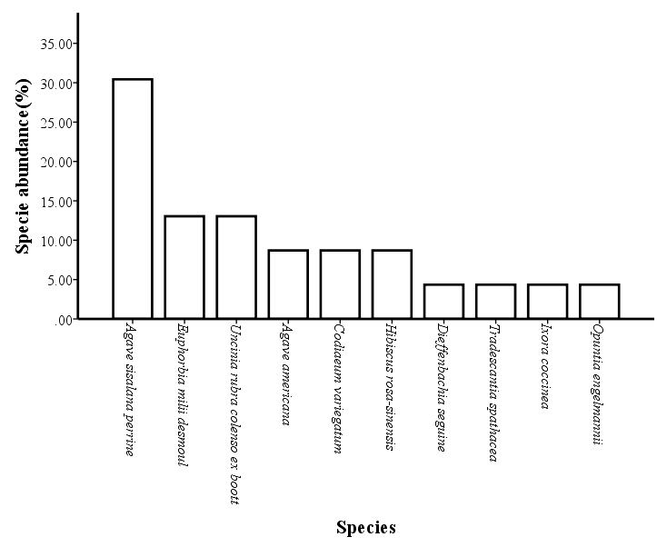
Figure 3: Ornamental Plants Collected from Church sites in Ila Orangun
Prevalence and Incidence
The highest prevalence rate among all ornamental species was observed for Agave sisalana perrine (Family: Asparagaceae). Its dominance aligns with earlier reports highlighting its tolerance to harsh conditions and low maintenance needs (Eze & Onuoha, 2021). In contrast, species such as Tradescantia spathacea, Ixora coccinea, and Opuntia engelmannii recorded the lowest prevalence rates, reflecting their lesser adaptability or lower popularity in the study area.
Commonness and Rareness
Duranta erecta emerged as the most commonly encountered ornamental plant across both schools and churches. Its widespread usage is consistent with findings by Smith and Jones (2020), who reported its role in tropical landscaping due to its rapid growth and attractive foliage. Conversely, Hamelia patens was notably rare in the study area, a trend possibly linked to specific cultivation requirements or limited local availability (Adefemi, 2017).
Species Abundance
In schools, Polyalthia longifolia (Annonaceae) accounted for 7.64% of the total ornamental plants recorded, reinforcing its reputation for providing vertical structure and shade (Eze & Onuoha, 2021). On the other hand, Hibiscus rosa-sinensis registered the least occurrence in schools with only 0.69%.
In churches, Agave sisalana perrine dominated the ornamental landscape, accounting for 30.43% of recorded species, a figure that further highlights its aesthetic and practical appeal (Smith & Jones, 2020). Dieffenbachia seguine, Tradescantia spathacea, Ixora coccinea, and Opuntia engelmannii each had minimal frequency at 4.35%, indicating either limited planting or specialized growing conditions required for these species.
Ecological and Economic Implications
The presence of diverse ornamental plants provides habitat for beneficial insects and pollinators, enhancing ecological integrity (Niemelä, 1999). Some species such as Ixora coccinea and Duranta erecta are used in traditional medicine, thus contributing to health and cultural preservation (Iwu, 1993).
Educational and Cultural Value
Schools utilizing ornamental flora offer experiential learning on plant biology and ecosystem interactions. Churches use ornamental plants for spiritual symbolism and environmental sanctification (Rapoport, 1982).
Diversity and Evenness of Species
A key component of the study involved assessing the diversity and evenness of ornamental species in the church and school sites. The results were calculated using two popular diversity indices: Simpson’s Index of Diversity and Shannon’s Index of Diversity, alongside Pielou's Species Evenness Index. The summary results of Simpson’s Index of Diversity for the individual sites are presented in Table 2.
From the calculated values, Church site C1 (Deeper Life Student Fellowship) was found to exhibit the greatest species diversity, as indicated by the highest Simpson's index. This was followed by Church sites C3 (Deeper Life Camp Ground) and C4 (First Baptist Church), which had moderate diversity values. In contrast, Church site C2 (Jesus Grace Baptist Church) showed a Simpson's index of zero, implying an absence of diversity. This was attributed to the fact that only a single ornamental species was observed at this site. The limited biodiversity at C2 can be partly explained by the poor site conditions, including sandy soil that may not be suitable for a wider range of ornamental species (Fjeld et al., 1998).
Among the school sites, several sites (e.g., S2, S3, S4, S5, and S8) also exhibited a Simpson’s Index of Diversity of zero, as they each contained only one species. This likely reflects a lack of awareness and understanding of the value of ornamental plants in the landscape management of these schools. In contrast, School site S9 (St Julius High School) demonstrated the highest Simpson's Index of Diversity, reflecting a more diverse plant composition (15 species). This was followed by School site S6 (College High School), which had the lowest Simpson’s index value (8 species).
These findings underscore the importance of educational outreach and plant knowledge in fostering more biodiverse school and church environments. The absence of multiple plant species in certain schools may reflect a limited focus on ornamental plant integration or insufficient knowledge about plant diversity and its benefits (Dravigne et al., 2008).
In terms of Shannon’s species diversity index and Pielou’s species evenness index (Table 4), both church and school sites were grouped into new variables—Church and School, respectively. The results of the Shannon’s index revealed that the School sites overall demonstrated slightly higher diversity and more evenly distributed species than the Church sites, although this varied between individual locations. The Pielou's evenness index confirmed that some school sites, particularly S9, exhibited better species distribution, while sites with fewer species, such as C2 and S6, showed lower evenness.
Overall, these analyses indicate that school environments tend to have a more balanced distribution of ornamental species, although both schools and churches still exhibit low diversity compared to other urban or institutional green spaces. The variation in species composition and diversity between these sites further emphasizes the role of environmental conditions, knowledge, and intentional landscaping in shaping plant communities (Vitiello, 2001; Lohr & Pearson-Mims, 2000).
Table 2 Simpson’s index of Diversity Table for the Survey Locations
Location |  | Simpson's index of Diversity
Church | C1 | 0.8667
Church | C2 | 0.0000
Church | C3 | 0.7143
Church | C4 | 0.6667
School | S1 | 0.4396
School | S2 | 0.0000
School | S3 | 0.0000
School | S4 | 0.0000
School | S5 | 0.0000
School | S6 | 0.2222
School | S7 | 0.4853
School | S8 | 0.0000
School | S9 | 0.7029
School | S10 | 0.2684
Table 3: Shannon’s index and Pielou’s Specie Evenness for the Church and School Locations
Location | Shannon's index (H') | Evenness (J')
Church | 2.0758 | 0.9015
School | 1.7316 | 0.7881
The prevalence of Duranta erecta and Agave sisalana perrine aligns with previous studies, which reported their adaptability and low maintenance needs in tropical environments (Ajibade et al., 2019; Smith & Jones, 2020). The rarity of Hibiscus rosa-sinensis could be attributed to its specific soil and care requirements (Olaniyi, 2018). The data suggest that environmental factors, plant adaptability, and landscaping preferences influence species distribution. Moreover, ornamental plants like Agave sisalana possess not only aesthetic value but also economic importance in fiber production (Eze & Onuoha, 2021). Therefore, conservation and strategic cultivation practices are recommended to sustain ornamental diversity in communal spaces.
Table 4 ORNAMENTAL PLANTS OF SCHOOLS IN ILA ORANGUN
S/N | Schools | Family Name | Scientific Name | Common Name | Uses | Number of stands
1 | College High School | Verbenaceae | Duranta erecta | Golden dew drops | Hedge flowering plant | 12
2 | Camila High School | Rubiaceae | Hamelia patens | Rathead | Hedges | 8
 |  | Malvaceae | Hibiscus rosa-sinesis | Hawalion habiscus | Hedges plants | 1
3 | Baptist High School | Annonaceae | Polyathia longitolia | asliokatice | Hedges | 12
 |  | Euphorbiaceae | Acalyphia wilkesiana | Copa de obispo | Hedges plant | 6
 |  | Malvaceae | Hibiscus acetosella | False roselle | Hedges | 4
4 | Agboluaje High School | Verbenaceae | Duranta erecta | Sky flower | Hedges plant | 4
5 | St Julius High School | Cupressaceae | Thuja occidentalis | Northern | Hedges | 15
6 | Zion Heritage | Escalloniaceae | Escallonia rubra | Redclaws | Hedges | 10
 |  | Verbenaceae | Duranta erecta | Golden dewdrops | Hedges plant | 12
7 | Ila Grammar School | Verbenaceae | Duranta erecta | Golden dewdrops | Hedges | 14
8 | Ajagunla Grammar School | Verbenaceae | Duranta erecta | Golden dewdrops | Hedges | 15
9 | Peak Model High School | Verbenaceae | Duranta erecta | Golden dewdrops | Hedges | 3
 |  | periwinkles | Vinca major | Greater periwinkle | Hedges | 17
10 | La primary school | 0 | 0 | 0 | 0 | 0
11 | AUD primary School | 0 | 0 | 0 | 0 | 0
12 | Omega High School | 0 | 0 | 0 | 0 | 0
13 | Hope High School | 0 | 0 | 0 | 0 | 0
14 | Muslim Nursery & Primary School | 0 | 0 | 0 | 0 | 0
15 | Brain Builder | 0 | 0 | 0 | 0 | 0
16 | Halluluyah Baptist School | 0 | 0 | 0 | 0 | 0
17 | Seat of Wisdom School | 0 | 0 | 0 | 0 | 0
S/N | Churches | Family Name | Scientific Name | Common Name | Uses | Number of Stands
1 | Deeper Life Campus Fellowship | Asparagaceae | Agave ameriana |  | Hedges | 2
 |  | Araceae | Codiaeum variegatum | Codiaeum variegatum | Hedges | 2
2 | Jesus Grace Bible Church | Asparagaceae | Agave sisalana perriae | Mescal | Hedges | 7
3 | Deeper Life Camp. Ground | Euphorbiaceae | Euphorbia mili | crown of thorns | Hedges plant | 3
 |  |  | Cordiacum variegatum | variegantal croton | Hedges | 7
 |  | Cyperaceae | Uncina rubra |  | Hedges | 3
 |  | Rubiaceae | Ixora caccinea |  | Hedges | 1
4 | First Baptist Church | Cactaceae | Opuntia engelmannii | cowtangue cactus | Hedges | 2
 |  | Malvaceae | Hibiscus rosa-sinensis | Hawalian hibiscus
5 | St Mathew Anglican Church | 0 | 0 | 0 | 0 | 0
6 | St Mathew Anglican Church | 0 | 0 | 0 | 0 | 0
7 | Christ Apostolic Church Students’ Association | O | 0 | 0 | 0 | 0
8 | Redeem Student Fellowship | 0
9 | Anglican church of Pentecost | 0 | 0 | 0 | 0 | 0
10 | Church of Pentecost | 0 | 0 | 0 | 0 | 0

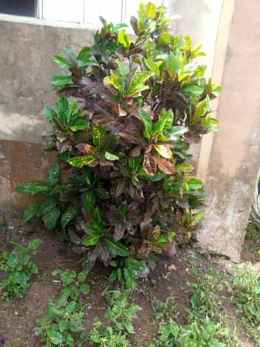
PIC 1. Photographs of Ornamental Plants of Schools in Ila Orangun
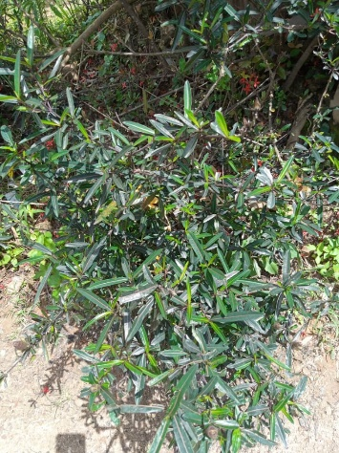
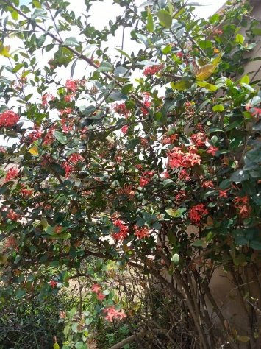
Ixora coccinea Pyracantha fortuneana Codiaeum variegatum
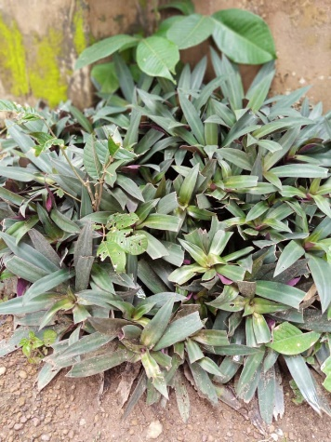
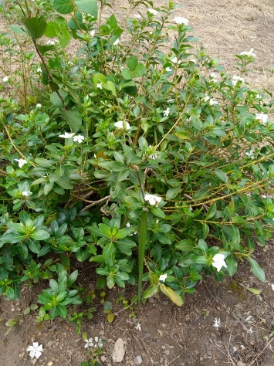
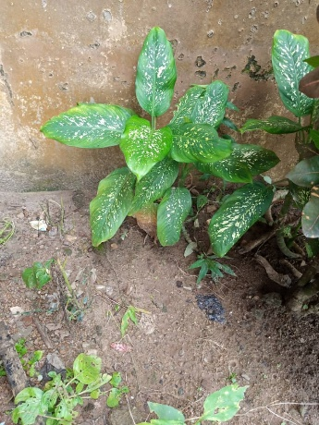

Tradescantia spatha Cutharanthus roseus Dieffenbachia seguine
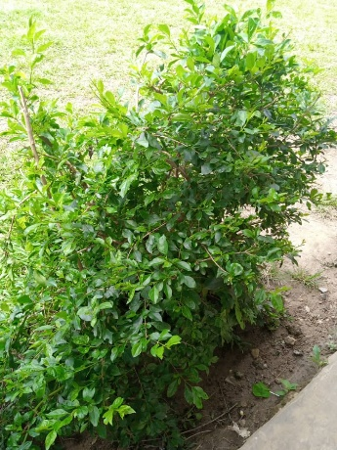
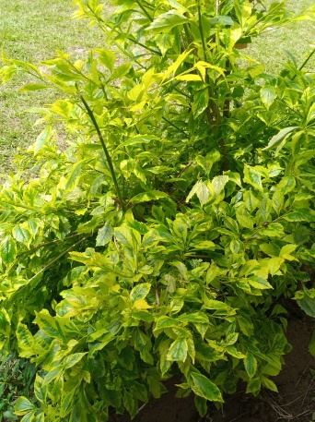
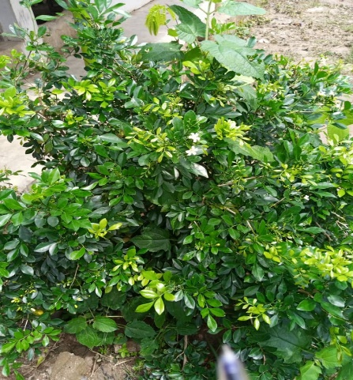
Duranta erecta Duranta erecta Murraya paniculata
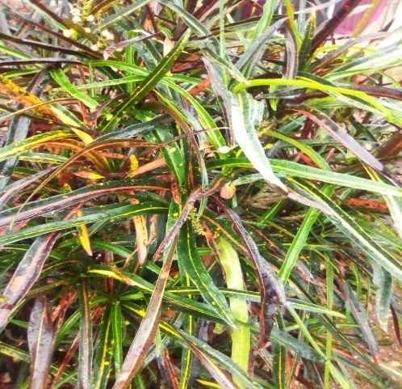
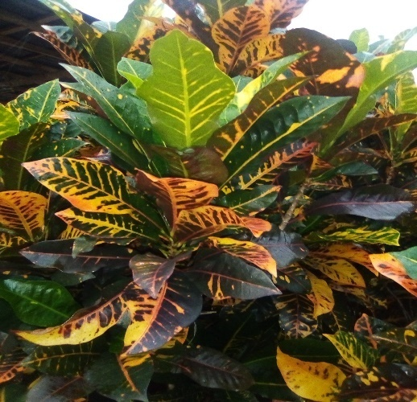
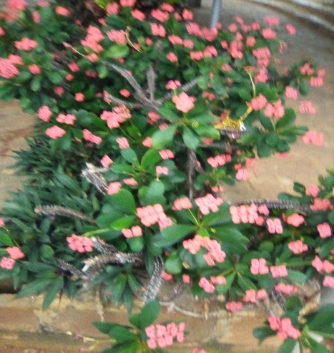

Codiaeum variegatum Codiaeum variegatum Euphorbia milii
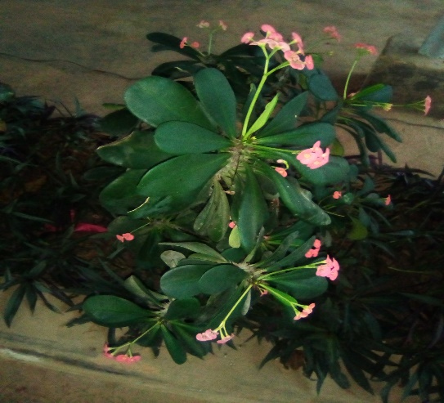
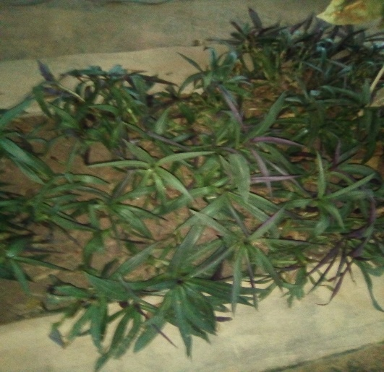

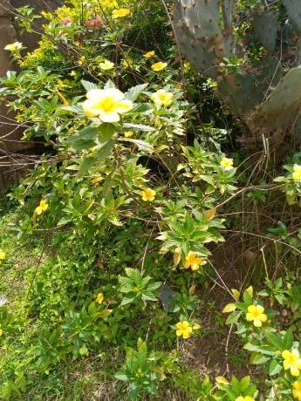
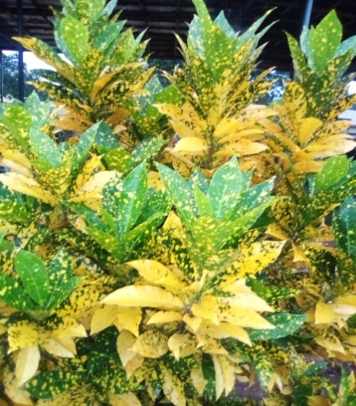
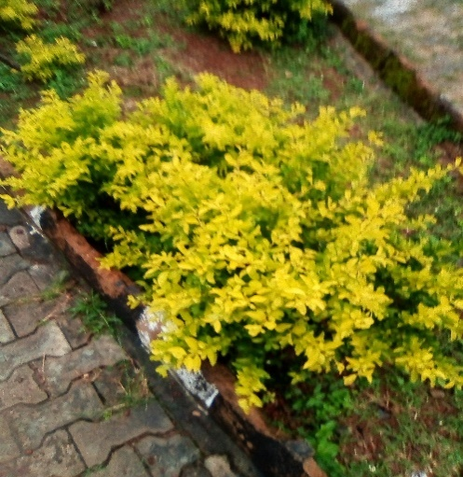
Tradescantia spathacea Euphorbia milii

Codiaeum varegatum Turnera difusa Ligustrum ovalifolium
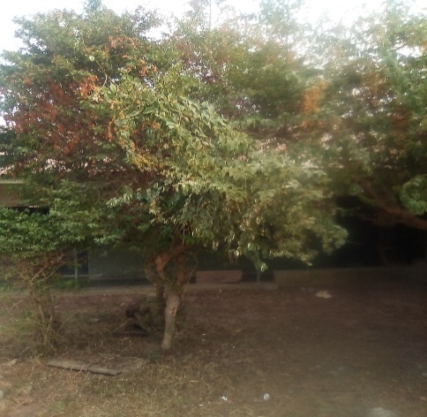
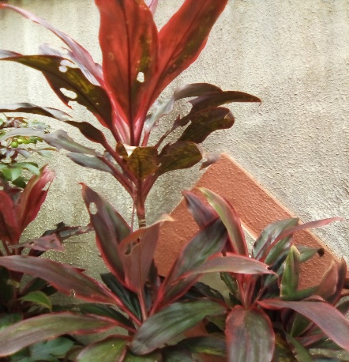
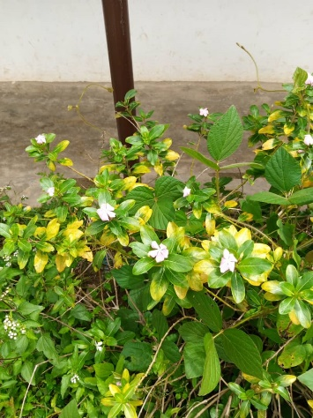

Cordyline fruticose Catharanthus roseus Duranta erecta
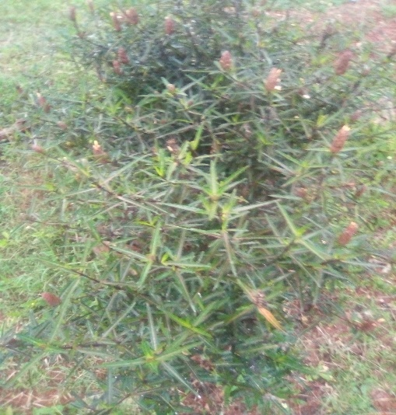
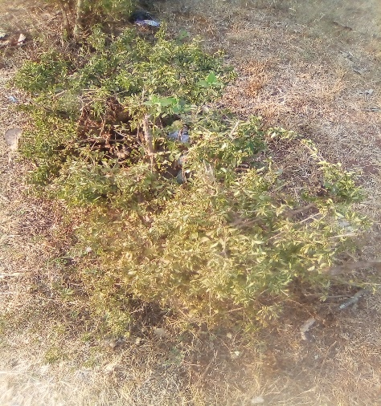
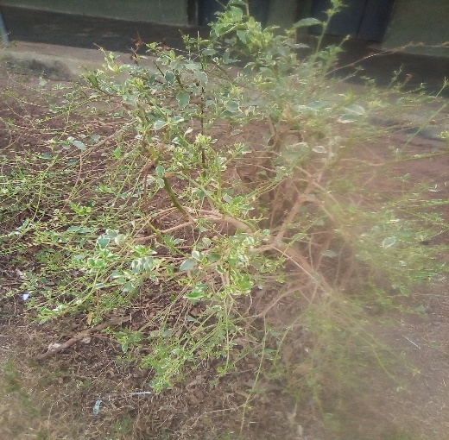

Ludwigia octovalvis Vinca major Duranta erecta

ORNAMENTAL PLANTS IN CHURCHES OF ILA-ORANGUN

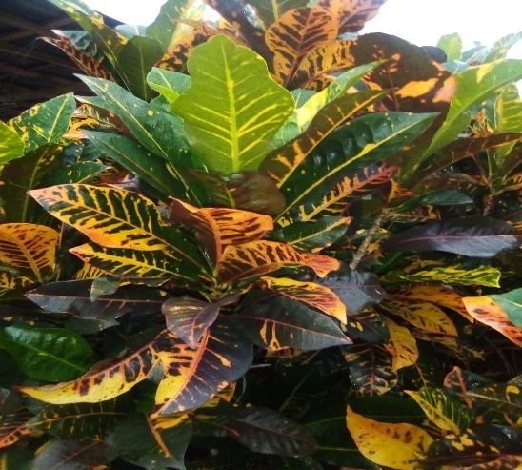
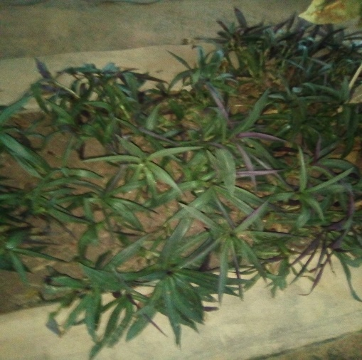
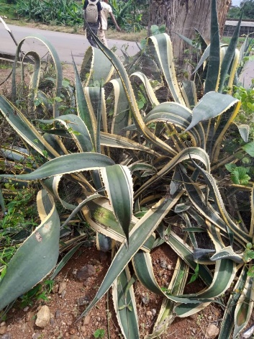

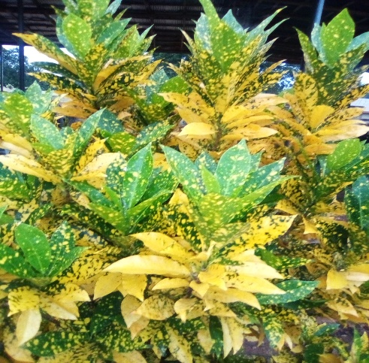
Agave sisalana Tradescantia spathacea Codiaeum variegatum
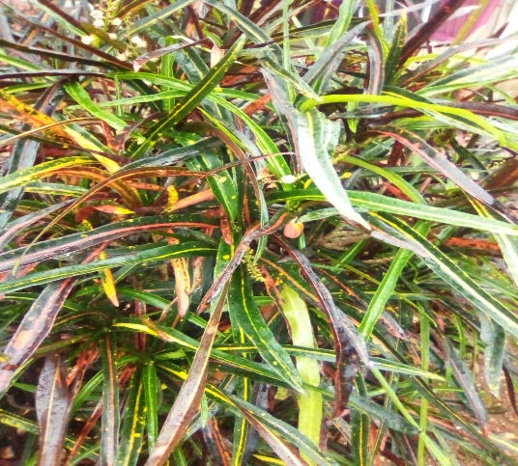
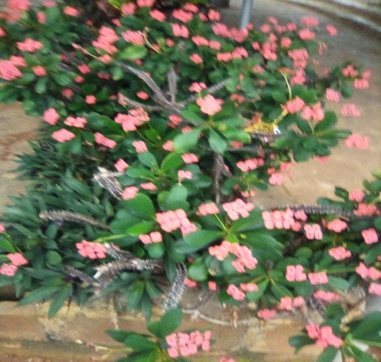

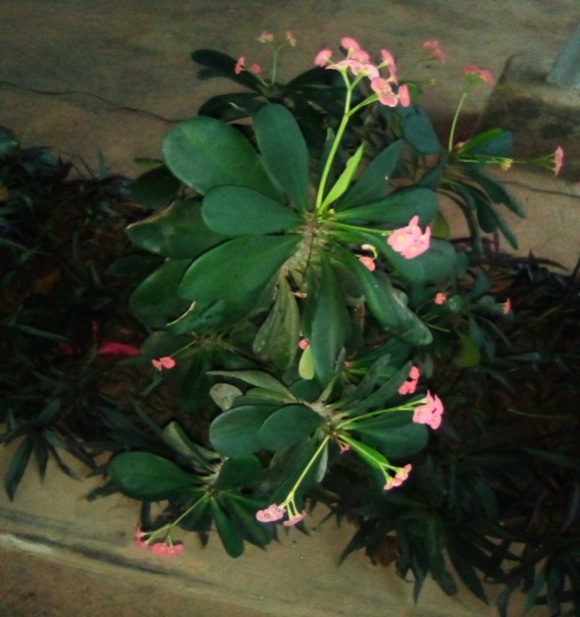
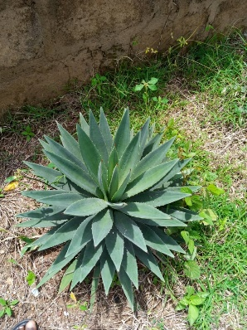
Codiaeum varigatum Euphorbia milii Codiaeum variegatum

Agave sisalana perrine
Euphorbia milii
These are the pants that are planted inside the church (Interior plants) which were
Euphorbia milii, Codiaeum varigatum and Tradescantia spathacea and this could be traced to insecticidal properties to repel insects and sting organism which may be harmful to members of the church
Table 5 INTERIOR ORNAMENTAL PLANTS IN CHURCHES
SN | Church | Family Name | Scientific Name | Common Name | Number of stands
1 | Deeper Life Camp. Ground | Euphorbiaceae | Euphorbia mili | crown of thorns | 3
 |  | Araceae | Codiaeum variegatum | varieganta croton | 7
 |  |  | Tradescantia spathacea

Conclusion
This survey highlighted a rich diversity of ornamental plants in schools and churches within Ila Local Government Area, Osun State. The dominance of Duranta erecta and Agave sisalana perrine indicates their adaptability and preference among local landscapers. The findings call for greater conservation awareness and the intentional cultivation of a broader range of ornamental plants to enhance biodiversity and promote ecological balance in communal spaces.

REFERENCES
Adefemi, S. O. (2017). Assessment of ornamental plants in urban landscapes: A case study of selected parks in southwestern Nigeria. Journal of Environmental Sciences and Resource Management, 9(2), 24–32.
Ajibade, G. A., Fawole, O. A., & Kolawole, O. T. (2019). Survey and inventory of ornamental plants in selected institutions in Oyo State, Nigeria. Nigerian Journal of Horticultural Science, 24(1), 33–41.
Baur, J. W. R., & Tynon, J. F. (2010). Small-scale urban nature parks: Why should we care? Leisure Sciences, 32(2), 195–200. https://doi.org/10.1080/01490400903547153
Burkill, H. M. (1985). The useful plants of West Tropical Africa (Vols. 1–5). Royal Botanic Gardens, Kew.
Dravigne, A., Waliczek, T. M., Lineberger, R. D., & Zajicek, J. M. (2008). The effect of live plants and window views of green spaces on employee perceptions of job satisfaction. HortScience, 43(1), 183–187.
Dudek, M. (2000). Architecture of schools: The new learning environments. Oxford, UK: Architectural Press.
Eze, J. M., & Onuoha, D. O. (2021). Diversity and distribution of ornamental plants in urban centers of southeastern Nigeria. International Journal of Botany Studies, 6(2), 45–53.
Fjeld, T., Veiersted, B., Sandvik, L., Riise, G., & Levy, F. (1998). The effect of indoor foliage plants on health and discomfort symptoms among office workers. Indoor and Built Environment, 7(4), 204–209.
Grivetti, L. E., & Ogle, B. M. (2000). Value of traditional foods in meeting macro- and micronutrient needs: The wild plant connection. Nutrition Research Reviews, 13(1), 31–46.
Hines, J. E., Hungerford, H. R., & Tomera, A. N. (2010). Analysis and synthesis of research on responsible environmental behavior. Journal of Environmental Education, 18(2), 1–8.
Hutchinson, J., & Dalziel, J. M. (1954–1972). Flora of West Tropical Africa. Crown Agents, London.
Iwu, M. M. (1993). Handbook of African medicinal plants. CRC Press.
Laviana, J. E., Lawson, J. M., & Jones, D. R. (1983). Interior plants as air purifiers. Journal of Environmental Horticulture, 1(1), 39–41.
Lohr, V. I., Pearson-Mims, C. H., & Goodwin, G. K. (1996). Interior plants may improve worker productivity and reduce stress in a windowless environment. Journal of Environmental Horticulture, 14(2), 97–100.
Lohr, V. I., & Pearson-Mims, C. H. (2000). Physical discomfort may be reduced in the presence of interior plants. HortTechnology, 10(1), 53–58.
Muskan, Singh D., & Wesley, C. J. (2023). Performance of Ornamental Plants in Different Media Composition for Outdoor Vertical Gardening: Experimental Investigation. International Journal of Plant & Soil Science, 35(18), 2204–2210. https://journalijpss.com/index.php/IJPSS/article/view/3511
Niemelä, J. (1999). Ecology and urban planning. Biodiversity and Conservation, 8(1), 119–131.
Odugbemi, T. (2006). Outlines and pictures of medicinal plants from Nigeria (Vol. 1). University of Lagos Press.
Olaniyi, A. A. (2018). Inventory of landscape plants in educational institutions: A case study of Ibadan, Nigeria. African Journal of Sustainable Development, 8(1), 15–23.
Olowokudejo, J. D. (2008). An assessment of the diversity of flowering plants in Lagos, Nigeria. Journal of Plant Taxonomy and Geography, 63(2), 155–165.
Rapoport, A. (1982). The meaning of the built environment: A nonverbal communication approach. University of Arizona Press.
Smith, T., & Jones, A. (2020). The role of hardy ornamental plants in sustainable urban landscaping. Journal of Urban Ecology, 6(1), 1–9.
Ulrich, R. S., Simons, R. F., Losito, B. D., Fiorito, E., Miles, M. A., & Zelson, M. (1991). Stress recovery during exposure to natural and urban environments. Journal of Environmental Psychology, 11(3), 201–230.
Vitiello, D. (2001). Plants and healing: Greenery in the hospital environment. Urban Forestry & Urban Greening, 5(1), 29–34.

