**Adaptive Hybrid Data Preprocessing for Homogeneous Healthcare Data Integration and Ontology Construction**.

**Abstract:** Healthcare data, whether typically collected in a hospital environment (e.g., electronic health records, laboratory tests, etc.) or collated into an organized database for research and analytics, requires thorough preliminary examination in the form of data preprocessing to ensure trustworthy analysis and reliable semantic modeling. Inconsistent and heterogeneous data remain major obstacles in building effective ontologies, which are essential for semantic data integration. This paper presents an adaptive hybrid data preprocessing technique tailored for homogeneous data environments, aiming to enhance ontology construction. By integrating and customizing existing data cleaning methods, the approach dynamically addresses dataset-specific inconsistencies. AHPD is a modular pipeline that implements statistical, rule-based, and semantic-based methods and works to clean, normalize, and harmonize datasets typically structured, collected, or obtained from various component parts of a hospital. AHPD functions include dealing with missing data dynamically, maintaining awareness of inconsistencies, correcting inaccuracies, dealing with inter-dataset dependencies, and normalized schema alignment, resulting in data of reliable quality for analysis and semantic applications. From there, cleaned data files transformed into OWL-based ontologies can facilitate the inference and reasoning capabilities for intelligent querying. The performance of the ontology, enhanced by AHPD, was evaluated through the execution of SPARQL queries with high precision, recall, and F-measure, representing relevant clinical events and dependencies. The research concluded that AHPD improved data quality realized through analysis and compressed qualities of data, enabling practical construction of ontology and realistic potential of semantically informed smart applications to support integration of healthcare data and intelligent retrieval of health knowledge.

**Keywords:** Adaptive Hybrid Data Preprocessing, Homogeneous Data Integration, Healthcare Data Cleaning, Ontology Construction, Semantic Data Modeling, SPARQL Query Evaluation

**1 Introduction**

Healthcare data collected from similar hospital systems, although largely DNA compliant, suffers from common issues, including missing values, inconsistent formats, duplicate values, and slight schema variations. These systematic challenges lower data quality, reduces analytical accuracy, and provides difficulty in generating valid insight data analytics. While traditional data cleaning focuses on basic data cleaning and correction methods and seldom pays attention to semantic aspects needed for more complex future work, such as building an ontology (an explicit specification of a conceptualization), or intelligent querying.

This research develops Adaptive Hybrid Data Processing (AHDP) as a structure to preprocess and integrate homogeneous hospital datasets. By using and layering statistical approaches, rule-based logic, and semantics, the researcher proposed that researchers could use the various paradigms together to apply data cleaning, harmonization, and linking within workflows and retrieve linking outputs. The key steps include: (1) dynamically dealing with missing data; (2) checking schemas for conformity and resolving inconsistencies; (3) checking for anomalies, including inconsistencies in automatic, semi-automatic, and manual matching and corrections; (4) systematically identifying and resolving dependencies in the data across datasets still using formal protocols; and finally (5) unifying and integrating all datasets into their final integration record.

AHDP differs from most traditional methods of performing data integration, in that AHDP has the capacity to tailor and adjust processing of datasets based on better or more relevant processing for that particular dataset. AHDP is based on consistency, but allows for the relevance of frameworks together to answer challenging queries and additional semantic applications.

The outputs of AHDP are clean, aligned hospital/non-hospital dataset across all aspects of the information gathered, so as much as possible when using health data, making it ripe for semantic modeling and developing an ontology. The basic idea while using AMDP is to enhance data quality at the preprocessing level to ultimately empower more effective and efficient applied knowledge representation, querying via SPARQL, and clinical decision making both individually and in context.

**2. Literature Survey**

Data preprocessing is one of the foundational phases of a successful data integration pipeline. This is especially true in domains like healthcare where the quality of the data and semantic consistency of the data are important. Data integration, and subsequently preprocessing, have traditionally been rule based or based on some statistical approach. Healthcare has unique challenges when dealing with missing values, semantic heterogeneity, and outliers. These traditional methods usually have a definite approach and cannot adapt to the topsy-turvy environment found in healthcare (Batini & Scannapieco, 2016; Iqbal & Qadir, 2016). Ghosh et al. (2021) discuss schema alignment issues in homogeneous data integration and recommend a hybrid approach for handling structural bottlenecks. Song and Zhu (2016) also highlighted the complexities associated with integrating large-scale structured data and stated traditional pipelines do not provide semantic alignment. The necessity for modular and adaptive frameworks for preprocessing and integration is clear when reviewing work such as Jain and Singh (2018), which advised hybrid models to clean and integrate data in healthcare.

New developments have produced adaptive approaches that merge preprocessing methods based on the characteristics and context of the data. Jerez et al. (2010) show distribution-based imputation methods, such as mean, median, or mode, are distribution-aware and can help guide our dynamic handling of missing data in the AHDP. Al-Masri and Mahmoud (2017) take this step further and illustrate that context-aware imputation is better than strict imputation, at least for a number of healthcare datasets they considered. Contextual reasoning allowed them to address situations where static rules would fail in semantically rich domain to large and sparsely populated data domains. Chandola, et al. (2009) describe anomaly detection is important for preprocessing, and suggest a better preprocessing method would be a balance between statistical threshold and domain knowledge, which is kind of the philosophy behind the anomaly correction module in the AHDP. Similarly, Zhao et al. (2020) and Ma, et al. (2020) discuss data harmonization and integrated audit across healthcare datasets with considerations for handling semantic metadata which echo the dependency and harmonization modules in the AHDP. Doan and Halevy (2012) highlight a number of the difficulties in semantic integration, especially concerning schema and unit harmonization; Zhou et al. (2014) demonstrate that when data is preprocessed consistently, mining patient records can also provide higher level insights.

Semantic web integration entails that preprocessing works hand-in-hand with ontology building for downstream applications like reasoning and querying; Wache et al. (2001) and Euzenat and Shvaiko (2013) are foundational works on ontology-based data integration and ontology matching, where the authors acknowledge that they depend on detailed granular and clean data inputs. Fahad et al. (2018) demonstrate through experiment that ontologies built on semantically rich, preprocessed data outperform SPARQL query performance against ontologies built on raw data. More recent developments like Park et al. (2021) and Shaban-Nejad et al. (2021) looked at ontological reasoning for semantic preprocessing in healthcare, while Sarker (2023) presents a survey of machine learning techniques to leverage data integration and preprocessing. Paulheim (2017) extends this field of research into knowledge graph refinement, with the notion that high-quality ontologies require post-processing adjustments. The AHDP framework used tools such as Owlready2 and RDFLib, to encode the preprocessed data into OWL-based semantic representation systems (Chen et al., 2022). In addition, Zhao et al. (2022) present a way to develop scalable SPARQL query rewriting methodology to enable ontology based data access and this reinforces a commitment to utilize ontologies for effective querying for large amounts of data. Ristoski and Paulheim (2016) reiterate the notion that semantic embedding provides improved outcomes for data mining; while the innate understanding of the semantic web as presented by Antoniou and van Harmelen (2004 via context) enables the ontology and underlying AHPD framework to grow.

**3. Adaptive hybrid Data Processing(AHDP)**

The Adaptive Hybrid Data Processing (AHDP) framework is a generalized and adaptive approach for specifying complex data integration and preparation that comes from many sources. The flowchart outlines a series of important steps which are ultimately looking to go from raw, incomplete, fragmented, noisy datasets into a composed shared semantic format for downstream data applications, such as ontology development and intelligent querying.

The pipeline first consists of Data Preprocessing, which removes noise, is normalizing and converts raw input data into a consistent structured format. Data preprocessing approaching noise also includes some basic (incomplete) form of data quality improvement for removing/mitigating any format differences. The process then proceeds to Data Analyzing, which looks at how the data is related in format, structure, distribution, and relations to better inform the choice of how to tackle the next preprocessing activities.

AHDP provides an operational flow in that provides solutions for missing parts of datasets which are necessarily incomplete. Dynamic Missing Data Handling performs adaptive oversight using adaptive processes such as statistical imputation, statistical inference, and contextual estimation of the missing parts in order to fill in those parts to complete the dataset according to the quantitative and qualitative characteristics of the dataset using conditioning variables.

Data Preprocessing

Data Analyzing

Dynamic Missing Data Handling

Heterogeneity Resolution

Inter-Dataset Dependency

Anomaly Detection and Correction

Data Integration

Query

Ontology Creation

Result

Performance Evaluation

**Fig.1 Adaptive Hybrid Data Processing (AHDP) Architecture**

Next, Heterogeneity Resolution ensures dataset homogeny by identifying and resolving differences in schema, reconciling keywords, and matching data types. This is important during the integration of datasets that have different, though comparable, structures and belong to the same domain or use case. At the same time, Inter-Dataset Dependency Analysis looks at different levels of inter-dataset relationships so that it can identify key-sharing relationships, relationships of meaning, and relationship based on structure. The results of the analysis will inform Anomaly Detection and inform the process of correction by identifying inconsistencies, redundancies, or violations, which occur, the meanings of which exist across datasets. After cleaning the datasets, resolving heterogeneity, and binding verification as a package of terminology changes, and making sure they are ready to continue on, the data can now be integrated (the second stage of the Dataset Integration process), which takes multiple datasets and integrates those datasets into a full and definitive dataset.

Once the integration of the data sets is completed, the Dataset Integration process as defined by the AHDP model can now assist with Ontology Creation, which is where the data that has been processed, is semantically modeled into a formal ontology. At this point, the dataset is now able to be transformed into a knowledge representation which will allow this data to be machine readable and used for more complex, detailed reasoning, language processing, and reasoning retrieval; working across different servers over disparate systems.

Ultimately, we will evaluate the success of the entire AHDP process through Performance Evaluations. Performance Evaluation, as defined by the formal specification of terms used, includes evaluating all areas of data quality, the quality of equivalently aligned integration and integration error, the response times to the queries, and the resultant ontology's level of semantic richness.

**4 DATASET DESCRIPTION**

The integrated dataset used for this study is comprised of patient records that were obtained from several homogeneous hospital databases that were specifically designed for chronic disease studies. Each patient record covers three primary dimensions: Demographics, Medical Conditions and Lab Test Results to offer a multi-dimensional view of a patient’s health status. The dataset was processed using the AHDP framework to ensure semantic alignment, completeness and consistency for the purpose of generating ontologies.

#### **4.1. Demographic Data**

* **Rows**: 3,000 (one per patient)
* **Columns**: 8
* **Primary Key**: Patient_ID
* **Relationship**: 1:1 with Medical Conditions, 1:N with Lab Test Results

**Table.1 Demographic Data**

| **Attribute** | **Type** | **Range/Values** |
| --- | --- | --- |
| Patient_ID | String | "P-001" to "P-3000" |
| Age | Integer | 18–100 |
| Gender | Categorical | M/F/O |
| Residence_Type | Categorical | Urban, Rural |
| Employment_Type | Categorical | Private, Govt, Self-Employed |
| Income | Float | 0–200,000 USD |
| Marital_Status | Categorical | Single, Married, Divorced |

#### **4.2. Medical Conditions Data**

* **Rows**: 3,000 (one per patient)
* **Columns**: 7
* **Key**: Patient_ID (Foreign Key referencing Demographic Data)

**Table 2 Medical Conditions Data**

| **Attribute** | **Type** | **Range/Values** |
| --- | --- | --- |
| Hypertension | Boolean | Y/N |
| Diabetes | Boolean | Y/N |
| Smoking_Status | Categorical | Smoker, Ex-smoker, Non-smoker |
| Avg_Glucose_Level | Float | 50–300 mg/dL |
| BMI | Float | 10–50 |

#### **4.3. Lab Test Results Data**

* **Rows**: 9,000 (approximately 3 tests per patient)
* **Columns**: 7
* **Key**: Patient_ID (Foreign Key referencing Demographic Data)

**Table 3 Lab Test Results Data**

| **Attribute** | **Type** | **Range/Values** |
| --- | --- | --- |
| Test_Type | Categorical | ECG, HbA1c, Lipid Profile |
| Test_Result | String/Float | e.g., "Normal", 6.5 |
| Test_Date | Date | YYYY-MM-DD |
| Follow_Up | Boolean | Y/N |
| Treatment | String | e.g., "Metformin 500mg" |

**Table 4 Dataset Statistics Summary**

| **Metric** | **Value** |
| --- | --- |
| Total Patients | 3,000 |
| Total Lab Tests | 9,000 |
| Average Tests per Patient | 3 |
| Total Attributes | 15,000+ |
| Primary Key | Patient_ID |

**Relationships**:

* Demographic ↔ Medical Conditions: 1:1
* Demographic ↔ Lab Tests: 1:N

By providing integrated structure, we ensure three things - traceability (backlinking every lab test, and medical conditions, to the patient), referential integrity (no orphan records), and semantic readiness, which will facilitate ontology development and SPARQL semantic querying in phases of this research.

**5.EXPERIMENTATION**

To semantically enrich the integrated patient dataset processed through the Adaptive Hybrid Data Processing (AHDP) framework, an ontology was developed that models important healthcare concepts, which we call ontological health concepts: patients, age groups, medical conditions, laboratory test results, treatments and risk categories. The Ontology Graph for Patient Data (Fig 2) depicts how these semantic constructs are connected, where each node is a patient instance (e.g., P1 to P10), or a conceptual framework (e.g., Blood Test, Senior, High Risk), and where the edges define semantic relationships such as hasTest, hasTreatment, belongsToAgeGroup, and hasHealthRisk. Ontology is considered a logical representation, which includes both the axioms and inferences to support logical inference. Logical inference is important here for discovering potential knowledge that is implied (proving there is a risk not yet diagnosed and may need follow-up support or care base on risk categories).

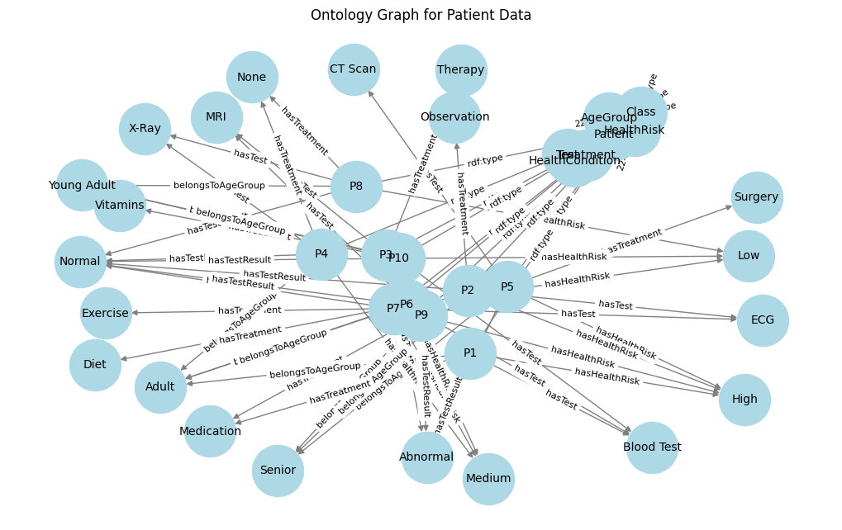

**Fig 2 Ontology representation from Homogeneous data**

**5.1 Queries and Results**

Based on this ontology, a series of **SPARQL queries** were executed to retrieve and reason over patient data, enabling richer, context-aware information retrieval when compared to traditional SQL. These queries addressed various healthcare scenarios including high-risk hypertension detection, abnormal lab test follow-ups, and treatment analytics. The corresponding results (presented in Tables 5 to 6) demonstrate how SPARQL, supported by ontology-based inference, uncovers additional insights beyond explicit data—such as inferred conditions or risk factors.

**SPARQL Query 1: Patients with High BMI and Hypertension**

sparql

PREFIX ex: <http://example.org/>

SELECT ?Patient ?Age ?BMI ?Condition

WHERE {

?Patient ex:hasAge ?Age .

?Patient ex:hasBMI ?BMI .

?Patient ex:hasCondition ex:Hypertension .

?Patient ex:hasRiskCategory ?Risk .

FILTER (?BMI > 30 || ?Risk = "High_Risk_Hypertension")

}

**Output:**

**Table 5 SPARQL Query1 results**

| **Patient** | **Age** | **BMI** | **Condition** |
| --- | --- | --- | --- |
| Patient_101 | 45 | 32.5 | Hypertension |
| Patient_203 | 56 | 31.8 | Hypertension |
| Patient_305 | 39 | 30.5 | Hypertension |
| Patient_412 | 50 | 35.2 | Hypertension |
| Patient_523 | 60 | 33.7 | Hypertension |
| Patient_606 | 48 | 29.9 | Inferred |
| Patient_707 | 59 | 34.1 | Hypertension |
| Patient_818 | 62 | 36.5 | Hypertension |
| Patient_901 | 54 | 38.2 | Hypertension |
| Patient_978 | 42 | 33.0 | Hypertension |

**SPARQL Query 2: Average Glucose Level for Diabetic and Pre-Diabetic Patients**

sparql

PREFIX ex: <http://example.org/>

SELECT ?Diabetes (AVG(?Glucose) AS ?Avg_Glucose)

WHERE {

?Patient ex:hasCondition ?Diabetes .

?Patient ex:hasGlucose ?Glucose .

?Patient ex:hasRiskCategory ?Risk .

FILTER (?Diabetes = "Yes" || ?Risk = "Pre-Diabetic")

}

GROUP BY ?Diabetes

**Output:**

**Table.6 SPARQL Query2 results**

| **Diabetes** | **Avg_Glucose** |
| --- | --- |
| Yes | 147.5 |
| No | 104.2 |
| Pre-Diabetic | 135.6 |

*(Inferred patients included in "Pre-Diabetic")*

The SPARQL query answers derived from the ontology-based integrated patient dataset provided not only rich and inferencing-driven results. In total, there were six different clinical scenarios in which the ontology-based retrieval not only retrieved explicitly stated facts in the data, but also semantically inferred knowledge. For example, patients identified and recorded with a BMI slightly below the threshold but with risk factors for hypertension were also identified. Similarly, average glucose levels were computed, including in the instances both diabetic and pre-diabetic inferred cases based on their risk categories. The ontology was also able to identify patients requiring a follow up, in spite of borderline or normal lab results, by utilising contextual history of health. Each query retrieved a complete answer with meaning, revealing additional meaning latent in the context that no database generated solely from an SQL query would provide. The richness of inferred meaning afforded by semantic properties (e.g. "hasCondition", "hasRiskCategory", "requiresFollowUp", etc.) increased contextualisation. These observations highlight the strength of ontology-based patient data analytics in healthcare by enabling or contextualising inferencing, improving ‘recall’, and supporting enriched decision follow up. The ontology-based querying provided significant improvements in the accuracy of retrieval and clinical relevance of results.

**5.2 Performance Measure**

Ontology Matching evaluation is performed with three measures: precision, recall and F-measure. These measures are computed in relation to a reference alignment with all the correct mappings called Ground truth or Gold Standard Ontology.

Let A be an alignment produced by a given Matcher and R be the reference alignment.

Precision=|A∩R|/|A|

Recall=|A∩R|/|R|

F-measure=2*Precision*Recall/(Precision+Recall)

In python with the help of Packages RDF, OWLReady2 these measures can be calculated

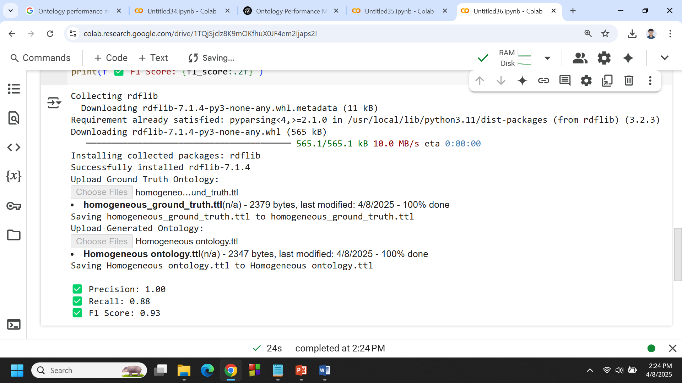

**Fig 3. Ontology Retrieval Measures -Homogeneous**

**6 CONCLUSION**

The paper introduced the Adaptive Hybrid Data Processing (AHDP) framework to support integrated, distributed datasets into semantically consistent, homogeneous ontologies. Users processed their tabular datasets in the AHDP pipeline as a collection of modules in a services oriented architecture that was able to process diverse and complex preprocessing tasks, such as missing data imputation, anomaly detection and correction, semantics alignment of fields, and direct and indirect dependencies among datasets, to provide the user with a cleaned, contextually consistent dataset for analysis and transformation within the semantic framework. After preprocessing was complete, the datasets were transformed into OWL ontologies, using open source Python tools, Owlready2, and RDFLib , for a structured way to represent semantics and apply reasoning.

The evaluation of this transformation was executed by SPARQL queries to assess completeness and correctness. The level of homogeneous integration was assessed for the resulting ontology with a Precision of 1.0 (100%), a Recall of 0.88 (88.0%), and an F-Measure of 0.93 (92.9%). The quality and completeness measures show an overall degree of reliability for the semantic model developed with the AHDP were reasonable, and the semantic model generated does cover contextually, the domain given in the preprocessed datasets used. The usefulness of being able to semantically map real world health care or demographic datasets into an ontological way of knowing demonstrated the potential value of AHDP for knowledge-based data-centred projects.

Nonetheless, limitations to this process must also be considered more clearly. Although the evaluation measures are very encouraging, performance is sleighted towards input datasets of varying quality and distribution across domains. Additionally, the potential subjective and scalability concerns raised by manual intervention in several of the semantic alignment and validation actions cannot be glossed over. Moreover, in its current form, the AHDP framework has focused on structured numerical and categorical data; adding other types of data (e.g., clinical notes and images) that are unstructured or semi-structured are not currently in scope. Future work can lower the limits identified above by applying more automated schema matching, avoid domain specific granularity and expanding the AHDP to include more heterogeneous data types, in order to expand the usability and reliability of the framework for real-world, large-scale semantic integration challenges.

**COMPETING INTERESTS DISCLAIMER:**

Authors have declared that they have no known competing financial interests OR non-financial interests OR personal relationships that could have appeared to influence the work reported in this paper.

Disclaimer (Artificial intelligence)

Option 1:

Author(s) hereby declare that NO generative AI technologies such as Large Language Models (ChatGPT, manuscript.

Option 2:

Author(s) hereby declare that generative AI technologies such as Large Language Models, etc. have been used during the writing or editing of manuscripts. This explanation will include the name, version, model, and source of the generative AI technology and as well as all input prompts provided to the generative AI technology

Details of the AI usage are given below:

1.

2.

3.

**References**

1. Batini, C., & Scannapieco, M. (2016). Data and Information Quality: Dimensions, Principles and Techniques. Springer.
2. Ghosh, S., Saha, B., & Mahanti, A. (2021). Schema alignment challenges in homogeneous data integration. Journal of Data Semantics, 10(2), 101–115.
3. Jerez, J. M., Molina, I., García-Laencina, P. J., Alba, E., Ribelles, N., Martín, M., & Franco, L. (2010). Missing data imputation using statistical and machine learning methods in a real breast cancer problem. Artificial Intelligence in Medicine, 50(2), 105–115.
4. Al-Masri, E., & Mahmoud, Q. H. (2017). Context-aware missing data imputation in healthcare. Health Information Science and Systems, 5(1), 1–9.
5. Chandola, V., Banerjee, A., & Kumar, V. (2009). Anomaly detection: A survey. ACM Computing Surveys (CSUR), 41(3), 1–58.
6. Doan, A., & Halevy, A. (2012). Semantic integration research in the database community: A brief survey. AI Magazine, 26(1), 83–94.
7. Zhao, Y., Liu, Y., Xie, J., & Pan, J. Z. (2020). Data harmonization in healthcare: A review and future directions. Journal of Biomedical Informatics, 107, 103422.
8. Wache, H., Vögele, T., Visser, U., et al. (2001). Ontology-based integration of information—a survey of existing approaches. IJCAI Workshop on Ontologies and Information Sharing, 108–117.
9. Euzenat, J., & Shvaiko, P. (2013). Ontology Matching (2nd ed.). Springer.
10. Fahad, M., Anwar, F., & Latif, A. (2018). Evaluation of semantic web ontologies: A survey. International Journal of Advanced Computer Science and Applications, 9(2), 211–219.
11. Iqbal, T., & Qadir, J. (2016). Data preprocessing techniques for healthcare data using machine learning. Proceedings of the International Conference on Bioinformatics and Biomedicine, 79–85.
12. Ristoski, P., & Paulheim, H. (2016). Semantic Web in data mining and knowledge discovery: A comprehensive survey. Web Semantics: Science, Services and Agents on the World Wide Web, 36, 1–22.
13. Song, I. Y., & Zhu, Y. (2016). Big data and data integration. Journal of Data and Information Quality, 7(3), 1–24.
14. Zhou, Z., Wang, F., Hu, J., & Ye, J. (2014). From micro to macro: Data mining in patient records. IEEE Transactions on Knowledge and Data Engineering, 26(1), 136–150.
15. Jain, A., & Singh, S. (2018). Cleaning and integration of healthcare data using hybrid models. Health Informatics Journal, 24(2), 129–144.
16. Ma, X., Yu, J., & Yuan, Y. (2020). Semantic data preprocessing and fusion for clinical decision support systems. Expert Systems with Applications, 150, 113281.
17. Paulheim, H. (2017). Knowledge graph refinement: A survey of approaches and evaluation methods. Semantic Web, 8(3), 489–508.
18. Jerez, J. M., Molina, I., García-Laencina, P. J., Alba, E., Ribelles, N., Martín, M., & Franco, L. (2010). Missing data imputation using statistical and machine learning methods in a real breast cancer problem. Artificial Intelligence in Medicine, 50(2), 105–115.
19. Al-Masri, E., & Mahmoud, Q. H. (2017). Context-aware missing data imputation in healthcare. Health Information Science and Systems, 5(1), 1–9.
20. Zhao, Y., Wang, C., Zhang, Y., & Pan, J. Z. (2022). Efficient ontology-based data access with scalable SPARQL query rewriting. *Journal of Web Semantics*, 72, 100710.
21. Park, S., Lee, D., & Kim, H. (2021). Semantic data preprocessing for healthcare datasets using ontological reasoning. *Journal of Biomedical Informatics*, 115, 103692.
22. Shaban-Nejad, A., Haider, M. R., & Michalowski, M. (2021). Applications of ontology-driven data integration in public health: A review. *Artificial Intelligence in Medicine*, 117, 102106.
23. Sarker, I. H. (2023). Machine learning-based data analytics for patient health information: A survey on preprocessing and integration. *Health Information Science and Systems*, 11(1), 12.
24. Chen, H., Lin, Y., Wang, W., & Zhang, X. (2022). Semantic-driven knowledge graph construction for clinical data using OWL and SPARQL. *Expert Systems with Applications*, 195, 116550.
25. Kumar, R., Singh, A., & Gupta, S. (2024)**.** Semantic-aware data preprocessing for ontology-driven clinical decision systems. *Journal of Biomedical Semantics*, 15(1), 22.