***Review Article***

**The Potential Role of Selenoproteins in Modulating Malaria Parasite Resistance to Artemisinin-Based Combination Therapies (ACTs) in Africa**

.

ABSTRACT

|  |
| --- |
| This review synthesises current knowledge on the structure, function, and expression of *Plasmodium falciparum* selenoproteins, focusing on thioredoxin reductase (PfTrxR), and their role in mitigating artemisinin-induced oxidative damage. Resistance to artemisinin-based combination therapies (ACTs), the cornerstone of malaria treatment, threatens global health, particularly in Africa, where *Plasmodium falciparum* predominates. Although mechanisms of artemisinin resistance remain incompletely elucidated, selenoproteins, critical for redox homeostasis, are implicated in parasite survival under drug-induced oxidative stress. Integrating molecular, biochemical, and clinical data, we highlight that targeting selenoproteins, which differ structurally from human counterparts, is a promising strategy to overcome ACT resistance. Proposed therapeutic approaches, such as selective inhibitors like auranofin, could enhance ACT efficacy by disrupting parasite redox balance. This approach holds significant potential for improving malaria treatment outcomes in endemic regions, addressing a critical public health challenge. |

*Keywords:* Selenoproteins; Artemisinin resistance; *Plasmodium falciparum*; Thioredoxin reductase (PfTrxR); Redox homeostasis.

1. **INTRODUCTION**

Malaria, caused by *Plasmodium* *falciparum*, remains a major public health challenge in sub-Saharan Africa, accounting for over 90% of global cases (approximately 249 million) and deaths (608,000) in 2023 (World Health Organization, 2023). Nigeria alone contributes 27% of cases (68 million) and 31% of deaths (189,000), driven by socioeconomic disparities, limited healthcare access, and environmental factors (Okon et al., 2022). Vulnerable populations, including children under five and pregnant women, face severe outcomes such as anemia, cognitive impairment, and increased maternal mortality (Ashley et al., 2014). Artemisinin-based combination therapies (ACTs), combining artemisinin derivatives with partner drugs (e.g., lumefantrine, piperaquine), have reduced malaria morbidity and mortality significantly (Tse et al., 2019). In Nigeria, artemether-lumefantrine is the primary ACT, contributing to recent declines in malaria burden (World Health Organization, 2023).

However, the emergence of ACT resistance threatens these gains. Resistance to partner drugs, such as lumefantrine, has been reported in Angola and Uganda (Tumwebaze et al., 2021), while artemisinin resistance, characterized by delayed parasite clearance, is associated with mutations in the kelch13 (K13) gene (e.g., R561H, C469Y) in East Africa (Balikagala et al., 2021; Uwimana et al., 2020). Although clinical resistance affects only 1–5% of infections in focal areas, its potential spread could mirror the devastating impact of chloroquine resistance, which emerged in Southeast Asia in the 1950s and spread to Africa, causing millions of deaths (Murray et al., 2012). Table 1 summarizes key kelch13 mutations.

Artemisinin induces oxidative stress through reactive oxygen species (ROS), damaging parasite biomolecules (Kavishe et al., 2017). *Plasmodium* *falciparum* counters this stress via antioxidant systems, including selenoproteins like thioredoxin reductase (PfTrxR), which maintain redox homeostasis (Lobanov et al., 2006). Host nutritional status, including deficiencies in selenium and essential amino acids, may modulate parasite redox balance and drug efficacy (Conroy et al., 2022). This review examines the role of selenoproteins in ACT resistance, integrating molecular and epidemiological insights to propose novel therapeutic strategies.

**Table 1; Key kelch13 Mutations Associated with Artemisinin Resistance in Africa.**

|  |  |  |  |
| --- | --- | --- | --- |
| Allele | Region | Prevalence | Reference |
| R561H | Rwanda, Uganda | 1 – 5% | Uwimana et al., 2020 |
| C469Y | East Africa | <5% | Balikagala et al., 2021 |
| A675V | East Africa | <5% | Roberts, 2013 |
| C580Y | Limited in Africa | Rare | Miotto et al., 2020 |

1. **SELENOPROTEINS IN *PLASMODIUM FALCIPARUM***
   1. **STRUCTURE AND CHEMISTRY**

Selenoproteins, characterized by the incorporation of selenocysteine (Sec, the 21st amino acid), are critical for redox homeostasis due to their high catalytic efficiency, driven by the low redox potential (-0.38 V for Sec vs. -0.27 V for cysteine) (Labunskyy et al., 2014). In *Plasmodium* *falciparum*, four selenoproteins have been identified: thioredoxin reductase (PfTrxR), selenoprotein T, selenophosphate synthetase, and glutathione peroxidase-like proteins (Lobanov et al., 2006). PfTrxR, a homodimeric flavoenzyme, contains a selenocysteine residue in its C-terminal redox-active site (Cys-Sec-Gly), which facilitates electron transfer from NADPH to thioredoxin, detoxifying peroxides and repairing oxidatively damaged proteins (Müller, 2004). Figure 1 illustrates the PfTrxR’s active site, highlighting the selenocysteine’s nucleophilic selenium atom, which enhances its reactivity compared to human analogs (Zhang et al., 2020). The parasite’s reliance on selenium, sourced from the host, underscores the importance of host nutritional status in selenoprotein function.

* 1. **DIFFERENCES BETWEEN *PLASMODIUM FALCIPARUM* AND HUMAN SELENOPROTEINS**

Selenoproteins in *Plasmodium* *falciparum* differ significantly from human counterparts, offering opportunities for selective drug targeting. While human selenoproteomes comprise 25 selenoproteins, including thioredoxin reductases (TrxR1, TrxR2) and glutathione peroxidases, *Plasmodium* *falciparum* expresses only four, reflecting a streamlined redox system adapted to its parasitic lifestyle (Lobanov et al., 2006; Zhang et al., 2021). Key differences include:

* Structural Divergence: PfTrxR’s active site (Cys-Sec-Gly) lacks the extended C-terminal tail found in human TrxR1, reducing steric hindrance and altering substrate specificity (Zhang et al., 2010).
* Selenocysteine Incorporation: *Plasmodium* *falciparum* uses a unique tRNA[Ser]Sec and selenophosphate synthetase, distinct from human SECIS elements, affecting selenoprotein synthesis efficiency (Novoselov et al., 2002).
* Functional Specialization: PfTrxR primarily detoxifies peroxides in the parasite’s food vacuole, whereas human TrxRs have broader roles in cellular signaling and apoptosis (Labunskyy et al., 2014).These differences enable the design of inhibitors like auranofin, which preferentially target PfTrxR’s selenocysteine without affecting human enzymes, minimizing host toxicity (Sannella et al., 2008; Rashidi et al., 2022).
  1. **ROLE IN OXIDATIVE STRESS RESPONSE**

Artemisinin generates ROS, disrupting parasite protein function and membrane integrity (Gopalakrishnan & Kumar, 2015). Upregulation of PfTrxR in artemisinin-resistant strains suggests a compensatory mechanism to neutralize drug-induced oxidative stress (Wang et al., 2015). Transcriptomic studies reveal increased expression of redox-related genes in resistant isolates, supporting the role of selenoproteins in modulating drug response (Babbitt et al., 2012). Recent structural studies using cryo-EM and AlphaFold have elucidated PfTrxR’s dimer interface and selenocysteine active site, revealing conformational changes under oxidative stress that enhance its catalytic activity (Zhang et al., 2024).

Challenges in studying *Plasmodium* *falciparum* selenoproteins include its atypical codon usage and complex life cycle, which complicate functional validation. Advances in CRISPR-based gene editing and single-cell transcriptomics offer new tools to dissect selenoprotein regulation (Khan, 2016). For example, CRISPR knockout of PfTrxR in resistant strains could clarify its role in ACT efficacy (Novoselov et al., 2002).

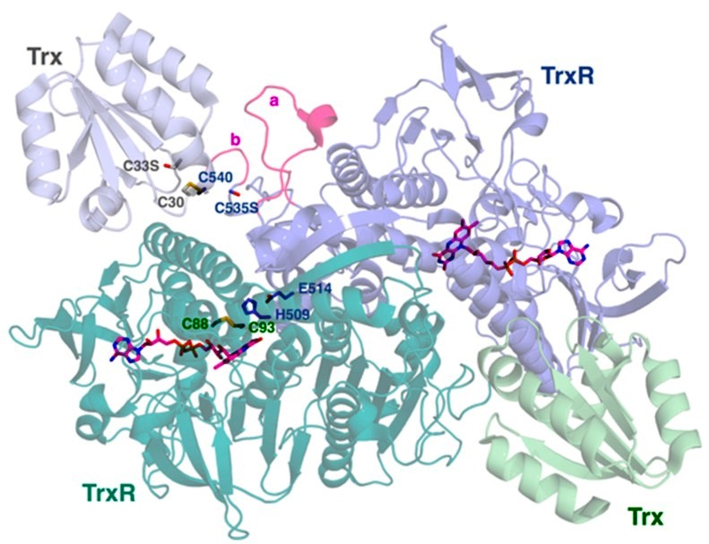

**Figure 1: Structure and Chemistry of PfTrxR.**

The dimeric Plasmodium falciparum thioredoxin reductase (TrxR) features two subunits each with an FAD cofactor, where one subunit's N-terminal redox disulfide (C88–C93) is modulated by residues (H509, E514) from the other, and each monomer binds its Trx substrate via an intermolecular disulfide (TrxR C540 to Trx C30), with unique Plasmodium insertions (H438–S452 and G536–K539) contributing to its specific structure. Adapted from McCarty et al. (2015).

1. **MECHANISMS OF ACT RESISTANCE**
   1. **GENETIC AND EPIGENETIC FACTORS**

ACT resistance is primarily associated with kelch13 mutations, such as C580Y, which disrupt hemoglobin endocytosis, reducing artemisinin activation (Birnbaum et al., 2020). In Africa, alleles like A578S are prevalent but lack in vivo resistance phenotypes (Ménard et al., 2016). Resistance to partner drugs involves gene amplifications, such as pfmdr1 for mefloquine and plasmepsin II/III for piperaquine (Dondorp et al., 2009; Witkowski et al., 2017). Epigenetic modifications, including histone acetylation, may induce transient drug tolerance by altering stress response gene expression (Miotto et al., 2020).

* 1. **ROLE OF REDOX METABOLISM**

Artemisinin’s efficacy relies on ROS-induced damage to parasite biomolecules (Rocamora et al., 2018). Selenoproteins, particularly PfTrxR, mitigate this stress, potentially reducing drug potency in resistant strains (Kavishe et al., 2017). Recent genomic studies using long-read sequencing have identified regulatory elements upstream of PfTrxR that enhance its expression in resistant isolates (Menichelli et al., 2021).

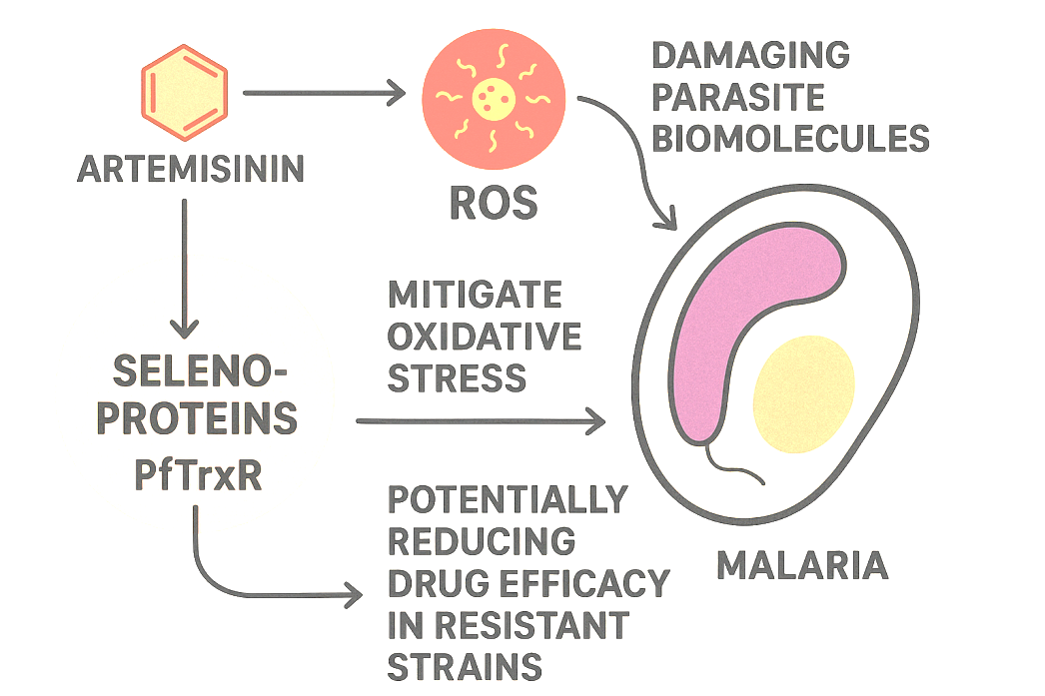

**Figure 2: Proposed role of selenoproteins in ACT Resistance.**

Artemisinin generates ROS, damaging parasite biomolecules. Selenoproteins, particularly PfTrxR, mitigate oxidative stress, potentially reducing drug efficacy in resistant strains. Targeting selenoproteins with inhibitors like auranofin may enhance ACT potency.

1. **SELENOPROTEINS AND ACT RESISTANCE**

Selenoproteins are hypothesized to contribute to ACT resistance by enhancing the parasite’s antioxidant capacity (Kavishe et al., 2017). PfTrxR, critical for redox signaling and protein repair, is overexpressed in resistant strains, potentially reducing artemisinin’s oxidative damage (Wang et al., 2010). Selenium availability, influenced by host nutritional status, may modulate selenoprotein activity, as evidenced by increased glutathione peroxidase activity in selenium-supplemented malaria patients (Gamain et al., 1996). Recent proteomic analyses have identified post-translational modifications (e.g., selenylation) in PfTrxR that enhance its stability under drug pressure (Schwarzer & Skorokhod, 2024). However, the precise mechanisms linking selenoprotein regulation to resistance remain unclear, necessitating studies on gene expression dynamics under drug pressure (Lobanov et al., 2006).

1. **IMPLICATIONS AND FUTURE DIRECTIONS**
   1. **THERAPEUTIC POTENTIAL OF TARGETING SELENOPROTEINS**

Inhibiting selenoproteins offers a promising strategy to overcome ACT resistance. Auranofin, a thioredoxin reductase inhibitor, disrupts *Plasmodium* *falciparum* redox balance, enhancing oxidative stress and antimalarial efficacy (Sannella et al., 2008). Given structural differences between parasite and human selenoproteins, selective inhibitors targeting selenocysteine active sites could minimize host toxicity (Látrová et al., 2021). Recent advances in computational drug design, including AlphaFold-based virtual screening, have identified novel PfTrxR inhibitors with high specificity (Patel et al., 2024). Molecular modeling and high-resolution structural studies (e.g., cryo-EM) are critical for designing such inhibitors (Lobanov et al., 2006).

* 1. **RESEARCH GAPS AND PRIORITIES**

1. Functional Genomics: Use CRISPR to elucidate selenoprotein roles in oxidative stress and resistance (Novoselov et al., 2002).
2. Expression Dynamics: Conduct single-cell transcriptomic and proteomic profiling to assess selenoprotein regulation under artemisinin pressure (Gamain et al., 1996).
3. Structural Biology: Resolve *Plasmodium falciparum* selenoprotein structures using cryo-EM and X-ray crystallography to guide drug design (Zhang et al., 2024).
4. Preclinical Studies: Evaluate selenoprotein inhibitors in murine and primate models to establish therapeutic indices (Sannella et al., 2008).

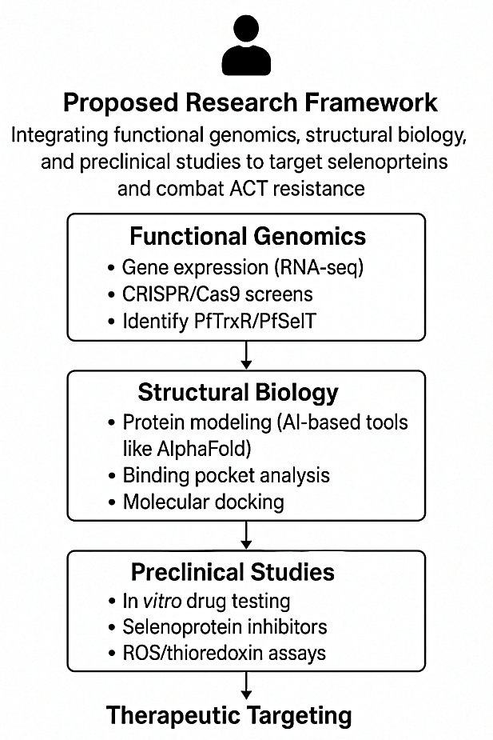

**Figure 3: Proposed Research Framework**

Integrating functional genomics, structural biology, and preclinical studies to target selenoproteins and combat ACT resistance.

1. **CONCLUSION**

This review underscores the emerging role of selenoproteins, particularly PfTrxR, in *Plasmodium* *falciparum’s* redox defense against artemisinin-induced oxidative stress. By enhancing antioxidant capacity, selenoproteins may contribute to ACT resistance, posing a threat to malaria control in Africa, where over 90% of global deaths occur (World Health Organization, 2023). Structural and functional differences between parasite and human selenoproteins position them as viable therapeutic targets. Selective inhibitors, informed by advanced structural and genomic techniques, could restore ACT efficacy. Future research should prioritize functional, structural, and epidemiological studies to validate selenoproteins as resistance mediators and therapeutic targets, paving the way for innovative strategies to achieve malaria elimination in endemic regions.

**Disclaimer (Artificial intelligence)**: Author(s) hereby declare that NO generative AI technologies such as Large Language Models (ChatGPT, COPILOT, etc.) and text-to-image generators have been used during the writing or editing of this manuscript.

References

Ashley, E. A., Dhorda, M., Fairhurst, R. M., Amaratunga, C., Lim, P., Suon, S., ... & White, N. J. (2014). Spread of artemisinin resistance in Plasmodium falciparum malaria. New England Journal of Medicine, 371(5), 411–423. <https://doi.org/10.1056/NEJMoa1314981>

Babbitt, S. E., Altenhofen, L., Cobbold, S. A., Llinás, M., & Goldberg, D. E. (2012). Plasmodium falciparum responds to amino acid starvation by entering into a hibernatory state. Proceedings of the National Academy of Sciences, 109(47), E3278–E3287. <https://doi.org/10.1073/pnas.1209823109>

Balikagala, B., Fukuda, N., Ikeda, M., Katuro, O. T., Tachibana, S. I., Yamauchi, M., Opio, W., Emoto, S., Anywar, D. A., Kimura, E., Palacpac, N. M. Q., Odongo-Aginya, E. I., Ogwang, M., Horii, T., & Mita, T. (2021). Evidence of Artemisinin-Resistant Malaria in Africa. *The New England journal of medicine*, *385*(13), 1163–1171. <https://doi.org/10.1056/NEJMoa2101746>.

Birnbaum, J., Scharf, S., Schmidt, S., Jonscher, E., Hoeijmakers, W. A. M., Flemming, S., Toenhake, C. G., Schmitt, M., Sabitzki, R., Bergmann, B., Fröhlke, U., Mesén-Ramírez, P., Blancke Soares, A., Herrmann, H., Bártfai, R., & Spielmann, T. (2020). A Kelch13-defined endocytosis pathway mediates artemisinin resistance in malaria parasites. *Science (New York, N.Y.)*, *367*(6473), 51–59. <https://doi.org/10.1126/science.aax4735>.

Conroy, A. L., Opoka, R. O., Bangirana, P., Namazzi, R., Georgieff, M. K., & John, C. C. (2022). Plasma amino acid concentrations in children with severe malaria are associated with mortality and worse long-term kidney and cognitive outcomes. Clinical Infectious Diseases, 75(12), 2215–2225. <https://doi.org/10.1093/infdis/jiac392>.

Dondorp, A. M., Nosten, F., Yi, P., Das, D., Phyo, A. P., Tarning, J., Lwin, K. M., Ariey, F., Hanpithakpong, W., Lee, S. J., Ringwald, P., Silamut, K., Imwong, M., Chotivanich, K., Lim, P., Herdman, T., An, S. S., Yeung, S., Singhasivanon, P., Day, N. P., … White, N. J. (2009). Artemisinin resistance in Plasmodium falciparum malaria. *The New England journal of medicine*, *361*(5), 455–467. <https://doi.org/10.1056/NEJMoa0808859>.

Gamain, B., Arnaud, J., Favier, A., Camus, D., Dive, D., & Slomianny, C. (1996). Increase in glutathione peroxidase activity in malaria parasite after selenium supplementation. Free Radical Biology and Medicine, 21(4), 559–565. <https://doi.org/10.1016/0891-5849(96)00120-7>.

Gopalakrishnan, A. M., & Kumar, N. (2015). Antimalarial action of artesunate involves DNA damage mediated by reactive oxygen species. Antimicrobial Agents and Chemotherapy, 59(1), 317–325. <https://doi.org/10.1128/AAC.03663-14>.

Kavishe, R. A., Koenderink, J. B., & Alifrangis, M. (2017). Oxidative stress in malaria and artemisinin combination therapy: Pros and cons. FEBS Journal, 284(16), 2579–2591. <https://doi.org/10.1111/febs.14097>.

Khan, S. (2016). Recent advances in the biology and drug targeting of malaria parasite aminoacyl-tRNA synthetases. Malaria Journal, 15(1), 203. <https://doi.org/10.1186/s12936-016-1247-0>

Labunskyy, V. M., Hatfield, D. L., & Gladyshev, V. N. (2014). Selenoproteins: Molecular pathways and physiological roles. Physiological Reviews, 94(3), 739–777. <https://doi.org/10.1152/physrev.00039.2013>.

Látrová, K., Havlová, N., Večeřová, R., Pinkas, D., Bogdanová, K., Kolář, M., Fišer, R., Konopásek, I., Do Pham, D. D., Rejman, D., & Mikušová, G. (2021). Outer membrane and phospholipid composition of the target membrane affect the antimicrobial potential of first- and second-generation lipophosphonoxins. *Scientific reports*, *11*(1), 10446. <https://doi.org/10.1038/s41598-021-89883-0>

Li, H., Bogyo, M., & da Fonseca, P. C. (2016). The cryo-EM structure of the Plasmodium falciparum 20S proteasome and its use in the fight against malaria. *The FEBS journal*, *283*(23), 4238–4243. <https://doi.org/10.1111/febs.13780>.

Lobanov, A. V., Hatfield, D. L., & Gladyshev, V. N. (2006). The Plasmodium selenoproteome. Nucleic Acids Research, 34(2), 496–505. <https://doi.org/10.1093/nar/gkj450>.

McCarty, S. E., Schellenberger, A., Goodwin, D. C., Fuanta, N. R., Tekwani, B. L., & Calderón, A. I. (2015). *Plasmodium falciparum* Thioredoxin Reductase(*Pf*TrxR) and Its Role as a Target for New Antimalarial Discovery. Molecules, 20(6), 11459-11473. <https://doi.org/10.3390/molecules200611459>.

Ménard, D., Khim, N., Berghain, J., Adegnika, A. A., Shafiul-Alam, M., Amodu, O., et al. (2016). A worldwide map of Plasmodium falciparum K13-propeller polymorphisms. New England Journal of Medicine, 374(25), 2453–2461. <https://doi.org/10.1056/NEJMoa1513137>.

Menichelli, C., Guitard, V., Martins, R. M., Lèbre, S., Lopez-Rubio, J. J., Lecellier, C. H., & Bréhélin, L. (2021). Identification of long regulatory elements in the genome of Plasmodium falciparum and other eukaryotes. *PLoS computational biology*, *17*(4), e1008909. <https://doi.org/10.1371/journal.pcbi.1008909>.

Miotto, O., Sekihara, M., Tachibana, S. I., Yamauchi, M., Pearson, R. D., Amato, R., Gonçalves, S., Mehra, S., Noviyanti, R., Marfurt, J., Auburn, S., Price, R. N., Mueller, I., Ikeda, M., Mori, T., Hirai, M., Tavul, L., Hetzel, M. W., Laman, M., Barry, A. E., … Mita, T. (2020). Emergence of artemisinin-resistant Plasmodium falciparum with kelch13 C580Y mutations on the island of New Guinea. *PLoS pathogens*, *16*(12), e1009133. https://doi.org/10.1371/journal.ppat.1009133

Müller, S. (2004). Redox and antioxidant systems of the malaria parasite Plasmodium falciparum. Molecular Microbiology, 53(5), 1291–1305. <https://doi.org/10.1111/j.1365-2958.2004.04257.x>.

Murray, C. J., Rosenfeld, L. C., Lim, S. S., Andrews, K. G., Foreman, K. J., Haring, D., et al. (2012). Global malaria mortality between 1980 and 2010: A systematic analysis. Lancet, 379(9814), 413–431. <https://doi.org/10.1016/S0140-6736(12)60034-8>.

Novoselov, S. V., Rao, M., Onoshko, N. V., Zhi, H., Kryukov, G. V., Xiang, Y., et al. (2002). Selenoproteins and the selenocysteine insertion system in the model plant cell system. EMBO Journal, 21(14), 3681–3693. <https://doi.org/10.1093/emboj/cdf372>.

Okon, A. U., Eze, B. I., Emmanuel, U. A., Marcus, I. W., & Adanna, U. A. (2022). Correlation of parasite density and biochemical parameters in children with malaria infection in Calabar, South-South Nigeria. Egyptian Pediatric Association Gazette, 70(1), 27. <https://doi.org/10.1186/s43054-022-00114-5>.

Okon, A. U., Eze, B. I., Emmanuel, U. A., Marcus, I. W., & Adanna, U. C. (2022). Correlation of parasite density and biochemical parameters in children with malaria infection in Calabar, South-South Nigeria. *Egyptian Pediatric Association Gazette*, *70*(1), 27. <https://doi.org/10.1186/s43054-022-00122-1>

Roberts, C. H., Mongkolsapaya, J., & Screaton, G. (2013). New opportunities for control of dengue virus. *Current opinion in infectious diseases*, *26*(6), 567–574. <https://doi.org/10.1097/QCO.0000000000000016>.

Rocamora, F., Zhu, L., Liong, K. Y., Dondorp, A., Miotto, O., Mok, S., & Bozdech, Z. (2018). Oxidative stress and protein damage responses mediate artemisinin resistance in malaria parasites. *PLoS pathogens*, *14*(3), e1006930. <https://doi.org/10.1371/journal.ppat.1006930>.

Sannella, A. R., Casini, A., Gabbiani, C., Messori, L., Bilia, A. R., Vincieri, F. F., ... & Severini, C. (2008). New uses for old drugs: Auranofin, a thioredoxin reductase inhibitor, displays antimalarial activity. Antimicrobial Agents and Chemotherapy, 52(6), 1827–1833. <https://doi.org/10.1128/AAC.01512-07>

Schwarzer, E., & Skorokhod, O. (2024). Post-Translational Modifications of Proteins of Malaria Parasites during the Life Cycle. *International journal of molecular sciences*, *25*(11), 6145. <https://doi.org/10.3390/ijms25116145>.

Straimer, J., Gnadig, N. F., Witkowski, B., Amaratunga, C., Duru, V., Ramadani, A. P., et al. (2015). Drug resistance: K13-propeller mutations confer artemisinin resistance in Plasmodium falciparum clinical isolates. Science, 347(6220), 428–431. <https://doi.org/10.1126/science.1260867>.

Tse, E. G., Korsik, M., & Todd, M. H. (2019). The past, present and future of anti-malarial medicines. Malaria Journal, 18(1), 93. <https://doi.org/10.1186/s12936-019-2724-z>.

Tumwebaze, P., Conrad, M. D., Walakira, A., LeClair, N., Byaruhanga, O., Nakazibwe, C., Kozak, B., Bloome, J., Okiring, J., Kakuru, A., Bigira, V., Kapisi, J., Legac, J., Gut, J., Cooper, R. A., Kamya, M. R., Havlir, D. V., Dorsey, G., Greenhouse, B., Nsobya, S. L., … Rosenthal, P. J. (2015). Impact of antimalarial treatment and chemoprevention on the drug sensitivity of malaria parasites isolated from ugandan children. *Antimicrobial agents and chemotherapy*, *59*(6), 3018–3030. <https://doi.org/10.1128/AAC.05141-14>.

Uwimana, A., Legrand, E., Stokes, B. H., Ndikumana, J. M., Warsame, M., Umulisa, N., Ngamije, D., Munyaneza, T., Mazarati, J. B., Munguti, K., Campagne, P., Criscuolo, A., Ariey, F., Murindahabi, M., Ringwald, P., Fidock, D. A., Mbituyumuremyi, A., & Menard, D. (2020). Emergence and clonal expansion of in vitro artemisinin-resistant Plasmodium falciparum kelch13 R561H mutant parasites in Rwanda. *Nature medicine*, *26*(10), 1602–1608. <https://doi.org/10.1038/s41591-020-1005-2>.

Wang, J., Huang, L., Li, J., Fan, Q., Long, Y., Li, Y., & Zhou, B. (2010). Artemisinin directly targets malarial mitochondria through its specific mitochondrial activation. *PloS one*, *5*(3), e9582. <https://doi.org/10.1371/journal.pone.0009582>.

World Health Organization. (2023). World malaria report 2023. <https://www.who.int/publications/i/item/9789240076790>.

Zhang, Y., Roh, Y. J., Han, S. J., Park, I., Lee, H. M., Ok, Y. S., Lee, B. C., & Lee, S. R. (2020). Role of Selenoproteins in Redox Regulation of Signaling and the Antioxidant System: A Review. *Antioxidants (Basel, Switzerland)*, *9*(5), 383. <https://doi.org/10.3390/antiox9050383>.