**Short communication**

**Climate-Resilient Poultry Feeding in Integrated Farming Systems of Northeast India.**

**Abstract**

Climate change has had a significant impact on the northeastern region of India, especially Meghalaya. This includes rising mean annual temperatures, unpredictable rainfall patterns, and deteriorating soil health, etc. In spite of these challenges, the locals have followed sustainable agricultural practices that allow for improved adaptation to climate change, reduced environmental degradation caused by agriculture, and better utilization of natural resources. One such approach is the integrated farming system (IFS) of agricultural practice that combine crops, livestock, fisheries, and agroforestry to maximize resource use and diversify farmer’s income. The principle of IFS is based on the effective recycling of resources, whereby the waste generated from one component is recycled and used as a resource for the other component. Here, we present the study on the utilisation of locally grown weed (Alligator weed) and herb (Peppermint) as feed supplement for enhanced production and improved health in grower chickens. In previously published work, for alligator weed experiment, 800 Vanaraja chicks were subjected to 4 dietary groups over summer and winter for 35 days- the control, 1%, 2% and 4% alligator weed supplemented group. And similarly, 240 roosters chicks were studied for peppermint experiment over 35 days, and were divided into 3 groups- the control group, 0.5% and 1% supplemented with Peppermint. It was found the beneficial effects of supplementation in grower chicken with alligator weed (1%) in winter season and peppermint (1%) in summer season in Umiam, Meghalaya weather condition when the ambient temperature varies with the thermal comfort zone of the poultry birds for its optimal production. It has higher body weight, greater average weight gain and a better feed conversion ratio. The weed and herb are easily grown and available resources in the traditional bun cultivation system of agriculture practice by the state’s tribal communities or the bench terracing on hilly slopes by levelling out slopes to enhance water retention and lessen soil erosion. Effective utilisation of plant resources (weed and herb) grown in the cultivation system which otherwise would have compete with other cultivated crops be use for enhancing poultry production is an implementable intervention for ameliorating food security, sustainability, and resilience in integrated system approach of agriculture. Therefore, climate adaptive management can serve to overcome the challenges in promoting sustainable practices in agriculture.

**Keywords:** poultry feeding, IFS, Sustainable, Climate adaptive management, Alligator weed, Peppermint

**Introduction**

Climate change has had a significant impact on the northeastern region of India, especially Meghalaya. This includes rising mean annual temperatures, unpredictable rainfall patterns, and deteriorating soil health. The state's weak economy, humid monsoon climate, and delicate geoenvironmental setting make it difficult to adjust to the effects of climate change. The economy of Meghalaya is primarily based on agriculture. But because of the climate change, agricultural sector has been greatly disturbed which results in reduced crop yield and low food productivity (Kresphulin 2025). Poultry farming is also one of the sources of employment and livelihood for the inhabitants of Meghalaya, not only it has economical values in terms of food security but also offers social, cultural and religious values. It economically benefits the people by providing source of income to the small holders, the women; it provides highly nutritious meat and eggs for household consumptions; and also, in some communities it is used in ritual offerings and is subjected to various traditional beliefs. However, climate changes threaten not only the agricultural productivity but also livestock’s performance. Increase in daily temperatures, higher humidity, and changed precipitation patterns creates unfavourable conditions for poultry farming. These conditions affect their body weight gain, their feed intake, health and productivity (Osuji *et al.,* 2024).

**Impacts of climate change on Poultry performance**

Climate change has become a major threat in poultry production. It affects their health, productivity and management. High ambient temperatures, changes in humidity, and extreme weather events have adverse consequences on poultry production systems (Kumar *et al.,* 2021).

*Heat stressed and productivity loss*:Heat stress is one of the major climatic problems which affects the production and growth performance of poultry. With increase in temperature, the chickens consume more water and less feed and also affects the utilization of nutrients by redirects energy from processes related to growth (Osuji *et al.,* 2024). This result in slower weight gain, low body weight and heightened vulnerability to various diseases (Oke *et al.,* 2024). Heat stressed has also been shown investigations to reduce egg production and quality (Osuji *et al.,* 2024).

*Immune suppression and susceptibility to infections*: As temperature rises, relative humidity drops which creates a favourable environment for bacteria and virus to grow, which can lead to outbreak of poultry diseases (Attia *et al.,* 2024).

*Scarcity of food and water*: Agricultural sector has been greatly disturbed by climate. The hilly nature of the state, excessive dependence on the natural resources, poor land management practices, and subsequent soil degradation make it more vulnerable to the effects of climate change. In addition, the uneven distribution of rainfall has led to frequent floods and droughts, which have resulted in reduced growth of fodder/grains (Osuji *et al.,* 2024). Thereby, the cost of the available feed increases.

Therefore, with rising in environmental stressor, feed strategies that support their health, resilience and locally sustainable and without increasing any input cost are critically needed to enhance poultry production. Several practices have been followed to adapt to these changes; one such practice is the integrated farming system (IFS).

**Integrated farming system (IFS): a sustainable approach**

IFS is an agricultural practice that combine crops and livestock to maximize resource use and diversify farmer’s income. This practice effectively recycles resources, whereby the waste generated from one component (like weeds) is recycled and used as a resource to support another (like feed for poultry). Therefore, by cultivating locally adaptable herb such as peppermint on buns and utilizing the naturally growing and invasive alligator plant that grows on the edges of the bench terracing, farmers can develop sustainable poultry feeding strategies.

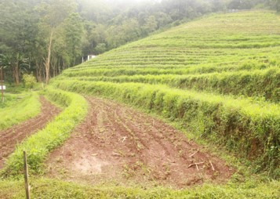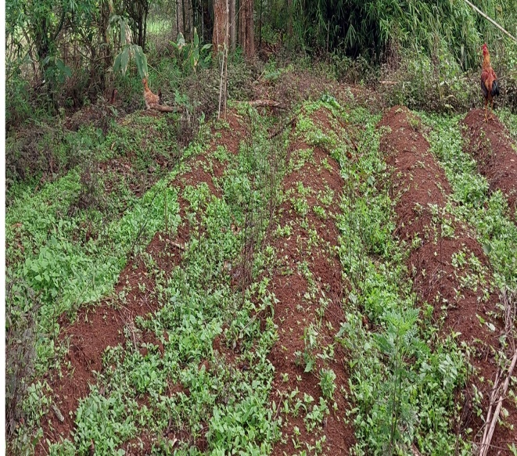

**A**

**B**

**Figure 1. (A)** Practices of bun cultivation and **(B)** Bench terracing in integrated farming system of agriculture in Meghalaya.

The bun cultivation (Fig1.A) is a traditional system practice by the state’s tribal communities including Khasi and Jaintia tribes, is an example of sustainable agriculture that shows resilience to climate change. In this type of farming, dried vegetations such as weeds, branches, twigs, etc. are placed on elevated beds, and then covered with soil, this is followed by burning the plant residue and other vegetation after drying, and planting the crops. This approach manages water flow by channelling the water flow through the furrows, thereby minimizing soil erosion, it utilizes limited biomass, land resources, and it is rain-fed conditions, therefore, this approach makes the system sustainable (Upadhaya *et al.,* 2019). In this setup garden kitchen herbs such as peppermint can be grown.

Another agricultural practices that followed by the locals is bench terracing (Fig1.B). The hilly nature and the slope terrain of the region, makes the farmers face difficulty in managing natural resources and water run-off from their agricultural land, therefore in this technique, benches are made on hilly slopes by levelling out slopes to enhance water retention and lessen soil erosion (Singh 2001), both of which are essential for sustainable agriculture in places like Meghalaya, that experience high rainfall and soil deterioration. These same environment supports the natural growth of weeds such as alligator weed along their edges. So, rather than treating them just as a kitchen garden herb or weeds, they can be repurposed into nutritive feed supplement, and support resource recycling in integrated farming systems.

**A**

**Potential of Alligator weed and** **Peppermint as herbal feed supplements in Poultry**

Alligator weed *(Alternanthera philoxeroides)*:

Alligator weed is often treated as an invasive plant, however, its potential as a resource is now being investigated in recent studies. It is known to have phenolic compounds and alkaloids thereby indicating anti-oxidant, anti-inflammatory and anti-microbial properties (Serdiati *et al.,* 2024). It grows naturally on the terrace edges; therefore, there’s no need of additional input for cultivation, thus, their use support resource recycling in IFS and sustainable feed resource. Chicks supplemented with 1% alligator weed showed significantly better body weight gain of approximately 41.28g and feed conversion ratio decreasing from 3.42 to 2.27, especially during the winter months with the average temperature of 16.57 ±1.37 °C (Puro *et al.,* 2025). This suggests more efficient energy use and better resilience even under climatic stress. Key immune markers particularly- iNOS, IFN-γ and IL-1β was analysed using Real time PCR and revealed upregulation in the alligator weed fed group (Fig. 2), which indicates enhanced immunity, which could improve resistance to infections and environmental stress.

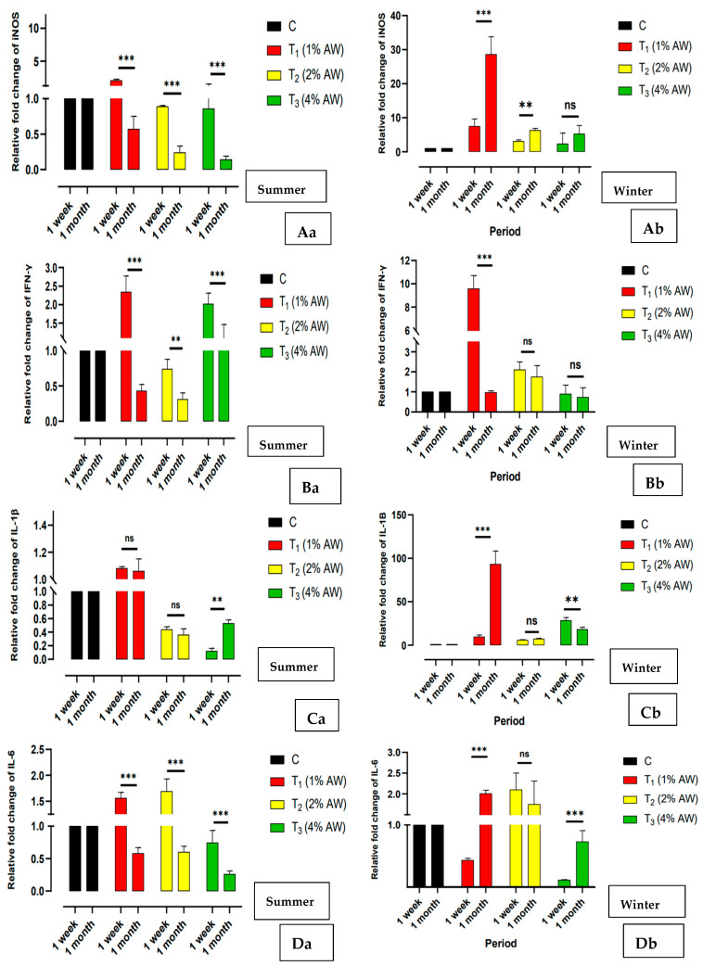 

C

B

A

**Figure 2**: Gene expression analysis of **(A)** iNOS, **(B)** IFN-γ and **(C)** IL-1β (Puro *et al.,* 2025).

Antioxidant enzymes activity, including SOD and CAT was analysed using ELISA and revealed elevation in supplemented birds, indicating antioxidant defence (Puro *et al.,* 2025). Also, Spectrophotometry assessment of liver enzyme like AST and ALT were within normal ranges, confirming that 1% supplementation was within the safe limits for the birds (Puro *et al.,* 2025). Thus, rather than treating them just an unwanted weed, these plants can be repurposed into nutritive feed supplements.

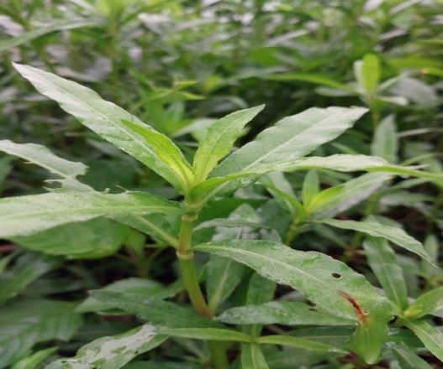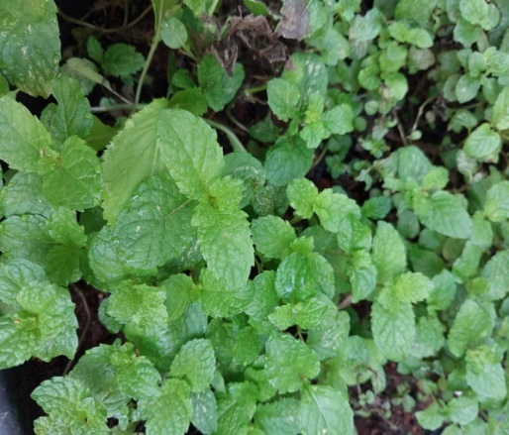

**A**

**B**

**Figure 3(A):** Alligator weed, **(B)** Peppermint

Peppermint *(Mentha piperita)*:

Peppermint is known to have antimicrobial, anti-oxidative, (Singh *et al.,* 2011) and anti-inflammatory properties (Goudarzi *et al.,* 2024), they contain bioactive compounds like flavonoid, polyphenol, which support digestion, and may boost immunity (Singh *et al.,* 2011). They are abundant and locally available in many rural and hilly regions and easy to cultivate. 1% peppermint-fed birds performed well, showing improved body weight gain and feed conversion efficiency, especially during the summer months with the average ambient temperature of 25.47 ±1.17 °C. This aligns with the studies that it can enhance poultry performance through its digestive and antioxidant properties. The supplemented birds also showed upregulation of immune markers like iNOS, IFN-γ, IL-6, (Fig. 4) suggesting immunomodulatory effect. These changes maybe especially helpful during seasonal transitions and environmental stress. The peppermint group also showed elevated SOD and CAT levels, with a corresponding reduction in cortisol, a stress hormone (Puro *et al.,* 2025). This indicates stronger antioxidant defence and reduced stress, which supports overall well-being in poultry



**Figure 4:** Gene expression analysis ofiNOS, IFN-γ, IL-6 (Puro *et al.,* 2025) in T1(0.5%) and T2 (1%).

**Table 1:** Summary of biomarkers analysed and the corresponding results for control and treatment group supplemented with Alligator weed (AW) and Peppermint (PM)

|  |  |  |  |
| --- | --- | --- | --- |
| Biomarkers | Treatment Group | | Function  (and References) |
| AW | PM |
| iNOS | Upregulated | Upregulated | It utilizes the oxidative damage of NO (Nitric oxide) to protect against infections (Knott & Bessy-Wetzel, 2009) |
| IFN-γ | Upregulated | Upregulated | It is an important pro- inflammatory cytokine and activates macrophages (Yang *et al.,* 2020) |
| IL-1β | Upregulated | - | It is essential for coordinating pro-inflammatory and host immunological responses. (Chen *et al.,* 2016) |
| IL-6 | - | Upregulated | It is an important pro- and anti-inflammatory cytokine (Scheller *et al.,* 2011) |
| CAT | Upregulated | Upregulated | It is responsible for radical detoxification ((Surai *et al.,* 2019) |
| SOD | Upregulated | Upregulated | It protects against lipid peroxidation (Surai *et al.,* 2019) |

**Discussion**

The study explores the use of Alligator weed and Peppermint as herbal feed supplements in poultry and focus on how these herbs may enhance production performance and support poultry health particularly in the context of climate change and sustainable integrated farming systems. The findings of the study offer several valuable insights. The use of alligator weed and peppermint as feed supplements for poultry shows measurable benefits in terms of growth performance, immune modulation, and antioxidant defense in poultry. These effects were more prominent at the 1% inclusion level, showing that even small additions of these herbs can produce meaningful outcomes. This approach is highly relevant in the context of climate change. With rising environmental stressors, feed strategies that support resilience without increasing input cost are critically needed. These herbs are not only effective but also locally available and abundant, making them practical for rural and hill-area farmer. This study highlights the importance of exploring other local, natural resources especially those that are invasive and grow unmanaged, their integration into farming system can promote resource use efficiency and long-term sustainability. These results also open doors for further research into a broader range of locally available herbs and weeds in livestock systems. Investigating their nutritional, medicinal, and economic potential could uncover new strategies for sustainable animal production. With just a modest level of awareness and basic management, these underutilized resources can be transformed into natural feed additives for long-term agricultural productivity. This aligns closely with the principles of Integrated farming System, where nothing goes to waste and every component contributes to overall farm health. Recent studies have also demonstrated the use of turmeric (*Cucurma longa*) (El-Sabrout *et al.,* 2023), black cumin (*Nigella sativa*), Cinnamon (Cinnamomumzeylanicum) (Oni *et al.,* 2023) as feed additives benefit the well-being of a chicken under heat stress conditions. These findings support the use of herbal feed additives to enhance poultry production system and reinforce resilience to climate change.

**Conclusion**

In conclusion, climate change will continue to threaten poultry farming system**,** especially for smallholder’s farmer. Integrating poultry farming with agricultural bund-based peppermint and alligator weed from the edges of the bench terrace offers a promising sustainable solution. These plant not only improve the health or performance of poultry but it also supports climate resilience by efficient use of existing landforms.

Disclaimer (Artificial intelligence)

Option 1:

Author(s) hereby declare that NO generative AI technologies such as Large Language Models (ChatGPT, COPILOT, etc.) and text-to-image generators have been used during the writing or editing of this manuscript.

Option 2:

Author(s) hereby declare that generative AI technologies such as Large Language Models, etc. have been used during the writing or editing of manuscripts. This explanation will include the name, version, model, and source of the generative AI technology and as well as all input prompts provided to the generative AI technology

Details of the AI usage are given below:

1.

2.

3.

**Reference**

1. Attia YA, Aldhalmi AK, Youssef IM, et al. Climate change and its effects on poultry industry and sustainability. *Discover Sustainability*. 2024;5(1). doi:10.1007/s43621-024-00627-2
2. Chen WT, Huang WY, Chen T, et al. Structure and function of chicken interleukin-1 beta mutants: uncoupling of receptor binding and in vivo biological activity. *Sci Rep*. 2016;6:27729. Published 2016 Jun 9. doi:10.1038/srep27729
3. El-Sabrout K, Khalifah A, Mishra B. Application of botanical products as nutraceutical feed additives for improving poultry health and production. Veterinary World. February 2023:369-379. doi:10.14202/vetworld.2023.369-379
4. Goudarzi MA, Radfar M, Goudarzi Z. Peppermint as a promising treatment agent in inflammatory conditions: A comprehensive systematic review of literature. *Phytother Res*. 2024;38(1):187-195. doi:10.1002/ptr.8041
5. Knott AB, Bossy-Wetzel E. Nitric oxide in health and disease of the nervous system. *Antioxid Redox Signal*. 2009;11(3):541-554. doi:10.1089/ars.2008.2234
6. Kresphulin W. A Study on Impact of Climate Change on Average Yields and their Variability of the Principal Crops in Meghalaya. *Journal of emerging technologies and innovative research* ISSN:2349-5162, Vol.12, Issue 1, page no.d414-d422, January-2025, Available :http://www.jetir.org/papers/JETIR2501343.pdf
7. Kumar M, Ratwan P, Dahiya SP, Nehra AK. Climate change and heat stress: Impact on production, reproduction and growth performance of poultry and its mitigation using genetic strategies. *Journal of Thermal Biology*. 2021;97:102867. doi:10.1016/j.jtherbio.2021.102867
8. Oni AI, Adeleye OO, Adebowale TO, Oke OE. The role of phytogenic feed additives in stress mitigation in broiler chickens. Journal of Animal Physiology and Animal Nutrition. 2023;108(1):81-98. doi:10.1111/jpn.13869
9. Osuji E, Ahamefule B, Ben-Chendo G, et al. Effect of climate variables on poultry production efficacy in Nigeria. *Online Journal of Animal and Feed Research*. May 2024. doi:10.51227/ojafr.2024.23
10. Oke OE, Akosile OA, Uyanga VA, et al. Climate change and broiler production. *Veterinary Medicine and Science*. 2024;10(3). doi:10.1002/vms3.1416
11. Puro K-u, Abedin SN, Hussain Z, Wankhar JBM, Doley S, Aochen C, Choudhury BU, Singh M, Katiyar R, Deori S. Effect of Alligator Weed (*Alternanthera philoxeroides*) Supplementation on Production Performance, Immune Response and Antioxidant Function of Improved Rural Chicken. *Animals*. 2025; 15(5):742. https://doi.org/10.3390/ani15050742
12. Scheller J, Chalaris A, Schmidt-Arras D, Rose-John S. The pro- and anti-inflammatory properties of the cytokine interleukin-6. *Biochim Biophys Acta*. 2011;1813(5):878-888. doi:10.1016/j.bbamcr.2011.01.034
13. Serdiati N, Islamy RA, Mamat N, Hasan V & Valen F. Nutritional Value of Alligator Weed (Alternanthera philoxeroides) and Its Application for Herbivorous Aquaculture Feed. *International Journal of Agriculture and Biosciences*. 2024; 13. 318-324. 10.47278/journal.ijab/2024.124.
14. Singh R, Shushni M & Belkheir A. Antibacterial and antioxidant activities of Mentha piperita L. Arabian J. Chemistry (Elsevier). (Impact Factor: 2.69). 2011; doi:10.1016/j.arabjc.2011.01.019.. 10.1016/j.arabjc.2011.01.019.
15. Singh, S.B. (2001). Valuation of soil erosion effects in bench terrace, Puertorican terrace and shifting cultivation systems in Meghalaya state. *Indian Journal of Agricultural Economics*. 56. 335-345.
16. Surai PF, Kochish II, Fisinin VI, Kidd MT. Antioxidant Defence Systems and Oxidative Stress in Poultry Biology: An Update. *Antioxidants (Basel)*. 2019;8(7):235. Published 2019 Jul 22. doi:10.3390/antiox8070235
17. Upadhaya, K., Barik, S.K., Kharbhih, V.M. *et al.* Traditional bun shifting cultivation practice in Meghalaya, Northeast India. *Energ. Ecol. Environ.* **5**, 34–46 (2020). <https://doi.org/10.1007/s40974-019-00144-3>
18. Yang X, Arslan M, Liu X, et al. IFN-γ establishes interferon-stimulated gene-mediated antiviral state against Newcastle disease virus in chicken fibroblasts. *Acta Biochim Biophys Sin (Shanghai)*. 2020;52(3):268-280. doi:10.1093/abbs/gmz158