# Prevalence and Antimicrobial Resistance Pattern of *Salmonella* Isolated from Table

1. **Eggs in Chitwan District, Nepal**

12

# Abstract

Non-typhoidal *Salmonella* is one of the most commonly reported enteric pathogens worldwide. The disease is estimated to cause approximately 153 million cases of gastroenteritis and 57,000 deaths globally each year. Egg-borne salmonellosis is a significant global public health issue. The increase in antimicrobial resistance of Salmonella has become a worldwide problem in recent decades. This study aimed to investigate the prevalence and antimicrobial resistance patterns o*f Salmonella* in table eggs in the Chitwan district. Purposive sampling was conducted in retail shops and layer farms of the Chitwan district, Nepal. Between September and December 2022, a total of 146 table eggs were collected from different retail shops and layer farms within the district—40 eggs from layer farms and 106 from retail shops. All 146 eggs were tested for *Salmonella* using standard culture-based methods.

19

1. The overall prevalence of *Salmonella* in table eggs was found to be 6.16%. Among eggs
2. obtained from retail shops, *Salmonella* was isolated from 2.73% of eggshells (shell only),
3. 1.36% of egg contents (content only), and 1.36% of samples in which both the shell and the
4. content tested positive. In contrast, eggs collected from layer farms exhibited a substantially
5. lower prevalence, with *Salmonella* detected in 0.68% of eggshells only. No *Salmonella* was
6. recovered from egg contents or from both components in the layer farm samples.
7. The resistance of *Salmonella* to Ceftriaxone, Tetracycline, Chloramphenicol, Enrofloxacin,
8. and Ciprofloxacin was 9.1%, 27.3%, 18.2%, 100%, and 36.3%, respectively. Additionally,
9. 18.18% of the *Salmonella* isolates were resistant to three or more antibiotic groups, indicating
10. multidrug resistance. Notably, all multidrug-resistant *Salmonella* were isolated from eggshells.
11. The results of this study indicate a higher prevalence of *Salmonella* in eggs from retail markets,
12. , suggesting a greater risk to consumers. Reducing the *Salmonella* contamination rate in retail
13. eggs require effective interventions at both the farm and packing station levels. Moreover,
14. eggs should be thoroughly cooked before consumption to minimise health risks.

34

1. ***Keywords:*** *AMR, egg contamination, MDR, Public health, Zoonosis, Salmonella, Chitwan,*
2. *Retail Shop*

37

38

39

40

41

42

43

# 1. Introduction

1. **1.1 Background**
2. Foodborne diseases are significant public health concerns worldwide, affecting both developed and developing countries. They impact health and have economic consequences. Salmonella poisoning is a major cause of bacterial enteritis, with 1 in 10 people falling ill each year and 33 million healthy life years lost. The most common Salmonella serotypes causing foodborne illness in humans are *S. Typhimurium* and *S. Enteritidis*, with approximately 75% of cases linked to contaminated food products like beef, pork, poultry, and eggs (Fayed et al., 2021; Abd El-fatah et al., 2020).
3. Non-typhoidal *Salmonella* is one of the most commonly reported enteric pathogens worldwide
4. (Tauxe & Pavia, 1998). In humans, Salmonella causes several clinical illnesses such as enteric fever, gastroenteritis, enterocolitis, septicemia and systemic infections (Hossain et al., 2019). The disease is estimated to cause approximately 153 million cases of
5. gastroenteritis and 57,000 deaths globally each year (Jessica et al., 2022). In 2018,
6. *Salmonella* was implicated in 30.7% of reported foodborne outbreaks, making it the second
7. most commonly reported zoonotic diseases leading to hospitalisation after campylobacteriosis,
8. and the second leading cause of death after listeriosis, due to the consumption of
9. contaminated foods in Europe (EFSA and ECDC, 2019). Several foods have been linked to
10. outbreaks of salmonellosis (Ferrari et al., 2019).
11. Poor implementation of biosecurity in poultry farms also increases the risk of zoonotic
12. pathogens like Salmonella enter the food chain (Dhakal et al., 2025). Consumption of
13. undercooked or raw eggs have been identified as a significant risk factor for salmonellosis,
14. contributing to 47.2% of total *Salmonella* infections (Ferrari et al., 2019). In most developed
15. countries, the prevalence of *Salmonella* in commercial table eggs is minimal (Harsha, 2011).
16. Poultry birds are frequently infected with *Salmonella*, making them a major source of human
17. infection (Vandeplas et al., 2010). The use of antimicrobial agents to treat salmonellosis in
18. poultry has led to the emergence of *Salmonella* spp. with increased resistance to these agents
19. (Phagoo & Neetoo, 2015). Furthermore, the routine use of antibiotics for growth promotion
20. and prophylaxis in layer hens has contributed to the development of antibiotic-resistant
21. bacteria (Mudenda et al., 2022).

65

# 1.2 Problem Statement

Egg-borne salmonellosis is a significant global public health issue (Rahman et al., 2019). The

1. % increase in antimicrobial resistance of Salmonella has become a worldwide problem in recent years
2. decades (Su et al., 2004). Due to the decreased effectiveness of antimicrobial treatments,
3. antibiotic-resistant bacteria isolated from foodborne diseases like Salmonellosis are a public
4. health problems (Sin et al., 2020). The common practice of using antibiotics for the growth
5. and prophylaxis of layers have contributed to the development of antibiotic-resistant bacteria
6. (Mudenda et al., 2022).
7. This study investigates the presence of Salmonella in eggshells and egg contents (albumin
8. and yolk), evaluates the contamination of table eggs collected from layer farms and retail
9. markets, examines the antibiotic resistance patterns of Salmonella isolates against commonly used
10. used antibiotics, and analyses the multidrug resistance profiles of the isolated strains to provide insights
11. into the public health risks associated with egg-borne salmonellosis.

79

80

81

82

83

84

85

86

87

88

# 2. Methodology

1. **2.1 Study Area**
2. The study was conducted in Chitwan District, Nepal, from September to December 2022.
3. Samples were collected from retail egg shops and layer farms within the district. The collected
4. samples were then transported to the laboratory of the National Avian Disease Investigation
5. Laboratory, Chitwan, Nepal.

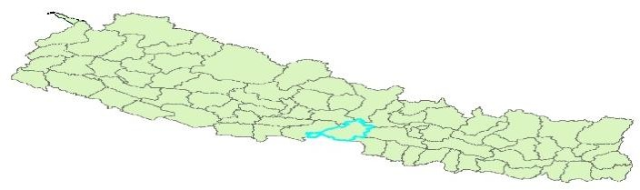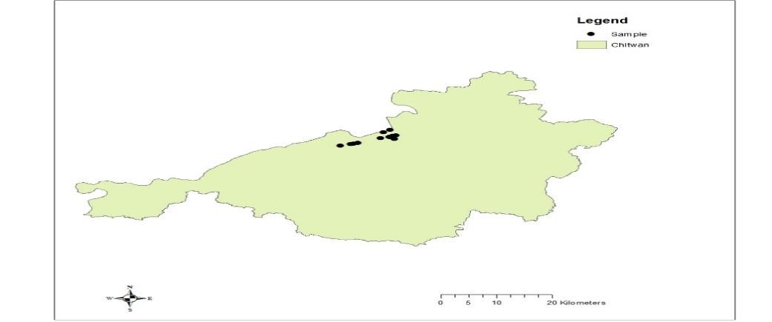

99

0

95

96

97

98

107

10

101

102

103

104

105

108

109

# Fig. 1. Map of Nepal showing the Study area

**2.2 Study Population and Sample Size**

106

110 Purposive sampling was conducted in retail shops and layer farms of the Chitwan district.

111

1. **Population Size:** Unknown
2. To determine the sample size for a study with an unknown population size, the following
3. formula was used:

115

𝑛 =

𝑍2 . 𝑃 . (1 − 𝑃)

𝑒2

|  |  |
| --- | --- |
| 116 | **Where:** |
| 117 | n = Required sample size |
| 118 | Z = Z-value (standard normal deviate) corresponding to the desired confidence level |
| 119 | P = Expected prevalence of the pathogen |
| 120 | e = Margin of error (desired level of precision) |
| 121 |  |
| 122 | Based on the findings of Sharma et al. (2021), the expected prevalence of the pathogen in |
| 123 | poultry feces is 10.6%. |
| 124 | Given: |
| 125 | Z = 1.96 (corresponding to a 95% confidence level) |
| 126 | P = 0.106 |

127

129

128

e = 0.05

𝑛 =

1.962 . 0.106 . (1 − 0.106)

0.052

130 Thus, the minimum required sample size is 146.

131

# 2.3 Sample Collection and Processing

1. **2.3.1 Collection of Sample:**
2. A total of 146 table eggs were collected, of which 40 were obtained directly from layer farms
3. and 106 from retail shops. The samples were collected aseptically using sterile zipper bags,
4. gloves and other appropriate materials. During the collection process, precautions were taken
5. at all stages—including sampling, transportation, and storage—to minimise the risk of cross-
6. contamination.

# 2.3.2 Pre-enrichment

1. A non-selective medium, such as buffered peptone water, was used as a pre-enrichment
2. medium in which most strains exhibit sufficient growth after incubation for 24 hours at 37°C.
3. The eggs were cracked into sterile aluminium foil bowls using sterile scissors. The contents of
4. the eggs (albumen and yolk) were mixed thoroughly. Then, 1 mL of the mixture was added to
5. 9 mL of buffered peptone water using a micropipette. The corresponding eggshells were
6. crushed, and 1 g of shell was mixed with 9 mL of buffered peptone water in a separate tube.
7. All tubes were incubated at 37°C for 24 hours.

# 2.3.3 Enrichment

1. Selenite broth was used as enrichment media. 1 ml of pre-enriched sample was mixed with 5
2. ml of selenite broth and incubated at 37°C for 4-6 hours.

# 2.3.4 Isolation

1. Xylose-Lysine Desoxycholate (XLD) agar medium was used for the isolation of *Salmonella*
2. species due to its high selectivity. A loopful of the enriched sample was streaked on XLD agar
3. media and incubated at 37°C for 24 hours. After 24-hour incubation, the pink colonies with the
4. black centres were used for biochemical characterisation.
5. Result of Gram Staining: In Gram staining under the microscope, the organism revealed gram-
6. negative, pink colour; small rod-shaped appearance, arranged in single, paired, or chain form

157

158

159

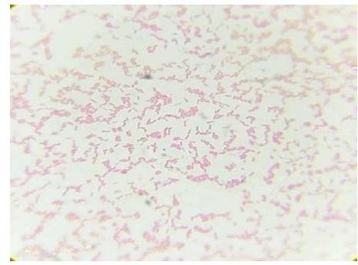160

161

162

163

164

165

166

167

168

# 169 Fig. 2. Gram’s stain Gram-negative medium-sized rod-shaped bacterium

170

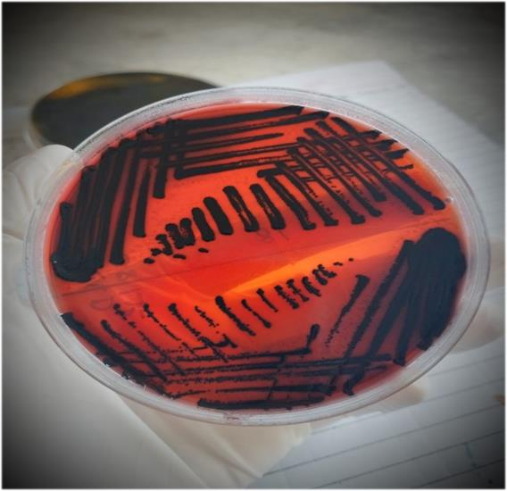180

171

172

173

174

175

176

177

178

179

# Fig. 3. Enrichment of sample in selenite broth Fig. 4. Salmonella on XLD Agar

1. **2.3.5 Biochemical tests:**

183

1. To confirm the identity of suspected *Salmonella* species, a series of biochemical tests were
2. performed. The initial screening involved Gram staining, catalase, and oxidase tests. Gram
3. staining identified the organisms as Gram-negative. The catalase test showed bubbling
4. when exposed to 5% hydrogen peroxide, indicating a positive reaction. The oxidase test
5. yielded a purple colouration on the oxidase disc, also confirming a positive result.
6. Colonies that tested positive in these preliminary assessments underwent further biochemical
7. testing. The Simmons Citrate test demonstrated the ability of the organism to utilise citrate,
8. evidenced by a colour change to blue. The Triple Sugar Iron (TSI) test was used to evaluate
9. carbohydrate fermentation and hydrogen sulfide (H₂S) production, with results indicated by
10. specific colour shifts in the medium. The Sulfur Indole Motility (SIM) test was employed to
11. examine motility, indole formation, and H₂S production, with blackening and medium turbidity
12. signalling positive results. The Methyl Red (MR) test confirmed acid production through a red
13. colour change, while the Voges-Proskauer (VP) test, used to detect butanediol fermentation,
14. showed no colour development, indicating a negative outcome.

# 2.3.6 Antibiotic susceptibility test:

1. Each isolate was tested for its sensitivity to the following antibiotics: Chloramphenicol,
2. Ciprofloxacin, Enrofloxacin, Tetracycline, and Ceftriaxone. Well-isolated colonies from XLD
3. agar plates were inoculated into the nutrient broth, and the turbidity of the suspension was adjusted
4. to a 0.5 McFarland standard. After 15 minutes, each *Salmonella* isolates were cultured on
5. Mueller-Hinton Agar using a sterile cotton swab. The antibiotic discs were then placed on the
6. media. The plates were incubated at 37°C for 24 hours. The diameters of zones of inhibition
7. were measured in millimetres with a vernier calliper scale. Using an interpretation chart,
8. ,according to the zone size of each antimicrobial reporting the organism was interpreted as
9. ‘Resistant’, ‘Intermediate’, and ‘Sensitive’.

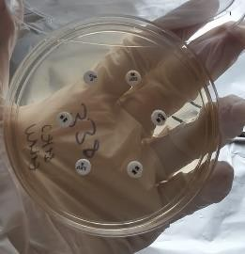208

209

210

211

212

213

214

215

216

217

# 218 Fig.5. Growth inhibition zone of *Salmonella* against selected antibiotic discs

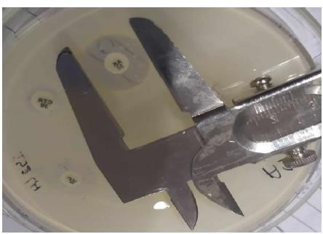219

220

221

222

223

224

225

226

227

# 228 Fig.6. Determination of inhibition zone diameter using a Vernier caliper

229

230

231

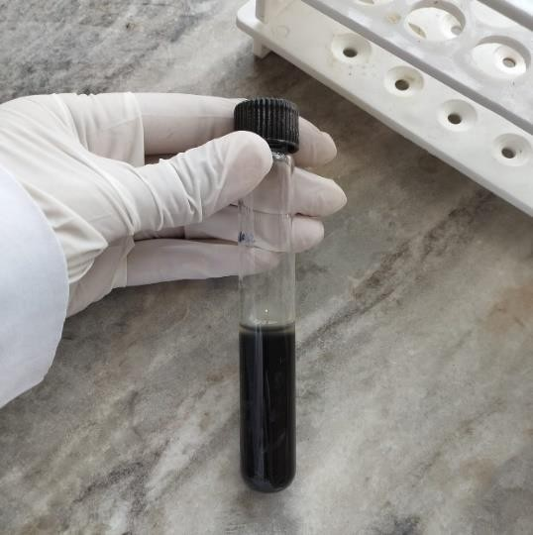 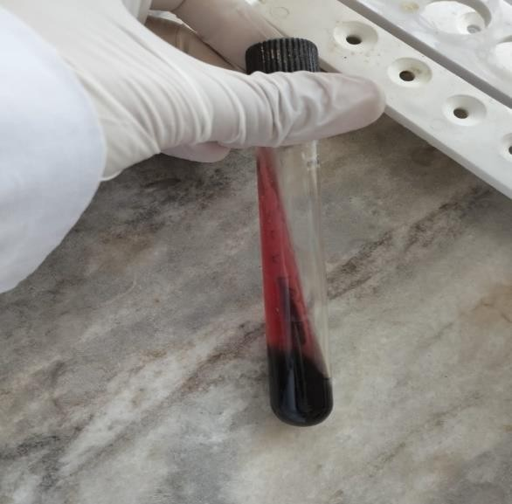

242

232

233

234

235

236

237

238

239

240

241

243

244

245

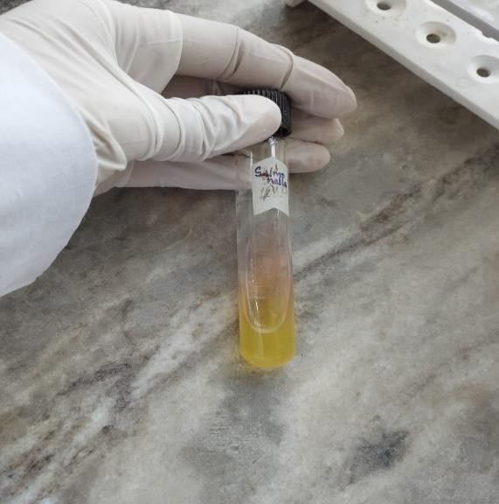246

258

259

260

# Fig. 7. SIM media for indole, motility and sulfide test Fig. 8. Triple Sugar Iron Test

247

248

249

250

251

252

253

254

255

256

257

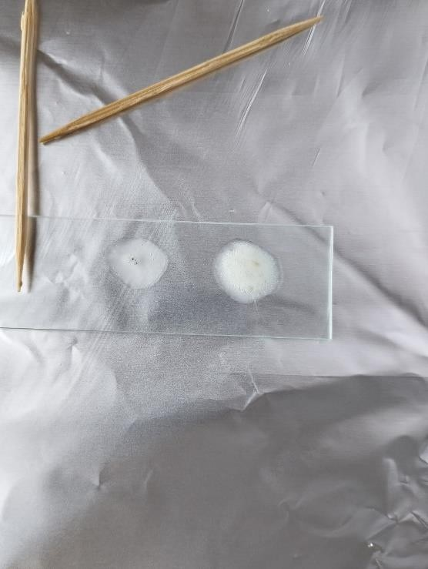

# Fig.9. Urease Test Fig.10. Catalase Test

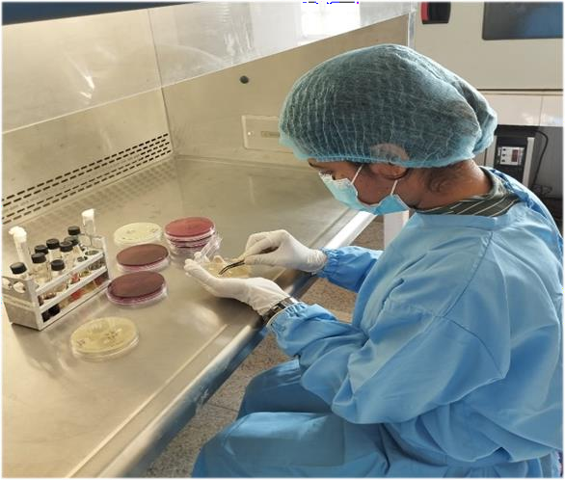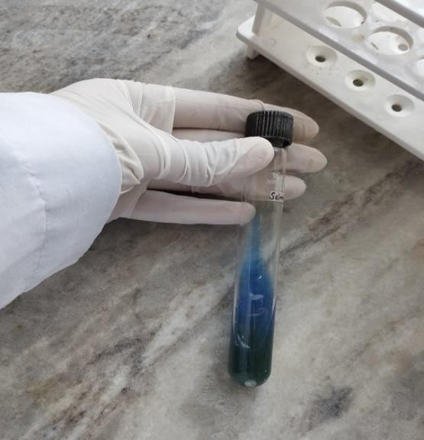269

261

262

263

264

265

266

267

268

# Fig.11. Citrate Utilisation Test Fig.12 Antibiotic Sensitivity Test

1. **2.4 Statistical analysis:**
2. The data were collected routinely and entered into an Excel sheet. The entered data will be
3. were analysed using IBM SPSS Statistics version 25.

274

1. **3. Result**
2. **3.1 Prevalence of *Salmonella* in table egg samples sourced from Chitwan district**
3. **Table 1: Prevalence of *Salmonella* from eggshell and contents**

|  |  |  |  |  |  |
| --- | --- | --- | --- | --- | --- |
| Collection point | Positive Samples | | | Negative Samples | Total No. of samples |
| Shell only | Content only | Shell and Content |
| Retail shops | 4 (2.73%) | 2 (1.36%) | 2 (1.36%) | 98 (67.1%) | 106 (72.6%) |
| Layer Farms | 1 (0.68%) | 0 (0%) | 0 (0%) | 39 (26.7%) | 40 (26.39%) |
| Total | 5 (3.42%) | 2 (1.36%) | 2 (1.36%) | 137 (93.84%) | 146 (100%) |
| 6.16% | | |

278

279

280

281

282

283

284

285

286

287

288

289

290

291

3.00 %

2.50 %

2.00 %

1.50 %

1.00 %

0.50 %

0.00 %

 Shell only  Content only  Shell and Content

Retail shops Layer farms



2.73 %

1.36 %

1.36 %

0.68 %

0%

0%

**Point of collection**

**Figure 13: Prevalence of *Salmonella* in eggs**

1. The overall prevalence of *Salmonella* in table eggs was found to be 6.16%. Among eggs
2. obtained from retail shops, *Salmonella* was isolated from 2.73% of eggshells (shell only),
3. 1.36% of egg contents (content only), and 1.36% of samples in which both the shell and the
4. content tested positive. In contrast, eggs collected from layer farms exhibited a substantially
5. lower prevalence, with *Salmonella* detected in 0.68% of eggshells only. No *Salmonella* was
6. recovered from egg contents or from both components in the layer farm samples.

298

299 **3.2 Prevalence of *Salmonella* in shell and content samples**

300 7 (4.8%) of 146 eggshells and 4 (2.7%) of 146 egg content samples tested positive for

301 Salmonella.

302



**Source of pathogen**

content

Shell

0.00%

2.70%

4.80%

80.00%

60.00%

40.00%

20.00%

97.30%

95.20%

120.00%

100.00%

Positive Negative

303 **Figure 14: Frequency of Salmonella in shell and content**

304

305

306

307

308

309

310

311

312

313

314

315

# Table 2. Statistical association of *Salmonella* with sample type

|  |  |  |  |  |  |  |
| --- | --- | --- | --- | --- | --- | --- |
| **Sample type** | **Number of sample (X)** | **Number of positive (Y)** | **Prevalence (Y/X)** | **Odds ratio (95% CI)** | ***p*- value** | **Association** |
| Shell | 146 | 7 | 4.79% | 1.78  (0.45–  7.04) | 0.54 | Statistically non- significant(*p*> 0.05) |
| Content | 146 | 4 | 2.74% | — | — | — |

The result showed that there is no significant difference in the prevalence of Salmonella between eggshell and content samples examined (p > 0.05).

**3.3 Prevalence of *Salmonella* in table eggs sourced from retail shops and layer farms**



120.00%

100.00%

80.00%

60.00%

40.00%

20.00%

0.00%

Layer farms

Retail shops

Positive Negative

|  |  |  |  |  |  |
| --- | --- | --- | --- | --- | --- |
| 97.50% | | |  | | |
|  |  |  |  | 92.50% |  |
|  |  |  |  |
|  |  |  |  |
|  |  |  |  |
| 2.50% |  | 7.50% |  |

**Figure 15: Prevalence of n table eggs sourced from retail shops and layer farms**

**Table 3. Statistical Association of *Salmonella* with Collection Point**

|  |  |  |  |  |  |  |
| --- | --- | --- | --- | --- | --- | --- |
| ***Collection Point*** | ***Number of samples (X)*** | ***Number of positive***  ***(Y)*** | ***Prevalence (Y/X)*** | ***Odds Ratio (95% CI)*** | ***p- value*** | ***Association*** |
| *Retail Shops* | *106* | *8* | *7.55%* | *3.18*  *(0.38–*  *26.36)* | *0.28* | *Statistically non-significant* |
| *Layer Farms* | *40* | *1* | *2.50%* | *—* | *—* |  |

*The result shows that there is no significant difference in the prevalence of Salmonella between*

316 *eggs collected from retail shops and layer farms (p > 0.05).*

317

1. The prevalence of *Salmonella* in eggs collected from **layer farms** was found to be **2.50%.** The
2. prevalence of *Salmonella* in eggs collected from the **retail market** was found to be **7.50%**.

# 3.4 Antimicrobial resistance profiles of *Salmonella* isolated from table eggs:



18.2

Ciprofloxacin

18.2

9.1

0

0

0

0 0

0

Ceftriaxone

Tetracycline

Chloramphenicol

**Antimicrobials**

Enrofloxacin

20

27.3

36.3

40

45.5

60

72.7

80

81.8

90.9

100

100

120

Sensitive Intermediate Resistant

321

322

323

324

325

326

327

# Figure 16: Antimicrobial resistance profiles of Salmonella isolated from Table eggs

The resistance of the *Salmonella* to Ceftriaxone, Tetracycline, Chloramphenicol, Enrofloxacin, and Ciprofloxacin was found to be 9.1%, 27.3%, 18.2%, 100%, and 36.3%, respectively.

# 3.5 Multi-drug resistance profiles of *Salmonella* isolated from table eggs



MDR , 18.18%

NON -MDR ,

81.82%

MDR NON-MDR

**Figure 17: Multi-drug resistance profiles of *Salmonella* isolated from table eggs**

1. 18.18% isolated *Salmonella* were found to be resistant to ≥3 antibiotic groups. All of the
2. MDR *Salmonella* were recovered from eggshells.

# 4. Discussion

1. The present study found an overall *Salmonella* prevalence of 6.16% in table eggs collected
2. from Chitwan, Nepal, with a notably higher prevalence in retail shop samples (7.55%) than in
3. farm-collected eggs (2.5%). This difference suggests that contamination is more likely to occur
4. during post-farm handling, such as transportation, storage, and display at markets. Similar
5. findings were reported by El Ftouhy et al. (2022), who observed significantly higher bacterial
6. contamination in eggs from informal markets than from formal sources in Morocco. This may
7. be due to poor hygiene practices, lack of refrigeration, and frequent human contact with eggs
8. during retail handling.
9. The lower prevalence of farm eggs observed in our study may be due to better on-site hygiene
10. and biosecurity. Dhakal et al. (2025) emphasised that poultry farms with improved biosecurity
11. in Chitwan had a reduced risk of *Salmonella* contamination. Similarly, Shah et al. (2021) found
12. that the prevalence of *Salmonella* was lower in eggs collected directly from farms compared to
13. to retail outlets in Peshawar, Pakistan.
14. Shell contamination (4.79%) was more common than contamination of egg contents (2.74%),
15. , which aligns with previous research. Gantois et al. (2009) reported that eggshells are more
16. are likely to be contaminated during or after laying, especially when they come into contact with
17. faeces, dirty nesting materials, or human hands. Contamination of the contents usually occurs
18. when bacteria penetrate the shell through cracks or pores, which is less common. Bruce and
19. Drysdale (1994) and Messens et al. (2007) both observed that environmental conditions, like
20. high humidity and improper washing can facilitate the movement of *Salmonella* through the
21. eggshell barrier.
22. Although our statistical analysis showed no significant difference in contamination between
23. shell and content samples (p > 0.05), the practical risk is considerable. Contaminated shells
24. can lead to cross-contamination during food preparation, especially when raw eggs are
25. handled or undercooked. This is consistent with the findings of Howard et al. (2012), who
26. stated that shell contamination remains a key route for *Salmonella* entry into households.
27. Antimicrobial resistance (AMR) patterns showed that all *Salmonella* isolates were resistant to
28. Enrofloxacin (100%), and many were resistant to Ciprofloxacin (36.3%), Tetracycline (27.3%),
29. and Chloramphenicol (18.2%). This trend is alarming but not surprising. Phagoo and Neetoo
30. (2015) found that the overuse of antibiotics like Enrofloxacin in poultry farms contributed to
31. high resistance rates in *Salmonella* isolates. Similar resistance to fluoroquinolones has been
32. documented by Sin et al. (2020) in Korea, and by Haque et al. (2021) in Bangladesh.
33. Additionally, 18.18% of the *Salmonella* isolates in our study were multidrug-resistant (MDR),
34. ,meaning they were resistant to three or more antibiotic classes. All MDR isolates were found
35. on eggshells. This suggests that MDR strains are more likely to be acquired from external
36. environmental sources, such as contaminated surfaces, farm litter, or human handling, rather
37. than vertical transmission through the egg contents. Rahman et al. (2019) similarly reported
38. that MDR *Salmonella* was more frequently recovered from eggshells than from the internal
39. contents.
40. Our prevalence rate (6.16%) falls between findings from different regions. It is lower than the
41. 11.5% reported by Shah et al. (2021) in Pakistan, but higher than the 2.5% found by Harsha
42. (2011) in India. These differences may be due to variations in biosecurity levels, antibiotic use,
43. temperature and humidity during storage, and national food safety regulations. In countries

|  |  |
| --- | --- |
| 374 | with strict egg handling protocols and routine refrigeration, such as in the United States or the |
| 375 | EU, contamination rates tend to be much lower (Howard et al., 2012). |
| 376 | In summary, the results highlight that eggs from retail outlets are more likely to be |
| 377 | contaminated with *Salmonella*, particularly on the shell, and that some of these isolates show |
| 378 | resistance to multiple antibiotics. This suggests an urgent need for better hygiene practices at |
| 379 | all levels of egg production and distribution, as well as careful monitoring and regulation of |
| 380 | antibiotic use in poultry farms to prevent the spread of resistant *Salmonella* strains. |
| 381 | **5. Recommendation** |
| 382 | To further support the findings of this study, future research should explore the epidemiology |
| 383 | of *Salmonella* in layer farm environments and its potential transmission to humans. |
| 384 | **6. Beneficiaries**: |
| 385 | Primary Beneficiaries: Layer Farmers and Consumers |
| 386 | Secondary Beneficiaries: Researchers |
| 387 | **7. Conclusion** |
| 388 | The higher prevalence of *Salmonella* in eggs from retail markets suggests an increased risk |
| 389 | to consumer health. Contamination on the eggshell surface can lead to the spread of the |
| 390 | bacteria, either directly—through contact with hands, kitchen tools, or surfaces—or indirectly, |
| 391 | when the bacteria enter food, as the eggs are broken. To reduce *Salmonella* contamination in |
| 392 | retail eggs, effective control measures should be applied at egg packing and processing |
| 393 | stations. Retailers should also follow safety practices, and consumers must be encouraged to |
| 394 | cook eggs thoroughly and prevent cross-contamination during food preparation. |
| 395 |  |
| 396 | **8. DISCLAIMER (ARTIFICIAL INTELLIGENCE):** |
| 397 | Author(s) hereby declare that NO generative AI technologies such as Large Language Models |
| 398 | (ChatGPT, COPILOT, etc) and text-to-image generators have been used during writing or |
| 399 | editing of this manuscript. |

400

403

COMPETING INTERESTS DISCLAIMER:

Authors have declared that they have no known competing financial interests OR non-financial interests OR personal relationships that could have appeared

to influence the work reported in this paper.

# References

1. Bruce, J., & Drysdale, E. M. (1994). Trans-shell transmission. In R. G. Board & R. Fuller (Eds.),
2. *Microbiology of the Avian Egg* (pp. 63–91). Springer US. https://doi.org/10.1007/978-1-4615-
3. 3060-2_4
4. Davies, R. h., & Breslin, M. (2003). Investigation of Salmonella contamination and disinfection
5. in farm egg-packing plants. *Journal of Applied Microbiology*, *94*(2), 191–196.
6. https://doi.org/10.1046/j.1365-2672.2003.01817.x

411

412 Dhakal, A., Devkota, S., Jethara, S. B., Yadav, R. K., & Phuyal, P. (2025). Assessment of

413 Biosecurity in Poultry Farms in Chitwan, Nepal. Veterinary Medicine and Science, 11(2),

414 e70232. <https://doi.org/10.1002/vms3.70232>.

415

416 El Ftouhy, F. Z., Nassik, S., Nacer, S., Kadiri, A., Charrat, N., Attrassi, K., Fagrach, A.,

417 Bahir, M. A., Derqaoui, S., & Hmyene, A. (2022). Bacteriological Quality of Table

418 Eggs in Moroccan Formal and Informal Sector. *International Journal of Food Science*,

419 *2022*, 1–9. https://doi.org/10.1155/2022/6223404

420

421 European Food Safety Authority and European Centre for Disease Prevention and

422 Control (EFSA and ECDC). (2019). The European Union One Health 2018 Zoonoses

423 Report. *EFSA Journal*, *17*(12). https://doi.org/10.2903/j.efsa.2019.5926

424

425 Ferrari, R. G., Rosario, D. K. A., Cunha-Neto, A., Mano, S. B., Figueiredo, E. E. S., &

426 Conte-Junior, C. A. (2019). Worldwide Epidemiology of *Salmonella* Serovars in

427 Animal-Based Foods: A Meta-analysis. *Applied and Environmental Microbiology*,

428 *85*(14), e00591-19. https://doi.org/10.1128/AEM.00591-19

429

430 Gantois, I., Ducatelle, R., Pasmans, F., Haesebrouck, F., Gast, R., Humphrey, T. J., & Van

431 Immerseel, F. (2009). Mechanisms of egg contamination by Salmonella Enteritidis. *FEMS*

432 *Microbiology Reviews*, *33*(4), 718–738. https://doi.org/10.1111/j.1574-6976.2008.00161.x

433

434 Haque, M. H., Rahman, M. M., Miah, M. L., Ahmed, S., Sazib, M. R. I., Khaton, R.,

435 Kabir, A., & Uddin, M. N. (2021). Exploring Antibiotic Resistance Pattern of Escherichia coli,

436 Salmonella spp., and Staphylococcus spp. Isolated from Eggs in Rajshahi. *European Journal*

437 *of Agriculture and Food Sciences*, *3*(4), Article 4. https://doi.org/10.24018/ejfood.2021.3.4.328

438

1. Harsha, H. (2011). Prevalence and antibiotic resistance of Salmonella from the eggs of
2. commercial samples. *Journal of Microbiology and Infectious Diseases*, *1*(3), 93–100.
3. https://doi.org/10.5799/ahinjs.02.2011.03.0023
4. Howard, Z. R., O’Bryan, C. A., Crandall, P. G., & Ricke, S. C. (2012). Salmonella Enteritidis
5. in shell eggs: Current issues and prospects for control. *Food Research International*, *45*(2),
6. 755–764. https://doi.org/10.1016/j.foodres.2011.04.030
7. Jessica, M., Healy, Beau, B., & Bruce. (2022). *Salmonellosis (Nontyphoidal) | CDC Yellow*
8. *Book*. https://relief.unboundmedicine.com/relief/view/cdc-
9. yellowbook/204128/all/Salmonellosis Nontyphoidal_
10. Messens, W., Grijspeerdt, K., & Herman, L. (2007). *Eggshell penetration by Salmonella: A*
11. *review | World’s Poultry Science Journal | Cambridge Core*.
12. https://[www.cambridge.org/core/journals/world-s-poultry-sciencejournal/article/abs/eggshell-](http://www.cambridge.org/core/journals/world-s-poultry-sciencejournal/article/abs/eggshell-)
13. penetration-by-salmonella-a-review/D820AEE250A202CEFF2B94D94684CE2E
14. Mudenda, S., Malama, S., Munyeme, M., Hang’ombe, B. M., Mainda, G., Kapona, O.,
15. Mukosha, M., Yamba, K., Bumbangi, F. N., Mfune, R. L., Daka, V., Mwenya, D., Mpundu, P.,
16. Siluchali, G., & Muma, J. B. (2022). Awareness of Antimicrobial Resistance and Associated
17. Factors among Layer Poultry Farmers in Zambia: Implications for Surveillance and
18. Antimicrobial Stewardship Programs. *Antibiotics*, *11*(3), Article 3.
19. https://doi.org/10.3390/antibiotics11030383
20. Phagoo, L., & Neetoo, H. (2015). *Antibiotic Resistance of Salmonella in Poultry Farms of*
21. *Mauritius. J. World’s Poult. Res. 5(3): 42-47.;* 7.
22. Rahman, Md. A., Haque, A., & Ahmad, T. (2019). Isolation, Identification, and Antibiotic
23. Sensitivity Pattern of Salmonella spp from Locally Isolated Egg Samples. *American Journal of*
24. *Pure and Applied Biosciences*, 1–11. https://doi.org/10.34104/ajpab.019.019111
25. Shah, I., Anwar, M., Rafiullah, R., Wazir, I., Riaz, M., Raziq, A., Ali, M., Hassan, F., Khan, K.,
26. Ahmad, Y., Ahmad, I., Rashid, M., & Zeb, M. (2021). *Identification and Characterization of*
27. *Salmonella Enteritidis and Salmonella Typhimurium in Table Eggs In Peshawar, Pakistan*. *10*,
28. 7–13. https://doi.org/10.17582/journal.sajls/2022/10.1.7.13
29. Sharma, S., Fowler, P. D., Pant, D. K., Singh, S., & Wilkins, M. J. (2021). Prevalence of non-
30. typhoidal Salmonella and risk factors on poultry farms in Chitwan, Nepal. *Veterinary World*,
31. *14*(2), 426. https://doi.org/10.14202/vetworld.2021.426-436
32. Sin, M., Yoon, S., Kim, Y. B., Noh, E. B., Seo, K. W., & Lee, Y. J. (2020). Molecular
33. characteristics of antimicrobial resistance determinants and integrons in Salmonella isolated
34. from chicken meat in Korea. *Journal of Applied Poultry Research*, *29*(2), 502–514.
35. https://doi.org/10.1016/j.japr.2019.12.010
36. Su, L.-H., Chiu, C.-H., Chu, C., & Ou, J. T. (2004). Antimicrobial Resistance in Nontyphoid
37. Salmonella Serotypes: A Global Challenge. *Clinical Infectious Diseases*, *39*(4), 546–551.
38. https://doi.org/10.1086/422726
39. Tauxe, R. V., & Pavia, A. T. (1998). Salmonellosis: Nontyphoidal. In A. S. Evans & P. S.
40. Brachman (Eds.), *Bacterial Infections of Humans: Epidemiology and Control* (pp. 613–630).
41. Springer US. https://doi.org/10.1007/978-1-4615-5327-4_32
42. Vandeplas, S., Dubois Dauphin, R., Beckers, Y., Thonart, P., & Théwis, A. (2010). *Salmonella*
43. *in chicken: current and developing strategies to reduce contamination at farm level*. *Journal of*
44. *Food Protection*, 73(4), 774–785. <https://doi.org/10.4315/0362-028X-73.4.774>.
45. Fayed AMS, Saad ASA. (2021). Effect of microencapsulated allyl-isothiocyanate on survival of salmonella enteritidis and enterotoxin production in
46. ready to eat chicken nuggets. Adv. Anim. Vet. Sci. 9(9): 1442-1448.
47. Abd El-fatah SS, AS Saad, Aesaae Salam, A Samir. (2020). Study on dispersal of *Escherichia coli* and *Salmonella enterica* in retail beef and chicken meat. Int J Vet Sci, 9(2): 309-312.
48. Hossain, M. S., Hossain, K. M. M., Sarker, M. M. A., & Hamid, S. A. (2019). Prevalence and Antibiotic Susceptibility of Salmonella from Chicken Eggs in Naogaon District of Bangladesh. *Journal of Advances in Microbiology*, *19*(2), 1–6.

483