Case report

Anhidrotic Ectodermal Dysplasia : Report of Two Cases

.

ABSTRACT

|  |
| --- |
| **Background:** Anhidrotic ectodermal dysplasia (AED), also referred to as hypohidrotic ectodermal dysplasia, is a rare genetic condition characterized by a triad of hypotrichosis, hypodontia, and hypohidrosis.  **Case report:** This article reports two illustrative cases : an adolescent and a child, both presenting with classic AED manifestations.  **Discussion:** We describe the clinical and histological features, provide insights into the diagnostic process, and discuss recent advances in the understanding and management of AED.  **Conclusion:** AED is a rare genetic disorder that requires early diagnosis, regular follow-up, and genetic counseling. New therapies offer promising outcomes. |

*Keywords:* *Anhidrotic ectodermal dysplasia, EDA mutation, hypohidrosis, dental anomalies, prenatal therapy, recombinant EDA-A1, genetic counseling.*

1. INTRODUCTION

Anhidrotic ectodermal dysplasia (AED), also known as hypohidrotic ectodermal dysplasia, is a rare congenital disorder that primarily affects structures derived from the embryonic ectoderm, including hair, teeth, nails, and sweat glands. The most common form is X-linked and results from mutations in the EDA gene, although autosomal dominant and recessive forms have also been described, associated with mutations in EDAR, EDARADD, and WNT10A genes (Agarwal S, et al., 2012), (Itin PH,et al., 2004). These genetic alterations lead to disrupted signaling pathways essential for the proper development and differentiation of ectodermal tissues during embryogenesis.

Clinically, AED is characterized by a classic triad consisting of hypotrichosis, hypodontia or anodontia, and hypohidrosis. These signs typically manifest during infancy or early childhood and can vary in severity. Due to the lack of functional sweat glands, affected individuals are prone to episodes of hyperthermia, particularly in warm climates or during febrile illnesses, which may be life-threatening in young children. Beyond the physical manifestations, AED can also impact the psychosocial development of affected individuals. Dental abnormalities and facial dysmorphism may contribute to social stigma or reduced self-esteem, emphasizing the importance of early diagnosis and comprehensive, multidisciplinary care. This includes regular monitoring, genetic counseling, prosthodontic rehabilitation, dermatologic management, and thermoregulation strategies (Clarke A, et al., 1987).

Given the potential severity of complications and the impact on quality of life, early recognition of AED and implementation of supportive interventions are crucial for improving both clinical outcomes and psychosocial well-being.

2. PRESENTATION OF CASEs

**Case 1 :**

An 18-year-old male was referred to our dermatology unit for evaluation of heat intolerance, reduced sweating, and poor dental development, all present since early childhood. His parents reported frequent episodes of unexplained fever during infancy, particularly in hot climates. Clinical history revealed no consanguinity.

On examination, the patient exhibited classic features of anhidrotic ectodermal dysplasia (AED): sparse, thin, and lightly pigmented scalp hair, almost absent eyebrows and eyelashes, prominent frontal bossing, a depressed nasal bridge, thick everted lips, and dry skin. Oral examination showed the presence of only two conical central incisors in both upper and lower jaws, and two premolars in both arches with wide spacing and poor enamel quality. The remaining teeth were congenitally absent. Panoramic dental radiograph confirmed oligodontia.

Growth and psychomotor development were within normal limits, and there were no signs of intellectual disability or other systemic malformations. The patient reported difficulties with social integration due to facial features and dental defects, indicating moderate psychosocial impact.

Histopathologic examination of a skin biopsy revealed a total absence of eccrine sweat glands and a reduced number of pilosebaceous units. Genetic testing for the EDA gene mutation was not available at the time of evaluation, but the clinical picture was highly suggestive of X-linked AED. Odontostomatologic management had been started and a plan for future dental implants was discussed. Genetic counseling was provided to the family.

**Case 2 :**

A 5-year-old boy presented with recurrent fevers since infancy, mainly during warmer months, along with delayed tooth eruption and sparse hair growth. There was a history of parental consanguinity, and no family members had similar features. He had no known chronic illnesses and was up to date on vaccinations.

On physical examination, he displayed characteristic AED features: fine, lightly pigmented scalp hair; sparse eyebrows and eyelashes; frontal bossing; saddle nose; and dry, finely wrinkled skin. Intraoral examination showed two conical incisors in both upper and lower jaws, and one lower premolar. No other teeth were present. Radiographic imaging revealed severe oligodontia, with only five developing tooth buds.

Growth and neurodevelopmental milestones were appropriate for age. No other malformations were detected. The child experienced social discomfort at school due to his appearance and limited dentition.

A skin biopsy showed complete absence of sweat glands and reduced follicular density. Genetic testing was not performed due to limited access, but clinical features were consistent with X-linked AED. Early dental rehabilitation with pediatric prosthesis was discussed. The family received genetic counseling, emphasizing the X-linked inheritance and future reproductive options.

3. discussion

AED is typically diagnosed based on clinical criteria and confirmed through genetic testing. Mutations in the EDA gene account for 50–60% of cases (Cluzeau C, et al. 2011). EDAR, EDARADD, and WNT10A mutations account for additional autosomal forms. While hair and tooth abnormalities are often the presenting signs, life-threatening hyperthermia due to hypohidrosis is a major concern, particularly in infants (Blüschke G, et al., 2010), (Bal E., et al. (2007).

From a dermatologic perspective, dry skin and eczematous dermatitis are common. Ocular involvement such as dry eye symptoms may occur due to defective meibomian glands. ENT complications include nasal concretions, recurrent infections, and asthma-like symptoms due to dysfunctional bronchial glands (Wright JT, et al., 2025)

Dental anomalies in AED are among the most significant and consistent findings. Only a few teeth erupt, and they often appear conical and widely spaced. Treatment begins in early childhood with prosthetic solutions that evolve as the child grows. Dental implants are usually feasible after 7 years of age. Management includes fluoride application and caries prevention (Lexner MO, et al., 2007). Recent advances include the development of recombinant EDA-A1 protein therapies. Prenatal administration of Fc-EDA (ER004) has shown promising results in restoring sweat gland function in affected fetuses (Körber I, et al., 2020), (Schneider H, et al., 2018).

Surveillance recommendations include annual evaluations of hair, skin, dental, respiratory, and ophthalmologic functions, along with biannual dental visits beginning at age one [6]. Genetic counseling is essential for family planning, with options for prenatal and preimplantation diagnosis (Doolan BJ, 2021).

4. Conclusion

Anhidrotic ectodermal dysplasia is a rare but impactful condition that requires early diagnosis and ongoing multidisciplinary care. New therapeutic avenues such as prenatal protein replacement are reshaping the future of AED management. Our cases illustrate the classical presentation of AED and highlight the importance of coordinated clinical and genetic evaluation.

**Significance of the study**

This case series highlights the classical phenotype of anhidrotic ectodermal dysplasia in two pediatric patients, with detailed clinical, histopathological, and radiological findings. Given the rarity of AED and its significant diagnostic and management implications, this article will help pediatricians and dermatologists recognize early signs and initiate timely interventions. The report also provides insights into emerging therapeutic options and reinforces the importance of genetic counseling. Such documentation is particularly valuable in low-resource settings where genetic testing may not be readily available.

Consent

All authors declare that ‘written informed consent was obtained from the patient’s legal guardian for publication of this case report and accompanying images. A copy of the written consent is available for review by the Editorial office/Chief Editor/Editorial Board members of this journal.

Ethical approval

All authors hereby declare that all experiments have been examined and approved by the appropriate ethics committee and have therefore been performed in accordance with the ethical standards laid down in the 1964 Declaration of Helsinki.

Disclaimer (Artificial intelligence)

Authors hereby declare that NO generative AI technologies such as Large Language Models (ChatGPT, COPILOT, etc.) and text-to-image generators have been used during the writing or editing of this manuscript.

References

Agarwal S, Gupta S. Hypohidrotic ectodermal dysplasia. Indian Dermatol Online J. 2012 May;3(2):125-7. doi: 10.4103/2229-5178.96711. PMID: 23130287; PMCID: PMC3481883.

Itin PH, Fistarol SK. Ectodermal dysplasias. Am J Med Genet C Semin Med Genet. 2004 Nov 15;131C(1):45-51. doi: 10.1002/ajmg.c.30033. PMID: 15468153.

Clarke A, Phillips DI, Brown R, Harper PS. Clinical aspects of X-linked hypohidrotic ectodermal dysplasia. Arch Dis Child. 1987 Oct;62(10):989-96. doi: 10.1136/adc.62.10.989. PMID: 2445301; PMCID: PMC1778691.

Cluzeau C, Hadj-Rabia S, Jambou M, Mansour S, Guigue P, Masmoudi S, et al. Only four genes (EDA1, EDAR, EDARADD, and WNT10A) account for 90% of hypohidrotic/anhidrotic ectodermal dysplasia cases. Hum Mutat. 2011 Jan;32(1):70-2. doi: 10.1002/humu.21384. PMID: 20979233.

Blüschke G, Nüsken KD, Schneider H. Prevalence and prevention of severe complications of hypohidrotic ectodermal dysplasia in infancy. Early Hum Dev. 2010 Jul;86(7):397-9. doi: 10.1016/j.earlhumdev.2010.04.008. Epub 2010 Jun 1. PMID: 20682465.

Bal E., Baala L., Cluzeau C., El Kerch F., Ouldim K., Hadj‐Rabia S., et al. (2007). Autosomal dominant anhidrotic ectodermal dysplasias at the EDARADD locus. Human Mutation, 28(7), 703-709.

Wright JT, Grange DK, Fete M. Hypohidrotic Ectodermal Dysplasia. 2003 Apr 28 [Updated 2025 Mar 20]. In: Adam MP, Feldman J, Mirzaa GM, et al., editors. GeneReviews®. Seattle (WA): University of Washington, Seattle; 1993-2025. Available from: https://www.ncbi.nlm.nih.gov/books/NBK1112/

Lexner MO, Bardow A, Hertz JM, Nielsen LA, Kreiborg S. Anomalies of tooth formation in hypohidrotic ectodermal dysplasia. Int J Paediatr Dent. 2007 Jan;17(1):10-8. doi: 10.1111/j.1365-263X.2006.00801.x. PMID: 17181574.

Körber I, Ophir D Klein, Patrick Morhart, Florian Faschingbauer, Dorothy K Grange. Safety and immunogenicity of Fc-EDA in human subjects. *Br J Clin Pharmacol*. 2020;86:2063-9.

Schneider H, Faschingbauer F, Schuepbach-Mallepell S, Körber I, Wohlfart S, Dick A, et al. Prenatal Correction of X-Linked Hypohidrotic Ectodermal Dysplasia. N Engl J Med. 2018 Apr 26;378(17):1604-1610. doi: 10.1056/NEJMoa1714322. PMID: 29694819.

Doolan BJ, Onoufriadis A, Kantaputra P, McGrath JA. WNT10A, dermatology and dentistry. Br J Dermatol. 2021 Dec;185(6):1105-1111. doi: 10.1111/bjd.20601. Epub 2021 Sep 7. PMID: 34184264.

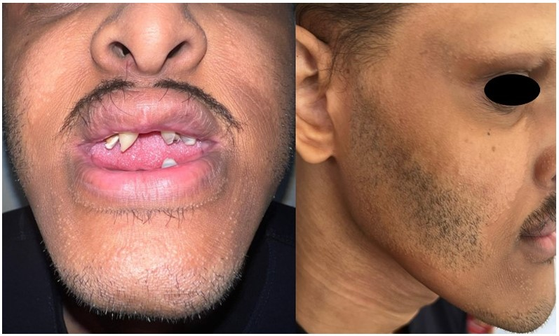

Figure 1 : 18-year-old adolescent with hypodontia, thick lips, and sparse scalp hair, eyebrows, eyelashes and beard.

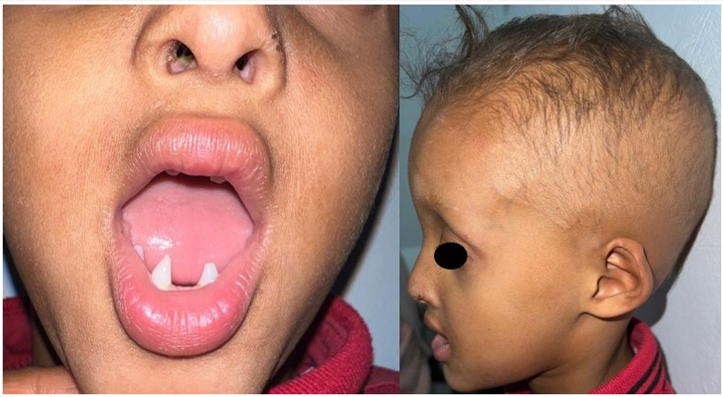

Figure 2 : 5-year-old child with hypodontia, thick lips, xerosis and sparse scalp hair, eyebrows and eyelashes.