Case report

Coexistence of Giant Congenital Melanocytic Nevus and Neurofibromatosis Type 1 among Child : A Rare Association

.

ABSTRACT

|  |
| --- |
| **Background:** Giant congenital melanocytic nevus (GCMN) are rare pigmented lesions present at birth, often exceeding 20 cm in size, and may be associated with serious complications such as melanoma and neurocutaneous melanosis. Neurofibromatosis type 1 (NF1) is a common phakomatosis characterized by café-au-lait macules and neurofibromas. The coexistence of GCMN and NF1 is rare and may represent overlapping activation of the RAS/MAPK pathway.  **Case report:** We report the case of a 5-year-old boy presenting with a bathing trunk–type GCMN involving the trunk, buttocks, and thighs, along with multiple smaller pigmented nevi. He also exhibited soft, mobile nodules on the lower back and pubic region, consistent with cutaneous and plexiform neurofibromas. Numerous café-au-lait macules were noted, but no axillary freckling. Ophthalmological, neurological, and radiological evaluations were normal. Histopathological examination confirmed congenital melanocytic nevus and neurofibromas. The diagnosis of NF1 was established based on NIH criteria.  **Discussion:** This case illustrates a rare co-occurrence of GCMN and NF1. Although both conditions share a RAS pathway dysregulation, their combination is seldom reported. The association may increase the risk of melanoma or neurocutaneous melanosis, requiring long-term clinical and imaging surveillance.  **Conclusion:** Recognizing the simultaneous presence of GCMN and NF1 is essential for early diagnosis, multidisciplinary management, and genetic counseling. This rare association highlights the importance of long-term surveillance to detect potential complications such as melanoma and neurocutaneous melanosis. |

*Keywords: Congenital melanocytic nevus, Neurofibromatosis type 1, Plexiform neurofibroma, Pediatric dermatology, Café-au-lait macules, Bathing trunk nevus, RAS/MAPK pathway.*

1. INTRODUCTION

Giant congenital melanocytic nevus (GCMN) are large pigmented lesions present at birth that typically exceed 20 cm in projected adult diameter. They are often associated with complications such as malignant melanoma and neurocutaneous melanosis, and their extensive distribution, especially in a "bathing trunk" pattern, poses additional aesthetic and psychological challenges (Macneal, et al., 2025), (Ruth J., 2024).

Neurofibromatosis type 1 (NF1), an autosomal dominant genodermatosis caused by mutations in the *NF1* gene, is characterized by café-au-lait macules, neurofibromas, Lisch nodules, and various systemic manifestations (Legius E, et al., 2021). Although both GCMN and NF1 involve dysregulation of the RAS/MAPK signaling pathway, their coexistence in a single patient is rare and may present diagnostic and prognostic implications (Mahajan A, et al., 2022), (Charbel C, et al., 2014).

Herein, we report a unique pediatric case of GCMN in a bathing trunk distribution associated with multiple cutaneous and plexiform neurofibromas fulfilling diagnostic criteria for NF1. This case highlights the importance of thorough systemic evaluation and long-term surveillance in patients presenting with extensive pigmented lesions.

2. PRESENTATION OF CASE

A 5-year-old boy was referred to our dermatology department for extensive pigmented skin lesions noted since birth. At delivery, the patient presented with a large confluent pigmented patch involving the trunk, buttocks, and thighs, covered with long dark hairs, consistent with a giant congenital melanocytic nevus, so-called “bathing trunk nevus” (Figure 1 and 3). In addition, numerous smaller pigmented macules were scattered over the face, scalp, and limbs (Figure 1 and 2). Some of these lesions were congenital, while others appeared during the first year of life.

Clinical examination revealed a homogeneous pigmented plaque with perifollicular hypopigmentation and terminal hairs on dermoscopy, supporting the diagnosis of a congenital melanocytic nevus. Multiple soft, skin-colored to slightly pigmented nodules were noted over the lower back and pubic region. These nodules were non-pulsatile, non-tender, and mobile on palpation, suggestive of cutaneous and plexiform neurofibromas (Figure 2).

Additionally, numerous medium-brown macules (0.5–1 cm) resembling café-au-lait spots were observed over the trunk, limbs, and face. However, axillary or inguinal freckling was absent. Ophthalmologic and neurologic evaluations were unremarkable. Imaging studies, including skeletal X-ray and MRI of the brain and spine, showed no abnormalities. Histopathologic examination of skin biopsies confirmed the presence of congenital melanocytic nevus and neurofibromas.

Based on the presence of café-au-lait macules and multiple neurofibromas, the diagnosis of Neurofibromatosis Type 1 (NF1) was established, according to the NIH diagnostic criteria.

Table 1 : Summary of Clinical and Paraclinical Findings Supporting the Diagnosis

|  |  |  |
| --- | --- | --- |
| Feature | Finding in Patient | Relevance |
| **Large pigmented patch (>20 cm)** | “Bathing trunk” nevus involving trunk, buttocks, thighs | Suggestive of GCMN |
| **Terminal hairs** | Present | Supports congenital origin of nevus |
| **Satellite nevi** | Multiple scattered pigmented lesions on face, scalp, limbs | Consistent with GCMN |
| **Histopathology of nevus** | Confirmed congenital melanocytic nevus | Confirms melanocytic origin |
| **Café-au-lait macules** | >6 lesions (0.5–1 cm), on trunk, limbs, face | NIH criterion for NF1 |
| **Neurofibromas** | Multiple soft nodules on back and pubic area | Meets NIH criterion for NF1 |
| **Plexiform neurofibroma** | Suggested by clinical presentation | Highly specific for NF1 |
| **Histopathology of nodules** | Confirmed neurofibromas | Confirms NF1 diagnosis |
| **Axillary/inguinal freckling** | Absent | Not required for diagnosis |
| **Ophthalmologic exam** | Normal | No Lisch nodules or optic glioma |
| **Neurologic evaluation** | Normal | No neurologic complications |
| **MRI (brain/spine)** | No abnormalities | Rules out neurocutaneous melanosis |

3. discussion

Giant congenital melanocytic nevus (GCMN) is a rare dermatosis (≈ 1 : 20 000 births) that arises from post-zygotic activating mutations, most often in NRAS, and may cover large anatomical surfaces such as the “bathing trunk” distribution seen in our patient (Legius E, et al., 2021). Neurofibromatosis type 1, by contrast, is an autosomal-dominant phakomatosis caused by pathogenic variants in NF1, with a clinical diagnosis based on the 2021 revised NIH criteria (Macneal et al. 2025). Although both conditions involve dysregulation of the RAS/MAPK pathway, their coexistence is decidedly uncommon; fewer than a dozen paediatric cases combining GCMN and NF1 have been documented, including the Indian case of Mahajan *et al.* (2022) and the Egyptian child reported in 2024 (Mahajan A, et al., 2022), (Sadek, A.A., et al. 2024).

Pathogenetically, NRAS mosaicism drives proliferative melanocytic nests in the dermis, whereas NF1 loss leads to constitutive RAS activation in Schwann-cell lineages. Convergence on RAS signalling offers a biologic rationale for their association and may potentiate tumourigenesis through additive pathway activation (Macneal et al., 2025), Legius E, et al., 2021).

Malignant melanoma is the gravest complication of GCMN, with meta-analyses estimating a lifetime incidence of 2-4 %, highest during early childhood and in lesions > 20 cm (Scard C, et al., 2023). NF1 individuals independently exhibit a 2- to 4-fold increased melanoma risk and tend to present with thicker tumours and poorer survival (Meyer SN, et al., 2023). In patients harbouring both conditions, cumulative oncologic risk is presumed to be amplified, justifying rigorous, lifelong dermatologic surveillance.

GCMN involving the axial midline also raises concern for neurocutaneous melanosis (NCM), leptomeningeal melanocytic proliferation that can provoke seizures or hydrocephalus. Although our patient’s brain and spinal MRI were normal, periodic neuro-imaging during early childhood is advocated when neurological signs emerge or when extensive posterior midline nevus are present (Ruth J., 2024).

Management of GCMN remains multidisciplinary. Staged surgical excision, curettage, dermabrasion, laser ablation or tissue expansion are selected case-by-case to lower melanoma risk and improve cosmesis; none eliminates risk entirely (Mologousis MA, et al. 2024). Experimental targeted approaches are under investigation : a 2025 *in vivo* study showed that BCL-2 inhibitors induced apoptosis of nevus cells and durable regression of GCMN in murine models, highlighting future therapeutic avenues (Wei B., et al., 2025)

Our case enriches the literature by illustrating, the *bathing trunk* variant of GCMN coexisting with multiple cutaneous and plexiform neurofibromas, the fulfilment of two NIH criteria (café-au-lait macules and ≥ 2 neurofibromas) sufficient for NF1 diagnosis at age five, and the importance of comprehensive systemic evaluation even when neuro-ophthalmologic and radiologic findings are initially unremarkable. Early recognition of this rare association permits tailored surveillance for melanoma, NCM and NF1-related neoplasms, and facilitates genetic counselling for the family.

Comparative analysis of previously reported cases supports the rarity and clinical heterogeneity of this association. For instance, Mahajan et al. (2022) described an Indian child with a bathing-trunk GCMN and axillary freckling, whereas our patient lacked freckling but fulfilled NIH criteria through the presence of multiple neurofibromas and café-au-lait macules. Sadek et al. (2024) reported an Egyptian patient with a similar nevus distribution but with early-onset neurological symptoms related to neurocutaneous melanosis, which were absent in our case. Across these reports, common features include midline-trunk distribution of the nevus and early childhood diagnosis, while variability lies in associated neurologic findings and freckling patterns. These observations reinforce the need for personalized clinical follow-up and highlight the diagnostic value of early histologic confirmation.

Given the increased risk of melanoma and potential neurologic complications, this association warrants regular dermatological, neurologic, and radiologic follow-up. Genetic counseling is also essential to support the patient and family in long-term disease management.

4. Conclusion

This case illustrates a rare coexistence of two distinct but potentially overlapping neurocutaneous conditions : giant congenital melanocytic nevus and neurofibromatosis type 1. Given the increased risk of melanoma and neurocutaneous melanosis associated with GCMN, especially when involving the axial midline, early recognition and multidisciplinary management are essential. Regular follow-up, patient education, and genetic counseling should be integral components of care to monitor for complications and provide appropriate support to affected families.

Consent

All authors declare that ‘written informed consent was obtained from the patient’s legal guardian for publication of this case report and accompanying images. A copy of the written consent is available for review by the Editorial office/Chief Editor/Editorial Board members of this journal.

Ethical approval

All authors hereby declare that all experiments have been examined and approved by the appropriate ethics committee and have therefore been performed in accordance with the ethical standards laid down in the 1964 Declaration of Helsinki.

Disclaimer (Artificial intelligence)

Authors hereby declare that NO generative AI technologies such as Large Language Models (ChatGPT, COPILOT, etc.) and text-to-image generators have been used during the writing or editing of this manuscript.

References

Macneal P, Syed HA, Patel BC. Congenital Melanocytic Nevi. [Updated 2024 Dec 2]. In: StatPearls [Internet]. Treasure Island (FL): StatPearls Publishing; 2025 Jan-. Available from: https://www.ncbi.nlm.nih.gov/books/NBK563168/

Ruth J. Congenital melanocytic nevus syndrome: An association between congenital melanocytic nevi and neurological abnormalities. Semin Pediatr Neurol. 2024 Oct;51:101153. doi: 10.1016/j.spen.2024.101153.

Legius E, Messiaen L, Wolkenstein P, et al. Revised diagnostic criteria for neurofibromatosis type 1 and Legius syndrome: an international consensus recommendation. Genet Med. 2021 Aug;23(8):1506-1513. doi: 10.1038/s41436-021-01170-5.

Mahajan A, Gogineni M, Lote S, Poulose D, Deora MS. Giant Congenital Melanocytic Nevus associated with Neurofibromatosis Type 1 in a young Indian girl - A Rare Presentation. Int J Med Rev Case Rep. 2022; 6(9): 87-89. doi:10.5455/IJMRCR.172-1643452872.

Charbel C, Fontaine RH, Malouf GG, et al. NRAS mutation is the sole recurrent somatic mutation in large congenital melanocytic nevi. J Invest Dermatol. 2014 Apr;134(4):1067-1074. doi: 10.1038/jid.2013.429.

Sadek, A.A., Aladawy, M.A., Mansour, T.M.M. *et al.* The rare association of congenital glaucoma, giant melanocytic nevus, alopecia, and hypospadias in an Egyptian child with neurofibromatosis type 1: a case report. *Egypt J Med Hum Genet* 25, 107 (2024). https://doi.org/10.1186/s43042-024-00579-2.

Scard C, Aubert H, Wargny M, Martin L, Barbarot S. Risk of melanoma in congenital melanocytic nevi of all sizes: A systematic review. J Eur Acad Dermatol Venereol. 2023 Jan;37(1):32-39. doi: 10.1111/jdv.18581.

Meyer SN, Simmons E, Studer AC, Rauen KA, Kiuru M. Melanocytic neoplasms in neurofibromatosis type 1: a systematic review. Melanoma Res. 2023 Dec 1;33(6):437-446. doi: 10.1097/CMR.0000000000000912.

Mologousis MA, Tsai SY, Tissera KA, Levin YS, Hawryluk EB. Updates in the Management of Congenital Melanocytic Nevi. Children (Basel). 2024 Jan 2;11(1):62. doi: 10.3390/children11010062.

Wei, B., Yu, Q., Jin, J. *et al.* Anti-BCL2 therapy eliminates giant congenital melanocytic nevus by senolytic and immune induction. *Sig Transduct Target Ther* 10, 161 (2025). https://doi.org/10.1038/s41392-025-02247-2.

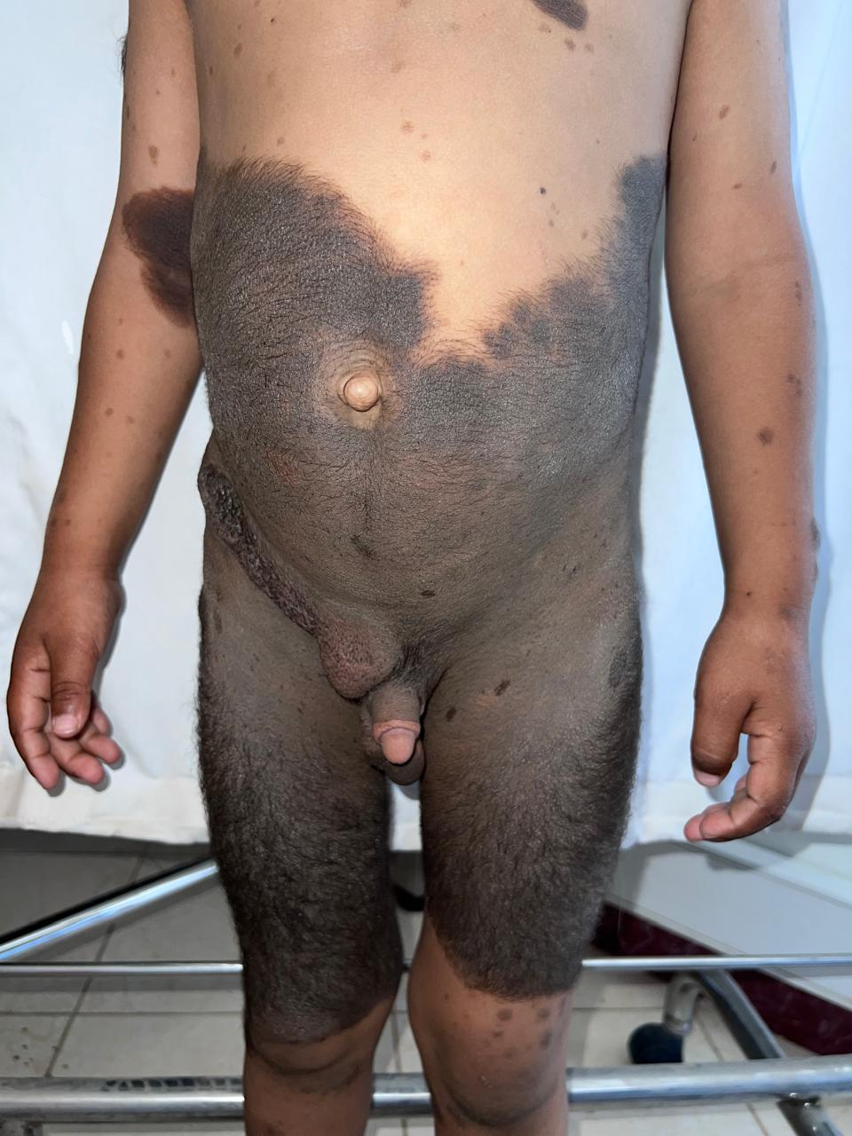

Figure 1 : Extensive bathing trunk–type giant congenital melanocytic nevus with numerous satellite nevi. Large, pigmented plaque covering the trunk, buttocks, and upper thighs, consistent with a bathing trunk distribution. The lesion is covered with terminal hairs and is associated with multiple satellite melanocytic nevi of varying sizes scattered over the surrounding skin.

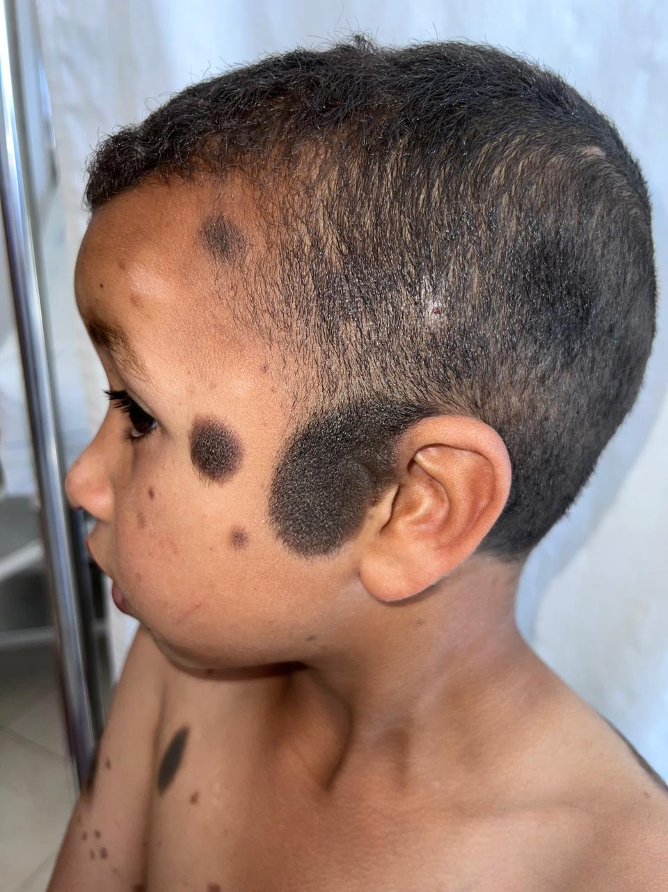

Figure 2 : Satellite congenital melanocytic nevi on the face and scalp. Close-up view showing several pigmented macules and papules located on the forehead, cheeks, and scalp, in keeping with satellite nevi commonly associated with giant congenital melanocytic nevus.

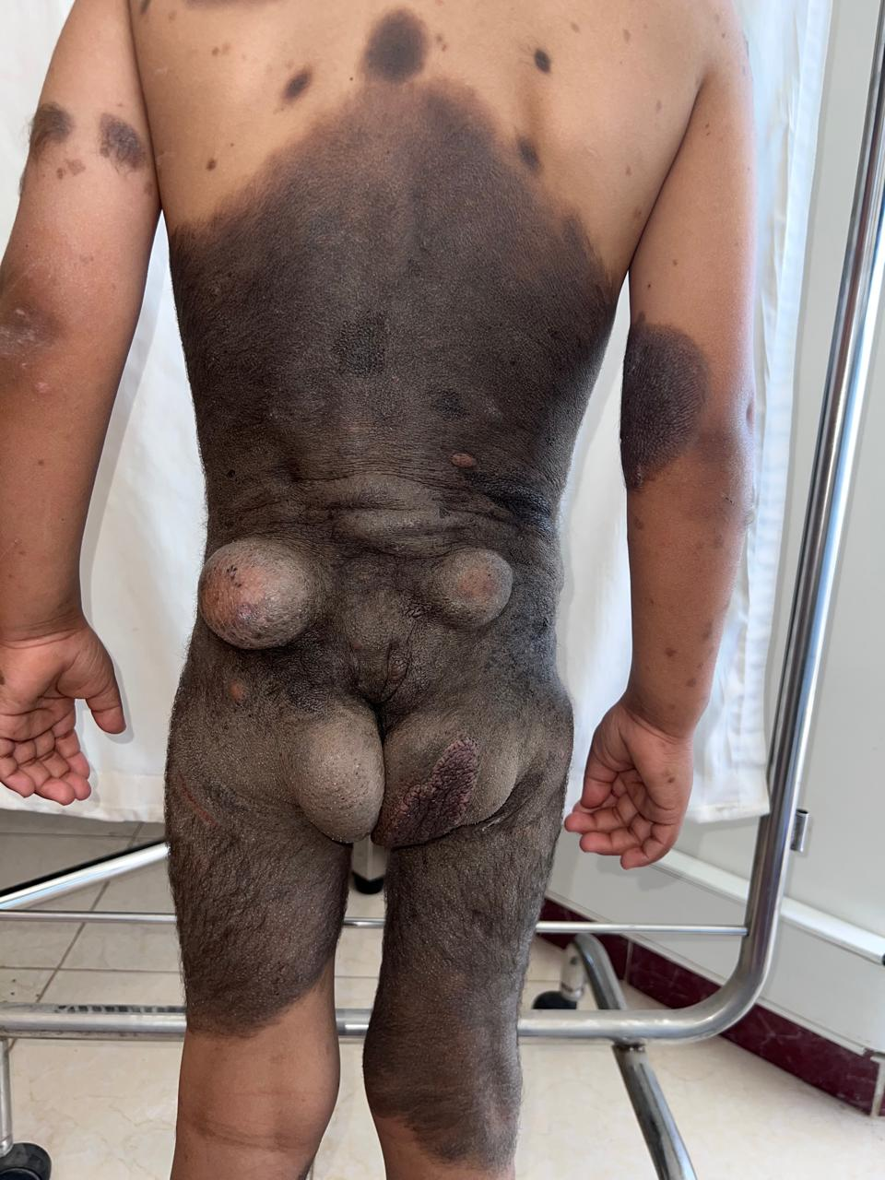

Figure 3 : Multiple cutaneous and plexiform neurofibromas involving the lower back and pubic region. Multiple soft, skin-colored to slightly pigmented nodules and tumefactions are visible over the lower back and pubic area. These lesions are non-tender, mobile, and consistent with cutaneous and plexiform neurofibromas.

**The importance of this manuscript :**

This case report documents a rare co-occurrence of Giant Congenital Melanocytic Nevus (GCMN) and Neurofibromatosis Type 1 (NF1), two neurocutaneous disorders with overlapping RAS/MAPK pathway dysregulation. Given the scarcity of pediatric cases presenting both entities simultaneously, this report contributes to the understanding of their potential pathogenic convergence. It emphasizes the increased oncologic risks, such as melanoma and neurocutaneous melanosis, and highlights the need for vigilant, multidisciplinary follow-up. The report serves as a valuable educational tool for dermatologists, pediatricians, and genetic counselors.