*Case report*

**Rising Incidence of Retinopathy of prematurity Blindness at Abuja’s Private Hospitals: A Growing Concern**

ABSTRACT

|  |
| --- |
| ABSTRACT:  **Aims: To increase the awareness about retinopathy of prematurity (ROP) blindness in unscreened preterm infants in Abuja”.**  **Presentation of cases**  Five (5) children who had become blind from ROP and referred to our facility were seen. Three of them were males. The mean gestational age was 30.4 $±$ 2.6 weeks ( 28 – 34 weeks). The median birth weight was 1000g while the interquartile range (IQR) was 700g.. All 5 blind children received neonatal care at private hospitals.  **Discussion:** With an average of 2,500 Preterm admissions in the Abuja and it’s rapidly expanding neonatal care and the grossly inadequate ROP screening services , Abuja may likely become the new frontier of ROP blindness in Nigeria. It is very worrisome that all 5 children who were blind form ROP had no ROP screening done. There is an urgent need to increase awareness and establish a comprehensive ROP services for Abuja with special focus on neonatologists especially in private hospitals to help drive the ROP services.  **Conclusion:** ROP remains a leading cause of blindness in children especially in the Federal Capital Territory of Nigeria, ROP services must expand to include private hospitals providing neonatal services in a well-coordinated manner in order to prevent blindness for ROP. |

***Keywords:*** *Retinopathy of prematurity, preterm, blindness, private hospitals.*

1. INTRODUCTION

Retinopathy of Prematurity (ROP) still remains an important cause of childhood blindness,1 especially in low income countries where screening and treatment programme are grossly inadequate. Zhang et al. estimated that in 2019, ROP led to moderate vision impairment in around 49,100 cases, severe vision impairment in 27,500 cases, and blindness in 25,000 cases.2

There are about 2,500 preterm admissions annually in Abuja, many of them in private hospitals and requiring screening for retinopathy of Prematurity (ROP). However, very few institutions provide ROP screening and treatment services. This lack of ROP services increases the risk of blindness from ROP. We report 5 cases of ROP blindness in the Federal Capital Territory (FCT), Abuja in order to increase the awareness about retinopathy of prematurity (ROP) blindness in unscreened preterm infants in Abuja

2. PRESENTATION OF CASES

Records of all preterm babies who became blind from ROP and were referred to our facility between 2020 and 2023 were extracted. Information obtained included age at presentation, birth weight, gestational age, whether ROP screening was done and the stage of the ROP at diagnosis. Detailed dilated ocular examination using the binocular indirect ophthalmoscopy was done for all 5 children. Pupils were dilated using tropicamide plus eye drops (Tropicamide 0.8%+Phenylephrine 5%). The international classification of Retinopathy of Prematurity 3rd Edition was used for diagnosis.3 Data was analyzed using SPSS version 26 ( IBM SPSS Statistics for Windows, Version 26.0. Armonk, NY: IBM Corp)

Five (5) children were seen. Three of them were males. The mean gestational age at birth was 30.4 $±$ 2.6 weeks ( 28 – 34 weeks). Mean birth weight was 1,200g $±46$ 5 g ( 850 – 2000g). The median birth weight was 1000g while the interquartile range (IQR) was 700g .Mean age at presentation was 11.4 $±7.13$ months. All 5 children received neonatal care at private hospitals (Table 1). Positive correlation exists between the birth weight and gestational age (Figure 1)

**Table 1: Summary of children blind from ROP**

|  |  |  |  |  |  |
| --- | --- | --- | --- | --- | --- |
| **Sex** | **Birth weight (grams)** | **Gestational Age at Birth (weeks)** | **ROP screening** | **Stage of ROP** | **Days on oxygen** |
| M  F  M  F  M | 2000  950  1200  850  1000 | 34  30  28  28  32 | No  No  No  No  No | 5 (B/E)®  R* 4b L+ 5  5 (B/E)  5 (B/E)  5 (B/E) | 30  14  14  10  Not known |

* Right eye, + Left eye ®B/E: Both eyes

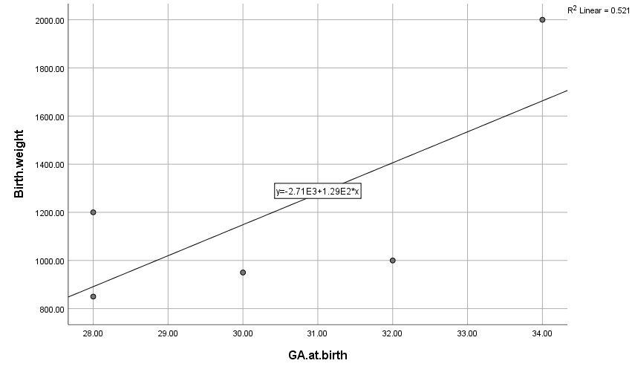

**Figure 1:** **Pearson’s correlation between Birth weight and gestational age**

**Correlation coefficient: 0.722 (strong positive correlation) P-Value 0.169**

3. discussion

Africa has been called the new frontier of ROP blindness.4 as neonatal care expands unless ROP services equally expands. The Federal Capital Territory, Abuja has a rapidly expanding neonatal care with grossly inadequate ROP screening and treatment services. This places preterm infants in the territory at risk of ROP blindness.. As survival improves due to better neonatal care, the number of babies blind from ROP is likely to increase except ROP screening and treatment services also expand. All the 5 blind children in our series received neonatal care in private hospitals and had no ROP screening. Ademola-Popoola et al 5 also found in their study that 33.3% of the children received neonatal care in private hospitals and nearly all of them were not screened for ROP. Their study reported 18 cases of ROP related blindness in Nigeria over a 5 year period.5

This is worrisome considering the large number of private hospitals within the FCT providing neonatal care. There is an urgent need to increase awareness and establish a comprehensive ROP services for the FCT. Special attnetion needs to be placed on neonatologists especially in private hospitals to help drive ROP services in the FCT.

A study by Herrod et al reported that ROP was estimated to be the cause of blindness for 10% of all blind children examined by ROP-involved pediatric ophthalmologists and retinal surgeons during 2019 across Africa.6

Jacoby et al in South Africa reported that 7 out of 238 babies with ROP were blind 7 while Melesse in Ethiopia reported that in the 66 infants reviewed, 10 (15.2%) were blind from ROP.8

Two of the blind children in our series were advised to go for ROP screening but did not have screening done highlighting the need for proper counselling of care givers on ROP screening services. All 5 of the cases in our series did not have ROP screening done highlighting the need for expansion of ROP services in the FCT. The prevalence of Blindness from ROP is dependent on the quality of neonatal care and availability of effective screening and treatment programmes.

Four of the infants blind from ROP in our series received supplemental oxygen highlighting the need for careful monitoring of preterm infants on oxygen. Several studies have shown that preterm infants who require oxygen for long periods have increased risks of developing ROP. 9 -11

Since ROP requiring treatment does not typically develop before 3rd week of life, this window provides a good opportunity for babies at risk to be transferred to centers providing ROP services. It may be better to establish an easy to manage “roving” ROP screening involving all hospitals providing neonatal services in the Abuja. Any such planned ROP intervention in the FCT must involve Private Hospitals providing intensive neonatal care and the provision of wide field cameras for screening by non-ophthalmologists. This will increase the number of infants that can be screened.12 Stakeholders must continue to create awareness and participate in the formulation of a policy to prevent, detect and treat ROP in a timely manner. There is also the urgent need to provide Health Insurance or a good financing mechanism ought to be in place so that every child gets ROP screening and is given treatment if required.12

4. Conclusion

ROP, though a preventable cause of blindness remains a leading cause of blindness in children especially in the Federal Capital Territory of Nigeria. ROP services in the FCT must expand to include all private hospitals providing neonatal services in an efficient, effective and well-coordinated manner in order to prevent blindness for ROP.

Consent

"All authors declare that ‘written informed consent was obtained from the care givers of the patients (or other approved parties) for publication of this case report . A copy of the written consent is available for review by the Editorial office/Chief Editor/Editorial Board members of this journal."

Ethical approval

This study adhered to the tenets of Helsinki declaration and the study was approved by the Health Research and Ethics committee of UATH, Gwagwalada (UATH/HREC/PR/457)

**DISCLAIMER (ARTIFICIAL INTELLIGENCE)**

Authors hereby declare that NO generative AI technologies such as Large Language Models (ChatGPT, COPILOT, etc.) and text-to-image generators have been used during the writing or editing of this manuscript.

References

1. Hong, E.H, Shin, Y.U, Cho, H. (2021). Retinopathy of prematurity: a review of epidemiology and current treatment strategies. Clinical and Experimental Pediatrics. 65 (3),115-126. doi: [10.3345/cep.2021.00773](https://doi.org/10.3345/cep.2021.00773)
2. Zhang, R, Liu, Y, Dong, L, Li, H, LI, Y, Zhou, W. et al . (2022). Prevalence, Years lived with Disability and time trends for 16 causes of Blindness and Vision Impairment: Findings highlight Retinopathy of Prematurity. Frontiers in Paediatrics 10, <https://doi.org/10.3389/fped.2022.735335>
3. Chiang, M.F, Quinn, G.E, Fielder, A.R, Ostmo, S.R, Paul Chan, R.V, Berrocal, A.et al (2021). International Classification of Retinopathy of Prematurity, Third Edition. Ophthalmology. 128(10):e51-e68. doi: 10.1016/j.ophtha.2021.05.031.
4. Gilbert, C, Malik, A.N.J, Nahar, N, Kumer Das, S, Visser, L, Sitati, S, et al. (2019). Epidemiology of ROP update – Africa is the new frontier. Seminars in Perinatology. 43 (6), 317–322. doi:10.1053/j.semperi.2019.05.002.
5. Ademola-Popoola, D.S, Onakoya, A.O, Ezisi, C.N, Okeigbemen, V.W, Aghaji, A.E, Musa, K.O, et al. (2021). Case series of retinopathy of prematurity blindness in Nigeria: A wakeup call to policy makers, hospitals, , ophthalmologists and paediatricians. Nigerian Postgraduate Medical Journal. 28 (4), 303-306. doi: 10.4103/npmj.npmj_595_21.
6. Herrod, S. K, Adio, A., Isenberg, S. J., and Lambert, S. R. (2022). Blindness Secondary to Retinopathy of Prematurity in Sub-Saharan Africa. Ophthalmic Epidemiology, 29 (2), 156 –163. doi:10.1080/09286586.2021.1910315.
7. Jacoby, M.R, Du Toit, (2016). Screening for retinopathy of prematurity in a provincial hospital in Port Elizabeth, South Africa. South African Medical Journal.106 (6). doi: 10.7196/SAMJ.2016.v106i6.10663.
8. Melesse, M.A, (2020). Retinopathy of prematurity – An emerging cause of childhood blindness in Ethiopia. Ethiopian Medical Journal.58(2):1-7.
9. Leng, Y., Huang, W., Ren, G., Cai, C., Tan, Q., Liang, Y. et al. (2018). The treatment and risk factors of retinopathy of prematurity in neonatal intensive care units. BMC ophthalmology, 18, 1-8.
10. Tapak, L., Farahani, L.N., Taleghani, N.T, [Ebrahimiadib](https://bmcophthalmol.biomedcentral.com/articles/10.1186/s12886-024-03637-w#auth-Nazanin-Ebrahimiadib-Aff4), N, [Pour](https://bmcophthalmol.biomedcentral.com/articles/10.1186/s12886-024-03637-w#auth-Elias_Khalili-Pour-Aff5), E.K, Farahani, A.D. *et al.* (2024). Risk factors for the time to development of retinopathy of prematurity in premature infants in Iran: a machine learning approach. BMC Ophthalmology 24, 364 <https://doi.org/10.1186/s12886-024-03637-w>
11. De las Rivas Ramírez, N., Luque Aranda, G., Rius Díaz, F. Javier Pérez Frías, F Tamayo, T.S.(2022).

Risk factors associated with Retinopathy of Prematurity development and progression. Scientific Reports  12, 21977 <https://doi.org/10.1038/s41598-022-26229-4>

1. Ademola-Popoola, D. S, Fajolu, B.I, Gilbert, C, Olusanya, B.A, Onakpoya, H.O, Ezisi, C.N, et al (2021) Strengthening retinopathy of prematurity screening and treatment services in Nigeria: a case study of activities, challenges and outcomes 2017-2020: BMJ Open Ophthalmology ;6:e000645.