Case report

Juvenile Lichenoid Mycosis Fungoides: A Rare Variant Case Report with Clinical and Dermoscopic Features

.

ABSTRACT

|  |
| --- |
| **Background:** Lichenoid mycosis fungoides is an exceptionally rare entity in children, often posing significant diagnostic challenges due to its atypical presentation and resemblance to benign dermatoses.  **Case report:** We report a pediatric case of lichenoid mycosis fungoides presenting with annular pigmented lesions and nail involvement. Dermoscopy raised initial suspicion, which was later confirmed only after repeated skin biopsies and immunohistochemical analysis. The diagnostic process illustrates the difficulty in confirming such rare variants and the need for persistence when clinical suspicion is high.  **Importance:** This case highlights a rare pediatric variant of mycosis fungoides and underscores the crucial role of dermoscopy and immunohistochemistry in its diagnosis. Given the limited literature on this condition in children, the report adds valuable insights for both dermatologists and pediatricians. It serves to raise awareness and may facilitate earlier recognition and appropriate management of similar atypical presentations in clinical practice. |

*Keywords: Lichenoid mycosis fungoides, pediatric,* *cutaneous T-cell lymphoma, dermoscopy.*

1. INTRODUCTION

Mycosis fungoides (MF) is the most common form of cutaneous T-cell lymphoma. It can present with a wide variety of atypical cutaneous lesions, earning its reputation as a "great imitator" (Hodak & Amitay-Laish, 2019).

MF is particularly rare in children and adolescents (Nanda et al., 2010), with North American and European studies reporting a prevalence of 0% to 5% in individuals under 20 years old (Hodak et al., 2014). Unlike adults, the majority of pediatric MF cases are nonclassic variants of the disease, which adds diagnostic complexity (Wu et al., 2020).

The lichenoid variant of MF is exceedingly rare, particularly in children, and poses significant diagnostic challenges.

This report highlights a rare case of juvenile lichenoid MF, emphasizing its clinical and dermoscopic characteristics.

2. CASE PRESENTATION

A 13-year-old boy was referred to our specialized pediatric dermatology consultation with annular, pigmented lesions that had been evolving for approximately one year. The lesions were primarily located on the abdomen and lower limbs, occasionally associated with mild pruritus (figure 1).

Clinical examination revealed nail involvement, including onychorrhexis affecting all nails, a pitted nail plate, and koilonychias (figure 2). The patient was otherwise in good general health with no lymphadenopathy, mucosal, or scalp involvement.

Dermoscopy of the lesions showed a peripheral granular pigmented pattern, localized erythema, chrysalis structures, and a hypopigmented halo surrounding the lesions (figure 3).

Given the appearance of the lesions, several differential diagnoses were considered, including lichen planus pigmentosus, lichenoid mycosis fungoides and annular lichenoid dermatitis of youth.

An initial skin biopsy was performed, and histopathological examination revealed acanthotic and papillomatous epidermis, overlying an orthokeratotic stratum corneum. The dermis contained a granulomatous inflammatory tissue composed of radial capillaries interspersed with a polymorphous inflammatory infiltrate. Additionally, a proliferation of activated myofibroblasts was noted in the deep dermis, which was also traversed by a congested capillary network (figure 4).

Immunohistochimy analysis showed a predominance of CD4+ T cells, with a complete loss of CD7 expression and partial loss of CD8 expression, consistent with the diagnosis of mycosis fungoides (figure 5).

A second lateral longitudinal nail biopsy was performed, revealing similar lichenoid changes in the nail bed and matrix, along with atypical lymphocytic infiltration, which further corroborated the diagnosis of lichenoid MF.

3. discussion

Mycosis fungoides typically affects older adults (>50 years) and is rarely encountered in children or adolescents (Nanda et al., 2010). Due to the chronic and indolent nature of the disease, symptoms in adults diagnosed with MF may have first appeared during childhood, making early recognition challenging (Koch et al., 1987).

Lichenoid MF is a rare histological variant of the disease, first described in 1997 in a cohort of 12 patients (Benarfa et al., 2022). It is characterized by lichenoid infiltration and is predominantly reported in middle-aged women. Clinically, lichenoid MF lesions often resemble other lichenoid dermatoses, such as lichen planus, due to overlapping clinical and histopathological features (Kianfar et al., 2023).

Histological diagnosis can be challenging and is often delayed due to its subtle and nonspecific features. Key histological features of lichenoid MF include basal layer vacuolization, keratinocyte necrosis, colloid bodies in the dermis, and epidermotropism of atypical CD4+ lymphocytes. Superficial dermal fibrosis and a polymorphous infiltrate with eosinophils can help distinguish it from lichen planus, although T-cell clonality may initially be undetectable (N. Ortonne, 2025; Massone C et al., 2025).

Another condition, annular lichenoid dermatitis of youth (ALDY), can closely mimic the annular or hypopigmented forms of MF. ALDY is differentiated by histological findings such as lichenoid infiltration localized to the base of rete ridges, absence of T-cell clonality, and a lack of atypical lymphocytes. These distinctions emphasize the importance of histopathological expertise in differentiating ALDY from MF (Annessi & Annessi, 2022).

The dermoscopic features of lichenSoid MF remain poorly documented in the literature, representing an area of potential exploration to aid in noninvasive diagnosis (Zengarini, C et al., 2025).

In pediatric MF cases, the rarity and nonclassical presentations add significant diagnostic complexity. Repeated biopsies, immunohistochemical analysis, and molecular studies are often required to confirm the diagnosis and prevent misdiagnosis (Heng et al., 2014).

Early recognition and accurate diagnosis are crucial, as treatment in pediatric MF is particularly complex and must be individualized based on clinical features, disease severity, and patient preferences (Wu et al., 2020; Kothari R et al., 2022).

4. Conclusion

Lichenoid mycosis fungoides is an exceptional variant of cutaneous T-cell lymphoma, particularly in children. Its rarity and atypical presentation pose significant diagnostic challenges for dermatologists and pathologists. Early recognition, thorough histopathological assessment, and repeated biopsies are essential for accurate diagnosis and appropriate management.

Consent

All authors declare that ‘written informed consent was obtained from the patient’s legal guardian for publication of this case report and accompanying images. A copy of the written consent is available for review by the Editorial office/Chief Editor/Editorial Board members of this journal.

Ethical approval

All authors hereby declare that all experiments have been examined and approved by the appropriate ethics committee and have therefore been performed in accordance with the ethical standards laid down in the 1964 Declaration of Helsinki.

Disclaimer (Artificial intelligence)

Authors hereby declare that NO generative AI technologies such as Large Language Models (ChatGPT, COPILOT, etc.) and text-to-image generators have been used during the writing or editing of this manuscript.

References

Hodak, E., & Amitay-Laish, I. (2019). Mycosis fungoides: a great imitator. Clin Dermatol, 37(3), 255–267. <https://doi.org/10.1016/j.clindermatol.2019.01.010>

Nanda, A., AlSaleh, Q. A., Al-Ajmi, H., Al-Sabah, H., Elkashlan, M., Al-Shemmari, S., et al. (2010). Mycosis fungoides in Arab children and adolescents: a report of 36 patients from Kuwait. Pediatr Dermatol, 27(6), 607–613. <https://doi.org/10.1111/j.1525-1470.2010.01290.x>

Hodak, E., Amitay-Laish, I., Feinmesser, M., Davidovici, B., David, M., Zvulunov, A., et al. (2014). Juvenile mycosis fungoides: cutaneous T-cell lymphoma with frequent follicular involvement. J Am Acad Dermatol, 70(6), 993–1001. <https://doi.org/10.1016/j.jaad.2014.01.882>

Wu, J. H., Cohen, B. A., & Sweren, R. J. (2020). Mycosis fungoides in pediatric patients: Clinical features, diagnostic challenges, and advances in therapeutic management. Pediatr Dermatol, 37(1), 18–28. <https://doi.org/10.1111/pde.13996>

Koch, S. E., Zackheim, H. S., Williams, M. L., Fletcher, V., & LeBoit, P. E. (1987). Mycosis fungoides beginning in childhood and adolescence. J Am Acad Dermatol, 17(4), 563–570. <https://doi.org/10.1016/S0190-9622(87)70207-1>

Benarfa, A., Oro, S., Ram-Wolff, C., Pham-Ledard, A., Bagot, M., & Beylot-Barry, M. (2022). Mycosis fongoïde lichénoïde: à propos de 3 cas. Ann Dermatol Venereol, 149(Suppl 12), A250. <https://doi.org/10.1016/j.fander.2022.09.251>

Kianfar, N., Ghanadan, A., Aryanian, Z., & Etesami, I. (2023). Lichenoid mycosis fungoides: Report of a case with lichen planus-like histopathologic features. Clin Case Rep, 11, e8347. <https://doi.org/10.1002/ccr3.8347>

N. Ortonne, Cas n◦2. Mycosis fongoïde lichénoïde, Annales de pathologie, <https://doi.org/10.1016/j.annpat.2025.04.006>

Massone C, Kodama K, Kerl H, Cerroni L. Histopathologic features of early (patch) lesions of mycosis fungoides: a morphologic study on 745 biopsy specimens from 427 patients. Am J Surg Pathol. 2005 Apr;29(4):550-60. doi: 10.1097/01.pas.0000153121.57515.c6.

Annessi, G., & Annessi, E. (2022). Annular Lichenoid Dermatitis (of Youth). Dermatopathology (Basel), 9(1), 23–31. <https://doi.org/10.3390/dermatopathology9010004>

Zengarini, C.; Tugnoli, F.; Natale, A.; Mussi, M.; Clarizio, G.; Agostinelli, C.; Sabattini, E.; Corrà, A.; Piraccini, B.M.; Pileri, A. Dermatoscopic Patterns in Mycosis Fungoides: Observations from a Case-Series Retrospective Analysis and a Review of the Literature. Diagnostics 2025, 15, 1136. <https://doi.org/10.3390/diagnostics15091136>

Heng, Y. K., Koh, M. J., Giam, Y. C., Tang, M. B., Chong, W. S., & Tan, S. H. (2014). Pediatric mycosis fungoides in Singapore: a series of 46 children. Pediatr Dermatol, 31(4), 477–482. <https://doi.org/10.1111/pde.12332>

Kothari R, Szepietowski JC, Bagot M, Sandhu S, Patil A, Grabbe S, Goldust M. Mycosis fungoides in pediatric population: comprehensive review on epidemiology, clinical presentation, and management. Int J Dermatol. 2022 Dec;61(12):1458-1466. doi: 10.1111/ijd.16098.

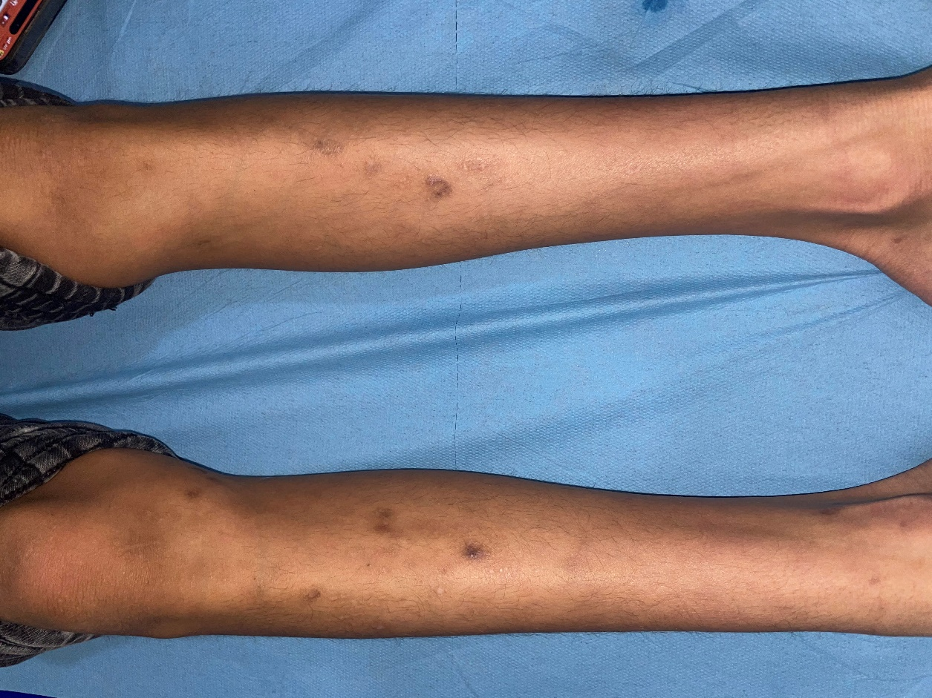

Figure 1: A 13-year-old boy presented multiple annular, pigmented lesions mildly pruritic located on the lower limbs

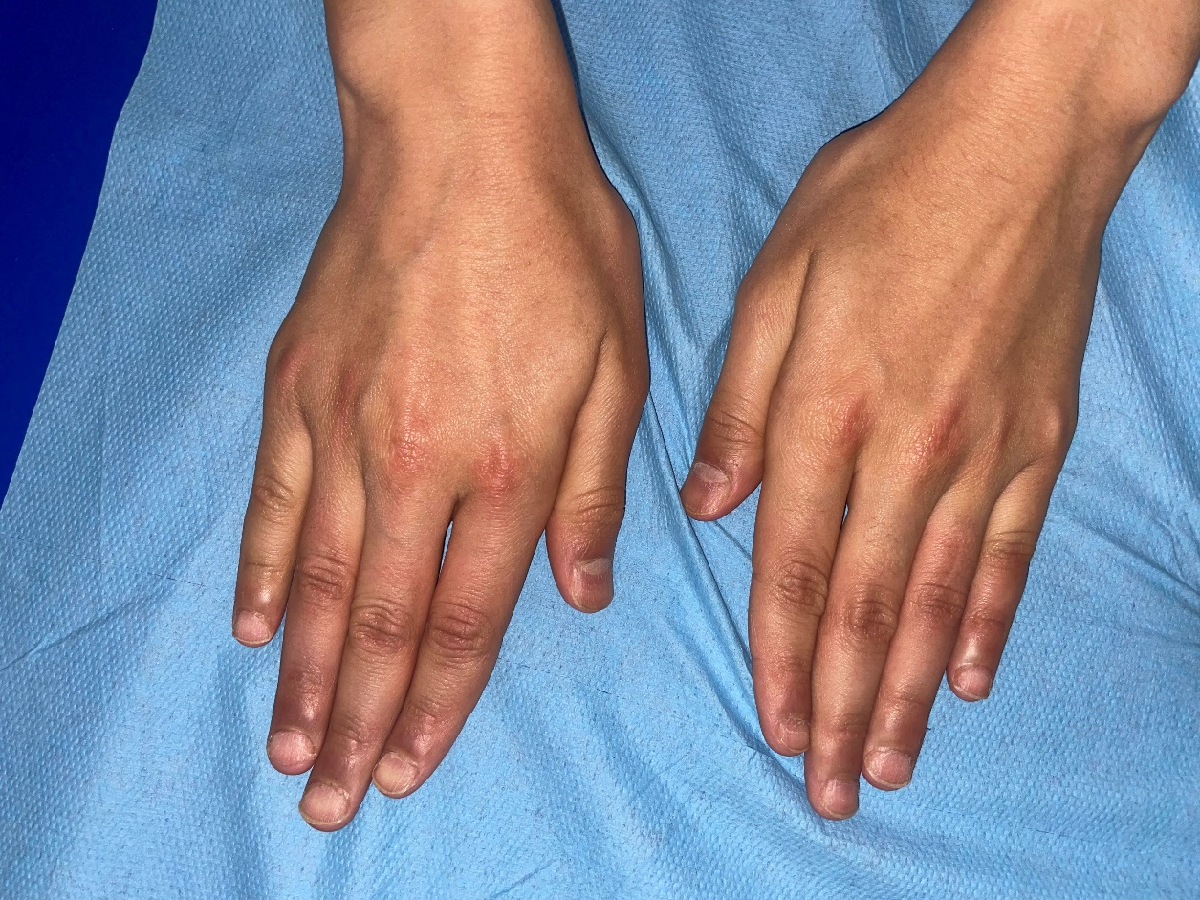

Figure 2: Nail involvement, including onychorrhexis affecting all nails, a pitted nail plate, and koilonychia.

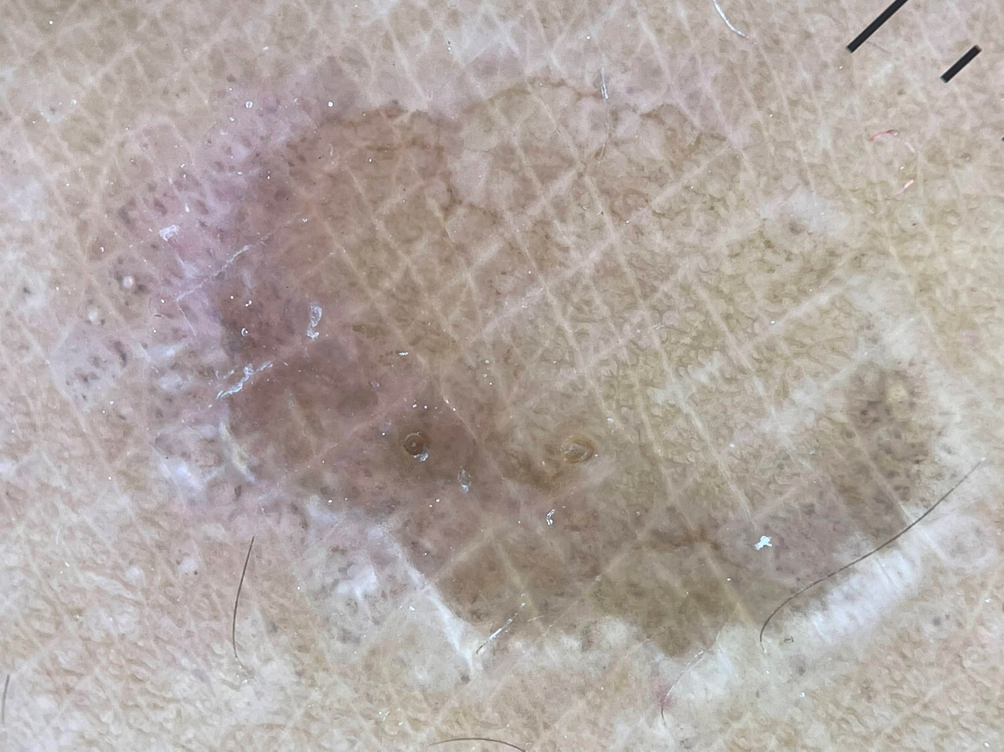

Figure 3: Dermoscopy showing a peripheral granular pigmented pattern, localized erythema, chrysalis structures, and a halo hypopigmented surrounding the lesion.

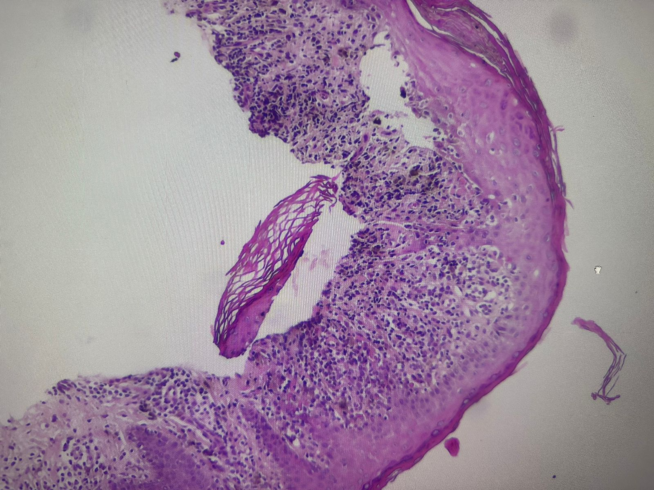

Figure 4: At 5x magnification, the skin is lined with an acanthotic epidermis, occasionally overlaid by an orthokeratotic stratum corneum. The dermis harbors a polymorphous inflammatory infiltrate arranged in a band-like pattern, consisting of numerous atypical lymphocytes with cerebriform nuclei, resulting in basal membrane vacuolization and keratinocyte necrosis. Pigment incontinence is also noted.

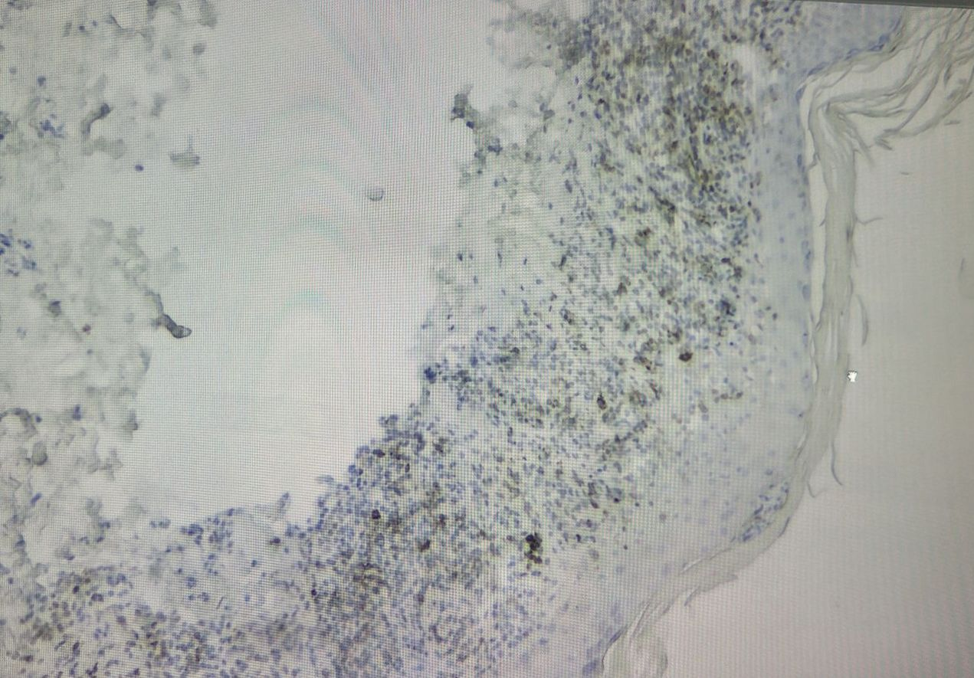

Figure 5 : Immunohistochimy: at 5x magnification: Complete loss of CD7 phenotype.