**DETECTING REGIME CHANGES IN BITCOIN MARKETS: APPLICATIONS OF HIDDEN MARKOV MODELS AND ADVANCED STATISTICAL TECHNIQUES.**

**Abstract**

This work integrates sophisticated modeling approaches, including HMMs, Markov-Switching, and Threshold models, to detect regime shifts in Bitcoin prices and volatility in an attempt to enhance pattern recognition and market forecasting. The dataset includes historical Bitcoin prices as well as trading volumes, capitalization, volatility, and key financial indicators such as minimum, maximum, and mean values, which can enhance exchange listings. A ‘bull’ is a market pattern that involves a continuous and permanent increase in the market price by more than 20%; a ‘bear’ is a market pattern that involves a continuous and permanent decline in the market price by more than 20%. This work explores traditional pricing conduct and identifies new market patterns by applying the Threshold model. This research analyzes traditional pricing behavior and detects significant market shifts via the Threshold model. HMMs provide insights into predicting future behavior, while Markov-switching models help identify regime changes. The results demonstrate HMMs' efficacy, particularly in predicting transitions from bullish to bearish markets that are critical for trading strategies. HMMs model non-stationary time series output, making them advantageous in cryptocurrency markets, where traditional models fail to address drivers like macroeconomic conditions, market sentiment, regulatory changes, and technological advancements. This study presents an HMM framework designed to facilitate accurate market evaluation and regime forecasting, helping traders refine entry and exit strategies and enhance profitability. However, incorporating additional explanatory variables could further improve the model’s forecasting accuracy, benefiting investors and policymakers. The findings showcase HMMs’ reliability in depicting the probabilistic nature of filtered regime shifts, aiding risk management and trading strategy adaptation in unstable cryptocurrency markets.

**Keywords:** Keywords: HMMs, MSMs, Threshold Model, Bitcoin price fluctuation, regime, market prediction, non-constant time series, Cryptocurrency market behavior, trading approach optimization, risk control.

**Introduction**

The Bitcoin markets and the other cryptocurrency markets are widely recognized for their volatility, which depends on a number of factors including changes in the regulatory environment; the level of market development; changes in the existing technology; and macroeconomic factors. Traditional models like Geometric Brownian Motion are insufficient for describing the constantly fluctuating nature of the price of cryptocurrencies due to their often nonstationary and speculative nature. In this work, HMMs are employed for regime changes in the cryptocurrency market for the shift from “Bull” market to a “Bear” market.

In their study, Ben et al. (2023) showed how HMMs can account for volatility and its intra-day movements, and that they provide the means to model unobservable market states. This helps in the study of the existing regime changes and the forecast for the future ones. In the same way, Kim et al. (2019) highlighted that HMMs should be used to identify particular regimes and changes in markets by focusing on the shift in price, volume and sentiment. Using the Viterbi Algorithm in this study establishes the most likely sequence of hidden states and the Forward Algorithm to predict the chance of regime change. These methods improve the forecasting procedures used to make it possible for investors to adopt efficient strategies in the unstable market. However, there are other methods of exploring non-stationary time series which are complementary to the HMMs such as the Markov-Switching Models and the Threshold Models where particular transition thresholds are important.

It is important for investors managing unpredictable assets in the case of Bitcoin to understand the models of the regime shift since these models could help more on improving the portfolio management and the sustainability of investments. In addition, integration of HMMs, as pointed by Koki et al. (2019), has applied prospect in enhancing trading methodologies by recognizing signals for getting into or exiting the market. This research adds to knowledge in the application of HMMs for comprehending and trading in cryptocurrencies to optimally.

**Literature Review**

1. Introduction

Considering Bitcoin’s previously established price swings, characterized by Bull, Bear, and stable market phases, academics have utilized advanced statistical models such as Threshold Models, Markov-Switching Models, and Hidden Markov Models (HMMs). These models effectively capture and analyze non-stationary time series, which characterize cryptocurrency markets, detecting latent states and volatility transitions critical for understanding such markets' dynamics. Considering Bitcoin’s previously established price swings, price fluctuations characterized by Bull, Bear, and stable market phases, and over months and years, academics have used advanced statistical models, namely, Threshold Models, Markov-Switching Models, and Hidden Markov Models (HMMs). These models are particularly well suited to capture and analyze non-stationary time series that characterize the Bitcoin and by extension the entire cryptocurrency market, to detect latent state and volatility transitions which are instrumental in a proper understanding of the dynamics of the specified type of markets. Actually, HMMs were first introduced by Rabiner in 1989 when he was showing how solid the mathematical theory behind HMMs was, and how useful these models are in fields other than voice recognition, finance, for instance, where HMMs help to explain the existence of hidden states. That is why, as Rydén et al. (1998) showed how HMMs can replicate their ability to detect shifts in market conditions through hidden regimes has made them valuable for asset cycle analysis. These models are of great importance to any analysis of the price behavior of Bitcoin as they enable one to better define the state space for different market regime, develop efficient methods of broadcasting states by employing transformation from HMMs to MSMs and Threshold Models.

1. Hidden Markov Models

As they allow defining transitions between the different phases of a market, HMMs are now critical tools for the analysis of unobserved regime shifts, and transitions in Bitcoin and other related financial instruments. Conventional finance models often do not incorporate high-switching regime features and high volatility of Bitcoin prices, and thus, the adjustment of HMMs in capturing the market characteristics are beneficial. These models assist analysts and investors to trace volatile cryptocurrency environment by simplifying to detect change over points and approximate likelihood distributions among hidden states.

It has been evidenced in various researches that HMMs can capture the complexity in various markets with ease. For example, Zhang et al. (2019) employed high order HMMs to enhance trend forecasting to the stock market by incorporating short- and long-term dependencies to enhance the measures of accuracy of its anticipations. Li et al. (2021) also showed that integrating HMMs with text mining into financial contexts can incorporate internal correlations and external shocks inside financial contexts to gauge systemic financial risks in China. Correspondingly, Phillips et al. (2017) applied HMMs for recognizing bubbled cryptocurrency price dynamics by employing epidemic modeling and using social media signals for stable prediction of price variations. A major advancement of the subject is the integration of HMM with deep learning techniques particularly the LSTM network. Applying the same model to high-frequency Bitcoin related data, Hashish et al. (2019) discussed it useful in enhancing regime detection and forecast significantly. Moreover, Giudici and Abu Hashish (2020) find that HMMs can provide value to investors and risk managers when they apply the model to classify Bitcoin price regimes according to covariance characteristics. As indicated in the articles like Li (2021) that established their improved efficiency in the short-term Bitcoin prediction, models of HMMs have shown their effectiveness in capturing volatility within the cryptocurrency. Bayesian HMMs helped spiter et al. (2019) to optimize Bitcoin market forecasts and employ them in efficient risk management. The research demonstrated the advantages of Bayesian HMMs in enhancing the forecasting precision of the market for Bitcoin and how they led to straightforward approaches towards risk control in uncertain markets. Similarly, Ke et al. (2022) employed HMMs with POT to analyze Bitcoin’s tail risks in order to identify key directions for managing extreme conditions in the market. Cross-sectional analyses have confirmed that Bitcoin fluctuations are higher than steadier inflation-sensitive and traditional instrument like S&P 500 according to Suda and Spiteri (2019). This shows that different cryptocurrency markets have unique patterns of movements, which can be well captured by HMMs.

Hachicha et al. (2022) used HMMs to test for price clustering of bitcoin and ethereum while incorporating investor sentiments, volatility and economic policy uncertainty, the. By applying K-means to identify the best states and by setting the HMM states to four, the study discovered that the approach has a 98% forecast accuracy. This study emphasizes how HMMs facilitate capturing market movements, coordinating the portfolio and enhancing risk diversification in high uncertainty crypto market.

c) Markov-Switching Models (MSM) and Regime-Switching Models

The use of MSMs was introduced by Hamilton (1989), and they significantly contribute to analysis and prediction of financial market regimes. These models are suitable for identifying various market phases, for example, ‘bull’, ‘bear’, and ‘stable’ phases, especially in the fluctuant market such as Bitcoin. Guidolin (2011) surveyed the empirical finance literature of MSMs published after Hamilton to consider it capable of reliably testing financial hypotheses and to fit data. Chen and Kawaguchi (2018) adopted Markov regime-switching asset-pricing model and defined different market regimes also pointing to its effects on risk premiums similar to Kodama et al. (2017) by sorting out the various volatile aspects of Bitcoin improving MSMs for Cryptocurrency market. By means of the MS-GARCH models, Caporale and Zekokh (2019) looked at several cryptos and demonstrated that counting.

Chappell et al. (2019) emphasized that the speculative behavior of bitcoins Log Returns were modeled using Discrete-State Markov Regime Switching (MRS) which is a nonlinear technique. In the preliminary multicompartment analysis of 2–7 states, the optimal 5-state model was determined using the AIC, BIC, and Hannan-Quinn (HQ) information criteria. The analysis provided artefacts like volatility clustering, non-successive and non-symmetric transitions, and permanent shocks. These developments highlight the need for the model in capturing higher order characteristics of Bitcoin regime heteroscedasticity and enhancing the understanding of market dynamics and price swings.

Bitcoin price fluctuation patterns are modeled using Hidden Markov Models (HMM) to analyze regime-switching characteristics in the market. SV model can be combined with HMM for the determination of change points in market conditions enhancing the estimation of volatility. Kang et al. (2023) also used this method on Bitcoin data from Upbit to improve on the SV model. The parameter estimation was carried out using the MCMC technique, while model performance was assessed by MAPE and MSE.

1. Threshold Models in Bitcoin Market Analysis

While belonging to the family of regime-switching models, the threshold models are well-suited for capturing nonlinear process and rapid price fluctuations in the markets. These models are more gainful suited to the changing tendencies of Bitcoin since they differentiate the different regimes by applying distinct hurdles that elicit change in the regime. De Guzman & So (2018) employed to threshold heteroskedastic model to examine highly volatile phases of Bitcoin and found a heavy impact of regime switches on markets peculiarities. Along the same line of this, Zhang et al. (2022) found out that extreme returns are highly relevant to future volatility by incorporating the threshold regression models that enhance the volatility forecasting by distinguishing between positive and negative returns.

Ke et al. (2022) achieved severe risk events by predicting Bitcoin’s tail risks applying the peak-over-threshold model. When using the Markov-Switching GARCH model as well as Self-Exciting Threshold Autoregressive (SETAR) models, Hamida and Scalera (2019) identified quite significant shifts in the volatility regime of Bitcoin. Given the inherent volatility of Bitcoin, the stated models offer solid foundations for identifying and managing price trends, and associated risks and opportunities.

**Methodology**

Two processes make up hidden Markov models (HMMs): one bearable assessment which rely on concealed state and an undetectable but evolving procedure of observable and concealed states responding to Markov chain. The nature of the State Transition Probability Matrix A is stated as

$$A= \left\{α_{ij}\right\} =P \left({S_{t+1}=j}_{ }| S_{t}=i\right) (i)$$

where 1 ≤ i,j < N, is the probability why one is moving from state $i$ to some other state $j$. The measurement emission probability matrix or the observation probability matrix B is defined as,

$$B= \left\{b_{j}(0)\right\}=P (O_{t}=o_{k},S_{t}=j) (ii)$$

Where the probability of seeing $o_{k}$ when the system is in a concealed state $j$ is denoted by $b_{j} (o)$.The expression for the Initial State Distribution $π$ is,

$$π = \{π_{i}\} = P (S_{1}= i), (iii)$$

where $πi$ denotes the likelihood of an observation series and the probability of beginning in state $i$. To calculate $O=\{O_{1},O_{2},...,O_{T}\}$, the forward probabilities $α_{t} (i)$ are used, which are specified as

$α_{t}(i) = P (O_{1}, O_{2}, . . . , O_{t}, S_{t} = i | λ)$.

The recursive formula for $α$ is

$$α_{t+1}\left(j\right)=[\sum_{i=1}^{N}{α_{t}\left(i\right)a_{ij}]b_{j}\left(O_{t+1}\right) (iv) }$$

The Viterbi Algorithm may be utilized for finding out the probable order of hidden states $S_{1}, S_{2} …,S_{T}$. It is provided by

$$δ_{t}\left(j\right)=max\left\{S_{1},S_{2},…,S_{t-1}\right\} P\left(S_{1},S_{2},…, =j, O_{1},O_{2},…O_{t} | λ\right) (v)$$

Independence across the regimes of parameters in Markov Switching Models (MSMs) that are often employed to model regime shifts in time series data is due to the Markov process with possible values or transitions between various regimes. Another way of articulating the Switching Mean Model is as in general notation s t refers to the latent regime at time $t$, a y t stands for the observed time series and y ${μ_{s}}_{t}$ is mean of the regime $s_{t}$ at time $t$, and $ϵ_{t}$ represents a Gaussian noise. Given by,

$$y_{t}= μ_{st} + ϵ_{t} \left(vi\right)$$

where $ϵ_{t}∼N (0, σ^{2}s_{t}).$

The latent regime at time $t$ is denoted by $s_{t}$, the observed time series by $y_{t}$, the mean in regime $s_{t}$ by $μ_{st}$, and a Gaussian noise factor by $ϵ_{t}$.

One way to formulate the State Transition Probabilities is as follows:

$$P \left(s_{t}=j \right|s_{t-1}= i) = p_{ij} (vii)$$

with the constraint

$$\sum_{j=1}^{N}{P_{ij}=1}$$

This is so particularly where the probability of a transition from regime $i$ to regime $j$ is denoted by $p_{ij}$. The equation $y_{t}=X_{t} β_{st}+ϵ_{t}$, used in the Switching Variance Model demonstrates that the regression coefficients and variances $σ_{st}^{2}$ are functions of latent regime variable $s_{t}$,

with $ϵ_{t}∼N (0, σ_{st}^{2})$

As threshold models allow different dynamic behaviors based on specific pre-set thresholds on the time series, non-linearity’s can be modeled. The following is a general description of the TAR model TAR is a non-linear model that was specifically designed for threshold autoregressive model.

$y_{t}=\left\{\begin{aligned}ϕ_{1}y_{t-1}+ϵ_{t}, if y_{t-d}≤θ \\ \\ ϕ_{1}y_{t-1}+ϵ_{t}, if y_{t-d}>θ\end{aligned}\right.$ $(vii)$

In this model $ϕ_{1}$ and $ϕ_{2}$ are the autoregressive coefficients for each regime, $d$ is the delay, and $θ$ is the threshold. TAR is extended to several regimes by the Self-Exciting Threshold Autoregressive (SETAR) Model, which has the following form:

$y_{t}=\left\{\begin{aligned}ϕ_{1}y_{t-1}+…+ϕ_{p}y_{t-p}+ϵ_{t}, if y_{t-d}≤θ_{1} \\ ϕ_{2}y_{t-1}+…+ϕ_{p}y_{t-p}+ϵ_{t}, if θ_{1}<y_{t-d}≤θ_{2} \\ . \\ . \\ .\end{aligned}\right.$ $(viii)$

Here, various autoregressive dynamics take place in different regimes. The indicator function captures the requirement for changing regimes.

$$I(y_{t-d} ≤ θ) =\left\{\begin{aligned}1, if y_{t-d} ≤ θ \\ 0, otherwise.\end{aligned}\right.$$

The Bayesian Information Criterion (BIC) and Akaike Information Criterion (AIC) are used for model selection and comparison. The AIC is computed as

$$AIC=-2\log\left(L\right)+2k (ix)$$

Where $k$ is the number of parameters and $L$ is the model's likelihood. The BIC is provided by

$$BIC=-2\log\left(L\right)+klog\left(n\right) (x)$$

The sample size is denoted by $n$. By punishing for complexity and preventing overfitting, these criteria aid in identifying the best model that fits the data.

**Results and Analysis**

Hidden Markov Models (HMMs)

This chapter provides insight into the volatility of the BTC-USD exchange rate by analyzing Bitcoin price predictions using the HMM.

TABLE 1: Statistics Description of BTC-USD Daily Data

|  |  |  |  |  |  |  |  |
| --- | --- | --- | --- | --- | --- | --- | --- |
| Start Date | End Date | Actual No. of days | Mean of log return | Max. of log return | Variance of log return | Skewness of log return | Kurtosis of log return |
| 01/01/2018 | 01/01/2024 | 2,190 | 0.0005 | 0.1718 | 0.0014 | -1.0554 | 14.2495 |

A mean return of 0.000516 is found when the daily logarithmic returns from real stock data are analyzed using yfinance data for 2,190 days. This suggests that the BTC-USD exchange rate is trending slightly upward. While the variance of 0.001355 suggests considerable volatility, the maximum logarithmic return of 0.171821 shows notable positive leaps on some days.

By regressing the daily logarithmic returns from real stock datasets a mean return of 0.000516 is realized. Are analyzed by using data from yfinance for 2,190 days. This can mean that the ratio of BTC and USD used in exchanging each has not significantly altered for a long time. It must be noted, however, that the rate of increase is only slightly higher at this point. Nonetheless, the obtained value of the variance equal to 0.001355 means that there is still a large volatility, and the value 0.171821 of the maximum logarithmic return reveals quite large positive spikes on certain days.

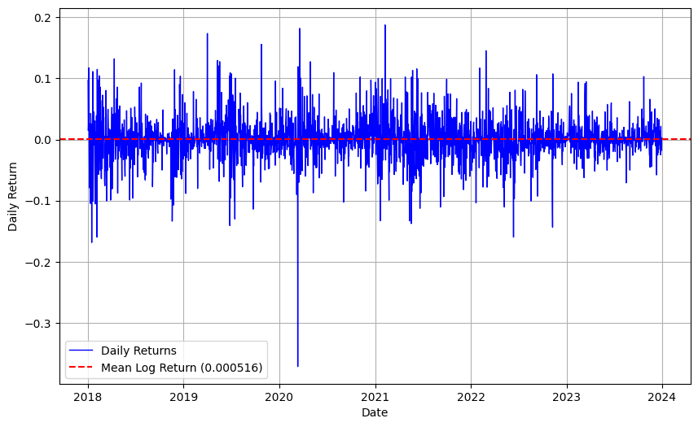

FIGURE 1: Daily Returns of bitcoin(BTC-USD)

A distribution that skews to the left that is characterized by many small positive returns and few large negative ones. Tent, indicated by the skewness of the return distribution of −1.0554 and also pointed to by the existence of negative skewed returns risk. In the same way, leptokurtosis – a distribution type associated with high skews in the frequency of large returns. This is revealed by the scale of kurtosis which stands at 14.249506. The findings presented here prove how endangered Haendel and Slezak associate Bitcoin to punctual price volatility and non-normal distributions requiring There is a need to use complex models such as Hidden Markov Models (HMMs) in order to capture these complex dynamics.

2-State HMM Parameter Estimation

By separating the price behavior of Bitcoin into two different regimes, high volatility and low regimes, the work makes a useful contribution towards the literature. volatility ——it is shown that the proposed 2-state HMM model can be employed to model the BTC-USD log returns.

TABLE 2: Parameter Estimation of 2-State HMM

|  |  |  |
| --- | --- | --- |
| Parameter | State 1 | State 2 |
| Initial State Probabilities | 0 | 1 |
| State Mean | -0.0007 | -0.0012 |
| State Variance | 0.0033 | 0.0003 |

The initial state probability is 1 which means that it is guaranteed to begin in state 2. The following is the transition probability matrix:

$$P\left(i,j\right)=\left[\begin{matrix}0.6747 & 0.3253 \\ 0.1789 & 0.8211\end{matrix}\right]$$

State means and variances provide the following insights: State 1: Great variations in price. are shown by having a slightly negative mean (- 0.0007) as well as high variance within 0.0033. State 2: With stable price movements, we find a more negative mean (-0.0012) and a lower variance. (0.0003).

In separating Bitcoin’s BTC-USD log returns into high and low volatility states, 2-state Markov switching GARCH model the coefficient HMM improves the analysis of market shifts.

It also shows that price fluctuation is high for State 1 with variance of 0.0033 and is fairly in table 2, the mean obtained was - 0.0007 which is a negative mean as expected of an efficiency measure. State 2 on the other hand exhibits constant price movements, more negative with a mean value -0.0012 and smaller variance 0.0003 as compared to the corresponding means and variance for negative stock returns.

In the same manner, transition probability matrix also indicates relatively higher regime shifts, while the initial state probability indicates 1 to be starting from State 2. Business people with this knowledge can be in a position to predict changes in the market and be in a position to adapt their plan towards risk diversification for more profit.

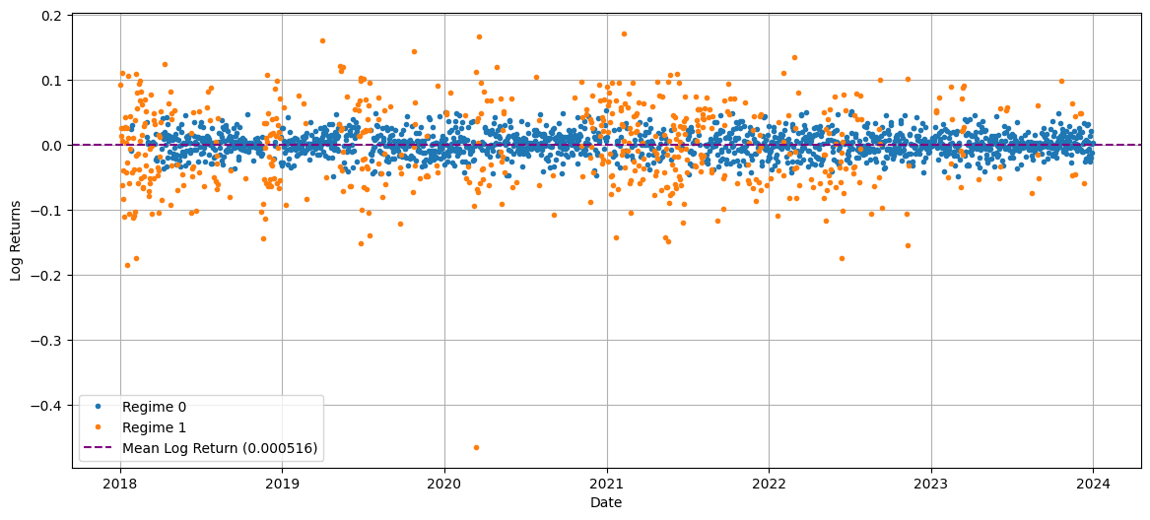

FIGURE 2: The regime plot for the 2-state HMM-BTC-USD

**3-State HMM Parameter Estimation**

By the 3-state technique, parameters for different market conditions are also estimated. HMM. Refer to Table 3.

TABLE 3: Parameter Estimation of 3-State HMM

|  |  |  |  |
| --- | --- | --- | --- |
| Parameter | State 1 | State 2 | State 3 |
| Initial State Probabilities | 0 | 1 | 2 |
| State Mean | 0.0007 | -0.0042 | 0.0026 |
| State Variance | 0.0002 | 0.0041 | 0.0018 |

$P\left(i,j\right)=\left[\begin{matrix}0.7208 & 0.0028 & 0.2764 \\ 0.0003 & 0.9626 & 0.0371 \\ 0.4347 & 0.0126 & 0.5528\end{matrix}\right]$

The three volatility regimes are Regime 0 (stable), Regime 1 (moderate) and Regime 2 (high) volatility. Three states that the 3-state HMM estimates parameters that reflects on different forms of Bitcoins. Market circumstances. The initial probabilities show moderate volatility. Suggest that they start at State 1 with a probability of 100 percent. The probability of change of states are shown and described in the structure of the matrix of transition. As seen before, the mean for State 2 is negative (- 0.0042), and a relatively high fluctuation, State 1 has slightly positive mean value 0.0007 and relatively low value of dispersion.

Knowledge of such shifts in regime helps traders in evaluating risks and drawing up their strategies market orientation as an organizational adaptation to environmental cues.

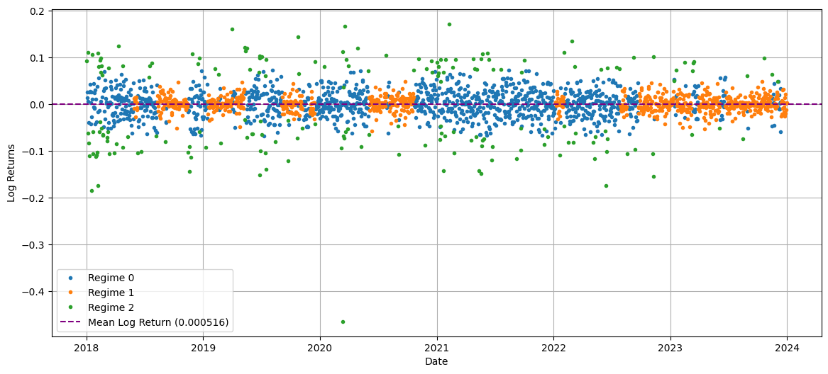

FIGURE 3: The regime plot for the 3-state hidden Markov Model(HMM)-BTC-USD

**4-State HMM Parameter Estimation**

Four different market regimes are identified using the 4-state HMM. The parameters are displayed in Table 4.

TABLE 4: Parameter Estimation of 4-State HMM

|  |  |  |  |  |
| --- | --- | --- | --- | --- |
| Parameter | State 1 | State 2 | State 3 | State 4 |
| Initial State Probabilities | 0 | 1 | 2 | 3 |
| State Mean | -0.0026 | -0.0158 | 0.0010 | 0.0006 |
| State Variance | 0.0015 | 0.0088 | 0.0019 | 0.0002 |

$$P \left(i, j\right)=\left[\begin{matrix}0.9200 & 0.0658 & 0.0034 & 0.0108 \\ 0.5196 & 0.4804 & 0.0000 & 0.0000 \\ 0.0000 & 0.0024 & 0.4898 & 0.5078 \\ 0.0001 & 0.0085 & 0.2038 & 0.7876\end{matrix}\right]$$

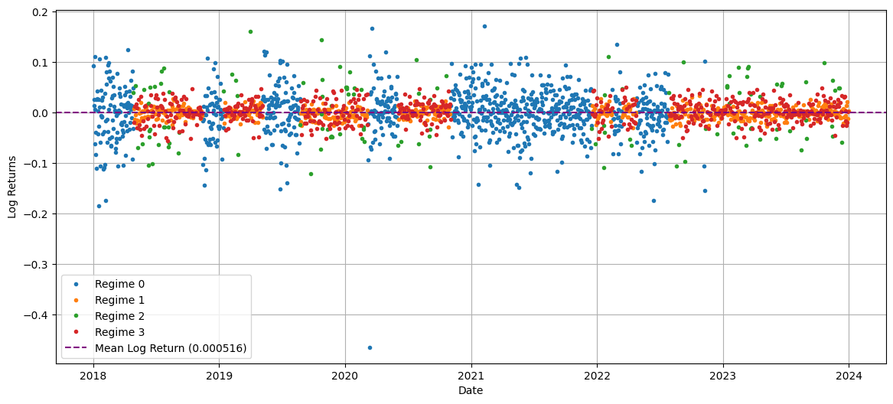

FIGURE 4: The regime plot for the 4-state hidden Markov Model(HMM)-BTC-USD

By distinguishing four different regimes—State 1 (stability), State 2 (severe volatility), State 3 (moderate volatility), and State 4 (consolidation)—the 4-state HMM provides a comprehensive perspective of Bitcoin's BTC-USD log returns. According to initial probabilities, there is 100% certainty that the system starts in State 4. With State 1 having a 92% chance of surviving, the transition matrix shows frequent state shifts. Different market circumstances are shown by state means and variances: States 1 and 4 show moderate variations, States 2 and 3 show extreme volatility, and State 1 has low volatility. The dynamic character of Bitcoin's price fluctuations, with frequent shifts between stability and volatility, is captured by the regime plot from 2018 to 2024.According to the model selection criteria, the 4-state HMM is the ideal model for examining the market behavior of Bitcoin since it provides the best balance between accuracy and simplicity, as seen by its lowest AIC (-9021.57) and BIC (-8862.20) values.

**Markov-Switching Model**

By permitting shifts between states depending on the current state, the Markov Switching Model (MSM) is able to reflect regime transitions in financial time series. It provides an adaptable framework for deciphering intricate dynamics that conventional linear models could overlook.

**2-State Regime-Switching Model**

|  |  |  |
| --- | --- | --- |
| Parameter | State 1 | State 2 |
| Initial State Probabilities | 0 | 1 |
| State Mean | 0.5533 | 0.3208 |

$$P \left(i, j\right)=\left[\begin{matrix}0.5000 & 0.5000 \\ 0.5002 & 0.4998\end{matrix}\right]$$

In the two-state regime-switching model, State 1 exhibits less variation and a higher level of mean reversion as compared with State 2. Returns, this means it is in the “bear” state, while State 2 has higher variance and lower returns. Indicating a "bull" market. Because the transition probabilities are so close to one another, there is an equal opportunity of switching states.

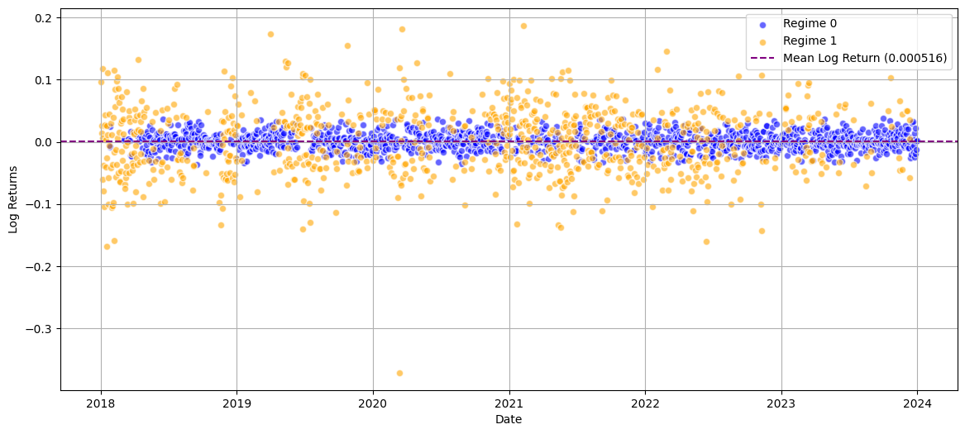

FIGURE 5: The regime plot for the 2-state Regime-Switching Model -BTC-USD

**3-State Regime-Switching Model**

The "bull" market is represented by state 3 and the "bear" market by state 2. The three-state model displays regimes arranged according to rising volatility. The 3-state model appears to offer a better match than the 2-state model, as indicated by the lower BIC value.

TABLE 6: Parameter Estimation of 3-State RSM;

|  |  |  |  |
| --- | --- | --- | --- |
| Parameter | State 1 | State 2 | State 3 |
| Initial State Probabilities | 0 | 1 | 2 |
| State Mean | 0.5180 | 0.2929 | 0.2752 |
| State Variance | 0.0000 | 0.0000 | $$-7.1439×{10}^{83}$$ |

$$P\left(i,j\right)=\left[\begin{matrix}0.5660 & 0.6045 & -0.1705 \\ 0.5776 & 0.5000 & -0.0776 \\ 0.4986 & 0.5039 & -0.0026\end{matrix}\right]$$

The dynamic market behavior of Bitcoin is captured by the 3-state Markov-Switching Model, which differentiates between regimes based on rising volatility. Favorable, steady conditions are reflected in State 1, which has the greatest mean (0.518) and almost zero variance. States 2 and 3 exhibit moderate and high volatility, respectively, with lower averages of 0.293 and 0.275. The system's dynamic nature is highlighted by the frequent state transitions. Investors may forecast regime changes and make well-informed decisions for risk management and possible profits by using the model's plot, which displays Blue (low volatility), Green (moderate), and Red (high volatility) dots.

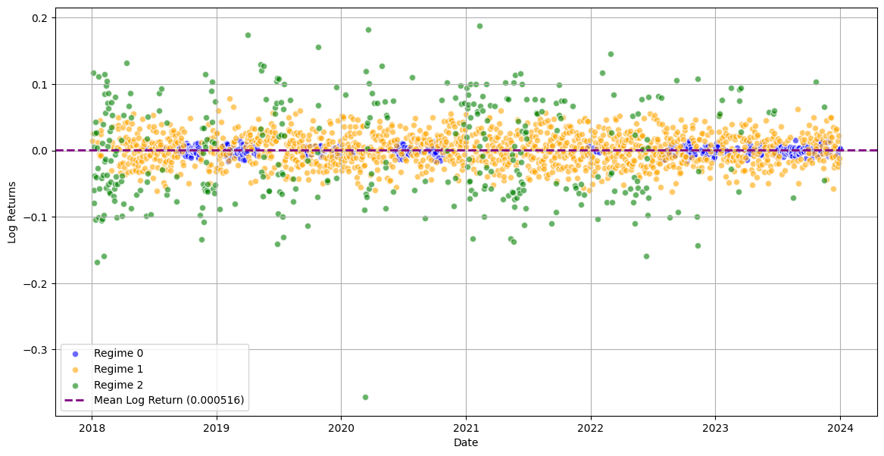

FIGURE 6: The regime plot for the 3-state Regime-Switching Model -BTC-USD

**4-State Regime-Switching Model**

Only the 2 and 3-state models were analyzed because the 4-state model had a higher BIC value, suggesting a poor fit for the data.

TABLE 7: Parameter Estimation of 4-State RSMl

|  |  |  |  |  |
| --- | --- | --- | --- | --- |
| Parameter | State 1 | State 2 | State 3 | State 4 |
| Initial State Probabilities | 0 | 1 | 2 | 3 |
| State Mean | 0.5124 | 0.2883 | 0.2625 | 0.2616 |
| State Variance | $$0.0000$$ | $$9.04 × {10}^{-82}$$ | $$4.66 × {10}^{-81}$$ | $$9.51× {10}^{-86}$$ |

$$P \left(i, j\right)=\left[\begin{matrix}0.6667 & 0.5417 & 0.5652 & 0.5597 \\ 0.5423 & -0.6501 & 0.5421 & 0.5657 \\ 0.5676 & 0.5556 & 0.5001 & 0.5000 \\ 0.4980 & 0.5004 & 0.5001 & -0.4985\end{matrix}\right]$$

A higher BIC value indicates that the 4-state Markov-Switching Model performs badly when compared to the 2- and 3-state models, despite its best efforts to represent market behavior over four regimes. While States 2, 3, and 4 have steadily declining means and little variance, indicating stable circumstances within each state, State 1 has the greatest mean (0.512) and stable returns. Four levels of volatility are represented by the model's plot: low (blue), moderate (green), normal (red), and high (yellow). The small variances, however, raise questions regarding the robustness of the model and may indicate overfitting. As a result, the 4-state model was not included in the analysis.

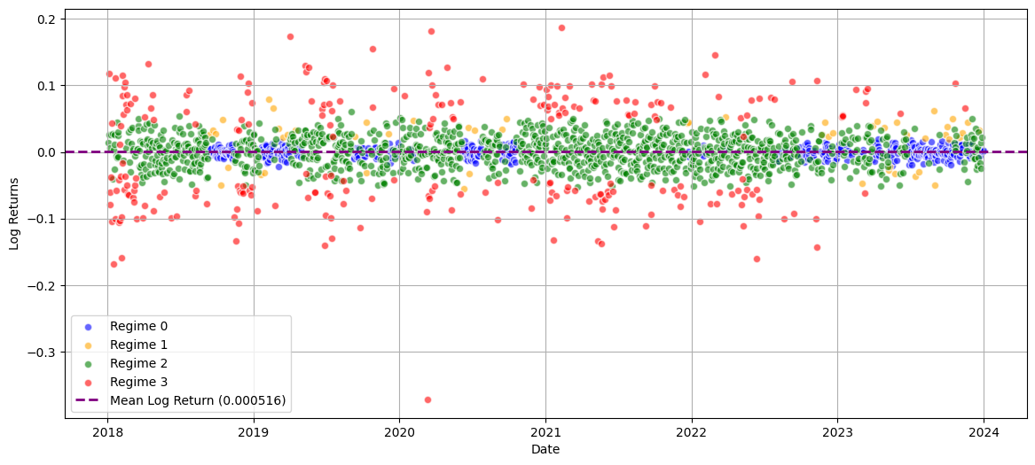

FIGURE 7: The regime plot for the 4-state Regime-Switching Model -BTC-USD

**Threshold Model**

Significant distinctions between periods of returns below and above the threshold are revealed by the threshold model analysis of returns.

TABLE 8: Statistics of Returns Below and Above

|  |  |  |
| --- | --- | --- |
| Statistic | Below Threshold | Above Threshold |
| Mean Return  Maximum Return  Variance of Return  Skewness of Return  Kurtosis of Return | -0.2295  0.0008  0.0008  3.4701  26.6323 | 0.0253  0.1875  0.0007  2.0831  5.4627 |

In particular, the mean return is negative below the threshold (-0.22949) and positive above it (0.025322). This suggests that there is an average loss during periods of low returns and better performance during periods of higher returns. The fact that maximum returns are much lower below the threshold (0.000785) than above it (0.187465) indicates that greater return periods are more likely to see severe positive returns. Furthermore, below the threshold, the variation of returns is somewhat higher, indicating higher risk. These discrepancies are further illustrated by skewness and kurtosis statistics, which demonstrate that above-threshold returns exhibit a right-skewed distribution with more frequent large positive returns, whereas below-threshold returns show a left-skewed distribution and extreme negative returns. All things considered, these results highlight the unique risk profiles and return characteristics in various return regimes.

**The 2-State Threshold Model**

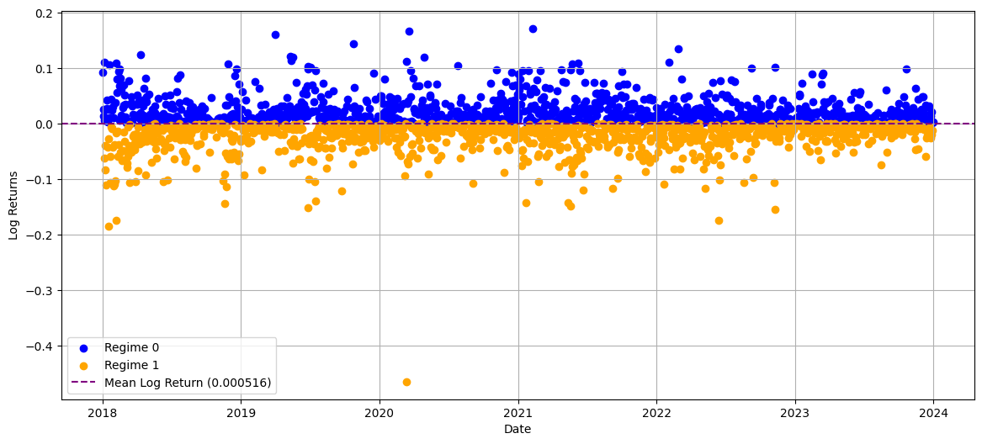

FIGURE 8: The regime plot for the 2-State Threshold Model -BTC-USD

Shifting analytical focus to the presence or absence of particular market conditions, this paper employs a 2-state threshold model. An essential limiting value, the figure represents the logarithmic gains of a time series analyzed into two states. While blue dots which constitute state “0” are bunched below the zero axis, the graph illustrates that a lesser performing or a less steady state; the orange circles depicting state ”1” are predominantly above a value of zero, which will suggest a higher performance regime or a stable performance regime. This nonlinear model provides information concerning varied behaviors of the market during the growth and decline phases. Effectively identifying and timing shifts in regime in the data. The timeline of observations is given at the x-axis, and the closer data points are grouped to each other, represents how long lasting the stages are. Analysts understand and forecast the markets.

**The 3-State Threshold Model**

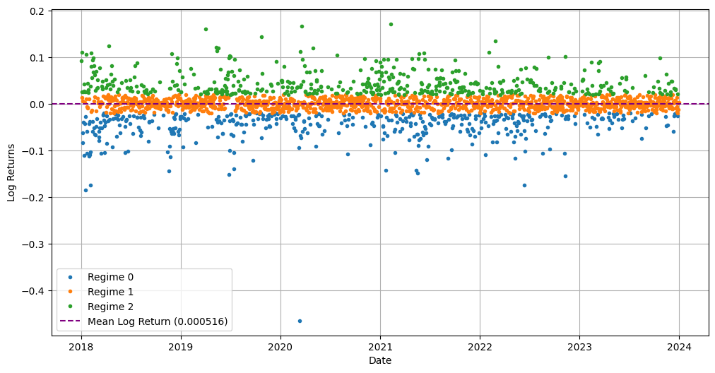

FIGURE 9: The regime plot for the 3-State Threshold Model -BTC-USD

State “0” (blue) referred to as Bear state or negative returns or downturns, state “1” (orange) referred to as, baseline or no trend. Stable market phase and “2” or state “Green” represent the condition of positive returns and high performance. The plot shows analysis of Bitcoins collected using a 3-state threshold model where Log returns of a time series into three different regimes. The addition of a third state enhances the ability of this model to portray regime-switching. Analysis and reveals more subtle tendencies of the market with the thresholds for basic parameters such as interest rates and prices. That division is done in such a way that it is easy to differentiate between the three groups. Concerning fluctuations in performance levels, and presents valuable data for managing risks. Predication and identifying potential market trends reversals.

**The 4-State Threshold Model**

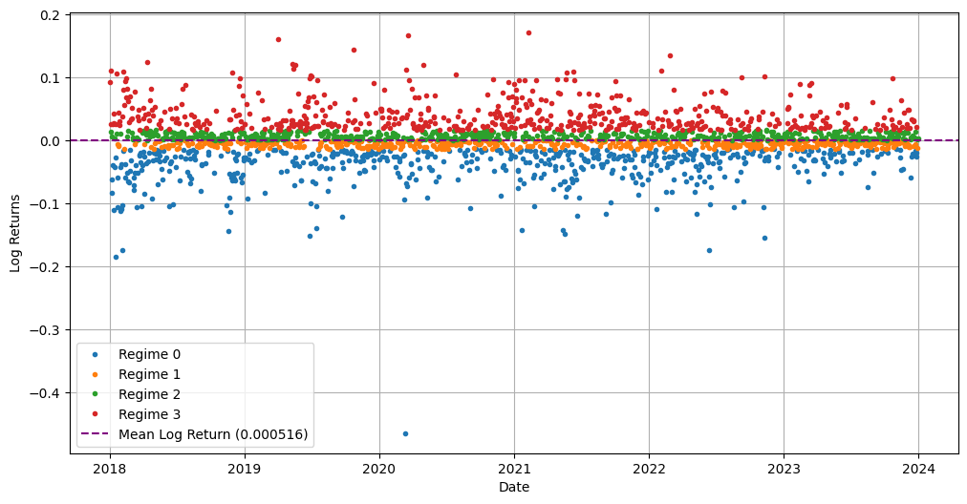

FIGURE 10: The regime plot for the 4-State Threshold Model -BTC-USD

Blue meaning low returns as well as high volatility, green meaning relatively low returns slightly above zero, red meaning somewhat positive volatility. during high return periods it appears red, blue indicates high volatility, moderate returns and the transitional phase appears as yellow. Into which the 4-state threshold model divides log returns. Therefore, it becomes possible to identify changes between depending on the numerous other economic factors and market states; the model allows giving correct estimations of risks and chance by being able to capture market flows.

**Conclusions and Recommendations**

For the purpose of analyzing regime switching in BTC-USD markets, this research proposed an architecture to incorporate Hidden Markov Models (HMMs) which we also used to determine their in comparison to Markov-Switching and Threshold models they performed well. The two-state HMM have shed light on permanency and shifts within a market by effectively capturing transitions between the low-volatility Bull market regime and the high volatility Bear market regime.

TABLE 9: AIC and BIC values for the three different Models

|  |  |  |
| --- | --- | --- |
| Model | AIC | BIC |
| Threshold Model  Markov-Switching  Hidden Markov Model | -212.841064  -8907.774222  -8910.944619 | -207.060366  -8873.624281  -8893.869648 |

These results indicated that the HMM provided the best fit of the models when determining fit by the BIC and A IC with the least amount of BIC (- 8893.87) and AIC (-8910.94). In fact, the parameters of the HMMs and its smoothed probability established an effective manner. This study also afforded further support to HMMs’ reliability and usefulness in market forecast. Changes, therefore, makes them very useful to the traders and investors.

Due to its applications in extending the 4-state HMM which was relatively simple in structure, it was even more useful for forecasting changes in the Bitcoin market.

**Recommendations**

The 4-state HMM is one of the common tools that the traders and investors can rely on to reduce risk exposures, anticipate trading strategies, as well as identify how the regime of the bitcoin market is likely to change in the future. HMMs can also be applied to select the time of investing and exiting in the market for both short and long term investors. These models can be used by the policymakers to monitor levels of volatility and recognize market bubbles or collapses for immediate actions, financial experts are advised to apply HMMs to other assets.

**Limitations of the Study**

The causes of inaccuracy were because the study considered only Bitcoin price leaving out the rest. Such factors as trading volume and factors in the macro environment affecting the trading partners’ economies. Other models that were more detailed could give a more detailed explanation but at a cost of increased computation, if not nevertheless, the best one was the 4-state HMM. The findings which were derived in this study may not necessarily help in predicting the future. Market situations since they have employed the historical data for the period 2018- to 2024.

**Suggestions for Further Research**

In future research, trading volume and worldwide patterns should be included in analysis which can be conducted by using the machine learning methods like Natural Language Processing (NLP). The use of HMMs may be improved through the mixture with other AI algorithms such as LSTM and reinforcement learning to improve the regime detection. Improve trading techniques and market insight through utilizing AI for real time analysis and extending the strategy to involve other forms of crypto currencies. While analyzing the performance of our techniques, comparative research could be conducted following models such as SVMs and Deep Neural Networks (DNN).

There are some benefits of HMMs, MSMs and the Threshold Model that can be strengthened through inclusion of the practical trading applications. The financial markets that relate to these models that I highlighted here are;

Hidden Markov Models (HMMs);

Utilized to analyze and forecast tendencies in stock or crypto prices in order to find out when the market is ‘bull’, ‘bear’ or ‘neutral’ which will give traders the best points to enter and exit the market for example: Top-down asset rebalancing methodologies that call on the regimes dynamically reinvent the portfolio allocation (Kim et al., 2019).

Markov-Switching Models (MSMs);

Used during the modeling of time-series volatility to understand the effects of macroeconomic announcement in changing market regime, for example; Using the probability estimates of the trading regime on equities or forex markets to derive trading signals.

Threshold Models:

Is useful in defining the major price levels that may cause the reactions of the market for example; Stop loss or breakout levels for high volatility stocks, commodities and foreign exchange.

**Disclaimer (Artificial intelligence)**

Option 1:

Author(s) hereby declare that NO generative AI technologies such as Large Language Models (ChatGPT, COPILOT, etc.) and text-to-image generators have been used during the writing or editing of this manuscript.

Option 2:

Author(s) hereby declare that generative AI technologies such as Large Language Models, etc. have been used during the writing or editing of manuscripts. This explanation will include the name, version, model, and source of the generative AI technology and as well as all input prompts provided to the generative AI technology

Details of the AI usage are given below:

1.

2.

3.

**REFERENCES**

Ben Aouicha, N., & Ayed, S. (2023). Ethereum Price Prediction Model Comparison Using HMM Models, HMM Pretrained and Custom Model Deep Reinforcement Learning and LSTM. *Sarra, Ethereum Price Prediction Model Comparison Using HMM Models, HMM Pretrained and Custom Model Deep Reinforcement Learning and LSTM (August 31, 2023)*.

Caporale, Guglielmo Maria, & Taras Zekokh. (2019). Modelling volatility of cryptocurrencies using Markov-Switching GARCH models. *Research in International Business and Finance*, *48*, 143-155.

Chappell, D. R. (2019). Regime heteroskedasticity in Bitcoin: A comparison of Markov switching models. *Journal of Applied Economic Sciences (JAES)*, *14*(65), 621-641.

Cheah, Eng-Tuck, & John Fry. (2015). Speculative bubbles in Bitcoin markets? An empirical investigation into the fundamental value of Bitcoin. *Economics letters*, *130*, 32-36.

Chen, Jiawen, & Yoshiro Kawaguchi. (2018). Multi-factor asset-pricing models under Markov regime switches: Evidence from the Chinese stock market. *International Journal of Financial Studies*, *6*(2), 54.

Magtanggol III De Guzman, Rafael Antonio, & Michael K. So. (2018). Empirical analysis of bitcoin prices using threshold time series models. *Annals of Financial Economics*, *13*(04), 1850017.

Filardo, Andrew J., & Stephen F. Gordon. (1998). Business cycle durations. *Journal of econometrics*, *85*(1), 99-123.

Giudici, Paolo, & Ibrahim Abu-Hashish. (2019). What determines bitcoin exchange prices? A network VAR approach. *Finance Research Letters*, *28*, 309-318.

Giudici, Paolo, & Ibrahim Abu Hashish. (2020). A hidden Markov model to detect regime changes in cryptoasset markets. *Quality and Reliability Engineering International*, *36*(6), 2057-2065.

Guidolin, Marco. (2011). Markov switching models in empirical finance. In *Missing data methods: Time-series methods and applications* (pp. 1-86). Emerald Group Publishing Limited.

Hachicha, F. (2022). Hidden Markov Model for Price Clustering Bitcoin-Ethereum Trading. *Edited by Sergey Y. Yurish*, 120.

Hamida, Houssem B. Hamida, & Francesco Scalera. (2019). Threshold mean reversion and regime changes of cryptocurrencies using SETAR-MSGARCH models. *International Journal of Academic Research in Accounting, Finance and Management Sciences*, *9*(3), 221-229.

Hamilton, James D. (1989). A new approach to the economic analysis of nonstationary time series and the business cycle. *Econometrica: Journal of the econometric society*, 357-384.

Kang, T. H., & Hwang, B. S. (2023). Hidden Markov model with stochastic volatility for estimating bitcoin price volatility. *The Korean Journal of Applied Statistics*, *36*(1), 85-100.

Ke, Renzhong, Lixia Yang, & Chun Tan. (2022). Forecasting tail risk for Bitcoin: A dynamic peak over threshold approach. *Finance Research Letters*, *49*, 103086.

Kim, K., Lee, S. Y. T., & Assar, S. (2019). Coin market behavior using social sentiment Markov chains.

Kodama, Osamu, Ladislav Pichl, & Kaizoji, T. (2017). Regime change and trend prediction for Bitcoin time series data. In *CBU International Conference Proceedings...* (Vol. 5, p. 384). Central Bohemia University.

Koki, Christos, Spyridon Leonardos, & Georgios Piliouras. (2019, October). Do cryptocurrency prices camouflage latent economic effects? A bayesian hidden markov approach. In *Proceedings* (Vol. 28, No. 1, p. 5). MDPI.

Li, Zhen, Yuhong Cai, & Shuang Hu. (2021). Research on systemic financial risk measurement based on HMM and text mining: a case of China financial market. *IEEE Access*, *9*, 22171-22185.

Pennoni, Fabio, Francesca Bartolucci, F., Forte, G., & Ametrano, F. (2020). Multivariate Hidden Markov model: An application to study correlations among cryptocurrency log-returns. In *The 2nd Crypto Asset Lab Conference* (pp. 1-27).

Phillips, R. C., & Gorse, D. (2017, November). Predicting cryptocurrency price bubbles using social media data and epidemic modelling. In *2017 IEEE symposium series on computational intelligence (SSCI)* (pp. 1-7). IEEE.

Rabiner, L. R. (1989). A tutorial on hidden Markov models and selected applications in speech recognition. *Proceedings of the IEEE*, *77*(2), 257-286.

Rydén, T., Teräsvirta, T., & Åsbrink, S. (1998). Stylized facts of daily return series and the hidden Markov model. *Journal of applied econometrics*, *13*(3), 217-244.

Suda, D., & Spiteri, L. (2019). Analysis and comparison of bitcoin and s and p 500 market features using HMMs and HSMMs. *Information*, *10*(10), 322.

Zhang, M., Jiang, X., Fang, Z., Zeng, Y., & Xu, K. (2019). High-order Hidden Markov Model for trend prediction in financial time series. *Physica A: Statistical Mechanics and its Applications*, *517*, 1-12.

Zhang, Y., He, M., Wen, D., & Wang, Y. (2022). Forecasting Bitcoin volatility: A new insight from the threshold regression model. *Journal of Forecasting*, *41*(3), 633-652.