Bone Grafting and Reverse Hybrid Fixation Technique for Treating Neglected Posterior Dislocation of the Hip with Acetabulum Fracture In a Young Adult: A Case Report

Abstract
Introduction
Posterior hip dislocations with acetabular fractures result from high-energy trauma, necessitating urgent medical attention due to their severity and potential complications. The posterior dislocation of the hip occurs when the femoral head is forced out of the acetabulum, typically accompanied by fractures to the acetabular wall. The complexity of these injuries presents a significant challenge in terms of diagnosis, treatment, and long-term management, with potential complications that can affect the patient’s quality of life. Neglected cases pose additional challenges, often requiring total hip replacement (THR) to restore function and mitigate complications. Development of avascular necrosis has been reported to range from 3% to 58% following traumatic hip dislocations.
Aim: This case report aims to highlight the complexities and treatment considerations for neglected posterior hip dislocations with acetabular fractures, particularly of the Judet-Letournel basic type posterior wall.
Case Presentation
A 35-year-old male presented with severe right hip pain for two months after a motorcycle accident and functional impairment with a tibia fracture, delaying diagnosis of neglected right hip dislocation with a posterior wall acetabular fracture. Limb length discrepancy (LLD) was 3 cm, and Harris Hip Score (HHS) was 68, which is a poor result. THR was followed by placing a bone graft from the femoral head and fix it with three screws, then perform reverse reaming on the bone graft. The patient does not experience pain after 6 months post-operation. The HHS at six months post-operation was 89, which is a good result.
Discussion
Neglected cases were challenges, and a complex treatment approach was required. The choice of THR with reverse hybrid fixation technique was guided by the patient's age and bone quality to restore joint function, alleviate pain, and enhance quality of life. This approach aimed to balance the benefits of both fixation methods, ensuring stability and promoting long-term implant survival. The use of reverse hybrid fixation in younger patients highlights its lower revision rates compared to other fixation methods. There was an improvement in LLD and the HHS from the preoperative compared to six months post-operative.
Conclusion
This case highlights the management complexities of neglected posterior hip dislocation with acetabular fracture. Timely intervention and appropriate surgical strategies, including THR with specific implant choices for optimal patient outcomes and long-term joint health. Also, this case underscores the critical role of timely intervention and tailored surgical strategies in achieving favourable outcomes, emphasising the importance of early recognition and comprehensive management in optimising patient recovery and long-term joint health.

Keywords: Hip dislocation, acetabular fracture, reverse hybrid, Posterior hip, total hip replacement
INTRODUCTION
Hip dislocations are an important condition presenting to the emergency department (ED), requiring rapid evaluation and management. More than 90% of hip dislocations are posterior, and the most common mechanism for native hip dislocation is a motor vehicle collision, causing a high-energy load on a flexed hip (Gottlieb, 2022). Posterior hip dislocations accompanied by acetabular fractures are often the result of high-energy trauma, such as motor vehicle accidents or falls from significant heights. These injuries are severe and require immediate medical attention due to the substantial force involved (1,2). The posterior dislocation of the hip occurs when the femoral head is forced out of the acetabulum, typically accompanied by fractures to the acetabular wall (3,4,5). The complexity of these injuries presents a significant challenge in terms of diagnosis, treatment, and long-term management, with potential complications that can affect the patient’s quality of life (3,4,5).
Hip fractures are a major healthcare problem, presenting a huge challenge and burden to individuals and healthcare systems. The number of hip fractures globally is rising rapidly. The majority of hip fractures are treated surgically (Lewis et al., 2022; Jin et al., 2021). Neglected injuries, where immediate medical intervention is not sought or achieved, can lead to severe complications, including damage to the arterial, venous, and nervous structures surrounding the hip joint.6 These complications can result in avascular necrosis, nerve damage, and impaired blood flow, exacerbating the injury and making treatment more complex. In such cases, the preferred course of action often shifts towards a total hip replacement (THR). THR becomes necessary to restore joint function, alleviate pain, and prevent further deterioration of the hip joint 6 The surgical approach must carefully consider the damaged structures and the overall health of the patient to ensure a successful outcome (6).
Total hip replacement (THR) is a procedure which can improve the quality of life in patients with osteoarthritis (Wareńczak & Lisiński, 2019). When choosing an implant for total hip replacement in adults with neglected posterior hip dislocation and acetabular fracture, several factors must be considered. The choice of implant depends on the extent of the acetabular and femoral head damage, bone quality, and the presence of any previous surgical interventions. For adult patients, a combination of a cemented acetabular cup and a cementless femoral stem has been advocated to address the unique biomechanical demands and bone quality considerations of such injuries. This approach aims to achieve stable fixation, minimise wear and osteolysis, and promote long-term implant survival in a challenging anatomical and physiological environment (7,8).
This case report aims to highlight the complexities and treatment considerations for neglected posterior hip dislocations with acetabular fractures, particularly of the Judet-Letournel basic type posterior wall. This case underscores the importance of timely diagnosis and intervention, as well as the challenges presented by delayed treatment. By sharing this case, the authors aim to contribute to the body of knowledge on managing such injuries and provide insights that may aid clinicians in making informed decisions in similar scenarios. The case report serves as a reminder of the critical role of early detection and intervention in preventing complications and improving patient outcomes.

Case Presentation
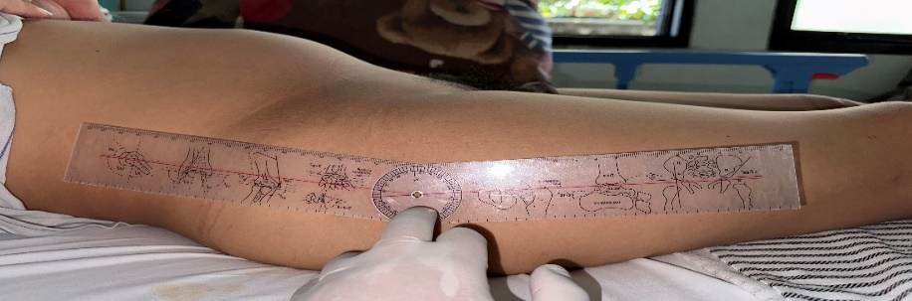
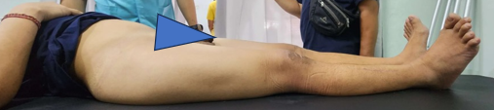
A male 35 year old came to Prof Ngoerah Hospital (1 January 2024) presenting with pain in the right hip since 2 months ago (14 November 2023). Pain was said to appear suddenly and prevent the patient can’t walking. Pain was getting worse when the patient was sitting or walking. He also complained about difficulty to straight or bending on the right hip since the pain appeared. There was no complaint about weakness or numbness in the right lower extremity. The mechanism of injury is that the patient was riding a motorcycle and then collided with another motorcyclist coming from the opposite direction. He was taken to Famili Husada Hospital and subsequently referred to Sanjiwani Hospital, where surgery was performed ORIF on the tibia the following day (15 November 2023). The patient was referred from Sanjiwani Hospital by an orthopaedic surgeon, and the patient was referred with a diagnosis of neglected right hip dislocation + suspensory fracture posterior wall acetabulum. On physical examination of the right knee region, was found deformity (+) shorthening LLD 3cm, tenderness (+) at the proximal femur, dorsalis pedis artery (+), CRT <2s, SpO2 99%, and normal sensation. Movement was found active ROM hip limited due to pain, active ROM knee limited due to pain, active ROM ankle 20/50, active ROM mtp-ip 0/90. The patient underwent THR. For the patient mentioned above, an HHS of 68 was obtained, which is considered a poor result.
B
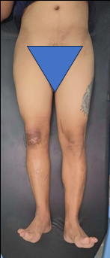
C
A

Figure 1 (A) and (B) Clinical of the patient, (C) angle of hip flexion
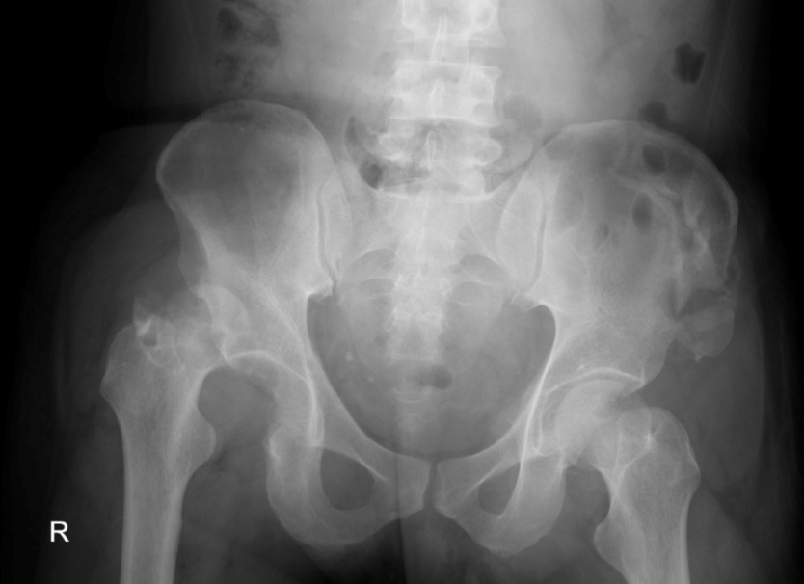
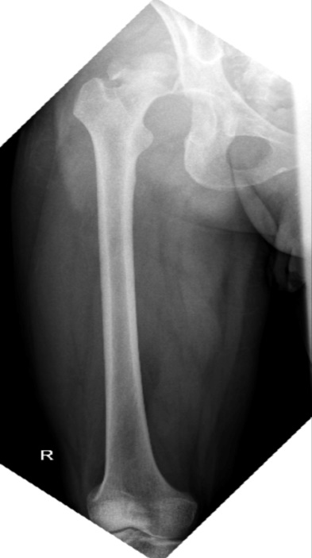
B
A

Figure 2 (A) X-Ray Pre OP Femur Anteroposterior (B) X-Ray Pre Op AP Hip

Durante Op
The patient was positioned in the left lateral decubitus position, and an incision was made according to the posterior approach. Superficial dissection was performed, involving the fat, fascia, and gluteus maximus. During the deep dissection, the short external rotators (SER) were identified, and stay sutures were placed on the SER tendon, followed by dissection. The joint capsule was identified, and a posterior capsulotomy was performed, followed by internal rotation of the hip. An osteotomy was performed on the femoral neck, and the femoral head was extracted, revealing flattening of the femoral head. Evaluation of the acetabulum showed shallowing in the superior part. Reaming and medialization of the acetabulum were performed up to size 44, with an inclination of 45° and anteversion of 15° and placing a bone graft from the femoral head and fix it with three screws, then perform reverse reaming on the bone graft. A trial was conducted, and a cemented acetabular cup of size 44/28 was implanted. The medullary canal of the femur was reamed up to size 3, followed by trial fitting and evaluation of limb length and stability (flexion, extension, adduction, and telescoping). A cementless femoral stem size #9 and femoral head size 28/0 were implanted. The hip joint was reduced, and limb length and stability were evaluated and found to be stable. The procedure concluded with suturing, placement of a drain, and suturing of the fat, subcutaneous tissue, and skin.

Post Operative and Rehabilitation
After the operation, place a pillow between the thighs to avoid flexion, adduction, and internal rotation. Perform active range of motion exercises, as well as quadriceps and ankle pumping exercises. Mobilise with partial weight bearing (PWB) using a walker. Observe for any complaints, monitor vital signs, and track drain output. The patient was followed up at 3 months and 6 months post-operatively. At 3 months post-operative, HHS was 79, which is a fair result, and the LLD was 0 cm. At the 6-month post-op, the patient reported a sensation of discomfort in the hip when sitting, which improved upon changing position. The patient mobilised with the aid of two crutches. Physical examination revealed a post-op scar (+) and an antalgic gait. There was no tenderness, distal AVN was good, and there was spasm in the latissimus dorsi, erector spinae, and gluteus maximus muscles. Active distal ROM was good, with normal ankle and toe dorsiflexion and plantarflexion (+), movement of external rotation and hip power generation do not reach normal levels, but good hip abduction is achieved. Both the straight leg raising test and Braggard's sign were negative. The HHS was 89, which is a good result, and the LLD was 0 cm.
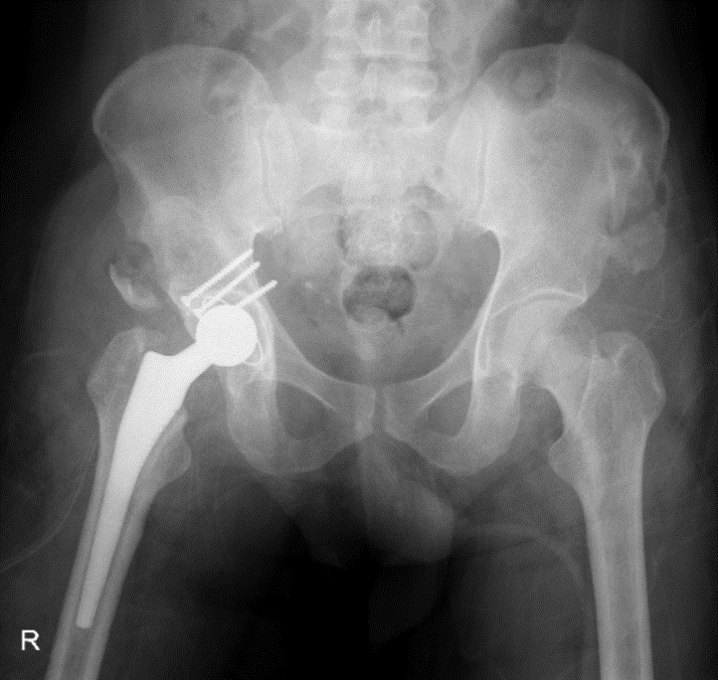
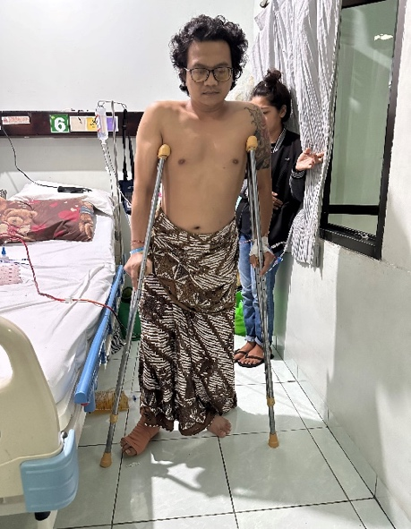
B
A

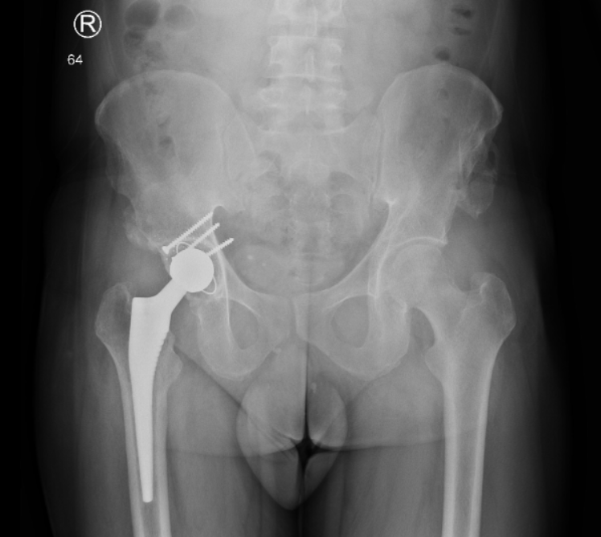
C

Figure 3 (A) Clinical of patient (B) X-Ray post op AP Hip (C) X-Ray 6 months post op AP Hip

Discussion
High-energy trauma, such as that sustained in a motorcycle collision, is a common cause of posterior hip dislocation with associated acetabular fractures(1,2). In this case, the patient, a 35-year-old male, experienced a sudden and severe impact caused by a motorcycle accident that resulted in a posterior dislocation of the right hip and a fracture of the posterior wall of the acetabulum.3 Such injuries are characterised by severe pain and functional impairment, as the dislocation disrupts the congruity of the hip joint and the fracture compromises the stability of the acetabulum (5).
Neglected posterior hip dislocations with acetabular fractures present significant challenges due to the potential for complications involving the vascular and nervous systems (1,6,7). Development of avascular necrosis has been reported to range from 3% to 58% following traumatic hip dislocations. Early reduction of the dislocated joint is necessary to reduce the risk of avascular necrosis, which is seen in 0¬-5% if the hip is reduced in less than six hours after the injury versus in 50% if the hip is reduced more than six hours after the injury. It has been well documented that delayed reduction of traumatic dislocation of the hip increases the risk of avascular necrosis and arthritis (6,8).
The selection of implants for THR in patients with neglected posterior hip dislocations and acetabular fractures must consider several factors, including the extent of bone loss, joint stability, and patient-specific anatomical considerations. Cemented fixation costs less money, requires longer surgical time and is associated with complications such as cement ageing, microfractures or late loosening, especially when used in young or middle-aged patients. On the contrary, cementless fixation is easier and faster to perform. However, they are costly, and complications such as thigh pain and stress shielding are also not uncommon (9,10).
Reverse hybrid THR has also been shown to provide the benefits of both fixations. The acetabular component involved reaming and medialization to achieve proper fit and fixation with screws, ensuring stability despite the superior acetabular shallowing. The femoral component involved a cementless stem to promote bone ingrowth and long-term stability. This combination of implants aims to provide a durable solution that accommodates the altered anatomy and addresses the biomechanical demands of the hip joint, ultimately facilitating successful rehabilitation and functional recovery. Cementless fixation, hybrid or reverse hybrid (cementless stem, cemented cup) fixation, on the contrary, were mostly performed in young patients less than 60 years of age (9,10).
Based on The Norwegian Joint Replacement Register showed that the hybrid and reverse hybrid fixation both showed higher revision rates than either cemented or cementless fixation. Reverse hybrid fixation has a lower risk of revision to cemented fixation in both periods (RR=0.83, p<0.001 in 1987-2014 and RR=0.91 in 2005-2014, respectively). The reverse hybrid fixation was noted to have a significantly lower revision rate in patients less than 65, regardless of sex, which may suggest its promising advantage in younger patients (9,10).
The Kaplan-Meier analyses with 10-year follow-up showed that cementless fixation has a higher cumulative revision probability than both cemented fixation and hybrid fixation (stratified by gender and age). Common causes of revision in cementless fixation included aseptic loosening, pain, dislocation, infection, periprosthetic fracture, malalignment, lysis, implant wear, implant fracture, head/socket mismatch, or adverse reaction to particulate debris. A study by Patil et al showed that a male 25 years old had a significant improvement after reverse hybrid THR for neglected anterior dislocation. At the end of one year, the patient is walking independently without any pain with a full range of motion at the hip joint, and an HHS was 92 at final follow-up (10,11).

Conclusion
This case report details the challenging management of neglected posterior hip dislocation with an associated acetabular fracture, stemming from high-energy trauma. Delayed treatment increases risks such as avascular necrosis and nerve damage, necessitating advanced surgical interventions like total hip replacement (THR). Reconstruction using a cemented acetabular cup and cementless femoral stem (reverse hybrid) aimed to stabilise the joint while addressing anatomical challenges. This case underscores the critical role of timely intervention and tailored surgical strategies in achieving favourable outcomes, emphasising the importance of early recognition and comprehensive management in optimising patient recovery and long-term joint health.

Consent
As per international standards or university standards, patient(s) written consent has been collected and preserved by the author(s).

Disclaimer (Artificial intelligence)

Option 1:

Author(s) hereby declare that NO generative AI technologies such as Large Language Models (ChatGPT, COPILOT, etc.) and text-to-image generators have been used during the writing or editing of this manuscript.

Option 2:

Author(s) hereby declare that generative AI technologies such as Large Language Models, etc. have been used during the writing or editing of manuscripts. This explanation will include the name, version, model, and source of the generative AI technology and as well as all input prompts provided to the generative AI technology

Details of the AI usage are given below:
1.
2.
3.

References
1. Jain M, Swaroop S, Kumar DS. Neglected posterior hip dislocation in adults presenting after one year managed successfully with single stage Total hip arthroplasty: A case series. J Orthop Case Rep 2021;11:84.
2. Mehlman CT, Hubbard GW, Crawford AH, Roy DR, Wall EJ. Traumatic hip dislocation in children. Long-term follow-up of 42 patients. Clin Orthop Relat Res 2000;376:68-79.
3. Aguilar JA. Treatment of neglected traumatic posterior hip dislocation in children. Tech Orthop 2006;21:143-9
4. Kumar S, Jain AK. Neglected traumatic hip dislocation in children. Clin Orthop Relat Res 2005;431:9-13
5. Laird A, Keating JF. Acetabular fractures: A 16-year prospective epidemiological study. J Bone Joint Surg Br 2005;87:969-73
6. Gardner RO, Worku N, Nunn TR, Zerfu TT, Kassahun ME. Management of neglected traumatic hip dislocation in children. J Pediatr Orthop 2020;40:e554-9.
7. Alonso JE, Volgas DA, Giordano V, Stannard JP. A review of the treatment of hip dislocations associated with acetabular fractures. Clin Orthop Relat Res 2000;377:32-43
8. Ilyas I, Rabbani SA. Total hip arthroplasty in chronic unreduced hip fracture dislocation. J Arthroplasty. 2009;24:903-8.
9. Berend KR, Lombardi AV Jr, Mallory TH, Adams JB, Russell JH, Groseth KL. The long-term outcome of 755 consecutive constrained acetabular components in total hip arthroplasty examining the successes and failures. J Arthroplasty. 2005;20(7 Suppl 3):93-102.
10. Zhang C, Yan CH, Zhang W. Cemented or cementless fixation for primary hip arthroplasty evidence from The International Joint Replacement Registries. Ann Joint. 2017;2:57.
11. Patil KS, Daulatni D, Bami M, Ithli M. Neglected Antero-Inferior Dislocation of Hip Treated With Primary Reverse Hybrid THR: A Rare Case Report. BLDEU’S Shri B.M. Patil Medical College, Bijapur. 2014 Jan 05; Published online 2014 Jan 05
12. Gottlieb, M. (2022). Managing posterior hip dislocations. Annals of Emergency Medicine, 79(6), 554-559.
13. Lewis, S. R., Macey, R., Parker, M. J., Cook, J. A., & Griffin, X. L. (2022). Arthroplasties for hip fracture in adults. Cochrane Database of Systematic Reviews, (2).
14. Jin, X., Gibson, A. A., Gale, J., Schneuer, F., Ding, D., March, L., ... & Nassar, N. (2021). Does weight loss reduce the incidence of total knee and hip replacement for osteoarthritis?—A prospective cohort study among middle-aged and older adults with overweight or obesity. International journal of obesity, 45(8), 1696-1704.
15. Wareńczak, A., & Lisiński, P. (2019). Does total hip replacement impact on postural stability?. BMC Musculoskeletal Disorders, 20, 1-9.

