**Design and construction of a solar/biomass hybrid cooker for Sahelian climatic conditions**

**Abstract**

Solar box cookers are eco-friendly and eliminate the need for wood, but they are not always sufficient to replace biomass stoves. Few studies have explored combining solar and biomass energy in a single system. In our study, we designed a hybrid device that integrates a box-type solar cooker with a biomass combustion chamber. This system prioritizes solar energy when it is available. When sunlight is insufficient, the biomass combustion chamber takes over, ensuring uninterrupted cooking while minimizing fuel consumption.

The dimensions of the combustion chamber were calculated using Winarsky’s laws and the optimized dimensions of a box-type solar cooker established by Nébié and colleagues. This methodology enabled the development of a hybrid system that operates in three modes: solar, biomass, or hybrid. Experimental tests revealed that the device has an overall heat loss coefficient of 2.845 W·m⁻²·K⁻¹ and a standardized cooking power of 20.73 W.

**Keywords:** Solar box cooker, combustion chamber, dimensions, solar energy, biomass.

# **Introduction**

Daily human activities have led to deforestation, while emissions of polluting gases from fossil fuels, such as oil, have intensified the natural greenhouse effect, thereby contributing to global warming (Dhillon & von Wuehlisch, 2013; Razmjoo et al., 2021). This phenomenon poses a major risk to the climate and terrestrial ecosystems. Traditional cooking using wood, being a common activity for all, is one of the major factors contributing to this issue. In response to these challenges, the international community has mobilized to propose alternatives aimed at limiting the use of forest wood and reducing greenhouse gas concentrations in the atmosphere, with the ambitious goal of halving global emissions by 2050 (Madignier et al., 2014). The government and non-governmental organizations are actively working to provide populations with cleaner and more efficient cookers as an alternative to traditional cooking methods. Significant progress has been made in cooker technology. Notable improvements include reduced fuel consumption through increased thermal efficiency or heat transfer, as well as a decrease in harmful particles due to better combustion. These advancements have enabled cooker designers and manufacturers to offer higher-performing devices to the populations in need.

However, despite these notable improvements, many households in developing countries like Burkina Faso continue to rely on inefficient cookers and methods due to the inability to afford imported improved cookers. An effective approach to providing better cooking options is to design technologies adapted to local socio-economic conditions and culinary culture, while exploring opportunities to transform them into valuable resources.

Improved cookstoves are designed with local conditions in mind. A detailed study revealed that fuel consumption was reduced by 33% compared to traditional three-stone stoves (MacCarty, N., Still, D., Ogle, 2010). Other studies conducted to assess the performance and use of domestic biomass cookstoves in real conditions across Africa, Asia, and South America (Berrueta et al., 2008; EPA, 2012; Kshirsagar & Kalamkar, 2014; Sutar et al., 2015) show that current research primarily focuses on improving combustion and heat transfer to the cooking pot in order to increase stove efficiency and reduce pollutant emissions (Bryden et al., 2006).

Solar cookers can serve as an alternative to the limitations of biomass cookstoves, as they operate solely using solar energy in the form of radiation, without consuming fuel or heating the kitchen. However, the widespread adoption of solar cookers seems to be struggling due to certain limitations. Various studies are underway to improve the performance and usability of solar cookers (Cuce, E., Cuce, 2013; Gebray, 2012; Rikoto, I.I., Garba, 2013; Sethi, V.P., Pal, D.S., Sumathy, 2014.; ASAE S580, 2003.).

The aim is to develop a hybrid solar/biomass cooking system with the goal of exploiting both the advantages of biomass cookstoves and solar box cookers, in order to combine their benefits through optimized performance and allow for interchangeable use based on needs, choosing either biomass or solar energy depending on the conditions. Current research primarily focuses on improving the efficiency of existing cookstoves. However, a combined cooking system represents a new dimension of research for intervention. In this study, the fundamental characteristics of sizing the solar cooker and the biomass combustion chamber were examined for their integration in cooking, which will help reduce dry fuel consumption by harnessing free solar energy.

# **METHODOLOGY**

# **Sizing of the hybrid cooker**

# **2.1 Sizing the solar cooker**

Nébié et al. (Nebie et al., 2019) developed a box-type solar thermal cooker equipped with an inclined receiver surface, double glazing, and a reflector. Numerical simulations were carried out for a sensitivity analysis to identify the optimal design parameters. These parameters are used in designing the solar component of our hybrid system. The parameters selected from Nébié's sensitivity analysis are presented in the table 1.

Table 1: Design parameters of the optimized box-type solar cooker (Nebie et al., 2019)

|  |  |  |
| --- | --- | --- |
| Thickness of insulation (kapok wool) | Thickness of the air layer between the two glass panes | Inclination angle of the collector surface |
| 6 cm | 1,3 cm | 13° |

Based on these studies, the appropriate dimensions of the cooker were determined, considering the cooking needs of a family of five (0.5 to 2 kg of rice per day; an average of 74 g of potatoes per day; 41 g of pasta per day (Des et al., 2019; Ilboudo et al., 2011)). The overall dimensions of the cooker with an inclined receiver surface are 80 cm x 70 cm x 30 cm x 15 cm. Figure 1 shows the schematic configuration and dimensions of the solar part of the cooker.

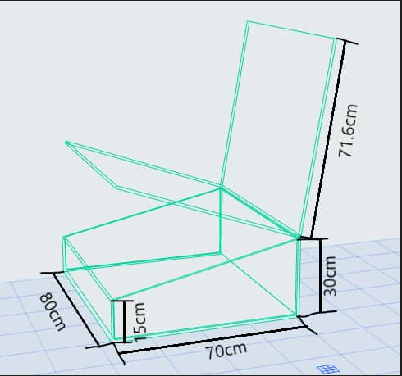

Figure 1: Dimensions of the proposed box-type solar cooker

# **Sizing of the combustion chamber (firebox).**

To use the Winiarski method to maintain a constant opening area of the combustion chamber, it is necessary to calculate the appropriate height of the space below the container. This height varies as you move from the center of the combustion chamber toward the edge of the container. To do this, it is necessary to calculate the required space between the edge of the combustion chamber and the edge of the container.

The calculation of the design parameters of the combustion chamber is carried out as follows:

1. **Determination of the opening area of the combustion chamber.** For a square or rectangular combustion chamber, the area is calculated as follows:

 (1)

where Sc​ is the opening area of the combustion chamber, and lll and www are the length and width of the combustion chamber.

1. **Determination of the required space Cc between the edge of the combustion chamber and the entry surface into the insulated chimney**. In the case of a square or rectangular chamber, this is the distance between the center of the combustion chamber and the edge of the chimney.
2. **Determination of the required gap between the bottom of the container and the top edge of the combustion chamber**. To calculate this, the cross-sectional area Sc determined in Step 1 is divided by the value of Cc​ determined in Step 2. This can be expressed as:

 (2)

where Gc​ is the required gap between the bottom of the container and the top edge of the combustion chamber.

1. **Determination of the circumference Cp of the container**. The simplest method is to use a piece of string, wrap it around the container, and measure the length of the string. Alternatively, the circumference can be calculated from the diameter.
2. **Determination of the required gap at the edge of the container Gp**​. This is calculated by dividing the cross-sectional area Sc​, determined in Step 1, by Cp​, determined in Step 4:

 (3)

After considering the dimensions of the solar cooker and using the Winiarski method to calculate the various dimensions of the combustion chamber, the obtained values are shown in Table 2.

Table 2: Dimensions of the combustion chamber

|  |  |
| --- | --- |
| Parameters | Dimensions |
| Opening area of the combustion chambe Sc  **3**  **2** | 253 cm2 |
| Distance between the combustion chamber and the chimney $C_{c}$ | 24 cm |
| Distance between the bottom of the container and the top edge of the combustion chamber $G_{c}$ **1** | 10,54 cm |
| Required lateral distance to the edge of the container $G_{p}$ | 4,03 cm |

The values in Table 2 are used for the design of the combustion chamber. Figure 2 shows the designed combustion chamber along with the various dimensions.

|  |  |
| --- | --- |
| **A** | **B** |

Figure 2: Dimensions of the combustion chamber. (A): Front view and (B): Top view.

# **Operation of the combustion chamber.**

One of the challenges of the hybrid system, especially for systems using solar energy, lies in the insulation of the system's walls. Therefore, it is necessary to reduce thermal bridges to minimize heat losses in the solar cooker's component. To achieve this, the combustion chamber has been designed with an opening divided into two parts for fuel loading, air intake, and smoke exit through the chimney.

The device containing the fuel is placed under the absorber. It is designed to allow ambient air to enter by passing underneath the absorber (between the combustion support and the absorber), as illustrated in Figure 3.

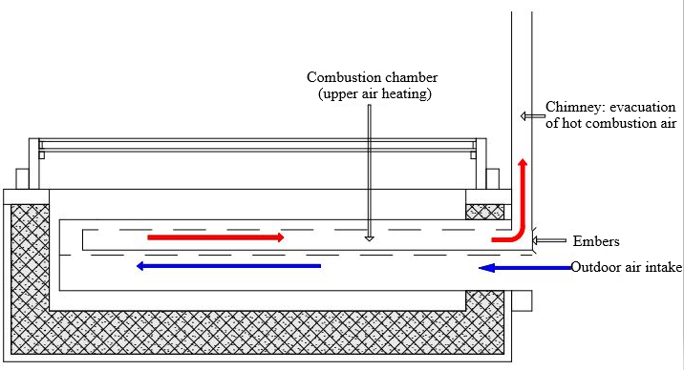

Figure 3: Description of the Combustion Chamber

# **Prototype of the Cooker System**

After considering the dimensions of the solar cooker part and the combustion chamber, we obtained the prototype shown in Figure 4.

|  |  |
| --- | --- |
|  | 1. Reflector 2. Chimney 3. Air inlet into the combustion chamber 4. Cooker pillar 5. Double glazing 6. Cooking chamber 7. Walls of the solar part 8. Walls of the hearth |

Figure 4: Prototype of the Cooker System

# **Parameters for Evaluating the Thermal Performance of the Hybrid Cooker**

After the construction of the solar/biomass hybrid cooker, an experimental study was conducted to understand its thermal behavior in solar, biomass, and hybrid operating modes, and to determine its thermal performance. Several methods are available to determine the performance of solar cookers. The most commonly used are the Indian standard and the ASAE (American Society of Agricultural Engineers) standard (Yettou F., Azoui B., Malek A., Gama A., 2014). To evaluate the cooker's performance, both a no-load test and a load test were conducted during the experimental study. Performance parameters, including the first and second figures of merit, were then calculated.

* The first figure of merit F1, representing the ratio between optical efficiency and the thermal loss factor, is determined using equation 4 (Lahkar & Samdarshi, 2010).

 (4)

Where $T_{abs}$, $T_{amb}$, $I_{G}$ are stagnation temperature of the absorber plate (°C), ambient temperature (for stagnation) and solar global irradiation (W/m²), respectively.

* The second figure of merit, F2​, which evaluates heat transfer between the container and its contents, is defined by Equation 5 (Lahkar & Samdarshi, 2010).

$F_{2}=\frac{({mCp)}_{w}}{Aτ}F_{1}ln[\frac{1-\frac{1}{F_{1}}\left(\frac{T_{wi}-T_{a}}{I_{G}}\right)}{1-\frac{1}{F_{1}}\left(\frac{T_{wf}-T_{a}}{I_{G}}\right)}]$ (5)

where $F_{1}$, $Cp$, $m$, $T_{wi}$, $T_{wf}$, $T_{a}$, $I_{G}$ are heat exchange factor, ratio of thermal capacities, specific heat, mass of water, water initial and final temperature, the average ambient temperature and the average solar irradiation.

* Another important metric for solar cookers is the cooking power. It is the main feature suggested by ASAE S580 in a cooking process and serves as a reliable parameter to assess the heating performance of a solar cooker. The aim of this standard is to provide a simple yet meaningful and objective measure of solar cooker performance. Equation 6 is used to calculate this parameter.

 (6)

The cooking power is standardized using a global solar irradiation of 700 W/m² to compare results obtained from measurements at different points and times, as well as to compare different solar cookers. The normalized cooking power is therefore given by Equation 7 (ASAE S580, 2003.):

 (7)

# **Results and Discussion of Thermal Performance**

# **6.1 Parameter: "First figure of merit" F1**

An experimental no-load study was conducted, allowing the calculation of the first figure of merit using Equation 4. These values are shown in Table 3.

Table 3 : values of F1 obtained for the hybrid cooker developed and other hybrid cookers.

|  |  |  |  |  |
| --- | --- | --- | --- | --- |
|  | $$T_{abs} (°C)$$ | $$T_{amb} (°C)$$ | $$I_{G} (W/m^{2})$$ | $$F_{1}(m^{2}.K/W)$$ |
| Test 1 | 118,25 | 35,98 | 795,76 | **0,104 $±0,006$** |
| Test 2 | 121,60 | 36,01 | 842,21 | **0,102 $±0,003$** |
| Quiroga et al. (Solar-biomass hybrid cooker) (Quiroga et al., 2019) | 110 | 37 | 500-600 | 0,100 |
| Saxena et al. (Hybrid cooker with air duct) (Saxena & Agarwal, 2018) | 110,70 | 37,8 | 710 | 0,102 |

The results in Table 3 show that our findings are of the same order of magnitude as those reported in the literature. Additionally, the values obtained for the hybrid cooker developed in this work are better than those of certain more complex box-type hybrid cooker variants found in the literature, which require significant investment. In general, the first figure of merit F1​ for hybrid cookers is relatively low compared to conventional box-type cookers. This can be attributed to the design of hybrid cookers, which often incorporate an alternative energy source, affecting insulation and, consequently, the figure of merit. The F1​ values for conventional solar cookers typically range between 0.11 and 0.17. (Folaranmi, 2013) (Guidara et al., 2017) (Harmim et al., 2012) (Aliyu & Garba, 2018)

# **6.2 Parameter: "Second figure of merit" F2**

The second figure of merit, calculated using Equation 5 under the conditions described by Mullick et al. (Mullick SC., Kandpal TC., 1997), is presented in Table 4.

Table 4 :Values of F2 obtained for the hybrid cooker developed.

|  |  |
| --- | --- |
| Second figure of merit $F_{2}$ | Values of the parameter F2 |
| Test 1 | **0,2732 $±$ 0,01** |
| Test 2 | **0,2801 $±$ 0,009** |

According to Mullick et al. (Mullick SC., Kandpal TC., 1997), F2​ ranges from 0.254 to 0.490 depending on the load and the number of utensils. The obtained values of F2​ indicate that the developed cooker has a sufficiently high heat exchange factor to ensure significant heat transfer between the absorber and the air inside the cooker, as well as to the food contained in the cooking vessel.

The values of F1 and F2 indicate good insulation and efficient heat exchange inside the cooker, despite the increased thermal inertia caused by the addition of the combustion chamber. These results demonstrate that it is possible to prepare a variety of dishes within a reasonable time using the proposed box solar cooker, which incorporates a combustion chamber to ensure continuous cooking throughout the year.

# **6.3 Parameter: " cooking power " Ps**

Figure 5 illustrates how the normalized power, calculated using Equation 6, varies with the temperature difference between the load and the ambient temperature.

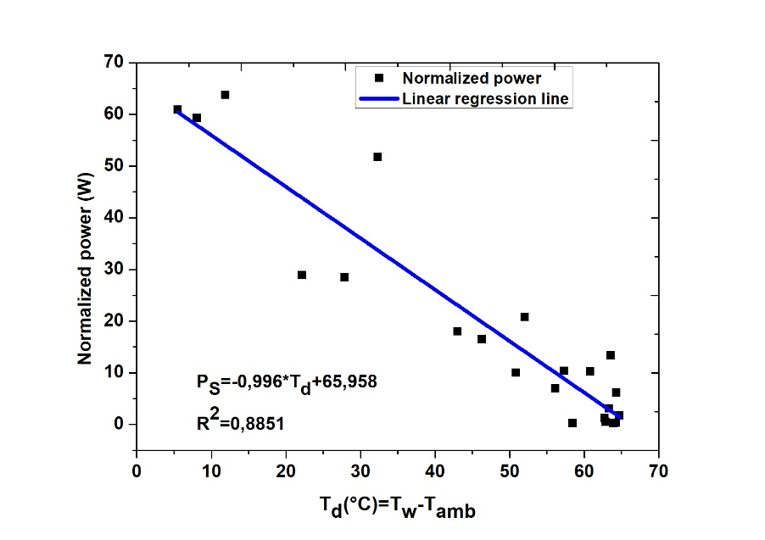

Figure 5: Normalized power as a function of the temperature difference

This figure highlights that the power decreases as the temperature difference increases, similar to the decay of thermal power over time. Linear regression was used to establish the relationship between the temperature difference and the normalized cooking power. This relationship allows us to determine the normalized cooking power Ps (at Td= 50 °C) and the heat loss coefficient (slope of the linear curve).

The linear regression coefficient for this relationship is R2 = 0,8851 ˃ 0,75 (higher than the recommended value) (Funk, 2000). The coefficient b = 65,958 W represents the initial cooking power or intercepted power (Td =0 °C) and a = 0,996 W/K represents the overall heat loss coefficient. By dividing aaa by the cooker’s capture area ( SC = 0,35 m2), , we obtain UT = 2,845 W.m-2.K-1 Additionally, the normalized cooking power for Td = 50 °C, PS(Td = 50 °C) = 20,73 W. These values are interesting when compared to the results of Nébié et al., who used a box-type solar cooker with kapok wool as thermal insulation, obtaining a solar loss coefficient of UT =3.06 W.m-2.K-1 (Nébié et al., 2021).

The high initial cooking power values, combined with a low heat loss coefficient, indicate good insulation for our box-type solar cooker, according to International Standards (Funk., 2000), and are comparable to those found in the literature.

# **Conclusion**

The hybrid cooker was designed by combining a combustion chamber, developed based on Winiarsky’s principles, with a box solar cooker. The performance parameters obtained are 0.104 and 0.102 for F1, and 0.2732 and 0.2801 for F2. The cooking power and heat loss coefficient were measured at 20.73 W and 2.845 W.m-2.K-1, respectively. These results demonstrate that adding the combustion chamber does not impact the performance of the box solar cooker. This hybrid solar cooker can be used year-round, without interruptions due to the lack of solar energy.

**Disclaimer (Artificial intelligence)**

Option 2:

Author(s) hereby declare that generative AI technologies such as Large Language Models, etc. have been used during the writing or editing of manuscripts. This explanation will include the name, version, model, and source of the generative AI technology and as well as all input prompts provided to the generative AI technology

Details of the AI usage are given below:

1. ChatGPT was used solely to correct a few errors in the English language.

2.

3.

# **References**

Funk P. (2000). Evaluating the international standard procedure for testing solar cookers and reporting performance. *Solar Energy*, *68(1)*, 1–7.

Aliyu, S., & Garba, M. M. (2018). Development of A Novel Double Exposure Solar Cooker And Its Comparative Performance With The Conventional Box Type Solar Cooker. *IOSR Journal of Mechanical and Civil Engineering*, *15*(1), 35–40. https://doi.org/10.9790/1684-1501013540

Berrueta, V. M., Edwards, R. D., & Masera, O. R. (2008). Energy performance of wood-burning cookstoves in Michoacan, Mexico. *Renewable Energy*, *33*(5), 859–870. https://doi.org/10.1016/j.renene.2007.04.016

Bryden, M., Still, D., Scott, P., Hoffa, G., Ogle, D., Bailis, R., & Goyer, K. (2006). Design Principles for Wood Burning Cook Stoves. *Aprovecho Research Center*, 18. https://www.bioenergylists.org/stovesdoc/Pcia/Design Principles for Wood Burning Cookstoves.pdf

Cuce, E., Cuce, P. M. . (2013). A comprehensive review on solar cookers. *Appl. Energy*, *87*, 1399–1421.

Des, V., Riz, A. D. E., Terre, P. D. E., Les, P. A. R., Fran, N., & Entre, A. I. S. (2019). *> Les synthèses de FranceAgriMer Février 2019 •*. 1–24.

Dhillon, R. S., & von Wuehlisch, G. (2013). Mitigation of global warming through renewable biomass. *Biomass and Bioenergy*, *48*, 75–89. https://doi.org/10.1016/j.biombioe.2012.11.005

Environmental Protection Agency (EPA). (2012). Test Results of Cook Stove Performance *Today ’ s Speakers*. *1*(866), 1–52.

Folaranmi, J. (2013). Performance Evaluation of a Double-Glazed Box-Type Solar Oven with Reflector. *Journal of Renewable Energy*, *2013*(iii), 1–8. https://doi.org/10.1155/2013/184352

Gebray, B. (2012). Theoretical Modeling and Experimental Analysis of Box Solar Cooker. *M.Sc. Thesis, Department of Mechanical Engineering, EiT – M, Mekelle University*.

Guidara, Z., Souissi, M., Morgenstern, A., & Maalej, A. (2017). Thermal performance of a solar box cooker with outer reflectors: Numerical study and experimental investigation. *Solar Energy*, *158*(June), 347–359. https://doi.org/10.1016/j.solener.2017.09.054

Harmim, A., Merzouk, M., Boukar, M., & Amar, M. (2012). Performance study of a box-type solar cooker employing an asymmetric compound parabolic concentrator. *Energy*, *47*(1), 471–480. https://doi.org/10.1016/j.energy.2012.09.037

Ilboudo, D., Compaore, P. G., Dynamique, L., Géographie, D., Ki-zerbo, U. J., Titulaire, P., Géographie, D., Joseph, U., & Compaoregeorgesgmailcom, B. F. (2011). *LA CONSOMMATION DU RIZ LOCAL A OUAGADOUGOU ( BURKINA FASO Introduction Entre 1990 et 2006 , la production du riz au Burkina Faso s ’ est accrue en moyenne de 8 , 4 % ( BADOLO F , 2012 : 325 ). consommation ( BADOLO F , 2012 : 325 ). Le reste ( 60 %) est*.

Kshirsagar, M. P., & Kalamkar, V. R. (2014). A comprehensive review on biomass cookstoves and a systematic approach for modern cookstove design. *Renewable and Sustainable Energy Reviews*, *30*, 580–603. https://doi.org/10.1016/j.rser.2013.10.039

Lahkar, P. J., & Samdarshi, S. K. (2010). A review of the thermal performance parameters of box type solar cookers and identification of their correlations. *Renewable and Sustainable Energy Reviews*, *14*(6), 1615–1621. https://doi.org/10.1016/j.rser.2010.02.009

MacCarty, N., Still, D., Ogle, D. . (2010). Fuel use and emissions performance of fifty cooking stoves in the laboratory and related benchmarks of performance. *Energy. Sustain. Dev*, *14*, 161–171.

Madignier, M. L., Benoit, G., & Roy, C. (2014). Les contributions possibles de l’agriculture et de la forêt à la lutte contre le changement climatique. *Rapport CGAAER*, 1–56.

Mullick SC., Kandpal TC., K. S. (1997). Testing of box-type solar cooker : second figure of merit f2 and its variation with load and number of pots. *Sol. Energy.*, *57(5)*, :409–413.

Nebie, J., Daho, T., Tubreoumya, G. C., Zongo, S., Zeghmati, B., & Chesnau, X. (2019). Modelisation des paramètre s de fonctionnement d ’ un cuiseur solaire de type boîte sous les conditions météorologiques du Burkina Faso. *Soaphys 1, 1–8.*

Nébié, J., Zongo, S., S. Zongo, A., Tubreoumya, G. C., S. Kam, Z., W. Igo, S., Daho, T., Konkobo, I., Béré, A., & Zeghmati, B. (2021). Thermal Performance Assessment of a Box-type Solar Cooker with an Inclined Collecting Surface and Kapok Wool Insulation. *Physical Science International Journal*, *25*(10), 29–38. https://doi.org/10.9734/psij/2021/v25i1030286

Quiroga, N. V, Esteves, A., Bailey, J., & Esteban, S. (2019). *Hybrid Oven ( Solar + Biomass ) for Cooking . Design , Construction and Thermal Evaluation*. *9*(1), 1–11. https://doi.org/10.5923/j.ep.20190901.01

Razmjoo, A., Rezaei, M., Mirjalili, S., Nezhad, M. M., & Piras, G. (2021). Development of sustainable energy use with attention to fruitful policy. *Sustainability (Switzerland)*, *13*(24), 1–17. https://doi.org/10.3390/su132413840

Rikoto, I.I., Garba, I. (2013). Comparative analysis on solar cooking using box type solar cooker with finned cooking pot. *Int. J. Mod. Eng. Res.*, *3(3),* 1290–1294.

Saxena, A., & Agarwal, N. (2018). Performance characteristics of a new hybrid solar cooker with air duct. *Solar Energy*, *159*(November 2017), 628–637. https://doi.org/10.1016/j.solener.2017.11.043

Sethi, V.P., Pal, D.S., Sumathy, K. (2014). performance evaluation and solar radiation capture of optimally inclined box type solar cooker with parallelepiped cooking vessel design. *Energy Convers. Manag. ,* *81*, 231–241.

Sutar, K. B., Kohli, S., Ravi, M. R., & Ray, A. (2015). Biomass cookstoves: A review of technical aspects. *Renewable and Sustainable Energy Reviews*, *41*, 1128–1166. https://doi.org/10.1016/j.rser.2014.09.003

ASAE S580 Jan 2003 (2003)Testing and Reporting Solar Cooker Performance. *S580, A. S. of A. Engineers. ASAE JAN03*.

ASAE S580 Jan 2003 (2003).Testing and Reporting Solar Cooker Performance. *ASAE S580 JAN03.*

Yettou F., Azoui B., Malek A., Gama A., P. N. (2014). Solar cooker realizations in actual use. *An Overview. Renew. Sustain. Energy Rev*, *37*, 288–306.