**Simulation of the Thermal Behaviour of a Building Constructed with Local Materials**

**ABSTRACT**

|  |
| --- |
| This study analyzes the thermal behavior of a 25 m² single-zone building in Ouagadougou, constructed with compresed earth blocks (CEB), a sustainable local material, using EnergyPlus simulations. The objective is to assess the impact of CEB on thermal comfort in a hot and arid tropical climate. Results show that 20 cm CEB walls under a metal roof reduce external temperatures by 0.86 °C. Adding a false ceiling significantly lowers indoor temperatures, while increasing the thickness of CEB walls to 40 cm and the CEB roof to 30 cm smooths thermal fluctuations, though it does not achieve the optimal thermal comfort of 26 °C. External insulation of CEB walls with 10 cm of polystyrene results in maximum indoor temperatures of approximately 27 °C, close to the comfort zone, outperforming internal insulation by reducing thermal bridges. An optimal configuration combining 20 cm CEB walls, externally insulated with 8-10 cm of polystyrene, under a 15 cm CEB roof with a false ceiling, enhances thermal comfort while minimizing costs. This research highlights the potential of CEB for designing sustainable, energy-efficient buildings in Burkina Faso, reducing reliance on air conditioning. |

*Keywords****:*** *Compressed earth blocks;**Insulation****;*** *thermal comfort; EnergyPlus; building insulation.*

1. **Introduction**

In Burkina Faso, the building sector faces significant challenges due to the hot and arid climate, as well as the unsuitability of constructions to local conditions, leading to thermal discomfort and excessive energy consumption (Coulibaly, O., 2011). Approximately 30 to 75% of total energy is dedicated to air conditioning and ventilation, with significant environmental impacts due to greenhouse gas emissions (Coulibaly, O., 2011). In Ouagadougou, most buildings are constructed with concrete blocks under metal roofing, contributing to indoor overheating (Sergio, M. R et al., 2020). In this context, the use of Compressed Earth Blocks (CEB), a sustainable local material, emerges as a promising solution for designing thermally efficient and energy-saving buildings (Malbila, E et al., 2021; [Louis Arnaud Ouedraogo](https://www.researchgate.net/profile/Louis-Ouedraogo) et al., 2023). This environmentally friendly and cost-effective material mitigates temperature fluctuations due to its high thermal inertia. This study relies on thermal simulations performed with EnergyPlus software, well-suited for this research due to its ability to model complex heat transfer dynamics and integrate local climate data, to analyze the behavior of a single-zone building in Ouagadougou (Coulibaly, O., 2011). The objective is to evaluate the influence of CEB, wall and roof thicknesses, and thermal insulation on indoor temperature (Césaire Hema et al., 2020). By exploring various configurations, such as the addition of false ceilings and insulators like polystyrene, this research aims to identify bioclimatic architectural solutions adapted to the local climate, reducing reliance on air conditioning while ensuring thermal comfort close to the recommended temperature of 26 °C (Neya.I et al., 2021). This work contributes to the promotion of CEB and the design of sustainable buildings in Burkina Faso (Césaire Hema et al., 2020).

**2. Methodology**

The EnergyPlus software was used to perform dynamic simulations to predict the thermal and energy behaviour of buildings (Madi Kaboré, 2015). Located in Ouagadougou, the simulated building is a single-zone structure of 25 m² (5 m × 5 m) with a height of 3 m. It includes a glazed window (south facade) of 1 m × 1.3 m with a metal frame and a metal door of 2 m × 1 m with a thickness of 4 cm thick. The glazing is single-pane, 4 mm thick. The walls are made of H-bricks, CEB, BLT, or concrete blocks, with a metal roofing (1.2 mm) and a detached false ceiling of 1.5 cm. The floor is concrete (15 cm) with tiling (5 mm), and an interior cement plaster (2.5 cm) is applied. No occupants or internal loads are considered, and the space is not cross-ventilated due to a single opening (Sergio, M. R et al., 2020).

The parameters introduced into the software include: a weather file for Ouagadougou (data compiled over 30 years with hourly time steps), the geometric description of the building, wall thicknesses, south-facing orientation, and the thermal properties of materials (Coulibaly, O., 2011; Malbila, E et al., 2021, [Louis Arnaud Ouedraogo](https://www.researchgate.net/profile/Louis-Ouedraogo) et al., 2023).

Table 1 provides the thermal parameters of the materials used.

|  |  |  |  |  |
| --- | --- | --- | --- | --- |
| Component | Material | Materials, and Thermo-Physical Parameters | | |
| Thermal Conductivity λ [W/(m.K)] | Specific Heat Cp [J/(kg.K)] | Density $ρ[$ kg/ $m^{3}$] |
| Wall | CEB (cement-stabilized) | 0,93 | 850 | 2200 |
| BLT | 0.872 | 726 | 2271 |
| H-Brick | 0.80 | 920 | 1570 |
| Hollow Concrete Block | 0.67 | 880 | 1250 |
| Roof | Aluminum-Zinc Sheet | 60 | 800 | 7600 |
| Door | Metal | 45.28 | 444 | 7824 |
| Window | Single Glazing | 1.15 | 1000 | 840 |
| Floor | Concrete | 1.75 | 653 | 2100 |
| Tile | 1.15 | 980 | 100 |
| Ceiling | Wood (1.5 cm) | 0.12 | 2510 | 593 |
| Plaster | Cement | 0.87 | 1050 | 2200 |
| Insulation | Expanded Polystyrene | 0.032 | 1450 | 20 |

The study was conducted in three stages. First, four types of walls (concrete blocks, H-bricks, CEB, BLT) were tested under a metal roof to identify the most thermally efficient material (Coulibaly, O., 2011). Second, the selected material (CEB) was combined with a concrete or CEB roof, varying the thicknesses of walls and roofs to address the following questions: Does wall thickness influence indoor temperature? What is the minimum wall thickness for thermal comfort? Does roof thickness influence indoor temperature? What is the minimum roof thickness for thermal comfort? (Malbila, E et al., 2021, [Louis Arnaud Ouedraogo](https://www.researchgate.net/profile/Louis-Ouedraogo) et al., 2023). Third, the effect of internal and external insulation of CEB walls was studied, varying the thickness of walls and insulation (polystyrene) (Césaire Hema et al., 2020).

**2.1 Thermal modeling equations**

Thermal simulations, conducted with EnergyPlus, rely on fundamental heat transfer equations to model the thermal behaviour of the building in Ouagadougou. These equations describe heat fluxes through walls and the evolution of indoor temperatures based on material properties. The conductive heat flux is modeled by Fourier’s law:

$q = -K.A. \frac{∆T}{∆x}$ (1)

where q is the heat flux (W), k is the thermal conductivity (W/m.K), A is the surface area (m²), ∆T is the temperature difference (°C), and ∆x is the thickness (m). The temporal temperature distribution in walls is described by the heat equation (Incropera, F. P et al., 2020):

$\frac{∂T}{ ∂t} = α.\frac{∂^{2}T}{ ∂x^{2}}$ (2)

where $α =\frac{ k }{ρ·Cp}$ is the thermal diffusivity (m²/s), with ρ as density (kg/m³) and Cp as specific heat capacity (J/kg.K). The thermal effusivity, which quantifies a material’s ability to exchange heat with its environment, is expressed as:

$e = \sqrt{k.ρ. Cp}$ (3)

where e is in J/m²·K·s¹/².

The thermal balance for the indoor zone (single-zone model) is given by:

$ρ.C_{P}.V.\frac{dT_{i}}{dt} = Q_{cond} + Q_{conv} + Q_{rad}$ (4)

where Ti is the indoor temperature (°C), V is the volume (m³), and Qcond, Qconv and Qrad are the heat fluxes by conduction, convection, and radiation (W). Internal loads are neglected in this study.

These equations, combined with Ouagadougou’s climate data and the thermal properties of materials (CEB, BLT, concrete blocks), enable EnergyPlus to evaluate the thermal performance of the studied configurations.

**2.2 Initial and boundary conditions**

To solve the heat transfer equations in thermal simulations with EnergyPlus, initial and boundary conditions are applied, considering Ouagadougou’s climate data and the building’s characteristics. Initial conditions assume a uniform temperature at the start of the simulation for walls and the building’s interior:

$T(x, t = 0) = T_{init}, T_{i}(t = 0) = T_{init}$ (5)

where Tinit is the initial temperature (°C), derived from Ouagadougou’s hourly meteorological data at t=0. At the outer surface of walls (x=0), a mixed condition combining convection and radiation is applied:

${\left.-k.\frac{∂T}{∂x}\right|}_{x=0}=h_{ext}.\left(T_{ext}\left(t\right)-T\left(0,t\right)\right)+q_{rad}$ (6)

where k is the thermal conductivity (W/m.K), hext is the external convection coefficient (W/m²·K), Text(t) is the outdoor temperature (°C), and qrad is the solar radiative flux (W/m²), both sourced from the weather file. At the inner surface of walls (x=L), the condition is:

${\left.-k.\frac{∂T}{∂x}\right|}_{x=L}=h_{int}.\left(T\left(L,t\right)-T_{i}\left(t\right)\right)$ (7)

where hint is the internal convection coefficient (W/m²·K) and Ti(t) is the indoor temperature (°C).  
For the floor, in contact with the ground, a constant temperature is assumed:

$T\left(x=L_{floor},t\right)=T_{soil}$ (8)

where Tsoil is the soil temperature (°C), estimated from local climate data. These conditions, combined with the thermal properties of materials (Table 1) and meteorological data, allow EnergyPlus to solve the thermal equations and evaluate the building’s performance.

**3. Results and discussion**

The simulations cover one year, with a detailed analysis of April 15 and 16, representative days of April (Madi Kaboré, 2015). The results are illustrated in Figures 1 to 10.

**3.1 Thermal behaviour of buildings under metal roofing without false ceiling**

Figure 1 shows the temperature evolution of buildings under metal roofing without a false ceiling.

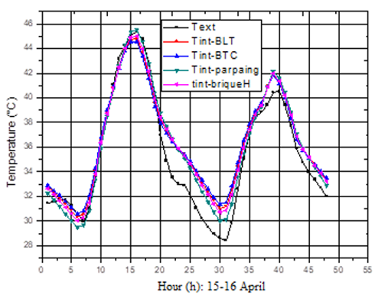

**Figure 1. Evolution of temperature in buildings under metal roofing without false ceiling**

The indoor temperature fluctuations of the four buildings follow those of the outdoor temperatures. It is observed that concrete blocks result in indoor temperatures higher than outdoor temperatures, even during overheating periods. In contrast, BLT, CEB, and H-bricks mitigate heat by 0.64°C, 0.86°C, and 0.4°C, respectively (Coulibaly, O., 2011, Zoure, A. N., & Genovese, P. V., 2022). Overall, these buildings exhibit very high temperatures both day and night, making them uncomfortable for occupants. This could be explained by the presence of the metal roof, which conducts heat easily due to its high thermal conductivity (Sergio, M. R et al., 2020). In the subsequent parts of the study, CEB was selected due to its superior thermal performance compared to the other three materials and its widespread availability across the country (Malbila, E et al., 2021).

**3.2 Influence of the variation in air gap thickness between the metal roof and false ceiling**

Figure 2 shows the evolution of indoor temperatures in a CEB building as a function of the air gap thickness between the metal roof and the false ceiling (wall thickness: 20 cm).

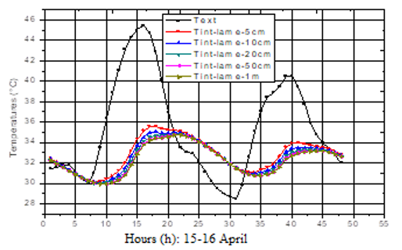

**Figure 2. Evolution of indoor temperatures in a CEB building as a function of the air gap thickness between the metal roof and false ceiling (wall thickness: 20 cm)**

Insulating the metal roof with a false ceiling cools the building’s interior (Wilfried Hounkpatin et al., 2018). Compared to Figure 1, Figure 2 highlights the importance of the false ceiling in reducing indoor temperatures. Its presence dampens indoor temperatures, attributed to the absence of conduction between the metal roof and the false ceiling due to the air gap, as well as the insulating properties of the ceiling itself.

The damping values as a function of air gap thickness are provided in Table 2.

**Table 2. Damping values as a function of air gap thickness**

|  |  |  |  |  |  |  |  |  |  |  |  |  |  |  |  |  |  |
| --- | --- | --- | --- | --- | --- | --- | --- | --- | --- | --- | --- | --- | --- | --- | --- | --- | --- |
| |  |  |  |  |  |  | | --- | --- | --- | --- | --- | --- | | Air Gap Thickness | 5cm | 10cm | 20 cm | 50 cm | 1 m | | Damping $∆T$ (°C) | 10.2 | 10.9 | 11.3 | 11.6 | 11.7 | |  |  |  |  |  |

∆T is the difference between the maximum outdoor temperature and the maximum indoor temperature.

The variation in air gap thickness has a minimal impact on indoor temperature variation. Nevertheless, slight changes in indoor temperatures are observed depending on the air gap thickness.

**3.3 Influence of the variation in CEB wall thickness**

The figure 3 shows the evolution of indoor temperatures in a CEB building under a metal roof with a false ceiling as a function of varying wall thickness.

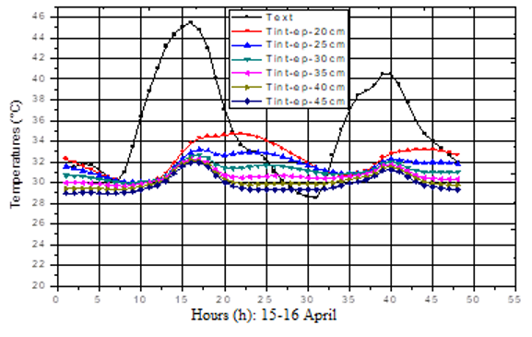

**Figure 3. Evolution of indoor temperatures in a CEB building under metal roofing with a false ceiling as a function of varying wall thickness**

The damping values as a function of wall thickness are provided in Table 3.

**Table 3. Damping values as a function of wall thickness**

|  |  |  |  |  |  |  |
| --- | --- | --- | --- | --- | --- | --- |
| Wall Thickness | 20 cm | 25 cm | 30 cm | 35 cm | 40 cm | 45 cm |
| Damping ∆𝑻 (°C) | 10.7 | 12.2 | 12.8 | 13 | 13.4 | 13.5 |

Wall thickness contributes to the climatic comfort of buildings (Césaire Hema et al., 2020). Increasing wall thickness leads to a decrease in indoor temperatures. Thicker walls better mitigate extreme heat, but beyond 40 cm, the variation is minimal (Malbila, E et al., 2021, Mohammadullah Hakim Ebrahimi et al., 2022). This value is close to 44 cm (Neya. I et al., 2021).

**3.4 Influence of the variation in concrete roof thickness without false ceiling**

The figure 4 shows the evolution of indoor temperatures in a CEB building as a function of varying concrete roof thickness without a false ceiling.

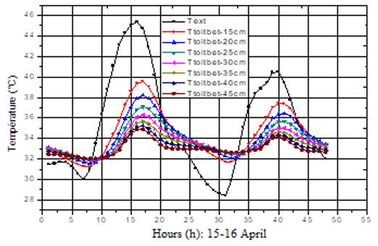

**Figure 4. Evolution of indoor temperatures in a CEB building as a function of varying concrete roof thickness without false ceiling**

**Table 4.Damping values as a function of concrete roof thickness**

|  |  |  |  |  |  |  |  |
| --- | --- | --- | --- | --- | --- | --- | --- |
| Roof Thickness | 15 cm | 20 cm | 25 cm | 30 cm | 35 cm | 40 cm | 45 cm |
| Damping ∆T (°C) | 6 | 7.2 | 8.4 | 9 | 9.8 | 10.2 | 10.5 |

The curves in Figure 4 show that thicker concrete roofs dampen outdoor temperature fluctuations more effectively than thinner ones. A 45 cm thick roof dampens indoor temperatures more than a 15 cm thick roof, although these temperatures remain far from those required for optimal thermal comfort. A 40 cm thick roof is preferable, as beyond this thickness, the variation in indoor temperatures is minimal.

**3.5 Influence of the variation in concrete roof thickness with false ceiling**

The figure 5 shows evolution of Indoor Temperatures in the Building as a Function of Varying Concrete Roof Thickness with False Ceiling (Wall Thickness: 40 cm)

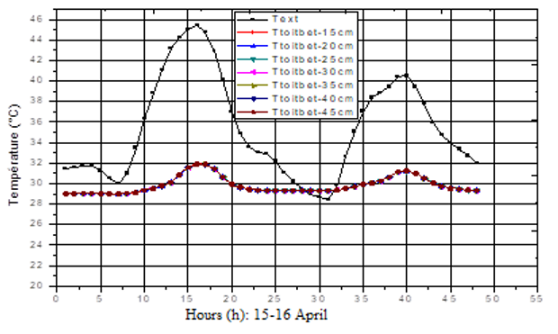

**Figure 5. Evolution of indoor temperatures in the building as a function of varying concrete roof thickness with false ceiling (wall thickness: 40 cm)**

The variation in concrete roof thickness with a false ceiling does not significantly affect indoor temperature variations, due to the presence of the false ceiling. However, a concrete roof with a false ceiling smooths indoor temperatures (∆T = 13.5°C). From this perspective, a thinner concrete roof (with a false ceiling) is preferable to a thicker one (with a false ceiling), as both produce the same effect. A thinner roof is thus recommended (Wilfried Hounkpatin et al., 2018).

**3.6 Influence of the variation in CEB roof thickness without false ceiling**

The figure 6 shows evolution of Indoor Temperatures in a CEB Building as a Function of Varying CEB Roof Thickness Without False Ceiling (Wall Thickness: 40 cm).

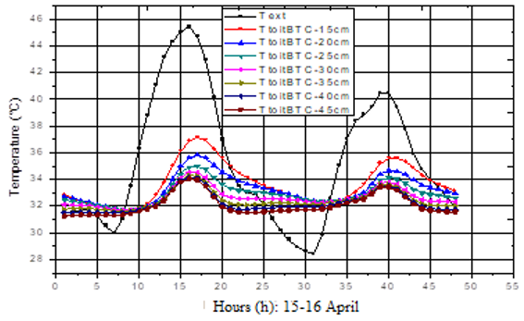

**Figure 6. Evolution of indoor temperatures in a ceb building as a function of varying CEB roof thickness without false ceiling (wall thickness: 40 cm)**

**Table 5** showing the damping values based on the thickness of the CEB roof.

**Table 5. Damping Values as a Function of CEB Roof Thickness**

|  |  |  |  |  |  |  |  |
| --- | --- | --- | --- | --- | --- | --- | --- |
| Roof Thickness | 15 cm | 20 cm | 25 cm | 30 cm | 35 cm | 40 cm | 45 cm |
| Damping ∆𝑻 (°C) | 8,4 | 9,6 | 10,4 | 10,9 | 11 | 11,2 | 11,4 |

A CEB roof significantly reduces outdoor temperature variations. The variation in CEB roof thickness has a considerable impact on the building’s thermal behaviour. A 30 cm thick roof is preferable, as beyond this thickness, the reduction in temperatures is no longer significant, confirming results from (Maria Aguilar-Sanchez et al., 2023). Additionally, it offers a 2.5°C reduction compared to a 15 cm thick roof.

**3.7 Influence of the variation in CEB roof thickness with false ceiling**

Figure 7 shows the thermal behavior of the CEB building based on the variation in CEB roof thickness with a false ceiling (wall thickness: 40 cm).

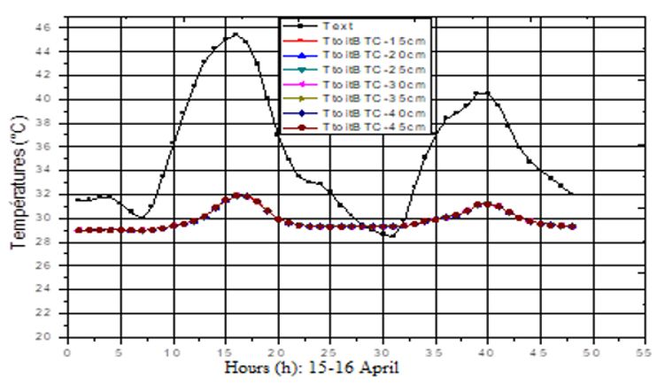

**Figure 7. Thermal behaviour of a CEB building as a function of varying CEB roof thickness with false ceiling (wall thickness: 40 cm)**

The variation in CEB roof thickness with a false ceiling does not significantly influence indoor temperatures, similar to the case of a concrete roof with a false ceiling. This is explained by the insulating effect of the false ceiling. When using a CEB roof with a false ceiling, a thinner roof is preferable to avoid additional costs, as it provides the same results as a thicker roof with a false ceiling (Wilfried Hounkpatin et al., 2018).

**3.8 Wall insulation**

The study now focuses on a CEB building under a 15 cm thick CEB roof with a false ceiling. First, the influence of internal and external wall insulation on the building’s thermal behaviour is examined. Then, wall thickness is varied to assess its impact in the presence of insulation. The insulation used is 2 cm thick polystyrene. Finally, the effect of varying insulation thickness on indoor temperature evolution is analyzed.

**3.8.1 Influence of CEB wall insulation on indoor temperature evolution**

Figure 8 shows influence of Internal and External Wall Insulation on Indoor Temperature Evolution (Wall Thickness: 40 cm).

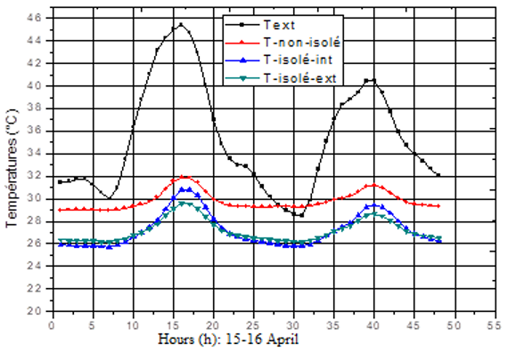

**Figure 8. Influence of internal and external wall Insulation on indoor temperature evolution (Wall thickness: 40 cm)**

Figure 8 reveals that insulated walls reduce heat exchange between the building’s interior and the external environment, with external insulation being more effective than internal insulation. Internal insulation achieves a damping of 14.6°C, while external insulation provides 15.8°C. This is explained by external insulation eliminating thermal bridges, which act as pathways for heat entry during hot periods.

**3.8.2 Influence of varying wall thickness with external insulation on indoor temperature evolution**

Figure 9 shows influence of varying wall thickness with external insulation on indoor temperature evolution.

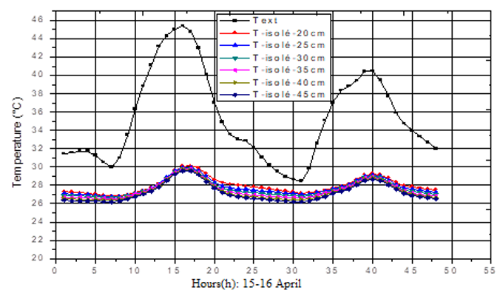

**Figure 9. Influence of varying wall thickness with external insulation on indoor temperature evolution**

With external insulation, varying wall thickness has minimal impact on indoor temperature evolution. This is due to the low thermal capacity of the insulation, which absorbs little heat. For external insulation, thinner walls are preferable to avoid additional costs.

**3.8.3 Influence of varying insulation thickness on indoor temperature evolution**

Figure 10 shows influence of varying insulation thickness on indoor temperature evolution (Wall thickness: 20 cm)

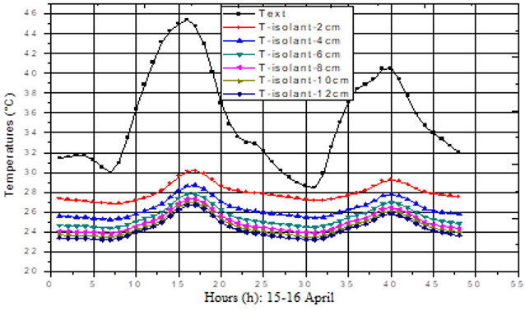

**Figure 10. Influence of varying insulation thickness on indoor temperature evolution (Wall thickness: 20 cm)**

**Table 6. Damping values as a function of insulation thickness**

|  |  |  |  |  |  |  |
| --- | --- | --- | --- | --- | --- | --- |
| Insulation Thickness | 2 cm | 4 cm | 6 cm | 8 cm | 10 cm | 12 cm |
| Damping $∆T$ (°C) | 15.4 | 16.7 | 17.6 | 18 | 18.5 | 18.7 |

The effect of an insulating material increases with its thickness. Varying insulation thickness impacts indoor temperatures; greater thickness leads to a more significant reduction in heat flux. Insulation thicknesses between 2 and 8 cm substantially lower indoor temperatures, but beyond 8 cm, the reduction is moderate. From 6 cm of polystyrene, energy consumption decreases moderately and approaches a limit. A 10 cm thick insulation achieves a maximum indoor temperature of approximately 27°C (Modeste Kameni Nematchoua et al., 2015).

**Conclusion**

This study demonstrates the potential of local materials, particularly CEB, to improve thermal comfort in buildings in Ouagadougou. EnergyPlus simulations show that 20 cm CEB walls, externally insulated with 10 cm of polystyrene, under a 15 cm CEB roof with a false ceiling, achieve indoor temperatures close to 27°C, reducing reliance on air conditioning ([Sofia Real](https://www.researchgate.net/profile/Sofia-Real-2), J. et al., 2024). While thicker walls and roofs enhance thermal inertia, external insulation is critical for eliminating thermal bridges and ensuring optimal comfort. These findings highlight the importance of bioclimatic design tailored to Burkina Faso’s hot climate, promoting cost-effective and environmentally friendly solutions. Further experimental measurements are needed to validate the simulations, and incorporating parameters like humidity and ventilation could refine thermal performance (Gratien Kiki et al., 2025). Promoting local materials through pilot projects and training is essential for their widespread adoption (Coulibaly, O., 2011).

**DISCLAIMER (ARTIFICIAL INTELLIGENCE)**

Author(s) hereby declares that NO generative AI technologies such as Large Language Models (ChatGPT, COPILOT, etc) and text-to-image generators have been used during writing or editing of this manuscript.

**References**

Césaire Hema, Adamah Messan, Abdou

Lawane, Geoffrey Van Moeseke

(2020).Impact of the Design of Walls

Made of Compressed Earth Blocks on

the Thermal Comfort of Housing in Hot

Climate. Buildings 2020, 10(9), 157;

[**https://doi.org/10.3390/buildings10090157**](https://doi.org/10.3390/buildings10090157)

Coulibaly, O. (2011). Contribution to the

development of thermal and energy

regulations for buildings in Burkina

Faso: Multiparametric baseline data

and thermo-aeraulic modeling using

CoDyBa and TRNSYS. Doctoral

dissertation, University of

Ouagadougou.

Gratien Kiki,Romain  Rémond,  Sahbi Ouertani,

Aristide Houngan, Philippe André

(2025). Hygrothermal performance of

compressed earth blocks incorporating

quackgrass straw. Construction and

Builduing Materials, volume 482, July

2025, 141495

<https://doi.org/10.1016/j.conbuildmat.2025.141495>

Incropera, F. P., DeWitt, D. P., Bergman, T. L.,

& Lavine, A. S. (2020). Fundamentals

of Heat and Mass Transfer (8th ed.).

Wiley. DOI :

<https://doi.org/10.1002/9781119722632>

[Louis Arnaud Ouedraogo](https://www.researchgate.net/profile/Louis-Ouedraogo), [Césaire Hema](https://www.researchgate.net/profile/Cesaire-Hema),

[Ibrahim Neya](https://www.researchgate.net/profile/Ibrahim-Neya), [Philbert Nshimiyimana](https://www.researchgate.net/profile/Philbert-Nshimiyimana),

[Daniel Yamegueu](https://www.researchgate.net/profile/Daniel-Yamegueu), [Yezouma Coulibaly](https://www.researchgate.net/profile/Yezouma-Coulibaly-3?_tp=eyJjb250ZXh0Ijp7ImZpcnN0UGFnZSI6InB1YmxpY2F0aW9uIiwicGFnZSI6InB1YmxpY2F0aW9uIn19),

[Kaboré Madi](https://www.researchgate.net/profile/Kabore-Madi), [Adamah Messan](https://www.researchgate.net/profile/Adamah-Messan?_tp=eyJjb250ZXh0Ijp7ImZpcnN0UGFnZSI6InB1YmxpY2F0aW9uIiwicGFnZSI6InB1YmxpY2F0aW9uIn19)

(2023).Comparative Assessment of

The Thermal Comfort in Naturally

Evolving Buildings in Hot and Dry

Sahelian Climate: Case of The City of

Ouagadougou in Burkina Faso. [Journal of Materials Science and Surface Engineering](https://www.researchgate.net/journal/Journal-of-Materials-Science-and-Surface-Engineering-2348-8956) 10:1104-1111. DOI: https://doi.org/[10.52687/2348-8956/103](http://dx.doi.org/10.52687/2348-8956/103)

Madi Kaboré. Enjeux de la simulation pour

l’étude des performances énergétiques

des bâtiments en Afrique sub-

saharienne. Génie civil. Université

Grenoble Alpes; Institut international

d’ingénierie de l’eau et de

l’environnement, 2015. Français.

ffNNT : 2015GREAA001ff. fftel-

01207884

Maria Aguilar-Sanchez, Jose-Manuel

Almodovar-Melendo, Joseph Cabeza-

Lainez (2023).Thermal Performance

Assessment of Burkina Faso’s

Housing Typologies.Buildings, 13(11),

2719.DOI :

<https://doi.org/10.3390/buildings13112719>

Modeste Kameni Nematchoua, Chrysostôme

R.R. Raminosoa,

Ramaroson  Mamiharijaona,

Tchinda René, José

A. Orosa,  Watis Elvis, Pierre Meukam

(2015).Study of the economical and

optimum thermal insulation thickness

for buildings in a wet and hot tropical

climate: Case of Cameroon.

[Renewable and Sustainable Energy](https://www.sciencedirect.com/journal/renewable-and-sustainable-energy-reviews) ,

Reviews [Volume 50](https://www.sciencedirect.com/journal/renewable-and-sustainable-energy-reviews/vol/50/suppl/C),1192-1202. DOI :

<https://doi.org/10.1016/j.rser.2015.05.066>

Mohammadullah Hakim Ebrahimi, Philippe

Devillers, E. Garcia-Diaz. Optimization

of the thermal performance of

compressed earth block wall for

affordable housing. NOMAD 2022 - 4e

conférence internationale francophone

Nouveaux Matériaux et Durabilité, IMT

Mines Alès; LMGC; LIFAM, Nov 2022,

Montpellier, France. ffhal-03879787

Malbila, E., Delvoie, S., Toguyeni, D., Courard,

L., & Attia, S. (2021). Improving the

Building Energy Efficiency and

Thermal Comfort through the Design

of Walls in Compressed Earth Blocks

of Agricultural and Biopolymer

Residues Masonry. Current Journal of

Applied Science and Technology,

40(45), 7–22. <https://doi.org/10.9734/cjast/2021/v40i4531624>

Sergio, M. R., Sarai, M. C. D., Avatar, F. G.,

Varun, T., & Juan, S. A. (2020). Study

of Huichol Vernacular Housing through

Thermal Analysis of the Construction

Elements Characteristic of the Pre-

hispanic Era. Journal of Energy

Research and Reviews, 6(4), 1–14.

<https://doi.org/10.9734/jenrr/2020/v6i430173>

[Sofia Real](https://www.researchgate.net/profile/Sofia-Real-2), [J. Alexandre Bogas](https://www.researchgate.net/profile/J-Bogas?_tp=eyJjb250ZXh0Ijp7ImZpcnN0UGFnZSI6InB1YmxpY2F0aW9uIiwicGFnZSI6InB1YmxpY2F0aW9uIn19), [Ricardo Cruz](https://www.researchgate.net/profile/Ricardo-Cruz-39),

[M. Glória Gomes](https://www.researchgate.net/profile/M-Gomes-5?_tp=eyJjb250ZXh0Ijp7ImZpcnN0UGFnZSI6InB1YmxpY2F0aW9uIiwicGFnZSI6InB1YmxpY2F0aW9uIn19), [Martim Nabais](https://www.researchgate.net/scientific-contributions/Martim-Nabais-2285770295)

(2024).Thermal performance of

compressed earth blocks stabilised

with thermoactivated recycled cement.

[Energy and Buildings](https://www.researchgate.net/journal/Energy-and-Buildings-0378-7788?_tp=eyJjb250ZXh0Ijp7ImZpcnN0UGFnZSI6InB1YmxpY2F0aW9uIiwicGFnZSI6InB1YmxpY2F0aW9uIn19) 314:114288DOI:

https://doi.org/[10.1016/j.enbuild.2024.114288](http://dx.doi.org/10.1016/j.enbuild.2024.114288)

Wilfried Hounkpatin, H., Chégnimonhan, V.,

Clarence Sèmassou, G., R.

Nathaniels, D., & Kounouhewa, B.

(2018). Simulation of the Thermal

Behavior of Various Local Roofings for

a Residential House in the Humid

Tropics. Advances in Research, 15(4),

1–15.

<https://doi.org/10.9734/AIR/2018/42065>

Zoure, A. N., & Genovese, P. V. (2022).

Development of Bioclimatic Passive

Designs for Office Building in Burkina

Faso. Sustainability, 14(7), 3879. DOI :

[**https://doi.org/10.3390/su14074332**](https://doi.org/10.3390/su14074332)