**Original Research Article**

**“Landslide Susceptibility Mapping of Churachandpur District, Manipur, India, Using Geospatial Techniques”.**

**ABSTRACT**

Landslides are a significant hazard in Churachandpur district, Manipur, frequently triggered by heavy rainfall, earthquakes and human activities such as deforestation, shifting cultivation and constructions. The landslides are more prominent in the district where high topography, ranging up to 2,100 metres above sea level are present. The research used Weighted-overlay GIS analysis methodologies to create a landslide susceptibility map for the study area. High-resolution thematic layers were generated from various data sources, including terrain-corrected data from earthexplorer.usgs.gov (SRTM 30 m resolution), Sentinel-2A multi-spectral satellite imagery (10 m resolution) and LANDSAT 8 satellite data, alongside other relevant factors such as rainfall distribution, slope and structural features (faults, drainage density, roads).

The study used weighted overlay analysis (0–10) to identify landslide-prone areas and analyse thematic layers using GIS (ArcGIS 10.8). The zones are categorized into high, medium and low based on the results; high-risk areas displayed notable terrain instability, ranging from massive debris flows to soil creep. The south-western, south-eastern and eastern regions of the district experience higher landslide frequency, particularly affecting the crucial Manipur-Mizoram national highway corridor in the south. These landslides regularly disrupt transportation networks, damage infrastructure, and endanger local communities. Important information for setting mitigation priorities in sensitive areas is provided by the susceptibility mapping. District planners can use these findings to implement land-use regulations, better drainage systems and targeted slope stabilization. In order to improve resilience, the study emphasizes the necessity of science-based regulations, early warning systems and community readiness initiatives. The final map shows the historical landslide areas where the authorities can take up important measures to lower the risk of landslides by incorporating these technical evaluations into development planning. This strategy promotes sustainable development throughout the Churachandpur area in addition to protecting infrastructure and human life. While long-term monitoring of medium-risk locations is maintained, immediate intervention is advised for high-risk zones to avert future tragedies.

**Keywords**: Landslide, Human Activities, Satellite Data, Thematic Maps, Development planning.

1. **INTRODUCTION**

Landslides are geological phenomena characterised by the downward movement of soil, rock, and debris on sloped terrains, often triggered by factors such as heavy rainfall, earthquakes, or human activity (Highland, L. M., & Bobrowsky, P., 2008). These events pose significant risks to life, property and infrastructure, particularly in mountainous regions (Beniston, M. 2003). The complex interplay of geological, hydrological and environmental factors contributes to their occurrence and severity (Gill, J. C., & Malamud, B. D., 2014), (Meusburger, K., & Alewell, C., 2008). Understanding landslide mechanisms is crucial for effective risk assessment and management, especially in vulnerable areas where development and natural hazards intersect, necessitating comprehensive monitoring and zonation strategies to mitigate impacts (Cascini, L. C. J. R. J. O., Bonnard, C., Corominas, J., Jibson, R., & Montero-Olarte, J., 2005). In the eastern Himalaya range, landslides are frequently triggered by seismic activity due to the region's tectonic instability (Mishra, B.K., Bhattacharjee, D., Chattopadhyay, A., & Prusty, G., 2018; Gerrard, J., 1994). Earthquakes can destabilise slopes, leading to the rapid movement of soil and rock (Jibson, R. W. 2011). The steep topography and diverse geological formations of the Himalayas further intensify this risk, particularly in areas with loose or saturated soil. Regions like Manipur, Nagaland, Mizoram, Sikkim and Arunachal Pradesh often experience landslides following significant seismic events, impacting local communities and infrastructure. Additionally, the heavy monsoon rains common in this area can saturate the soil, making it more susceptible to landslides (Jeong, S., Lee, K., Kim, J., & Kim, Y., 2017). especially in regions already weakened by seismic activity. Implementing early warning systems and conducting thorough geological assessments are vital for minimising the impact of landslides in these earthquake-prone zones, ensuring community safety and resilience (McBride, S.K., Smith, H., Morgoch, M., Sumy, D., Jenkins, M., Peek, L., ... & Wood, M. 2022).

1. **STUDY AREA**

Churachandpur district is located in the south-western part of Manipur, India, situated at coordinates 24.3335° N latitude and 93.6815° E longitude. Its location underscores its importance as a gateway between Manipur and Mizoram, with its highways serving as lifelines for the communities residing in this hilly terrain. This region boasts a wealth of cultural and natural diversity.

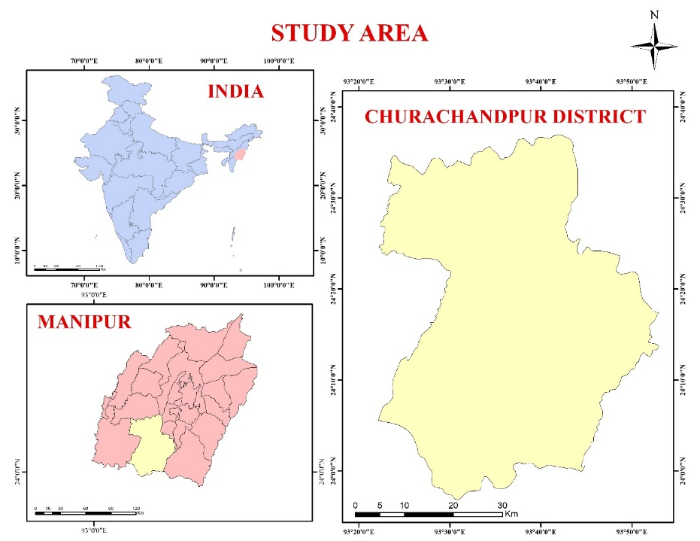

Figure 1. Locational Map of Study Area.

Churachandpur district in Manipur spans 2,392 km2, bordering Mizoram, Nagaland, Assam and Myanmar. Its headquarters, Lamka, is a vital connectivity hub. The district’s terrain is predominantly mountainous (94.75%), with smaller valleys (5.25%), making it highly susceptible to landslides. Key transit routes, including National Highways 150 and 102B, which link Manipur to Myanmar, face frequent disruptions due to landslides triggered by rainfall, steep slopes, unstable soil and tectonic activity. Located in UTM North 46, landslide-prone areas endanger infrastructure and safety, emphasising the need for zonation mapping. Using GIS, remote sensing and field data, factors like slope, soil and vegetation are assessed to identify high-risk zones. This approach aids in safeguarding infrastructure, ensuring highway connectivity and guiding sustainable planning and disaster resilience in northeast India. The concept of the study on this topic will enhance the awareness of landslides and its risks management (Crozier, M. J., & Glade, T., 2005).

* 1. **Climatic Condition**

Churachandpur experiences a subtropical highland climate with distinct wet and dry seasons. The monsoon season, from May to October, brings heavy rainfall, ranging from 1,500 to 2,500 mm annually, often causing floods and landslides in the hilly areas. The winter months, from November to February, are dry and cool, with temperatures dropping to around 5°C in the colder regions. Summers, from March to April, can reach temperatures up to 30°C. Humidity is high during the monsoon season but decreases in winter. Rainfall can vary significantly across the district, sometimes reaching 2,000 mm during the peak monsoon months from June to September.

* 1. **Topography**

Churachandpur district, in southwestern Manipur, spans a rugged terrain with 94.75% hilly areas and 5.25% plains. It lies within the Indo-Burma range, with elevations from 300 m to over 2,100 m above sea level. High hills and ridges dominate the north and east (Batar, A.K., & Watanabe, T., 2021), gradually descending to flatter, cultivable lands in the south and west. Rivers like the Khuga, locally known as *Tuitha*, shape the valleys and provide vital water resources. This diverse landscape, marked by steep slopes and deforested areas, is prone to natural hazards like landslides. The district’s topography significantly impacts land use, agriculture and environmental challenges, highlighting the need for sustainable development and hazard management.

* 1. **Historical Background**

Churachandpur district, in southwestern Manipur, features a diverse and rugged topography critical to its environmental and developmental dynamics. About 5.25% comprises plains or valleys, while 94.75% is hilly terrain. It lies within the Indo-Burma range, with elevations from 300 m to over 2,100 m above sea level. The northern and eastern regions are dominated by high hills and ridges that gradually descending southward and westward into flatter, cultivable lands. Rivers like the Khuga (*locally Tuitha*) carve through the landscape, forming valleys and supplying vital water resources. This distinct terrain, marked by steep gradients and deforested slopes, makes the region highly susceptible to natural hazards like landslides. The district’s topography significantly shapes its land use, agriculture and vulnerability, presenting both challenges and opportunities for sustainable regional development.

**MATERIALS & METHODS**

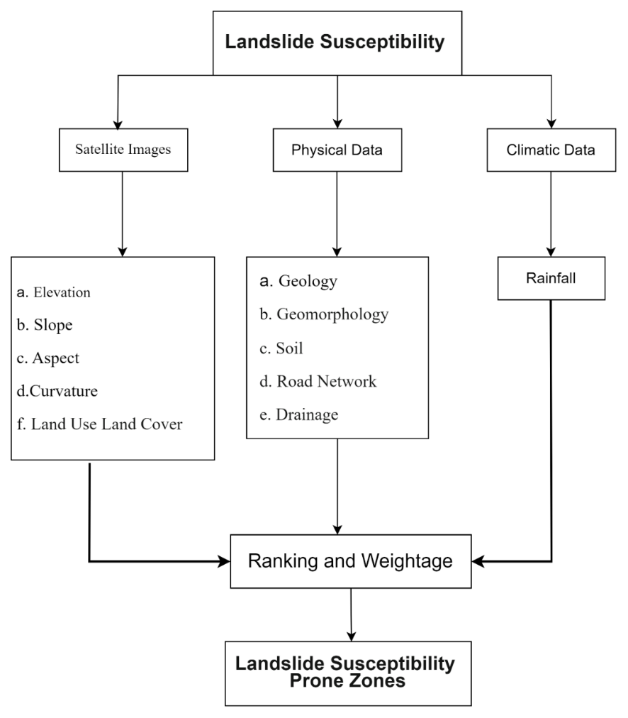

Figure 2. Framework for mapping Landslide Susceptibility.

A systematic approach was undertaken to collect a wide range of data for this study, primarily from primary sources, with rainfall data obtained as a secondary source. Essential geographical attributes such as geology, elevation, slope, aspect and curvature were gathered from the USGS Earth Explorer portal, while rainfall data was sourced from the CHRS data portal. Additionally, geomorphology, lineament and lithology information were acquired through Bhukosh GSI, soil data from NBSSLUP, drainage details from Hydrosheds and the road network from the PMGSY portal. Integrating these diverse data sources establishes a robust base for analysing land features and assessing terrain risks.

Table 1: Data and Sources

|  |  |  |
| --- | --- | --- |
| Sl. No. | **Data** | **Data Sources** |
|  | 1. Geology 2. Elevation 3. Slope 4. Aspect 5. Curvature 6. Land use and Land cover | *USGS Earth Explorer* ([earthexplorer.usgs.gov](https://earthexplorer.usgs.gov/)) |
|  | * 1. Geomorphology   2. Lineament   3. Lithology | *Bhukosh GSI* ([bhukosh.gsi.gov.in](https://bhukosh.gsi.gov.in/)) |
|  | Soil | *NBSSLUP* (nbsslup.icar.gov.in) |
|  | Drainage | *Hydrosheds* ([hydrosheds.org](https://hydrosheds.org/)) |
|  | Road Network | *PMGSY Portal* (pmgsy.nic.in) |
|  | Rainfall | *CHRS Data Portal* ([chrsdata.uci.edu](https://chrsdata.uci.edu/)) |

* 1. **Thematic Layers**
     1. **Slope**

A slope map is a critical thematic layer in landslide studies, representing the steepness or inclination of the terrain. Slope angles are directly correlated with landslide susceptibility, as steeper slopes are generally more prone to failure. This map is generated using an SRTM DEM. The slope is classified into 5 (five) classes, ranging from 0° to 70°.

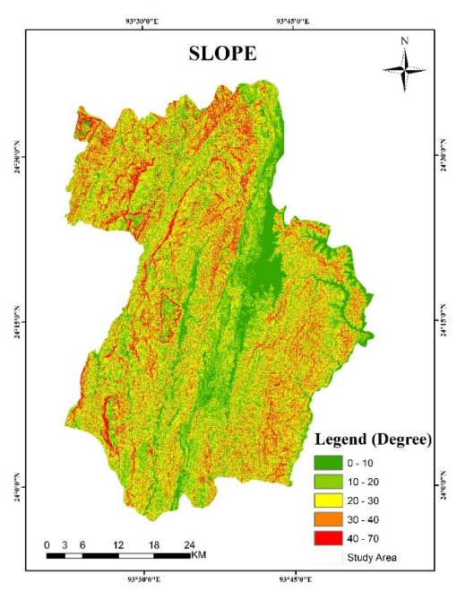

Figure 3. Slope Profile.

The slope map helps identify areas where the angle of inclination exceeds the threshold for stability, making them more likely to experience landslides. It also aids in planning mitigation measures such as slope reinforcement or terracing in these high-risk zones. One of the most important factors which plays as an indicator for landslide susceptibility zonation is the natural arrangement of the Slope (Hack, R., Alkema, D., Kruse, G. A., Leenders, N., & Luzi, L., 2007). The physiography of Churachandpur depicts that of the whole north eastern region of the country, where the plains and valleys are surrounded by high hills and mountains (Bhusan, K., Pande, T., & Kayal, J. R., 2022).

* + 1. **Elevation**

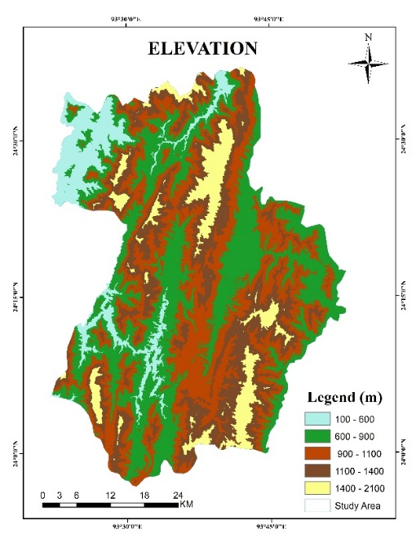

Figure 4. Elevation Profile.

The elevation of Churachandpur, Manipur, ranges from 100 m to 2,000 m. Lower elevations (100 m-400 m) are flat plains supporting agriculture and settlements. Between 400 m and 800 m, the terrain features gentle slopes, while 800 m to 1,200 m showcases rolling hills. From 1,200 m to 1,600 m, the land becomes steeper with dense forests. The highest regions, 1,600 m to 2,000 m, consist of rugged mountainous areas. Compared to most of the northeast states like, Sikkim, Arunachal Pradesh, the Northern part of West Bengal, Manipur is not that high, but still it is still risky for landslide (Sonker, I., & Tripathi, J. N. 2022). This elevation classification informs land use, environmental diversity and vulnerability to hazards like landslides.

* + 1. **Curvature**

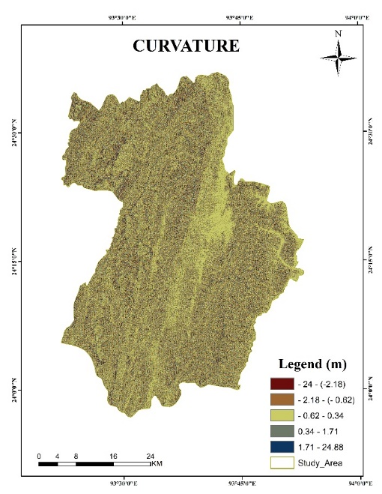

Figure 5. Curvature Profile.

Churachandpur district in Manipur features a diverse elevation range, classified into five classes from -24 m to 24.88 m, according to data from Earth Explorer (USGS). The elevation variation, especially the lower and upper limits, influences the district’s landslide susceptibility, with low-lying areas facing erosion and the higher slopes vulnerable to instability. The district’s hilly terrain and soil types, influenced by clay and sandy deposits, also play a significant role in landslide occurrence. Effective mapping of elevation variations is essential to understanding high-risk zones and implementing proper landslide management strategies.

* + 1. **Aspect**

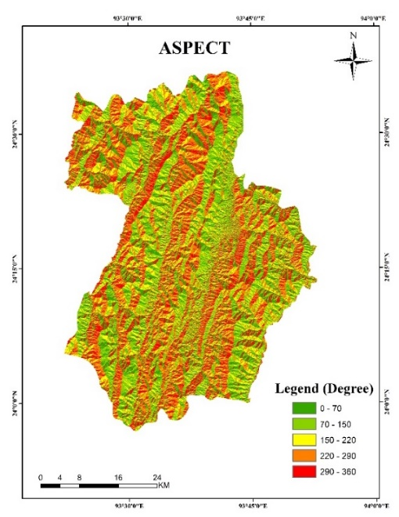

Figure 6. Aspect Profile.

An aspect map shows the direction a slope faces, influencing environmental factors like sunlight, moisture, and wind patterns. The slope's orientation affects erosion and vegetation, both crucial to landslide risk. Southern-facing slopes (in the Northern Hemisphere) are drier and more erosion-prone, while north-facing slopes retain more moisture, impacting soil stability. Aspect can be classified into five classes, ranging from 70° to 360°. An aspect map provides vital information for understanding how slope orientation contributes to landslide risk.

* + 1. **Geology**

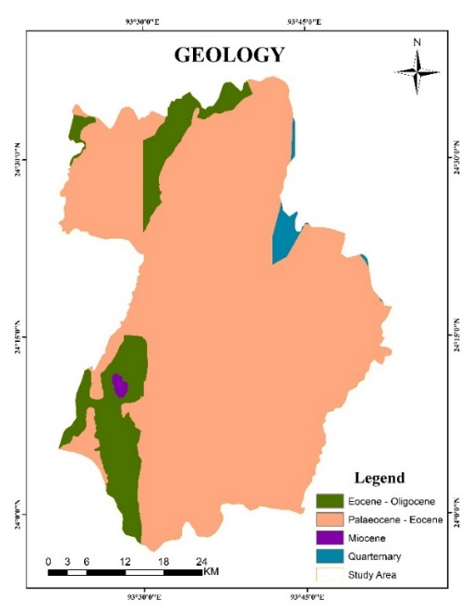

Figure 7. Geological Profile.

A geological map is indispensable in landslide studies as it shows the distribution of different rock types, fault lines and soil compositions within the study area. The nature of the bedrock and surface materials plays a crucial role in determining slope stability. Fault lines also indicate zones of weakness where landslides are more likely to occur. Understanding the geological context through this map helps in predicting potential landslide zones and in designing appropriate engineering solutions to mitigate risks.

* + 1. **Geomorphology**

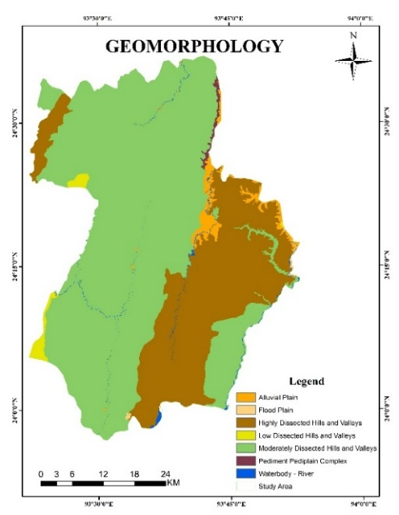

Figure 8. Geomorphological Profile

The geomorphology of Churachandpur district, analysed from Bhukosh.GSI.gov.in data, is categorised into seven classes, reflecting terrain characteristics that influence landslide susceptibility. Moderately dissected hills and valleys, covering about half of the area, feature rugged slopes prone to significant soil erosion. Highly dissected hills and valleys, with steep gradients, are especially vulnerable to landslides during heavy rainfall. Other geomorphic units, like low dissected hills and isolated hillocks, contribute to the region’s complex topography, necessitating detailed landslide susceptibility zonation and monitoring. Whereas the geomorphological structure of the study area explains the significance of the earth surface and processes (Cammeraat, L. H. 2002).

* + 1. **Soil**

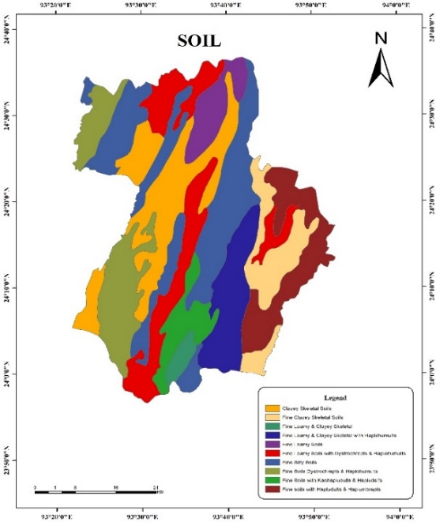

Figure 9. Soil Map

A soil map provides detailed information on the types and properties of soils present in the study area, including factors like soil texture, composition, permeability and cohesion. These properties are critical in determining the stability of a slope. For instance, soils with high clay content may expand and contract significantly with moisture changes, leading to slope instability. Sandy soils, on the other hand, may have low cohesion, making them prone to erosion and landslides.Understanding the soil characteristics through this map helps in assessing landslide susceptibility and in designing appropriate mitigation measures such as soil stabilisation techniques.

* + 1. **Land Use and Land Cover**

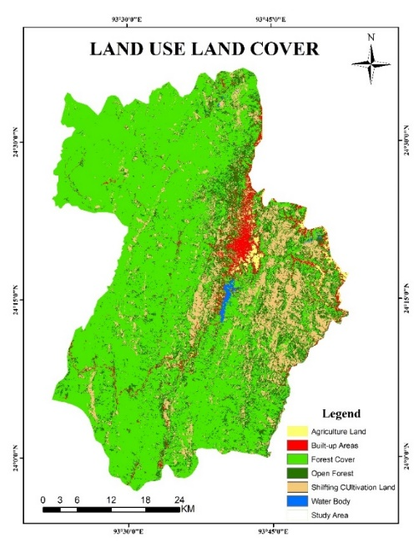

Figure 10. Land Use Land Cover

Land use and land cover maps provide detailed information on how the land is being utilised, including vegetation cover, agricultural activities, urban development and deforestation. Human activities, such as construction and deforestation, can significantly alter the natural stability of slopes, making them more susceptible to landslides. For example, areas that have been deforested or converted for agriculture might lose the root structures that help bind the soil, increasing the likelihood of landslides. This map is crucial for assessing the impact of human interventions on slope stability and for planning land use in a way that minimises landslide risk. The study area is mostly comprised of hills and mountains, where it covers 94.75% of the total area, and the plains and valleys cover just about 5.25% of the total area.

* + 1. **Drainage**

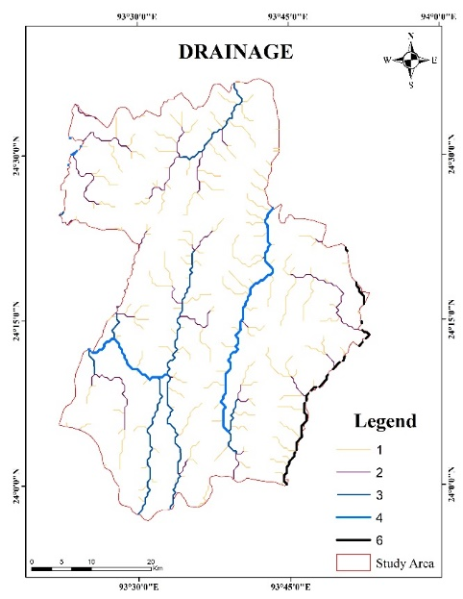

Figure 11. Drainage System.

The drainage system of Churachandpur, classified as 1, 2, 3, 4, and 6 based on data from Earth’s Hydrosheds.org, significantly influences landslide susceptibility. Higher drainage classes represent larger, more defined water channels. In the hilly topography, streams in classes 1 and 2 are prone to rapid water flow and erosion, creating high-risk zones for landslides due to slope instability. Conversely, class 4 and 6 drainages, with larger networks, accumulate more water, contributing to soil saturation and weakening, particularly during heavy rainfall. Traditionally, it is also learned that landslide mostly occurs in high terrain adjacent to the river bank where large quantities of water deposits are located, losing the density of the soil (Kasana, S. 2019). Understanding these patterns is crucial for identifying landslide-prone areas and implementing erosion control.

* + 1. **Road Network**

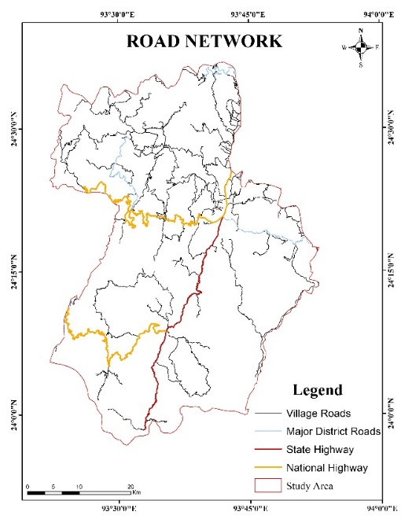

Figure 12. Road Network System.

Churachandpur's road network, critical for regional connectivity, includes Village Roads, Major District Roads, State Highways and National Highways. Data from the PMGSY portal highlights the vulnerability of these roads, particularly due to frequent landslides from the district's rugged topography and heavy monsoon rains.National Highways 150 and 102B, essential for trade, are especially susceptible to landslides. These disruptions require extensive maintenance, particularly in steep areas with unstable soil types like Barail and Surma-Disang formations. Effective road planning and drainage management are vital for enhancing resilience and safety.

* + 1. **Rainfall**

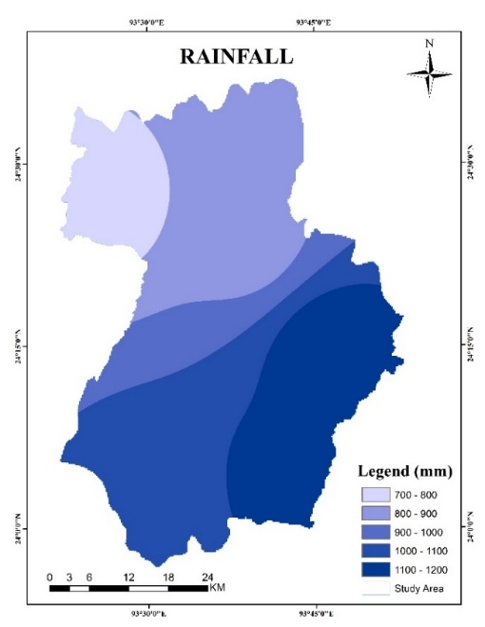

Figure 13. Rainfall Distribution

Churachandpur district experiences substantial annual rainfall, generally ranging from 700 mm to 1,200 mm, as indicated by CHRS data portal records, with some years experiencing surges up to 2,000 mm due to climatic variability. The district's rainfall distribution varies geographically, with the southern and southeastern areas, particularly near the Myanmar border, receiving higher rainfall compared to the northern parts. This gradient is shaped by topography and monsoon patterns, bringing more moisture-laden winds to the southern regions. While this supports rich biodiversity, it also contributes to soil erosion and landslide susceptibility, especially on steep slopes. These conditions underscore the district’s vulnerability to extreme weather events and the need for effective watershed management to mitigate environmental risks. Rainfall gradually occurs heavily during monsoon season, and most parts of the Himalayan region in the north eastern states get affected severely, causing landslides, mudslides, etc. (Dikshit, A., Sarkar, R., Pradhan, B., Segoni, S., & Alamri, A. M. 2020)

|  |  |  |  |  |
| --- | --- | --- | --- | --- |
| Sl. No | Count | Weightage | Ranking | Total |
| 1 | 416237 | 9 | 1 | 9 |
| 2 | 731558 | 9 | 2 | 18 |
| 3 | 821443 | 9 | 3 | 27 |
| 4 | 551553 | 9 | 4 | 36 |
| 5 | 173604 | 9 | 5 | 45 |

Table 2: Slope Data

|  |  |  |  |  |
| --- | --- | --- | --- | --- |
| Sl. No | Count | Weightage | Ranking | Total |
| 1 | 205610 | 9 | 1 | 9 |
| 2 | 475624 | 9 | 2 | 18 |
| 3 | 621587 | 9 | 3 | 27 |
| 4 | 744623 | 9 | 4 | 36 |
| 5 | 643646 | 9 | 5 | 45 |

Table 3: Elevation Data

|  |  |  |  |  |
| --- | --- | --- | --- | --- |
| Sl. No | Count | Weightage | Ranking | Total |
| 1 | 87349 | 9 | 1 | 9 |
| 2 | 615560 | 9 | 2 | 18 |
| 3 | 1104173 | 9 | 3 | 27 |
| 4 | 729425 | 9 | 4 | 36 |
| 5 | 166432 | 9 | 5 | 45 |

Table 4: Curvature Data

|  |  |  |  |  |
| --- | --- | --- | --- | --- |
| Sl. No | Count | Weightage | Ranking | Total |
| 1 | 505539 | 9 | 1 | 9 |
| 2 | 608310 | 9 | 2 | 18 |
| 3 | 503068 | 9 | 3 | 27 |
| 4 | 577966 | 9 | 4 | 36 |
| 5 | 499512 | 9 | 5 | 45 |

Table 5: Aspect Data

|  |  |  |  |  |
| --- | --- | --- | --- | --- |
| Sl. No | Categories | Weightage | Ranking | Total |
| 1 | Disang FM. | 10 | 1 | 10 |
| 2 | Barail Gp. | 10 | 3 | 30 |
| 3 | Undiff. Fluvial & Sediments | 10 | 4 | 40 |
| 4 | Surma Gp. | 10 | 5 | 50 |

Table 6: Geological Data

|  |  |  |  |  |
| --- | --- | --- | --- | --- |
| Sl. No | Categories | Weightage | Ranking | Total |
| 1 | Alluvial Plain | 5 | 1 | 5 |
| 2 | Flood Plain | 5 | 2 | 10 |
| 3 | Highly Dissected Hills and Valleys | 5 | 5 | 25 |
| 4 | Low Dissected Hills and Valleys | 5 | 3 | 15 |
| 5 | Moderately Dissected Hills and Valleys | 5 | 4 | 20 |
| 6 | Pediment Pedi plain Complex | 5 | 1 | 5 |
| 7 | Waterbody - River | 5 | 3 | 15 |

Table 7: Geomorphological Data

|  |  |  |  |  |
| --- | --- | --- | --- | --- |
| Sl. No | Count | Weightage | Ranking | Total |
| 1 | 1227467 | 7 | 5 | 35 |
| 2 | 1366269 | 7 | 3 | 21 |
| 3 | 109236 | 7 | 1 | 7 |

Table 8: Soil Data

|  |  |  |  |  |
| --- | --- | --- | --- | --- |
| Sl. No | Categories | Weightage | Ranking | Total |
| 1 | Agriculture Land | 4 | 5 | 20 |
| 2 | Built-up Areas | 4 | 5 | 20 |
| 3 | Forest Cover | 4 | 4 | 16 |
| 4 | Open Forest | 4 | 3 | 12 |
| 5 | Shifting Cultivation Land | 4 | 2 | 8 |
| 5 | Water Body | 4 | 5 | 20 |

Table 9: Land Use Land Cover Data

|  |  |  |  |  |
| --- | --- | --- | --- | --- |
| Sl. No | Count | Weightage | Ranking | Total |
| 1 | 778669 | 2 | 1 | 2 |
| 2 | 598967 | 2 | 2 | 4 |
| 3 | 615545 | 2 | 3 | 6 |
| 4 | 463449 | 2 | 4 | 8 |
| 5 | 246476 | 2 | 5 | 10 |

Table 10: Drainage Data

|  |  |  |  |  |
| --- | --- | --- | --- | --- |
| Sl. No | Count | Weightage | Ranking | Total |
| 1 | 912566 | 3 | 1 | 3 |
| 2 | 747762 | 3 | 2 | 6 |
| 3 | 606019 | 3 | 3 | 9 |
| 4 | 312043 | 3 | 4 | 12 |
| 5 | 124716 | 3 | 5 | 15 |

Table 11: Road Network

|  |  |  |  |  |
| --- | --- | --- | --- | --- |
| Sl. No | Count | Weightage | Ranking | Total |
| 1 | 295625 | 8 | 1 | 8 |
| 2 | 731689 | 8 | 2 | 16 |
| 3 | 297087 | 8 | 3 | 24 |
| 4 | 754962 | 8 | 4 | 32 |
| 5 | 628702 | 8 | 5 | 40 |

Table 12: Rainfall Data

1. **RESULTS AND DISCUSSIONS**

Churachandpur district in Manipur, India, is prone to landslides due to its rugged terrain, frequent rainfall and seismic activity. The area’s steep slopes, combined with deforestation and human activities, make it particularly vulnerable to landslide events. Landslides in Churachandpur often disrupt transportation, notably along major highways such as NH 150 and NH 102b, impacting connectivity and local economies. The causes can be natural and anthropogenic, where the impact on the land varies from activities of the people (McColl, S. T. 2022). Understanding the distribution of landslide-prone zones within the district is essential for infrastructure planning, disaster risk reduction and ensuring the safety of residents and travellers.

* 1. **Analysis**

In the analysis, each parameter (e.g., lineament, curvature, soil, aspect, and slope) is assigned weightage and ranked by subcategories or counts. The weightage reflects the importance of each parameter, with higher values indicating greater significance (Mandal, S., & Maiti, R., 2015). Rankings show the relative position of subcategories within each parameter. Total scores are calculated by multiplying the weightage and ranking for each subcategory, reflecting their contribution to the overall analysis. Integrating these insights into zonation mapping enables proactive disaster management, safeguarding infrastructure from natural hazards (Dikshit, K. R., Dikshit, J. K., Dikshit, K. R., & Dikshit, J. K. 2014), livelihoods and resilience in vulnerable areas through informed data-driven decisions.

* 1. **LANDSLIDE SUSCEPTIBLE ZONES:**

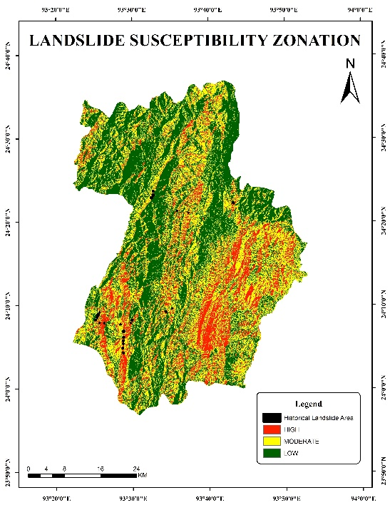

Figure 14. Landslide Susceptibility Zonation

|  |  |  |  |
| --- | --- | --- | --- |
| Susceptibility Class | Pixel Count | Area (km²) | Percentage (%) |
| Low | 1,225,383 | 1,090.59 | 45.59 |
| Medium | 1,010,577 | 899.41 | 37.59 |
| High | 452,229 | 402.00 | 16.82 |
| Total | 2,688,189 | 2,392 | 100.00 |

Table 13. Landslide Distribution data

* + 1. **Low Landslide Zones**

Low Landslide Zones in Churachandpur district cover 1,090.59 sq. km (45.59% of the area), offering stable terrain with minimal landslide risks, making them suitable for development and infrastructure. These zones include Lamka town, much of the northwestern and northeastern regions and areas bordering Bishnupur district, primarily valley regions with naturally lower landslide risks. Villages like Kangvai, Tolbung, Zalenphai, Tollen, etc. lies within these zones, providing safer environments for expansion. Ongoing monitoring and sustainable practices like controlled land use, vegetation preservation and soil conservation are crucial for maintaining stability and fostering resilient growth.

* + 1. **Medium Landslide Zones**

Medium Landslide Zones in Churachandpur district cover 899.41 sq. km (37.60% of the area), facing moderate landslide risks. These regions require careful construction and land use planning, incorporating mitigation strategies like slope stabilisation, vegetation reinforcement and improved drainage to minimise incidents, particularly during heavy rains. Located mainly in the southeastern, southwestern and northern areas, these zones include villages such as Suangdoh, Changlei, Lungthul, Behiang, Panglian, Munhoih, Lhangnom, Nabil and Sehken. Critical transit routes, including National Highways NH-150 and NH-102B, also fall within these zones, requiring close monitoring and regular maintenance to ensure stability and prevent disruptions.

* + 1. **High Landslide Zones**

High Landslide Zones in Churachandpur district cover 402.00 sq. km (16.82% of the area) and present severe hazards due to steep slopes and frequent landslides. These zones are mainly located in the southeastern, southwestern and northern parts, making them unsuitable for extensive development without specialised engineering solutions. Critical highways NH-150 and NH-102B pass through these high-risk areas, connecting Lamka town to Tipaimukh and Behiang at the Mizoram border. NH-150 serves residents in Henglep subdivision, while NH-102B is crucial for communities affected by the 2023 violence. The southern and eastern sectors of the district, including Gelbung village and its vicinity and also Haosapi range, exhibit lower population density and reduced risk to human settlements compared to the more vulnerable south-western region. This spatial variation in landslide risk correlates strongly with settlement patterns, as the south-western zone contains both steeper terrain and more densely populated areas along critical transport corridors. Important measures like slope stabilisation, erosion control and deforestation restrictions are essential to reduce risks and ensure infrastructure stability.

This map provides a crucial planning tool for infrastructure development and landslide mitigation in Churachandpur, Manipur (Northeast India), helping authorities implement targeted safety measures and sustainable development strategies in this vulnerable Eastern Himalayan region.

1. **CONCLUSION**

Landslide-prone areas in the Churachandpur district need to be managed immediately and strategically to reduce the risks to infrastructure and human life. Because of their steep slopes and unstable geology, high landslide zones (398.01 sq. km, 16.64%), especially along NH-102B (Singngat to Tuivai bridge) and close to the Mizoram border, require stringent erosion control, limited development, and ongoing monitoring. Reinforced slopes, better drainage, and controlled land use are necessary to reduce moderate risks in medium landslide zones (904.52 sq. km, 37.81%), which include villages like Suangdoh and Changlei. Despite the relative stability of Low Landslide Zones (1,089.47 sq. km, 45.55%) like Lamka, Kangvai and Tolbung, sustainable practices are still crucial to averting future dangers.

The yearly minor to medium-sized landslides that frequently occur along NH-150 and NH-102B, with NH-102B being particularly vulnerable as shown in fig.14, where the historical landslide mostly took place along this road are of particular concern. In order to prevent future disasters, district planners, administrators and concerned departments should give priority to this study and put the required measures in place, such as proper drainage systems, slope stabilization and early warning systems. To protect lives and the district's essential road networks, proactive mitigation and prompt action are essential. For Churachandpur's long-term resilience and safe development, a comprehensive strategy that incorporates risk assessment, sustainable land-use planning and emergency preparedness is essential.

**COMPETING INTERESTS DISCLAIMER:**

**Authors have declared that they have no known competing financial interests OR non-financial interests OR personal relationships that could have appeared to influence the work reported in this paper.**

Disclaimer:

Author(s) hereby declare that NO generative AI technologies such as Large Language Models (ChatGPT, COPILOT, etc.) and text-to-image generators have been used during the writing or editing of this manuscript.

**References**

1. Batar, A. K., & Watanabe, T. (2021). Landslide susceptibility mapping and assessment using geospatial platforms and weights of evidence (WoE) method in the Indian Himalayan Region: recent developments, gaps, and future directions. *ISPRS International Journal of Geo-Information*, *10*(3), 114.
2. Beniston, M. (2003). Climate change in mountain regions: a review of possible impacts. *Climatic change*, *59*(1), 5-31.
3. Bhusan, K., Pande, T., & Kayal, J. R. (2022). Landslide-affected areas and challenges imposed in North Eastern Region of India: an appraisal. Aust J Eng Innov Technol, 4(2), 32-44.
4. Cammeraat, L. H. (2002). A review of two strongly contrasting geomorphological systems within the context of scale. Earth Surface Processes and Landforms, 27(11), 1201-1222.
5. Cascini, L. C. J. R. J. O., Bonnard, C., Corominas, J., Jibson, R., & Montero-Olarte, J. (2005). Landslide hazard and risk zoning for urban planning and development. In Landslide risk management (pp. 209-246). CRC Press.
6. Crozier, M. J., & Glade, T. (2005). Landslide hazard and risk: issues, concepts and approach. Landslide hazard and risk, 1-40.
7. Dikshit, A., Sarkar, R., Pradhan, B., Segoni, S., & Alamri, A. M. (2020). Rainfall-induced landslide studies in Indian Himalayan region: a critical review. Applied Sciences, 10(7), 2466.
8. Dikshit, K. R., Dikshit, J. K., Dikshit, K. R., & Dikshit, J. K. (2014). Natural Hazards in the North-East Region of India. North-East India: Land, People and Economy, 175-191.
9. Gill, J. C., & Malamud, B. D. (2014). Reviewing and visualizing the interactions of natural hazards. *Reviews of geophysics*, *52*(4), 680-722.
10. Gerrard, J. (1994). The landslide hazard in the Himalayas: geological control and human action. In *Geomorphology and natural hazards* (pp. 221-230). Elsevier.
11. Hack, R., Alkema, D., Kruse, G. A., Leenders, N., & Luzi, L. (2007). Influence of earthquakes on the stability of slopes. Engineering geology, 91(1), 4-15.
12. Highland, L. M., & Bobrowsky, P. (2008). *The landslide handbook-A guide to understanding landslides* (No. 1325). US Geological Survey.
13. Jeong, S., Lee, K., Kim, J., & Kim, Y. (2017). Analysis of rainfall-induced landslide on unsaturated soil slopes. *Sustainability*, *9*(7), 1280.
14. Jibson, R. W. (2011). Methods for assessing the stability of slopes during earthquakes—A retrospective. Engineering geology, 122(1-2), 43-50.
15. Kasana, S. (2019). Geographical Perspective of Landslide Prone Area with Respect to Himachal Pradesh. Landslides, 20.
16. Kumar, D., Thakur, M., Dubey, C. S., & Shukla, D. P. (2017). Landslide susceptibility mapping & prediction using support vector machine for Mandakini River Basin, Garhwal Himalaya, India. *Geomorphology*, *295*, 115-125.
17. McBride, S. K., Smith, H., Morgoch, M., Sumy, D., Jenkins, M., Peek, L., & Wood, M. (2022). Evidence-based guidelines for protective actions and earthquake early warning systems. *Geophysics*, *87*(1), WA77-WA102.
18. Mandal, S., & Maiti, R. (2015). Semi-quantitative approaches for landslide assessment and prediction (pp. 57-93). Singapore: Springer.
19. McColl, S. T. (2022). Landslide causes and triggers. In Landslide hazards, risks, and disasters (pp. 13-41). Elsevier.
20. Meusburger, K., & Alewell, C. (2008). Impacts of anthropogenic and environmental factors on the occurrence of shallow landslides in an alpine catchment (Urseren Valley, Switzerland). *Natural Hazards and Earth System Sciences*, *8*(3), 509-520.
21. Mishra, B. K., Bhattacharjee, D., Chattopadhyay, A., & Prusty, G. (2018). Tectonic and lithologic control over landslide activity within the Larji–Kullu Tectonic Window in the Higher Himalayas of India. *Natural Hazards*, *92*, 673-697.
22. Rajakumar, P., Sanjeevi, S., Jayaseelan, S., Isakkipandian, G., Edwin, M., Balaji, P., & Ehanthalingam, G. (2007). Landslide susceptibility mapping in a hilly terrain using remote sensing and GIS. Journal of the Indian Society of Remote Sensing, 35, 31-42.
23. Ramesh, V., & Anbazhagan, S. (2015). Landslide susceptibility mapping along Kolli hills Ghat road section (India) using frequency ratio, relative effect and fuzzy logic models. *Environmental Earth Sciences*, *73*, 8009-8021.
24. Sonker, I., & Tripathi, J. N. (2022). Remote sensing and GIS-based landslide susceptibility mapping using frequency ratio method in Sikkim Himalaya. *Quaternary Science Advances*, *8*, 100067.