**FAUNAL ASSEMBLAGES AND BIOTA-SUBSTRATE INTERACTIONS IN TROPICAL NIGERIAN TIDAL FLATS: INFLUENCE OF SEDIMENT GRAIN SIZE AND PHYSICOCHEMICAL PARAMETERS**

**ABSTRACT**

This study investigates benthic faunal assemblages and their relationships with sediment grain size and physicochemical parameters in the tropical tidal flats of the Calabar and Great Kwa Rivers, southeastern Nigeria. Systematic seasonal sampling was carried out from July 2011 to March 2012, encompassing both the wet (April-November) and dry (December-March) seasons. This seasonal variation allowed for an examination of how temporal environmental shifts affect benthic faunal assemblages. The study employed quadrat and core sampling techniques to collect benthic fauna, with environmental parameters such as dissolved oxygen, salinity, and temperature measured in situ using portable multi-parameter probes. These methods provided a robust dataset for analyzing faunal distribution with sediment characteristics and physicochemical conditions. Results revealed that sediment texture is a key determinant of faunal community composition, with coarser sediments favouring burrowing crabs (*Afruca tangeri*, *Cardisoma armatum*) and finer sediments supporting polychaetes and bivalves. The two dominant species in the study, Uca tangeri and Cardisoma armatum, exhibited different distribution patterns related to sediment grain size and environmental conditions. In addition to the macrofauna, the study also identified meiofauna (organisms between 0.1 and 0.5 mm) and microfauna (organisms smaller than 0.1 mm) in sediment samples. These organisms were most abundant in fine sediments. Dissolved oxygen was identified as a critical environmental variable influencing species diversity and abundance. Spatial and temporal variations highlight the dynamic nature of these intertidal ecosystems, with anthropogenic activities such as dredging and urban runoff negatively impacting faunal diversity and sediment quality. This multidisciplinary approach fills significant knowledge gaps in West African tropical tidal flat ecology and provides essential baseline data to guide coastal habitat conservation and sustainable management under environmental change.

Keywords: *Benthic, Faunal Assemblages, Tropical, Tidal Flats, Seasonal*

**INTRODUCTION**

Tidal flats represent dynamic intertidal ecosystems that play vital ecological roles in coastal environments worldwide (Li et al. 2021). These flats act as critical habitats for a diverse range of benthic macrofauna, including crustaceans, molluscs, polychaetes, and other invertebrates (Abdul Jaleel et al. 2022; Bhuiyan et al. 2025). These organisms contribute to nutrient-cycling sediment bioturbation and serve as key links in coastal food webs, supporting higher trophic levels such as fish and shorebirds (Meijer et al. 2021).

The ecological functions of benthic faunal communities depend heavily on substrate characteristics and environmental conditions. Sediment grain size and composition directly affect habitat suitability by influencing sediment stability, pore water chemistry, and organic matter content (Mulat et al. 2024; Hatkar et al. 2024). Similarly, physicochemical parameters such as dissolved oxygen, salinity, and temperature regulate physiological tolerance and species distribution (Pearson 2001). Understanding how faunal assemblages respond to biotic and abiotic factors in tidal flats is essential for assessing ecosystem health, biodiversity conservation, and managing anthropogenic impacts (Coblentz et al. 2015).

Interactions between benthic fauna and their sedimentary habitats are fundamental to the functioning of intertidal ecosystems (Schowalter 2006). Sediment grain size affects species' burrowing ability, feeding strategies, and shelter availability. Fiddler crabs (*Afruca spp*.) prefer sandy substrates that facilitate burrowing and feeding, whereas other species may thrive in muddier sediments rich in organic content (Chen et al. 2017). Physicochemical parameters such as dissolved oxygen and pore water chemistry interact with sediment texture to create microhabitats with varying suitability for different species (Mokhtari et al. 2015). Hypoxic or anoxic conditions in fine-grained sediments can limit species diversity, while well-oxygenated sandy sediments typically support richer faunal assemblages. Seasonal and tidal fluctuations further modulate these interactions by altering sediment moisture, temperature, and chemical gradients (Wiesebron et al. 2021). Faunal assemblages often exhibit temporal shifts linked to these environmental drivers, highlighting the dynamic nature of intertidal biota-sediment relationships.

Globally, studies have demonstrated that sediment texture gradients and water quality fluctuations shape faunal community structure and spatial distribution (Orpin and Woolfe 1999; Kuang et al. 2013; Zeng et al. 2021; Bredes et al. 2022; Chen and Lee 2022). Despite extensive research in temperate regions (Flemming 2003; Daidu et al. 2013; Gao 2019), tropical tidal flats, particularly in West Africa, remain underexplored in this regard, limiting comprehensive ecological assessments. Addressing these gaps is crucial as West African tidal flats face increasing environmental threats from urbanisation, industrialisation, and climate change. Improved understanding of sediment-fauna relationships is vital for predicting ecosystem responses and guiding conservation efforts.

This study focuses on the tidal flats of the Calabar and Great Kwa Rivers, tropical systems exhibiting high biodiversity and complex environmental gradients. The tidal flats in Calabar and Great Kwa rivers support diverse benthic communities dominated by key macrofaunal taxa, including fiddler crabs (*Afruca tangeri;* Eydoux, 1835), land crabs (*Cardisoma armatum*), polychaetes, bivalves, and gastropods. These organisms play crucial roles in sediment bioturbation, organic matter cycling, and as prey for higher trophic levels. Vegetation on the flats is limited but includes patches of mangroves and salt-tolerant plants in upper intertidal zones, providing additional habitat complexity and influencing sediment stability.

The tidal flats are subject to increasing anthropogenic pressures from urban expansion in Calabar city, industrial activities, and artisanal fishing and harvesting. Dredging operations in the Marina area alter hydrodynamics and sediment composition, potentially impacting faunal habitats. Pollution from urban runoff and industrial effluents affects water quality, leading to fluctuations in dissolved oxygen and other key physicochemical parameters critical for benthic fauna.

The Calabar and Great Kwa tidal flats represent ecologically important but understudied tropical West African intertidal systems. Understanding the interplay between sediment characteristics, physicochemical environment, and faunal assemblages in these flats is vital for biodiversity conservation, ecosystem management, and assessing resilience to environmental change. Evaluating faunal-sediment interactions aims to deepen ecological understanding of tropical intertidal zones and inform sustainable management.

This study represents one of the initial integrative investigations in the region to simultaneously assess sediment characteristics, physicochemical parameters, and faunal assemblages, thereby advancing ecological knowledge in tropical tidal systems. It aims to fill that gap by investigating how sediment grain size and physicochemical parameters influence faunal assemblages in tidal flats, providing a tropical perspective on sediment-biota dynamics. Research on benthic fauna in West African tidal flats is sparse and often limited to taxonomic inventories or broad ecological surveys (Aheto et al. 2014; Jóźwiak et al. 2022; Nauta et al. 2024). Detailed studies linking faunal community structure to sedimentological and physicochemical factors are rare, hampering effective ecosystem management. Previous work in Nigerian coastal zones has documented species presence and general habitat descriptions (such as *Afruca tangeri* and *Cardisoma armatum*) but lacks comprehensive assessments of spatial and temporal variability driven by sediment and water quality gradients (Adekola and Mitchell 2011; Mmom and Chukwuokeah 2011; Aheto et al. 2014; Moslen et al. 2024). Moreover, the impacts of anthropogenic pressures such as pollution and habitat alteration remain poorly quantified.

The primary objective of this study is to examine the spatial and temporal distribution of benthic faunal assemblages across tidal flats of the Calabar and Great Kwa Rivers, with a focus on their relationships to sediment grain size and physicochemical parameters. Using quantitative sampling and multivariate ecological analyses, the study seeks to assess how substrate texture and environmental conditions shape faunal community composition, diversity, and abundance. Particular attention is given to key species such as *Afruca tangeri* and *Cardisoma armatum*, which play significant ecological roles.

By linking sediment and water quality metrics with faunal data, the study provides insights into ecosystem functioning and resilience under natural variability and human pressures. The findings are expected to contribute to baseline ecological data, inform coastal habitat management, and support biodiversity conservation strategies in tropical tidal flat ecosystems regionally and globally.

**Study Area**

The study was conducted in the tidal flats of the Calabar River (Lat. 5˚ 05' 17N, Long. 8˚ 15' 08N) and Great Kwa River (Lat. 4˚ 58' 45N, Long. 8˚ 18' 27N), Southeastern Nigeria (Fig. 1). These tropical tidal river systems form part of the larger Cross River estuarine complex, draining into the Gulf of Guinea along the Atlantic Ocean coastline. Both rivers originate from the Oban Hills and flow through low-lying coastal plains before discharging into the Atlantic Ocean, creating extensive tidal flats and estuarine environments (Lynda and Asuquo 2012).

The tidal flats are characterised by distinct supratidal, intertidal, and subtidal zones, with variable sediment textures ranging from coarse sands near river mouths to finer silts and clays in sheltered creek areas. The region experiences a humid tropical climate with a pronounced wet season from April to November and a drier season from December to March. Mean annual rainfall exceeds 3,000 mm, fueling river discharge that influences sediment and nutrient transport to the tidal flats. The tidal regime is semi-diurnal, with an average tidal range of 1–2 meters (Emeka et al. 2010). Seasonal and tidal fluctuations modulate sediment deposition and physicochemical parameters such as dissolved oxygen, salinity, and temperature, thereby 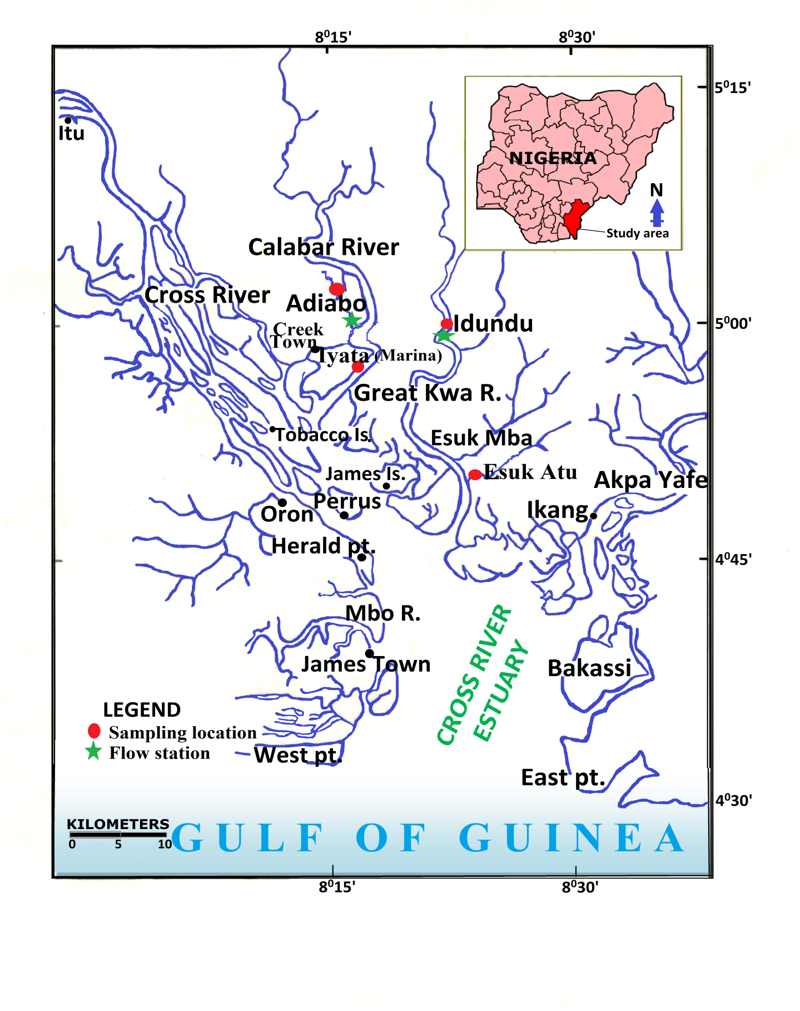influencing faunal habitat conditions.

**Fig. 1**: Location map showing Calabar and Great Kwa Rivers with sampling points across tidal flats (Adiabo, Marina, Atu, Idundu).

**Materials and Methods**

Sampling was conducted across the tidal flats of the Calabar and Great Kwa Rivers to capture spatial and temporal variability in faunal assemblages, sediment characteristics, and physicochemical conditions. Sampling sites were selected to represent the supratidal, intertidal, and subtidal zones of each tidal flat (Adiabo, Marina, Atu, and Idundu). Sampling occurred seasonally to encompass variations between wet and dry seasons, accounting for changes in river discharge and tidal influence.

**Fauna processing and analyses**

Benthic macrofauna were sampled using a combination of quadrat and core sampling methods. At each site and tidal zone, replicate 0.25 m² quadrats were excavated to a depth of approximately 15 cm to collect sediment and associated fauna. Samples were sieved in the field through a 0.5 mm mesh to retain macrofauna (Tagliapietra and Sigovini, 2010). Sieving was performed very carefully in order to avoid damage to fragile organisms. To separate macrofauna, a sieve of 1mm was used. For meiofauna and microfauna, separation was done using a 6.3 µm mesh sieve within the silt/clay fraction.

Collected organisms. Samples were placed in a narcotic and relaxant solution (10-15% ethanol) to relax the organisms before fixation. Fixation was through the use of 10% formalin solution (or 4% formaldehyde) for three days, after which the organisms were removed from the fixing solution, rinsed and placed in a preservative solution (aqueous solution of ethanol = 70% ethanol + 5% glycerin). Samples were stored in dark (amber) containers for laboratory identification and counting.

Samples were washed from the preservation fluid using a mesh sieve with a pore size of 0.25mm. The sieve was placed in Rose Bengal stain (1 g/dm3 of tap water + 5g of phenol for adjustment to pH 4-5) for 20 minutes with the sample well covered (Tagliapietra and Sigovini, 2010).

Qualitative and quantitative analysis of microfauna was performed using an Accu-scope 3030 Inverted Plankton Microscope. Sub-samples were mixed by swirling and filled into Hydro-Bios chambers (5ml capacity). After complete sedimentation, microscopic analysis was performed according to UNESCO (1978). Large organisms were sorted out by hand picking using a hand lens. After sorting, organisms were identified to taxonomic levels using identification schemes by Edmonton (1959), Prescott (1970) and Sharma (1986).

Taxonomic identification was performed to the lowest possible level, generally species or genus, using standard identification keys (Crane, 1975; Holthuis, 1980). Special attention was given to dominant taxa such as *Afruca tangeri* and *Cardisoma armatum*.

Faunal abundance and diversity metrics were calculated for each site and tidal zone, including species richness, Shannon-Wiener diversity index, evenness, and dominance indices. The ecological parameters were analysed using the following methods (Mwakisunga et al. 2020):

*Numerical and relative abundance*

% (Ra) = (1)

Where Ra = Relative abundance

n = Number of individual species

N = Total number of all species per sampling station

*Species Richness Indices (Margalef's Index, d)*

d = $\frac{S - 1 }{ loge N}$ (2)

Where S = Number of species per station

N = Total number of individuals per station

*Species Diversity Index (Shannon Weaver's Index, H)*

H = $\frac{Nlog N- \sum_{i=1}^{s}{filogfi}}{N}$ (3)

Where N = Total number of individuals per station

*fi* = Number of individual species per station

*Species Dominance Index (Simpson's Dominance Index, D)*

D = $\frac{ \sum_{i=1}^{s}{ni(ni-1)}}{N(N-1)}$ (4)

Where *ni* = Number of individual species

N = Total number of all individual species groups studied.

*Species Evenness (Shannon's equitability, E)*

E = $\frac{H}{In S }$ (5)

Where H = Shannon Weaver's Diversity Index

S = Total number of individuals per station

Consequently, Water quality parameters (dissolved oxygen (DO), temperature, salinity, pH, and Conductivity) were measured in situ at each sampling location using portable multi-parameter probes. Measurements were taken during low tide periods to characterise conditions experienced by benthic organisms, and field and laboratory procedures adhered to standardised protocols to minimise sampling bias. Replicate samples and instrument calibrations ensured data reliability.

**RESULTS**

**Faunal Community Composition and Abundance**

Across the four tidal flats, Adiabo, Marina, Atu, and Idundu, a total of 38 benthic macrofaunal species were identified, representing multiple taxonomic groups, revealing spatial variability in benthic assemblages (Fig. 2). Crustaceans, particularly fiddler crabs (*Afruca tangeri*) and land crabs (*Cardisoma armatum*), dominated the assemblages, followed by polychaetes, bivalves, gastropods, and small fish species.

In addition to the macrofauna, the study also identified meiofauna (organisms between 0.1 and 0.5 mm) and microfauna (organisms smaller than 0.1 mm) in sediment samples. These organisms were most abundant in fine sediments, particularly in the Marina flat, where they contributed to the biodiversity but were overshadowed by the larger, more mobile species like *Uca (Afruca) tangeri* and *Cardisoma armatum*.

**Fig. 2:** Photo Plate of Macrobenthic Species from the Tidal Flats of Calabar River and Great Kwa River. Visual observation photographs of the fauna species in the studied flats: **A** – *Periophthalmus koelreuteri*; **B** – *Nereis* sp.; **C** – *Pachymelania aurita*; **D** – *Parapenaeopsis atlantica*; **E** –*Uca tangeri*; **F** – *Cardisoma armatum*; **G** –*Nerita senegalensis*;  **H** –*Tympanotonus fuscata.*

The overall faunal abundance varied significantly among the tidal flats and tidal zones (Fig. 3). Adiabo exhibited the highest faunal density, averaging 350 individuals per square meter, with *Afruca tangeri* accounting for approximately 45% of the total abundance. This high abundance is attributed to favourable habitat conditions characterised by well-oxygenated coarse sands and moderate salinity.

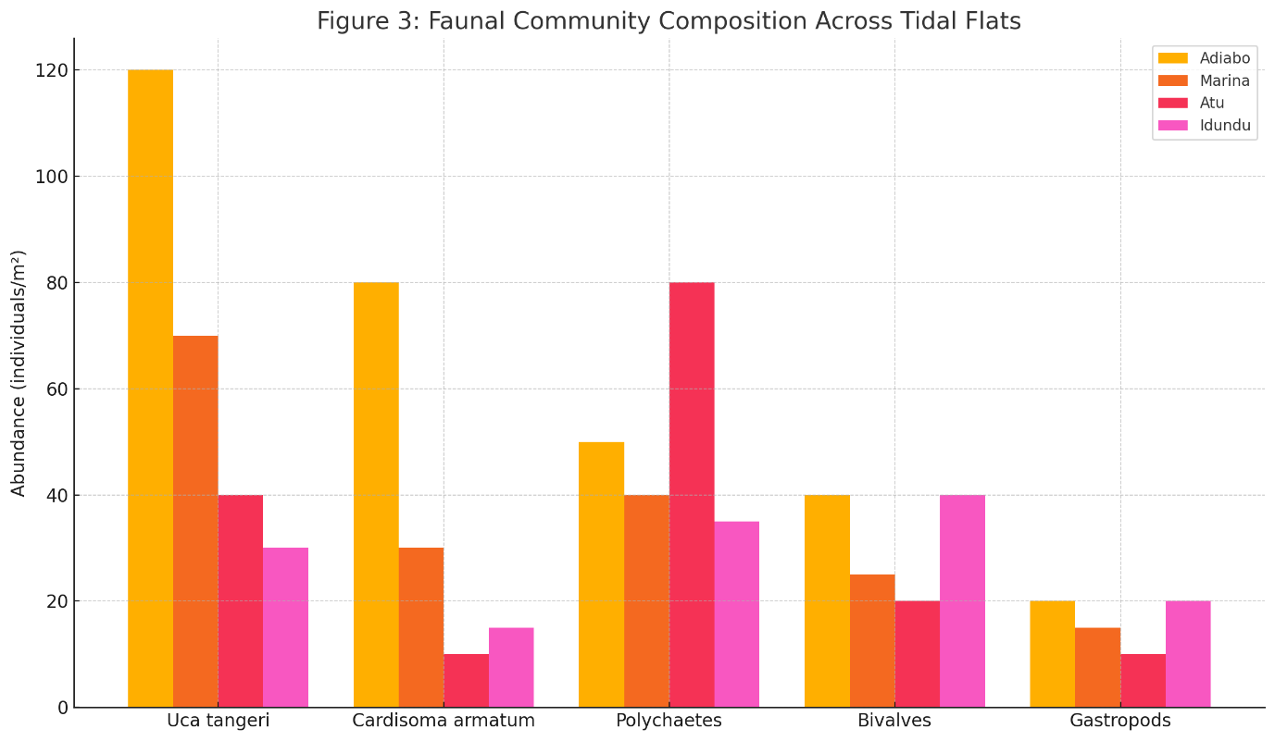**Fig. 3:** Faunal community composition across tidal flats showing the abundance (individuals/m² /m²) of dominant taxa: *Uca* (*Afruca) tangeri*, *Cardisoma armatum*, polychaetes, bivalves, and gastropods.

In contrast, Marina showed moderate species richness (26 species) but significantly lower faunal density (~180 individuals/m² /m²). This reduced density likely reflects anthropogenic disturbances, including dredging and urban runoff, which negatively impact sediment quality and water parameters.

Atu flat's assemblage was distinctive, dominated by polychaetes such as *Nereis* spp. and *Hediste diversicolor*, reflecting its coarser sediment texture and high hydrodynamic energy. Crabs were less abundant here, suggesting sediment substrate constraints on burrowing behaviour. Idundu flat, although exhibiting the lowest species richness (21 species), showed relatively even distribution among taxa, with no single group overwhelmingly dominant. This evenness may indicate more stable environmental conditions or limited habitat complexity.

Table 1 summarises key faunal diversity metrics across flats and zones, including species richness, Shannon-Wiener diversity index, evenness, and dominance indices. Shannon diversity ranged from 1.8 in Idundu to 3.1 in Adiabo, while evenness values suggest moderately balanced communities except for Marina, where dominance by a few species was evident.

|  |  |  |  |  |
| --- | --- | --- | --- | --- |
| **Tidal Flat** | **Species Richness** | **Shannon Index** | **Evenness Index** | **Dominance Index** |
| Adiabo | 32 | 3.1 | 0.85 | 0.45 |
| Marina | 26 | 2.5 | 0.75 | 0.6 |
| Atu | 25 | 2.8 | 0.8 | 0.5 |
| Idundu | 21 | 1.8 | 0.7 | 0.65 |

**Table 1:** Summary Faunal Diversity Metrics Across the Tidal Flats

Faunal assemblages exhibited marked spatial variation related to tidal zonation. In the supratidal zones, crab species (*Afruca tangeri* and *Cardisoma armatum*) were highly abundant and adapted to periodic exposure and terrestrial influence. Their burrowing activity contributed to sediment aeration and bioturbation. The intertidal zones harboured the greatest species diversity, with polychaetes, bivalves, and gastropods thriving in the moist sediment environment. The diversity here reflects the balance between sediment moisture, salinity, and substrate texture optimal for varied feeding and reproductive strategies.

Subtidal zones, characterised by longer submersion, supported more sessile filter feeders, such as bivalves (*Anadara* spp.), which rely on suspended particulate organic matter. Faunal densities here were lower but essential for ecosystem functioning. Seasonal comparisons revealed a reduction in species richness and abundance during the wet season (April to November), especially pronounced at Marina and Idundu flats. Elevated river discharge during this period increased sediment load and turbidity, disrupting benthic habitats. Many species showed adaptive responses, including reduced activity or temporary migration. Conversely, the dry season (December to March) exhibited higher faunal densities and diversity associated with stabilised sediment and improved water quality.

**Sediment Grain Size Characteristics**

Sediment analysis confirmed a gradient of grain sizes across the tidal flats. Atu and Adiabo flats were dominated by coarse to medium sands (mean grain size approximately 0.9–1.8 phi), indicative of higher energy depositional environments favouring coarser substrate.

Marina and Idundu flats contained finer sediments, ranging from fine sands to silts (mean grain size 3.1–3.8 phi), corresponding to more sheltered, low-energy settings conducive to fine sediment accumulation.

Sorting values ranged from 1.2 phi (well-sorted) at Atu to 2.1 phi (poorly sorted) at Marina, suggesting variable sediment input and hydrodynamic sorting. Skewness analyses indicated positively skewed sediments at Marina and Idundu, highlighting fine particle dominance, whereas Atu and Adiabo showed near-symmetric distributions.

These sediment characteristics correlate well with observed faunal distributions; coarser, well-sorted sands at Atu and Adiabo support burrowing crabs, while finer sediments at Marina and Idundu favour polychaetes and filter feeders.

**Physicochemical Parameter Variability**

In situ water quality measurements revealed spatial heterogeneity in physicochemical parameters (Fig. 4). Dissolved oxygen (DO) levels were highest at Adiabo (mean 6.8 mg/L) and lowest at Marina (mean 3.1 mg/L). Reduced DO at the Marina is likely due to organic pollution and sediment disturbance from dredging.

Salinity ranged from 20 PSU during wet season high river discharge to 32 PSU during dry season, reflecting tidal influence and freshwater inputs. Temperature showed minor seasonal variation, averaging 28.5 °C.

pH values were near neutral (6.8–7.3), while Conductivity reflected salinity trends. These parameters influence faunal metabolic processes and habitat suitability, contributing to species distribution patterns.

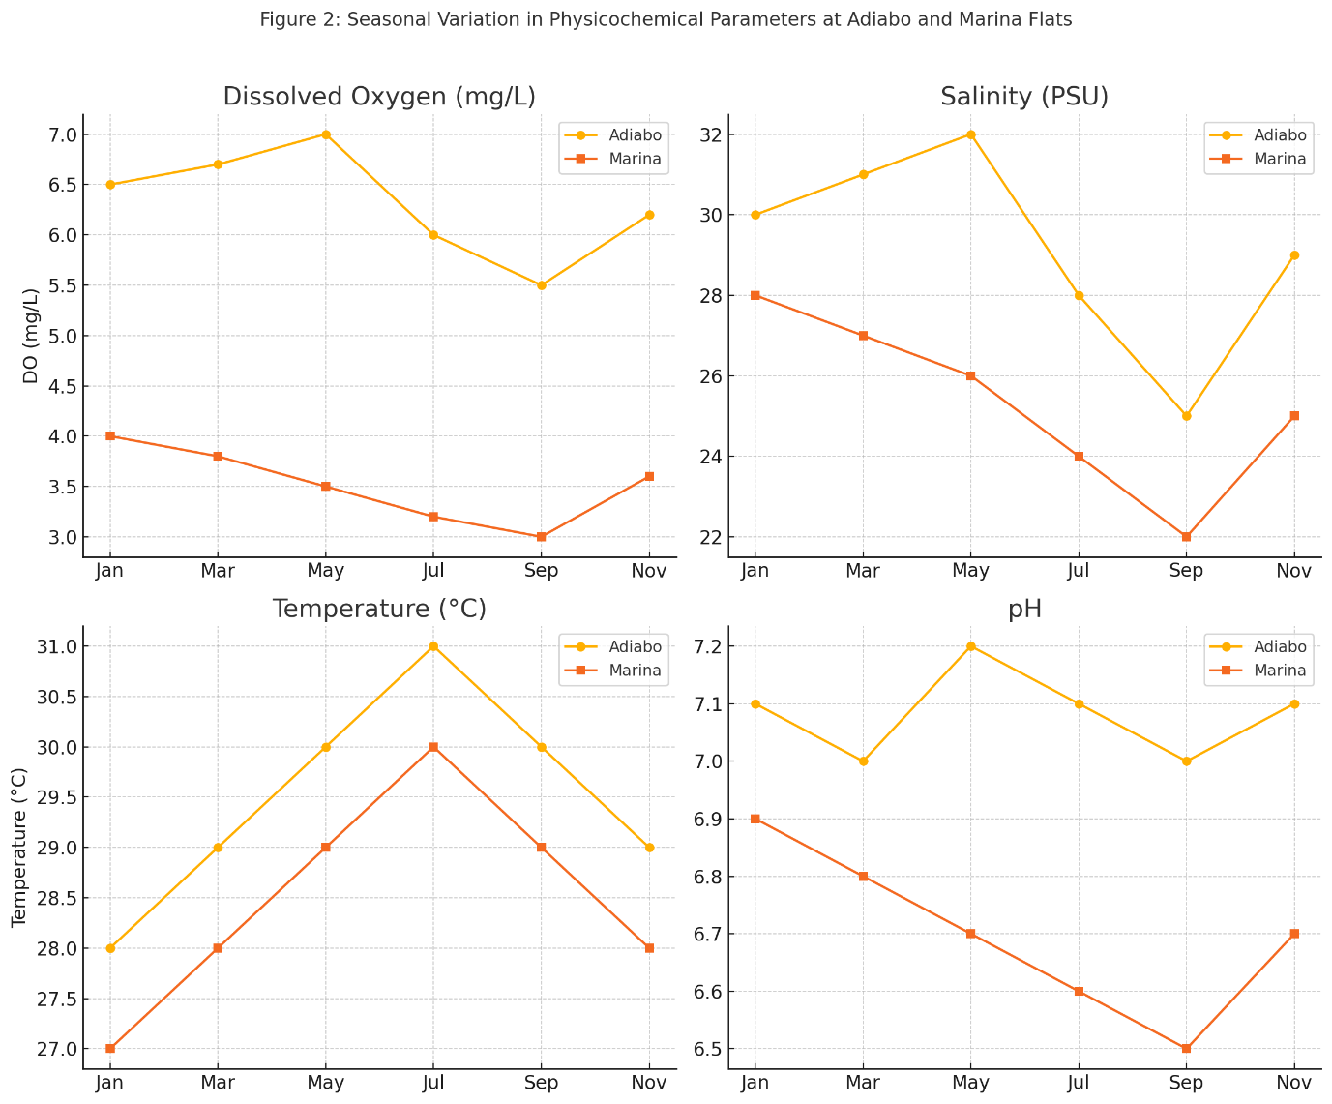

**Fig. 4:** Seasonal variation of key physicochemical parameters: dissolved oxygen (mg/L), salinity (PSU), temperature (°C), and pH, measured monthly at Adiabo and Marina tidal flats, illustrating environmental fluctuations influencing benthic fauna.

**Faunal Species Observations**

Detailed observations of *Afruca tangeri* revealed its strong preference for sandy substrates with adequate oxygenation, where burrow density exceeded 250 m². In contrast, *Cardisoma armatum* was more tolerant of variable sediment textures but declined sharply in areas of low DO. Other taxa, such as bivalves (*Anadara* spp.) and polychaetes (*Nereis* spp.), displayed broad tolerance but showed optimal densities in intertidal zones with fine sediments and moderate DO levels.

Overall, the findings demonstrate a complex interplay of sediment grain size, physicochemical parameters, and seasonal hydrodynamics structures in benthic faunal assemblages in the Calabar and Great Kwa tidal flats. Coarser, well-oxygenated sediments favour burrowing crabs and diverse macrofauna, while finer, oxygen-poor sediments support different assemblages dominated by polychaetes and filter feeders. Anthropogenic influences, particularly at Marina, modify these patterns by altering sediment composition and reducing water quality, with evident impacts on faunal community structure.

**Faunal Relationship with Environmental Parameters**

To explore the relationships between environmental variables and faunal assemblages, the Principal Component Analysis (PCA) was conducted on the dataset to assess the influence of various factors: Dissolved Oxygen (DO), Water Temperature, Conductivity, and pH, on two key biological metrics: the Average Species Diversity Index (H) and Average Numerical Abundance (Table 2). The PCA reveals that the first principal component (PC1) explains 86.27% of the variance in the data, making it the most significant component. The second principal component (PC2) accounts for an additional 12.22% of the variance. This indicates that the majority of the data's variability is captured by PC1, with PC2 providing only a modest contribution.

T**able 2: Principal Component Analysis (PCA) and Faunal Indices**

|  |  |  |  |  |
| --- | --- | --- | --- | --- |
| **Index** | **PC1** | **PC2** | **H (Diversity Index)** | **Numerical Abundance** |
| 0 | 1.055822 | 0.223521 | 1.106 | 25.00 |
| 1 | -2.398193 | -0.805990 | 0.645 | 5.75 |
| 2 | 2.408356 | -0.445556 | 1.986 | 124.60 |
| 3 | -1.065985 | 1.028026 | 1.175 | 21.75 |

The biplot (Fig. 5) shows that DO (Dissolved Oxygen) and Water Temperature have strong contributions to the variance along PC1, as their vectors are the longest in the plot. This suggests that variations in these factors play a central role in explaining the differences observed in the diversity index (H) and numerical abundance. Conductivity and pH, while contributing less, still exhibit distinct directional relationships with the principal components. These factors might not be as dominant, but still play a role in shaping the biological metrics.

The points representing the data samples are widely distributed along PC1, with high diversity index (H) values associated with lower values of PC1 and lower values of numerical abundance showing a clear correlation with positive values of PC1. The explained variance plot confirms that PC1 explains the majority of the variability in the dataset, underlining its importance in the overall structure of the data. The PCA results highlight the significant role of DO and Water Temperature in shaping species diversity and abundance, with Conductivity and pH contributing to secondary variances in the dataset.

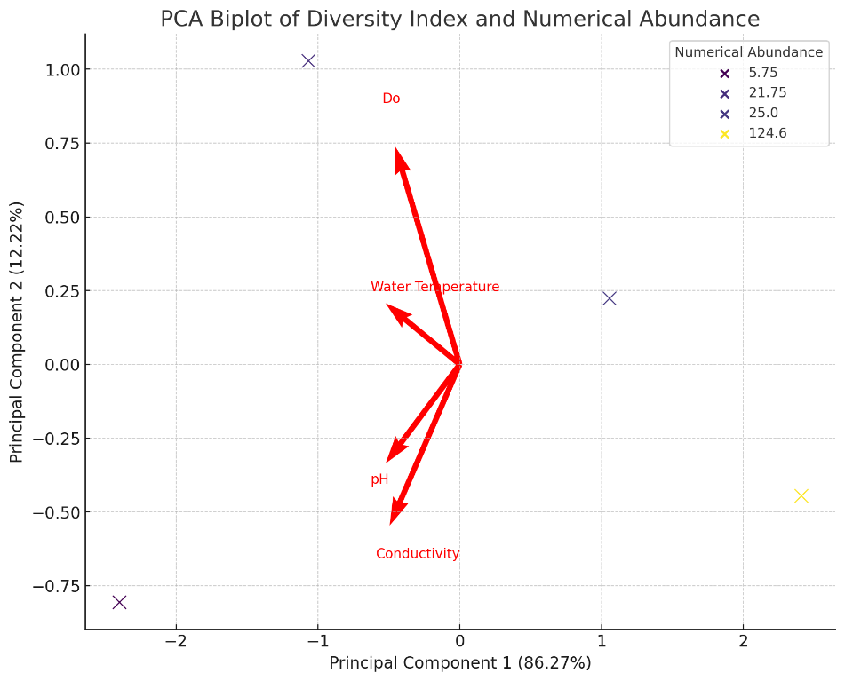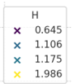

**Fig 5.** Principal Component Analysis (PCA) biplot showing the relationships between Diversity Index and Numerical Abundance with physicochemical parameters DO, Water Temperature, Conductivity, and pH.

The ANOVA results (Fig. 6 )revealed that faunal abundance and diversity varied significantly across the study sites (p < 0.05). The mean interaction indicated significant effects of both location (station) and season on the Diversity Index and Faunal Abundance, as well as a notable interaction between these two factors. The diversity index was influenced by both location and season, with distinct patterns observed across the stations. At Adiabo, there was a marked difference in the diversity index between the Wet and Dry seasons, with higher diversity during the Wet season. Conversely, Atu displayed relatively consistent diversity levels across both seasons, though slightly lower than at Adiabo during the Wet season. The interaction between season and location suggests that the seasonal impact on diversity varies between the two stations.

Similar patterns were observed in faunal abundance, where both location and season significantly impacted the abundance of fauna. At Adiabo, faunal abundance was higher during the Wet season compared to the Dry season, showing a positive response to seasonal changes. In contrast, Atu showed a more stable faunal abundance, with smaller fluctuations between the Wet and Dry seasons. This suggests that faunal abundance at Atu is less sensitive to seasonal changes compared to Adiabo.



Fig. 6 A two-way ANOVA mean plot showing location and Seasonal impact on Diversity Index and Faunal Abundance.

**DISCUSSION**

**Influence of Sediment Grain Size on Faunal Assemblages**

This study demonstrates a clear and significant influence of sediment grain size on the composition, abundance, and diversity of benthic faunal assemblages within the tidal flats of the Calabar and Great Kwa Rivers (Mwakisunga et al. 2020; de Montaudouin et al. 2023). The faunal assemblages in the tidal flats included dominant species such as *Afruca tangeri*, *Cardisoma armatum*, and *Parapenaeopsis atlantica* (arthropods), along with *Nerita senegalensis* and *Pachymelania aurita* (gastropods). Although the focus was on *Afruca tangeri* and *Cardisoma armatum*, other taxa, including polychaetes like *Neiris sp.,* were observed and their distribution linked to sediment characteristics. Coarser substrates, characterised predominantly by medium to coarse sands, supported the highest abundances of crustacean taxa, such as *Afruca tangeri* and *Cardisoma armatum*. These species' preference for sandy substrates is well documented, as such sediments provide optimal conditions for burrowing, foraging, and protection from predators (Moruf and Asafe 2017). The ability of fiddler crabs to manipulate sandy sediments through their burrowing activity not only shapes their habitat but also influences sediment biogeochemistry by enhancing aeration and organic matter turnover, thereby creating microhabitats that can support a variety of other benthic species (Smith and Lessmann 2009; Tyrrell et al. 2023).

Conversely, finer sediments, dominated by silts and clays, were correlated with greater abundance and diversity of polychaetes and bivalves, which are known to tolerate or thrive in low-energy, fine-grained environments where organic matter accumulates (Healy et al. 2005; Jayaraj et al. 2008; Quintanar-Retama et al. 2022). These taxa contribute substantially to sediment stabilisation, nutrient cycling, and organic matter degradation through their burrowing and feeding activities. The spatial heterogeneity of sediment grain size across the flats thus generates a variety of microhabitats, each favouring distinct faunal assemblages and trophic functions.

The faunal distribution patterns observed in the Calabar and Great Kwa rivers tidal flats are consistent with findings from other tropical and temperate tidal flats (Dittmann 2002; Fagherazzi et al. 2013; Wiesebron et al. 2021; Ali et al. 2024). Faunal diversity was closely tied to sediment grain size and oxygen levels. Species like *Afruca tangeri* preferred well-oxygenated, coarse-grained substrates, whereas species such as *Nerita senegalensis* thrived in finer sediments. The interaction between these factors determined the overall biodiversity and ecosystem function in the tidal flats. Similar studies have shown that sediment texture and dissolved oxygen are key determinants of benthic faunal composition. Dittman (2002) found that tropical tidal flats with coarser sediments supported higher species richness, while Chen et al. (2017) noted that fine sediments correlated with dominance by filter feeders in temperate systems. Hence, this study contributes to this body of literature by focusing on the specific dynamics of West African tidal flats, highlighting the fundamental role sediment texture plays in structuring benthic communities by influencing habitat complexity and resource availability.

**Role of Physicochemical Parameters in Shaping Faunal Patterns**

Physicochemical factors, particularly dissolved oxygen (DO), emerged as crucial regulators of faunal community structure in the studied tidal flats. Sites with higher DO levels, such as Adiabo and Atu, exhibited greater species richness and abundance, supporting the notion that oxygen availability directly influences benthic fauna metabolism, behaviour, and survival (Zabbey and Hart 2006; Best et al. 2007; Mishra et al. 2023). Low DO concentrations observed at Marina Flat likely reflect organic pollution and sediment disturbance from dredging and urban runoff, which can lead to hypoxic or suboxic conditions detrimental to many macrofaunal species (Gammal et al. 2016; Bernardino et al. 2018).

The importance of DO as a limiting factor aligns with extensive research showing that benthic community composition shifts in response to oxygen depletion, often leading to reduced diversity and dominance by a few tolerant species (Mattone and Sheaves 2017; Ciraolo et al. 2025). This has significant implications for ecosystem functioning, as the loss of sensitive species may alter nutrient cycling, sediment stability, and trophic interactions.

Salinity and temperature, while fluctuating seasonally and tidally, had less pronounced direct correlations with faunal metrics in this study, although they undoubtedly influence physiological tolerances and species distributions (Farias et al. 2024). Stable pH and conductivity readings suggest that the tidal flats have not yet experienced severe acidification or salinity perturbations, but continued monitoring is essential, given ongoing anthropogenic pressures.

**Spatial and Temporal Dynamics of Faunal Assemblages**

The spatial gradients observed in this study highlight the complexity of tropical tidal flat ecosystems, where both natural factors, such as sediment texture, hydrodynamics (Zhang et al. 2023) and anthropogenic influences interact to shape faunal communities. The highest species richness and abundance in Adiabo and Atu tidal flats, characterised by coarse sediments and higher DO, contrast with the relatively depauperate communities at Marina and Idundu, where fine sediments and lower DO prevail.

Temporal variations, particularly seasonal reductions in diversity and abundance during the wet season, are consistent with increased freshwater input, sediment resuspension, and turbidity associated with high river discharge (Hernández-Guevara et al. 2008; Ge et al. 2025). These seasonal dynamics demonstrate the resilience and adaptability of benthic fauna, many of which employ life history strategies such as burrow retreat, reproductive timing, and opportunistic feeding to cope with environmental variability.

Such temporal patterns have been reported in other tropical and subtropical estuarine systems, emphasising the importance of incorporating seasonal monitoring into ecological assessments to capture the full range of ecosystem dynamics (McClanahan 2015).

**Anthropogenic Impacts and Ecological Consequences**

Anthropogenic activities, most notably dredging at Marina flat and urban runoff associated with Calabar, have demonstrable negative effects on benthic communities through sediment alteration and water quality degradation. Dredging disrupts sediment structure, increases turbidity, and can induce hypoxia, thereby reducing habitat suitability and faunal diversity (Nayar et al. 2007; Heery et al. 2017). The reduced faunal density and altered community composition observed at Marina corroborate these impacts.

Urban runoff introduces nutrients and contaminants that may exacerbate oxygen depletion and affect benthic physiology (Wurtsbaugh et al. 2019; Malone and Newton 2020). The combined effects threaten ecosystem functions and services, such as nutrient cycling and habitat provision for higher trophic levels, including commercially important fish and bird species. These findings emphasise the urgency for integrated coastal zone management strategies that regulate dredging activities, control pollution sources, and protect critical benthic habitats in tropical tidal flats.

**Ecological and Conservation Implications**

The results contribute valuable baseline data on tropical West African tidal flat ecology, a region historically underrepresented in benthic ecological research. By elucidating sediment-biota interactions, this study informs conservation priorities and ecosystem-based management approaches.

The species *Uca tangeri* and *Cardisoma armatum* serve as potential bioindicators of habitat quality. Their abundance was notably higher in areas with well-oxygenated, coarse-grained sediments (Adiabo flat), indicating their preference for oxygen-rich environments. In contrast, low dissolved oxygen levels and finer sediments in the Atu flat were associated with reduced abundance of these species, highlighting their sensitivity to water quality changes.

The demonstrated sensitivity of benthic communities to sediment texture and oxygen availability highlights potential vulnerabilities to climate change and increased human pressures, including sea-level rise, altered sediment dynamics, and pollution. Maintaining sediment heterogeneity and water quality is critical for sustaining the functional diversity and resilience of these ecosystems. Efforts should focus on habitat protection, pollution mitigation, and long-term ecological monitoring to detect and respond to environmental changes.

While this study focuses on Nigerian tidal flats, its findings resonate with global patterns in tidal flat ecology (Dittmann 2002; Heery et al. 2017; Wurtsbaugh et al. 2019; Ge et al. 2025). These parallels suggest fundamental ecological principles governing intertidal benthic communities across latitudes while also emphasising the importance of region-specific studies to capture local environmental and anthropogenic nuances.

To deepen understanding, future studies should incorporate long-term, high-frequency monitoring to capture interannual variability and responses to climate change. Molecular techniques such as environmental DNA (eDNA) metabarcoding could improve species identification and detect cryptic diversity. Linking functional traits of benthic fauna to ecosystem processes would provide insights into resilience mechanisms and ecosystem service provisioning. Expanding the geographic scope to include additional West African tidal flats will enhance regional conservation planning.

**CONCLUSIONS**

This study provides a comprehensive assessment of benthic faunal assemblages and their interactions with sediment grain size and physicochemical parameters in the tropical tidal flats of the Calabar and Great Kwa Rivers, southeastern Nigeria. By integrating biological, sedimentological, and environmental data, the research fills critical gaps in understanding the ecology of West African tropical intertidal systems. Key findings demonstrate that sediment texture is a primary driver of faunal community composition and diversity, with coarser sediments supporting burrowing crustaceans such as *Afruca tangeri* and *Cardisoma armatum*, and finer sediments favouring polychaetes and bivalves adapted to low-energy, organic-rich habitats. Physicochemical parameters, particularly dissolved oxygen, further modulate these patterns, with lower oxygen levels associated with reduced diversity and faunal abundance.

Spatial and temporal variations reveal complex dynamics, with the highest faunal diversity and abundance in well-oxygenated, coarse sediment flats (Adiabo and Atu) and reduced communities in finer, more impacted sediments (Marina and Idundu). Seasonal changes linked to river discharge and tidal cycles highlight the adaptability of benthic fauna to environmental fluctuations. Anthropogenic pressures, including dredging and urban runoff, exert significant negative impacts on sediment quality and benthic communities, underscoring the need for sustainable coastal management. Protecting sediment heterogeneity and water quality is essential to maintain the ecological integrity and ecosystem services of these tidal flats.

This work presents an integrated, multidisciplinary approach within a tropical West African context, by providing valuable baseline data for a region where such studies are scarce. The insights gained contribute to regional biodiversity conservation, ecosystem management, and broader tropical coastal ecology understanding. Future research should emphasise long-term monitoring, molecular biodiversity assessments, and functional ecology to better predict ecosystem responses under increasing environmental pressures and climate change.

Disclaimer (Artificial intelligence)

Author(s) hereby declare that NO generative AI technologies such as Large Language Models (ChatGPT, COPILOT, etc.) and text-to-image generators have been used during the writing or editing of this manuscript.

**REFERENCES**

Abdul Jaleel KU, Parameswaran U V., Gopal A, et al (2022) Spatio-temporal variations of benthic communities along the coast. Ecol Biodivers Benthos 287–313. https://doi.org/10.1016/B978-0-12-821161-8.00003-9

Adekola O, Mitchell G (2011) The Niger Delta wetlands: Threats to ecosystem services, their importance to dependent communities and possible management measures. Int J Biodivers Sci Ecosystem:50–68. https://doi.org/10.1080/21513732.2011.603138

Aheto D, Okyere I, Asare N, et al (2014) A Survey of the Benthic Macrofauna and Fish Species Assemblages in a Mangrove Habitat in Ghana. West African J Appl Ecol 22:1–15

Ali S, Siddiqui NA, Haque AE, et al (2024) Heterolytic tide-dominated sedimentary facies and depositional environment: An Example from the Boka Bil formation, Sitapahar anticline, Bangladesh. Heliyon 10:e38178. https://doi.org/10.1016/j.heliyon.2024.e38178

Bernardino A, Gomes LE, Hadlich H, et al (2018) Mangrove clearing impacts on macrofaunal assemblages and benthic food webs in a tropical estuary. Mar Pollut Bull 126:228–235. https://doi.org/10.1016/j.marpolbul.2017.11.008

Best M, Wither AW, Coates S (2007) Dissolved oxygen as a physico-chemical supporting element in the Water Framework Directive. Mar Pollut Bull 55:53–64. https://doi.org/10.1016/j.marpolbul.2006.08.037

Bhuiyan MKA, Godoy O, González-Ortegón E, et al (2025) Salt Marsh Macrofauna: An Overview of Functions and Services. Mar Environ Res 106975. https://doi.org/10.1016/j.marenvres.2025.106975

Bredes AL, Miller JK, Kerr L, Brown DR (2022) Observations of Wave Height Amplification Behind an Oyster Castle Breakwater System in a High-Energy Environment: Gandys Beach, NJ . Front. Built Environ. 8

Chen T-Y, Hwang G, Mayfield A, et al (2017) The relationship between intertidal soil composition and fiddler crab burrow depth. Ecol Eng 100:256–260. https://doi.org/10.1016/j.ecoleng.2016.12.011

Chen ZL, Lee SY (2022) Tidal Flats as a Significant Carbon Reservoir in Global Coastal Ecosystems. Front Mar Sci Volume 9-:

Ciraolo AC, Snelgrove PVR, Cecchetto MM, Sweetman AK (2025) The roles of benthic diversity and environmental factors in nutrient and macrofaunal dynamics within the oxygen minimum zone of the British Columbia continental slope. Deep Sea Res Part I Oceanogr Res Pap 222:104530. https://doi.org/https://doi.org/10.1016/j.dsr.2025.104530

Coblentz KE, Henkel JR, Sigel BJ, Taylor CM (2015) Influence of sediment characteristics on the composition of soft-sediment intertidal communities in the northern Gulf of Mexico. PeerJ 3:e1014. https://doi.org/10.7717/peerj.1014

Daidu F, Yuan W, Min L (2013) Classifications, sedimentary features and facies associations of tidal flats. J Palaeogeogr 2:66–80. https://doi.org/https://doi.org/10.3724/SP.J.1261.2013.00018

de Montaudouin X, Blanchet H, Gouillieux B, et al (2023) Benthic community impacts from sediment dredging and disposal: A comparison of sampling gear. Mar Pollut Bull 194:115278. https://doi.org/https://doi.org/10.1016/j.marpolbul.2023.115278

Dittmann S (2002) Benthic fauna in tropical tidal flats - A comparative perspective. Wetl Ecol Manag 10:189–195. https://doi.org/10.1023/A:1020119512225

Emeka NC, Antia VI, Ukpong AJ, Amah EA (2010) A study on the Sedimentology of tidal rivers: Calabar and Great Kwa, SE Nigeria. Eur J Sci Res 47:370–386

Fagherazzi S, FitzGerald D, Fulweiler W, et al (2013) Ecogeomorphology of Tidal Flats. Treatise Geomorphol 12:201–220. https://doi.org/10.1016/B978-0-12-374739-6.00403-6

Farias L, Beszteri B, Burfeid Castellanos A, et al (2024) Influence of salinity on the thermal tolerance of aquatic organisms

Flemming BW (2003) Tidal flats BT - Encyclopedia of Sediments and Sedimentary Rocks. In: Middleton G V, Church MJ, Coniglio M, et al. (eds). Springer Netherlands, Dordrecht, pp 734–737

Gammal J, Norkko J, Pilditch C, Norkko A (2016) Coastal Hypoxia and the Importance of Benthic Macrofauna Communities for Ecosystem Functioning. Estuaries and Coasts 40:1–12. https://doi.org/10.1007/s12237-016-0152-7

Gao S (2019) Chapter 10 - Geomorphology and Sedimentology of Tidal Flats. In: Perillo GME, Wolanski E, Cahoon DR, Hopkinson CSBT-CW (Second E (eds). Elsevier, pp 359–381

Ge J, Chen J, Zi F, et al (2025) Seasonal Variations in Macrobenthos Communities and Their Relationship with Environmental Factors in the Alpine Yuqu River. Biology (Basel). 14

Hatkar P, Vachhrajani K, Kuppusamy S (2024) Marine Benthic Diversity of the Gulf of Kutch, Gujarat: A review. UTTAR PRADESH J Zool 45:268–283. https://doi.org/10.56557/upjoz/2024/v45i154243

Healy TR, Stone K, Magoon O, et al (2005) S BT - Encyclopedia of Coastal Science. In: Schwartz ML (ed). Springer Netherlands, Dordrecht, pp 819–939

Heery EC, Bishop MJ, Critchley LP, et al (2017) Identifying the consequences of ocean sprawl for sedimentary habitats. J Exp Mar Bio Ecol 492:31–48. https://doi.org/https://doi.org/10.1016/j.jembe.2017.01.020

Hernández-Guevara N, Pech D, Ardisson P (2008) Temporal trends in benthic macrofauna composition in response to seasonal variation in a tropical coastal lagoon, Celestun, Gulf of Mexico. Mar Freshw Res 59:772–779. https://doi.org/10.1071/MF07189

Jayaraj KA, Jacob J, DineshKumar PK (2008) Infaunal Macrobenthic Community of Soft Bottom Sediment in a Tropical Shelf. J Coast Res 24:. https://doi.org/10.2112/06-0790.1

Jóźwiak P, Pabis K, Sobczyk R, Serigstad B (2022) A Paradise for Rare Species: Tanaidacean Fauna of the West African Continental Margin. Front Mar Sci Volume 9-:

Kuang C, Liu X, Gu J, et al (2013) Numerical prediction of medium-term tidal flat evolution in the yangtze Estuary: Impacts of the three gorges project. Cont Shelf Res 52:12–26. https://doi.org/10.1016/j.csr.2012.10.006

Li H, Li L, Su F, et al (2021) Ecological stability evaluation of tidal flat in coastal estuary: A case study of Liaohe estuary wetland, China. Ecol Indic 130:108032. https://doi.org/https://doi.org/10.1016/j.ecolind.2021.108032

Lynda E, ASUQUO FE (2012) The impact of flow regime on the sedimentation pattern of Calabar River, South-East Nigeria. J Oceanogr Mar Sci 3:19–31

Malone TC, Newton A (2020) The Globalization of Cultural Eutrophication in the Coastal Ocean: Causes and Consequences. Front Mar Sci Volume 7-:

Mattone C, Sheaves M (2017) Patterns, drivers and implications of dissolved oxygen dynamics in tropical mangrove forests. Estuar Coast Shelf Sci 197:. https://doi.org/10.1016/j.ecss.2017.08.028

Mcclanahan T (2015) Effects of river sediments on coral recruitment, algal abundance benthic community structure on Kenyan coral reefs

Meijer K, El-Hacen H, Govers L, et al (2021) Mangrove-mudflat connectivity shapes benthic communities in a tropical intertidal system. Ecol Indic 130:108030. https://doi.org/10.1016/j.ecolind.2021.108030

Mishra AP, Kumar S, Patra R, et al (2023) Physicochemical Parameters of Water and Its Implications on Avifauna and Habitat Quality. Sustainability 15

Mmom P, Chukwuokeah G (2011) Factors and Processes of Coastal Zone Development in Nigeria: A Review. Res J Environ Earth Sci 3:

Mokhtari M, A.G. M, Usup G, Cob Z (2015) Determination of Key Environmental Factors Responsible for Distribution Patterns of Fiddler Crabs in a Tropical Mangrove Ecosystem. PLoS One 10:e0117467. https://doi.org/10.1371/journal.pone.0117467

Moruf O, Asafe O (2017) Biology of the West African fiddler crab, Uca tangeri (Eydoux, 1835) (Decapoda: Ocypodidae) from a mangrove wetland in Lagos, Nigeria. Int J Aquat Biol 5:263–267. https://doi.org/10.22034/ijab.v5i4.328

Moslen M, Fihto G, Bob-Manuel K (2024) Impacts of Solid Wastes on Physicochemical Characteristics and Habitats of Fiddler Crabs (Uca tangeri) on the Intertidal Sediments of Part of the Bonny Estuary, in Rivers State, Nigeria. J Appl Sci Environ Manag 28:2713–2722. https://doi.org/10.4314/jasem.v28i9.14

Mulat K, Mekoya A, Mekoya Jemaneh A (2024) Impact of Fine Sediment on Benthic Macroinvertebrates Communities of Freshwater Ecosystem: A Review. East African J For Agrofor 7:146–174. https://doi.org/10.37284/eajfa.7.1.1895

Mwakisunga B, Machiwa J, Pratap H (2020) Assessment of Sediment and Benthic Macrofauna Distribution at Dar es Salaam Harbour Channel. J Geosci Environ Prot 08:133–147. https://doi.org/10.4236/gep.2020.83010

Nauta J, Leurs G, Nieuwenhuis B, et al (2024) Bioturbation by Benthic Stingrays Alters the Biogeomorphology of Tidal Flats. Ecosystems 27:1–15. https://doi.org/10.1007/s10021-024-00901-4

Nayar S, Miller D, Hunt A, et al (2007) Environmental effects of dredging on sediment nutrients, carbon and granulometry in a tropical estuary. Environ Monit Assess 127:1–13. https://doi.org/10.1007/s10661-006-9253-2

Orpin AR, Woolfe KJ (1999) Unmixing relationships as a method of deriving a semi-quantitative terrigenous sediment budget, central Great Barrier Reef lagoon, Australia. Sediment Geol 129:25–35. https://doi.org/10.1016/S0037-0738(99)00084-6

Pearson TH (2001) Functional group ecology in soft-sediment marine benthos: The role of bioturbation. Oceanogr Mar Biol An Annu Rev 39:233–267

Quintanar-Retama O, Armenteros M, Gracia A (2022) Diversity and distribution patterns of macrofauna polychaetes (Annelida) in deep waters of the Southwestern Gulf of Mexico. Deep Sea Res Part I Oceanogr Res Pap 181:103699. https://doi.org/10.1016/j.dsr.2022.103699

Schowalter TD (2006) Ecosystem Structure and Function. Insect Ecol 315–345. https://doi.org/10.1016/B978-012088772-9/50037-6

Smith N, Lessmann J (2009) Fiddler Crab Burrowing Affects Growth and Production of the White Mangrove (Laguncularia racemosa) in a Restored Florida Coastal Marsh. Mar Biol 146:2255–2266. https://doi.org/10.1007/s00227-009-1253-7

Tyrrell MC, Courtney S, Brown E, von Sperber C (2023) Burrowing crabs' influence on tidal marsh vegetation species composition and abundance in a temperate back-barrier marsh, Cape Cod, Massachusetts, USA. J Exp Mar Bio Ecol 567:151931. https://doi.org/https://doi.org/10.1016/j.jembe.2023.151931

Wiesebron LE, Steiner N, Morys C, et al (2021) Sediment Bulk Density Effects on Benthic Macrofauna Burrowing and Bioturbation Behavior. Front Mar Sci Volume 8-:

Wurtsbaugh WA, Paerl HW, Dodds WK (2019) Nutrients, eutrophication and harmful algal blooms along the freshwater to marine continuum. WIREs Water 6:e1373. https://doi.org/https://doi.org/10.1002/wat2.1373

Zabbey N, Hart A (2006) Influence of some physico-chemical parameters on the composition and distribution of benthic fauna in Woji Creek, Niger Delta, Nigeria. Glob J Pure Appl Sci 12:. https://doi.org/10.4314/gjpas.v12i1.16541

Zeng L, Zhan C, Wang K, et al (2021) Sediment Coarsening in Tidal Flats and Stable Coastline of the Abandoned Southern Yellow River Sub-Delta in Response to Fluvial Sediment Flux Decrease During the Past Decades. Front Mar Sci 8:. https://doi.org/10.3389/fmars.2021.761368

Zhang L, Chen D, Gao S, et al (2023) Distribution of benthic macrofaunal communities in intertidal flat under hydrodynamic influence: a case study of Jiangsu coast, East China. J Oceanol Limnol 41:1024–1038. https://doi.org/10.1007/s00343-022-1061-1