**Green synthesis of AgNPs Using Curry leaves Aqueous Extract for Selective Detection of Zn+2 Ions**

**Abstract**

The study of chemical interaction between biogenic silver nanoparticles and several metal (II) ions have been discussed as a practical colorimetric and plasmon resonance sensing method for the recognition of divalent Zn+2 in aqueous solutions. In this paper, the green synthesized AgNPs, using curry leave extract as a reducing agent, were characterized by a IR spectroscopy and TEM. The colour of the AgNPs colloidal solutions obtained was reddish-brown centred between 10 and 50 nm. AgNPs with spherical, triangular, and hexagonal shapes were found by TEM analyses. Despite their divergent morphologies, these AgNPs can be employed as Plasmon resonance sensors for detection of divalent Zn2+, primarily in aqueous solutions. Sensibility studies based on molar concentrations were also performed for these metal ions. These bio composites resulted to be good adsorbent materials of Zn+2 ions.

**GRAPHICAL ABSTRACT:**

E:\Analysis Data CUG\MI1\MI1111111111111111.tif

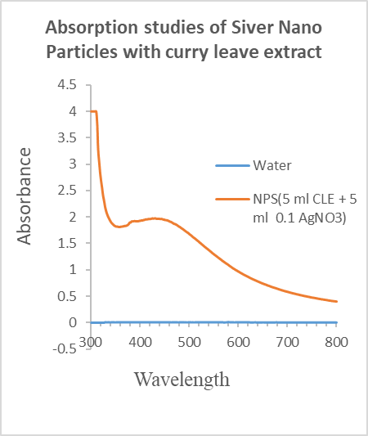

Key Words: TEM, Surface Plasmon resonance, Nanoparticle, Bio-composite, Murraya koenigii (Curry Pant)

**1. Introduction**

The accomplishment of numerous biological responses in living organisms is attributed to metallic ions. Many of these metallic ions, however, cause risks to people and other living things based on their concentration. “As a result, within the past ten years, there has been a noticeable increase in interest in creating straightforward, trustworthy, and affordable techniques for metal ion detection. Materials with one or more exterior dimensions between 1 and 100 nm are called nanoparticles.” [1]. Therefore, it has been shown that nanoparticles possess special chemical and physical characteristics, which have aided in the development of nanotechnology since roughly 20 years ago. [2]. “Since many nanoparticles are naturally generated and remain in the environment, it has also been studied that they are not exclusively synthesised.” [3]. “As a subset of nanomaterials, nanoparticles (NPs) are particles that range in size from 1 to 100 nm. These nanostructures have better qualities than the bulk material, including improved optical qualities that can be adjusted by adjusting the size, shape, and chemical environment.” [4]. “Because of their surface plasmon resonance (SPR), chemical inertness, stable dispersions, chemical environment, and biocompatibility, silver nanoparticles (NPs) are of tremendous interest to scientists and technologists. Particles' optical characteristics may alter if their size, shape, surface composition, or separation from one another varies even little. Because of their simple synthesis techniques and intrinsic chemical and optical characteristics, Au and Ag nanoparticles are the most researched of these metals.” [5, 6]. “Optical devices, surface-enhanced Raman scattering, bioimaging, colorimetric sensors, localised surface plasmon sensing, and fluorescence-enhanced sensors can all be made with these tiny particles.” [7]. D. Ramachandrian and K. Rajesh have demonstrated very high detection of Zn +2 ions and photocatalytic activities of biosynthesised silver nanoparticles utilising leaf extract from *Nilgirianthus Ciliatus*. [8]. Wenkai Zhu et al. have extensively studied salen-based chemosensors for the highly selective identification of Zn2+ ions [9]. In 2020, S. Balasurya et al. reported that surface functionalised silver nanoparticles could detect mercury in the presence of tyrosine using colorimetric and spectroscopic methods [10]. “The UV-vis spectroscopy approach for the sensitive and selective detection of mercury by silver nanoparticles in the presence of alanine has been studied by B. Janani et al., M.” [11]. “Shrddha Pai et al. have extensively studied the fabrication of photocatalytic zinc oxide nanoparticles using Peltophorum pterocarpum leaf extract and their characterisation” [12]. An earlier research by Chin Boon Ong et al. reviewed ZnO nanoparticles as solar photocatalysts. [13] In 2020, Asim Ali Yaqoob et al. published a paper on the use of nanoparticles in wastewater treatment [14]. NPs are suitable for sensing applications because of these characteristics. [15]. Because of these pertinent applications, researchers worldwide are looking for environmentally responsible ways to synthesise NPs, such as biological approaches that use bacteria, plants, or plant extracts. These techniques are a substitute for physical and chemical techniques. The synthesis is done extracellularly using plant extracts, and it's a really simple and economical procedure. Polyphenols found in the plant extracts have the capacity to act as capping and reducing agents. [4]. Both carboxylic and hydroxyl acid groups found in polyphenols are essential for biosynthesis. Two vicinal hydroxyl groups are said to function as reducing agents in molecules [16]. “The carboxylic moiety has an impact on the regulation of the size and form of the metal nanoparticles since it serves as a capping agent and stabilises the nanoparticle. In contrast to previous biosynthetic techniques, the Curry leaf aqueous extract with polyphenols serves as a biogenic reaction medium to produce Ag and Au nanoparticles with high morphological control and a narrower size distribution” [17–19]. AgNPs of varying sizes aggregate to produce interparticle surface plasmon coupling, which causes a discernible colour shift from pink to purple and is the cause of colorimetric sensing. According to reports, the colour shift that occurs when the NPs aggregate offers useful information for several analytes [20]. Molecular recognition by aggregation is the sensing method employed in this study. Due to the interaction, two NPs that are near one another show an extra resonance and become optically connected. The SPR undergoes several alterations that result in a redshift and a colour shift based on the distance between the NPs [13, 21–23]. “The concentration of metal ions in the solution determines how much the SPR redshifts. The creation of smaller aggregates in the presence of metal ions is responsible for the bathochromic shift, also known as the red shift, in the SPR band. The number of NPs and their closeness determine the new location of the resonance band when two NPs are near one another, causing their SPR to be coupled” [8, 13, 21–23]. For this application, the optical characteristics of the NPs provide a practical and somewhat easy way to detect metal ions in water [7, 24–29]. Furthermore, nanoparticles with plasmonic characteristics that can be applied to sensing applications are referred to as nanoplasmonic devices. Additionally, the nanoparticles on the substrate can be immobilised via a variety of techniques. In this work, an NPs/cellulosic material composite was prepared using the dip-coating approach. Easy construction, reasonably priced materials, biodegradability, and environmental friendliness are some of the benefits [30].

Curry leaf extract was used as a reducing agent in this study's straightforward synthesis of biogenic AgNPs. These AgNPs were employed in colloidal solutions as plasmon resonance and colorimetric sensors of divalent metal Zn2+ ions in aqueous solution. Furthermore, composites of AgNPs and cellulosic materials were made and evaluated as possible portable metal ion sensors.

**2. Experimental**

2.1 Material and Method

The fresh Curry plant leaves were collected from a local surrounding in college campus plant garden. (23.529522801362894° N, 72.71866637116382° E)., ZnCl2 was purchased from Sigma-Aldrich as analytical-grade reagents. Deionised water was utilised for the synthesis and the sensing tests, and all compounds were used without additional purification.

2.2. Preparation of Curry leave Aqueous Extract



Figure 1: Curry leaves

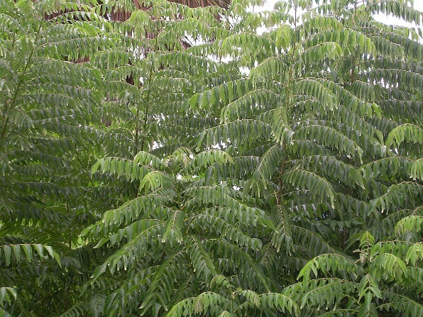

Figure 2: Curry tree

1 g of Curry leave was boiled for 1 hour in 100 mL of deionized water. Upon cooling, the infusion was filtered. The resulting extract was stored for a day at room temperature and used as a reducing and capping agent [31].

2.3. Biosynthesis of AgNPs

The biosynthesis of AgNPs was carried out by using 5 mL of 10-3 M of AgNO3 solution and 5 mL of Curry leave extract. the mix was left standing for 24 h. The synthesis performed was an adaptation of a method previously reported by us [31].

2.4. Characterization of AgNPs

The characterization of AgNPs was carried out by the UV-Vis spectroscopy, using a Systrnic UV-Vis spectrophotometer with PC 119. For transmission electron microscopy (TEM) analyses, the samples were prepared by placing drops of the reaction mixture over carbon-coated grids and allowing evaporation. TEM observations were performed on a JEOL 2100 microscope operated at accelerating voltage of 200 kV with a LaB6 filament at CU Gandhinagar.

2.5. Sensing Studies

AgNPs were prepared with 5 mL of reducing agent at room temperature and then used for sensing experiments. For it 1 mL of 10-3 M solutions of ZnCl2 was added separately to 1 mL of the AgNPs solution at room temperature. To carry out the study of sensibility of the AgNPs towards detection of the Zn2+ ions, various concentrations of this ions: 10-1, 10-2, 10-3 M, were added to the AgNPs solution. The sensing and selectivity of the metal ions by the AgNPs solution were analyzed by using a systronic UV-Vis spectrophotometer -119 with PC.

**3. Results and Discussion**

3.1. Synthesis and Characterization of AgNPs

A 10-1 M AgNO3 solution was mixed with 5 mL of curry leaf extract and left in the dark to create AgNPs. The creation of AgNPs is indicated by the reddish-brown colour that was seen in the solution after 24 hours of the reaction. The experiment's colloidal solution was analysed using TEM micrographs and UV-Vis spectroscopy.

E:\Analysis Data CUG\MI1\MI1111111111111111.tif

Figure 3: TEM micrograph of biogenic AgNPs obtained with 5 mL of Curry leave extract collected after 24 h of reaction.

Figures 3 shows transmission electron microscopy (TEM) images of the AgNPs synthesized with 5 mL of Curry leave extract at room temperature. Various shapes of the AgNPs: green synthesized spherical (90%), triangular (9%), and hexagonal (1%), can be seen. TEM analyses reveal the formation of spherical shapes AgNPs, an average size of 15 nm.

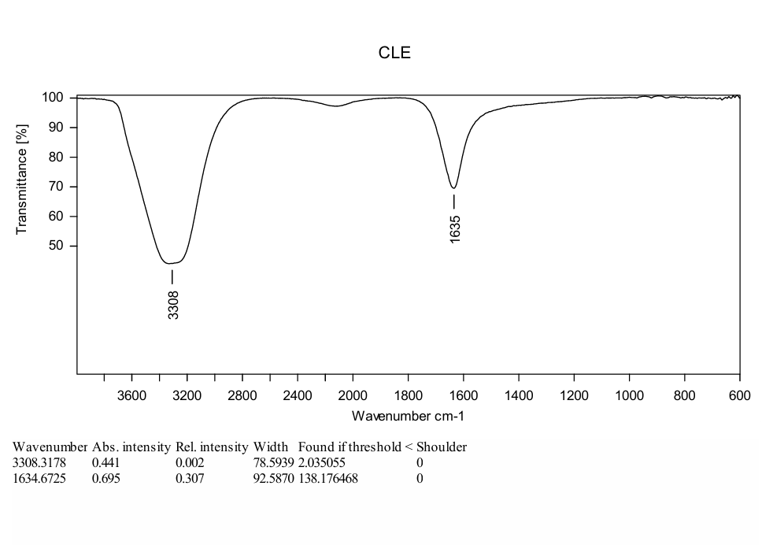

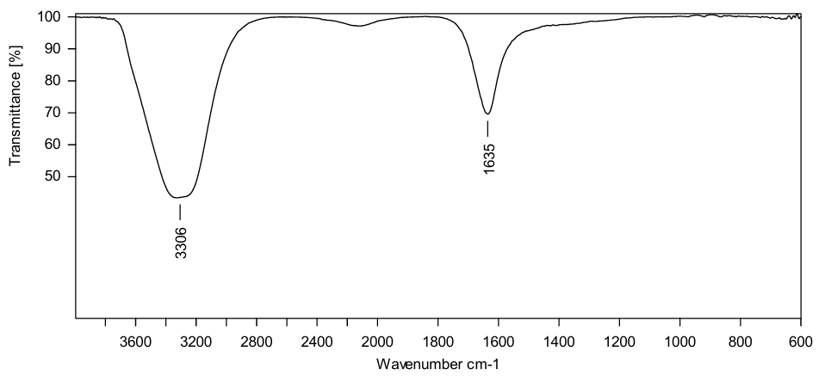

Figure 4(a): FTIR studies of AgNPs with curry leave extract. Figure 4(b): FTIR studies of curry leave extract

FTIR spectroscopy revealed the functional groups responsible for the exterior deposition and stabilisation of AgNPs synthesised using extracts of curry plants. The FTIR of AgNPs showed COOH carboxyl group peaks (~3308 cm−1 and 1635 cm−1). The peaks resulted from the oxidation of phenolic radicals.[32]

3.2. Plasmon Resonance Sensing

The plant extract contains the polyphenolic compounds on the its surface area, like caffeine, epicatechin, and benzoic acid and they are capable to form complexes with heavy metal ions. Many of them preferentially bind with the phenolic groups of the biomolecules [16]. In the present investigation the addition of the Zn2+ ions to the AgNPs solution resulted in a bathochromic shift in the plasmon resonance. In this study the absorption band appeared at 450 nm, which is responsible for AgNPs was shifted to 500 nm with slowly addition of Zn2+ ions and lastly it was disappeared with decreases in the concentration of Zn2+ ions. The extent of the shift depends on the concentration of the ions in the AgNPs solution [16]. The shift in the plasmon resonance absorption band (Figures 4a and 4b) can be attributed to the formation of aggregates of the NPs in the presence of Zn2+ ions. To confirm the presence of aggregates, TEM studies were carried out with the AgNPs only and AgNPs with Zn2+ (Figure 5). It is observed that the formation of the aggregates can be seen in the presence of metal ions (Figure 4). So, the complexation of the metal ions with the phenolic hydroxyl groups present in the surface of the nano particles can bring the Ag particles close together. This proximity induces the coupling of the plasmon resonance resulting thus in a bathochromic shift.

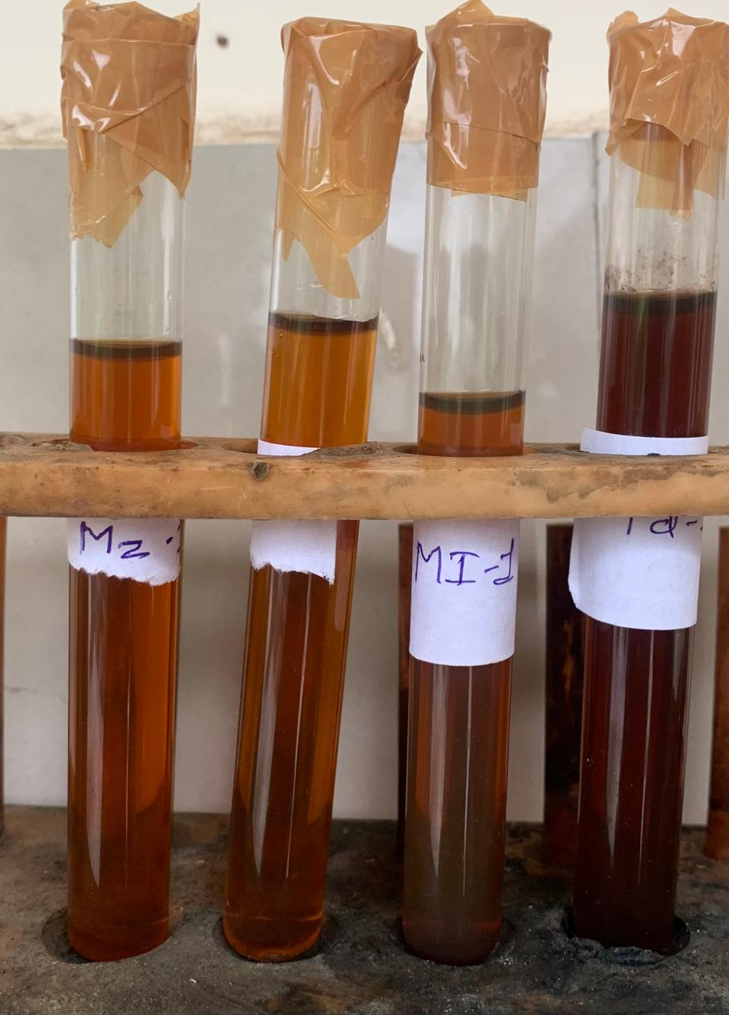

Figure: 5 AgNPs with curry leave extract

There was no special shifts observed with the decreasing in metal concentration below 10-1 M. It seems that aggregates of AgNPs are formed more readily when these metal ion concentration is in the order of 10-1 M, throughout complexation with these metal ions, resulting in a smaller interparticle gap and therefore greater bathochromic shifts in the plasmon resonance.

The presence of the metal ion signal, with a homogeneous distribution around all the Ag/biocomposite, is evident, indicating the retention of the metal ions. This suggests that, even though the Ag/biocomposite cannot be used as a naked-eye detector for metal ions, it certainly can be considered a functional material to be employed to remove metal ions from aqueous solutions.

Figure 6: Absorption studies of AgNPs with curry leave extract.

Figure 7: Absorption studies of AgNPs with curry leave extract and its sensing studies with aqueous solution of Zn+2 ions.

**4. Conclusion**

A simple, sensitive, and to some extent selective plasmonic sensor for divalent metal ions in aqueous solution has been extensively developed using biosynthetic and unmodified AgNps produced using green curry leaf as the reducing and passivating agent. This dual AgNPs colloidal sensor functioned exceptionally well for detecting Zn2+. They also functioned as a plasmon resonance sensor for Zn2+ ions. Sensitivity experiments show that a 10-1 M solution of Zn2+ is ideal for detecting these ions. The detection of Zn+2 is effective and environmentally friendly. Lower concentrations prevent the development of complexes between AgNPs and metal ions, which can inhibit naked-eye and plasmon resonance detection. Furthermore, additional research is being conducted to determine the minimal detectable concentration.

**Acknowledgments**

The authors are thankful to Department of Chemistry, Pacific Academy of Higher Education and Research University, Udaipur, Rajasthan for providing laboratory facility. The authors are grateful to Shri U P Arts, Smt. M G Panchal Science and Shri V L Shah Commerce College, Pilvai (N. Guj.) for providing laboratory facility. The authors thank to Central University Gandhinagar, Gujarat for the SEM and TEM characterization.

**Highlights:**

* Nanoparticles are materials where one or more external dimensions are in the range of 1–100 nm.
* It has also been studied that nanoparticles are not only synthesized since many are formed naturally and coexist in the environment.
* NPs of silver are of great interest due to their strong absorption in the visible region of the spectrum, chemical inertness, stable dispersions, chemical ambient, and biocompatibility.
* Curry leave aqueous extract with polyphenols was used as a biogenic reaction medium to obtain Ag nanoparticles with good control of the morphology and narrower size distribution.
* The dip-coating method was used to prepare a NPs/cellulosic material composite, offering advantages such as easy fabrication, relatively cheap material, eco-friendly, and biodegradable.

Disclaimer (Artificial intelligence)

Author(s) hereby declare that NO generative AI technologies such as Large Language Models (ChatGPT, COPILOT, etc.) and text-to-image generators have been used during the writing or editing of this manuscript.

**References**

1. Aragay G., Pons J., and Merkoçi A., Recent trends in macro-, micro-, and nanomaterial-based tools and strategies for heavy-metal detection, Chemical Reviews. (2011) 111, no. 5, 3433–3458, https://doi.org/10.1021/cr100383r, 2-s2.0-79955921205, 21395328.

2. Ramsurn H. and Gupta R. B., Nanotechnology in solar and biofuels, ACS Sustainable Chemistry & Engineering. (2013) 1, no. 7, 779–797, https://doi.org/10.1021/sc400046y, 2-s2.0-84884212030.

3. Savolainen K., Alenius H., Norppa H., Pylkkänen L., Tuomi T., and Kasper G., Risk assessment of engineered nanomaterials and nanotechnologies-a review, Toxicology. (2010) 269, no. 2-3, 92–104, https://doi.org/10.1016/j.tox.2010.01.013, 2-s2.0-77950145080, 20105448.

4. Song J. Y., Jang H. K., and Kim B. S., Biological synthesis of gold nanoparticles using Magnolia kobus and Diopyros kaki leaf extracts, Process Biochemistry. (2009) 44, no. 10, 1133–1138, https://doi.org/10.1016/j.procbio.2009.06.005, 2-s2.0-69249208522.

5. Cheun Yeh Y., Creran B., and Rotello V. M., Gold nanoparticles: preparation, properties, and applications in bionanotechnology, Nanoscale. (2012) 4, no. 6, 1871–1880, https://doi.org/10.1039/c1nr11188d, 2-s2.0-84857855167, 22076024.

6. RoÂżalska B., Sadowska B., Budzyńska A., Bernat P., and RoÂżalska S., Biogenic nanosilver synthesized in Metarhizium robertsii waste mycelium extract–as a modulator of Candida albicans morphogenesis, membrane lipidome and biofilm, PLoS One. (2018) 13, no. 3, article e0194254, https://doi.org/10.1371/journal.pone.0194254, 2-s2.0-85044196711, 29554119.

7. Annadhasan M., Muthukumarasamyvel T., Sankar Babu V. R., and Rajendiran N., Green synthesized silver and gold nanoparticles for colorimetric detection of Hg2+, Pb2+, and Mn2+ in aqueous medium, ACS Sustainable Chemistry & Engineering. (2014) 2, no. 4, 887–896, https://doi.org/10.1021/sc400500z, 2-s2.0-84897999380.

8. D. Ramachandrian and K. Rajesh, Highly detection of Zn (II) ion sensing and photocatalytic activities of biosynthesized AgNPs using *NilgirianthusCiliatus* leaf extract and its properties, Materials Research Bulletin. (2022) 111715, 149, https://doi.org/10.1016/j.materresbull.2021.111715

9. Wenkai Zhu et al., The salen based chemosensors for highly selective recognition of Zn2+ ion, Spectrochimica Acta Part A: Molecular and Biomolecular Spectroscopy (2018) 203, 501–509, https://doi.org/10.1016/j.saa.2018.06.008.

10. S. Balasurya et al., Rapid colorimetric and spectroscopy based sensing of mercury by surface functionalized silver nanoparticles in the presence of tyrosine. Optics Communication, (2020) 125512, V.464, https://doi.org/10.1016/j.optcom.2020.125512.

11. B. Janani et al., M., UV–vis spectroscopic method for the sensitive and selective detection of mercury by silver nanoparticles in presence of alanine, Optik. (2020) 164160, V. 204, https://doi.org/10.1016/j.ijleo.2019.164160.

12. Shrddha Pai et al., Photocatalytic zinc oxide nanoparticles synthesis using Peltophorum pterocarpum leaf extract and their characterization, Optik. (2019) V. 185, 248–255, https://doi.org/10.1016/j.ijleo.2019.03.101.

13. Chin Boon Ong et al., A review of ZnO nanoparticles as solar photocatalysts, Renewable and Sustainable Reviews, (2018) V. 81 Part-1, 536-551, https://doi.org/10.1016/j.rser.2017.08.020.

14. Asim Ali Yaqoob et al., Role of Nanomaterials in the Treatment of Wastewater: A Review, Water. (2020) V. 12, 495, 10–19, http://dx.doi.org/10.3390/w12020495, http://www.mdpi.com/journal/water.

15. Priyadarshini E. and Pradhan N., Gold nanoparticles as efficient sensors in colorimetric detection of toxic metal ions: a review, Sensors and Actuators B. (2017) 238, 888–902, https://doi.org/10.1016/j.snb.2016.06.081, 2-s2.0-84979787878.

16. Yoosaf K., Itty Ipe B., Suresh C. H., and George Thomas K., In situ synthesis of metal nanoparticles and selective naked-eye detection of lead ions from aqueous media, The Journal of Physical Chemistry C. (2007) 111, no. 34, 12839–12847, https://doi.org/10.1021/jp073923q, 2-s2.0-34548588511.

17. Rababah T. M., Hettiarachchy N. S., and Hora R., Total phenolics and antioxidant activities of fenugreek, green tea, black tea, grape seed, ginger, rosemary, gotu kola, and ginkgo extracts, vitamin E, and tert-butylhydroquinone, Journal of Agricultural and Food Chemistry. (2004) 52, no. 16, 5183–5186, https://doi.org/10.1021/jf049645z, 2-s2.0-3843095141, 15291494.

18. Loo Y. Y., Chieng B. W., Nishibuchi M., and Radu S., Synthesis of silver nanoparticles by using tea leaf extract from Camellia sinensis, International Journal of Nanomedicine. (2012) 7, 4263–4267, https://doi.org/10.2147/IJN.S33344, 2-s2.0-84867534472, 22904632.

19. Owuor P. O. and Obanda M., The use of green tea (Camellia sinensis) leaf flavan-3-ol composition in predicting plain black tea quality potential, Food Chemistry. (2007) 100, no. 3, 873–884, https://doi.org/10.1016/j.foodchem.2005.10.030, 2-s2.0-33746114537.

20. Saha K., Agasti S. S., Kim C., Li X., and Rotello V. M., Gold nanoparticles in chemical and biological sensing, Chemical Reviews. (2012) 112, no. 5, 2739–2779, https://doi.org/10.1021/cr2001178, 2-s2.0-84861058714, 22295941.

21. Wang C. and Yu C., Detection of chemical pollutants in water using gold nanoparticles as sensors: a review, Reviews in Analytical Chemistry. (2013) 32, no. 1, 1–14, https://doi.org/10.1515/revac-2012-0023, 2-s2.0-84877940207.

22. Howes P. D., Chandrawati R., and Stevens M. M., Colloidal nanoparticles as advanced biological sensors, Science. (2014) 346, no. 6205, article 1247390, https://doi.org/10.1126/science.1247390, 2-s2.0-84907485592, 25278614.

23. Polavarapu L., Pérez-Juste J., Qi H. X., and Liz-Marzán L. M., Optical sensing of biological, chemical and ionic species through aggregation of plasmonic nanoparticles, The Journal of Materials Chemistry C. (2014) 2, no. 36, https://doi.org/10.1039/C4TC01142B, 2-s2.0-84906539665.

24. Li X., Tang Y., Cao X., Lu D., Luo F., and Shao W., Preparation and evaluation of orange peel cellulose adsorbents for effective removal of cadmium, zinc, cobalt and nickel, Colloids and Surfaces A: Physicochemical and Engineering Aspects. (2008) 317, no. 1-3, 512–521, https://doi.org/10.1016/j.colsurfa.2007.11.031, 2-s2.0-39149133131.

25. Momodu M. A. and Anyakora C. A., Heavy metal contamination of ground water: the Surulere case study, Research Journal Environmental and Earth Sciences.(2010) 2, no. 1, 39–43.

26. Joseph Kirubaharan C., Kalpana D., Lee Y. S., Kim A. R., Yoo D. J., Nahm K. S., and Gnana Kumar G., Biomediated silver nanoparticles for the highly selective copper(II) ion densor applications, Industrial & Engineering Chemistry Research. (2012) 51, no. 21, 7441–7446, https://doi.org/10.1021/ie3003232, 2-s2.0-84865573409.

27. Prosposito P., Mochi F., Ciotta E., Casalboni M., De Matteis F., Venditti I., Fontana L., Testa G., and Fratoddi I., Hydrophilic silver nanoparticles with tunable optical properties: application for the detection of heavy metals in water, Beilstein Journal of Nanotechnology. (2016) 7, 1654–1661, https://doi.org/10.3762/bjnano.7.157, 2-s2.0-84995495736, 28144514.

28. Priyadarshini E. and Pradhan N., Metal-induced aggregation of valine capped gold nanoparticles: an efficient and rapid approach for colorimetric detection of Pb2+ ions, Scientific reports. (2017) 7, no. 1, article 9278, https://doi.org/10.1038/s41598-017-08847-5, 2-s2.0-85028298037, 28839229.

29. Kaviya S. and Prasad E., Sequential detection of Fe3+ and As3+ ions by naked eye through aggregation and disaggregation of biogenic gold nanoparticles, Analytical Methods. (2015) 7, no. 1, 168–174, https://doi.org/10.1039/C4AY02342K, 2-s2.0-84917709163

30. Polavarapua L. and Liz-Marzán L. M., Towards low-cost flexible substrates for nanoplasmonic sensing, Physical Chemistry Chemical Physics. (2013) 15, no. 15, 5288–5300, https://doi.org/10.1039/c2cp43642f, 2-s2.0-84875444339, 23303134

31. Silva De Hoyos L. E., Sánchez Mendieta V., Vilchis Nestor A. R., and Camacho López M. A., Biogenic silver nanoparticles as sensors of Cu2+ and Pb2+ in aqueous solutions, Universal Journal of Materials Science. (2017) 5, no. 2, 29–37,

<https://doi.org/10.13189/ujms.2017.050201>.

32. Pasieczna-Patkowska S, Cichy M, Flieger J. Application of Fourier Transform Infrared (FTIR) Spectroscopy in Characterization of Green Synthesized Nanoparticles. Molecules. 2025; 30(3):684. <https://doi.org/10.3390/molecules30030684>

33. Luisa E. Silva-De Hoyos, Victor Sánchez-Mendieta, Alfredo R. Vilchis-Nestor, Miguel A. Camacho-López, Jésica Trujillo-Reyes, Miguel Avalos-Borja (2019). Plasmonic Sensing of Aqueous-Divalent Metal Ions by Biogenic Gold Nanoparticles. <https://doi.org/10.1155/2019/9846729>