***Short communication***

**New distributional record of *Brugmansia arborea* (L.) Sweet (Solanaceae) from Nagaland, NE India**

**ABSTRACT**

*Brugmansia arborea* (L.) Sweet, (Solanaceae), is reported for the first time for the North East India from Nagaland. A comprehensive taxonomic account of the species is presented here with morphological description, colour photographs, ecological notes, phenology and the need for conservation.

*Keywords:**Brugmansia arborea*, Solanaceae, Nagaland flora, Taxonomic description.

**1. INTRODUCTION**

The genus *Brugmansia* is indigene to the tropical parts of South America, predominantly found along the Andes from Venezuela to northern Chile, and in southeastern Brazil. Belonging to the family Solanaceae, commonly referred to as the nightshade family, *Brugmansia* species are well-known for their richness in alkaloids. Cultivated globally as ornamental container plants, they have also become naturalized in various isolated tropical regions, including parts of North America, Africa, Australia, and Asia (Sandra Knapp *et al*. 2012). Notably, extracts derived from its tissues and organs are recognized for their psychoactive properties (Rojas *et al.* 2023). Several *Brugmansia* species have anti-inflammatory, antispasmodic, antiasthmatic, antinociceptive, anti-addictive and, antiprotozoal capabilities, indicating their medicinal potential (Algradi, A. M. 2021) to treat acne, menstruation pain, wound healing, joint pain, headaches, and other conditions. Major alkaloids found in phytochemical studies include atropine, scopolamine, and nor-hyoscyamine (Pérez-González *et al*. 2025). *Datura* and *Brugmansia* are frequently misidentified due to their morphological similarities; however, a reliable distinguishing characteristic is the orientation of their flowers: *Datura* typically exhibits erect, upward-facing blooms, whereas *Brugmansia* is characterized by pendulous, downward-facing flowers (Dhanya, C., & Devipriya, V. 2016).

*Brugmansia arborea* (L.) Sweet (*Datura arborea* L.) (Solanaceae), often known as “Angel’s Trumpet,” was described by Carl Linnaeus in 1753. *Brugmansia arborea* is characterized as a shrub or small tree, obtaining a height of 6–12 m (Kim *et al.* 2020), and it thrives across both tropical and temperate zones. The plant flourishes in both cold and drought regions, (IUCN 2014) where it is cultivated in indigenous gardens. The species is also found in the shaded vegetation along the riverbanks. *Brugmansia arborea* is typically pollinated by moths. Their attraction is drawn by the blooms' white hue and the intensified aroma that emanates in the nights. According to the IUCN 2014 Red List, *Brugmansia arborea* is currently classified as extinct in the wild since there are no records of wild species in South America or cultivated from wild-collected material (Hay A. 2014).

**2. MATERIALS AND METHODS**

During a field survey, in a semi-evergreen forest of Akuluto village, Zunheboto district, we encountered a species along the river bank inhabiting along with *Mucunna interrupta*. Based on morphological analysis and thorough literature study, the species was determined to be *Brugmansia arborea.* The species identification and detailed in this research were referred from San Francisco Botanical Garden. Accession 2008-0567. In India, the species is reported to be cultivated in the states of Karnataka, Kerela, and Tamil Nadu, specifically in Dindigul and Nilgiri hills (Flora of Tamil Nadu, VOL. II, 1987). Plant with flower were collected and the herbarium specimens were prepared following standard field and herbarium methods (Rao and Jain 1977). The specimens were stored in the Herbarium of Nagaland University, Lumami, Zunheboto, Nagaland (Fig. 2). A comprehensive botanical description, notes on ecology, distribution and morphological characteristics have been provided.

**3. TAXONOMIC TRETAMENT**

***Brugmansia arborea*** L. Sweet Hortus. Suburbanus. Londimensis: 41 (1818), *Datura speciosa* Salisb. in Prodromus. Stirpium. Chap Allerton: 131. 1796, nom. superfl, *Brugmansia arbuscula* Bosse in Neue Allg. Deutsche Garten- Blumenzeitung 2: 192. 1846, *Brugmansia cornigera* (Hook.) Lagerh. in Bot. Jahrb. Syst. 20: 663. 1895, *Datura cornigera* Hook. in Bot. Mag. 72: t. 4252. 1846 (Fig. 3).

Large shrub or small tree, 3–9 m tall, woody, branching, evergreen. Leaves alternate, ovate, 9–25 cm long, 4–15 cm wide with an acuminate apex, oblique at base; with 5-12 pairs of lateral veins, mid-rib distinct; petiole smooth, 2–6 cm long, Flower solitary, axillary, large, white, fragrant, pendulous, actinomorphic, and hermaphroditic; measuring 11.5 x 12 cm in diameter and 12–26 cm in length, each flower is borne on a peduncle up to 3–5 per plant with each peduncle up to 2.5 cm long; sepals 3, 8–13 cm long, calyx tubular, 12–22 cm long, persistent, **Corolla** infundibuliform, large, 15–20 cm long, white to cream, fragrant; tube elongate, slightly constricted above base; limb spreading, shallowly 5-lobed, lobes short, broadly triangular, aestivation contorted. Stamens 5, epipetalous; anthers linear, 3.8 cm long dehiscing longitudinally; Ovary superior, bilocular; style up to 20-21 cm long; stigma bilobed. **Fruit** berry, indehiscent, ovoid to ellipsoid, smooth or slightly verrucose, 5–10 cm long, green when immature, turning yellowish or brown at maturity; pericarp thick, fleshy. Seeds numerous, flattened, embedded in a mucilaginous pulp. discoid to reniform, flattened, 5–8 mm in diameter; testa hard, rough, brown to tan, minutely reticulate; endosperm copious, embryo curved.

*Brugmansia arborea* (L.)Sweetis distinguished by its unusual combination of ovate leaves with a slightly serrated border, gigantic, pendulous, trumpet-shaped white flowers, and tree-like form. Known for their potent nocturnal scent, the single flowers are carried in the leaf axils. The corolla has a slightly recurved limb and is funnel-shaped, usually 20 to 30 cm long. As the bloom grows, the tubular calyx splits on one side. Included stamens, are joined to the corolla tube's base. The species' shorter floral tube, less recurved corolla lobes, and more arborescent (tree-like) growing habit readily set it apart from its near relatives, including *Brugmansia suaveolens*. In addition, compared to other species in the genus, *B. arborea* typically flowers at higher elevations and at a younger age.

**Phenology:** Flowering- February–March. Fruiting- May - July

H**abitat:** The field study was carried out on 16th May 2025 in the Reserve Forest of Akuluto village, Zuneheboto district, Nagaland, located between 26.22657 N, 94.48178 Eat an elevation of 787.6 m above sea level along the bank of the river (Fig. 1). The region receives 2500 mm of rain annually, and its elevation ranges from 800 to 1800 m above MSL. The region is Temperate and humid.

**Specimen examined:** Akuluto village, Zuneheboto district, Nagaland, India (26.22657 N, 94.48178), 16th May, 2025, NU/FRS–239 (Fig. 2).

**Distribution:** The native range of the species is assumed as South America from Andes to Northern Chile, presently not seen in the wild. Introduced throughout the tropic as an ornamental where it got naturalised. In India it is reported from Karnataka, Kerala, Tamil Nadu and Nagaland. The present report on the occurrence of *B. arborea* from Zunheboto district, Nagaland is a new species record to the state flora.

**Etymology*:*** Derived from the Latin arbor (tree), this term describes the species' tree-like growth habit. Its arborescent structure, one of its primary distinguishing characteristics, is emphasized by the specific epithet.

**Preliminary Conservation Status:** *Brugmansia arborea* has been assessed as Extinct in the Wild (EW) for *The IUCN Red List of Threatened Species* in 2014. Hay A. 2014, reported that notwithstanding historical accounts of wild occurrences, there is no verified herbarium evidence for the species been collected from authentic wild populations. Moreover, no botanist specializing in this species has ever recorded or observed such plants in their natural environments. Infrequent assertions by non-expert botanists about the existence of 'wild' specimens have repeatedly been shown to be either misidentifications predominantly with Datura or misconceptions regarding semi-naturalized populations. These instances generally pertain to remains of cultivated flora or limited escapes, particularly along waterways, where vegetative proliferation from stem pieces may create a misleading perception of natural populations. Field research in Ecuador and Colombia have verified that all examples pertain to anthropogenic hybrids, which do not form self-sustaining, sexually reproducing populations.

The lack of evidence for fruit dispersal or the occurrence of spontaneous seedlings, despite the presence of numerous fruits containing viable seeds (except *B. insignis*), suggests the extinction of natural seed dispersers. Based on these data, it seems most suitable to categorize all species under this genus as Extinct in the Wild. This situation is further aggravated by persistent threats in their indigenous South American habitat, where the plants are systematically eradicated from agriculture due to their toxic characteristics. The progressive depletion of indigenous ethnobotanical knowledge exacerbates this vulnerability, as it has traditionally supported their maintenance and may have facilitated their survival throughout millennia. In the absence of immediate conservation efforts, many species are at risk of complete extinction.

**Affinities:** Only *Brugmansia suaveolens* (Humb. & Bonpl. ex Willd.) shares similarities, in its arborescent habit, leaf size and form, and huge, trumpet-shaped, pendulous flowers with reflexed corolla lobes and an elongated floral tube. However, *B. arborea* flowers are more horizontally aligned and erect, as compared to *B. suaveolens* prominently drooping blooms; leaves with a narrower, usually 9–25 cm long (compared to larger leaves up to 30 cm in *B. suaveolens*; and flowers that are usually white and less varied in color (as compared to white to pink or peach, which are frequently highly variable in *B. suaveolens*. Fruit of *B. arborea* is short, ovoid, and smooth, while that of *B. suaveolens* is longer, fusiform. Additionally, Brugmansia arborea blooms more frequently in cooler, high-elevation conditions (usually above 700 m), while *B. suaveolens* prefers lowland, tropical conditions. The corolla (up to 20 cm) and the small basal tube in *B. arborea* are consistent identifying characteristics, despite the similarity in flower size and aroma. Although the two species are occasionally confused in cultivation, their classification as distinct taxa is supported by these consistent physical characteristics.

4. **CONCLUSION**

This study expands the known geographical distribution of *Brugmansia arborea* (L.) Sweet beyond its previously documented areas by reporting it for the first time in Nagaland, Northeast India. The ecological tolerance of the species and the region's underappreciated botanical diversity are highlighted by this new distributional record. The necessity for more thorough floristic surveys and ecological evaluations in the Eastern Himalayan biodiversity hotspot is highlighted by the presence of *B. arborea* in Nagaland. Because of the species' aesthetic and ethnobotanical significance, this study may have ramifications for the conservation of area biodiversity, horticulture interest, and future ecological investigations.

**Disclaimer (Artificial intelligence)**

Author(s) hereby declares that NO generative AI technologies such as Large Language Models (ChatGPT, COPILOT, etc.) and text-to-image generators have been used during the writing or editing of this manuscript.

**REFERENCES**

Algradi, A. M., Liu, Y., Yang, B. Y., & Kuang, H. X. (2021). Review on the genus Brugmansia: Traditional usage, phytochemistry, pharmacology, and toxicity. Journal of Ethnopharmacology, 279, 113910. <https://doi.org/10.1016/j.jep.2021.113910>

Dhanya, C., & Devipriya, V. (2016). Pollen morphological studies on two solanaceous genera Brugmansia Pers. and Datura L. L. International Journal of Advanced Research, 4, 1879-1887. DOI:[10.21474/IJAR01/1669](http://dx.doi.org/10.21474/IJAR01/1669)

Hay A. 2014. *Brugmansia arborea*. The IUCN Red List of Threatened Species 2014: e.T51247708A58386508. <https://dx.doi.org/10.2305/IUCN.UK.20141.RLTS.T51247708A58386508.en>.

Kim HG, Jang D, Jung YS, Oh HJ, Oh SM, Lee YG, Baek NI. 2020. Anti-inflammatory effect of flavonoids from Brugmansia arborea L. flowers. Journal of Microbiology and Biotechnology 30(2): 163.  doi: [10.4014/jmb.1907.07058](https://doi.org/10.4014/jmb.1907.07058)

Pérez-González MZ, del Carmen Juárez-Vázquez M, Sánchez-Ramos M, Moreno-Villalba L, Jiménez-Arellanes MA. 2025. Anti-inflammatory, antioxidant, and acute toxicity of *Brugmansia arborea* extracts from wild plants and shoots obtained by indirect organogenesis. A thermographic assay to anti-inflammatory evaluation. Biomedicine & Pharmacotherapy 186, 117972. <https://doi.org/10.1016/j.biopha.2025.117972>

Rojas S, Madriñan S, Stahl M, Harter K. 2023. Cultural use of tropane alkaloids of Brugmansia species and cultivars in Colombia depends on local plant growth environment rather than genetic diversity. bioRxiv 2023-11 m <https://doi.org/10.1101/2023.11.02.565279>.

Sandra Knapp, Huanduj: Brugmansia, Botanical Journal of the Linnean Society, Volume 171, Issue 4, April 2013, Page 777, <https://doi.org/10.1111/boj.12026>

The IUCN Red List of Threatened Species: Brugmansia arborea – published in 2014. <http://dx.doi.org/10.2305/IUCN.UK.2014-1.RLTS.T51247708A58386508.en>

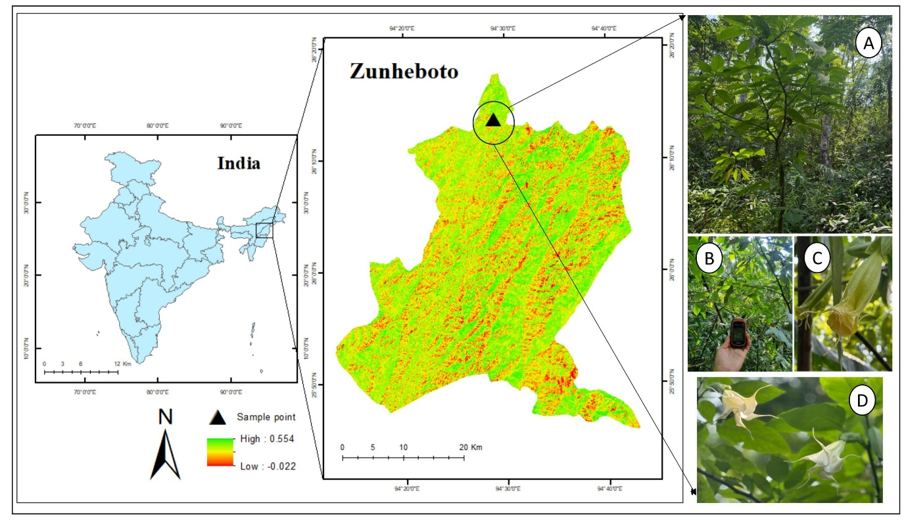

**Fig 1.** Map of Study Area. Photo plate A,B,C,D showing *Brugmansia arborea* from the field site.

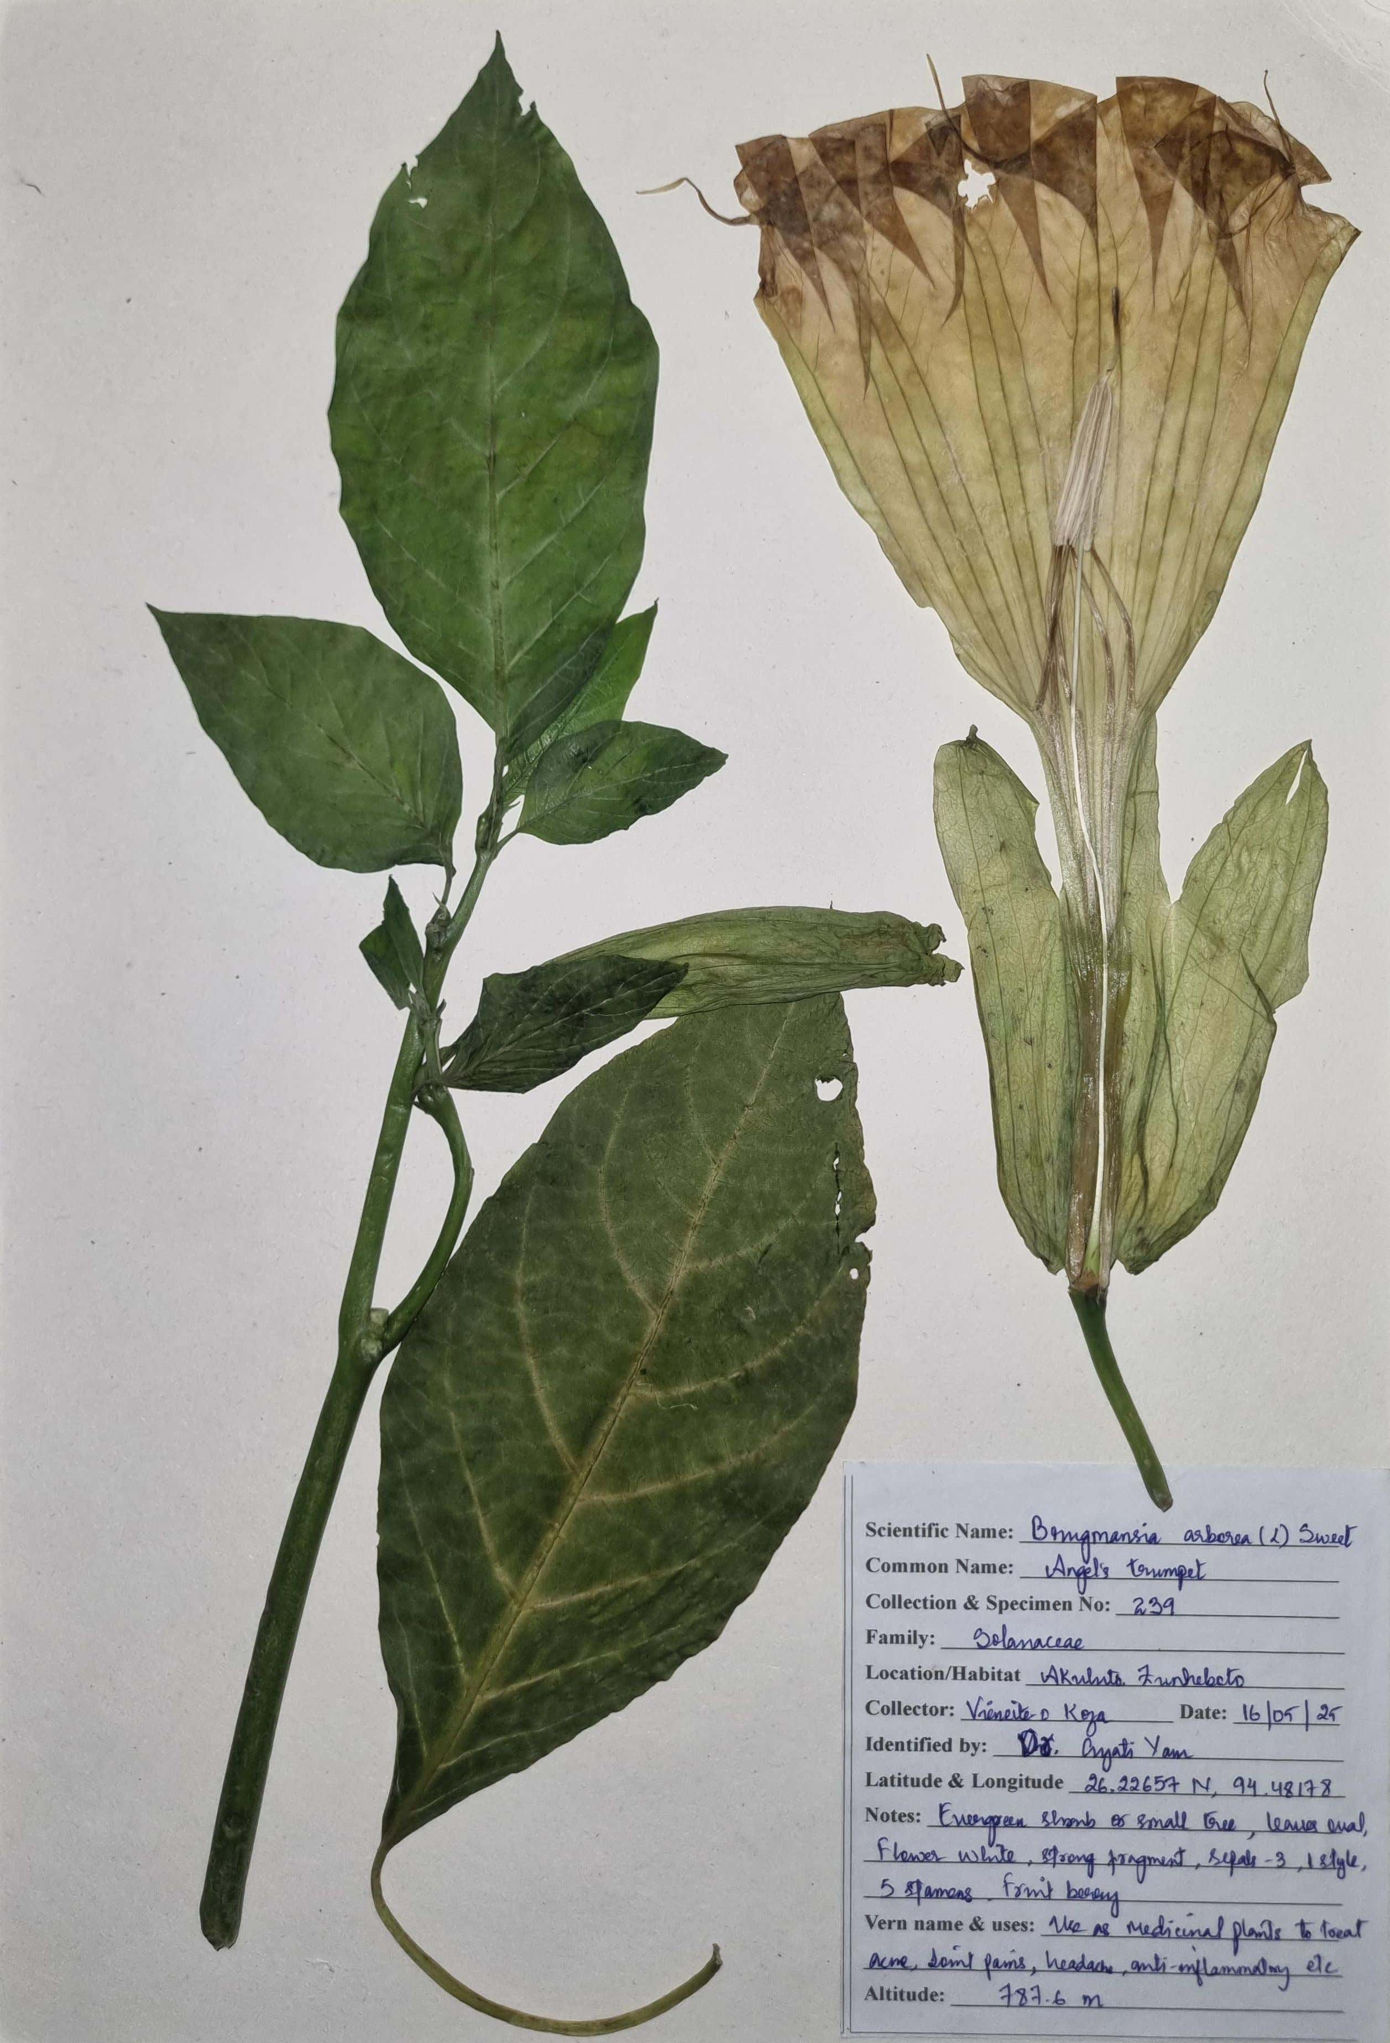

**Fig. 2** Herbarium specimen of *Brugmansia arborea* deposited at Nagaland University, Lumami (NU/FRS-239)

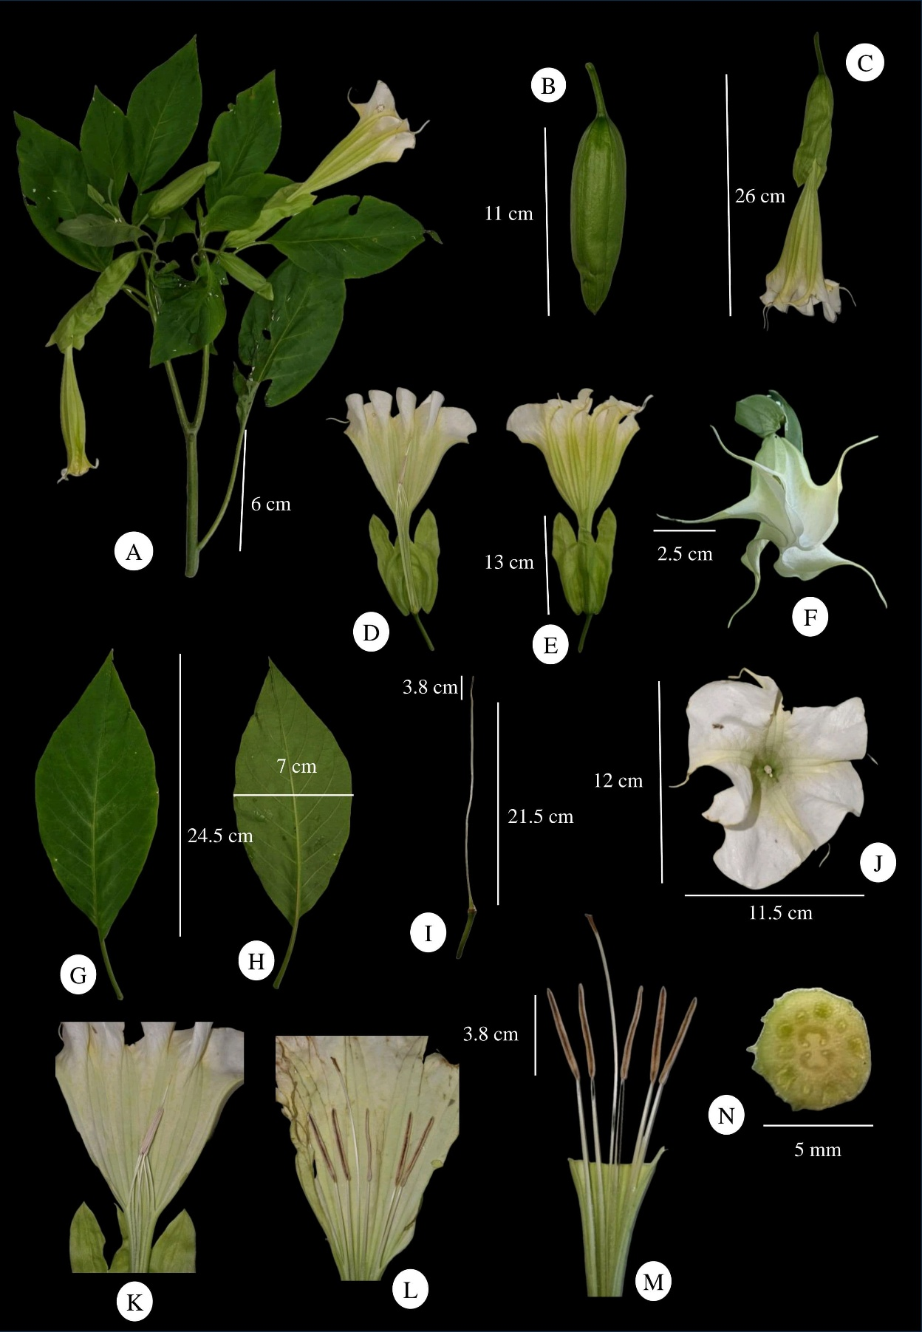

**Fig. 3** *Brugmansia arborea*: **A**. Plant. **B–C**. Young flower buds. **D–E.** Ventral and dorsal view of Corolla with Calyx. **F.** Enclosed flower with 5 spikes. **G–H.** Leaves. **I.** Calyx with style and stigma. **J.** Flower top view. **K–L.** Longitudinally dissected corolla with enclosed and open stamens- style. **M.** Stamens. **N.** Cross section of ovary.