**ORIGINAL RESEARCH ARTICLE**

**THE ROLE OF HISTOMORPHOMETRIC ANALYSIS OF SPERMATOZOA AMONGST INFERTILE MALES AND ITS IMPLICATIONS IN AN INFERTILITY CLINIC**

**ABSTRACT**

**Background:** Infertility is a global health concern, with male factor infertility accounting for half of cases. Increased awareness and access to reproductive health services in Nigeria prompt more male fertility evaluations, improving diagnostic accuracy and patient counselling.

**Aims:** Male infertility has been a cause for concern globally, and with this in mind, this study has investigated the histomorphometric characteristics of spermatozoa and their implications for male infertility.

**Methods:** The cross-sectional descriptive study examined semen samples from 120 males with infertility issues attending a major fertility hospital in Port Harcourt. These samples were analysed following World Health Organization guidelines for sperm assessment for abnormalities and morphological defects. The metric dimensions of the head length, midpiece length and tail length of the sperm cells were measured via photomicrographs using Image J software. Data were analysed using SPSS version 27. Chi-square and Spearman Correlation tests were used to determine the relationship between sperm dimensions and categories of abnormalities at a significance level of 0.05.

**Results:** Histomorphometric analysis revealed that the tail dimensions of spermatozoa, regardless of the abnormality type, averaged 35.57 micrometres. This is below the reported standard measurement of 45.00 micrometres for fertile males. Males with teratozoospermia had spermatozoa with a midpiece length of 3.09 micrometres; those with asthenoteratozoospermia exhibited a head length of 5.62 micrometres and a tail length of 36.49 micrometres.

**Conclusion:** The findings also indicated that teratozoospermia is the most common abnormality among infertile males, showing the highest prevalence of head, midpiece, and tail morphological defects. No significant (p>0.05) correlation was found between head, midpiece, and tail lengths and the types of sperm abnormalities. In conclusion, the study demonstrates that spermatozoa dimensions are not reliable for predicting the specific sperm abnormalities in infertile males.

**Keywords:** Spermatozoa, Morphology, Histomorphometry, Infertility

**1.0 INTRODUCTION**

Infertility has become a global concern, prompting extensive research across different regions to provide satisfactory explanations to experts and the public regarding potential causes of infertility [1,2]. It is a condition affecting the male and female reproductive systems, resulting in the inability to conceive after a year or more of regular unprotected sexual intercourse [3,4,5]. According to the World Health Organization [6], millions of people of reproductive age worldwide are affected by infertility, with an estimated 48 million couples (15% of all couples) and 186 million individuals living with the condition globally. In African societies, at least 1 in every 10 couples faces infertility issues. Vanders and Wyns [7] define infertility as the failure to establish a clinical pregnancy after 12 months of consistent, unprotected sexual activity.

Infertility has significant social and psychological implications for couples in Nigeria because one of the primary reasons couples marry is for procreation to continue family lineages [8,9]. When this goal is unmet, it becomes a major issue within the family and society at large. The causes of infertility could be due to structural or hormonal defects in either the male or female partner. Unfortunately, most of the blame for infertility is commonly placed on the female partner. This study aims to challenge that notion because the male factor plays a substantial role, contributing to about 30% of infertility cases. Advances in the study of sperm function and dysfunction have provided a better understanding of the role of male infertility [10,11,12]. In 2003, Ikechebulu et al., [13] observed that the male factor accounted for 42.4% of infertility cases (133 males), compared to 25.8% (85 females) among 314 couples evaluated. Semen analysis serves as the foundation for the laboratory evaluation of infertile men and aids in defining the severity of the male factor. It provides indications of testicular function and the integrity of the male genital tract, which may help with treatment plans [14]. Investigations such as semen analysis have now been conducted to identify specific factors responsible for male infertility. The most common issues include abnormal sperm shape, absence or low sperm count, and reduced sperm motility. Male infertility however results from a variety of pathogenic mechanisms including pre-testicular, testicular, and post-testicular factors. The causes may be congenital or acquired and include congenital abnormalities (cryptochordism), chromosomal disorders (specifically abnormalities of the Y chromosome), genital tract infections leading to obstructive oligozoospermia/ azoospermia, drugs, use of alcohol and tobacco, abuse of cannabis, and wearing of tight underwear [15].

Sperm morphology is critical in assessing male factor infertility, as any impairment in the shape of the sperm cell might affect its fertilising potential [16,17]. Sperm morphology refers to the size, shape and appearance of a man’s sperm, which, when abnormal, can decrease a man's fertility and make it more difficult to fertilise the woman’s egg [18]. The morphology of seminal spermatozoa is the end consequence of a highly complex process of cellular alterations occurring during spermiogenesis. In humans, it leads to widely diverse morphological patterns, with several cellular abnormalities which may be related with sperm failure. Semen analysis in couples seeking help for infertility has traditionally included the morphological assessment of human spermatozoa, which includes calculating the percentage of morphologically normal sperm and the prevalence of various morphological defects [19]. The 2010 WHO manual defines a morphologically “normal” sperm as having a head (with acrosome), midpiece, and tail. Specifically, a “normal” head has an oval shape with smooth contours. The acrosome is visible, well-defined, exhibits a homogenous light-blue staining, and covers 30–60% of the anterior portion of the sperm head [20]. A “normal” midpiece lacks cytoplasmic residues and is axially attached to the head, without forming a definite angle to the head, ≤ 1 μm in width and approximately 1.5 times the head length [21]. The tail should also lack cytoplasmic residues, be apically inserted to the post-acrosomal end of the midpiece, have a length of approximately 45–50 μm, and lack any sharp bends [22]. This study aims to evaluate the histomorphometry of spermatozoa present in the different patterns of semen abnormalities among infertile Nigerian males.

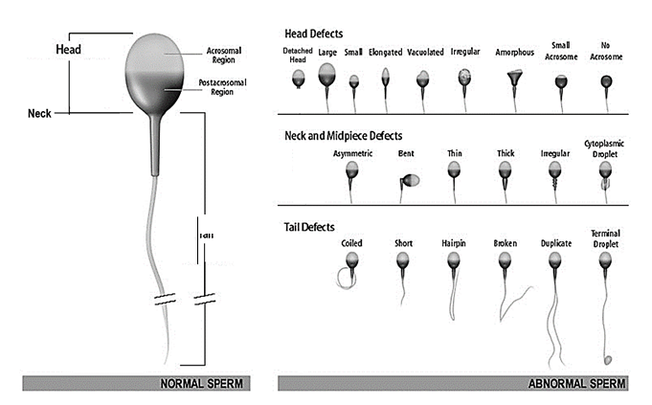

**Figure 1. Normal and abnormal sperm morphology [23]**

**2.0 MATERIALS AND METHODS**

**2.1 Study Design**

This is a cross-sectional and descriptive study involving laboratory and anthropometric (histomorphometry) procedures. The study spanned from April to October 2023, and a total of 120 semen samples were used for this study. Male patterns of couples that present to the Bridge Clinic for problems relating to infertility were used for this study.

**2.2 Selection Criteria**

**Inclusion Criteria**

Only those patients between the age of 25-60 years were recruited for this study.

**Exclusion Criteria**

Those below the age were omitted from the study.

**2.3 Method of Data Collection**

Following a three to five-day abstinence interval, semen samples were obtained by masturbating into a sterile wide-mouthed calibrated container. These samples were allowed to liquefy and then analysed following World Health Organization guidelines to assess the sperm parameters. (Volume, sperm count, motility, morphology, colour, etc.). A 10-microliter aliquot was placed onto a glass slide, and a coverslip was placed over it. Using the Olympus CX41 phase contrast microscope, motility was scored for, and a Neubauer counting chamber was used to score for density/concentration.

After that, a photomicrograph of the semen sample was taken on the Nikon Eclipse ti2 inverted microscope and then input into IMAGE J software, where the type of morphological defects was assessed for and the metric dimensions of the head, midpiece and tail of the sperm cells were measured. Sperm cells without much clustering around them were selected for easy and adequate measurement. The head length was measured by drawing a straight line from the proximal to the distal part of the head, and the head width was measured by drawing a straight line from the left part of the head to the right part of the head. The length of the midpiece was measured by drawing a straight line from the proximal part of the midpiece to its distal part, and finally, the tail measurement was taken by using a segmented line to measure the tail from the distal part of the midpiece to the distal part of the tail. The average measurements of each part of the selected sperm cells were recorded and labelled

**3.0 RESULTS**

Fig. 1 shows the sperm abnormalities among participants of this study. 59.2% of the 120 participants had teratozoospermia making it the highest occurring sperm abnormality, followed by oligoteratozoospermia with a percentage of 17.5. Oligoasthenoteratozoospermia and asthenoteratozoospermia had a percentage of 11.7 and 5.0 respectively while 6.7% of the participants had no sperm abnormalities.

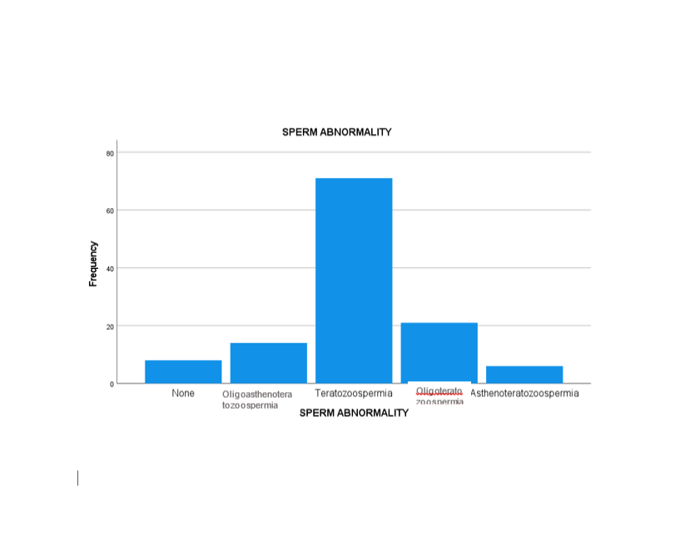

**Figure 2. Frequency of sperm abnormalities.**

|  |  |  |  |  |
| --- | --- | --- | --- | --- |
| Table 1 Descriptive Statistics | | | | |
| **Dependent Variable: Head, Midpiece and Tail.** | | | | |
|  |  |  |  |  |
| **SPERM ABNORMALITY** | **Head (um)** | **Midpiece (um)** | **Tail (um)** | **N** |
| **Normal morphometric values (None)** | **4.00 to 5.50 um** | **6.00** | **45.00** | **_** |
| **Oligoasthenoteratozoospermia** | **5.61** | **3.04** | **31.87** | **14.00** |
| **Teratozoospermia** | **5.33** | **3.09** | **36.12** | **71.00** |
| **Oligoteratozoospermia** | **5.43** | **2.97** | **34.83** | **21.00** |
| **Asthenoteratozoospermia** | **5.62** | **2.97** | **36.49** | **6.00** |
| **Total** | **5.39** | **3.05** | **35.57** | **120.00** |

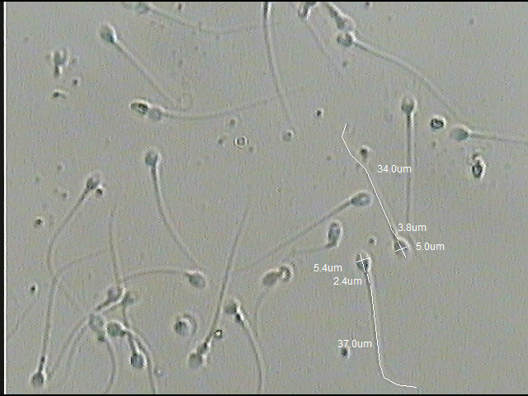

**Figure 3 Photomicrograph of morphologically normal sperm cells and their morphometric measurements. X40**

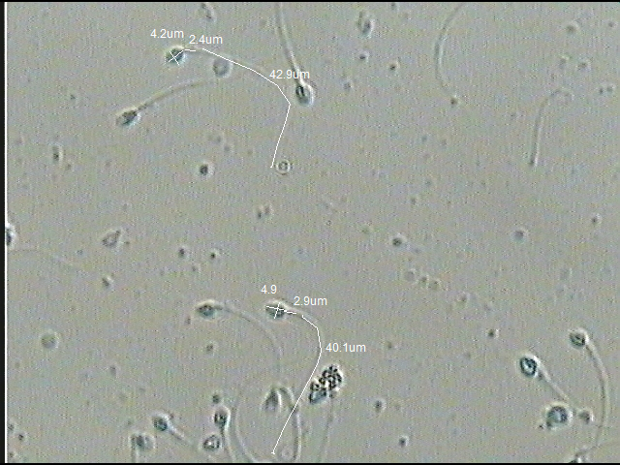

**Figure 4 Photomicrograph of sperm cells with small(micro) heads and their morphometric measurements. X40**

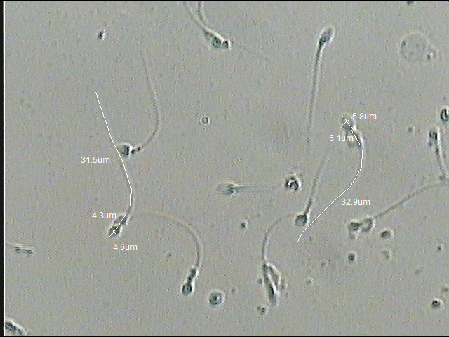

**Figure 5 Photomicrograph of sperm cells with small(micro) heads with Excess cytoplasmic residue and their morphometric measurements. X40**

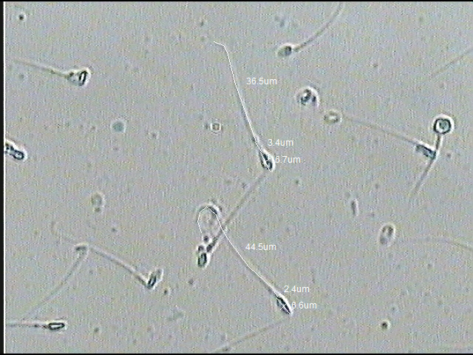

**Figure 6 Photomicrograph of sperm cells with tapered head defects and their morphometric measurements. X40**

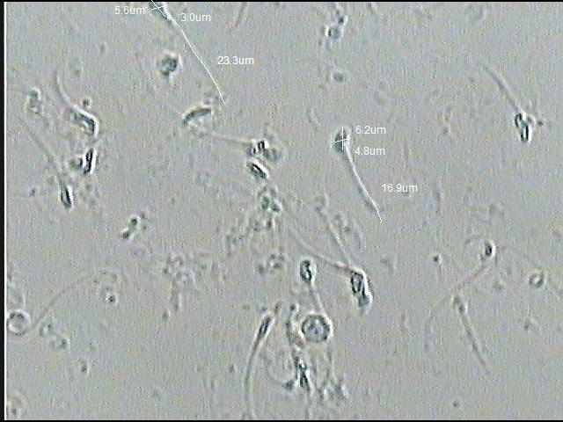

**Figure 7 Photomicrograph of sperm cells with tapered & amorphous head defects and short tail defects and their morphometric measurements. X40**

**4.0 DISCUSSION**

There is limited data on using histomorphometric measurements of abnormal spermatozoa to identify sperm abnormalities. However, this study analysed the histomorphometric parameters of the head, midpiece, and tail of sperm cells with various abnormalities. The average head measurement was 5.39 micrometres in length and 3.55 micrometres in width, similar to the figures reported by Katz et al.[24], but slightly higher than those reported by Bellastella et al.[25]. This difference may be due to their use of the CASMA system for measuring sperm dimensions in fertile subjects. The findings suggest a high occurrence of tapered head defects among our subjects with different sperm abnormalities. The midpiece and tail measurements were approximately 3.05 micrometres and 35.57 micrometres, respectively. These are lower than the values reported by Durairajanayagam et al.[26], who measured a tail length of 45 micrometres, likely because their data was collected from a population of fertile men with normal sperm. Due to limited data on these parameters in infertile populations—most studies focus solely on head morphometry—our findings on midpiece and tail measurements cannot be directly compared. Hence, further research on midpiece and tail morphometry is recommended. Regarding sperm abnormalities, Table 1 shows the mean head measurement in sperm classified as oligoasthenozoospermia at 5.61 micrometres, possibly associated with tapered head defects, which tend to increase head size. Sperm in teratozoospermia have a head measurement of 5.33 micrometres; in oligoteratozoospermia, 5.42 micrometres; and in asthenoteratozoospermia, 5.61 micrometres. All these are related to the presence of tapered head defects, common in these conditions. Notably, head measurements are higher in asthenoteratozoospermia and oligoteratozoospermia, which may explain why sperm in these groups struggle to penetrate the oocyte’s cumulus, affecting fertilisation as noted by Roger et al.[27]. This could be caused by errors in spermiogenesis, such as improper chromatin condensation in the sperm head nucleus, according to Singh[28]. However, head measurements did not significantly predict these abnormalities, consequently, these abnormalities can be overcome by ICSI[29]. Similarly, the relationship between head defects and their measurements shows no significant predictive value for the occurrence of head morphological defects, despite these measurements being marginally above the standard of 5.50 micrometres. The midpiece measurement in oligoasthenozoospermia is about 3.04 micrometres; in teratozoospermia, 3.09 micrometres; in oligoteratozoospermia, 2.98 micrometres; and in asthenoteratozoospermia, 2.97 micrometres. These abnormal groups display higher frequencies of large and bent midpiece defects, which impair sperm motility, since the midpiece contains mitochondria vital for energy production, as noted by Singh[28]. Reduced motility impacts male fertility. Midpiece measurements tend to be higher in teratozoospermia, indicating a link between this condition and increased morphological defects. Yet, similar to head measurements, midpiece size did not significantly predict these abnormalities. The relationship between midpiece defects and their measurements shows no significant predictive value. The same pattern applies to tail measurements: in asthenoteratozoospermia, the average tail length was approximately 36.49 micrometres, shorter than the standard 45 micrometres. The main defect involves a short tail, which affects motility. The tail consists of the principal piece and end piece, with axial filaments responsible for movement. Disruption during spermiogenesis may hinder the elongation of these filaments, leading to shorter, less motile sperm that cannot reach the oocyte during ovulation, thus causing infertility, as reported by Singh[28]. Despite this, tail measurements did not significantly predict these abnormalities. Additionally, the overall mean tail length of 35.57 micrometres is well below the standard length, possibly indicating common spermatogenic disorders among residents of Port Harcourt.

**5.0 CONCLUSION**

Our findings have shown that teratozoospermia had higher midpiece measurement, and asthenoteratozoospermia has higher head and tail measurements, but generally the tail length measurement of the spermatozoa of males in Port Harcourt for all the abnormalities were lower than the standard measurement, however, the histomorphometric measurement of the spermatozoa in the different patterns of sperm abnormalities did not significantly predict whether the patient will have these sperm abnormalities. In conclusion, the study shows that spermatozoa dimensions cannot be used to indicate the type of sperm abnormalities in infertile males.

**ETHICAL APPROVAL**

Ethical approval was granted by the University of Port Harcourt's Research Ethics Committee in Port Harcourt, Nigeria. Each participant was thoroughly informed about the study's protocol before providing written consent.

**CONSENT**

A written agreement form explaining the study's objectives was given to each participant, and only those who provided their consent were allowed to participate. Consent was received and saved by the authors.

Disclaimer (Artificial intelligence)

Option 1:

Author(s) hereby declare that NO generative AI technologies such as Large Language Models (ChatGPT, manuscript.

Corresponding Author: Prof. L.E. Oghenemavwe

Corresponding Author email ID: [Lovedayese@gmail.com](mailto:Lovedayese@gmail.com)

Type of Article: Original Research Article

**REFERENCE**

1. Barrera N, Omolaoye TS, Du Plessis SS. A contemporary view on global fertility, infertility, and assisted reproductive techniques. Infertility, Pregnancy, and Wellness 2022 Jan 1 (pp. 93-120). Elsevier.
2. Thoma M, Fledderjohann J, Cox C, Adageba RK. Biological and social aspects of human infertility: a global perspective. In: Galea S, editor. Oxford Research Encyclopedia of Global Public Health. Oxford: Oxford University Press; 2021 Mar 25.
3. Mustafa M, Sharifa AM, Hadi J, IIIzam E, Aliya S. Male and female infertility: causes, and management. IOSR Journal of Dental and Medical Sciences. 2019 Sep 28;18(9):27-32.
4. Anwar S, Anwar A. Infertility: A review on causes, treatment and management. Womens Health Gynecol. 2016;5:2-5.
5. Obeagu EI, Njar VE, Obeagu GU. Infertility: Prevalence and consequences. Int. J. Curr. Res. Chem. Pharm. Sci. 2023;10(7):43-50.
6. World Health Organization. Infertility prevalence estimates, 1990–2021. Geneva: World Health Organization; 2023 Apr 4 [cited 2024 Mar 14]. Available from: https://www.who.int/publications/i/item/9789240072887.
7. Vander Borght M, Wyns C. Fertility and infertility: Definition and epidemiology. Clinical biochemistry. 2018 Dec 1;62:2-10.
8. Giwa OM. The impact of infertility diagnosis and subsequent treatment on couples’ relational dynamics in South West Nigeria. Faculty of health sciences and sport eThesis. 2019 Oct 30:1-2
9. Anyanwu PU. The sociocultural implications of infertility amongst Mbaise couples. Nigerian Journal of African Studies (NJAS). 2020 Dec 1;2(2):1-2
10. Fainberg J, Kashanian JA. Recent advances in understanding and managing male infertility. Faculty Review. 2019 May 16;8:3-4
11. Barratt CL, Mansell S, Beaton C, Tardif S, Oxenham SK. Diagnostic tools in male infertility—the question of sperm dysfunction. Asian journal of andrology. 2010 Nov 22;13(1):53.
12. Onyeka CA, Ashiru OA, Duru FI, Olorunfemi OO, Oluwatunyi TS. Semen analysis of 263 sample men from infertility clinic in Western Nigeria. West African Journal of Assisted Reproduction. 2012:1-6
13. Ikechebelu JI, Adinma JI, Orie EF, Ikegwuonu SO. High prevalence of male infertility in southeastern Nigeria. Journal of Obstetrics and Gynaecology. 2003 Nov 1;23(6):657-9.
14. Green KI, Nwachukwu EO. Seminal analysis as a tool to determine the infertility prevalence among men reported to infertility clinic in Port Harcourt. Asian Journal of Medicine and Health*.* 2018;11(1):1–6.
15. Laura OI, Tamunoimiegbam WK, Danagogo LS. Male pattern infertility in a referral hospital, Southern Nigeria. International Journal of Tropical Disease and Health. 2017;28(1):1–7.
16. Moretti E, Signorini C, Noto D, Corsaro R, Collodel G. The relevance of sperm morphology in male infertility. Frontiers in reproductive health. 2022 Aug 3;4:945351
17. Khatun A, Rahman MS, Pang MG. Clinical assessment of the male fertility. Obstetrics & gynecology science. 2018 Mar 5;61(2):179-91.
18. Auger J, Jouannet P, Eustache F. Another look at human sperm morphology. Human Reproduction. 2016 Jan 1;31(1):10-23.
19. Rowe J, Comhaire H, Frank H, Hargreave A, Timothy B, Mellows E, Heather J, World Health Organization. WHO manual for the standardized investigation and diagnosis of the infertile couple. Cambridge: Cambridge University Press; 1993.
20. Danis RB, Samplaski MK. Sperm morphology: history, challenges, and impact on natural and assisted fertility. Current urology reports. 2019 Aug;20:1-8.
21. Zhu WJ. Atlas of human sperm ultrastructural morphology. Singapore: Springer; 2020 Aug 31.
22. Menkveld R. Sperm morphology assessment using strict (tygerberg) criteria. Methods in molecular biology. 2013 Aug 9: 39-50.
23. McGlynn A, Bowling M. Understanding sperm morphology. Raleigh, NC: Carolina Conceptions Fertility Press; 2017
24. Katz DF, Overstreet JW, Samuels SJ, Niswander PW, Bloom TD, Lewis EL. Morphometric analysis of spermatozoa in the assessment of human male fertility. Journal of Andrology. 1986 Jul 8;7(4):203-10.
25. Bellastella G, Cooper TG, Battaglia M, Ströse A, Torres I, Hellenkemper B, Soler C, Sinisi AA. Dimensions of human ejaculated spermatozoa in Papanicolaou-stained seminal and swim-up smears obtained from the Integrated Semen Analysis System (ISAS®). Asian journal of andrology. 2010 Sep 20;12(6):871.
26. Durairajanayagam D, Rengan AK, Sharma RK, Agarwal A. Sperm biology from production to ejaculation. Unexplained Infertility: Pathophysiology, Evaluation and Treatment. 2015:29-42.
27. Rogers BJ, Bentwood BJ, Van-Campen HA, Helmbrecht G, Soderdahl D, Hale RW. Sperm morphology assessment as an indicator of human fertilizing capacity. Journal of andrology. 1983 Mar 4;4(2):119-25.
28. Singh V. Textbook of clinical embryology. New Delhi, India: Elsevier; 2012.
29. Zakaria M, Al-ibraheemi A, Senhaji W, Ennaji M, Louanjli N, Zarqaoui M. Severe oligospermia treatment with testicular sperm using “ICSI”. Annual Research and Review in Biology. 2022;37(6):37–44.