**ANTIBIOTIC SUCEPTIBILITY AND MOLECULAR CHARACTERIZATION OF *Proteus* SPECIES IN UTERINE POSTPARTUM INFECTIONS IN BENUE STATE, NIGERIA**

**ABSTRACT**

Postpartum infections also known as puerperal infections are bacterial infection that occur in women after childbirth. They are relatively common and are among the leading causes of maternal morbidity and mortality. The aim of the study was to assess the antibiotic susceptibility pattern and to characterize *Proteus* species implicated in uterine postpartum infection in women of child bearing age in the three senatorial zones (A, B & C) in Benue state. The study was conducted across three Zones: Zone A (Katsina Ala), Zone B (Makurdi) and Zone C (Otukpo). A total of 500 hundred clinical samples (high vaginal swab and urine) were collected from women of child bearing age, attending maternity clinics in the hospital facilities and private maternity homes for routine checkup. Standard microbiological procedures were used for sample analysis. Seventy (70) *Proteus* mirabilis was isolated out of the 500 hundred specimens collected. Fifteen (15) samples were ESBL producers. Antibiotic susceptibility testing revealed high (100%) sensitivity of *Proteus* *mirabilis* isolates to Amikacin (Aminoglycoside), Imipenem and Meropenem (carbapenems), and Piperacillin/ Tazobactam (β- lactam/ β- lactamase inhibitor). However, isolates exhibited high resistance to tetracycline and nitrofurantoin. Sensitivity profiles showed that isolates from the Federal Medical Center had high susceptibility to Amikacin 100%, Imipenem (100%), Gentamycin (85.7%), Meropenem (85.7%) and Piperacillin- tazobactam (85.7%). Similar trends were observed in Benue State University Teaching Hospital, where isolates exhibited high susceptibility to Meropenem (100%), Imipenem (95.2%), Amikacin (90.5%) and Ciprofloxacin (81.0%). Federal University of Health Science Teaching Hospital Otukpo and General Hospital Katsina Ala also demonstrated high sensitivity to Meropenem (100%), Imipenem (93.3%), Ciprofloxacin (86.7%) and Amoxicillin (86.7%). Notably, 28.6% of *Proteus* *mirabilis* from Benue State University Teaching Hospital were extended-spectrum beta-lactamase (ESBL) producers. Molecular analysis confirmed the presence of TEM, AAC, and qnrA resistance genes in 15 ESBL- producing *Proteus* *mirabilis* isolates with qnrA detected in 93.3% and both TEM and AAC genes present in all isolates (100%). Molecular analysis of the isolates revealed genetic clustering, indicating transmission pathways within and across maternity clinic. MEGA BLAST analysis of the16S rRNA sequences showed 100% similarity between isolates and closely related *Proteus* *species*. These results align with global studies that have identified similar genetic patterns in bacterial pathogens implicated in postpartum infections, reflecting the dynamic epidemiology of such infections. These findings highlight potential transmission routes of *Proteus* *mirabilis* strains within health care facilities, emphasizing the need for urgent and improved infection control measures to reduce postpartum infections in maternity settings.

**KEY WORDS**

Antibiotic, Susceptibility, Characterization, *Proteus* species, Postpartum infection, Child Bearing Age.

**INTROUCTION**

Postpartum infections are relatively common, affecting an estimated 5 to 7% of women during this time. Postpartum endometritis infection occurs in the lining of the uterus (endometrium) and has been identifying as the most frequent occurring postpartum infections, since the lining of the uterus is usually subjected to trauma and tear during the birthing process. This infection can also be initiated in the uterus following the rupture of the membrane (amniotic sac). This is the membrane that contains the foetus and fluids. Infected amniotic sac and its fluid can equally infect the uterus (Emma *et* *al*., 2022; Marina *et* *al*., 2022).

In a year, about 303,000 maternal deaths are recorded worldwide, 99% of which occurs in developing regions with sub-Saharan Africa accounting for about 66%. It has been suggested that for each maternal death, 20–30 women suffer from morbidity, acute or chronic (Natalia *et* *al*., 2020; Marina *et* *al* 2022). Quality health care during pregnancy in the form of antenatal care attendance and the presence of skilled attendants at delivery can reduce postpartum morbidities and prevent a lot of maternal deaths. The socio-environmental factors are important determinants of maternal outcomes in this life-threatening situation.

**MATERIALS AND METHOD**

**Sample size**

To determine the sample size, a finite population was considered with a 95% confidence level, with a standard normal of distribution and an expected proportion of uterine postpartum infections of 50% to maximize the sample size using this formula:

N= (Z^2*P*(1-P)) /E^2. Where:

N is the sample size, Z is the Z score corresponding to the desired confidence level (e.g., for a 95% confidence level, Z= 1.96).

P is the estimated proportion of the population (which is unknown, therefore 0.5 for maximum variability is used).

E is the desire margin of error (express as a proportion) which is 5% = 0.05.

N= (1.96^2*0.5*(1-0.5)) /0.05^2

N= (3.8416*0.5*0.5)/0.0025

N= 384.16

10% of N= 38.416 which is attrition rate, added to N to give an estimated sample size of;

N=384.16 +38.416

N=422.576

The study was carried out in the three senatorial zones (A, B, & C) of Benue state, Nigeria. The zones include A (katsina- Ala), B (Makurdi), and C (Otukpo).

A research was conducted on 500 hundred postpartum women who attended maternity clinics for infant immunization and routine check-up at six week post-delivery in the hospitals, primary health care, family support clinics, and unlicensed midwives in the three zones. Post discharge outcomes data and demographic treatment were also collected from them for proper record and accuracy.

**Sample Collection**

High vaginal swab and urine samples of women presented with signs and symptoms of postpartum infections were taken from five hundred (500) postpartum women using sterile swab and sterile EDTA bottle for inoculation onto the appropriate agar.

**Inoculation and incubation**

Collected samples were streaked on blood agar and MacConkey agar using a sterile loop or swab. The incubated plates were then incubated at the optimal temperature for Proteus growth, which is usually 370C for 24 to 48hours

**Colony identification**

After incubation, colonies with characteristic features of *Proteus* *mirabilis* were identified based on their swarming growth, fishy odor and a yellowish-brown color.

**Biochemical characteristics**

The following biochemical characteristics was carried out on the isolate; Indole, Urease, Motility, Catalase, Capsule, Nitrate, Citrate and Triple Sugar Iron (TSI) agar test.

**Antimicrobial Susceptibility Test**

The disc diffusion susceptibility test according to Wayne (2009) was used. Commercially prepared, fixed concentrated paper antibiotics disk were placed on inoculated agar (Muller Hinton agar) surface and the zones diameter of each drug were interpreted using the criteria chart published by the clinical and laboratory Standard Institute (CLSI) 2021).

**Principle**

The Kirby -Bauer test also refer to as the disc diffusion test is a valuable standard tool for measuring the effectiveness of antimicrobics against pathogenic microorganisms. In the test, antimicrobics impregnated papers disks (Gentamycin, Amikacin, Ciprofloxacin, Imipenem, Meropenem, Amoxicillin, Nitrofurantoin, Peperacillin/Tazobactam, Tetracycline and Trimethoprim/Sulfamethoxazole were placed on a plate that was inoculated to form a bacterial lawn. The plates were incubated to allow growth of the bacteria and time for the agent to diffuse into the agar. As the drug moves through the agar. It establishes a concentration gradient if the organism is susceptible to it, a clear zone will appear around the disk where growth has been inhibited. The size of this zone of inhibition depends upon the sensitivity of the bacterial to the specific antimicrobial agent and the point at which the chemicals minimum inhibitory concentration (MIC) is reached.

**Procedure**

The test organism was inoculated on to sterile peptone water and was incubated at 37oC for 2-4 hours. After proper incubation, the suspension was swabbed on to sterile Muller- Hinton agar using sterile cotton swab and kept in position for some time. The antibiotics discs were placed on to the agar surface using sterile forceps and gently pressed it. Incubate the plates at 370C for 24 hours and observed it carefully. Observed the zone of growth inhibition around the disc and measured it and then compared the value with standard antibiogram. Based on the comparison the organism can be differentiated into sensitive, intermediate and resistant.

**MOLECULAR IDENTIFICATION**

**Bacterial DNA extraction**

Extraction was done using a ZR fungal/bacterial DNA mini prep extraction kit supplied by Inqaba South Africa. A heavy growth of the pure culture of the suspectedisolates was suspended in 200 microliters of isotonic buffer into a ZR Bashing Bead Lysis tubes, 750 microliter of lysis solution was added to the tube. The tubes were secured in a bead beater fitted with a 2ml tube holder assembly and processed at maximum speed for 5 minutes. The ZR bashing bead lysis tube were centrifuged at 10,000x*g* for 1 minute.

Four hundred (400) microliters of supernatant were transferred to a Zymo-Spin IV spin Filter (orange top) in a collection tube and centrifuged at 7000 x*g* for 1 minute. One thousand two hundred (1200) microliters of fungal/bacterial DNA binding buffer were added to the filtrate in the collection tubes bringing the final volume to 1600 microliter, 800 microliter was then transferred to a Zymo-Spin IIC column in a collection tube and centrifuged at 10,000x*g* for 1 minute, the flow through was discarded from the collection tube. The remaining volume was transferred to the same Zymo-spin and spun. Two hundred (200) microliter of the DNA Pre-Was buffer was added to the Zymo-spin IIC in a new collection tube and spun at 10,000x*g* for 1 minute followed by the addition of 500 microliter of fungal/bacterial DNA Wash Buffer and centrifuged at 10,000x*g* for 1 minute.

The Zymo-spin IIC column was transferred to a clean 1.5 microliter centrifuge tube, 100 microliter of DNA elution buffer was added to the column matrix and centrifuged at 10,000x*g* microliter for 30 seconds to elute the DNA. The ultra-pure DNA was then stored at -20 degree for other downstream reaction.

**DNA quantification**

The extracted genomic DNA was quantified using the Nanodrop 1000 spectrophotometer. The software of the equipment was lunched by double clicking on the Nanodrop icon. The equipment was initialized with 2 ul of sterile distilled water and blanked using normal saline. Two microlitre of the extracted DNA was loaded onto the lower pedestal, the upper pedestal was brought down to contact the extracted DNA on the lower pedestal. The DNA concentration was measured by clicking on the “measure” button.

**Amplification of TEM genes**

**TEM** genes from the isolates were amplified using the TEM F: 5-TTTCGTGTCGCCCTTATTCC-3’ and TEM R: 5'- ATCGTTGTCAGAAGTAAGTTGG-3' primers on a ABI 9700 Applied Biosystems thermal cycler at a final volume of 30 microlitres for 35 cycles. The PCR mix included: the X2 Dream taq Master mix supplied by Inqaba, South Africa (taq polymerase, DNTPs, MgCl), the primers at a concentration of 0.4M and 50ng of the extracted DNA as template. The PCR conditions were as follows: Initial denaturation, 95ºC for 5 minutes; denaturation, 95ºC for 30 seconds; annealing, 55ºC for 40 seconds; extension, 72ºC for 30 seconds for 35 cycles and final extension, 72ºC for 5 minutes. The product was resolved on a 1% agarose gel at 200V for 15 minutes and visualized on blue light imaging system for a 401bp product size.

**Amplification of AAC genes**

**AAC** genes from the isolates were amplified using the AAC(6/-E). IBF: 5-TTGCGATGCTCTATGAGTGGCTA-3’ and AAC(6/-E). IBR: 5'- CTCGAATGCCTGGCGTGTTT-3' primers on an ABI 9700 Applied Biosystems thermal cycler at a final volume of 30 microlitres for 35 cycles. The PCR mix included: the X2 Dream taq Master mix supplied by Inqaba, South Africa (taq polymerase, DNTPs, MgCl), the primers at a concentration of 0.4M and 50ng of the extracted DNA as template. The PCR conditions were as follows: Initial denaturation, 95ºC for 5 minutes; denaturation, 95ºC for 30 seconds; annealing, 58ºC for 40 seconds; extension, 72ºC for 30 seconds for 35 cycles and final extension, 72ºC for 5 minutes. The product was resolved on a 1% agarose gel at 200V for 15 minutes and visualized on blue light imaging system for a 490bp product size.

**Amplification of QNRA genes**

**QNRA** genes from the isolates were amplified using the QNRAF: 5-AGAGGATTTCTCACGCCAGG-3’ and QNRAR: 5'- GCAGCACTATKACTCCCAAGG-3' primers on an ABI 9700 Applied Biosystems thermal cycler at a final volume of 30 microlitres for 35 cycles. The PCR mix included: the X2 Dream taq Master mix supplied by Inqaba, South Africa (taq polymerase, DNTPs, MgCl), the primers at a concentration of 0.4M and 50ng of the extracted DNA as template. The PCR conditions were as follows: Initial denaturation, 95ºC for 5 minutes; denaturation, 95ºC for 30 seconds; annealing, 59ºC for 40 seconds; extension, 72ºC for 30 seconds for 35 cycles and final extension, 72ºC for 5 minutes. The product was resolved on a 1% agarose gel at 200V for 15 minutes and visualized on blue light imaging system for a 750bp product size.

**16S rRNA Amplification**

The 16s RRNA region of the rRNA genes of the isolates were amplified using the 27F: 5'-AGAGTTTGATCMTGGCTCAG-3’ and 1492R: 5'-CGGTTACCTTGTTACGACTT-3’ primers on an ABI 9700 Applied Biosystems thermal cycler at a final volume of 50 microlitres for 35 cycles. The PCR mix included: the X2 Dream Taq Master mix supplied by Inqaba, South Africa (Taq polymerase, DNTPs, MgCl), the primers at a concentration of 0.4M and the extracted DNA as template. The PCR conditions were as follows: Initial denaturation, 95ºC for 5 minutes; denaturation, 95ºC for 30 seconds; annealing, 52ºC for 30 seconds; extension, 72ºC for 30 seconds for 35 cycles and final extension, 72ºC for 5 minutes. The product was resolved on a 1% agarose gel at 120V for 15 minutes and visualized on a UV transilluminator.

**List 1:Primers used for the Amplifications of ESβLs Resistance Genes**

|  |  |  |  |
| --- | --- | --- | --- |
| Gene | Primer Sequence (5’ 3’) | TM **(oC**) | Amplicons size (bp) |
| TEM | Forward TTTCGTGTCGCCCTTATTCC  Reverse ATCGTTGTCAGAAGTAAGTTGG | 72 | 401 |
| AAC (6/-E) | Forward TTGCGATGCTCTATGAGTGGCTA  Reverse CTCGAATGCCTGGCGTGTTT | 72 | 490 |
| QNRA | Forward AGAGGATTTCTCACGCCAGG  Reverse GCAGCACTATACTCCCAAGG | 72 | 750 |

**Sequencing**

Sequencing was done using the BigDye Terminator kit on a 3510 ABI sequencer by Inqaba Biotechnological, Pretoria South Africa. The sequencing was done at a final volume of 10ul, the components included 0.25 ul BigDye® terminator v1.1/v3.1, 2.25ul of 5 x BigDye sequencing buffer, 10uM Primer PCR primer, and 2-10ng PCR template per 100bp. The sequencing conditions were as follows 32 cycles of 96°C for 10s, 55°C for 5s and 60°C for 4min.

**Phylogenetic Analysis**

Obtained sequences were edited using the bioinformatics algorithm Trace edit, similar sequences were downloaded from the National Centre for Biotechnology Information (NCBI) data base using BLASTN. These sequences were aligned using ClustalX. The evolutionary history was inferred using the Neighbor-Joining method in MEGA 6.0 (Saitou and Nei, 1987). The bootstrap consensus tree inferred from 500 replicates (Felsenstein, 1985) is taken to represent the evolutionary history of the taxa analyzed. The evolutionary distances were computed using the Jukes-Cantor method (Jukes and Cantor 1969).

**RESULTS**

**Table 1: Antibiotic Sensitivity Profile of *Proteus* *mirabilis* isolates in FMC**

|  |  |  |  |
| --- | --- | --- | --- |
| **Antibiotics** | **Concentration (mcg/disc)** | **No. of *P*. *mirabilis* n=7 Sensitivity (%)** | **No. of *P*. *mirabilis* n=7 Resistant (%)** |
| Gentamycin | 10 | 6 (85.7) | 1(14.3) |
| Amikacin | 30 | 7 (100) | 0(0.0) |
| Ciprofloxacin | 5 | 5 (71.4) | 2 (28.6) |
| Imipenem | 10 | 7 (100) | 0 (0.0 |
| Meropenem | 30 | 6 (85.7) | 1 (14.3) |
| Amoxicillin | 20/10 | 4 (57.1) | 3 (42.9) |
| Nitrofurantoin | 300 | 1 (14.3) | 6 (85.7) |
| Piperacillin /Tazobactam | 100/10 | 6 (85.7) | 1 (14.3) |
| Tetracycline | 30 | 0 (0.0) | 7 (100) |
| Trimethoprim /Sulfamethoxazole | 30 | 5 (71.4) | 2 (28.6) |

X2=33.737, P=0.001

At confidence interval P = 0.05, P< 0.05. This means there is significant difference in the antibiotic profile of the isolates in FMC.

Antibiotic sensitivity profile of *Proteus* *mirabilis* isolates in FMC was summarized in Table 1. Out of the 10 antibiotics disc examined, *P*. *mirabilis* was highly sensitive (100%) to Amikacin and Imipenem and resistant to Tetracycline (100%). The organism was sensitive to a good number of the antibiotics used.

**Table 2: Antibiotic Sensitivity Profile of *Proteus* *mirabilis* isolates in BSUTH**

|  |  |  |  |
| --- | --- | --- | --- |
| **Antibiotics** | **Concentration mcg/disc** | **No. of *P*. *mirabilis* isolates n=21 Sensitivity (%)** | **No. of *P*. *mirabilis* isolates n=21 Resistant (%)** |
| Gentamycin | 10 | 16 (76.2) | 5 (23.8) |
| Amikacin | 30 | 19 (90.5) | 2(9.5) |
| Ciprofloxacin | 5 | 17 (81.0) | 4 (19.0) |
| Imipenem | 10 | 20 (95.2) | 1 (4.76) |
| Meropenem | 30 | 21 (100) | 0 (0.0) |
| Amoxicillin | 20/10 | 14 (66.7) | 7 (33.3) |
| Nitrofurantoin | 300 | 0 (0.0) | 21 (100) |
| Piperacillin /Tazobactam | 100/10 | 15 (71.4) | 6 (28.6) |
| Tetracycline | 30 | 3 (14.3) | 18 (85.7) |
| Trimethoprim /Sulfamethoxazole | 30 | 16 (76.2) | 5 (23.8) |

X2=96.031, P=0.001

At confidence interval P= 0.05, P< 0.05. There is significant difference in the antibiotic profile the isolate in this facility.

As shown in table 2, *Proteus* *mirabilis* was highly sensitive to Meropenem (100%), Imipenem (95.2%) and resistant to Nitrofurantoin (100%) and Tetracycline (85.7%). High level of resistant was observed in Nitrofurantoin and Tetracycline.

**Table 3: Antibiotic Profile of *Proteus* *mirabilis* isolates in FUHSTHO**

|  |  |  |  |
| --- | --- | --- | --- |
| **Antibiotics** | **Concentration mcg/disc** | **No. of *P*. *mirabilis* isolates n=15 Sensitivity (%)** | **No. of *P*. *mirabilis* isolates n=15 Resistant (%)** |
| Gentamycin | 10 | 12 (80.0) | 3 (20.0) |
| Amikacin | 30 | 11 (73.30 | 4 (26.7) |
| Ciprofloxacin | 5 | 13 (86.7) | 2 (13.3) |
| Imipenem | 10 | 14 (93.3) | 1 (6.7) |
| Meropenem | 30 | 15 (100) | 0 (0.0) |
| Amoxicillin | 20/10 | 13 (86.7) | 2 (13.3) |
| Nitrofurantoin | 300 | 2 (13.3) | 13 (86.7) |
| Piperacillin /Tazobactam | 100/10 | 11 (73.3) | 4 (26.7) |
| Tetracycline | 30 | 2 (13.3) | 13 (86.7) |
| Trimethoprim /Sulfamethoxazole | 30 | 10 (66.7) | 5 (33.3) |

X2=59.523, P=0.001

At confidence interval P = 0.05, P< 0.05. There is significant difference in the antibiotic susceptibility profile of the isolates.

Table 3 displays the antibiotic profile of *Proteus* *mirabilis* isolates in FUHSTHO. High sensitivity was recorded in Meropenem (100%) and Imipenem (93.3%). Resistant was equally high in tetracycline and Nitrofurantoin (86.7%). *P*. *mirabilis* was resistant to tetracycline and Nitrofurantoin.

**Table 4: Antibiotic Profile of *Proteus* *mirabilis* isolates in G H K / ALA**

|  |  |  |  |
| --- | --- | --- | --- |
| **Antibiotics** | **Concentration mcg/disc** | **No. of *P*. *mirabilis* isolates n=14 Sensitivity (%)** | **No. of *P*. *mirabilis* isolates n=14 Resistant (%)** |
| Gentamycin | 10 | 9 (64.2) | 5(35.7) |
| Amikacin | 30 | 11 (78.5) | 3 (21.4) |
| Ciprofloxacin | 5 | 12 (85.7) | 2 (14.3) |
| Imipenem | 10 | 13 (92.9) | 1 (7.1) |
| Meropenem | 30 | 12 (85.7) | 2 (14.3) |
| Amoxicillin | 20/10 | 14 (100) | 0 (0.0) |
| Nitrofurantoin | 300 | 4 (28.6) | 10 (71.4) |
| Piperacillin /Tazobactam | 100/10 | 11 (78.5) | 3 (21.4) |
| Tetracycline | 30 | 0 (0.0) | 14 (100) |
| Trimethoprim /Sulfamethoxazole | 30 | 10 (71.4) | 4 (28.6) |

X2=59.523, P=0.001

At confidence interval P= 0.05, P< 0.05. There is significance difference.

Antibiotic sensitivity profile of *P*. *mirabilis* isolates in General Hospital Katsina Ala was revealed in Table 4. The organism was highly sensitivity (100%) to Amoxicillin and resistant to Tetracycline (100%) and Nitrofurantoin (71.4%). High sensitivity and resistant was seen in Amoxicillin and Tetracycline.

**Table 5: Antibiotic Sensitivity Profile of *Proteus* *mirabilis* isolates in PMH**

|  |  |  |  |
| --- | --- | --- | --- |
| **Antibiotics** | **Concentration**  **mcg /disc** | **No of P. mirabilis isolates n=13 sensitivity (%)** | **No. of P. mirabilis isolates n=13 Resistant (%)** |
| Gentamycin | 10 | 12 (92.3) | 1 (7.6) |
| Amikacin | 30 | 10 (76.9) | 3 (23.1) |
| Ciprofloxacin | 5 | 8 (61.5) | 5 (38.5) |
| Imipenem | 10 | 10 (76.9) | 3 (23,1) |
| Meropenem | 30 | 11 (84.6) | 2 (15.4) |
| Amoxicillin | 20/10 | 12 (92.3) | 1 (7.6) |
| Nitrofurantoin | 300 | 3 (23.1) | 10 (76.9) |
| Piperacillin /Tazobactam | 100/10 | 13 (100) | 0 (0.0) |
| Tetracycline | 30 | 0 (0.0) | 13 (100) |
| Trimethoprim / Sulfamethoxazole | 30 | 11 (84.6) | 2 (15.4) |

X2=58.500, P=0.001

At confidence interval P =0.05, P< 0.05. There is significance difference in the antibiotic profile of the isolates.

Table 5 revealed antibiotic sensitivity profile of *P*. *mirabilis* isolates in Private Maternity Homes. The organism displays highly sensitivity to Piperacillin/Tazobactam (100%) and resistant to tetracycline (100%). High level of sensitivity and resistant was found in Piperacillin/ Tazobactam and Tetracycline.

1 2 3 4 5 6 7 8 9 A 10 11 12 13 14 15

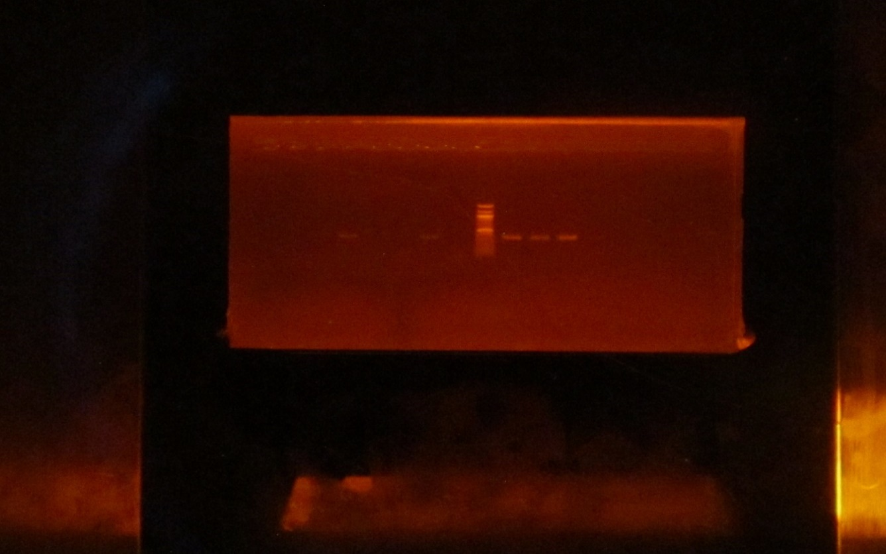

401bp

1500bp

PLATE:1 Agarose gel electrophoresis of Tem gene of some selected bacterial isolates. Lanes 5,8 and 10-12 are the representatives of positive BlaTem gene bands (401bp). Lane represents the 100bp Molecular ladder.

1 2 3 4 5 6 7 8 A 9 10 11 12 13 14 15



Plate: 2 Agarose gel electrophoresis of isolates. Lanes 1,2,4,5,7,8,9,10,13,14 and 15 represent AAC gene bands (490bp). Lane A represents the bacterial 100bp Molecular ladder.

490bp

1500bp

1 2 3 4 5 6 7 8 A 9 10 11 12 13 14 15

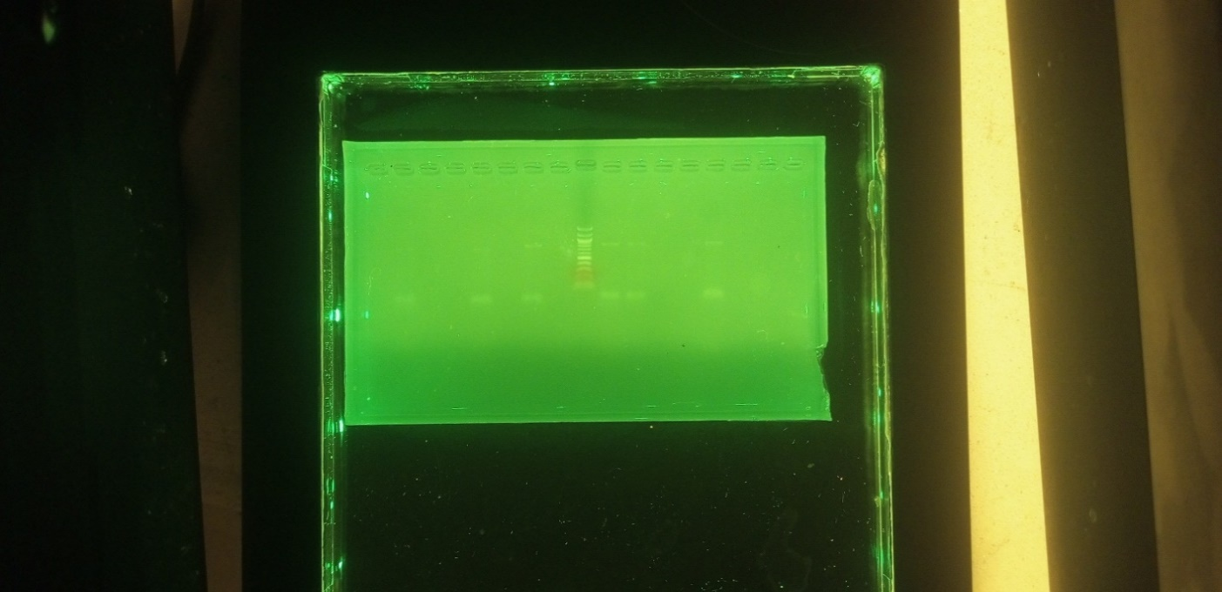

200bp

750bp

PLATE:3 Agarose gel electrophoresis of QNRA gene of bacterial isolates. Lanes 5,7,9,10 and 13 are the representatives of QNRB gene bands (750bp). Lane A represents the 100bp Molecular ladder.

1 2 3 4 5 6 L 7 8 9 10

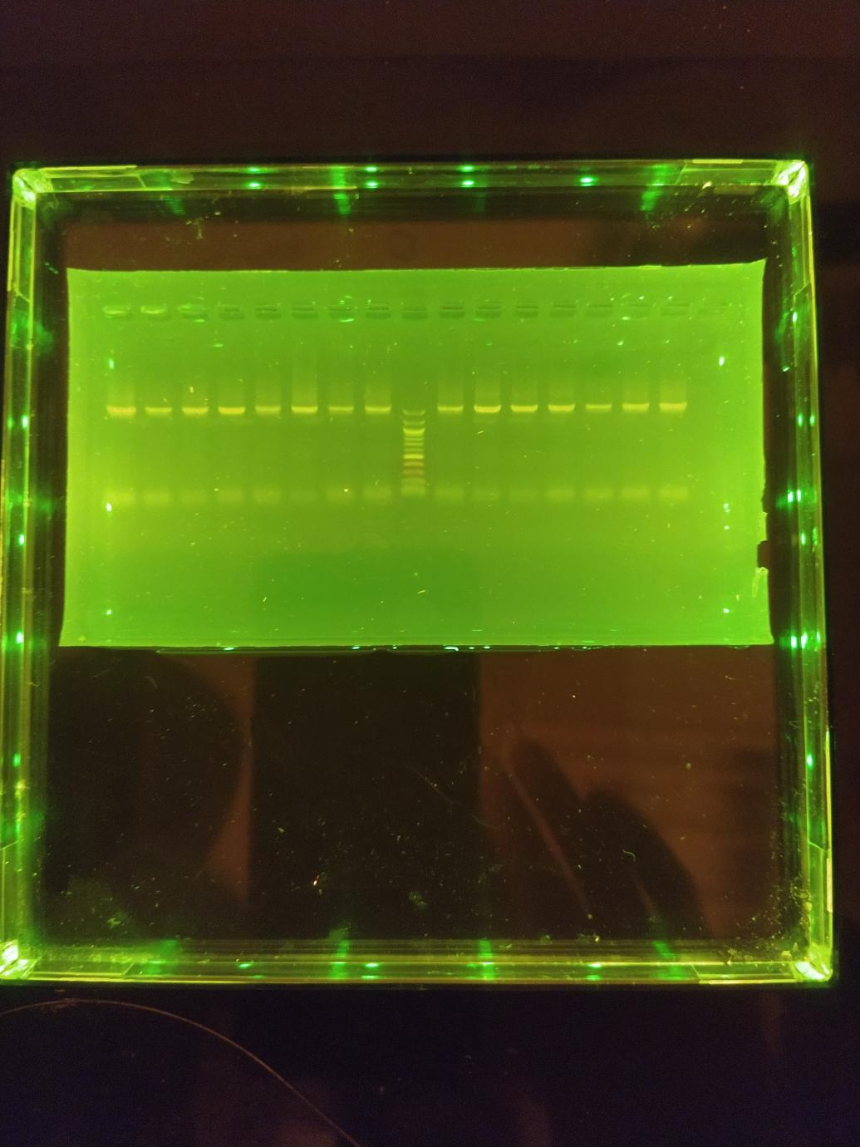

16SrRNA(1500bp)

500bp

Plate 4: Agarose gel electrophoresis showing the amplified 16srRNA. Lanes 1-10 represent the amplified 16srRNA at 1500bp while lane L represents the 100bp DNA ladder.

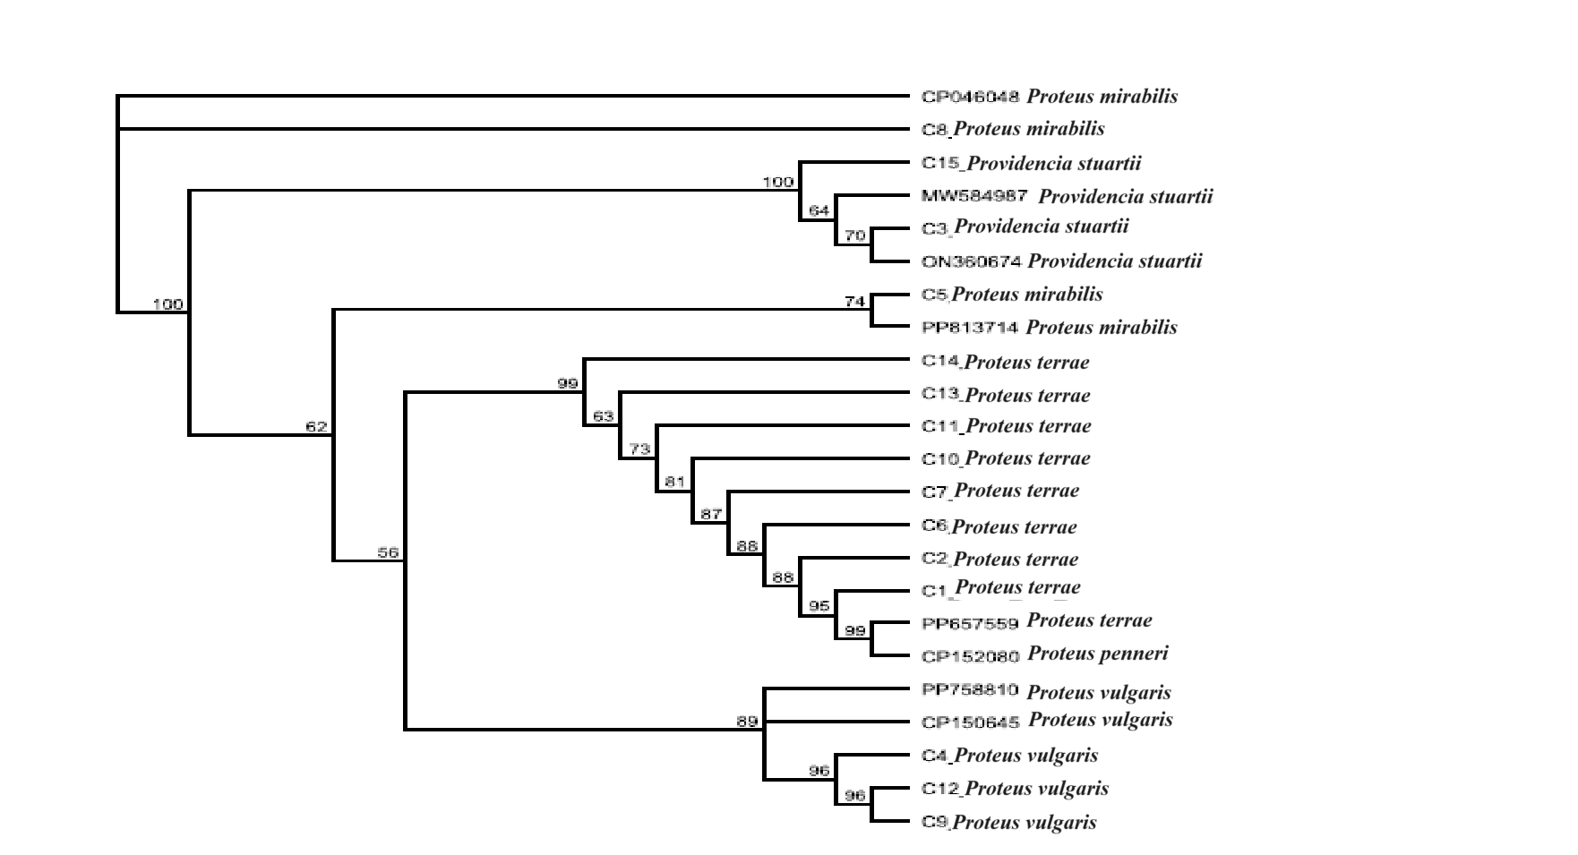

Fig 1: Phylogenetic tree showing the evolutionary relationship between the bacterial isolates

The obtained 16s rRNA sequence from the isolates produced an exact match during the mega blast search for highly similar sequences from the NCBI non-redundant nucleotide (nr/nt) database. The 16S rRNA of the isolates showed a percentage similarity to other species at 100%. The evolutionary distances computed using the Jukes-Cantor method were in agreement with the phylogenetic placement of the 16S rRNA of the isolates within the *Proteus* and *Providencia* sp and revealed a closely relatedness to the *Proteus mirabilis, Proteus vulgaris, Proteus terrae* and *Providencia stuartii* as shown in (Fig. 1).

**DISCUSSION**

Antibiotic susceptibility testing of *Proteus* *mirabilis* across the facilities from the study revealed high (100%) sensitivity to Amikacin (Aminoglycoside) Imipenem, Meropenem (carbapenem) and Piperacillin/ Tazobactam (Ampicillin with β- lactamase inhibitor). This agrees with Codioe *et* *al*. (2018) report that Carbapenems are known to be an effective antimicrobial agent which is used to cure hospital-acquired infections (HAIs). Findings from the study revealed that *Proteus* *mirabilis* was sensitive to a good number of the antibiotics used. This finding support report of Mutair *et* *al*. (2021) that *Proteus spp*. was observed to showed lower resistance to all antimicrobial classes.

The study revealed a high percentage of resistance to tetracycline and nitrofurantoin. This finding aligns with the report by Mirzaei *et* *al*. (2021), which identified *Proteus* *mirabilis* as having a natural resistance to tetracycline, likely contributing to its increasing tolerance. Furthermore, tetracycline resistance in Enterobacteriaceae has been linked to the *tet*(*A*) to *tet*(*E*) gene determinants (Kuleshov *et* *al*., 2021). These genes are primarily associated with efflux mechanism, a common bacterial strategy to expel antibiotics and other toxic substances from the cell. Efflux pumps, integral membrane proteins, actively transport antibiotics out of bacterial cells, reducing intracellular drug concentrations and promoting resistance.

Additionally, efflux resistance genes are frequently located on mobile genetic elements, facilitating their horizontal transfer between bacterial species. Notably, the class A tetracycline resistance (*tet*) determinant, first identified in the RP1/Tn1721 system (Wang *et* *al*., 2017), underscores the critical role of mobile genetic elements in disseminating resistance. These findings highlight the importance of understanding efflux mechanisms and their genetic determinants to combat the rising prevalence of tetracycline resistance.

The antibiotic sensitivity profile of *Proteus* *mirabilis* from Federal Medical Center demonstrated high susceptibility to Amikacin 100%, Imipenem (100%), Gentamycin (85.7%), Meropenem (85.7%) and Piperacillin- tazobactam (85.7%). Similarly, In Benue State University Teaching Hospital, the susceptibility profile showed Meropenem (100%), Imipenem (95.2%), Amikacin (90.5%) and Ciprofloxacin (81.0%). These findings align with Han *et* *al*. (2020), who reported high susceptibility of *P*. *mirabilis* isolates to Imipenem and other antibiotics. Aminoglycosides such as amikacin and gentamycin have also been identified as effective options, despite concerns about resistance and toxicity (Canstanheira et al., 2018; Googlet et al., 2019). Nevertheless, their efficacy against multidrug (MDR) bacteria highlights their continued relevance in clinical practice.

In this study, isolates from the Federal University of Health Science Teaching Hospital Otukpo and General Hospital Katsina Ala exhibited high sensitivity to Meropenem (100%), Imipenem (93.3%), Ciprofloxacin (86.7%) and Amoxicillin (86.7%). This finding aligns with Verpoten *et* *al*. (2018) who noted fluoroquinolones like ciprofloxacin as widely used antibiotics in Western Europe, North America, and Japan, particularly for infections such as postpartum Infections. However, resistance to gentamicin (7.6%) and amoxicillin (7.6%) was observed in isolates from Private Maternity Homes, a result consistent with Mestrovic et al. (2018), who reported resistance rates of 8.4% for *P. mirabilis* to antibiotics including ciprofloxacin, amoxicillin, gentamicin, amoxicillin/clavulanic acid.

Interestingly, resistance rates to imipenem (23.1%) and meropenem (15.4%) in Private Maternity Homes contrast with findings from Bul *et* *al*. (2022) who reported significantly lower resistance rates to imipenem (3.6%) and meropenem (4%) in Iran.

This discrepancy may reflect regional differences in antibiotic use, resistance patterns and infection control practices, emphasizing the need for localized antibiotic stewardship programs to address emerging resistance trends effectively.

The study revealed the molecular detection of TEM, AAC, and qnrA genes in 15 *Proteus* *mirabilis* isolates producing extended-spectrum beta-lactamases (ESBL). Using agarose gel electrophoresis, the qnrA gene was detected in 14(93.3%) of the isolates, while the AAC and TEM genes were identified in all 15(100%) ESBL producing *P.* *mirabilis*. This finding aligns with the report by Varughese *et* *al*. (2018), which highlighted the presence of β-lactamases and broad-spectrum β-lactamases in *Proteus* *mirabilis* with DNA sequence analyses revealing the genetic mutations in clinical isolates. The high prevalence of these genes may be attributed to the quinolone resistance determining regions (QRDRs) which are reported to be highly conserved among the isolates. Furthermore, this study confirms the presence of *blaTEM* genes in both genomes of *P.* *mirabilis.* Specifically, *blaTEM-2* encoding beta-lactamases effective against early cephalosporins and penicillin, was detected. However, these enzymes could not be directly linked to the ESBL phenotype, as noted by Yang *et* *al*. (2020). Additionally, this finding is consistent with Boudiemaa *et* *al*. (2019), who reported that current strains of ESBL producing *P.* *mirabilis* universally harbor the *blaTEM* gene*.* This highlights the continued role of the *blaTEM* in the resistance profiles of ESBL-producing isolates.

The MEGA BLAST analysis of the16S rRNA sequences of the isolates revealed 100% similarity to other closely related species. The evolutionary distance was computed using the Jukes-Cantor method, corroborated the phylogenetic placement of the 16S rRNA sequences within the *Proteus* and *Providencia* genera. The analyses further demonstrated close relatedness to the *Proteus mirabilis, Proteus vulgaris, Proteus terrae* and *Providencia stuartii,* highlighting the genetic similarity and evolutionary relationships among these species.

**CONCLUSION**

The findings of this research underscore the critical role of *Proteus* *species* in postpartum infections, emphasizing the need for targeted surveillance and intervention strategies. The antibiotic susceptibility profiles revealed a concerning pattern of resistance to commonly used antibiotics, underscoring the need for routine antimicrobial stewardship programs to prevent the escalation of resistant strains.

Furthermore, molecular analysis highlighted the genetic relatedness of the isolates, revealing clusters of genetically similar strains within and across the zones. This suggests the possibility of shared sources of infection or common transmission pathways, emphasizing the urgent need for improved infection control measures in maternity clinics.

In summary, the detection of ESBL-producing *Proteus* *mirabilis* in BSUTH signals a pressing need for enhanced infection control measures, improved antimicrobial stewardship, and continued research to mitigate the impact of antibiotic resistance. Potential community spread: if left unchecked, these resistant strains could spread beyond healthcare settings into the community leading to more widespread and harder- to- treat infections. The molecular characterization of isolates revealed notable genetic diversity, suggesting both clonal and non-clonal dissemination of *Proteus* strains within the study population. These results align with global studies that have identified similar genetic patterns in bacterial pathogens implicated in postpartum infections, reflecting the dynamic epidemiology of such infections.

By identifying the genetic relatedness of *Proteus* strains, this study highlights potential pathways for their transmission within maternity clinics, as well as broader implications for infection control practices. The observed clustering of certain genetic types in specific zones suggests localized outbreaks, which may be driven by factors such as inadequate sterilization protocols, poor hygiene practices, or the sharing of medical instruments across patients. The findings provide valuable insights into the distribution and characteristics of *Proteus* *species* implicated in postpartum infections

Ethical approval and Consent

Ethical clearance was collected from Federal Ministry of Health Nigeria or ethical committee of Federal Medical Centre Makurdi, Benue State University Teaching Hospital Makurdi, Federal University of health Science Teaching Hospital Otukpo and General Hospital Katsina Ala. Written informed consent were provided for all eligible participants before enrolment. The participating clinics includes; Federal Medical Centre, General Hospital, Teaching Hospitals and Private Maternity Homes operated by unlicensed midwives in the zones.

Disclaimer (Artificial intelligence)

Option 1:

Author(s) hereby declare that NO generative AI technologies such as Large Language Models (ChatGPT, COPILOT, etc.) and text-to-image generators have been used during the writing or editing of this manuscript.

Option 2:

Author(s) hereby declare that generative AI technologies such as Large Language Models, etc. have been used during the writing or editing of manuscripts. This explanation will include the name, version, model, and source of the generative AI technology and as well as all input prompts provided to the generative AI technology

Details of the AI usage are given below:

1.

2.

3.

**REFERENCES**

Alhumaid, S. Mutair, A.A., Alawi, Z.A., Alzahrani, A.J., *et al.* (2021) Antimicrobial Susceptibility of Gram-Positive and Gram-Negative Bacteria: A 5-Year Retrospective Analysis at a Multi-Hospital Healthcare System in Saudi Arabia. *Annals of Clinical Microbiology and Antimicrobials*, 20, Article No. 43.  
<https://doi.org/10.1186/s12941-021-00450-x>

Admas A, Gelaw B, Worku A, Melese A. Proportion of bacterial isolates, their antimicrobial susceptibility profile and factors associated with puerperal sepsis among post-partum/aborted women at a referral Hospital in Bahir Dar, Northwest Ethiopia. Antimicrob Resist Infect Control 2020; 9(1): 1-10. https:/link.springer.com/article/10.1186/s13756-019-0676-2

Boudjemaa H, Allem R, Fonkou MDM, el Houda Khennouchi NC, Kerkoud M. Molecular drivers of emerging multidrug resistance in *Proteus mirabilis* clinical isolates from Algeria. *J Glob Antimicrob Resist.*2019; 18:249-256.

Bui T, Press CV. Cephalosporin. National Library for Medicine, Bookshelf ID: NBM551517. StatPearls. Publishing LLC.2022. https://www.ncbi.nih.gov/NBK551517/

Castanheira M, Deshpande LM, Woosley LN, Serio AW, Krause KM, Flamm RK. Activity of plazomicin compared with other aminoglycosides against isolates from European and adjacent countries, including *Enterobacteriaceae* molecularly characterized for aminoglycoside-modifying enzymes and other resistance mechanisms. *J Antimicrob Chemother.*2018;73(12):3346-3354.

Codjoe FS, Donkor ES. Carbapenem resistance: a review. *Med Sci.*2018;6(1):1.

Emma Nicholls, Mechelle Renee Akers; Healthline Article Current Version, may 2. 2022. Medically Reviewed by University of Illinois- Chicago.

Goodlet KJ, Benhalima FZ, Nailor MD. A systematic review of single-dose aminoglycoside therapy for urinary tract infection: is it time to resurrect an old strategy? *Antimicrob Agents Chemother.*2019;63(1):e02165-18.

Han P, Luo L, Shahid M, et al. Prevalence, Genetic Diversity and Antimicrobial Resistance of *Proteus mirabilis* Isolated from Dogs Hospitalized in Beijing. *Pak Vet J.* 2020;40(1):61-66.

Kuleshov, K. V., Pavlova, A. S., Shedko, E. D., Mikhaylova, Y. V., Margos, G., Hepner, S., Chebotar, I. V., Korneenko, E. V., Podkolzin, A. T., & Akimkin, V. G. (2021). Mobile Colistin Resistance Genetic Determinants of Non-Typhoid *Salmonella enterica* Isolates from Russia. Microorganisms, 9(12), 2515. https://doi.org/10.3390/microorganisms9122515

Marina Boushra, Omar Rahman vidant; Medical centre Indiana University of Health.: National Library of medicine, National Centre for Biotechnology Information last update July 12. 2022.

Mestrovic T, Lukic-Grlic A, Bogdan M, et al. Molecular Epidemiology of Cephalosporinases and Extended Spectrum β-Lactamases (ESBLs) in *Proteus mirabilis* Isolates From Croatia: Following the Spread of Resistance Determinants Between Long-Term Care Facilities and the Community. *Open Forum Infect Dis.*2018;5(Suppl 1):S363.

Mirzaei, A., Habibi, M., Bouzari, S., & Asadi Karam, M. R. (2019). Characterization of antibiotic susceptibility patterns, virulence factor ptofiles and clonal relatedness in Proteus mirabilis isolates from patients with urinary tract infections in Iran. Infection and drug resistance, 3967-3979. https://www.tandfonline.com/doi/abs10.2147/IDR.S230303.

Mirzaei A, Esfahani BN, Raz A, Ghanadian M, Moghim S. From the Urinary Catheter to the Prevalence of Three Classes of Integrons, β-Lactamase Genes, and Differences in Antimicrobial Susceptibility of *Proteus mirabilis* and Clonal Relatedness with Rep-PCR. *Biomed Res Int.* 2021; 2021:9952769.

Natalia F, Shi SM, Kim DH. Accuracy of diagnosis and health service codes in identifying frailty in Medicare data. BMC Geriatrics 2020, 20: 329. PMID:32894057, PMCID: PMC7487915, DOI:10.1186/s12877-020-01739-w

Varughese LR, Rajpoot M, Goyal S, Mehra R, Chhokar V, Beniwal V. Analytical profiling of mutations in quinolone resistance determining region of gyrA gene among UPEC. *PLoS One.* 2018;13:e0190729.

Versporten A, Zarb P, Caniaux I, et al. Antimicrobial consumption and resistance in adult hospital inpatients in 53 countries: results of an internet-based global point prevalence survey. *Lancet Glob Health.* 2018;6(6):e619-e629.

Wang S, Gao X, Gao Y,et al. Tetracycline resistance genes identified from distinct soil environments in China by functional metagenomics. *Front microbial.*2017;8:1406.

Yang JH, Sheng WH, Hsueh PR. Antimicrobial susceptibility and distribution of extended-spectrum β-lactamases, AmpC β-lactamases and carbapenemases among *Proteus, Providencia* and *Morganella*isolated from global hospitalised patients with intra-abdominal and urinary tract infections: Results of the Study for Monitoring Antimicrobial Resistance Trends (SMART), 2008-2011. *J Glob Antimicrob Resist.* 2020;22:398-407.