# Case Report

# Fetal Goiter: Ultrasound Diagnosis- A Case Report

## Abstract

Fetal goiter is a rare condition characterized by abnormal enlargement of the fetal thyroid gland and can be associated with hypo- or hyperthyroidism. This article presents the case of a 27-year-old patient with a history of Graves’ disease, with her last thyroid function test with elevated T3 in blood, T4 within normal ranges and a lowered TSH and anti-thyroid hormone intake (Propylthiouracil) during the first trimester, unaware of her pregnancy. At 29.3 weeks of gestation, an ultrasound revealed a heterogeneous mass in the fetal neck with peripheral vascularity, consistent with fetal goiter. Growth restriction was also noted, the case was followed up by two endocrinologists, but, for economic reasons, the patient forfeits the treatment within two weeks of the beginning.  
  
Fetal goiter is a rare condition, seen in 1 of 50,000 of newborns, The main causes include genetic mutations, maternal autoimmune conditions, and the use of antithyroid drugs during pregnancy. This condition can severely impair fetal development, leading to mechanical complications (such as asphyxia) and metabolic abnormalities (such as mental retardation or heart failure). Prenatal diagnosis through ultrasound is essential, as it allows early treatment planning and prevents severe neonatal complications.  
  
The study concludes that obstetric ultrasound plays a vital role in the early detection of fetal goiter and associated malformations. Accurate evaluation can guide therapeutic interventions and minimize risks during pregnancy and delivery.

**Keywords**

Congenital syndromes, Thyroid, Fetal goiter, Graves' disease, Obstetric ultrasound.

## Introduction

Goiter is defined as the generalized enlargement of the thyroid gland, which may be accompanied by hormonal disorders such as increased or decreased thyroid hormone levels in the blood[1].  
  
In the fetus, goiter manifests as disruption in proper thyroid function. A decrease in thyroid hormone synthesis results in increased thyroid-stimulating hormone (TSH)[2], a process known as dyshormonogenesis.  
  
Genetic alterations are the second leading cause of the condition, involving mutations in TSH receptors[3], which generate antibodies that block thyroid stimulation (TSAb). These mutations often involve substitution of essential amino acids, most frequently serine to asparagine at position 281[3], leading to gain-of-function mutations that block TSH action in the thyroid parenchyma[4], causing central hypothyroidism and morphological thyroid changes in the mother, causing a T3 diminution in the fetus, the regulatory mechanisms will hypertrophy the thyroid gland, with the intent of elevate the production of thyroid hormone in the fetus[4].   
  
The third cause is pregnancy-related changes; human chorionic gonadotropin act similar with maternal TSH, increasing thyroid hormone-binding globulin levels, which leads to a sudden rise in free T4 and a drop in TSH[5]. In some cases, mothers may develop Graves' disease due to excess thyroid hormone production and TSH suppression. Volumenie et al. (2000)[6] found that thyroid-stimulating immunoglobulins can cross the placenta, altering fetal thyroid function. A second cause is the use of antithyroid medications during pregnancy, which also cross the placenta and inhibit fetal thyroid function[7].  
  
Fetal goiter is rare, occurring in approximately 1 in 50,000 live births[8], and may cause mechanical (e.g., neck structure compression, asphyxia, polyhydramnios)[9] and metabolic complications (e.g., heart failure, poor brain development, growth restriction)[10].  
  
Diagnosis is typically made postnatally, but fetal ultrasound is an essential tool for early detection. Key ultrasound findings include thyroid enlargement and altered vascularity on color Doppler [11].

## Case Presentation

This case involves a 27-year-old female with two prior anembryonic pregnancies and a history of Graves’ disease, with her last thyroid function test (TFT) with elevated T3 in blood, T4 within normal ranges and a lowered TSH, who took anti-thyroid treatment (propylthiouracil) during the first trimester, unaware of her pregnancy. The second-trimester ultrasound was the first performed during the entire pregnancy.  
  
At 29.3 weeks gestation, the femur measured 5.0 cm, corresponding to 27.1 weeks (Fig. 1), suggesting growth restriction.

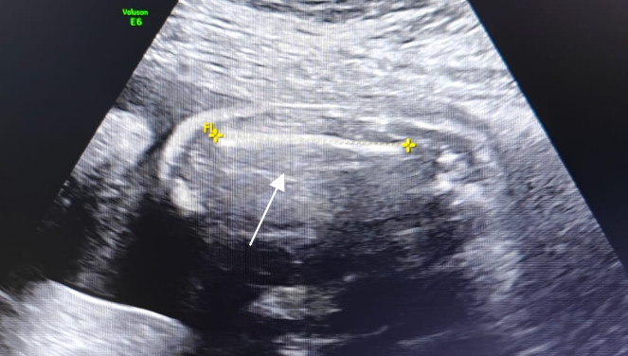

Figure 1 Grayscale ultrasound image showing the femur in a longitudinal plane with a measurement of 5.0 cm ( ), corresponding to a gestational age of 27.1 weeks.

Continued fetal examination revealed a heterogeneous mass in the neck with peripheral vascularity on color Doppler (Fig. 2), displacing cervical structures.

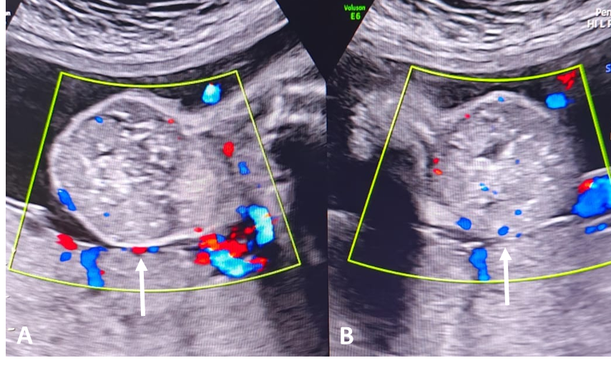

**Figure 2** Color Doppler ultrasound images showing a heterogeneous mass located on the lateral portion of the neck ( ), with peripheral vascularity evident on Doppler in coronal (A) and axial plane (B).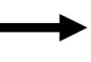

Axial and sagittal views showed the mass shifted laterally, without compressing vascular structures, trachea, or esophagus (Fig. 3).

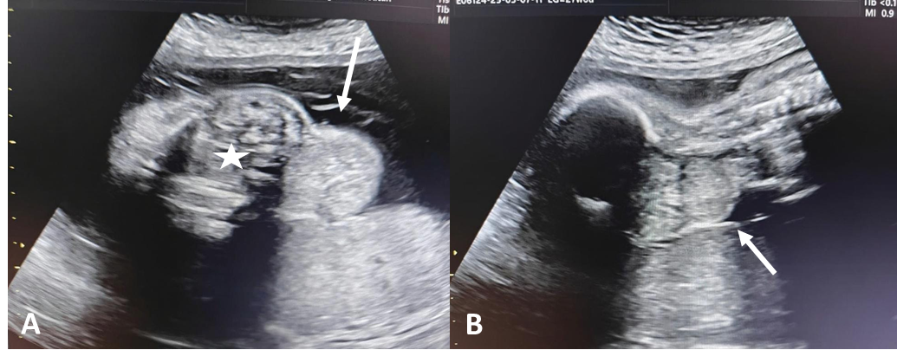

**Figure 3** Grayscale ultrasound shows two images, A in sagittal plane and B in axial plane, demonstrating a lesion ( ) on the lateral portion of the neck that does not cause compression of the neck structures ( ).

The final diagnosis was fetal growth restriction associated with fetal goiter. The patient was referred to an endocrinology specialist.

## Discussion

The main risk factor for fetal thyroid abnormalities is maternal autoimmune disease, producing antibodies that damage thyroid parenchyma[6]. Thyroid hormones are essential for fetal development, including stature, structural integrity, and metabolic functions, especially in the central nervous system. Thyroid hormone deficiency affects GABAergic receptor development and the growth of axons and dendrites in cholinergic cells, Purkinje cells, and pyramidal neurons in the motor cortex[12].  
  
More severe alterations include disruption of communication tracts in the corpus callosum, affecting commissural layers II and III and the primary auditory cortex[13].  
  
Mental capacity impairment and, in severe cases, hearing disorders are the main manifestations. Infants with low thyroid hormone levels at birth are more likely to develop schizophrenia later in life [14].

It’s important to evaluate the mother and fetal growth during pregnancy, as stated by Delay et all (2020), requiring the evaluation of an endocrinologist, accentuating the relevance of the TFT as the primal evaluator in the disease, evaluation of the poor/positive response to treatment, using it at least once a month in these cases [15]. Also, gynecology evaluation of the mother and fetus is the standard of follow up in these patients, utilizing an echography expert for fetal growth [16].

## Conclusions

The importance of obstetric ultrasound in patients with thyroid hormone abnormalities lies in early detection of central nervous system malformations and thyroid anomalies. Early diagnosis allows planning of interventions to prevent asphyxia in cases of obstructive goiter, treatment to reduce developmental sequelae, and monitoring of fetal growth restriction.

Disclaimer (Artificial intelligence)

Author(s) hereby declares that NO generative AI technologies such as Large Language Models (ChatGPT, COPILOT, etc.) and text-to-image generators have been used during the writing or editing of this manuscript.

## References

1.- Hughes K, Eastman C. Goitre - causes, investigation and management. Aust Fam Physician. 2012 Aug;41(8):572-6. PMID: 23145396.  
2.- Davidson KM, Richards DS, Schatz DA, Fisher DA. Successful in utero treatment of fetal goiter and hypothyroidism. N Engl J Med 1991;324:543–6.  
3.- Kleinau G, Vassart G. TSH Receptor Mutations and Diseases. [Updated 2017 Jul 24]. In: Feingold KR, Ahmed SF, Anawalt B, et al., editors. Endotext [Internet]. South Dartmouth (MA): MDText.com, Inc.; 2000-. Available from: https://www.ncbi.nlm.nih.gov/books/NBK279140/  
4.- Winkler F, Kleinau G, Tarnow P, et al. A new phenotype of nongoitrous and nonautoimmune hyperthyroidism caused by a heterozygous thyrotropin receptor mutation in transmembrane helix 6. The Journal of clinical endocrinology and metabolism 2010; 95:3605-3610  
5.- Brent GA. Función tiroidea materna: interpretación de las pruebas de función tiroidea durante el embarazo. Clin Obstet Gynecol. 1997;40:3–15. doi: 10.1097/00003081-199703000-00004.  
6.- Volumenie JL, Polak M, Guibourdenche J, Oury JF, Vuillard E, Sibony O. Manejo del bocio tiroideo fetal: informe de 11 casos en una sola unidad perinatal. Prenat Diagn. 2000;20:799–806. doi: 10.1002/1097-0223(200010)20:10<799::aid-pd925>3.0.co;2-v.  
7.- Luton D, Le Gac I, Vuillard E, Castanet M, Guibourdenche J, Noel M, Toubert ME, Léger J, Boissinot C, Schlageter MH, Garel C, Tébeka B, Oury JF, Czernichow P, Polak M. Management of Graves’ disease during pregnancy: the key role of fetal thyroid gland monitoring. J Clin Endocrinol Metab. 2005;90:6093–6098. doi: 10.1210/jc.2004-2555.  
8.- Saini A, Reddy MM, Panchani R, Varma T, Gupta N, Tripathi S. Two cases of fetal goiter. Indian J Endocrinol Metab 2012;16(Suppl 2):S358–60.  
9.- Kurtoglu S, Ozdemir A. Fetal neonatal hyperthyroidism: diagnostic and therapeutic approachment. Turk Pediatri Ars 2017;52(1):1–9.  
10.- Corda, V., Peddes, C., Iuculano, A. and Monni, G. (2021) Prenatal Diagnosis and Management of Fetal Goiter Treated Successfully with Intra-Amniotic Levothyroxine. Open Journal of Obstetrics and Gynecology, 11, 48-52. https://doi.org/10.4236/ojog.2021.111006.  
11.- Abuhamad AZ, Fisher DA, Warsof SL et-al. Antenatal diagnosis and treatment of fetal goitrous hypothyroidism: case report and review of the literature. Ultrasound Obstet Gynecol. 1995;6 (5): 368-71. doi:10.1046/j.1469-0705.1995.06050368.  
12.- Dusart I, Flamant F. Profound morphological and functional changes of rodent Purkinje cells between the first and the second postnatal weeks: a metamorphosis? Front Neuroanat. 2012;6:11.  
13.- Goodman J. H., Gilbert M. E. (2007). Modest thyroid hormone insufficiency during development induces a cellular malformation in the corpus callosum: a model of cortical dysplasia. Endocrinology 148 2593–2597. 10.1210/en.2006-1276  
14.- Melamed S. B., Farfel A., Gur S., Krivoy A., Weizman S., Matalon A., et al. (2020). Thyroid function assessment before and after diagnosis of schizophrenia: a community-based study. Psychiatry Res. 293:113356. 10.1016/j.psychres.2020.113356  
15.- Delay, Fabienne; Dochez, Vincent; Biquard, Florence; Cheve, Marie-Thérèse; Gillard, Philippe; Arthuis, Chloe; Winer, Norbert . (2018). Management of fetal goiters : 6-year retrospective observational study in three prenatal diagnosis and treatment centers of the Pays de Loire perinatal network. The Journal of Maternal-Fetal & Neonatal Medicine, (), 1–191. doi:10.1080/14767058.2018.1555803  
16.- Ceccaldi PF, Cohen S, Vuillard E et al. Correlation between colored doppler echography of fetal thyroid goiters and histologic study. Fetal Diagn Ther 2010; 27:233-235.