Original Research Article

Diagnostic Utility of Lipid Indices for Detecting MASLD in Patients with Metabolic Syndrome

|  |
| --- |
| **ABSTRACT : Background:** Metabolic Dysfunction-Associated Steatotic Liver Disease (MASLD) is a prevalent hepatic manifestation of metabolic syndrome and is emerging as a leading cause of chronic liver disease globally. Early detection is essential for effective risk stratification and intervention. Lipid abnormalities – especially elevated triglycerides - are central to MASLD pathophysiology and may serve as cost-effective, non-invasive diagnostic indicators.  **Objectives:** To evaluate the clinical utility of lipid parameters and lipid-derived indices in predicting the presence and severity of MASLD in adults with metabolic syndrome.  **Methodology:** A prospective observational study was conducted at a tertiary care hospital in 2024. A total of 110 adult patients with metabolic syndrome were enrolled. Anthropometric data, fasting lipid profiles, liver enzymes, glucose metabolism markers and derived indices (TG/HDL, TG/LDL, TG/Total Cholesterol, HDL/LDL and TyG index) were assessed. Abdominal ultrasonography was used to classify MASLD severity . Statistical analyses included ROC curves, Pearson correlation, t-tests and chi-square tests were done.  **Results:** Triglyceride levels were significantly higher in patients with MASLD (median 112.00 vs. 92.00 mg/dL, *p* = 0.0001), whereas HDL, LDL and total cholesterol showed no significant differences. ROC analysis indicated that the TG/Total Cholesterol ratio had the highest discriminative power (AUC = 0.70, *p* < 0.001), followed by TG/HDL (AUC = 0.64, *p* = 0.010), TyG index (AUC = 0.64, *p* = 0.007) and TG/LDL (AUC = 0.63, *p* = 0.016). The HDL/LDL ratio was not predictive (AUC = 0.46, *p* = 0.484).  **Conclusion:** Triglyceride-based indices- especially TG/Total Cholesterol and TG/HDL, demonstrate strong potential as non-invasive predictors of MASLD. These markers may complement imaging tools and support early screening in metabolic syndrome patients, enhancing timely intervention and clinical outcomes.  **Keywords:** MASLD; Nonalcoholic Fatty Liver Disease; Triglycerides; Lipid Profile; TG/HDL Ratio; TyG Index; Ultrasound; Metabolic Syndrome; ROC Curve; Predictive Biomarkers |

# INTRODUCTION

Metabolic Dysfunction-Associated Steatotic Liver Disease (MASLD) - formerly known as non-alcoholic fatty liver disease (NAFLD) - has rapidly emerged as a major global public health concern.1,2 This disease is characterized by hepatic steatosis in individuals with underlying metabolic dysfunction.3,4 MASLD represents the hepatic manifestation of metabolic syndrome and is now recognized as the most common chronic liver disease worldwide.5,6 The global prevalence of MASLD is estimated to exceed 25%; significant regional variations have been observed depending on the burden of obesity, insulin resistance and other metabolic risk factors.7 In countries with rising rates of type 2 diabetes, hypertension and central obesity, MASLD has become increasingly prevalent and is now considered a leading cause of liver-related morbidity and mortality.8,9

MASLD encompasses a spectrum of liver disease ranging from simple steatosis to Metabolic Dysfunction-Associated Steatohepatitis (MASH).10 MASH may progress to fibrosis, cirrhosis and hepatocellular carcinoma.11,12 While liver biopsy remains the gold standard for diagnosis and staging, it is invasive, costly and not feasible for routine screening.13,14 Non-invasive imaging modalities such as ultrasound, transient elastography and magnetic resonance-based techniques are commonly employed.15 Access to these technologies may be limited - especially in resource-constrained settings.16 Hence there is a critical and growing need for simple and affordable biochemical markers that can provide early detection and stratification of MASLD severity.17

Among the various metabolic derangements implicated in MASLD, dyslipidemia is particularly noteworthy. Abnormal lipid metabolism is central to the pathophysiology of hepatic steatosis. Elevated serum triglycerides, reduced high-density lipoprotein (HDL) cholesterol and increased low-density lipoprotein (LDL) cholesterol are frequently observed in individuals with MASLD.18 These lipid abnormalities not only reflect the underlying metabolic dysfunction but may also serve as potential indicators of hepatic involvement. In recent years, several lipid-derived indices such as the triglyceride-to-HDL ratio (TG/HDL), LDL/HDL ratio, non-HDL cholesterol and the triglyceride-glucose (TyG) index have been proposed as surrogate markers for insulin resistance and hepatic fat accumulation.19 In spite of multiple studies on this topic, the clinical utility of these lipid indices in diagnosing and assessing MASLD remains uncertain.20,21 Previous studies have yielded promising but inconsistent results and few have compared multiple lipid parameters within the same population cohort. There is limited data exploring the relationship between these indices and the severity of MASLD as graded by ultrasound findings. Given the increasing burden of MASLD and its strong association with metabolic risk factors , reliable and accessible lipid- based markers could optimize screening and early intervention.22 Our study aimed to evaluate the role of lipid parameters and derived indices in predicting the presence and severity of MASLD in adults with metabolic syndrome. By correlating clinical, biochemical and ultrasound findings - this research sought to determine whether commonly available lipid tests can serve as practical tools for MASLD detection. Deriving such correlations could support more widespread and cost-effective screening strategies - especially in primary care and high-risk populations.

# METHODOLOGY

This study was designed as a prospective observational study conducted at a tertiary care hospital. The primary objective was to evaluate the clinical utility of lipid parameters in predicting the presence and severity of Metabolic Dysfunction-Associated Steatotic Liver Disease (MASLD). The study was conducted over the duration of one year and included adult patients attending the General Outpatient Department (OPD) who were previously diagnosed with metabolic syndrome.

A total of 110 participants were enrolled in the study using a purposive sampling method based on predefined inclusion and exclusion criteria. Inclusion criteria comprised adults aged 18 years and above who fulfilled diagnostic criteria for metabolic syndrome, were willing to undergo lipid profile testing and abdominal ultrasonography and had no prior history of chronic liver disease. Exclusion criteria included individuals with alcohol intake more than a standard drink, known liver or biliary diseases, recent infections, muscle injury, autoimmune diseases, thyroid disorders and secondary causes of diabetes or hypertension. Patients using steroids, hepatotoxic drugs, chemotherapy and those with familial dyslipidemia were also excluded.

After obtaining written informed consent, participants underwent a comprehensive clinical evaluation that included a clinical assessment questionnaire and anthropometric measurements. Blood samples were collected after an overnight fast to assess biochemical and metabolic parameters. These included a full lipid profile (total cholesterol, low-density lipoprotein [LDL], high-density lipoprotein [HDL], triglycerides), Liver function tests, fasting blood glucose and glycated haemoglobin (HbA1c) .Lipid-derived indices such as TG/HDL ratio, LDL/HDL ratio, non-HDL cholesterol and the triglyceride-glucose (TyG) index were calculated.

Abdominal ultrasonography was used to assess the presence and severity of MASLD. The ultrasound evaluation was conducted by trained radiologists using standardized criteria to grade hepatic steatosis on a scale of 0 to 3 based on echogenicity, liver-to-kidney contrast, deep beam attenuation, vessel wall visibility and gallbladder wall definition. The grading system used was as follows: Grade 0 indicated normal liver echogenicity, Grade 1 denoted mild fatty infiltration, Grade 2 represented moderate steatosis and Grade 3 indicated severe steatosis with poor visualization of intrahepatic vessels.

Data were entered into IBM SPSS Statistics for Windows, Version 20.0 (IBM Corp., Armonk, NY, USA). Continuous variables were summarized using means with standard deviations or medians with interquartile ranges depending on data distribution, which was assessed using the Kolmogorov–Smirnov test. Independent sample t-tests and Mann–Whitney U tests were used for group comparisons. Categorical variables were expressed as frequencies and percentages and analyzed using the Chi-square test.

To assess associations between lipid parameters and MASLD severity, Pearson’s correlation coefficient was used. Diagnostic performance of lipid indices in predicting MASLD was evaluated using Receiver Operating Characteristic (ROC) curve analysis, with area under the curve (AUC) values calculated for TG/HDL, TG/LDL, HDL/LDL, TG/Total Cholesterol and TyG index. A p-value of less than 0.05 was considered statistically significant for all analyses and AUC value of 1.0 indicates good discrimination between diseased and non-diseased.

# RESULTS

**Participant Characteristics:** A total of 110 participants were enrolled in the study, comprising 52 females and 51 males. The mean age did not differ significantly between participants with fatty liver and those without (58.33 ± 13.34 vs. 56.23 ± 14.22 years; *p* = 0.4694). As shown in **Table 1**, there were no significant differences in height, weight, or BMI between the two groups.

# Table 1 - Baseline Demographics and Clinical Characteristics

|  |  |  |  |
| --- | --- | --- | --- |
| **Parameter** | **No Fatty Liver** | **Fatty Liver** | **P-Value** |

|  |  |  |  |
| --- | --- | --- | --- |
| Age | 56.23 ± 14.22 | 58.33 ± 13.34 | 0.4694 |
| Height | 1.65 ± 0.09 | 1.66 ± 0.09 | 0.4924 |
| Weight | 72.54 ± 10.03 | 75.44 ± 9.72 | 0.1637 |
| BMI | 26.60 ± 2.32 | 27.38 ± 3.35 | 0.1609 |
| Waist Circumference | 89.43 ± 5.25 | 92.87 ± 4.85 | 0.0019 |
| WBC Count | 7.11 ± 1.78 | 7.04 ± 1.55 | 0.8515 |
| Haemoglobin | 13.00 (12.00 - 13.00) | 13.00 (11.40 - 13.20) | 0.9024 |
| Platelet | 252.83 ± 60.67 | 268.16 ± 73.06 | 0.2572 |
| CRP | 3.00 (0.95 - 7.50) | 2.25 (1.00 - 6.75) | 0.9763 |
| ESR | 25.00 ± 18.16 | 24.52 ± 18.79 | 0.9115 |
| Fasting Glucose | 122.73 ± 34.09 | 120.96 ± 45.41 | 0.8267 |
| HbA1c | 6.00 (5.50 - 7.65) | 6.20 (5.67 - 7.03) | 0.3995 |
| MPV | 10.10 (9.55 - 10.65) | 9.60 (8.96 - 10.50) | 0.0536 |

Waist circumference was significantly higher in participants with fatty liver (92.87 ± 4.85 cm) compared to those without (89.43 ± 5.25 cm), with a *p*-value of 0.0019. This supports the association between central adiposity and the presence of MASLD, in line with its established link to metabolic syndrome.19,26

Among lipid parameters, triglyceride levels were significantly elevated in the fatty liver group (median 112.00 vs. 92.00 mg/dL, *p = 0.0001*), while total cholesterol, HDL and LDL levels did not show statistically significant differences. This highlights triglycerides as a potential distinguishing factor.

# Table 2 - Lipid & Biochemical Profile Comparison

|  |  |  |  |
| --- | --- | --- | --- |
| **Parameter** | **No Fatty Liver** | **Fatty Liver** | **P-Value** |
| HDL | 41.38 ± 17.14 | 45.42 ± 14.53 | 0.2092 |
| LDL | 105.19 ± 40.56 | 108.50 ± 36.50 | 0.6853 |
| Triglycerides | 92.00 (66.50 - 115.50) | 112.00 (99.75 - 170.50) | 0.0001 |
| Total Cholesterol | 173.64 ± 40.33 | 171.71 ± 39.86 | 0.8169 |
| AST | 21.00 (18.00 - 27.50) | 23.00 (18.00 - 30.40) | 0.4107 |
| ALT | 21.00 (17.00 - 30.00) | 25.50 (18.00 - 38.12) | 0.1013 |

**Figure 1 - Lipid & Biochemical Profile Comparison (Mean values)**

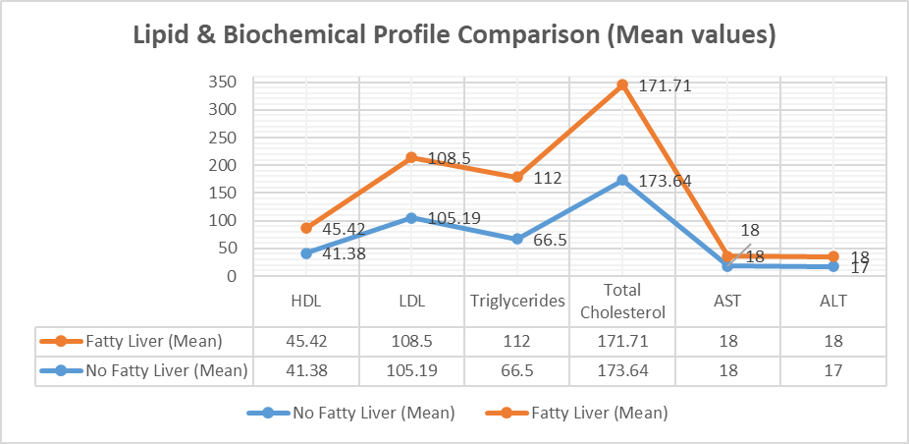

Liver enzymes such as **ALT and AST**, while slightly higher in the fatty liver group, also failed to reach statistical significance (*p* = 0.1013 and 0.4107, respectively), indicating that biochemical liver dysfunction may not be pronounced in early or moderate stages of MASLD. Other metabolic markers, including fasting glucose and HbA1c, were not significantly different between groups. These findings support the hypothesis that **triglyceride elevation** - especially when interpreted through derived ratios (as explored further in ROC analysis), may provide added clinical value in MASLD risk assessment beyond standard lipid or glucose metrics.

**ROC Curve Analysis for Lipid Indices:** To assess the diagnostic utility of lipid-derived indices in predicting MASLD, a Receiver Operating Characteristic (ROC) analysis was performed. The results demonstrated that the TG/Total Cholesterol ratio had the highest discriminative ability, with an area under the curve (AUC) of 0.70 (p < 0.001), indicating acceptable diagnostic accuracy. This was followed by the TG/HDL ratio (AUC = 0.64, p = 0.010), the TyG index (AUC = 0.64, p = 0.007) and the TG/LDL ratio (AUC = 0.63, p = 0.016), all of which showed statistically significant predictive value for MASLD.

# Table 3 - Predictive accuracy metrics of Lipid Ratios

|  |  |  |  |
| --- | --- | --- | --- |
| **Parameter** | **AUC** | **Standard Error** | **P-Value** |
| TG/HDL | 0.64 | 0.054 | 0.01 |
| TG/LDL | 0.63 | 0.055 | 0.016 |
| HDL/LDL | 0.46 | 0.06 | 0.484 |
| TG/Total Cholesterol | 0.7 | 0.051 | 0 |
| TyG Index | 0.64 | 0.054 | 0.007 |

In contrast, the HDL/LDL ratio exhibited an AUC of only 0.46 (p = 0.484), suggesting no significant diagnostic capability. These findings highlight the superior performance of triglyceride-based indices—particularly TG/Total Cholesterol and TG/HDL ratios—as potential non-invasive tools for identifying individuals at risk for MASLD.

# Figure 2 - ROC Curve for Lipid Indices

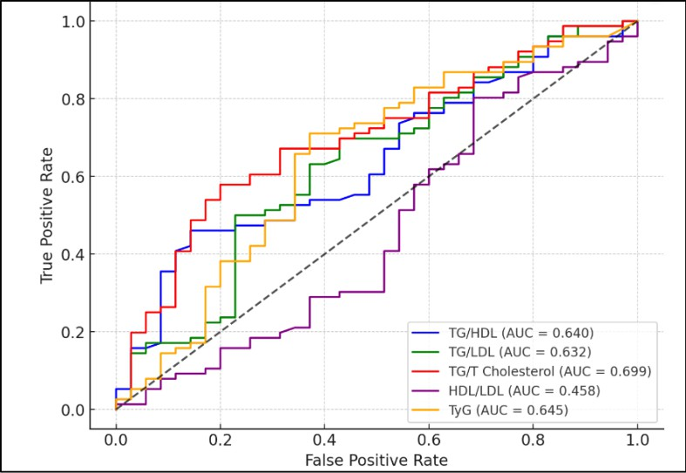

These results suggest that triglyceride-based ratios are more effective in predicting fatty liver than cholesterol ratios alone. The results align with the study's primary objective of evaluating the clinical utility of lipid parameters in predicting the presence and severity of MASLD.

A statistically significant association was observed between gender and fatty liver grades, as determined by the Chi-square test (χ² = 27.68, *p* = 0.00108). As shown in **Table 4**, females comprised a larger proportion of the no- fatty liver group (62.86%), while males were increasingly represented in higher grades of fatty liver.

# Table 4 - Fatty Liver Grades by Gender

|  |  |  |  |  |
| --- | --- | --- | --- | --- |
| **Grade** | **Female (Count)** | **Male (Count)** | **Female (%)** | **Male (%)** |
| 0 (No Fatty Liver) | 22 | 13 | 62.86% | 37.14% |
| "1" | 25 | 30 | 42.37% | 50.85% |
| "2" | 5 | 6 | 33.33% | 40.00% |
| "3" | 0 | 2 | 0.00% | 100.00% |

**Figure 3 - Fatty Liver Grades by Gender (%)**

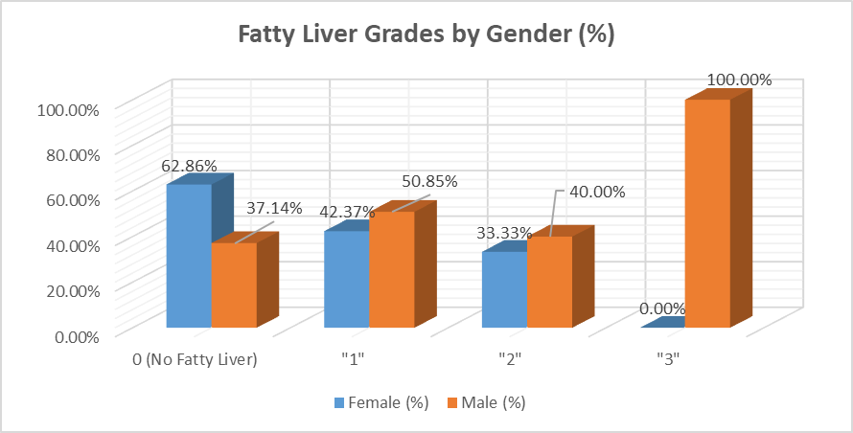

Notably, 100% of participants classified as grade 3 were male and males also outnumbered females in grade 1 and grade 2 categories. This trend is visually depicted in **Figure 3**, which illustrates the distribution of fatty liver severity across genders.

# DISCUSSION

In our previous study, we evaluated the diagnostic accuracy of non-invasive scores for MASLD based on general clinical parameters.26 Building on that ,the current study aimed to evaluate the clinical utility of lipid parameters in predicting the presence of Metabolic Dysfunction-Associated Steatotic Liver Disease (MASLD). Our findings demonstrate a clear association between certain lipid markers—particularly triglyceride levels and triglyceride-derived indices—and the presence of hepatic steatosis. These results support the existing evidence suggesting that lipid metabolism plays a key role in the pathogenesis of MASLD; and further that specific lipid indices may serve as cost- effective, non-invasive tools for its detection and risk stratification.

Consistent with prior research, central obesity emerged as a significant factor associated with fatty liver.26 While overall anthropometric measures such as weight, BMI and height did not differ significantly between participants with and without fatty liver, waist circumference was markedly higher in the MASLD group (p = 0.0019). This supports previous studies linking visceral adiposity to hepatic fat accumulation, independent of general obesity metrics. Central obesity is a well-established driver of insulin resistance and metabolic dysregulation—key mechanisms implicated in MASLD development.11

Among the lipid parameters, triglyceride levels were significantly elevated in participants with fatty liver compared to those without (p = 0.0001), while HDL, LDL and total cholesterol did not show meaningful differences. These results align with existing literature where hypertriglyceridemia is frequently reported as a hallmark of hepatic steatosis. However, the lack of difference in total cholesterol and LDL levels further emphasizes that simple lipid panel components, while informative, may not be sufficient in isolation for MASLD screening.

To explore this further, we examined the predictive performance of various lipid-derived indices using ROC curve analysis. The TG/Total Cholesterol ratio emerged as the strongest predictor with an AUC of 0.70 (p < 0.001), indicating acceptable discriminative power. This was followed by the TG/HDL ratio (AUC = 0.64), TyG index (AUC = 0.64) and TG/LDL ratio (AUC = 0.63), all of which were statistically significant. These findings suggest that ratios incorporating triglycerides offer enhanced diagnostic utility over traditional lipid values alone.

The superior performance of the TG/Total Cholesterol and TG/HDL ratios aligns with previous studies that have identified these indices as surrogate markers of insulin resistance and hepatic fat deposition. The TyG index, which incorporates both triglycerides and fasting glucose, has similarly gained traction as a reliable indicator of metabolic liver disease in diverse populations.

The HDL/LDL ratio did not exhibit significant predictive value (AUC = 0.46, p = 0.484), suggesting that this index may have limited applicability in the context of MASLD diagnosis. This is not entirely surprising, as both HDL and LDL are less directly reflective of hepatic lipid handling or insulin resistance compared to triglycerides. Hepatic fat buildup is influenced by a range of factors—like de novo lipogenesis, free fatty acid uptake, and reduced fat export—along with obesity, insulin resistance, dietary habits, and even genetics. Even when LDL/HDL levels are normal, patients can still have significant liver fat and underlying metabolic dysfunction, which means relying solely on these values might miss early or hidden disease.1

Another important finding from our study was the association between gender and fatty liver severity. While females were more prevalent in the non-fatty liver group, males dominated the higher steatosis grades. This sex-based distribution was statistically significant (χ² = 27.68, p = 0.00108), suggesting that male gender may confer a higher risk of advanced MASLD. Males are often more susceptible to its progressive forms.

Despite the insights offered by this study, some limitations must be acknowledged. First, the study was observational in nature, limiting causal inference. Second, while ultrasound is widely used for fatty liver assessment, it is operator-dependent ,however effort was made to minimize errors. Finally, although several lipid ratios showed predictive promise, the AUC values are modest and further validation in larger, more diverse populations is needed.

Flores et al. (2021) studied the association between serum lipid profiles and nonalcoholic fatty liver disease (NAFLD) in a high-risk Mexican population. This nested case-control study included 98 clinically confirmed NAFLD cases and 100 healthy controls. The results showed significantly elevated serum triacylglycerols and reduced lysophosphatidylcholines and cholesterol esters in NAFLD cases; a panel of 10 lipid species predicted NAFLD status with an AUC of 0.83 after adjusting for age, sex, BMI and PNPLA3 genotype. The study concluded that specific alterations in serum lipid composition—especially increased saturated TAGs and decreased LPCs and CEs—may serve as non-invasive biomarkers for NAFLD detection and risk stratification in Latino populations.23

Wu et al. (2023) studied hepatic lipidomic alterations and their association with fibrosis severity in morbidly obese patients with nonalcoholic steatohepatitis (NASH). This prospective cohort study included 60 patients undergoing laparoscopic sleeve gastrectomy; wedge liver biopsies were performed during surgery and patients were classified into two groups based on fibrosis stage (F0–F1 vs. F2–F4).

The study concluded that specific hepatic lipid species are associated with fibrosis severity in NASH which supports their potential utility as biomarkers in predictive models for advanced liver disease in morbid obesity.19

Wang et al. (2022) reviewed the dual role of nonalcoholic fatty liver disease (NAFLD) and its pharmacological treatments on lipid profiles and atherosclerotic cardiovascular disease (ASCVD) risk. This narrative review analyzed findings from experimental, mechanistic and clinical studies; key therapeutic agents targeting hepatic lipid metabolism were examined, including ACC inhibitors, FXR agonists, GLP-1 receptor agonists, PPAR agonists and FASN inhibitors; lipid profile changes and ASCVD implications were evaluated.24

The review reported that ACC and FXR agonists improved hepatic steatosis but frequently increased circulating triglycerides and LDL-cholesterol, which may elevate ASCVD risk; GLP-1 receptor agonists, PPAR agonists, FASN inhibitors and THR-β agonists showed favorable effects on both hepatic and systemic lipid metabolism; agents like resmetirom and lanifibranor reduced hepatic fat and improved LDL, HDL, TG and ApoB levels; combination therapies were proposed to offset lipid-related side effects of individual drugs. The study concluded that while NAFLD treatments offer metabolic benefits, their effects on lipid profiles are variable; careful cardiovascular risk assessment and targeted therapeutic combinations are essential for optimizing safety and efficacy in patients with NAFLD.24

Carli et al. (2024) reviewed the pathophysiological connections between lipid metabolism and MASLD.The narrative review synthesized data from various research studies, focusing on hepatic lipid synthesis, de novo lipogenesis, lipid droplet formation, adipose tissue mobilization, mitochondrial β-oxidation, and VLDL secretion. The accumulation of triglycerides in the liver was attributed to increased de novo lipogenesis and insulin resistance in adipose tissue, while the progression to MASH was associated with dysfunctional mitochondrial oxidation, shifts in ceramide and sphingolipid profiles, and metabolic inflexibility. Therapeutic weight loss and medications, such as semaglutide and resmetirom, were found to reduce steatosis and partially improve lipidomic profiles, with a shift towards less lipotoxic lipid species correlating with better MASH histology. The authors concluded that specific hepatic and circulating lipid species are pivotal in MASLD and MASH progression, suggesting that interventions targeting lipid flow, lipogenesis, and oxidation could improve liver histology and aid in developing biomarkers and precision therapies.1

Mansour-Ghanaei et al. (2019) studied the relationship between biochemical markers, lipid profile and nonalcoholic fatty liver disease (NAFLD) in an Iranian population. This analytical cross-sectional study included 950 adults aged 35–60 years enrolled in the PERSIAN Guilan Cohort Study; participants were assessed using fasting blood tests for liver enzymes and lipids and underwent abdominal ultrasound to determine NAFLD presence and severity. 25

The study’s results showed that NAFLD was significantly associated with higher systolic and diastolic blood pressure, elevated fasting blood sugar and increased hepatic enzymes (AST, ALT, GGT); lipid abnormalities included higher triglycerides, total cholesterol, LDL/HDL ratio and TC/HDL ratio and lower HDL; LDL and ALP were not significantly different between groups. Severity of NAFLD based on ultrasound grading correlated with rising levels of AST (p < 0.001), ALT (p < 0.001) and GGT (p = 0.004); no significant association was observed for age, LDL, TG, HDL, or ALP with grade progression. Their study concluded that changes in biochemical markers and lipid profile are significantly associated with both the presence and severity of NAFLD; routine clinical screening using ultrasound is recommended when such abnormalities are detected.20

The findings of the present study align closely with those of Flores et al. (2021), who demonstrated that elevated triglycerides and alterations in lipidomic profiles are strongly associated with NAFLD in a Mexican population.23 Similar to their use of triglyceride-based indices as predictive tools, our study found that triglyceride levels and derived ratios such as TG/HDL and TG/Total Cholesterol had significant predictive value for MASLD, with TG/Total Cholesterol achieving the highest AUC. Wu et al. (2023) further supported the relevance of lipidomic shifts in liver disease progression, showing that specific lipid species correlated with fibrosis in NASH; while our study did not include histological staging, the trend of lipid alterations increasing with disease severity on ultrasound was consistent.19

The mechanistic insights from Carli et al. (2024) and Wang et al. (2022) strengthen our clinical findings - as both reviews highlighted the central role of triglyceride accumulation and disrupted lipid oxidation in MASLD pathophysiology. Moreover, Carli et al. emphasized the importance of lipotoxic species and metabolic inflexibility in disease progression. This complemented our finding that higher grades of fatty liver were predominantly observed in males—potentially due to sex-based metabolic differences. 1,24

The pharmacological effects discussed by Wang et al. emphasized the clinical importance of monitoring lipid parameters during treatment, especially as some therapies may worsen lipid profiles.24 Finally, the large-scale population-based study by Mansour-Ghanaei et al. (2019) from Iran corroborates our results and showed significant associations between NAFLD and elevated triglycerides, cholesterol ratios and reduced HDL levels.25 Regional data have also emphasized on the critical role of metabolic dysfunction in the pathogenesis of MASLD.27 Collectively, these studies supported our conclusion that simple, cost-effective lipid markers involving triglyceride ratios hold promise as non-invasive tools for MASLD screening and stratification. Although there are no FDA approved medications, AASLD recommends Semaglutide and Pioglitazone in patients with underlying Type 2 Diabetes Mellitus.28

**CONCLUSION**

Our study affirms that triglyceride levels and triglyceride-based indices – especially TG/Total Cholesterol, TG/HDL and TyG index - hold strong potential as non-invasive predictors of MASLD. These indices complement existing diagnostic modalities and could serve as accessible tools for early detection and risk stratification in clinical practice. Given the growing global burden of MASLD, integrating such markers into routine metabolic evaluations may enhance early intervention and ultimately improve patient outcomes.

**CONSENT AND ETHICAL APPROVAL**

Consent for treatment and publication was obtained or waived by all participants in this study. Ethics committee of Amrita School of Medicine issued approval ECASM-AIMS-2023-079. The ethics committee reviewed the presentation along with submitted documents of the research protocol and no ethical issue has been identified hence clearance was granted.

**Disclaimer**

Author(s) hereby declare that no generative AI technologies such as Large Language Models have been used during the writing or editing of this manuscript.

# REFERENCES

1. Carli F, Della Pepa G, Sabatini S, Vidal-Puig A, Gastaldelli A. Lipid metabolism in MASLD and MASH: From mechanism to the clinic. JHEP Rep [Internet]. 2024;6(12):101185. Available from: <https://doi.org/10.1016/j.jhepr.2024.101185>
2. Lindenmeyer CC, McCullough AJ. The Natural History of Nonalcoholic Fatty Liver Disease—An Evolving View. Vol. 22, Clinics in Liver Disease. 2018. doi: 10.1016/j.cld.2017.08.003
3. Godoy-Matos AF, Silva Júnior WS, Valerio CM. NAFLD as a continuum: From obesity to metabolic syndrome and diabetes. Vol. 12, Diabetology and Metabolic Syndrome. 2020. doi: 10.1186/s13098-020-00570-y
4. Gofton C, Upendran Y, Zheng MH, George J. MAFLD: How is it different from NAFLD? Vol. 29, Clinical and Molecular Hepatology. 2023. doi: 10.3350/cmh.2022.0367
5. Hutchison AL, Tavaglione F, Romeo S, Charlton M. Endocrine aspects of metabolic dysfunction-associated steatotic liver disease (MASLD): Beyond insulin resistance. Vol. 79, Journal of Hepatology. 2023. doi: 10.1016/j.jhep.2023.08.030
6. Chan WK, Chuah KH, Rajaram RB, Lim LL, Ratnasingam J, Vethakkan SR. Metabolic Dysfunction-Associated Steatotic Liver Disease (MASLD): A State-of-the- Art Review. Vol. 32, Journal of Obesity and Metabolic Syndrome. 2023. doi: 10.7570/jomes23052
7. Lazarus J V., Mark HE, Anstee QM, Arab JP, Batterham RL, Castera L, et al. Advancing the global public health agenda for NAFLD: a consensus statement. Vol. 19, Nature Reviews Gastroenterology and Hepatology. 2022. doi: 10.1038/s41575-021-00523-4.
8. Younossi ZM, Henry L. Understanding the burden of nonalcoholic fatty liver disease: Time for action. Diabetes Spectrum. 2024;37(1). <https://doi.org/10.2337/dsi23-0010>
9. Kasper P, Martin A, Lang S, Kütting F, Goeser T, Demir M, et al. NAFLD and cardiovascular diseases: a clinical review. Vol. 110, Clinical Research in Cardiology. 2021. doi: 10.1007/s00392-020-01709-7
10. Li Y, Yang P, Ye J, Xu Q, Wu J, Wang Y. Updated mechanisms of MASLD pathogenesis. Lipids Health Dis [Internet]. 2024;23(1):117. Available from: https://doi.org/10.1186/s12944-024-02108-x
11. Chakravarthy M V., Neuschwander-Tetri BA. The metabolic basis of nonalcoholic steatohepatitis. Vol. 3, Endocrinology, Diabetes and Metabolism. 2020. doi: 10.1002/edm2.112
12. Xian YX, Weng JP, Xu F. MAFLD vs. NAFLD: Shared features and potential changes in epidemiology, pathophysiology, diagnosis, and pharmacotherapy. Chin Med J (Engl). 2021;134(1). doi: 10.1097/CM9.0000000000001263
13. Byrne CD, Targher G. NAFLD: A multisystem disease. Vol. 62, Journal of Hepatology. 2015. <https://doi.org/10.1016/j.jhep.2014.12.012>
14. Nassir F. NAFLD: Mechanisms, Treatments, and Biomarkers. Vol. 12, Biomolecules. 2022. doi: 10.3390/biom12060824.
15. Zoncapè M, Liguori A, Tsochatzis EA. Non-invasive testing and risk-stratification in patients with MASLD. Vol. 122, European Journal of Internal Medicine. 2024. doi: 10.1016/j.ejim.2024.01.013
16. Pouwels S, Sakran N, Graham Y, Leal A, Pintar T, Yang W, et al. Non-alcoholic fatty liver disease (NAFLD): a review of pathophysiology, clinical management and effects of weight loss. Vol. 22, BMC Endocrine Disorders. 2022. doi: 10.1186/s12902-022-00980-1.
17. Parlati L, Régnier M, Guillou H, Postic C. New targets for NAFLD. Vol. 3, JHEP Reports. 2021. doi: 10.1016/j.jhepr.2021.100346
18. Deprince A, Haas JT, Staels B. Dysregulated lipid metabolism links NAFLD to cardiovascular disease. Vol. 42, Molecular Metabolism. 2020. doi: 10.1016/j.molmet.2020.101092
19. Wu HC, Hsieh YR, Wang W, Chang CW, Chang IW, Chen CL, et al. Potential Hepatic Lipid Markers Associated with Nonalcoholic Steatohepatitis and Fibrosis in Morbid Obesity Patients. J Clin Med. 2023;12(11). doi: 10.3390/jcm12113730
20. Kim SJ, Hyun J. Altered lipid metabolism as a predisposing factor for liver metastasis in MASLD. Vol. 47, Molecules and Cells. 2024. doi: 10.1016/j.mocell.2024.100010
21. Syed-Abdul MM. Lipid Metabolism in Metabolic-Associated Steatotic Liver Disease (MASLD). Vol. 14, Metabolites. 2024. doi: [10.3390/metabo14010012](https://doi.org/10.3390/metabo14010012)
22. Yanai H, Adachi H, Hakoshima M, Iida S, Katsuyama H. Metabolic-Dysfunction- Associated Steatotic Liver Disease—Its Pathophysiology, Association with Atherosclerosis and Cardiovascular Disease, and Treatments. Vol. 24, International Journal of Molecular Sciences. 2023. doi: 10.3390/ijms242015473
23. Flores YN, Amoon AT, Su B, Velazquez-Cruz R, Ramírez-Palacios P, Salmerón J, et al. Serum lipids are associated with nonalcoholic fatty liver disease: a pilot case-control study in Mexico. Lipids Health Dis. 2021;20(1). doi: [10.1186/s12944-021-01526-5](https://doi.org/10.1186/s12944-021-01526-5)
24. Wang Z, Ye M, Zhang XJ, Zhang P, Cai J, Li H, et al. Impact of NAFLD and its pharmacotherapy on lipid profile and CVD. Vol. 355, Atherosclerosis. 2022. doi: 10.1016/j.atherosclerosis.2022.07.010.
25. Mansour-Ghanaei R, Mansour-Ghanaei F, Naghipour M, Joukar F. Biochemical markers and lipid profile in nonalcoholic fatty liver disease patients in the PERSIAN Guilan cohort study (PGCS), Iran. J Family Med Prim Care. 2019;8(3). doi: 10.4103/jfmpc.jfmpc_243_18
26. Thomson E S, Oommen A T, S S V, et al. (October 23, 2024) Comparison of Non-invasive Liver Fat Scoring Systems as Markers of Metabolic Dysfunction-Associated Liver Disease. Cureus 16(10): e72222. doi:10.7759/cureus.72222
27. Karam, P., Kalaiselvi, V. S. and Shanthi, B. (2021) “A Study of Non Alcoholic Fatty Liver Disease in Metabolic Syndrome Patients”, *Journal of Pharmaceutical Research International*, 33(22B), pp. 83–93. doi: 10.9734/jpri/2021/v33i22B31401.

28. Rinella ME, Neuschwander-Tetri BA, Siddiqui MS, Abdelmalek MF, Caldwell S, Barb D, Kleiner DE, Loomba R. AASLD Practice Guidance on the clinical assessment and management of nonalcoholic fatty liver disease. Hepatology. 2023 May 1;77(5):1797-1835. doi: 10.1097/HEP.0000000000000323.