**Synthesis, Characterization and Biological Evaluation of Thiazolidinedione substituted derivatives**

**ABSTRACT:**

In modern science of medicinal chemistry, the heterocyclic compounds are playing vital roles in biological activities. Thiazolidine-2,4- Dione are the heterocyclic compounds which were widely used for designing novel drugs which can treat – inflammations, diabetes, seizures and cancer. Thus we tried to synthesize some of the thiazolidine-2,4-dione derivatives. We synthesized thiazolidinedione derivatives from fluorobenzaldehyde, nitrobenzaldehyde & dimethyl aminobenzaldehyde using conventional method and green synthesis method (microwave assisted). These derivatives are characterized using Infrared spectral method and ¹H NMR method and yielded consistent spectral data. Along with the spectral characterization the physicals characterizations such as melting point, TLC, were performed. When comparing the methods of synthesis microwave assisted method shown a significant advantage than the conventional method by producing high amount of yield with required purity of the substance. The derivatives were evaluated for anti-inflammatory activity using Invivo Carrageenan-induced paw edema model. The ‘P’ significance value of all the derivatives were calculated using One-way ANOVA method. Among all the derivatives 5[4-(Nitro) benzylidene]-2,4-thiazolidinedione exhibits notable anti-inflammatory activity.

# Key words:

Thiazolidinedione,Conventional method, Green Chemistry, Microwave assisted method, Characterization, Anti-inflammatory, Paw edema

**INTRODUCTION:**

The main aim of the organic chemistry and medicinal chemistry is to design, synthesize and produce the molecules which possess wide range of therapeutic activities. Many heterocyclic compounds play a vital role in biological activities. Among them, the use of thiazolidine-2,4-dione and its derivatives has increased in recent times, due to their wide spectrum of biological properties. [1,2]

Thiazolidine-2,4- Dione is a five membered heterocyclic compound containing three carbon atoms, one nitrogen atom, and one Sulphur atom and two oxygen molecules substituted at 2&4 position. The pharmacological activities of thiazolidine-2,4-dione derivatives are explained based on the substitution of functional groups around the nucleus. Its heterocyclic nucleus is extensively used for designing the novel drugs which are used to treat conditions like inflammation, diabetes, cancer, seizures and many microbial infections. 2,4-Thiazolidinedione (TZD) is a prosperous and highly utilized compound for the expansion of pharmaceutically active compounds. This sulfur-containing heterocyclic compound is an adaptable pharmacophore that affords a vast range of pharmacological activities. TZD have significant biological activity against a wide range of targets, which make them interesting to medicinal chemists. TZD exists as a white crystalline solid with a melting point of 123–125 °C and is stable when kept below 30 °C.3 In terms of solubility, TZD is only sparingly soluble in a variety of common organic solvents including water, MeOH, EtOH, DMSO and Et₂O. [1][3][7]

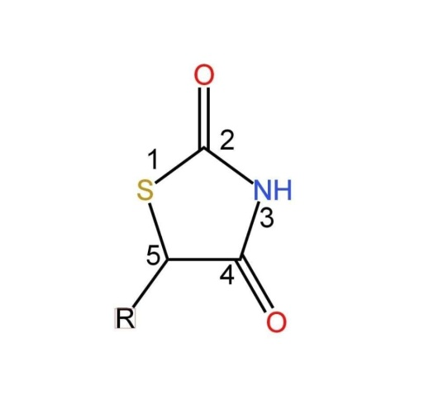

Thiazolidine-2,4-dione

**Inflammation:**

Inflammation is the Latin term *inflammare* which means ‘to set on fire’. It is a part of body’s natural defense mechanism triggered by biochemical factors such as cytokines, histamines, prostaglandins, interleukins, etc. The body’s immune system shows response to the harmful stimuli such as toxic compounds, pathogens, damaged cells. Usually inflammation is characterized by swelling, redness, heat, pain and loss of tissue function. It is classified into acute and chronic inflammation. While the acute inflammation acts as a protective mechanism, the chronic inflammation results in several health issues.[4]

**Acute Inflammation:**

Acute inflammation is a result of microbial inflammation, trauma. The symptoms of this type may last for short period of time i.e., for few days for example: a sore throat from cold or flu, acute bronchitis. It occurs rapidly and become severe in a short period.[5][6]

**Chronic Inflammation:**

Chronic inflammation occurs due to autoimmune reactions, chronic stress, etc. It is a slow, long term inflammation which may last for prolonged period i.e. from months to years. The effect of inflammation may depend upon the ability of the body to overcome the injury. [5][6]

* **Conventional method:**

The conventional method for the synthesis of thiazolidinedione typically involves a cyclization reaction between a thioamide or related thiocarbonyl compound and a carbonyl source. This process is widely used in organic synthesis, particularly for pharmaceutical applications, as thiazolidinedione derivatives have significant importance in medicinal chemistry, especially as antidiabetic agents.

* ***General Conventional Approach***

1. Base-Catalyzed Cyclization:

Reagents: Thiourea or thioacetamide and a dicarbonyl compound, such as glyoxal or diketones.

Conditions: Involves heating in a suitable solvent like hydrochloric acid. Reaction: The carbonyl group reacts with the thiocarbonyl or thioamide, leading to the formation of the thiazolidinedione ring.

1. Stepwise Synthesis:

Step 1: Reaction between thiourea and an α-halocarbonyl compound to form an intermediate.

Step 2: Cyclization under acidic or basic conditions to form the desired thiazolidinedione core.

1. Solvent-Based Reaction: In many conventional methods, polar solvents (likeethanol or DMF) are used to dissolve reactants, facilitating the nucleophilic attack of the thiocarbonyl group on the carbonyl compound. [7]

* **Green Chemistry:**

Green Chemistry is a design or processes to minimize or to eliminate the production of hazardous substances. [8]

* ***Principles of Green synthesis method:***
* Two scientist had published the series of principles.
* They have proposed twelve principles, which focus on different methods to decrease the environmental impacts as well as the health impacts.
* The twelve principles that were proposed are as follows:

1. Prevention of waste
2. Maximization of atom economy
3. Design less hazardous chemical methods
4. Design safe products and chemicals
5. Usage of safe solvents and reaction conditions
6. Enhance energy efficiency
7. Usage of renewable feedstock
8. Avoiding the use of chemical derivatives
9. Use catalysts, not stoichiometric reagents
10. Design degradable chemicals
11. Real time analysis
12. Minimize the potential for accidents [9]

**MATERIALS AND METHODS:**

**Methods used for synthesis of thiazolidinedione:**

Thiazolidinedione is synthesized by using two different methods such as Conventional method and Green synthesis method.

* ***Microwave irradiation technique:***
* Microwave irradiation is a phenomenon that utilizes electromagnetic waves and heat transfer, any material which is exposed to electromagnetic radiation will be heated up.
* It has become a popular heating technique in organic synthesis when compared to the conventional reflux synthesis, as it heats the compound quickly, efficiently, and results high yield in less time.
* Additionally, microwave irradiation lowers consumption of energy and consequently, is ideal for optimization processes.
* There are two types of microwave irradiation reactions they are, solvent free and solution phase reaction [10]11]
* ***Mechanism of microwave irradiation:***

The heating mechanism of microwave irradiation can be explained from two main process namely:

1. Dipolar polarization
2. Ionic conduction

1. ***Dipolar polarization:***

➢ For a substance to be able to produce heat when irradiated with microwaves it must be a dipole, i.e., the structure of molecule must be partly negative and partly positively charged. The microwaves when starts to oscillate, the dipoles in the field orient to the oscillating field. These orientation causes rotation, which results in an ultimately in heat energy.

2***. Ionic conduction:***

➢ During ionic conduction, the completely charged ions oscillate back and forth under the influence of microwave irradiation. This oscillation results in collisions between the charged particles andneighboring molecules, which are ultimately creates heat energy. [12]

* Purity of the synthesized intermediate and final compounds was confirmed by TLC using benzene and ethyl acetate as well as determined the melting points in open capillary tube method. IR spectra were recorded on FTIR. Chemical shift is reported in δ unit. [13] The compounds were synthesized by the following procedure:
* **Procedure Involved inGeneral & Microwave Irradiation Synthesis**:

The conventional method and the microwave irradiation technique of synthesis was performed in two steps

***Step-1: Synthesis of Thiazolidine-2,4-dione***

Mix 0.6 mol of chloroacetic acid in 60 ml of water and 0.6 mol of thiourea in 60 ml of waterseparately. Stir the mixture for 15 min until a white precipitate forms and cool the mixture. Then slowly add 60 ml of hydrochloric acid to the reaction mixture using a dropper. Connect the flask to reflux condenser and apply gentle heat. In case of conventional method stir the content and reflux the reaction mixture for 8-10 hours. In case of using microwave oven reflux the content for 5min at 280W and cool the product, filter, wash & dry at room temperature. Recrystallize the product using ethanol.

***Step-2: Synthesis of 5[(4-fluoro) benzylidene] thiazolidine-2,4-dione***

Take 0.25 mol of 2,4-Thiazolidinedione and dissolve it in a 50ml of hot glacial acetic acid, add 1.8gm fused sodium acetate. Add the mixture into the solution of 0.25 mol of 4-Fluorobenzaldehyde. . In case of conventional method reflux the content for an hour and cool it. In case of using microwave oven reflux the contents for 5min at 280W. Recrystallize it using glacial acetic acid.

***Synthesis of 5[(4-Nitro) benzylidene] thiazolidine-2,4-dione***

Take 0.25 mol of 2,4-Thiazolidinedione and dissolve it in a 50ml of hot glacial acetic acid, add 1.8gm fused sodium acetate. Add the mixture into the solution of 0.25 mol of p-Nitro benzaldehyde. Reflux the content for an hour in case of conventional method and cool it. In case of microwave oven reflux the content for 5min at 280W. Recrystallize it using glacial acetic acid.

***Synthesis of 5[(4-Dimethyl) amino benzaldehyde] thiazolidine-2,4-dione***

Take 0.25 mol of 2,4-Thiazolidinedione and dissolve it in a 50ml of hot glacial acetic acid, add 1.8gm fused sodium acetate. Add the mixture into the solution of 0.25 mol of p-Dimethyl amino benzaldehyde. In case of using conventional method reflux the content for an hour. In case of using microwave oven reflux the content for 5 min at 280W and cool it. Then recrystallize the product by using glacial acetic acid. [14]

***Scheme: - Step-1***

***Synthesis of thiazolidinedione(TZD)***

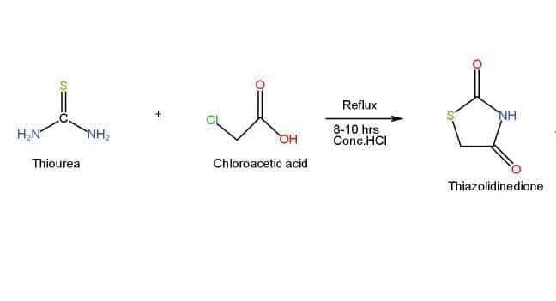

***Step-2***

1. ***Substitution of Fluoro benzaldehyde on thiazolidinedione(FBTZD)***

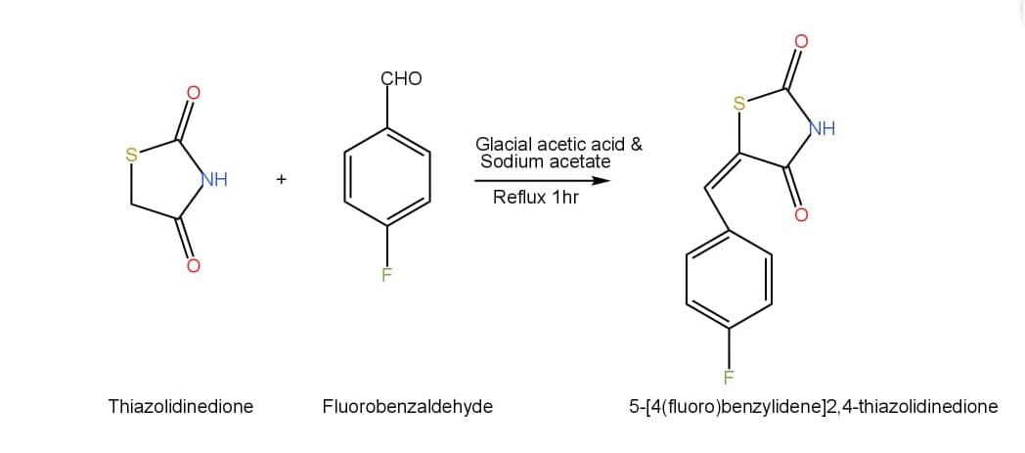

1. ***Substitution of Nitro benzaldehyde on thiazolidinedione(NBTZD)***

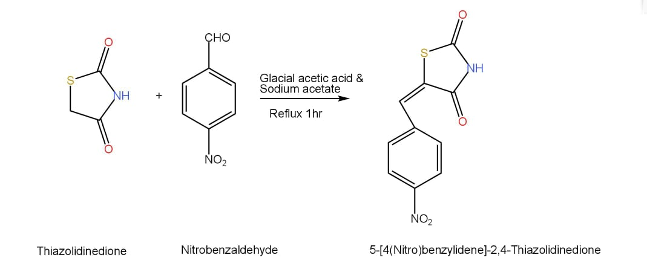

1. ***Substitution of Dimethyl amino benzaldehyde on thiazolidinedione***

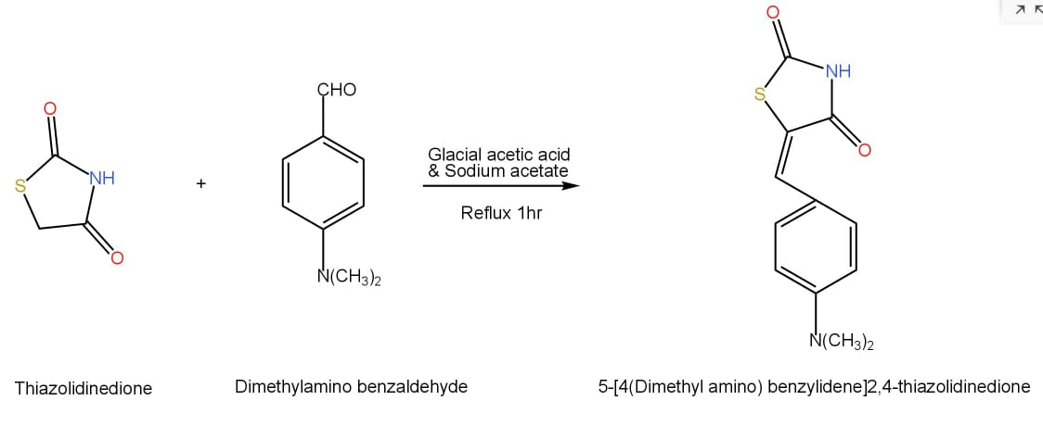

**Characterization of Compounds:**

***5-[4-(fluoro) benzylidene]-2,4-thiazolidinedione***

Molecular mass: 222 g/mol; Yellow; Yield: 74.5%; Melting point: 135-140ºC; Rf value:0.53; IR(cm­¹) Deuterated Triglycine Sulfatels (DTGSKbr) 2952(C-H),1670(C=O),1599(C=C),1412(C-H),1141(C-N),926(C-S),521(C­F), ¹H NMR (ppm) DMSO solvent δ: 4.034(CH-1H), 7.164-7.816(Ar-H,4H), 9.991(NH-1H)

***5-[4-(nitro) benzylidene]-2,4-thiazolidinedione***

Molecular mass: 234 g/mol; Pale Yellow; Yield: 80.6%; Melting point: 180-224ºC; Rf value: 0.67; IR(cm-¹) Deuterated Triglycine Sulfatels (DTBS Kbr) 2979(C-H), 1747(C=O), 1664(C=C), 1530(N-O), 1144(C-S), ¹H NMR (ppm) DMSO solvent δ: 4.084(CH-1H), 7.749-8.550(Ar-H-4H), 10.161(NH-1H)

***5-[4-(dimethyl amino) benzylidene]-2,4-thiazolidinedione***

Molecular mass:249 g/mol; Brownish; Yield:76%; Melting point: 159-163ºC; Rf value: 0.64; IR(cm-¹) Deuterated Triglycine Sulfatels (DTBS Kbr) 1142(C-S), 1221(C-N), 1617(C=C), 1674(C=O), 2904(C-H) ¹H NMR (ppm) DMSO solvent δ: 3.026(CH3, 6H), 4.06(CH, 1H), 6.787-7.701(Ar-H, 4H), 9.672(NH, 1H) [15]16]

**EXPERIMENTAL ANIMALS**

**Anti-Inflammatory Activity:**

Chemicals: Carrageenan, Diclofenac sodium

Instrument: Vernier caliper(mm)

***Carrageenan-induced paw edema:***

The procedure followed for In-vivo method was approved by Institutional Animal Ethics Committee (IAEC) registration no. IAEC/1684/PRIP/01-03-2025/Mice-24/06. Female Albino mice weighing 19-25gm were acquired from animal house. All animals were housed in polypropylene cages and maintained under controlled standard conditions (24±2ºC, 50±5%) in light and dark cycles(12h). The animals were fed with standard laboratory diet and water ad libitum. The animals were acclimatized to laboratory conditions before the commencement of experiment. Animal handling and care was taken as per the Committee for Purpose of Control and Supervision of Experiments on Animals(CCSEA) guidelines. All the animals were weighed individually and initial paw volume of each mice was noted. [17] [18] Animals were divided into four groups (n=6). A positive control, Negative control, low dose (3mg/kg), high dose(10mg/kg) of thiazolidinedione derivatives. 0.1ml of 1% freshly prepared carrageenan suspension was injected into plantar surface region of left hind paw, after 30 min of test drug administration through intraperitoneal route. The Negative control were received normal saline as vehicle and positive control group were received Diclofenac Sodium(10mg/kg). The development of paw volume of each group of animals was measured at 0, 15, 30, 45, 60, & 90 min intervals using Vernier caliper. The percentage (%) inhibition of edema was calculated as per the formula shown: [19] [20] [21]

$$\%Inhibition=\frac{Change in Control-Change in treatment}{Change in Control}×100$$

**RESULTS AND DISCUSSION:**

The below table shows the physical and chemical characteristics of different derivatives substituted on 2,4-thiazoldinedione

|  |  |  |  |  |  |  |  |
| --- | --- | --- | --- | --- | --- | --- | --- |
| Compound code | R group | Mol Formula | Mol wt.  gm | Melting point  (ºC) | Rf Value | %Yield | |
| Con | mw |
| TZD | - | C₃H₃NO₂S | 117 | 127-130ºC | 0.14 | 75% | 83% |
| FBTZD | 4-(fluoro) benzylidene | C₁₀H₆NSFO₂ | 222 | 135-140ºC | 0.53 | 60% | 74% |
| NBTZD | 4-(nitro)benzylidene | C₁₀H₆N₂SO₃ | 234 | 180-224ºC | 0.67 | 65% | 80% |
| DBTZD | 4-(dimethyl amino) benzylidene | C₁₂H13N2O2S | 249 | 159-163ºC | 0.64 | 60.4% | 76% |

Abbreviations:

TZD- Thiazolidinedione

FBTZD- [(Fluoro)benzylidene] thiazolidinedione

NBTZD-[(Nitro)benzylidene] thiazolidinedione

DBTZD- [(dimethyl amino) benzylidene] thiazolidinedione

Con& Mw- Conventional method& Microwave Assisted Method

Table-1: Physical and Chemical Properties of Thiazolidinedione & its derivatives

**In-vivo Anti-Inflammatory activity:**



Graph-1: Paw volume(mm) vs Treatment groups of FBTZD

**Results of 5[4-(fluoro) benzylidene]-2,4-thiazolidinedione:**The table presents the effect of the compound*5[4-(fluoro) benzylidene]-2,4-thiazolidinedione* in comparison to the Diclofenac sodium as a standard and control (Normal saline) group. The paw volume of mice was measured at regular intervalsi.e. 15, 30, 45, 60, & 90 min. The * indicates the P significance value of paw volume. The test compound shows the effective anti-inflammatory activity as that of the standard drug.

|  |  |  |  |  |  |  |  |  |  |  |  |  |
| --- | --- | --- | --- | --- | --- | --- | --- | --- | --- | --- | --- | --- |
| S.No | Treatment | Dose  (mg/kg) | PAW VOLUME AT REGULAR INTERVALS | | | | | | | | | |
| 15 min | % Inhibition | 30 min | %  Inhibition | 45 min | % Inhibition | 60 min | % Inhibition | 90 min | % Inhibition |
| 1 | Control | — | 0.4±  0.002 |  | 0.49±  0.002 |  | 0.49±  0.002 |  | 0.47±  0.003 |  | 0.44±  0.004 |  |
| 2 | Diclofenac sodium | 5mg/kg | 0.48±  0.004*** | 18 % | 0.35±  0.01  *** | 30% | 0.32±  0.011*** | 36 % | 0.3±  0.009  *** | 40% | 0.21±  0.006  *** | 46% |
| 3 | 5(4[Fluoro] benzylidine) 2,4-Thiazolodine done | 3mg/kg | 0.41±  0.011** | 10% | 0.39±  0.01  ** | 16.3% | 0.37±  0.006** | 20.4% | 0.35±  0.006  ** | 25.7% | 0.32±  0.006** | 31% |
| 10mg/kg | 0.43±  0.011** | 12.2% | 0.4±  0.01  ** | 18.3% | 0.39±  0.006** | 20.4% | 0.31±  0.006  ** | 36.7% | 0.25±  0.006** | 40% |

Table-2: Paw volume of mice at regular time intervals and the % inhibition of the test drug FBTZD



Graph-2: Paw volume(mm) vs treated groups of NBTZD

|  |  |  |  |  |  |  |  |  |  |  |  |  |  |
| --- | --- | --- | --- | --- | --- | --- | --- | --- | --- | --- | --- | --- | --- |
| S.No | Treatment | Dose  (mg/kg) | PAW VOLUME AT REGULAR INTERVALS | | | | | | | | | | |
| 15 min | % Inhibition | 30 min | %  Inhibition | 45 min | % Inhibition | 60 min | % Inhibition | 90 min | % Inhibition | | |
| 1 | Control | — | 0.49±  0.002 |  | 0.49±  0.002 |  | 0.49±  0.002 |  | 0.47±  0.003 |  | 0.44±  0.004 |  |
| 2 | Diclofenac sodium | 5mg/kg | 0.31±  0.006  *** | 22.5% | 0.3±  0.005*** | 25% | 0.26±  0.006*** | 35 % | 0.242±  0.006  *** | 40% | 0.21±  0.006*** | 46% |
| 3 | 5(4[Nitro] benzylidene) 2,4-Thiazolodine done | 3mg/kg | 0.41±0.006** | 16% | 0.38±0.007** | 20% | 0.35±0.006** | 24% | 0.32±0.006** | 29% | 0.29±0.006** | 35% |
| 10  mg/kg | 0.32±  0.011  ** | 17.9% | 0.29±  0.007** | 25% | 0.26±  0.006** | 33% | 0.24±  0.007  ** | 38% | 0.23±  0.007** | 41% |

**Results of 5[-4(nitro)benzylidene]-2,4-thiazolidinedione:**The below table presents the effect of the compound *5[4-(nitro) benzylidene]-2,4-thiazolidinedione* in comparison to the Diclofenac sodium as a standard and control (Normal saline) group. The paw volume of mice was measured at regular intervals i.e. 15, 30, 45, 60, & 90 min. The * indicates the P significance value of paw volume. The test compound shows the effective anti-inflammatory activity as that of the standard drug.

Table-3: Paw volume at regular time intervals & % inhibition of the test compound NBTZD



Graph-3: Paw volume (mm) vs. Treated groups of DBTZD

**Results of 5[4-(dimethylamino) benzylidene]-2,4-thiazolidinedione:**The table presents the effect of the compound *5[4-(dimethyl amino) benzylidene]-2,4-thiazolidinedione* in comparison to the Diclofenac sodium as a standard and control (Normal saline) group. The paw volume of mice was measured at regular intervals i.e. 15, 30, 45, 60, & 90 min. The * indicates the P significance value of paw volume. The test compound shows the good anti-inflammatory activity as that of the standard drug

|  |  |  |  |  |  |  |  |  |  |  |  |  |
| --- | --- | --- | --- | --- | --- | --- | --- | --- | --- | --- | --- | --- |
| S.No | Treatment | Dose  (mg/kg) | PAW VOLUME AT REGULAR INTERVALS | | | | | | | | | |
| 15 min | % Inhibition | 30 min | %  Inhibition | 45 min | % Inhibition | 60 min | % Inhibition | 90 min | % Inhibition |
| 1 | Control | — | 0.493±  0.002 |  | 0.49±  0.002 |  | 0.49±  0.002 |  | 0.47±  0.003 |  | 0.44±  0.004 |  |
| 2 | Diclofenac sodium | 5mg/kg | 0.28±  0.019  *** | 22.2% | 0.26±  0.019  *** | 27.7% | 0.24±  0.019  *** | 33.3 % | 0.24±  0.019  *** | 33.3% | 0.20±  0.014  *** | 45% |
| 3 | (Dimethyl amino benzylidene)2-4 Thiazolidinedionedione | 3mg/kg | o.4±  0.006  ** | 15% | 0.35±  0.006  ** | 20% | 0.33±  0.006 | 25% | 0.32±  0.02** | 30% | 0.3±  0.02** | 32% |
| 10mg/kg | 0.32±  0.021  ** | 15.7% | 0.30±  0.021  ** | 22% | 0.28±  0.019  ** | 27% | 0.28±  0.019  ** | 36.8% | 0.28±  0.019  ** | 36.8% |

Table-4: Paw volume of mice at regular time intervals & % inhibition of the test compound DBTZD

**DISCUSSION:**

The above study was undertaken to evaluate the anti-inflammatory potential of synthesized thiazolidine 2,4 Dione derivatives using carrageen induced paw edema models in albino mice. The results obtained demonstrate that the compounds exhibited significant inhibition of paw edema. anti-inflammatory activity was assessed at different time intervals for fluorobenzylidene thiazolidine-2,4-dione at low dose initial (15min) paw volume shows 10% inhibition at late phase (90 min) it reaches to 31 % of inhibition. For high dose at initial (15 min) shows 12.2% inhibition and late phase (90 min) it reaches to 40% inhibition. The percentage inhibition shown by the Diclofenac sodium is 18% at (15min) and it reaches t0 46% at 90 min. It suggests that the effect of the test compound is as good as the standard drug. ForNitrobenzyldiene thiazolidinedione at low dose of initial phase (15 min) exhibited 16% inhibition, high dose (90 min) exhibits 35 % inhibition. High dose at initial phase (15 min) exhibits 17.9 % inhibition late phase (90 min) exhibit 41% inhibition.Dimethyl amino benzylidene thiazolidinedione at low dose exhibits (15 min) 15% inhibition late phase (90 min) shows 32% inhibition. High dose initial phase (15 min) 15.7 % inhibition at late phase (90 min) 36.8% inhibition. Differences in paw volume between control and treated groups were statistically significant as indicated by the p value < 0.05 for most of the compounds and even < 0.001 in some areas. A value < 0.05 conforms that the presence of anti inflammatory effect. In our study most of the tested groups show statistical significance inhibition of paw edema when compared to the control group among all the synthesized derivatives nitrobenzaldiene thiazolidine Dione shows highest inhibition and lowest p value Indicating a strong and reliable anti inflammatory activity. Among all tested compounds, Nitrobenzyldiene thiazolidinedione derivative exhibited the highest anti-inflammatory effect showing the greatest percentage inhibition. These suggest that the synthesis of Thiazolidinedione derivatives possess notable anti-inflammatory activity and could serve as potential candidates for development of novel anti Inflammatory agents. The ‘p’ significance value was calculated using One-way ANOVA method. We have represented the results in the graphs (paw volume mm vs treated groups) as well.

**CONCLUSION:**

The conducted research resulted in formation of new derivatives of 2,4-thiazolidinedione which might show anti-inflammatory activity. All the derivatives were synthesized by two different methods i.e. a) Conventional method and b) Green synthesis method (microwave irradiation technique) and compared the product results. While both methods successfully produced thiazolidinedione derivatives, the microwave assisted method demonstrated a significant advantage such as rapid synthesis and high yield of product. Based on the features microwave assisted method appears to be better option for the synthesis of compounds. The results of the characterization performed for the derivatives were found to be accurate and we have performed the biological activity for all three derivatives using carrageen induced paw edema model. That resulted in, 5[4-(fluoro) benzylidene]-2,4-thiazolidinedione exhibited notable inhibition at high dose. 5[4-(nitro) benzylidene]-2,4-thiazolidinedione shows significant inhibition at high dose. 5[4-(dimethyl amino) benzylidene]-2,4-thiazolidinedione shows inhibition . Among all the tested compounds, 5[4-(nitro) benzylidene]-2,4-thiazolidinedione exhibited a significant anti-inflammatory activity showing greatest percentage inhibition.

**COMPETING INTERESTS DISCLAIMER:**

Authors have declared that they have no known competing financial interests OR non-financial interests OR personal relationships that could have appeared to influence the work reported in this paper.

Disclaimer (Artificial intelligence)

Option 1:

Author(s) hereby declare that NO generative AI technologies such as Large Language Models (ChatGPT, COPILOT, etc.) and text-to-image generators have been used during the writing or editing of this manuscript.

Option 2:

Author(s) hereby declare that generative AI technologies such as Large Language Models, etc. have been used during the writing or editing of manuscripts. This explanation will include the name, version, model, and source of the generative AI technology and as well as all input prompts provided to the generative AI technology

Details of the AI usage are given below:

1.

2.

3.

**REFERENCE:**

1. Viral S Jain, Dhagash K Vora, C S Ramaa; Thiazolidine-2,4-diones: Progress Towards Multifarious Applications; DOI: 10.1016/j.bmc. 2013.01.029; 2013 Apr 1;21(7): 1599-620.
2. NazarTrotsko, AgataPrzekora, JustynaZalewska, GrazynaGinalska, Agata Paneth, Monika Wujec; Synthesis and Invitro Anti-proliferative and Anti-bacterial activity of New Thiazolidine-2,4-dione derivatives; DOI: 10.1080/1456366.2017.1387543; November 2017. 33(1): 17-24
3. Nathon Long, Adam Le Gresley, Stephen P. Wren; Thiazolidinediones: AnIn-Depth Study of their Synthesis and Application to Medicinal Chemistry in the Treatment of Diabetes Milletus; DOI: org/10.1002/cmdc.202100177; Volume 16, Issue 11, 12 April 2021
4. L Ferrero-Miliani, O H Nielsen, P S Andersen, S E Girardin; Chronic Inflammation: Importance of NOD2 and NALP3 in Interleukin-1β generation; DOI:10.1111/j.1365-2249.2006. 03261.x; 2007 Feb;147(2):227-235.
5. Linlin Chen, Huidan Deng, Hengmin Cui, Jing Fang, ZhicaiZuo, Junliang Deng, Yinglun Li, Xun Wang, Ling Zhao; Inflammatory responses and inflammation-associated diseases in organs; DOI: 10.18632/oncotarget.23208; 2017 Dec 14;9(6):7204-7218.
6. Roma Pahwa, Amandeep Goyal, IshwarlalJialal; Chronic Inflammation; StarPearls Publishing; 2025 Jan-Available from: https://www.ncbi.nlm.nih.gov/books/NBK493173.
7. Srikanthkumarkarumanchi, Lakshmana raoAtmakuri, VBasaveswararao Mandava, Srikala Rajala; Synthesis and Hypoglycemic and Anti-inflamatory activity Screening of Novel Substituted 5-[Morpholino (Phenyl)Methyl]-thiazolidine-2,4-dione and their Molecular Docking studies; DOI: 10.4274/tjps.galenos.2018.82612; 2019 Nov 11;16(4):380-391.
8. Prof. DR. Roger Arthur Sheldon, Dr.Isabel W.C.E. Arends, Dr. UifHnefeld; Green Chemistry And Catalysis; DOI: 10.1002/9783527611003; 23 February 2007.
9. Dr. Shanshank Tiwari, Shreya Talreja; Green Chemistry And Microwave Irradiation Technique: A Review; DOI: 10.9734/JIPRI/2022/b34i39A36240; 28 May 2022.
10. C. Oliver Kappe University of Graz, Austria; Microwave Assisted Synthesis
11. Helio M T Albuquerque, Diana C G A Pinto, Artur M S Silva; Microwave Irradiation Alternative Heating Process for Synthesis of Biologically Applicable Chromosomes, Quinolones and Their Precusors; DOI: 10.3390/molecules26206293; October 18 2021.
12. Mayuri V. Bhosale, Akshay R. Yadav, Dr. Chandrakant S. Magdum, Dr. Shrinivas K. Mohite; Microwave Assisted Synthesis, Molecular Docking Studies and Anticancer Screening of Some 1,3,4-thiadiazole Derivatives; ISSN: 1007-6735
13. YotsrayuthSeekaew, OnsudaArayawut, KriengkriTimsrorn, Chatchawal Wongchoosuk; Synthesis, Characterization, and Applications of Graphene and Derivatives; DOI: org/10.1016/B978-0-12-813248-7.00009-2; 2019.
14. B.Geetha, G. Swarnalatha and G.V. Subba Reddy; Microwave Assisted Synthesis, QSAR and Moleculaer Docking Studies of 2,4-Thiazolidinedione Derivatives; Vol.12| No.3 | 1063- 1071 | July-September | 2019; ISSN: 0974-1496| e-ISSN: 0976-003.
15. Prashantha Kumar Br, M. J. Nanjan, Bhavana Suresh, M. D. Karvekar, L. Adhikary; Microwave Induced Synthesis of the Thiazolidinedione-2,4-dione Motif and the Efficient Solvent Free-Solid Phase Parallel Syntheses of 5-Benzylidene-thiazolidine-2,4-dione and 5-Benzylidene-2-thioxo-thiazolidine-4-one Compounds; DOI:10.1002/jhet.5570430413; July 2006. ChemInform43(4):897-903
16. OyaBozdag-Dundar, OzenOzgen, ArzuMentese, NurtenAltanlar, OnurAtli, EnginKendi, RahmiyeErtan; Synthesis and Antimicrobial activity of some new thiazolyl thiazolidine-2,4-dione derivatives; DOI: org/10.1016/j.bmc.2007.06.049; Volume 15, Issue 18, 15 September 2007.
17. Zulkifal Malik, Muzaffar Abbas, Lina Tariq Al Kury, Fawad Ali Shah, MahboobAlam, Arif-ullah Khan, Humaira Nadeem, Saad Alghamdi, Muhammad Umar KhayamSahibzada, Shupeng Li; Thiazolidine Derivatives Attenuate Carrageenan-Induced Inflammaotry Pain in Mice; DOI: 10.2147/DDDT.S281559.
18. Flavia De Toni Uchoa, Teresinha Goncalves da Saliva, Maria do CarmoAlvesde Lima, SuelyLinsGaldino, Ivan da Rocha Pitta, Teresa Dalla Costa; Preclinical pharmacokinetic and pharmacodynamics evaluation of thiazolidinone PG15: an anti-inflammatory candidate; DOI: 10.1211/jpp/61.03.00xx.
19. Nada Fayez, Waleed Khalil, Essam Abdel-Sattar, Abdel-Fattah Mohamed Abdel-Fattaj; In vitro and in vivo assessment of the anti-inflammatory activity of olive leaf extract in rats; DOI: 10.1007/s10787-023-01208-x; 2023 Apr 8;31(3):1529-1538.
20. SarikaAmbedkar, Purabi Roy, Vinod Singh, Avinah Kumar, Rambir Singh, Poonam Sharma; Anti-inflammatory Activity of Lactobacillus on Carrageenan-Induced Paw Edema in Male Wistar Rats; DOI: 10.1155/2012/752015; 2012 Feb 22.
21. L.C.Santos, Flavia De Toni, A.R.P.A. Canas, I.A. Sousa; Synthesis and anti-inflammatory activity of new thiazolidine-2,4-diones,4-thioxothiazolidinones and 2-thioxoimidazolidinones; DOI: 10.1515/HC.2005.11.2.121; April 2005.