Monitoring Beta and Gamma Radiation Exposure Rates at Nuclear Medicine Installation of Bali Mandara Regional Hospital

.

ABSTRACT

|  |
| --- |
| **Aims:** To knowing the values of gamma radiation exposure rate, to knowing the values of beta radiation exposure rate, and to comparing the monitoring results of gamma radiation exposure rate and beta radiation exposure rate with BAPETEN regulation number 17 of 2012 article 33.  **Place and Duration of Study:** Nuclear Medicine Installation of Bali Mandara Hospital, Denpasar from March 2024 to June 2024.  **Methodology:** This study used a surveymeter ranger to measure the gamma and beta radiation exposure rate in hotlab room and injection room, with 30 mCi total activity of I-131 as radiation source. In both rooms, several measurement points were determined as places for preparation, administration, and storage of I-131 such as work table, patient chair, and trolley. The entrance door is considered to be a measurement point to ensure radiation does not penetrate outside the room.The data were analyzed by calculating the actual radiation exposure rate using the formulas in equations 1 and 2, statistical test for normality, and one sample t-test to compare with BAPETEN regulation number 17 of 2012 article 33.  **Results:** The values of gamma radiation exposure rate are 0,149 – 2,307 μSv / h. The values of beta radiation exposure rate in the Nuclear Medicine Installation of Bali Mandara Regional Hospital is 1,534 – 13,739 μSv / h. The t-value of gamma radiation exposure rate is -27,020 and the t-value of beta radiation exposure rate is -156, 413. The t-value is smaller than the t-table (1,94318), it means the values of gamma radiation and beta radiation exposure rate doesn’t exceed the NBD that has been determined in BAPETEN regulation number 17 of 2012 article 33, which is 10 μSv/h for gamma radiation exposure rate and 250 μSv/h for beta radiation exposure rate.  **Conclusion:** The gamma radiation exposure rates and the beta radiation exposure rates in Bali Mandara Hospital Nuclear Medicine Installation are still very safe and far from the NBD because the number of patients and radioisotope activities used is still minimum, that is 30 mCi. Therefore, it is important to limit the use of radioisotopes because the more radioisotope activity used, the longer the time used for preparation and administration to patients which can cause more radiation exposure. |

*Keywords: beta radiation exposure rate; gamma radiation exposure rate; NBD; Nuclear Medicine Installation; surveymeter*.

1. INTRODUCTION

Advances in nuclear technology are matched by many applications in various fields of life. One application of nuclear technology that is closely related to humans is nuclear medicine. Nuclear medicine is a branch of medical science that uses open radioactive sources derived from artificial radionuclide nuclei to study changes in physiology and biochemistry, so that they can be used for diagnostic, therapeutic, and research purposes. Nuclear medicine uses radiopharmaceuticals that can be introduced into the patient's body through respiratory, oral, or injection routes [1]. Radiopharmaceuticals generally consist of radioactive elements (radionuclides) that allow external scanning, linking with non-radioactive elements, biologically active molecules, drugs or cells that act as carriers or ligands, responsible for delivering the radionuclide to a specific organ [2].

Radiation helps treat cancer and select other diseases by destroying cells. When radiation damages cancer cells’ DNA, it affects the cells’ ability to continue reproducing. By nature, cancer cells divide rapidly, which makes them particularly susceptible to radiation.14 Delivering ionizing radiation to patients to target specific cells requires unparalleled accuracy. Too little radiation can allow cancerous cells to regrow, but too much radiation or missed targets can harm the patient. Ensuring consistent, accurate and effective radiation treatment requires cooperation of a team of radiation oncology specialists: radiation oncologists, medical physicists, radiation therapists, medical dosimetrists and nurses [3].

There are three basic principles of radiation protection: justification, optimization, and dose limitation. Justification involves an appreciation for the benefits and risks of using radiation for procedures or treatments. Physicians, surgeons, and radiologic personnel all play a key role in educating patients on the potential adverse effects of radiation exposure. The benefits of exposure should be well known and accepted by the medical community. Often, procedures that expose patients to relatively higher doses of radiation—for example, interventional vascular procedures—are medically necessary, and thus the benefits outweigh the risks. The As Low as Reasonably Achievable (ALARA) principle, defined by the code of federal regulations, was created to ensure that all measures to reduce radiation exposure have been taken while acknowledging that radiation is an integral part of diagnosing and treating patients. Any amount of radiation exposure will increase the risk of stochastic effects, namely the chances of developing malignancy following radiation exposure. These effects are thought to occur as a linear model in which there is no specific threshold to predict whether or not malignancy will develop reliably. For these reasons, the radiologic community teaches protection practices under the ALARA principle [4].

Nuclear medicine in Indonesia has started since 1967, after Indonesia's first atomic reactor started operating in Bandung. Nuclear medicine is one of the specialized medical services that is being actively developed by hospitals all over Indonesia. Until now there are 27 hospitals in Indonesia that provide nuclear medicine services, one of which is Bali Mandara Hospital. Radioisotopes commonly used in nuclear medicine have a fairly short half-life, this aims to reduce radiation exposure received by patients [5]. Radioisotopes commonly used in nuclear medicine are F-18, I-131, and Tc-99m. Radioisotopes F-18 and I-131 can emit beta and gamma radiation, while radioisotope Tc-99m only emits gamma radiation [6]. Bali Mandara Hospital Nuclear Medicine uses Tc-99m and I-131 radioisotopes.

In preparing radiopharmaceuticals, administering radiopharmaceuticals to patients, and imaging patients, workers in the Nuclear Medicine Installation are routinely exposed to radiation. The potential radiation exposure that can be produced by radioisotopes depends on the type of isotope and the amount of activity used [6]. Based on BAPETEN Regulation number 17 of 2012 article 33 states that the maximum dose allowed to be received by radiation workers for the body is 20 mSv per year and for the skin is 500 mSv per year.

Based on previous research by Alkhoyaref, et al (2023), the results of radiation exposure monitoring on 30 nuclear medicine workers during a year period at King Faisal Specialist Hospital and Research Center (KFSHRC) in Riyadh were below the annual dose limit (500 mSv for skin and 20 mSv for body) [7]. Research by Ernawati, et al (2022) in one of the hospitals in Jakarta, obtained a beta exposure dose rate of 0.03 - 5608.77 μSv/h and a gamma exposure dose rate of 0.02 - 68.65 μSv/h [6]. Another research by Martin, et al (2023) at Meixoeiro Hospital, Spain obtained a mixed exposure rate (beta and gamma) between 0.1 μSv/h - 0.1 Sv/h [8].

Based on this explanation, monitoring of beta and gamma radiation exposure rates at the Bali Mandara Hospital Nuclear Medicine Installation is needed to prevent and minimize exposure of beta and gamma radiation received by radiation workers and the general public. Monitoring of radiation exposure rates is carried out by means of measurements followed by an assessment of the measurement results with the aim of assessing the level of radiation in the work area so that potential dangers that may be received by workers and the public can be avoided.

**1.1 Beta Radiation**

Beta (β) particles are electrons or positrons released from the nucleus in the process of nuclear decay. β particles are usually electrons formed from neutron decay (producing electrons and protons [9]. Beta radiation is particle radiation consisting of high-speed electrons, which are quickly attenuated by tissue. It is very useful for surface radiation treatment because the chance of deep tissue penetration is very small. Beta radiation has been used extensively for treatment [9]. In clinical oncology, beta radiation has become more important because of effective treatments using beta-emitting isotopes such as iodine 131 (131I), yttrium 90 (90Y), samarium 153 (153Sm), strontium 89 (89Sr), phosphorus 32 (32P), and others. 90Y, 89Sr, 32P are pure beta emitters, while 131I and 153Sm emit beta and gamma radiation that allows for easier and more effective imaging [10].

**1.2 Gamma Radiation**

Gamma radiation is transmitted from radioactive nuclides as photons, not particles which means that gamma radiation has no mass or charge. Radionuclides are decayed in the form of gamma radiation, the process is not accompanied by changes in atomic number or atomic mass [11].

Gamma rays have no mass and so they have a higher penetrating power than beta particles. Technetium-99m is an example of a radionuclide that decays in the form of gamma radiation. Gamma rays have energies ranging from 104 to 107 eV. Gamma rays are often emitted as part of nuclear reactions, when atomic nuclei are left in an excited state, or during isomer transitions. Gamma radiation can penetrate living matter easily and these rays travel at the speed of light. Gamma rays have enough energy to ionize materials [9].

**1.3 I-131**

Iodine-131 is used to treat several diseases of the thyroid gland. Iodine-131 is widely used in thyroid imaging and in treating thyroid cancer and other abnormal conditions such as hyperthyroidism. It is also used to diagnose abnormal liver function, kidney, blood flow and urinary tract obstruction. Iodine-131 is a strong gamma emitter but is used for beta therapy [12].

I-131 for the treatment of thyroid disorders has been the success story of nuclear medicine. It involves the use of an economic readily available radionuclide which is highly concentrated by the thyroid gland. The results of its use in the treatment of differentiated cancer of the thyroid are excellent, acting as a model for molecular radiotherapy [13].

According to the Environmental Protection Agency, I-131 has a very short half-life of around eight days with beta radiation and gamma radiation, which means it almost completely decays in the environment within a few months. As it decays, 131I most often (89% abundance) releases 971 KeV of its decay energy by transforming into stable 131Xe (Xenon) in two steps, with gamma decay following quickly after beta decay [14].

**1.4 Surveymeter**

Surveymeter is an essential component of any radiation safety program. A surveymeter is a portable ionization detector, battery-operated, and gas-filled that used to monitor radiation exposure levels [15].

The surveymeter used in this study uses a Geiger Muller gas fill detector. The working principle starts from radiation (gamma rays or beta particles) entering the detector, then the radiation ionizes the gas in the tube and produces positive ions and negative ions (electrons) proportional to the radiation intensity. Then, the ions move toward the appropriate electrode (cathode or anode) and generate an electrical voltage pulse [16].

2. material and methods

This study was done in two rooms in the Nuclear Medicine Installation where there was I-131 activity, which were the hotlab room and the injection room. In both rooms, several measurement points were determined as places for preparation, administration, and storage of I-131 such as work table, patient chair, and trolley. The entrance door is considered to be a measurement point to ensure radiation does not penetrate outside the room. Measurements were carried out using a ranger surveymeter as a radiation measuring instrument, I-131 with a total activity of 20 mCi as a source of beta and gamma radiation, 3 mm thick aluminum as a beta radiation blocking filter, and a ruler as a measuring tool for the distance between the researcher and the measurement point, which is about 30 cm.

Data were taken in two steps. The first step was taken with the detector without a beta radiation blocking filter, so that the unknown separately gamma and beta radiation exposure rate were read. The second step was taken by covering the entire surface of the detector on the surveymeter using a beta radiation blocking filter (3 mm aluminum), so that only the gamma radiation exposure rate was read. To know the measured beta radiation exposure rate is calculated by using equation 1 [4].

$X_{u}β$ = ${(X}_{u}β$, $γ$– $X_{u}γ$) x ${FK}_{filter}$ (1)

where $X_{u}β$ is the measured beta radiation exposure rate ($μSv/h$) , $X_{u}β$, $γ$ is the unknown separately gamma and beta radiation exposure ($μSv/h$), and ${FK}_{filter}$ is correction factor of aluminum filter (6.25).

The measurement results are the read values of the surveymeter and didn't show the actual radiation exposure rate value, so the calculations to get the actual radiation exposure rate value should be done by using equation 2 for the gamma radiation exposure rate and equation 3 for the beta radiation exposure rate [4].

$X_{s}γ$ = $\left(X_{u}γ-X_{BG}\right) x{ FK}_{γ}$ (2)

where $X_{s}γ$ is the actual gamma radiation exposure rate ($μSv/h)$, $X_{u}γ$ is the measured gamma radiation exposure rate ($μSv/h)$, $X_{BG}$ is the background radiation ($μSv/h)$, and ${ FK}_{γ}$ is the gamma calibration factor ($0.98 μSv/h$).

$X_{s}β$ = $\left(X_{u}β-X_{BG}\right) x{ FK}_{β }$ (3)

where $X_{s}β$ is the actual beta radiation exposure rate ($μSv/h)$, $X_{u}β$ is the measured beta radiation exposure rate ($μSv/h)$, $X_{BG}$ is the background radiation ($μSv/h)$, and ${ FK}_{β}$ is the beta calibration factor ($2.09 μSv/h$).

The results of calculation actual gamma radiation exposure rate and beta radiation exposure rate then compared with NBD that has been determined in BAPETEN Regulation number 17 of 2012 article 33 using one sample t-test. One sample t-test was analyzed by using IBM SPSS Statistics Version 25. Hypotheses proposed in this study are:

* H0: The beta radiation exposure rate and gamma radiation exposure rate doesn’t exceed the NBD in PERKA BAPETEN number 17 of 2012 article 33.
* H1: The beta radiation exposure rate and gamma radiation exposure rate exceeds the NBD in PERKA BAPETEN number 17 of 2012 article 33.

Basic decision making in the t test are [17]:

* If t-value > t-table, then H0 is rejected.
* If t-value < t-table, then H0 is accepted.

Requirements of one sample t-test is that the data is normally distributed, so it is necessary to do a normality test first with the following hypotheses:

* H0: Data is normally distributed.
* H1: Data is not normally distributed.

Basic decision making in the normality test are [17]:

* If sig > .05, then H0 is accepted.
* If sig < .05, the H0 is rejected.

3. results and discussion

The measurement results of gamma radiation exposure rate and beta radiation exposure rate are shown in Figure 1 for measurement in hotlab room and Figure 2 for measurement in injection room.

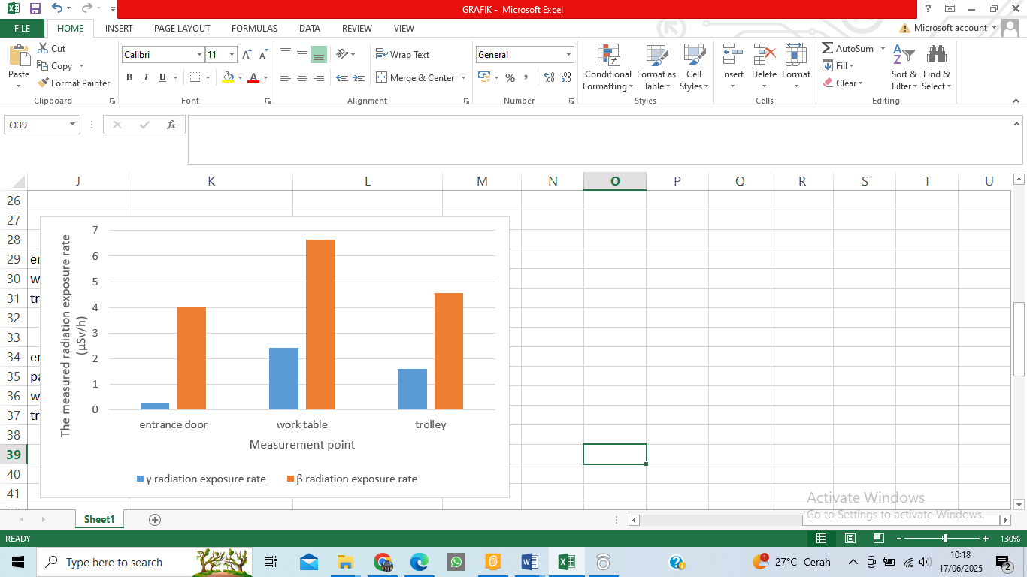

**Fig. 1. Graph of the average measured radiation exposure rate in the hotlab room.**

Based on the graph in Figure 1, it can be seen that the highest measured radiation exposure rate is found on the work table, which are 2.435 $μSv/h$ for gamma radiation exposure rate and 6.654 $μSv/h$ for beta radiation exposure rate.

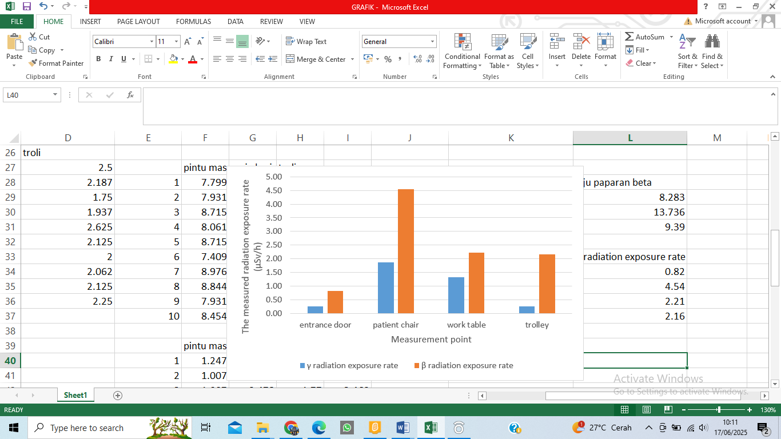

**Fig. 2. Graph of the average measured radiation exposure rate in the injection room.**

Based on the graph in Figure 2, it can be seen that the highest measured radiation exposure rate is found on the patient’s chair, which are 1.872 $μSv/h$ for gamma radiation exposure rate and 4.537 $μSv/h$ for beta radiation exposure rate.

The measured radiation exposure rate then used to find the actual radiation exposure rate. The calculation results of the actual gamma radiation exposure rate and the actual beta radiation exposure rate are shown in Table 1.

**Table 1. The actual gamma radiation exposure rate and the actual beta radiation exposure rate.**

|  |  |  |
| --- | --- | --- |
| **Measurement point** | **The actual gamma radiation exposure rate $(μSv/h$)** | **The actual beta radiation exposure rate $(μSv/h$)** |
| **Hotlab room** | | |
| Entrance door | 0.185 | 8.282 |
| Work table | 2.307 | 13.739 |
| Trolley | 1.499 | 9.392 |
| **Injection room** | | |
| Entrance door | 0.149 | 1.534 |
| Patient chair | 1.746 | 9.294 |
| Work table | 1.197 | 4.434 |
| Trolley | 0.169 | 4.317 |

The data in Table 1 are compared with NBD that has been determined in PERKA BAPETEN number 17 of 2012 article 33, 20 mSv/th for the gamma radiation exposure rate and 500 mSv/th for the beta radiation exposure rate. The NBD was converted from mSv/th (milisievert per year) units to μSv/h (mikrosievert per hour) units to match the units used in this study. NBD was converted based on effective working hours at the Nuclear Medicine Installation. Effective working hours at the Nuclear Medicine Installation are 8 hours per day, while effective working days are 5 days a week, and in a year there are 50 weeks.

$${8 hours}/{day}x {5 days}/{week}x {50 weeks}/{year}= {2000 hours}/{year}$$

then the effective working hours in one year are 2000 hours, so NBD for the gamma radiation exposure rate if converted into μSv / h units, then obtained:

$${20 mSv}/{th}= {20.000 μSv}/{2000 h}= {10 μSv}/{ h}$$

and NBD for the beta radiation exposure rate if converted into μSv / h units, then obtained:

$${500 mSv}/{th}= {500.000 μSv}/{2000 h}= {250 μSv}/{ h}$$

The data in Table 1 were subjected to a normality test as a requirement for a one sample t-test to compare gamma radiation exposure rates and beta radiation exposure rates with NBD. The results of normality and one sample t-test are shown in Table 2 and Table 3.

**Table 2. Normality test result**

|  |  |
| --- | --- |
| **Tested variables** | **Signification value** |
| Gamma radiation exposure rate | .872 |
| Beta radiation exposure rate | .955 |

The significance value obtained is more than .05, so the data of gamma radiation exposure rate and beta radiation exposure rate are normally distributed, so it is eligible to do the t-test.

**Table 3. One sample t-test result with NBD**

|  |  |
| --- | --- |
| **Tested variable** | **t-value** |
| Gamma radiation exposure rate | -27.020 |
| Beta radiation exposure rate | -156.413 |

The t-value obtained is smaller than the t-table, 1.94318, so H0 is accepted, that the gamma radiation exposure rate and beta radiation exposure rate does not exceed the NBD set in PERKA BAPETEN number 17 of 2012 article 33. The comparison between gamma radiation exposure rate and beta radiation exposure rate with NBD can be interpreted in graphs as shown in Figure 3 and Figure 4.

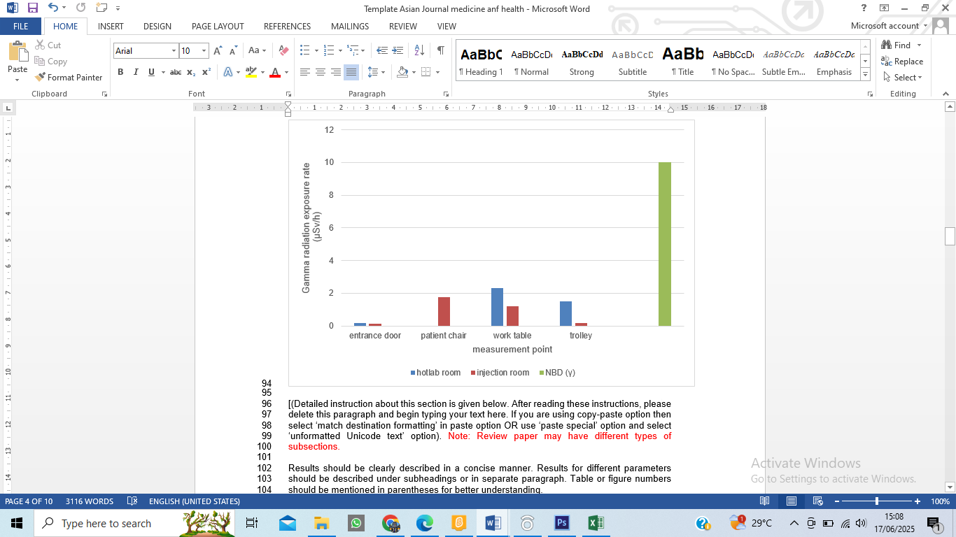

**Fig. 3. Graph of the comparison between gamma radiation exposure rate with NBD.**

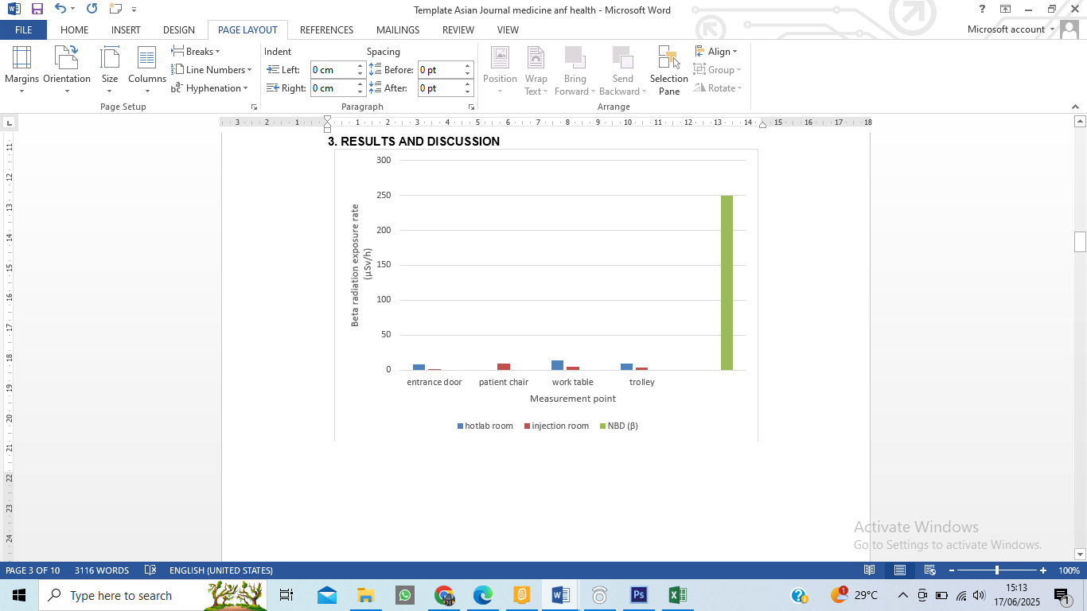

**Fig. 4. Graph of the comparison between beta radiation exposure rate with NBD.**

Based on the graphs in Figure 3 and Figure 4, it can be seen that the gamma radiation exposure rate and the beta radiation exposure rate doesn’t exceed the NBD that has been determined in PERKA BAPETEN number 17 of 2012 article 33. The highest gamma radiation exposure rate and beta radiation exposure rate are found at the same point, at the work table in the hotlab room and the patient chair in the injection room. The highest radiation exposure rate on the work table could be caused the work table is a place for radiopharmaceutical preparation that can take a long time depending on the total activity of I-131 that will be used. The highest radiation exposure rate on the patient chair could be caused the patient chair is the place where I-131 is administered to the patient that can also cause the occur time of I-131 activity longer than other measurement points, because after the radiopharmaceutical given to the patient, the patient will become a radioactive source.

**4. CONCLUSION**

Based on the results of this study, it can be concluded that the gamma radiation exposure rate and beta radiation exposure rate in the Nuclear Medicine Installation of Bali Mandara Hospital are still very safe and far from NBD because the amount of patients and radioisotope activities used are still low. Therefore, it is important to limit the usage of radioisotopes because the more radioisotope activity used, the longer the time needed for preparation and administration to patients that can cause more radiation exposure. According to the WHO article in 2023 [16], excessive radiation exposure can interfere tissue or organ function and can cause acute effects such as skin redness, hair loss, burn injuries, and acute radiation syndrome, and even though the resulting exposure is low, if given for a long time there will still be a risk of long-term effects such as cataracts or cancer that may appear several years later.

**ACKNOWLEDGEMENTS**

The authors would like to thank Dr. Ida Bagus Made Suryatika, S. Si., M.Si, Drs. Bunawas, APU, Dr. Gusti Ngurah Sutapa, S.Si, M.Si., Prof. Dr. Drs. Anak Agung Ngurah Gunawan, MT, and Ir. Putu Suardana, M.Si. for their valuable guidance and direction in this research process. The author also expresses his gratitude to Bali Mandara Hospital for providing facilities in the form of a research site and research support equipment, and thanks to all those who have contributed to this research, both directly and indirectly.

Ethical Approval:

As per international standards or university standards written ethical approval has been collected and preserved by the author(s).

**COMPETING INTERESTS**

Authors have declared that no competing interests exist.

**REFERENCES**

1. Wiharto, K. (1996). Nuclear Medicine and Applications of Nuclear Engineering in Medicine. *Proceedings of the Scientific Presentation on Radiation Safety and the Environment.* Page 8 – 15.
2. Payolla, F. B., Massabni, A. C., & Orvig, C. (2019). Radiopharmaceuticals for Diagnosis in Nuclear Medicine: A Short Review. *Eclética Química*. Vol 44 (3): 11 – 19. <https://doi.org/10.26850/1678-4618eqj.v44.3.2019.p11-19>
3. Odle, T. G., and Rosier, N. 2012. Radiation Therapy Safety: The Critical Role of the Radiation Therapist. ASRT Education and Research Foundation. [https://www.asrt.org/docs/default-source/research/whitepapers/rt-safety---the-critical-role-of-the-rad-therapist.pdf?sfvrsn=7ce57dd0_12](https://www.asrt.org/docs/default-source/research/whitepapers/rt-safety---the-critical-role-of-the-radtherapist.pdf?sfvrsn=7ce57dd0_12%20)
4. Frane, N., and Bitterman A. (2023). Radiatio Safety and Protection. Florida: StatPearls Publishing.
5. Badawi, R. D. (2001). Nuclear Medicine. *Physics Education*. Vol 36(6): 452-459.
6. Ernawati, H. E., Herwiningsih, S., & Bunawas. (2022). Monitoring Dose Rates of Beta and Gamma Radiation Exposure in Nuclear Medicine Installation. *Si-INTAN Seminar Proceedings*. Vol 2(1): 14-21.
7. Alkhorayef, M., Mayhoub, F. H., Salah, H., Sulieman, A., Al-Mohammed, H. I., Almuwannis, M., Kappas, C., & Bradley, D. A. (2020). Assessment of Occupational Exposure and Radiation Risks in Nuclear Medicine Departments. *Radiation Physics and Chemistry*. Vol 170. <https://doi.org/10.1016/j.radphyschem.2019.108529>
8. Martin, M. R., Struelens, L., Iglesias, J. M., Schoonjans, W., Tabuenca, O., Nogueiras, J. M., Gomez, F. J. S., & Medina, A. L. (2023). Radiation Exposure Assesment of Nuclear Medicine Staff Administering [177Lu] Lu – DOTA –TATE with Active and Passive Dosimetry. *EJNMMI Physics*. Vol10(70): 1 – 25. [https://doi.org/10.1186/s40658-023 00592-1](https://doi.org/10.1186/s40658-023-00592-1).
9. Karmaker, N., Maraz, K. M., Islam, F., Haque, M. M., Razak, M., Mollah, M. Z. I., Faruque, M. R. I., & Khan, R. A. 2021. Fundamental Characteristics and Application of Radiation. *GSC Advanced Research and Reviews*. Vol 07(01): 064 – 072. <https://doi.org/10.30574/gscarr.2021.7.1.0043>
10. Welsh, J. S. 2006. Beta Radiation. *The Oncologist*. Vol 11: 181 – 183.
11. Ridwan, Jatu. 2015. Numerical Simulation of Nuclei Decay Mass of Radioactive Element Uranium-238 by Matrix Algebra Method. *Thesis*. Physics Department Faculty of Teaching and Education Jember University. Jember.
12. Oliveira, C. M., Silva, T. V., Alonso, T. C., & Squair, P. L. 2009. Calibration of CTDN Whole Body Counter for *In Vivo* Measurements of I-131. *International Nuclear Atlantic Conference*.
13. McCready, V. R. 2017. Radioiodine – the success story of Nuclear Medicine. Eur J Nucl Med Mol Imaging. Vol 44: 179 – 182. <https://doi.org/10.1007/s00259-016-3548-5>
14. Al-jubeh, W., Shaheen, A., & Zalloum, O. 2012. Radioiodine I-131 for Diagnosing and Treatment of Thyroid. *Paper*. Palestine Polythenic University. Palestine.
15. Bailey, D. L., Humm, J. L., Pokropek, A. T., & Aswegen, A. V. 2014. *Nuclear Medicine Physics: A Handbook for Teachers and Students*. Vienna: International Atomic Energy Agency.
16. Steinmeyer, P. R. 2005. G-M Pancake Detectors: Everyhting You’ve Wanted to Know (But Were Afraid to Ask). *RSO Magazine*. Vol 10(5): 7-17.
17. Muhid, Abdul. (2019). *5* Practical Steps for Statistical Analysis with SPSS for Windows. Sidoarjo: Zifatama Jawara.
18. WHO. (2023). Ionizing radiation and health effects. <https://www.who.int/news-room/fact-sheets/detail/ionizing-radiation-and-health-effects>