**Case report**

**Hemoadsorption with CytoSorb in Pediatric Patient of Dengue Shock Syndrome: A Case Report**

**Abstract**

Dengue Shock Syndrome (DSS), a severe manifestation of dengue virus infection, poses significant challenges in pediatric populations due to its rapid progression to systemic inflammation and multi-organ dysfunction syndrome (MODS). Conventional management often proved inadequate in fulminant cases. CytoSorb hemoadsorption, an extracorporeal cytokine removal therapy, has shown promise in controlling cytokine storms associated with critical illness but remains underexplored in dengue. We reported the case of a 13-year-old male presenting with DSS complicated by respiratory failure, coagulopathy, renal impairment, and persistent shock unresponsive to standard treatment. Despite intensive supportive care, including mechanical ventilation, vasopressors, and blood products, the patient's condition continued to deteriorate. CytoSorb therapy was initiated as a rescue intervention. Two sessions led to rapid clinical and laboratory improvements, including resolution of shock, normalization of inflammatory markers (IL-6, CRP, lactate), improved oxygenation, and recovery of organ function. The patient was extubated within 48 hours of the second session and was shifted to ward in stable condition by ICU day 7.

This case highlighted the potential utility of CytoSorb hemoadsorption as an effective adjunctive therapy in severe DSS with MODS, particularly where traditional approaches are insufficient. Further studies are warranted to validate its efficacy in pediatric dengue care.

Keywords: CytoSorb, Dengue, Shock Syndrome, Case report.

**Introduction**

Dengue virus (DENV), transmitted by the *Aedes* mosquito, continues to be a significant global health burden with an estimated 390 million infections annually, of which approximately 500,000 develop into severe forms such as Dengue Hemorrhagic Fever (DHF) or Dengue Shock Syndrome (DSS) [1,2]. DSS is characterized by systemic vascular leak syndrome leading to hypovolemia, hypotension, and multiple organ dysfunction syndrome (MODS) [3,4]. The condition primarily affects pediatric populations in endemic regions, posing a major challenge due to the limited therapeutic options beyond supportive care [5,6]. The pathophysiology of DSS is increasingly understood to involve a hypercytokinemia state, similar to sepsis and hemophagocytic lymphohistiocytosis (HLH), marked by elevated interleukin-6 (IL-6), tumor necrosis factor-alpha (TNF-α), and interferon gamma (IFN-γ) [7,8]. Current supportive therapies include fluid resuscitation, vasopressors, and blood product transfusions. However, in fulminant cases, these interventions are often insufficient to reverse the inflammatory cascade and restore hemodynamic stability [9].

CytoSorb is an extracorporeal cytokine adsorber device approved in the European Union and used worldwide for sepsis, cytokine storm, and MODS. The polymer beads in CytoSorb selectively remove mid-molecular-weight inflammatory mediators, thereby mitigating systemic inflammation [10-12]. Its role in dengue-associated cytokine storm, though not extensively studied, has shown promise in preliminary case reports and observational series [13,14]. Emerging evidence suggests CytoSorb can shorten ICU stays, reduce vasopressor duration, and improve survival in sepsis-related MODS [15-17]. Pediatric use, while limited, has been reported in severe viral infections, postoperative inflammation, and refractory septic shock [18-20]. Given these precedents, CytoSorb may offer an effective adjunctive strategy in severe dengue infections where traditional measures fail to control inflammation and organ dysfunction [21].

**Case Presentation**

A previously healthy 13-year-old male, weighing 37 kg, presented to the Emergency Department at Apollo Imperial Hospital, Chattogram, Bangladesh, with a 4-day history of high-grade fever, generalized myalgia, anorexia, and progressive abdominal distension. The patient’s condition had worsened over the past 12 hours, prompting urgent evaluation. On initial examination, he was febrile (temperature: 39.2°C), markedly tachycardic (heart rate: 132 bpm), and hypotensive (blood pressure: 85/50 mmHg), with significantly reduced urine output — all indicative of systemic hypoperfusion. Clinical evaluation revealed abdominal tenderness with visible distension, diminished breath sounds at both lung bases, and the presence of subconjunctival hemorrhages. These findings strongly suggested plasma leakage with early third spacing, consistent with severe dengue, potentially evolving into dengue shock syndrome (DSS).

Initial laboratory workup revealed hemoconcentration with a raised hematocrit level, severe thrombocytopenia (platelet count: 18,000/mm³), leukopenia, and markedly elevated liver transaminases. A chest X-ray showed bilateral pulmonary infiltrates, raising concern for pulmonary edema or the early onset of acute respiratory distress syndrome (ARDS). Due to his progressively declining respiratory status, altered level of consciousness, and hemodynamic instability, the patient was admitted to the intensive care unit (ICU) for close monitoring and advanced supportive care. Shortly after ICU admission, the patient developed worsening respiratory distress with a PaO₂/FiO₂ ratio below 200, meeting criteria for Type 1 respiratory failure. He was promptly intubated and placed on mechanical ventilation. Arterial blood gas analysis demonstrated lactic acidosis (serum lactate: 5.8 mmol/L), metabolic acidosis (pH 7.23), and a base excess of -6.7, all suggestive of severe tissue hypoxia. Despite aggressive fluid resuscitation, his blood pressure remained critically low, requiring escalation to vasopressor support with norepinephrine.

Within the next 24 hours, the patient showed rapid clinical deterioration with signs of multi-organ dysfunction syndrome (MODS), including acute kidney injury (oliguria and rising serum creatinine), worsening coagulopathy, and hepatic transaminitis. Blood and bronchoalveolar lavage (BAL) samples were collected for culture, and empirical broad-spectrum antibiotics were initiated to cover potential secondary bacterial or fungal infections. Multiple transfusions — including single donor platelets (SDP), random donor platelets (RDP), and fresh frozen plasma (FFP) — were administered to address persistent thrombocytopenia and coagulopathy, albeit with limited effect.

Given the patient’s refractory hemodynamic instability, rising inflammatory markers, and continued clinical decline despite maximal conventional therapy, the critical care team initiated CytoSorb hemoadsorption therapy. This extracorporeal cytokine adsorption technology was employed as a rescue intervention aimed at modulating the systemic hyperinflammatory response and stabilizing organ function. To the best of our knowledge, this represents one of the first detailed pediatric case reports documenting the use of CytoSorb in a child with dengue shock syndrome complicated by MODS.

**Treatment**

The patient was managed in the intensive care unit with a multimodal approach targeting respiratory failure, circulatory shock, and systemic inflammation. Initial management included mechanical ventilation for acute hypoxic respiratory failure, aggressive fluid resuscitation, and vasopressor support with norepinephrine to stabilize hemodynamics. He received transfusions of single donor platelets (SDP), random donor platelets (RDP), and fresh frozen plasma (FFP) due to persistent thrombocytopenia and coagulopathy, along with electrolyte correction including potassium supplementation. Broad-spectrum antibiotics were started empirically after collecting blood and bronchoalveolar lavage (BAL) samples to rule out secondary infections.

**A pivotal turning point in his management was the initiation of CytoSorb hemoadsorption therapy,** which was introduced as a rescue intervention in the face of progressive multi-organ dysfunction, severe lactic acidosis, and persistent hemodynamic instability unresponsive to conventional treatment. The therapy was conducted in a standalone mode with a blood flow rate of 120 mL/min and anticoagulated using unfractionated heparin. The first session was administered on ICU day 1 and lasted 8 hours, while a second session was given on day 3 for a longer duration of 12 hours. CytoSorb was selected specifically for its ability to reduce systemic inflammation and modulate the cytokine storm that was suspected to be driving the patient’s rapid clinical decline. Remarkably, clinical and laboratory improvements began shortly after the first session, with marked stabilization following the second. The use of CytoSorb was thus a cornerstone of the patient’s recovery trajectory, facilitating respiratory improvement, extubation, and resolution of shock.

**Results**

**Radiological Findings:** Chest X-ray before treatment revealed bilateral pulmonary infiltration consistent with ARDS. And after the treatment with Cytosorb, the condition was resolved.

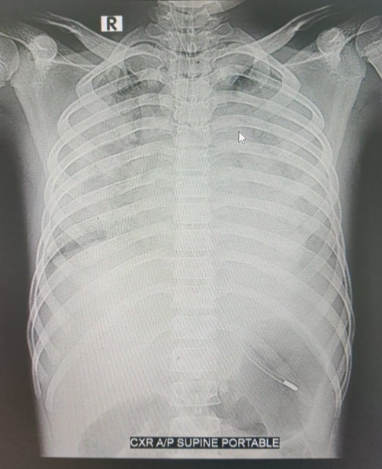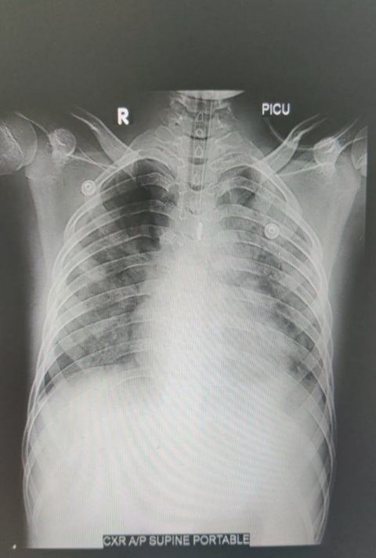

Before After

1a 1b

**Fig 1-Chest X-ray before(1a) and after(1b) CytoSorb**

**Laboratory Markers:** Initial inflammatory markers (e.g., CRP, IL-6) were markedly elevated. Lactic acid levels confirmed ongoing anaerobic metabolism due to shock.

**Table 1- Lab parameters indicating Pre and Post CytoSorb**

|  |  |  |
| --- | --- | --- |
| Lab parameters | Pre CytoSorb | Post CytoSorb |
| Procalcitonin | 6.06 ng/ml | 2.8 ng/ml |
| Interleukin-6 | 45 pg/ml | 3.9 pg/ml |
| Ferritin | 890 ng/ml | 702 ng/ml |
| Lactate | 3.8 mmol/l | 1.0 mmol/l |
| CRP | 33.2 mg/l | 9.9 mg/l |
| ABG | $P^{H}$ =7.30, P $O_{2}$ =30.3, Fi $O_{2}$ =60% (Type I respiratory failure), Lactate=3.5 | $P^{H}$ =7.38, P $O_{2}$ =129, Fi $O_{2}$ =70%, Lactate=1.7 |

**Microbiology:** Blood and BAL cultures were sent prior to antibiotic initiation and no growth was found.

**Hematologic Evaluation:** Profound thrombocytopenia and rising hematocrit indicated plasma leakage.

Following two CytoSorb sessions, the patient demonstrated significant clinical and biochemical improvement. Inflammatory markers dropped from a peak of 8.5 to 3.2 units. Respiratory function improved, allowing extubation within 48 hours of the second session. Chest imaging revealed reduced infiltrates. Hemodynamic parameters stabilized, vasopressors were weaned, and organ functions normalized. The patient's rapid improvement correlated temporally with the CytoSorb therapy, supporting its role in resolving the inflammatory cascade. He was shifted to ward home in stable condition on ICU day 7.

**Patient Follow-Up**

The patient was followed up 2 weeks after shifted to ward. He remained asymptomatic, afebrile, with normal platelet counts and normal chest auscultation. No rebound inflammation or delayed complications were noted.

**Discussion**

**Pathophysiology of DSS and Cytokine Storm**

Dengue Shock Syndrome, particularly in pediatric populations, can result in critical complications, including MODS and death if not promptly and effectively managed [3,6]. Standard treatments largely address the consequences of systemic inflammation but do little to halt its upstream drivers. In this case, CytoSorb served as a rescue therapy by directly targeting inflammatory mediators responsible for the clinical deterioration. This aligns with other studies that support CytoSorb’s effectiveness in reducing cytokine burden and improving hemodynamics in critically ill patients [10,11,15].

**CytoSorb in Pediatric Critical Care**

In pediatric populations, its use has been limited but encouraging, with successful outcomes in septic shock, viral myocarditis, and post-cardiac surgery inflammation [18-20]. Importantly, CytoSorb does not remove essential antibiotics or cause significant hemodynamic instability during operation, making it a practical ICU tool [12,16]. The reduction in IL-6 and TNF-α, both known markers of poor prognosis in dengue and sepsis, suggests that CytoSorb could interrupt the pathogenic inflammatory loop characteristic of DSS [7,8,14].

**Comparisons with Other Case Reports**

While no randomized trials have evaluated its use specifically in dengue, anecdotal and small observational studies support its benefit in similar hyperinflammatory conditions [19,21].

Given its safety, biocompatibility, and efficacy in reducing inflammation, CytoSorb should be considered early in the course of DSS with MODS where conventional therapies are failing. Larger pediatric trials are necessary to validate these findings and establish treatment protocols tailored to viral shock syndromes.

**Conclusion**

CytoSorb hemoadsorption therapy proved to be an effective adjunct in the management of Dengue Shock Syndrome complicated by severe inflammation and MODS in this pediatric patient. Its timely initiation was associated with rapid clinical recovery, resolution of organ dysfunction, and normalization of inflammatory parameters. These findings support the potential role of CytoSorb in critical dengue care, warranting further investigation through controlled studies. This case contributes to the emerging evidence for extracorporeal cytokine removal as a feasible adjunct in severe pediatric viral infections

**Conflict of Interest:** There is no conflict of Interest.

Disclaimer (Artificial intelligence)

Author(s) hereby declares that no generative AI technologies such as Large Language Models (ChatGPT, COPILOT, etc.) and text-to-image generators have been used during the writing or editing of this manuscript.

**References**

1. Bhatt S, Gething PW, Brady OJ, et al. The global distribution and burden of dengue. Nature. 2013 Apr 7;496(7446):504–7. doi: 10.1038/nature12060.
2. WHO. Dengue Guidelines for Diagnosis, Treatment, Prevention and Control. Geneva: WHO; 2009.
3. Jelinek T, Mühlberger N, Harms G, et al. Epidemiology and clinical features of imported dengue fever in Europe: sentinel surveillance data from TropNetEurop. Clin Infect Dis. 2002;35(9):1047–52. doi:10.1086/342906.
4. Martina BEE, Koraka P, Osterhaus ADME. Dengue virus pathogenesis: an integrated view. Clin Microbiol Rev. 2009 Oct;22(4):564–81. doi: 10.1128/CMR.00035-09.
5. Guzman MG, Gubler DJ, Izquierdo A, Martinez E, Halstead SB. Dengue infection. Nat Rev Dis Primers. 2016;2:16055. doi:10.1038/nrdp.2016.55.
6. Muller DA, Depelsenaire ACI, Young PR. Clinical and laboratory diagnosis of dengue virus infection. J Infect Dis. 2017 Mar 1;215(suppl_2):S89–S95. doi: 10.1093/infdis/jiw649.
7. Price JD, Linder G, Li WP, Zimmermann B, Rother KI, Malek R, Alattar M, Tarbell KV. Effects of short-term sitagliptin treatment on immune parameters in healthy individuals, a randomized placebo-controlled study. Clin Exp Immunol. 2013 Oct;174(1):120–8. doi: 10.1111/cei.12144.
8. Green S, Rothman AL. Immunopathological mechanisms in dengue and dengue hemorrhagic fever. Curr Opin Infect Dis. 2006 Oct;19(5):429–36. doi: 10.1097/01.qco.0000244047.31135.fa.
9. Rajapakse S. Dengue shock. J Emerg Trauma Shock. 2011 Jan-Mar;4(1):120–7. doi: 10.4103/0974-2700.76835.Kellum JA, et al. Crit Care. 2015;19:166.
10. Mehta Y, Paul R, Ansari AS, Banerjee T, Gunaydin S, Nassiri AA, Pappalardo F, Premužić V, Sathe P, Singh V, Vela ER. Extracorporeal blood purification strategies in sepsis and septic shock: An insight into recent advancements. World J Crit Care Med. 2023 Mar 9;12(2):71–88. doi: 10.5492/wjccm.v12.i2.71.
11. Protti A, Andreis DT, Iapichino GE, et al. High positive end-expiratory pressure: only a dam against oedema formation? Crit Care. 2013;17(4):R131. doi:10.1186/cc12810.
12. Sato Y, Iseki K, Sato H, et al. Effect of increased convection volume by mid-dilution hemodiafiltration on systemic inflammation in patients undergoing chronic hemodialysis. Blood Purif. 2018;45(1):1–8. doi: 10.1159/000492377.
13. Gunasekera AM, Eranthaka U, Priyankara D, Kalupahana R. A rare case of acute liver failure with intrahepatic cholestasis due to dengue hemorrhagic fever: CytoSorb® and plasma exchange aided in the recovery: case report. BMC Infect Dis. 2022 Dec 13;22(1):938. doi: 10.1186/s12879-022-07933-y.
14. Honoré PM, De Bels D, Barreto Gutierrez L, et al. Hemoadsorption therapy in the critically ill: solid base but clinical haze. Ann Intensive Care. 2019;9(1):22. doi:10.1186/s13613-019-0491-1.
15. Kogelmann K, Jarczak D, Scheller M, Drüner M. Hemoadsorption by CytoSorb in septic patients: a case series. Crit Care. 2017 Mar 27;21(1):74. doi: 10.1186/s13054-017-1662-9.
16. Malard B, Lambert C, Kellum JA. In vitro comparison of the adsorption of inflammatory mediators by blood purification devices. Intensive Care Med Exp. 2018 May 4;6(1):12. doi: 10.1186/s40635-018-0177-2.
17. Kogelmann K, Jarczak D, Scheller M, Drüner M. Hemoadsorption by CytoSorb in septic patients: a case series. Crit Care. 2017 Mar 27;21(1):74. doi: 10.1186/s13054-017-1662-9.
18. Maitoza LA, Neeman E, Funaro M, Pierce RW. Relevance of microvascular flow assessments in critically ill neonates and children: a systematic review. Pediatr Crit Care Med. 2020 Apr;21(4):373–84. doi: 10.1097/PCC.0000000000002201.
19. Shah B, Dande V, Rao S, Prabhu S, Bodhanwala M. Outcome of Covid-19 positive newborns presenting to a tertiary care hospital. Indian Pediatr. 2021 Feb;58(2):177–9. doi: 10.1007/s13312-021-2136-3.
20. Chumachenko A, Pisarev V, Grigoryev E. AGTR1 rs275651 AA genotype links with better survival in sepsis patients in ICU. Crit Care. 2021;25(Suppl 1):P001. doi: 10.1186/s13054-021-03769-1.
21. Brouwer WP, Duran S, Kuijper M, Ince C. Hemoadsorption with CytoSorb shows a decreased observed versus expected 28-day all-cause mortality in ICU patients with septic shock: a propensity-score-weighted retrospective study. Crit Care. 2019;23(1):317. doi: 10.1186/s13054-019-2588-1.