**EVALUATION OF ANTI-INFLAMMATORY ACTIVITY BY *EUCALYPTUS CAMADULENSIS* AND *OCIMUM TENUIFLORUM***

**ABSTRACT**

This study examines the anti-inflammatory activities of bark from *Eucalyptus camaldulensis* and leaves from *Ocimum tenuiflorum*. Phytochemical extraction was done using methanol and water, followed by extraction, and thorough phytochemical screening. The analysis confirmed the presence of various bioactive compounds such as alkaloids, flavonoids, saponins, tannins, proteins, amino acids, and phenolic compounds. Physiochemical tests also showed good results towards solubility, pH range, and other sensory attributes. The results indicate that both plants have substantial anti-inflammatory activity which is likely due to their abundant bioactive compounds. The study affirms the anti-inflammatory folkloric medicinal claims of the plants and stimulates further investigation towards the plants' pharmaceuticals.

KEYWORDS: Inflammation, pathogens, damaged cells, Adipose tissue

**1.INTRODUCTION :**

**Inflammation: An In-Depth Review**

Inflammation represents a protective mechanism disturbance of biological functions mediated through the immune system and directed towards harmful stimuli such as pathogens, damaged cells or toxic compounds (Medzhitov, 2008). Acute Inflammation is the term used for short term responses consisting of Rubor, Tumor, Calor, Dolor and Loss Of Function. It lasts from a few days to a week. This is resolved by the clearence of the harmful agents and tissue repair by the immune cells (Nathan & Ding, 2010). On the other hand, chronic inflammation develops when the inflammation did not resolve over the period of time. Chronic inflammation is connective tissue dominated repair seen in some neoplastic, diabetic, cardiovascular, autoimmune disorders and even cancer (Hunter, 2012). These processes have tender to work in unison like a complex network design with a variety of molecular cues. First onset stage in the processes, are pattern recognization receptors (PRRs) such as toll-like receptors (TLRs) engages recognition through pathogens that drives immune response activation (Takeuchi & Akira, 2010). This later follows with releasing of a set of pro inflammatory mediators for example cytokines such as interleukin 1 (IL 1) tumor necrosis factor alpha (TNF-α), Chemokines and Prostaglandins (Medzhitov, 2010).

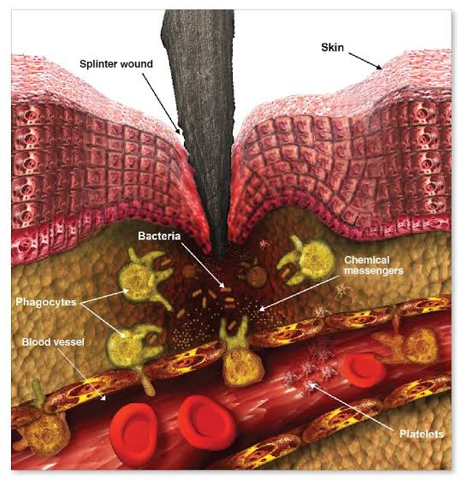

**Figure 1- Immune response of the body to a splinter wound**

Prolonged exposure to toxic substances, autoimmune reactions, or recurring infections are frequently the causes of chronic inflammation. It is linked to many illnesses, such as atherosclerosis, where inflammatory mediators encourage the buildup of plaque in blood vessels, raising the risk of strokes and heart attacks (Libby, 2002). Adipose tissue secretes pro-inflammatory cytokines like TNF-α and IL-6 in obesity-related inflammation, which disrupt insulin signaling and lead to metabolic diseases like type 2 diabetes (Hotamisligil, 2006). Similarly, there is evidence that the pathophysiology of Alzheimer's and Parkinson's diseases is influenced by microglial activation and the release of inflammatory mediators, indicating that chronic inflammation is a hallmark of neurodegenerative diseases (Heneka et al., 2015).

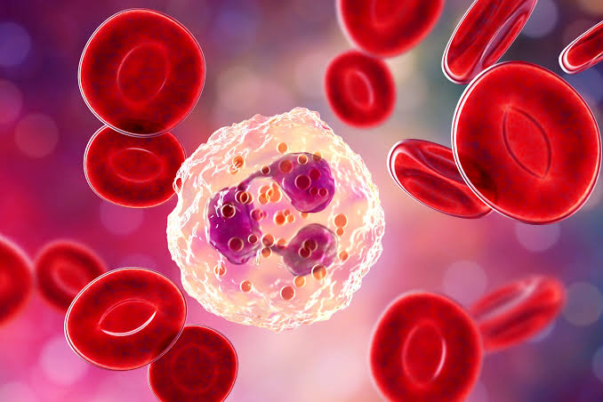

**Figure 2- Illustration of Red Blood Cells (RBCs)**

Inflammation can be reduced and homeostasis can be restored by the immune system. Pro-inflammatory signals are countered by anti-inflammatory mediators, such as interleukin-10 (IL-10), and specialized pro-resolving lipid mediators, such as lipoxins and resolvins (Serhan et al., 2008). As observed in chronic inflammatory diseases, dysregulation of these mechanisms can result in tissue damage and protracted inflammation (Tabas & Glass, 2013). Targeted treatments for inflammatory diseases have been developed as a result of research advances. By blocking cyclooxygenase (COX) enzymes, nonsteroidal anti-inflammatory drugs (NSAIDs) like aspirin and ibuprofen lower inflammation and prostaglandin synthesis (Vane & Botting, 2003). By altering nuclear factor-kappa B (NF-κB) signaling, corticosteroids such as dexamethasone reduce the expression of inflammatory genes(Barnes, 2011). Moreover, autoimmune diseases like rheumatoid arthritis are treated with biologic therapies like interleukin blockers (like anakinra) and TNF inhibitors (like infliximab) (McInnes & Schett, 2011). Changes in lifestyle are also essential for controlling inflammation. Regular exercise has been demonstrated to lower pro-inflammatory cytokine and CRP levels, thereby reducing systemic inflammation (Gleeson et al., 2011).

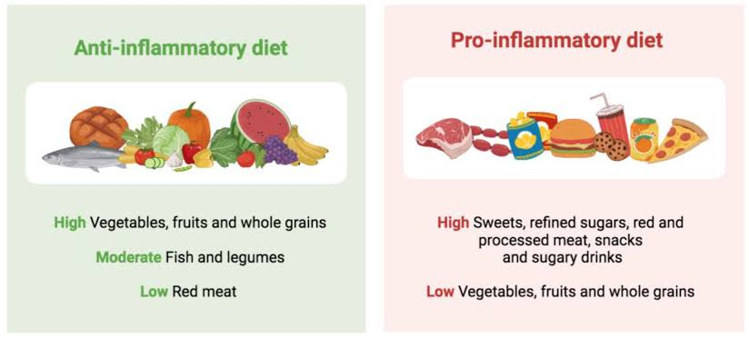

**Figure 3: Differences between anti-inflammatory and pro-inflammatory diet**

**2.MATERIALS AND METHODS :**

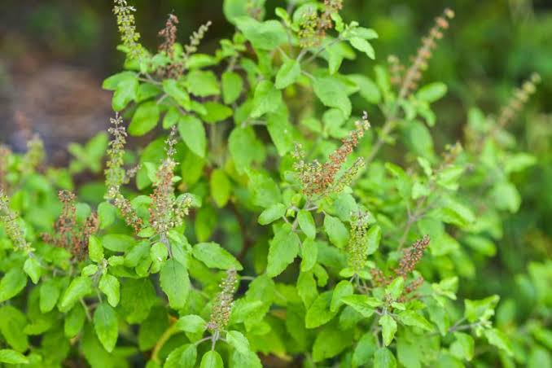 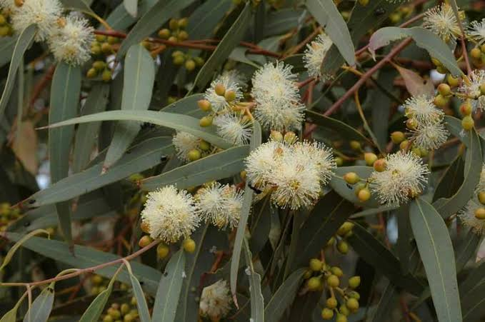***Figure 6 - Ocimum tenuiflorum Figure 7 - Eucalyptus***

***camaldulensis***

**Extraction Process of Ocimum tenuiflorum Leaves and Eucalyptus camaldulensis Bark**

From a home garden in BHEL, Hyderabad, Telangana (India), fresh Ocimum tenuiflorum leaves and Eucalyptus camaldulensis bark were gathered. To get rid of dust and other contaminants that had stuck, the gathered plant materials were first thoroughly cleaned with distilled water. To protect the heat-sensitive phytoconstituents, the materials were properly cleaned and then allowed to dry in the shade for seven to ten days at room temperature. In order to promote solvent penetration during extraction and increase surface area, the leaves and bark were mechanically ground into a coarse powder once they had completely dried. Methanol and distilled water were the two distinct solvents employed in the extraction procedure. In separate conical flasks, a weighed amount (about 50 g) of powdered plant material was soaked in 250 ml of methanol (for a methanolic extract) and 250 ml of distilled water (for an aqueous extract). To improve phytochemical extraction, the mixtures were macerated for 72 hours at room temperature while being shaken periodically. Following maceration, solid residues were eliminated from the extracts by filtering them using Whatman No. 1 filter paper. In order to produce semisolid crude extracts, the filtrates were then concentrated under lower pressure using a rotary evaporator for methanol extracts and evaporated over a water bath at 40 to 50°C for aqueous extracts.

The dried crude extracts were collected in airtight containers and stored at 4°C until further use for phytochemical screening, physiochemical testing, and biological evaluation. The yield and physical characteristics of each extract were also recorded.

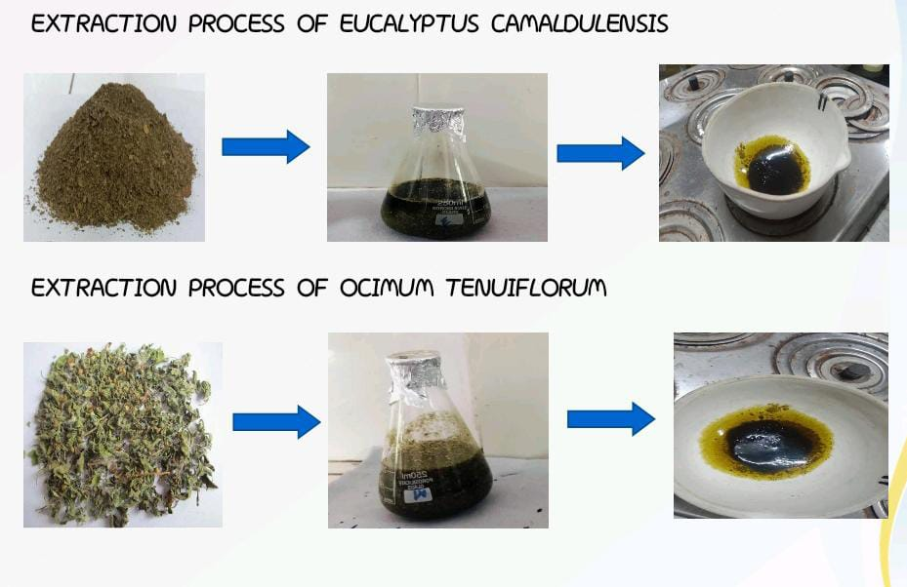

**Figure 8- Illustration of the extraction process of Eucalyptus camaldulensis and Ocimum tenuiflorum**

### **3.Phytochemical Screening:** Eucalyptus camaldulensis and Ocimum tenuiflorum

### To find bioactive substances in plants, phytochemical screening is a crucial technique. The presence of several phytochemicals in Eucalyptus camaldulensis and ocimum tenuiflorum was assessed using the following methods.

#### **3.1 Test for Alkaloids**

* **Dragendorff’s Test**
  + Procedure: The extracted solution was mixed with Dragendorff’s reagent
  + Observation: A reddish-brown precipitate was formed (Evans, 2009).
* **Mayer’s Test**
  + Procedure: The extracted solution was mixed with Mayer’s reagent.
  + Observation: Formation of a cream-colored precipitate was formed.(Sofowora, 1993).
  + **Wagner’s Test**
  + Procedure: The extracted solution was mixed with Wagner’s reagent (iodide potassium iodide solution).
  + Observation: A reddish-brown precipitate was formed (Harborne, 1998).
* **Hager’s Test**
  + Procedure: The extracted solution was mixed with Hager’s reagent
  + Observation: A yellow precipitate was formed (Trease & Evans, 2002).

#### **3.2 Test for Amino Acids**

* + **Ninhydrin Test**
  + Procedure: The extracted solution was heated with ninhydrin reagent.
  + Observation: A white precipitate was formed (Sadasivam & Manickam, 2008).

#### **3.3 Test for Reducing Sugars**

* **Benedict’s Reagent Test**
  + Procedure: The extracted solution was mixed with Benedict’s reagent and heated.
  + Observation: A brick-red color was appeared (Harborne, 1998).

#### **3.4 Test for Proteins**

* **Biuret Test**
  + Procedure: The extracted solution was mixed with Biuret reagent.
  + Observation: The violet color was appeared (Sadasivam & Manickam, 2008).

#### **3.5 Test for Phenolic Compounds**

* **Ferric Chloride Test**
  + Procedure: The extracted solution was mixed with ferric chloride solution.
  + Observation: The blue and green color was appeared (Harborne, 1998).

#### **3.6 Test for Tannins**

* + **Ferric Test**
  + Procedure: The extracted solution was mixrd with a ferric reagent.
  + Observation: A grey or black color was appeared (Sofowora, 1993).

#### **3.7 Test for Saponins**

* **Foam Test**
  + Procedure: The extracted solution was vigorously shaken with distilled water.
  + Observation: Persistent foam formation (Trease & Evans, 2002).
* **Keller-Kiliani Test**
  + Procedure: The extracted solution was mixed with glacial acetic acid, ferric chloride, and sulfuric acid.
  + Observation: A brown ring was formed (Harborne, 1998).

#### **3.8 Test for Flavonoids**

* **Alkaline Reagent Test**
  + Procedure: The extracted solution was treated with sodium hydroxide and diluted HCl.
  + Observation: A deep yellow color was appeared (Trease & Evans, 2002).

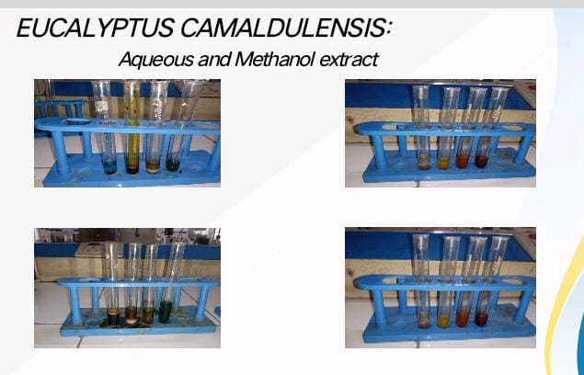

**Figure 9- Aqueous and methanol extract of Eucalyptus camaldulensis**

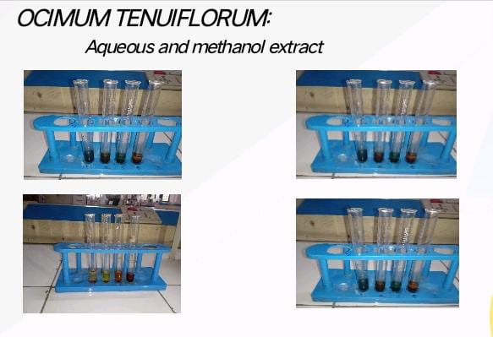

***Figure 10- Aqueous and methanol extract of* *Ocimum tenuiflorum***

**5.RESULT AND DISCUSSION:**

**RESULTS OF PRELIMINARY PHYTOCHEMICAL INVESTIGATION**

Both methanol and aqueous extracts of *Eucalyptus camaldulensis* bark powder included a number of significant bioactive components, according to the results of the initial phytochemical screening. Alkaloids, flavonoids, proteins, amino acids, phenolic substances, and tannins were all detected in both extracts. But only the aqueous extract included saponins, and only the methanol extract contained reducing sugars. This discrepancy results from the distinct solubility characteristics of phytochemicals in semi-polar and polar liquids. Strong anti-inflammatory, analgesic, and antioxidant qualities are well-known for alkaloids and flavonoids. The bark's historic medicinal use is supported by the presence of tannins and phenolic chemicals, which show strong antibacterial and astringent activity. All things considered, *Eucalyptus camaldulensis* demonstrates a variety of pharmacologically active components that could support its medicinal potential.Results of preliminary phytochemical investigation of *Eucalpytus camaldulensis* bark powder as shown the presence of **Alkaloids, flavonoids, phenolic compounds, saponins and tannins . All the results are shown below**

**Table 1: Preliminary phytochemical constituents of *Eucalpytus camaldulensis***

|  |  |  |  |
| --- | --- | --- | --- |
| **S.NO** | ***CONSTITUENTS*** | ***METHANOL EXTRACT*** | ***AQUEOUS EXTRACT*** |
| *1* | *Alkaloids* | *+* | *+* |
| *2* | *Flavonoids* | *+* | *+* |
| *3* | *Amino acids* | *+* | *+* |
| *4* | *Proteins* | *+* | *+* |
| *5* | *saponins* | *+* | *+* |
| *6* | *Phenolic compounds* | *-* | *+* |
| *7* | *Tannins* | *+* | *+* |
| *8* | *Reducing sugars* | *+* | *-* |

Both methanol and aqueous extracts of *Ocimum tenuiflorum* leaf powder had a wealth of medicinal ingredients, according to the phytochemical analysis. Both extracts contained proteins, alkaloids, amino acids, saponins, and tannins. Remarkably, only the aqueous extract included flavonoids and phenolic chemicals, while the methanol extract contained reducing sugars. This implies that while sugars are more soluble in methanol, some polar chemicals and antioxidants are better extracted in water. Its historic usage in treating inflammation and respiratory infections is supported by the aqueous extract's potential antioxidant action, which is highlighted by the presence of flavonoids and phenolic components. *Tulsi* is a valuable therapeutic plant in Ayurveda and contemporary herbal medicine because of its adaptogenic, immunomodulatory, and antibacterial qualities, which are reflected in its phytoconstituents.Results of preliminary phytochemical investigation of *ocimum tenuiflorum* tulsi leaves powder have shown the presence of **alkaloids,flavonoids,saponins and tannis**.all the results are shown below

**Table 2: preliminary phytochemical constitutents of *Ocimum tenuiflorum:***

|  |  |  |  |
| --- | --- | --- | --- |
| **S.NO** | ***CONSTITUENTS*** | ***METHANOL EXTRACT*** | ***AQUEOUS EXTRACT*** |
| *1* | *Alkaloids* | *+* | *+* |
| *2* | *Flavonoids* | *-* | *+* |
| *3* | *Amino acids* | *+* | *+* |
| *4* | *Proteins* | *+* | *+* |
| *5* | *saponins* | *+* | *+* |
| *6* | *Phenolic compounds* | *-* | *+* |
| *7* | *Tannins* | *+* | *+* |
| *8* | *Reducing sugars* | *+* | *-* |

**Physiochemical tests**

**physiochemical test for *eucalyptus camaldulensis***

To evaluate the fundamental physical and chemical properties of *Eucalyptus camaldulensis* bark powder, a physicochemical evaluation was conducted. The powdered bark had a light brown hue, a strong scent, and a bitter flavor. Alkaloids and tannins are probably the cause of the bitterness. Its solubility in methanol and water suggests that it contains a variety of polar and semi-polar molecules that these solvents can extract. The solution's pH ranged from 5.5 to 6.5, indicating that the extract is slightly acidic—a characteristic that is normally advantageous for the majority of pharmaceutical formulations. These physicochemical properties validate the plant's eligibility for additional pharmacological and formulation research while also bolstering its stability and utility in herbal remedies**.** The *eucalyptus camadulensis* preliminary physiochemical studies were conducted. the existence of characteristics like as color, odor, solubility, and pH.

**Table 3: Results of physiochemical tests of *eucalyptus camaludensis***

|  |  |  |
| --- | --- | --- |
| **S.NO** | **PARAMETERS** | **OBSERVATIONS** |
| **1** | Colour | Light brown |
| **2** | Odour | Aromatic |
| **3** | Taste | bitter |
| **4** | Solubility | Soluble in Methanol and water |
| **5** | PH | 5.5-6.5 |

**physiochemical test for *Ocimum tenuiflorum***

*Ocimum tenuiflorum* leaf powder's initial physicochemical analysis identified a number of significant properties that are helpful in recognizing and standardizing the herbal material. As is common with dried leafy material high in chlorophyll and secondary metabolites, the powder had a green appearance. It has a strong, aromatic smell and a strong, slightly bitter taste, which are characteristics typically linked to the phytoconstituents and essential oils found in tulsi, such as flavonoids and eugenol. Both polar and semi-polar phytochemicals were present in the extract, as evidenced by its solubility in both methanol and water. The extract's nearly neutral to slightly acidic character, shown by its pH range of 6.0 to 7.0, makes it perfect for oral herbal preparations. *Ocimum tenuiflorum's* identity, stability, and purity are supported by these physicochemical properties, which also guarantee the plant's efficacy in both conventional and contemporary medicinal preparations. *Ocimum tenuiflorum's* initial physiochemical experiments were conducted. characteristics such as color, odor, solubility, and PH

**Table .4: Results of physiochemical tests of *Ocimum tenuiflorum***

|  |  |  |
| --- | --- | --- |
| **S.NO** | **PARAMETERS** | **OBSERVATIONS** |
| **1** | Colour | Green |
| **2** | Odour | Strong Aromatic |
| **3** | Taste | Pungent,slightly bitter |
| **4** | Solubility | Soluble in Methanol and water |
| **5** | PH | 6.0-7.0 |

**Discussion**

“Evaluation of Anti-Inflammatory Activity by *Eucalyptus camaldulensis* and *Ocimum tenuiflorum”*

The goal of the current study was to assess the anti-inflammatory properties of *Ocimum tenuiflorum (tulsi)* leaves and *Eucalyptus camaldulensis* bark using physiochemical analysis and phytochemical screening. In traditional medical systems, these herbs are well known for their ability to alleviate inflammation and associated conditions. Numerous physiologically active substances, including as alkaloids, flavonoids, tannins, saponins, phenolic compounds, amino acids, and proteins, were found in the initial phytochemical analysis. The literature has extensively shown the considerable contribution of these components to anti-inflammatory action. For example, flavonoids have antioxidant properties that can prevent the release of pro-inflammatory mediators like prostaglandins and cytokines, whereas alkaloids are known to disrupt pain perception and inflammation pathways. Remarkably, the methanol extract of *Eucalyptus camaldulensis* included reducing sugars that were not present in its aqueous extract, whereas the aqueous extract of *Ocimum tenuiflorum* mostly contained flavonoids and phenolic chemicals. This highlights the significance of choosing a solvent depending on the target component group and implies that the solvent system is essential for extracting particular classes of phytoconstituents. The physiochemical analyses provided more evidence that both plants were suitable for use in pharmaceuticals. Features that are advantageous for formulation and patient compliance include solubility in methanol and water, mild to neutral pH, fragrant odor, and distinctive taste. Both *Eucalyptus camaldulensis* and *Ocimum tenuiflorum* are appropriate for oral and topical anti-inflammatory compositions since they have somewhat acidic pH ranges (5.5–6.5 and 6.0–7.0, respectively). These results are consistent with other research that found tulsi and eucalyptus to be natural sources of anti-inflammatory compounds. Their historic usage are well supported by the observed phytochemical profiles, which also point to the possibility of creating standardized herbal formulations. To validate the mechanisms of action and assess dose-response correlations, more pharmacological research is advised, including molecular-level studies and in vivo models (such as the carrageenan-induced paw edema test). In conclusion, the investigation supports the traditional assertions that *Ocimum tenuiflorum* and *Eucalyptus camaldulensis* have anti-inflammatory properties. Their use in herbal medicine is supported by the presence of important phytochemicals, and the information gathered could aid in the future study and creation of safe, all-natural anti-inflammatory treatments.

**6.Conclusion**:

The present study highlights the significant anti-inflammatory potential of Eucalyptus camaldulensis bark and Ocimum tenuiflorum leaves. Phytochemical screening confirmed the presence of important bioactive compounds such as alkaloids, flavonoids, tannins, saponins, and phenolic compounds, which are known contributors to anti-inflammatory activity. The favorable physicochemical properties further support their suitability for medicinal use. Overall, the findings validate the traditional use of these plants in treating inflammatory conditions and suggest that they can serve as promising natural sources for developing safe and effective anti-inflammatory agents. Further detailed pharmacological and clinical investigations are recommended to explore their mechanisms of action and therapeutic efficacy.

Disclaimer (Artificial intelligence)

Option 1:

Author(s) hereby declare that NO generative AI technologies such as Large Language Models (ChatGPT, COPILOT, etc.) and text-to-image generators have been used during the writing or editing of this manuscript.

Option 2:

Author(s) hereby declare that generative AI technologies such as Large Language Models, etc. have been used during the writing or editing of manuscripts. This explanation will include the name, version, model, and source of the generative AI technology and as well as all input prompts provided to the generative AI technology

Details of the AI usage are given below:

1.

2.

3.

**7. REFERENCES:**

1. Hunter, P. (2012). The inflammation theory of disease. EMBO Reports, 13(11), 968-970. <https://doi.org/10.1038/embor.2012.142>.
2. Libby, P. (2002). Inflammation in atherosclerosis. Nature, 420(6917), 868-874. <https://doi.org/10.1038/nature01323>
3. Medzhitov, R. (2008). Origin and physiological roles of inflammation. Nature, 454(7203), 428-435. <https://doi.org/10.1038/nature07201>.
4. Medzhitov, R. (2010). Inflammation 2010: new adventures of an old flame. Cell, 140(6), 771-776. <https://doi.org/10.1016/j.cell.2010.03.006>
5. Nathan, C., & Ding, A. (2010). Nonresolving inflammation. Cell, 140(6), 871-882. <https://doi.org/10.1016/j.cell.2010.02.029>
6. Ridker, P. M. (2016). From C-Reactive Protein to Interleukin-6 to Interleukin-1: Moving Upstream to Identify Novel Targets for Atheroprotection. Circulation Research, 118(1), 145-156. <https://doi.org/10.1161/CIRCRESAHA.115.306656>
7. Serhan, C. N., Chiang, N., & Van Dyke, T. E. (2008). Resolving inflammation: dual anti-inflammatory and pro-resolution lipid mediators. Nature Reviews Immunology, 8(5), 349-361. <https://doi.org/10.1038/nri2294>
8. Tabas, I., & Glass, C. K. (2013). Anti-inflammatory therapy in chronic disease: challenges and opportunities. Science, 339(6116), 166-172. <https://doi.org/10.1126/science.1230720>
9. Takeuchi, O., & Akira, S. (2010). Pattern recognition receptors and inflammation. Cell, 140(6), 805-820. <https://doi.org/10.1016/j.cell.2010.01.022>
10. Vane, J. R., & Botting, R. M. (2003). The mechanism of action of aspirin. Thrombosis Research, 110(5-6), 255-258. <https://doi.org/10.1016/S0049-3848(03)00379-7>
11. Barnes, P. J. (2011). Corticosteroids: The drugs to beat. British Journal of Pharmacology, 163(1), 17-33. <https://doi.org/10.1111/j.1476-5381.2011.01249.x>
12. Gleeson, M., et al. (2011). The anti-inflammatory effects of exercise. Journal of Applied Physiology, 110(6), 1490-1495. <https://doi.org/10.1152/japplphysiol.00008.2011>
13. Heneka, M. T., et al. (2015). Neuroinflammation in Alzheimer’s disease. The Lancet Neurology, 14(4), 388-405. <https://doi.org/10.1016/S1474-4422(15)70016-5>
14. Honda, K., & Littman, D. R. (2012). The microbiome in infectious disease and inflammation. Annual Review of Immunology, 30, 759-795. <https://doi.org/10.1146/annurev-immunol-020711-075001>
15. Hotamisligil, G. S. (2006). Inflammation and metabolic disorders. Nature, 444(7121), 860-867. <https://doi.org/10.1038/nature05485>
16. Evans, W.C. (2009). Trease and Evans Pharmacognosy (16th ed.). Saunders Ltd.
17. Sherborne, J.B. (1998). Phytochemical Methods: A Guide to Modern Techniques of Plant Analysis (3rd ed.). Springer.
18. Sadasivam, S., & Manickam, A. (2008). Biochemical Methods (3rd ed.). New Age International.
19. Sofowora, A. (1993). Medicinal Plants and Traditional Medicine in Africa (2nd ed.). Spectrum Books Ltd.
20. Trease, G.E., & Evans, W.C. (2002). Pharmacognosy (15th ed.). Saunders Ltd.

Appendix

**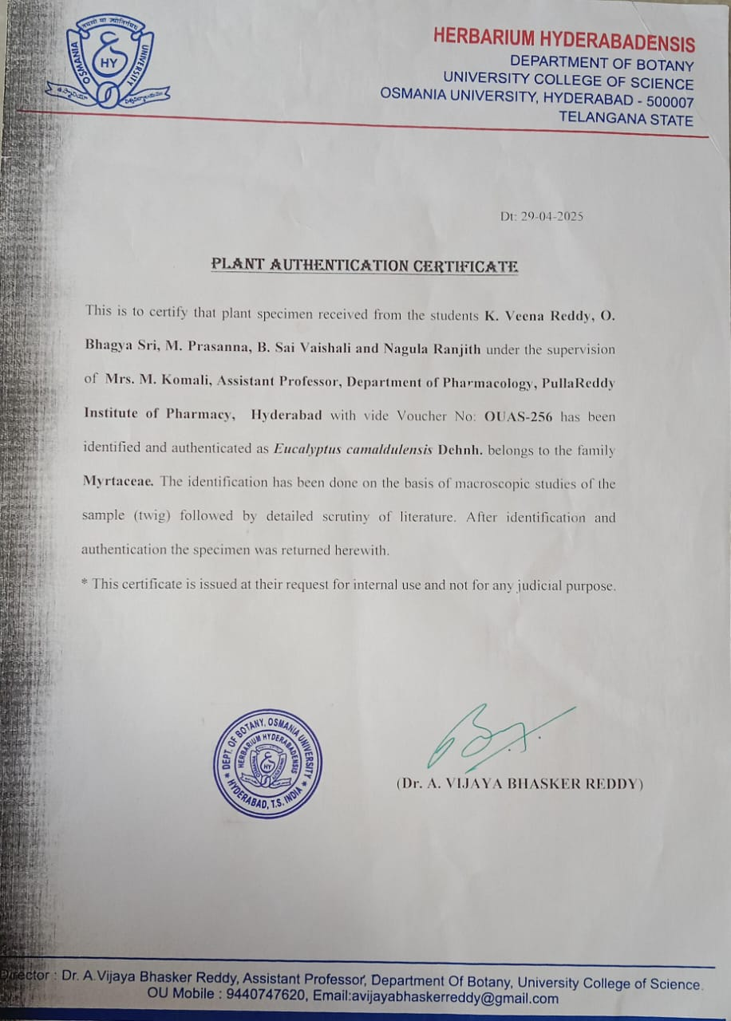 *Figure 1 A – Authentication of Eucalyptus Camaldulensis***

***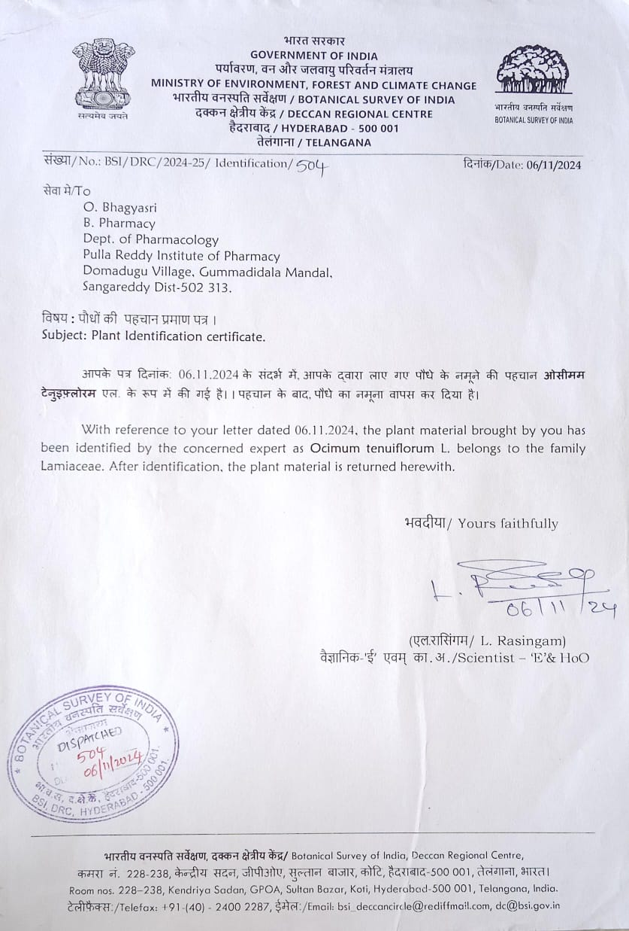* *Figure 2 A – Authenfication ocimum tenuiflorum***