Original Research Article

Endotyping Cellular and Humoral cross-reactivity among Canine, Feline, and Swine Allergens in Patients with Allergic Multimorbidity.

ABSTRACT

Background: The cat-pork syndrome and the cross-reactivity between cat dander and dog dander are particular situations associated with the allergic multimorbidity phenotypes. The perception of this cross-reactivity must benefit the allergist dealing with these conditions.
Aim: To evaluate the capacity of the Tube Titration of Precipitins (TTP) and the Leukocyte Adherence Inhibition Test (LAIT) to discriminate cellular and humoral immunoreactivity against cat fur and dog fur extracts as well as pork meat extract in patients with non–IgE-mediated multimorbidity phenotypes.
Study Design: We examined retrospectively the medical charts of two cohorts of patients clinically diagnosed with non–IgE-mediated multimorbidity allergic phenotypes related to inhalation or contact with cat fur, dog fur, and/or consumption of pork meat, who were investigated with the help of TTP or LAIT.
Methodology:---------The correlation between the paired assays was calculated using Pearson's methodology and demonstrated by dispersion graphs.
Results: ------ Pearson's correlation indicated a significant positive relationship between the cat fur and dog fur extracts in LAIT results: r(98) = 0.395, p-value < 0.001. --------- The paired-t test indicated a significant difference between the TTP results of cat fur and pork meat extracts (p-value = 0.009). Pearson correlation analysis indicated a non-significant, negative relationship between the TTP results of cat fur and pork meat (p-value = 0.644). The paired t-test indicated a significant difference between the TTP results of dog fur and pork meat extracts (p < 0.001). -----------
Conclusion: The preliminary results suggest that the TTP and LAIT may discriminate between diverse humoral and cellular immunoreactivity levels in patients with various allergic phenotypes, as observed in cat and dog fur and pork meat extracts. A significant association was found between the immunoreactivity of cat fur and dog fur. There was no clear association between pork meat and fur immunoreactivity.

Keywords: Endotype; Hypersensitivity; Cat fur; Dog fur; Leukocyte Adherence Inhibition Test; Non–IgE-mediated Immunoreactivity; Pork meat; Precipitins.

1. INTRODUCTION

Hypersensitivity conditions, such as allergic rhinoconjunctivitis and allergic bronchitis caused by sensitization to allergens from furry pets, affect more than 10% of the worldwide population, producing a deleterious impact on patients' quality of life (Chan and Leung 2018, van Hage et al. 2023, Konradsen et al. 2015).
Allergic Multimorbidity (defined in patients with concomitant or consecutive allergic phenotypes) is the subject study for the "Mechanisms of the Development of ALLergy" (MeDALL) project to understand the links between multimorbidity and polysensitization in allergic phenotypes that may be IgE-mediated, partly IgE-mediated, or non-IgE-mediated (Bousquet et al. 2015, Bousquet et al. 2025).
Allergic Multimorbidity is a concept associated with the "Atopic March", a pattern of allergic disease development recognized in children with sequential and concomitant sensitization to food allergens and inhalant allergens (Hahn and Bacharier 2005; Kulig et al. 1999).
Allergic sensitization may happen at any age. In general, no clinical symptoms are detectable at birth; however, the earlier sensitization is usually directed against food proteins (hen's egg and cow's milk, occurring via the mother's milk), while sensitization to environmental allergens and other food allergens (such as soy and wheat allergens) are increasingly progressing after the first birthday (Wahn 2000).
Initial signs of allergic disease are atopic dermatitis and food allergies, which typically have their most significant incidence peaks during the first two years of life. Nearly half of children with atopic dermatitis develop symptoms within the first six months of life, and approximately 85% of individuals with eczema have symptoms onset by the age of five years (Kay et al. 1994).
Allergic multimorbidity represents a group of conditions that deleteriously impair the quality of life and usually involves polysensitization in which cat and dog dander may be particularly associated (Li et al. 2025). Cross-reactivities among related and unrelated allergens are standard features in allergic patients for whom allergen immunotherapy represents the appropriate treatment, necessitating the identification of responsible allergens (Liang et al., 2024; Alvarez-Cuesta et al., 2007; Patel et al., 2013; Varney et al., 1997; Worm, Patel, and Creticos, 2013). Some murine models have been developed to study cross-reactivity among multiple food allergens (Musa et al. 2024). Cross-reactivity between furry animals and animal-derived food allergens is under review (Gromek et al., 2025).
The Allergen Nomenclature Sub-Committee of the World Health Organization and International Union of Immunological Societies (WHO/IUIS) has recognized so far eight allergens weighing from 11 to 1,000 KDa, identified from the domestic cat (Felis domesticus) named after Fel d 1 (uteroglobin) to Fel d 8 (latherin-like protein) (Sub-Committee 2025b). The same Sub-Committee has recognized eight allergens so far, weighing from 14 to 29 kDa, identified in the domestic dog (Canis familiaris), named after Can f 1 (Lipocalin) to Can f 8 (Cystatin) (Sub-Committee, 2025a). The Allergen Nomenclature Sub-Committee of the World Health Organization and the International Union of Immunological Societies (WHO/IUIS) has recognized one allergen from the domestic pig (Sus scrofa) to date: a serum albumin of 60 kDa, named Sus s 1 (Sub-Committee, 2025c).
Cross-reactivity between cat fur and dog fur is a particular situation, as dog extracts contain a Fel d 1-like allergen that is cross-reactive to Fel d 1 (Hellu et al., 2024). Molecular mimicry between unrelated mammalian proteins from different animal species has been associated with unexpected cross-reactive allergic reactions, particularly between proteins from cat dander and pork meat (Kile et al., 2023). The first reports of a direct cross-reactivity between cat dander and pork meat came from France in 1994, manifested as urticaria associated with abdominal symptoms, and were named the "cat-pork syndrome" (also referred to as pork-cat syndrome) (Drouet et al. 1994, Drouet, Lauret and Sabbah 1994a, Drouet, Lauret and Sabbah 1994). The first case report was accompanied by an extensive investigation performed with skin tests, specific IgE quantification, electrophoresis, Western Blot, and chromatography that confirmed a crossed reaction against a common epitope from pork meat and cat extract, a protein with a molecular weight of 67 kDa (Sabbah et al. 1994a, Sabbah et al. 1994b). After this initial description, several cases in France were further reported, associating the syndrome with cross-reactivity against similar allergens, such as dog dander, boar meat, and heparin (Couturier, Basset-Sthème, and Sainte-Laudy, 1999; Drouet et al., 2001; Drouet, Le Sellin, and Sabbah, 1997; Drouet and Sabbah, 1996).
The first description of the so-called cat-pork syndrome in the United States of America was published in 2013, reporting eight patients with elevated specific IgE against cat dander, dog dander, and pork meat allergens. The more illustrative cases presented abdominal cramping, nausea, itching, and hives after ingestion of pork (Posthumus et al. 2013). In 2014, Spanish physicians also described a case of occupational asthma in a patient sensitized to cat dander, dog dander, and pork meat (Alvarez-Perea et al., 2014). Soon, in 2015, the cat-pork syndrome became just one more example of cross-reactivity among aeroallergens and food allergens (Popescu 2015).
Further, in 2019, Japanese investigators reported a case of early childhood onset pork-cat syndrome associated with dog sensitization. A 6-year-old girl presented with recurrent episodes of urticaria after consumption of pork meat with specific IgE (≥ 50 UI/mL) against cat dander, dog dander, pork meat, Sus s 1, Fel d 2, Can f 1, Can f 2, and Can f 3. Western blotting analysis demonstrated specific IgE activity against a 67-kDa protein in pork meat and cat dander extract. Cross-reactivity between these two proteins was confirmed by an inhibition test (Yamada et al. 2019). More recently, Component Resolved Diagnosis associated Fel d 2 and Sus s 1 as the main molecular allergens involved in cross-reactivity (Barradas Lopes et al. 2022).
The Alpha-gal syndrome is another condition that warrants careful diagnosis, as it may present cross-reactive allergens in cat and dog dander, as well as pork meat (Commins and Platts-Mills, 2013). First put in evidence in 2009, the alpha-gal syndrome is a cross-reactive allergic multimorbidity condition elicited by IgE and non-IgE antibodies against the galactose-α-1,3-galactose (α-gal), a carbohydrate moiety commonly expressed on non-primate mammalian proteins (such as beef, pork, and lamb), and in the cat IgA (Commins et al. 2009). Allergy against α-gal is usually triggered by tick bites (Van Nunen et al. 2009).
Besides the classic Gell and Coombs IgE-mediated type I hypersensitivity mechanism, several types and subtypes of non-IgE-mediated hypersensitivity mechanisms are being studied, associated with various allergic phenotypes (Jutel et al., 2023).
Humoral immunoreactivity against food allergens and aeroallergens has been traditionally evaluated through research on precipitins (Augustin, 1953; Augustin, Hayward, and Longbottom, 1960; Cunningham-Rundles et al., 1978; Ferguson and Carswell, 1972; Heiner, Sears, and Kniker, 1962).
We also routinely employ the Tube Research of Precipitins (TTP) in our facilities as a triage to evaluate humoral non–IgE-mediated immunoreactivity against suspected allergens before performing more exhaustive in vivo provocation tests (Olivier et al. 2023e, Olivier et al. 2021e, Olivier et al. 2021d, Olivier et al. 2024e, Olivier et al. 2024c).
The Leukocyte Adherence Inhibition Test (LAIT) and its similar assay, the Leukocyte Migration Inhibition Test (LMIT), have traditionally been used to differentiate non–IgE-mediated immunoreactivity against microorganisms and aeroallergens (Fink et al. 1987, Kallen and Nilsson 1979, Kuratsuji 1981, Thomson 1982). The LAIT and the LMIT have also been used to differentiate non–IgE-mediated immunoreactivity against food allergens (Allardyce and Shearman 1975, George and Vaughan 1962, Ashkenazi et al. 1980, Butler et al. 1981, Papageorgiou et al. 1983).
Non–IgE-mediated cellular immunoreactivity against food allergens had also been reported by our group with the help of the LAIT (Olivier et al. 2022b, Olivier et al. 2022a, Olivier et al. 2022c, Olivier et al. 2023a). Non–IgE-mediated cellular immunoreactivity against aeroallergens and microorganisms had also been reported by our group with the help of the LAIT (Olivier et al. 2023d, Olivier et al. 2023f, Olivier et al. 2023b, Olivier et al. 2023c, Olivier et al. 2024f). We also routinely employ the Tube Research of Precipitins (TTP) in our facilities as a triage to evaluate non–IgE-mediated immunoreactivity against suspected allergens before performing more exhaustive in vivo provocation tests (Olivier et al. 2024b, Olivier et al. 2024d, Olivier et al. 2024g, Olivier et al. 2025)
To evaluate the potential of the LAIT and TTP to endotype non–IgE–mediated cellular and humoral immunoreactivity against cat dander, dog dander, and pork meat extract, we retrospectively compiled the electronic medical charts of patients diagnosed with non–IgE–mediated allergic multimorbidity who were investigated for immunoreactivity simultaneously using one of these assays.
The present study serves as a proof-of-concept, hypothesizing that LAIT and the TTP may demonstrate a correlation between cellular and/or humoral immunoreactivity against cat dander, dog dander, and pork meat proteins in patients suffering from non–IgE–mediated Allergic Multimorbidity.

2. MATERIALS AND METHODS

2.1 Subjects
After receiving Institutional Review Board approval from the Instituto Alergoimuno de Americana (Brazil; 03/2025), we reviewed the electronic chart of 10,500 outpatients who attended our facility from January 2018 to June 2025 selecting patients diagnosed with allergic multimorbidity who were evaluated simultaneously with LAIT or TTP against cat dander, dog dander and pork meat extracts.
A cohort of 100 consecutive outside patients (TTP cohort) had been submitted to TTP with cat dander, dog dander, and pork meat extract for presenting Non–IgE-mediated Allergic Multimorbidity as defined by the concomitant or consecutive presence of at least two allergic phenotypes (allergic rhinoconjunctivitis, allergic bronchitis, atopic dermatitis, urticaria, gastrointestinal hypersensitivity, and/or anaphylaxis). This cohort counted 39 males; mean age 32.2 years; SD 20.2 years; range 3 to 88 years; median 31 years; mode = 7 (appeared six times); geometric mean = 24.6 years.
A cohort of 100 consecutive outside patients (LAIT cohort) had been submitted to LAIT with cat dander, dog dander, and pork meat extract for presenting non–IgE-mediated Allergic Multimorbidity as defined by the concomitant or consecutive presence of at least two allergic phenotypes (allergic rhinoconjunctivitis, allergic bronchitis, atopic dermatitis, urticaria, gastrointestinal hypersensitivity, and/or anaphylaxis). This cohort counted 29 males; mean age 30.3 years; SD 17.2 years; range 5 to 86 years; median 30 years; mode = 32 (appeared five times); geometric mean = 24.9 years.
Inclusion criteria: these procedures were offered to patients with allergic multimorbidity and had an undetectable specific IgE and had demonstrated a non-reactive or inconclusive skin test against cat fur, dog fur, and pork meat extracts (Olivier et al. 2013a).
Exclusion criteria: this study excluded patients receiving biological and/or systemic anti-inflammatory therapy.

2.2 Pork meat extract
Pork meat (shank) acquired from the local market was crushed, homogenized, and then left for 48 hours in a Coca-based extractor solution (propylparaben 0.5g, methylparaben 1g, sorbitol 30g, NaCl 5g, NaHCO₃ 2.5g, 1,000mL H₂O) at 4 °C for protein extraction before centrifugation and separation of the water-soluble fraction from solid particles and oily fraction (Coca 1922). The protein quantification of the allergen extracts was done according to Bradford's protein-dye binding methodology (Bradford 1976). The solution was diluted in an antigen dilution solution (NaCl, 10g; KH2PO4, 0.72g; Na3PO4, 2.86g; methylparaben, 1g; propylparaben, 0.5g; glycerin, 400mL; H2O, 600mL) to an estimated protein concentration of 1 mg/mL and stored at 4 °C in amber, opaque glass vials. The pork extract solution was used to perform allergic skin tests, TTP, and LAIT. All relevant and mandatory laboratory health and safety measures have been complied with during the experiments.

2.3 Dog and cat fur extracts
The dog and cat fur's protein extraction was performed as follows: the material was furnished by a veterinarian who took special care not to mix cat fur with dog fur collected from several animals. The fur was treated with acetone to remove the fat. After this, the acetone was removed from the sample using the autoclave. The sample was ground for 48 hours at 4 °C with a Coca-based extractor solution added to cover the amount of antigen. The sample was centrifuged (4,500 rpm for 10 min) and filtered. The protein concentration was estimated spectrophotometrically and diluted to 1 mg/mL in antigen dilution solution to perform allergic skin tests, TTP, and LAIT.

2.4. LAIT: Ex vivo Investigation: Leukocyte Adherence Inhibition Test

2.4.1 LAIT: Procedure for allergen ex vivo challenging
We performed the LAIT as previously described (Olivier et al. 2012, Olivier et al. 2014, Olivier et al. 2021a, Olivier et al. 2021b, Olivier et al. 2021c). Shortly, each donor's fresh plasma was divided into two parts and used in parallel ex vivo challenging tests with the three allergen extracts (cat fur, dog fur, and pork meat) and the unchallenged plasma (added with antigen dilution solution as a control). We collected plasma with high leukocyte content (buffy coat) from the heparinized tube after one hour of sedimentation at 37 °C. Then, we distributed aliquots of 100 μL into Eppendorf tubes with (or without) the challenging extract and kept them under agitation for 30 minutes (200 rpm at 37 °C).

2.4.2 LAIT: Procedure for adherence assay
After incubation, the challenged plasma was allocated into a standard Neubauer hemocytometer counting chamber with a plain, non-metallic glass surface and left to stand for 2 hours at 37 °C in a humidified atmosphere of the covered water bath, allowing leukocytes to adhere to the glass. Next, we counted the leukocytes, removed the coverslip, and washed the chamber by immersing it in a beaker containing phosphate-buffered saline (PBS) at 37 °C. Then, we added a drop of PBS to the hemocytometer's chamber and covered it with a clean coverslip. The remaining cells were counted in the same squares as previously examined.

2.4.3 LAIT: Procedure for calculation
The percentage of Leukocyte Adherence (LA) of each assay was estimated as: (the number of leukocytes observed on the hemocytometry chamber after washing divided by the number of leukocytes observed on the hemocytometry chamber before washing) and multiplied by 100 (%). The Leukocyte Adherence Ratio (LAR) was estimated based on the ratio between the Leukocyte Adherence (LA) from the antigen-specific challenged plasma and the LA from the unchallenged control plasma: LAR = LA of the challenged sample divided by LA of the unchallenged control plasma, multiplied by 100 (%). To further calculate the Leukocyte Adherence Inhibition (LAI), we subtracted the LAR from 100 (%). We utilized the LAI results for the cascade distribution chart and the statistical calculations, both of which were performed using the Microsoft Excel statistical package.

2.5 TTP: In vitro Investigation: Tube Titration of Precipitins
As previously reported, the semi-quantitative TTP was performed in a transparent vitreous tube array (Olivier et al. 2024a). Shortly, the patient's blood was collected in a clot-activator collecting tube. After separation, the serum was centrifuged at 2,000 rpm for 10 minutes. Each allergen extract was allocated in sets of eleven glass tubes at progressively diluted serum concentrations. The progressive dilutions were combined with separated aliquots of 15 μL of the allergen extract with 250 μL of the patient's serum, progressively diluted into physiological saline solution (NaCl 0,9%) in the dilution ratios of 1:1; 1:2; 1:4; 1:8; 1:16; 1:32; 1:64; 1:128; 1:256; and 1:512. One tube was a blank control, performed with water and serum, to observe occasional spontaneous precipitation (Sia Test). After 24 hours, the tubes were examined, and the titers (the highest dilution factor that yields a positive reading) were recorded (Williams and Chase, 1971).

3. RESULTS

As a retrospective survey, no research protocol was in place; therefore, we report the incidental immune investigation as documented in the digital medical charts.
The TTP for the cat fur extract showed a distribution concentrated on the higher dilutions (Fig. 1). There was no negative result. The mean was estimated at 1:352; the median was 1:512; the standard deviation was estimated at 1:170; the mode was 1:512 (appeared 51 times); the geometric mean was estimated at 1:296 (see Fig. 1).
The TTP for the dog fur extract showed a distribution concentrated on the higher dilutions (Fig. 2). There was no negative result. The mean was estimated at 1:318; the median was 1:256; the standard deviation was estimated at 1:176; the mode was 1:512 (appeared 42 times); the geometric mean was estimated at 256 (see Fig. 2).
The TTP for the pork meat extract showed a distribution concentrated on the higher dilutions (Fig. 3). There was no negative result. The mean was estimated at 1:413; the median was 1:512; the standard deviation was estimated at 1:144; the mode was 1:512 (appeared 67 times); the geometric mean was estimated at 1:377 (see Fig. 3).
The LAIT for the cat fur extract showed a wide distribution range of results. The LAI ranged from 0% to 100%. The mean was 56.2%; the median was 57.5%; the standard deviation was 27.0%; the mode was 68% (appeared six times). The cascade distribution demonstrates a wide range of LAI results. Most patients exhibited strong immunoreactivity, which could reflect the participation of cat fur allergens in a Non–IgE-mediated hypersensitivity condition in these patients (see Fig. 4).
The LAIT for the dog fur extract showed a wide distribution range of results. The LAI ranged from 0% to 100%. The mean was 56.1%; the median was 60.5%; the standard deviation was 29.1%; the mode was 0% (appeared seven times). The cascade distribution demonstrates a wide range of LAI results. Most patients exhibited strong immunoreactivity, which may reflect the involvement of dog fur allergens in a Non–IgE-mediated hypersensitivity condition in these patients (see Fig. 5).
The LAIT for the pork meat extract showed a wide distribution range of results. The LAI ranged from 0% to 100%. The mean was 46.8%; the median was 48%; the standard deviation was 27.6%; the mode was 0% (appeared six times). The cascade distribution demonstrates a wide range of LAI results. Most patients showed low or moderate immunoreactivity during the ex vivo challenge test. In contrast, others displayed strong immunoreactivity, which could reflect the involvement of pork meat allergens in a Non–IgE-mediated hypersensitivity condition in these patients (see Fig. 6).
The paired t-test indicated a non-significant, slight difference between the TTP results of cat fur and dog fur (p-value = 0.165). Pearson's correlation indicated a non-significant small positive relationship between TTP results of cat fur and dog fur; r(98) = 0.0337; p-value = 0.739 (see Fig. 07).
The paired t-test indicated a significant small difference between the TTP results of cat fur and pork meat (p-value = 0.009). Pearson correlation indicated a non-significant, minimal negative relationship between TTP results of cat fur and pork meat; r(98) = 0.0468; p-value = 0.644 (see Fig. 08).
The paired t-test indicated a significant small difference between the TTP results of dog fur and pork meat (p < 0.001). Pearson's correlation indicated a significant small negative relationship between TTP results between dog fur and pork meat; r(98) = 0.248; p-value = 0.013) (see Fig. 09).
The paired t-test indicated no significant difference between cat fur and dog fur LAIT results (p-value = 0.9949). Pearson's correlation indicated a significantly moderate positive relationship between the cat fur and dog fur LAIT results: r(98) = 0.395, p-value < 0.001 (see Fig. 10).
The paired t-test indicated a significant small difference between cat fur and pork meat LAIT results (p-value = 0.009082). Pearson's correlation indicated a non-significant, small positive relationship between cat fur and pork meat LAIT results: r(98) = 0.193, p-value = 0.054 (see Fig. 11).
The paired t-test indicated a significant small difference between dog fur and pork meat LAIT results (p-value = 0.01968). However, Pearson's correlation indicated a non-significant, minimal positive relationship between dog fur and pork meat LAIT results: r(98) =0.0519, p-value = 0.608 (see Fig. 12)

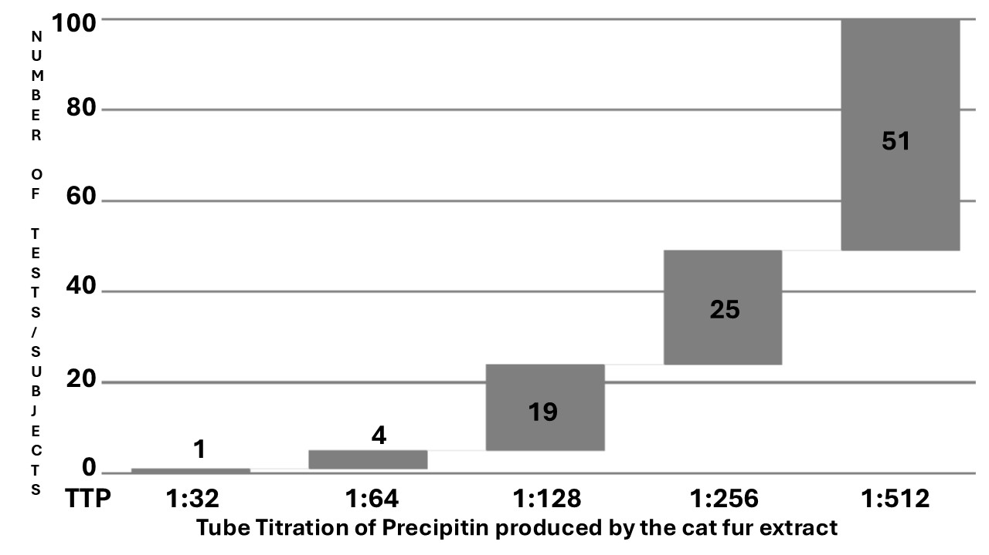

Fig. 1. Cascade distribution chart of the tube titration of precipitins (x-axis %) resulting from the cat dander extract against the serum of the TTP cohort of 100 tests/subjects (y-axis). The graph shows a concentration of results in higher titrations.
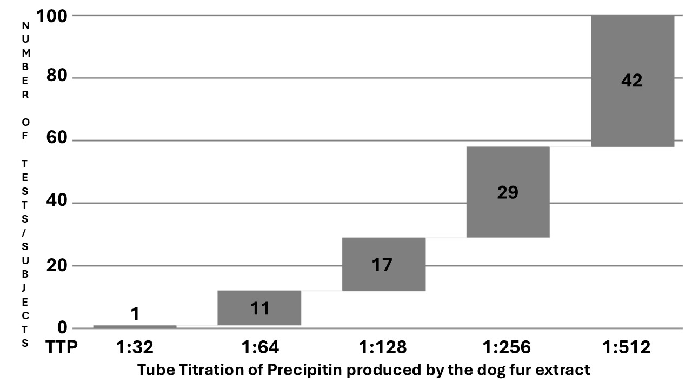
Fig. 2. Cascade distribution chart of the tube titration of precipitins (x-axis %) resulting from the dog dander extract against the serum of the TTP cohort of 100 tests/subjects (y-axis). The graph shows a concentration of results in higher titrations.

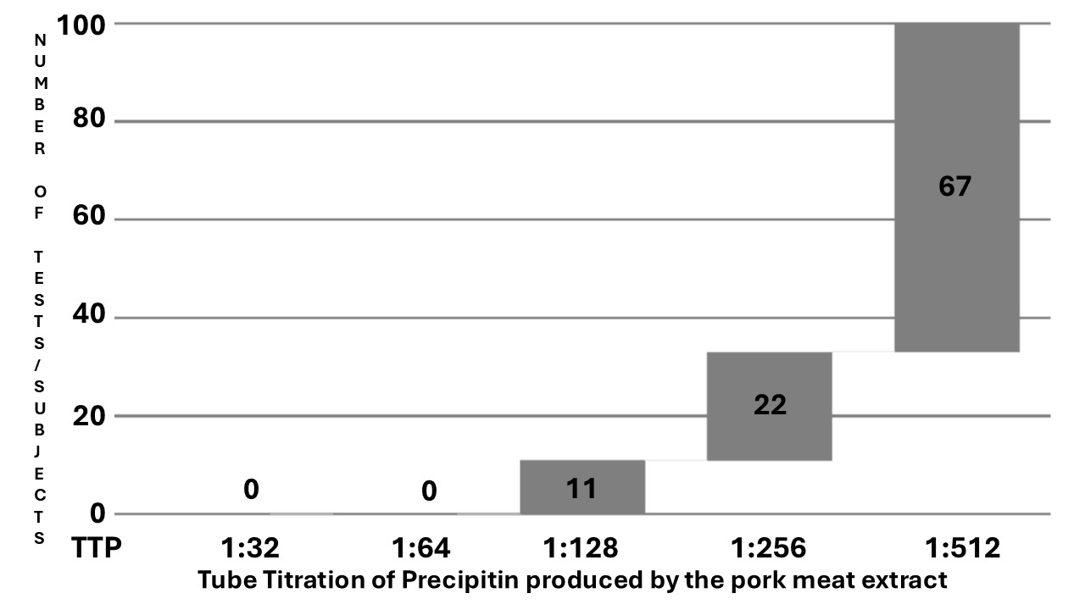
Fig. 3. Cascade distribution chart of the tube titration of precipitins (x-axis %) resulting from the pork meat extract against the serum of the TTP cohort of 100 tests/subjects (y-axis). The graph shows a concentration of results in higher titrations.

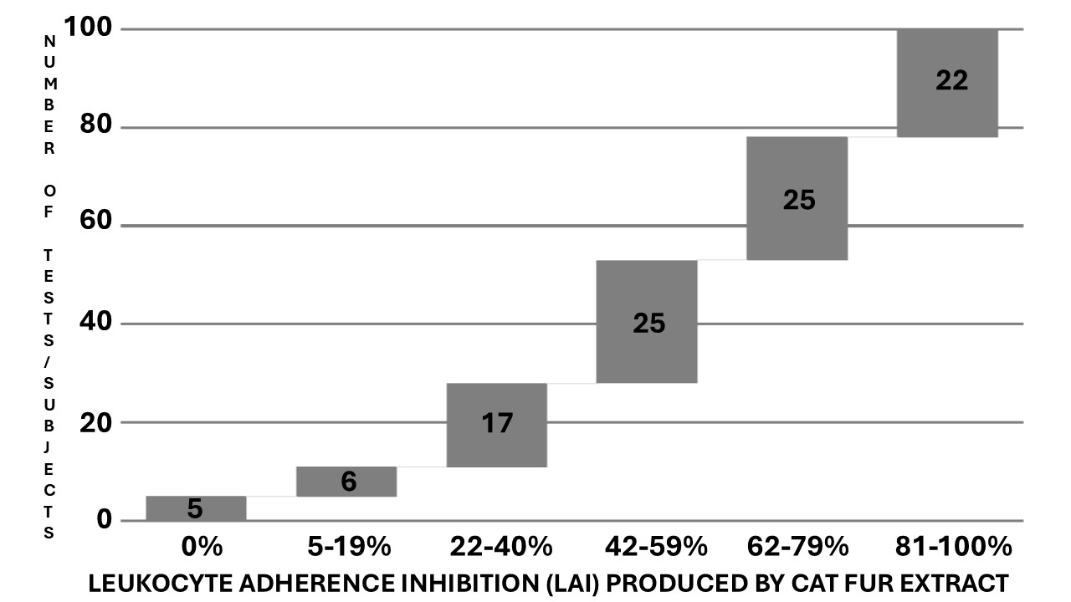

Fig. 4. Cascade distribution chart of the range groups of Leukocyte Adherence Inhibition (LAI) results (x-axis %) of the ex vivo challenge test against cat fur extract monitored by the Leukocyte Adherence Inhibition Test (LAIT), according to the respective number of outcomes over the LAIT cohort with 100 tests/subjects (y-axis). The graph shows a wide distribution of results.

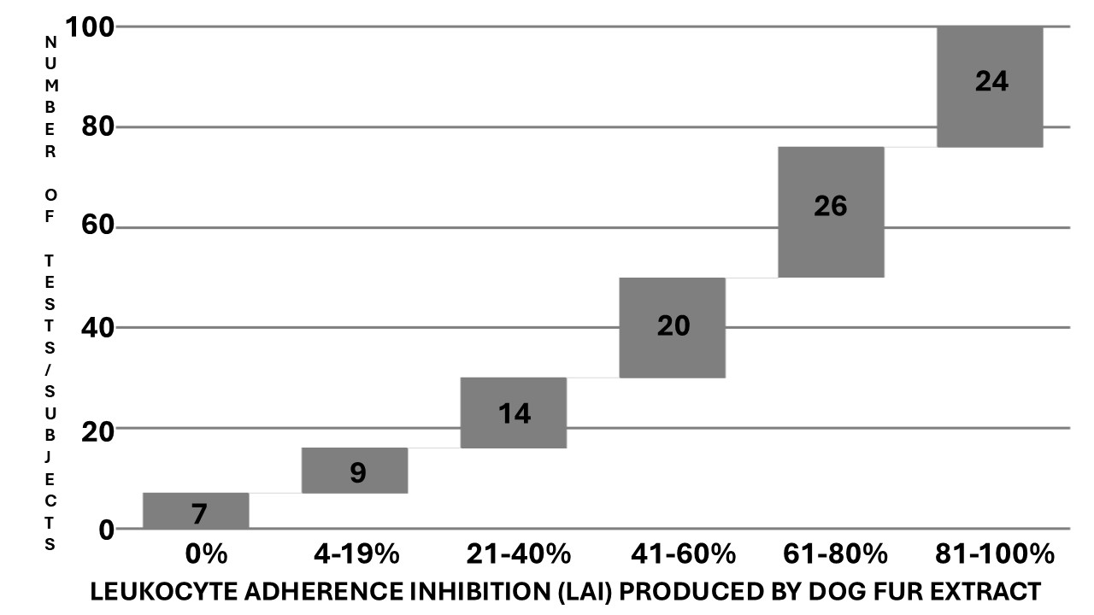

Fig. 5. Cascade distribution chart of the range groups of Leukocyte Adherence Inhibition (LAI) results (x-axis %) of the ex vivo challenge test against dog fur extract monitored by the Leukocyte Adherence Inhibition Test (LAIT), according to the respective number of outcomes over the LAIT cohort with 100 tests/subjects (y-axis). The graph shows a wide distribution of results.

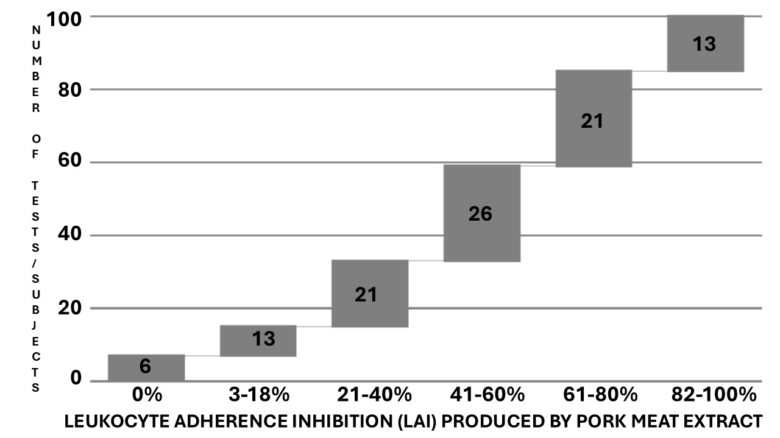

Fig. 6. Cascade distribution chart of the range groups of Leukocyte Adherence Inhibition (LAI) results (x-axis %) of the ex vivo challenge test against pork meat extract monitored by the Leukocyte Adherence Inhibition Test (LAIT), according to the respective number of outcomes over the LAIT cohort with 100 tests/subjects (y-axis). The graph shows a wide distribution of results.

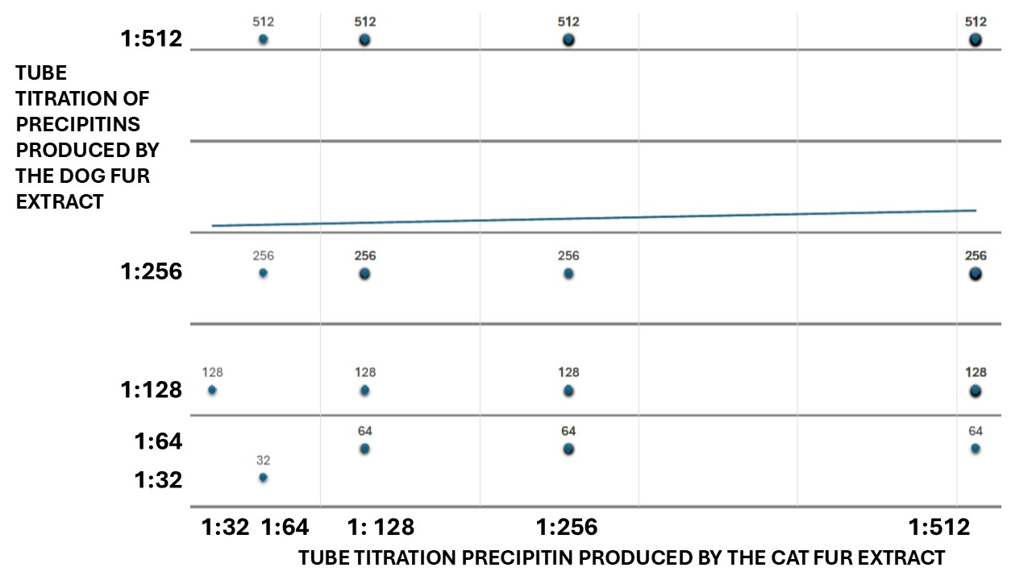
Fig. 7. Dispersion chart of the Tube Titration of Precipitins (TTP) against cat fur extract (x-axis %), plotted against the TTP against dog fur extract (y-axis %). The paired t-test indicated a non-significant, slight difference between the TTP results of cat fur and dog fur (p-value = 0.165). Pearson's correlation indicated a non-significant small positive relationship between TTP results of cat fur and dog fur; r(98) = 0.0337; p-value = 0.739.

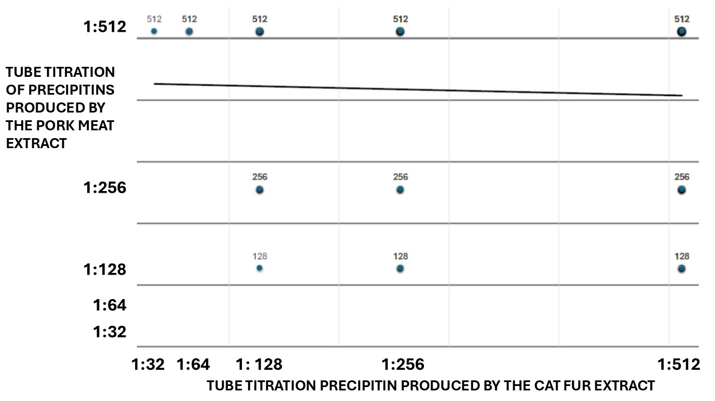
Fig. 8. Dispersion chart of the Tube Titration of Precipitins (TTP) against cat fur (x-axis %), plotted against the TTP against pork meat extract (y-axis %). The paired t-test indicated a significant small difference between the TTP results of cat fur and pork meat (p-value = 0.009). Pearson correlation indicated a non-significant, minimal negative relationship between TTP results of cat fur and pork meat; r(98) = 0.0468; p-value = 0.644.

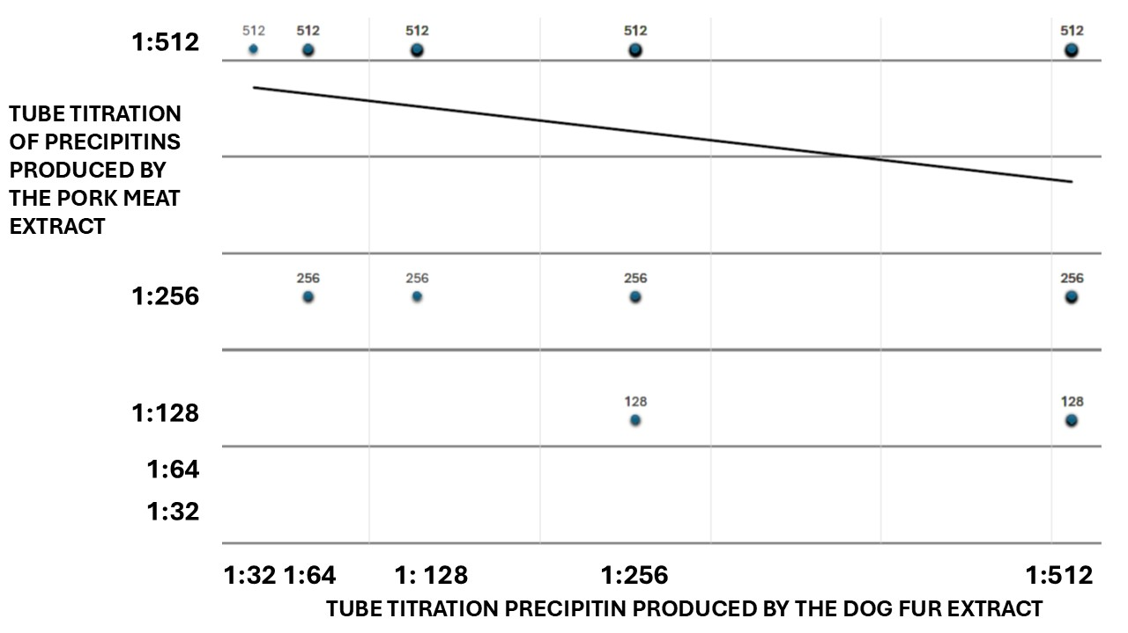

Fig. 9. Dispersion chart of the Tube Titration of Precipitins (TTP) against dog fur extract (x-axis %), plotted against the TTP against pork meat extract (y-axis %). The paired t-test indicated a significant small difference between the TTP results of dog fur and pork meat (p < 0.001). Pearson's correlation indicated a significant small negative relationship between TTP results between dog fur and pork meat; r(98) = 0.248; p-value = 0.013).

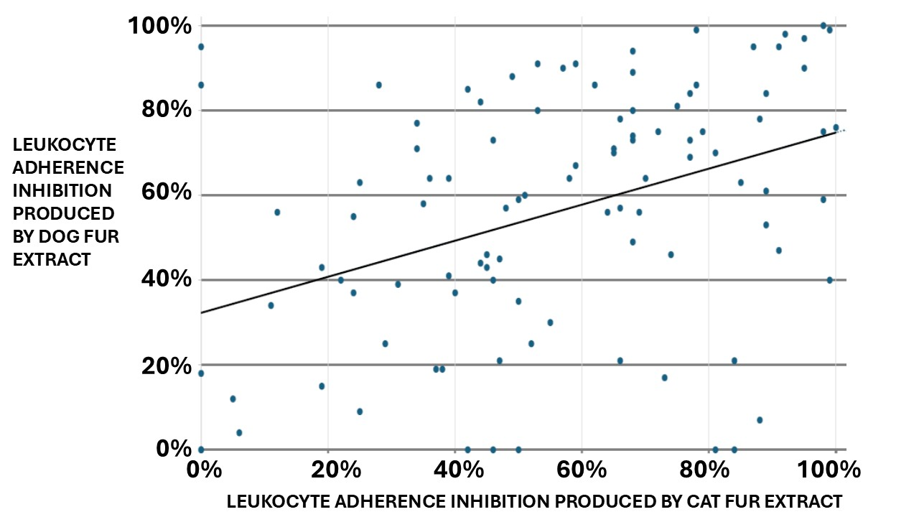
Fig. 10. Dispersion chart of the Leukocyte Adherence Inhibition (LAI) results of the ex vivo challenge test against cat fur extract (x-axis %), plotted against the LAI results of the ex vivo challenge test against dog fur extract (y-axis %). The paired t-test indicated no significant difference between cat fur and dog fur LAIT results (p-value = 0.9949). Pearson's correlation indicated a significantly moderate positive relationship between the cat fur and dog fur LAIT results: r(98) = 0.395, p-value < 0.001.

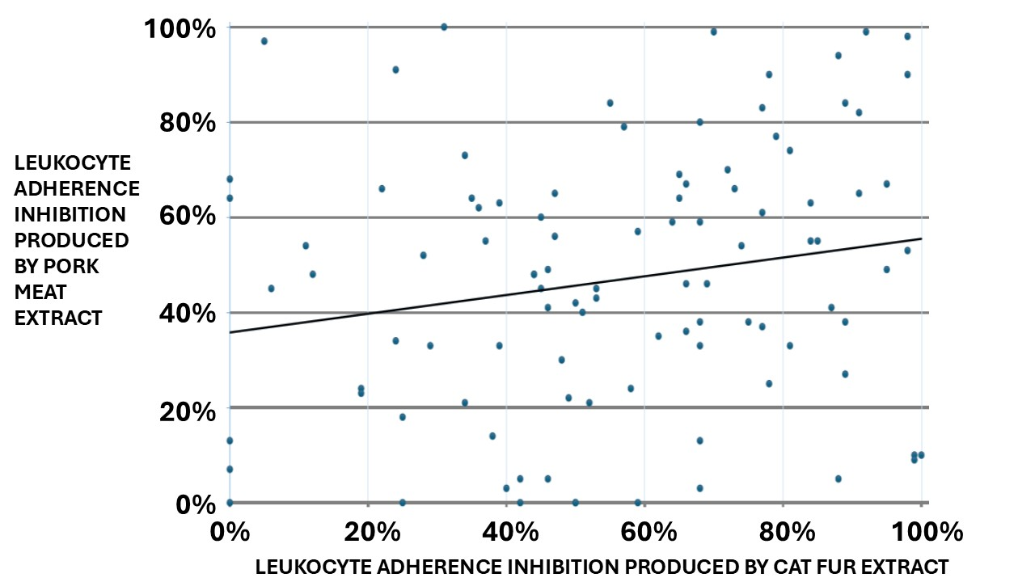
Fig. 11. Dispersion chart of the Leukocyte Adherence Inhibition (LAI) results of the ex vivo challenge test against cat dander (x-axis %), plotted against the LAI results of the ex vivo challenge test against pork meat extract (y-axis %). The paired t-test indicated a significant small difference between cat fur and pork meat LAIT results (p-value = 0.009082). Pearson's correlation indicated a non-significant, small positive relationship between cat fur and pork meat LAIT results: r(98) = 0.193, p-value = 0.054.

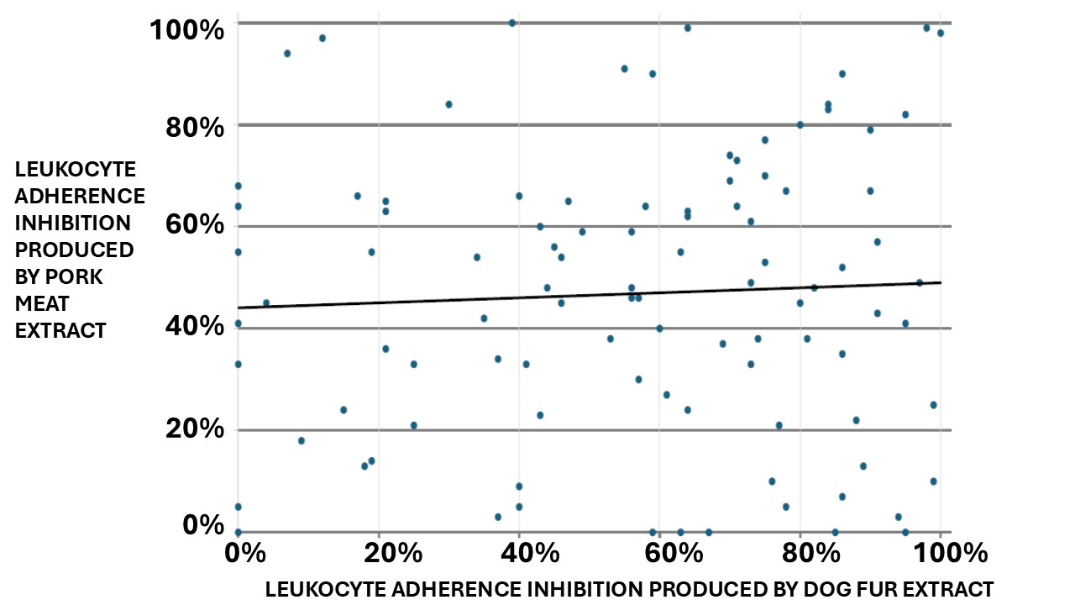

Fig. 12. Dispersion chart of the Leukocyte Adherence Inhibition (LAI) results of the ex vivo challenge test against dog dander extract (x-axis %), plotted against the LAI results of the ex vivo challenge test against pork meat extract (y-axis %). The paired t-test indicated a significant small difference between dog fur and pork meat LAIT results (p-value = 0.01968). However, Pearson's correlation indicated a non-significant, minimal positive relationship between dog fur and pork meat LAIT results: r(98) =0.0519, p-value = 0.608.

4. DISCUSSION

Currently, efforts to understand the Innate Immune System's role in allergic diseases are increasing, accompanied by a growing arsenal of tools (Lee and Cohen, 2025).
The correlation and distribution of simultaneous positive specific IgE against food allergens and inhalant allergens are usually weak; however, polysensitization and cross-reactivity are more the rule than the exception (Zhang et al., 2025; Čelakovská et al., 2024; Hasnain, Alqassim, and Al-Frayl, 2017).
The treatment of monosensitized allergic patients through subcutaneous shots raised the paradigm of allergen-specific Immunotherapy (Olivier 2017). However, despite the use of precision techniques such as the Component Resolved Diagnosis to identify allergens at a molecular level, several allergens (such as the major cat allergen Fel d 1) present great diversity (dissimilar substitutions in the protein sequence) among cat species reflecting the genetic evolution of Felidae (Cleveland et al. 2024). Therefore, it is common to see patients who report allergic symptoms elicited by some cats but not by others. The same happens concerning dogs.
In the context of polysensitization, multimorbidity, and cross-sensitization, where several allergens appear to be clinically relevant, a more rational treatment strategy consists of the use of group-specific multiallergen desensitization immunotherapy, which subcutaneous shots cannot administer due the extension of the local inflammatory response, but rather by the sublingual-swallow route, where the collateral effects are minimal (Olivier et al. 2013b, Khan 2016).
Assessing diverse ways of immunoreactivity and hypersensitivity against allergens responsible for clinical symptoms is a multi-omics approach to evaluate both the diagnosis and treatment of allergic patients (Czolk et al., 2021).
Alternative approaches, such as the LAIT and the TTP, are proposed not to pinpoint the molecular allergen responsible for the allergic phenotype but to obtain an overall view of the patient's immunoreactivity against the whole extract. However, executing these immunoassays with molecular allergens to demonstrate a specific reaction is also possible. We usually do not use molecular allergens purely due to a lack of resources.
To contour the difficulties in diagnosing Non–IgE-mediated hypersensitivity, some scientists have committed to evaluating the utility of the specific IgG in helping clinically diagnose their patients (Alkhateeb 2020). This is controversial, as IgG may function as both a hypersensitivity trigger and an allergen blocker, depending on the reaction of the other immune players (Atwah and Koshak, 2024). IgG antibodies can participate in type II (antibody-dependent cell-mediated) and type III (immune complex disease) Gell and Coombs hypersensitivity reactions, which may be theoretically reproduced by the LAIT and the TTP assays, respectively (Olivier et al., 2021a; Olivier et al., 2021d).
The semi-quantitative titration of precipitins is a pioneering laboratory exam that laid the fundamental basis of immunology (Wells 1911). Precipitating antibodies indicate the presence of a humoral immune response against the tested antigens (Gell, Harington, and Rivers, 1946). Before the discovery of IgE, research on precipitins was the leading method for in vitro diagnosis of immunoreactivity against allergenic agents (Augustin and Hayward, 1960).
The LAIT is an ex vivo challenge test performed with a viable leukocyte buffy coat, which can theoretically explore the most well-known immune pathways, as it allows the interaction of all immune-circulating participants with the allergens (Olivier et al., 2021a). Several immune pathways can inhibit leukocyte adherence (Tong et al., 1979; Halliday, Maluish, and Miller, 1974).
The present study is a proof-of-concept that hypothesizes that LAIT and the TTP may differentiate diverse degrees of cellular and humoral immunoreactivity against cat dander, dog dander, and pork meat allergens among patients suffering from non–IgE-mediated allergic multimorbidity. As the tests were performed simultaneously with the same venous sample with the three allergens, it was possible to calculate a correlation to distinguish some order of cross-reactivity between them.
The retrospective compilation of our data revealed a wide distribution of results when we assessed the outcomes of TTP and LAIT to explore humoral and cellular immunoreactivity against the studied allergens. These immunoassays did not precisely identify the mechanisms responsible for clinical conditions. Instead, they provide evidence about cellular and humoral immunoreactivity distributed across an extensive spectral range, which may suggest immune tolerance or hypersensitivity.
This preliminary retrospective survey demonstrated extensive results from the TTP and the ex vivo challenge test monitored by LAIT against cat fu, dog fur, and pork meat in two cohorts of non–IgE-mediated allergic multimorbidity patients. TTP and LAIT are complementary triage tests used at our facilities to select worthwhile antigens to proceed with more laborious in vivo provocation tests when the specific IgE is undetectable. None of our patients presented an exclusive reaction to these allergens. Every patient was simultaneously evaluated for several chemical and biological allergens, demonstrating positive results for some of them. Our results suggest that dog and cat dander allergy patients may experience additional symptoms when consuming pork meat and vice versa.

5. LIMITATIONS

This study is a retrospective analysis of data collected over seven years since our facility began employing laboratory immune assays. There was no protocol research, and the subject's data was limited to the essentials available on our electronic sheets. Therefore, we could not establish a cross-comparison between the positive and negative controls to validate the results. The number of subjects is suitable for a preliminary study; however, future studies should be more comprehensive. The lack of a research protocol implies the possibility of bias introduced by the physician's point of view (CEO) based on a clinical suspicion driven solely by the anamnesis and physical examination. The study lost many of these patients to follow-up, so it is not yet possible to ensure the relationship between the immunoassay results and the patient's clinical outcome. Unfortunately, comparing the two procedures using paired t-tests was impossible because they were obtained from distinct patient groups.

6. CONCLUSION

The preliminary results suggest that the TTP and LAIT, when applied to cat and dog fur extracts and pork meat extract, may discriminate between diverse humoral and cellular immunoreactivity levels in patients with various allergic phenotypes. A significant association was found between the immunoreactivity of cat fur and dog fur. The association between pork meat and fur immunoreactivity was not clear. LAIT and TTP are inexpensive, can be performed with minimum laboratory equipment, and can be incorporated into strategies to address health disparities in respiratory and food allergies (Anagnostou et al. 2025). As a preliminary report, the propaedeutic significance of the presented results and the potential interfering factors must be further established (Anouar, Hazim, and Brahim, 2024). More studies focused on the quality-by-design approach with larger, prospective, double-blind cohorts are needed to evaluate the potential contribution of LAIT and TTP for endotyping cellular and humoral immunoreactivity in patients suspected of hypersensitivity to cat fur, dog fur, and pork meat allergens (Chiarentin et al., 2023).

7. FUTURE DIRECTIONS AND RECOMMENDATIONS FOR CLINICAL PRACTICE
The primary intended use of in vitro or ex vivo allergen challenge tests is to spare patients from undergoing unnecessary, exhaustive, and potentially hazardous in vivo challenge tests. Exploring the humoral and the cellular arms of immune systems, the TTP and LAIT alone or combined may represent, in the near future, a tool for allergists to elaborate etiologic diagnosis for their patients, as well as determine the endotypes (mechanisms) of hypersensitivity, in order to choose more convenient and personalized therapies (Adly e. al., 2021). Adding data provided by TTP and LAIT may also contribute to streamlining biomedical research and improving tools, such as large language models, which clinicians often use as decision support systems to enhance diagnostic accuracy (Abers and Mathias, 2025).

CONSENT

As a retrospective compilation of results recorded in cognito, consent was obtained collectively by the institution's ethics committee, following the principles of the Declaration of Helsinki (WMA, 2013).

ETHICAL APPROVALS

The authors have obtained and documented written ethical approval in accordance with international standards.

Disclaimer (artificial intelligence)
Authors hereby declare that NO generative AI technologies such as Large Language Models (ChatGPT, COPILOT, etc.) and text-to-image generators have been used during the writing or editing of this manuscript.
Abbreviations:
LAI: Leukocyte Adherence Inhibition.
LAIT: Leukocyte Adherence Inhibition Test
TTP: Tube Titration of Precipitins

REFERENCES
Abers, M. S., Mathias, R. A. (2025). Novel applications of large language models in clinical research. Journal of Allergy and Clinical Immunology, 155(3): 813-814.
Adly, M. N., Mandour, M. F., Abd Elaziz, M. F., & Saafan, M. E. (2021). Efficacy of Allergen Specific Immunotherapy for Treatment of Allergic Rhinitis: A Systematic Review and Meta-analysis. Journal of Advances in Medicine and Medical Research, 33(22), 200–213. https://doi.org/10.9734/jammr/2021/v33i2231172

Alkhateeb, A. F. (2020). Foods Causing Highest IgG Immune Response in Saudi Arabia. Annual Research and Review in Biology, 35(3): 115-127.
Allardyce, R. A., Shearman, D. J. (1975). Leukocyte reactivity to alpha-gliadin in dermatitis herpetiformis and adult coeliac disease. International Archives of Allergy and Applied Immunology, 48(3): 395-400.
Alvarez-Cuesta, E., Berges-Gimeno, P., González-Mancebo, E., Fernández-Caldas, E., Cuesta-Herranz, J., Casanovas, M. (2007). Sublingual immunotherapy with a standardized cat dander extract: evaluation of efficacy in a double-blind placebo-controlled study. Allergy, 62(7): 810-817.
Alvarez-Perea, A., Caralli, M. E., Zubeldia, J. M., Baeza, M. L. (2014). Pork-cat syndrome as a cause of occupational asthma. Journal of Investigational Allergology and Clinical Immunology, 24(3): 209-211.
Anagnostou, A., Wang, J., Chinthrajah, S., Gupta, R., Davis, C. M., Parrish, C., et al. (2025). Addressing health disparities in food allergy: A Position Statement of the AAAAI Prior Authorization Task Force. Journal of Allergy and Clinical Immunology, 155(1): 53-61.
Anouar, S., Hazim, R., Brahim, A. (2024). Interferences in Immunological Assays: Causes, Detection, and Prevention. Asian Journal of Immunology., 7(1): 71-78.
Ashkenazi, A., Levin, S., Idar, D., Or, A., Rosenberg, I., Handzel, Z. T. (1980). In Vitro Cell-Mediated Immunologic Assay for Cow's Milk Allergy. Pediatrics, 66(3): 399-402.
Atwah, A. F., Koshak, E. A. (2024). Exploring food-specific IgG responses in pediatric allergic disorders: A retrospective cross-sectional study. Allergologia et Immunopathologia (Madrid), 52(6): 85-90.
Augustin, R. (1953). Precipitins to grass pollen proteins. Nature, 172(4372): 307.
Augustin, R., Hayward, B. J. (1960). Human reagins to grass pollens and moulds: their purification and physico-chemical characterization. Immunology, 3(1): 45-73.
Augustin, R., Hayward, B. J., Longbottom, J. L. (1960). Isolation and physico-chemical characterization of reagins, blocking antibodies and precipitins to grass pollens. Clinical and Experimental Allergy (Copenhagen), 7: 31-37.
Barradas Lopes, J., Labrador-Horrilo, M., Bartolomé, B., Cunha, L. (2022). The Role of Molecular Allergens in the Diagnosis of Cat-Pork Syndrome: An Unusual Case Report. Acta Medica Portuguesa, 35(5): 388-391.
Bousquet, J., Anto, J. M., Haahtela, T., Sousa-Pinto, B., Morais-Almeida, M. (2025). From "one airway, one disease" to "one airway, many diseases". Journal of Allergy and Clinical Immunology.
Bousquet, J., Anto, J. M., Wickman, M., Keil, T., Valenta, R., Haahtela, T., et al. (2015). Are allergic multimorbidities and IgE polysensitization associated with the persistence or re-occurrence of foetal type 2 signaling? The MeDALL hypothesis. Allergy, 70(9): 1062-1078.
Bradford, M. M. (1976). A rapid and sensitive method for the quantitation of microgram quantities of protein utilizing the principle of protein-dye binding. Analytical Biochemical, 72: 248-254.
Butler, H. L., Byrne, W. J., Marmer, D. J., Euler, A. R., Steele, R. W. (1981). Depressed Neutrophil Chemotaxis in Infants with Cow's Milk and/or Soy Protein Intolerance. Pediatrics, 67(2): 264-268.
Čelakovská, J., Čermákova, E., Andrýs, C., Boudkova, P., Krejsek, J. (2024). Sensitization to latex and food allergens in atopic dermatitis patients according to ALEX2 Allergy Xplorer test. Molecular Immunology, 175: 89-102.
Chan, S. K., Leung, D. Y. M. (2018). Dog and Cat Allergies: Current State of Diagnostic Approaches and Challenges. Allergy Asthma and Immunology Research, 10(2): 97-105.
Chiarentin, L., Gonçalves, C., Augusto, C., Miranda, M., Cardoso, C., Vitorino, C. (2023). Drilling into "Quality by Design" Approach for Analytical Methods. Critical Reviews in Analytical Chemistry: 1-42.
Cleveland, C. W., Davis, B. W., Khatri, K., Pomés, A., Chapman, M. D., Brackett, N. F. (2024). Genetic diversity of the major cat allergen, Fel d 1. PNAS Nexus, 3(11): pgae447.
Coca, A. F. (1922). Studies in Specific Hypersensitiveness V. The Preparation of Fluid Extracts and Solutions for Use in the Diagnosis and Treatment of the Allergies with Notes on the Collection of Pollens. The Journal of Immunology, 7(2): 163-178.
Commins, S. P., Platts-Mills, T. A. (2013). Delayed anaphylaxis to red meat in patients with IgE specific for galactose alpha-1,3-galactose (alpha-gal). Current Allergy and Asthma Reports, 13(1): 72-77.
Commins, S. P., Satinover, S. M., Hosen, J., Mozena, J., Borish, L., Lewis, B. D., et al. (2009). Delayed anaphylaxis, angioedema, or urticaria after consumption of red meat in patients with IgE antibodies specific for galactose-alpha-1,3-galactose. Journal of Allergy and Clinical Immunology, 123(2): 426-433.
Couturier, P., Basset-Sthème, S., Sainte-Laudy, J. (1999). [Pork-cat syndrome in a 16-month-old child]. Allergie et Immunologie (Paris), 31(2): 60.
Cunningham-Rundles, C., Brandeis, W. E., Good, R. A., Day, N. K. (1978). Milk precipitins, circulating immune complexes, and IgA deficiency. Proceedings of the National Academy of Sciences of the United States of America, 75(7): 3387-3389.
Czolk, R., Klueber, J., Sørensen, M., Wilmes, P., Codreanu-Morel, F., Skov, P. S., et al. (2021). IgE-Mediated Peanut Allergy: Current and Novel Predictive Biomarkers for Clinical Phenotypes Using Multi-Omics Approaches. Frontiers in Immunology, 11: 594350.
Drouet, M., Boutet, S., Lauret, M. G., Chène, J., Bonneau, J. C., Le Sellin, J., et al. (1994). [The pork-cat syndrome or crossed allergy between pork meat and cat epithelia (1)]. Allergie et Immunologie (Paris), 26(5): 166-168, 171-162.
Drouet, M., Lauret, M. G., Sabbah, A. (1994). [The pork-cat syndrome: effect of sensitivity to cats on that to pork meat. Based on an observation]. Allergie et Immunologie (Paris), 26(7): 261-262.
Drouet, M., Lauret, M. G., Sabbah, A. (1994a). [The pork-cat syndrome: effect of sensitization to cats on sensitization to pork meat. Apropos of a case]. Allergie et Immunologie (Paris), 26(8): 305-306.
Drouet, M., Le Sellin, J., Sabbah, A. (1997). [Does the pork/cat syndrome constitute a predisposition to heparin allergy?]. Allergie et Immunollogie (Paris), 29(2): 43-45.
Drouet, M., Sabbah, A. (1996). The pork/cat syndrome or crossed reactivity between cat epithelia and pork meat. Monographs in Allergy, 32: 164-173.
Drouet, M., Sabbah, A., Le Sellin, J., Bonneau, J. C., Gay, G., Dubois-Gosnet, C. (2001). [Fatal anaphylaxis after eating wild boar meat in a patient with pork-cat syndrome]. Allergie et Immunologie (Paris), 33(4): 163-165.
Ferguson, A., Carswell, F. (1972). Precipitins to dietary proteins in serum and upper intestinal secretions of coeliac children. British Medical Journal, 1(5792): 75-77.
Fink, A., Heller, L., Eliraz, A., Weisman, Z., Miskin, A., Schlezinger, M., et al. (1987). Allergen-specific leukocyte adherence inhibition (LAI) assay: sensitivity, specificity, and mechanism. Immunology Letters, 16(1): 65-70.
Gell, P. G. H., Harington, C. R., Rivers, R. P. (1946). The antigenic function of simple chemical compounds; production of precipitins in rabbits. British Journal of Experimental Pathology, 27(5): 267-286.
George, M., Vaughan, J. H. (1962). In vitro cell migration as a model for delayed hypersensitivity. Proceedings of the Society of Experimental Biology and Medicine, 111: 514-521.
Gromek, W.; Kołdej, N.; Kurowski, M.; Majsiak, E. (2025) Furry Animal Allergy: Lipocalins, Serum Albumins and Secretoglobins - Cross-Reactivity, Diagnosis and Management Strategies. Clinical Reviews in Allergy & Immunology 2025, in press.
Hahn, E. L., Bacharier, L. B. (2005). The atopic march: the pattern of allergic disease development in childhood. Immunology and Allergy Clinics of North America, 25(2): 231-246.
Halliday, W. J., Maluish, A., Miller, S. (1974). Blocking and unblocking of cell-mediated anti-tumor immunity in mice, as detected by the leucocyte adherence inhibition test. Cellular Immunology, 10(3): 467-475.
Hasnain, S. M., Alqassim, A., Al-Frayl, A. (2017). Diagnosis of allergy: IgE mediated cross-reactions amongst selected asthma elicitors. Journal of Diseases and Global Health, 10(4): 111-122.
Heiner, D. C., Sears, J. W., Kniker, W. T. (1962). Multiple Precipitins to Cow's Milk in Chronic Respiratory Disease: A Syndrome Including Poor Growth, Gastrointestinal Symptoms, Evidence of Allergy, Iron Deficiency Anemia, and Pulmonary Hemosiderosis. American Journal of Diseases of Childhood, 103(5): 634-654.
Hellu, T., Gomez, R., Weiss, S., Smith, D., Steigelman, D. (2024). Do commercial dog extracts cross-react with Felis domesticus allergen 1. Allergy and Asthma Proceedings, 45(6): 447-452.
Jutel, M., Agache, I., Zemelka-Wiacek, M., Akdis, M., Chivato, T., Del Giacco, S., et al. (2023). Nomenclature of allergic diseases and hypersensitivity reactions: Adapted to modern needs: An EAACI position paper. Allergy, 78(11): 2851-2874.
Kallen, B., Nilsson, O. (1979). Effect of encephalitogenic protein. PPD and tetanus toxoid on leukocyte migration in agarose. A study of "cross-reactivity". Allergy, 34(2): 97-102.
Kay, J., Gawkrodger, D. J., Mortimer, M. J., Jaron, A. G. (1994). The prevalence of childhood atopic eczema in a general population. Journal of the American Academy of Dermatology, 30(1): 35-39.
Khan, M. M. (2016). Allergic Disease. In M. M. Khan (Ed.), Immunopharmacology: 197-225. Cham: Springer International Publishing.
Kile, M. R., Lucas, M. D., Ganguli, M. P., Dimov, V. (2023). The Feline and the Swine: A Peculiar Case in an Allergy Clinic. Cureus, 15(9): e46284.
Konradsen, J. R., Fujisawa, T., van Hage, M., Hedlin, G., Hilger, C., Kleine-Tebbe, J., et al. (2015). Allergy to furry animals: New insights, diagnostic approaches, and challenges. Journal of Allergy and Clinical Immunology, 135(3): 616-625.
Kulig, M., Bergmann, R., Klettke, U., Wahn, V., Tacke, U., Wahn, U. (1999). Natural course of sensitization to food and inhalant allergens during the first 6 years of life. Journal of Allergy and Clinical Immunology, 103(6): 1173-1179.
Kuratsuji, T. (1981). Studies on leukocyte adherence inhibition test. Part II. Clinical applications of LAI test to detect delayed-type hypersensitivity in infants and children. Keio Journal of Medicine, 30(2): 65-69.
Lee, R. J., Cohen, N. A. (2025). Innate immune function in chronic rhinosinusitis. Journal of Allergy and Clinical Immunology, 155(5): 1472-1474.
Li, Y. T., Ye, Q. Q., Lu, Y. X., Yang, K. X., Zhang, P. P., Chen, C., et al. (2025). Allergen sensitization patterns: Allergic rhinitis with multimorbidity versus alone-A real-world study. Clinical Transactions in Allergy, 15(1): e70030.
Liang, L., Hwang, A. R., Shin, Y. J., Jeong, K. Y., Park, K. H., Lee, J. H., et al. (2024). Fel d 1 specific IgE measurement for dog exclusive owners co-sensitized to dog and cat. World Allergy Organization Journal, 17(12): 101007.
Musa, I., Ardalani, F., Yang, N., Maleki, S. J., Li, X. M. (2024). Murine model of cross-IgE sensitization and cross-anaphylactic reactions among multiple group food allergens. Frontiers in Immunology, 15: 1497368.
Olivier, C. E. (2017). The use of allergoids and adjuvants in Allergen Immunotherapy. Archives of Asthma Allergy and Immunology, 1: 40-60.
Olivier, C. E., Argentão, D. G. P., Santos, R. A. P. G., Silva, M. D., Lima, R. P. S., Zollner, R. L. (2013a) Skin scrape test: an inexpensive and painless skin test for recognition of immediate hypersensitivity in children and adults. The Open Allergy Journal, 6: 9-17.
Olivier, C. E., Lima, R. P. S., Pinto, D. G., Santos, R. A. P. G. (2021a). The Plasma Preincubation with Papain Before the Assay Suggests that a Gell and Coombs Type II Reaction is Been Demonstrated by the Leukocyte Adherence Inhibition Test. Biomedical Journal of Scientific and Technical Research, 36(3): 28647-28655.
Olivier, C. E., Lima, R. P. S., Argentão, D. G. P., Silva, M. D, Santos, R. A. P. G., Pensuti, M., et al. (2013b). Group-specific Multi-allergen Sublingual/Swallow Immunotherapy Improves the Quality of Life of Polysensitized Children and Adults with Allergic Rhinitis. Journal of Allergy and Therapy, 4(5): 148. doi: 110.4172/2155-6121.1000148.
Olivier, C. E., Lima, R. P. S., Pinto, D. G., Santos, R. A. P. G., Silva, G. K. M., Lorena, S. L. S., et al. (2012). In search of a tolerance-induction strategy for cow's milk allergies: significant reduction of beta-lactoglobulin allergenicity via transglutaminase/cysteine polymerization. Clinics, 67(10): 1171-1179.
Olivier, C. E., Pinto, D. G., Lima, R. P. S., Silva, M. D., Santos, R. A. P. G., Teixeira, A. P. M., et al. (2021b). Assessment of Immunoreactivity against Therapeutic Options Employing the Leukocyte Adherence Inhibition Test as a Tool for Precision Medicine. European Journal of Clinical Medicine, 2(3): 40-45.
Olivier, C. E., Pinto, D. G., Santos, R. A. P. G., Lima, R. P. S. (2021c). Dextran's interference over the Leukocyte Adherence Inhibition Test. Academia Letter, Article (number): 3792.
Olivier, C. E., Pinto, D. G., Teixeira, A. P. M., Miguel, C. S., Santos, R. A. P. G., Rocha, N. S., et al. (2025). Endotyping Cellular and Humoral Immunoreactivity against Pollen and Citrus Fruits in Patients with Non IgE mediated Rhinoconjunctivitis. Asian Journal of Immunology, 8(1): 8-25.
Olivier, C. E., Pinto, D. G., Teixeira, A. P. M., Miguel, C. S., Santos, R. A. P. G., Santana, J. L. S., et al. (2024a). Cellular and Humoral Immunoreactivity against Hen's Egg White: Relevance in Allergic Patients. Asian Journal of Immunology, 7(1): 274-284.
Olivier, C. E., Pinto, D. G., Teixeira, A. P. M., Miguel, C. S., Santos, R. A. P. G., Santana, J. L. S., et al. (2024b). Endotyping Cellular and Humoral Immunoreactivity against Allium spices and Sulfites preservatives in Allergic Patients. A Retrospective Study. Asian Journal of Immunology, 7(1): 185-200.
Olivier, C. E., Pinto, D. G., Teixeira, A. P. M., Miguel, C. S., Santos, R. A. P. G., Santana, J. L. S., et al. (2024c). Endotyping Cellular and Humoral Immunoreactivity Against Tartrazine in Allergic Patients: A Retrospective Study. Asian Journal of Immunology, 7(1): 217-227.
Olivier, C. E., Pinto, D. G., Teixeira, A. P. M., Santana, J. L. S., Santos, R. A. P. G., Lima, R. P. S. (2021d). Self-imposed food restriction and oral food challenges are correlated with precipitin's accuracy in the diagnosis of Non–IgE-mediated food-related adulthood acute episodes of urticaria. Journal of Allergy and Therapy, 12(8): 1-8.
Olivier, C. E., Pinto, D. G., Teixeira, A. P. M., Santana, J. L. S., Santos, R. A. P. G., Lima, R. P. S. (2023a). Contribution of the Leukocyte Adherence Inhibition Test to the Diagnosis of Innate Non–IgE-mediated Immunoreactivity against Saccharomyces cerevisiae. Asian Journal of Immunology, 6(1): 234-241.
Olivier, C. E., Pinto, D. G., Teixeira, A. P. M., Santana, J. L. S., Santos, R. A. P. G., Lima, R. P. S. (2024d). Endotyping Cellular and Humoral Immunoreactivity against Aluminum in Allergic Patients: A Retrospective Study. Asian Journal of Immunology, 7(1): 149-158.
Olivier, C. E., Pinto, D. G., Teixeira, A. P. M., Santana, J. L. S., Santos, R. A. P. G., Lima, R. P. S. (2024e). Endotyping Non-IgE-mediated Immunoreactivity to Polyethylene Glycol: Implications for Allergic Patients. Asian Journal of Immunology, 7(1): 100-111.
Olivier, C. E., Pinto, D. G., Teixeira, A. P. M., Santana, J. L. S., Santos, R. A. P. G., Lima, R. P. S., et al. (2023b). Contribution of the Leukocyte Adherence Inhibition Test to the Diagnosis of Innate Non–IgE-mediated Immunoreactivity against Alternaria alternata. Asian Journal of Immunology, 6(1): 243-251.
Olivier, C. E., Pinto, D. G., Teixeira, A. P. M., Santana, J. L. S., Santos, R. A. P. G., Lima, R. P. S., et al. (2023c). Contribution of the Leukocyte Adherence Inhibition Test to the Diagnosis of Non–IgE-mediated Immunoreactivity against Candida albicans in Patients with Atopic Dermatitis. Asian Journal of Immunology, 6(1): 268-276.
Olivier, C. E., Pinto, D. G., Teixeira, A. P. M., Santana, J. L. S., Santos, R. A. P. G., Lima, R. P. S., et al. (2023d). Evaluating Non-IgE-mediated Allergens' Immunoreactivity in Patients with "Intrinsic" Persistent Rhinitis with Help of the Leukocyte Adherence Inhibition Test. European Journal of Medical and Health Sciences, 5(1): 17-22.
Olivier, C. E., Pinto, D. G., Teixeira, A. P. M., Santana, J. L. S., Santos, R. A. P. G., Lima, R. P. S., et al (2024f). Contribution of the Leukocyte Adherence Inhibition Test in Diagnosing Non–IgE-Mediated Immunoreactivity against Aspergillus fumigatus in Patients with Allergic Rhinitis and Asthma. Asian Journal of Immunology, 7(1): 12-20.
Olivier, C. E., Pinto, D. G., Teixeira, A. P. M., Santana, J. L. S., Santos, R. A. P. G., Lima, R. P. S., et al. (2024g). Endotyping Non-IgE-Mediated Immunoreactivity to Dermatophagoides farinae: Implications for Allergic Patients. Asian Journal of Immunology, 7(1): 90-99.
Olivier, C. E., Pinto, D. G., Teixeira, A. P. M., Santana, J. L. S., Santos, R. A. P. G. S., Lima, R. P. S. (2021e). Intrinsic Atopic Dermatitis: Titration of Precipitins in the Screening of Food Allergens for Prescription of Elimination Diets and Desensitization Strategies. European Journal of Clinical Medicine, 2(6): 1-9.
Olivier, C. E., Pinto, D. G., Teixeira, A. P. M., Santana, J. L. S., Santos, R. A. P. G. S., Lima, R. P. S. (2022ª). Contribution of the Leukocyte Adherence Inhibition Test for the evaluation of immunoreactivity against gluten extracts in non—IgE-mediated / non-autoimmune Gluten-Related Disorders. European Journal of Clinical Medicine, 3(2): 1-7.
Olivier, C. E., Pinto, D. G., Teixeira, A. P. M., Santana, J. L. S., Santos, R. A. P. G. S., Lima, R. P. S. (2022b). Contribution of the Leukocyte Adherence Inhibition Test to the Evaluation of Cellular Immunoreactivity against Latex Extracts for Non—IgE-Mediated Latex-Fruit-Pollen Syndrome in Allergic Candidates to Exclusion Diets and Allergic Desensitization. European Journal of Clinical Medicine, 3(1): 11-17.
Olivier, C. E., Pinto, D. G., Teixeira, A. P. M., Santana, J. L. S., Santos, R. A. P. G. S., Lima, R. P. S. (2022c). Leukocyte Adherence Inhibition Test to the Assessment of Immunoreactivity Against Cow's Milk Proteins in Non—IgE-Mediated Gastrointestinal Food Allergy. European Journal of Clinical Medicine, 3(2): 38-43.
Olivier, C. E., Pinto, D. G., Teixeira, A. P. M., Santana, J. L. S., Santos, R. A. P. G. S., Lima, R. P. S. (2023e). Anti-Saccharomyces cerevisiae antibodies (ASCA) researched by tube precipitins are elevated in patients with dermatologic and gastrointestinal Non—IgE-mediated hypersensitivity. European Journal of Clinical Medicine, 4(2): 25-30.
Olivier, C. E., Pinto, D. G., Teixeira, A. P. M., Santana, J. L. S., Santos, R. A. P. G. S., Lima, R. P. S., et al. (2023f). Evaluating Non-IgE-Mediated Allergens' Immunoreactivity in Patients Formerly Classified as "Intrinsic" Asthmatics with Help of the Leukocyte Adherence Inhibition Test. European Journal of Clinical Medicine, 4(2): 1-7.
Olivier, C. E., Santos, R. A. P. G., Lima, R. P. S., Argentão, D. G. P., Silva, G. K. M., Silva, M. D. (2014). A Novel Utility for an Old Method: The Leukocyte Adherence Inhibition Test Is an Easy Way to Detect the Immunoreactive Interference of the Collection Tube Anticoagulant on Cellular Immunoassays. Journal of Cell Adhesion, Article ID 860427(http://dx.doi.org/10.1155/2014/860427): 1-6.
Papageorgiou, N., Lee, T. H., Nagakura, T., Cromwell, O., Wraith, D. G., Kay, A. B. (1983). Neutrophil chemotactic activity in milk-induced asthma. Journal of Allergy and Clinical Immunology, 72(1): 75-82.
Patel, D., Couroux, P., Hickey, P., Salapatek, A. M., Laidler, P., Larché, M., et al. (2013). Fel d 1-derived peptide antigen desensitization shows a persistent treatment effect 1 year after the start of dosing: a randomized, placebo-controlled study. Journal of Allergy and Clinical Immunology, 131(1): 103-109.e101-107.
Popescu, F. D. (2015. Cross-reactivity between aeroallergens and food allergens. World Journal of Allergology, 5(2): 31-50).
Posthumus, J., James, H. R., Lane, C. J., Matos, L. A., Platts-Mills, T. A., Commins, S. P. (2013). Initial description of pork-cat syndrome in the United States. Journal of Allergy and Clinical Immunology, 131(3): 923-925.
Sabbah, A., Lauret, M. G., Chène, J., Boutet, S., Drouet, M. (1994). [The pork-cat syndrome or crossed allergy between pork meat and cat epithelia (2)]. Allergie et Immunollogie (Paris), 26(5): 173-174, 177-180.
Sabbah, A., Rousseau, C., Lauret, M. G., Drouet, M. (1994). [The pork-cat syndrome: RAST inhibition test with Feld One]. Allergie et Immunologie (Paris), 26(7): 259-260.
Sub-Committee, A. N. (2025a). The official list of allergens from Blomia tropicalis, Vol. 2025: WHO/International Union of Immunological Societies.
Sub-Committee, A. N. (2025b). The official list of allergens from Felis domesticus, Vol. 2025: WHO/International Union of Immunological Societies.
Sub-Committee, A. N. (2025c). The official list of allergens from Sus scrofa, Vol. 2025: WHO/International Union of Immunological Societies.
Thomson, D. M. P. (1982). Assessment of immune status by the leukocyte adherence inhibition test. New York: Academic Press.
Tong, A. W., Burger, D. R., Finke, P., Barney, C., Vandenbark, A. A., Vetto, R. M. (1979). Assessment of the mechanism of the leukocyte adherence inhibition test. Cancer Research, 39(2 Pt 2): 597-603.
van Hage, M., Käck, U., Asarnoj, A., Konradsen, J. R. (2023). An update on the prevalence and diagnosis of cat and dog allergy – Emphasizing the role of molecular allergy diagnostics. Molecular Immunology, 157: 1-7.
Van Nunen, S. A., O'Connor, K. S., Clarke, L. R., Boyle, R. X., Fernando, S. L. (2009). An association between tick bite reactions and red meat allergy in humans. The Medical Journal of Australia, 190(9): 510-511.
Varney, V. A., Edwards, J., Tabbah, K., Brewster, H., Mavroleon, G., Frew, A. J. (1997). Clinical efficacy of specific immunotherapy to cat dander: a double-blind placebo-controlled trial. Clinical and Experimental Allergy, 27(8): 860-867.
Wahn, U. (2000). What drives the allergic march? Allergy, 55(7): 591-59
Wells, H. G. (1911). Studies on the chemistry of anaphylaxis (III). Experiments with
isolated proteins, especially those of the hen's egg. Journal of Infectious Diseases, 9: 147-171.
Williams, C. A., Chase, M. W. (1971). CHAPTER 13 - Precipitation Reactions, Reactions of Antibodies with Soluble Antigens, Vol. 3: 1-102: Academic Press.
WMA. (2013). World Medical Association Declaration of Helsinki: Ethical principles for medical research involving human subjects. Journal of the American Medical Association, 310(20): 2191-2194.
Worm, M., Patel, D., Creticos, P. S. (2013). Cat peptide antigen desensitization for treating cat allergic rhinoconjunctivitis. Expert Opinion on Investigative Drugs, 22(10): 1347-1357.
Yamada, S., Matsubara, K., Chinuki, Y., Hori, M., Masaki, T. (2019). [Early childhood-onset pork-cat syndrome due to sensitization by both cats and dogs - A case report]. Arerugi, 68(9): 1141-1147.
Zhang, J., Tang, Y., Yang, D., Yu, J. (2025). Investigating allergen-specific IgE distribution and correlations in chronic urticaria: a retrospective study in Shanghai, China. European Journal of Medical Research, 30(1): 182.

