***Original Research Article***

**Geostatistical Trend Analysis of Rainfall pattern in Thanjavur District, Tamil Nadu, India**

.

ABSTRACT

**Aims:** This research investigates the temporal and spatial distribution of seasonal rainfall in Thanjavur district, aiming to enhance our understanding of climatic patterns prevailing in Thanjavur district. The study investigates the return period, probability of occurrence and the seasonal changes in rainfall for five decades. Employing a comprehensive analysis of historical meteorological data, the study seeks to identify trends, anomalies, and potential shifts in rainfall patterns.

**Study design:** Geostatistical techniques are adopted for studying trend analysis in rainfall pattern using Annual and monthly rainfall data for 51 years from 1972 to 2022

**Place and Duration of Study:** The study area, Thanjavur district is predominantly an agricultural region which lies in the Eastern part of Cauvery delta and it is called the Rice Bowl of Tamil Nadu. This study takes a period of data for 51 years from 1972 to 2022.

**Methodology:** The return period and probability of occurrence are calculated using MS Excel. Linear regression model is adopted to predict the variations in rainfall depending on changing years. The trend analysis in rainfall for the years 1972 to 2022 using Mann – Kendall Test and Sen's Slope Estimator Test are performed using XLSTAT.

**Results:** The maximum rainfall received in the study area is 2141.760 mm and a minimum of 494.600 mm. The mean rainfall is 1144.131 and the calculated value of standard deviation reveals that deviation of rainfall is 342.168 mm over a period of 51 years. Large value of Standard deviation indicates that there is larger variation in rainfall pattern in the study area. Regarding the regression analysis, out of 51 observation years nearly 15 years (1974, 1977, 1980, 1982, 1993, 2001, 2002, 2003, 2010, 2011, 2012, 2016, 2017, 2018, 2021) have outlying residual values. The remaining years follow good fit. From the values of Kendall's Tau, it is assumed that in the 51 years of period in the months of January, May and August there is stronger positive trend. In which, January exhibits the higher value, showing a high increasing trend in rainfall.

**Conclusion:**

Changing rainfall patterns are not just a climate concern, but are deeply interlinked with national development goals. Accurate rainfall monitoring and interpretation can help in designing the climate resilient policies, secure sustainable water use, and protect lives and livelihoods through planning. Regarding the rainfall pattern in the study area, the January, April, May, June, August and November are showing an increasing trend in which January, May and August months are showing higher values of increase. Although the study area receives its maximum rainfall in the NE monsoon season (Oct – Dec), September, October and December months are showing a decreasing trend. Only November month shows a slight increase trend. As the study area stays on agrarian economy and the agriculture pattern mostly depend on NE monsoon. The decrease trend in rainfall pattern indirectly affects the economy and further developments.

***Key words:*** *Rainfall pattern, Probability of occurrence, Return period, Trend analysis, Mann - Kendall Test, Sen's Slope Estimator*

1. INTRODUCTION

Rainfall is a primary source of fresh water. The analysis of rainfall patterns helps in understanding the water availability for agriculture and helps in planning planting and harvesting schedules, choosing appropriate crops, and implementing water conservation strategies. Rainfall data is crucial for studying and understanding climate patterns. Rainfall can impact soil erosion and nutrient leaching. Rainfall influences ecosystems and biodiversity. Analysing rainfall patterns helps to monitor changes in habitats, migration patterns, and the overall health of ecosystems. Summary of the 62nd Session of IPCC, 2025 report confirms the strong interactions of the natural, social and climate systems and that human-induced climate change has caused widespread adverse impacts to nature and people. It is clear that across sectors and regions, the most vulnerable people and systems are disproportionately affected and climate extremes have led to irreversible impacts.

One of the important problems in hydrology deals with the interpreting past records of hydrological event in terms of future probabilities of occurrence. Analysis of rainfall and determination of annual maximum daily rainfall would enhance the management of water resources applications as well as the effective utilization of water resources (Subudhi, 2007, Bhim Singh, 2012) The present study is carried out to analyse the rainfall pattern in Thanjavur district, the Rice Bowl of Tamil Nadu. Even though it is located at the deltaic region of River Cauvery, the region greatly depends on the monsoon rainfall. As the study area is an agrarian region, these findings are anticipated to contribute for decision making and planning the cropping pattern in different months of the year. In this context the study of rainfall pattern may throw some light on agricultural development and further researches on alternate measures for ensuring the sustainable development.Any changes in rainfall patterns directly affect crop ecosystems. Whether it is rainfed agriculture or irrigated agriculture, rainfall remains the primary source of water for crop production. In countries like India, which heavily rely on agriculture, achieving grain self-sufficiency has been a significant accomplishment. (Muthiah, M, et al., 2024)

Analysis of rainfall and determination of annual maximum daily rainfall would enhance the management of water resources applications as well as the effective utilization of water resources (Subudhi, 2007). Probability and frequency analysis of rainfall data enables us to determine the expected rainfall at various chances (Bhakar et al., 2008). Though the rainfall is erratic and varies with time and space, it is commonly possible to predict return periods using various probability distributions (Upadhaya and Singh, 1998). Therefore, probability analysis of rainfall is necessary for solving various water management problems and to access the crop failure due to deficit or excess rainfall. Return period or recurrence interval is the average interval of time within which any extreme event of given magnitude will be equalled or exceeded at least once (Patra, 2001). Return period is calculated by Weibull’s plotting position formula (Chow, 1964).

Availability of water is largely dependent on the amount of precipitation received by an area. Fluctuations in precipitation pattern exercises significant impact on the livelihood of the people especially in areas where rainfed agriculture has predominance (Mohammad Zakwan, Zeenat Ara, 2019). The temporal variation of rainfall in Bihar and Trend analysis for monthly, seasonal as well as annual rainfall series for the duration of 1950–2016 was performed using non-parametric Mann–Kendall. Parametric linear regression test was also used to check the trends. Rainfall data is necessary for the mathematical modelling of extreme hydrological events, such as droughts or floods, as well as for evaluating surface and subsurface water resources and their quality. Rainfall trends analysis is an appropriate step in assessing the impact of climate change on water availability and food security. The set of processes involved in the analysis of rainfall data in order to predict the future trend is known as Trend analysis.

Rainfall prediction is helpful to avoid flood which save lives and properties of humans. Moreover, it helps in managing resources of water. Information of rainfall in prior helps farmers to manage their crops better which result in growth of country’s economy. Fluctuation in rainfall timing and its quantity makes rainfall prediction a challenging task for meteorological scientists. (Rushil Patel, 2021). Climate signals are the indicators of climate change evidence in a particular region or area, which can be witnessed through an erratic rainfall pattern showing less variability than usual which simultaneously affects the hydrological cycle of water systems in major. The behaviour of any weather pattern can be visualized by statistical analysis in combination with trend patterns. (Malarvizhi Ramaswami, 2021).

Rainfall trend is an urgent call as availability of freshwater is depleting. It is also necessary as the food security of country like India dependent on the downpour of rainfall. Recent erratic changes in rainfall pattern lead toward low agriculture production, thus creating food insecurity for an ever-increasing world population. Flood, drought, and famine are the consequences of these changing patterns. Dhar O. N., Rakhecha P. R., Kulkarni A. K, (1982), have analysed the average rainfall series of Tamil Nadu for the northeast monsoon months of October to December and the season as a whole were for trends, periodicities and variability using standard statistical methods.

The analysis of long-term changes in climatic variables is a fundamental task in studies on climate change detection. The understanding of past and recent climate change has received considerable attention through improvements and extensions of numerous datasets and more sophisticated data analyses across the globe (Kumar et al., 2010). Arvind G, P Ashok Kumar, S Girish Karthi and C R Suribabu, (2017) have used the daily rainfall data for a period of 30 years to understand normal rainfall, deficit rainfall and Seasonal rainfall of the selected circle headquarters. Further various plotting position formulae available is used to evaluate return period of monthly, seasonally and annual rainfall.

Sivajothi, K. Karthikeyan, (2018), have analyzed spatial and temporal precipitation changeability in Tamil Nadu State in India by utilizing month to month precipitation information for a long time (1901-2002) from 29 stations. The coefficient of variation (CV) was used to analyze precipitation variability. Changing climate is great cause of concern for all over the world especially rain fed developing country since change in amount and intensity of rainfall adversely affect all sectors of country. (Kailas Vijay Karnewar, 2018). Lavanya S, M Radha and U Arulanandu (2018) have attempted to show the pattern of rainfall in TNAU Station Coimbatore through the Statistical distributions. The trend test such as Mann Kendall trend test and Sen’s slope estimation was performed for studying the rainfall pattern.

Arpita Panda, Netrananda Sahu, (2019), have derived the trend and tested by Mann–Kendall (M–K) trend test and slope of the regression line using the least squares method. The mean, SD and coefficient of variation (CV) of rainfall and temperatures have been calculated to analyze the relationship. Sivaranjania et al., (2020) have examined the various rainfall variations in the state of Tamil Nadu between 1971 and 2017. Average, minimum and maximum precipitation data have been used for the analysis and interpolation methods using Arc GIS are adopted. There is interdependence of climate, ecosystems and biodiversity, and human societies; the value of diverse forms of knowledge; and the close linkages between climate change adaptation, mitigation, ecosystem health, human well-being and sustainable development, and reflects the increasing diversity of actors involved in climate action (IPCC, 2023).

As rainfall plays an important role in the agriculture, hydrology, water resource, energy and health sector, these results will provide useful input in the planning and management of the state of Karnataka. (Krushna Chandra Gouda, et al., 2024). Variations in the pattern of precipitation have an immediate impact on the management of water resources. To improve water resource management techniques, it is critical to investigate differences in the temporal and geographical rainfall patterns. (Belfin Raj Selvaraj et al., 2024)

2. material and methods

The mean monthly rainfall data for 51 years from 1972 to 2022 are collected from India - Water Resource Information System Portal (WRIS)*. The annual average rainfall, moving average, the mean rainfall and departure from mean value are computed. Ranks are assigned in the descending order of rainfall incidence and the probability is derived using the formula, (100(2n-1)/2y). The return period is also computed using the formula (100/P). The basic measures of descriptive statistics like, minimum value, maximum value, mean and standard deviation are measured in MS Excel. Annual and Monthly rainfall are analysed and are plotted in graphs. Simple linear regression model is adopted to predict the variations in rainfall depending on the changing years.

The Mann-Kendall test has been used to detect trends in time series data and to assess whether there is a monotonic upward or downward trend over time in a set of observations. Sen's slope is employed to identify the magnitude of trend in a rainfall data series. Mann-Kendall and Sen's slope estimator tests have been performed using XLSTAT 2023 software. The Kendall's tau, p-value and Sen's slope are computed and are plotted in graphs.

The study area, Thanjavur District is in the east coast of Tamil Nadu. It lies between 9º 50’ and 11º 25’ North latitude and between 78º 45’ and 79º 25’ East longtitude. Thanjavur district is called ‘The Rice Bowl of Tamil Nadu’ because of its agricultural activities in the delta region of river Cauvey.  Within the Thanjavur district the rainfall is uneven. In Thanjavur the climate is tropical. When compared with winter, the summers have much more rainfall. Study area is mapped and presented in *Fig1.*

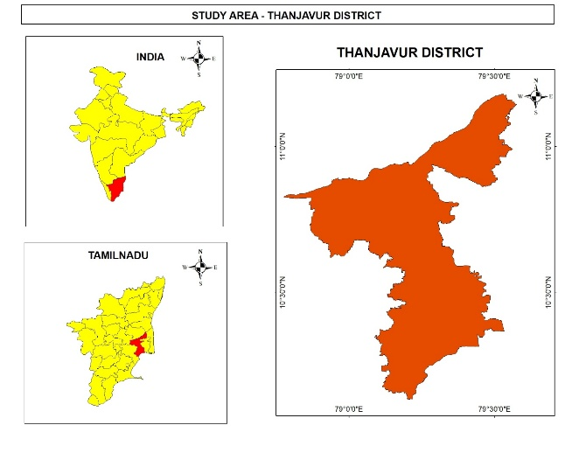

**Fig 1 Study area**

3. results and discussion

**Average Rainfall, Moving Average and Departure from Mean**

The long-term variability and trend of the area's rainfall pattern can be evaluated using statistical techniques such as mean, standard deviation, skewness, kurtosis, and coefficient of variation. The return period of yearly rainfall is evaluated using plotting position formulas such as Califonia, Hazen, Weibull, Chegodayev, Blom and Gringorten., (Shanomae Oneka Eastman et al., 2022)

The basic statistics of rainfall, such as annual average rain fall, moving average, the mean rainfall and departure from mean value are computed and presented in ***Table 1***. The average rainfall for the entire period is 1144.131 mm.

**Table 1 Basic statistics**

|  |  |  |  |
| --- | --- | --- | --- |
| YEAR | ANNUAL RAINFALL in mm | Deviation from Average | 3 years Moving Average |
| 1972 | 1301 | 156.9 |  |
| 1973 | 924.92 | -219.2 |  |
| 1974 | 719.98 | -424.2 | 981.97 |
| 1975 | 1307.18 | 163.0 | 984.0 |
| 1976 | 1237.38 | 93.2 | 1088.2 |
| 1977 | 1549.04 | 404.9 | 1364.5 |
| 1978 | 1310.32 | 166.2 | 1365.6 |
| 1979 | 1239.52 | 95.4 | 1366.3 |
| 1980 | 651.19 | -492.9 | 1067.0 |
| 1981 | 1297.41 | 153.3 | 1062.7 |
| 1982 | 733.23 | -410.9 | 893.9 |
| 1983 | 1416.3 | 272.2 | 1149.0 |
| 1984 | 1230.32 | 86.2 | 1126.6 |
| 1985 | 1211.62 | 67.5 | 1286.1 |
| 1986 | 1142.81 | -1.3 | 1194.9 |
| 1987 | 1059.03 | -85.1 | 1137.8 |
| 1988 | 865.52 | -278.6 | 1022.5 |
| 1989 | 867.66 | -276.5 | 930.7 |
| 1990 | 987.61 | -156.5 | 906.9 |
| 1991 | 987.61 | -156.5 | 947.6 |
| 1992 | 926.03 | -218.1 | 967.1 |
| 1993 | 1531.65 | 387.5 | 1148.4 |
| 1994 | 863.48 | -280.7 | 1107.1 |
| 1995 | 927.83 | -216.3 | 1107.7 |
| 1996 | 1442.65 | 298.5 | 1078.0 |
| 1997 | 1431.43 | 287.3 | 1267.3 |
| 1998 | 1265.3 | 121.2 | 1379.8 |
| 1999 | 1003.13 | -141.0 | 1233.3 |
| 2000 | 1235.55 | 91.4 | 1168.0 |
| 2001 | 641.85 | -502.3 | 960.2 |
| 2002 | 559.17 | -585.0 | 812.2 |
| 2003 | 494.6 | -649.5 | 565.2 |
| 2004 | 1333.32 | 189.2 | 795.7 |
| 2005 | 1495.62 | 351.5 | 1107.8 |
| 2006 | 980.45 | -163.681 | 1269.80 |
| 2007 | 1299.75 | 155.619 | 1258.61 |
| 2008 | 1540.34 | 396.209 | 1273.51 |
| 2009 | 1321.45 | 177.319 | 1387.18 |
| 2010 | 1622.3 | 478.169 | 1494.70 |
| 2011 | 2141.76 | 997.629 | 1695.17 |
| 2012 | 1595.02 | 450.889 | 1786.36 |
| 2013 | 839.5 | -304.631 | 1525.43 |
| 2014 | 1089.26 | -54.871 | 1174.59 |
| 2015 | 1322.46 | 178.329 | 1083.74 |
| 2016 | 641.01 | -503.121 | 1017.58 |
| 2017 | 604.67 | -539.461 | 856.05 |
| 2018 | 756.09 | -388.041 | 667.26 |
| 2019 | 1110.27 | -33.861 | 823.68 |
| 2020 | 1127.67 | -16.461 | 998.01 |
| 2021 | 1746.86 | 602.729 | 1328.27 |
| 2022 | 1420.57 | 276.439 | 1431.7 |
| Average | 1144.131 |  |  |
|  |  |  |  |

The study area has recorded a maximum rainfall of 2141.76 mm in the year 2011 and a minimum of 494.6 mm in the year 2003. In 2011 northeast monsoon was one of the wettest in decades in Tamil Nadu due to La Nina conditions in the Pacific Ocean, which enhanced monsoonal rainfall over South India, saturating the delta. Agricultural lands were flooded, affecting paddy fields and samba cultivation. In 2003, low rainfall is recorded due to suppressed monsoonal activity in the Bay of Bengal. The annual rainfall is depicted in graph as shown in ***Fig.2.***

**Fig.2 Annual Rainfall**

The departure from mean is shown in ***Fig.3.***The positive departure values against the years shows excess rainfall and negative values shows the deficit of rainfall in the corresponding years.

**Fig.3. Departure from Mean Rainfall**

The three years moving average are shown in ***Fig.4***. Irregular pattern with increasing in the years 1976 to 1979, 1985 -1987, 1997 – 1999, 2009 – 2012, with highest average in 2011.

**Fig.4. Rainfall - Moving Average**

The average value is showing again an increasing trend with positive value in 2022. The study area has shown decreased average values in 19880 – 1982, 1988 – 1991, 2001 – 2003 and in 2016 – 2019. This graph gives a prediction that the average is going to be higher in the successive years.

**4.1 Probability and Return Period of Rainfall**

Rainfall data is often modelled using probability distributions. The return period is a concept related to the probability of extreme events occurring. It represents the average time between the occurrences of events of a certain magnitude. The rainfall data are ranked in descending order and various plotting position and probabilistic methods are applied to determine the return period. Rainfall magnitudes were calculated for different return periods using the rainfall return period equation and is tabulated as in **Table 2**.

**Table 2 Probability and Return Period**

|  |  |  |  |  |
| --- | --- | --- | --- | --- |
| YEAR | ANNUAL RAINFALL in mm | RANK | PROBABILITY % | RETURN PERIOD |
| 2011 | 2141.76 | 1 | 0.980392157 | 102 |
| 2021 | 1746.86 | 2 | 2.941176471 | 34 |
| 2010 | 1622.3 | 3 | 4.901960784 | 20 |
| 2012 | 1595.02 | 4 | 6.862745098 | 15 |
| 1977 | 1549.04 | 5 | 8.823529412 | 11 |
| 2008 | 1540.34 | 6 | 10.78431373 | 9 |
| 1993 | 1531.65 | 7 | 12.74509804 | 8 |
| 2005 | 1495.62 | 8 | 14.70588235 | 7 |
| 1996 | 1442.65 | 9 | 16.66666667 | 6 |
| 1997 | 1431.43 | 10 | 18.62745098 | 5 |
| 2022 | 1420.57 | 11 | 20.58823529 | 5 |
| 1983 | 1416.3 | 12 | 22.54901961 | 4 |
| 2004 | 1333.32 | 13 | 24.50980392 | 4 |
| 2015 | 1322.46 | 14 | 26.47058824 | 4 |
| 2009 | 1321.45 | 15 | 28.43137255 | 4 |
| 1978 | 1310.32 | 16 | 30.39215686 | 3 |
| 1975 | 1307.18 | 17 | 32.35294118 | 3 |
| 1972 | 1301 | 18 | 34.31372549 | 3 |
| 2007 | 1299.75 | 19 | 36.2745098 | 3 |
| 1981 | 1297.41 | 20 | 38.23529412 | 3 |
| 1998 | 1265.3 | 21 | 40.19607843 | 2 |
| 1979 | 1239.52 | 22 | 42.15686275 | 2 |
| 1976 | 1237.38 | 23 | 44.11764706 | 2 |
| 2000 | 1235.55 | 24 | 46.07843137 | 2 |
| 1984 | 1230.32 | 25 | 48.03921569 | 2 |
| 1985 | 1211.62 | 26 | 50.0000000 | 2 |
| 1986 | 1142.81 | 27 | 51.96078431 | 2 |
| 2020 | 1127.67 | 28 | 53.92156863 | 2 |
| 2019 | 1110.27 | 29 | 55.88235294 | 2 |
| 2014 | 1089.26 | 30 | 57.84313725 | 2 |
| 1987 | 1059.03 | 31 | 59.80392157 | 2 |
| 1999 | 1003.13 | 32 | 61.76470588 | 2 |
| 1990 | 987.61 | 33 | 63.7254902 | 2 |
| 1991 | 987.61 | 34 | 65.68627451 | 2 |
| 2006 | 980.45 | 35 | 67.64705882 | 1 |
| 1995 | 927.83 | 36 | 69.60784314 | 1 |
| 1992 | 926.03 | 37 | 71.56862745 | 1 |
| 1973 | 924.92 | 38 | 73.52941176 | 1 |
| 1989 | 867.66 | 39 | 75.49019608 | 1 |
| 1988 | 865.52 | 40 | 77.45098039 | 1 |
| 1994 | 863.48 | 41 | 79.41176471 | 1 |
| 2013 | 839.5 | 42 | 81.37254902 | 1 |
| 2018 | 756.09 | 43 | 83.33333333 | 1 |
| 1982 | 733.23 | 44 | 85.29411765 | 1 |
| 1974 | 719.98 | 45 | 87.25490196 | 1 |
| 1980 | 651.19 | 46 | 89.21568627 | 1 |
| 2001 | 641.85 | 47 | 91.17647059 | 1 |
| 2016 | 641.01 | 48 | 93.1372549 | 1 |
| 2017 | 604.67 | 49 | 95.09803922 | 1 |
| 2002 | 559.17 | 50 | 97.05882353 | 1 |
| 2003 | 494.6 | 51 | 99.01960784 | 1 |

From the table it is derived that the probability of occurrence of rank 1 rainfall event is below 1%. Rank 2 to Rank 5 rainfall has the probability between 1% to 10%, rank 6 to 10 rainfall has probability between 10% to 20%, like wise we can find an increasing trend along with increasing the rank value and so above 90 % of probability is observed for the rainfall in ranks 47 to 51. So, it is concluded that as the rank increases the probability also increases, that is the probability of occurrence of lower rainfall events are high and the possibility of occurrence of high rainfall events are lower. Regarding the return period, it is found out that the maximum rainfall of rank 1 (2141.76mm) is supposed to occur once in 102 years, The rank 2 value has a chance of occurrence once in 34 years and rank 3 in 20 years. We can find here that rank 12 to 15 has chances of occurrence once in 4 years, from rank 15 to 20, 3 years period, rank 21 to 34 once in 2 years period and from rank 35 to 51, there is possibility of occurrence in every year.

**4.2 Descriptive Statistics: Mean (Average):** Calculating the average rainfall over a specific period provides a general overview of the typical precipitation for that timeframe. **Standard Deviation:** This measures the amount of variation or dispersion from the mean in the given rainfall data. A higher standard deviation indicates greater variability. Summary of these statistics are shown in **Table 3.** By analysing the rainfall data for 51 years from 1972 to 2022, The January month recorded a rainfall of minimum 0 mm to 334.470mm maximum with mean value of 32.789 mm and a standard monthly deviation of 58.262mm.

It is observed that the months of January, February, March, April and May months have received no rainfall in many of the years and a minimum of 54.130 mm is observed in the month of October. The study area received a maximum of 720.620mm of rainfall in the month of November and 714.570 mm in December month. On an average March month has received a rainfall of 178.710 mm. A rainfall between 200mm to 300 mm are received by February, April, May, July, August and September months. The months of January and June have received a rainfall between 300 – 400 mm. The October month received a maximum of 452.590 mm rainfall.

January to June month has below 50 mm of mean rainfall and July, August months has a mean value between 50 mm and 100 mm. 100 to 200mm of mean rainfall is observed in the months of September, October and December and November month received 297.257 mm of mean rainfall.

The standard deviation of monthly rainfall is more for the months of November and December i.e., a deviation of 166.511 mm and 146.176 mm respectively. A monthly deviation of 92.896 mm from mean value is observed in the month of October. All other months tend to have a standard monthly deviation below 60 mm.

**Table 3 Summary statistics**

|  |  |  |  |  |  |  |  |
| --- | --- | --- | --- | --- | --- | --- | --- |
| Variable | Observations | Obs. with missing data | Obs. without missing data | Minimum | Maximum | Mean | Std. deviation  (monthly) |
| JAN | 51 | 0 | 51 | 0.000 | 334.470 | 32.789 | 58.262 |
| FEB | 51 | 0 | 51 | 0.000 | 237.980 | 20.908 | 44.867 |
| MAR | 51 | 0 | 51 | 0.000 | 178.710 | 20.343 | 33.024 |
| APR | 51 | 0 | 51 | 0.000 | 246.800 | 34.960 | 48.640 |
| MAY | 51 | 0 | 51 | 0.000 | 215.430 | 53.934 | 44.416 |
| JUN | 51 | 0 | 51 | 3.420 | 382.110 | 43.330 | 58.470 |
| JUL | 51 | 0 | 51 | 2.050 | 262.890 | 62.640 | 52.424 |
| AUG | 51 | 0 | 51 | 12.880 | 278.870 | 98.724 | 58.905 |
| SEP | 51 | 0 | 51 | 14.500 | 257.350 | 115.209 | 56.965 |
| OCT | 51 | 0 | 51 | 54.130 | 452.590 | 189.125 | 92.896 |
| NOV | 51 | 0 | 51 | 21.330 | 720.620 | 297.257 | 166.511 |
| DEC | 51 | 0 | 51 | 19.610 | 714.570 | 175.612 | 146.176 |

**4.3 Trend Analysis:** Examining long term trends in rainfall data helps to identify patterns of increase, decrease, or stability over time. Linear Regression model, Goodness of fit statistics, Mann – Kendall’s Test, Sen’s Slope analysis are adopted to analyse the trend in rainfall.

**4.3.1 Linear Regression**

Linear regression model is exercised using XLSTAT, which illustrates that, the predicted or fitted value is the value of the rainfall estimated by the regression equation for a given set of years. The residual is the difference between the observed (actual) value of the rainfall and the predicted (fitted) year value. A positive residual indicates that the model underestimates the actual value, while a negative residual suggests an over estimation. The goal is to have residuals as close to zero as possible. In the study area, we can find, highest positive residual value of 965.374 in the year 2011 and lowest positive value of 22.772 in the year 1986. Highest negative residual values between 500 to 600 are observed in the years2001 – 2003 and between 2016 – 2019.

Standard residuals provide a standardized measure of how far each data point is from the mean prediction in units of standard deviation. A large number of residuals close to zero indicates a good fit, A standard residual that is significantly larger than 1 or smaller than -1 suggests that the corresponding data point has a larger influence on the model than the other points. Outliers can be influential in skewing the results of the regression analysis, and standard residuals help to flag these points. In this study, out of 51 observation yearsnearly 15 years **(**1974, 1977, 1980, 1982, 1993, 2001, 2002, 2003, 2010, 2011, 2012, 2016, 2017, 2018, 2021) have outlying residual values. The remaining years follow good fit. The standard deviation from the predicted mean ranges from 40 to 95. Other observations are tabulated in **Table 4.**

**Table 4 Linear Regression**

|  |  |  |  |  |  |  |  |  |  |
| --- | --- | --- | --- | --- | --- | --- | --- | --- | --- |
| **YEAR** | **Pred (Total rainfall in mm)** | **Residual** | **Std. residual** | **Std. dev. on pred. (Mean)** | **Lower bound 95% (Mean)** | **Upper bound 95% (Mean)** | **Std. dev. on pred. (Observation)** | **Lower bound 95% (Observation)** | **Upper bound 95% (Observation)** |
| 1972 | 1088.483 | 212.517 | 0.618 | 94.934 | 897.706 | 1279.260 | 356.840 | 371.386 | 1805.580 |
| 1973 | 1090.737 | -165.817 | -0.482 | 92.129 | 905.596 | 1275.878 | 356.104 | 375.119 | 1806.355 |
| 1974 | 1092.991 | -373.011 | -1.084 | 89.356 | 913.423 | 1272.559 | 355.397 | 378.794 | 1807.187 |
| 1975 | 1095.245 | 211.935 | 0.616 | 86.618 | 921.180 | 1269.310 | 354.718 | 382.412 | 1808.078 |
| 1976 | 1097.499 | 139.881 | 0.407 | 83.918 | 928.859 | 1266.138 | 354.069 | 385.971 | 1809.026 |
| 1977 | 1099.753 | 449.287 | 1.306 | 81.260 | 936.454 | 1263.051 | 353.448 | 389.472 | 1810.033 |
| 1978 | 1102.007 | 208.313 | 0.606 | 78.649 | 943.956 | 1260.057 | 352.857 | 392.914 | 1811.099 |
| 1979 | 1104.261 | 135.259 | 0.393 | 76.088 | 951.356 | 1257.165 | 352.295 | 396.297 | 1812.224 |
| 1980 | 1106.514 | -455.324 | -1.324 | 73.584 | 958.642 | 1254.387 | 351.763 | 399.621 | 1813.408 |
| 1981 | 1108.768 | 188.642 | 0.548 | 71.143 | 965.802 | 1251.735 | 351.260 | 402.885 | 1814.652 |
| 1982 | 1111.022 | -377.792 | -1.098 | 68.770 | 972.824 | 1249.221 | 350.787 | 406.089 | 1815.956 |
| 1983 | 1113.276 | 303.024 | 0.881 | 66.474 | 979.692 | 1246.861 | 350.344 | 409.233 | 1817.319 |
| 1984 | 1115.530 | 114.790 | 0.334 | 64.263 | 986.390 | 1244.671 | 349.931 | 412.317 | 1818.744 |
| 1985 | 1117.784 | 93.836 | 0.273 | 62.145 | 992.899 | 1242.669 | 349.549 | 415.340 | 1820.229 |
| 1986 | 1120.038 | 22.772 | 0.066 | 60.131 | 999.201 | 1240.875 | 349.196 | 418.302 | 1821.774 |
| 1987 | 1122.292 | -63.262 | -0.184 | 58.231 | 1005.273 | 1239.311 | 348.874 | 421.203 | 1823.381 |
| 1988 | 1124.546 | -259.026 | -0.753 | 56.457 | 1011.091 | 1238.000 | 348.582 | 424.043 | 1825.049 |
| 1989 | 1126.800 | -259.140 | -0.753 | 54.821 | 1016.633 | 1236.967 | 348.321 | 426.822 | 1826.778 |
| 1990 | 1129.054 | -105.744 | -0.307 | 53.336 | 1021.871 | 1236.236 | 348.091 | 429.539 | 1828.568 |
| 1991 | 1131.308 | -143.698 | -0.418 | 52.015 | 1026.780 | 1235.835 | 347.891 | 432.195 | 1830.420 |
| 1992 | 1133.562 | -207.532 | -0.603 | 50.870 | 1031.335 | 1235.788 | 347.721 | 434.789 | 1832.334 |
| 1993 | 1135.815 | 395.835 | 1.151 | 49.914 | 1035.510 | 1236.121 | 347.583 | 437.322 | 1834.309 |
| 1994 | 1138.069 | -274.589 | -0.798 | 49.157 | 1039.285 | 1236.854 | 347.475 | 439.793 | 1836.346 |
| 1995 | 1140.323 | -212.493 | -0.618 | 48.609 | 1042.639 | 1238.008 | 347.398 | 442.201 | 1838.445 |
| 1996 | 1142.577 | 300.073 | 0.872 | 48.278 | 1045.559 | 1239.595 | 347.352 | 444.548 | 1840.606 |
| 1997 | 1144.831 | 286.599 | 0.833 | 48.167 | 1048.036 | 1241.626 | 347.336 | 446.833 | 1842.829 |
| 1998 | 1147.085 | 118.215 | 0.344 | 48.278 | 1050.067 | 1244.103 | 347.352 | 449.056 | 1845.114 |
| 1999 | 1149.339 | -146.209 | -0.425 | 48.609 | 1051.655 | 1247.023 | 347.398 | 451.217 | 1847.461 |
| 2000 | 1151.593 | 83.957 | 0.244 | 49.157 | 1052.808 | 1250.378 | 347.475 | 453.316 | 1849.870 |
| 2001 | 1153.847 | -511.997 | -1.488 | 49.914 | 1053.542 | 1254.152 | 347.583 | 455.353 | 1852.340 |
| 2002 | 1156.101 | -596.931 | -1.735 | 50.870 | 1053.874 | 1258.328 | 347.721 | 457.329 | 1854.873 |
| 2003 | 1158.355 | -663.755 | -1.930 | 52.015 | 1053.827 | 1262.882 | 347.891 | 459.242 | 1857.467 |
| 2004 | 1160.609 | 172.711 | 0.502 | 53.336 | 1053.426 | 1267.791 | 348.091 | 461.094 | 1860.123 |
| 2005 | 1162.863 | 332.757 | 0.967 | 54.821 | 1052.695 | 1273.030 | 348.321 | 462.885 | 1862.840 |
| 2006 | 1165.117 | -184.667 | -0.537 | 56.457 | 1051.662 | 1278.571 | 348.582 | 464.614 | 1865.619 |
| 2007 | 1167.370 | 132.380 | 0.385 | 58.231 | 1050.351 | 1284.390 | 348.874 | 466.282 | 1868.459 |
| 2008 | 1169.624 | 370.716 | 1.078 | 60.131 | 1048.787 | 1290.462 | 349.196 | 467.888 | 1871.361 |
| 2009 | 1171.878 | 149.572 | 0.435 | 62.145 | 1046.993 | 1296.763 | 349.549 | 469.434 | 1874.323 |
| 2010 | 1174.132 | 448.168 | 1.303 | 64.263 | 1044.992 | 1303.273 | 349.931 | 470.919 | 1877.346 |
| 2011 | 1176.386 | 965.374 | 2.806 | 66.474 | 1042.802 | 1309.971 | 350.344 | 472.343 | 1880.429 |
| 2012 | 1178.640 | 416.380 | 1.210 | 68.770 | 1040.441 | 1316.839 | 350.787 | 473.707 | 1883.573 |
| 2013 | 1180.894 | -341.394 | -0.992 | 71.143 | 1037.928 | 1323.860 | 351.260 | 475.011 | 1886.777 |
| 2014 | 1183.148 | -93.888 | -0.273 | 73.584 | 1035.275 | 1331.021 | 351.763 | 476.254 | 1890.041 |
| 2015 | 1185.402 | 137.058 | 0.398 | 76.088 | 1032.497 | 1338.307 | 352.295 | 477.439 | 1893.365 |
| 2016 | 1187.656 | -546.646 | -1.589 | 78.649 | 1029.606 | 1345.706 | 352.857 | 478.563 | 1896.748 |
| 2017 | 1189.910 | -585.240 | -1.701 | 81.260 | 1026.611 | 1353.208 | 353.448 | 479.629 | 1900.190 |
| 2018 | 1192.164 | -436.074 | -1.268 | 83.918 | 1023.524 | 1360.803 | 354.069 | 480.636 | 1903.691 |
| 2019 | 1194.418 | -84.148 | -0.245 | 86.618 | 1020.352 | 1368.483 | 354.718 | 481.585 | 1907.250 |
| 2020 | 1196.671 | -69.001 | -0.201 | 89.356 | 1017.103 | 1376.239 | 355.397 | 482.475 | 1910.868 |
| 2021 | 1198.925 | 547.935 | 1.593 | 92.129 | 1013.785 | 1384.066 | 356.104 | 483.307 | 1914.543 |
| 2022 | 1201.179 | 219.391 | 0.638 | 94.934 | 1010.402 | 1391.957 | 356.840 | 484.082 | 1918.276 |

**Goodness of fit statistics**

The value of R2 normally ranges from 0 to 1, with higher values indicating a better fit. Goodness of fit statistics is computed as shown in **Table 5.** The computed R2 value of this study is 0.010, which shows that it is less significantly fit with the regression line. All these observations are depicted in graphs as shown **in Fig 5.**

**Table 5** **Goodness of fit statistics**

|  |  |
| --- | --- |
| **Regression of variable TOTAL RAINFALL IN MM:** | |
| Goodness of fit statistics (TOTAL RAINFALL IN MM): | |
| Observations | 51 |
| Sum of weights | 51 |
| DF | 49 |
| R² | 0.010 |
| Adjusted R² | -0.011 |
| MSE | 118322.340 |
| RMSE | 343.980 |
| MAPE | 29.216 |
| DW | 1.312 |
| Cp | 2.000 |
| AIC | 597.699 |
| AICC | 597.949 |
| SBC | 601.563 |
| PC | 1.071 |

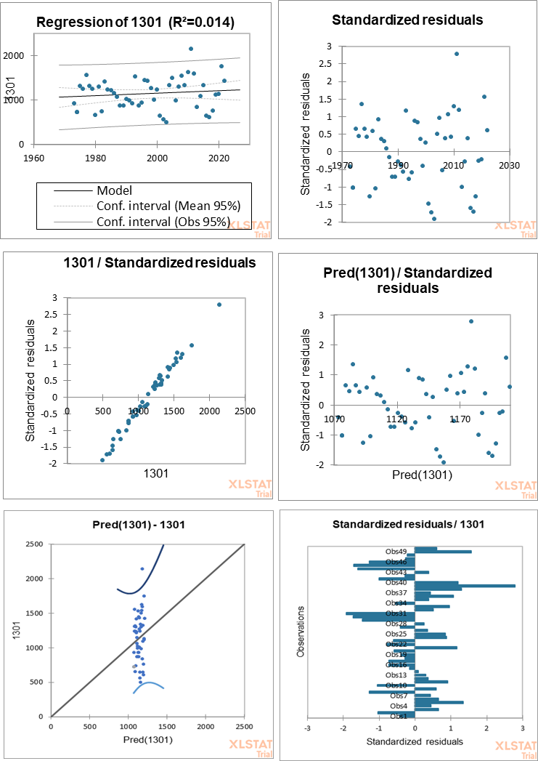

**Fig. 5 Regression Analysis**

**4.3.2 Mann-Kendall Test**

The trend of rainfall is analysed using a non-parameter Mann-Kendall statistical test, which finds trends in time series and is widely used in precipitation analysis (Ahmad et al., 2015).

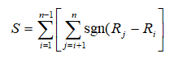

The Mann-Kendall test statistic is calculated according to

where sgn(x) = 1 for x > 0, sgn(x) = 0 for x = 0, sgn(x) = -1 for x < 0, If the null hypothesis H0is true, then S is approximately normally distributed.

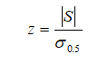The z-statistic is therefore

As the computed p values are greater than 0.05, except in January, the probability of the trend is less than 95% of significance level in all other months, implying that the trend is not statistically significant. Only the January month shows a significant trend in rainfall with 97 % of probability of occurrence. All the other months show a probability at very low significance levels.

The Mann – Kendall’s test analyses the increasing or decreasing trend of rainfall occurrence and the probability of occurrence of trend. The Sen’s slope value quantifies the possibility of trend ie., how much amount of rainfall changes per unit of time. Kendall's Tau is the statistical test and the p-value is the probability of observing such a value solely as a result of random variation. The Mann-Kendall Test Summary is presented in ***Table6.***

**Table 6 Mann-Kendall Test** **Summary**

|  |  |  |  |
| --- | --- | --- | --- |
| Series\Test | Kendall's tau | p-value | Sen's slope |
| JAN | 0.211 | **0.029** | 0.286 |
| FEB | 0.095 | 0.342 | 0.003 |
| MAR | -0.044 | 0.660 | -0.010 |
| APR | 0.078 | 0.426 | 0.142 |
| MAY | 0.126 | 0.194 | 0.436 |
| JUN | 0.023 | 0.820 | 0.053 |
| JUL | -0.063 | 0.521 | -0.194 |
| AUG | 0.114 | 0.242 | 0.612 |
| SEP | -0.115 | 0.236 | -0.739 |
| OCT | -0.133 | 0.172 | -1.096 |
| NOV | 0.002 | 0.987 | 0.039 |
| DEC | -0.057 | 0.559 | -0.643 |

**Kendall's Tau**

As the tau value lies in the range from 0 to 0.3, there exists a weak increasing trend in rainfall in January, February, April, May, June, August and November months. And among these months, January exhibits the higher value, showing a high increasing trend in rainfall. Likewise, the tau between 0 to -0.3 bearing in the months of March, July, September, October and December implies that there exists a weak decreasing trend in rainfall occurrence in these months. The Kendall’s tau values are plotted on graph shown in ***Fig.6.***

**The p value**

The p values in the graph shown in ***Fig.7***, clearly illustrates that except January month all other months have p vales greater than 0.1 and so the trends in these months exhibit lower probabilities with less significance levels.

Even though the January month is showing an increasing trend in rainfall, the quantity is very low with a mean value of 32.789 mm per year (Table 3). The concentration of study to know the trend of rainfall in the months of monsoon season, that is in the September, October, November and December month. According to this study even though the trend is showing a high negative trend, that is even though it is following a high trend in occurrence, the quantity is highly decreasing. This is a serious problem in the study area.

**Fig.6 Kendall’s tau Fig.7 p- values**

**4.3.3 Sen's Slope Estimator Test**

The magnitude of a trend in a time series can be determined using a nonparametric method known as Sen's estimator (Sen, 1968). To estimate the true slope of an existing trend such as amount of change per year. This slope corresponds to the median of all the slopes calculated between each pair of points in the series. A positive value of Sen's slope indicates an upward or increasing trend and a negative value gives a downward or decreasing trend in the time series.

The slope value shown in **Fig 8,** reveals that February, March, June and November months have very low value of the slope. The September, October and December months have highest values of Slope in the decreasing order. The January, April, May, August and November months exhibit a positive trend and July, September, October and December months show a negative trend.

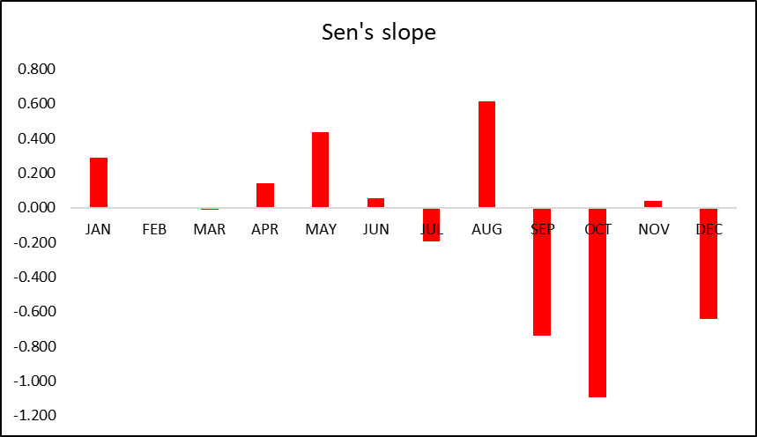

**Fig 8 Sen’s Slope**

**Fig 9,** exhibits the monthly pattern of Sen’s Slope for the study period. The upward and downward slope shows the increasing and decreasing trend of monthly rainfall in different years.

The January, April, May, June, August and November has increasing trend in which January, May and August months are showing higher values of increase. Although the study area receives its maximum rainfall in the NE monsoon season (Oct – Dec), September, October and December months are showing a decreasing trend. Only November month shows a slight increase trend. As the study area stays on agrarian economy and the agriculture pattern mostly depend on NE monsoon, the decrease trend in rainfall pattern indirectly affects the economy and further developments.

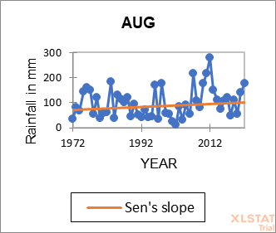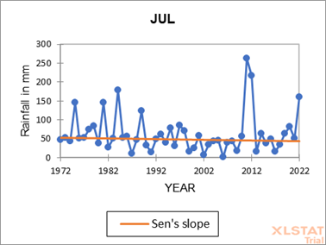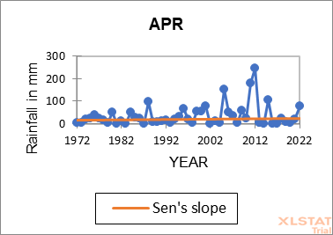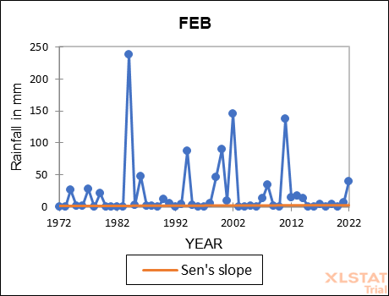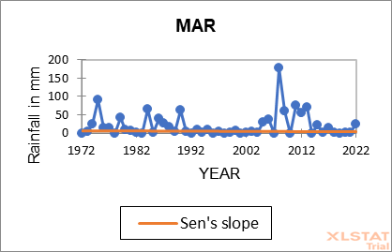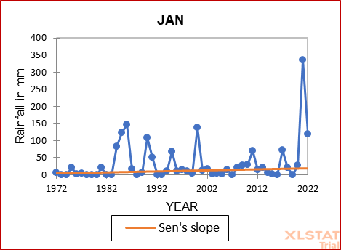

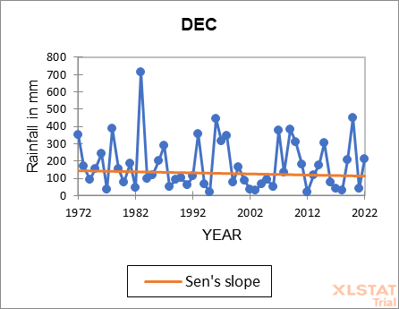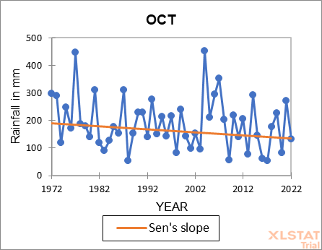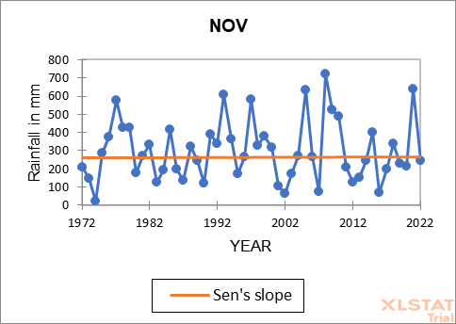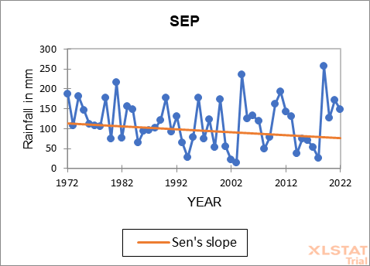**Fig. 9 Sen’s Slope Monthly Analysis**

4. Conclusion

Rainfall is one of the most important natural input resources to crop production and its occurrence and distribution is erratic, temporal and spatial variations in nature.

The Annual and monthly rainfall data for 51 years from 1972 to 2022 are collected and trend analysis using statistical techniques are performed. The maximum rainfall received in the study area is 2141.760 mm and a minimum of 494.600 mm is received. The mean rainfall is 1144.131 mm and has a standard deviation of 342.168 mm rainfall.

Regarding the regression analysis, out of 51 observation yearsnearly 15 years **(**1974, 1977, 1980, 1982, 1993, 2001, 2002, 2003, 2010, 2011, 2012, 2016, 2017, 2018, 2021) have outlying residual values. The remaining years follow good fit. The standard deviation from the predicted mean ranges from 40 to 95. As the R2 value of this study is 0.010, it is less significantly fit with the regression line.

According to the trend analysis using Mann – Kendall test only in the month of January the computed p-value is lower than the significance level alpha=0.05, which assumes that, the rainfall occurrence in the month of January follows a regular trend in the study period. In all other months the computed p-value is greater than the significance level alpha=0.05, meaning that there are irregularities in the rainfall pattern in all other months. This uncertainty in the rainfall may directly affect the agricultural production in this area.

This study of 51 years rainfall events, it is concluded that the study area is showing very low trend with more irregularities in the occurrence of rainfall. This is a serious issue in an agrarian region. It is also observed from Sen's estimator test that, the January, April, May, August and November months exhibit a positive trend and July, September, October and December months show a negative trend. The study area has received excess of rainfall in some months and deficit in some others. So, measures should be taken to conserve the excess rainfall and plan for alternate irrigation methods in the deficit months.

Changing rainfall patterns are not just a climate concern, but are deeply interlinked with national development goals. Accurate rainfall monitoring and interpretation can help in designing the climate resilient policies, secure sustainable water use, and protect lives and livelihoods through planning. Regions with declining rainfall face groundwater depletion and lowering of water table leading to scarcity and stress. This can recommend for groundwater recharge programs. Studies on rainfall trends emphasize the need for drainage infrastructure, sewage systems, and flood zone regulations and necessitates policies on rainwater harvesting and green infrastructure.

By knowing the trend, farmers can also plan their cropping pattern and should be ready to face the consequences due to heavy or deficit rainfall situations. They can choose the crop varieties according to the changes in conditions. The NGOs, Krishi Vigyan Kendras (KVKs), Farmer Producer Organizations (FPOs), Uzhavan App, TNAU Agri-Tech Portal, TNAU Crop Doctor App can help the farmers in this regard.

DISCLAIMER (ARTIFICIAL INTELLIGENCE)

Author hereby declares that NO generative AI technologies such as Large Language Models (ChatGPT, COPILOT, etc) and text to image generators have been used during writing or editing of manuscripts.

**REFERENCES**

1. Arpita Panda, Netrananda Sahu, Trend analysis of seasonal rainfall and temperature pattern in Kalahandi, Bolangir and Koraput districts of Odisha, India, Atmospheric Science Letters Volume20, Issue10, 2019.

2. Arvind G, P Ashok Kumar, S Girish Karthi and C R Suribabu, Statistical Analysis of 30 Years Rainfall Data: A Case Study, IOP Conf. Series: Earth and Environmental Science, 80, 2017.

3. Belfin Raj Selvaraj, Srinivasan Krishnasamy, Jessy Mol Irudhaya Dhason, Investigation of climate change by analysing the rainfall pattern in Kuzhithuraiyar sub-basin of India using GIS-based spatial analysis, Sustainable Chemistry for Climate Action, Volume 4, 2024.

4. Bhakar, S. R., M. Iqbal, Mukesh Devandra, Neeraj Chhajed and A. K. Bansal, Probability analysis of rainfall at Kota. Indian Journal of Agricultural Research, 42: 201-206, 2008.

5. Bhim Singh, Deepak Rajpurohit, Amol Vasishth and Jitendra Singh, Probability Analysis for Estimation of Annual One Day maximum Rainfall of Jhalarapatan Area of Rajasthan, India, Plant Archives Vol. 12 No. 2, 2012 pp. 1093-1100.

6. Bullon-Cassis, Laura, María Gutiérrez, Moritz Petersmann, and Jessica Templeton. 2025. Summary of the 62nd Session of the Intergovernmental Panel on Climate Change. Earth Negotiations Bulletin/IISD, Vol. 12 No. 866.

7. Chow, V. T., Hand book of applied hydrology. McGraw-Hill Book Company, New York, 1964.

8. Dhar O. N., P. R. Rakhecha, A. K. Kulkarni, Fluctuations in northeast monsoon rainfall of Tamil Nadu, Journal of Climatology, 1982, Volume2, Issue4, pp: 339-345.

9. Donald W. Meals, Jean Spooner, Steven A. Dressing, and Jon B. Harcum, Statistical Analysis for Monotonic Trends, National Nonpoint Source Monitoring Program November 2011, Technical notes 6, pp. 1- 23.

10. Gilbert, R.O. 1987. Statistical Methods for Environmental Pollution Monitoring, Wiley, NY.

11. Hoesung Lee Chairman, IPCC; José Romero Head, Technical Support Unit, IPCC (Edited); CLIMATE CHANGE 2023 Synthesis Report, Summary for Policymakers - A Report of the Intergovernmental Panel on Climate Change (IPCC).

12. Kailas Vijay Karnewar, Analysis of rainfall trends over Nanded of Maharashtra, India, International Journal of Research, 2018, 5(16):571-581

13. Kailas Vijay Karnewar, (2018) has attempted was made to study variation in monthly, seasonal and annual rainfall over Nanded of Maharashtra state of India during period from 1969 to 2010.

14. Krushna Chandra Gouda, Nikhilasuma P, Mahendra Benke, Geeta Agnihotri, (2024), Assessment of Rainfall Variability over Karnataka state in India, Natural Hazards Research, Volume 4, Issue 2, 2024, pp. 246-254.

15. Kumar, V., Jain, S. K. & Singh, Y. (2010) have analysed monthly, seasonal and annual trends of rainfall using monthly data series of 135 years (1871–2005) for 30 sub-divisions (sub-regions) in India.

16. Kumar, R. and Gautam, H.R. (2014) Climate change and its impact on agricultural productivity in India. Journal of Climatology and Weather Forecasting, 2, 109.

17. Kumar, V., Jain, S.K. and Singh, Y. (2010) Analysis of long-term rainfall trends in India. Hydrological Sciences Journal, 55(4), 484–496.

18. Lavanya S, M Radha and U Arulanandu, Statistical Distribution of Seasonal Rainfall Data for Rainfall Pattern in TNAU Station Coimbatore, Tamil Nadu, India International Journal of Current Microbiology and Applied Sciences, (2018) 7(4), pp: 3053-3062.

19. Lewis, S.C. and King, A.D. (2016) Evolution of mean, variance and extremes in 21st century temperatures. Weather and Climate Extremes, 7, 1.

20. Mann, H.B. (1945) non-parametric tests against trend. Econometrica, 13, 163–171.

21. Mohammad Zakwan, Zeenat Ara, Statistical analysis of rainfall in Bihar, Sustainable Water Resources Management, 2019, 5(4):1781-1789.

22. Muthiah, M.; Sivarajan, S.; Madasamy, N.; Natarajan, A.; Ayyavoo, R. (2024) Analyzing Rainfall Trends Using Statistical Methods across Vaippar Basin, Tamil Nadu, India: A Comprehensive Study. Sustainability 2024, 16, 1957. https:// doi.org/10.3390/su16051957

23. Pal, A.B. and Mishra, P.K. (2017) Trend analysis of rainfall, temperature and runoff data: a case study of Rangoon watershed in Nepal. International Journal of Students' Research in Technology & Management, ISSN 2321–2543, 5(3), 21–38.

24. Panneerselvam S. and T. N. Balasubramanian, Rainfall study for dry land areas of selected districts of Tamil Nadu for crop planning S. KOKILAVANI, Mausam, 2016, Vol.67, Iss.4, pp: 869-878.

25. Patra, P. C. Hydrology and water resources engineering. Narosa Publishing House Pvt. Ltd., New Delhi, 2001.

26. Rushil Patel, Literature Review on Rainfall Prediction, Research and Reviews: Journal of Engineering and Technology, Vol. 10, Issue 9, 2021.

27. Sen A., Poverty and Famines: An Essay on Entitlement and Deprivation, Clarendon Press , Oxford, UK, 1981.

28.Shanomae Oneka Eastman, Basheer Khan, Statistical Analysis of Rainfall Data: A Case Study of Georgetown, Guyana, International Journal of Innovative Research in Engineering & Multidisciplinary Physical Sciences, Volume 10, Issue 6, 2022, (E-ISSN: 2349-7300)

29. Sivajothi, K. Karthikeyan, (2018) Long-Term Trend Analysis of Changing Precipitation in Tamil Nadu, India, International Journal of Engineering & Technology, Volume4, Issue10,2018, pp: 980-984.

30. Sivaranjani a, Muthumari b, Devakanth a, Jeyamugesh b, Sathees Kumar b, Zunaithur Rahman, Rainfall Seasonal Analysis and Trend Variation Using ArcGIS in Southern Districts of Tamilnadu, India, Gis Science Journal, Volume 7, Issue 6, 2020, pp.548 – 566.

31. Subodh Kant Pandey & H.L. Tiwari, Rainfall Trend Detection –A Review, International Journal of Creative Research Thoughts,2021, Volume 9, Issue 11, pp.521-524.

32. Upadhaya, A. and S. R. Singh, Estimation of consecutive day’s maximum rainfall by various methods and their comparison. Indian Journal of Soil Conservation, 26, 1998, pp:193-201.