Impact of the Implementation of Sustainable Forest Practices in the Buffer Zone on Dryland Forest Cover Change in Endau Forest, Kenya

.

|  |
| --- |
| ABSTRACT  Deforestation of dryland forests in Africa threatens their existence, which may lead to climate change and loss of biodiversity. This study explores how the community's perceptions towards sustainable forest management practices in dryland ecosystems affect the forest cover. The primary objective was to establish the effects of the implementation of sustainable forest practices in the buffer zone of Endau Forest between 1979 and 2024. A cross-sectional survey design was employed involving 298 randomly selected household heads from the Endau location through structured questionnaires, and six key informants who were interviewed through a semi-structured interview. Descriptive statistics, Pearson correlation, regression analysis, and thematic analysis were used to evaluate sustainable forest management. Satellite imagery from 1979, 1994, 2009, and 2024 was used to assess land cover changes. Results revealed an improvement of forest class from 3,397.32 hectares in 1979 to 6,465.05 hectares in 2009, followed by a decline to 5,727.04 hectares in 2024. Shrubland and bare land fluctuated over the years. A strong positive correlation (*r* = 0.868, *p* = 0.01) and significant regression (*β* = 0.149, *p* = 0.012) indicated that sustainable practices had a positive effect on forest cover. The findings underscore that sustainable forest practices are significant to dryland forest conservation. There is a need for policy interventions by training community forest to support sustainable forest management and community advocacy. |

***Keywords:*** *Sustainable Forest Management, Endau Forest, Dryland Forest, Forest Cover Change, Community Perceptions, Deforestation.*

*Introduction*

1. Background of the study

The main objective of this paper was to establish the impacts of the implementation of sustainable forest practices in the buffer zone on dryland forest cover change in Endau Forest. The forest's sustainable practices enhance the forest cover health. Most of these sustainable practices are done by individual farmers. Community-based initiatives, including forest restocking after degradation, are vital for supporting dryland forest regeneration, but their impacts are not fully understood [1]. Land cover changes significantly contribute to modifying the Earth's surface [2]. If this modification is not mitigated through restocking, reforestation, and afforestation, the Earth's environmental services will likely be interfered with. The drylands are usually defined by the ratio of annual precipitation (P) to annual potential evapotranspiration (PET); drylands have a P/PET ratio. Drylands are typically identified by comparing annual rainfall to potential evapotranspiration, using the aridity index (AI), or the P/PET ratio [2]. Based on this index, drylands fall into four categories: hyper-arid (AI below 0.05), arid (0.05 to less than 0.2), semi-arid (0.2 to less than 0.5), and dry sub-humid (0.5 to less than 0.65). These regions experience limited rainfall and high rates of evaporation. Dryland forests, therefore, are those that grow within zones where the aridity index ranges from 0.05 to 0.65 [2].

Dryland forests are vital ecosystems that cover approximately 27% of the Earth's forested area. Dryland forests provide environmental services such as carbon sequestration and biodiversity conservation. Dryland forests are a source of livelihood that supports approximately two billion people in the world [3]. Despite their importance, these ecosystems are increasingly threatened by human activities like agricultural expansion, logging, and overgrazing, as well as by the impacts of climate change. Globally, the degradation of dryland forests contributes to rising carbon emissions, exacerbates desertification, and diminishes biodiversity [4]. According to FAO 2020, all types of forests constitute 31% of the total land in the world. Studies by FAO have shown that the forest cover has been decreasing at alarming rates. The first Forest Research Assessment (FRA) was done in 1948. In 1948, FRA indicated that 66% of the world was forested. In 2020, only 30.8% (4.06 billion hectares) of the world was forested. Therefore, more than half of the area that was occupied by the forest in 1948 has been deforested [3]. More than half of the forests have been deforested in seven decades. Despite extensive research on tropical rainforests, there is a significant gap in the literature concerning the spatiotemporal dynamics of dryland forests, particularly in understanding the specific patterns and drivers of change over extended periods. Addressing these knowledge gaps is crucial for developing effective conservation strategies that are tailored to the unique challenges faced by dryland forests.

African forests account for only 16% (636 million hectares) of the world's forests [3]. The African forest cover is almost half the world's average. However, Africa experienced significant deforestation, losing 3.9 million hectares annually between 2010 and 2020 [3]. Forest services such as food, fibre, medicinal, pharmaceutical plants, timber, and biofuel production will be affected if deforestation continues [5]. In Africa, dryland forests are especially vulnerable due to rapid population growth, poverty, and a heavy reliance on natural resources for livelihoods [6]. Dryland forests that are found in regions such as the Sahel, in the Horn of Africa, and Southern Africa, are under immense pressure from agricultural expansion, charcoal production, and unsustainable land-use practices [7]. While there is growing research on the drivers of deforestation in Africa, regional studies often cover short periods. The specific impacts of economic activities on forest cover remain underexplored. The intersection of economic factors with forest cover change is particularly critical, as economic pressures frequently lead to the conversion of forested land into agricultural land or the extraction of forest resources for income generation.

In East Africa, dryland forests are facing significant threats due to economic, environmental, and social pressures [8]. These forests are crucial for the ecological balance and the livelihoods of local communities, yet they have experienced notable degradation over the past four decades [8]. However, the literature on forest cover change in East Africa often lacks a comprehensive analysis of the spatial and temporal dynamics specific to dryland forests, which are distinct from other forest types in the region. Moreover, there is limited literature on Participatory Forest Management (PFM), which is used to mitigate forest degradation in these areas, specifically dryland forests.

The forest's sustainable practices enhance the forest cover. Most of these sustainable practices are done by individual farmers or community-based groups. Community-based initiatives, including forest restocking after degradation, are vital for supporting dryland forest regeneration, but their impacts are not fully understood [1]. Globally, there is a growing interest in the role of community-based resource management in conservation, yet studies often overlook the specific challenges and outcomes associated with dryland forests. In Africa, while community restocking initiatives are expected in response to the degradation of forests, there is limited research on how these practices impact forest cover. The existing literature tends to focus more on restocking western and montane forests [9]. In East Africa, very little information exists about the community's restocking of forest cover. This study seeks to assess the impact of community restocking on forest cover in the Endau Forest, to identify strategies that support both sustainable livelihoods and forest conservation.

2. Materials and Methods

This research used a descriptive survey design. The sample of 298 respondents was interviewed using the Yamane formulae, and six people were interviewed who including two foresters, two researchers, a ranger, and local leaders. Questionnaires were used to collect data from the household heads, while semi-structured interview guide was used to collect data from 6 key informants.

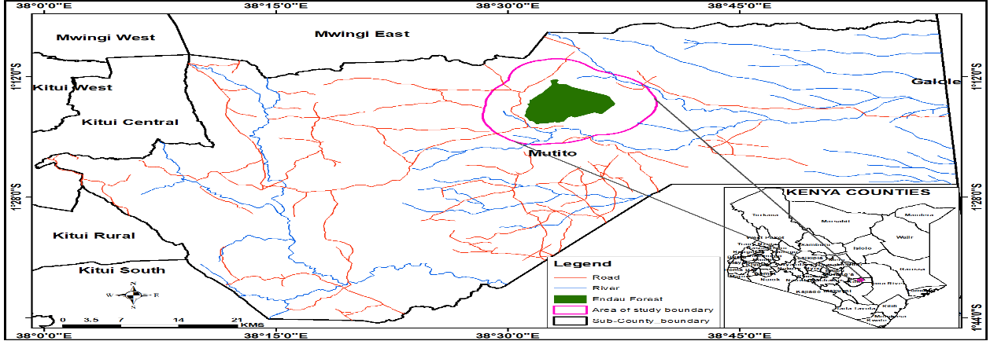

Figure 1: Endau Forest (Study Area)

This research was conducted in the Mutitu Sub-County in Kitui County. The forest is located on Endau Hill, with several peaks ranging between 814 M and 1400 M above sea level. The sampling frame was derived from households within the buffer zone, which was divided into four administrative sublocations. To ensure fair representation, proportionate sampling was used, distributing th sample size among these sublocations according to their respective population sizes. This approach guaranteed that each sublocation was adequately represented in the study. This paper used a sample size of 298, which was calculated using the Yamane formula. From 2020 household. Proportionate distribution was used for fair representation [10]. The highest number of respondents came from Ndetani 121 (40.6%), reflecting its population size. While some imbalance did exist, all sub-locations were reasonably represented, followed by Yiuku 73 (24.49%), Katumbi 53 (17.78%), and the lowest from Kathua 51 (17.11%), which enhanced the validity of the data and reduced location bias.

Responses to closed-ended survey questions were analysed to determine the frequency of different perceptions and attitudes toward forest restocking. Descriptive statistics, such as frequencies and percentages, were used for Likert scale responses to assess community perceptions [10].

Satellite data were sourced from reputable remote sensing Landsat 1-9 to assess historical and current forest cover trends. Image processing and classification techniques were applied using Geographic Information Systems (GIS) to detect changes in forest cover over time. This analysis provided quantitative evidence of deforestation patterns and land-use transformations.

A manual thematic analysis approach was used to identify themes and patterns in the qualitative data collected from community surveys and interviews [11]). Responses were transcribed and organised systematically to facilitate coding and analysis. Themes captured overarching patterns and trends in community perceptions.

Findings from the qualitative and quantitative analyses were triangulated to provide a comprehensive understanding of community perceptions [11]. Consistent patterns and discrepancies between the two data sets were identified and explored. Qualitative insights were used to contextualise and explain quantitative findings, providing a deeper understanding of the factors influencing community perceptions of forest restocking.

3. results and discussion

Table 1 shows the classification schemes that were used in this study. The forest had three classes, which were shrub, forest, and bare land. The classes were used to make maps and calculate the area of each class.

Table 1: Land Cover Classification Scheme

|  |  |
| --- | --- |
| **Class** | **Description** |
| Shrub | This category is characterised by scattered deciduous perennial vegetation of mainly less than 3m in height. |
| Forest | Evergreen woody vegetation with an interlocking canopy of height above 3m, with a canopy of more than ten percent. |
| Bare land | Bare ground usually with no vegetation. Usually characterised by rocks and without trees. |

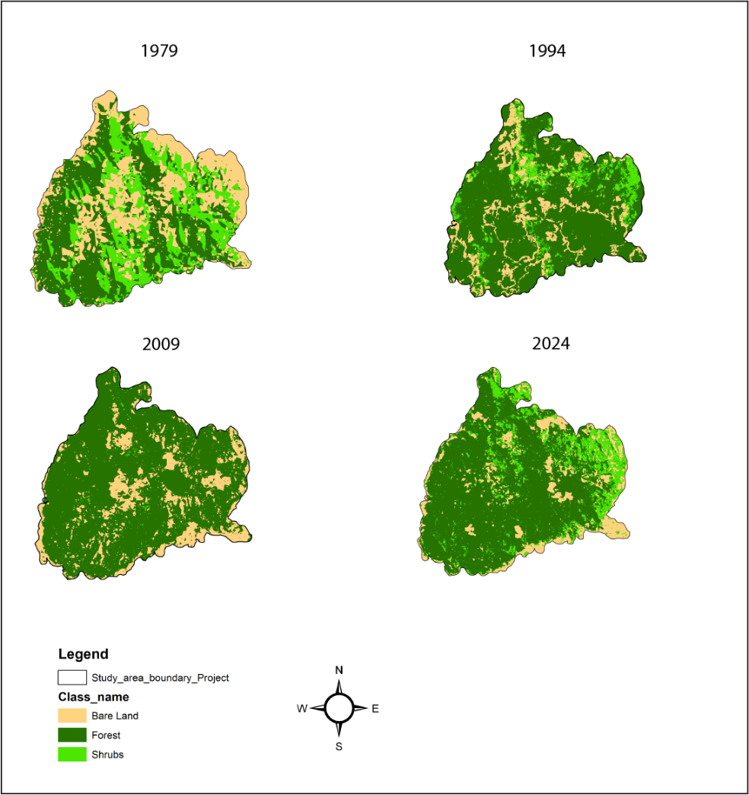Table 1 shows the land cover classification schemes that were used in the research.

Figure 2: Maps showing Endau Forest Cover Change between 1979, 1994, 2009, and 2024

## **3.1 Endau Forest Cover Change between 1979, 1994, 2009, and 2024**

As shown in Table 2, the changes in Endau Forest cover between 1979, 1994, 2009, and 2024 reveal significant shifts in land cover categories, reflecting both conservation efforts and degradation trends. The key land cover classes analysed include bare land, forest, and shrubs. Understanding these changes is crucial in assessing the effectiveness of forest management strategies, conservation interventions, and external pressures affecting forest sustainability over the decades.

Table 2: Endau Forest Cover Change between 1979, 1994, 2009, and 2024

|  |  |  |  |  |
| --- | --- | --- | --- | --- |
| CLASSES | 1979 | 1994 | 2009 | 2024 |
| Bare land | 2593.91 | 1230.23 | 1564.64 | 1119.36 |
| Forest | 3397.32 | 5959.91 | 6465.05 | 5727.04 |
| Shrubs | 2067.94 | 872.34 | 32.16 | 1214.62 |

**3.2. The analysis of land cover changes**

The analysis of land cover changes in Endau Forest between 1979 and 2024 reveals significant shifts in bare land coverage. In 1979, bare land occupied 2,593.91 hectares, but by 1994, this figure had declined sharply to 1,230.23 hectares, indicating potential afforestation efforts or natural vegetation regrowth. However, in 2009, bare land slightly increased to 1,564.64 hectares, suggesting possible land degradation due to deforestation caused by overgrazing by livestock. By 2024, a further decline to 1,119.36 hectares was observed, reinforcing the idea that conservation strategies, including reforestation and enforcement of laws, may be contributing to the reduction of barren land. The forest improvement may have been contributed by the decision of the government to evict all the people who lived in the forest in 1993 when the forest was gazetted.

Forest cover exhibited a notable increase over the study period, rising from 3,397.32 hectares in 1979 to a peak of 6,465.05 hectares in 2009. The sharp expansion between 1979 and 1994 (5,959.91 hectares) may indicate effective forest conservation programs, strict regulatory enforcement. However, by 2024, forest cover declined to 5,727.04 hectares, reflecting renewed deforestation pressures. This decline could be attributed to human activities such as illegal logging and charcoal burning, which continue to pose challenges to forest sustainability. The fluctuation in forest cover highlights the need for continuous conservation efforts to maintain and expand forested areas. This decline may be caused by the fact that the community forest association stopped its operations.

Shrubland, on the other hand, experienced a dramatic decline from 2,067.94 hectares in 1979 to just 32.16 hectares in 2009. This reduction suggests that shrubland areas were converted into forests due to natural regeneration and the reduction of anthropogenic activities. Interestingly, by 2024, shrubland had rebounded to 1,214.62 hectares, suggesting natural regeneration, land abandonment. This resurgence of shrubs may play a crucial role in ecosystem restoration, soil stabilisation, and biodiversity conservation. The patterns observed indicate the dynamic nature of land use and highlight the importance of sustainable forest management policies to balance conservation and land utilization.

**3. 3 Sustainable Forest Management**

The findings suggest that respondents held generally positive views towards a variety of sustainable forest practices. A considerable proportion (72.1%) of participants agreed that climate change adaptation strategies, such as the planting of drought-resistant tree species, are necessary for the conservation of dryland forest ecosystems. The results indicate that it is important to mix different tree species when planting, to promote biodiversity and improve environmental health.

Support was also evident for the sustainable harvesting of forest resources, including firewood and medicinal plants. A total of 69.8% of respondents either agreed with the role of sustainable harvesting in forest preservation. Only a small proportion (14.4%) expressed disagreement, while 15.8% remained neutral, reflecting consensus with a slight variation in views. Those who did not agree may be due to the unsustainability of harvesting medicinal roots that sometimes destroy the whole tree.

Alternative energy solutions, such as solar and biogas, were also endorsed, with 69.5% of participants acknowledging diversification through activities such as beekeeping and eco-tourism receiving similarly high support, with 69.1% of respondents agreeing that such strategies help reduce pressure on dryland forests. These findings suggest that communities are open to adopting alternative income-generating opportunities that align with conservation goals.

The role of agroforestry in balancing forest conservation with agricultural needs was also positively rated, with 68.5% of respondents expressing agreement. Although a modest proportion of respondents disagreed (16.4%) or were neutral (15.1%), most of the response suggests that agroforestry is viewed favourably as a viable land-use strategy. Once the residents get trees in their farm forestry, it will reduce the need to get timber products from the forest.

Although slightly lower in level of agreement, the view that community involvement enhances forest management outcomes still received support from 65.8% of participants. While a notable minority (15.5%) disagreed and 18.8% were neutral, this pattern may reflect diverse experiences with participatory governance and varying levels of community engagement in forestry programmes.

**3.4 Discussion**

The Pearson correlation coefficient of 0.868, significant at the .01 level, indicates a very strong positive relationship between these variables. This suggests that the adoption of sustainable forest management practices has a significant impact on improving dryland forest cover. Sustainable forestry practices, such as selective logging, controlled grazing, and afforestation, contribute to the restoration and expansion of forested areas. The high correlation emphasises the need for promoting sustainable forest utilization to ensure long-term ecological balance. These results align with the findings of [12], who reported that the implementation of sustainable forest practices leads to measurable improvements in forest cover and biodiversity conservation.

The results imply that policymakers and conservation agencies should prioritise sustainable forest practices as a core strategy for dryland forest management. The promotion of community-based forestry, the enforcement of anti-deforestation policies, and the investment in afforestation projects are key measures that can support dryland forest regeneration. Additionally, integrating traditional knowledge with modern conservation techniques can enhance the effectiveness of sustainable forest management. According [13], combining indigenous conservation practices with scientific forestry approaches leads to better ecological outcomes in forest restoration efforts. Therefore, fostering sustainable forest management practices through policy support and community engagement can significantly improve dryland forest cover over time.

***Hypothesis testing:*** The results indicate that **sustainable forest practices (*B* = 0.149, *t* = 2.515, *p* = 0.012)** have asignificant positive impact on forest cover change. This suggests that initiatives such as afforestation, soil conservation, and controlled logging contribute to improved forest conditions. The findings are supported by [14]**,** who found that sustainable management practices enhance forest resilience and reduce degradation in dryland ecosystems. The positive relationship implies that conservation programs focusing on sustainable land use have played a critical role in shaping the forest landscape. Given the statistical significance of the results, the null **hypothesis, that there is no significant relationship between the implementation of sustainable forest practices in buffer zones and changes in dryland forest cover between 1979 and 2024, was rejected,** confirming that sustainable forest practices have significantly influenced dryland forest cover change between 2004 and 2024.

4. Conclusion

The implementation of sustainable forest practices in the buffer zones has had a significant and measurable effect on dryland forest cover change. Respondents rated sustainable practices such as selective harvesting, agroforestry, and controlled grazing as effective strategies for mitigating deforestation. The correlation between the adoption of these practices and improvements in forest health reinforces the argument that sustainable management is essential for long-term conservation. To promote sustainable forest management practices, targeted training of the community adjacent to the forest should be done. We recommend further that resources should be made available to local communities to enable them do advocacy and ensure that they are equipped to implement sustainable methods that reverse the decline in forest cover.

Ethical approval

This study was approved by the Chuka University Ethics Committee. Informed consent was obtained from all participants. Author(s) hereby declares that NO generative AI technologies such as Large Language Models and text-to-image generators have been used during the writing or editing of this manuscript.

Definitions, Acronyms, Abbreviations

**CFA** Community Forest Association

**PFM** Participatory Forest Management

**Buffer Zones:** The area approximately five kilometres from the forest boundary.

**Community Forest**: The people who live within a five-kilometre radius around the forest boundary. They form the forest buffer zone and are interested in the forest.

**Deforestation:** The conversion of forests to other land uses.

**Dryland Areas:** The areas that receive very little rainfall throughout the year, and very little crop farming is done due to aridity. Dryland areas are places where the ratio of annual precipitation and mean annual potential evapotranspiration is less than 0.65.

**Dryland Forests:**Forests found in areas with low precipitation and high evaporation (dryland). These trees should cover more than half a hectare.

**Sustainable Forest Management (SFM):** It is the approach aimed at ensuring that forest ecosystems are managed in a way that maintains their biodiversity, productivity, regeneration capacity, and vitality, while also meeting social, economic, and ecological needs.

References

|  |  |
| --- | --- |
| [1] | A. Sharifi and E. Moradi, “Assessment of forest cover changes using multi‑temporal observation,” *Environment Development and Sustainability,* p. 1351–1360, 2022. |
| [2] | H. Wang, Y. Liu, Y. Wang, Y. Yao and C. Wang, “Land cover change in global drylands: A review,” *Science of The Total Environment,* p. 1, 2023. |
| [3] | FAO, “Global Forest Resources Assessment 2020: Main report,” Food and Agriculture Organization of the United Nations, Rome, 2020. |
| [4] | FAO, “Trees, forests and land use in drylands: the first global assessment-Full report,” FAO Forestry, Rome, 2019. |
| [5] | U. N. E. Programme, “Climate Change Impacts on Africa’s Economic Growth,” African Development Bank, Nairobi, 2019. |
| [6] | J. Mohammed, O.-F. A. Kofi and H. Yusif, “Factors influencing households’ participation in forest management in the northern region of Ghana,” *Independent Journal of Management & Production,* pp. 1324-1340, 2017. |
| [7] | R. M. David, N. J. Rosser and D. N. M. Donoghue, “Remote sensing for monitoring tropical dryland forests: a review of current research, knowledge gaps and future directions for Southern Africa,” *Environmental Research Communication,* p. 4, 2022. |
| [8] | W. Mwikali, “Historical Causes of Farmer-Herder Conflict in Kitui East Sub-County, Kenya, 1895-1963,” *International Journal of Humanities Social Sciences and Education,* pp. 55-64, 2019. |
| [9] | M. T. Mbuvi, “Policy Makers’ Perspective on Impacts of Decentralizing Forest Management in Kenya on Forestry Conservation and Community Livelihoods,” Kenyatta University, Nairobi, 2020. |
| [10] | Creswell and C. Plano, “Research Design: Qualitative, Quantitative and Mixed Methods Approaches (4th ed.),” *Canadian Center of Science and Education,* p. 5, 2014. |
| [11] | D. Kombo and D. Tromp, Proposal and Thesis Writing, Nairobi: Paulines Publications Africa, 2016. |
| [12] | E. W. Githae and I. M. Mutiga, “Ecological restoration of pastoral landscapes in the drylands of East Africa,” *Journal of Dryland Agriculture,* 2021. |
| [13] | A. Worku, E. Auch, J. Pretzsch and H. Kassa, “The significance of dry forest income for livelihood resilience: the case of pastrolist ànd agro-pastrolist in dryland of southern Ethiopia,” *Forest policy and economics,* vol. 41, pp. 51-59, 2014. |
| [14] | H. Djoudi, E. Vergles, R. R. Blackie, C. K. Koame and D. Gautier, “Dryland forests, livelihoods and poverty alleviation: understanding current trends,” *International Forestry Review,* vol. 17, no. 2, pp. 55-69, 2015. |
| [15] | S. Sengupta and M. Saha, “Dependence on Forest products to Sustain Rural Livelihood: An Expirience from Bankura Forest, West Bengal,” *Environmental Management and Sustainability,* pp. 447-477, 2023. |
| [16] | A. Beuchle and C. Bourgoin, “Deforestation and Forest Degradation in the Amazon - Status and trends up to year 2020,” *International Journal of Sustainable and Green Energy,* pp. 1-11, 2019. |
| [17] | Global Forest Watch, “Location of deforestation alerts in Kitui, Kenya,” 2 September 2023. [Online]. Available: https//www.Globalforestwatch.org. |