Mapping and Analysis of Physical Features and Land Use Land Cover Using Geospatial Techniques in Churachandpur District, Manipur, India

Abstract

The Physical environment and land use and land cover (LULC) dynamics of Churachandpur district, Manipur are investigated analytically using Geographic Information System (GIS) methods and high-resolution remote sensing (RS) data. The diverse terrain and changing land use practices of the recently demarcated district necessitate a thorough and accurate examination of the physical data for sustainable development. Anthropogenic impacts, topographical influences, and land use trends were discovered through the analysis of spatial datasets, offering vital information for environmental management and regional planning. The study produced detailed maps of physical features using RS and GIS methodologies. Sentinel-2A multispectral imagery (10 m resolution), LANDSAT 8 satellite imagery, terrain-corrected SRTM (30 m resolution), and other data sources, along with structural characteristics like curvature, slope, elevation, and rainfall distribution,

*Keywords: Physical Setting, Land use Land Cover, Spatial Datasets, Thematic Layers, Planning.*

Introduction

Churachandpur district in Manipur is located in the north-eastern region of India, it is characterized by a complex physical landscape, surrounded by mountain ranges in all direction, marked by diverse topography, dense forests, agricultural fields and human settlements (Antrop, M. 2005). The district's unique geography and dynamic land use practices are influenced by natural and anthropogenic factors, making it essential to understand and document these patterns (Matthews, H. D., Weaver, A. J., Meissner, K. J., Gillett, N. P., & Eby, M. 2004). Accurate mapping of physical features and land use and land cover (LULC) is critical for effective regional planning, sustainable resource management and environmental conservation (Cihlar, J., & Jansen, L. J. (2001).

In recent years, advanced technologies such as Remote Sensing (RS) and Geographic Information System (GIS) have revolutionized the way spatial data is captured, processed and analysed (Yasir, M., Hui, S., Binghu, H., & Rahman, S. U. 2020). High-resolution satellite imagery and GIS platforms enable detailed and precise mapping, allowing for better understanding of terrain characteristics, land use trends and their implications (Rogan, J., & Chen, D. 2004). This study leverages these technologies to analyse the physical setting and LULC patterns of Churachandpur district. The research employs high-resolution datasets, (Zandbergen, P. A. (2011) including terrain-corrected Shuttle Radar Topography Mission (SRTM) data, Sentinel-2A multispectral imagery and LANDSAT 8 satellite imagery, along with factors such as rainfall distribution, slope, drainage density and structural features (Tucker, G. E., & Bras, R. L. 1998). Using GIS tools, these datasets are integrated to generate thematic layers that depict the district’s physical and land use characteristics. This study aims to provide critical insights into the district's spatial dynamics, serving as a valuable resource for infrastructure planning, disaster management and sustainable development. It also highlights the importance of employing geospatial techniques for informed decision-making in environmentally sensitive regions.

Study Area: Churachandpur District, Manipur

Churachandpur district is situated at the coordinates Latitude 23.75°N to 24.30°N Longitude 93.20°E to 93.80°E. Its location underscores its importance as a gateway between Manipur, Mizoram and Myanmar which is the corridor to South East Asia, with its highways serving as lifelines for the communities residing in this hilly terrain. This region boasts a wealth of cultural and natural diversity.

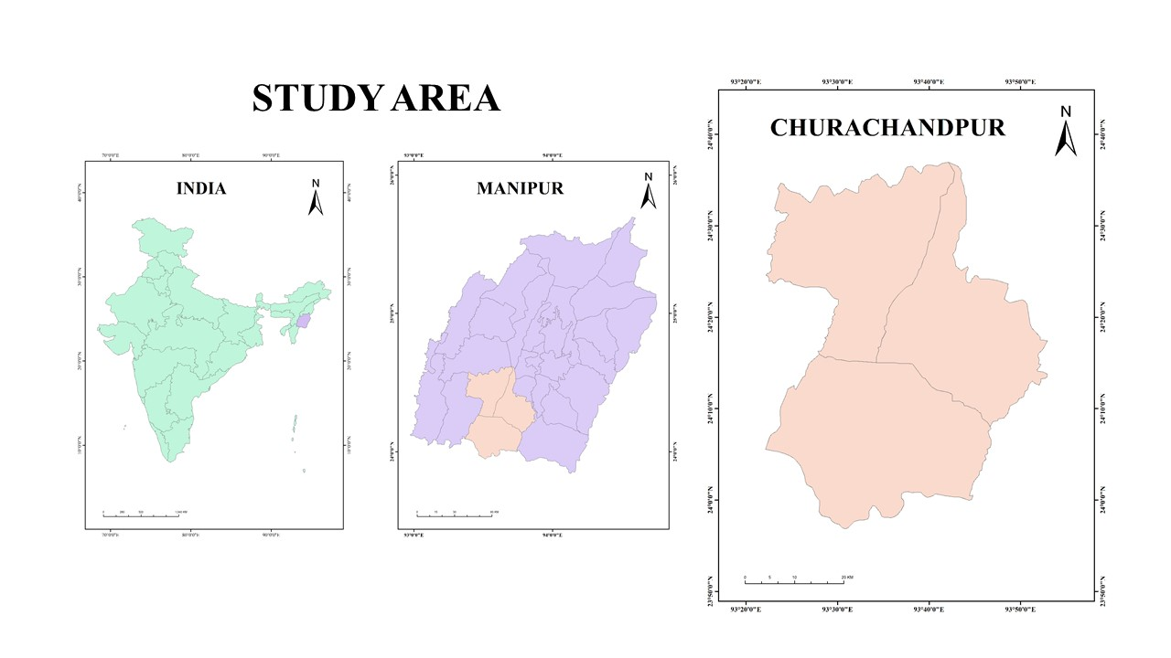

Figure 1. Locational Map of the Study Area.

The 2,392-square-kilometer Churachandpur district of Manipur shares borders with Mizoram, Nagaland, Assam and Myanmar. It is mostly mountainous (94.75%) and there is a significant risk of landslides, particularly along National Highways 150 and 102B, which connect Myanmar and the Manipur Valley. The district headquarters and a major hub for connectivity is Churachandpur town, also known as Lamka.

Tectonic activity, steep slopes, unstable soil and frequent rainfall all increase the risk of landslides. The district, which is in UTM North 46, puts local safety and infrastructure at risk due to its unstable terrain. In order to identify high-risk areas, landslide zonation mapping evaluates slope, soil type and vegetation cover by combining GIS, remote sensing and field data. Targeted zonation improves community resilience, reduces highway disruptions, and protects infrastructure. It is essential to northeast India's disaster response and sustainable regional planning.

Materials & Methods

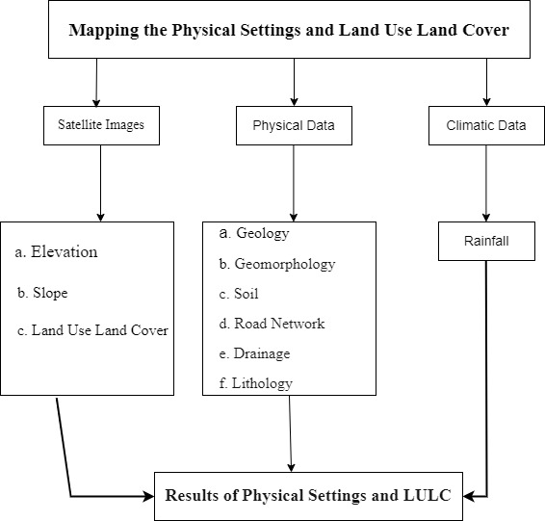

Figure 2. Framework for Mapping Physical Settings and Land Use Land Cover (LULC).

In accordance with the framework shown in the picture, a systematic methodology was used for this study to gather and examine important datasets. The main sources of physical data, such as elevation, slope, drainage, lithology, geomorphology, soil

and road network, were the following reputable databases: PMGSY for road infrastructure, NBSSLUP for soil classification, Hydro SHEDS for drainage patterns, and Bhukosh GSI for geology and lithology. The CHRS portal provided climate data, particularly rainfall, as a secondary dataset. The USGS Earth Explorer was used to extract Land Use Land Cover (LULC) data.

Through the integration of these multi-source datasets covering anthropogenic features, climate, and terrain attributes, the study creates a strong geospatial basis for mapping physical environments, analysing LULC dynamics, and assessing risks associated with terrain.

Results and Discussion

Physical Setting and its Salient Features: Elevation

Churachandpur district in Manipur exhibits a remarkable range of elevations, from 10 m to 2,100 m above sea level, profoundly influencing its climate and ecology. The highest elevations, between 1,800 m and 2,100 m are found in the Thangting *lhang*/Range, Haosapi Range and *Tonglon* range.

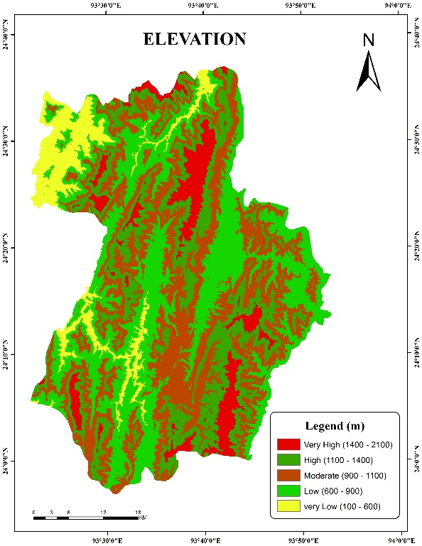

Figure 3. Elevation Profile.

These highlands are essential for biodiversity, water catchment and preserving colder climates. With elevations between 1,000 and 1,300 meters, the secondary highlands contribute to the district's untamed landscape and are home to a variety of plants and animals. Between 700 and 1,000 meters above sea level, the town areas including Lamka town enjoy a temperate climate that is ideal for both agriculture and habitation. The lowest areas, on the other hand, are mostly found in the western portion of the district that borders Assam and are only around 10 meters above sea level. In stark contrast to the hilly and mountainous terrain found elsewhere in the district, these low-lying areas are flatter and more vulnerable to flooding.

Slope

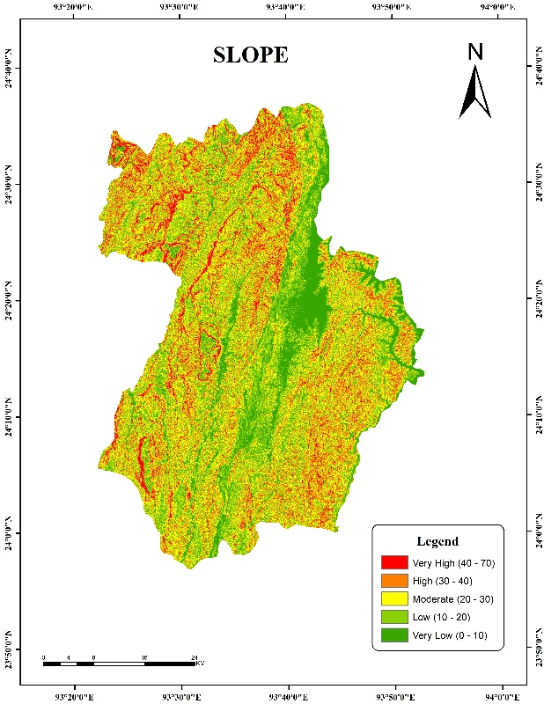

Figure 3. Slope Profile

The topography of the Churachandpur district in Manipur is varied, with slopes varying from 0° to 10° to 40° to 70°, according to the slope profile map. Low-lying regions with few slopes (0°–10°) are mostly found in town areas, especially in the Khuga River basin, which is where Lamka town is located. Agriculture and urban development are made easier by the comparatively level terrain. The majority of the district has a high degree of slope, with the exception of a small area that has plains that stretch northward through Bishnupur district.

The district's terrain gets rockier outside of the town areas, with slopes that are higher than 40° to 70°, especially in the westernmost portions and the Thangting ranges. Although the development of infrastructure is hampered by these steep terrains, their biodiversity makes them ideal for forest conservation. Although the plains offer rich soil, it is not enough for the people due to small area in size.

Top of FormBottom of FormDrainage System

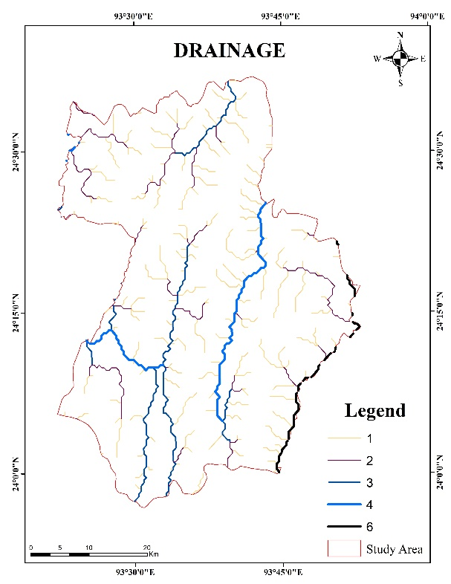

Figure 4. Drainage Classification.

Two significant river systems drain the district:

The Manipur River system in the east and the Barak River system in the west. Although the district is not directly traversed by the principal rivers Barak and Manipur, it is heavily traversed by their tributaries.

The Barak River System

The Barak River rises in Liyai Khunou, Senapati District and flows 38 km southwest through Churachandpur before joining the Tuivai River at Tipaimukh. Before entering Bangladesh as the Surma River and joining the Brahmaputra, it forms borders with Mizoram (25 km) and Assam (31 km). Navigation is restricted to areas close to Tipaimukh due to swift currents.

Key tributaries:

* Irang River: Forms a 35-km boundary before joining the Barak.
* Leimatak River: Flows 34 km north, joining the Irang.
* Tuipilui River: Travels 48 km, merging with the Irang.
* Tuijanglui River: Flows 40 km, joining the Irang. The Tuivai River (originating in Myanmar) and its tributaries, such as Tuivel and Tuila also feed the Barak system.

Manipur River System

The Manipur River, originating in Lakhamei village (2,473 m), drains the district’s eastern region before flowing into Myanmar’s Chindwin River.

Key tributaries:

* Khuga River: Travels 45 km northward, joining the Manipur River at Ithai.
* Tuining River: Flows 29 km into the Manipur River.
* Tuitha River: Flows 16 km south, merging with the Khuga.

This intricate system defines Churachandpur’s geography, supporting livelihoods and shaping settlement patterns.

Geology

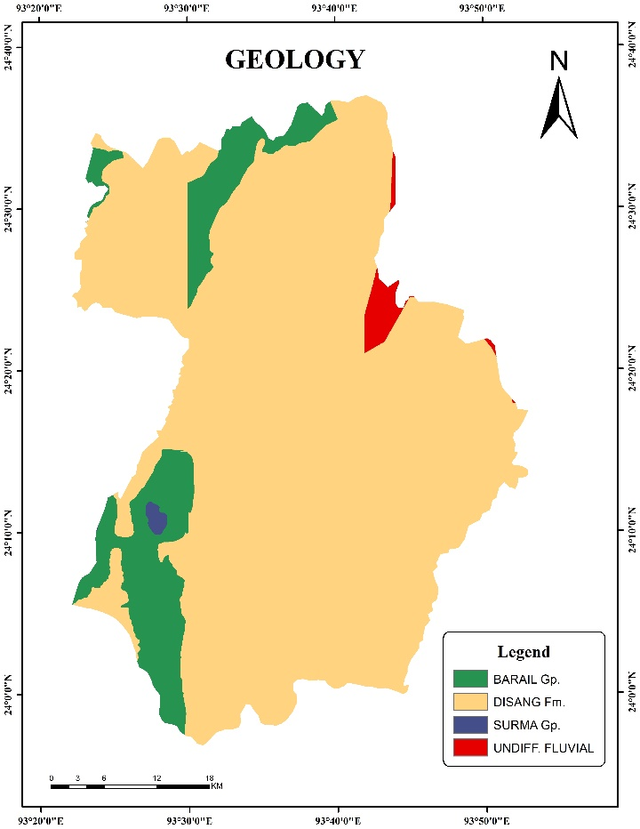

Figure 5. Geological profile.

Table 1. Geological Data

|  |  |  |  |
| --- | --- | --- | --- |
| Sl. no | Names of Geological Period | Area in Sq. km | Area in % |
| 1 | DISANG fm. | 2071.40 | 86.59 |
| 2 | BARAIL Gp. | 293.19 | 12.26 |
| 3 | UNDIFF. FLUVIAL | 19.50 | 0.85 |
| 4 | SURMA Gp. | 7.11 | 0.30 |
|  | Total | 2,392 | 100 |

The Geology of Churachandpur is divided into four major Geological types, the Palaeogene-Eocene, Eocene-Oligocene, Miocene and Quaternary. The data provided outlines the distribution of land area across different geological periods.

1. Palaeocene - Eocene (86.59%): This period is the dominant geological phase in the area, taking up the majority of the land (2071.40 sq. km). About 85.76 percent of the Churachandpur district is covered by the Palaeocene-Neogene geological type. Located throughout the majority of the district, which stretches from south to north, are locations such as Churachandpur town and the surrounding area, the majority of the Henglep subdivision, Churachandpur subdivision, and Singngat subdivision.

2. Eocene–Oligocene (12.26%): This time period encompasses a smaller area (293.19 sq. km), indicating a less substantial but still noteworthy presence. Although it occupies a smaller area (293.19 sq. km), the Eocene–Oligocene period suggests a lesser but still significant presence. primarily located in the western regions of Henglep and Singngat Sub-division.

3. Quaternary (0.85%): With an area of only 19.50 sq. km, the Quaternary period makes up a very small percentage of the total land area. Only the north-eastern portion of the district that borders Bishnupur in the north is home to this era. This region has a mild slope and is primarily flat.

4. Miocene (0.30%): At just 7.11 square kilometres, the Miocene period has the smallest coverage. Only a small area of the district's southwest, inside the Singngat subdivision, contains this geological period. The combined area of these periods is 2,392 square kilometres, with the Palaeocene-Eocene period accounting for the largest portion, indicating the era's geological dominance.

Lithology

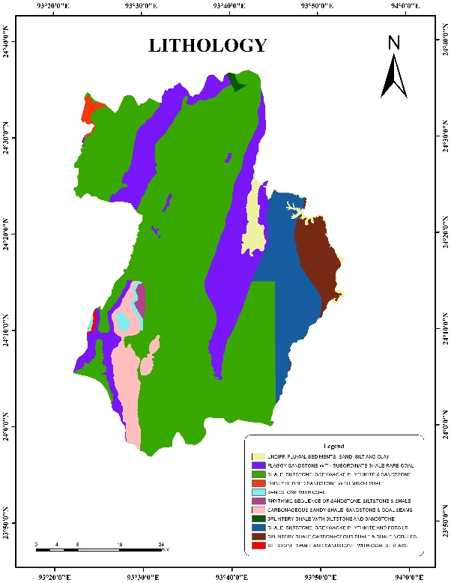

Figure 6. Lithological Profile

Table 2. Lithological Data

|  |  |  |  |  |
| --- | --- | --- | --- | --- |
| Sl.no | Lithological Types | Age | Area in sq. km | area in % |
| 1 | Undiff. fluvial sediments-sand, silt and clay | quaternary (unclassified) | 42.96 | 1.80 |
| 2 | Thinly bedded sandstone with Minor Shale | Miocene | 12.63 | 0.53 |
| 3 | Ferruginous sandstone with siltstone and clay | Miocene - Pleistocene | 1.38 | 0.06 |
| 4 | Shale, siltstone, Greywacke Rhythmite & sandstone | Miocene | 1687.02 | 70.50 |
| 5 | Sandstone with Coal | Miocene | 17.87 | 0.75 |
| 6 | Carbonaceous sandy shale, sandstone & coal seams | Eocene - Oligocene | 107.11 | 4.48 |
| 7 | Splintery Shale with Siltstone and Sandstone | Eocene - Oligocene | 5.90 | 0.25 |
| 8 | Splintery shale, Carbonaceous shale and Shale Noodles | Miocene | 85.30 | 3.56 |
| 9 | Flaggy sandstone with subordinate shale, coal | Eocene – Oligocene | 413.68 | 17.29 |
| 10 | Siltstone, shale and sandstone with coal streaks | Eocene - Oligocene | 4.49 | 0.19 |
| 11 | Rhythmic sequence of sandstone, siltstone & shale | Miocene | 13.66 | 0.57 |
|  | Total |  | 2,392 | 100 |

The provided data categorizes various lithological types across different geological ages, highlighting their respective areas and percentages within a total land area of 2,392 sq. km.

Undifferentiated Fluvial Sediments (Quaternary, 1.80%): These deposits, which primarily consist of sand, silt and clay, make up 42.96 square kilometres and make up a small percentage of the entire land area. And also areas like; Kangvai, Zalenphai and Torbung are among the plain areas in the north that border the Bishnupur district which is under these sediments.

Lithology’s of the Miocene: Minor Shale with Thinly Bedded Sandstone (0.53%): This is a very small portion of the area, taking up 12.63 square kilometres. It is located near the Pherzawl district in the northwest of the district.

Shale, Siltstone, Greywacke Rhythmite & Sandstone (70.50%): Dominating the region, this lithology spans 1687.02 sq. km, showing the significance of Miocene rocks in the area. It is found in the western, central, and eastern parts of the district, excluding the Lamka plain and some portions of the Henglep sub-division. Almost all other settlements come under this category.

Miocene sandstone, siltstone, greywacke Rhythmite and shale make up the majority of the study area, which is located in the western, central, and eastern regions and makes up 70.50% (1687.02 sq. km). Around Pherzawl, 0.53% (12.63 sq. km) is made up of minor Miocene shale with thinly bedded sandstone. Northern plains such as Kangvai and Torbung are home to Quaternary undifferentiated fluvial sediments (1.80%, 42.96 sq. km) of sand, silt, and clay. The Eocene-Oligocene coal seams, sandstone and carbonaceous shale (4.48%, 107.11 sq. km) in Singngat, close to Myanmar, and the Miocene coal-containing sandstone (0.75%, 17.87 sq. km) in southwest Singngat are examples of coal-bearing formations.

While splintery shale with siltstone (0.25%, 5.90 sq. km) is found close to Chandel, flaggy sandstone with shale and coal (17.29 percent, 413.68 sq. km) indicates varied deposition. Cyclic sedimentation is indicated by a minor Miocene rhythmic sequence (0.57%, 13.66 sq. km). The region's geological history is highlighted by the predominance of Miocene lithology’s, with localized coal deposits indicating former swampy habitats. Miocene Rhythmic Sequence (0.57%): This 13.66 sq. km. sequence of sandstone, siltstone, and shale points to a cyclical depositional environment. Overall, the dominant lithology in the region is Miocene shale and sandstone, which constitutes over 70% of the total area. The presence of coal-rich layers in several formations also indicates significant past depositional environments conducive to coal formation.

Geomorphology

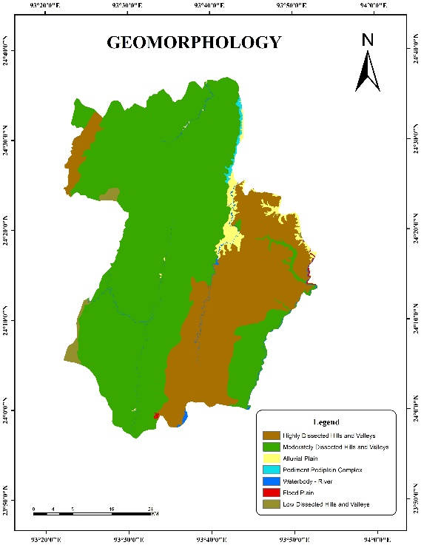

Figure 7. Geomorphological Profile.

Table 3. Geomorphological Data.

|  |  |  |
| --- | --- | --- |
| Names of different Landforms | Area in Sq. Km | Area in % |
| Alluvial Plain | 28.89 | 1.21 |
| Flood Plain | 2.94 | 0.12 |
| Highly Dissected Hills and Valleys | 693.64 | 28.99 |
| Low Dissected Hills and Valleys | 29.70 | 1.24 |
| Moderately Dissected Hills and Valleys | 1608.83 | 67.26 |
| Pediment Pedi plain Complex | 15.89 | 0.66 |
| Water Body – River | 12.11 | 0.51 |
| Total | 2,392 | 100 |

Churachandpur District, in south-western Manipur, features seven major geomorphological types, primarily dominated by dissected hills and valleys, which shape its landscape and influence land use.

1. Alluvial Plain (1.21%): Spanning 28.89 sq. km, these fertile low-lying areas support agriculture but are limited in extent, restricting large-scale farming. Seasonal flooding may pose challenges for settlements.
2. Flood Plain (0.12%): Covering 2.94 sq. km, these areas experience periodic inundation, offering fertile soil but posing localized waterlogging risks.
3. Highly Dissected Hills & Valleys (28.99%): Encompassing 693.64 sq. km, this rugged terrain faces soil erosion and landslide risks, making it less suitable for farming but crucial for biodiversity.
4. Low Dissected Hills & Valleys (1.24%): Spanning 29.70 sq. km, these gentler slopes offer better suitability for settlement and agriculture.
5. Moderately Dissected Hills & Valleys (67.26%): Dominating 1,608.83 sq. km, these rolling hills support mixed land use, requiring sustainable management to prevent erosion and conserve water.
6. Pediment-Pedi Plain Complex (0.66%): Covering 15.89 sq. km, these rocky areas are unsuitable for farming but may support grazing or infrastructure.
7. Water Bodies – Rivers (0.51%): Spanning 12.11 sq. km, these provide crucial water resources, necessitating conservation measures.

With over 96% of the area covered by hills, efficient land use planning, slope stabilization and water conservation are essential for sustainable development.

Climatic Condition

The climate of Churachandpur is subtropical monsoon with distinct seasons. With temperatures between 20°C and 35°C and sporadic thunderstorms, the summer months of March through May are warm. Heavy rainfall, averaging 1100 mm to 1200 mm per year (occasionally up to 2000 mm or more), is brought on by the monsoon season (June to September). This rainfall is essential for agriculture, but it can also cause landslides in hilly regions. Temperatures can drop to 5°C in some places during the mild to chilly winter months of December through February, especially at higher elevations. Because of the area's thick forests and copious amounts of rainfall, the humidity level stays high all year round. Winter mornings frequently experience fog, which impairs vision. Clear skies and moderate temperatures characterize the comparatively pleasant seasons of spring and fall. However, erratic rainfall patterns are a result of climate change.

Climate Overview

Summers (March to June) are hot and humid, with temperatures often exceeding 30°C. The monsoon, from June to September, brings heavy rainfall vital for agriculture, with frequent thunderstorms and strong winds, creating lush, vibrant landscapes. Winters (November to February) are cool and dry, with temperatures dropping to around 5°C, offering pleasant weather ideal for outdoor activities and tourism.

Köppen Climate Classification:

Under the Köppen climate classification, Churachandpur's climate is categorized as Cwa:

* **C**: Warm temperate/mild climate.
* **w**: Dry winters with average coldest month temperatures above 0°C but below 18°C.
* **a**: Hot summers with the warmest month exceeding 22°C.

This classification reflects hot, humid summers, mild winters and significant monsoonal rainfall that sustains agriculture and vegetation (Rohli R. V., Andrew Joyner T., Reynolds S. J., Shaw C. & Vázquez J. R. (2015). Microclimates vary due to elevation and local geography, enhancing climatic diversity within the district.

Rainfall

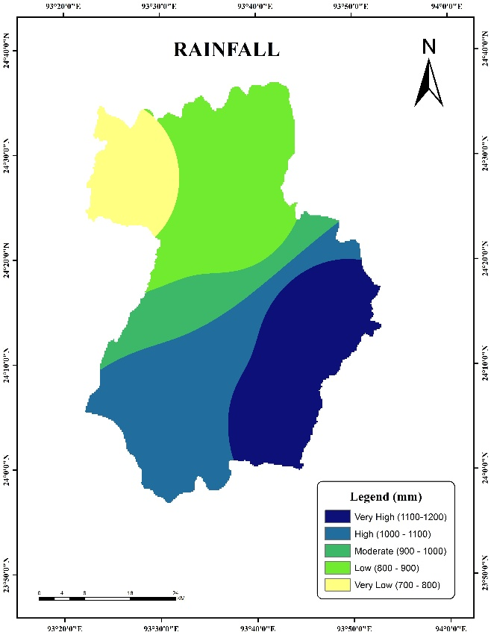

Figure 8. Rainfall Classification.

Churachandpur district experiences a varied rainfall distribution, with amounts increasing towards the southern areas bordering Myanmar. The annual rainfall is divided into five classes, ranging from 700 mm to 1,200 mm, influenced by the district's topography and climate.

The first class (700 mm - 800 mm) is found in the northernmost regions, which receive lower rainfall due to distance from moisture-laden winds. The second class (800 mm - 900 mm) extends southward, showing a slight increase in precipitation. In the central region, the third class (900 mm - 1,000 mm) sees further rainfall increase, influenced by topographic uplifts.

Moving south, the fourth class (1,000 mm - 1,100 mm) marks areas closer to the border, with higher rainfall due to elevation and monsoon effects. The fifth class (1,100 mm - 1,200 mm) represents the peak rainfall near Myanmar, were orographic lifting and moisture accumulation result in dense rainfall. This southward rainfall gradient reflects the district's diverse climatic and geographical influences.

Road Network

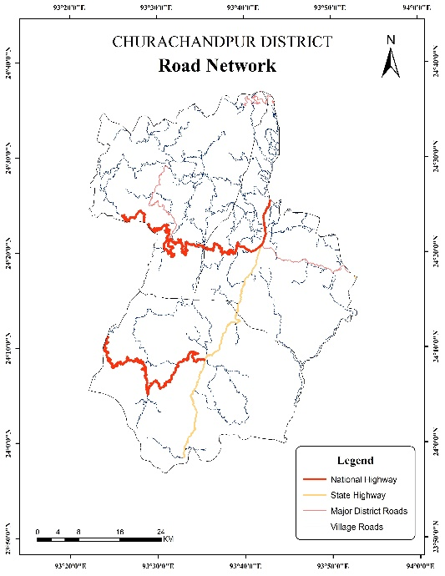

Figure 9. Road Network Distribution.

**National Highway 150 (NH-150):** The journey from Imphal to Lamka (Churachandpur) to Tipaimukh and further to Aizawl via NH150 is approximately 300 km.

**National Highway 102B (NH-102B)**: Depending on road conditions and other factors, the approximately 490-kilometer journey from Imphal to Lamka (Churachandpur) to Aizawl via NH-102B usually takes 10 to 12 hours. Along the way, the highway travels through many small towns and villages, as well as picturesque landscapes and isolated locations. National highways are essential for facilitating the flow of people and goods between Churachandpur and other regions of Manipur as well as neighbouring states. With internet connectivity growing and mobile networks reaching most places, communication infrastructure has improved. Hilly and isolated places, however, continue to have poor connectivity. To close the digital divide, spur economic expansion, and enhance access to services like healthcare and education, more funding must be allocated to the transportation and telecommunications infrastructure.

Soil

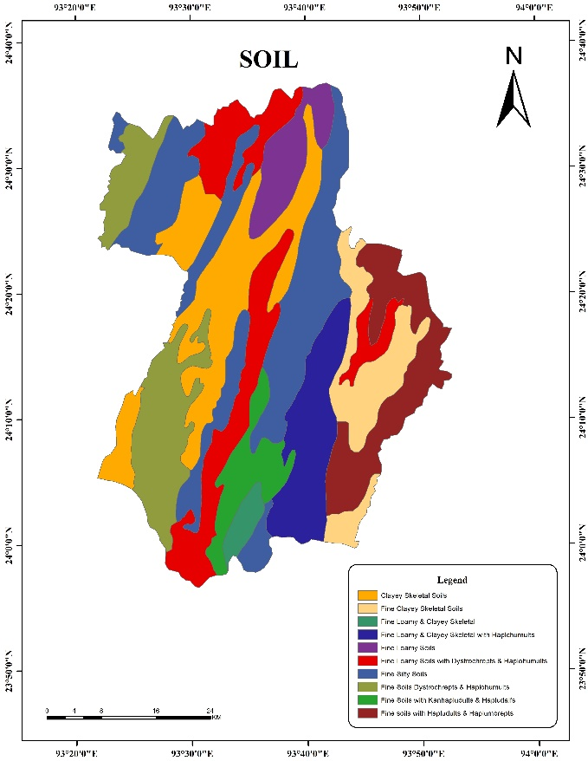

Figure 10. Soil Type Classification.

Table 4. Soil Data.

|  |  |  |  |
| --- | --- | --- | --- |
| Sl.No. | Soil Types | Area in Sq.km | Area in % |
| 1 | Fine Silty Soils | 526.28 | 22.00 |
| 2 | Fine Soils with Dystrochrepts & Haplohumults | 279.96 | 11.70 |
| 3 | Clayey Skeletal Soils | 379.92 | 15.88 |
| 4 | Fine Loamy Soils | 116.59 | 4.87 |
| 5 | Fine Clayey Skeletal Soils | 189.73 | 7.93 |
| 6 | Fine Loamy with Dystrochrepts & Haplohumults | 322.45 | 13.48 |
| 7 | Fine Soils with Hapludults & Haplumbrepts | 225.36 | 9.42 |
| 8 | Fine Loamy & Clayey Skeletal | 34.56 | 1.44 |
| 9 | Fine Loamy & Clayey Skeletal with Haplchumults | 203.29 | 8.50 |
| 10 | Fine Soils with Kanhapludults & Hapludalfs | 113.86 | 4.76 |
|  | Total | 2,392 | 100 |

### Soil Composition and Land Use in Churachandpur District

Churachandpur district has a diverse soil composition that significantly impacts agriculture, settlement patterns and land use. The district covers a total area of 2,392 sq. km, with ten distinct soil types contributing to varying land use potential and agricultural productivity.

#### Dominant and Widely Distributed Soils:

**Fine Silty Soils** constitute the largest portion, covering 526.28 sq. km (22.00%). These soils are primarily found in and around Lamka town and extend to the western parts of the district. Their fine texture and excellent water retention make them highly suitable for agricultural activities, particularly for paddy cultivation and horticulture.

**Clayey Skeletal Soils**, covering 379.92 sq. km (15.88%), are the second most prevalent type. Despite their high nutrient retention, they pose potential drainage limitations, which may require proper land management for sustainable cultivation. These soils are widely distributed in the central region of the district, including Henglep and the areas bordering Tamenglong.

**Fine Loamy with Dystrochrepts & Haplohumults** spans 322.45 sq. km (13.48%). This soil type is well-distributed across several regions, contributing to land fertility and supporting various crops, including maize and vegetables. It is prominent in Singngat and the northern region towards the Haopi range and Henglep areas.

**Fine Soils with Dystrochrepts & Haplohumults**, covering 279.96 sq. km (11.70%), enhance soil fertility and allow versatile land use. These soils are widespread in the southern parts of the district, particularly along the boundary with Mizoram and play a crucial role in shifting cultivation and agroforestry practices.

#### Moderately Distributed Soils:

**Fine Soils with Hapludults & Haplumbrepts** occupy 225.36 sq. km (9.42%) and are predominantly found in the Haosapi range in the eastern region. Additionally, these soils are common in the areas bordering Chandel district, where they support both agriculture and natural vegetation.

**Fine Loamy & Clayey Skeletal with Haplchumults** cover 203.29 sq. km (8.50%), primarily located in the mid-eastern part of the district. These soils are particularly present in forested and hilly regions where natural vegetation thrives, contributing to the ecological balance of the region.

**Fine Clayey Skeletal Soils**, covering 189.73 sq. km (7.93%), are spread across several upland areas and hill slopes, including locations near Tuibong and the southern hill ranges. Due to their skeletal nature, they support agroforestry and limited cultivation practices.

#### Least Distributed Soils:

**Fine Loamy Soils**, covering 116.59 sq. km (4.87%) are found in Henglep, Singngat and some parts of the Tuibong region. Their loamy texture provides moderate fertility and drainage capabilities, making them suitable for mixed cropping systems.

**Fine Soils with Kanhapludults & Hapludalfs**, spanning 113.86 sq. km (4.76%), are distributed in scattered patches across the northern parts of the district, supporting natural vegetation and limited agricultural activities.

**Fine Loamy & Clayey Skeletal Soils**, the smallest category, cover only 34.56 sq. km (1.44%). They are mostly found in the remote westernmost regions bordering Pherzawl and Tamenglong, where forest cover dominates.

The diverse soil composition of Churachandpur district influences agricultural productivity, urban expansion, and forest conservation. The widespread Fine Silty Soils around Lamka town offer prime agricultural opportunities, while Clayey Skeletal Soils in the central region require proper drainage management. The presence of Fine Soils with various properties across different sub-regions, including the Haosapi range and the border with Mizoram, highlights the need for strategic land use planning. Sustainable practices, erosion control, and conservation efforts are essential for maintaining soil health and supporting the region’s long-term development.

Land use Land Cover Change (LULC)

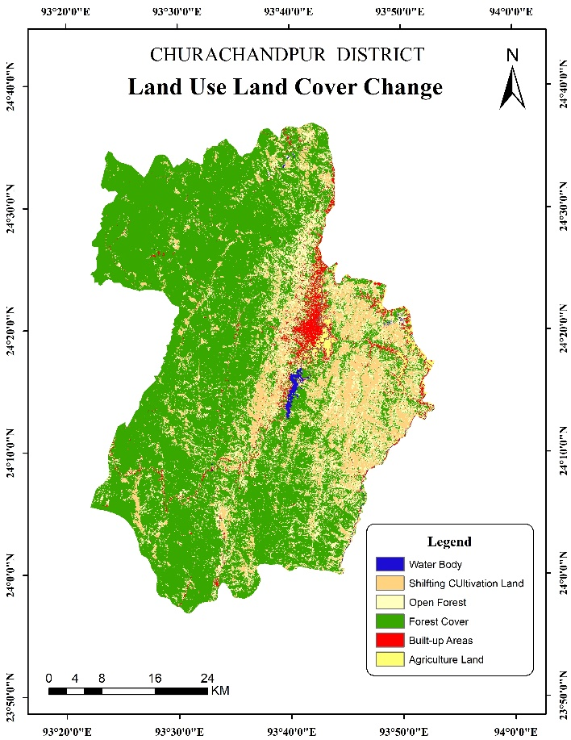

Figure 11. Land Use Land Cover Classification.

Table 5. Land Use Land Cover Data.

|  |  |  |  |
| --- | --- | --- | --- |
| Sl. No | Items | Area in Sq.km | Area in Percentage |
| 1 | Water Body | 9.42 | 0.39 |
| 2 | Agriculture Land | 36.49 | 1.53 |
| 3 | Built up Areas | 88.19 | 3.69 |
| 4 | Shifting Cultivation | 305.74 | 12.78 |
| 5 | Open Forest | 374.82 | 15.67 |
| 6 | Forest Cover | 1577.35 | 65.94 |
|  | Total | 2,392 | 100 |

Chart 1. Land Use Land Cover Distribution.

These visualizations highlight the dominance of forest cover, with shifting cultivation and open forest areas also taking up significant portions of the total area. The land use and land cover data for Churachandpur district provide insights into the region’s terrain and its socio-economic activities. Covering a total area of 2,392 sq.km., the district’s land distribution is predominantly marked by forest and agricultural use.

Analysis and Interpretation:

Churachandpur district exhibits a diverse land use pattern that significantly impacts its ecological balance, agricultural productivity and urban development. The district's land use is generally categorized into six major types: forest cover, open forest, shifting cultivation, built-up areas, agricultural land and water bodies.

Forest Cover (65.94%):

With 1,577.35 sq km (65.94%) of forest cover, Churachandpur district is dominated by forest cover, which is essential for local livelihoods, biodiversity, and climate regulation. These forests help conserve soil and water, support a variety of ecosystems, and store carbon. However, their sustainability is threatened by logging, shifting cultivation, and encroachment-related deforestation. Low-activity areas like Henglep and Singngat are dominated by dense forests, whereas Churachandpur subdivision is experiencing forest loss as a result of agriculture and population pressure. To prevent further deterioration of these essential ecosystems, immediate conservation measures and reforestation are required.

Open Forest (15.67%):

374.82 sq. km (15.67%) of the land is open forest, indicating sizable areas of the terrain with sporadic tree cover. These regions frequently serve as transitional spaces between populated areas and dense forests. Because of logging, shifting cultivation, and the growth of settlements, they are vulnerable to deforestation. The majority of open forests are located near populated areas, especially in regions like the Thangting Range, Teiseng, Dampi and portions of the Haopi Range. These areas are more susceptible to degradation because they have substantially less tree cover than dense forest areas. These wooded areas can be preserved and revitalized by implementing afforestation initiatives and encouraging agroforestry. To stop additional environmental deterioration, conservation initiatives should concentrate on reducing deforestation in these transition zones and encouraging sustainable land management techniques.

Shifting Cultivation (12.78%):

In Churachandpur, shifting cultivation covers 305.74 sq km (12.78%), supporting indigenous communities but degrading the soil and destroying forests. It is common in eastern regions such as the Thangting and Haosapi ranges, and through forest clearing, it endangers biodiversity. Unsustainable practices are still in place in Singngat and Henglep, albeit less frequently. Crop rotation and agroforestry promotion could preserve traditional livelihoods while lowering environmental effects (Chakraborty, K., Mohapatra, J., Mandal, S., Sarma, K. K., & Das, A. K. (2022). In order to maintain forest ecosystems and agricultural viability for future generations, sustainable land management is essential.

Built-Up Areas (3.69%):

The rapidly growing town of Lamka is at the centre of the 88.19 sq. km (3.69%) of built-up areas. Lamka, the district's commercial centre, is home to all businesses, establishments, and services, which contributes to pollution and deforestation. Henglep and Singngat, meanwhile, are less developed. Unplanned urban growth puts the environment and resources at risk, so sustainable building and zoning regulations are necessary to maintain ecosystem protection and balanced regional development.

Agricultural Land (1.53%):

The majority of farming in Churachandpur relies on shifting cultivation, with permanent agricultural land making up only 36.49 sq. km (1.53%). The amount of arable land has drastically declined since the Khuga Dam was built in 2006. Food security is at risk since the remaining farmland close to Lamka town is dwindling as a result of urbanization and could vanish in 30 to 40 years. Productivity could be increased by promoting sustainable techniques like organic farming, terrace farming, and better irrigation. In the face of growing urbanization, sustainable farming livelihoods require modern methods and improved market accessibility.

Water Bodies (0.39%):

The Khuga reservoir and rivers like Tuivai and Leimata are the main sources of water in Churachandpur, which has water bodies that cover only 9.42 Sq. km (0.39%). Ecosystems, irrigation, and drinking water are all at risk due to this shortage. Demands for agriculture and urbanization are growing faster than supply, so immediate conservation action is required. To guarantee sustainable water security for future development while preserving ecological balance, rainwater harvesting, watershed management, and small reservoirs must be put into place.

Key Implications for Regional Planning and Development:

1. Forest Conservation: Because of the high proportion of forest cover, conservation policies ought to concentrate on stopping illegal logging, soil erosion and deforestation. Afforestation initiatives and community based forest management programs can support the preservation of forest resources.

2. Controlling Shifting Cultivation: To avoid long-term land degradation, shifting cultivation must be controlled and observed. Reducing reliance on forest clearing for agriculture can be achieved by introducing alternate livelihood options like horticulture and agroforestry.

3. Planned Urban Development: Sustainability, infrastructure resilience and environmental impact mitigation should be prioritized in the planning of urban growth as built-up areas increase.

4. Agricultural Sustainability: Expanding permanent agricultural land through soil conservation practices, irrigation facilities and improved farming techniques can enhance food security and economic stability.

5. Water Resource Management: Since the district has very few water bodies, increasing water storage, irrigation capabilities and rainwater collection will be crucial to supplying its water needs.

Conclusion

Churachandpur district exhibits a predominantly forested landscape (66.10%), underscoring its ecological significance for biodiversity, carbon sequestration, and watershed protection. Open forests (15.69%) and shifting cultivation (12.80%) reflect the reliance of local communities on forest-based livelihoods, while limited agricultural land (1.46%) and water bodies (0.38%) pose challenges for food security and water availability. Built-up areas (3.57%) signal gradual urbanization, necessitating balanced planning to mitigate environmental strain. The district’s undulating terrain further shapes its land use dynamics, with forests stabilizing soils and regulating water flows. However, unsustainable practices such as unregulated shifting cultivation and urban expansion threaten these fragile ecosystems. To ensure sustainable development, integrated land management strategies must harmonize conservation with economic growth. Prioritizing forest protection, promoting climate-resilient agriculture and implementing efficient water management (e.g., rainwater harvesting) are critical.

A holistic approach, combining policy enforcement, community engagement and eco-friendly infrastructure, will safeguard Churachandpur’s natural resources while supporting livelihoods and regional progress.

Declaimer:

The Author(s) hereby declare that NO generative AI technologies such as Large Language Models such as ChatGPT, etc. were used in writing and editing of this manuscript. The work is entirely original.

Reference

1. Ali, A. I., & Das, I. (2003). Tribal situation in north east India. *Studies of Tribes and Tribals*, *1*(2), 141-148.
2. Antrop, M. (2005). Why landscapes of the past are important for the future. *Landscape and urban planning*, *70*(1-2), 21-34.
3. Arif, M., Sengupta, S., Mohinuddin, S. K., & Gupta, K. (2023). Dynamics of land use and land cover change in peri urban area of Burdwan city, India: a remote sensing and GIS based approach. *GeoJournal*, *88*(4), 4189-4213.
4. Ayad, Y. M. (2005). Remote sensing and GIS in modeling visual landscape change: a case study of the northwestern arid coast of Egypt. *Landscape and Urban Planning*, *73*(4), 307-325.
5. Bhattacharjee, S., Islam, M. T., Kabir, M. E., & Kabir, M. M. (2021). Land-use and land-cover change detection in a north-eastern wetland ecosystem of Bangladesh using remote sensing and GIS techniques. *Earth Systems and Environment*, *5*(2), 319-340.
6. Chakraborty, K., Mohapatra, J., Mandal, S., Sarma, K. K., & Das, A. K. (2022). Understanding the Land Use/land cover Dynamics in a Shifting Cultivation Dominated Region Using Geospatial Technique. A Tradition in Transition: Understanding the Role of Shifting Cultivation for Sustainable Development of North East India, 32-55.
7. Cihlar, J., & Jansen, L. J. (2001). From land cover to land use: a methodology for efficient land use mapping over large areas. *The Professional Geographer*, *53*(2), 275-289.
8. Choudhury, B. U., Das, P. T., Ngachan, S. V., Islam, M., Das, A., Verma, B. C., ... & Munda, G. C. (2014). Landuse land cover change detection, soil health assessment and socioeconomy in Northeast India: a remote sensing and GIS approach. *Research Bulletin, NAIP publication*, (7), 53.
9. Dabral, P. P., Baithuri, N., & Pandey, A. (2008). Soil erosion assessment in a hilly catchment of North Eastern India using USLE, GIS and remote sensing. *Water Resources Management*, *22*, 1783-1798.
10. Dikshit, K. R., & Dikshit, J. K. (2014). *North-east India: Land, people and economy*. Dordrecht: Springer Netherlands.
11. Das, A., Ghosh, P. K., Choudhury, B. U., Patel, D. P., Munda, G. C., Ngachan, S. V., & Chowdhury, P. (2009, December). Climate change in North East India: recent facts and events–worry for agricultural management. In *Proceedings of the workshop on impact of climate change on agriculture* (Vol. 2009, pp. 32-37).
12. Dash, S. K., Sharma, N., Pattnayak, K. C., Gao, X. J., & Shi, Y. (2012). Temperature and precipitation changes in the north-east India and their future projections. *Global and Planetary Change*, *98*, 31-44.
13. de Paul Obade, V., & Lal, R. (2013). Assessing land cover and soil quality by remote sensing and geographical information systems (GIS). *Catena*, *104*, 77-92.
14. De, U. K., & Vupru, V. (2017). Location and neighbourhood conditions for housing choice and its rental value: Empirical examination in an urban area of North-East India. *International Journal of Housing Markets and Analysis*, *10*(4), 519-538.
15. Gao, J., & Liu, Y. (2010). Determination of land degradation causes in Tongyu County, Northeast China via land cover change detection. *International Journal of Applied Earth Observation and Geoinformation*, *12*(1), 9-16.
16. Gosai, K., Arunachalam, A., & Dutta, B. K. (2009). Influence of conservation tillage on soil physicochemical properties in a tropical rainfed agricultural system of northeast India. *Soil and Tillage Research*, *105*(1), 63-71.
17. Haque, M. I., & Basak, R. (2017). Land cover change detection using GIS and remote sensing techniques: A spatio-temporal study on Tanguar Haor, Sunamganj, Bangladesh. *The Egyptian Journal of Remote Sensing and Space Science*, *20*(2), 251-263.
18. Matthews, H. D., Weaver, A. J., Meissner, K. J., Gillett, N. P., & Eby, M. (2004). Natural and anthropogenic climate change: incorporating historical land cover change, vegetation dynamics and the global carbon cycle. *Climate Dynamics*, *22*, 461-479.
19. Prabu, P., & Dar, M. A. (2018). Land-use/cover change in Coimbatore urban area (Tamil Nadu, India)—a remote sensing and GIS-based study. *Environmental monitoring and assessment*, *190*, 1-14.
20. Rajeevan, M., Unnikrishnan, C. K., Bhate, J., Niranjan Kumar, K., & Sreekala, P. P. (2012). Northeast monsoon over India: variability and prediction. *Meteorological Applications*, *19*(2), 226-236.
21. Rawat, J. S., & Kumar, M. (2015). Monitoring land use/cover change using remote sensing and GIS techniques: A case study of Hawalbagh block, district Almora, Uttarakhand, India. *The Egyptian Journal of Remote Sensing and Space Science*, *18*(1), 77-84.
22. Reddy, C. S., Jha, C. S., & Dadhwal, V. K. (2013). Assessment and monitoring of long-term forest cover changes in Odisha, India using remote sensing and GIS. *Environmental monitoring and assessment*, *185*, 4399-4415.
23. Ritse, V., Basumatary, H., Kulnu, A. S., Dutta, G., Phukan, M. M., & Hazarika, N. (2020). Monitoring land use land cover changes in the Eastern Himalayan landscape of Nagaland, Northeast India. *Environmental Monitoring and Assessment*, *192*, 1-17.
24. Rohli, R. V., Andrew Joyner, T., Reynolds, S. J., Shaw, C., & Vázquez, J. R. (2015). Globally extended Kӧppen Geiger climate classification and temporal shifts in terrestrial climatic types. *Physical Geography*, *36*(2), 142-157.
25. Rogan, J., & Chen, D. (2004). Remote sensing technology for mapping and monitoring land-cover and land-use change. *Progress in planning*, *61*(4), 301-325.
26. Rongmei, L., Meitei, I. L., & Raman, E. (2023). Application of remote sensing and GIS techniques for landslide hazard zonation in Tamenglong District of Manipur, North East India. In *Sustainable development goals in Northeast India: challenges and achievements* (pp. 553-570). Singapore: Springer Nature Singapore.
27. Shimrarh, T., Rao, K. S., & Saxena, K. G. (2015). Soil property variations under different land use/cover types in traditional agricultural landscape in Northeast India. *Journal of Chemistry, Environmental Sciences and its Applications*, *2*(1), 73-97.
28. Tucker, G. E., & Bras, R. L. (1998). Hillslope processes, drainage density, and landscape morphology. *Water resources research*, *34*(10), 2751-2764.
29. Van Westen, C. J. (2013). Remote sensing and GIS for natural hazards assessment and disaster risk management. *Treatise on geomorphology*, *3*(15), 259-298.
30. Xie, Y., Wang, Z., Fan, Y., Huang, J., & Xie, B. (2023). Retracted Article: Application of GIS image system and remote sensing technology in physical geography land planning. *Soft Computing*, *27*(12), 8403-8414.
31. Yasir, M., Hui, S., Binghu, H., & Rahman, S. U. (2020). Coastline extraction and land use change analysis using remote sensing (RS) and geographic information system (GIS) technology–A review of the literature. *Reviews on environmental health*, *35*(4), 453-460.
32. Zandbergen, P. A. (2011). Dasymetric mapping using high resolution address point datasets. *Transactions in GIS*, *15*.