***Review Article***

**Waste to Wellness: Nutraceutical Innovation through Agri-Waste**

**Abstract**

The global emphasis on food security and sustainability has generated great excitement in using food and agricultural waste for functional food invention, mostly because these byproducts are abundant sources of important nutrients, including dietary fibers, vitamins, minerals, and a varied range of phytochemicals renowned for their antioxidant, anti-inflammatory, antimicrobial, and prebiotic qualities. The main purpose of this study is to investigate current developments in bioprocessing techniques—including enzymatic hydrolysis, microbial fermentation, and green solvent extraction—which improve bioavailability, stability, and extraction of these compounds. Gathering data from current research, the review shows how these inventions aid in the transformation of waste into nutraceuticals and health-promoting functional substances. Unlike other reviews that concentrate just on waste management or functional food design, this study offers an integrative viewpoint connecting biochemical potential, technical inventions, health consequences, and environmental effects. It also covers socio-economic elements like consumer acceptance and policy integration, both of which are crucial for widespread adoption. According to this analysis, agri-food waste valorization is a crucial tactic in the circular bioeconomy, supporting zero-waste objectives, lowering greenhouse gas emissions, and assisting in sustainable food systems. In essence, it presents a plan for turning garbage into wellbeing, with both nutritional advantages and environmental awareness in quest of worldwide sustainability goals.

**Keywords**: Agri-food waste valorization, bioactive compounds, functional foods, sustainable nutrition, environmental conservation, green extraction technologies, circular bioeconomy, dietary polyphenols

**1. Introduction**

As food security and sustainability become more important worldwide, interest in reusing agricultural and food waste as a priceless resource for functional food innovation has been sparked. While these byproducts offer a mostly untapped source of medicinal and nutraceutical potential, many health-promoting bioactive compounds are often lost during the processing and disposal of peels, seeds, skins, and pulp. Rich in vital vitamins, minerals, dietary fibers, and a wide range of phytochemicals with antioxidant, anti- inflammatory, antibacterial, and prebiotic characteristics, agri-food trash presents great opportunities for the creation of targeted nutritional treatments and functional meals. The valorization of agri-food garbage has gained increasing attention in the last ten years because of its rich phytochemical profile and possible usage in sustainable nutrition. Recent developments in bioprocessing techniques—such as microbial fermentation, enzymatic hydrolysis, and green solvent extraction—have made it possible to effectively recover, stabilize, and improve the bioavailability of these strong bioactive molecules. Several studies have paved the way in this area (Zhang et al., 2020).

Mirabella et al. (2014) examined various valorization pathways for food manufacturing waste, pointing out technical limitations and policy gaps in modern waste management systems. Shahidi and Ambigaipalan (2015) emphasized the strong antioxidant and anti-inflammatory properties of polyphenols and flavonoids present in common food byproducts including grape pomace and citrus peels. Zhang et al. (2020) offered a worldwide overview of food waste-derived bioactives, underscoring the necessity for scalable recovery and formulating methods. Moreover, Chemat et al. (2017) investigated how green extraction methods—including enzyme-assisted processes and supercritical fluid extraction—could improve the recovery efficiency of these compounds while maintaining their bioactivity and environmental integrity. Notwithstanding these useful contributions, present evaluations typically focus on either health-related results or technical processes, without including the several aspects that impact the actual implementation of agri-waste valorization—that is, environmental impact, consumer acceptance, and legislative channels. Employing a holistic perspective that combines the biochemical makeup of agri-food waste, current bioprocessing techniques, nutraceutical advantages, sustainability measures, and functional food applications, the present review fills this void. This integrated approach aids researchers, business stakeholders, and legislators operating at the crossroads of food, health, and sustainability by guiding a circular bioeconomy. Besides helping to enhance human health, their effective inclusion into functional foods and nutraceutical preparations supports the switch to zero-waste food systems, so lowering landfill load, limiting greenhouse gas emissions, and therefore meets global environmental objectives (FAO, 2019; Mirabella et al., 2014).

The biochemical wealth of agricultural waste, recent advances in bioactive recovery techniques, and its translational promise in creating health-related food items are combined in this review. It also emphasizes how crucial consumer acceptance and public health consequences are and positions waste valorization as a transformational approach inside the circular bioeconomy (**Figure 1**) (Reale et al., 2021). Converting trash into money, such projects set the path for more robust food systems, therefore promoting worldwide nutritional objectives while simultaneously reinforcing environmental stewardship and climate sustainability (Barros et al., 2012; Zhang et al., 2020).

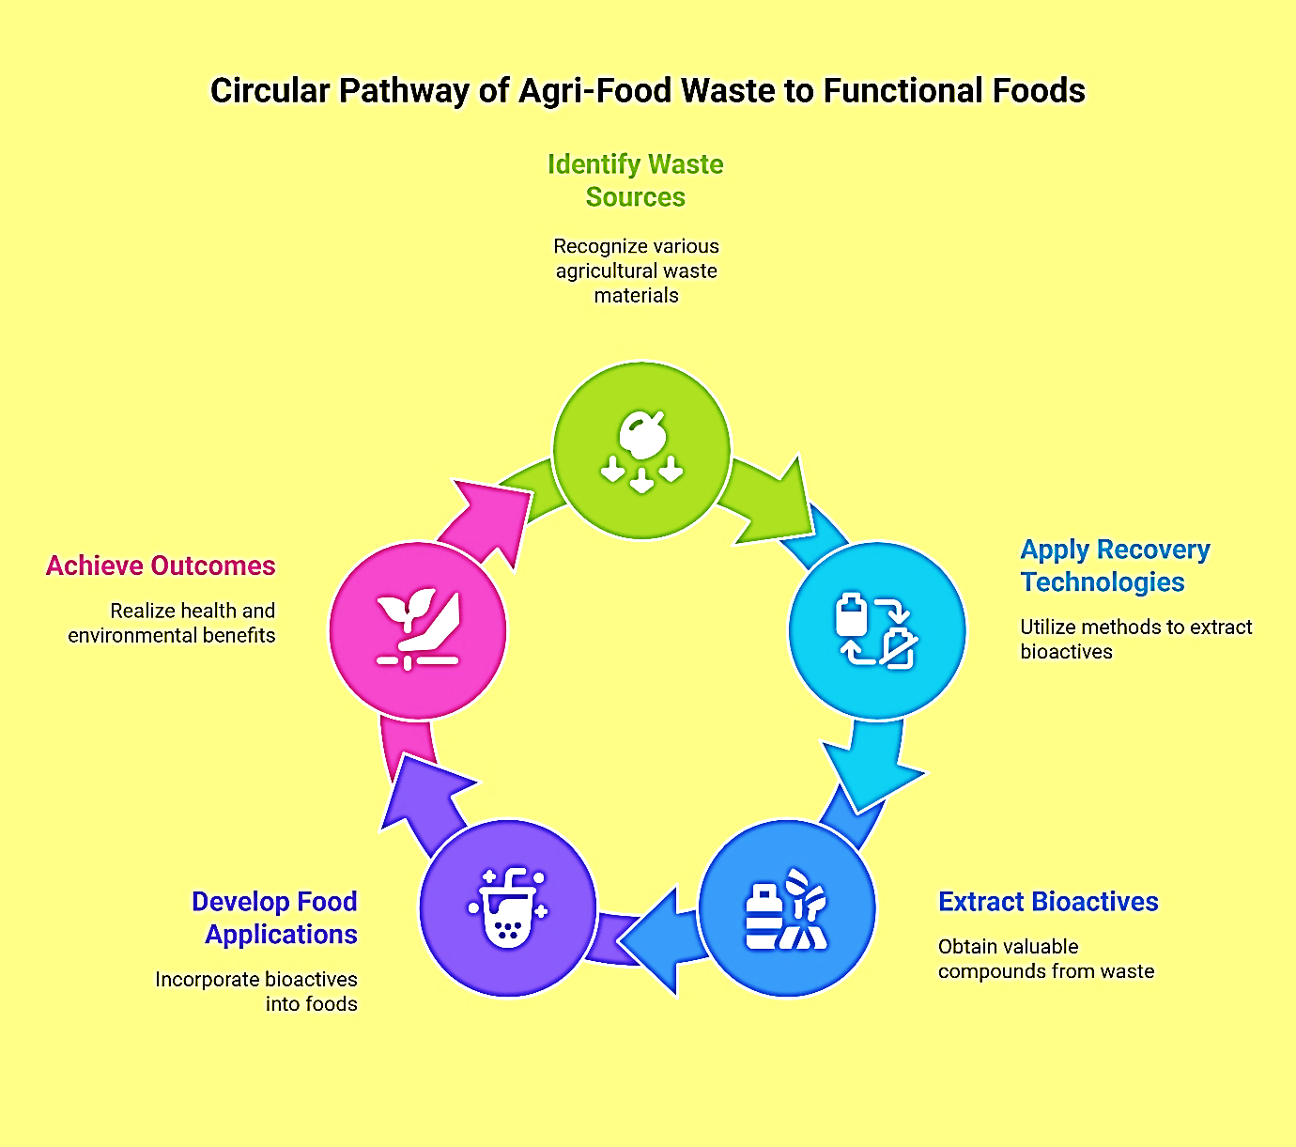

**Figure 1: Agri-food waste transformation Cycle** (Reale et al., 2021)

Preservation and maximum retrieval of these sensitive compounds have been made possible in great part by cutting-edge green extraction techniques like as ultrasound-assisted extraction, enzyme-assisted methods, and supercritical fluid approaches. Without jeopardizing environmental integrity, these developments guarantee the long-lasting conversion of garbage streams into high-value functional ingredients. This approach directly promotes several United Nations Sustainable Development Goals (SDGs)—specifically SDG 2 (Zero Hunger), SDG 3 (Good Health and Well-being), SDG 12 (Responsible Consumption and Production), and SDG 13 (Climate Action)—by opening up the full potential of agri-food waste. By lowering waste, improving resource efficiency, and closing nutrient loops inside the food system, it also advances circular bioeconomy ideas (Chemat et al., 2017; Barbanti and Falcone, 2024).

Recent reviews have stressed the need to change from linear to circular food systems by using food waste as a source for bioactive recovery (Sharma et al., 2020; Zhang et al., 2020). Few studies, though, have offered an integrated framework connecting bioactive extraction, nutritional potential, and sustainability results. By compiling current studies across these fields, this review hopes to close the gap. This review gathers current advances in the recovery of health-promoting molecules from agriculture waste products, emphasizes the technical advancements motivating these initiatives, and examines the ensuing health and environmental advantages. By doing so, it affirms the part of waste valorization as a forward-looking tactic that bridges environmental sustainability, global health promotion, and economic resilience, well in line with current food and nutrition policy frameworks (Chemat et al., 2017; Alara et al., 2021).

**2. Composition and Nutraceutical Potential of Agri-Food Waste**

Agri-food waste is increasingly acknowledged as a great source of bioactive compounds with important functional and nutraceutical potential. Growing data show the great prebiotic capacity of agricultural and food by-products, including citrus peels, banana pulp, and cereal bran. These byproducts promote the development of good gut bacteria and aid in regulating immune responses and glycemic control (Singh et al., 2021). Their inclusion into functional foods fits with current trends in sustainable nutrition and gut health management. These include metabolic regulatory, antioxidant, anti-inflammatory, antibacterial, and prebiotic effects that can greatly improve the therapeutic and nutritional worth of standard foods. Polyphenols, flavonoids, carotenoids, saponins, tannins, dietary fibers, vitamins A, C, and E, and trace minerals including zinc, magnesium, and selenium are among the important bioactives present in agri-waste (**Figure 2**) (Barros et al., 2012; Mirabella et al., 2014; Reale et al., 2021). Polyphenols found in fruit pomace and seed coats, for example, display strong free radical scavenging and cholesterol-lowering effects; nutritional fibers from cereal bran and vegetable leftovers help to enhance glycemic control and support a healthier gut flora (Gullón et al., 2016; Martins et al., 2011). Polyphenols and flavonoids abound in fruit and vegetable peels—especially from apples, pomegranates, and citrus fruits—well-known for their antioxidant, anti-inflammatory, and cardiovascular protective properties. Along with scavenging reactive oxygen species (ROS), these molecules chelate pro-oxidant metal ions and regulate important signaling pathways involved in cellular aging and chronic disease progression (Martins et al., 2011; Sharma et al., 2020). Notable examples are catechins from grape pomace and quercetin from onion skins, both of which show strong antioxidant capabilities (Gullón et al., 2016).

Mostly found in carrot, tomato, and citrus peels, carotenoids such as β-carotene, lutein, and lycopene are lipophilic pigments. Besides providing bright color, these molecules act as forerunners to vitamin A and offer protection against oxidative stress and age-related macular degeneration (Rodriguez-Amaya, 2016). Common in legume hulls, fruit seeds, and nut shells, saponins and tannins exhibit antibacterial, cholesterol-lowering, and immunomodulatory qualities. While saponins improve mucosal immunity and lower serum lipid levels (Aguilar et al., 2017; Manach et al., 2004), tannins can stop lipid peroxidation and change gut microbiota composition. Abundant in cereal bran, fruit pomace, and vegetable trimmings, dietary fibers—both soluble and insoluble—serve as prebiotics that promote intestinal health, control postprandial glycemia, and support helpful gut flora. By binding bile acids and regulating lipid metabolism, they help to prevent obesity and cardiovascular disease (Elleuch et al., 2011; Saikia et al., 2015). Moreover, agri-waste sources like guava seeds, citrus peels, and leaf remains make great supplies of antioxidant vitamins. Derived from carotenoid precursors, vitamin A helps eyesight, epithelial integrity, and immune reactions; vitamin E (tocopherols)

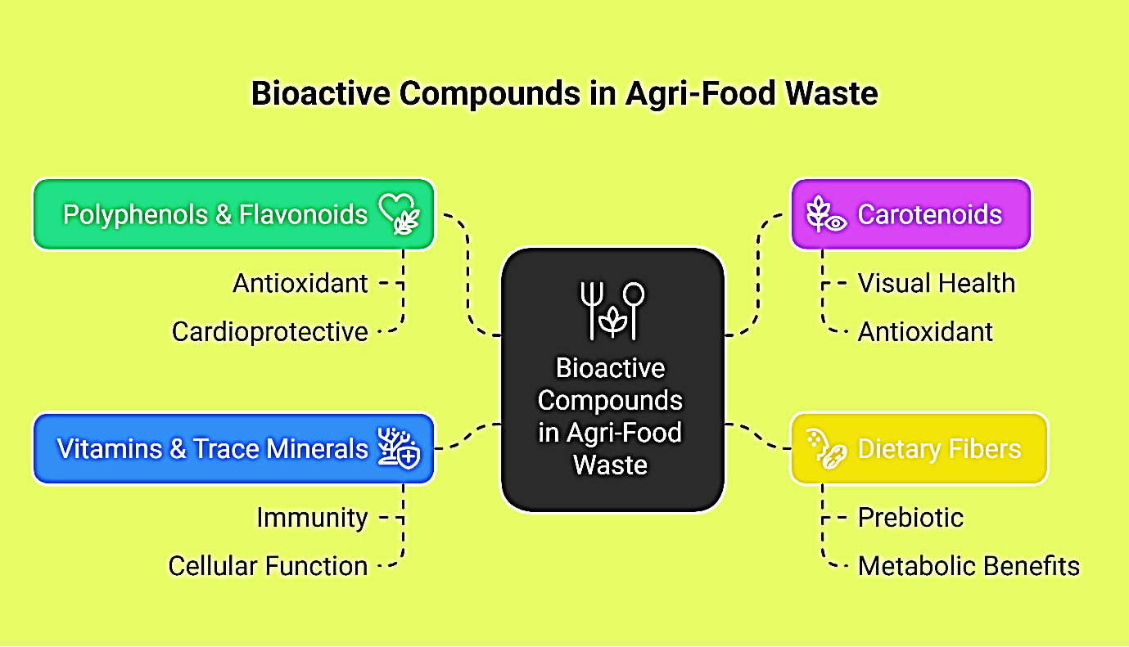

**Figure 2: Bioactive Compounds and associated health benefits derived from**

**Agri-food waste** (Reale et al., 2021)

**Table 1: Bioactive Compounds in Agri-Food Waste and Their Health Benefits**

(Shahidi & Ambigaipalan, 2015; Elleuch et al., 2011)

| **Source of Agri-Food Waste** | **Bioactive Compounds** | **Functional Properties** | **Health Benefits** |
| --- | --- | --- | --- |
| Grape pomace | Resveratrol, Quercetin, Anthocyanins | Antioxidant, anti-inflammatory, cardioprotective | Reduces oxidative stress, supports heart health |
| Citrus peels | Hesperidin, Naringin | Anti-inflammatory, lipid-lowering, antimicrobial | Lowers cholesterol, improves blood pressure |
| Apple pomace | Polyphenols, Dietary fiber | Antioxidant, prebiotic, anti-obesity | Supports gut health, regulates metabolism |
| Carrot and tomato skins | β-Carotene, Lycopene | Antioxidant, pro-vitamin A | Supports vision, prevents oxidative damage |
| Cereal bran | Insoluble fiber, Phytochemicals | Prebiotic, glucose regulation, lipid metabolism | Improves digestion, reduces risk of cardiovascular disease |
| Potato peels | Vitamin C, Potassium | Antioxidant, immune-boosting | Enhances immunity, supports electrolyte balance |

guards cell membranes from oxidative damage; and vitamin C (ascorbic acid) boosts immunological defense and aids iron absorption (Sahni et al., 2022; Pandey and Bhonde, 2020). Trace elements like selenium, magnesium, and zinc—found in cereal bran, fruit remains, and nut shells—further have essential functions in cellular defense mechanisms and metabolic control. While magnesium helps cardiac rhythm and neuromuscular activity, zinc encourages immunological function, DNA synthesis, and wound healing; selenium is a crucial element of glutathione peroxidase, a significant endogenous antioxidant enzyme (**Table 1**, **Figure 2**) (Shahidi & Ambigaipalan, 2015; Reale et al., 2021). All in all, this complex network of nutrients and phytochemicals makes agri-food waste a priceless resource for the creation of functional foods, nutraceuticals, and dietary supplements. Besides its health-improving ability, valuing these byproducts supports sustainable food systems by lowering environmental loads and maximizing resource utilization—therefore connecting nutrition, environmental stewardship, and circular economy concepts (Barros et al., 2012; Rayman, 2012). Particularly from fruits like apples, grapes, and citrus, agricultural and food processing byproducts are especially high in polyphenols and flavonoids—bioactive substances well known for their strong antioxidant, anti-inflammatory, and cardioprotective qualities. Significant amounts of resveratrol, quercetin, and anthocyanins, for instance, found in grape pomace have been connected with decreased oxidative stress and a lower incidence of metabolic and cardiac problems. Citrus peels are also a great source of hesperidin and naringin—flavonoids proven to reduce cholesterol and control blood pressure, hence helping to maintain general cardiovascular health (Shahidi and Ambigaipalan, 2015).

Along with polyphenols, agri-food waste is high in nutritional fibers that are necessary for preserving intestinal and metabolic well-being. Acting as prebiotics, non-digestible carbohydrates from cereal husks, apple pomace, and citrus pulp help to satisfy, moderate glycemic response, and sustain a strong intestinal flora. Incorporating them in baked items not only improves nutritional value but also provides functional benefits that satisfy consumer expectations for better ingredients (Elleuch et al., 2011). Agri-waste also offers a significant supply of vital minerals and nutrients. While tomato and carrot remains include β-carotene and lycopene—phytochemicals renowned for their antioxidant ability and pro-vitamin A activity—potato skins, for example, are abundant in vitamin C and potassium. Spent grains produced during brewing procedures are great sources of B-complex vitamins and trace minerals as well, thus they are perfect candidates for use in functional beverages and nutraceutical formulations (Reis et al., 2014). By lowering trash and encouraging circularity in food manufacture, the valorization of these nutrient-dense by-products enhances food system sustainability in addition to supporting human health overall (Sharma and Singh, 2025).

**3. Innovative Technologies for Bioactive Recovery**

Recent developments in extraction and processing techniques have helped to unleash the possibility of agricultural and food waste by allowing the effective recovery of bioactive substances with enhanced stability and bioavailability, thereby transforming the scenario. Low yield, degradation of heat-sensitive chemicals, and the use of poisonous solvents were all restrictions often brought about by conventional extraction techniques. Modern green technologies, however, such as ultrasound-assisted extraction (UAE), microwave-assisted extraction (MAE), enzyme-assisted extraction (EAE), pressurized liquid extraction (PLE), and supercritical fluid extraction (SFE), provide improved selectivity, shorter processing times, and little environmental impact (**Table 2**, **Figure 3**) (Chemat et al., 2017).

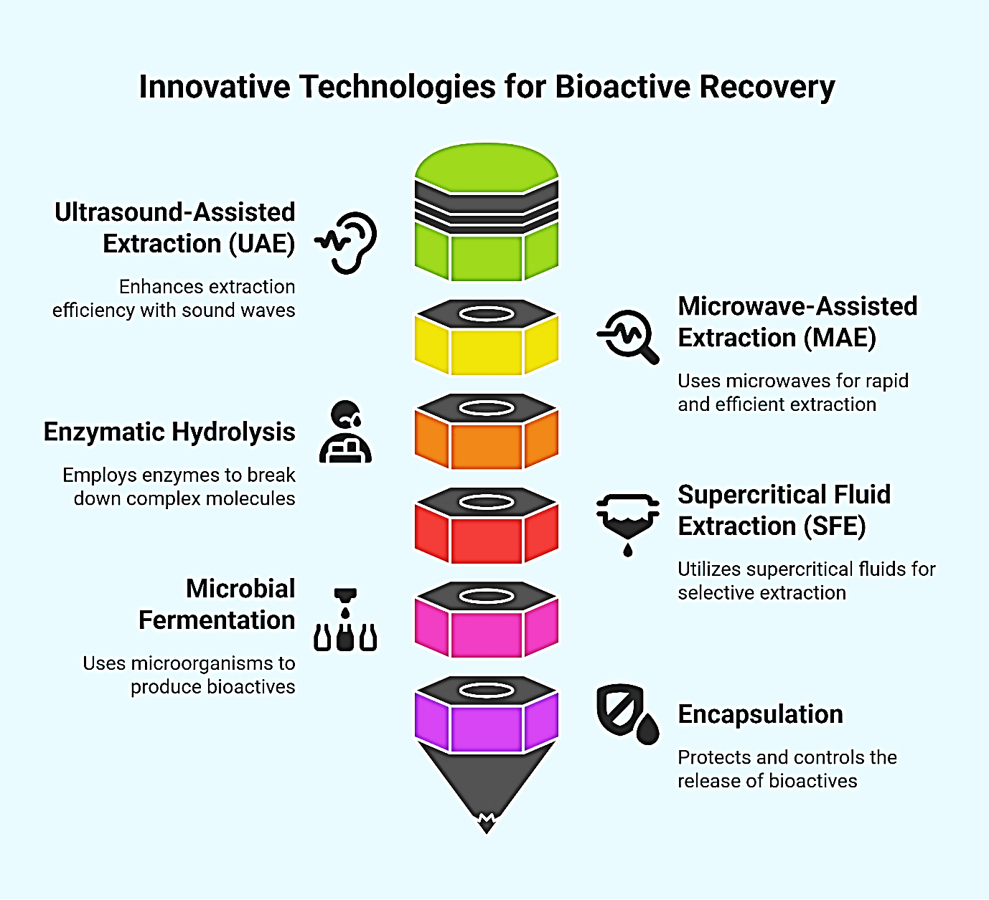

**Figure 3: Innovative Technologies for Bioactive Recovery**

(Chemat et al., 2017; Dhillon et al., 2013)

**Table 2: Green Technologies for Bioactive Recovery from Agri-Waste**

(Pérez-Burillo et al., 2021; Chemat et al., 2017)

| **Technology** | **Mechanism** | **Advantages** | **Applications** |
| --- | --- | --- | --- |
| Ultrasound-Assisted Extraction (UAE) | Cavitation disrupts cell walls, enhances mass transfer | High yield, low temperature, short extraction time | Polyphenols from grape seeds, citrus peels |
| Microwave-Assisted Extraction (MAE) | Microwave energy ruptures cell structures and releases bioactives | Rapid heating, solvent-saving, energy-efficient | Phenolics and flavonoids from fruit peels |
| Supercritical Fluid Extraction (SFE) | Uses CO₂ under supercritical conditions to extract compounds | Solvent-free, selective, ideal for lipophilic compounds | Carotenoids from tomato skins, essential oils |
| Enzymatic Hydrolysis | Enzymes break down cell walls and release bound compounds | Mild conditions, selective release, high bioavailability | Mangiferin from mango peels, fibers from cereals |
| Fermentation (LAB, yeasts) | Microbial biotransformation enhances bioactive release and function | Improves bioavailability, reduces anti-nutrients, enhances flavor | Citrus peel, pomace, vegetable trimmings |

From complicated matrices like fruit pomace, vegetable peels, cereal bran, and seed residues, these sophisticated methods are especially good at isolating and preserving sensitive bioactives, including polyphenols, flavonoids, carotenoids, and dietary fibers. UAE and MAE, for example, more effectively break down plant cell walls to help intracellular substances escape while maintaining their functional integrity. EAE employs certain enzymes to disassemble cell walls and liberate bound phenolics, therefore boosting yield and lowering chemical solvent need. Especially useful for food and pharmaceutical uses, supercritical CO₂ extraction can extract lipophilic substances without leaving hazardous residues. Besides higher yields, these technologies improve the stability and bioavailability of recovered chemicals, essential factors that influence their performance in functional foods and nutraceutical formulations. Often used post-extraction to shield fragile substances from decay and to increase their absorption in the gastrointestinal tract are microencapsulation and nanoemulsion methods. These technical advancements especially fit the ideals of green chemistry and sustainable manufacturing, therefore lowering energy consumption, solvent usage, and waste output. Integrating such eco-efficient techniques will enable the food sector to transform agri-waste into high-value functional ingredients, thereby helping to minimize waste, maximize resource efficiency, and advance health-promoting food systems. Fundamentally, these biotechnological developments close the distance between human health and environmental sustainability, therefore strengthening the worldwide plan for circular bioeconomy and ethical consumption (Chemat et al., 2017; Wang et al., 2024).

*Enzymatic Hydrolysis*

Using particular enzymes like cellulases, hemicellulases, and proteases, enzymatic hydrolysis is a targeted, environmentally friendly method designed to disintegrate complicated plant cell wall matrices and release bound bioactive chemicals. This approach works especially well in breaking apart lignocellulosic structures, which are often resistant to conventional extraction because of their dense and stiff nature. Enzymatic hydrolysis helps to release phenolic acids, flavonoids, soluble fibers, and other precious phytochemicals that would otherwise be inaccessible by selectively degrading cellulose, hemicellulose, and related proteins. One prominent instance is the enzymatic processing of mango peel with a combination of cellulases, which has been shown to greatly increase the extraction yield of mangiferin, a xanthonoid with strong anti-inflammatory and antioxidant properties (Dhillon et al., 2013). Enzymatic hydrolysis's selectivity enables directed activity under gentle processing, hence lowering chemical and thermal breakdown of fragile bioactives. This approach preserves the structural integrity and biological activity of the discharged substances compared to more aggressive mechanical or solvent-based techniques. Furthermore, enzymatic extraction is in line with sustainable processing objectives as it runs at low temperatures, so it reduces the use of hazardous solvents and produces less poisonous by-products. Its potential for food processing byproduct valorization utilizing its adaptability to different agri-waste substrates and scalability for industrial uses makes it a hopeful instrument. Ultimately, enzymatic hydrolysis illustrates a precision-driven strategy that improves the sustainability and effectiveness of bioactive compound extraction in functional food creation (Puri et al., 2012; Jafari et al., 2020).

*Fermentation*

An excellent biotechnological approach to improve the nutritional, functional, and sensory profile of agri-food waste is fermentation with helpful microbes including lactic acid bacteria (LAB), yeasts, and molds. Fermentation produces bioconversion of complex substrates, which releases bioactive peptides, improves bioavailability of phenolic compounds, and lowers anti-nutritional agents Via microbial metabolism. Additionally, improving the digestibility and absorption of polyphenols, it enriches the substrate with new metabolites displaying antioxidant, anti-inflammatory, and metabolic regulatory characteristics (Pérez-Burillo et al., 2021).

One outstanding illustration is the fermentation of citrus peels, in which microbial hydrolysis—especially by LAB and yeast strains—decomposes bitter limonoid chemicals, hence enhancing flavor. Simultaneously, the procedure increases the total phenolic content and greatly boosts the antioxidant ability of the resulting item. The dual enhancement of sensory and functional properties increases the suitability of fermented citrus peel for use in functional foods and nutraceutical formulations. Furthermore, microbial fermentation lowers anti-nutritional chemicals like phytic acid and tannins while encouraging the release of vital amino acids, bioactive peptides, and short-chain fatty acids—molecules connected to gut microbiota modulation and immune support. Therefore, fermentation stands out as a sustainable, scalable, and ecologically friendly way to turn food trash into premium goods, therefore supporting the goals of the circular bioeconomy and zero-waste food production (Pérez-Burillo et al., 2021).

*Green Extraction Techniques*

Green extraction techniques, including microwave-assisted extraction (MAE), ultrasonic-assisted extraction (UAE), and supercritical fluid extraction (SFE) are transforming the way bioactive substances are extracted from agricultural and food waste. High extraction efficiency, decreased solvent use, quick processing times, and little environmental impact of these techniques make them perfect for sustainable and large-scale uses in the food and nutraceutical sectors. UAE uses ultrasonic waves to produce cavitation effects that destroy plant cell walls and boost mass transfer, therefore drastically increasing the extraction yields of heat-sensitive and structurally complicated substances. Phenolic acids have been efficiently derived from grape seeds using UAE, for instance, therefore increasing yield and antioxidant efficacy. MAE, on the other hand, employs microwave energy to quickly heat the intracellular water in plant tissues, hence causing cell rupture and helping with the release of bioactives. For polyphenol extraction, especially, this technique is very successful; it can be coupled with supercritical fluids to create solvent-free, clean-label extracts. Usually employing supercritical CO₂, SFE works under high pressure and fairly low temperature to allow the selective extraction of lipophilic molecules, including carotenoids, essential oils, and flavonoids. Its adjustable parameters provide exact control over extract composition while avoiding thermal degradation and hazardous residues. Because SFE lacks solvents, it is particularly appropriate for making high-purity components for functional foods and medicines (Chemat et al., 2017). Together, these green solutions provide ecologically efficient, high-performance substitutes for traditional solvent-based techniques, so as to further the creation of clean, bioactive-rich formulations from agricultural food waste and strengthen the tenets of circular bioeconomy and sustainable food production (Patel and Singh, 2024).

*Encapsulation and Stabilization*

By encapsulating delicate bioactive substances inside carrier matrices made of biopolymers including alginate, chitosan, maltodextrin, and gelatin, encapsulation methods are often used to protect them from deterioration during handling, storage, and digestion. Encapsulation is a very important stage to improve the stability, solubility, and controlled release of bioactives extracted from agri-food waste, including polyphenols, flavonoids, or curcumin. Effectively shielding the bioactive molecules from harmful environmental elements like heat, light, oxygen, and pH changes, these carrier systems create protective barriers surrounding them. For compounds that are hydrophobic or physically delicate, whose functional effectiveness is diminished under conventional food processing or gastrointestinal conditions, this approach is especially useful. Curcumin and some polyphenols, for instance, are extremely oxidation-sensitive and have poor bioavailability; encapsulating them in biodegradable polymers guarantees preservation of their chemical integrity and enables targeted delivery in the gastrointestinal tract. Encapsulation techniques also help bioaccessibility and therapeutic efficacy by allowing for sustained or site-specific release. Their perfect fitting into functional foods, drinks, and nutritional supplements, calling for increased shelf-life and physiological efficacy, makes them. Beyond maximizing the health advantages of bioactives, the use of nano- and micro-encapsulation techniques helps consumers need for clean-label, health-enhancing items sourced from sustainable food sources (Munin and Edwards-Lévy, 2011).

**4. Applications of Agriwaste-Derived Bioactives in Functional Foods**

Functional foods, including bio-active ingredients extracted from agri-food waste, are becoming more popular across a range of food compositions. Various functional food matrices, including drinks, baked goods, dairy replacements, meat substitutes, and nutritional supplements, are growing increasingly populated with these bioactives—polyphenols, flavonoids, carotenoids, dietary fibers, prebiotics (Zhang et al., 2020; Reale et al., 2021). Such integration not only raises the nutritional and therapeutic value of food items but also fits consumer preferences for clean-label, plant-based, and environmentally sourced ingredients. Commonly added to teas, juices, and functional beverages to raise antioxidant capacity, extend shelf life of the product, and provide health-promoting benefits, for instance, are polyphenol- and carotenoid-rich extracts derived from fruit peels such as citrus, apple, and carrot. Particular compounds like quercetin, hesperidin, and β-carotene help to produce these benefits while also lending natural color, flavor, and anti-inflammatory characteristics. These applications meet the growing need for healthful, free-from-synthetic-additives functional drinks (Shahidi and Ambigaipalan, 2015).

Dietary fibers obtained from citrus pulp, apple pomace, and cereal brans are used in the baking industry to strengthen items, including cookies, muffins, granola bars, and breads. Beyond increasing fiber, these ingredients help to improve satiety, control glycemic response, boost moisture retention, and favorably affect the texture and shelf-life of baked goods (Elleuch et al., 2011). Furthermore, gaining popularity in plant-based yogurts, dairy-free probiotic drinks, and fermented goods are prebiotic-rich fibers like inulin and pectin, usually extracted from fruit pomace and vegetable trimmings. Promoting gut flora balance, enhancing immunological modulation, and enhancing gastrointestinal health, these fibers act as substrates for probiotic cultures (Saikia et al., 2015; Pérez-Burillo et al., 2021). Integrating agriwaste-derived functional ingredients into popular food goods is a powerful meeting of health promotion, consumer happiness, and sustainability all around. By converting by-products into high-value, health-enriching ingredients inside the contemporary food system, it not only helps to lower resource inefficiency and food waste but also demonstrates the ideas of the circular bioeconomy.

**5. Health Benefits of Functional Foods from Agriwaste**

The health benefits associated with functional foods derived from agriwaste include antioxidant, anti-inflammatory, prebiotic, antimicrobial, and metabolic regulatory effects. Driven by their high content of bioactive compounds like polyphenols, flavonoids, dietary fibers, vitamins, and essential minerals, functional foods made from agri-food waste provide a broad spectrum of health-promoting benefits. Often disposed of in traditional food processing, these compounds can be recovered via valorization techniques and used successfully to improve human health and avoid disease. The antioxidant characteristics of phenolic-rich agriwaste extracts provide some of the most important medical advantages. These compounds have been found to neutralize reactive oxygen species (ROS), therefore lowering oxidative stress, an important component in the development of several chronic diseases, including cardiovascular diseases, type 2 diabetes, neurodegenerative disorders, and certain cancers (**Figure 4**) (Zhang et al., 2020; Calabrò and Scuderi, 2024).

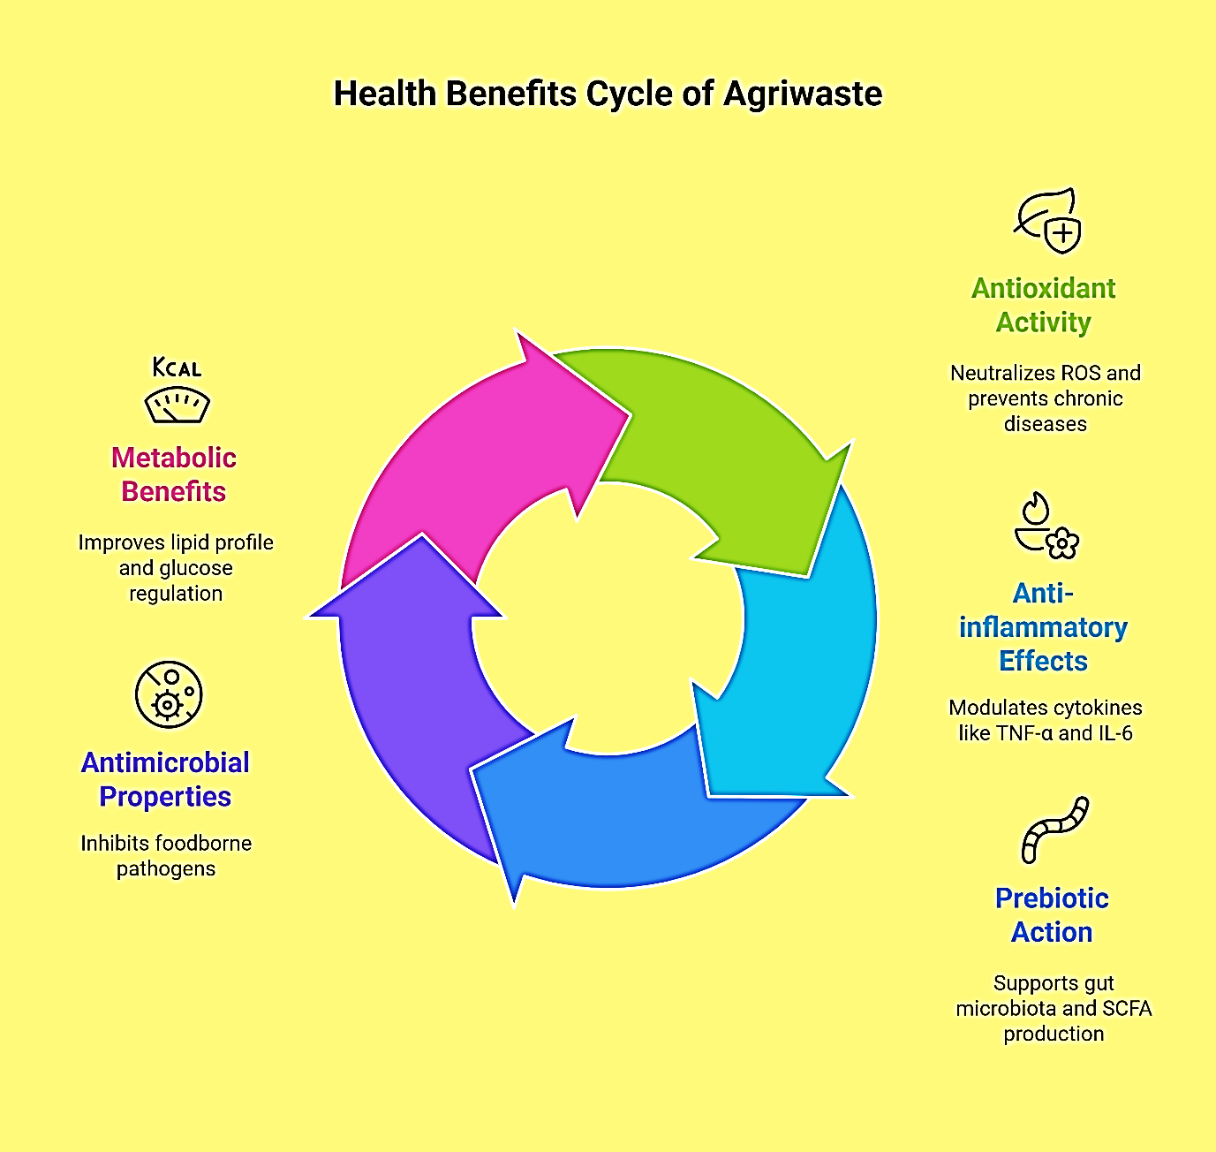

**Figure 4: Health Benefits of Functional Foods from Agriwaste**

(Zhang et al., 2020)

Several compounds derived from agriwaste also exhibit significant anti-inflammatory properties. Extracted from fruit peels, seed husks, and vegetable trimmings, polyphenols and flavonoids have been shown to modify inflammatory pathways by lowering pro-inflammatory cytokines such as TNF-α, IL-6, and IL-1β. Managing inflammatory diseases like arthritis, metabolic syndrome, and inflammatory bowel disease can especially benefit from this. The prebiotic potential of dietary fibers derived from agriwaste—like banana peels, citrus pulp, or cereal bran—supports the rise of friendly gut bacteria, including *Bifidobacterium* and *Lactobacillus*. Enhancing the immune system, increasing nutrient absorption, and preserving gut barrier integrity all depend on a good gut flora. Prebiotic fibers help to generate short-chain fatty acids (SCFAs), which are vital for metabolic control and colon health as well. Extracts from pomegranate peels, grape pomace, and onion skins, for example, have demonstrated inhibitory effects against foodborne pathogens such as *Escherichia coli*, *Staphylococcus aureus*, *Salmonella* spp., and *Listeria monocytogenes* (Reale et al., 2021; Bhandari and Singh, 2025).

These characteristics make such compounds not only useful for human health but also helpful for extending the shelf life of food items and improving their microbiological safety. Additionally, particular agriwaste-derived components influence insulin sensitivity, blood glucose levels, and lipid profiles through metabolic regulatory action. Polyphenols from mango peel or olive pomace, for instance, have been found to reduce LDL cholesterol and triglycerides while also increasing HDL levels and improving glycemic control—therefore making them valuable for treating metabolic syndrome and warding off type 2 diabetes. The systematic inclusion of agriwaste-derived functional foods in the human diet offers a sustainable and scientifically supported approach to health promotion and disease prevention overall (Sharma et al., 2020). Strengthens the idea that routes from waste to health might be both effective and environmentally responsible by bridging nutritional science, food invention, and environmental consciousness (Elleuch et al., 2011; Saikia et al., 2015).

**6. Environmental Impact and Sustainability**

Utilizing agri-food waste for functional food production offers considerable environmental benefits. This technique's most clear environmental benefits are the great decrease in organic waste buildup. By diverting agri-food byproducts—such as fruit peels, vegetable trimmings, cereal husks, and dairy residues—from landfills, this strategy helps curb the generation of methane, a powerful greenhouse gas produced during the anaerobic decomposition of organic matter. This relieves demand on waste management infrastructure as well as helps to reduce air pollution (Mirabella et al., 2014). Moreover, valuing agri-food trash helps to conserve resources. Companies may use naturally occurring bioactives, fibers, antioxidants, and phytochemicals isolated from food waste streams rather of depending mostly on synthetic additives or industrially produced functional ingredients. This helps to minimize the environmental impact connected with chemical synthesis, heavy land use, and intensive agriculture methods. Reusing fruit pomace or spent grains, for instance, lowers the demand for fresh raw materials, hence saving soil minerals, water, and energy. At a wider systems level, this behavior supports the ideals of a circular bioeconomy in which waste is seen as a resource and continuously reintegrated into the production cycle (Zhang et al., 2020; Chemat et al., 2017).

By lowering reliance on virgin inputs and cutting emissions across the lifetime of food items, such circular systems maximize resource efficiency and boost supply chain sustainability. This closed-loop approach helps food systems become resilient and directly backs global climate change reduction initiatives. Importantly, the inclusion of food trash valorization into regular manufacturing fits with several United Nations Sustainable Development Goals (SDGs), namely Goals 12 (Responsible Consumption and Production), 13 (Climate Action), and 3 (Good Health and Well-being). This approach provides a roadmap for sustainable development by targeting food loss, lowering environmental damage, and supplying health-promoting products. The environmental needs of such sustainable food innovations are likely to find more traction across sectors and policy platforms as consumer awareness rises and government frameworks change (UNEP, 2021).

**7. Consumer Perception and Acceptance**

Consumer attitudes toward foods developed from waste-derived ingredients play a critical role in market success. Market success depends greatly on consumer perceptions of meals produced from waste-derived components. Although environmental consciousness and demand for sustainable products are expanding, adoption can be hampered by issues with food safety, sensory quality, and cultural acceptability. Some consumers might associate the word "waste" with poor quality or contamination, therefore questioning or rejecting such items despite their nutritional advantages. Effective communication, education, and clear labeling are critical to alleviate these issues. Educating customers about the scientific methods employed in waste transformation—including strict quality checks, microbial safety, and advanced purification—can reduce concerns and encourage wise decisions (Sijtsema et al., 2016).

Highlighting the nutritional and environmental benefits of such goods via reliable endorsements, sustainability certifications, and public awareness initiatives can boost consumer confidence and acceptance. Improving palatability and appeal also depends on developments in flavor enhancement and product formulation (Grasso & Asioli, 2020). Flavor masking, textural improvement, and integration into well-known food types—like snacks, drinks, and baked goods—can help doubtful customers ease into upcycled foods. Encouragement of trial via focused advertising, incentives, and partnerships with reliable food brands or influencers can help overcome initial reluctance and normalize upcycled food use. Furthermore, involvement of communities in sustainability narratives and highlighting of success stories from other countries may help change attitudes and foster long-term consumer loyalty (Aschemann-Witzel et al., 2019). Agriwaste-derived functional foods are well-placed to win approval as customer attitudes toward sustainability, ethical sourcing, and health awareness change. But bridging the gap between awareness and adoption will need constant efforts in consumer education, sensory innovation, and targeted communication. Innovations in product formulation and flavor enhancement are also key to improving palatability and acceptance (Stangherlin & de Barcellos, 2018).

**8. Challenges and Future Prospects**

Despite the promising potential of agriwaste valorization, several challenges remain. These include variability in raw material quality, lack of standardization in processing techniques, regulatory hurdles, and market barriers. The conversion of agricultural and food garbage into useful foods exemplifies convergence of innovation, sustainability, and public health. Using contemporary bioprocessing techniques and drawing on the rich reservoir of bioactive substances in agriwaste, we may solve several world problems from malnutrition and food poverty to environmental damage and waste management (Mirabella et al., 2014).

Creating functional foods with these bioactives not only gives value to what would otherwise be regarded as waste but also promotes preventive healthcare by providing components with antioxidant, anti-inflammatory, antibacterial, and prebiotic qualities. From a sustainability perspective, this paradigm reduces greenhouse gas emissions, preserves natural resources, and reduces trash, hence supporting the circular bioeconomy. It promotes a move from a linear consumption model to a more regenerative and ecologically friendly food system. The valuing of agri-food trash is growing not only a scientific and technological need but also a societal imperative as consumer awareness expands and the demand for sustainable, health-focused goods rises (Aschemann-Witzel et al., 2019).

Though agriwaste valorization shows great promise, certain problems still remain. These include disparities in raw material quality, absence of standards in processing methods, legal obstacles, and market obstacles. Rising these innovations calls for investment in research, infrastructure, and legislative systems. Future studies should concentrate on creating energy-efficient, scalable, and affordable technologies for bioactive recovery. Turning agriwaste into popular functional food components will depend on multidisciplinary cooperation among food experts, environmentalists, legislators, and industry partners. Moving forward, mainstreaming of these practices requires sustained research and development, enabling policy structures, and stakeholder cooperation. Integrating agriwaste valorization into functional food manufacturing has great potential not only for improving human health but also for stimulating environmental consciousness and accelerating worldwide objectives for sustainable development and climate resilience. Agriwaste-to-functional food approaches provide a convincing, multidimensional answer to urgent worldwide problems. They also represent a strong move toward a more sustainable and health-conscious future (Zhang et al., 2020; Shahidi & Ambigaipalan, 2015).

**9. Conclusion**

The valuation of agri-food waste into functional foods marks a major convergence of sustainability, nutrition science, and public health innovation. Once regarded as environmental burdens, agri-waste materials are in reality rich sources of bioactive chemicals, including polyphenols, dietary fibers, carotenoids, vitamins, and minerals with strong antioxidant, anti-inflammatory, and prebiotic properties, according to this study. As green and eco-efficient extraction techniques, including enzymatic hydrolysis, fermentation, and supercritical fluid extraction, develop, these chemicals can be properly recovered and stabilized for integration into health-promoting food products. From an environmental viewpoint, this change in thinking helps to minimize waste, lower greenhouse gas emissions, and support the more general aims of the circular bioeconomy as well as the UN Sustainable Development Goals (SDGs). Furthermore, increasing the need and market potential of this strategy is consumer demand for clean-label, sustainable, and functional food goods. Practical implementation, though, still has many problems, including fluctuations in raw material makeup, absence of uniform extraction methods, legislative ambiguity, and low customer awareness. Resolving these calls for coordinated action between researchers, politicians, the food industry, and consumers to increase valorization techniques and enhance regulatory transparency and customer awareness. In general, changing agri-food waste into functional foods is not just a scientific opportunity but also a societal obligation. It presents a practical, multi-faceted answer to urgent global problems, including health, nutrition security, environmental protection, and sustainable food systems. Mainstreaming these solutions for a better and more sustainable future depends on ongoing innovation, multidisciplinary cooperation, and policy support.

Disclaimer (Artificial intelligence)

Option 1:

Author(s) hereby declare that NO generative AI technologies such as Large Language Models (ChatGPT, COPILOT, etc.) and text-to-image generators have been used during the writing or editing of this manuscript.

Option 2:

Author(s) hereby declare that generative AI technologies such as Large Language Models, etc. have been used during the writing or editing of manuscripts. This explanation will include the name, version, model, and source of the generative AI technology and as well as all input prompts provided to the generative AI technology

Details of the AI usage are given below:

1. Tools such as Edit Pad, a paraphrasing utility were employed to a limited extent

2. The images were designed using AI tools.

**References**

Aguilar, C. N., Augur, C., Favela-Torres, E., Viniegra-Gonzalez, G., & Contreras-Esquivel, J. C. (2017). Microbial tannases: Advances and perspectives. *Applied Microbiology and Biotechnology*, 76(1), 47–59.

Alara, O. R., Abdurahman, N. H., & Ukaegbu, C. I. (2021). Extraction of phenolic compounds: A review. Current Research in Food Science, 4, 200–214. https://doi.org/10.1016/j.crfs.2021.03.011

Aschemann-Witzel, J., de Hooge, I. E., Amani, P., Bech-Larsen, T., & Oostindjer, M. (2019). Consumer-related food waste: Causes and potential for action. *Sustainability*, 7(6), 6457–6477.

Barbanti, D., & Falcone, P. M. (2024). Unveiling the potential of agri-food by-products: A comprehensive review of bioactive compounds, extraction techniques, and industrial applications. Waste and Biomass Valorization.

Barros, L., Dueñas, M., Ferreira, I. C. F. R., Baptista, P., & Santos-Buelga, C. (2012). Phenolic acids determination by HPLC-DAD-ESI/MS in sixteen different Portuguese wild mushrooms species. *Food and Chemical Toxicology*, 50(12), 3142–3147.

Bhandari, R., & Singh, S. (2025). Valorization of agri-food crucifer vegetable waste for food, functional food, and nutraceutical applications. Bioresources and Bioprocessing, 12, 42.

Borrello, M., Caracciolo, F., Lombardi, A., Pascucci, S., & Cembalo, L. (2020). Consumers’ perspective on circular economy strategy for reducing food waste. *Sustainability*, 12(15), 617.

Calabrò, E., & Scuderi, A. (2024). Enhancement of waste from the agri-food chain in functional food: Impact on chronic kidney disease. In P. Tripathi, S. Nanda, & D. Pant (Eds.), AI for Sustainable Materials and Energy (pp. 45–62).

Chemat, F., Abert-Vian, M., Fabiano-Tixier, A. S., Strube, J., Uhlenbrock, L., Gunjevic, V., & Cravotto, G. (2017). Green extraction of natural products: Concept and principles. *International Journal of Molecular Sciences*, 18(4), 708.

Chirinos, R., Rogez, H., Campos, D., Pedreschi, R., & Larondelle, Y. (2010). Optimization of extraction conditions for antioxidant phenolic compounds from mashua (*Tropaeolum tuberosum*) tubers. *Separation and Purification Technology*, 72(2), 217–225.

Dhillon, G. S., Kaur, S., Brar, S. K., & Verma, M. (2013). Green synthesis approach: Extraction of polyphenols from grape seeds and skin. *Food Chemistry*, 133(1), 236–245.

EFSA. (2020). Scientific opinion on the safety and efficacy of enzymes. *European Food Safety Authority Journal*, 18(1), e05991.

Elleuch, M., Bedigian, D., Roiseux, O., Besbes, S., Blecker, C., & Attia, H. (2011). Dietary fibre and fibre-rich by-products of food processing: Characterisation, technological functionality and commercial applications: A review. *Food Chemistry*, 124(2), 411–421.

FAO. (2019). *The State of Food and Agriculture: Moving forward on food loss and waste reduction*. Rome: Food and Agriculture Organization of the United Nations.

González-Molina, E., Moreno, D. A., & García-Viguera, C. (2010). A new drink rich in healthy bioactives combining lemon and pomegranate juices. *Food Chemistry*, 120(4), 1363–1372.

Grasso, S., & Asioli, D. (2020). Consumer preferences for upcycled ingredients: A case study with biscuits. *Food Quality and Preference*, 84, 103951.

Grunert, K. G. (2011). Sustainability in the food sector: A consumer behavior perspective. *International Journal on Food System Dynamics*, 2(3), 207–218.

Gullón, B., Gullón, P., Sanz, Y., Alonso, J. L., & Parajó, J. C. (2016). Prebiotic potential of a refined product containing pectic oligosaccharides derived from orange peel. *Food Chemistry*, 199, 422–430.

Gustavsson, J., Cederberg, C., Sonesson, U., Otterdijk, R. V., & Meybeck, A. (2011). *Global food losses and food waste – Extent, causes and prevention*. FAO.

Jafari, S. M., He, Y., & Bhandari, B. (2020). Enzyme-assisted extraction for efficient recovery of bioactive compounds from plant materials: Mechanisms and recent applications. *Critical Reviews in Food Science and Nutrition*, 60(16), 2720–2741.

Kibler, K. M., Reinhart, D., Hawkins, C., Motlagh, A. M., & Wright, J. (2018). Food waste and the food-energy-water nexus: A review of food waste management alternatives. *Waste Management*, 74, 52–62.

Manach, C., Scalbert, A., Morand, C., Rémésy, C., & Jiménez, L. (2004). Polyphenols: Food sources and bioavailability. *The American Journal of Clinical Nutrition*, 79(5), 727–747.

Martins, N., Barros, L., & Ferreira, I. C. F. R. (2011). Nutritional and antioxidant properties of edible wild mushrooms. *Food and Chemical Toxicology*, 49(2), 304–311.

Mirabella, N., Castellani, V., & Sala, S. (2014). Current options for the valorization of food manufacturing waste: A review. *Journal of Cleaner Production*, 65, 28–41.

Munin, A., & Edwards-Lévy, F. (2011). Encapsulation of natural polyphenolic compounds: A review. *Pharmaceutics*, 3(4), 793–829.

Pandey, A., & Bhonde, R. (2020). Vitamins and their role in immune modulation. *Clinical Immunology and Immunopathology*, 23(1), 13–22.

Patel, D., & Singh, V. (2024). Food waste valorization: A sustainable pathway for circular bioeconomy. RSC Sustainability, 2, 784–798. https://doi.org/10.1039/D3FB00156C

Pérez-Burillo, S., Hinojosa-Nogueira, D., Pastoriza, S., & Rufián-Henares, J. A. (2021). Potential probiotic properties of fermented orange juice. *LWT-Food Science and Technology*, 145, 111328.

Puri, M., Sharma, D., & Barrow, C. J. (2012). Enzyme-assisted extraction of bioactives from plants. *Trends in Biotechnology*, 30(1), 37–44.

Rayman, M. P. (2012). Selenium and human health. *The Lancet*, 379(9822), 1256–1268.

Reale, A., Di Renzo, T., Rossi, F., Zotta, T., & Iorizzo, M. (2021). Food waste recovery: Polyphenol extraction from apple pomace. *Foods*, 10(7), 1620.

Reis, S. F., Rai, D. K., Abu-Ghannam, N., & Mullen, A. M. (2014). Extraction of bioactive compounds from apple pomace using water and hydroalcoholic solvents. *Food Chemistry*, 162, 89–95.

Rodriguez-Amaya, D. B. (2016). Food carotenoids: Chemistry, biology, and technology. *John Wiley & Sons*.

Sahni, P., Arora, M., & Jain, D. (2022). Antioxidant vitamins and their therapeutic potential in aging and related disorders. *Nutrition Research Reviews*, 35(1), 1–19.

Saikia, S., Deka, D. C., & Deka, S. (2015). Cereals: Potential source of prebiotics. *International Journal of Food Science & Nutrition*, 66(6), 630–635.

Shahidi, F., & Ambigaipalan, P. (2015). Phenolics and polyphenolics in foods, beverages and spices: Antioxidant activity and health effects – A review. *Journal of Functional Foods*, 18, 820–897.

Sharma, R., & Singh, A. (2025). Fruit and vegetable biowaste as a source of functional nutritional components for animal feed. Frontiers in Sustainable Food Systems, 9, 1512577.

Sharma, S., Kaur, M., & Goyal, R. (2020). Polyphenols from food waste: Extraction, identification and health benefits. *Journal of Food Biochemistry*, 44(10), e13449.

Sijtsema, S. J., Snoek, H. M., & Toet, A. (2016). Waste valorisation: Consumer acceptance of food containing recycled ingredients. *Wageningen UR Report*.

Singh, R., Shukla, A., Tiwari, S., & Srivastava, M. (2021). Prebiotic potential of fruit and vegetable by-products: Current status and future perspectives. *Food Bioscience*, 40, 100882.

Slavin, J. (2013). Fiber and prebiotics: Mechanisms and health benefits. *Nutrients*, 5(4), 1417–1435.

Stangherlin, I. D. C., & de Barcellos, M. D. (2018). Drivers and barriers to food waste reduction. *British Food Journal*, 120(10), 2364–2387.

Thomas, M., & George, J. (2024). Exploring antioxidant potential of agricultural by-products: A systematic review. F1000Research, 13, 1008.

UNEP. (2021). *Food Waste Index Report 2021*. United Nations Environment Programme.

Viuda-Martos, M., Fernández-López, J., & Pérez-Álvarez, J. A. (2010). Pomegranate and its many functional components as related to human health: A review. *Comprehensive Reviews in Food Science and Food Safety*, 9(6), 635–654.

Wang, Y., Liu, J., & Chen, Z. (2024). Exploration of novel eco-friendly techniques to utilize bioactive compounds from household food waste: A sustainability perspective. Frontiers in Food Science and Technology, 4, 1388461.

Zhang, Y., Li, H., Wang, X., Zhao, J., & Xu, W. (2020). Utilization of food waste-derived bioactive compounds in functional food development: Trends and prospects. *Critical Reviews in Food Science and Nutrition*, 60(21), 3652–3671.

Zhou, Y., Cao, H., Hou, Y., & Li, Y. (2022). Spent grain protein as meat substitute: A sustainable approach. *Food Hydrocolloids*, 124, 107254.