*Original Research Article*

**Consumer Concerns on Food Safety in Goat Meat Distribution Channels: Evidence from Bangladesh**

.

ABSTRACT

|  |
| --- |
| **Introduction:** Food safety is a growing concern in Bangladesh, particularly in the goat meat distribution channel, where supply chain risk and consumer distrust threaten market integrity. The safety of goat meat depends on various stakeholders, from producer farms to consumers’ tables.  **Objectives:** The study aims to (a) understand consumers’ preferences and consumption behavior of meat, mainly goat meat; (b) assess meat handling practices at butcher shops and consumer satisfaction with hygiene; (c) understand consumers’ concerns about safety in the goat meat distribution channel; and (d) assess opinions on willingness to pay for safer goat meat.  **Materials and Methods:** Data were collected from a total of 160 consumers (40 randomly selected from each upazila) through personal interviews using structured questionnaires from September to October 2019. Additionally, open discussions and observations were conducted to supplement the findings. Correlation analysis was performed to see the relationship between socio-demographic variables and food-related behaviors.  **Results:** Beef was preferred by 54% of the respondents, followed by goat meat (36%), but chicken was consumed most due to price and availability. Only 21% consumed goat meat during festivals. 88% consumers had idea about food poisoning, diarrheal disease may occur from unhygienic goat meat but only 49% respondent had knowledge about zoonotic disease. Consumers with higher income spent more and bought more goat meat. There was a positive correlation between education and food safety awareness including zoonotic disease knowledge. 48% of consumers reported seller malpractices (e.g., underweight, mixing fat etc.). While most consumers expressed a positive response to pay extra for safe goat meat, only 19% are prepared to pay an additional BDT 100 per kg. 96% demanded improved goat meat handling systems.  **Discussion:** Consumers in Bangladesh prefer goat meat and beef, but price drives chicken purchases. While concern of basic food safety risks, knowledge gaps exist. Moreover, distrust between sellers and buyers is prevalent.  **Conclusion**. Consumer awareness about the safety of goat meat is limited, despite concerns. Building trust between butchers and consumers is essential. Policymakers should promote food safety campaigns, enforce hygiene standards, and prioritize zoonotic education to align consumer concerns with a safer meat distribution system. |

*Keywords: Food safety, Goat meat, Consumer behavior, Meat distribution*

1. INTRODUCTION

Food safety is one of the major concerns for consumers due to its direct influences on human health. It is becoming an important issue for consumers in making purchase decisions. Meat is a risky item regarding food safety. It is a fact that consumers have the right to expect safe and suitable food (Hossain et al., 2008). Comparing to other meat, goat meat production is safer than beef and chicken meat in Bangladesh because they are still reared in a domestic way by local farmers without using antibiotics or growth promoters (Alam, 2019) which is an advantage of goat meat for consumers. Goats are often farmed using traditional free-range pastoral systems, grazing on natural pastures with minimal industrial interventions and limited medicinal use for sustainable production practices (Hamad et al., 2025). Meat consumption is affected by many factors, such as price, income, nutritional value, dietary habits, safety, eating quality, the convenience of purchase and so on (Wu and Xiao, 2013; Liang et al., 2014; Zhang et al., 2014). The quantity and quality requirements of consumers in terms of meat are influenced by income, religious beliefs, nutritional value and quality of meat (Yanwei et al., 2016). Delgado (2003) found that the amount of meat consumed in developing countries grew three times as much as it did in developed countries between the early 1970s and mid-1990s reflecting different rates of income growth.

Within the modern meat chain, consumers occupy a crucial position and are being situated at the end of the chain as the end-user as well as at the start of the chain as inspiration for a consumer-driven or market-oriented chain organization (Gellynck et al., 2004).

A recent research by Ishra et al. (2022) found urban supermarket consumers in Bangladesh were far more concerned about food risk and adopted more precautionary practices of purchasing safer food than those in urban and rural bazaars. This reflects the growing food safety concern between different consumer groups in different market settings. But there have been very few studies about consumers’ perceptions of meat in Bangladesh. Sarma (2017) studied consumers’ preference and willingness to pay premium prices for organic beef in Dhaka city of Bangladesh. He collected data of beef consumers from supermarkets and found about 73% of consumers are willing to pay an extra 26.12% for organic beef. But this study focused on supermarkets customers who are generally high salaried persons in the context of Bangladesh. Islam et al., (2018) recently conducted consumer profile analysis towards chicken, beef, mutton, fish, and egg consumption in Bangladesh. According to their findings, Bangladeshi consumers had no specific reason for preferences and consumption patterns of fish, chicken, beef, mutton, and egg consumption. They emphasized the necessity of studies on each product individually for better understanding of the consumption pattern.

This study focuses on the consumers' concerns about safety issues in the distribution system of goat meat from the slaughterhouse to consumers. Since this issue is not well understood, the present study aims to

1. Understanding the consumer's preferences and consumption behavior on meat and goat meat, considering the socio-economic condition.
2. Ascertaining the meat handling in the butcher's shop, considering consumer satisfaction, and exploring ways to improve the situation.
3. Understanding the consumer's concern about safety in the goat meat distribution system and their approach towards ensuring safe goat meat from the market.
4. Assessing the consumers' opinion on willingness to pay for safer goat meat to improve food safety awareness.

2. material and methods

**2.1 Research site and time**

This research was conducted in the Mymensingh district of Bangladesh. It ranked 4th in terms of goat population in the country (BBS, 2011). Four upazilas of Mymensingh district, namely Mymensingh Sadar, Muktagacha, Gafargaon, and Bhaluka. These four upazilas were selected considering the density of urban population and the availability of consumers. Mymensingh Sadar ranked 1st in terms of the density of urban people among the upazilas of Mymensingh, whereas Gafargaon, Muktagacha, and Bhaluka ranked 2nd, 3rd, and 4th, respectively (BBS, 2011).



**Figure 1 Research Site (Mymensingh district, Bangladesh)**

**2.2 Data Collection and analysis**

The questionnaire survey was conducted during the field visit from Mid-September to Mid-October 2019. In depth interviews using a questionnaire were conducted at the branch office of a state-owned commercial bank located in each upazila. Since consumers at meat shops were very busy, only simple information was available. To get in-depth information, bank customers who had free time while waiting for their turns were selected as informants. Bank customers are of different social classes from various places, and therefore, wide range of informants was expected to be available.

A semi-structured questionnaire was used for face to face interviews of the bank customers. The first section of the survey questionnaire was composed of socio-economic information of consumers (name, age, education, marital status, source of income, household numbers, monthly average income, place of living, etc.). The second section of the questionnaire was composed of the questions related to consumers preferences of meat and goat meat, consumption pattern, meat purchasing behavior, frequency of visiting a restaurant, concern about safe and quality goat meat, perception about the use of the hormone, antibiotic, growth promoter in goat production, understanding about the effect of rough handling to meat quality, knowledge of the zoonotic disease, opinion about the present hygienic condition of the meat shop, satisfaction level towards freshness of meat, attitude towards malpractices by butchers or sellers, consumer perspectives on paying for safe and fresh goat meat. The questionnaires were pre-tested in Mymensingh Sadar and Muktagacha.

A total of 160 consumers (40 randomly selected from each upazila) participated in the questionnaire survey. Additionally, the author conducted an observation of meat shop activities and hygienic conditions, and held open discussions with meat sellers and consumers at Mechua Bazar during the field visit in March 2020. Data were analyzed using IBM SPSS software (version 20.0). Both descriptive statistics (e.g., frequencies, percentages, and means) and correlation analyses were conducted to summarize the findings and identify relationships between variables.

3. results

**3.1 Socio-economic and demographic characteristics of respondents of consumer survey**

Table 1 shows the socio-economic and demographic background of respondents. Among the 160 respondents, 86% were men, 14% were women, 83% were married, and 17% were unmarried. The age groups of the participants were as follows: 36% were between 31 and 40 years old, 29% were between 21 and 30 years old, 17% were 50 or older, 13% were between 41 and 50 years old, and 6% were 20 or younger. About 67% of respondents had a tertiary education, 24% had a secondary education, 4% had primary education, and 5% had no formal education. The rate of tertiary education was higher than the national average of 17.33%. Fifty-four percent of respondents came from medium-sized families (5-8 people), 41% from small families (3-4 people), and only 5% from large families (>8 people). About 36% of respondents lived in cities or urban areas, 31% in peri-urban or upazila areas, and 33% in rural areas.

Out of the 160 respondents, more than half (55%) reported service as their primary occupation, followed by 22% in business, 6% as students, 6% as farmers, 5% as homemakers, and 3% receiving foreign remittance, while 3% reported another primary occupation. Monthly income ranged from BDT 10,000 to BDT 50,000. Sixty percent of respondents’ monthly income fell between BDT 10,000 and BDT 25,000, and 24% earned between BDT 26,000 and BDT 50,000. About 13% had household incomes of BDT 10,000 or less, and only 3% earned BDT 50,000 or more per month. Religiously, approximately 88% identified as Muslim, and 12% as Hindu.

**Table 1 Socio-economic and demographic characteristics of respondents (N=160)**

|  |  |  |  |  |
| --- | --- | --- | --- | --- |
| **Variable** | **Category** | **Frequency** | **Percent** | **Mean ± SD** |
| Gender | Male | 138 | 86 |  |
|  | Female | 22 | 14 |  |
| Marital Status | Married | 133 | 83 |  |
|  | Unmarried | 27 | 17 |  |
| Age (years) | ≤ 20 | 9 | 6 |  |
|  | 21-30 | 46 | 29 |  |
|  | 31-40 | 57 | 36 | 37.4±12.0 |
|  | 41-50 | 21 | 13 |  |
|  | ≥50 | 27 | 17 |  |
| Education | No Education | 8 | 5 |  |
|  | Primary | 6 | 4 |  |
|  | Secondary | 39 | 24 |  |
|  | Tertiary | 107 | 67 |  |
| Family Size | Small (3-4) | 66 | 41 |  |
|  | Medium (5-8) | 86 | 54 | 4.8±1.5 |
|  | Large (>8) | 8 | 5 |  |
| Place of Living | City/Urban | 57 | 36 |  |
|  | Peri Urban/Upazila | 49 | 31 |  |
|  | Rural/Union | 53 | 33 |  |
| Occupation | Service | 88 | 55 |  |
|  | Business | 35 | 22 |  |
|  | Student | 10 | 6 |  |
|  | Farmer | 10 | 6 |  |
|  | Housewife | 8 | 5 |  |
|  | Foreign Remittances | 4 | 3 |  |
|  | Others | 5 | 3 |  |
| Monthly income | ≤ BDT 10,000 | 21 | 13 |  |
|  | BDT 10,000 - BDT 25,000 | 96 | 60 | 22518.8±11394.0 |
|  | BDT 26,000 - BDT 50,000 | 39 | 24 |  |
|  | ≥ BDT 50,000 | 4 | 3 |  |
| Religion | Muslim | 141 | 88 |  |
|  | Hindu | 19 | 12 |  |
|  | Others | 0 | 0.0 |  |

(Source: Field Survey, 2019)

**3.2 Consumer preferences, consumption behavior of meat and goat meat**

The type of meat mostly preferred and consumed by the consumers is shown in Figure 2. The majority of consumers liked beef (54%), followed by goat meat (36%) and Chicken meat (10%). By contrast, the most consumed meats were chicken (43%), followed by beef (39%) and goat (18%).

**Figure 2 Meat types preferred and consumed by the consumers (**Source: Field Survey, 2019)

The frequency of meat and goat meat intake is shown in Figure 3a and 3b. Out of 160 respondents, none intake meat every day. 63% took meat once a week, 29% took it fortnightly, 7% took it monthly, and 1% took it quarterly.  31% of respondents consumed goat meat once a month, 26% once a quarter, 21% only at events or festivals (Eid, Akika, wedding ceremony, etc.), 19% once a fortnight, and 3% consumers consumed goat meat once a week.

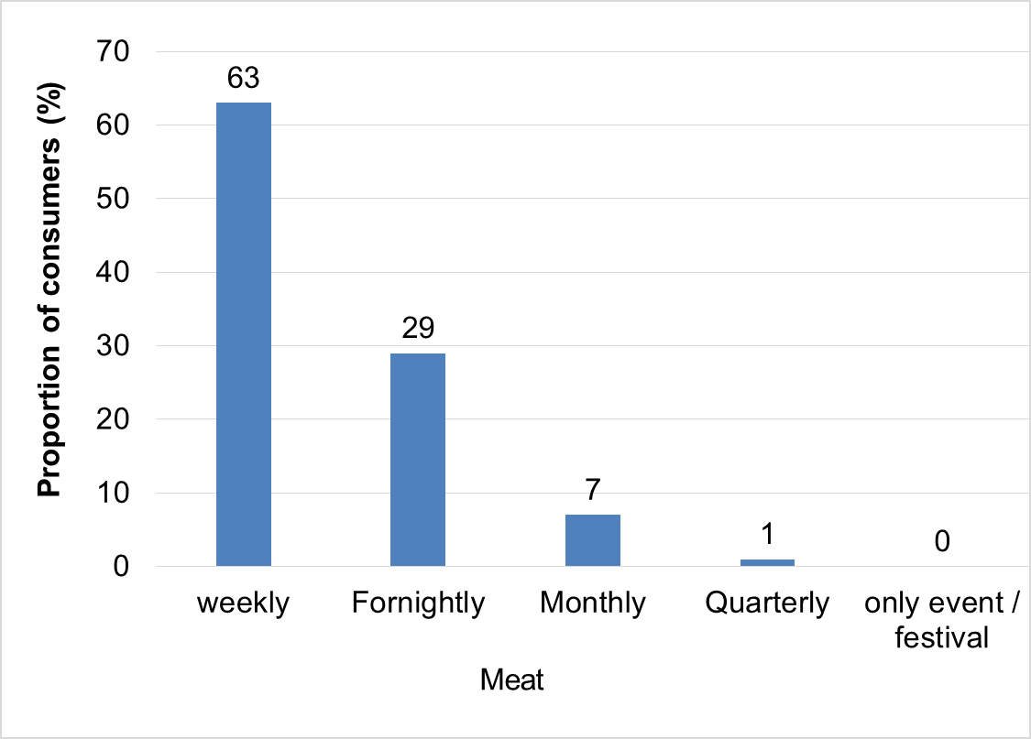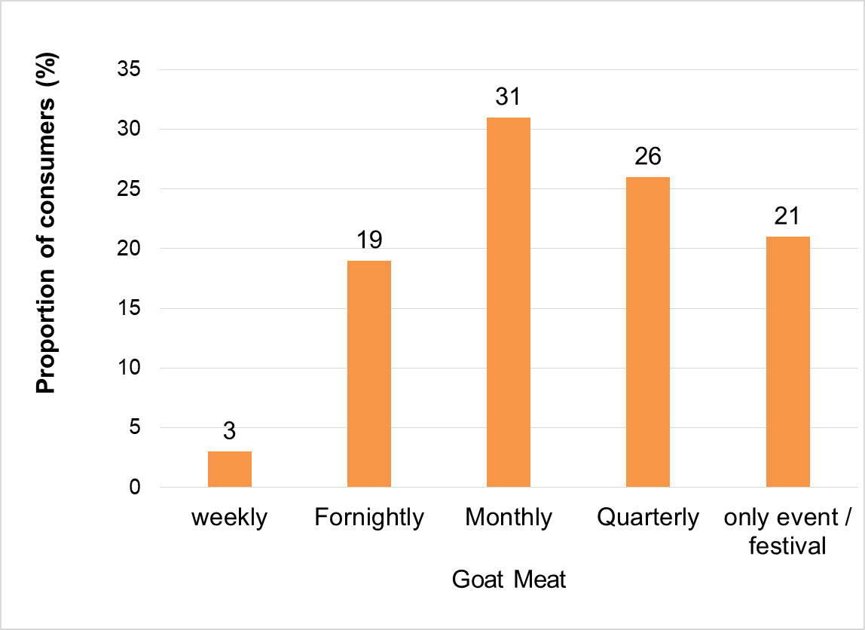

**Figure 3a Intake frequency of meat** (Source: Field Survey). **Figure 3b Intake frequency of goat meat**

Figure 4a describes the preferences over the type of goat meat. 61% liked the Khasi (castrated male goat) the most, 12% liked the young kid, and only 2% liked the Buck (male goat). 96% of consumers prefer live goats as a source of goat meat over the processed goat meat available in supermarkets (Figure 4b)

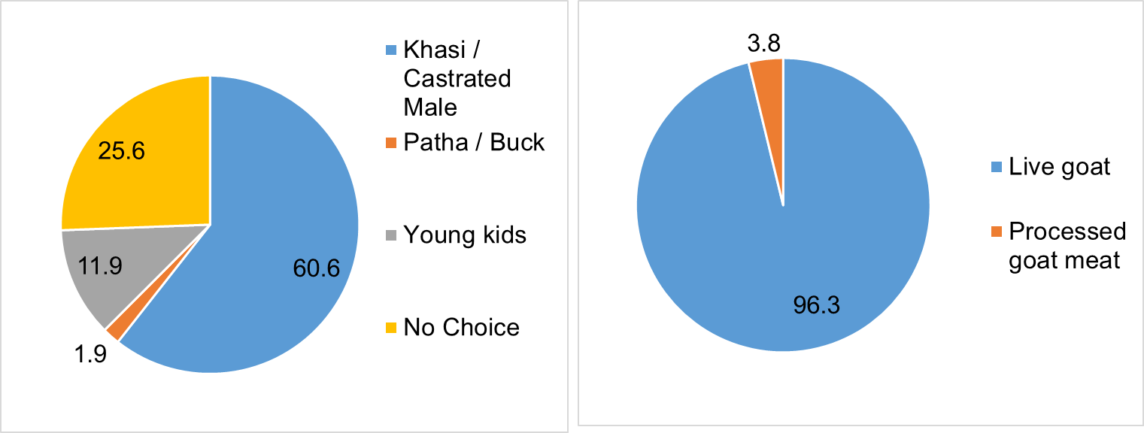

**Figure 4a Consumers preferences over goat meat type** **Figure 4b Consumers preferences over the source of**

**goat meat**

Figure 5 shows the frequency of goat meat purchases. 34% of the respondents purchased goat meat during festivals and special events, 31% purchased it monthly, 18% purchased it every other week (fortnightly), and 15% purchased it quarterly. Only 2% of consumers purchased goat meat weekly.

**Figure 5 Goat meat purchase frequency** (Source: Field Survey, 2019).

At the time of purchase of goat meat, 33% of respondents paid the most attention to the freshness, 31% to the safety of meat, 21% to taste, 10% to price, and 5% to fat content (Figure 6).

**Figure 6 Most considering points during purchasing of goat meat** (Source: Field Survey, 2019).

Information regarding goat meat purchase patterns, such as monthly meat consumption costs, the distance between consumers' homes and the meat shop, and the usual time required by consumers to return home after purchasing meat, is shown in Table 2.

**Table 2 Consumers purchase and consumption behavior of goat meat**

|  |  |  |  |  |
| --- | --- | --- | --- | --- |
| **Variable** | **Category** | **Frequency** | **Percent** | **Mean±SD** |
| Amount of goat meat purchased in each time | small (<1.5 kg) | 94 | 59 |  |
| Medium (1.5- 3.0 kg ) | 64 | 40 | 1.5±0.7 |
| Large (>3.0kg) | 2 | 1 |  |
| Monthly consumption  cost for meat (BDT) | < BDT 1000 | 22 | 14 |  |
| BDT 1000-2000 | 104 | 65 | 1863±898 |
| BDT 2000-4000 | 29 | 18 |  |
| > BDT 4000 | 5 | 3 |  |
| Distance of meat shop  from home (km) | < 1 km | 80 | 50 |  |
| 1- 5 km | 71 | 44 | 2.4±2 |
| 6-10 km | 6 | 4 |  |
| > 10 km | 3 | 2 |  |
| Time required to return home after meat purchase (minutes) | <25 minutes | 78 | 49 |  |
| 25-50 minutes | 59 | 37 | 30.0±26.9 |
| 50-75 minutes | 18 | 11 |  |
| >75 minutes | 5 | 3 |  |
| Purchasing goat meat  from same shop | Yes | 69 | 43 |  |
| No | 91 | 57 |  |

(Source: Field Survey, 2019)

On average, 1.5 kg of goat meat was purchased by consumers each time. 59% of consumers purchased less than 1.5 kg of goat meat each time, whereas 40% purchased 1.5 – 3.0 kg, and only 1% of consumers purchased more than 3.0 kg of goat meat each time. Most consumers (65%) spent BDT 1000–2000 on their monthly meat consumption costs, followed by BDT 2000–4000 (18%), less than BDT 1000 (14%), and more than BDT 4000 (3%) as their monthly meat consumption expenses. 50% of respondents purchased meat from the nearest local meat shop (less than 1 km distance from home), whereas 44% from a 1-5 km distance, 4% from a 6-10 km distance, and 2% of consumers purchased meat from more than 10 km distant meat shop. 49% of respondents returned home within 25 minutes after purchasing goat meat, 37% returned home between 25 and 50 minutes, 11% returned home between 50 and 75 minutes, and 3% of consumers returned home after 75 minutes. 43% of them purchased from the same shop regularly, and 57% purchased goat meat from different shops. Consumers cited various reasons for purchasing goat meat from the same shop. 22% of respondents purchased meat from the same shop due to personal relationships fostered by long-term relationships with sellers, and sometimes they received a discount. 14% of consumers trusted the specific shop for its meat quality, and 2% of consumers sought fresh meat at a fair price and with optimal weight.

Out of 160 consumers who responded, only 17% reported eating at restaurants less than once a year. To eat in the restaurant, 32% visited quarterly, whereas 22% visited monthly, 21% visited during festivals, 6% visited fortnightly, and 2% visited weekly. In an open discussion, consumers expressed their preferences for Kacchi Biryani (a goat meat dish made with seasoned rice) at restaurants.

**3.3 Activities and hygienic condition of meat shops**

Most consumers (93%) agreed that the sanitation and cleanliness of slaughterhouses and meat shops were important to obtaining fresh and quality goat meat. Figure 7 is a photo of the storefront of a meat shop. Meats hung bared, and there were flies. Therefore, the hygienic situation at the meat shops was not at a desirable standard.

**Figure 7 Hygienic condition of meat shop**

Figure 8 illustrates consumers' opinions on the most important aspects of sanitation and hygienic practices in slaughterhouses.

**Figure 8 Consumers opinion about the sanitation and hygienic practices of slaughterhouses** (Source: Field survey, 2019).

36% of respondents expressed the opinion that goats should be properly slaughtered in slaughterhouses, 29% focused on the point that meat should not be mixed with dung, and 28% emphasized the importance of clean and blood-free meat. Only 7% of consumers had no opinion regarding the importance of sanitation and cleanliness of slaughterhouses. Regarding the current situation, 52% of respondents believed they could obtain fresh meat from the market, while 48% did not think they could obtain fresh goat meat. Consumers' opinions about the freshness of purchased goat meat are shown in Figure 9. About 37% of respondents reported that the freshness of the meat was at an acceptable level, 25% responded that it was good, and 6% of consumers responded that it was perfect regarding the freshness of the purchased goat meat. On the other hand, 32% of respondents reported that the freshness of the goat meat was poor.

**Figure 9 Consumers opinion about the freshness of purchased goat mea**t (Source: Field survey, 2019).

From the observation at Mechua Bazar, a total of 25 consumers purchased meat from a shop on one weekday. The number of consumers increased in the weekly holidays. Out of 25 consumers, the number of male consumers was 23 (92%) and female was 2 (8%). In Bangladesh, shopping is under male’s responsibility. Though women also have come to go for shopping these days, but the shopping of meat is still dominantly under male’s responsibility.

**3.4 Consumers’ perception about the present distribution system of goat meat**

Consumers had various concerns about the goat meat supply chain. 52% had no concerns about the safety and quality of the meat. Others had specific expectations 17% wanted disease free healthy goats 14% wanted higher quality meat 9% wanted organic and natural production 8% wanted better hygienic conditions in slaughterhouses and meat shops to reduce contamination risks (Figure 10).

**Figure 10 Existence of concern about safe and quality goat meat by respondents** (Source: Field survey, 2019).

Table 3 shows consumer knowledge and perception on food safety. 88% believed farmers sometimes use hormones, growth promoters or excessive antibiotics in animal production farming. 76% agreed that such practices are less common in goat meat production compared to beef and chicken production (Figure 11). Food safety awareness issues such as food borne illnesses (88%) and zoonotic diseases (49%) were high. 41% of respondents mentioned rough handling and transportation affects meat quality, shows there is a gap in consumer awareness. Out of 160 consumers who responded, only 52% believed they received fresh meat from the butchers, whereas 48% believed that butchers or meat sellers did not provide fresh goat meat at all times.

**Table 3 Consumer’s knowledge and opinion about various aspects of food safety regarding goat meat**

|  |  |  |  |
| --- | --- | --- | --- |
| **Statements** | **Category** | **Frequency** | **Percent** |
| Do you know that sometimes farmers use hormone, growth promoter or excessive amount of antibiotic  for rapid growth of animals (cattle, chicken and goats) | Yes | 141 | 88 |
| No | 19 | 12 |
| Do you agree with this statement, use of hormone or excessive antibiotic in goat meat production is less than beef and chicken meat production | Yes | 122 | 76 |
| No | 38 | 24 |
| Do you know that rough handling (Stress, injury) of live goat and uncomfortable transportation may affect the meat quality | Yes | 66 | 41 |
| No | 94 | 59 |
| Do you know that eating unhygienic goat meat may cause food poisoning, diahhoera which may lead you to death | Yes | 141 | 88 |
| No | 19 | 12 |
| Do you know about zoonotic disease (disease may transfer to man from animal) | Yes | 78 | 49 |
| No | 82 | 51 |
| Do you think at present situation, you get fresh goat meat from the market | Yes | 83 | 52 |
| No | 77 | 48 |

(Source: Field survey, 2019).

Consumers believed that goat meat sellers tried to cheat buyers in various ways, such as providing less weight, mixing fat with flesh meat, mixing female meat with male goats, selling the previous day’s meat as current date meat, and mixing mutton meat with goat meat (Figure 11).

**Figure 11 Consumers concern on adulteration of goat meat by meat sellers (**Source: Field survey, 2019)

**3.5 Consumers’ opinion towards ensuring about getting safe goat meat from market**

Most respondents (96%) agreed that improving the goat handling system from farm to market, as well as ensuring stress-free transportation from market to slaughterhouses, was necessary for producing quality goat meat. To minimize the existing mismanagement by butchers, consumers provide free answers, focusing on the points outlined in Table 4.

**Table 4 Consumer’s opinion and activities to buy safe and quality goat meat from butchers’ shop**

|  |  |  |  |
| --- | --- | --- | --- |
| **S.L. No.** | **Consumers opinion and activities** | **Frequency** | **Percent** |
| 1 | Increase inspection | 43 | 27 |
| 2 | Purchase goat meat from known butchers | 27 | 17 |
| 3 | Slaughter goat in presence of customers | 27 | 17 |
| 4 | Live goat purchase by group or individual | 18 | 11 |
| 5 | No idea | 13 | 8 |
| 6 | Effective Supervision | 9 | 6 |
| 7 | Improvement of Hygienic condition the of slaughterhouse | 7 | 4 |
| 8 | Improve knowledge and awareness of consumers about good quality | 6 | 4 |
| 9 | Improvement of facilities of slaughterhouse and meat shop | 5 | 3 |
| 10 | Development of any easy and quick test | 5 | 3 |
|  | Total | 160 | 100 |

(Source: Field survey, 2019)

Approximately 27% of consumers focused on increasing inspection by concerned authorities of the slaughterhouses and meat shops, 17% preferred to buy goat meat from reliable butchers, and 17% preferred to buy goat meat from butchers who slaughtered goats in front of them (Table 4). 11% of respondents reported that they have ever purchased live goats individually or in groups to ensure fresh goat meat consumption. Consumers also emphasized the need for effective supervision, enhanced knowledge and awareness among the public, and improvements in facilities and hygienic conditions of slaughterhouses and meat shops. Moreover, 3% of respondents expected the invention of an easy and quick test to determine the quality of goat meat.

**3.6 Consumers’ opinions to pay more prices for safe goat meat**

Figure 12 ilustraste the level of extra pay consumer’s desire for safe goat meat.

**Figure 12 Level of extra pay for safe goat meat production** (Source: Field survey, 2019)

Most respondents expressed a positive response to paying extra money for safe and quality goat meat, even though the current price of goat meat is higher than that of other types of meat. In response to the level of extra pay for safe meat, 31% of respondents were willing to pay an additional BDT 50 per kg of goat meat, whereas 41% were willing to pay an additional BDT 75, and 19% were willing to pay an additional BDT 100. 9% of consumers were not interested in paying extra money for safe goat meat.

**3.6 Relationship of consumers’ socio-demographic condition with meat consumption and their perceptions of food safety and opinions to pay.**

**3.6.1 Socio-Demographic Factors and Meat Consumption Patterns**

Table 5 highlights the relationships between socio-demographic conditions and meat consumption behaviors.

The correlation coefficients demonstrate a significantly weak positive relationship among the following variables: the coefficient of correlation between age and their average monthly income was found to be 0.326 ** (at the 0.01 level of significance).

The findings indicate that the age of the respondents has a significant positive relationship with their average monthly income, implying that the age of the respondents increases with the increase in average monthly income among them. There is also a positive relationship between age and the amount of meat bought (kg) each time, education, and the monthly average income, and the monthly average income and the amount of goat meat bought (kg)/each time. Consumers with a high monthly income spend more money on meat than others, as well as buy more meat each time, because a positive relationship is found between the amount of goat meat bought (kg) each time and the monthly consumption cost for goat meat.

**Table 5 Relationship between socio-demographic condition and meat consumption**

|  |  |  |  |  |  |  |
| --- | --- | --- | --- | --- | --- | --- |
| **Pearson Correlation** | | | | | | |
|  | Age | Education | Monthly average income | Most preferred type of meat | Amount of goat meat bought (kg)/each time | Monthly consumption cost for meat/goat meat |
| Age | 1 |  |  |  |  |  |
| Education | -0.095NS | 1 |  |  |  |  |
| Monthly average income | **.326\*\*** | **.435\*\*** | 1 |  |  |  |
| Most preferred type of meat | -0.045NS | 0.088NS | 0.031NS | 1 |  |  |
| Amount of goat meat bought (kg)/each time | **.196\*** | **.223\*\*** | **.316\*\*** | 0.023NS | 1 |  |
| Monthly consumption cost for meat/goat meat | 0.115NS | 0.154NS | **.325\*\*** | -0.022NS | **.322\*\*** | 1 |

NS Means not significant (P>0.05) ** Correlation is significant at the 0.01 level* Correlation is significant at the 0.05 level of significance, List wise N=160

**3.6.2 Socio-Demographic Factors and Food safety Perceptions Patterns**

The relationships between socio-demographic factors and food safety perceptions, as shown in Table 6, underscore the importance of education in shaping consumer awareness.

Table 6 shows the relationship between socio-demographic conditions and consumers' perceptions of food safety. There is no effect of age on knowledge regarding various aspects of safe animal handling and food safety. Educated individuals had concerns and knowledge about hygienic meat, the drawbacks of rough handling of goats during transportation, and awareness of zoonotic diseases. So, according to Pearson correlation analysis education has positive relation with some variables like concern about hygienic and safe meat,  opinion of no using hormone or excessive antibiotic in goat meat, rough handling of (stress, injury) live goat has effect on meat quality, unhygienic goat meat intake may cause food poisoning, diahhoera and knowledge about zoonotic disease. The monthly average income has a weak, positive, and significant relationship with concerns about hygienic and safe meat, but no significant relationship with other safety issues, such as rough handling of goats, unhygienic goat meat intake, and knowledge of zoonotic diseases. Consumers who expressed concern about the hygienic and safe handling of meat also showed a positive attitude towards other safety issues related to the goat meat distribution channel.

**Table 6 Relationship between socio-demographic condition and consumers perceptions of food safety**

|  |  |  |  |  |  |  |  |  |
| --- | --- | --- | --- | --- | --- | --- | --- | --- |
| **Pearson Correlation** | | | | | | | | |
|  | Age | Education | Monthly Average Income | Consumer’s concern about hygienic and safe meat | Opinion of no using hormone or excessive antibiotic in goat meat | Rough handling of (Stress, injury) live goat has effect on meat quality | Unhygienic goat meat intake may cause food poisoning, Diahhoera. | Knowledge about zoonotic disease |
| Age | 1 |  |  |  |  |  |  |  |
| Education | -0.095 | 1 |  |  |  |  |  | . |
| Monthly Average Income | .326** | 435** | 1 |  |  |  |  |  |
| Consumer’s concern about hygienic and safe meat | -0.052 | .577** | .201* | 1 |  |  |  | . |
| Opinion of no using hormone or excessive antibiotic in goat meat | -0.092 | .265** | 0.138 | .**250\*\*** | 1 |  |  | . |
| Rough handling of (Stress, injury) live goat has effect on meat quality | -0.016 | .442** | 0.133 | **.515\*\*** | **.206\*\*** | 1 |  |  |
| Unhygienic goat meat intake may cause food poisoning, Diahhoera. | -0.016 | .311** | 0.01 | **.180\*** | **.189\*** | **.283\*\*** | 1 |  |
| Knowledge about zoonotic disease | -0.014 | .525** | 0.142 | **.512\*\*** | **.287\*\*** | **.454\*\*** | **.335\*\*** | 1 |

** Correlation is significant at the 0.01 level* Correlation is significant at the 0.05 level of significance. List wise N=160

**3.6.3 Socio-Demographic Factors and opinion to pay for safe goat meat**

As presented in Table 7, positive opinion to pay a premium for safe goat meat showed a positive relationship with both education (r = 0.195, p < 0.05) and monthly average income (r = 0.207, **p < 0.01**). Table 7 illustrates the relationship between socio-demographic characteristics and consumers’ willingness to pay extra money for higher-quality goat meat. In this study, the coefficient of correlation between education and willingness to pay for safe goat meat was found to be 0.195* (at the 0.05 level of significance), indicating that education has a positive impact on willingness to pay extra for safe meat to some extent. There is also a positive relationship between the monthly average income and consumers’ willingness to pay extra money to get safe goat meat. Therefore, consumers with higher education and higher income expressed their opinion to pay extra money for safe goat meat.

**Table 7 Relationship between socio-demographic condition and consumers’ opinion to pay extra money to get more quality goat meat**

|  |  |  |  |  |
| --- | --- | --- | --- | --- |
| **Pearson Correlation** | | | | |
|  | Age | Education | Monthly average income | Consumers’ willingness to pay extra money to get safe goat meat ( as farmers, traders and butchers give opinion it required for safe meat production) |
| Age | 1 |  |  |  |
| Education | -0.095NS | 1 |  |  |
| Monthly average income | .326** | .435** | 1 |  |
| Consumers’ willingness to pay extra money to get safe goat meat ( as farmers, traders and butchers give opinion it required for safe meat production) | 0.046 | **.195\*** | **.207\*\*** | 1 |

NS Means not significant (P>0.05)

** Correlation is significant at the 0.01 level* Correlation is significant at the 0.05 level, Listwise N=160

**4. DISCUSSION**

In Bangladesh, shopping is often considered a male responsibility. Though women also have come to go shopping these days, the shopping for meat is still dominantly under males' responsibility. In this survey, the participation of female respondents (14%) was remarkable compared to their male counterparts (86%) involved in goat meat purchase. The middle-aged groups predominantly make purchasing decisions, reflecting their role as primary earners in households. Respondents were highly educated. Education levels among respondents were higher than the national average, with 67% attaining tertiary education, compared to the national tertiary education rate of 17.33% (BBS, 2018). Bafanda et.al (2017) also reported that middle-age and highly educated consumer are primarily responsible for meat purchase in their research on meat hygiene and associated health hazards awareness among consumers of Jammu District of Jammu and Kashmir, India.

The average family size of 4.8 individuals was slightly higher than the national average of 4.5 (United Nations, 2017). The urban or city is becoming a good choice for living day by day due to the country's rapid urbanization. This survey also indicated that some respondent works at the peri-urban or upazila level but live in an urban area. The average monthly income of Bangladeshi people was 13,258 BDT per month in 2017 (BBS, 2018), indicating that the respondents in this survey had a higher monthly income (BDT 22,519). Consumption decisions are heavily influenced by one’s degree of education and level of disposable income (Khara et al., 2021). Bangladesh is a country comprising several religious and ethnic groups, with the two major groups being Muslim and Hindu. Mymensingh district is also a favorable place for all types of religious people, which is why the proportion of Hindu consumers is found to be higher (12%) than the national level (9%).

This survey indicated that the majority of consumers preferred beef, goat meat, and chicken meat; however, they primarily consumed chicken meat due to its lower price and greater availability. The high consumption of chicken compared to other meat types could be attributed to its relatively low price (the most affordable type of meat available in the market) and typically convenient portions (Lamri et al., 2022). The goat meat intake frequency was lower than the total meat intake frequency of the respondent, but the goat meat intake frequency was higher on the occasion of different events or festivals. Goat meat is the ultimate choice for various official parties, birthday celebrations, wedding ceremonies, picnics, and even religious programs of both Muslims and Hindus. In Bangladesh, these two major religious communities live as neighbors throughout the country and actively participate in each other’s programs. The Hindu community cannot consume beef due to religious barriers, and goat meat is a compulsory item in festivals and various events.

Respondents of this study did not want to buy goat meat from supermarkets. Li (2012) studied consumers’ behavior when purchasing quality and safety beef and reported that those with higher education were more likely to buy meat from supermarkets in China. By contrast, Kiran et al. (2017) reported that 46.5% of respondents purchased meat from a meat shop. In contrast, only 4.7% purchased it from a supermarket, despite 72.7% of consumers having a tertiary level of education. These are the standard consumption practices observed in the South Asian countries. The price of meat and income level also affect meat consumption (Liang et al., 2014). Most consumers can only judge the color and appearance of meat to evaluate its freshness during the purchasing process (Li, 2012). It is better to return home just after finishing the shopping to keep the meat fresh.

The hygienic condition of a meat shop is also important for supplying fresh goat meat. In this regard, the satisfaction level of consumers should be high or above average in terms of quality. Consumers expressed their dissatisfaction with the hygienic conditions in butcher shops and strongly emphasized the need for regular inspections by local authorities. About 36% of respondents recognized proper slaughtering practices in slaughterhouses as a key sanitation priority, while 49% demonstrated awareness of zoonotic diseases (diseases that can be transmitted from animals to humans). These concerns highlight a growing awareness of foodborne and animal-origin health risks. These results align with Bafanda et al. (2017), who reported that 32.5% of consumers in Jammu and Kashmir prioritized hygienically slaughtered meat, and 66.7% were aware of zoonotic risks. Together, these findings highlight rising consumer demand for safer meat handling and disease prevention in both Bangladesh and similar contexts. These findings underscore the urgent need for improved slaughterhouse practices, hygiene enforcement, and public education on food safety. Hasan et al. (2024) recently carried out a knowledge, attitudes, and practices (KAP) survey study of 408 meat handlers in Bogura, Bangladesh. They found that 70.7% of the meat handlers possessed good hygiene knowledge yet only 49.8% possessed good meat-handling practices. These sorts of discrepancies place pressures on consumers to push higher hygiene standards at the retail level.

Trust is considered to be a precondition for exchange (Fischer et al., 2006). One of the primary objectives of food safety measures is to enhance consumers' trust in food and alleviate uncertainty; therefore, information regarding meat quality and safety must be provided to consumers (Gellynck et al., 2006). The meat sellers should be considered in consumers’ trust by avoiding malpractices or cheating activities. Like with Mwangi et al. (2021) in Kenya, the consumers in this study also demonstrated a lack of trust regarding meat hygiene due to poor regulation and operation in the informal market. This finding highlights the necessity of much stronger control in traditional meat supply chains. Consumers also try to ensure the quality of meat through various activities, such as purchasing goat meat from reputable butchers, or meat from goats slaughtered in the presence of consumers, or purchasing live goats by group or individually. Although these activities have a positive impact on meat safety and may foster new networking based on trust, they are not sustainable for a large number of consumers. The active involvement of the government/concerned authorities may improve the situation, as some consumers gave their opinion about adequate supervision.

The price of goat meat is higher than beef and chicken. So, it is not easy for consumers of different income groups to express positive response to pay extra price for safe meat. Consumers having better education and high salary show more interest to pay extra money for safe goat meat which indicates that consumers’ economic capability has direct impact on response to extra pay.

This study revealed several weak but notable correlations between socio-demographic characteristics, meat consumption patterns, food safety perceptions, and the understanding of paying for premium quality goat meat. Consumers with better economic conditions tend to prioritize larger purchases, which may include higher-quality meats. Consumers with heightened awareness of one food safety issue are more likely to be knowledgeable about other related concerns, suggesting that integrated educational campaigns could effectively address multiple aspects of food safety. Respondents who were educated and those with higher incomes were more likely to invest in premium-quality meat, reflecting a direct link between socio economic capacity and consumer preferences.

This behavior aligns with global trends, where financially secure and better-educated consumers prioritize food safety and quality, even at higher prices. The findings suggest that policies and initiatives targeting affordability and accessibility could ensure safe goat meat for consumers across all socio-economic groups. For example, subsidies or tiered pricing strategies could cater to lower-income segments while maintaining safety and quality standards.

5. Conclusion

Goat meat is very popular but consumption is limited due to high price. Despite that goat meat has cultural and social value, it’s an essential item for festivals and special occasions. The study found that consumers are not aware of meat safety and therefore not concerned about goat meat safety. Moreover, dissatisfaction with the hygiene of butcher shops and butchers’ behavior has led some consumers to buy goats directly from farmers to ensure freshness and quality.

Regular inspection by technical personnel from local government is very important to improve the safety and hygiene of meat shops. Good to see that most consumers are willing to pay extra for safe and quality goat meat, that’s a growing trend of food safety.

These findings can help to raise awareness of local consumers about food safety and bring positive behavioral change in traditional meat markets especially in developing countries. Bangladesh government should take proactive step to promote safe handling of goats and establish a monitoring system throughout the supply chain from live goat markets to meat shops. That’s the only way to ensure availability of safe and quality goat meat for all.

Competing interests

The authors whose names are listed below certify that they have no affiliation with or involvement in any organization or entity with any financial interest (such as honoraria, membership, employment or any other equity interest; expert testimony), or non-financial interest (such as personal relationship, affiliations) with respect to the research, authorship, and /or publication of this article.

**Disclaimer (Artificial intelligence)**

Author(s) hereby declare that generative AI technologies such as Large Language Models (Chat GPT, Gemini 2.5 flash etc. have been used during the editing of manuscripts. Details of the AI usage are given below:

1. Check the grammar and spelling especially in abstract, discussion and conclusion.

2. Reformatted the objectives to increase readability.

3. Authors declared that The AI technology only use for grammar check and language improve the manuscript not for generating any kind of text, image.

References

Alam, M., K. (2019). The changes and present situation of goat meat production and distribution system through comparison with other meats in Bangladesh. Report on Agricultural Economic Studies, 50, 1-11.

Bafanda, R. A., Khandi, S. A., Minhaj, S. U., & Khateeb, A. M. (2017). Meat Hygiene and Associated Health Hazards Awareness among Consumers of Jammu District of Jammu and Kashmir. *Current Journal of Applied Science and Technology*, *23*(3), 1–11. https://doi.org/10.9734/CJAST/2017/36045

BBS (2011). Bangladesh population and housing census, 2011, National Volume 2, Union Statistics, Bangladesh Bureau of Statistics, Statistics Division, Ministry of Planning, Government of the people`s republic of Bangladesh, Dhaka, Retrieved from<http://203.112.218.65:8008/WebTestApplication/userfiles/Image/National%20Reports/Union%20Statistics.pdf>

BBS (2018). Statistical Year Books. Bangladesh. Bangladesh Bureau of Statistics, Statistics Division, Ministry of Planning, Government of the people`s republic of Bangladesh, Dhaka.

Delgado, C. L. (2003). Rising consumption of meat and milk in developing countries has created a new food revolution. The Journal of Nutrition, 3907S–3910S.

Fischer, C., Gonzalez, M., Henchion, M., & Leat, P. (2006). Factors influencing trust -supporting mechanisms in European afri-food chains. In proceedings of the 99th European seminar of the EAAE on Trust and risk in business networks’ (pp. 63-72). Bonn, Germany: University of Bonn.

Gellynck, X., Verbeke, W., & Vermeire, J. (2006). Pathway to increase consumer trust in meat as a safe and wholesome food. Meat Science 74, 161-171

Gellynck, X., Verbeke, W., & Viaene, J. (2004). Quality management in the food supply chain: how does the food industry interact with consumers, retailers and public authorities? In G. Schiefer & U. Rickert (Eds.). Quality assurance, risk management and environmental control in agriculture and food supply networks, Germany: Universita ̈t Bonn-ILB. Vol. B, 443–452.

Hamad, B., Hadef, L., Bellabidi, M. and Chaib, S. (2025). Effect of Consumers’ Attitudes and the Factors Related to Socio-demographic and Economic Context on Goat Meat Consumption Willingness. Asian Journal of Dairy and Food Research. 44(3): 369-374. doi: 10.18805/ajdfr.DRF-418

Hasan, M. A., Uddin, M. B., & Ahmed, S. S. U. (2024). Knowledge, attitudes and practices of meat hygiene among slaughterhouse workers and retail meat sellers in Bangladesh. Heliyon 10 (2024) e40066 <https://doi.org/10.1016/j.heliyon.2024.e40066>

Hossain, M., Heinonen, V. & Islam, K.M. (2008). Consumption of foods and foodstuffs processed with hazardous chemicals: a case study of Bangladesh. International Journal of Consumer Studies, 32(6), 588–595.

Ishra, R., Khanam, R., & Soar, J. (2022). Influence of food safety concerns on safe food purchasing at rural and urban consumers in Bangladesh. *Appetite*, *179*, 106306. <https://doi.org/10.1016/j.appet.2022.106306>

Islam, M., J., Sayeed M., A., Akhtar, S., Hossain, M., S. & Liza, A. (2018).　Consumers profile analysis towards chicken, beef, mutton, fish and egg consumption in Bangladesh. British Food Journal, https://doi.org/10.1108/BFJ-03-2018-0191

Khara, T., Riedy, C. & Ruby, M. B. (2021). A cross cultural meat paradox: A qualitative study of Australia and India. Appetite, 164, 105227.

Kiran, M., Nithin Prabhu, K., Paramesha, S. C., Rajshekar, T., Praveen, M. P., Punitkumar, C., Puneetha, S. C., Kumar, R., Rahul, Y. & Nagabhushan, C (2017). Consumption pattern, consumer attitude and consumer perception on meat quality and safety in Southern India. International Food Research Journal 25(3), 1026-1030.

Lamri, M., Djenane, D., & Gagaoua, M. (2022). Goat meat con­sumption patterns and preferences in three provinces of Kabylia region in Algeria compared to other meat species: Results of an online survey. *Meat Technology*, *63*(2), 96–108. https://doi.org/10.18485/meattech.2022.63.2.3

Li, F. (2012). A study on behavior of consumer’s purchase quality safety beef – based on the survey in Jilin province (Master’s thesis). Retrieved on March 27 2016: http://www.cnki.net/KCMS/detail/ detail.aspx?QueryID=4&CurRec=1&recid= & filename=1013126799.nh&dbname=CMFD201301&dbcode=CMFD&pr=&urlid=&yx=&v=0NjRSTCtmWWVkbUZ5 MjQemtWcjNNVkYyNkhiSzZ .

Liang, D., Li, T. & Gai, L. (2014). Characteristics and influencing factors of rural resident’s beef consumption. Food and Nutrition in China 20(5), 50-52.

Mwangi, K., Gathecha, G., Nyamongo, M., Kimaiyo, S., et al. (2021) Reframing Non-Communicable Diseases and Injuries for Equity in the Era of Universal Health Coverage: Findings and Recommendations from the Kenya NCDI Poverty Commission. Annals of Global Health, 87, 3. https://doi.org/10.5334/aogh.3085

Sarma, P.K. (2017). Determinating Consumers` preference and Willingness to Pay Premium Price for Organic Beef in Bangladesh. International Journal of Science and Research (IJSR), Volume 6, Issue 9, September 2017.

United Nations Educational, Scientific and Cultural Organization. (2017). Country Profile, Bangladesh. UNESCO Institute for Statistics: Montreal, Quebec, Canada. Retrieved from <http://uis.unesco.org/country/BD>

Wu, Q. & Xiao, H. (2013). Characteristics and influence factors of mutton consumption of China’s urban and rural residents. Agricultural Outlook 8, 71-75

Yanwei, M., Hopkins, D. L., Zhang, Y. &Luo, X. (2016). Consumption Patterns and consumer attitudes to beef and sheep meat in china. American Journal of Food and Nutrition 4(2), 30-39.

Zhang, H., Sun, S. and Feng, Y. (2014). Analysis of mutton consumption habit and buying behavior in urban and rural area. Xinjiang State Farms Economy 1, 46-51.