Original Research Article

Echoing the Voices of Teachers Beyond Specialization: The Lived Experiences of Non-Tle Teachers in Teaching Tle Subjects

ABSTRACT
Out-of-field teaching has been a common problem in many countries. Teaching outside their area of specialization can profoundly affect their instructional effectiveness, as they are essentially novices in that subject. This study explored the lived experiences of non-TLE teachers teaching Technical and Livelihood Education (TLE) subjects. It sought to gain a deeper understanding of the participants' experiences and explore the coping strategies they employ to navigate the challenges they face. This study utilized a phenomenological approach as its research design. The data were gathered from three (3) participants through In-depth Interviews (IDI) and Focus Group Discussions (FGD). Thematic analysis, following the Braun and Clarke framework, was used for data analysis.Results revealed that participants' experiences in the study emerged into two main themes:Teaching Beyond the Comfort Zone and Struggles to Meet Teaching Demands. Meanwhile, regarding coping with the challenges encountered by the non-TLE teachers teaching TLE subjects, two main themes were formulated: Collaborative Growth in the Face of Resource Challenges and Turning Doubt into Growth. The findings indicate that non-TLE teachers encountered significant challenges while teaching TLE subjects outside their area of expertise. These challenges included a lack of specialized knowledge, insufficient resources, and limited access to necessary equipment.This study highlights non-TLE teachers' challenges when teaching outside their expertise, including limited resources, insufficient knowledge, and pressure to adapt to new curriculum demands. The key recommendation emerging from this study is the implementation of targeted professional development and mentorship programs to address these issues. To further empower non-TLE teachers and ensure quality education delivery in TLE subjects, collaboration, professional development, mentorship, and technology integration are crucial.

Keywords: Non-TLE teachers, out-of-field teaching, lived experiences, TLE (Technology and Livelihood Education), teaching challenges.

1. INTRODUCTION
Teachers often find themselves in positions or subjects that do not correspond with their areas of specialization or training. Teaching courses outside their area of expertise is known as “out-of-field teaching,” it can result in problems like low student interest, a lack of resources, and inadequate content knowledge (Mercado &Morante, 2024). Additionally, the dearth of on-field teachers’ schools is compelled to hire out-of-field teachers to fill in the need; however, in the long run, it does not solve the actual need. The problems arising from teacher shortages are compounded by unqualified teachers being hired while there are too few qualified personnel to fill classrooms. These less qualified teachers were not randomly assigned, as were the students who could best learn independently and had the most resources to learn at home (Carothers et al., 2019). This can cause problems with professionalism, student safety, and learning outcomes, which can eventually affect the standard of instruction and the professional identities of teachers. as claimed by Nakar and Du Plessis (2023).
Due to the “structural teacher shortage” issue in many primary schools, which hinders these teachers’ professional development, there have been many instances of out-of-field teaching in China in recent years (Ma, 2024). Furthermore, due to insufficient training and credentials, teachers in Canada encounter difficulties when instructing students in subjects outside of their areas of expertise. This can hinder their ability to teach those subjects effectively (Hobbs andPorsch, 2021).
In the Municipality of Kidwalan, Davao del Sur, non-TLE teachers who are teaching TLE subjects had a difficult time in their current teaching careers because the subjects they are teaching are outside of their area of expertise, and they lack the necessary resources and equipment to effectively teach TLE subjects (TingzonandBuyok, 2022). Moreover, in Cebu City, the teaching process suffers when instructors are not qualified. When planning and executing their lessons, these social studies teachers operating outside their field face various challenges (Pacana et al., 2019). After the findings of the Second Congressional Commission on Education (EDCOM 2), which showed that 62% of educators teach subjects in which they did not major in college (Press Release - EDCOM 2: DepEd to Address Teacher Mismatch, Quizzed on Low Utilization Rate in House Budget Hearing, 2024).
Furthermore, in the locality of Tagum City Davao del Norte, non-TLE teachers are teaching TLE subjects despite not possessing all the competencies of a fully qualified TLE teacher. Some acquired TLE competencies through experiences, peer tutorials, self-study, social media and other technology. Despite these initiatives, teachers remain problematic (TingzonandBuyok, 2022). A mismatch between duties and abilities in the position negatively affects the macroeconomic and microeconomic productivity levels at work (Taripe, 2024).
The researchers perceive a dearth of research on the challenges faced by non-TLE teachers instructing TLE topics in Tagum City Davao del Norte. This research must immediately be done, since employing teachers who are not specialists in their field can impede the delivery of high-quality instruction. This study aims to advance knowledge about the challenges faced by non-TLE teachers and their coping mechanisms.
Similar to prior research, this study examines the experiences of non-TLE teachers assigned to TLE subjects. While past research highlights emotional struggles and calls for systemic reform, this study focuses on practical challenges such as inadequate preparation, curriculum demands, limited resources, and shifting self-efficacy. Unlike broader analyses, it aims to improve teaching effectiveness and job satisfaction within the existing educational framework.
2. OBJECTIVES
This study aims to explore the lived experiences of non-TLE teachers teaching TLE subjects. Specifically, this research sought to answer the following questions: 1. What are the experiences of non-TLE teachers in teaching TLE subjects?2. What strategies did the school employ to support non-TLE teachers to effectively teach the TLE subject?3. How do teachers' perceptions of self-efficacy and career interests shift when assigned TLE subjects outside their area of expertise?
3. MATERIALS AND METHODS
3.1 Research Design
This study employs a qualitative, phenomenological approach to explore the experiences of non-TLE teachers teaching TLE subjects. Qualitative research focuses on context, perspective, and meaning to interpret complex social phenomena (Lim, 2024). Phenomenology seeks to understand the universal essence of a phenomenon by examining individuals’ lived experiences while setting aside researchers’ biases (H, 2023).

3.2 Research Instruments
The primary research instrument used in this study was an interview guide composed of open-ended questions aimed at gathering insights from non-TLE teachers handling TLE subjects in the Division of Tagum City.

3.3 Respondents of the Study
The study involved teachers from the Division of Tagum City, Department of Education (DepEd), who hold a baccalaureate degree and have at least two to three years of experience teaching TLE subjects. Both male and female teachers were included as participants.

3.4 Data Gathering
The following are the methods that were utilized in data collection:
To shed light on issues and offer answers, such as formulating a hypothesis or assessing a result, data collection is the process of obtaining reliable information from a variety of sources, evaluating it, and using it to assess potential outcomes, trends, and problems in research (Simplilearn, 2023). Focus Group Discussions (FGDs) with smaller participant groups (3-5 individuals) can significantly enhance the depth and quality of qualitative data collected. This approach fosters a more intimate environment, encouraging participants to share their insights more freely (Masriwati et al., 2024). Smaller groups also minimize digressions, allowing for focused discussions that yield richer data (Pérez & Pérez, 2024).

Before Interview

The data collection procedure for this study followed the following arrangements:
1. Made sure to secure approval from the dean.
2. Submitted the Interview Guide to the validators.
3. Informed the participants and asked their permission to participate
4. Ask the school where they are connected for approval.
5. Ask the participants to audiotape their responses for verification.

During Interview

The participants were asked three (3) significant research questions followed by probing questions to be answered. Face-to-face interviews were likely conducted in private settings to ensure discretion. Researchers emphasized confidentiality during interviews and reassured participants of the secure handling of their responses through encryption and data anonymization. In focus group discussions, ground rules were established to respect participant privacy and prevent the sharing of identifying information. Moderated discussions were facilitated to encourage open and honest dialogue. The set of questions is the same during the in-depth interviews.

After Interview

The researchers employed a six-phase coding system created by Braun and Clark (2006) to find the primary themes and patterns in the data. As part of this framework, they had to become acquainted with the data, generate codes, classify codes into themes, assess their significance, and present their findings.
The researchers transcribed the participants' audio responses and converted them to English. The researchers then supplied a letter for member verification. Participants were contacted and sent a letter requesting their opinions on the translated and transcribed responses. Furthermore, the participant responses were grouped and arranged according to topics.

3.5 Data Analysis

The researchers utilized Braun and Clark's 2006 thematic analysis, as citedby Nowell et al. (2017), as the primary method for analyzing qualitative data. This six-phase coding framework is a widely recognizedapproach for identifying,analyzing, and interpreting patterns and themes within qualitative data.Thematic analysis involves systematically identifying, analyzing, andinterpreting patterns and themes within qualitative data. This involves six key phases: 1) familiarization with the data; 2) generating initial codes; 3) searching for themes: 4) reviewing themes; 5) defining and naming themes, and 6) producingthe report (Caulfield, 2019).

4. RESULTS AND DISCUSSION
In-depth interviews were conducted and transcribed, including translations from the local language to English. To transcribe and translate the data, the researchers followed McMullin's (2021) method, carefully listening to the recordings and converting them into written text. A focus group discussion (FGD) was conducted to triangulate the data. The analysis involves three stages: data reduction, data display, and conclusion drawing, all rigorously verified. The transcriptions focused on the participants' perspectives, biases, and the credibility of their accounts to ensure the reliability and validity of the findings. Data reduction techniques were used to condense a large amount of data into manageable information (Moustakas, 1994; Creswell, 2012). This process, guided by the researchers' mentor, made extensive qualitative data more accessible for analysis.
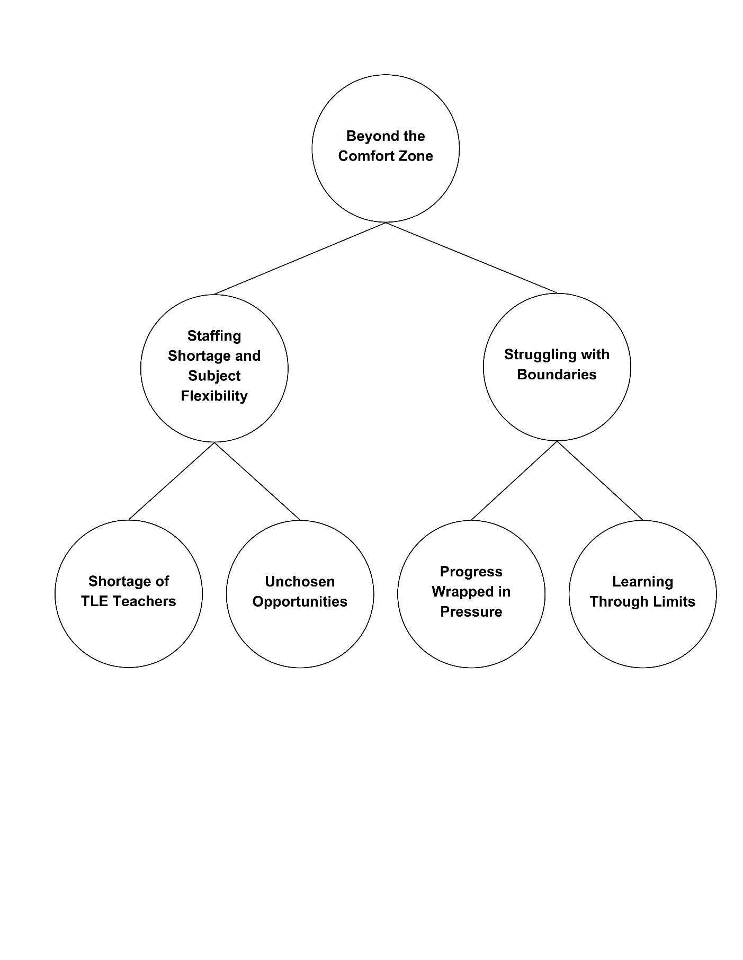
Themes and Sub Themes generated for Research Question No. 1.

Fig. 1. Emergent Themes, Categories, and Codes on the Lived Experiences of Non-TLE Teachers Teaching TLE Subjects
RQ.1 What are the experiences of non-TLE teachers teaching TLE subjects?
Lived Experiences of Non-TLE Teachers Teaching TLE Subjects.
Figure 1 presents the emergent themes, categories, and codes derived from the lived experiences of non-TLE teachers tasked with teaching TLE subjects. The overarching theme is that these educators often find themselves beyondtheir Comfort Zone.
In-depth interviews were conducted and transcribed, including translations from the local language to English. To transcribe and translate the data, the researchers followed McMullin's (2021) method, carefully listening to the recordings and converting them into written text. A focus group discussion (FGD) was conducted to triangulate the data. The analysis involves three stages: data reduction, data display, and conclusion drawing, all rigorously verified. The transcriptions focused on the participants' perspectives, biases, and their accounts' credibility to ensure the findings' reliability and validity. Data reduction techniques were used to condense a large amount of data into manageable information (Moustakas, 1994; Creswell, 2012). This process, guided by the researchers' mentor, made extensive qualitative data more accessible for analysis.
Theme 1: Beyond the Comfort Zone
Non-TLE teachers, thrust into unfamiliar territory, have been compelled to step beyond their comfort zones, embracing new challenges and honing unexpected skills. Acknowledging the potential difficulties that non-TLE teachers may face when venturing into unfamiliar territory is important. Balancing new responsibilities with existing commitments can be demanding, and the fear of failure may hinder their willingness to take risks. There are two (2) categories under this area: Staffing Shortage and Subject Flexibility and Innovating Strategies to Meet Student’s Diverse Needs. Non-TLE teachers stepping out of their comfort zone encounter difficulties due to a lack of expertise in specific subject areas. Some teachers also feel the fear of failure due to the new responsibilities.
Sub-theme 1: Staffing Shortage and Subject Flexibility
The growing shortage of TLE teachers has compelled schools to assign non-TLE teachers to fill the gap. Non-TLE teachers may lack the specialized knowledge and skills required to teach technical-vocational subjects effectively. Two codes are generated under this category: Shortage of TLE Teachers and Unchosen Opportunities. This situation highlights the increasing demand for teacher flexibility, as educators must often adapt to changing circumstances and teach subjects outside their primary area of expertise.
Shortage of TLE Teachers
The persistent shortage of TLE teachers poses a significant challenge to the quality of technical-vocational education in schools. This scarcity limits students' access to hands-on learning experiences, hindering their development of practical skills. Issues with teacher staffing are caused by numerous elements, such as the creation of new instructors in different professions, turnover, adjustments to curricula and student-teacher ratios, and the drawbacks of teaching generally and in particular areas (Sutcher et al., 2019).
A shortage of qualified TLE teachers significantly impacts the quality of vocational education. Generelao et al. (2021) emphasized that teacher quality is crucial for student learning. With fewer specialized instructors, students have limited access to hands-on training and practical skills development (Antera, 2023). This limits their ability to apply theoretical knowledge and explore diverse career paths. Moreover, teacher shortages negatively impact school operations, affecting staff morale, organizational stability, and student performance (Castro, 2022). Students miss valuable learning experiences and may be unprepared for the workforce.
Unchosen Opportunities
Driven by pressing economic concerns, many teachers are compelled to accept positions with the Department of Education, even if it means teaching subjects outside their expertise. This trend is particularly evident in Technology and Livelihood Education, where teachers who graduate in English, Science, or Math are tasked to teach TLE. While their dedication to education remains unwavering, the lack of specific training in this field may pose challenges in delivering quality instruction and preparing students for future endeavors. Teachers' attitudes towards teaching subjects outside their expertise varied, ranging from positive to negative. Regardless of their feelings, the challenge of teaching unfamiliar subjects remained (Tran, 2023).
Teachers assigned to teach areas outside of their expertise face several problems affecting their professional development. Teachers lack the in-depth knowledge and abilities required to deliver the curriculum effectively. This might lead to a less engaging and practical learning experience for students since they do not receive the necessary support. The teachers struggle to develop appropriate teaching practices and assessments that address the subject's needs, perhaps resulting in inferior student performance. Teaching outside one's expertise presents hurdles for teachers at every career stage. They must invest time and effort to learn new material and have a solid foundation in teaching techniques to effectively impart this knowledge to their students (Hobbs andPorsch, 2021).
Furthermore, teaching outside of one's area of competence can significantly impact a teacher's professional satisfaction and morale. Feeling unprepared or inexperienced to teach a specific subject can cause more stress and anxiety, affecting overall job performance. It may also limit a teacher's professional development and success by preventing them from specializing in a specific subject area.
Sub-theme 2: Struggling with Boundaries
Struggling with Boundaries highlights the challenges non-TLE teachers face in balancing their increased workload and responsibilities with their limitations in knowledge and skills. Non-TLE teachers often feel pressured to deliver effective TLE education despite needing more specific training and expertise in the subject area. Additionally, they may need more access to resources, time, and support, which can hinder their ability to acquire the necessary knowledge and skills to teach TLE subjects effectively. Two (2) codes arise in this area: 1.) Progress Wrapped in Pressure, and 2.) Learning Through Limits.
Stress from Adapting to New Content
The challenges of adapting to unfamiliar content and assessments often result in stress, anxiety, This code captures the urgency and pressure experienced by non-TLE teachers to deliver TLE education, often at the expense of their well-being and professional development. They may feel overwhelmed by the demands of the role, leading to feelings of stress, anxiety, and burnout. The difficulties brought on by adjustments to the curriculum's content and assessment are among the strains on teachers' jobs. Teachers have expressed high levels of stress and burnout due to the increased pressure from test-based accountability systems. There are connections between high teacher stress and absenteeism, burnout, school atmosphere, and behavior management. In order to lessen these detrimental effects, teacher stress interventions can be a crucial first step (Von Der Embse et al., 2019).
The pressure and unfamiliarity cannot be hidden despite the teachers' progress. They were thrust into an unfamiliar territory, grasping new concepts. The pressure of delivering quality instruction is a significant hurdle for the teachers. For the sake of their growth and the delivery of teaching, educators must embrace shifts (Culajara, 2023). As teachers adjusted to this new way of teaching, they felt stressed and overwhelmed. To make the most of these new teaching methods, schools need to continuously support teachers and provide them with training to help them become skilled and confident in using technology.
Learning Through Limits
Participants expressed challenges such as encountering unfamiliar terms and tools, feeling pressured by misaligned curriculum expectations, and experiencing restrictive monitoring and checks. While often frustrating, these limitations also highlight learners' resilience and adaptability as they strive to acquire new skills and knowledge. Many teachers lack the confidence and skills to teach new curricula effectively, which can lead to student confusion and frustration (Cheruiyot, 2024).
Teachers may feel overwhelmed by unfamiliar terms and tools, especially when they do not directly align with their chosen field of study. New tools and unfamiliar terms can overwhelm teachers, making it difficult for them to learn and implement new curricula. Because of their limited resources, out-of-field teachers must study a lot and look for peer tutoring. Despite early challenges, they improve their knowledge and teaching effectiveness by creating appropriate teaching strategies and using English for efficient communication (ArendainandLimpot, 2022). While external regulations and monitoring may ensure quality standards, they can stifle creativity and flexibility.
Themes, Sub Themes, and Codes generated for the Research Question No. 1. EXPERIENCES
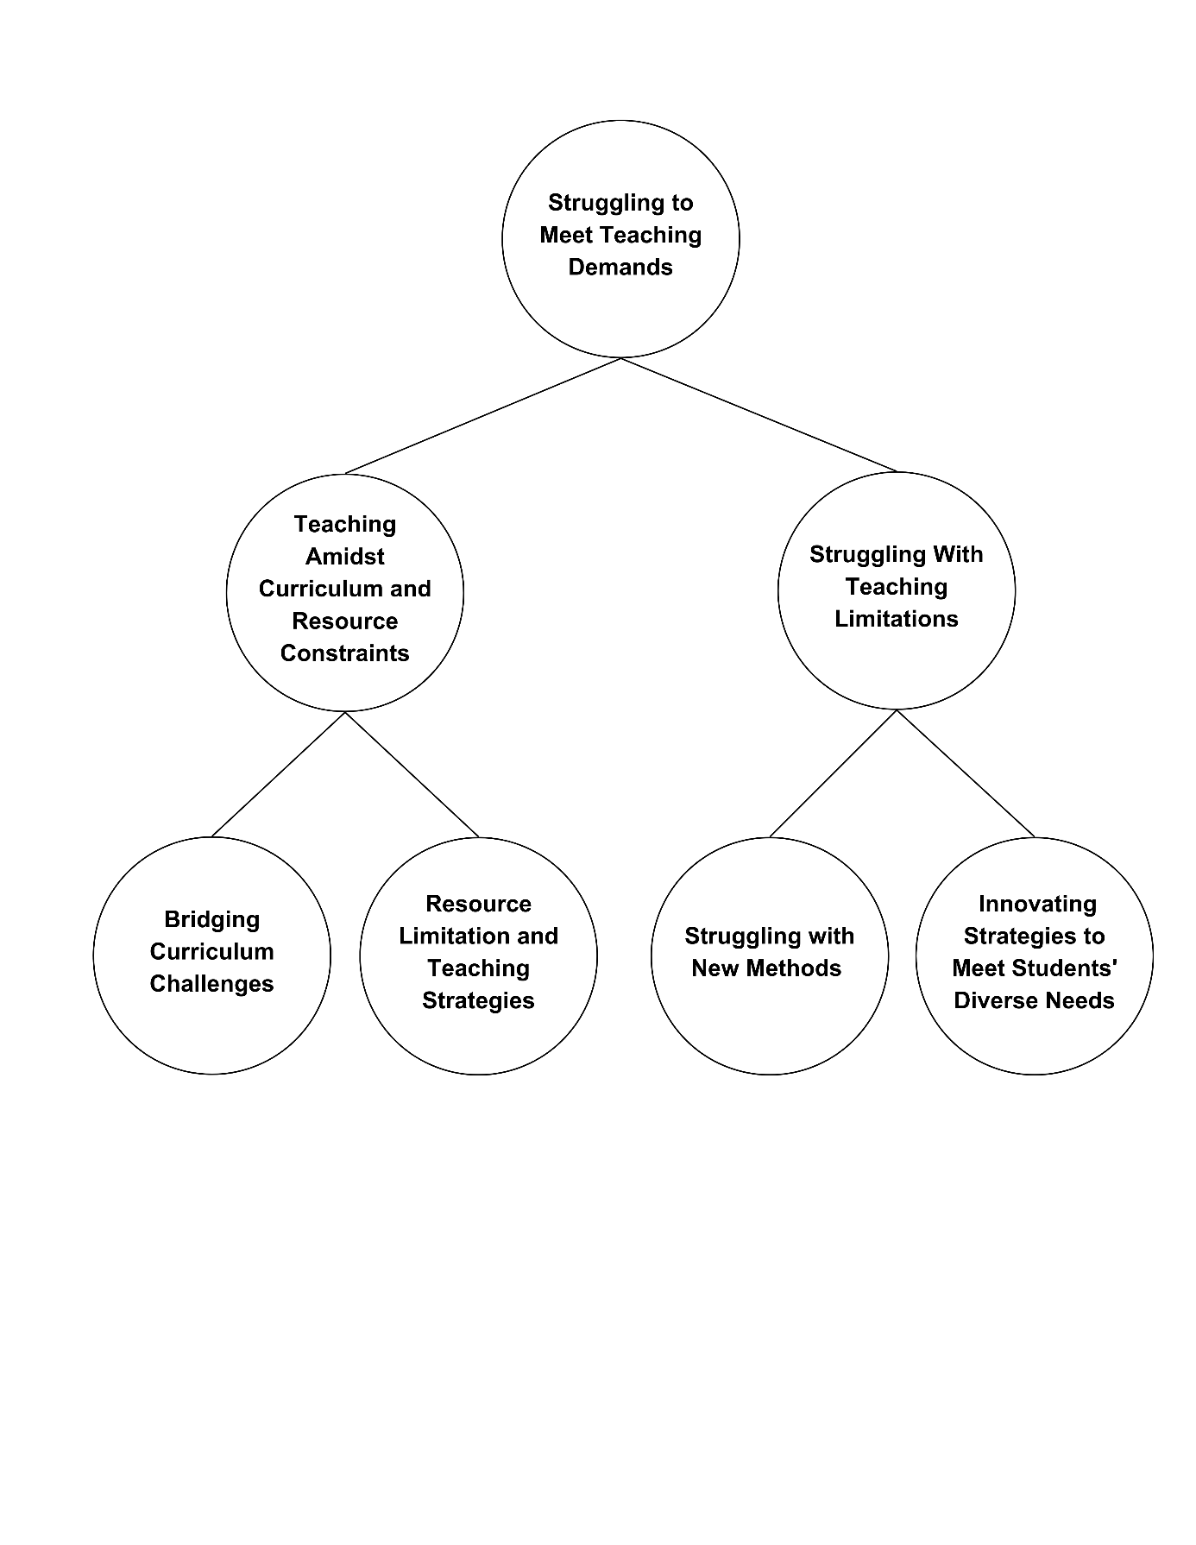

Fig. 2. Emergent Themes, Categories, and Codes on the Lived Experiences of Non-TLE Teachers Teaching TLE Subjects

RQ.1 What are the experiences of non-TLE teachers teaching TLE subjects?
Lived Experiences of Non-TLE Teachers Teaching TLE Subjects.
The second finding delves more into the challenges faced by non-TLE teachers in effectively teaching TLE subjects, focusing on the theme of Struggling to Meet Teaching Demands. The analysis reveals two (2) categories that emerged from the data: Teaching Amidst Curriculum and Resource Constraints and Struggling with Teaching Limitations.
Teaching Amidst Curriculum and Resource Constraints highlights the difficulties non-TLE teachers encounter in balancing the demands of the TLE curriculum with limited resources. Struggling with Teaching Limitations emphasizes the specific obstacles non-TLE teachers face in delivering effective TLE instruction. These limitations include a lack of subject matter expertise, inadequate pedagogical skills, and insufficient time for lesson preparation.
Theme 2: Struggling to Meet Teaching Demands
Participants described feeling overwhelmed by the demands of the TLE curriculum and the lack of resources. Frustration stemmed from insufficient training and support, making it difficult to address diverse learners’ needs effectively.
Sub-theme 1: Teaching Amidst Curriculum and Resource Constraints
Participants shared that they encountered significant challenges in implementing the new curriculum due to inadequate resources. The absence of sufficient references, especially for technical terms, hindered their ability to explain concepts to students effectively. This limitation was further compounded by the difficulty in assessing students' performance on tasks that required specialized knowledge. To address these challenges, teachers often relied on their expertise and online resources to develop instructional materials, which could be time-consuming and may not always meet the specific needs of their students.
Bridging curriculum challenges
Participants emphasized the difficulty of adapting to the new TLE curriculum, particularly due to limited time for learning and preparation (Pak et al., 2020), as shared by participants (IDI_2 and IDI_3). The lack of adequate references, especially for technical terms, further hindered their ability to explain concepts clearly and effectively to students.
Maffea (2020) emphasizes that inadequate resources create stress and hinder learning, underscoring the need for sufficient materials and targeted professional development.
Frequent curriculum changes pose challenges for teachers, making it hard to adapt strategies and plans. Thi et al. (2023) note that such transitions can affect teaching quality and professional growth.
Limited Resources and Teaching Strategies
Participants (IDI_2, IDI_3) shared limited time and insufficient administrative support affected their ability to create quality resources and assess technical tasks effectively (Jr &Sumeg-ang, 2023). As a result, teachers often used self-made materials from online sources, though these were not always curriculum aligned.
Teachers face difficulties implementing the new curriculum due to a lack of reference materials, especially for technical terms, making concept explanation harder (Ana et al., 2023). They also struggle to grade performance tasks outside their expertise and feel overwhelmed by the workload of creating and contextualizing instructional materials.
Sub-theme 2: Struggling with teaching limitations
Non-TLE teachers assigned to TLE faced challenges adapting to hands-on teaching and working beyond their expertise. They adjusted strategies, addressed diverse student needs, and relied on creativity and experience to deliver quality instruction despite limitations.

Struggling with New Methods
Participants (IDI_1 and IDI_2) shared challenges in adapting to TLE’s hands-on approach, often departing from traditional methods. Limited materials and equipment restricted practical lessons, leading teachers to rely on outdated strategies (TingzonandBuyok, 2022).Teaching outside one’s specialization, such as in TLE, requires educators to adapt their methods to meet curriculum demands. Limited resources often hinder effective instruction (Canoy et al., 2022).
Innovating Strategies to Meet Students' Diverse Needs
Participants felt uncertain and doubtful about teaching outside their expertise, but saw it as a learning opportunity IDI_1 and IDI_3). Despite the steep learning curve, they embraced continuous skill development (Grünwald, 2021).
Many experiences self-doubt, questioning their ability to teach unfamiliar subjects (Tran, 2023; Zaid et al., 2020). Still, this struggle can lead to professional growth as educators develop new strategies and expand their skills.
A shortage of subject specialists often forces teachers into roles they’re unprepared for, increasing stress and affecting learning quality. Limited resources and training make it harder to adopt innovative methods. Supporting diverse learners, especially those with special needs, requires institutional backing, family involvement, and ongoing professional development (Damyanov, 2024).

Themes, Sub-Themes and Codes generated for the Research Question No. 2. COPING MECHANISMS
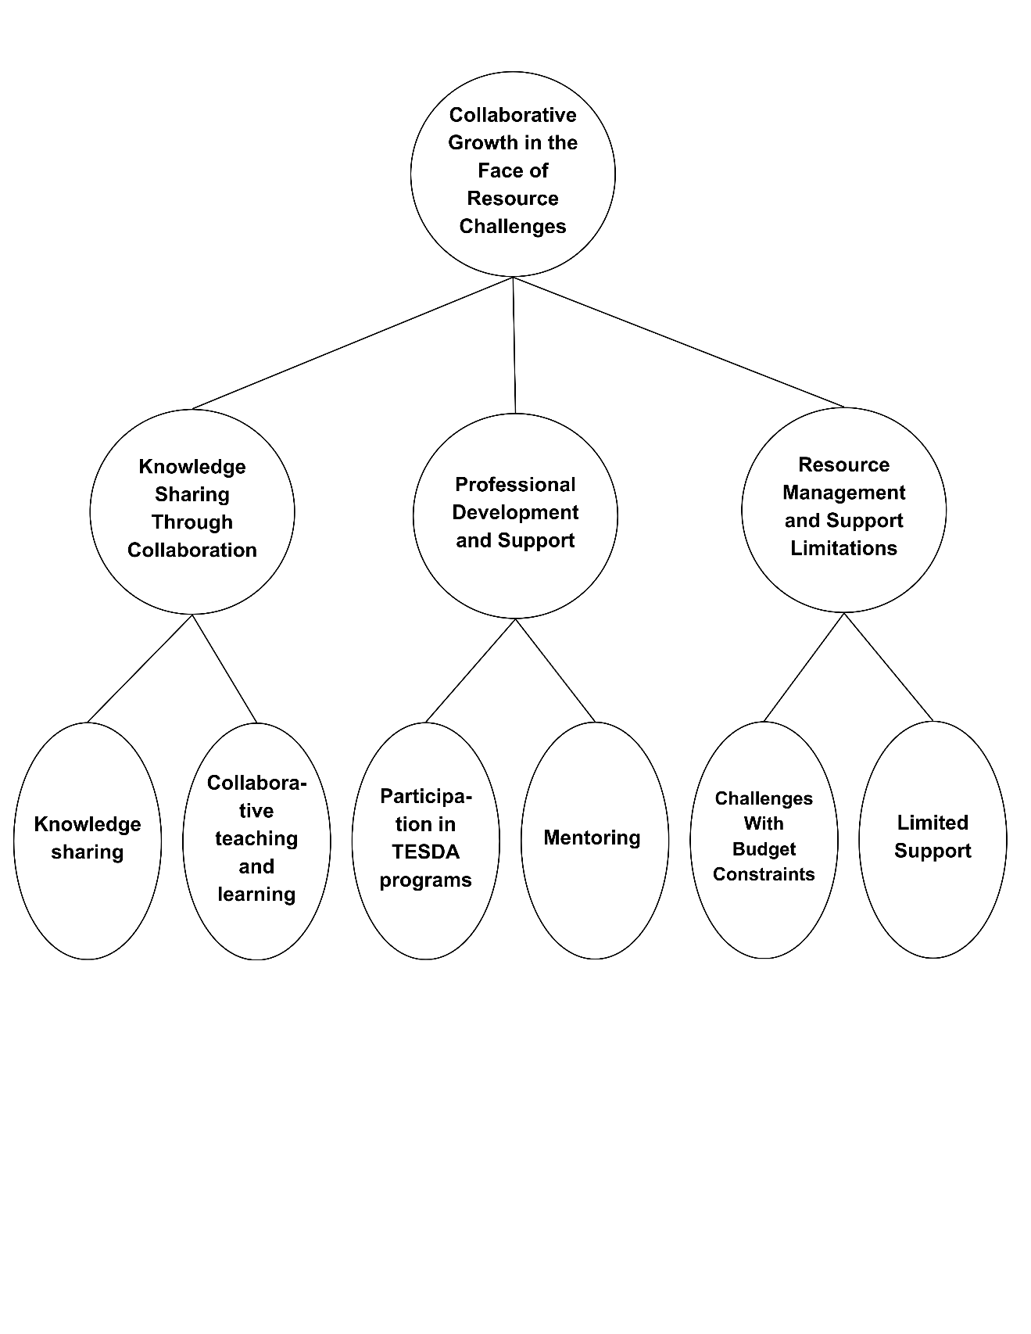

Fig. 3. Emergent Themes, Categories, and Codes on the Strategies Employ to Support Non-TLE Teachers in Effectively Teaching TLE Subjects
RQ. 2 What strategies did the school employ to support non-TLE teachers to effectively teach the TLE subject?
Strategies Employed to Support Non-TLE Teachers in Effectively Teaching TLE Subjects.
The second finding delves into the strategies employed to support non-technical-vocational-livelihood (TLE) teachers effectively teaching TLE subjects. The analysis reveals three (3) categories that emerged from the data: 1.) Knowledge Sharing Through Collaboration, 2.) Professional Development and 3.) Support, and Resource Management and Support Limitations.
Knowledge Sharing Through Collaboration highlights the significance of collaborative teaching and learning among educators to exchange expertise and best practices. Professional Development and Support emphasize the need for ongoing training and mentoring to equip non-TLE teachers with the necessary skills and knowledge to teach TLE effectively. Resource Management and Support Limitations highlight the need for innovative strategies to maximize available resources and address non-TLE teachers' specific needs.
Theme 1: Collaborative Growth in the Face of Resource Challenges
Participants highlighted the importance of teacher collaboration as a crucial strategy to address resource constraints. They emphasized sharing expertise, lesson plans, and innovative teaching techniques. By working together, teachers can pool their resources, reduce workload, and create a more supportive learning environment for students. Additionally, participants noted the significance of collaborative professional development opportunities, such as workshops and peer observations, to enhance their teaching skills and knowledge.
Sub-theme 1: Knowledge Sharing through Collaboration
Participants highlighted the significant role of collaborative platforms like LAC sessions, FGDs, and SLACs in fostering knowledge sharing. These forums facilitated the exchange of ideas, strategies, and experiences between teachers, particularly between TLE and non-TLE educators. The involvement of senior high school TVL teachers in these collaborative efforts further enriched the knowledge base of the participants. Additionally, peer-to-peer learning and mentorship relationships emerged as valuable avenues for knowledge acquisition and skill development.
Knowledge Sharing
Participants (IDI_1 and IDI_3) emphasized the importance of peer-to-peer learning and mentorship in acquiring knowledge and developing skills. The involvement of senior high school TVL teachers in providing guidance and sharing expertise was seen as a crucial factor in enhancing the participants' knowledge base.
These days, collaborative learning serves as a catch-all phrase: different teaching strategies for learning in small groups, encompassing, but not restricted to, study groups, peer tutoring, cooperative learning, team-based learning, and project-based learning, learning communities, and problem-based learning (Yang, 2023). Collaborative learning and professional development initiatives offer significant benefits but reveal specific challenges and areas that need improvement. Peer collaboration, for instance, is a valuable way to exchange ideas and strategies, yet fostering effective group dynamics and ensuring equal participation among members can be difficult. In schools, teacher-centered collaborative practices are particularly beneficial for teacher learning because they enable educators to have in-depth conversations about instructional strategies and student learning that are appropriate to their setting (Dejong et al., 2022). Without proper facilitation, collaboration may result in uneven contributions or missed opportunities for learning.
Additionally, while integrating insights from various learning experiences is crucial, applying these effectively in classroom practice poses its own challenges. Teachers may struggle to adapt new strategies to their specific contexts, especially when facing systemic barriers or limited resources. Even structured programs like SLAC (School Learning Action Cell) sessions, though beneficial, can face obstacles such as time constraints, lack of follow-up support, or challenges in translating acquired knowledge into practice. To maximize the impact of collaboration and professional development, these limitations must be addressed through better planning, support, and resource allocation. Educators frequently impart what they have learned and experienced, so they must have assistance, instruction, or professional development (PD) opportunities to implement their lesson plans and subject areas successfully (Barksdale et al., 2021).
Collaborative Teaching and Learning (CTL)
Participants (IDI_1 and IDI_2) highlighted the value of collaborative platforms, specifically LAC sessions, FGDs, and SLACs, in facilitating knowledge sharing among teachers. These forums enabled the exchange of ideas, strategies, and experiences, particularly between TLE and non-TLE educators.Collaborative Teaching and Learning (CTL) plays a key role in professional development, especially for TVL and non-TVL teachers. Platforms like LAC sessions, FGDs, and SLACs promote knowledge sharing and skill enhancement (Culajara, 2023).
Sub-theme 2: Professional Development and Support
Participants emphasized mentoring and TESDA programs as vital to professional development. Mentoring by experienced TLE teachers offered valuable guidance, while TESDA programs provided opportunities for skill and knowledge enhancement, supporting overall growth.
Participation in TESDA Programs
These programs offered opportunities for professional growth and development as shared by the participants (IDI_1 and IDI_2). The ability to effectively convert information and knowledge into novel goods and services will characterize prosperous organizational economies (CatarajaandCataraja, 2022).
While teachers acknowledged the potential benefits of participating in TESDA programs, concerns were raised regarding the quality and relevance of these programs. Some teachers expressed doubts about the practical application of the skills and knowledge gained from these programs, particularly in the context of their specific teaching roles. According to Edralin& Pastrana (2023), to strengthen TVET in the Philippines and match its future direction with SDG #4: Quality Education and Lifelong Learning, the curriculum development of TVET should be in line with the current Philippine Development Plan 2022-2028 as well as industry demands, especially those of Industry 4.0. Additionally, the frequency and timing of these programs may conflict with teachers' existing workloads, making it difficult to benefit from the opportunities offered fully. To maximize the impact of TESDA programs, it is crucial to carefully select programs that align with TLE teachers' specific needs and goals. Furthermore, providing adequate support and resources to teachers during and after their participation in these programs can help ensure their successful integration into the classroom in order to improve the caliber of instruction and collaboration among teachers in the classroom and, therefore, to keep on board new instructors who can successfully oversee their classes (Abdallah &Alkaabi, 2023).
Mentoring
Participants (IDI_2 and IDI_3) emphasized that mentoring from experienced TLE teachers is vital for professional growth. Out-of-field teaching demands proper training, mentoring, resources, and support networks to address pedagogical, technological, and content challenges, improving teacher effectiveness (Nob andTañola, 2024).
Mentoring is vital for the professional growth of TLE teachers, as experienced mentors provide guidance and support (BelavinaandKlyuchko, 2024). However, time and resource limitations can hinder its effectiveness.
Sub-theme 3: Resource Management and Support Limitations
Participants emphasized the limitations in support activities and budget constraints as significant challenges in technical-vocational education. The primary support activities were identified as SLAC sessions and mentorship programs, which were often insufficient to address the diverse needs of non-TLE teachers. Additionally, budget constraints limited resources, such as equipment, materials, and professional development opportunities, hindering the effective implementation of TLE programs.
Challenges with Budget Constraints
Education funding has been repeatedly reviewed to address misallocation and better support specific needs (Treto-French, 2024). Budget constraints significantly hinder TLE and non-TLE teachers by limiting professional development, essential materials, and the creation of effective learning environments as shared by the participants (IDI_1, IDI_2 and IDI_3).Out-of-field teaching, often driven by financial constraints, adversely affects student outcomes and education quality. Effective policies requiring teacher certification in their fields are needed (Du Plessis, 2020). Budget constraints highlight the need for efficient resource distribution and creative solutions to improve education without increasing costs (Garbuzova et al., 2024).
Limited Support
Participants identified the limited support activities available to non-TLE teachers, mainly relying on SLAC sessions and mentorship programs (IDI_1, IDI_2, and IDI_3). These were often insufficient to address their specific needs.Though SLAC sessions and mentoring support professional growth, teachers noted limited help for non-TLE educators. Activities like SLACs and FGDs often don't meet their varied needs. Specialized workshops, coaching, and resources could boost effectiveness. Gamboa (2023) recommends enhancing SLACs through balanced workloads, innovation, and improved monitoring.

Themes, Sub Themes and Codes generated for Research Question No. 3. INSIGHTS
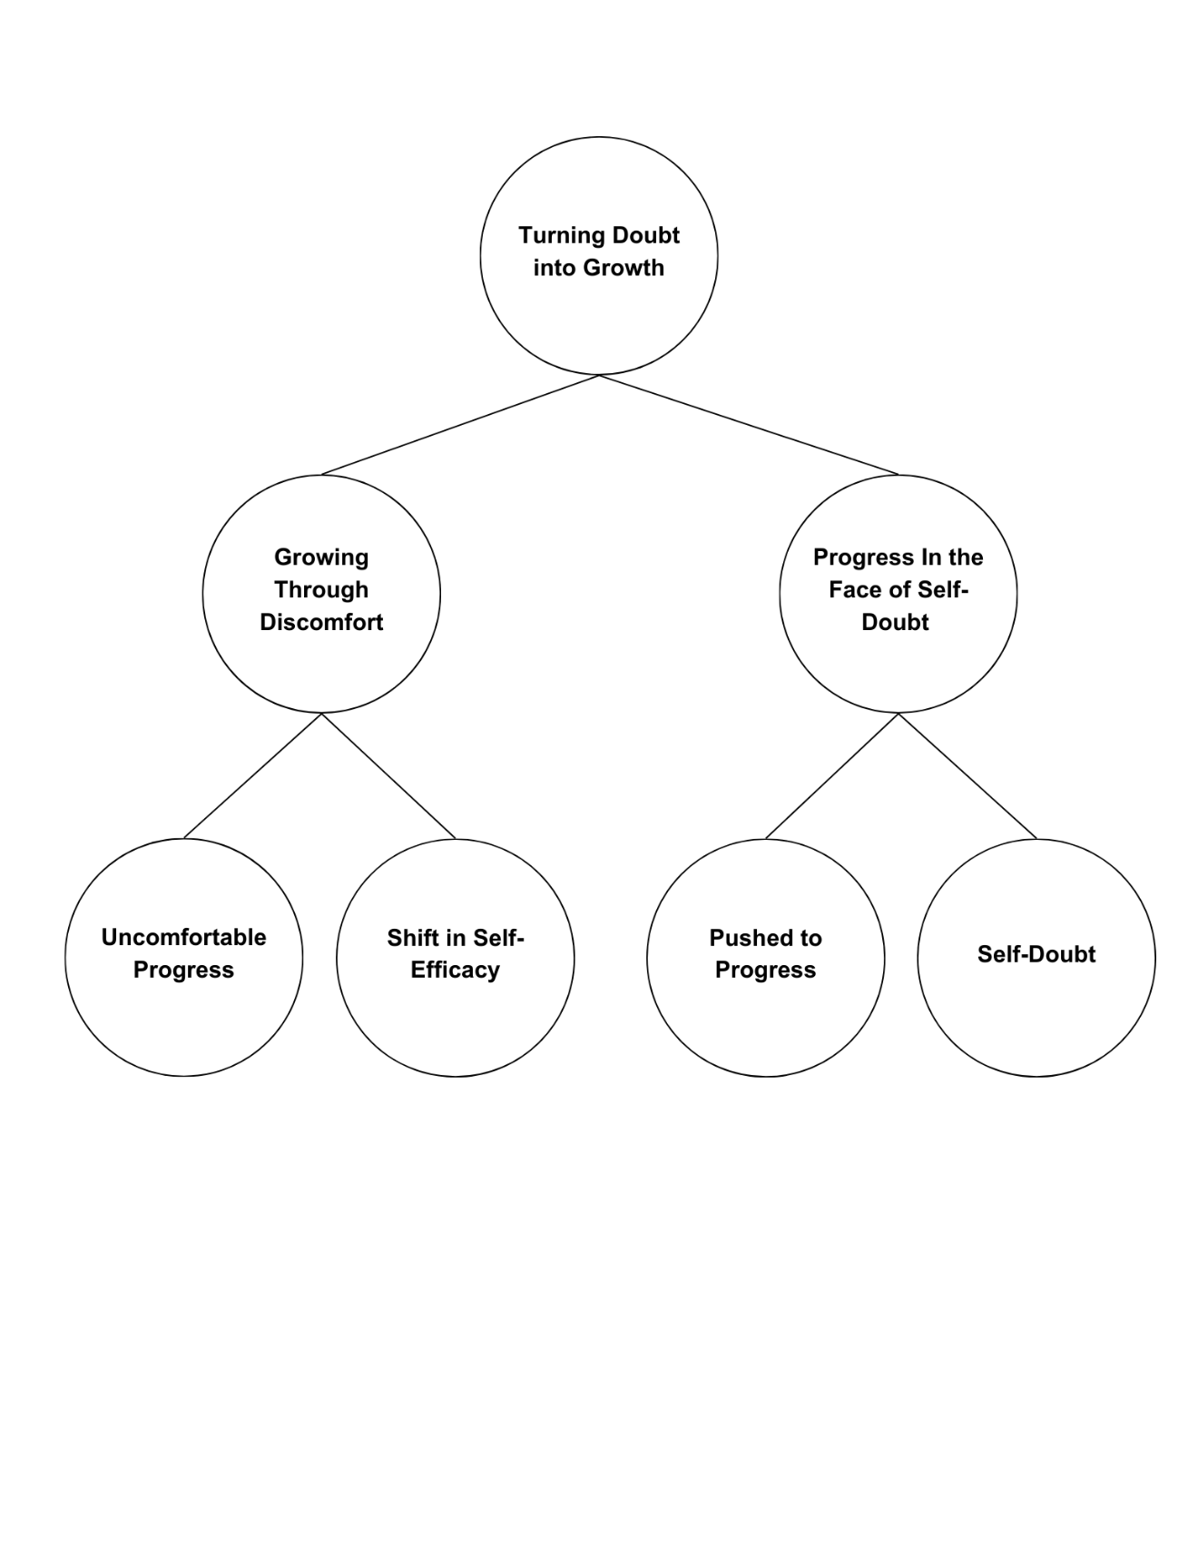

Fig. 4. Emergent Themes, Categories, and Codes on the Teachers’ Perceptions of Self-Efficacy and Career Interests Shift When Assigned to Teach TLE Subjects

RQ. 3 How do teachers' perceptions of self-efficacy and career interests shift when assigned TLE subjects outside their area of expertise?
Teachers’ Perceptions of Self-Efficacy and Career Interests Shift When Assigned to Teach TLE Subjects.
Non-TLE teachers assigned to teach TLE subjects experienced complex challenges and growth opportunities. Many participants initially expressed self-doubt and uncertainty as they ventured into unfamiliar territory. However, a significant shift in their self-perception emerged as they navigated the challenges and acquired new skills. They recognized personal and professional growth potential by embracing discomfort and stepping outside their comfort zones.
A broadening of their career interests accompanied this newfound confidence. These teachers discovered a renewed sense of purpose and fulfillment by engaging in practical, hands-on activities. They realized that their roles extended beyond traditional classroom instruction and encompassed the development of essential life skills. This shift in perspective highlighted the transformative power of out-of-field assignments, which can lead to unexpected growth and a deeper understanding of the multifaceted nature of teaching.
Theme 1: Turning Doubt into Growth
The participants shared that they initially experienced feelings of self-doubt and uncertainty. However, as they navigated the challenges and acquired new skills, they transformed these doubts into opportunities for growth. By embracing discomfort and stepping outside their comfort zones, they gained confidence in their abilities and expanded their career horizons. This theme highlights the resilience and adaptability of teachers who, despite initial challenges, were able to thrive in new and unfamiliar roles.
Sub-theme1: Growing Through Discomfort
Participants emphasized growth through discomfort, recognizing that personal and professional development often occurs outside one's comfort zone. They acknowledged the value of embracing challenges, such as teaching subjects outside their major, as opportunities for learning and growth. By stepping outside their comfort zones, participants gained new skills and knowledge and developed valuable life skills and a stronger sense of self-efficacy.
Uncomfortable Progress
Participants (IDI_1, and IDI_2) acknowledged the importance of embracing discomfort as a catalyst for growth. They highlighted that personal and professional development can occur in various situations outside one's comfort zone.The belief that growth can occur anywhere is idealistic but often unrealistic for educators facing such challenges, leading to frustration and burnout.
Out-of-field teachers, in particular, struggle with professional development due to broad subject demands, negative attitudes, and low self-confidence, making it difficult to adapt and succeed (Ma, 2024).Many educators report that traditional PD lacks sufficient preparation time and fails to support the use of evidence-based strategies in the classroom (Wong et al., 2022).
Shift in Self-Efficacy
Participants (IDI_1 and IDI_3) noted that taking on new challenges positively impacted their self-efficacy. According to Arias-Pastor et al. (2024), teachers with strong self-efficacy are more open to new ideas, use innovative methods, plan effectively, and teach with greater enthusiasm.Teaching outside one’s specialization offers growth but also challenges, including stress, self-doubt, and lower instructional quality without proper support. Regier (2021) notes this can impact teacher confidence, highlighting the need for thoughtful curriculum design.
Sub-theme2: Progress in the Face of Self-Doubt
Despite initial self-doubt, non-TLE teachers persisted in their efforts to teach TLE subjects. They recognized the importance of pushing beyond their limitations and embracing challenges as opportunities for growth. As they gained experience and confidence, they developed a stronger sense of professional identity and a deeper understanding of the multifaceted nature of teaching.
Pushed to Progress
Despite initial self-doubt, participants (IDI_1 and IDI_2) were motivated to embrace the challenges of teaching TLE subjects. Almerez et al. (2019) note that TLE teachers demonstrate resilience and dedication, often collaborating and utilizing resources to overcome obstacles. While it broadens their view of the profession, this growth often comes with the challenge of leaving their comfort zone without adequate support, leading to feelings of being overwhelmed and underprepared.
Self-Doubt
While many non-TLE teachers experienced a sense of growth and empowerment, others struggled with feelings of self-doubt and uncertainty (IDU_1, IDI_2 and IDI_3). These doubts can hinder professional development and impact overall job satisfaction. Teaching outside one’s specialization can cause self-doubt and lower confidence, especially without adequate support. Brushkova et al. (2020) highlight that declining status, mistrust, and diverse student needs increase this uncertainty. Such challenges may prompt teachers to question their career paths.
5. CONCLUSION AND RECOMMENDATION
5.1 Conclusion
Based on the findings of the study, the following conclusions were drawn:
- Non-TLE teachers in selected schools around Tagum City, Davao del Norte, experienced both positive and negative aspects of teaching TLE. Key challenges included staffing shortages, limited subject flexibility, and resource constraints.
- These teachers struggled with TLE content and assessment practices due to unfamiliarity, particularly with performance-based tasks and the practical nature of the curriculum.
- Their professional identity and self-efficacy were impacted, as many felt uncertain about their ability to deliver quality instruction despite mentorship and peer support.

- Teachers showed resilience by using online resources, adapting materials, and learning independently. However, limited budgets—especially in smaller schools—restricted access to essential tools and technology.

- Overall, the study highlights the complexity of teaching outside one’s specialization and emphasizes the need for continuous learning, adaptability, and strong institutional support to help non-TLE teachers succeed.
5.2 Recommendations
- Schools should implement structured mentorship, team teaching, and regular knowledge-sharing sessions to support non-TLE teachers and foster collaboration.
- Targeted professional development—through workshops, seminars, and online training—should focus on TLE-specific content and pedagogy to build teacher confidence and competence.
- Teachers are encouraged to use resources creatively, integrate digital tools, and engage in reflective practices to enhance resilience and self-efficacy.
- School leaders should recognize non-TLE teachers’ efforts through incentives, public acknowledgment, and improved access to instructional resources. Subject-specific networks can support ongoing collaboration.
- Strategic workforce planning and hiring aligned with teachers' expertise should be prioritized. Budget allocations must ensure equitable access to materials for performance-based subjects like TLE.
- DepEd is encouraged to align teacher assignments with specialization, address staffing shortages through better recruitment and retention, and offer training for non-TLE teachers teaching TLE.
- DepEd may also support professional learning communities and provide updated materials and technologies. Regular assessments of teacher credentials and classroom needs should guide policy decisions.
- Future research should broaden the study beyond Tagum City to include more schools in Davao del Norte and explore the long-term effects of teaching outside one's specialization.
- Investigating the reasons behind subject misassignments can offer insights into recruitment practices and reinforce the need for subject-aligned staffing to uphold education quality.
Consent
As per international standards or university standards, Participants’ written consent has been collected and preserved by the author(s).
Disclaimer (Artificial intelligence)
Option 1:
Author(s) hereby declare that NO generative AI technologies such as Large Language Models (ChatGPT, COPILOT, etc.) and text-to-image generators have been used during the writing or editing of this manuscript.
Option 2:
Author(s) hereby declare that generative AI technologies such as Large Language Models, etc. have been used during the writing or editing of manuscripts. This explanation will include the name, version, model, and source of the generative AI technology and as well as all input prompts provided to the generative AI technology
Details of the AI usage are given below:
1.
2.
3.

References
Abdallah, A. K., &Alkaabi, A. M. (2023). Induction Programs' effectiveness in boosting new teachers' instruction and student achievement: A Critical review. International Journal of Learning Teaching and Educational Research, 22(5), 493–517. https://doi.org/10.26803/ijlter.22.5.25
Almerez, Q. L. G., Adolfo, G. C., Bucod, J. E. G., Egos, M. B., &Tangpos, A. S. (2019). Technical Vocational Education in the context of Globalization: Its pedagogy and Strategies. Asian Journal of Education and Social Studies, 1–10. https://doi.org/10.9734/ajess/2019/v5i330144
Ana, A. N. F., Safrizal, N., &Sunarti, N. (2023). ANALISIS KESULITAN GURU DALAM MENGIMPLEMENTASIKAN KURIKULUM MERDEKA. MUBTADI Jurnal Pendidikan Ibtidaiyah, 4(2), 96–110. https://doi.org/10.19105/mubtadi.v4i2.8043
Antera, S. (2023). Competence importance and acquisition: comparing qualified and non-qualified vocational teachers. Journal of Education and Work, 36(2), 109–124. https://doi.org/10.1080/13639080.2023.2167956
Arendain, N. I. E., &Limpot, N. M. Y. (2022). PHENOMENOLOGICAL APPROACH OF OUT-OF-FIELD TEACHING: CHALLENGES AND OPPORTUNITIES. EPRA International Journal of Multidisciplinary Research (IJMR), 165–170. https://doi.org/10.36713/epra9379
Arias-Pastor, M., Van Vaerenbergh, S., González-Bernal, J. J., & González-Santos, J. (2024). Analysis of Teacher Self-Efficacy and Its Impact on Sustainable Well-Being At Work. Behavioral Sciences, 14(7), 563. https://doi.org/10.3390/bs14070563
Barksdale, S., Upadhyay, B., & Vernon, M. (2021). Teacher professional development: mobile and limited technology-enhanced pedagogy. International Journal of Technology in Education and Science, 5(4), 486–511. https://doi.org/10.46328/ijtes.249
Belavina, Y., &Klyuchko, O. (2024). Mentoring as a developmental mechanism of the All-Russian Olympiad for Primary School Teachers "My First Teacher." Primary Education, 12(2), 9–17. https://doi.org/10.12737/1998-0728-2024-12-2-9-17
Braun, V., & Clarke, V. (2006). Using thematic analysis in psychology. Qualitative research in psychology, 3(2), 77-101.
Brushkova, L. A., Gavrov, S. N., Zaia, I. Y., Gevorkyan, A. R., &Manuilova, E. A. (2020). The problem of confidence in schoolteachers in the context of new normality. SHS Web of Conferences, 79, 03002. https://doi.org/10.1051/shsconf/20207903002
Canoy, P. F., Gido, N., Montajes, G. J., Canoy, R., &Tuyor, A. (2022). TEACHING SUBJECTS BEYOND EXPERTISE. International Journal of Multidisciplinary Research and Studies, 05(07), 01–10. https://doi.org/10.33826/ijmras/v05i07.4
Carothers, D. E., Aydın, H., &Houdyshell, M. (2019). Teacher shortages and cultural mismatch: district and university collaboration for recruiting. Journal of Social Studies Education Research, 10(3), 3963. http://files.eric.ed.gov/fulltext/EJ1229410.pdf
Castro, A. J. (2022). Managing Competing demands in a Teacher Shortage context: The impact of teacher shortages on principal leadership practices. Educational Administration Quarterly, 59(1), 218–250. https://doi.org/10.1177/0013161x221140849
Cataraja, G., &Cataraja, R. (2022). Evaluation of the performance of the Technical Education and Skills Development Authority (TESDA) training institutions in Region VIII. East Asian Journal of Multidisciplinary Research, 1(6), 947–960. https://doi.org/10.55927/eajmr.v1i6.695
Caulfield, J. (2019 ). How to do thematic analysis | Step-by-step guide & examples. Retrieved on July 23, 2023 from https://www.scribbr.com/methodology/thematic-analysis/
Cayabas, J. P., Jr, &Sumeg-Ang, D. A. (2023). Challenges and interventions in developing instructional materials: Perspectives of public school teachers in basic education. International Journal of Innovative Research and Scientific Studies, 6(4), 849–855. https://doi.org/10.53894/ijirss.v6i4.2059
Cheruiyot, B. (2024). Challenges faced in the implementation of Competency-Based Curriculum (CBC) in junior schools in Kenya. East African Journal of Education Studies, 7(3), 260–266. https://doi.org/10.37284/eajes.7.3.2098
Culajara, C. J. (2023). Improving teachers' professional development through School Learning Action Cell (SLAC). Journal of Research Policy & Practice of Teachers & Teacher Education, 13(1), 76–88. https://doi.org/10.37134/jrpptte.vol13.1.6.2023
Culajara, C. J. (2023). The voices of physical education teachers: its pressure, measure, and treasure in delivering instruction in physical education. Indonesian Journal of Research in Physical Education, Sport, and Health, 1(2), 98–109. https://doi.org/10.17977/um086v1i22023p98-109
Damyanov, P. K. (2024). Effective Pedagogical Strategies and Support Mechanisms for Enhancing the Learning Outcomes of Students with Special Educational Needs: A Systematic Approach. International Journal of Scientific Research and Management (IJSRM), 12(10), 3700–3718. https://doi.org/10.18535/ijsrm/v12i10.el03
De Jong, L., Meirink, J., &Admiraal, W. (2022). School-based collaboration as a learning context for teachers: A systematic review. International Journal of Educational Research, 112, 101927. https://doi.org/10.1016/j.ijer.2022.101927
DePED releases implementation guidelines on Rationalizing teachers' workload and overload compensation | Department of Education. (2024, October 2). https://www.deped.gov.ph/2024/10/02/deped-releases-implementation-guidelines-on-rationalizing-teachers-workload-and-overload-compensation/#:~:text=2024%20reiterates%20that%20teachers%20are,two%20additional%20hours%20per%20day
Du Plessis, A. E. (2020). Connecting the dots: Policy development and the Out-of-Field Teaching Reality in education. In Springer eBooks (pp. 1–45). https://doi.org/10.1007/978-981-15-1948-2_1
Edralin, D., & Pastrana, R. (2023). Technical and vocational education and training in the Philippines: In retrospect and its future directions. Bedan Research Journal, 8(1), 138-172.
Gamboa, M. Q. (2023). Implementation of School Learning Action Cell (SLAC) and its Monitoring & Evaluation Strategies Employed by Teachers and School Heads in the Division of Occidental Mindoro, Philippines. International Journal of Research Publication and Reviews, 4(11), 2157–2161. https://doi.org/10.55248/gengpi.4.1123.113119
Garbuzova, T., Habibullina, L., Sergeev, N., Grigoriev, A., &Svistunova, I. (2024). EFFECTIVE USE OF EDUCATIONAL RESOURCES IN CONDITIONS OF a LIMITED BUDGET: THE EXPERIENCE OF ECONOMIC PLANNING IN EDUCATION. Moscow Economic Journal, 663–673. https://doi.org/10.55186/2413046x_2024_9_5_273
Generelao, I. N., Ducanes, G., Yee, K. M., & David, C. (2021). Teacher education in the Philippines: Are we meeting the demand for quality? Philippine Journal of Public Policy Interdisciplinary Development Perspectives, 2022. https://doi.org/10.54096/iene4805
Grünwald, J. G. (2021). Embracing Doubt: Teaching in a Post-digital age. In Springer eBooks (pp. 257–267). https://doi.org/10.1007/978-3-030-73770-2_15
H, L. (2023, August 30). What is Phenomenological Research Design? — Delve. Delve. https://delvetool.com/blog/phenomenology
Hobbs, L., &Porsch, R. (2021). Teaching out-of-field: challenges for teacher education. European Journal of Teacher Education, 44(5), 601–610. https://doi.org/10.1080/02619768.2021.1985280
Lim, W. M. (2024). What is qualitative research? An overview and guidelines. Australasian Marketing Journal (AMJ). https://doi.org/10.1177/14413582241264619
Ma, L. (2024). Challenges in the Professional Development of Teachers Teaching Out-of-field in Chinese Elementary Schools under the Background of "Structural Teacher Shortage." In Advances in Social Science, Education and Humanities Research/Advances in social science, education and humanities research (pp. 419–427). https://doi.org/10.2991/978-2-38476-253-8_51
Maffea, J. (2020). Lack of resources in classrooms. Research Commons at Kutztown University. https://research.library.kutztown.edu/wickedproblems/38/?utm_sour
Masriwati, S., Krismiadi, D., Dina, H., &Amirudin, N. (2024). Pengaruh Focus Group Discussion TerhadapPengetahuan Dan SikapLansia Yang MenderitaHipertensiTentang Gaya HidupDipuskesmasKemaraya Kota Kendari. JurnalAnoaKeperawatan Mandala Waluya. https://doi.org/10.54883/jakmw.v3i2.890
McMullin, C. (2021). Transcription and Qualitative Methods: Implications for third sector research. VOLUNTAS International Journal of Voluntary and Nonprofit Organizations, 34(1), 140–153. https://doi.org/10.1007/s11266-021-00400-3
Mercado, H. a. R., &Morante, L. M. (2024). Experiences of senior high school mathematics teachers in out-of-field teaching. SaludCiencia Y Tecnología - Serie De Conferencias, 3, 1125. https://doi.org/10.56294/sctconf20241125
Moran, M. (2024b, December 31). What is Trustworthiness in Qualitative Research? Statistics Solutions. https://www.statisticssolutions.com/what-is-trustworthiness-in-qualitative-research/
Nakar, S., & Plessis, D. (2023). Facing the dilemma of the Out-of-Field teaching phenomenon in Vocational Education and Training (VET). Vocations and Learning, 16(3), 551–575. https://doi.org/10.1007/s12186-023-09329-8
Nob, N. J. M. R., &Tañola, N. M. (2024). Ang Magturo ay Di Biro: A HERMENEUTIC PHENOMENOLOGICAL STUDY ON THE LIVED-EXPERIENCES OF MATH EDUCATORS IN OUT-OF-FIELD TEACHING. EPRA International Journal of Research & Development (IJRD), 131–141. https://doi.org/10.36713/epra15810
Nowell , L.S., Norris, J.M., White, D.E., & Moules, N.J. (2017). Thematic analysis: Striving to meet the trustworthiness criteria. International Journal of Qualitative Methods, 16, 1–13. https://doi.org/10.1177/1609406917733847
Pacana, N. M. S., Ramos, C. D., Catarata, M. N., &Inocian, R. B. (2019). Out-of-Field Social Studies Teaching through Sustainable Culture-Based Pedagogy: A Filipino Perspective. International Journal of Education and Practice (Online), 7(3), 230–241. https://doi.org/10.18488/journal.61.2019.73.230.241
Pak, K., Polikoff, M. S., Desimone, L. M., & García, E. S. (2020). The Adaptive Challenges of Curriculum Implementation: Insights for Educational Leaders Driving Standards-Based Reform. AERA Open, 6(2). https://doi.org/10.1177/2332858420932828
Pérez, I. M. M., & Pérez, S. E. M. (2024). Group Discussions as a Methodology in Multicultural Settings. Advances in Library and Information Science (ALIS) Book Series. https://doi.org/10.4018/979-8-3693-3306-8.ch005
Regier, B. J. (2021). Preservice music teachers' self-efficacy and concerns before and during student teaching. International Journal of Music Education, 39(3), 340–352. https://doi.org/10.1177/0255761421990787
Simplilearn. (2023, September 1). What is data collection: methods, types, tools. Simplilearn.com. https://www.simplilearn.com/what-is-data-collection-article
Sutcher, L., Darling-Hammond, L., & Carver-Thomas, D. (2019). Understanding teacher shortages: An analysis of teacher supply and demand in the United States. Education Policy Analysis Archives, 27, 35. https://doi.org/10.14507/epaa.27.3696
Taripe, A. L. C. (2024). Technology and Livelihood Education (TLE) During In-Person Classes: Experiences of Secondary School Teachers. International Journal of Research in Interdisciplinary Studies, 2(4), 7-12. https://journal.ijris.com/index.php/ijris/article/view/38
Thi, P., Tham, H., Nguyen, H., Toan, N., Nguyen, T., Trang, H., Nguyen, T., Thuc, T., Hien, N., Mai, M., & Nguyen, M. (2023). The Current Situation of Professional Work Pressure of Junior High School Teachers during the Implementation of the 2018 General Education Curriculum. Hong Kong Journal of Social Sciences, 61. https://doi.org/10.55463/hkjss.issn.1021-3619.61.25
Tingzon, L. L., &Buyok, H. J. A. (2022). LIVED EXPERIENCES OF NON-TLE TEACHERS TEACHING TLE SUBJECTS: A PHENOMENOLOGICAL INQUIRY. European Journal of Education Studies, 9(11). https://doi.org/10.46827/ejes.v9i11.4538
Tran, H. L. (2023). TEACHING OUTSIDE AREA OF EXPERTISE: a BARRIER TO OR ENABLER OF TEACHERS' SENSE OF COMPETENCE? VNU Journal of Foreign Studies, 39(6), 86–99. https://doi.org/10.63023/2525-2445/jfs.ulis.5162
Treto-French, M. (2024). SCHOOL DISTRICT BUDGETING: HOW SCHOOL PRINCIPALS' LACK OF BUDGET KNOWLEDGE CAN LEAD TO NEGATIVE IMPACT ON FUNDING. Huskie Commons. https://huskiecommons.lib.niu.edu/allgraduate-disspractice/35?utm_source=huskiecommons.lib.niu.edu%2Fallgraduate-disspractice%2F35&utm_medium=PDF&utm_campaign=PDFCoverPages
Von Der Embse, N., Ryan, S. V., Gibbs, T., &Mankin, A. (2019). Teacher stress interventions: A systematic review. Psychology in the Schools, 56(, 1328–1343. https://doi.org/10.1002/pits.22279
Wong, J. T., Bui, N. N., Fields, D. T., & Hughes, B. S. (2022). A Learning Experience Design Approach to Online Professional Development for Teaching Science through the Arts: Evaluation of Teacher Content Knowledge, Self-Efficacy and STEAM Perceptions. Journal of Science Teacher Education, 34(6), 593–623. https://doi.org/10.1080/1046560x.2022.2112552
Yang, X. (2023). A historical review of collaborative learning and cooperative learning. TechTrends, 67(4), 718–728. https://doi.org/10.1007/s11528-022-00823-9
Zaid, B., Gunn, C., Fedtke, J., &Ibahrine, M. (2020). Teaching outside your area of expertise: an opportunity for professional development. Journal of Further and Higher Education, 45(5), 629–640. https://doi.org/10.1080/0309877x.2020.1804538

