**Exploring Difficulties in Internet Adaptation for Students in Developing Countries: A Machine Learning Approach to Network Visualization and Cluster Analysis**

**Abstract**

**Aim:** This study investigates the challenges students in developing countries face in adapting to internet-based education. It aims to identify key trends, influential contributors, and research gaps, with a particular emphasis on the potential of innovative technologies such as artificial intelligence (AI) and blockchain in addressing digital inequality.

**Methods:** A bibliometric analysis was conducted on 352 scholarly documents sourced from the Scopus database. Advanced analytical tools, including Machine Learning techniques, R programming, Bibliometrix, and VOSviewer, were employed to assess performance indicators, visualize topic clusters, and map the research landscape.

**Findings:** The analysis indicates a growing body of research focused on digital adaptation in education, with substantial contributions from Germany, India, and the UK. Although Hong Kong and Singapore contribute fewer publications, their research garners high citation visibility. Prominent authors such as Choo, Fung, and Wootton have significantly influenced the field. The study identified five major thematic clusters: psychosocial barriers (e.g., internet addiction and academic stress), technological innovations (AI, blockchain, and digital platforms), socioeconomic challenges (connectivity costs and gender disparities), research trends and bibliometric mapping, and multi-stakeholder collaboration involving government, academia, and civil society. A notable research gap exists regarding the practical implementation of AI and blockchain to alleviate these challenges.

**Originality:** This study is among the few to systematically map the global academic discourse on internet adaptation in education within developing regions using bibliometric and machine learning approaches. It introduces an interdisciplinary perspective by combining education, technology, and policy analysis.

**Academic Value:** By synthesizing global research trends and highlighting underexplored areas, particularly the role of emerging technologies, gender disparities, and collaborative strategies, this study provides a valuable reference for scholars, policymakers, and educators. Additionally, by identifying key gaps, it supports evidence-based policy formulation and encourages further localized, gender-sensitive research and pilot interventions to enhance educational equity.

**Keywords:** Students; Internet Adaptation; Developing countries; Bibliometric Analysis.

**Introduction**

The internet is a significant technological innovation that involves global communication, making the concept of a ‘global village’ where people are connected through the internet possible (Bener & Bhugra, 2013; Mamun et al., 2019). Internet adoption and access refer to the uptake and utilization of internet services by individuals and communities, including the availability and affordability of internet connectivity and related infrastructure (Rodríguez-Castelán & Pierola, 2022). The internet began in the early 1960s. The internet is believed to transform personal and professional lives, especially in developing countries where industrial growth and the HDI (human development index) are lower than those in developed countries (Tan and Teo, 1998; Developing Country - Wikipedia, n.d.).

Difficulties in internet adaptation (effective internet use) in developing countries refer to the challenges individuals, particularly students, encounter in accessing and effectively using internet resources like educational platforms, databases, websites, online articles, social media etc. These difficulties often stem from issues such as inadequate infrastructure, high costs of connectivity, limited digital literacy, and sociopolitical barriers that prevent consistent access to internet resources (Nye, 2015; Kloza, 2023). Because of the internet's affordability, accessibility, and anonymity, its use and penetration are growing quickly on a global scale. Recent research has shown that 50% of teenagers in South America and 80% of teenagers in the UK, USA, and Asia use the internet (Cerniglia et al., 2017). Currently, various sectors or organizations worldwide are tapping the potential of the internet as a medium to boost their operational task, while embracing new technologies such as artificial intelligence (AI), blockchain technologies, etc., in the landscape, and education using the internet is obvious.

Technological integration in the learning environment has gained significant attention in recent years because of the impact of computers on teaching and learning, particularly in developing countries (Accilar 2011; Georgsen and Zander 2013; Haleem et al., 2022). In the classroom, technology-assisted learning through interactive tools (e.g., mobile devices, smartboards, massive open online courses (MOOCs, tablets, laptops, simulations, dynamic visualizations, and personalized experiences (AI-assisted learning) make learning more appealing to the next generation (Haleem et al., 2022).

The rise of the internet has also enabled students to access vast resources via search engines, databases, and indexing algorithms, facilitating their academic work. Despite the rapid changes in the educational system, the university sector has undergone significant transformations (Segura-Robles et al., 2020), with institutions successfully using the internet for distance learning, smart tutoring systems (Beyth-Marom et al., 2003), and blended learning (Sun, 2016). However, developing countries face challenges in effectively integrating digital technologies into their education systems, with students experiencing difficulties in internet usage, highlighting the need for further research (Moorthy et al., 2019; Sambuli, 2016).

The idea of internet adaptation in education has been examined in numerous areas, such as digital literacy, technological infrastructure, sociopolitical obstacles, and cost issues. Scholars from various disciplines, such as education, sociology, information science, and technology studies, have investigated the benefits and challenges related to internet use, especially in developing countries (Bener & Bhugra, 2013; Kloza, 2023). Several strategies have been proposed as a result of this comprehensive strategy to better recognize and address the difficulties students face when adjusting to internet use. Although traditional internet-related issues have received much attention, comprehending how emerging technologies such as blockchain and AI are changing digital literacy and educational institutions is becoming increasingly important. While blockchain can provide safe, decentralized systems for credential verification and data management—both essential for increasing transparency and accessibility in education—AI offers chances to automate repetitive educational tasks and personalize learning experiences, increasing efficiency and inclusivity (Pedro et al., 2019; El Koshiry, 2023). These technologies could significantly influence how students in developing countries access, interact with, and benefit from internet-based education. The increasing intricacy of these issues, coupled with the steady expansion of research in this area, highlights the suitability of this topic for bibliometric analysis, a quantitative method used to track and assess scholarly publications, identify influential authors, and highlight emerging research areas (de Oliveira et al., 2019).

This paper's goal is to provide a broad overview of the key features of publications and cluster analysis that address internet adaptation challenges. On the basis of bibliometric analysis, future research can investigate the potential contribution of cutting-edge technologies such as blockchain and AI to these problems. To inform future research and useful initiatives in the field, this analysis attempts to examine publication outputs, citation patterns, country-specific contributions, and authorship trends in publications on the challenges of internet adaptation among students in developing nations.

To achieve this research goal, this study aims to address core questions about students’ obstacles in accessing the internet in developing countries. First, how do research trends, coauthorship networks, and citation patterns capture the way scholars consult internet adjustment obstacles for students? Identifying these intersections can provide insights into how knowledge in this field has evolved over time. Second, what are the predominant obstacles that students face when adapting to internet use in these regions? Through bibliometric analysis and clustering techniques, this study seeks to determine continual themes and patterns in the research. Finally, what are the key factors that influence students' internet usage in developing countries? On the basis of NLP text analysis and topic clustering, this study evaluates the main issues affecting students' ability to effectively connect with online resources. Ultimately, these research questions are attached to the study’s bibliometric and scientometric approach, aiding in uncovering critical insights into internet adoption in educational aspects.

### Conceptual Framework

Adapting to the internet among students in developing countries is a multifaceted issue influenced by infrastructural, socioeconomic, educational, and cultural factors. Limited internet infrastructure, high costs of connectivity, and inadequate digital literacy remain critical barriers, particularly in rural and underserved areas (Rodríguez-Castelán & Pierola, 2022). Despite the growing penetration of internet access, disparities persist due to income inequality, gender differences, and sociopolitical challenges, which restrict equitable opportunities for students (Nye, 2015; Kloza, 2023). With the development of new technologies such as AI and blockchain, overcoming these difficulties by individualizing knowledge acquisition, increasing the accessibility of educational content, and improving the system of certification is possible (Pedro et al., 2019; El Koshiry, 2023). However, these solutions require robust foundational support in the form of reliable internet infrastructure something many developing countries still lack (Accilar, 2011). In addition, an insufficient number of digital literacy programs continues to widen the digital divide and slow the integration of internet-based instruction into traditional education systems (Marope, 2017). These barriers demotivate students from fully leveraging the internet for academic and personal development, thus limiting their ability to thrive in an increasingly digital global economy.

This study situates itself within this complex landscape by conducting a bibliometric analysis to systematically examine how these barriers and opportunities are reflected in global scholarly discourse. A bibliometric analysis of publications on internet adaptation challenges among students in developing countries provides pertinent information for understanding this phenomenon. Through such analysis, by identifying trends, gaps, and country-specific contributions it becomes easier to spotlight impactful studies and frequently cited scholars (de Oliveira et al., 2019). For instance, current literature highlights how sectors like higher education have adopted tools such as MOOCs and smart tutoring systems, though their application remains inconsistent in resource-constrained regions (Segura-Robles et al., 2020). Bibliometric studies can also deepen our understanding of how AI and blockchain are being positioned as transformative tools in digital education by automating learning processes, preserving data integrity, and enabling personalized instruction (El Koshiry, 2023).

This conceptual framework anchors our study by identifying and linking the causal factors (barriers and technological solutions) to the research methodology (bibliometric and cluster analysis), which is designed to explore how the academic community has addressed these issues over time. It offers a structured lens to interpret publication patterns, citation behaviors, and collaborative research efforts, thereby clarifying where the academic conversation currently stands and where it may head next. In doing so, the framework aligns with our study’s objective of uncovering thematic clusters, influential contributors, and underexplored opportunities in internet adaptation scholarship.

Moreover, the framework emphasizes the interdisciplinary nature of this issue, requiring insights from education, sociology, information technology, and public policy to address digital inequity holistically (Bener & Bhugra, 2013; Mamun et al., 2019). It also underlines the importance of implementing supportive policy measures—such as access to affordable internet, computational literacy programs, and curriculum integration—to enable inclusive digital education. Our study contributes to this discourse by identifying the degree to which these policy dimensions and emerging technologies have been covered in the academic literature. In this way, the research aligns with the Sustainable Development Goal 4 (SDG-4) of ensuring inclusive and equitable quality education, while acknowledging the broader implications of internet adoption for personal and vocational development in developing regions.

This conceptual framework connects the fragmented barriers, proposed solutions, and academic efforts into a coherent structure—thereby directly informing the design, scope, and analytical approach of this paper.

**Methodology**

The data for this study were collected from SCOPUS, the largest abstract indexing database, on May 3, 2024. SCOPUS provides reliable search terms, ensuring that key research articles are not overlooked (Abbas et al., 2022; Haque et al., 2023). The search strategy was designed to capture relevant literature on students' challenges in adapting to the internet in developing countries.

The search terms and syntax include the following:

(TITLE-ABS-KEY (internet AND (adaptation OR use OR usage)) AND TITLE-ABS-KEY (difficulties OR problems OR barriers OR obstacles) AND TITLE-ABS-KEY (students OR learners) AND TITLE-ABS-KEY ((developing AND countries) OR (least AND developed AND countries) OR (emerging AND countries) OR (third AND world)) AND (LIMIT-TO (DATABASE, "Scopus") AND LIMIT-TO (LANGUAGE, "English")).

This study examined 352 research documents on students' internet adaptation setbacks in developing countries extracted from the SCOPUS database, applying a focused search strategy. The search was limited to English-language documents, resulting in 352 publications after language filters were used. These documents were retrieved in Excel for initial processing and analyzed via tools such as VOSviewer, Python for bibliometric analysis, R (Biblioshiny), visualization, computational modeling, and performance analysis to determine key standards, viz. Authoritative authors, affiliations, and citations, while scientific mapping, grouped topics into clusters exploiting NLP techniques (Gupta et al., 2017). The text preprocessing steps included converting text to lowercase, followed by number deletion and stopping word elimination and the lemmatization procedure. Python was used to run machine learning operations through the combination of term frequency-inverse document frequency (TF-IDF) vectorization with k-means clustering and principal component analysis (PCA), a multivariate technique for analyzing intercorrelated quantitative dependent variables, to show the relevance of keywords to some specific documents (Qaiser & Ali, 2018; Abdi & Williams, 2010). TF-IDF converts raw data numbers to numerical data using the most significant terms within 500 parameters, following which K-Means organizes five document clusters. Using PCA, the high-dimensional data were aligned into two dimensions to display multiple patterns where certain clusters were closely arranged but other clusters were spread out. This study uses word cloud analysis, a visual summary of key terms by frequency, and reveals dominant phrases that help identify five main themes: sociopsychological problems, technological advancements, socioeconomic barriers, research trends and multistakeholder collaboration (Heimerl et al, 2014; Chandrapaul et al., 2019). The integration of bibliometric analysis with NLP and visualization provided an overall view of the thematic aspects associated with internet adaptation challenges in education.

The search methods and data exclusion criteria are presented in Figure 1.

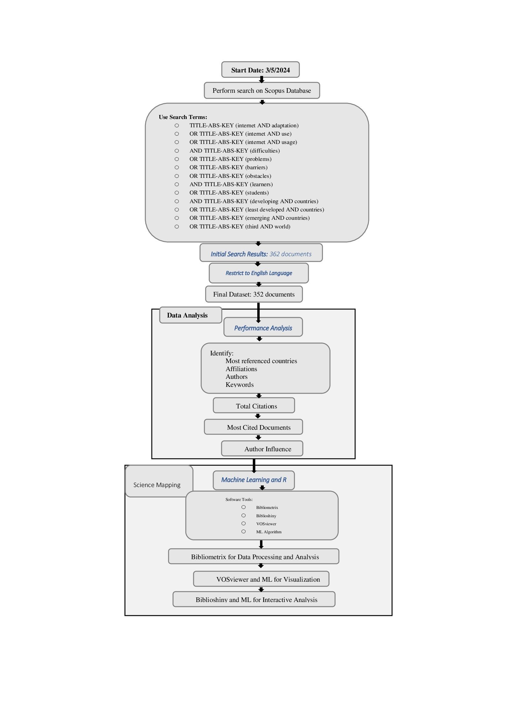

**Figure 1. Research Process**

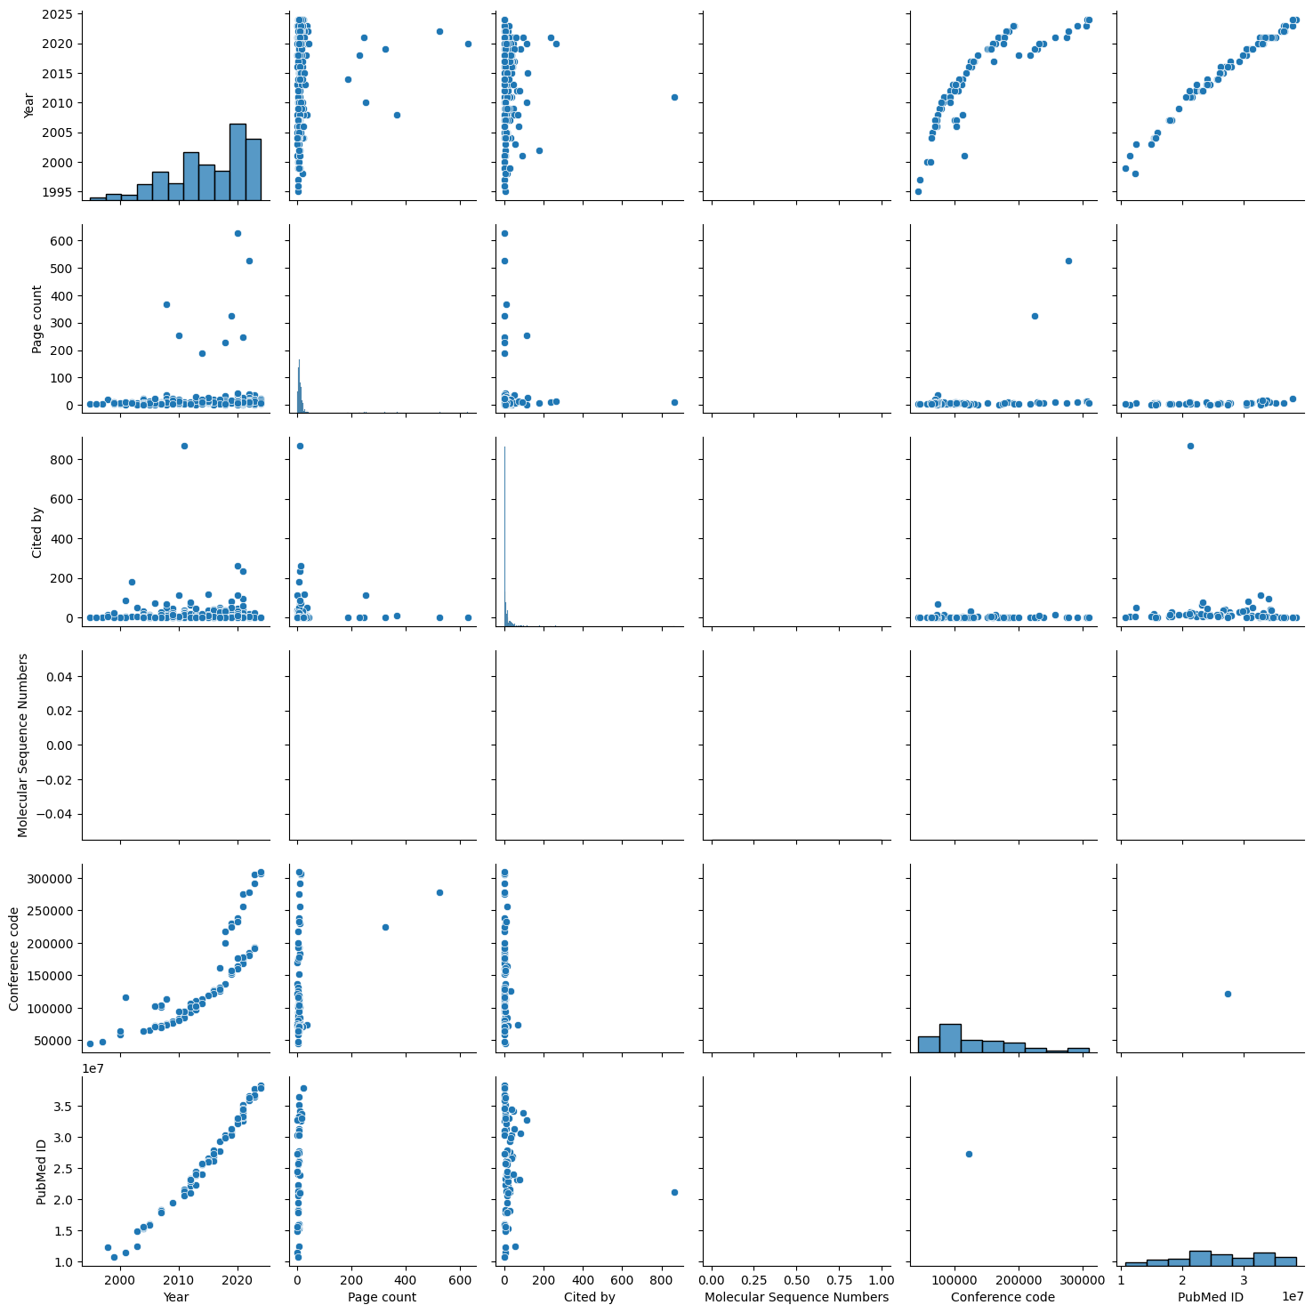

**Figure 2. Relationships between numeric columns**

Numerous factors connected to scientific publications are presented in Figure 2, which is a correlation matrix that shows the correlations. Histograms along the diagonal indicate the distribution of individual variables: publication year increases over time, page count is often low, and the number of citations is highly skewed toward fewer citations for the majority of publications. Scatter plots off the diagonal show the relationships between variable pairs. A positive association exists between the publishing year and both the conference code and PubMed ID, demonstrating a growth in these identifiers over time. Most other scatter plots do not demonstrate strong connections, with dots dispersed and no distinct trends. Overall, the matrix indicates an increase in the number of publications in recent years, as well as correlations between publication year and indexing IDs.

**Result And Discussions**

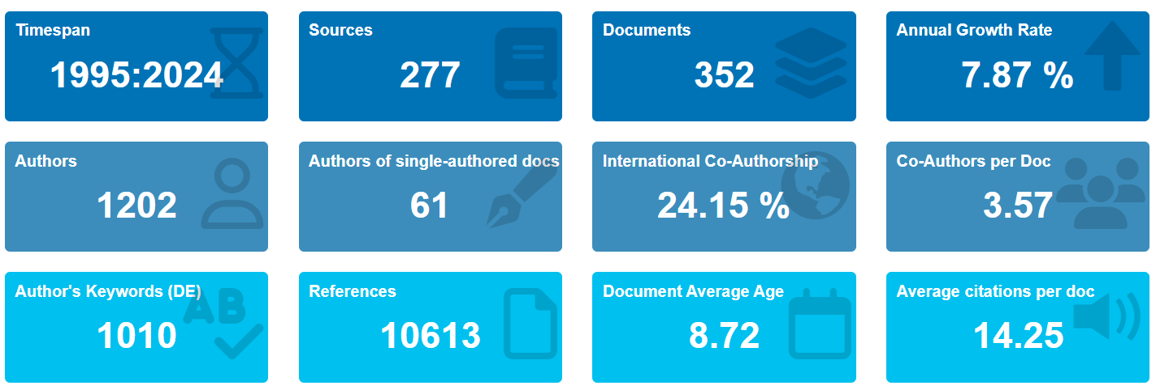

**Figure 3. Focal data (source: authors’ figures- data computed through Biblioshiny)**

Figure 3 represents the most significant general data on the research topic over 29 years (1995–2024), and the time of the study frame was selected to gain further understanding of the growing trends and patterns that have been observed since the study's initial publication in 1995. This removes exclusions on the basis of a particular year and makes it possible to thoroughly and methodically review advancements made in the theoretical literature. These data allow readers to comprehend the intricacies of research-based work while also providing a thorough understanding of the various breakthroughs and improvements in theoretical research during this time. A total of 352 papers were unequivocally identified from 277 diverse sources, such as books and journals, resulting in a mean yearly expansion rate of 7.87% alongside an average number of citations per document of 14.25.

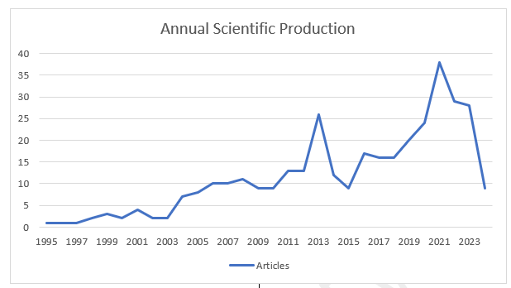

**Figure 4. Scientific Production over time (source: Scopus Database)**

**Table 1. Most productive years based on article publications**

|  |  |  |  |  |  |  |  |  |  |  |
| --- | --- | --- | --- | --- | --- | --- | --- | --- | --- | --- |
| **Year** | 2021 | 2022 | 2023 | 2013 | 2020 | 2019 | 2016 | 2017 | 2018 | 2011 |
| **Articles** | 38 | 29 | 28 | 26 | 24 | 20 | 17 | 16 | 16 | 13 |

Figure 4 and Table 1 show the evaluation of research activity in this field over 29 years, from 1995--2023. To start with, it (1995--2003), the publications that arose comprised a small volume and constant rate, which points to the truth that scientific focus was just starting. The first change in the increasing trend was observed approximately 2003, and it was marked by a subsequent increase in publications that could result from technological progress and growing concern regarding the educational potential of the topic. Yearly, there was a substantial increase from 2009--2013, with the highest modesty at 26 articles in the year 2013. Following this drop, publication rates again increased with 2021 data, suggesting a total of 38 articles, most likely due to the COVID-19 pandemic, which has led to increased interest in educational technology. Publication rates diminished in 2022 (29) and 2023 (28), but the consistent publication indicates an ongoing interest in the post-COVID-19 period.

***Most productive and impactful authors***

Table 2 presents The data concerns the first 10 authors by the number of citations and publications

**Table 2. Authors by the number of citations**

|  |  |  |  |  |
| --- | --- | --- | --- | --- |
| **Id** | **Author** | **Documents** | **Citations** | **Total link strength** |
| 1 | Choo, Hyekyung | 1 | 867 | 6 |
| 2 | Fung, Daniel | 1 | 867 | 6 |
| 3 | Gentile, Douglas A. | 1 | 867 | 6 |
| 4 | Khoo, Angeline | 1 | 867 | 6 |
| 5 | Li, Dongdong | 1 | 867 | 6 |
| 6 | Liau, Albert | 1 | 867 | 6 |
| 7 | Sim, Timothy | 1 | 867 | 6 |
| 8 | Chung, Ellen | 1 | 261 | 2 |
| 9 | Dass, Laura Christ | 1 | 261 | 2 |
| 10 | Subramaniam, Geetha | 1 | 261 | 2 |
| **Authors by the number of publications** | | | | |
| **Id** | **Author** | **Documents** | **Citations** | **Total link strength** |
| 1 | Edirippulige, Sisira | 3 | 19 | 17 |
| 2 | Fujisawa, Yoshikazu | 3 | 19 | 17 |
| 3 | Marasinghe,  Rohana B. | 3 | 19 | 17 |
| 4 | Smith, Anthony C. | 3 | 19 | 17 |
| 5 | Wootton, Richard | 3 | 19 | 17 |
| 6 | Rathore,  Farooq Azam | 2 | 148 | 3 |
| 7 | Nye, Benjamin D. | 2 | 119 | 0 |
| 8 | Karyotaki, Eirini | 2 | 91 | 14 |
| 9 | Cahyadi, Ani | 2 | 46 | 7 |
| 10 | Hendryadi | 2 | 46 | 7 |

To analyze the ten most published and cited authors, the study used the previous authors’ ranking quantitative data. As evident from Table 2, Edirippulige, Fujisawa, Marasinghe, Rohana B, Smith and Wootton published three articles each. Together, their investigations were designed to pinpoint the strengths and weaknesses as well as gaps in the e-health knowledge concerns of Sri Lankan medical students to determine potential future themes and trends in how e-health may be incorporated and implemented in medical education and practice (Edirippulige et al., 2007a; Edirippulige et al., 2006; Edirippulige et al., 2007). The authors that were cited most frequently were Choo, Fung, Gentile, Khoo, Li, Liau, and Sim, with 867 citations; the fewest were Chung, Dass, and Subramaniam, with 261 citations. Another outstanding study was conducted by Choo et al., who examined youth pathological video game use together with the risk factors for impulsivity, excessive game play, poor social skills, and outcomes, including depression, anxiety, and academic performance reduction. According to Ge and colleagues, those using the internet were described as at risk (Gentile et al., 2011).

***Productive and impactful nations by citation count***

**Table 3. Countries by citation count**

|  |  |  |  |  |
| --- | --- | --- | --- | --- |
| **Id** | **Country** | **Documents** | **Citations** | **Total link strength** |
| 1 | United States | 63 | 1979 | 36 |
| 2 | Hong Kong | 6 | 874 | 8 |
| 3 | Singapore | 2 | 868 | 4 |
| 4 | United Kingdom | 32 | 566 | 64 |
| 5 | Malaysia | 17 | 367 | 27 |
| 6 | Philippines | 8 | 359 | 6 |
| 7 | Australia | 20 | 349 | 43 |
| 8 | Pakistan | 16 | 326 | 27 |
| 9 | Nigeria | 22 | 247 | 29 |

Most importantly, the influence of the 63 documents is 1979, indicating that the United States has had a great impact on research in the field. Next are Hong Kong and Singapore, with 874 and 868 citations per document, respectively, from only 6 and 2 documents, indicating the quality of the research done by these countries. The United Kingdom occupies fourth place in the list, with 566 citations from the 32 documents indicating the dominance of academic writers. Similarly, Malaysia has also left a significant impact, although it is not as large as Indonesia is (367 citations in 17 documents); the Philippines is slightly behind, with 359 citations in 8 documents. The next three countries in terms of their citation and document production are Australia = 349 citations, 20 documents, Pakistan = 326 citations, 16 documents and Nigeria = 247 citations, 22 documents, which are in the less influential category. An interesting trend emerges: for example, the rankings show that some countries, such as Hong Kong and Singapore, attract high citation rates despite having fewer stocked articles, stressing the need to produce more valuable research papers, which may gain as much as or even more than larger producing region

***Productive and impactful nations by publications count***

The further analysis based on countries and the total number of quantitative publications with the help of the received material was also performed. Physical fitness was confirmed to have the largest number of publications in the United States, with 63 publications, followed by the United Kingdom with 32 publications and India with 24 publications. Another rather interesting observation that can be made based on the table is that the abundance of publications from India, with 24 publications and 184 citations, has a lower total link strength (9) compared to Germany, which has 12 publications and 239 citations but a higher total link strength (27). This suggests Germany's publications are more influential and better integrated into the global research network.

***T*able 4. The top 10 countries by the number of publications**

|  |  |  |  |  |
| --- | --- | --- | --- | --- |
| **Id** | **Country** | **Documents** | **Citations** | **Total link strength** |
| 1 | United states | 63 | 1979 | 36 |
| 2 | United Kingdom | 32 | 566 | 64 |
| 3 | India | 24 | 184 | 9 |
| 4 | Nigeria | 22 | 247 | 29 |
| 5 | Australia | 20 | 349 | 43 |
| 6 | Malaysia | 17 | 367 | 27 |
| 7 | Pakistan | 16 | 326 | 27 |
| 8 | South Africa | 14 | 139 | 28 |
| 9 | China | 13 | 240 | 3 |
| 10 | Germany | 12 | 239 | 27 |

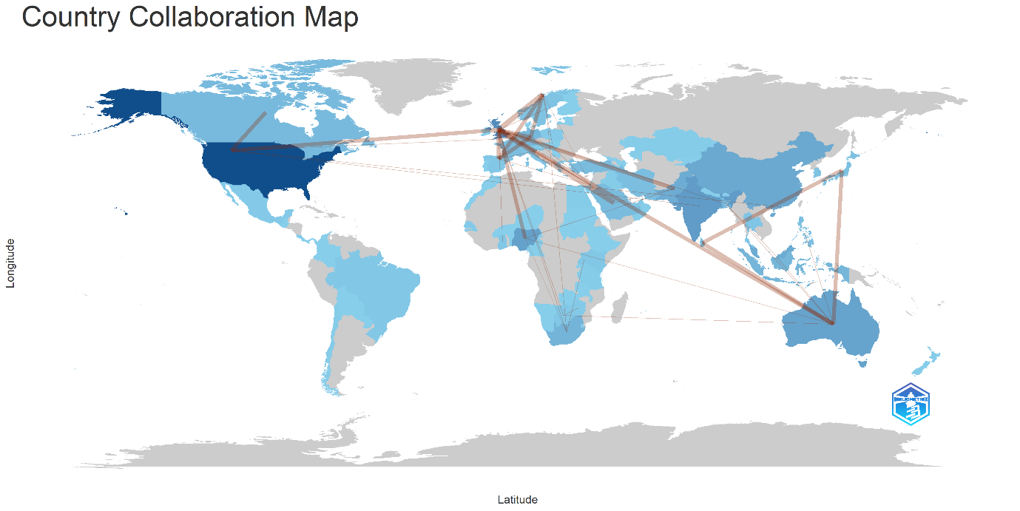

**Figure 5. Countries' collaboration world map**

The country collaboration map is a visual representation of worldwide collaborative partnerships in this domain, with links between countries indicating how frequently these collaborations occur, where the thickness of lines depicts the frequency of collaboration, and the intensity of the color on the map corresponds to the frequency. Figure 5 illustrates the highest frequency of collaboration (frequency = 4) with the United Kingdom (UK), collaborative hubs, Norway and Saudi Arabia, and a high frequency (frequency = 3) with countries such as Australia, France, Germany, Nigeria, and Pakistan. In addition, Australia has a significant collaboration with Japan, Sri Lanka, Bangladesh, Botswana, Malaysia, Nigeria, and the Philippines. Germany and France exhibit strong bilateral collaborations and additional connections with Hungary and Israel. Owing to geopolitical considerations, Hungary, rising EU research strengths, and Israel, a leader in high-tech innovation, are included in the robust research collaborations between Germany and France, which are based on historical ties and EU projects. These collaborations seek to address global issues, advance science, and economic growth while supporting diplomacy. On the other hand, the USA has higher collaboration rates with Canada and the United Kingdom. Notably, this map illustrates a global network of collaborative activities spanning multiple landforms, including North America, Europe, Asia, Africa, and Australia. The map highlights that European countries (the UK, Germany, and France) play prominent roles in global collaboration, whereas Australia also has a noteworthy influence.

Table 4 and Figure 5 indicate that the USA leads in terms of the number of publications but has fewer global collaborations than European countries such as the UK, Germany, and France do. This is largely due to the strong emphasis of the European Union (EU) on collaborative research within Europe, facilitated by programs such as Horizon Europe. Additionally, the geographic proximity and political integration of Europe make frequent and intensive collaborations more feasible. In contrast, the USA, despite its high volume of research output, tends to focus more on domestic resources and collaborations, primarily with nearby countries such as Canada and the UK. This difference highlights how European countries prioritize broad, cross-border cooperation, while the approach of the USA is more regionally concentrated

***Keyword in Terms of Occurrence***

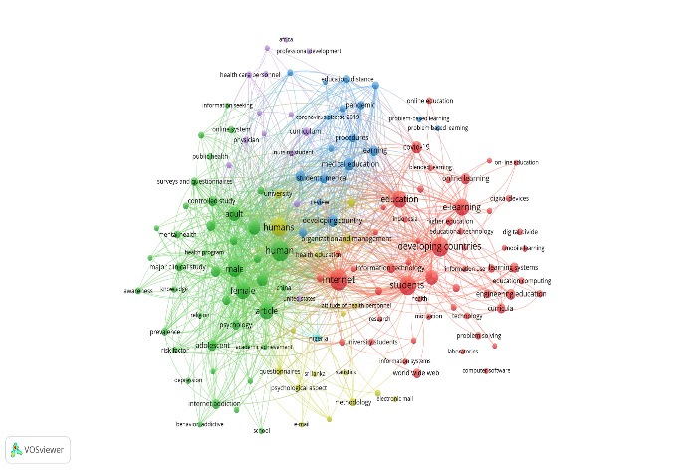

**Figure 6. Keyword analysis**

Keyword co-occurrence phenomena can generally be used in the analysis of research themes in certain academic fields. The various combinations of different keywords in the same contextual environment usually reflect the focus of research in an article (Su & Sun, 2020). This section delineates various studies focused on internet adoption in education, which are analyzed through keyword co-occurrence via VOSviewer. Adopting a minimum occurrence of 1 for the keywords generated a total number of links of 32238, a link strength of 43462, and 23 clusters among 1000 keywords. Given that ‘Internet’ is the most frequent keyword with respect to ‘education’, Human and Developing Countries emphasize that digital technologies have transformed world society (Martínez-Domínguez & Mora-Rivera, 2020). This focus on internet adoption mirrors its key role in redesigning human life, especially education (Saif et al., 2024), and in changing the dynamics of conventional teaching methods and knowledge delivery (Coman et al., 2020). Indeed, in bibliometric analysis, studying the link between the internet and education yields the necessary information on the changes to the academic research and development paradigms. On the internet, digital learning services are supported by many opportunities for education, such as MOOCs, e-learning portals, and virtual classes, leading to the creation of global communities for learning (Siergiejczyk, 2020). It operates as a large library for facilitating research and learning with easy access information in the form of articles, papers and videos. These are communication technologies such as forums, video conferences, and social media that support student, teacher, and researcher interactions to promote peer relationships and enhance learning (Ali, 2020).

The internet drives the growth of EdTech innovations to deliver customized teaching technologies through learning software, EdApps and intelligent tutoring systems (Ayeni et al., 2024). It subverts spatial location and provides educational resources to areas that people can hardly reach and helps people work and learn simultaneously during their spare time with well-designed schedules and various courses. Additionally, online platforms collect information about student progress and activity to make appropriate decisions and improve lessons. Therefore, the internet contributes to a reduction in educational unfairness and increases learner accessibility by allowing most of the internet’s resources to be free (Eden et al., 2024). This interconnection extends the significance of ‘digital technologies’ for changing education, which is further examined via bibliometric analysis to establish citation patterns, a coauthorship network and keyword frequencies to establish research trends and the role of internet technologies in education. As educational units incorporate digitization into their practice, discussions of the “Human” and “Internet” research into the interaction of human and computer digital literacy (Farias-Gaytan et al., 2023). Nevertheless, there are issues with internet-enabled education, especially for learners in ‘‘Developing Countries’’ (Jamil, 2021). The increased coverage of these countries makes it clear that decisive measures should be taken to close the digital divide, becoming a serious obstacle to socioeconomic development due to essential differences in access and infrastructure. In developing countries, women face obstacles due to sociocultural norms and limitations, which ensures the presence of gender disparities. However, a multidimensional approach requires addressing these challenges and intervention to promote digital literacy and empower marginalized communities (Zamil, 2021). Collaborative efforts between governments, civil society, and the private sector are crucial in developing comprehensive strategies to bridge the digital divide and leverage the internet for sustainable development. Hence, the analysis of keyword co-occurrence in Figure 6 offers insights into the multifaceted nature of internet adoption, emphasizing the need for concerted action to address digital inequality and foster an inclusive digital ecosystem.

**Table 5. Thematic Cluster based on authors' keywords (sources: writers’ operation through**

|  |  |  |  |  |  |
| --- | --- | --- | --- | --- | --- |
| **Cluster** | **Calloncentrality** | **Callondensity** | **Rank centrality** | **Rank density** | **Cluster Frequency** |
| Internet Of Things | 0.425 | 38.534 | 1 | 4 | 34 |
| Students | 17.232 | 36.984 | 5 | 3 | 285 |
| Developing Countries | 6.883 | 25.283 | 4 | 1 | 185 |
| Engineering Education | 3.785 | 27.898 | 3 | 2 | 137 |
| Internet | 47.015 | 88.166 | 7 | 7 | 944 |
| Online Learning | 1.116 | 38.994 | 2 | 5 | 37 |
| Female | 26.203 | 77.759 | 6 | 6 | 546 |

The authors’ keywords presented in Table 5 were used to generate 7 thematic clusters that were tabulated. In this context, the clusters may be subdivided into four quadrants comprising Name, CallonCentrality, Callon Density, Rank Centrality, RankDensity, and ClusterFrequency. The 7 distinct clusters include the various valuables of RankCentrality and Rank Density and are dispersed on the four quadrants of the thematic map. The methodology automatically confers each cluster a designation on the basis of the concept that appears most regularly in it. By and large, the designations of the respective clusters include:

‘’internet’’ 944, ‘’female’’ 546, ‘’Students’’ 285, ‘’Developing Countries’’ 185,

‘’ Engineering Education’’ 137, ‘’ Online Learning’’ 37, and ‘’ Internet of Things’’ 34.

***Thematic Map***

Thematic map identifies in the figure 7, the degree of development (density) and relevance (centrality) of research themes, resulting in four quadrants: Niche Themes, Motor Themes, Emerging or Declining Themes and Basic Themes. Niche Themes quadrants remain sophisticated but work across all sorts of sectors. The Motor Themes quadrant with its strong development and central themes of the internet, human, humans, female, male, and adult indicates that these are the most important topics that have driven the research field. Themes which are less central and quite underdeveloped, such as engineering education, curricula, learning systems, developing countries (where we have a lot of projects), e-learning, theworld wide web obviously play together in the quadrant Emerging or Declining Themes. The first quadrant, Basic Themes, covers basic yet minimally elaborated themes (e.g., students, education and teaching) and suggests their centrality to the field combined with the need of heightened interrogation.

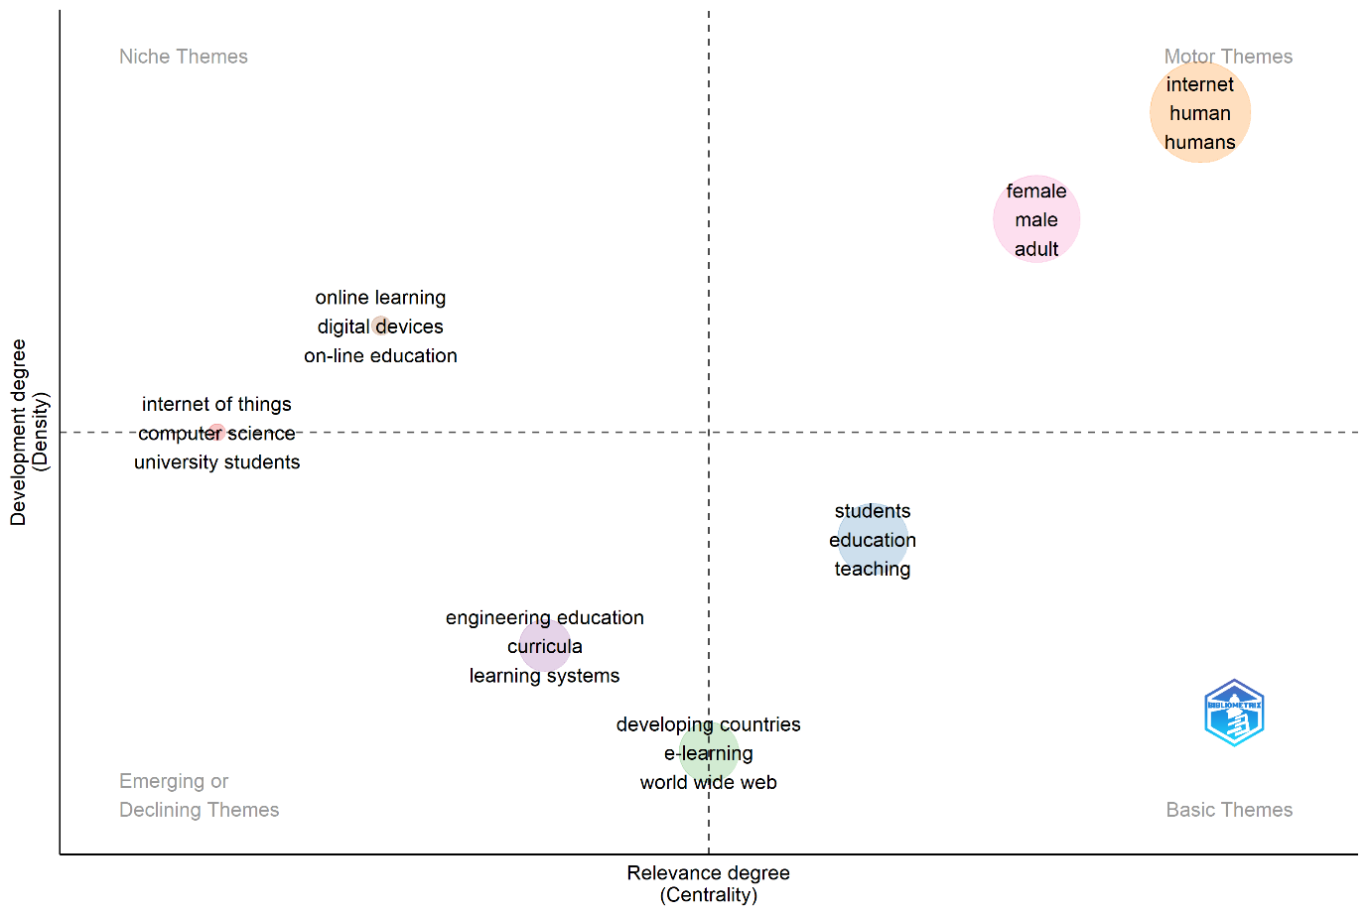

**Figure 7. Thematic map**

***Cluster Analysis***

This study operates a clustering analysis of a bibliometric dataset of 352 research documents so that it identifies thematic trends in literature on the shortcomings that students encounter when adapting to the Internet in developing states. Further, this work focuses on determining relevant issues, trends and gaps in the literature and highlighting emerging research areas. Based on their content resemblance, multiple Natural Language Processing (NLP) techniques were applied for this, and then K-Means was conducted on the sentences to cluster them. This was adorned by Principal Component Analysis (PCA), which aided us in visualising and deriving the clusters better.

***Abstract Preprocessing and Text Preparation for Cluster Analysis***

Firstly, lowercasing all text for coordination and to escape inconsistencies arising from capitalization. Then numerical values, special characters, and punctuation were eliminated due to they didn’t provide useful information for clustering. This permitted us to execute analysis on the textual information itself, to ensure that manipulate the text at the word level.

Secondly, this is the most informative part of the research through preprocessing of the clustering algorithm, which is called Lemmatisation and stop words. Lemmatisation was used to break words down to their base forms, extracting only their key meanings. Furthermore, stop words removal as low-information words viz. "the," "and," and "is" out of the equations, but contains common.

Thirdly, for vectorising the preprocessed text into a numerical format, TF-IDF (Term Frequency-Inverse Document Frequency) was applied, which is appropriate for clustering. This technique includes how crucial a word is in a document about the whole corpus. TF characterises the frequency of words in a document, while IDF values support in providing more weightage to the words which are restricted to a document. The consequence was the words on the horizontal axis and a high-dimensional matrix with documents on the vertical axis, and the value in the matrix corresponding to how much that word contributes to the document (as a numeric vector). For clustering, the top 500 most pertinent words related to them were selected from the dataset. Finally, it K-Means clustering was achieved on the 352 documents and extracted them into 5 groups. K=5, the number of clusters, was chosen as introduced in the initial data analysis. In the K-Means algorithm, primarily random centroids are entrusted to the clusters, then based on the average position of each document in a cluster, centroids are recalculated over each iteration. This process is repeated until centroidsbecome stable. The result was five clusters (0, 1, 2, 3, and 4), each one aligned with a specific research theme.

To blueprint the high-dimensional data to a lower-dimensional space to understand it in a more interpretable way, we established PCA to reduce the data into principal components and exhibited the data on a 2D graph (Pandey, 2024). We then exhibited the clusters in a two-dimensional scatter plot, where each document is a point and each colour portrays each cluster. PCA plot  displayed documents in the same cluster are closely discovered, meaning they have common topics (research themes) (Chen et al., 2010). However, some clusters, e.g. Cluster 2 of Figure 8, showed more dispersion, resulting of more variety of topics in those clusters.

To further conclude the thematic orientation of each cluster, we generated corresponding word clouds. These word clouds illustrate the top occurring words within each cluster, with large words indicating high frequency. Insights from analysis were that: ⇒ cluster 0's keywords were "internet addiction," "depression," and "academic achievement," mainly socio-psychological problems regarding mental health and academic performance. Cluster 1 involved terms such as “AI,” “Blockchain,” and “technology integration” indicating that these are topics of interest that came out of the interview extracts in terms of advanced technologies that can overcome obstacles to internet adoption in the educational sector. Similarly, Cluster 2 included terms such as “socio-political barriers,” “cost of connectivity,” and “gender inequality” that spotlighted socio-economic restrictions, particularly the cost of using the internet and gender-based challenges. Cluster 3 consisted of terms such as "research output," "scientific mapping," and "bibliometric analysis," which drawn studies on research trends and the scientific mapping of internet adaptation (Liu, 2022). Group 4 composed words like "collaboration," "government," and "private sector," signifying that multi-stakeholder efforts need to be used to tackle the digital divide.

This study denoted a number of noticeable insights into the research literature. Cluster 0 main concern was on indispensable psychosocial and educational issues of internet addiction, cyberbullying and mental health for students, which highlighted the need for addressing these issues. In Cluster 1, the core analysis was an investigation of the potential of digital technologies, including AI and Blockchain, to aid in overcoming challenges of internet adaptation, especially in educational contexts. Cluster 2 identified socio-economic factors, such as cost and gender inequalities, as barriers to internet access that warrant targeted interventions to overcome these diversities. Cluster 3 published the significant tracking research trends as well as mapping the scientific output related to the adaptation of the internet, which is important in future policy formulation and scientific research. Cluster 4 intensified the need for involvement across governments, the private sector and civil society to effectively tackle the digital divide.

Several future research recommendations are endorsed according to the clustering results. Exploring emerging technologies such as AI and Blockchain Sources. The title is extracted from an earlier version of this article, which had initially focused on the potential of emerging technologies like AI and Blockchain to increase access to the internet and further hackerspace initiatives in developing countries. Second, more in-depth research is warranted to explore the specific barriers that women confront when accessing the internet for educational purposes, particularly for regions with high gender gaps. Third, detailed case studies in certain regions must be carried out to gather empirical evidence on the success of mobile learning platforms and inexpensive digital devices. Lastly, studies could explore the potential of collaboration between our government, private sector companies, and civil society to support us work towards bridging our digital divide and enrich access to education.

This study concluded some normative perspectives on the literature of internet adjustment issues in developing parts of the world, before 2023. The five novel clusters detected —those that analyse psychological, socio-economic, technological and collaborative challenges—produce a clear overview of how research has advanced in the current context. These results add to the current understanding of the main barriers stumbled by students in the transition to internet-based education and serve as a guide for research in the future that would like to cross the digital divide and enlarge educational opportunities in developing countries.

***Clustering of Research Topics***

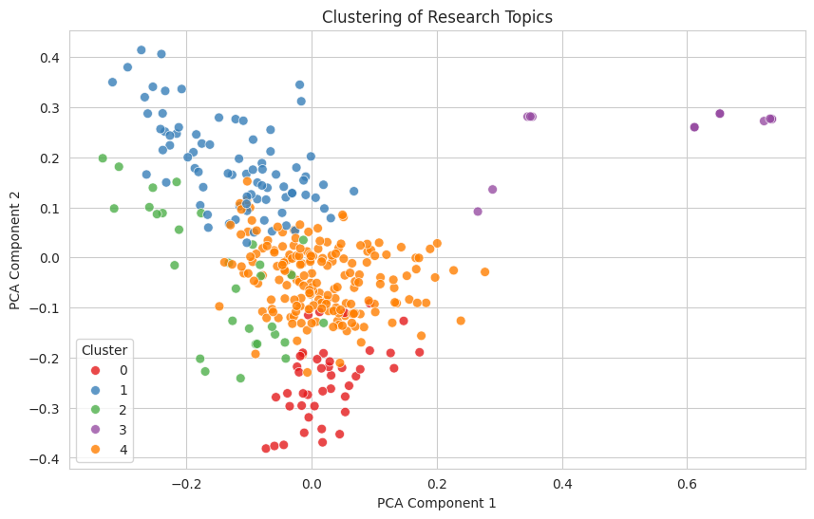

**Figure 8. PCA scatter plot visualizing the clustering of documents**

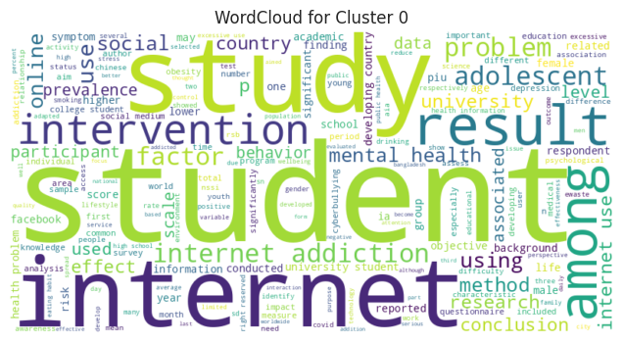

**Figure 9. Word cloud for Cluster 0**

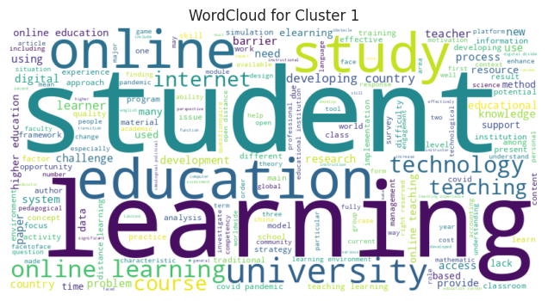

**Figure 10. Word cloud for Cluster 1**

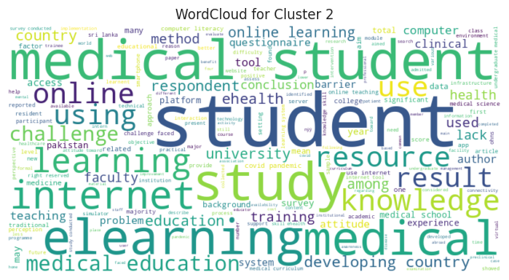

**Figure 11. Word cloud for Cluster 2**

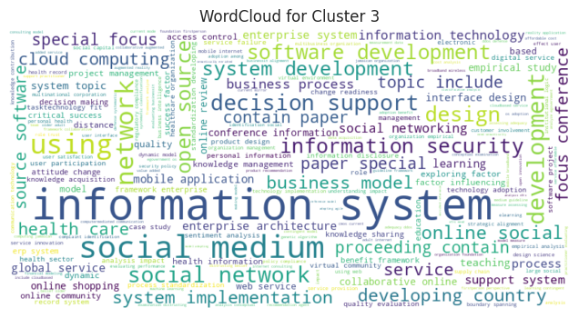

**Figure 12. Word cloud for Cluster 3**

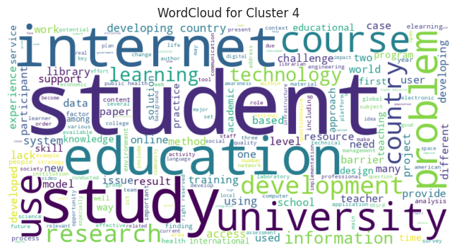

**Figure 13.Word cloud for Cluster 4**

The research gap emphasizes the limited exploration of bibliometric analysis concerning the challenges students in developing countries face when adapting to the internet. This study aimed to analyze publications and trends addressing these challenges while promoting further research into utilizing advanced technologies like AI and blockchain to reduce digital inequality. Findings covered a 29-year period (1995–2024), drawing from 352 documents across 277 sources, with a 7.87% annual growth rate and an average of 14.25 citations per document. A significant increase in publications began in 2009, with a peak of 26 articles in 2013. After a brief decline, a notable surge occurred in 2021 (38 articles), likely due to the educational technology shift prompted by the COVID-19 pandemic, and interest remained strong through 2023.

One of the most important outcomes of the review of previous research is that the internet transforms education by enhancing accessibility, lifelong learning, and equity through digital platforms like MOOCs and e-learning portals. Collaborative tools such as forums and video conferencing enrich educational experiences (Siergiejczyk, 2020; Haleem et al., 2022). However, challenges like inadequate infrastructure, high costs of connectivity, limited digital literacy, and socio-political barriers—particularly for women—remain prominent in developing nations (Nye, 2015). These findings highlight the ongoing need for collaborative efforts from governments, civil society, and the private sector to improve digital skills and bridge the digital divide.

The analysis also found that the United States leads in research output on internet adaptation, with 63 publications and 1,979 citations, reflecting its strong scholarly impact. However, European countries such as the United Kingdom, Germany, and France dominate global collaborative networks, driven by EU initiatives like Horizon Europe. These countries emphasize cross-border cooperation, while the USA’s collaborations remain more regionally focused, primarily with Canada and the UK. Developing countries such as India and the Philippines contribute meaningful research but face challenges in global collaboration and influence. For example, although India has a significant number of publications, its lower integration into global research networks signals a need for increased international partnerships to enhance research impact. The most influential author is Choo, followed by Fung, Gentile, Khoo, Li, Liau, and Sim, with 867 citations. Their work focused on pathological video game use among youth and its implications for academic and psychological outcomes (Gentile et al., 2011). Similarly, Edirippulige, Fujisawa, Marasinghe, Smith, and others contributed multiple studies on e-health knowledge among Sri Lankan medical students (Edirippulige et al., 2007a; Edirippulige et al., 2006; Edirippulige et al., 2007).

The keyword analysis reveals a strong focus on terms like "Internet," "education," "human," and "developing countries," while secondary themes include "digital literacy," "e-learning," and "collaboration." These keywords reflect the central theme of digital learning challenges, especially in underserved regions. The thematic map analysis supports this, identifying “Internet,” “human,” and “female” as dominant motor themes, underscoring their centrality in the literature. Underdeveloped themes such as “engineering education” and “e-learning” suggest potential areas for further exploration. Notably, the limited visibility of AI and blockchain technologies in both the keyword co-occurrence and thematic analyses points to a significant research gap. Although these technologies offer substantial promise in enhancing access, personalization, and data security in education, they remain underrepresented in current bibliometric trends. Their integration into future research agendas could offer innovative solutions for addressing internet adaptation challenges in developing regions.

While this research offers a macroscopic view of the topic by identifying top authors, influential countries, and key themes in internet adaptation challenges, future studies should explore the role of advanced technologies like AI and Blockchain in addressing internet adoption barriers in developing countries it as shown in figures 8 -13.

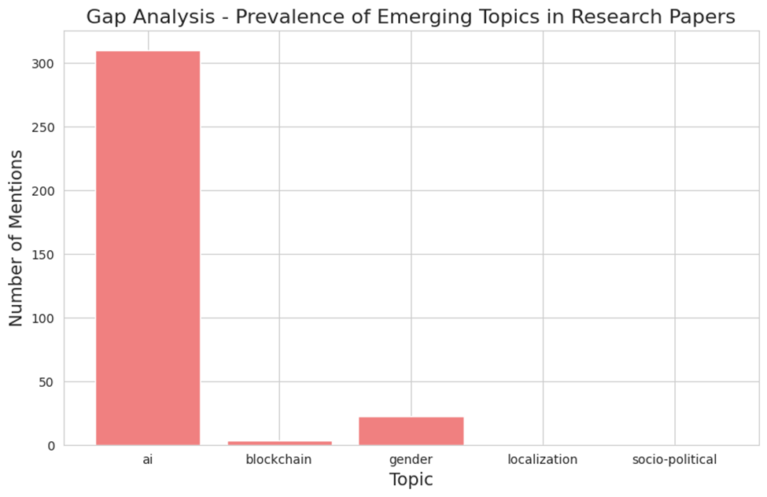

**Figure 14. Gap Analysis-prevalence of emerging topics in research papers**

Specialized policy measures can be developed by decision-makers to comfort underdeveloped countries through initiatives focusing on infrastructure and socioeconomic barriers blocking internet adoption. The identification of these obstacles enables them to create programs that help communities connect to stable online services for greater technology accessibility. The study data allows educational institutions to create modern teaching practices which effectively incorporate technology despite limited resources. Educational institutions can improve their approach by employing mobile devices for learning activities and online information dissemination in addition to virtual classroom delivery for remote students. Future academic research will gain direction from the analysis results to discover emerging trends like AI (Figure 14) that will affect upcoming investigations.

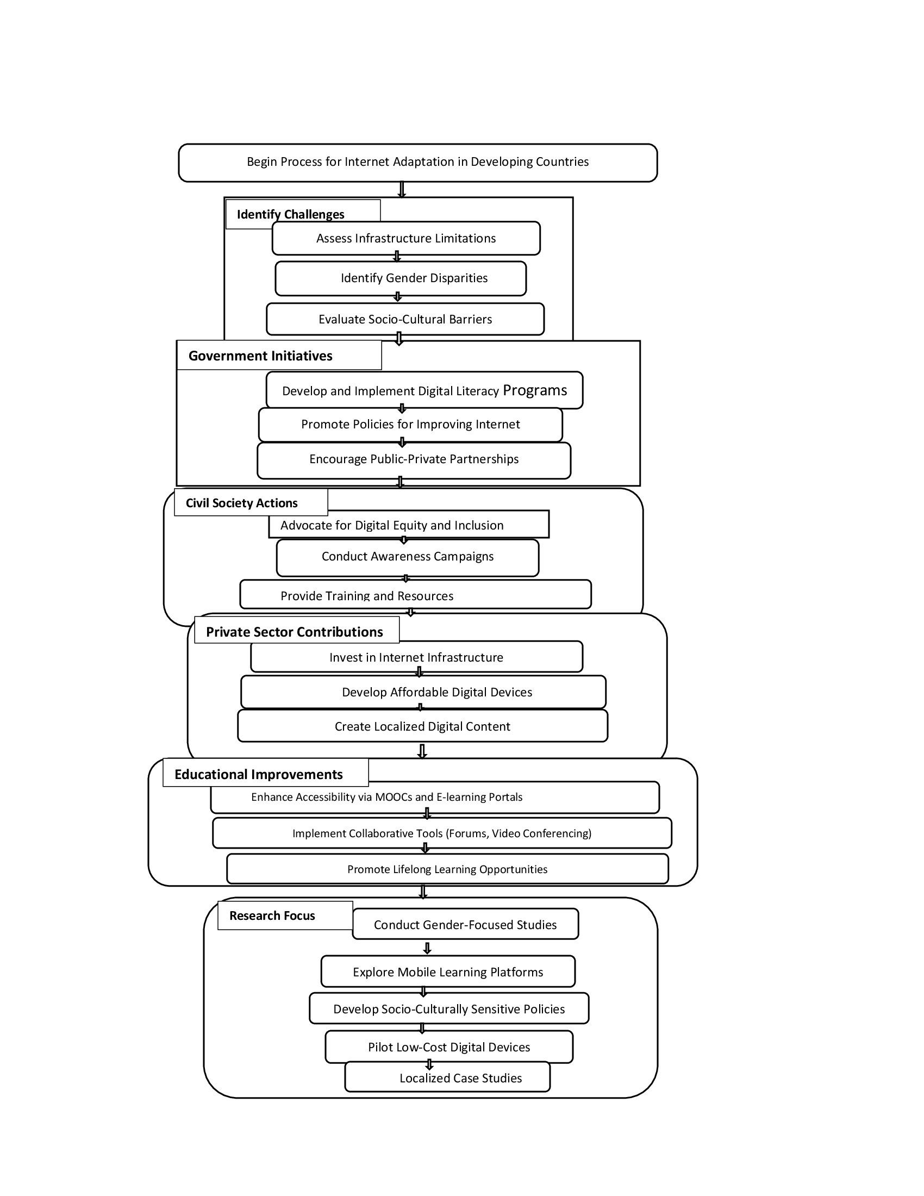

**Figure 15. Proposed guidelines for the effective and responsible use of the internet by the students in developing countries.**

**Conclusion**

The research takes into account the fact that the challenges facing internet adoption have a severe effect on education, especially in developing countries. The transformative potential of digital platforms like MOOCs and e-learning, while also addressing the limitations posed by infrastructure and societal constraints (Nye, 2015; Haleem et al., 2022; Kloza, 2023). The analysis highlights the thematic focuses, leading authors and source countries, and common in the absence of exploration for innovative technologies such as AI or Blockchain. The future research should be directed to the analysis of how these technologies may help to minimize the gap, increase access, and enhance education opportunities. The study presents ideas for future research and functional approaches to this problem area. The main limitations in this study are the use of data from Scopus that has several inherent problems: full count, lack of a capability to sort papers by journal categories or levels (journals, conference proceedings, book chapters, etc.). Finally, only research papers from journals were given consideration and papers from books, novels, and research papers in languages other than English were not taken into consideration since they may not be indexed in Scopus. Further research on such challenges and solutions must use case analyses and pilot projects, including mobile learning platforms, as examples in different spatial settings. Furthermore, Figure 15 depicts a comprehensive framework outlining the proposed guidelines for the effective and responsible use of the internet by students in developing countries. The flowchart begins with the identification of key challenges such as infrastructure limitations, gender disparities, and socio-cultural barriers. It highlights coordinated efforts across five main sectors: government initiatives, civil society actions, private sector contributions, educational improvements, and focused research. These components emphasize the importance of digital literacy programs, infrastructure investment, public-private partnerships, digital equity advocacy, and the development of culturally sensitive policies. The model ultimately aims to create an inclusive, accessible, and sustainable internet ecosystem to enhance educational and developmental outcomes for students.

**Disclaimer (Artificial intelligence)**

Option 1:

Author(s) hereby declare that NO generative AI technologies such as Large Language Models (ChatGPT, COPILOT, etc.) and text-to-image generators have been used during the writing or editing of this manuscript.

Option 2:

Author(s) hereby declare that generative AI technologies such as Large Language Models, etc. have been used during the writing or editing of manuscripts. This explanation will include the name, version, model, and source of the generative AI technology and as well as all input prompts provided to the generative AI technology

Details of the AI usage are given below:

1. The Language and Grammatical concerns have been improved though ChatGPT.

**Reference**

Abbas, A. F., Jusoh, A., Mas’od, A., Alsharif, A. H., & Ali, J. (2022). Bibliometrix analysis of information sharing in social media. *Cogent Business & Management*, 9(1). https://doi.org/10.1080/23311975 .2021.2016556

Abdi, H., & Williams, L. J. (2010). Principal component analysis. *Wiley interdisciplinary reviews: computational statistics*, *2*(4), 433-459.

Accilar, A. (2011). Exploring the aspects of digital divide in a developing country. *Issues in Informing Science and Information Technology*, 8 (1), 231–244.

Ali, W. (2020). Online and remote learning in higher education institutes: A necessity in light of COVID-19 pandemic. *Higher education studies*, *10*(3), 16-25.

## Ayeni, O. O., Al Hamad, N. M., Chisom, O. N., Osawaru, B., & Adewusi, O. E. (2024). AI in education: A review of personalized learning and educational technology. *GSC Advanced Research and Reviews*, 18(2), 261-271.

Bener, A., & Bhugra, D. (2013). Lifestyle and depressive risk factors associated with problematic internet use in adolescents in an Arabian Gulf culture. *Journal of Addiction Medicine*, 7(4), 236–242.

Beyth-Marom, Ruth, Eran Chajut, Sonia Roccas, and Lilach Sagiv. (2003). Internet-assisted versus traditional distance learning environments: Factors affecting students’ preferences. *Computers & Education,* 65–76.

Bozkurt A, Karadeniz A, Baneres D, Guerrero-Roldán AE, Rodríguez ME. (2021). Artificial intelligence and reflections from educational landscape: A review of AI Studies in half a century. *Sustainability*, 13(2), 800. https://doi.org/10.3390/su13020800

Cerniglia, L., Zoratto, F., Cimino, S., Laviola, G., Ammaniti, M., & Adriani, W. (2017). Internet Addiction in adolescence: Neurobiological, psychosocial and clinical issues. *Neuroscience & Biobehavioral Reviews*, 174–184.

Chandrapaul, Soni, R., Sharma, S., Fagna, H., & Mittal, S. (2019). News analysis using word cloud. In *Advances in Signal Processing and Communication: Select Proceedings of ICSC 2018* (pp. 55-64). Springer Singapore.

Chen, C., Ibekwe‐SanJuan, F., & Hou, J. (2010). The structure and dynamics of cocitation clusters: A multiple‐perspective cocitation analysis. *Journal of the American Society for information Science and Technology*, *61*(7), 1386-1409. https://doi.org/10.1002/asi.21309

## Coman C, Țîru LG, Meseșan-Schmitz L, Stanciu C, Bularca MC. (2020). Online teaching and learning in higher education during the coronavirus pandemic: Students’ perspective. *Sustainability*, 12(24), 10367. <https://doi.org/10.3390/su122410367>

de Oliveira, O. J., da Silva, F. F., Juliani, F., Barbosa, L. C. F. M., & Nunhes, T. V. (2019). Bibliometric method for mapping the state-of-the-art and identifying research gaps and trends in literature: An essential instrument to support the development of scientific projects. In *Scientometrics recent advances.* IntechOpen.

*Developing country—Wikipedia*, (n.d.), <https://en.wikipedia.org/wiki/Developing_country#cite_note-3>

## Eden, C. A., Chisom, O. N., & Adeniyi, I. S. (2024). Online learning and community engagement: Strategies for promoting inclusivity and collaboration in education*. World Journal of Advanced Research and Reviews*, 21(3), 232-239.

Edirippulige, S., Fujisawa, Y., Marasinghe, R., Jiffry, M., Smith, A., & Wootton, R. (2007). Medical Students’ Knowledge in E-Health in Developing Countries: A Survey in Sri Lanka. In *9th International Conference 2007: International Conference on e-Health Networking, Application and Services,* 19-22, 95-99. <https://doi.org/10.1109/HEALTH.2007.381612>

Edirippulige, S., Marasinghe, R., Smith, A., Fujisawa, Y., Herath, W., Jiffry, M., & Wootton, R. (2006). Knowledge and Perceptions of e-Health: Results of a Survey of Medical Students in Sri Lanka.  In *2006 international conference on information and automation*, 437-439. <https://doi.org/10.1109/ICINFA.2006.374093>

Edirippulige, S., Marasinghe, R., Smith, A., Fujisawa, Y., Herath, W., Jiffry, M., & Wootton, R.. (2007). Medical students’ knowledge and perceptions of e-health: Results of a study in Sri Lanka. *Studies in Health Technology and Informatics*, *129*(2), 1406–1409.

El Koshiry, A., Eliwa, E., Abd El-Hafeez, T., & Shams, M. Y. (2023). Unlocking the power of blockchain in education: An overview of innovations and outcomes. *Blockchain: Research and Applications*, 100165.

## Farias-Gaytan S, Aguaded I, Ramirez-Montoya MS. (2023). Digital transformation and digital literacy in the context of complexity within higher education institutions: a systematic literature review. *Humanities and Social Sciences Communications*, 10(1), 1-1. <http://dx.doi.org/10.1057/s41599-023-01875-9>

Gaviria-Marin M, Merigo JM, Popa S. (2018). Twenty years of the Journal of Knowledge Management: A bibliometric analysis. *Journal of Knowledge Management*, 22(8), 1655-87. https://doi.org/10.1108/JKM-10- 2017-0497

Gentile, D., Choo, H., Liau, A., Sim, T., Li, D., Fung, D., & Khoo, A. (2011). Pathological Video Game Use Among Youths: A Two-Year Longitudinal Study. *Pediatrics*, 127(2), 319-29. <https://doi.org/10.1542/peds.2010-135>

Georgsen, M., & Zander, P-O. (Eds.) (2013). Changing education through ICT in developing countries. *Aalborg Universitetsforlag.*

Gupta, B., Negi, M., Vishwakarma, K., Rawat, G., Badhani, P., & Tech, B. (2017). Study of Twitter sentiment analysis using machine learning algorithms on Python. *International Journal of Computer Applications*, *165*(9), 29-34.

Haleem, A., Javaid, M., Qadri, M. A., & Suman, R. (2022). Understanding the role of digital technologies in education: A review. *Sustainable Operations and Computers*, 3, 275-285.

Haque, M. A., Rahman, Z., Pervez, A. K. M., Banik, P., Aziz, D. A. B., Sarker, B., & Bhuiyan, M. F. K. (2023). Knowledge sharing and students’ development: R-based bibliometric study. *Asian Journal of Education and Social Studies*, *48*(1), 144-165.

Harzing, A. W., & Alakangas, S. (2016). Google Scholar, Scopus and the Web of Science: a longitudinal and cross-disciplinary comparison. *Scientometrics*, *106*, 787-804.

Heimerl, F., Lohmann, S., Lange, S., & Ertl, T. (2014, January). Word cloud explorer: Text analytics based on word clouds. In *2014 47th Hawaii international conference on system sciences* (pp. 1833-1842). IEEE.

## Jamil S. (2021). From digital divide to digital inclusion: Challenges for wide-ranging digitalization in Pakistan. *Telecommunications Policy*, 45(8), 102206. <https://doi.org/10.1016/j.telpol.2021.102206>

Kloza, B. (2023). Digital Divide in Developing Countries: Why We Need to Close the Gap. *Connecting the Unconnected*. <https://ctu.ieee.org/digital-divide-in-developing-countries-why-we-need-to-close-the-gap/>

Liu, Z. (2022). Mapping the research trends of third language acquisition: A bibliometric analysis based on Scopus. *Frontiers in Psychology*, *13*, 1021517. <https://doi.org/10.3389/fpsyg.2022.1021517>

Mamun, M. A., Hossain, Md. S., Siddique, A. B., Sikder, Md. T., Kuss, D. J., & Griffiths, M. D. *(*2019). Problematic internet use in Bangladeshi students: The role of socio-demographic factors, depression, anxiety, and stress. *Asian Journal of Psychiatry, 44*, 48–54. <https://doi.org/10.1016/j.ajp.2019.07.005>

## Marope, P. T. M. (2017). Advancing inclusive and quality education through human rights education. *Prospects*, *47*(1), 1-2. https://doi.org/10.1007/s11125-018-9430-4

## Martínez-Domínguez M, Mora-Rivera J. (2020). Internet adoption and usage patterns in rural Mexico. *Technology in society*, 60(1), 101226. <https://doi.org/10.1016/j.techsoc.2019.101226>

Moorthy, Krishna, Loh Chun T’ing, Khor Mei Wei, Pauline Tan Zi Mei, Chai Yan Yee, Kevin Jia Wern, and Yue Mei Xin. *(*2019). Is facebook useful for learning? A study in private universities in Malaysia*. Computers and Education,* 130, 94–104.

Mougenot B, Doussoulin JP. (2022). Conceptual evolution of the bioeconomy: A bibliometric analysis. *Environment, Development and Sustainability*, 24(1) 1031-47.

Pandey, R. (2024). *Investigating the use of dimensionality reduction techniques in the machine learning-based alignment-free genomic sequence analysis* (Doctoral dissertation, University of Prince Edward Island).

Pedro, F., Subosa, M., Rivas, A., & Valverde, P. (2019). Artificial intelligence in education: Challenges and opportunities for sustainable development.

Qaiser, S., & Ali, R. (2018). Text mining: use of TF-IDF to examine the relevance of words to documents. *International journal of computer applications*, *181*(1), 25-29.

Rodríguez-Castelán, C., & Pierola, D. *(*2022). Determinants and Welfare Impacts of Mobile Internet Adoption in African Countries. *World Bank.* https://doi.org/10.1596/38007

## Saif N, Khan SU, Shaheen I, ALotaibi FA, Alnfiai MM, Arif M. (2024). Chat-GPT; validating Technology Acceptance Model (TAM) in education sector via ubiquitous learning mechanism. *Computers in Human Behavior*, 154(1), 108097. <https://doi.org/10.1016/j.chb.2023.108097>

Sambuli, N. *(*2016). Challenges and opportunities for advancing Internet access in developing countries while upholding net neutrality*. Journal of Cyber Policy,* 1(1),61–74.

Segura-Robles, A., Moreno-Guerrero, A. J., Parra-González, M. E., & López-Belmonte, J. (2020). Review of research trends in learning and the internet in higher education. *Social Sciences*, *9*(6), 101.

## Siergiejczyk, G. (2020). Virtual international exchange as a high-impact learning tool for more inclusive, equitable and diverse classrooms. *European Journal of Open, Distance and E-Learning*, *23*(1), 1-17.

## Su, W.C. and Sun, Y.L. (2020). Research on the Library Users’ Information Retrieval Behaviour: From a Bibliometric Perspective. *Open Access Library Journal*, 7, 6460. <https://doi.org/10.4236/oalib.1106460>

## Sun J. (2016). Convergence and divergence in blended learning. In Blended Learning: Aligning Theory with Practices: 9th International Conference, ICBL, 292-301. Springer International Publishing. <https://doi.org/10.1007/978-3-319-41165-1_26>

## Tan M, Teo TS. (1998). Factors influencing the adoption of the Internet*. International Journal of Electronic Commerce*, 2(3), 5-18. <http://dx.doi.org/10.1080/10864415.1998.11518312>

Van Eck, N. J., Waltman, L., Dekker, R., & Van Den Berg, J. (2010). A comparison of two techniques for bibliometric mapping: Multidimensional scaling and VOS. *Journal of the American Society for Information Science and Technology*, *61*(12), 2405-2416.

Zamil IA, Ramakrishnan S, Jamal NM, Hatif MA, Khatib SF. (2023). Drivers of corporate voluntary disclosure: A systematic review. *Journal of Financial Reporting and Accounting,* 21(2), 232-67. https://doi.org/10.1108/JFRA04- 2021-0110