Original Research Article

Domestic Water Accessibility and Its Effect to Households Livelihood: A case of Maswa District, Shinyanga Region, Tanzania.

ABSTRACT
Water supply is an essential requirement for people and it has intrinsic connection with lives and livelihoods. Water shortage affects households’ labour because of much time and energy spent on obtaining it. Unavailability of safe and clean water has several implications, among them include waterborne diseases, labour, income and time. The study was carried out to explore information on domestic water accessibility and its effects to households Livelihood in Maswa District of Tanzania. Specifically the study intended to get information related to sources of water for domestic use and its accessibility, who are mostly responsible for collecting water, time spent seeking for water and challenges related to unsafe and clean water.
120 respondents were engaged in this study. Data were collected through the use of structured questionnaire and focused group discussions (FGDs).Descriptive statistics and content analysis techniques were applied in analyzing the data. Results from the study show that unavailability of safe and clean water affects income through consuming time and loss of labour during fetching water. In addition, water related diseases consumes labour’s time and money for caring patients. Moreover, most of labour used in fetching water was mothers and daughters. Consequently, women face many challenges which are associated by carrying water on their heads at a distance and time wasted during fetching water. The challenges particularly time waste during fetching water hinders women’s participation to other income generating activities. The study concludes that sources of water such as traditional dug wells and hand dug wells at the river bed represent the most important water sources for rural households in the study area. Moreover, women face a number of challenges related to water shortage and time spent fetching water. The study recommends that authority’s responsible for facilitating Water supply systems both at National and Regional level should Increase mechanisms which will enable large population to access water within acceptable distance in order to reduce women and children burden of carrying water at a distance.

Key words: domestic water, accessibility, traditional dug wells, Challenges, Maswa district, Tanzania

1. INTRODUCTION
Clean and safe water availability for domestic use is important for households’ economies. However, water shortage, becomes a common problem to many rural households in Africa. Women and children spend many hours and distance looking for water (Masanyiwa et al., 2015), which affects labour for household economic development activities. People in rural areas especially women spend hours each day fetching water instead of using that time for income generating activities thereby improving their income and diets (Rosen and Vincent, 1999). Moreover, poor quality of water affects people’s health, productivity and increases work load to the poor in the provision of water and its many domestic uses (Abanyie et al., 2023; Esrey et al., 1991; Prüss et al., 2002). Hence, water and sanitation services delivery has become one of the most challenging problems in both rural and urban areas in developing countries.

Tanzania remains one of the world’s poorest economies (World Bank Group, 2019), importantly unavailability of water for domestic consumption imposes another challenge. For example, in 2007, about 41% of rural households had access to safe and clean water (URT, 2009). Of which 59.5% of the rural households had unprotected water and only 22.8% had piped water (URT, 2009). This shows that majority of rural households in Tanzania have poor access to safe and clean water, which in turn consumes labour, household income and time for other economic activities at both household and community levels. Basing on the above fact, unavailability of safe and clean water for domestic consumption has economic impact. However, very little has been examined on the shortage of safe and clean water and its implications on households’ income.

This study was carried out to explore information on domestic water accessibility and Its effects to households Livelihood in Maswa District. Maswa District is found in Shinyanga Region. About 90% of the population in Maswa District lives in rural areas where the unavailability of water for domestic consumption has been a critical problem (URT, 2009). Findings of this study will be used to develop strategies for addressing water challenges in both rural and urban communities by involving policy makers, planners, and development partners. This will improve water availability and accessibility in rural and urban areas. Implications of unavailability of safe and clean water and related factors for this paper are summarized in Figure 1.
Background variable
- Age
- Sex
- Education
- Marital status
- Household size
Implications for household
- Reduced time for productive activities
- Spending on treatment of waterborne diseases
- Tiredness due to walking distance to water sources
- Less participation in social activities
- Absentees of pupils to school
- Insufficient of water fetched
- inadequate water storage system
- Insufficiency of water consumption per day

Independent variable:
- Distance to water sources
- Time spent to water sources
- Water quantity
- Means of water collection
- Means of water storage
- Water consumption

Water sources:
- Traditional wells,
- Shallow wells,
- Ponds,
- Tape water,
- Boreholes

Reduced household income

Figure 1: Conceptual framework showing domestic water accessibility and its implications for households’ income
Researcher’s Own Source

2. RESEARCH METHODOLOGY

2.1 Description of the Study Area
Maswa District is bordered to the north by Bariadi District, East by Meatu District, South by Kishapu District and West by Mwanza Region (Figure 2). According to the 2012 Tanzanian National population and Housing Census, the population of Maswa District was 304,402 (URT, 2013). Maswa District has a semi arid climate with bimodal rainfall pattern of between 450 and 1000 mm with an average of 750mm. The average rainfall decreases from north to south and from west to east. The short rains start in mid November to mid January and the long rains start early March up to May. The average temperature is 26o C. Large parts of the district have few vegetative cover and the soil fertility in large tracks of the District is medium to poor.
The income of the district depends on agriculture output livestock keeping. However, inadequate rainfalls to a large extent affect crops and livestock production. According to URT (2013) national population census, about 76% of the population is employed in agriculture sector. The most important cash crops are cotton and rice. Food crops include sorghum/millets, maize, rice, sweet potatoes and groundnuts and cassava.

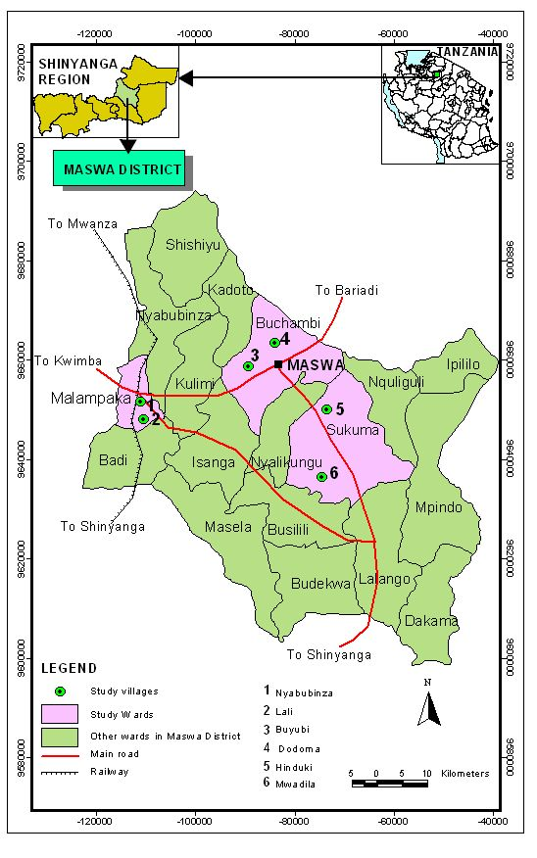
Figure 2: A Map of Maswa District showing location of the study area

2.2 Research Design
The study adopted a cross-sectional research design.Purposive sampling was employed in selecting three Divisions namely; Mwagala, Sengerema and Nung’hu. Random sampling technique was applied to obtain three wards out of 18 and one village from each selected ward making a total of six (3) villages. In each selected village, twenty (40) households were selected randomly from village registry books. A sample size of 120 households was obtained.

2.3 Data Collection and analysis
Data were collected through interview using a structured questionnaire administered to heads of selected households using personal in-depth approach. In the absence of the heads of households, any member of the household represented provided that he or she was in position of providing required information. Personal or participant observation was used to collect qualitative data such as observation of water sources and their status, means of water collection and containers used to carry water from the source. These required direct observation of an activity. The method enabled to connect together different information gathered from other methods..

3. RESULTS AND DISCUSSION

3.1 Water sources for domestic use
Table 1 results show that more than half (52.5%) of respondents use shallow wells as their means for obtaining water at their households. More than quarter (40%) of all respondents obtained water from traditional dug wells, and few (7.4%) of respondents use other water sources such as tap water and ponds (Table 1). Water from shallow wells cannot cater the needs of the people since the wells dries during dry season. The situation is worse with the traditional wells, since the wells are not protected and in most cases people share these source with animals. During Focus Group Discussion, most of respondents reported that they were frequently suffering from diarrhea because they had been using unsafe water obtained from tradition dug wells. Only fewer households (3.3%) used tape water (private sources) as source of water for domestic use. The sources are located at the individual premises which are sometimes shared with neighbors. In addition during FGDs some of the respondents reported that they were poor and thus could not afford to have access to tap water stored in their homes. The findings show that many households in rural areas of Maswa District have a problem of accessing clean and safe water as they depend on unsafe water from shallow and traditional dug wells(Table 1 and Plate;1).

Table 1: Main water sources and Management of the sources(n-120)
Main water sources | Number | Percentage
Traditional dug wells | 48 | 40
Ponds | 5 | 4.1
Shallow wells | 63 | 52.5
Tape water | 4 | 3.3
Total  Water sources management  Owners/individuals/households  Water users association  Community  Total | 120  8  20  92  120 | 100  6.6  16.7  76.7  100

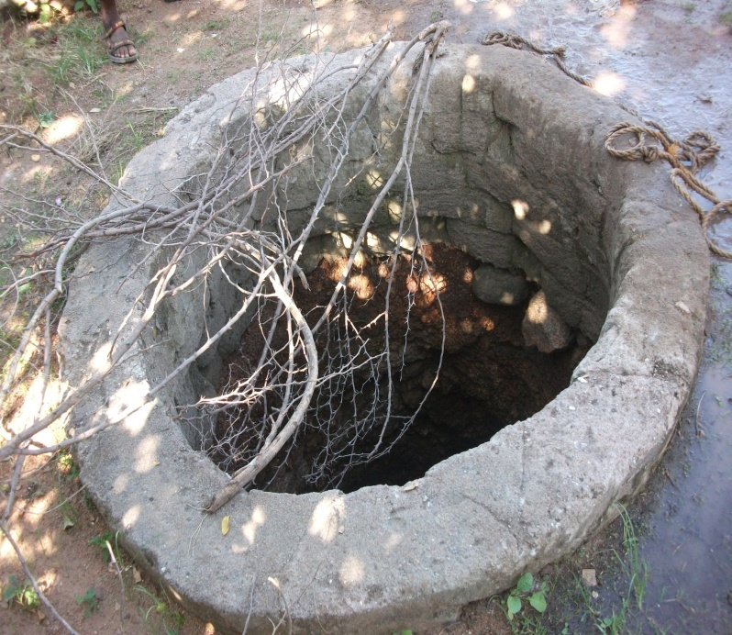
Plate 1: Traditional/Unprotected well in Buyubi village

3.2 Management and ownership of water sources
Respondents were asked to articulate how water sources had been maintained. Results from Table 1 show that majority (76.7%) of the respondents mention that water sources were managed by the community, while (16.7%) of the respondents mention water user groups/associations and few (6.6%) mention individuals were responsible for managing water sources. In addition, during direct observations, researchers observed water user groups/associations from the villages cleaning and maintaining shallow wells. However some villages’ water user groups were observed not to be active since shallow wells were not discharging water appropriately. One respondent during FGDs responded that since traditional dug wells are known to be the property of the whole community therefore every person was responsible for maintaining the source either by cash or labour contribution. From the observation, it can be noted that water sources in rural locations are owned and managed by the entire community.

3.3 Trends of water accessibility
Results from Table 2 show that more than half (56.7%) of respondents spends half an hour to one hour for fetching water to and from the water sources. The result implies that majority of the people in the study area are spending much time for water searching instead of performing other social and economic activities. The findings are supported by the study done in Sub Saharan Africa by Rosen and Vincent (1999) who reported that majority of people (especially women and girls) in sub Sahara Africa spent more time for domestic water searching and concluded that time saved from looking for water could be used in agricultural and other income generating activities.

Table 2: Time spent to and from the water sources
Time used to and fro water sources | Number | Percentage
Less than 30 minutes | 20 | 16.7
30 minutes -1 hour | 68 | 56.7
1 hour to 2 hours | 26 | 21.6
2 hours to 3 hours | 5 | 4.2
More than 3 hours | 1 | 0.8
Total | 120 | 100.0
Source: Field Survey, 2021
Table 3 highlights on the time spent by respondents to from the water sources. During FGDs one respondent explained that apart from walking long distance to and from water sources, women and girls have also had to stand in line because majorities depend on cheap water from the traditional dug wells. On average more than quarter of respondents (32.5%) spend 1 to 2 hours before they can draw water from the wells. On the other hand, others spend over 2 hours in the line (queues) (Table 3). The results implies that time spent in fetching water has socio-economic effects to households. The results are supported by information obtained during FGDs where by one women respondent from Mwagala division reported that:
“We are accused, abused and beaten by our husbands because of staying out of home for too long waiting for water at water collection sources”. ((FGDs in Mwagala divisiont, 12th June 2021)
Moreover, women respondents reported that the time spent in line/ queues sometimes makes children not to report to schools in time”. Another challenge which were reported due to time spent in queues was struggling for positions in queues/lines at the water which results into conflicts among individuals. Results of the study are in line with the study done by Gleditsch et al. (2007) who observed that demand for natural resource principally water has been resulting to water use conflicts.

Table 3: Queuing time at water sources
Queuing | Number | Percentage
15 to 30 minutes | 17 | 14.2
30 minutes to 1 hour | 19 | 15.8
1 hour to 2 hours | 39 | 32.5
2 hours to 3 hours | 28 | 23.3
3 hours to 4 hours | 13 | 10.8
4 hours to 5 hours | 1 | 0.8
Do not wait | 3 | 2.5
Total | 120 | 100

Source: Field Survey, 2021

3.4 Responsibility of water collection in Households
Table 4 result shows type of labour involved in water collection. Majority of respondents (65%). mentioned that the activity of water collection at household level is performed by women and children. The result implies that women play a significant role in domestic water collection at household level. Observation of this study is supported by the report from ADF (2006) which indicates that women in rural areas are the ones who are responsible for collecting water. In addition the results are supported by women during FGDs. Women reported that:
“We are being facing a lot of problems related with time spent in searching for water”(FGDs in Maswa district, 12th June 2021)
Women further mentioned challenges such as misunderstanding and conflict among individuals responsible for collecting water, violence between women and their husbands, wild animals, not taking care of their young children and delaying of other farm related activities.

In most societies, women have the primary responsibility for collecting and managing water for their households. In rare cases, tap water may be found at neighbor’s premises or nearby river. In the worst cases, getting water may be a day-long activity. In Africa during dry season it is common for women and girls to walk more than 10 kilometres to fetch water for their families. The results are supported by the study done by Masanyiwa et al., (2015) and Abasa et. al., (2013 ) who reported that women and children spend many hours and distance looking for water which affects labour for household economic development activities. Girls are often forced to help other household chores instead of going to school. Results from this study differs to the study conducted in Ghaba by Abanyie et al., (2023) who reported that people had to walk fewer distances to access potable water, Moreover, the study done by Reid (2019) found that people are walking an average of 600 metres to the water sources.

Table 4: Responsibility of Water Collecting at household Level (n=120)
Responsibility | Number | Percentage
Husband | 1 | 0.8
Wife | 30 | 25.0
Both husband and wife | 6 | 5.0
Children | 2 | 1.7
Mother and children | 78 | 65.0
Relatives during Visit  Total | 3  120 | 2.5  100

3.5 Income generating activities performed by households in the study area
Time is an important resource for both rural and urban households. Results from Table 5 show that more than half (65%) of respondents are engaged in agriculture and petty trade, while less than quarter (16.7%) are engaged in tailoring and 18.3% of respondents are food venders.

Table 5: Income generating activities performed by households (n=120)
Activities could be performed | Number | Percentage
Agriculture and Petty trade | 78 | 65.0
Tailoring | 20 | 16.7
Food vender | 22 | 18.3
Total | 120 | 100

Non-farm activities have become an important component of people’s livelihood among rural households since it contributes significantly to households’ income (Zeeshana and Arun, 2019). If water services could be available at a reasonable distance, non-farm activities could have been effectively performed hence household improvements in terms of income. Since majority of the people in Maswa District still face difficulties in accessing safe and clean water for domestic use, water deficiency have affected performance of activities that could have generated income for people’s livelihood improvement. This has got a negative impact to the household due to long distance and time lost during water collection. Households in Maswa District have to walk a long distance more than 1km a day looking for water and in most cases people carry water on their heads. Bringing water closer to households can help to reduce the burden faced by women and children and therefore enable them to participate in other productive activities for the welfare of their households and community at large.

Women and children bear primary responsibility for water collection and they walk long distance to and from the source, carrying water on their heads using jerry cans and buckets. Women who participated in FGDs said that;
“We spend more time in water collection activities than in other income generating activities and we are facing health problems such as back and chest aches which are related to carrying buckets of water on our heads for a long distance. Therefore health problems reduce our labour for income generating activities”….. (FGDs in Maswa district, 12th June 2021)

The observations pointed by women in this study are similar to the findings reported by Rosen and Vincent (1999), Mehretu and Mutambirwa (1992) and Makule (1997) who reported that, water carriers in developing countries, especially in Sub-Saharan Africa are women and children (in most cases girls). Authors further reported that women and children are subjected to health problems such as headaches, general fatigue, and pains in their chest, neck, and waist. Pains of their organs leads to poor participation in social, economic and development activities which in turn reduces households’ income. The results differs from the study which was conducted at kabuku ndani in Tanzania by Saladi and Salehe (2017) who reported that men used bicycles to collect water from the water sources since the water from wells were located at a distance from their premises.

3.6 Waterborne diseases and their Impacts
Inadequacy of rural water supply and sanitation coverage has been recognized to be a major contributor to human disease in Maswa District. Table 6 results highlight that majority (70%) of respondents reported to have been affected by diseases associated with unsafe water (waterborne diseases) while more than half (54.2%) reported to have time spent on taking care of patients and 56.7% of respondents reported of using household’s income for treatment. The results majority of the respondents reported to have been affected by diseases related to unsafe water and also more than half of them spent time and money for caring and treatment of patients.
Table 6: Response to Waterborne diseases and their Impacts
Impact | Number | Percentage
Have you been Affected by Water Borne Diseases?  No | 36 | 30
Yes | 84 | 70
Have you spent Time for caring patients instead of production activities  No  Yes  Have you spent household’s income in treatment?  No  Yes | 55  65  52  68 | 45.8  54.2  43.3  56.7
Total | 120 | 100.0

Results from the study are supported by Hunter et al. (2000) who reported that about 20% of the world's population lacks access to safe drinking water, and more than 5 million people die annually from illnesses associated with unsafe drinking water or inadequate sanitation. Author further argued that failure to provide adequate water services has resulted to loss of working days, missing education opportunities for school children, health care costs, and the draining of family resources. Moreover, results of the study is supported by WHO and UNICEF (2000) who reported that the health of community members is clearly and directly impacted by improved water and sanitation services. The main outcome of the improved water services is the reduction in the number of cases related to water diseases and accordingly a proportional reduction in the number of deaths.

4. CONCLUSIONS AND RECOMMENDATIONS

Based on the results of the study the following are conclusions and recommendations:
Sources of water such as traditional dug wells and hand dug wells at the river bed represent the most important water sources for rural households in the study area. The sources are being used throughout the year although water availability from these sources entail a great challenge due to its inability to meet the demands of the community who are in needy. Improved access to reliable water sources has an impact on community’s health through reducing time lost and energy burden to households particularly women and children, who bear the responsibilities for seeking and carrying water for domestic uses. It can also be concluded that water related diseases and household’s income which was spent for the treatment of patients affected by water related diseases has a significant effect to the household’s labour, time and income.

From the above conclusion it can therefore be recommended that;
In order to reduce women and children burden of carrying water at a distance:
The authority’s responsible for facilitating Water supply systems both at National and Regional level should Increase mechanisms which will enable large population to access water within acceptable distance. This is possible by putting more emphasis on both technical and community building capacity from the village levels to ensure its sustainability

Non-Government Organizations (NGOs) should design and implement water services projects in maswa district and other areas with shortage of water to enhance access to water services delivery to households.

Since water harvesting is another alternative for accessing safe and clean water, development planners at the district level have to include water harvesting budget in their district development plans as one of the strategies for improving water availability both at district and village level.

REFERENCES
Abanyie, A.K., Ampadu,B., Frimpong, N.A., et al., (2023). Impact of improved water supply on livelihood and health: Emphasis on Doba and Nayagnia, Ghana. Innovation and Green Development, 2(1).

Asaba, R.B., Fagan, G. H., Kabonesa, C., and Mugumya, F. (2013). Beyond Distance and Time: Gender and the Burden of Water Collection in Rural Uganda. Journal of Gender and Water (2013).
ADF (2006). Rural Water Supply and Sanitation Program in Tanzania Appraisal Report. [http://www.afdb.org/fileadmin/uploads/afdb/Documents/Project Operations/TZ-2006-086-EN-ADF-BD-WP-TANZANIA-RWSSI APPRAISAL-REPORT.PDF] site visited on 16/3/2021.
Esrey, S.A., Potash, J.B., R. and Shiff, C. (1991). Effects of improved water supply and sanitation on ascariasis, diarrhea, dracunculiasis, hookworm infection, schistosomiasis, and trachoma; Bulletin of the World Health Organization 69 (5):609-621.
Gleditsch, N. P., Nordås, R. and Salehyan, I. (2007). Climate Change, Migration, and Conflict. Coping with Crisis, Conflict, and Change: The United Nations and Evolving Capacities for Managing Global Crises. New York: International Peace Academy, [http://www.ipacademy.org.] Website visited on 6/11/2019.
Hunter, P.R., J.M. Colford, M.W. Le Chevallier, S. Binder, P.S. Berger. (2000). Emerging Infectious Diseases, Journal of Waterborne Diseases 7, (3) 344-545.
Makule, D.E. (1997). Water and sanitation—gender perspective.
[http://www.lboro.ac.uk/departments/cv/wedc/23conts.htm] site visited on 27/12/2017.
Masanyiwa, Z.S.; Niehof, A.; Termeer, C.J.A.M. (2015). Users' perspectives on decentralized rural water services in Tanzania. Gender, Place and Culture: A Journal of Feminist Geography 22:920 – 936
Mehretu, A. and Mutambirwa C. (1992). Time and energy costs of distance in rural life space of Zimbabwe: case study of the Chiduku Communal Area. Social Science and Medicine 34(1):17-24.
Prüss A, Kay D, Fewtrell L and Bartram, J. (2002), Estimating the burden of disease from water, sanitation and hygiene at a global level. Environmental Health Perspectives 110(5):537-542.

Reid, K. (2019). Walk for water: Your 6K vs. theirs. World Vision
https://www.worldvision.org/clean-water-news-stories/walk-water-6k,

.
Rosen, S. and Vincent, J.R. (1999). Household water resources and rural productivity in Sub- Saharan Africa: a review of the evidence, Development discussion paper No. 673, Harvard Institute for International Development, Harvard University. [http://www.cid.harvard.edu/archive/events/cidneudc/papers/rosenvincent.pdf] site visited on 10/3/2018.

Saladi, J.A. and Sa;ehe, F.S. (2017). Assessment of Water Supply and Its Implications on Household Income in Kabuku Ndani Ward, Handeni District, Tanzania. Asian Journal of Environment and Ecology.2(1) of 2017
THDS (1996). Tanzania Health Demographic Survey. National Bureau of Statistics. Print Park Ltd. Dar es Salaam, Tanzania. 312 pp.
URT (2009). Poverty and Human Development Report. Research and Analysis Working Group MKUKUTA Monitoring System. Ministry of Finance and Economic Affairs
URT (2013). The 2012 Population and Housing Census General Report. Central Census Office, National Bureau of Statistics. Govt. Printers, DSM, Tanzania. 193pp.
WHO and UNICEF (2000), Global Water Supply and Sanitation Assessment 2000 Report, Geneva/New York. [www.who.int/entity/water_sanitation_health/.../Glassessment1.pdf] site visited on 11/8/2011.
World Bank Group (2019). Tanzania’s Path to Poverty Reduction and Pro-Poor Growth
Zeeshana, G.M. and Arun, K.G.(2019). The Effects of Non-Farm Enterprises on Farm Households’ Income and Consumption Expenditure in Rural India. Economía Agraria y Recursos Naturales. 19(1) pp. 195-222

