**Survey and Documentation of Some Loranthaceae species in Karnataka, India**

.

ABSTRACT

|  |
| --- |
| Mistletoe constitutes the most important parasitic plant group, which has been considered a damaging agent of many of our fruit-yielding, timber-yielding and other economically important trees. The present study provides a detailed enumeration of 9 species belonging to 5 genera of the Loranthaceae family. All the collected plants were provided with a dichotomous key, colour photographs, and detailed illustrations to facilitate easy identification. Future studies should address the relationship between parasitic plant distribution, their host species and dispersal agents, so that we can safeguard our valuable trees. |

*Keywords: Angiosperms;**Diversity; Documentation; Mistletoe; Parasitic plants*

1. INTRODUCTION

The term phyto-diversity refers to the variety of plant species within a particular region. It includes a variety of plant species ranging from taller trees to microscopic fungi in a particular ecosystem it plays a crucial role in ecosystem stability like, climate change and habitat degradation and they help to change environmental conditions, ensuring the stability and productivity of an ecosystem. It also functioning as food security like variety of food crops, a genetic resource for food production, different plant species offers diverse nutrients, flavors contributing the nutrition and it also act as medicinal resources like traditional and modern medicine, like pharmaceuticals and therapeutic agents for treating various diseases (Suyal *et al.*, 2010). Mistletoe leads to reduced growth and productivity and eventually death of the host trees (Menezes et al., 2022). Parasitic plants are classified as hemiparasites (photosynthetic), which are able to perform photosynthesis, or holoparasites (nonphotosynthetic), which cannot perform photosynthesis and are completely dependent on the host (Twyford, 2018).

The medicinal mistletoe *Cladocolea micrantha* (Loranthaceae) utilized globally in conventional medicine to cure a variety of ailments, including diabetes, arthritis, inflammatory diseases, as well as breathing, neurological difficulties, and several cancers (Guimares *et al*., 2007). They largely depend on water, nutrients and other organic substances from the vascular system of their host plant. (Gill & Hawksworth, 1961). Loranthaceae belongs to the order Santalales, which is the largest mistletoe family with 78 genera and more than 1074 species (POWO, 2025). In Karnataka, the latest data shows that 20 species belonging to 7 genera (Sanjappa & Sringeswara, 2019). Ravikumar *et al*. (2021) published a Checklist on Seed Plants of Karnataka, which reported 24 species of 7 genera of Loranthaceae. The present work is an attempt to document the diversity of some loranthaceae species in Karnataka.

2. material and methods

2.1 Collection:

Field trips were conducted from January 2024 May 2024, covering all seasons. For collection and preservation, procedures provided by Jain & Rao (1976) were followed. Plant specimens were collected from various localities across Karnataka, including districts like Belagavi, Shimoga, Anshi, Chikmagalur and Dharwad. The collected plant specimens were identified from fresh specimens with the help of descriptions and keys provided in the following flora (Cooke, 1906; Gamble, 1928; Saldanha, 1994; Sanajappa & Sringeswara, 2019). The identification was confirmed by referencing an online database of the Herbarium catalog of Kew Botanical Gardens (K) and Digital Flora of Peninsular India (JCB). The specimen will be pressed and dried with the help of the Jain & Rao (1976) method. The dried specimens will be poisoned with ethanol and mercuric chloride mixture (2%) to keep away from fungal attacks and insects **(**Ravindranath & Premnath, 1977). Prepared herbarium sheets were submitted to the Herbarium of Karnataka Science College Dharwad (HKSCD).

**2.2 Morphological studies:**

Artificial botanical keys are provided for facilitating the identification of genera and species. A detailed description of each species has been given. The description of taxa followed by host of the parasitic plant, place of collection, date of collection, collector number, phenology, IUCN status, nativity range, and vernacular names were documented. The description of each species starts with the valid name along with its full citation and its synonyms, followed by the brief details of taxa based on field observations, personnel descriptions, and terminologies (Radford *et al*., 1974; Beentje, 2016).

3. results and discussion

In the present study, field trips were conducted to record the members of Loranthaceae from Dharwad, Shimoga, Uttara Kannada, Belagavi and Haveri districts of Karnataka state. A total of 9 species belonging to 5 genera were documented during the study. Plants were illustrated to facilitate easy identification of each species and along with their colour photographs of habit and close-ups of the flowers were provided. Each plant is documented taxonomically with a detailed description, followed by the Host, Habitat, Place of Collection, Date of Collection, Collector number, Flowering and Fruiting season, Nativity, IUCN status, Common name and Vernacular name. Herbarium sheets were deposited in the Herbarium of Karnatak Science College, Dharwad.

**LORANTHACEAE** Juss.

**Table 1: Key to genera of Loranthaceae**

|  |  |  |
| --- | --- | --- |
| 1. | Flowers subtended by single bract; corolla lobes usually 4-5 | **2** |
| 1. | Flowers subtended by bract and 2 bracteoles; corolla lobes usually 6 | **Macrosolen** |
| 2. | Corolla lobes 4 | **3** |
| 2. | Corolla lobes 5 | **4** |
| 3. | Flowers zygomorphic; corolla gamopetalous | **Scurrula** |
| 3. | Flowers actinomorphic; corolla polypetalous | **Helixanthera** |
| 4. | Inflorescence of fascicles; corolla lobes spirally twisted | **Helicanthes** |
| 4. | Inflorescence a raceme, spike or sub umbel; corolla lobes not as above | **Dendrophthoe** |

**Dendrophthoe**Mart.

Table 2: Key to genera of Dendrophthoe

|  |  |  |
| --- | --- | --- |
| 1**.** | Petiole more than 0.5 cm long; midrib and petiole purplish at base; corolla deep scarlet | **D. falcata var. coccinea** |
| 1. | Petiole sessile; midrib and petiole not as above; corolla yellowish-green | **2** |
| 2. | Leaf elliptical; corolla pubescent | **D. falcata var. pubescens** |
| 2. | Leaf falcate; corolla glabrous | **D. falcata var. falcata** |

**Dendrophthoe falcata** var. **coccinea** (Talbot) Santapau, Fl. Saurashtra: 34. 1953; Parimala & Hegde, Fl. Dharwad 2:416. 2010; Punekar & Lakshminarasimhan, Fl. Anshi. 401. 2011; Ravikumar *et al.,* Seed plants Karnataka 448:2021. **(Figure 1 & 2A)**.

**Etymology**: coccinea: scarlet.

Parasitic plant, Stem woody, well-branched, brown, terete, erect. leaf simple, opposite, coriaceous, having red colour veins, reticulate venation, leaves ovate or elliptical, petiolate, leathery, ca 6-6.5cm×4-5cm. Inflorescence fascicle, ca 4.0-4.5cm, each inflorescence has about 8-16 flowers. Flowers regular, bisexual, gamopetalous, valvate aestivation, pedicellate, bracteate, 4.0-4.5cm long, tubular, length of the tube is 2.0-2.5cm long, usually red to orange, reflexed at the tip of the petals. Cup-shaped calyx ca 0.5-0.6cm, Stamens 5, epipetalous. Ovary inferior, epigynous ovule, length of style is 3.5-4cm, fruit ovule-shaped berry.

**Host:** *Terminilia* spp.; **Habitat:** Dry deciduous forest; **Place of Collection**: Halsi, Khanapura taluka, Belagavi district; **Date of Collection:** 20/01/2024; **Collector no**.: 0006; **Flowering and Fruiting season**: February-July; **Nativity:** Indian Subcontinent, E. Queensland; **IUCN status**: Not evaluated (NE); **Common name:** Long-leaved mistletoe; **Vernacular name:** Kannada: Bandanki, Marabhaksha (Kannada); Vrushadani (Sanskrit); Banda (Hindi); Banika (Telugu)

**Dendropthoe falcata** var. **falcata** (L.f.) Etting, Denkschr. Kaiserl. Akad. Wiss., Math. Naturwiss. K1. 32: 52. 1872;Saldanha, Fl. Karnataka 2:78. 1984; *Loranthus longiflorus* var. falcatus, Kurz, For. Fl. v. 2: 321. 1877; Cooke, Fl. Pres. Bombay 3:41. 1958; Gamble, Fl. Pres. Madras 2:1254. 2008 (Repr). **(Figure 1 & 2B)**.

Parasitic plants. Stem woody, branched, brown, cylindrical, terete, erect. Leaf simple, opposite or alternate phyllotaxy, reticulate venation, coriaceous, elliptical, acute, pedicellate, approximately 12-13cm×6.0-6.5cm. Inflorescence raceme about 12-16 flowers, ca 4cm long. Flowers regular, bisexual, pentamerous 4.0-5.0 cm long**,** fused, valvate aestivation, pedicellate, bracteate, leafy, ca 0.3 cm. Calyx cup-shaped, fused, 0.5-0.6 cm long. Corolla tubular, gamopetalous, valvate aestivation, tip of the petals reflexed and free, pubescent, length is about 3.0-4.0 cm. Stamens 5, epipetalous, 2.0-2.5cm long, basifixed anther, filament is about 1.5-2.0cm. Ovule epigynous, stigma capitate, style elongated, ca 3cm. Fruit ovoid drupaceous.

**Host:** *Senna siamea* (Lam.) H.S. Irwin & Barneby; **Habitat:** Dry deciduous forest; **Place of Collection:** Botanical Garden, Karnatak University Campus, Dharwad; **Date of Collection**: 24/01/2024; **Collector no.:** 0010; **Flowering and Fruiting season**: January-December; **Nativity**: Indian Subcontinent, E. Queensland; **IUCN status**: Not evaluated; **Common name**: Honey Suckle Mistletoe; **Vernacular name**: Kan: *Madhuka*, San: *Vriksadani*, Telugu: *Jiddu*, Hindi: *Banda.*

**Dendrophthoe falcata** var. **pubescence** (Hook.f.) V. Chandras, Fl. Tamil Nadu 2: 215. 1987; Parimala & Hegde, Fl. Dharwad 2:416. 2010; Ravikumar *et al.,* Seed Plants of Karnataka 448. 2021. **(Figure 1 & 2C)**.

**Etymology**: pubescence: soft and rather short hairs.

Parasitic plants. Stem woody, branched, brown in colour, cylindrical, terete and erect. Leaf simple, opposite, entire, almost elliptical, acute, coriaceous, petiolate, reticulate venation, primary veins are ca 13-14 in number &12.0-13.0×7.0-8.0cm. Inflorescence axillary raceme about 14-18 flowers, ca 5cm. Flowers regular, bisexual, pentamerous 4.0-5.0 cm long**,** usually pink to yellowish white, pedicellate, bract concave**,** leafy, ca 0.3cm. Calyx cup-shaped, fused, 0.5-0.6cm long. Corolla tubular, gamopetalous, valvate aestivation, tip of the petals reflexed and free, pubescent, length is about 3.0-4.0 cm. Stamens 5, epipetalous, 2.0-2.5cm long, basifixed anther, filament is about 1.5-2.0cm, dehiscing longitudinally. Ovule epigynous, stigma capitate, length of style is about 3cm. Fruit ovoid drupaceous.

**Host:** *Senna siamea* (Lam.) H.S. Irwin & Barneby; **Habitat:** Dry deciduous forests; **Place of Collection:** Botanical Garden, Karnatak University Campus, Dharwad; **Date of Collection:** 24/01/2024; **Collector no**.: 0013; **Flowering and Fruiting season**: January-December; **Nativity**: Indian Subcontinent, E. Queensland; **IUCN status**: Not evaluated; **Common name**: Honey Suckle Mistletoe; **Vernacular name:** Kannada: *Madhuka*, Sanskrit: *Vriksadani*, Telugu: *Jiddu*, Hindi: *Banda*

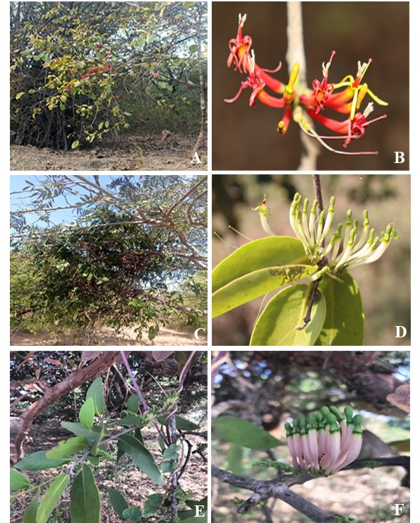

**Figure 1: Dendrophthoe falcata var coccinea**(Talbot) Santapau **A.** Habit**, B.** Inflorescence; **Dendrophthoe falcata var falcata**(L.f.) Etting.**C.** Habit, **D**. Inflorescence; **Dendrophthoe falcata var pubescens** (Hook.f.) V. Chandras **E.** Habit, **F.** Inflorescence.

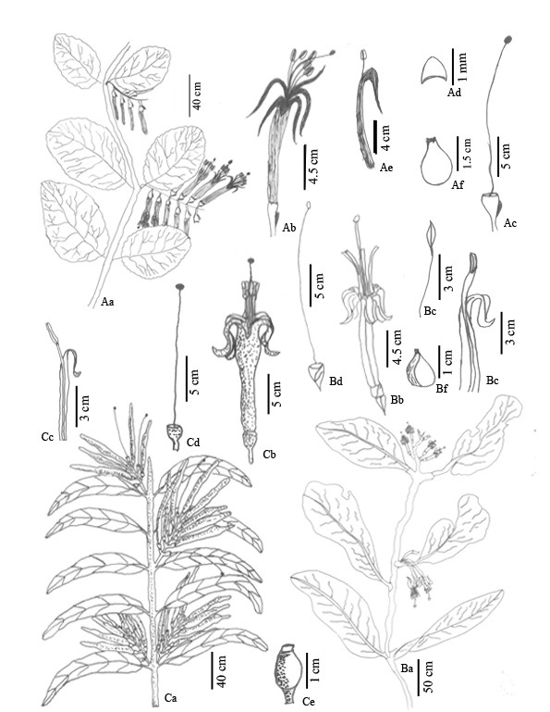

**Figure 2:** **A.** **Dendrophthoe falcata var. coccinea**(Talbot) Santapau, Aa. Flowering twig; Ab. Flower; Ac. Style: Ad. Bract; Ae. Epipetalous stamen; Af. Fruit; **B**. **Dendropthoe falcata var. falcata** Etting,Ba. Flowering twig; Bb. Flower; Bc. Epipetalous stamen; Bd. Style; Be. Stamen; Bf. Fruit; **C.** **Dendrophthoe falcata var. pubescences**(Hook.f.) V. Chandras, Ca. Flowering twig; Cb. Flower; Cc. epipetalous stamens; Cd. Style; Ce. Fruit.

**Helicanthes** Danser

**Helicanthes elastica**(Desr.) Danser Verh. Kon. Akad. Wetensch., Afd. Natuurk., Sect. 2, 29(6): 55 1933; Saldanha, Fl. Karnataka 2:77. 1984; *Loranthus elasticus* (Desr.) Dans. In Lam. Encycl. 3:599. 1789; Cooke, Fl. Pres. Bombay 3:41. 1958; Gamble, Fl. Pres. Madras 2:1254. 2008 (Repr.).  **(Figure 3 & 4A)**.

**Etymology:** Helicanthes: Helically coiled petals; elastica: rubbery (refer to its flower).

Parasitic plant. Stem woody, soft, green to reddish brown colour, branched, pendulous, terete. Leaf simple, opposite, reticulate venation, primary veins are 6 -7, ovate to oblong, apex acute and base rounded, petiolate, coriaceous, ca 7-8cm×4.5-5cm. Inflorescence fascicle ca 3.5-4.0cm, each inflorescence has 5-7 flowers. Flowers actinomorphic, bisexual, pentamerous, sessile, bracteate, green to white, corolla fused, gamopetalous, valvate aestivation, tip of the petal is spirally coiled, 3.5-4cm long, calyx cup-shaped, reddish brown. Stames-5, epipetalous, basifixed, filament red, anther lobes are pale yellowish, ca 0.4-0.5cm long. Ovule epigynous, inferior ovary. Fruit ovoid drupe.

**Host:** *Mangifera indica* L.; **Habitat**: Dry deciduous forest; **Place of Collection:** Sunnadakoppa village, Shikarpur taluk, Shimoga district; **Date of Collection:** 14/01/2024; **Collector no.:** 0004; **Flowering and Fruiting season:** January-March; **Nativity:** India; **IUCN status:** Not evaluated; **Common name:** Rubbery mango mistletoe; **Vernacular name:** Kannada- Bandaneeke, Malayalam-MavuIthill; **Chromosome number:** n = 8 (Johri *et al.* in Phytomorphology 7: 336 - 354. 1957).

**Helixanthera**Lour.

Table 3: Key to genera of Helixanthera

|  |  |  |
| --- | --- | --- |
| 1. | Branchlets and inflorescence pubescent; flowers more than 1 cm | **H. obtusata** |
| 1. | Branchlets and inflorescence glabrous; flowers less than 0.8 cm | **H. wallichiana** |

**Helixanthera obtusata**(Wall. ex Wight & Arn.) Danser Bull. Jard. Bot. Buitenzorg, ser. 3, 10:317 1929; Saldanha, Fl. Karnataka 2:78. 1984; *Loranthus obtusatus* Wall. ex Wight & Arn. Prodr. Fl. Ind. Orient. 1:381. 1834; Cooke, Fl. Pres. Bombay 3:39. 1958; Gamble, Fl. Pres. Madras 2:1251. 2008 (Repr.). **(Figure 3 & 4B)**.

**Etymology:** Helix: winding around, Anthera: anther, Obtuse: blunt, dull.

Parasitic plant. Stem woody, well-branched, erect. Leaf entire, simple, opposite, coriaceous, apex obtuse, approximately 7cm-8cm×4-5cm, petiolate ca 0.5cm long, reticulate venation, red colored mid-rib, primary veins are 13-14. Inflorescence axial raceme, each inflorescence has 18-19 flowers. Flowers regular, actinomorphic, bisexual, pedicellate ca 0.3cm, bracteate, ca 0.1cm, corolla tubular ca 1.7-1.8cm, tetramerous, gamopetalous, valvate aestivation, calyx cup-shaped, ca 0.3cm. Stamens 4, epipetalous, basifixed anther. Epigynous ovule, inferior ovary, stigma globular, style 1.6-1.7cm long, fruit berries.

**Host:** *Termenalia* spp***;* Habitat:** Dry deciduous forest; **Place of Collection:** Nagaragali-Halasi road, Khanapura taluka, Belagavi district; **Date of Collection:** 30/03/2024; **Collector no.:** 016; **Flowering and Fruiting season:** February-May; **Nativity:** India; **IUCN status:** Not evaluated; **Common name:** Blunt leaf mistletoe; **Vernacular name:** Ittikkanni (Malayalam), lal bangdul (Marathi), pulluruvi (Tamil).

**Helixanthera wallichiana** (Schult. & Schult. f.) Danser Bull. Jard. Bot. Buitenzorg 3, 10:317. 1929; Saldanha, Fl. Karnataka 2:78. 1984; *Loranthus wallichianus* Schultes, Syst. 7: 100. 1829; Cooke, Fl. Pres. Bombay 3:43. 1958; Gamble, Fl. Pres. Madras 2:1253. 2008 (Repr.). **(Figure 3 & 4C).**

A parasitic plant, Stem erect, branches terete, woody, brown colored. Leaves are entire, opposite, coriaceous, 10.7cm-11.6cm×3.9cm-4.3cm, petiole 1cm-0.7cm, reticulate venation. Inflorescence axillary raceme, each inflorescence has 11- 15 flowers. Flowers regular 0.8cm-1.0 cm, actinomorphic, reddish-orange in color, bisexual, pedicellate approximately 3mm, bracteate approximately 1mm, corolla tubular, tetramerous, gamopetalous, valvate aestivation, calyx cup-shaped approximately 2mm, stamens 4 epipetalous ca 1.5mm, basifixed anther. Inferior flowers, epigynous ovule, stigma globular, style 1.5mm-2mm long, fruit berries.

**Host:** *Memecylon umbellatum* Burm.f.; **Habitat:** Semi-evergreen forest; **Place of collection:** Anshi National Park, Uttara kannada district; **Date of collection:** 06/06/2024; **Collector number:** 0017; **Flowering and Fruiting season:** January- March; **Nativity:** India; **IUCN Status:** Not evaluated; **Common name:** Four-stamen mistletoe; **Vernacular names:** Tamil: *Pulluruvi.*

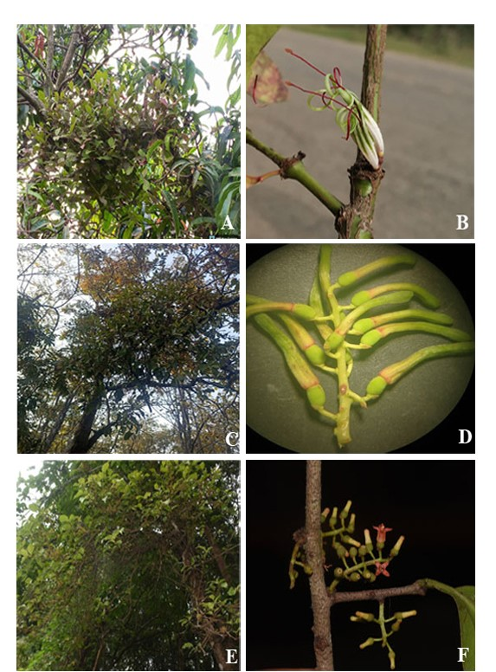

**Figure 3:** **Helicanthes elastica**(Desr.) Danser, **A.** Habit, **B***.* Inflorescence***;* Helixanthera obtusata**(Schultes) Danser, **C.** Habit, **D.** Inflorescence**; Helixanthera wallichiana**(Schultes) Danser, **E.** Habit**, F.** Inflorescence.

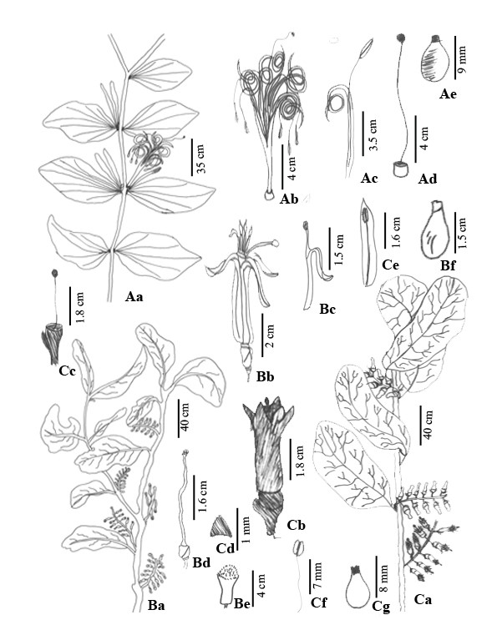

**Figure 4:** **A.** **Helicanthes elastica**(Desr.) Danser, Aa. Flowering twig. Ab. Flower; Ac. Epipetalous stamen; Ad. Style; Ae. Fruit; **B. Helixanthera obusata** (Schultes) Danser, Ba. Flowering twig; Bb. Flower; Bc. Epipetalous stamen; Bd. Style; Be. Bract with pedicel; **C. Helixanthera wallichiana**(Schlutes) Danser, Ca. Flowering twig; Cb. Flower; Cc. Gynoceioum; Cd. Bract; Ce. Epipetalous stamen; Cf. Stamen; Cg. Fruit.

**Macrosolen**(Blume) Rchb.

|  |  |  |
| --- | --- | --- |
| 1. | Erect; stem triangular; leaves whorled, flowers more than 6.0 cm long | **M. trigona** |
| 1 | Pendant; stem terete; leaves opposite; flowers up to 3.0 cm long | **M. capitellatus** |

**Macrosolen capitellatus**(Wight &Arn.) Danser Blumea 2: 36 1936; Saldanha, Fl. Karnataka 2:78. 1984; *Loranthus capitellatus* Wight & Arn., Prodr. 382. 1834; Cooke, Fl. Pres. Bombay 3:44. 1958; Gamble, Fl. Pres. Madras 2:1254. 2008 (Repr). **(Figure 5 & 6A).**

**Etymology:** Macrosolen; large tubes (referring to its flowers)

Parasitic plant, Stem woody, smooth, branched, hanging. Leaf simple, opposite, ovate, acute, coriaceous, glabrous, reticulate venation, petiolate, ca 13cm×9cm. Flowers regular, bisexual, pentamerous, bracteate ca 0.3cm, bracteolate ca 0.2 cm, corolla fused, gamopetalous, valvate aestivation, tip of the petals reflexed, calyx cupular, corolla tube approximately 2cm long. Stamens 5, epipetalous, filament green, ca 0.8 cm, basifixed anther, yellowish-orange, and 0.3-0.4cm. Epigynous ovule, inferior ovary, Fruit ovoid berries.

**Host:** *Ficus* sp.; **Habitat:** Dry deciduous forest; **Place of Collection:** Department of Tourism, Karnatak College, Dharwad; **Date of Collection:**08/02/2024; **Collector no.:** 0014; **Flowering and Fruiting season:** September-April; **Nativity:** India, Myanmar, Sri Lanka; **IUCN status:** Not evaluated; **Common name:** South Indian mistletoe; **Vernacular name:** Marathi- *Lahan Bandgul*.

**Macrosolen** **trigona**(Wight & Arn.) Tiegh., Bull. Soc. France 42: 442 1895; *Dendrophthoe trigona* (Wight & Arn.) Danser ex Santapau, Rec. Bot. Surv. India 16(1): 263 (1953); Saldanha, Fl. Karnataka 2:76. 1984; *Loranthus trigonus* Wight & Arn., Prodr. 386. 1834; Cooke, Fl. Pres. Bombay 3:43. 1958; Gamble, Fl. Pres. Madras 2:1253. 2008 (Repr.). **(Figure 5 & 6B).**

Parasitic plant, young stem trigonous, woody, well-branched, bushy, erect. Leaf simple, opposite or whorled, reticulate venation, primary veins 8-9, ovate or elliptical, acute to obtuse, coriaceous, glabrous, petiolate, ca 13 cm × 9 cm. Inflorescence axillary raceme, each has 14-16 flowers, ca 7-8cm. Flowers are complete, regular, bisexual, pedicellate, corolla fused, tubular, tube approximately 6-7cm long, gamopetalous, tip of petals are reflexed, valvate aestivation, calyx cupular, corolla tube ca 2cm long. Stamens 5, epipetalous, opposite to petals, filaments are white, anthers basifixed, anther lobes are pinkish red, ca 0.5-0.6 cm. Epigynous ovule, inferior ovary, style ca 7-8cm long, stigma capitate, Fruit ovoid berries.

**Host:** *Ficus benghalensis* L.; **Habitat:** Dry deciduous forest; **Place of Collection:** Karajagi, Khanapura taluka, Belagavi district; **Date of Collection:** 20/01/2024; **Collector no.:** 0010; **Flowering and Fruiting season**: November-February; **Nativity:** Indian Subcontinent, E. Queensland; **IUCN status:** Not evaluated; **Common name:** Three-angled mistletoe.

**Scurrula** L.

**Scurrula parasitica**L., Sp. Pl.: 110 1753; Saldanha, Fl. Karnataka 2:76. 1984; *Loranthus scurrula* (L.) Sp. Pl. (ed.2), 472. 1762; Cooke, Fl. Pres. Bombay 3:40. 1958; Gamble, Fl. Pres. Madras 2:1251 2008 (Repr.). **(Figure 5 & 6C).**

Parasitic plant, Stem woody, well-branched, dirty brown, erect. Leaf entire, simple, opposite, approximately 6-7cm×3.5-4cm, glabrous, brownish green, reticulate venation, primary veins 14-16, petiolate, ca 0.5-0.8 cm long. The inflorescence is a fascicle, ca 3-4cm. Flowers are complete, actinomorphic, rust brownish in colour, tetramerous, petals are free to base and fused at the end, valvate aestivation. Stamens 4, epipetalous, opposite to petals, anther basifixed, filament is 2.0-2.5cm long. Epigynous ovule, inferior ovary. Fruit cuneiform berry.

**Host:** *Terminalia anogeissiana* Gere & Boatwr*;* **Habitat:** Dry deciduous forest; **Place of Collection:** Kyasanur Reserve Forest, Hanagal Taluka, Haveri district; **Date of Collection:** 20/01/2024; **Collector no.:** 0008; **Flowering and Fruiting season:** October-February; **Nativity:** China South-central; **IUCN status:** Not evaluated; **Common name:** Powdery mistletoe, pomegranate honeysuckle, cinnamon mistletoe; **Vernacular name:** Hindi-Banda; Oria-Madang.

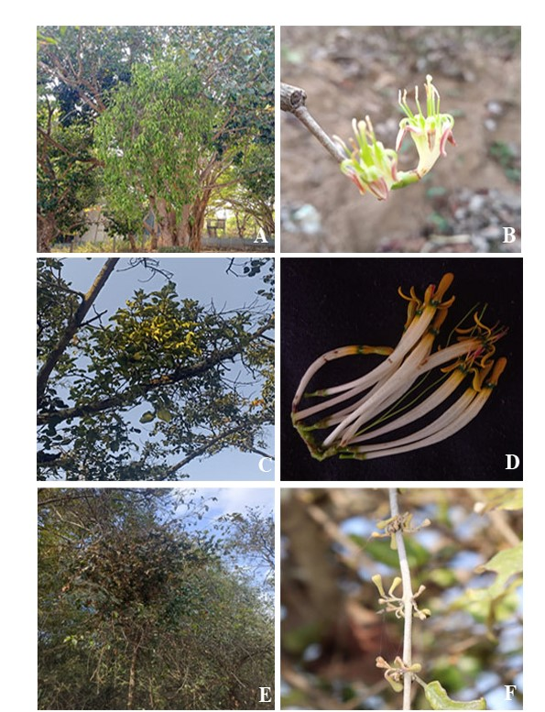

**Figure 5:** **Macrosolen capitellatus**(Wight & Arn.) Danser, **A.** Habit, **B**. Inflorescence; **Macrosolen trigona**(Wight & Arn.) Tiegh, **C**. Habit, **D**. Inflorescence; **Scurrula parasitica**L., **E**. Habit, **F**. Inflorescence.

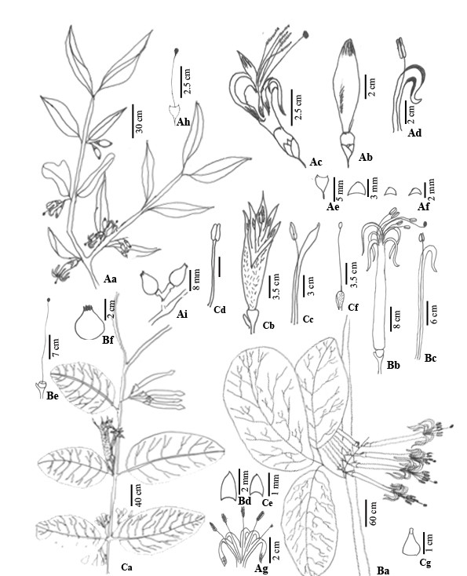

**Figure 6: A. Macrosolen capitellatus** (Wight & Arn.) Danser, Aa. Flowering twig; Ab. Flower bud; Ac. Flower; Ad. Epipetalous stamen; Ae. Calyx; Af. Bract and Bracteoles; Ag. Corolla with stamens; Ah. Gynoceioum; Ai. Fruit; **B. Macrosolen trigona**(Wight & Arn.) Tiegh., Ba. Flowering twig; Bb. Flower; Bc. Epipetalous stamen; Bd. Bract; Be. Gynoceioum; Bf. Fruit; **C. Scurrula parasitica** L., Ca. Flowering twig; Cb. Flower; Cc. epipetalous stamen; Cd. Stamen; Ce. Bract; Cf. Gynoceioum; Cg. Fruit.

**4. CONCLUSION:**

The present study is a detailed enumeration of 9 species belonging to 5 genera of the Loranthaceae family. All the collected plants were provided with a dichotomous key, colour photographs and detailed illustrations to facilitate the easy identification of each taxon. Mistletoe constitutes the most important parasitic plant group which has been considered a damaging agent of many of our fruit-yielding, timber-yielding and other economically important trees. Future studies should address the relationship between parasitic plant distribution, their host species and dispersal agents, so that we can safely guard our valuable trees.

Disclaimer (Artificial intelligence)

Option 1:

Author(s) hereby declare that NO generative AI technologies such as Large Language Models (ChatGPT, COPILOT, etc.) and text-to-image generators have been used during the writing or editing of this manuscript.

Option 2:

Author(s) hereby declare that generative AI technologies such as Large Language Models, etc. have been used during the writing or editing of manuscripts. This explanation will include the name, version, model, and source of the generative AI technology and as well as all input prompts provided to the generative AI technology

Details of the AI usage are given below:

1.

2.

3.

References

Beentje, H.J., (2016). The Kew plant glossary: an illustrated dictionary of plant terms. Second edition, Royal Botanic Gardens. Kew.

Cooke, T., (1967). *The Flora of The Presidency of Bombay,* (2nd reprinted edition), Botanical Survey of India, Calcutta.

Gamble, J. S., (2008). *Flora of the Presidency of Madras*. 11 parts (1-7 Gamble & 8-11 by Fischer), Bishen Singh Mahendra Pal Singh, Dehradun; (Reprint edition).

Gill, L.S. and Hawksworth F.G., (1961). *The Mistletoes. A literature reviews*. Technical Bulletin No.1242. United States. Department of Agriculture, Washington, DC.

Guimares, A. C., Ricardo M. K., Ana Claudia F. A., Jose Luis P. F., and Antonio C. S. (2007). Histological study of the leaf and stem of the Amazonian medicinal mistletoe *Cladocolea micrantha* (Loranthaceae). *International Journal of Botany.* 3(2):218-21.

Jain, S. K. and Rao, R. R. (1976). *A Hand book of field and Herbarium Methods*. Today and Tomorrow`s printers and publishers, New Delhi.

POWO (2025). *Plants of the World Online*. Facilitated by the Royal Botanic Gardens, Kew. Published on the internet: http://www. plantsoftheworldonline.org.

Radford, A.E., Dickson, W.C., Massey, J.R. and Bell, C.R., (1974). *Vascular plant systematics.* Harper & Row Publishers, New York, Evanston, London.

Ravikumar, K., Tangavelou, A. C. and Navenadu, Page. (2021). *Seed Plants of Karnataka, India* Foundation for Revitalisation of Local Health Traditions Transdisciplinary University (FRLHT-TDU) Bengaluru and National Biodiversity Authority Chennai

Ravindranath, S. & S. Premnath, (1997). *Biomass Studies; Field Methods for Monitoring Biomass*. Oxford & IBH Publishing Co. Pvt. Ltd., New Delhi.

Saldahna, C. J. (1996). *Flora of Karnataka,* vol. 2. Oxford and IBH Publishing Co. Pvt. Ltd., New Delhi.

Sanjappa, M. and Sringeswara, A. N. (2019). *Flora of Karnataka, A Checklist,* Volume – 2: Gymnosperms and Angiosperms. Karnataka Biodiversity Board. 1-1002.

Suyal, S., Sharma, C. M., Gairola, S., Ghildiyal S. K., Rana C.S. and Butola D. S. (2010). Phytodiversity (Angiosperms and Gymnosperms) in Chaurangikal forest of Garhwal Himalaya, Uttarakhand, India *Indian Journal of Science and Technology*. 3 pp. 267-275.

Twyford, A.D. 2018. Parasitic plants. *Curr. Biol*., 28(16): R857 R859.

Menezes, M.O.D., B.L. Stannard, C.S. Caires, M.I.B. Loiola and M.F. Moro. 2022. Flora of Ceará, Brazil: Loranthaceae. *Rodriguesia*., 73. 7860202273082 https://doi.org/10.1590/2175