**Appraisal of radioactive particle concentration in near-surface weathered regolith of Biliri, Gombe state, Nigeria**

**ABSTRACT**

Soils, being the foundation upon which several activities occur, have consequently experienced elevated levels of radionuclides. This is profoundly significant as soils serve as a transfer medium for radionuclides throughout the food chain, involving processes of systemic radionuclide uptake by plant roots and subsequent transmission to animals. This study aimed to assess the activity concentrations of alpha and beta radioactive particles in soil samples collected at varying depths from Billiri, Gombe State, Nigeria. Standard procedures and radiation guidelines were employed for sample collection, preparation, and processing, followed by analysis using the Gas-flow dual phosphor counter Model MPC 2000DP at the Centre for Energy Research and Training (CERT), Ahmadu Bello University, Zaria. The results revealed a range of radioactive particle concentrations, with alpha particles varying between 7.70 Bq/kg to 83.40 Bq/kg, and beta activity concentrations ranging from 13.10 Bq/kg to 88.40 Bq/kg. The distribution of activity concentrations indicated that areas with higher concentrations were associated with soils derived from banded gneiss, biotite gneiss, feldspathic sandstones, calcareous sandstones, and shaly limestone. Conversely, lower concentrations were observed in areas linked to porphyroblastic gneisses. Beta activity concentrations were consistently higher than alpha activity concentrations throughout the study area, highlighting the potential implications for targeted exploration of radioactive resources and minerals favouring specific particle concentrations. Importantly, the study found that the alpha and beta activity concentrations in the study area were well below the standard health risk limit of 0.5 Bq/kg recommended by prominent regulatory bodies such as the World Health Organization (WHO), the International Atomic Energy Agency (IAEA), the Nigeria Nuclear Regulatory Agency (NNRA), and the International Commission on Radiological Protection (ICRP). Consequently, it can be concluded that the concentration of radioactive particles poses no significant radiological threat to the environment or the health of local inhabitants. This study holds significant value for informed health policies, enhancing environmental management and advancing research on radiation safety decisions. Furthermore, it enriches global knowledge on NORM in data-limited regions.

***Keywords:*** radionuclides, activity concentration, mineral exploration, naturally occurring radioactive materials, radiological hazards

1. **INTRODUCTION**

The human-driven activities of solid mineral mining, processing of uranium ores and mineral sands, smelting of metalliferous ores, manufacturing of fertilisers, and the extraction and combustion of fossil fuels have led to increased concentrations of naturally occurring radioactive materials (NORM) in the environment (Cardi *et al.,* 2021). This may occur during planned or existing exposure situations which, under current radiation protection standards, require identification, management, and regulatory control as for other practices associated with man-made radionuclides that may result in the exposure of people and non-human biota (Michalik et al., 2023). Soils, being the foundation upon which these activities occur, have consequently experienced elevated levels of radionuclides. This is profoundly significant as soils serve as a transfer medium for radionuclides throughout the food chain, involving processes of systemic radionuclide uptake by plant roots and subsequent transmission to animals (Efenji *et al.,* 2022; Ahijo and Baba-Kutigi, 2023). The polluting of soils with heavy metals and radionuclides can be natural or anthropogenic. Furthermore, different heavy metals have a specific accumulation rate and bioavailability based on the physical and chemical properties of soils; therefore, they have different biomagnification rates, impact on human health, and ecological risk level (Chernysh et al., 2024).

Given that naturally occurring radioactive materials (NORMs) are commonly distributed across various geological formations (Cardi *et al.,* 2021; Efenji *et al.,* 2022; Pollonen *et al.,* 1999; Nakale *et al.,* 2023), and since soils are a product of weathered rock materials, they characteristically retain (depending on type of radionuclides, soil composition and properties, source materials and environmental conditions) of the radioactivity of their source materials, leading to secondary effects on plants and, ultimately, impacting the soil composition and properties, source materials and environmental conditions) of the radioactivity of their source materials, leading to secondary effects on plants and, ultimately, impacting the health risks of the human population. The concentrations of radionuclides within soils vary in accordance with local geological conditions (Uzuegbu *et al.,* 2018; Adabanija *et al.,* 2020). Consequently, due attention must be given to the determination of the extent of natural radioactivity at both the surface and subsurface levels, given that rocks and soil form considerable sources of radiological hazards.

Previous research has disclosed the presence of uranium mineralisation in North-Eastern states such as Bauchi, Gombe, Yobe, Adamawa, and Borno, and in other Nigerian states including Imo, Bayelsa, Benue, and Cross River. Since Uranium stands out as the principal contributor to human exposure, its presence indicates the likelihood of elevated radionuclide concentrations possibly exceeding permissible limits for health safety (Sehrawat *et al.,* 2024). These findings provide the rationale for the current investigation within this environment.

The study area, situated in Billiri, Gombe state (Figure 1), with geographic coordinates ranging from 9°51 N to 9°54 N and 11°10 E to 11°13 E, has an approximate population of 202,680 based on the 2006 population census, covering an area of 737 km2 with an average population density of 3,789 km-2. Billiri, renowned for its mineral ores historically associated with heightened radionuclide concentrations, has been the site of mining activities for uranium and other mineral deposits such as tantalite, tin, beryl, columbite, and batholitic clay, with similar geological characteristics reported in adjacent regions (Van-Briston *et al.,* 1995).

It is probable that radioactive decay releases particles such as alpha and beta particles, could elevate the risks linked with radionuclide concentrations in the soils within the study area. Considering the predominant human economic activity in Billiri—crop and animal farming—it becomes evident that the risk to human health is significantly amplified.

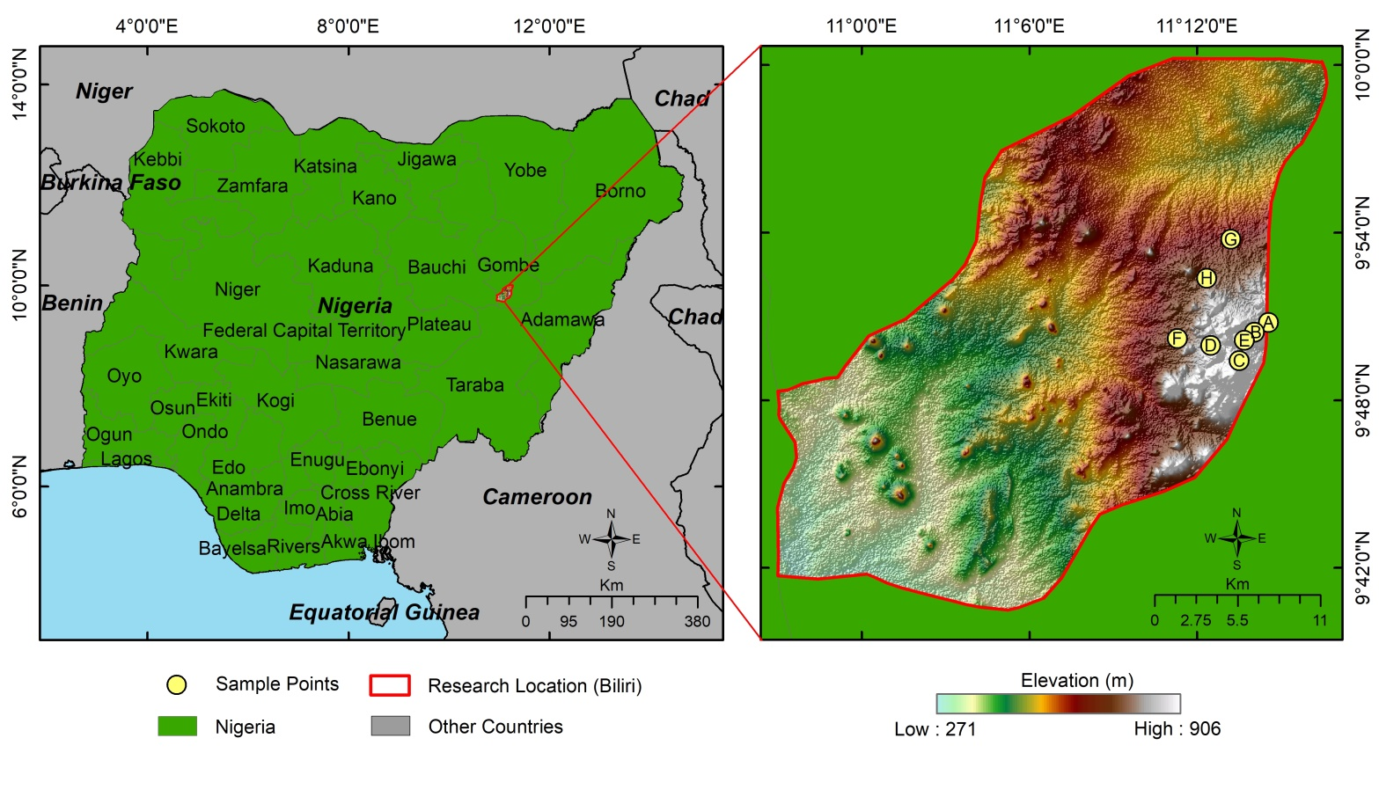

**Figure 1:** Map of Billiri Local Government Area showing the Study area and sample locations

Alpha and beta particles, which are fundamental byproducts of numerous radionuclide decay processes, reflect the level of radioactivity present, and their concentrations can serve as indicators of the health risks associated with exposure to soils and the ingestion of plants grown in such environments.

The existing research landscape concerning radioactive particle concentrations in the designated study area is notably deficient, where only a scant number of studies, like that of Aremu *et al.* (2022), have delved into the presence of radionuclides attributed to anthropogenic influences. Notably, the focus of these previous investigations has been solely directed toward radionuclides of human origin. However, our study associates radionuclide concentrations within the study location to the ambient geology thereby establishing a baseline or natural background levels of radioactivity in the study area. This distinction is crucial for discerning between naturally occurring radionuclides and those introduced through human activities. This then offers a nuanced perspective that is essential for accurate risk assessment, robust environmental management, and informed policy-making in the context of radiological safety and environmental health.

The primary objective of this study is to assess the levels of gross alpha and beta activities present in soil samples taken from Billiri. A pivotal aspect of this research involves the direct comparison of these determined activity levels with the established Maximum Permissible Levels (MSL). The profound significance of this study transcends mere academic examination; it serves as a crucial intervention in bridging extant research lacunae and shaping the development of robust radiological health management and safety policies specific to the nuanced context of the Nigerian region under scrutiny.

Furthermore, the implications of the discoveries made in this study extend beyond the immediate scope of the research. They are anticipated to serve as a foundational cornerstone for future inquiries, offering valuable insights and evidence to policymakers, scientific communities, and society at large. The integrative nature of this study, aligning with pressing societal needs and scientific advancements, highlights its potential to catalyse informed decision-making, promote public health, and propel advancements in radiological safety measures.

1. **MATERIALS AND METHODS**

The samples were collected from various locations within the study area, taking note to ensure reasonable spread as shown in Table 1. Care was taken to adhere to the established quality assurance and control of the sample collection protocol. A Ceramic Petri dish was used in place of glass materials to minimise reactions with metals. This reduced errors and ensured the reliability of results. Also, care was taken to ensure that sample collection in volatile soil, such as tropical black soils, coarse gritty soils, and peat, was done at a depth of 20 cm to 30 cm. The rate of evaporation in volatile soils is high, and this is usually accompanied by the release of water and other radionuclides such as radon to the atmosphere (Markert, 1994). In muddy and humid soil, samples were collected at a depth of about 10 cm to 20 cm. This depth choice was because muddy soils do not readily give out water and radionuclides to the air because of their high water content.

The samples obtained from the various locations were moved to the Centre for Energy Research and Training (CERT), Ahmadu Bello University (ABU), Zaria, where they were processed and prepared for the determination of alpha and beta concentration activity, respectively.

The soil samples were manually ground with an agate mortar and pestle to obtain a homogenous powder of the order 125 $μm$; mixed with three drops of toluene, an organic liquid and pressed with a 10 ton-hydraulic press. Weighing was carried out before and after oven drying. The results for the weight of the soil samples containing moisture (initial weight) and after oven-drying (final weight), as well as the drying efficiency, were recorded,and the remnant rinsed off with distilled water. The pellet and the residue were then mounted on the proportional counter MPC 2000DP Gas-flow detector Dual phosphor for measurement to obtain the alpha and beta count rates.

**2.1 ALPHA AND BETA RADIOACTIVITY IN SOIL**

The alpha and beta activity concentration of the soils were calculated from the count rates using the relation, Equation 1 (Ogundare and Adekoya, 2015; Umar *et al.*, 2012; Pollonen *et al.*, 1999; Romero *et al.*, 1992; Njinga *et al.,* 2016):

$A=\frac{C_{cpm}-B_{cpm}}{S_{ε}×S_{σ}×δ_{ε}}0.0167$ (Eq. 1)

where A is the activity concentration in Bqkg-1; is the alpha or beta count per minute; $B_{cpm}$ is the background count per minutes; $S_{ε}$ is the sample efficiency; $S_{σ}$ is the sample size; $δ_{ε}$ is the detector efficiency; 0.0167 or (1.67 x 10-2) is the unit coefficient of alpha and beta particle conversion factor from cpm to cps (1*cps*=1*Bq*).

The sample efficiency was calculated from the relation, Equation 2.

$S_{ε}=\frac{W_{r}}{0.077}100\text{\%}$ (Eq. 2)

where $S_{ε}$ is the sample efficiency; and $W_{r}$ is the weight of the residue

**Table 1:** geographical location, lithology and labels of samples collected for the study

|  |  |  |  |
| --- | --- | --- | --- |
| **Town/ Village** | **Coordinates** | **Sample Label** | **Lithology** |
| Latede | N 09050'47.0''  E 011014'33.7'' | Soil A | Porphyroblastic Gneiss |
| Poshiya | N 09050'26.1''  E 011014'03.4'' | Soil B | Porphyroblastic Gneiss |
| Kamkuyo | N 09049'24.6''  E 011013'30.7'' | Soil C | Feldspathic Sandstones/calcareous sandstones/shaly limestone |
| Tal | N 09049'57.3''  E 011012'29.5'' | Soil D | Banded Gneiss/Biotite Gneiss |
| Billiri town | N 09050'08.3''  E 011013'41.5'' | Soil E | Feldspathic Sandstones/calcareous sandstones/shaly Limestone |
| Baganje | N 09050'12.4''  E 011011'17.8'' | Soil F | Banded Gneiss/Biotite Gneiss |
| Kummana | N 09053'45.4''  E 011013'12.6'' | Soil G | Porphyroblastic Gneiss |
| Kalmai | N 09052'22.0''  E 011012'21.2'' | Soil H | Banded Gneiss/Biotite Gneiss |

The following steps were taken in order to improve accuracy and ensure reliability of the results ~~after~~ (Efenji *et al.,* 2022; Pollonen *et al.,* 1999; Burns *et al.,* 1990; Fasae, 2013; Jwanbot *et al.,* 2023; and ICRP, 1979;1991):

1. Moisture absorbed by the sample will interfere with counting and obstruct self-absorption characteristics. Therefore, samples were oven dried to remove moisture before counting.
2. Non-uniformity of the sample residue in counting pellet interferes with the accuracy and precision of the process; therefore, the samples were manually pounded until consistency of the sample was attained, thus ensuring sample uniformity.
3. When counting alpha and beta activity by a gas-flow detector counting system, counting at the alpha plateau discriminates against beta particle activity, whereas counting at the beta plateau is sensitive to alpha particle activity present in the sample. These effects were determined and compensated for during the calibration of the instrument used for measurement.
4. Care was taken to ensure that sample density on the pellet area was not more than 10 mg cm-2 for alpha activity concentration measurement and 20 mg cm-2 for beta activity concentration measurement.
5. **RESULTS AND DISCUSSION**

The results for the weights of the samples containing moisture (initial weight) and after it had been oven-dried (final weight) are presented with the drying efficiency in Table 2.

The alpha and beta counts for samples within the study area and their corresponding counts per minute, otherwise called count rate, are presented in Table 3. The results were obtained in $Bqg^{-1}$ but converted to $Bq{kg}^{-1}$ using the relevant standard conversion factor in order to ensure conformity to the International System of Units convention and for consistency in units. The alpha and beta counts presented in Table 3 were used to calculate the Gross Alpha and Beta activity concentration, respectively, by means of Equation 1 for the soil samples within the study area and the data are presented in Table 4.

**Table 2: Initial, Final Weight and Sample Efficiency**

|  |  |  |  |  |
| --- | --- | --- | --- | --- |
| **S/N** | **Sample ID** | **Initial weight(g)** | **Final weight(g)** | **Efficiency** |
| 1 | A | 0.5044 | 0.4984 | 0.9881 |
| 2 | B | 0.5025 | 0.4948 | 0.9847 |
| 3 | C | 0.5030 | 0.4372 | 0.8692 |
| 4 | D | 0.5029 | 0.4767 | 0.9479 |
| 5 | E | 0.5028 | 0.5330 | 1.0601 |
| 6 | F | 0.5020 | 0.4510 | 0.8984 |
| 7 | G | 0.5042 | 0.4005 | 0.7943 |
| 8 | H | 0.5036 | 0.4150 | 0.8241 |

**Table 3: Alpha and Beta Counts and their Respective Counts per Minutes**

|  |  |  |  |  |  |
| --- | --- | --- | --- | --- | --- |
| **S/N** | **Sample ID** | α-**counts** | α-**CPM** | β-**counts** | β-**CPM** |
| 1 | A | 40 | 1.33 | 34 | 1.13 |
| 2 | B | 33 | 1.10 | 41 | 1.37 |
| 3 | C | 14 | 0.47 | 25 | 0.83 |
| 4 | D | 39 | 1.30 | 46 | 1.53 |
| 5 | E | 73 | 2.43 | 58 | 1.93 |
| 6 | F | 115 | 1.50 | 47 | 1.57 |
| 7 | G | 32 | 1.07 | 29 | 0.97 |
| 8 | H | 63 | 2.10 | 31 | 1.43 |

From Table 4, we denote that the observed alpha activity concentration of radioactive particles ranged from 6.60 *Bq kg-1* to 83.40 *Bq kg-1* with a mean value of 38.32 ${Bqkg}^{-1}$ while the beta activity concentration in the same soil sample ranged from 13.10 *Bq kg-1* to 88.40 *Bq kg-1* , with a mean value of 60.45 ${Bqkg}^{-1}$ computed for the entire study area.

**Table 4: Gross Alpha and Beta Activity of Counted Soil Samples**

|  |  |  |  |
| --- | --- | --- | --- |
| **S/N** | **Soil Sample ID** | **Alpha (Bq/kg)** | **Beta (Bq/kg)** |
| 1 | A | 19.20 | 56.30 |
| 2 | B | 6.60 | 13.10 |
| 3 | C | 36.40 | 40.00 |
| 4 | D | 29.40 | 75.40 |
| 5 | E | 61.40 | 88.40 |
| 6 | F | 42.10 | 88.00 |
| 7 | G | 28.00 | 37.40 |
| 8 | H | 83.40 | 88.40 |

**3.1 Geological Distribution of Activity Concentration**

Figures 2 and 3present the distribution of alpha and beta particle concentrations within the designated study area, respectively. In Figure 2, two distinct zones of anomalous Alpha concentrations are illustrated. A positive anomaly, indicative of relatively high alpha concentration, is situated in the northwestern regions of the study area, with concentrations ranging from 50 *Bq kg-1* to 90 Bq/kg. Conversely, an abnormally low concentration zone, with values falling below 25 Bq/kg, is observed in the east and southern sectors of the map. The high anomaly zones grade into low anomaly regions as one moves easterly within the study area, the change suggestive of potential geological contacts or structures serving as significant control factors for the radionuclide concentration. Notably, the closure of distinct anomaly patterns in the alpha particle concentration map may signify the centre or top of the underlying causative geomaterials.

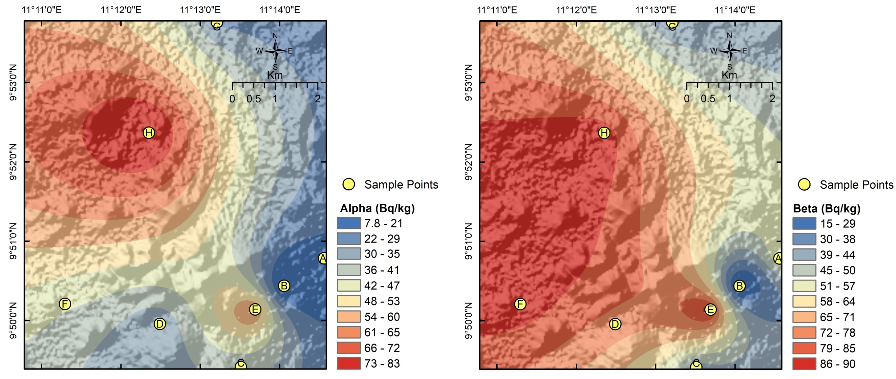

Figure 2: Alpha activity concentration distribution for the study area

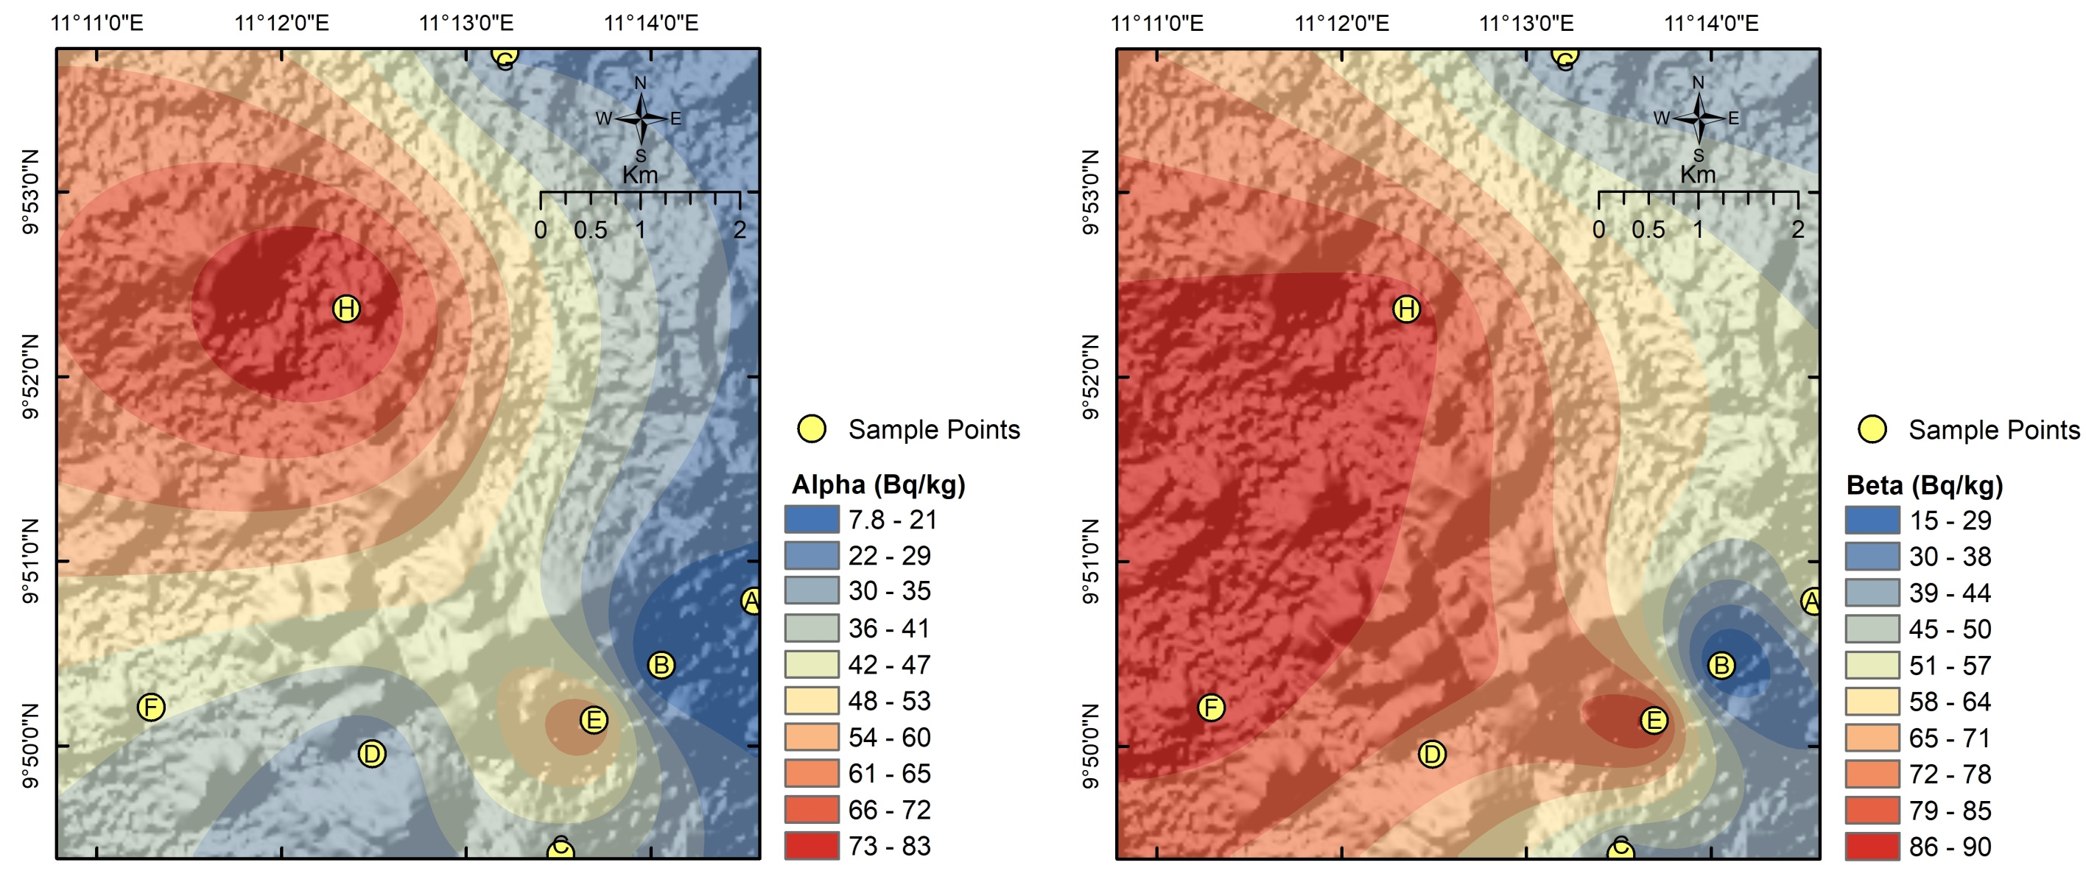

Figure 3: Beta activity concentration distribution for the study area

Meanwhile, the beta concentration distribution map (Figure 3) portrays relatively elevated beta concentrations in the southern portions of the study area, ranging from 75 *Bqkg-1* to 100 Bq/kg, distinct from the low alpha concentrations observed in Figure 2 for the same region. Otherwise, the beta concentration map shows a similar distribution, with the eastern portions of the study area having distinctly higher activity concentrations. A prevailing trend of increasing beta concentration towards the south and south-east is evident for beta concentration. This may be due to the influences of geological processes relating to the interaction of extrusive and intrusive volcanism in the Paleogene with rocks deposited in the Lower Cretaceous. Other factors could be increased hydrothermal activity, metamorphism, higher Uranium and thorium concentration or extensive weathering and erosion.

Noteworthy features common to both radionuclide particle concentration distribution maps, and especially prominent in the southeastern segment around Biliri town and Poshiya, include contrasting anomaly peaks indicative of abrupt transitions from low to high concentrations. This is more clearly evident for the beta concentration distribution (Figure 3). Such phenomena may signify sharp geological contacts, lithological variations, fault lines, or the influence of hydrothermal alteration processes leading to the heightened concentration of radioactive minerals. Processes such as alteration, shearing, rock deformation, metamorphism, and weathering have been acknowledged in literature, such as in Johnson (1979) and Verdoya *et al.* (2001), as crucial mechanisms impacting the redistribution of radioactive elements within rocks.

While a consistent regional trend is observed in both alpha and beta concentration distributions across the study area, notable deviations in concentration signatures are evident in the southwestern and central areas of the maps. The lowest activity concentrations of both particles are recorded in samples (B, A, and G) obtained from weathered soils associated with porphyroblastic gneisses. In contrast, relatively higher activity levels correspond to soils weathered from lithologies like banded gneiss/biotite gneiss for basement rocks (samples F & H) and feldspathic sandstones, calcareous sandstones, and shaly limestone for sedimentary formations (sample E).

The disparities in activity levels likely stem from a combination of factors such as the specific mineral compositions of the lithologies, the geological history, the accumulation and retention of radioactive elements, and the prevailing environmental conditions during the weathering processes. Detailed elucidation of the precise causes behind activity concentration variations within the geological framework necessitates further investigations and analyses surpassing the confines of the current research endeavour. Table 5 shows the ascending order of particle activity concentration for the samples with their corresponding lithology.

**Table 5: Particle activity concentration showing corresponding lithology**

|  |  |  |  |  |  |
| --- | --- | --- | --- | --- | --- |
| **Soil Sample ID** | **Beta (Bq/kg)** | **Lithology** | **Soil Sample ID** | **Alpha (Bq/kg)** | **Lithology** |
| B | 13.1 | Porphyroblastic Gneiss | B | 6.6 | Porphyroblastic Gneiss |
| G | 37.4 | Porphyroblastic Gneiss | A | 19.2 | Porphyroblastic Gneiss |
| C | 40.0 | Feldpasthic Sandstone/  Calcereous Sandstone/  Shaly Limestone | G | 28.0 | Porphyroblastic Gneiss |
| A | 56.3 | Porphyroblastic Gneiss | D | 29.4 | Banded Gneiss/  Biotite Gneiss |
| D | 75.4 | Banded Gneiss/  Biotite Gneiss | C | 36.4 | Feldpasthic Sandstone/  Calcereous Sandstone/  Shaly Limestone |
| F | 88.0 | Banded Gneiss/  Biotite Gneiss | F | 42.1 | Banded Gneiss/  Biotite Gneiss |
| E | 88..4 | Feldpasthic Sandstone/  Calcereous Sandstone/  Shaly Limestone | E | 61.4 | Feldpasthic Sandstone/  Calcereous Sandstone/  Shaly Limestone |
| H | 88.4 | Banded Gneiss/  Biotite Gneiss | H | 83.4 | Banded Gneiss/  Biotite Gneiss |

**3.2 Comparative Analysis of the Activity Concentrations of Alpha and Beta Particles in Soil Samples**

A comparative evaluation of the activity concentrations of alpha and beta particles at various sample locations was conducted, and the result is outlined in Figure 4. The trend of alpha and beta particle concentrations is similar within the study area, except for samples D and F, where reducing alpha concentration values correspond with an increasing trend in beta concentration values. It was also noted that beta particle concentrations surpassed those of alpha particles in all soil samples analysed. The disparity observed in the activity concentrations of alpha and beta particles can be attributed to the distinct characteristics and origins of each particle type.

Our study suggests several factors could contribute to the observed discrepancy within the study area. Primarily, the soil samples likely contained higher levels of radioactive isotopes like Carbon-14 (β-), a natural component of organic matter (Kondev *et al.,* 2021; Dean *et al.,* 2019) which predominantly emit beta particles, in contrast to uranium-238 and thorium-232 and their decay series, which tend to favor alpha particle emissions. It is also plausible that the decay process initially manifested through alpha emissions but subsequently exhibited a preference for beta particle emission, resulting in their prevalence over alpha particles. Additionally, the samples measured might have been obtained at a depth where the superior penetrating ability of beta particles enabled them to traverse the soil with minimal interaction, hence establishing their dominance over alpha particles.

Understanding the unique behaviours of alpha and beta radiation within specific soil samples carries significant implications for focused exploration efforts aimed at identifying particular radioactive resources and minerals like zircon, monazite, and other uranium-bearing deposits. This differentiated activity concentration profile provides valuable insights for strategic mineral exploration campaigns and resource evaluation initiatives.

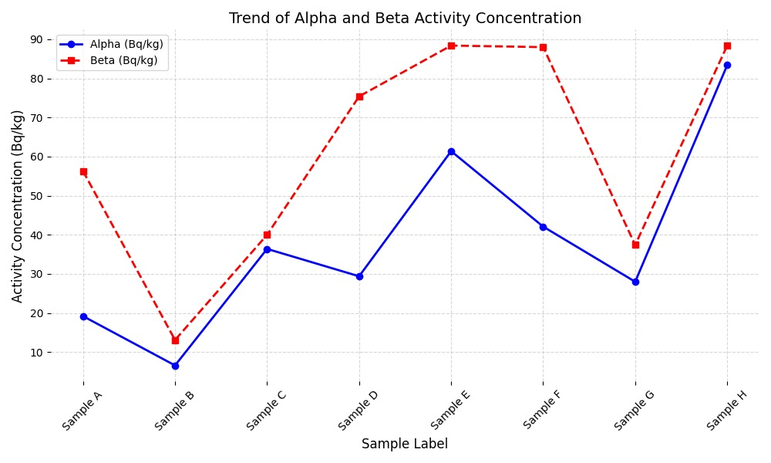

Figure 4: Comparison of Alpha and Beta Activity Concentration for Sample locations in the study area

**3.3 Radiological Hazard Exposure Risks**

The examination of alpha and beta particle activity concentrations was meticulously conducted to assess potential risks to the local population by comparing them against the exposure limit prescribed by the World Health Organisation (WHO). This critical exposure threshold, established at 0.5 Bq g-1 or 500 Bqkg-1 by reputable international regulatory bodies such as the International Atomic Energy Agency (IAEA), the Nigerian Nuclear Regulatory Agency (NNRA), and the International Commission on Radiological Protection (Jwanbot *et al.,* (2023); ICRP, 1979:1991; IAEA, 2003); UNSCEAR, (2000); Chijioke *et al.,* (2015), serves as a fundamental standard for upholding radiological safety protocols.

A thorough analysis of the results revealed a range of radioactive particle concentrations, with alpha particles varying between 7.70 Bq/kg and 83.40 Bq/kg, and beta activity concentrations ranging from 13.10 Bq/kg to 88.40 Bq/kg. The maximum values of both particles (83.40 Bq/Kg and 88.40 Bq/Kg) consistently remain significantly below the designated exposure risk limit.

This outcome likely mirrors the inherent background activity concentrations within the surveyed area, as mining and other activities are limited within the locations where samples were obtained. There is, however, the potential for values to surpass acceptable limits due to escalating anthropogenic actions.

Nonetheless, it is a reasonable inference that interactions with or exposure to the examined soil samples pose negligible radiological risks to human, plant, and animal health at present. Consequently, our findings strongly suggest that the inhabitants of the region are predominantly shielded from substantial radiological hazards originating from the soil, thereby verifying their safety (Efenji *et al.,* 2022; Mehade Hassan, 2014; Turhan, 2009; Turhan, 2010).

1. **CONCLUSION**

The study conducted a laboratory analysis of soil samples obtained from Billiri to determine the activity concentration of Alpha and Beta particles. The results revealed a clear association between activity concentrations and specific geological formations. Relatively higher activity concentrations correlated with banded/biotite gneiss, feldspathic/calcareous sandstones, and shaly limestone, while lower concentrations were observed in areas dominated by porphyroblastic gneisses. Interestingly, the beta activity concentrations were consistently higher than the alpha activity concentrations at the same sample locations, indicating potential implications for targeted exploration of radioactive resources.

Our study recognises that a more in-depth understanding of the geological composition and processes of the study area can shed light on the geological origins and pathways of radionuclides, and this may be an area for future study.

Furthermore, the study found that the gross alpha and beta activity concentrations in the soil samples ranged from 6.60 Bq/kg to 83.40 Bq/kg and 13.10 Bq/kg to 88.40 Bq/kg, respectively. Importantly, these values were well below the acceptable limits set by the WHO, signifying that exposure to the soil within the study area is unlikely to pose any radiological health hazards to the inhabitants.

This result may reflect the natural background activity concentration within the study area, and activity concentration values may increase beyond acceptable limits with increasing anthropogenic activities. There is therefore a need for time-lapse surveys to monitor changes in activity concentrations within the area.

In summary, these findings not only provide valuable insights into the distribution of radioactive particles in the region but also underscore the minimal radiological risk associated with the soils in the study area, highlighting the importance of further research and monitoring in understanding the environmental and health implications of radioactive elements in the region.

DISCLAIMER (ARTIFICIAL INTELLIGENCE)

Author(s) hereby declare that NO generative AI technologies such as Large Language Models (ChatGPT, COPILOT, etc) and text-to-image generators have been used during writing or editing of this manuscript.

References

Adabanija, M. A., Anie, O. N., & Oladunjoye, M. A. (2020). Radioactivity and gamma ray spectrometry of basement rocks in Okene area, southwestern Nigeria. NRIAG Journal of Astronomy and Geophysics, 9(1), 71–84. <https://doi.org/10.1080/20909977.2020.1711695>

Ahijjo, Y. M., & Baba-Kutigi, A. N. (2023). Natural radioactivity levels and radiological hazards indices of soil samples from selected mining sites, Dange-Shuni, Sokoto State, Nigeria. FUDMA Journal of Sciences, 7(1), 290–296. <https://doi.org/10.33003/fjs-2023-0701-2064>

Aremu, S. O., Haque, M. F., Olasoji, O. W., & Ibrahim, M. (2022). Investigation of the concentration of anthropogenic radionuclide in soil samples from Kaltungo and its environs. Global Scientific Journals, 10(3), 185–194.

Burns, P. A., Cooper, M. B., Johnston, P. N., & Williams, G. A. (1990). Properties of plutonium contaminated particles resulting from British Vixen B trials at Maralinga. Australian Radiation Laboratory ARL/TR086, 1–23.

Cardi, F., Di Bella, M., Sabatino, G., Belmusto, G., Fede, M. R., Romano, D., Italiano, F., & Mottese, A. F. (2021). Assessment of natural radioactivity and radiological risks in river sediments from Calabria (Southern Italy). Applied Sciences, 11(4), Article 1729. <https://doi.org/10.3390/app11041729>

Chijioke, M. A., Nnamdi, N. J., & Chikwendu, E. O. (2015). Gross alpha and beta activity concentrations in cassava tubers (Manihot esculenta) from old coal mining area in Enugu, South Eastern Nigeria. British Journal of Applied Science & Technology, 9(2), 200–205. <https://doi.org/10.9734/BJAST/2015/15268>

Dean, J. F., Garnett, M. H., Spyrakos, E., & Billett, M. F. (2019). The potential hidden age of dissolved organic carbon exported by peatland streams. Journal of Geophysical Research: Biogeosciences, 124(2), 328–341. <https://doi.org/10.1029/2018JG004650>

Efenji, G. I., Egeonu, E. K., Isah, I., Onimisi, S. F., Uloko, F. O., Nakale, J. A., Ayua, K. J., & Idris, M. O. (2022). Determination of activity concentration of radioactive elements in borehole and well water samples from Adankolo New Layout Lokoja. FUDMA Journal of Sciences, 6(3), 160–166. <https://doi.org/10.33003/fjs-2022-0603-950>

Fasae, K. P. (2013). Gross alpha and beta activity concentrations and committed effective dose due to intake of groundwater in Ado-Ekiti metropolis; the capital city of Ekiti State, Southwestern, Nigeria. Journal of Natural Sciences, 3(12), 61–66. <http://www.iiste.org/Journals/index.php/JNSR/article/view/8509/8449>

Hassan, M. M., Ali, M. I., Paul, D., Haydar, M. A., & Islam, S. M. A. (2014). Natural radioactivity and assessment of associated radiation hazards in soil and water samples collected from and around Barapukoria 2X125MW coal fired thermal power plant, Dinajpur, Bangladesh. Journal of Nuclear & Particle Physics, 4(1), 13–22. <http://dx.doi.org/10.5923/j.jnpp.20140401.03>

International Atomic Energy Agency. (2003). International basic safety standards for protection against ionizing radiation and for the safety of radiation sources (No. 115). IAEA.

International Commission on Radiological Protection. (1979). Limits for intakes of radionuclides by workers. Pergamon Press.

International Commission on Radiological Protection. (1991). 1990 recommendations of the International Commission on Radiological Protection (Publication No. 60). ICRP.

Johnson, S. S. (1979). Radioactivity surveys: Virginia Division of Mineral Resources. Virginia Minerals, 25(2), 9–15. <https://energy.virginia.gov/commercedocs/VAMIN_VOL25_NO02.PDF>

Jwanbot, D. I., Izam, M. M., & Nyam, G. G. (2023). Gamma radioactivity levels and their corresponding external exposure of some soil samples on the Jos-Plateau, Nigeria. Adamawa State University Journal of Scientific Research, 2(2). <https://adsujsr.adsu.edu.ng/wp-content/uploads/2023/12/8.-Gamma-Radioactivity-Levels-and-their-corresponding-external-exposure-of-some-Soil-Samples-on-the-Jos-Plateau-Nigeria.pdf>

Kondev, F. G., Wang, M., Huang, W. J., Naimi, S., & Audi, G. (2021). The NUBASE2020 evaluation of nuclear properties. Chinese Physics C, 45(3), 030001. <https://doi.org/10.1088/1674-1137/abddae>

Markert, B. (1994). Environmental sampling for trace analysis. VCH Verlagsgesellschaft.

Nakale, J. A., Ayua, K. J., Uloko, F. O., & Haruna, B. S. (2023). Determination of radon concentration in selected groundwater sources in Obajana, Kogi State. Nigerian Journal of Physics, 32(1), 114–121.

Njinga, R. L., Tshivhase, V. M., Onoja, R. A., & Aisha, I. P. (2016). Evaluation of gross alpha and beta activity concentration in five vital organs of some goats. Journal of Animal & Plant Sciences, 27(2), 4219–4229.

Ogundare, F. O., & Adekoya, I. O. (2015). Gross alpha and beta radioactivity in surface soil and drinkable water around a steel processing facility. Journal of Radiation Research and Applied Sciences, 8(3), 411–417. <https://doi.org/10.1016/j.jrras.2015.02.009>

Pollonen, R., Ikaheimonen, T. K., Klemola, S., & Juhanoja, J. (1999). Identification and analysis of a radioactive particle in a marine sediment sample. Journal of Environmental Radioactivity, 45(2), 149–160. <https://doi.org/10.1016/S0265-931X(98)00099-X>

Romero, L., Lobo, A. M., & Holm, E. (1992). New aspects on the transuranics transfer in the Palomares marine environment. Journal of Radioanalytical and Nuclear Chemistry, 161(2), 489–494. <https://doi.org/10.1007/BF02040496>

Sehrawat, B., Bangotra, P., Mehra, R., Choudhury, A., Saini, G. S. S., & Kumar, R. (2024). Estimation of uranium retention, radiological and chemical doses from the exposure of uranium through drinking water. Journal of Radioanalytical and Nuclear Chemistry. <https://doi.org/10.1007/s10967-024-09504-8>

Turhan, S. (2009). Radiological impacts of the usability of clay and kaolin as raw material in manufacturing of structural building materials in Turkey. Journal of Radiological Protection, 29(1), 75–83. <https://doi.org/10.1088/0952-4746/29/1/005>

Turhan, S. (2010). Radioactivity levels of limestone and gypsum used as building raw materials in Turkey and estimation of exposure doses. Radiation Protection Dosimetry, 140(4), 402–407. <https://doi.org/10.1093/rpd/ncq132>

Umar, A. M., Onimisi, M. Y., & Jona, S. A. (2012). Baseline measurement of natural radioactivity in soil, vegetation and water in the industrial district of the Federal Capital Territory (FCT) Abuja, Nigeria. British Journal of Applied Science & Technology, 2(3), 266–274. <https://doi.org/10.9734/BJAST/2012/1467>

United Nations Scientific Committee on the Effects of Atomic Radiation. (2000). Sources and effects of ionizing radiation (Vol. 1). United Nations.

Uzuegbu, E. C., Avwiri, G. O., Ndukwu, B. C., & Ononugbo, C. P. (2018). Gross alpha and beta radioactivity in soil and sediment around selected mining sites of Kogi State, Nigeria. Journal of Environment Pollution and Human Health, 6(4), 157–164. <https://doi.org/10.12691/jephh-6-4-5>

Van-Briston, G., Slowikowski, B., & Bickel, M. A. (1995). Rapid method for detection of uranium in surface waters. Science of the Total Environment, 173(1–6), 83–89. <https://doi.org/10.1016/0048-9697(95)04766-2>

Verdoya, M., Chiozzi, P., & Pasquale, V. (2001). Heat-producing radionuclides in metamorphic rocks of the Brianconnais-Piedmont Zone (Maritime Alps). Eclogae Geologicae Helvetiae, 94(2), 213–219.

Michalik, B., Dvorzhak, A., Pereira, R., Lourenço, J., Haanes, H., Di Carlo, C., ... & Popic, J. M. (2023). A methodology for the systematic identification of naturally occurring radioactive materials (NORM). *Science of the Total Environment*, *881*, 163324.

Chernysh, Y., Chubur, V., Ablieieva, I., Skvortsova, P., Yakhnenko, O., Skydanenko, M., ... & Roubík, H. (2024). Soil contamination by heavy metals and radionuclides and related bioremediation techniques: A review. *Soil Systems*, *8*(2), 36.