***Review Article***

**ANTERIOR AND POSTERIOR MATRIX SYSTEMS: A COMPREHENSIVE REVIEW**

**ABSTRACT**

Establishment of an ideal contact and contour between adjacent and opposing teeth are of paramount clinical importance. It ensures the correct deflection of food and debris from the interproximal spaces called embrasures. This prevents food impaction, restoration overhanging, interproximal caries, and subsequent periodontal disease. Establishing an ideal contact is and has always been a challenging task for the clinician. However, a close-to-ideal contact can be recreated using matricing and matrix systems. This review article presents the various types of anterior and posterior matrix systems available, its classifications, indications, contraindications, advantages and disadvantages. It also indicates and explains the type of matrix to be used according to different clinical situations based on the category of caries.

**Keywords : anterior ,posterior matrix,** **interproximal caries,** **periodontal disease**

**INTRODUCTION**

The existence of an anatomically accurate proximal contact and contour is crucial to maintain stability and occlusal harmony [1]. Failure to comprehend the relationships between adjacent teeth will not only lead to premature failure of restorations but will also lead to periodontal problems as well as the carious involvement of adjacent tooth surfaces [12]. Restoring lost contacts and contours is achieved by the use of matrix systems [2]. Matricing was invented by Dr Louis Jack in 1871 [1].

Definitions:

Matrix- According to Sturdevant, a matrix is a device that is applied to a prepared tooth before the insertion of the restorative material to assist in the development of the appropriate axial tooth contours and in order to confine the restorative material excess. [1]

Matricing- According to Marzouk, matricing is the procedure whereby a temporary wall is created opposite to the axial walls, surrounding areas of tooth structure that were lost during preparation. [2]

Ideal Requirements of a Matrix System: [1-3][11]

1. Ease of application and removal.
2. Should be rigid- to confine the restorative material during condensation and without displacement
3. Versatile enough to provide proper contacts and contours in various situations
4. Non-reactive
5. Economical

Objectives of Matricing: [1-3][11]

1. Must act as a temporary wall of resistance during placement of the restorative material
2. Should provide shape to the restoration
3. Should confine the restoration
4. Must help in isolating the gingiva and during rubber dam isolation
5. Must assist in maintaining a dry operative field; hence avoiding contamination of the restoration
6. Prevention of gingival excess

**Various Classification of Matrices** [1][3]**:**

1. Depending on type of band material-
   1. Stainless steel
   2. Copper band
   3. Cellophane
   4. Mylar
2. Depending on preparation-
   1. Custom made/ anatomic matrix- Example : Compound matrix
   2. Mechanical matrix- Eg: Tofflemire matrix, Ivory No.1 matrix, Ivory No.8 matrix
3. Depending on mode of retention-
   1. With retainer- Eg: Tofflemire matrix, Ivory No.1 matrix, Ivory No.8 matrix
   2. Without retainer- Eg: Automatrix, Omnimatrix
4. Depending on cavity preparation-
   1. Class I with buccal or lingual extension-
      1. Barton matrix/Doube banded tofflemire matrix
   2. Class II cavities-
      1. Tofflemire matrix
      2. Ivory No.1matrix
      3. Ivory No.8 matrix
      4. Copper band matrix
      5. L band matrix
      6. T band matrix
      7. Automatrix
   3. Class III cavities-
      1. S-shaped
      2. Cellophane strips
      3. Mylar strips
   4. Class IV cavities-
      1. Cellophane strips
      2. Transparent celluloid crown forms
   5. Class V cavities-
      1. Window matrix
      2. Preformed transparent cervical matrix
5. Depending on site of use-
   1. Anterior matrix systems
   2. Posterior matrix systems

**Matrix Systems Used For Class I Restorations**

**BARTON/DOUBLE BANDED TOFFLEMIRE MATRIX**

Because the Tofflemire retainer and band do not conform closely to the lingual groove*,* it can lead to land sliding of the restoration [13]. A piece of the stainless-steel matrix band placed between the lingual surface and the band already in position [14]. A wedge may be placed in between the strip of matrix band and the Tofflemire matrix band to **prevent the strip of matrix from shifting lingually during condensation** [1][2].

**Matrix Systems Used For Class II Restorations**

**UNIVERSAL TOFFLEMIRE MATRIX**

It was introduced by Dr Benjamin Franklin Tofflemire in the year 1946 (Fig 1). It is designed in a way that the band could be easily taken out from the thumb screw retainer [1].

**Parts Of a Universal Tofflemire Matrix-**

Fig 1. Tofflemire Matrix (*Courtesy carousell.ph*)

1. Head /Outer slot- to hold the position of the band.
2. Locking vise/Diagonal slot- to receive the ends of the matrix band.
3. Pointed spindle.
4. Large knurled nut- to adjust the diameter of the matrix loop.
5. Small knurled nut- to lock in the matrix band.

Indications-

* For Class I cavities with buccal/lingual extensions
* For restoring unilateral/bilateral Class II cavities

Advantages-

* Easy to use
* Provids good contact and contour for most amalgam restorations
* Rigid and stable

Disadvantages-

* Does not provide optimum contact and contour for posterior composite restorations
* Not useful for extensive Class II restorations

2 sizes of tofflemire retainer available:

* Standard: Adult dentition
* Small: Primary dentition

Bands of tofflemire are of two types:

* Pre-contoured bands
* Non-contoured bands

**IVORY NO.1 MATRIX**

Matrix bands are usually made of brass, steel and come in various shapes and sizes [16]. **The band is secured to the retainer by a wedge-shaped projection that locks into the tooth at the embrasures of the unprepared surfaces** [2] (Fig 2).

Indications- For restoring a unilateral Class II cavity especially when on the unprepared side, the contact is very tight [17]

Advantages- Economical, can be sterilized

Disadvantage- Difficult to place and remove

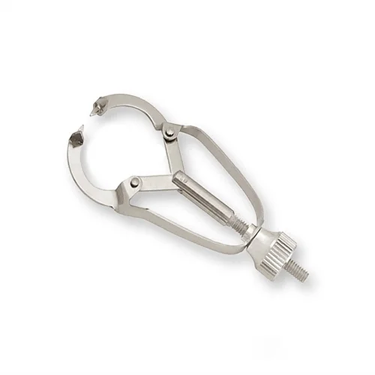

Fig 2. Ivory No.1 Matrix (*Courtesy garimadental.com*)

**IVORY NO.8 MATRIX**

It was introduced in 1905. This system helps in restoring missing walls on both sides (MOD) by encircling the tooth [1][3] (Fig 3).

Advantages- Economical, can be sterilized

Disadvantages- Cumbersome to apply and remove

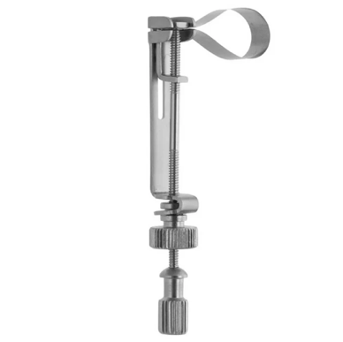

Fig 3. Ivory No. 8 Matrix (*Courtesy medicalinst.net*)

**COPPER BAND MATRIX**

Consists of assorted copper or stainless-steel full circle or ring bands (Fig 4).

Indication- MOD complex restorations

Advantages- Provides excellent contour

Disadvantage- Time consuming

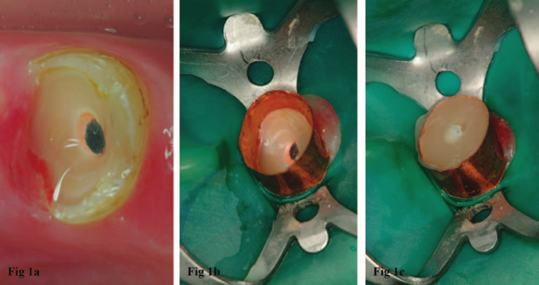

Fig 4. Copper Band Matrix (*Courtesy Peña, Victor & Lopez, Iria & Caserío Valea, Martin & Santana, Urbano. (2015). Use of a Copper Band to Make Resin Cores in Endodontically Treated Teeth Lacking Coronal Structure. Operative dentistry. 40. 10.2341/14-206-T.)*

**AUTOMATRIX**

This is a retainer-less alternative to the universal retainer. It usually comes with a tightening device (Automate) [15]. The bands are pre-formed into a circle, and each band has a coil-like auto-lock loop [10]. **The band is tightened by inserting the wrench into the coil and turning it in a clockwise direction**. The matrix bands come in narrow, medium and wide sizes (Fig 5).

Advantage- Removes the need for bulky retainers, easy to place, good access.

Disadvantage- Bands are not pre-contoured making proximal contouring difficult.

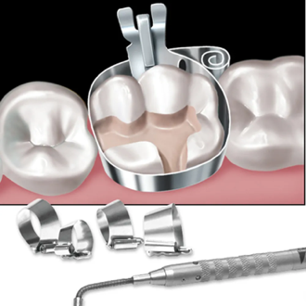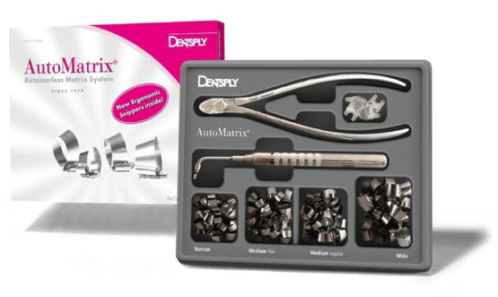

Fig 5. AutoMatrix (*Courtesy dentalkart.com and megadental.fr*)

**OMNIMATRIX**

It was developed by Ultradent. It is a disposable, pre-assembled matrix system designed for efficient and precise restorations. It eliminates the complexities of traditional retainers (e.g., Tofflemire) by providing a simple and ergonomic solution for both posterior and anterior restorations [4] (Fig 6).

Indications-

* Class II restorations
* Class III, IV restorations- transparent Omnimatrix bands

Advantages-

* Easy to use- pre-assembled design; suitable for dentists at all experience levels
* Time saving- ready to use, quick to place
* Better patient comfort- compact design reduces bulk
* Versatile
* Precise

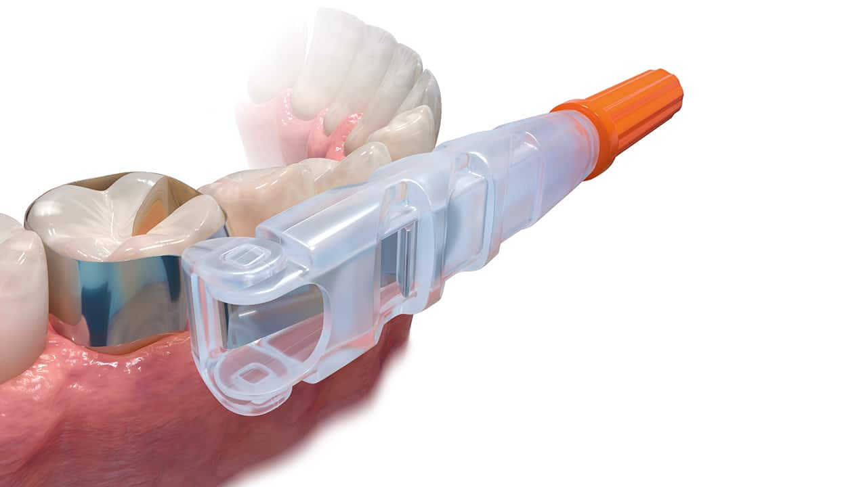

Fig 6. Omnimatrix (*Courtesy decisionsindentistry.com)*

**SECTIONAL MATRIX SYSTEMS**

It is the most commonly used system for restoring proximal walls [18]. It is used in combination with a ring retainer and/or without a wedge for good contouring and ease of placement (Fig 7). It is the best way to create a strong contact point in Class II restorations while using composite resin [2][9].

Indications-

* Small to moderate Class II cavities
* Amalgam and composite restorations

Advantages-

* Easy to use and good access and visibility
* Provides optimal contact, contour and embrasures
* Good aingival adaptation of restoration

Disadvantages-

* Expensive
* Matrix bands may get deformed/dented easily especially if the contact area of the adjacent tooth is too tight

**COMPONENTS OF SECTIONAL MATRIX SYSTEM**

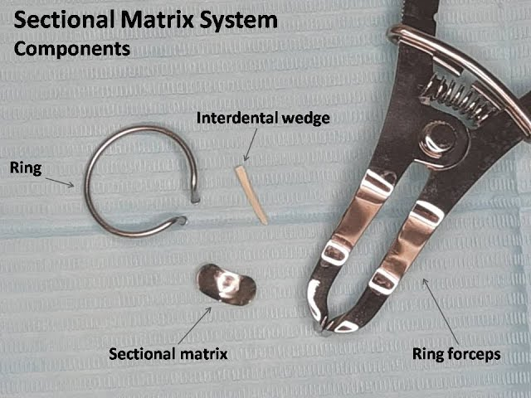

Fig 7. Parts of a Sectional Matrix System (*Courtesy Placement of Sectional Matrix System- YouTube*)

Matrix Bands:

* Thin, pre-contoured metal or plastic bands designed to fit around the proximal surface of the tooth
* These bands are anatomically shaped to recreate natural tooth contours

Separation Rings:

* Spring-like rings that fit around the tooth to provide separation and stabilize the matrix band

Wedges:

* Triangular wooden or plastic pieces inserted interproximally to seal the gingival margin of the band, preventing overhangs
* Ensure a tight seal at the margin to avoid microleakage

**BIOCLEAR BIOFIT HD POSTERIOR MATRIX SYSTEM**

This is a newer matrix technology and design which ensures reproduction of ideal tooth contours. It consists of a 75µ translucent white mylar band (Fig 8). **The rigidity of the mylar matrix with its placement tab facilitates precise positioning, while its translucent properties enable optimal light transmission for effective polymerization [19] . Compared to conventional metal matrices, this system produces a superior surface finish with enhanced polish and anatomical contouring, avoiding the dull surface texture associated with metal alternatives.**

With their innovative anatomical design, Biofit matrices deliver significantly improved coverage (30% increase in buccal/lingual and occlusal extension) relative to traditional options, addressing the requirements for most (75%) posterior molar cases. The HD product line includes four precisely calibrated sizes: 4.5mm, 5.5mm, and 6.5mm for molars, plus a 5.5mm pre-molar variant.

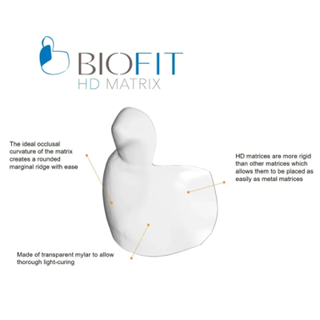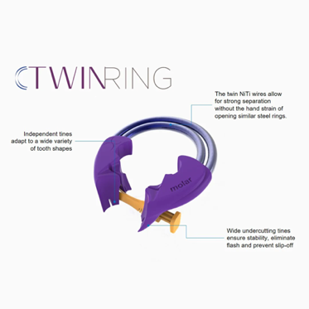

Fig 8. Bioclear Biofit HD Posterior Matrix System (*Courtesy- https://dentalavenueindia.com/products/bioclear-biofit-hd-posterior-refill-packs-matrix-system-for-posterior-class-ii-restorations*)

Advantages-

* Improved Contact Points
* High-Definition Margins
* Better Adaptation
* Simplified Technique
* Enhanced Aesthetics
* Versatility
* Minimized Flash
* Support for Injection Moulding Technique

**Matrix Systems Used For Class III and Class IV Restorations (Anterior Matrix Systems)**

Classification of Anterior Matrix Systems [1-4][11]:

1. Transparent matrix systems-
   1. Mylar Strip
   2. Bioclear matrix
   3. Transparent crowns
   4. Contoured anterior matrices
2. Non-transparent matrix systems-
   1. Unica anterior
   2. Unica minideep
   3. Fusion anterior matrix
   4. Burton band anterior
3. Rigid matrix system- Putty index

**MYLAR STRIP**

A **Mylar strip** is a transparent, flexible plastic film commonly used in dentistry as a **matrix** for various dental procedures. Made of polyester material (often referred to as "Mylar," a brand name), these strips are primarily used in **anterior restorations (Fig 9).** It is 5.8 microns in thickness [3]. The matrix strip is burnished over the end of the steel instrument to produce a ‘belly’ in the strip, allowing for proper reproduction of contact and contour.

Advantages-

* Allows light to pass through
* Produces smooth and glossy finish

Disadvantages-

* Limited to anterior teeth (not suitable for most posterior restorations)
* May not provide sufficient rigidity for extensive restorations
* Requires careful placement to avoid overhangs or inadequate contact points

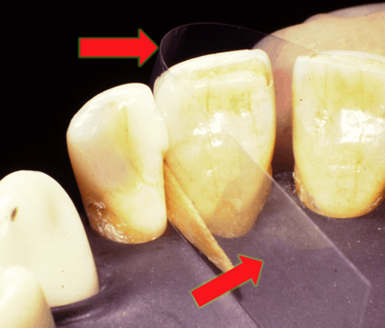

Fig 9. Mylar Strip *(Courtesy- https://stevensondentalsolutions.com/shop/mylar-strip*)

**S- SHAPED BANDS**

These bands have a distinctive S-shaped curvature that helps mimic the natural contours of the tooth structure. The mirror handle is used to crate the S-shape and the band is placed interproximally [4] (Fig 10). Stability to the matrix band can be provided by using impression compound.

Indications-

* Class III and facial/lingual extensions of Class V
* Ideal for restoring the distal part of canine and premolar

Advantages-

* Improved Contact Points
* Better Gingival Adaptation
* Reduced Finishing Time
* Ideal for Complex Cases

Disadvantages-

* Requires skill and experience for proper placement and adjustment
* Primarily designed for specific scenarios and may not be suitable for all restorations

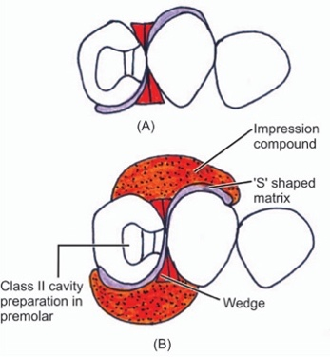

Fig 10. S-shaped Matrix Band (*Courtesy- Textbook of Operative Dentistry. Matrices, Retainers and Wedges (Separators). Jaypee Brothers Medical Publishers (P) Ltd. 2007/01/01*)

**L- SHAPED MATRIX BAND**

Indicated for inciso-proximal cavities, the strip is folded in an ‘L-Shape’. A wedge is used to help in adaptation of the strip. The angle formed when the strip is folded should approximate the tooth corner and support the matrix on the lingual surface (which is held by forefinger of the left hand) (Fig 11). It is often available in thin stainless steel or clear plastic for better visibility and light-curing of composite materials [20].

Advantages-

* Recreates Natural Contours
* Prevents Overhangs
* Improves Composite Curing
* Minimizes Finishing Work
* Versatility

Fig 11. L- shaped Matrix Band (*Courtesy- Textbook of Operative Dentistry. Matrices, Retainers and Wedges (Separators). Jaypee Brothers Medical Publishers (P) Ltd. 2007/01/01*)

**BIOCLEAR ANTERIOR MATRIX SYSTEM**

It was introduced by David Clark in the year 2007. The Bioclear matrix system is designed for conservative restorative and aesthetic procedures, particularly in cases requiring small-area fillings with minimal curvature—unlike diastema closure matrices, which address wider spaces. Its anatomical design enables predictable contouring and modification of a tooth’s emerging profile, even permitting wedge-free placement to seal narrow areas with broad contacts [7].

Upon insertion into the sulcus, the matrix gently stabilizes the papilla while providing a subtle seal. The pre-contoured shape of Bioclear matrices facilitates direct composite injection or placement into the embrasure, eliminating risks of overhanging margins. Additionally, the system ensures optimal smoothing and anatomical contouring of interproximal composite restorations (Fig 12).

Indications-

* All anterior cases
* Diastema closure >1mm
* Development of new and exaggerated emergence profiles
* Closure of big black triangles

Advantages-

* Excellent cervical adaptation
* Better than flat mylar strips
* Preserves gingival papilla
* Easy matrix selection

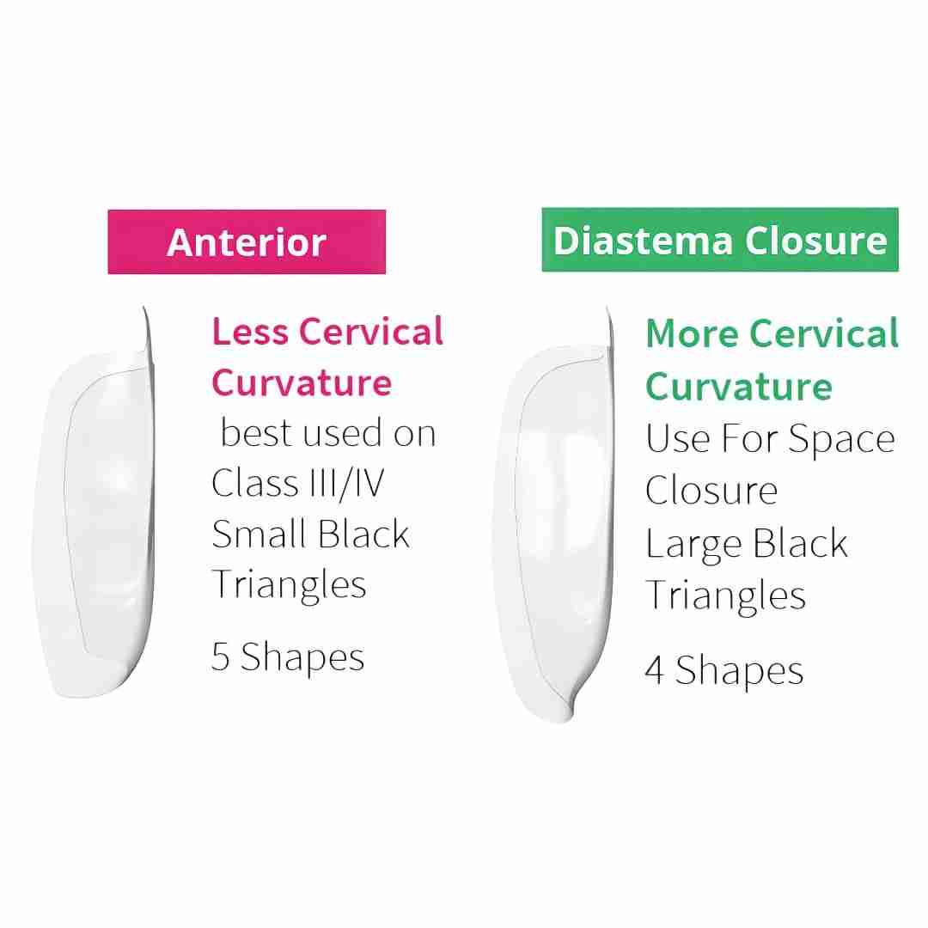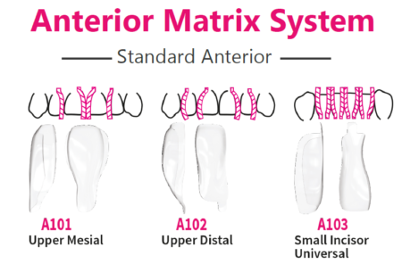

Fig 12. Bioclear Anterior Matrix System (*Courtesy- https://dentalavenueindia.com/products/bioclear-anterior-matrix)*

**UNICA ANTERIOR MATRIX**

Developed collaboratively by Polydentia and Style Italiano (2018), this anatomically curved matrix system adapts to the diverse morphologies of anterior teeth, enabling simultaneous restoration of proximal and cervical margins. Its design accommodates rubber dams and gingival retraction cords, significantly reducing chair time [4]. The matrix features integrated placement wings for rapid, precise positioning, ensuring efficient restoration of both proximal and cervical margins in a single step. This system not only recreates the natural contour of proximal margins but also simplifies cervical margin management, enhancing restoration predictability and facilitating gingival retraction [11] (Fig 13).

Indications-

* Class III, IV, and V anterior restorations
* Direct composite veneers

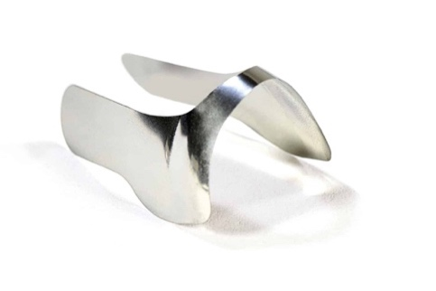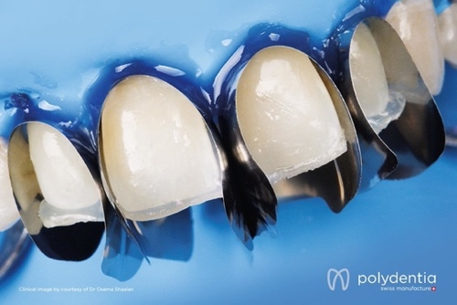

Fig 13. Unica Anterior Matrix (*Courtesy- https://polydentia.ch/en/product/unica-anterior-matrix/*)

**UNICA ANTERIOR MINIDEEP MATRIX**

This is a smaller version of the Unica Anterior matrix system (Fig 14). Crafted from a malleable alloy, this matrix system can be precisely contoured to accommodate the anatomy of smaller anterior teeth. Recognized as a premier choice for aesthetic dentistry, it is particularly effective for **direct stratification composite veneers, morphological modifications of maxillary central incisors, Class III, IV, and V direct composite restorations.** The material's adaptability combined with its anatomical precision establishes it as an indispensable tool for achieving predictable, high-quality aesthetic outcomes in anterior restorative procedures [4].

Indications-

* Maxillary and mandibular lateral incisors, mandibular central incisors, coronoid teeth, triangular teeth, peg laterals, and teeth with narrow cervical diameters

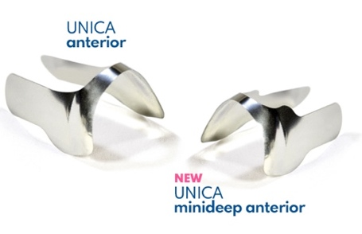

Fig 14. Unica Anterior MiniDeep (*Courtesy- https://www.4cleverdental.nl/product/po6911/)*

**TRANSPARENT CROWN FORM MATRICES**

They are ‘stock’ plastic crowns made of cellulose acetate which can be adapted to tooth anatomy. The entire crown form can be used for bilateral Class IV mesio-incisal-distal cavities. For unilateral Class IV cavities, the crown form is cut inciso-gingivally to use one half of the crown according to the side of the restoration [4] (Fig 15).

Indications-

* Large Class IV cavities
* Oblique fractures of anterior teeth

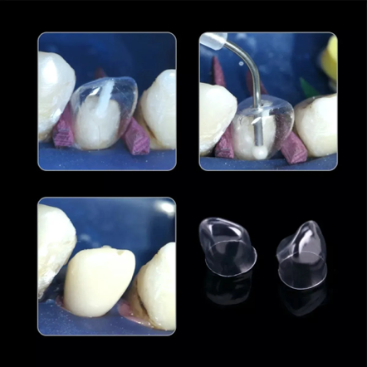

Fig 15. Transparent Crown Form Matrices (*Courtesy- https://www.dentalkart.com/russia-tor-vm-transparent-crowns*)

**FUSION TM ANTERIOR MATRIX SYSTEM**

Introduced by Garrison Dental in 2021, this matrix system utilizes precision-engineered 0.0015" thick stainless steel bands that combine exceptional durability with clinical versatility. The robust yet flexible design facilitates effortless sulcular insertion while maintaining perfect contour integrity without distortion. When properly seated, the matrix automatically establishes ideal anatomical curvature in both gingivo-incisal and facio-lingual orientations (Fig. 16), making it particularly effective for restoring challenging deep carious lesions. The ultra-thin stainless steel construction provides the optimal balance of strength and adaptability, ensuring precise marginal adaptation even in complex restorative scenarios.

Indications-

* In anterior restorations like Class III and IV crowns
* Composite veneers

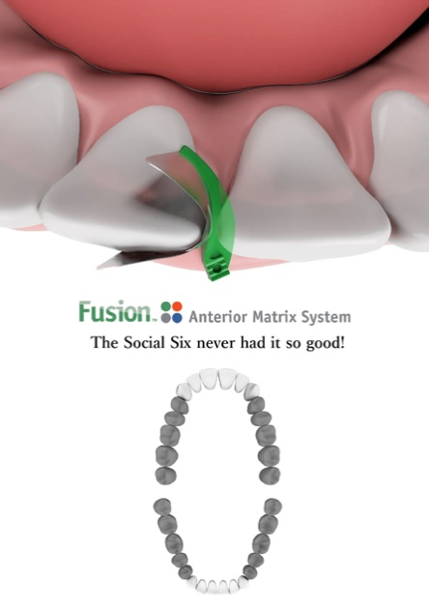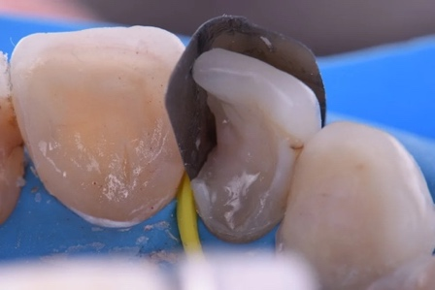

Fig 16. FusionTM Anterior Matrix (*Courtesy- https://www.garrisondental.com/products/fusiontm-anterior-matrix-system)*

**BURTONBANDS MATRIX SYSTEM**

It was introduced by Dr Matthew Burton. The system comprises a 38-micron metal matrix securely attached to a uniquely designed plastic wedge. The wedge features a notched edge that audibly clicks into place upon proper positioning, providing immediate stabilization of the matrix and freeing the clinician's hands for restorative procedures. Its distinctive handle design enhances ergonomic control, while the matrix's combination of curvature and flexibility enables precise adaptation to the tooth anatomy—seamlessly conforming from the root surface to the incisal edge (Fig 17).

Advantages-

* Improving the face embrasures formation and enabling the incisal embrasure to be shaped and positioned correctly.
* Simple installation
* Combines precise contour control with reliable marginal sealing
* Maintains accessibility to subgingival areas without sacrificing isolation quality
* Offers adaptable height adjustment for space closure procedures

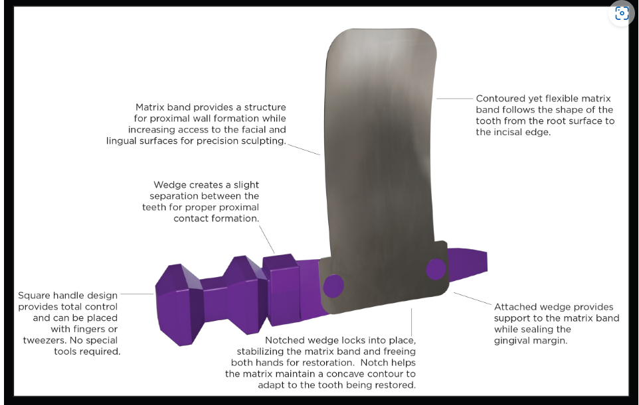

Fig 17. Burtonband Matrix System (*Courtesy- https://burtonbands.com/burtonbands-anterior-matrix-system-1/)*

**BLUE VIEW VARISTRIPTM MATRIX**

This anatomically contoured anterior matrix system is designed to deliver optimal curvature and band height for virtually all anterior restorative procedures. The 0.05 mm thin plastic anatomical strip features a precision taper from end to end, facilitating effortless interproximal placement. Clinicians can slide the strip until perfect tooth-height alignment is achieved (Fig. 18), ensuring accurate reproduction of occluso-gingival anatomy through its pre-contoured design while preventing flat embrasures. The matrix incorporates a blue tint that enhances visual contrast against tooth structures without compromising composite resin polymerization. This strategic design combination enables predictable, esthetic outcomes across diverse anterior restoration scenarios.

Indications-

* Class IV and diastema closure cases.

 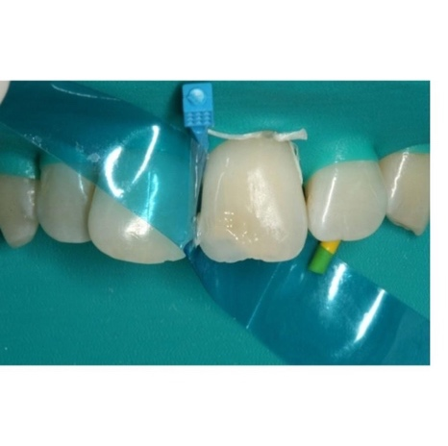

Fig 18. BlueView Varistrip Matrix Band (*Courtesy- https://www.garrisondental.com/products/blue-viewtm-varistriptm-anterior-matrices)*

**MODIFIED PUTTY INDEX USING MYLAR STRIP**

It is a rigid type of matrix system where the putty index is routinely fabricated when restoring incisor defects, serving as a key reference for both direct and indirect restorative techniques The putty index is placed on the palatal surface for composite insertion after acid-etching and bonding agent application on the tooth surface to be repaired. At this stage, a Mylar strip is placed over the adjacent tooth to prevent the adhesion of composite material, which differs from the typical approach [8] (Fig 19).

Advantages-

* Establishes the correct contour and incisal edge length, which can then be used as a guide to support the labial surface composite buildup
* Can also help with moisture control on the palatal surface
* The flexible Mylar strip matrix system enables precise anatomical contouring and optimal labial surface polishing for superior aesthetic outcomes

Limitations-

* Need for a second appointment

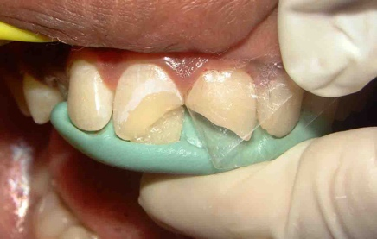

Fig 19. Putty Index *(Courtesy- ref.8)*

**CLEAR SILICONE INDEX**

This transparent silicone matrix system enables complete polymerization of composite resin through its optically clear material while simultaneously transferring precise tooth morphology from diagnostic wax-ups to the clinical restoration [4,7] . The system's unique properties allow for both single-tooth repairs and full-arch rehabilitations (Fig. 20), making it particularly versatile for various restorative scenarios.

Features-

* Firm, but flexible
* Prevents the formation of an oxygen inhibition layer while using composites, so final polishing is easier
* Easy to drill holes for injection moulding technique

Advantages-

* Simple
* Time saving
* Achieves glossy finish
* Doesn’t necessitate polishing

Disadvantages-

* Only monochromatic shade can be used

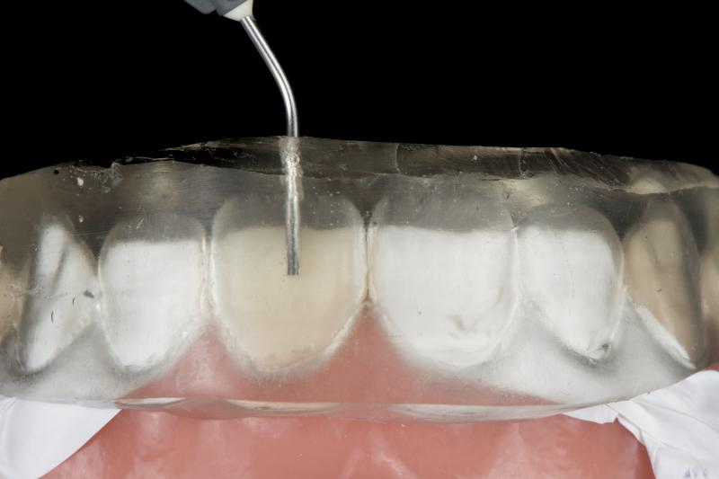

Fig 20. Clear Silicone Index (*Courtesy- https://www.promodentaire.com/exaclear-gc-cartouche-2x51g.html*)

**Matrix Systems Used For Class V Restorations**

**CERVICAL MATRIX**

This is an instrument used for modelling composites in class V restorations, composed of five different sizes and flexible shell shapes [4] (Fig 21).

* Eg- Blue View cervical matrix kit (Garrison)

Types of cervical matrices-

1. Rigid Matrices-
   1. Made of materials like metal or thick plastic
   2. Provides stable support during restoration placement
2. Flexible Matrices-
   1. Made of transparent, flexible plastic
   2. Adapts well to irregular contours and allows for light curing of the composite

Advantages-

* Protects the restoration from contamination
* Eliminates oxygen inhibition layer
* Eliminates time spent hand sculpting and reduces finishing time

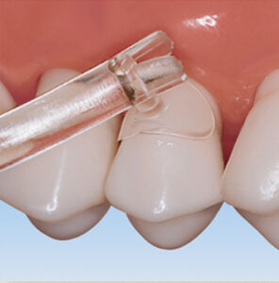

Fig 21. Cervical Matrix (*Courtesy- https://www.amtouch.com/shop-by-category/matrix-materials/premier-cure-thru-clear-cervical-matrices/)*

**WINDOW MATRIX**

This is another type of matrix system used to restore cervical cavities on anterior teeth. It has a **window or a cut-out section** that provides access to the restorative area while maintaining support and contour for the restoration [4][7].

The window exposes the Class V cavity allowing for the direct placement of the restorative material. It is usually made from clear plastic to allow for light curing to pass through while using a composite restoration [4].

Indications-

* Cervical lesions caused by abrasion, erosion, abfraction or caries

Advantages-

* Precise placement of restoration
* Avoids overextension of material
* Helps in achieving a smooth and natural finish of the restoration

Disadvantages-

* It is technique sensitive
* May not adapt well to deep cavities

**CONCLUSION**

Matrix systems undoubtedly are indispensable tools in restorative dentistry, playing a critical role in achieving functional and aesthetic restorations. They provide support, contour, and proper adaptation of restorative materials to the prepared tooth, ensuring smooth margins, tight contact points, and a natural tooth anatomy.

From traditional matrix bands to modern systems like sectional, window, and cervical matrices, the variety of designs caters to different restorative requirements and challenges, including Class II, Class III, Class IV, and Class V restorations. Advancements in matrix technology, such as pre-contoured and transparent materials, have further enhanced efficiency, precision, and clinical outcomes.

The proper selection and use of matrix systems are essential for the success of restorations, minimizing risks like overhangs, open contacts, and microleakage. By mastering these tools and techniques, dentists can deliver high-quality restorations that restore both function and aesthetics, contributing to better patient satisfaction and overall oral health outcomes.

**AI Disclaimer- Option 1.**

Disclaimer (Artificial intelligence)

Option 1:

Author(s) hereby declare that NO generative AI technologies such as Large Language Models (ChatGPT, COPILOT, etc.) and text-to-image generators have been used during the writing or editing of this manuscript.

**REFERENCES**

1. Harald O Heymann, Edward J Swift, Jr., Andre V Ritter. ‘Sturdevant’s Art & Science of Operative Dentistry; A South Asian Edition. 2016
2. M.A. Marzouk, Simonton, Gross. ‘Operative Dentistry- Modern Theory and Practice’
3. Vimal Sikri .Textbook of Operative Dentistry, 3rd Edition
4. Urkande NK, Mankar N, Nikhade PP, Chandak M, Ikhar A, Patel A. Anterior Matrix Systems for Composite Restorations: A Review. Cureus. 2023 Apr 4;15(4):e37145. doi: 10.7759/cureus.37145. PMID: 37168162; PMCID: PMC10166279.
5. Ramya R, Raghu S. India: Emmess Medical Publisher; 2007. Clinical operative dentistry principles and practices.
6. Markose A. Restoring proximal contacts of teeth. IOSR J Dent Med Sci. 2017;16:46–49.
7. Owens BM, Phebus JG. An evidence-based review of dental matrix systems.. Gen Dent. 2016; 64:64–70
8. Sherwood IA, Rathakrishnan M, Savadamaoorthi KS, Bhargavi P, Vignesh Kumar V. Modified putty index matrix technique with mylar strip and a new classification for selecting the type of matrix in anterior proximal/incisal composite restorations. Clin Case Rep. 2017 Jun 1;5(7):1141-1146. doi: 10.1002/ccr3.1006. PMID: 28680613; PMCID: PMC5494407.
9. Summitt J M. Fundamentals of Operative Dentistry. Quintessence Publishing. 3rd Ed 2006.
10. Vaishnavi Rajendra Patekar, Nikhil Mankar, Karuna Burde, Aparna Achanta. Choice of Matrix System in Dentistry, J Res Med Dent Sci, 2022, 10 (11): 120-126.
11. Akshada Mungee, Rachit Mathur, Babra Khan, Ajay Kore. Everything About Matrix and Matrix Systems. A Review Article. IOSR Journal of Dental and Medical Sciences (IOSR-JDMS) e-ISSN: 2279-0853, p-ISSN: 2279-0861.Volume 23, Issue 7 Ser. 9 (July. 2024), PP 28-36
12. Ercoli C, Caton JG. Dental prostheses and tooth‐related factors. Journal of periodontology. 2018 Jun;89:S223-36.
13. Mandurino, M., Di Domenico, G. L., Baldani, S., Collivasone, G., Gherlone, E. F., Cantatore, G., & Paolone, G. (2023). Dental Restorations. *Bioengineering*, *10*(7), 820.
14. Rekow, E. D., Fox, C. H., Petersen, P. E., & Watson, T. (2013). Innovations in materials for direct restorations: why do we need innovations? Why is it so hard to capitalize on them?. *Journal of Dental Research*, *92*(11), 945-947.
15. Shaalan, O. O. (2020). Evaluation of matrix band systems for posterior proximal restorations among Egyptian dentists: a cross-sectional survey. *Acta Stomatologica Croatica*, *54*(4), 392.
16. Owens, B. M., & Phebus, J. G. (2016). An evidence-based review of dental matrix systems. *Gen Dent*, *64*(5), 64-70.
17. Malik, T. A. M. S. I. L. A., Malik, T. A. H. R. E. E. M., Mahmood, A. S. A. D., Naz, S. H. A. R. I. N. A., & Sajid, M. U. S. T. A. F. A. (2020). Choice of matrix system for class II composite restoration; a cross sectional survey among the dentists of Multan Dental College. *Pak J Med Health Sci*, *14*(4), 829-31.
18. Bailey, O. (2021). Sectional matrix solutions: the distorted truth. *British Dental Journal*, *231*(9), 547-555.
19. Sulaiman, T. A., Alsahafi, T. A., Frizoni, F. D. O., & Suliman, A. A. (2025). Reconstructing Tooth Proximal Surface With Composite Resin Using Contemporary Sectional Matrix Systems. *Journal of Esthetic and Restorative Dentistry*.
20. Jiang, T., Jiao, T., & Li, Y. (2016). Array mutual coupling reduction using L‐loading E‐shaped electromagnetic band gap structures. *International Journal of Antennas and Propagation*, *2016*(1), 6731014.
21. Goyal, A., Nikhil, V., & Singh, R. (2016). Diastema closure in anterior teeth using a posterior matrix. Case reports in dentistry, 2016(1), 2538526.