***Case report***

**A Rare occurrence of mucocele of ventral surface of the tongue : A case report**

**ABSTRACT:**

Mucoceles are benign lesions of the oral cavity, usually resulting from trauma or obstruction caused in the salivary glands. However, their occurrence on the ventral surface of the tongue is rare and often misdiagnosed due to their hidden presentation. This case highlights an unusual mucous extravasation cyst presenting as a subtle swelling on the ventral tongue, emphasizing the need for careful clinical and histopathological evaluation. Prompt diagnosis and appropriate surgical intervention ensured complete resolution and prevented recurrence. This report underlines the necessity of considering mucocele in the differential diagnosis of lingual swellings.

Due to their asymptomatic and often translucent appearance, mucoceles on the ventral tongue may be mistaken for vascular or soft tissue lesions such as hemangiomas, lymphangiomas, or lipomas. Clinical vigilance is required, especially when the lesion persists or changes in size over time. Histopathological confirmation remains essential, as imaging alone may not differentiate mucoceles from other cystic pathologies. The treatment of choice involves complete surgical excision, including the affected glandular tissue, to minimize the risk of recurrence. The rarity of ventral tongue mucoceles necessitates increased awareness among clinicians and pathologists for accurate identification and management.

**Keywords**: Mucocele, Ventral tongue, Mucous Extravasation, Oral Lesion, Salivary Gland Cyst

**INTRODUCTION:**

Mucoceles are benign, mucus-filled cystic lesions that most frequently originate from the minor salivary glands. The floor of the mouth, the cheek mucosa, the lower lip, and occasionally the ventral surface of the tongue are common sites of occurrence (1,2). Two main processes are involved in their pathophysiology: mucous retention caused by ductal occlusion and mucous extravasation resulting from salivary duct rupture (3).

Despite being common in clinical practice, mucocele occur rarely on the ventral tongue and may pose diagnostic challenges due to their atypical presentation. These lesions can be mistaken for benign salivary gland tumors, vascular abnormalities, or pyogenic granulomas (4,5). A combination of thorough clinical assessment, imaging where required, and histopathological confirmation is necessary for accurate diagnosis.

Prompt identification and treatment are vital to prevent complications such as lesion enlargement, discomfort, or secondary infection. Mucoceles often arise following repetitive trauma, such as lip biting or irritation from dental appliances, particularly in younger individuals. The preferred course of treatment remains complete surgical excision, including the associated minor salivary gland, to minimize the risk of recurrence (6). In certain cases, alternative management options like laser ablation or cryosurgery may be considered depending on the size and location of the lesion. Ultimately, a multidisciplinary approach enhances diagnostic accuracy and therapeutic success.

**CASE PRESENTATION**

A 20-year-old male patient reported with the chief complaint of swelling in lower surface of tongue for past one month. Patient was normal before a month after which he noticed a small swelling in the lower border of the tongue which showed gradual increase to the current size. No pain and pus discharge evident. [Figure 1]. No history of past trauma.No relevant medical history seen. Patient is under orthodontic treatment for past 6 months.

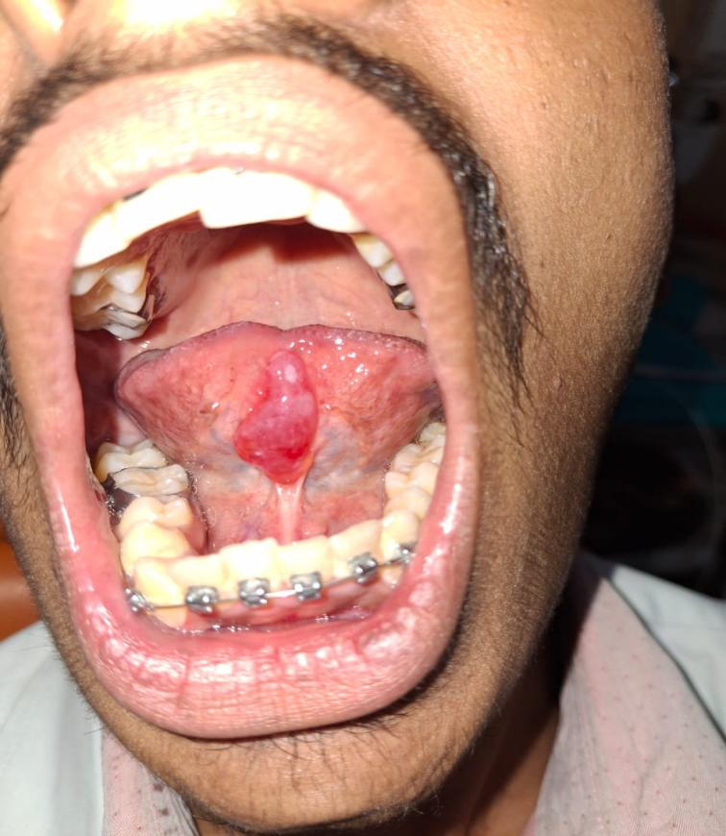

**Figure 1:** Intra oral finding reveals a swelling in the ventral surface of the tongue

A 5x3 cm enlargement that is soft, variable, and non-tender to the touch is found on the tongue's ventral surface. It has a dome form, is mucosa coloured, well-defined, and shows no surface alterations. The inspection findings including the growth's boundaries and extent, are validated by palpation. The swelling was tentatively diagnosed as mucocele since it is soft, fluctuating, and nontender to the touch.The case was differentially diagnosed as lipoma.

Under local anaesthesia, the lesion was excised and the gross specimen was submitted for histopathology reporting which included several soft tissue fragments. Specimen was processed and routinely stained. Histopathology of the specimen reveals a non- keratinized stratified squamous epithelium with an irregular surface which seems to be thin and stretched out in most of the areas excepting in few areas where it is hyperplastic with proliferative rete processes. The underlying connective tissue area seems to be in fragments and reveals a homogenous eosinophilic to basophilic delicate mucinous component. [Figure 2].

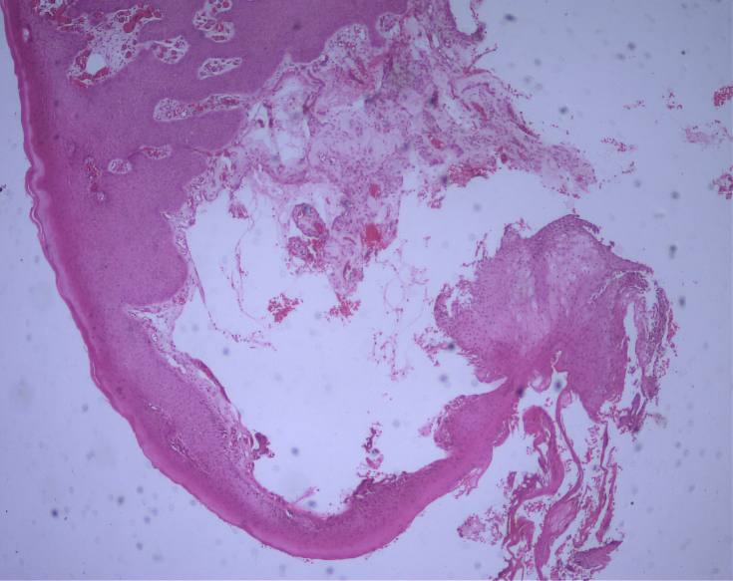

10x

**Figure 2:** Histopathology (H&E stain) showing fragmented connective tissue area which reveals a homogenous eosinophilic to basophilic mucinous component.

The rest of the connective tissue appears fibro-cellular with numerous endothelium lined capillaries of varying sizes and extravasated RBCs. Dispersed within the mucinous connective tissue areas are numerous macrophages/ mucinophages and acute and chronic inflammatory cells predominantly neutrophils, eosinophils, lymphocytes and plasma cells [Figure 3,4].

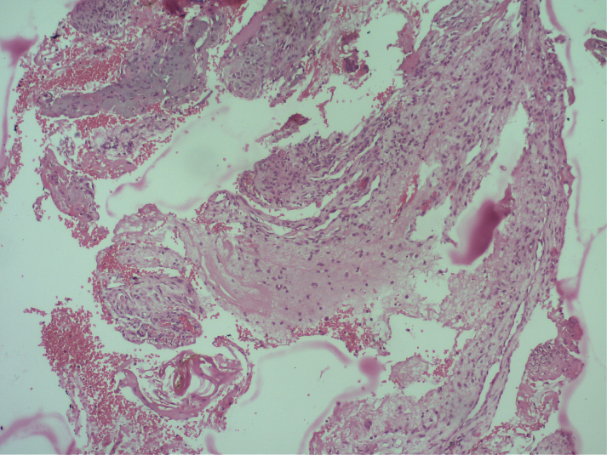

10x

**Figure 3:** Histopathology (H&E stain) showing Fibro-cellular connective tissue with numerous endothelium lined capillaries of varying sizes and extravasated RBCs dispersed within the mucinous connective tissue areas.

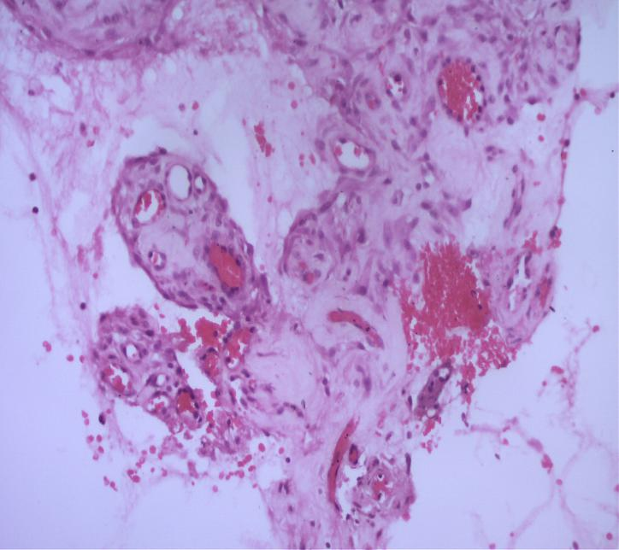

20x

**Figure 4:** Histopathology (H&E stain) showing numerous macrophages/ mucinophages and acute and chronic inflammatory cells predominantly neutrophils, eosinophils, lymphocytes and plasma cells

Mucin extravasation within the connective tissue is seen as amorphous, PAS-positive (magenta-pink) material under PAS staining. The most prevalent kind of mucocele on the ventral tongue, extravasation-type mucocele, is indicated by this mucin pool's frequent appearance of non-encapsulation. The bright magenta staining highlights glycoproteins and mucopolysaccharides (mucin) in the spilled salivary secretion [Figure 5]

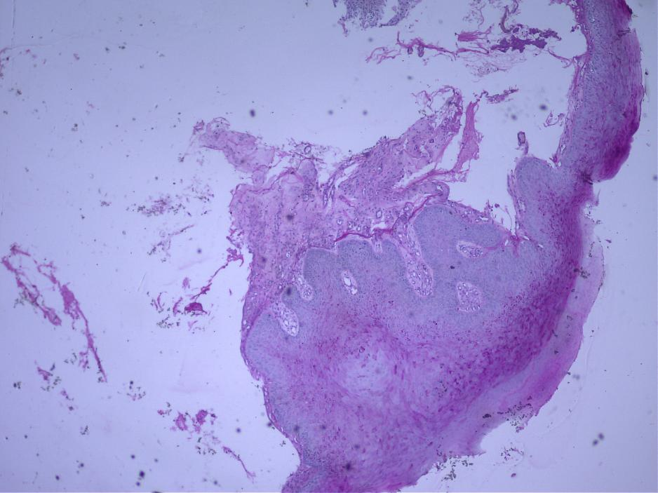

10x

**Figure 5:** PAS staining reveals **extravasation of mucin** within the connective tissue, presenting as **amorphous, PAS-positive (magenta-pink) material**.

The clinicopathological correlation led to a final diagnosis of Mucocele. The patient underwent surgical excision under local anesthesia. No recurrence was noted at 1month and 6 months follow up

**DISCUSSION:**

One of the most common lesions of the salivary glands is mucocele, which often arises due to mechanical injury that damages the duct of salivary glands and causes mucus to leak into the surrounding connective tissue (1). Although mucoceles are frequently encountered on the lower lip, they are uncommon and sometimes misdiagnosed when they arise on the ventral aspect, from the minor salivary glands (2,3). Lesions originating from the minor salivary glands can manifest as soft, fluctuant superficial swellings (4). These mucoceles can vary in size and, depending on their position and size, might cause discomfort or even disturb speech or mastication (5). Clinical diagnosis is difficult because their presentation might resemble other pathologies including vascular lesions, lipomas, fibromas, or even malignant neoplasms (6).

Oral mucoceles are benign cystic lesions commonly occurring on the lower lip, mainly resulting from trauma to minor salivary glands. Pathogenesis includes habitual lip biting causing rupture of salivary ducts and mucin extravasation into surrounding connective tissue, forming a pseudocyst lacking an epithelial lining (7,8,10). Studies have confirmed that trauma such as cheek or lip biting accounts for majority of cases (8,9). Adolescents and young adults are mostly affected due to higher prevalence of parafunctional habits (8).

Retention-type mucoceles, although occurring rarely, develop when ductal obstruction occurs, due to mucus plugs, fibrosis, or sialoliths, resulting in an epithelial-lined cyst [10]. While environmental and behavioural causes are well documented, recent investigation into genetics is emerging. Studies on mucin gene polymorphisms of MUC7 gene which influence salivary viscosity and resilience of salivary ductal system suggest a possible genetic predisposition to mucocele formation through difference in mucin composition and fragility of salivary ductal system (11). Also, familial recurrence patterns and individual differences in extracellular matrix remodelling may reflect heritable anatomical variations of salivary ducts in individuals (12).

Histologically, mucoceles are divided into two categories: mucous retention cysts, which are actual cysts bordered by epithelium, and mucous extravasation cysts, which are encircled by granulation tissue and lack an epithelial lining (13). Due to trauma-related aetiology, the majority of lesions on the ventral tongue are extravasation type, especially those originating from the Blandin–Nuhn glands (14). In order to prevent recurrence, treatment typically entails total surgical excision, which includes the removal of the involved minor salivary glands (15). Although there have been reports of other treatments such laser ablation, cryosurgery, and marsupialization, surgical excision is still the gold standard because of its efficacy and decreased recurrence rates (16,17). Mucoceles accounts approximately of 2.5% of oral lesions though ventral tongue involvement is rare (<2). Malignant transformation to mucoepidermoid carcinoma is rarely reported and recurrence occurs in 5–18% of cases, especially if incompletely treated (18,19).

**CONCLUSION:**

Because of their hidden position and diverse presentation, mucoceles that arise on the ventral surface of the tongue from the minor salivary glands of tongue are uncommon and frequently clinically ignored. Accurate diagnosis, supported by histopathological evaluation, is essential to differentiate them from other oral pathologies.

To reduce the chance of recurrence, complete surgical excision including the minor salivary glands involved remains the preferred treatment of choice. In addition to restoring the patient’s comfort and oral function, early detection and treatment guarantee a great prognosis. The necessity of increased clinical awareness of such unusual presentations during routine oral examinations is highlighted in this report.

Disclaimer (Artificial intelligence)

Author(s) hereby declare that NO generative AI technologies such as Large Language Models (ChatGPT, COPILOT, etc.) and text-to-image generators have been used during the writing or editing of this manuscript.

Consent

As per international standards or university standards, patient(s) written consent has been collected and preserved by the author(s).

**REFERENCES**

1. Kumar R, Kumar MP, Arularasan G. Incidence and Management of Obstructive and Traumatic Lesions of the Salivary Glands: A Prospective Institutional Study. Library of Progress-Library Science, Information Technology & Computer. 2024 Jul 15;44(3).
2. Sheikh O, Perry M. The Lips, Mouth, Tongue and Teeth: Part II. Diseases and Injuries to the Head, Face and Neck: A Guide to Diagnosis and Management. 2021:1085-168.
3. Hayashida AM, Zerbinatti DC, Balducci I, Cabral LA, Almeida JD. Mucus extravasation and retention phenomena: a 24-year study. BMC Oral Health. 2010 Dec;10:1-4.
4. Swain SK. Oral mucocele: A narrative review. Journal of Indira Gandhi Institute Of Medical Science. 2024 Jul 1;10(2):87-92.
5. Oliveira DT, Consolaro A, Freitas FJ. Histopathological spectrum of 112 cases of oral mucoceles in children. Int J Pediatr Otorhinolaryngol. 1993;26(3):223–7.
6. Valério RA, Queiroz AM, Romualdo PC, Brentegani LG, Paula-Silva FW. Mucocele and fibroma: treatment and clinical features for differential diagnosis. Brazilian dental journal. 2013;24(5):537-41.
7. More CB, Bhavsar K, Varma S, Tailor M. Oral mucocele: a clinical and histopathological study. Journal of oral and maxillofacial pathology. 2014 Sep 1;18(Suppl 1):S72-7.
8. Hassan MK, Kallarakkal TG. Trauma to the Lower Lip: Mucocele. InClinicopathological Correlation of Oral Diseases 2023 Jul 22 (pp. 93-99). Cham: Springer International Publishing.
9. Choi YJ, Byun JS, Choi JK, Jung JK. Oral mucocele: review of literature and a case report. *Medicina Oral Patol Oral Cir Bucal*. 2015;20(2):e152‑6.
10. Thompson LD. Mucocele: retention and extravasation types. Ear, Nose & Throat Journal. 2013 Mar;92(3):106-8.
11. Aoki H, Imamura Y, Ouryouji K, Miyazawa H, Wang P‑L. Genetic polymorphism of the salivary mucin gene MUC7 in severe caries in Japanese pediatric patients. *Pediatr Dent J*. 2010;20(2):152–7.
12. Chibly AM, Aure MH, Patel VN, Hoffman MP. Salivary gland function, development, and regeneration. Physiological reviews. 2022 Jul 1;102(3):1495-552.
13. Kalaimani G, Sivapathasundharam B, Priyadarshini L, Rajeswari MR, Karthick BP. Mucous extravasation phenomenon: A clinicopathologic evaluation of 68 cases. Journal of Oral and Maxillofacial Pathology. 2024 Apr 1;28(2):182-5.
14. More CB, Bhavsar K, Varma S, Tailor M. Oral mucocele: a clinical and histopathological study. J Oral Maxillofac Pathol. 2014;18(Suppl 1):S72–7.
15. Giraddi GB, Saifi AM. Micro-marsupialization versus surgical excision for the treatment of mucoceles. Annals of maxillofacial surgery. 2016 Jul 1;6(2):204-9.
16. Yagüe-García J, España-Tost AJ, Berini-Aytés L, Gay-Escoda C. Treatment of oral mucocele–scalpel versus CO₂ laser. Med Oral Patol Oral Cir Bucal. 2009;14(9):e469–74.
17. Hashemi M, Zohdi M, Zakeri E, Abdollahzadeh-Baghaei T, Katebi K. Comparison of the recurrence rate of different surgical techniques for oral mucocele: A systematic review and Meta-Analysis. Medicina Oral, Patología Oral y Cirugía Bucal. 2023 Jun 18;28(6):e614.
18. Nagar SR, Fernandes G, Sinha A, Rajpari KN. Mucocele of the tongue: A case report and review of literature. Journal of Oral and Maxillofacial Pathology. 2021 Mar 1;25(Suppl 1):S37-41.
19. Saquete Martins-Filho PR, de Santana Santos T, Da Silva HF, Piva MR, de Souza Andrade ES, da Silva LC. A clinicopathologic review of 138 cases of mucoceles in a pediatric population. Quintessence International. 2011 Sep 1;42(8).