***Case report***

**Management of Mucocele: A Case Report**

**ABSTRACT**

A mucocele is a prevalent benign lesion of the oral cavity that typically appears when mucus builds up due to the rupture or blockage of tiny salivary gland ducts. It can cause the accumulation of mucus due to changes in the minor salivary glands. Mucocele is the most prevalent condition affecting salivary glands in the oral cavity. The case report aimed to explain the history, clinical features and surgical removal of mucocele using a simple surgical technique, which helps to enhance the knowledge of the general dental practitioner. According to this case study, a 25-year-old male patient developed a bluish, fluctuating, painless growth on his lower lip that grew larger over the course of a week. On intra-oral examination, dental caries were found in 17, 27, 36, 46, and 47. There was widespread dental plaque and calculus in the lower anterior region. The results of the routine blood tests fell within the usual range. The clinical examination and history pointed to a mucocele. A mucocele was suggested by the history and clinical examination. Under local anaesthesia, small salivary glands were surgically excised. Histopathology was suggestive of a mucocele. Surgical excision of minor salivary glands was performed under local anaesthesia. Histopathological evaluation confirmed the diagnosis of a mucocele. The patient showed uneventful healing with no recurrence during the follow-up period. This report highlights the clinical presentation, differential diagnosis, and effective management of oral mucoceles. It was concluded that compared to conventional surgical excision, oral mucocele ablation using a CO2 laser provides more predictable outcomes and fewer problems and recurrences.

**Keywords:** Mucoceles, lower lip, dental caries, effective management, surgical removal

# **INTRODUCTION**

Mucoceles are one of the most frequent benign soft tissue masses that occur in the oral cavity (1). It is described as a 'mucus-filled' cyst that may present in the oral cavity. It can cause the accumulation of mucus due to changes in the minor salivary glands. Mucocele is the most prevalent condition affecting salivary glands in the oral cavity (1,2). The lower lip is the most frequently affected site, followed by the floor of the mouth and ventral tongue. When it occurs on the floor of the mouth, the term ranula is used. Clinically, the lesions present with an asymptomatic dome-shaped nodule or blister, often with a blue hue due to the extravasated mucin (Miranda et al., 2022; Cordeiro et al., 2025). There are two kinds of mucocele that can develop in the oral cavity: extravasation and retention. While retention-type mucoceles are extremely uncommon in children, extravasation mucoceles are frequently observed. A damaged salivary gland duct that allows saliva to leak into the soft tissues surrounding the gland causes extravasation of mucocele. Three stages of evolution are experienced by these extravasation mucoceles. Mucus diffusely leaks into the connective tissues from the excretory duct during the first phase. Granuloma formation happens in the subsequent phase, known as the resorption phase, as a result of the foreign body reaction. During the last stage, a pseudocapsule—which lacks an epithelial lining—forms around the mucosa. Retention mucocele results from blockage of the salivary gland ducts, which reduces or eliminates glandular output. Mucoceles are transparent, blue, and soft swellings that often go away on their own. Vascular congestion, cyanosis of the tissue above, and fluid buildup below are the causes of the blue colour. However, the lesion's size, proximity to the surface, and the flexibility of the surrounding tissue can all affect pigmentation. Complete surgical excision is normally the chosen treatment, and it must be done in association with the removal of any minor salivary gland involved in order to minimise the possibility of recurrence. However, the lesion size, extent, and depth, as well as the age of the patient, are important parameters that should be considered to determine the best therapeutic technique (Curvelo et al., 2021). The case report aimed to explain the history, clinical features and surgical removal of mucocele using a simple surgical technique, which helps to enhance the knowledge of the general dental practitioner.

**CASE PRESENTATION**

A 25-year-old male patient came to the "Department of Oral Medicine and Radiology" report with complaints of a swelling in his lower lip for the past 6 months. The patient was apparently normal before 6 months, and on eliciting history. The patient initially noticed a small swelling in his lower lip region, which was initially small in size. The Swelling was filled with clear water-like fluid that ruptured on its own within 2 months. It gradually progressed to its current size. No evidence of pain and no evidence of lip biting habit. No relevant medical history. First dental visit. Patient brushes their teeth every day using a toothbrush and toothpaste.

On examination of the lesion, a solitary growth of size approximately 0.5 cm in diameter is seen in the left labial mucosa located medio laterally 0.2 mm lateral to the midline and In relation to 31 32 region 1 cm away from the left commissure of the lips, superio inferiorly 1 cm above the left anterior labial vestibule and 1 cm from the vermillion border of lower lip. It is roughly oval in shape, appears pale pink in colour, surface appears smooth and regular.

On intra-oral examination, dental caries were found in 17, 27, 36, 46, and 47. There was widespread dental plaque and calculus in the lower anterior region. The results of the routine blood tests fell within the usual range.

1. Preoperative stage

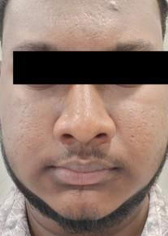

B. Excisional biopsy was performed under local anaesthesia inrelation to left mandibular labial mucosa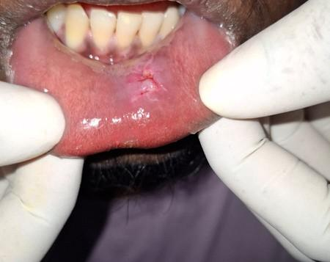

C.Post-surgical excision

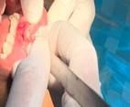

**Fig. 1: Intra-oral surgical experiments**

**INVESTIGATION**

**Table 1: Advised haematological investigation**

|  |  |
| --- | --- |
| Bleeding time: | 02 minutes 30 seconds |
| Clotting time: | 4minutes 45 seconds |
| Haemoglobin: | 11.8 gm% |

Based on clinical characteristics, the case was ultimately determined to be a mucocele in the lower labial mucosa. The patient was informed and given a plan for the treatment. During their first clinical visit, oral prophylaxis was initially administered. The lesion was surgically removed by making a vertical incision while under local anaesthesia. This caused the mucosa to split over, and the mucocele was then removed from the base. As a result, the likelihood of recurrence is reduced. After seven days of intermittent monitoring, the suture was put in place and taken out. Patients were told to attend routine recall visits and to be examined every month; for more than a month, there was no recurrence.

# Surgical excision: Under local anaesthetic, the mucocele should be completely removed. (One cartridge of 2% lidocaine and 1:100.000 epinephrine) The nearby little salivary glands that feed the lesion should also be removed to prevent recurrence. (6) Restorative treatment done in 17 27 26 46 47. The sample should be sent for Histopathology. Histopathologic report revealed a Hematoxylin and

Eosin-stained section showing the given soft tissue specimen reveals hyperplastic parakeratinized/non-keratinised stratified squamous epithelium. The underlying connective tissue is seen as a delicate fibrocellular matrix with spaces, numerous capillaries of different sizes, and a dilated, severed duct is also seen. Inflammatory cell infiltration, including both acute and chronic (lymphocytes and plasma cells), macrophages/mucinophages, eosinophils, and a few mast cells, is also noticed. The deeper connective tissue areas show aggregates of mucous minor salivary glands with dilated ducts, blood vessels of varying sizes with extravasated RBCs, and a few adipocytes.

A. Excised Mucocele in the left mandibular labial mucosa

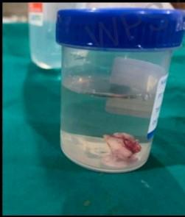

1. After suturing

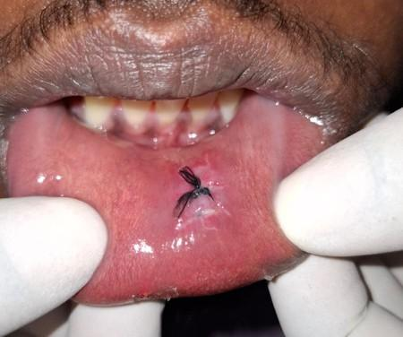

Histological features

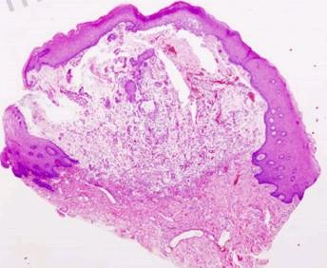

POST-OPERATIVE

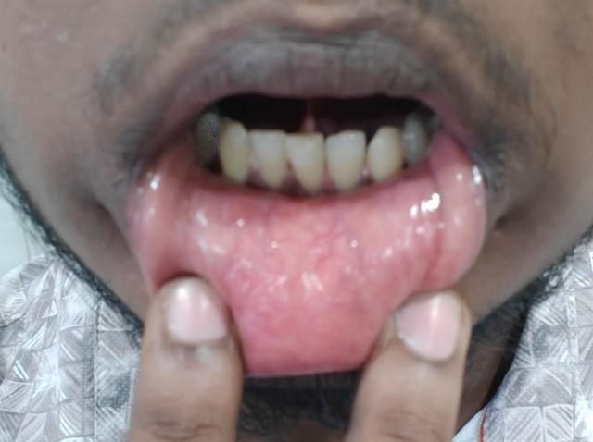

**Fig. 2: Surgical excision**

**Follow up**

For over 30 months, our patient underwent thorough reviews at 3-month intervals. The prognosis was favourable throughout the review, and no recurrence was discovered.

**DISSCUSSION**

A common oral mucosal lesion that may affect the general population is a mucocele. An accumulation of mucus can cause small salivary glands to undergo alterations, which might result in a mucocele. Fluid escaping from ducts or acini to the surrounding tissue is the cause of extravasation mucocele. (8,9) The small salivary glands are frequently home to this kind of mucocele. Saliva may seep into the surrounding submucosal tissue as a result of physical damage. The most frequent aetiology of mucocele is trauma.

Mucoceles are frequently caused by biting the lip or buccal mucosa. Lip- sucking, intubation damage, and chronic inflammation from smoking or tobacco usage are other factors. Usually appearing as dome-shaped mucosal swellings, mucoceles can vary in size from a few millimetres to several centimetres. gives the swelling a bluish, transparent tint, while darker mucoceles might be typical. It is characterised by fluctuations. Mucocele is mostly commonly seen in children and young adults. Perhaps because young people are more likely to experience trauma that induces mucin spillage. Location: The mucocele most frequently occurs on the lower lip. The floor of the mouth (ranulas: 5.8%) is a less frequent location; not a single example was identified from the upper lip. Salivary gland tumors, on the other hand, are quite uncommon in the lower lip but relatively uncommon in the upper lip. An oral mucocele, a type of mucous cyst, is usually diagnosed through a physical examination of the mouth, where its appearance can be quite characteristic. If the diagnosis is unclear or if the mucocele is unusual, further tests like ultrasound or biopsy might be needed.

Oral mucocele must be distinguished from conditions such as” lipoma, oral hemangioma, oral lymphangioma, pyogenic granuloma, and benign or malignant salivary gland neoplasms”. The superficial mucoceles can be mistaken for bullous lichen planus, cicatricial pemphigoid, etc. [5,12]

Treatment Options:

Observation: Many mucoceles resolve spontaneously within a few weeks or months. Laser Ablation: A laser is used to vaporise the cyst tissue. Cryotherapy: Surgery with cryoprobe is also helpful in managing the mucocele(3). Extreme cold is applied to freeze and destroy the mucocele. Intralesional Corticosteroids: Injections of steroids are used to reduce inflammation and shrink the cyst. Micromarsupialization: A small opening is created in the cyst, allowing it to drain. Other Methods: Electrosurgery and topical steroids are also used. (12)

When to Seek Treatment:

If the mucocele persists beyond a few weeks or months.

If the mucocele becomes painful or significantly enlarged. If you suspect an infection.

**CONCLUSION**

The most prevalent benign lesion, mucocele, is self-limiting and is initially diagnosed based on clinical signs before being definitively diagnosed by histological analysis. (1) The majority of published research revealed that lesion formation was followed by trauma and recurrent lip-biting. (5) The simplest therapeutic option has been complete surgical excision; partial removal of the lesion has been linked to recurrence. Compared to conventional surgical excision, oral mucocele ablation using a CO2 laser provides more predictable outcomes and fewer problems and recurrences (3). For over 30 months, our patient underwent thorough reviews at 3-month intervals. The prognosis was favourable throughout the review, and no recurrence was discovered.

Consent

As per international standards or university standards, patient(s) written consent has been collected and preserved by the author(s).

Disclaimer (Artificial intelligence)

Option 1:

Author(s) hereby declare that NO generative AI technologies such as Large Language Models (ChatGPT, COPILOT, etc.) and text-to-image generators have been used during the writing or editing of this manuscript.

Option 2:

Author(s) hereby declare that generative AI technologies such as Large Language Models, etc. have been used during the writing or editing of manuscripts. This explanation will include the name, version, model, and source of the generative AI technology and as well as all input prompts provided to the generative AI technology

Details of the AI usage are given below:

1.

2.

3.

**REFERENCE**

1. [Mucocele: A Case Report.](https://pubmed.ncbi.nlm.nih.gov/39346302/)Ghunawat DB, Marathe S, Thete SG, Chakraborty S, Lath H,

Shehare NV, Laddha R.J Pharm Bioallied Sci. 2024 Jul;16(Suppl 3):S2962-S2964. doi: 10.4103/jpbs.jpbs_108_24. Epub 2024 Jun 7.

1. [A rare case of submandibular mucocele extending into the oral cavity: A case](https://pubmed.ncbi.nlm.nih.gov/37716059/) [report.](https://pubmed.ncbi.nlm.nih.gov/37716059/)Houas J, Krimi H, Kermani W, Ghammam M, Bellakhdher M, Abdelkefi M.Int J Surg Case Rep. 2023 Oct;111:108798. doi: 10.1016/j.ijscr.2023.108798. Epub 2023 Sep 7.PMID: 37716059
2. [Laser-Assisted Surgical Management of Oral Mucocele: A Case Report.](https://pubmed.ncbi.nlm.nih.gov/38410325/)Shinde S, Lohe V, Shirbhate U, Mohod S, Solanki D.Cureus. 2024 Jan 26;16(1):e53020. doi: 10.7759/cureus.53020. eCollection 2024 Jan.
3. [Mucocele:](https://pubmed.ncbi.nlm.nih.gov/39346302/) [A Case Report.](https://pubmed.ncbi.nlm.nih.gov/39346302/)Ghunawat DB, Marathe S, Thete SG, Chakraborty S, Lath H, Shehare NV, Laddha R.J Pharm Bioallied Sci. 2024 Jul;16(Suppl 3):S2962-S2964. doi: 10.4103/jpbs.jpbs_108_24. Epub 2024
4. [Intraoral Lipoma: A Case Report.](https://pubmed.ncbi.nlm.nih.gov/37693971/)Ashika BK, Bagchi A, Chawla R, Kumar N, Sowmya K, Shetty RR.J Pharm Bioallied Sci. 2023 Jul;15(Suppl 2):S1338-S1340. doi: 10.4103/jpbs.jpbs_143_23. Epub 2023
5. [Case report of the management of the ranula.](https://pubmed.ncbi.nlm.nih.gov/31966981/)Choi MG.J Korean Assoc Oral Maxillofac Surg.

2019 Dec;45(6):357-363. doi: 10.5125/jkaoms.2019.45.6.357. Epub 2019 Dec 26.PMID:

31966981

7.[[Mucocele o](https://pubmed.ncbi.nlm.nih.gov/32655754/)f [the oral mucous membrane].](https://pubmed.ncbi.nlm.nih.gov/32655754/)Essaket S, Hakkou F, Chbicheb S.Pan Afr Med J. 2020 Apr 29;35:140. doi: 10.11604/pamj.2020.35.140.21079. eCollection 2020.

1. [An unusual occurrence of oral mucocele: A case report and literature review.](https://pubmed.ncbi.nlm.nih.gov/36719085/)

de Lima KL, Silva LR, Vêncio EF, Yamamoto-Silva FP, Silva BSF.Int J Paediatr Dent. 2023 Jul;33(4):418-421. doi: 10.1111/ipd.13057. Epub 2023 Feb 15.PMID: 36719085

1. [Oral mucocele: Review of literature and a case report.](https://pubmed.ncbi.nlm.nih.gov/26538955/)Nallasivam KU, Sudha BR.J Pharm Bioallied Sci. 2015 Aug;7(Suppl 2):S731-3. doi: 10.4103/0975-7406.163516.PMID: 26538955
2. [Mucocele of the tongue: A case report and review of literature.](https://pubmed.ncbi.nlm.nih.gov/34083968/)Nagar SR, Fernandes G, Sinha A, Rajpari KN.J Oral Maxillofac Pathol. 2021 Mar;25(Suppl 1):S37-S41. doi: 10.4103/jomfp.jomfp_396_20. Epub 2021 Mar 19.PMID: 34083968
3. [Nonsurgical Management of Oral Mucocele Occurring on a Rare Site.](https://pubmed.ncbi.nlm.nih.gov/36686989/)Gaikwad TV, Maini AP, Das S, Lokhande S, Patil SK, Sarma A.Contemp Clin Dent. 2022 Oct-Dec;13(4):389-391. doi: 10.4103/ccd.ccd_531_21. Epub 2022 Nov

11.PMID: 36686989

1. [Mucocele of the Lower Li](https://pubmed.ncbi.nlm.nih.gov/39497885/)p [and Its Surgical Management.](https://pubmed.ncbi.nlm.nih.gov/39497885/)Kannan N, Ramalingam K, Ramani P, Krishnan M.Cureus. 2024 Oct 5;16(10):e70874. doi: 10.7759/cureus.70874. eCollection 2024 Oct.PMID: 39497885
2. Miranda, G. G. B., Chaves-Junior, S. D. C., Lopes, M. P., Rocha, T. B. D., Colares, D. F., Ito, F. A., ... & Cunha, J. L. S. (2022). Oral mucoceles: A Brazillian multicenter study of 1,901 Cases. *Brazilian dental journal*, *33*, 81-90.
3. Curvelo, J. A. R., Xavier, B., Elbert, A. C., & Janini, M. E. R. (2021). Unusual Aspects of Oral Mucocele can Jeopardize Clinical Diagnosis: A Case Report. *J Med Case Rep Case Series*, *2*, 14.
4. Cordeiro, J. F. B., Vanolli, R. da S., Oliveira, G. C. de, Souza, B. C. R. de, Schmidt, P. R. C., Conci, R. A., Júnior , E. Álvaro G., Griza, G. L., & Santos, M. B. M. dos. (2025). Multidisciplinary Surgical Management of Coexisting Frontoethmoidal Mucocele and Meningioma: A Case Report. *Journal of Advances in Medicine and Medical Research*, *37*(3), 119–126.