***Case Report***

**Unmasking Atrioventricular Block in Rheumatoid Arthritis: A Case Report of a Rare Extra-Articular Involvement**

**Abstract**

Rheumatoid arthritis is a systemic condition impacting not only joints but also various organs, with potential life-threatening consequences, particularly involving the heart. Pericardial damage is a prevalent cardiovascular manifestation that generally responds well to anti-inflammatory interventions. While atrioventricular block in RA is uncommon, it remains a possibility and poses a threat to vital prognosis in the absence of proper treatment. Despite the rarity of this manifestation, recognising and understanding the mechanisms underlying AVB in RA is crucial for timely diagnosis and appropriate management. The case of a young female patient with a 23-year history of rheumatoid arthritis, experiencing recurrent syncope episodes associated with complete atrioventricular block, was presented. The severity of the condition necessitated the implantation of a dual-chamber pacemaker. It was done 48 hours later, with uncomplicated postoperative monitoring. The patient was discharged after a 4-day hospital stay, with scheduled rhythmology follow-up. In order to address the left external malleolus fracture, orthopaedic treatment in the form of a cast boot was administered for six weeks, accompanied by oral preventive anticoagulation using apixaban (2.5 mg twice daily). It was noted that Pericarditis stands out as the most prevalent cardiovascular manifestation, affecting up to 30 to 50% of patients, depending on the series. This case holds significance due to the rarity of atrioventricular block in rheumatoid arthritis, its complex pathophysiology, and the essential reliance on cardiac stimulation for treatment, as anti-inflammatory interventions show limited efficacy in this particular scenario.

Keywords: syncope, atrioventricular block, rheumatoid arthritis, cardiac pacing

**INTRODUCTION**

Rheumatoid arthritis (RA) is a chronic inflammatory disease whose etiopathogenesis is still poorly understood. In addition to the almost constant joint involvement, it can also affect several organs, some of which are life-threatening, particularly the heart [[1]](javascript:void(0)). Although a number of biomolecular mechanisms have been proposed, the aetiology of RA is not yet fully elucidated, a current hypothesis being that dysregulated citrullination leads to the production of anti-citrullinated protein antibodies. The evolution of RA is fluctuant with episodic exacerbations, and in the absence of optimal treatment, symptoms gradually worsen until the joints are irreversibly damaged and physical and psychological functioning is affected (Radu & Bungau, 2021; Dhengare et al., 2021).

Atrioventricular block (AVB) is a rare extra-articular manifestation of rheumatoid arthritis. AVB in RA is often asymptomatic; the diagnosis is often made incidentally during a routine workup, including an ECG [[2]](javascript:void(0)). Treatment is essentially based on cardiac stimulation, with no interest in anti-inflammatory treatment in this situation [[2]](javascript:void(0)). It can be observed especially in old, erosive and nodular polyarthritis. An incidence of AVB in the range of 1 per 1000 patients followed for severe rheumatoid arthritis (Asmaa et al., 2023). Despite the rarity of this manifestation, recognising and understanding the mechanisms underlying AVB in RA is crucial for timely diagnosis and appropriate management. Several mechanisms can be considered in its pathogenesis. Destructive invasion of the conductive tissue by a rheumatoid nodule could be the main cause of conduction disorders, amyloid infiltration of the connective tissue or rheumatoid vasculitis, which remains rare (Dihi et al., 2022). This case report underscores the importance of heightened clinical awareness, thorough cardiovascular assessment, and collaborative management strategies in mitigating the impact of RA on cardiac function.

**Case Presentation**

A 42-year-old female patient, devoid of modifiable cardiovascular risk factors, presented with a 23-year history of RA managed with Methotrexate and corticosteroids, and a concurrent 2-year history of celiac disease controlled by a gluten-free diet. She was admitted to our department due to recurrent episodes of sudden syncope resulting in a fall and left external malleolus fracture. Clinical examination revealed bradycardia at 35 bpm, finger deformities with a camelback appearance (Figure [*1*](javascript:void(0))), and functional impairment of the left lower limb with inflammatory signs at the external malleolus.

An electrocardiogram (ECG) displayed a complete atrioventricular block with a junctional escape rhythm at 35 cpm (Figure [*2*](javascript:void(0))). Biochemical analyses, including metabolic and infectious work-ups, were unremarkable, and transthoracic echocardiogram showed no cardiac abnormalities such as valvulopathy, myocardial, or pericardial damage. In this case, the AVB was attributed to RA after excluding other potential causes of AVB, notably ischemic, metabolic, and infectious factors.

Emergency temporary pacing lead placement was performed, followed by the subsequent implantation of a double-chamber pacemaker 48 hours later, with uncomplicated postoperative monitoring (Figure [*3*](javascript:void(0))). The patient was discharged after a 4-day hospital stay, with scheduled rhythmology follow-up.

Finally, to address the left external malleolus fracture (Figure [*4*](javascript:void(0))), orthopedic treatment in the form of a cast boot was administered for six weeks, accompanied by oral preventive anticoagulation using apixaban (2.5 mg twice daily).

**Discussion**

RA is a chronic inflammatory disease with an etiopathogenesis that remains poorly understood. Aside from almost constant joint involvement, it can also impact various organs, some of which pose life-threatening risks, notably the heart [[1]](javascript:void(0)). Pericarditis stands out as the most prevalent cardiovascular manifestation, affecting up to 30 to 50% of patients, depending on the series. Generally, it responds well to RA treatment [[3]](javascript:void(0)). Other cardiac conditions like myocarditis, coronary vasculitis, cardiac amyloidosis, valvulopathy, and arrhythmias have been reported in RA, albeit less frequently [[3]](javascript:void(0)).

Atrioventricular and intraventricular conduction disorders are also documented in RA patients. These may involve right or left bundle branch block, hemiblock, or any degree of AVB. While complete AVB is rare, occurring in approximately 1 in 1000 patients, it tends to show a female preponderance [[2,4]](javascript:void(0)), as observed in our case. The duration for the development of AVB varies, potentially extending up to 12 years or more [[4]](javascript:void(0)). In our case, AV block manifested after 23 years of RA evolution. AVB in RA can be complete from the outset, although some cases have reported lower-degree blocks preceding the appearance of high-degree blocks [[2]](javascript:void(0)). In our instance, the AVB was complete from the start.

The pathophysiology of conduction disorders in RA, especially AVB, encompasses several mechanisms: damage to the conduction system due to inflammatory granuloma and subsequent fibrosis [[5]](javascript:void(0)), extension of the inflammatory process from the base of the aorta or mitral valves to the conduction pathways [[2,6]](javascript:void(0)), secondary AA amyloidosis [[2]](javascript:void(0)), hemorrhage in a rheumatoid nodule [[4,5,7]](javascript:void(0)), coronary arteritis causing ischemia of the conduction tissue [[5]](javascript:void(0)), myocarditis with focal damage to the conduction tissue [[5]](javascript:void(0)), and early coronary artery disease due to the acceleration of the atherosclerotic process by RA [[8]](javascript:void(0)). We consider the involvement of an inflammatory granuloma with subsequent fibrosis as the likely aetiology of AVB in our patient. However, confirmation through an endomyocardial biopsy was not performed due to the high risk of intra- and postoperative complications compared to the diagnostic benefits.

AVB in RA is often asymptomatic, with the diagnosis typically incidental during routine workups, including an ECG. However, many cases in the literature describe syncopal or symptomatic AVB [[2]](javascript:void(0)). Our patient experienced several episodes of syncope, leading to the placement of an emergency temporary pacing lead.

The treatment of AVB in RA relies on permanent cardiac pacing, with indications similar to those for AV block without RA [[2]](javascript:void(0)). Anti-inflammatory treatment has no role in this case [[5]](javascript:void(0)). Our patient underwent double-chamber pacemaker implantation 48 hours after the installation of the temporary pacing lead, with a straightforward postoperative follow-up.

**Conclusion**

The AVB in RA is rare but remains possible; its physiopathology is complex, involving several mechanisms, and it is often asymptomatic; for this reason, an ECG should be performed systematically and regularly in all patients with systemic diseases, particularly those affecting the cardiovascular system. Treatment is based on permanent cardiac pacing; there is no benefit of anti-inflammatory treatment on the evolution of atrioventricular block in this situation.

**Disclaimer**

This paper is an extended version of a preprint document of the same author.

The preprint document is available in this link: <https://www.researchsquare.com/article/rs-5645413/v1>

[As per journal policy, preprint /repository article can be published as a journal article, provided it is not published in any other journal]

**Abbreviation:**

**RA**: Rheumatoid arthritis

**AVB**: Atrioventricular block

**ECG**: Electrocardiogram

**Consent**

Written informed consent was obtained from the patient for publication of this case report and accompanying images.

**Ethical Approval:**

As per international standards or university standards written ethical approval has been collected and preserved by the author(s).

Disclaimer (Artificial intelligence)

Option 1:

Author(s) hereby declare that NO generative AI technologies such as Large Language Models (ChatGPT, COPILOT, etc.) and text-to-image generators have been used during the writing or editing of this manuscript.

Option 2:

Author(s) hereby declare that generative AI technologies such as Large Language Models, etc. have been used during the writing or editing of manuscripts. This explanation will include the name, version, model, and source of the generative AI technology and as well as all input prompts provided to the generative AI technology

Details of the AI usage are given below:

1.

2.

3.

**References**

1. Girard, C., Haroutunian, G., Guerne, P. (2019: [Manifestations cardiovasculaires et pulmonaires de la polyarthrite rhumatoïde](https://www.revmed.ch/revue-medicale-suisse/2019/revue-medicale-suisse-641/manifestations-cardiovasculaires-et-pulmonaires-de-la-polyarthrite-rhumatoide). Rev Med Suisse. 5:542-548.
2. Pandit, Amar & Londhey, Vikram & Chawla, Bharati & Khedkar, Umesh & Sundaram, Sridhar & Asgaonkar, D. (2013: [Complete heart block in a case of rheumatoid arthritis. The Journal of the Association of Physicians of India](https://pubmed.ncbi.nlm.nih.gov/24974502/). 61-836.
3. Harris M. (1970: [Rheumatoid heart disease with complete heart block](https://www.researchgate.net/profile/Sridhar-Sundaram/publication/263512690_Complete_heart_block_in_a_case_of_rheumatoid_arthritis/links/5b70686892851ca65056d321/Complete-heart-block-in-a-case-of-rheumatoid-arthritis.pdf). Journal of clinical pathology. 23:623-626.
4. Seferovic PM, Ristic AD, Maksimovic R, Simeunovic DS: [Ristic GG, Radovanovic G, et al.: Rheumatology, suppl. Heart Involvement in Autoimmune Rheumatic Diseases 45](https://doi.org/10.1093/rheumatology/kel315). 4:39-42.
5. Ahern M: [Complete heart block in rheumatoid arthritis.](https://doi.org/10.1136%2Fard.42.4.389). Annals of the rheumatic diseases vol. 42,4. ::389-97.
6. [J David-Chaussé(1976), P Blanchot, J Warin, J Dehais, R Bullier, JM Texier. Atrioventricular blocks and rheumatoid arthritis; Revue du rhumatisme et des maladies osteoarticulaires](https://pubmed.ncbi.nlm.nih.gov/1265414/). 43:177-183.
7. Buleu F: [Heart Involvement in Inflammatory Rheumatic Diseases: A Systematic Literature Review](https://doi.org/10.3390/medicina55060249). Medicina (Kaunas. 55:249.
8. Kubba S, Bali HK, Bahl A, Nand Kumar S: [Recurrent syncopal attacks in a lady with rheumatoid arthritis](https://pubmed.ncbi.nlm.nih.gov/15623976/). J Postgrad Med. 50:291-2.
9. Radu, A.-F., & Bungau, S. G. (2021). Management of Rheumatoid Arthritis: An Overview. *Cells*, *10*(11), 2857.
10. Asmaa, B., Marouane, B., Badr, E., Hiba, A. Z., Rachida, P. A., & Jamila, P. Z. 2023*.* Complicated Atrioventricular Block Rheumatoid Arthritis Complete and Intracardiac Mass. *IJCMCR; 35 (2)*, *5*.
11. Dihi, B., Eljazouli, H., Bouzerda, A., & Khatouri, A. (2022). A Complete Atrioventricular Block Revealing Rheumatoid Arthritis: A Case Report. *SAS J Med*, *6*, 430-432.
12. Dhengare, A., Ankar, R., Sharma, R., Sakharkar, S., Raut, A., & Wavare, S. (2021). Case Report On: Complete Heart Block. *Journal of Pharmaceutical Research International*, *33*(59A), 82–87.

[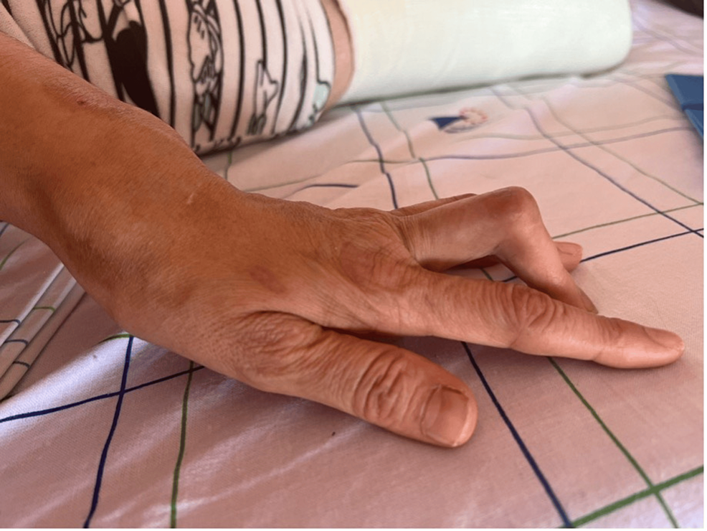](https://assets.cureus.com/uploads/figure/file/902110/lightbox_9db57890bdff11eeb97acb39812cdac1-RA1.png)

**Figure 1: Distortion of the fingers presenting a camelback-like appearance**

[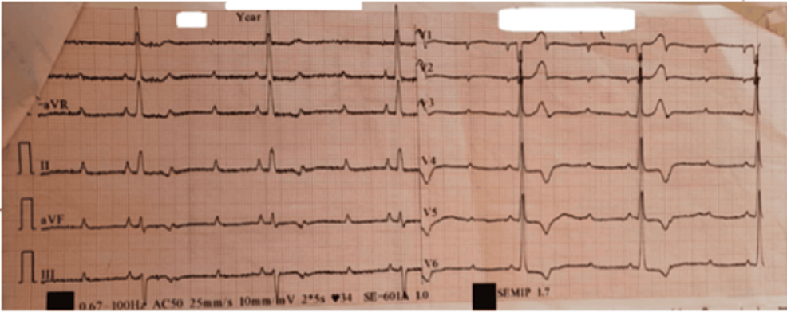](https://assets.cureus.com/uploads/figure/file/902111/lightbox_eddbb150beda11eeb60651dce5345404-RA2-final.png)

**Figure 2: Electrocardiogram showing complete AV block**

[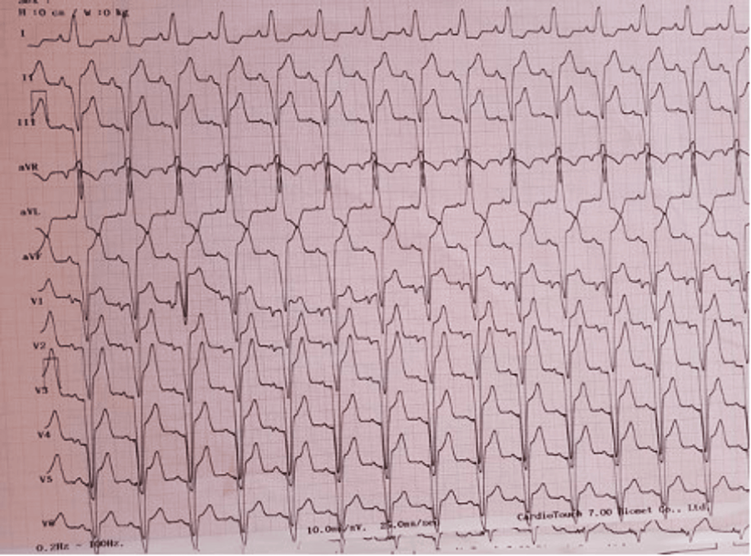](https://assets.cureus.com/uploads/figure/file/902112/lightbox_3fe324b0bedb11eeb984974db61d8291-RA3.png)

**Figure 3: Electrocardiogram after cardiac pacing**

[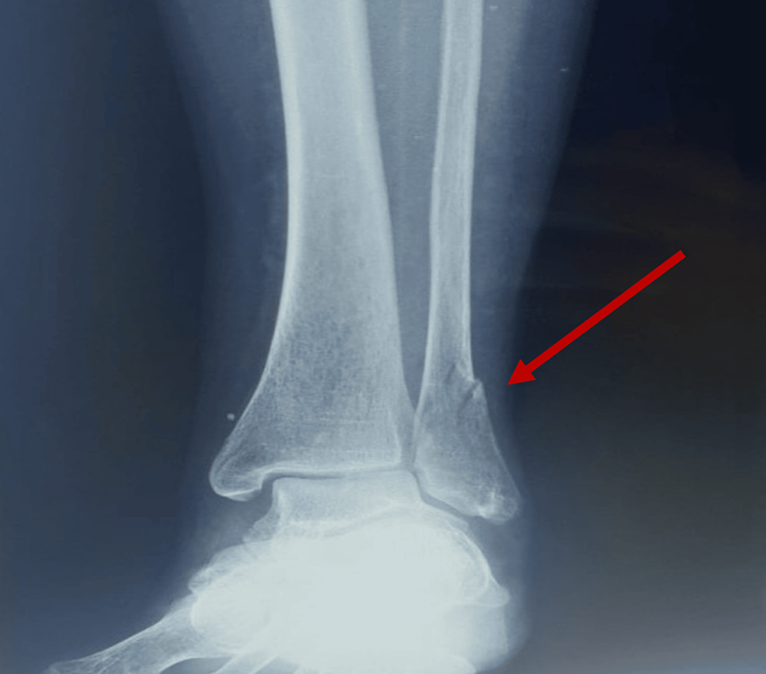](https://assets.cureus.com/uploads/figure/file/902157/lightbox_a52c6750bedb11ee8f141570a3033816-Capture-d-ecran-2024-01-29-a-20.21.40.png)

**Figure 4: : X-ray showing a fracture of the left lateral malleolus (red arrow)**