**Exploring Underrated Cardiotoxicity and Neurovascular Implications in a 13-Month-Old Infant Following Accidental MDMA Ingestion: A Case Report and 3-Month Follow-Up**

**Abstract**

Background: MDMA (3,4-methylenedioxymethamphetamine) intoxication in children is rare but potentially life-threatening. While neurotoxicity is better documented, cardiotoxicity in infants remains underreported.

Case: Seizures in infants can have various causes, including febrile episodes, metabolic disturbances, and toxic exposures. A 13-month-old male infant presented with generalized tonic-clonic seizures and altered consciousness following confirmed accidental ingestion of MDMA. On admission, he displayed persistent sinus tachycardia (170 bpm), bilateral mydriasis, and unresponsiveness. Laboratory workup showed elevated troponin (308 ng/L), increased CPK, and normal renal function. Brain CT revealed left-sided cortico-subcortical atrophy with hypodensities. Echocardiography demonstrated preserved systolic function (EF 65%). Toxicological screening confirmed MDMA exposure. Intensive care support, including sedation, intubation, and cardiac monitoring, led to full recovery.

Workup Enhancement: In addition to routine investigations, we conducted a 12-lead ECG, cardiac biomarkers (NT-proBNP, lactate), and echocardiographic strain analysis. An EEG was performed post-stabilization. Follow-up echocardiography at 3 months confirmed preserved systolic and diastolic function. Neurodevelopmental evaluation at 3 months was normal.

Discussion: MDMA causes sympathetic hyperactivity via serotonin and catecholamine release, inducing cardiovascular strain. In infants, enzymatic immaturity and low body mass exacerbate toxic effects. Troponin elevation in this context likely reflects catecholaminergic myocardial stress rather than infarction. This case highlights the value of extended cardiologic workup, including strain imaging and longitudinal follow-up.

Conclusion: MDMA intoxication in infants may lead to significant though reversible cardiac injury. Early recognition, intensive management, and comprehensive cardiac assessment are essential. This case supports the integration of strain echocardiography into pediatric toxicology protocols.

Keywords: MDMA, infant, cardiotoxicity, troponin, echocardiography, strain imaging, pediatric intensive care, neurotoxicity,

---

**1. Introduction**

3,4-Methylenedioxymethamphetamine (MDMA), commonly known as ecstasy, is a synthetic amphetamine derivative that acts as a potent central nervous system stimulant. It exerts its effects primarily through the release and reuptake inhibition of serotonin, dopamine, and norepinephrine, leading to heightened mood, increased energy, and sensory perception alterations. While its recreational use is most often associated with adolescents and young adults, the risk of accidental pediatric exposure is growing due to its availability in household settings. The type of toxic substances ingested varies geographically and by physical form (tablet, powder, liquid), making household context crucial in assessing pediatric exposures. Previous case reports highlight the diversity of substances involved and the dangers of unintentional ingestion [4].

From a pharmacodynamic perspective, MDMA induces a hyperadrenergic state [1,2,3] that can lead to a range of acute toxic effects, including hyperthermia, seizures, hyponatremia, and rhabdomyolysis. Neurotoxicity is well documented in both animal models and clinical reports, with evidence pointing toward serotonin-mediated excitotoxicity and oxidative stress. However, its cardiovascular implications, especially in infants, are less thoroughly characterized [4] in the literature.

MDMA-induced cardiotoxicity is believed to result from sustained sympathetic stimulation, with increased circulating catecholamines leading to tachycardia, hypertension, vasospasm, and direct myocardial injury. In severe cases, this may result in arrhythmias, myocardial infarction, or sudden cardiac death. In pediatric patients, and particularly in infants, immature hepatic metabolism, lower enzyme activity (especially cytochrome P450 isoenzymes), and a reduced volume of distribution compound the effects of MDMA, potentially magnifying its toxic profile.

To date, few studies have focused on the cardiologic consequences of MDMA ingestion in children under the age of two. Furthermore, conventional evaluations such as ejection fraction may fail to detect subtle myocardial dysfunction. Emerging tools like speckle-tracking echocardiography and global longitudinal strain (GLS) analysis offer a more sensitive assessment of subclinical myocardial injury. These advanced imaging techniques, combined with serial biomarker monitoring, provide a more nuanced understanding of cardiac involvement in pediatric MDMA intoxication.

In this report, we present a case of accidental MDMA ingestion in a 13-month-old infant, with a focus on the acute cardiac manifestations, diagnostic workup, and 3-month follow-up. Our objective is to underscore the importance of incorporating comprehensive cardiac assessment into the management protocol for young children exposed to sympathomimetic agents.

**2. Case Presentation**

A 13-month-old boy with a history of febrile seizures was admitted to the pediatric emergency department for status epilepticus. According to family members and police reports, MDMA tablets were discovered at the site of ingestion. On arrival, the patient was unconscious, febrile, and in generalized tonic-clonic seizures.

A brain CT scan showed left-sided cortico-subcortical atrophy with hypodense regions, consistent with seizure-related changes. Echocardiography showed a preserved ejection fraction (65%), no dilation, no hypertrophy

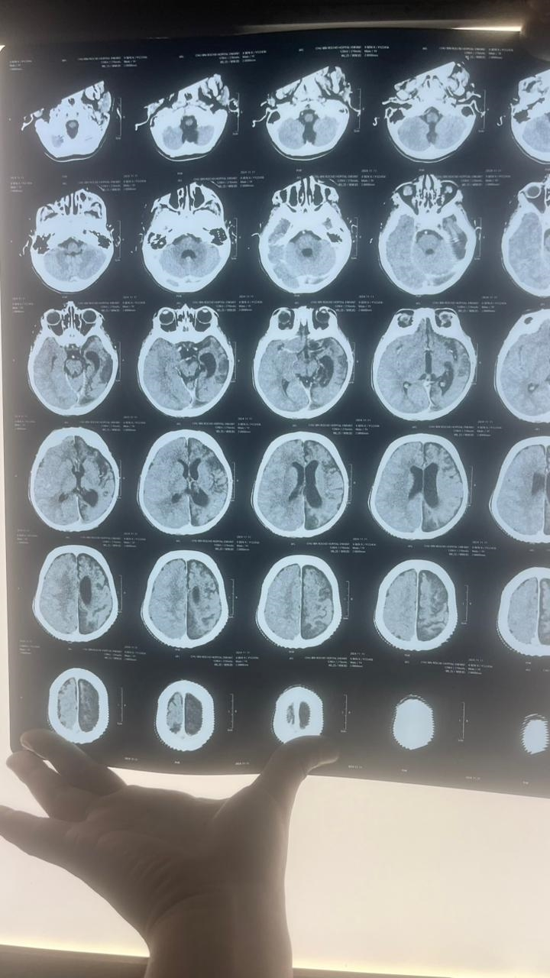

**Figure 1. Non-contrast Brain CT Showing Left Cortico-Subcortical Atrophy and Hypodense Areas Suggestive of Seizure-Related Injury**

Initial vitals showed sinus tachycardia (170 bpm), blood pressure of 100/80 mmHg, and oxygen saturation of 98%. The patient exhibited bilateral mydriasis and muscle rigidity. Immediate intubation and sedation were initiated, followed by gastric decontamination. Toxicology screening confirmed the presence of MDMA in urine and blood.

Laboratory findings included elevated troponin (308 ng/L), CPK (206 then 301 U/L), and LDH (260 U/L). CRP and renal function were normal. Brain CT revealed left cortico-subcortical atrophy and hypodensities, likely postictal.

|  |  |  |
| --- | --- | --- |
| **Parameter** | **Day 1** | **Day 2** |
| Troponin (ng/L) | 308 | 13.5 |
| CPK (U/L) | 206 | 301 |
| LDH (U/L) | 260 | 259 |
| CRP (mg/L) | 0.4 | 0.4 |
| Creatinine (mg/dL) | 0,23 | 0,26 |

**Table 1. Serial Biological Parameters Following MDMA Ingestion in a 13-Month-Old Infant**

Cardiac workup included a 12-lead ECG showing sinus tachycardia with no ischemic changes. Echocardiography confirmed preserved ejection fraction (65%), no chamber dilation or wall motion abnormalities. Longitudinal strain analysis yielded a global longitudinal strain (GLS) of -18.2%, within normal limits.

NT-proBNP was mildly elevated (312 pg/mL), and lactate was 2.3 mmol/L. EEG post-stabilization showed generalized slowing but no epileptiform discharges.

**3. Management and Evolution**

Upon admission to the pediatric intensive care unit (PICU), the patient was immediately stabilized with airway protection, sedation, and seizure control. Intravenous midazolam was administered as a continuous infusion following initial boluses to achieve rapid cessation of seizure activity. Endotracheal intubation was performed due to persistent unresponsiveness, ongoing tonic-clonic seizures, and risk of aspiration. Mechanical ventilation was initiated with supportive parameters, and normothermia was maintained through external cooling, given the risk of MDMA-induced hyperthermia.

Initial laboratory investigations guided supportive therapy. The elevated troponin level (308 ng/L) raised concern for myocardial injury; hence, cardiac telemetry and serial electrocardiograms were performed. Although no arrhythmias were detected, sinus tachycardia persisted during the first 36 hours. Electrolyte levels, renal function, liver enzymes, and inflammatory markers were monitored closely and remained within acceptable ranges, excluding other systemic causes of hemodynamic instability.

Gastric decontamination was attempted via orogastric lavage within two hours of presentation, given the reported recent ingestion. Activated charcoal was not administered due to altered consciousness and aspiration risk. The patient’s urine output remained adequate, and no signs of acute kidney injury or syndrome of inappropriate antidiuretic hormone secretion (SIADH) were observed.

A comprehensive cardiac workup included a 12-lead ECG (revealing isolated sinus tachycardia), transthoracic echocardiography (showing preserved left ventricular ejection fraction of 65%), and speckle-tracking analysis. Global longitudinal strain (GLS) was within normal limits for age (-18.2%), with no regional wall motion abnormalities or chamber enlargement.

Serial biomarker follow-up showed a significant decline in troponin levels by day 2 (13.5 ng/L), and normalization of CPK and LDH levels over 48–72 hours. Neurologically, the child regained consciousness within 24 hours post-extubation and showed progressive improvement in tone, responsiveness, and feeding behavior. EEG performed 48 hours after stabilization revealed generalized slowing without epileptiform activity, consistent with postictal encephalopathy.

The patient was discharged on day 6 after multidisciplinary evaluation, including pediatric cardiology and neurology consultations. No pharmacologic cardiac therapy was initiated, and no further seizures occurred during hospitalization. Follow-up at 3 months included repeat echocardiography, which confirmed stable cardiac function and normal GLS. Neurodevelopmental evaluation using the Bayley Scales of Infant Development indicated normal age-appropriate motor and cognitive function.

This favorable outcome reflects the importance of prompt intensive care management, early cardiac assessment using advanced imaging, and structured neurologic monitoring in pediatric toxicological emergencies involving sympathomimetic agents.

**4. Discussion**

MDMA intoxication induces a complex and multisystemic response, primarily mediated by acute surges in serotonin, norepinephrine, and dopamine. In pediatric populations, and particularly in infants, the toxicodynamic and toxicokinetic profiles are amplified due to physiological immaturity, including underdeveloped hepatic cytochrome P450 metabolism (notably CYP2D6), decreased renal clearance, and a lower volume of distribution per unit body weight [1].

Neurologically, MDMA can lead to seizures, agitation, altered consciousness, and in severe cases, serotonin syndrome [2]. However, cardiovascular involvement remains underreported in pediatric literature despite its potentially life-threatening implications. Our case illustrates that myocardial involvement may occur even in the absence of overt structural cardiac dysfunction. The transient elevation in troponin likely reflects catecholaminergic myocardial stress—often referred to as “stress cardiomyopathy”—rather than ischemic necrosis [3,4].

Sympathomimetic toxicity is known to provoke direct myocardial injury through mechanisms including increased oxygen demand, coronary vasospasm, calcium overload, and oxidative stress [5]. In animal studies, MDMA administration has been shown to disrupt myocardial mitochondrial integrity [3], leading to impaired contractility [6]. Although ejection fraction in this infant remained preserved, the use of global longitudinal strain (GLS) analysis offered valuable reassurance, identifying no subclinical myocardial dysfunction typically missed by conventional echocardiography [7].

Strain imaging has emerged as an essential non-invasive tool for detecting early myocardial injury, particularly in the context of toxic exposure or myocarditis. The GLS value of –18.2% observed in our patient falls within the pediatric normal range (–17% to –22%), supporting the reversibility of cardiac insult [8]. The mild elevation of NT-proBNP was consistent with transient myocardial stress and normalized on follow-up.

From a toxicological standpoint, this case reinforces the necessity of including MDMA and its metabolites in routine toxicology screens in children presenting with unexplained seizures, hyperthermia, or autonomic dysfunction. Due to its rapid absorption and wide distribution, MDMA may be undetected without targeted screening, especially when history is unclear. Notably, delayed recognition and treatment have been associated with poor outcomes, including severe seizures and prolonged encephalopathy in toddlers [9,10]. Prior reports highlight that delayed recognition can significantly worsen outcomes [9,10].

The normalization of cardiac biomarkers, echocardiographic parameters, and neurologic function at 3-month follow-up aligns with previous case reports and experimental data indicating that MDMA-related organ injury is largely reversible if addressed early [8]. However, severe outcomes including fulminant cardiomyopathy and fatal arrhythmias have been documented, even in older pediatric patients and adolescents, demonstrating that age does not confer protection [8].

Evaluation of seizures in infants should include infectious, metabolic, structural, and toxicologic causes. In this case, MDMA ingestion was confirmed early, but the differential diagnosis initially included febrile seizures, encephalitis, and metabolic derangements. Early comprehensive workup remains essential in such acute settings.

While our patient demonstrated normal neurodevelopment on the Bayley Scales at 3 months, the long-term effects of MDMA exposure during critical neurodevelopmental windows remain unclear. Even brief exposures to serotonergic agents can potentially have delayed neurocognitive repercussions [2].

Ultimately, this case illustrates the value of a multidisciplinary approach encompassing pediatric intensive care, cardiology, and neurology. It also underscores the vital role of public health efforts in preventing pediatric access to psychoactive substances through community education and household safety initiatives.

**5. Conclusion**

This report underscores the potential for reversible cardiotoxicity in pediatric MDMA intoxication. A structured cardiologic approach—including strain echocardiography and serial biomarker monitoring—may enhance risk stratification and guide both acute and long-term management. The use of advanced imaging modalities such as global longitudinal strain can detect subclinical myocardial injury even when conventional echocardiography appears normal.

Multidisciplinary collaboration involving pediatric intensive care, cardiology, and neurology is critical for optimal outcomes. Additionally, public health initiatives and caregiver education remain essential to prevent accidental exposure to illicit substances in vulnerable populations.

Further reporting of similar cases and prospective studies are warranted to better define standardized protocols for cardiovascular surveillance and neurodevelopmental follow-up in pediatric patients exposed to MDMA.

Ethical Approval:

As per international standards or university standards written ethical approval has been collected and preserved by the author(s).

Consent

As per international standards, parental written consent has been collected and preserved by the author(s).

Disclaimer (Artificial intelligence)

Option 1:

Author(s) hereby declare that NO generative AI technologies such as Large Language Models (ChatGPT, COPILOT, etc.) and text-to-image generators have been used during the writing or editing of this manuscript.

Option 2:

Author(s) hereby declare that generative AI technologies such as Large Language Models, etc. have been used during the writing or editing of manuscripts. This explanation will include the name, version, model, and source of the generative AI technology and as well as all input prompts provided to the generative AI technology

Details of the AI usage are given below:

1.

2.

3.

# References

1. Gowing R, Ali R, White JM. MDMA Toxicity. In: StatPearls [Internet]. Treasure Island (FL): StatPearls Publishing; 2023. Available from: https://www.ncbi.nlm.nih.gov/books/NBK538482/

2. Henry JA, Jeffreys KJ, Dawling S. Toxicity and deaths from 3,4-methylenedioxymethamphetamine ('ecstasy'). Br J Anaesth. 2006;96(6):678–85. Available from: https://academic.oup.com/bja/article/96/6/678/326917

3. Capela, J. P., & Carvalho, F. D. (2022). A review on the mitochondrial toxicity of “ecstasy”(3, 4-methylenedioxymethamphetamine, MDMA). Current Research in Toxicology, 3, 100075.

4. Chang YJ, Lai MW, Kong MS, Chao HC. Accidental ingestion of Ecstasy in a toddler. Pediatr Emerg Care. 2006;22(4):254–6. Available from: https://pubmed.ncbi.nlm.nih.gov/16607453/

5. Lemoine C, Bréhin C, Micheau P, et al. An unusual route of non-intentional intoxication by ecstasy in a toddler. Arch Pediatr. 2023;30(3):234–6. Available from: https://pubmed.ncbi.nlm.nih.gov/37061359/

6. Perrine, S. A., Michaels, M. S., Ghoddoussi, F., Hyde, E. M., Tancer, M. E., & Galloway, M. P. (2009). Cardiac effects of MDMA on the metabolic profile determined with 1H‐magnetic resonance spectroscopy in the rat. NMR in Biomedicine: An International Journal Devoted to the Development and Application of Magnetic Resonance In vivo, 22(4), 419-425.

7. Turillazzi, E., Riezzo, I., Neri, M., Bello, S., & Fineschi, V. (2010). MDMA toxicity and pathological consequences: a review about experimental data and autopsy findings. Current pharmaceutical biotechnology, 11(5), 500-509.

8. Hall, A. P., & Henry, J. A. (2006). Acute toxic effects of ‘Ecstasy’(MDMA) and related compounds: overview of pathophysiology and clinical management. BJA: British Journal of Anaesthesia, 96(6), 678-685.

9. Hahn IH, Hoffman RS, Goldfrank LR. MDMA toxicity. In: Goldfrank’s Toxicologic Emergencies. 11th ed. New York: McGraw Hill; 2019.

10. Huntjens DW, Weersink EPS, Hilarius DL, Ran NC, Franssen EJF. Severe epileptic seizures after accidental MDMA exposure in a 14-month-old child. Clin Toxicol (Phila). 2022;60(4):389–392.