**Ultrasound Discovery of a Myocardial Cleft : Case Report**

**Abstract**

We report the case of a 54-year-old patient with poorly controlled hypertension who was admitted for the management of exertional dyspnea due to severe mitral regurgitation caused by restriction of the posterior valve. The TTE has objectified a cleft in the inferior myocardial wall. Myocardial clefts are common in the general population but are often underdiagnosed. Appropriate echocardiographic views can facilitate their identification and delineation. Most studies consider myocardial clefts to be benign anatomical variants. It is essential to clarify their clinical relevance in order to appropriately stratify additional tests and limit unnecessary invasive interventions.

**Introduction**

Myocardial clefts, also known as myocardial fissures, are defined as invaginations that penetrate more than 50% of the thickness of the adjacent myocardium, typically oriented perpendicular to the longitudinal axis of the left ventricle. These clefts tend to narrow or become obliterated during systole without causing local hypokinesia or dyskinesia. They can be observed in healthy individuals, as well as in patients with hypertrophic or hypertensive cardiomyopathy. Initially described in post-mortem studies of patients with hypertrophic cardiomyopathy (HCM), the interpretation of imaging modalities such as angioventriculography or echocardiography can be challenging due to the presence of clefts in the left ventricular myocardium. **This often leads to additional diagnostic tests, such cardiac magnetic resonance imaging (CMR) to clarify their origin. Some earlier studies have suggested that myocardial clefts may also serve as markers for carriers of HCM mutations in the absence of left ventricular hypertrophy.[1]**

**Case Report**

We present the case of a 54-year-old patient, with a history of poorly controlled hypertension, admitted for the evaluation of exertional dyspnea. Echocardiography revealed severe mitral regurgitation due to restriction of the posterior valve, along with diffuse concentric left ventricular hypertrophy identified on both electrocardiographic and echocardiographic assessment. The left ventricular ejection fraction was 57%, with a reduced global longitudinal strain of -11%. A myocardial cleft appearing as a fissure, was identified in the inferior myocardial wall, penetrating more than 50% of the wall thickness and demonstrating near-complete obliteration during systole. Laboratory evaluation indicated relative renal insufficiency secondary to hypertensive nephropathy.

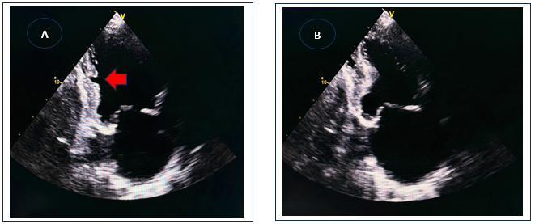

**Figure 1** : PLAX TEE views with a diastolic (A) and a systolic frame (B). In diastole (A), a crypt is well identified in the inferior wall extending for more than 50% of the wall thickness. The crypt is not evident in systole (B).

septum (arrow), extending for more than 50% of septal thickness. The crypt is not evident in systole (B).

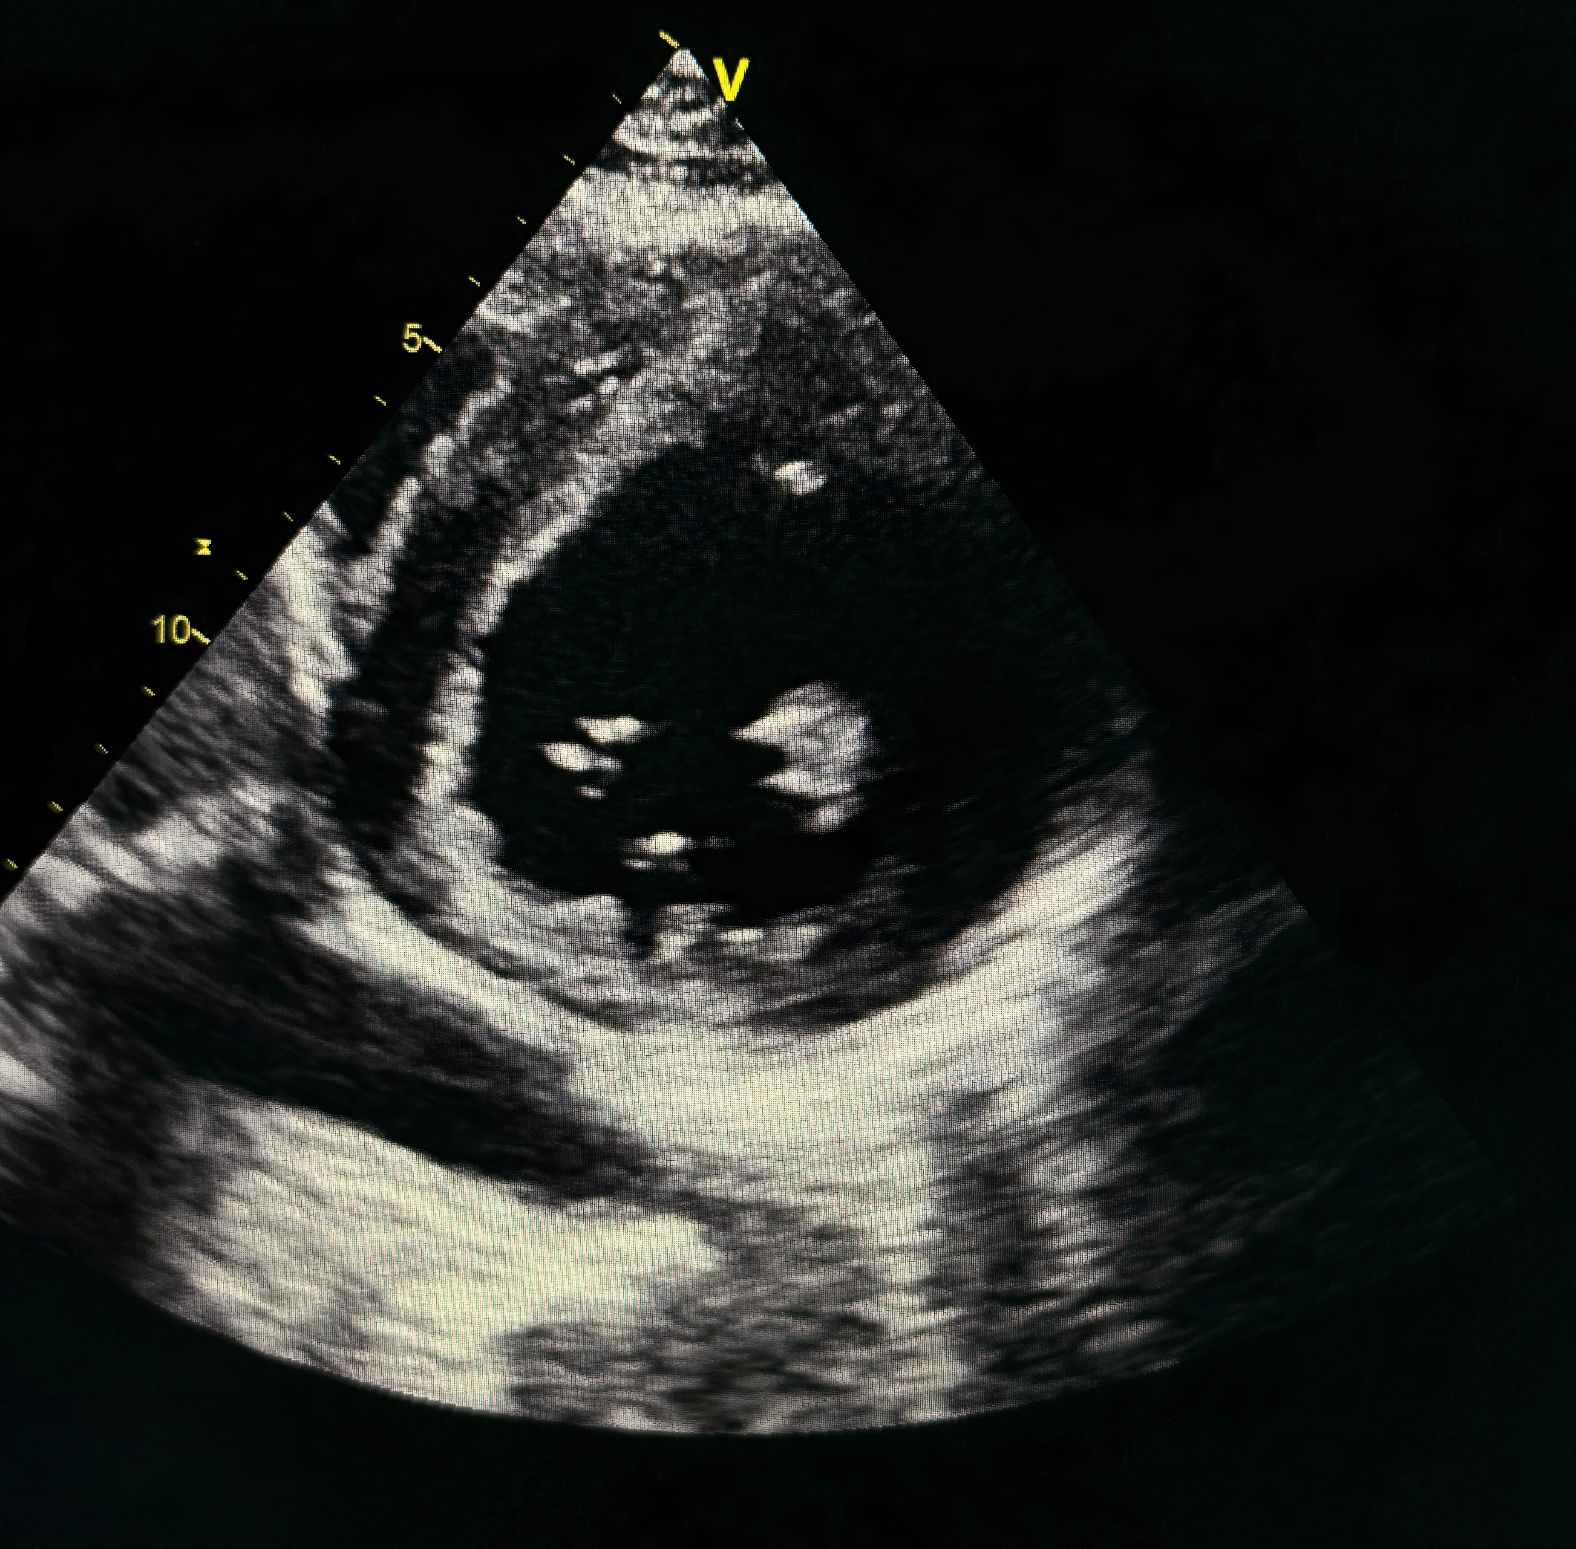

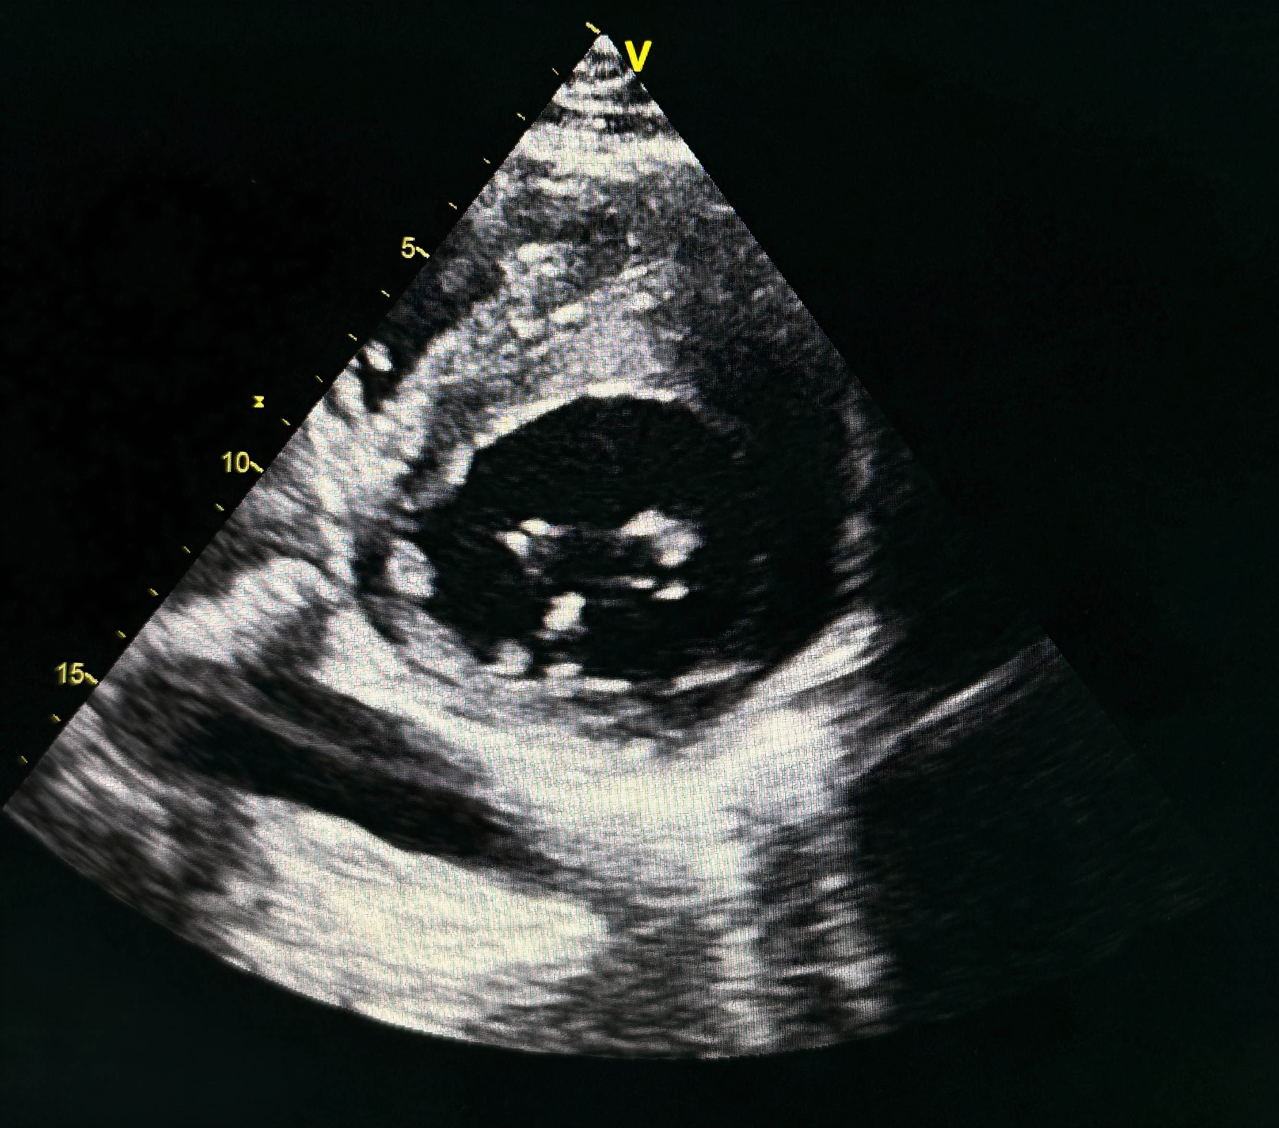

**Figure 2** : PSAX TEE views with a diastolic (A) and a systolic frame (B). In diastole (A), a crypt is well identified in the inferior wall (arrow). The crypt is not evident in systole (B).

nferior wall (arrow). The crypt is not evident in systole (B).

**Discussion**

Our report is based on a review of the literature regarding the significance and incidence of myocardial cleft— a diagnosis that remains relatively rare and underrecognized in clinical practice— and their impact on patient management, particularly regarding diagnostic and therapeutic decision-making. The central question is whether the presence of myocardial clefts is inherently pathological or represents a normal anatomical variant. This issue has generated considerable debate in the literature, with some studies viewing clefts as benign variants and others suggesting they may be early subclinical markers of myocardial hypertrophy, warranting genetic testing for HCM even in the absence of ventricular hypertrophy.

Recent systematic reviews emphasize that while echocardiography remains the first-line tool for identifying myocardial clefts, its sensitivity is limited, especially for small or atypically located clefts. Advanced imaging modalities such as cardiac magnetic resonance (CMR) and computed tomography (CT) provide superior spatial resolution and tissue characterization, allowing for more accurate differentiation between clefts, recesses, and other myocardial anomalies. The combined use of these modalities is now considered essential for definitive diagnosis and risk stratification in patients with suspected myocardial invaginations**[2]**

Most authors describe clefts or fissures, predominantly located in the inferoseptal wall, that do not extend beyond the epicardium.[3] Some studies have reported an association between ventricular clefts and genetic mutations related to HCM, even in patients without left ventricular hypertrophy. For example, German et al. found ventricular clefts in 81% of patients carrying HCM-associated genetic mutations. Such findings may have clinical utility, as identifying these anomalies could serve as a screening tool for familial HCM. However, there is currently no definitive evidence linking clefts to pathological conditions, as larger studies, such as that by Johansson et al., have found clefts in 8% of healthy volunteers.  A 2021 study described a series of patients in whom myocardial clefts were identified using two-dimensional echocardiography. The authors found that these clefts, which appeared in various segments of the left ventricle and septum, were generally incidental findings without significant clinical implications, particularly regarding preclinical hypertrophic cardiomyopathy.[4]

Two distinct locations have been described: the basal inferior segment, observed only in healthy volunteers, and the septal region, seen in both healthy volunteers and patients referred for cardiac MRI for other indications. The significance of these findings lies in the fact that cardiac MRI can detect myocardial clefts in over 8% of healthy individuals, a finding with no pathological significance but important for avoiding misdiagnosis, such as confusing clefts with left ventricular non-compaction.

Although most studies support the benign nature of myocardial clefts, recent case series have reported their incidental detection in patients who experienced sudden cardiac arrest.[5]

Some studies have emphasized the importance of distinguishing clefts from other anatomical anomalies of the left ventricle, such as pseudoaneurysms, true aneurysms, and diverticula, as these entities differ in their anatomical and histological features and prognostic implications,[6] **particularly in the presence of multiple clefts, which may mimic the trabeculations seen in left ventricular non-compaction.[7]**

In a study of patients with HCM, 39% had two or more clefts, and 28% had three or more, whereas normal subjects typically had only one cleft, and patients with hypertension or aortic stenosis had one or two. Only HCM patients had three or more clefts.[8]

In our case, there is no evidence that the presence of a single ventricular cleft contributed to our patient's clinical presentation, especially since an alternative etiology was identified.

The patient exhibited features of hypertensive heart disease and severe mitral regurgitation which explained his dyspnea. He underwent successful mechanical valve replacement surgery with good postoperative outcomes and optimization of antihypertensive therapy.

Given the sometimes conflicting findings in the literature —where clefts are described as both distinctive markers of HCM and as benign variants—their interpretation remains uncertain. Larger prospective studies are needed to determine the true prevalence and clinical significance of myocardial clefts in healthy populations.

Multiple clefts may represent a pre-phenotypic marker of HCM, while single incidental clefts in otherwise normal patients likely represent a normal variant.[9]

**A recent systematic review of over 13,000 patients found that myocardial crypts and clefts are more common than previously thought, with a prevalence of up to 9% in the general population and as high as 25% in patients with hypertrophic cardiomyopathy. Importantly, the presence of these invaginations was not associated with an increased risk of major adverse cardiovascular events during follow-up, supporting their generally benign prognosis in most clinical scenarios[10]**

**Conclusion**

Myocardial clefts are relatively common in the general population and are often underdiagnosed. Most studies emphasize that these clefts are benign anatomical variants.[11] Single myocardial clefts in the left ventricle are frequently observed in the general population and are not associated with major adverse cardiovascular events in the medium term. Myocardial clefts should be considered in the diagnostic process to avoid unnecessary interventions, and modified echocardiographic views can help in their optimal delineation.[12]

**Abbreviations :**

**TTE** : Transthoracic Echocardiogram

**CMR** : Cardiac Magnetic resonance imaging

**CT** : Computed tomography

**HCM** : Hypertrophic Cardiomyopathy

**PLAX**: Parasternal Long Axis

**PSAX** : Parasternal Short Axis

Disclaimer (Artificial intelligence)

Option 1:

Author(s) hereby declare that NO generative AI technologies such as Large Language Models (ChatGPT, COPILOT, etc.) and text-to-image generators have been used during the writing or editing of this manuscript.

Option 2:

Author(s) hereby declare that generative AI technologies such as Large Language Models, etc. have been used during the writing or editing of manuscripts. This explanation will include the name, version, model, and source of the generative AI technology and as well as all input prompts provided to the generative AI technology

Details of the AI usage are given below:

1.

2.

3.

**References :**

1. Seraphim A, Papachristidis A, Bratt N, Shiu MF. (2014). Significance of left ventricular clefts—a case report. *J Cardiol Cases*, 1(1), e6. <https://doi.org/10.1016/j.jccase.2013.12.006>.
2. Neunhäuserer D, Ermolao A, Corbetti F, Niebauer J, Zaccaria M, Gasperetti A. (2015). Myocardial crypt in an asymptomatic young athlete: how to interpret? *Med Sci Sports Exerc*, 47(2), 246-249. <https://doi.org/10.1249/MSS.0000000000000406>.
3. Almeida JG, Ladeiras-Lopes R, Bettencourt N, Ferreira N, Ribeiro J, Ribeiro VG. (2016). Multiple myocardial crypts: multimodality imaging evaluation. *Rev Port Cardiol*, 35(2), 113.e1-113.e5. <https://doi.org/10.1016/j.repc.2015.07.021>.
4. Arow Z, Hochstadt A, Granot Y, et al. (2019). Prevalence and morphology of myocardial crypts in normal and hypertrophied myocardium by computed tomography. *Int J Cardiovasc Imaging*, 35(7), 1249-1257. <https://doi.org/10.1007/s10554-019-01597-2>.
5. Garau G, Bataille Y, Larose E, Hoffer E. (2020). Incidental detection of myocardial clefts in a patient with acute inferior ST-segment elevation myocardial infarction: a very unusual and potentially ominous association—a case-report. *Eur Heart J Case Rep*, 5(1), ytaa472. <https://doi.org/10.1093/ehjcr/ytaa472>.
6. Sigvardsen PE, Pham MHC, Kühl JT, et al. (2020). Left ventricular myocardial crypts: morphological patterns and prognostic implications. *ESC Heart Fail*, 7(1), 75-83. <https://doi.org/10.1002/ehf2.12538>.
7. **Alhatemi G, Sood A, Aldiwani H, Alhatemi R, Ahmed A, Shokr M, Zghouzi M, Alraies MC, Cardozo S. (2021). Description and clinical implications of myocardial clefts using echocardiography. *Cureus*, 13(7), e16345.**[**https://doi.org/10.7759/cureus.16345**](https://doi.org/10.7759/cureus.16345)**.**
8. **Hoyland K, Ali AM, Vegsundvåg J, Chambers JB, Saeed S. Echocardiographic features of left ventricular recess, cleft, diverticulum, and aneurysm: A systematic review. *J Clin Ultrasound*. 2022;50(3):339–346. doi:10.1002/jcu.23155.**
9. **Perrone R, Faggiano F, Marra MP, et al. The use of multimodality imaging for the diagnosis of myocardial outpouchings and invaginations: A systematic review. *Life (Basel)*. 2023;13(3):650. doi:10.3390/life13030650.**
10. **Caraffini A, Bricoli S, Canu E, et al. Finding of myocardial crypts in sudden cardiac arrest patients: two case report. *Eur Heart J Suppl*. 2023;25(Suppl D):D31. doi:10.1093/eurheartjsupp/suad111.074.**
11. **Garau G, Bataille Y, Larose E, Hoffer E. (2024). Myocardial crypts and ventricular fibrillation: two case reports. *EMJ Cardiol*. 2024**

1. Garau G, Bataille Y, Larose E, Hoffer E. (2024). Myocardial crypts and ventricular fibrillation: two case reports. *EMJ Cardiol*. 2024
2. Hoyland K, Ali AM, Vegsundvåg J, Chambers JB, Saeed S. Echocardiographic features of left ventricular recess, cleft, diverticulum, and aneurysm: A systematic review. *J Clin Ultrasound*. 2022;50(3):339–346. doi:10.1002/jcu.23155.
3. Seraphim A, Papachristidis A, Bratt N, Shiu MF. (2014). Significance of left ventricular clefts—a case report. *J Cardiol Cases*, 1(1), e6. <https://doi.org/10.1016/j.jccase.2013.12.006>.
4. Alhatemi G, Sood A, Aldiwani H, Alhatemi R, Ahmed A, Shokr M, Zghouzi M, Alraies MC, Cardozo S. (2021). Description and clinical implications of myocardial clefts using echocardiography. *Cureus*, 13(7), e16345. <https://doi.org/10.7759/cureus.16345>.
5. Caraffini A, Bricoli S, Canu E, et al. Finding of myocardial crypts in sudden cardiac arrest patients: two case report. *Eur Heart J Suppl*. 2023;25(Suppl D):D31. doi:10.1093/eurheartjsupp/suad111.074.
6. Arow Z, Hochstadt A, Granot Y, et al. (2019). Prevalence and morphology of myocardial crypts in normal and hypertrophied myocardium by computed tomography. *Int J Cardiovasc Imaging*, 35(7), 1249-1257. <https://doi.org/10.1007/s10554-019-01597-2>.
7. Almeida JG, Ladeiras-Lopes R, Bettencourt N, Ferreira N, Ribeiro J, Ribeiro VG. (2016). Multiple myocardial crypts: multimodality imaging evaluation. *Rev Port Cardiol*, 35(2), 113.e1-113.e5. <https://doi.org/10.1016/j.repc.2015.07.021>.
8. Neunhäuserer D, Ermolao A, Corbetti F, Niebauer J, Zaccaria M, Gasperetti A. (2015). Myocardial crypt in an asymptomatic young athlete: how to interpret? *Med Sci Sports Exerc*, 47(2), 246-249. <https://doi.org/10.1249/MSS.0000000000000406>.
9. Garau G, Bataille Y, Larose E, Hoffer E. (2020). Incidental detection of myocardial clefts in a patient with acute inferior ST-segment elevation myocardial infarction: a very unusual and potentially ominous association—a case-report. *Eur Heart J Case Rep*, 5(1), ytaa472. <https://doi.org/10.1093/ehjcr/ytaa472>.
10. Perrone R, Faggiano F, Marra MP, et al. The use of multimodality imaging for the diagnosis of myocardial outpouchings and invaginations: A systematic review. *Life (Basel)*. 2023;13(3):650. doi:10.3390/life13030650.

    12 Garau G, Bataille Y, Larose E, Hoffer E. (2024). Myocardial crypts and ventricular fibrillation: two case reports. *EMJ Cardiol*. 2024
11. Sigvardsen PE, Pham MHC, Kühl JT, et al. (2020). Left ventricular myocardial crypts: morphological patterns and prognostic implications. *ESC Heart Fail*, 7(1), 75-83. <https://doi.org/10.1002/ehf2.12538>.
12. Almeida JG, Ladeiras-Lopes R, Bettencourt N, Ferreira N, Ribeiro J, Ribeiro VG. (2016). Multiple myocardial crypts: multimodality imaging evaluation. *Rev Port Cardiol*, 35(2), 113.e1-113.e5. <https://doi.org/10.1016/j.repc.2015.07.021>.